

PulsoDSPH: An Electronic Health Records System for Davao del Sur Provincial Hospital

Introduction
Electronic Health Records (EHR) have become important tools in modern healthcare, serving as centralized digital repositories that help store and share patient information digitally to improve care quality and reduce errors. In the Philippines, especially in areas like Digos City, healthcare systems face severe challenges such as limited access to technology, a heavy reliance on manual records, and fragmented patient data. These manual methods result in extended waiting times and poor care coordination among doctors, nurses, administrative staff, and patients. Despite the global advancement of health information platforms and technologies, resource-limited provincial institutions like the Davao del Sur Provincial Hospital (DSPH) still lack an integrated digital system to address these operational issues.
Seeing how fragmented records and manual processing affect healthcare delivery motivates the proponents from Davao del Sur State College to develop PulsoDSPH, a desktop-based Electronic Health Records system. Designed to operate securely over the hospital's Local Area Network (LAN), the system eliminates the risks of data silos and fragmented care pathways. To ensure robust data integrity, compliance with national policies like the Data Privacy Act of 2012 (Republic Act No. 10173), and to protect sensitive patient information from unauthorized access, basic security and access-control features are built into the architecture from the ground up. Furthermore, rather than utilizing advanced AI infrastructure that requires complex technical expertise, the system incorporates descriptive data analytics to summarize existing data into intuitive reports. This allows the hospital to assess operational patterns, monitor record completeness, and verify health document status. With this, the platform evaluates administrative and clinical workflows, increases service delivery efficiency, and promotes evidence-based decision-making in alignment with the Department of Health's eHealth strategic framework and Universal Health Care mandates.
PulsoDSPH: An Electronic Health Records System for Davao del Sur Provincial Hospital seeks to bridge local digital gaps through the development of two core modules. First, a super administrator account module is developed to allow the following functionalities: create and manage administrator accounts, track and monitor patient health records across all departments, generate approved record entries and certifications, and produce
system-wide data analytics on patient distributions and incomplete record submissions. Second, an admin patient records page module is developed to allow the following functionalities: encode and update patient medical histories, verify and validate submitted health documents, update document and record statuses, add optional clinical remarks, and generate department-specific descriptive analytics. The system’s effectiveness and quality are identified through an evaluation evaluating its functional suitability, performance efficiency, usability, reliability, and compatibility.

Materials and Methods
One of the focal points of the study is the development and evaluation of PulsoDSPH, a desktop-based Electronic Health Records System for Davao del Sur Provincial Hospital. To ensure a systematic and efficient development process, the researchers employed the Rapid Application Development (RAD) Model. This model emphasizes rapid prototyping, iterative development, and continuous user feedback.
The development process followed four major phases: Requirements Planning, User Design, Construction, and Cutover (Implementation). During the Requirements Planning phase, system requirements were gathered from hospital personnel. The User Design phase involved prototyping, database design, and user interface development. In the Construction phase, the actual coding and system integration were carried out. The Cutover phase included deployment, testing, and user training within the hospital environment.
The system was developed as a desktop-based application using C# programming language with Visual Studio Code as the Integrated Development Environment. For efficient and secure data storage, MySQL was used as the backend database. The system operates on the hospital’s Local Area Network (LAN), enabling real-time access while maintaining data security.
The hardware specifications listed in Table 2 were used during system development and testing to ensure that the application runs efficiently on the hospital’s existing computers.
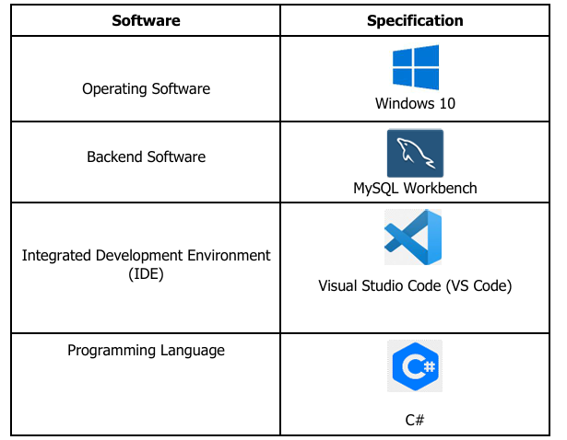
Table 1. Software Requirements for System Development

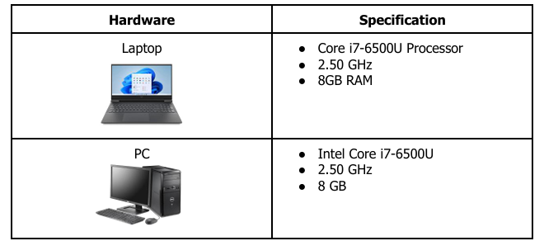
Table 2. Hardware Requirements
To evaluate the system, the researchers gathered primary data through surveys. Questionnaires were distributed to doctors, nurses, and administrative staff of Davao del Sur Provincial Hospital who served as the primary respondents. The survey instruments were designed to measure the system’s performance based on the ISO/IEC 25010 Software Quality Model, specifically focusing on Functional Suitability, Performance Efficiency, Usability, Reliability, and Compatibility. The collected data were stored and managed using the MySQL database integrated into the PulsoDSPH system.
The developed system was evaluated using the ISO/IEC 25010 Software Quality Model. This combination of development methodology, technology stack, research locale, and evaluation procedure ensured that the PulsoDSPH system is functional, reliable, and well-aligned with the operational requirements of Davao del Sur Provincial Hospital.

User Interface of Account Modules
The PulsoDSPH system was developed as a desktop-based application designed to run on the hospital’s Local Area Network (LAN). This ensures secure, real-time access and smooth performance for authorized users within Davao del Sur Provincial Hospital. The system features two primary account modules: the Administrator Module and the Super Administrator Module, each equipped with a clean, intuitive, and user-friendly graphical interface.
Figure 1 presents the Administrator Dashboard, which serves as the main interface for doctors, nurses, and administrative staff. The dashboard is divided into several key sections. The top portion contains summary cards that display important metrics such as the number of patients in the department, total records, pending tasks, and incomplete submissions. Below this, the "My Patients" and "Medical Records" sections provide searchable tables showing patient details including Patient Code, Full Name, Age, Gender, Phone, Status, and Action buttons (Manage). The interface also includes a Recent Activity log and a table for Recent Records in My Department, allowing quick monitoring of health record submissions and status updates. Additional navigation links lead to Reports for health record type distribution and My Settings for managing personal permissions.
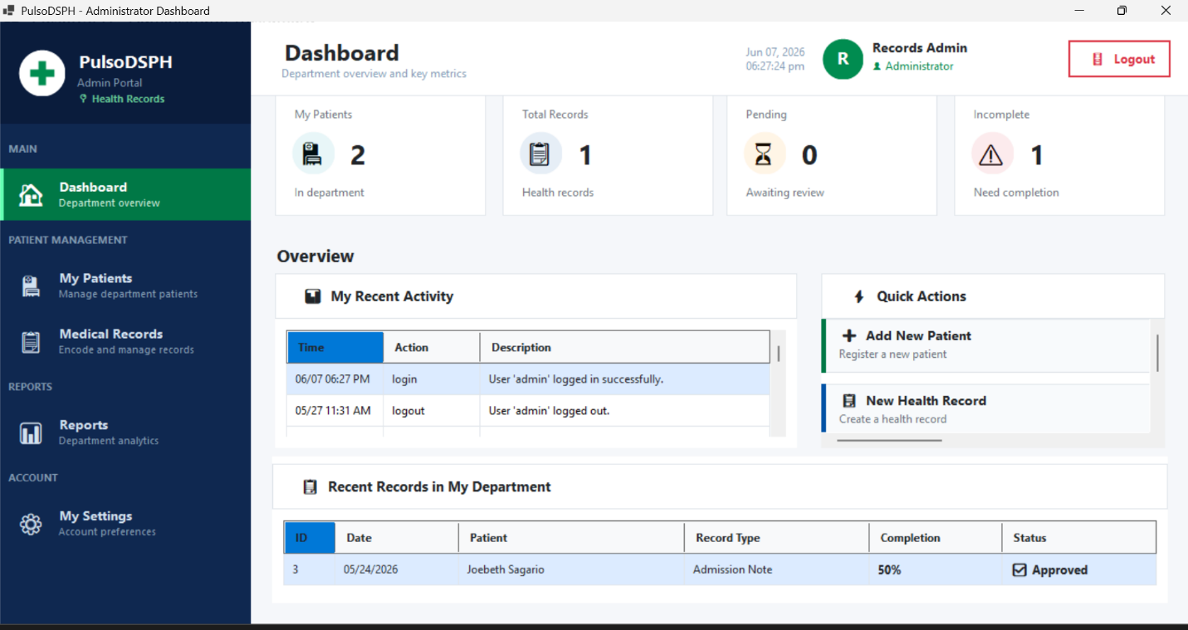
Figure 1. Administrator Dashboard
On the other hand, Figure 2 shows the Super Administrator Dashboard, designed for higher-level system oversight and management. This interface offers a more comprehensive view with advanced features. The top section displays system-wide statistics including total patients, total records, certifications, and database connection status. The left sidebar provides access to key modules such as User Management, All Patients, Patient Records, Certifications, Analytics, and Export Reports. The main area includes tools for managing administrator accounts, generating descriptive analytics (such as patient demographics and health record distributions), issuing official certifications, and exporting reports in PDF and Excel formats. The dashboard also features real-time system monitoring and database statistics for better administrative control.
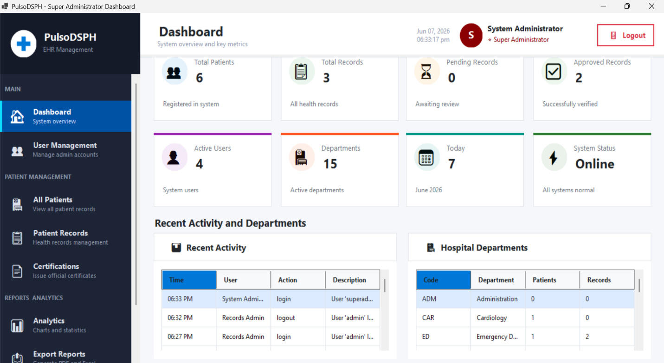

Figure 2. Super Administrator Dashboard
The user interfaces of both modules were intentionally designed to be simple, responsive, and easy to navigate, minimizing the learning curve for hospital staff while providing quick access to essential functions such as patient record encoding, document verification, status monitoring, and data analytics.

Testing and Evaluation
A convenience sampling method was utilized in identifying the six (6) respondents who evaluated the PulsoDSPH system. The evaluation focused on the system’s Functional Suitability, Performance Efficiency, Usability, Reliability, and Compatibility using a questionnaire adapted from the International Standard Organization’s (ISO) Software Quality Model 25010. Table 3 shows the distribution of the respondents involved in the study. They were asked to rate the Electronic Health Records System and express their feedback using the Likert Scale method with five-point measurement namely: Strongly Agree, Agree, Fairly Agree, Disagree, and Strongly Disagree.
Table 3. Distribution of Respondents
Evaluators | Sample Size
Super Administrator | 1
Administrative Staff | 5

Results and Discussion
A thorough assessment process was conducted to test and evaluate the developed PulsoDSPH system. Questionnaires were given to respondents to gauge their experience in using the system in line with its intended functionalities. Prior to testing, respondents were informed about the system’s objectives and available features to ensure they had a full understanding of the study. Six (6) respondents, composed of one (1) Super Administrator and five (5) Administrative Staff from Davao del Sur Provincial Hospital, evaluated the system (see Table 3 for distribution).

Table 4. Descriptive Rating of the Functionality Suitability for the Super Administrator account
Particular | Mean | Verbal Interpretation
The PulsoDSPH allows me to manage administrator accounts by updating profile information, resetting credentials, and monitoring account statuses effectively. | 5 | Strongly Agree
The PulsoDSPH allows me to create new administrator accounts with secure credentials and unique identifiers effectively. | 5 | Strongly Agree
The PulsoDSPH allows me to assign role-based permissions and access privileges to administrator accounts effectively. | 4 | Agree
The PulsoDSPH enables me to track and monitor patient health records across all hospital departments from a single  dashboard. | 4 | Agree
The PulsoDSPH allows me to generate and approve patient record entries effectively. | 4 | Agree
The PulsoDSPH allows me to generate and approve official certifications as required effectively. | 3 | Fairly Agree
The PulsoDSPH generates accurate system-wide descriptive analytics, including patient admission distribution. | 3 | Fairly Agree
The PulsoDSPH generates accurate system-wide descriptive analytics on consultation distribution across all  departments. | 3 | Fairly Agree
The PulsoDSPH allows me to generate lists of patients with incomplete health record submissions across all departments effectively. | 4 | Agree
The PulsoDSPH allows me to view and display lists of patients with incomplete health record submissions across all departments effectively. | 4 | Agree
Consolidated Mean | 3.9 | Agree

Functionality Suitability refers to the system’s capability to provide the necessary features and perform the specific tasks required for effective system management and operations. Based on the evaluation, illustrated in Table, 4 the Functionality Suitability of the PulsoDSPH of Super Administrator account obtained a consolidated mean of 3.9, verbally interpreted as Agree. This indicates that the system effectively supports key super administrator tasks such as account management, patient record monitoring, and report generation, although some areas like certification approval and system-wide analytics received lower ratings and may benefit from further enhancement.

Table 5. Descriptive Rating of the Functionality Suitability for the Admin account
Particular | Mean | Verbal Interpretation
The PulsoDSPH allows me to encode and update patient health information and medical histories accurately and completely. | 4.2 | Agree
The PulsoDSPH enables me to verify and validate submitted health documents with all the necessary tools available. | 4.4 | Agree
The PulsoDSPH allows me to update document and record statuses to pending effectively. | 4.2 | Agree
The PulsoDSPH allows me to update document and record statuses to verified effectively. | 3.8 | Agree
The PulsoDSPH allows me to update document and record statuses to complete effectively. | 3.6 | Agree
The PulsoDSPH allows me to add optional clinical remarks to patient health records as needed effectively. | 4.2 | Agree
The PulsoDSPH allows me to add optional instructions to patient health records as needed effectively. | 4 | Agree
The PulsoDSPH generates department- level descriptive analytics, including health record type distribution and lists of patients with incomplete submissions. | 3.8 | Agree
Consolidated Mean | 4.025 | Agree

As illustrated in Table 5, the Functionality Suitability for Administrative Staff achieved a consolidated mean of 4.025, verbally interpreted as Agree. This reflects strong approval of the system’s core features for encoding, updating, verifying patient records, and generating department-level analytics.

Table 6. Descriptive Rating of the Performance Efficiency for the Super Administrator account
Particular | Mean | Verbal Interpretation
The PulsoDSPH responds quickly when accessing and monitoring patient health records across all hospital departments. | 3 | Fairly Agree
The PulsoDSPH operates without noticeable slowdowns when multiple administrators and users are simultaneously active on the LAN. | 3 | Fairly Agree
Generating PDF and Excel reports for department-level analytics is completed within an acceptable amount of time. | 4 | Agree
The PulsoDSPH processes account management tasks and system-wide monitoring functions efficiently without  performance issues. | 3 | Fairly Agree
Consolidated Mean | 3.25 | Fairly Agree

Performance Efficiency refers to the system’s ability to respond promptly, utilize resources effectively, and operate without noticeable slowdowns under normal and multi-user conditions. As illustrated in Table 6, the Performance Efficiency of the PulsoDSPH for the Super Administrator obtained a consolidated mean of 3.25, verbally interpreted as Fairly Agree. This suggests that while basic operations perform adequately, improvements are needed in response times during simultaneous access and system-wide monitoring tasks.

Table 7. Descriptive Rating of the Performance Efficiency for Admin account
Particular | Mean | Verbal Interpretation
The PulsoDSPH responds quickly when encoding or retrieving patient health records during administrative tasks. | 4.4 | Agree
The PulsoDSPH operates without noticeable slowdowns during multi- user access on the hospital's local area network (LAN). | 4.4 | Agree
Generating PDF and Excel reports for department-level analytics is completed within an acceptable amount of time. | 4 | Agree
The PulsoDSPH processes document verification and status updates efficiently without lagging or freezing. | 3.8 | Agree
Consolidated Mean | 4.15 | Agree

As illustrated in Table 7, the Performance Efficiency obtained a consolidated mean of 4.15, verbally interpreted as Agree. Administrative staff appreciated the system’s quick response during record encoding, retrieval, and report generation within the hospital LAN environment.

Table 8. Descriptive Rating of the Usability for the Super Administrator account
Particular | Mean | Verbal Interpretation
The Super Administrator dashboard is easy to navigate and provides a clear overview of all system operations. | 4 | Agree
Managing administrator accounts and their privileges through the system is straightforward and easy to perform. | 4 | Agree
The system-wide analytics and data  visualization features are easy to use and provide actionable insights. | 3 | Fairly Agree
The report export features (PDF and Excel) are easy to use and produce well- organized outputs. | 4 | Agree
I am satisfied with the overall usability of the system for my role as a super  administrator. | 3 | Fairly Agree
Consolidated Mean | 3.6 | Agree

Usability refers to the ease with which users can navigate, understand, and interact with the system to accomplish their tasks effectively and satisfactorily. Based on the evaluation, illustrated in Table 8, the Usability of the PulsoDSPH garnered a consolidated mean of 3.6, verbally interpreted as Agree. Respondents found the dashboard and core management features relatively straightforward, though analytics visualization and overall satisfaction could be further improved to enhance user experience.

Table 9. Descriptive Rating of the Usability for the Admin account
Particular | Mean | Verbal Interpretation
The PulsoDSPH interface for encoding and managing patient health records is easy to navigate without extensive training. | 4 | Agree
The labels, buttons, and form fields for health record encoding are clearly labeled and easy to understand. | 4.4 | Agree
The PulsoDSPH significantly reduces the time and effort required for manual patient records management tasks. | 4.4 | Agree
The department-level analytics and reporting features of the system are easy to use and interpret. | 4.2 | Agree
I am satisfied with the overall usability of the system for my role as an administrator. | 4.2 | Agree
Consolidated Mean | 4.24 | Agree
As illustrated in Table 9, the Usability of the PulsoDSPH garnered a consolidated mean of 4.24, verbally interpreted as Agree. The interface, form fields, and reporting features were found to be intuitive and time-saving, contributing to high user satisfaction.

Table 10. Descriptive Rating of the Reliability for the Super Administrator account
Particular | Mean | Verbal Interpretation
The PulsoDSPH operates consistently and without unexpected crashes during system-wide monitoring and management tasks. | 3 | Fairly Agree
Administrator accounts, user privileges, and system-wide records remain accurate and intact after any modifications. | 3 | Fairly Agree
The PulsoDSPH maintains stable access to all department-level records and analytics even during network fluctuations. | 3 | Fairly Agree
I trust the system to reliably protect  data integrity and uphold role-based access controls across all accounts. | 3 | Fairly Agree
Consolidated Mean | 3 | Fairly Agree

Reliability refers to the system’s ability to perform consistently, maintain data integrity, and recover from issues without unexpected failures over time. Based on the evaluation, illustrated in Table 10, the Reliability aspect received a consolidated mean of 3, verbally interpreted as Fairly Agree. This indicates moderate confidence in the system’s stability and data protection, highlighting the need for stronger consistency during monitoring and network fluctuations.

Table 11. Descriptive Rating of the Reliability for the admin account
Particular | Mean | Verbal Interpretation
The PulsoDSPH operates consistently without unexpected crashes or errors during health record encoding and document processing. | 4.4 | Agree
Patient records and health documents remain accurate and intact after encoding, editing, or status updates. | 4 | Agree
The PulsoDSPH recovers from local network interruptions without data loss or corruption of encoded records. | 4.2 | Agree
I trust the system to maintain the accuracy and completeness of patient health records over time. | 4.2 | Agree
Consolidated Mean | 4.2 | Agree

As illustrated in Table 11, the Reliability achieved a consolidated mean of 4.2, verbally interpreted as Agree. Respondents expressed confidence in the system’s stability, data accuracy, and recovery capabilities during daily operations.

Table 12. Descriptive Rating of the Compatibility for the Super Administrator account
Particular | Mean | Verbal Interpretation
The PulsoDSPH runs properly on the computer units designated for super administrator use in the hospital. | 3 | Fairly Agree
The PulsoDSPH functions correctly and stably across all departments within the hospital's local area network (LAN). | 3 | Fairly Agree
Reports and files exported by the system (PDF, Excel) are fully compatible  with standard office software tools. | 3 | Fairly Agree
The PulsoDSPH performs consistently across all hospital workstations and administrative terminals connected to the  LAN. | 3 | Fairly Agree
Consolidated Mean | 3 | Fairly Agree
Compatibility refers to the system’s ability to operate effectively across different hardware, software environments, and network setups, including seamless integration with standard office tools for exported files. Based on the evaluation, illustrated in Table 12, the Compatibility of the PulsoDSPH obtained a consolidated mean of 3, verbally interpreted as Fairly Agree. While the system runs on designated workstations and the hospital LAN, minor compatibility refinements are recommended for more consistent performance across all terminals.

Table 13. Descriptive Rating of the Compatibility for the Admin account
Particular | Mean | Verbal Interpretation
The PulsoDSPH runs properly on the computer units available in the administrative department of the hospital. | 4.4 | Agree
The PulsoDSPH functions correctly and stably within the hospital's local area network (LAN) environment. | 4.4 | Agree
The reports and files generated by the system (PDF, Excel) are compatible with standard office software tools. | 4.4 | Agree
The PulsoDSPH performs consistently across the different workstations used within the hospital's administrative offices. | 4.2 | Agree
Consolidated Mean | 4.35 | Agree

As illustrated in Table 13, the Compatibility aspect obtained a consolidated mean of 4.35, verbally interpreted as Agree. The system demonstrated strong performance across administrative workstations, the hospital LAN, and compatibility with PDF/Excel tools.

Conclusion
PulsoDSPH: An Electronic Health Records System for Davao del Sur Provincial Hospital was evaluated using the ISO/IEC 25010 Software Quality Model, focusing on Functional Suitability, Performance Efficiency, Usability, Reliability, and Compatibility. The Super Administrator module obtained a consolidated mean of 3.35, interpreted as “Fairly Agree,” while the Administrator module obtained a consolidated mean of 4.193, interpreted as “Agree.” Majority of the respondents expressed satisfaction with the system’s core features such as patient record encoding, document verification, status updating, account management, and descriptive analytics.
However, some areas received lower ratings, particularly in system-wide analytics, report generation speed, and performance during multi-user access. These insights are taken into account for future improvements of the system. Overall, the study successfully achieved its objectives. It effectively addressed the problems of manual record-keeping at Davao del Sur Provincial Hospital by providing a secure, organized, and functional desktop-based Electronic Health Records system that runs on the hospital’s Local Area Network. The ratings reflect the team’s dedication in developing a practical solution that can improve health record management, enhance care coordination, and support better decision-making in a provincial hospital setting.
Recommendations
Based on the findings of the system evaluation, the following recommendations are proposed for the future enhancement of PulsoDSPH:
- Optimize multi-user LAN performance through database indexing improvements, connection pooling, and network configuration tuning to address the lower scores observed in Performance Efficiency and Compatibility under concurrent access.
- Enhance the system’s user interface, particularly the analytics dashboard and clinical remarks entry fields, through user experience (UX) testing and iterative design refinements to improve Usability scores.
- Implement an automated backup and recovery mechanism with configurable schedules to improve system resilience against network interruptions and data loss, addressing reliability concerns noted during evaluation.
- Explore phased integration with external health information systems such as PhilHealth portals and the DOH National Health Data Network to overcome the current limitation of non-interoperability with external platforms.
- Develop a comprehensive user training program and manual to support smoother system adoption across all user roles, reducing the learning curve for administrative staff and other healthcare personnel unfamiliar with EHR platforms.
These recommendations are derived from the respondents’ feedback and the identified limitations of the current system. Implementing them will further strengthen PulsoDSPH, making it more robust, user-friendly, and scalable for full deployment at Davao del Sur Provincial Hospital.

References
- Almutairi, M., Alkulaib, L., Wang, S., Chen, Z., ALMutairi, Y., Alenazi, T. M., Luther, K. & Lu, C. (2024). FHIRViz: Multi-Agent Platform for FHIR Visualization to Advance Healthcare Analytics. ACM International Conference on Bioinformatics, Computational Biology and Biomedicine. https://doi.org/10.1145/3698587.3701392

- Alshamrani, N. S. (2025). Digital Health Transformation Through EHRs in Saudi Arabia: Operational Insights and MIS Implications. International Journal of E-Services and Mobile Applications (IJESMA), 17(1), 1-19.

- Babatope, A. E., Adewumi, I. P., Ajisafe, D. O., Adepoju, K. O., & Babatope, A. R. (2024). Assessing the factors militating against the effective implementation of electronic health records (EHR) in Nigeria. Scientific Reports, 14(1), 31398. https://doi.org/10.1038/s41598-024-83009-y

- Barbalho, I. M. P., Fonseca, A. L. A., Fernandes, F., Henriques, J., Gil, P., Nagem, D., Lindquist, R., Lima, T., Santos, J. P. Q. D., Paiva, J., Morais, A. H. F., Júnior, M. E. T. D., & Valentim, R. a. M. (2023). Digital health solution for monitoring and surveillance of Amyotrophic Lateral Sclerosis in Brazil. Frontiers in Public Health, 11, 1209633. https://doi.org/10.3389/fpubh.2023.1209633

- Barbalho, I., Fernandes, F., Barros, D. M. S., Paiva, J. C., Henriques, J., Morais, A. H. F., Coutinho, K., Neto, G. C. C., Chioro, A. & Valentim, R. A. M. (2022). Electronic health records in Brazil: Prospects and technological challenges. Frontiers in Public Health. https://doi.org/10.3389/fpubh.2022.963841

- Chagas, M. E. V., Silva, G. d. O. L., Fernandes, G. R., Aguilar, G. T., da Silva, M. M. D., Moraes, E. L., Lottici, I. D. A., de Amorim, J. d. R., de Abreu, T., Moreira, T. d. C. & Cabral, F. C. (2025). The evolution of digital health: a global, Latin American, and Brazilian bibliometric analysis. Frontiers in Digital Health, 7. https://doi.org/10.3389/fdgth.2025.1582719

- Chandra, A., Sreeganga, S., Rath, N. & Ramaprasad, A. (2023). Healthcare Policies to Eliminate Neglected Tropical Diseases (NTDs) in India: A Roadmap. International Journal of Environmental Research and Public Health, 20. https://doi.org/10.3390/ijerph20196842

- Dantas, J. N., & Da Silva, M. a. D. (2025). A Descriptive and Correlational Study Assessing the Integration of Digital Health into Brazil’s Dentistry Master’s Degree Programs. Evaluation & the Health Professions, 48(4), 463–470. https://doi.org/10.1177/01632787251333780

- de Aquino, V. W., Silveira, G. d. O., Boniatti, M. M. & Terres, M. d. S. (2024). Communication, Shared Decision-making and Goals of Care in the ICU through Electronic Health Records: A Scoping Review. Indian Journal of Critical Care Medicine, 28. https://doi.org/10.5005/jp-journals-10071-24818

- Fernandes, F., Barbalho, I., Júnior, A. B., Alves, L., Nagem, D., Lins, H., Júnior, E. A., Coutinho, K. D., Morais, A. H. F., Santos, J. P. Q., Machado, G. M., Henriques, J., Teixeira, C., Júnior, M. E. T. D., Lindquist, A. R. R., & Valentim, R. a. M. (2023). Digital Alternative Communication for Individuals with Amyotrophic Lateral Sclerosis: What We Have. Journal of Clinical Medicine, 12(16), 5235. https://doi.org/10.3390/jcm12165235

- Fiore, M., Bianconi, A., Sicari, G., Conni, A., Lenzi, J., Tomaiuolo, G., Zito, F., Golinelli, D., & Sanmarchi, F. (2024). The Use of Smart Rings in Health Monitoring—A Meta-Analysis. Applied Sciences, 14(23), 10778. https://doi.org/10.3390/app142310778

- Fonsêca, A. L. A., Barbalho, I. M. P., Fernandes, F., Júnior, E. A., Nagem, D. A. P., Cardoso, P. H., Veras, N. V. R., Farias, F. L. d. O., Lindquist, A. R. R., Santos, J. P. Q. d., de Morais, A. H. F., Henriques, J., Lucena, M. & Valentim, R. A. d. M. (2024). Blockchain in Health Information Systems: A Systematic Review. International Journal of Environmental Research and Public Health, 21(11). https://doi.org/10.3390/ijerph21111512

- Gerk, A., Forbes, C., Wurdeman, T., Kumar, N., McLeod, E., Meara, J. G., Jimbo-Sotomayor, R., McClain, C. D., Fuentes, M., Uribe‐Leitz, T. & Vega, A. B. (2024). Promoting climate-resilient health systems through national surgical plans. The Lancet Regional Health - Americas, 40. https://doi.org/10.1016/j.lana.2024.100911

- Lessa, C. L. S., Fiuza, B. S. D., Hodel, K. V. S., Minafra, C., De Souza Gonçalves, M., & Machado, B. a. S. (2025). Understanding Dengue Underreporting: An analysis of the impacts for the world, Latin America and Brazil. The Scientific World JOURNAL, 2025(1), 9993911. https://doi.org/10.1155/tswj/9993911

- Morley, J., Hine, E., Roberts, H. et al. Global Health in the Age of AI: Charting a Course for Ethical Implementation and Societal Benefit. Minds & Machines 35, 31 (2025). https://doi.org/10.1007/s11023-025-09730-3

- Neto, A. L. d. S., Mendes‐Rodrigues, C., Pedroso, R. d. S. & Röder, D. V. D. d. B. (2024). Revisiting the COVID-19 Pandemic: Mortality and Predictors of Death in Adult Patients in the Intensive Care Unit. Life, 14(8). https://doi.org/10.3390/life14081027

- Reegu, F. A., Abas, H., Gulzar, Y., Xin, Q., Alwan, A. A., Jabbari, A., Sonkamble, R. G., & Dziyauddin, R. A. (2023). Blockchain-Based Framework for Interoperable Electronic Health Records for an Improved Healthcare System. Sustainability, 15(8), 6337. https://doi.org/10.3390/su15086337

- Silva, D. B. L., Queiroga, E. M., Barros, A. N., Marcolino, M. R., Dermeval, D., Lima, A., Marques, L. B., Cechinel, C., & Vieira, T. (2025b). Leveraging string similarity algorithms for educational data validation. Conference on Digital Government Research, 1. https://doi.org/10.59490/dgo.2025.942

- Xie, H., Cebulla, A., Bastani, P. & Balasubramanian, M. (2024). Trends and Patterns in Electronic Health Record Research (1991–2022): A Bibliometric Analysis of Australian Literature. International Journal of Environmental Research and Public Health. https://doi.org/10.3390/ijerph21030361

- Zharima, C., Griffiths, F. & Goudge, J. (2023). Exploring the barriers and facilitators to implementing electronic health records in a middle-income country: a qualitative study from South Africa. Frontiers in Digital Health, 5. https://doi.org/10.3389/fdgth.2023.1207602

- Zonta, R., Galana, M. Z., Zepeda, J., De Barros Perini, F., Fairall, L. R., Pinto, F. K. K. M. S., De Andrade, M. P., Eloi, B. M., Da Silveira, J. P. M., Siqueira, E. F., Báfica, A. C. M. F., Awotiwon, A., Spiller, P. W., Wattrus, C., Ras, C. J., Georgeu-Pepper, D., & Cornick, R. V. (2024). Supporting a rapid primary care response to emergent communicable disease threats with PACK (Practical Approach to Care Kit) in Florianópolis, Brazil. BMJ Global Health, 9(Suppl 3), e013815. https://doi.org/10.1136/bmjgh-2023-013815

