GEOSPATIAL DISTRIBUTION OF TAROK SACRED GROVE OF LANGTANG
NORTH AND LANGTANG SOUTH LOCAL GOVERNMENT AREAS

Dr. Sunday Nannim¹, Gwamzhi Ponsah Emmanuel², Ramnap Nansel Venyir², Nanzhi Zakka²
Zonal Advanced Space Technology Applications Laboratory, Plateau State, Nigeria.

Levite Sunday Nannim²
Abubakar Tafawa Balewa University (ATBU), Bauchi, Nigeria

ABSTRACT
This study examines the spatial distribution of Tarok sacred groves in Langtang North and South Local Government Areas of Plateau State, Nigeria, with a view to understanding their distribution patterns, ownership, and conservation significance. Sacred Groves are culturally protected forest patches that serve as important reservoirs of biodiversity and traditional heritage. However, increasing anthropogenic pressures are undermining the ecological and cultural sustainability of these Groves.

The study utilized geospatial data comprising 531 Sacred Grove locations collected as point data, with associated attributes such as coordinates and individual grove areas in hectares. Descriptive statistical analysis was employed to examine the size characteristics of the groves, while Geographic Information System (GIS) techniques were used to map their spatial distribution and develop a geodatabase. Findings revealed that the Tarok Sacred Groves are generally small in size, with a mean area of 0.856 hectares, indicating fragmentation. The spatial distribution pattern is clustered rather than random, reflecting the influence of cultural practices, settlement patterns, and environmental factors.

Although ownership data were not explicitly available in the dataset, existing literature suggests that Sacred Groves are commonly owned by communities, families, or traditional religious institutions. The study highlights the ecological and cultural importance of sacred groves as biodiversity refuges and indigenous conservation systems. However, they are increasingly threatened by land-use changes, agricultural expansion, climate change, and the weakening of traditional beliefs.

The study recommends proper documentation, integration into formal conservation policies, community participation, and the establishment of a comprehensive geodatabase for effective management. This research contributes to knowledge by demonstrating the application of GIS in analyzing cultural landscapes and by providing baseline data for conservation planning.

Keywords: Sacred Groves, Ancestral cult, Biodiversity, Conservation, GIS, Geodatabase

INTRODUCTION
The Tarok people, who refer to themselves as oTárók, speak the language iTárók and inhabit the land known as ìTàrók. They constitute a relatively homogeneous ethno-national group predominantly located in Langtang North, Langtang South, and Wase Local Government Areas of Plateau State in central Nigeria. Significant Tarok populations are also found in Shendam, Mikang, Kanke, and Kanam LGAs, while smaller farming communities are dispersed across Nasarawa and Taraba States (Lar, 2015; Longtau, Selbut R. 1991). Their principal towns—Langtang in Langtang North and Mabudi in Langtang South—are situated approximately 186 kilometres southeast and 210 kilometres south of Jos, the Plateau State capital, respectively.

Although the majority of Tarok population now identifies as Christian, others still maintain a strong traditional ancestral cult known as Orìm (Blench, Roger, 2021), which continues to command significant prestige and cultural relevance despite the widespread influence of Christianity in the region. Ritual activities associated with Orìm are typically conducted in Sacred Groves known as Ebgong Orìm, which is preserve and protected as the dwelling place of the ancestors (Lar, Isaac B., 2015). The Ebgong Orìm are located on the outskirts of nearly all Tarok settlements.

Sacred Groves are patches of natural vegetation that are protected and conserved by local communities due to their cultural, spiritual, and religious significance (Ramakrishnan, 1996; Sheridan Nyamweru, 2007). These Groves are often associated with traditional beliefs, rituals, and taboos that regulate human activities within them (Colding and Folke, 2001). Across Africa, Sacred Groves have historically served as important sites for worship, initiation rites, and cultural ceremonies (Anderson and Grove, 1987).

In Nigeria, Sacred Groves are widely distributed across different ethnic groups and ecological zones. For example, the Osun-Osogbo Sacred Grove, containing dense forests, is located just outside the city of Osogbo. It is dedicated to the fertility god in Yoruba mythology, and is dotted with shrines and sculptures (Adekunle, V. A. J. (2010). Among the Tarok people of Langtang North, Langtang South LGAs and other Tarok farming communities found elsewhere, Sacred Groves represent an integral part of cultural identity and environmental stewardship. These Groves are preserved through indigenous knowledge systems and customary laws that restrict exploitation (Osemeobo, 1994; Oyelowo & Aduradola, 2017).

Beyond their cultural significance, sacred groves play an important ecological role. They act as biodiversity hotspots, conserving rare plant and animal species that may have disappeared from surrounding landscapes due to deforestation and land use changes (Bhagwat & Rutte, 2006; Aerts et al., 2016). They also contribute to climate regulation, soil conservation, and water resource protection (Millennium Ecosystem Assessment, 2005). However, rapid population growth, urbanization, agricultural expansion, climate change, and the erosion of traditional belief systems have led to the degradation and loss of many Sacred Groves (Faleyimu et al., 2013; Alohou E. C., et al., 2016). This has raised concerns about the sustainability of these important cultural landscapes.

Geospatial technologies such as Geographic Information Systems (GIS) and Remote Sensing provide powerful tools for mapping, analyzing, and managing spatial data (Malczewski, 1999). These technologies can be used to assess the distribution, size, and conservation status of Sacred Groves, thereby supporting effective planning and decision-making (Sutton et al., 2009; Shashi S. B. et al., 2015). This study therefore focuses on the spatial distribution of Tarok Sacred Groves in Langtang North and Langtang South Local Government Areas, with the aim of providing baseline data for conservation and sustainable management.

The specific objectives are to: 1) identify the ownership of the Sacred Groves for conservation purposes, 2) Produce a map of Langtang North and South showing the spatial distribution of Sacred groves, 3) Create a geodatabase for the Sacred Groves within the study area, while the objective of study was to: i. Examine the custodianship structure of Sacred Groves, ii. Identify conservation methods in use, iii. Assess the presence of wildlife, iv. Evaluate the age distribution of Sacred Groves.

Most studies on Sacred Groves focus on biodiversity and cultural aspects, with limited emphasis on spatial analysis using GIS. This study fills the gap by: Providing spatial analysis of Sacred Groves; Creating a geodatabase; Supporting conservation planning.

STUDY AREA
The study was conducted in Langtang North and Langtang South Local Government Areas, of Plateau State, Nigeria, situated between latitudes 8⁰25’0” N and 9⁰15’0” N and longitudes 9°25'0" E and 10°15'0" E. These Local Government Areas share borders with five other LGAs within States and a border with Taraba at the southern part. The area is characterized by: undulating terrain; Guinea savannah vegetation and agricultural activities. The inhabitants are predominantly Tarok people, known for their rich cultural heritage.

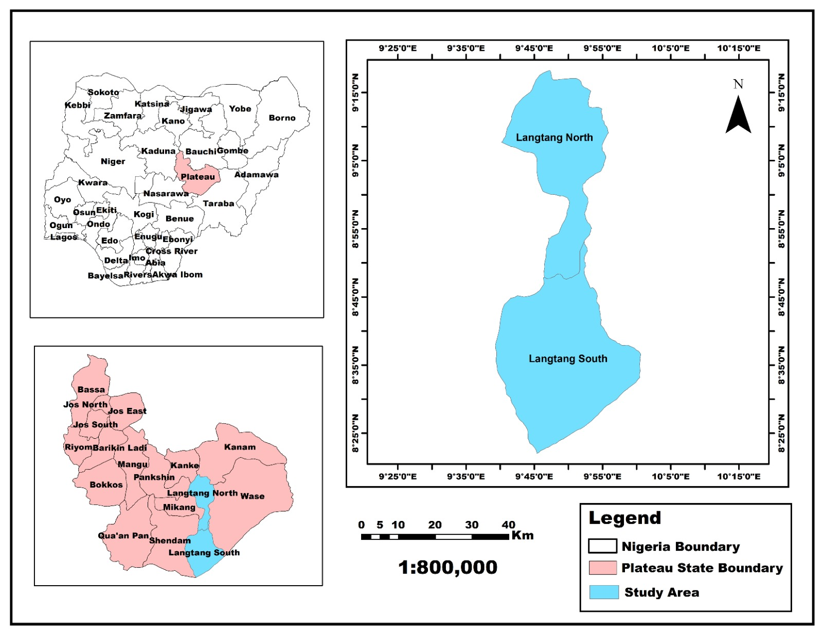
Figure 1: The Study Area (Langtang North and Langtang South LGAs)

MATERIALS AND METHODS

Materials used for the study are GPS, administrative boundaries, Satellite imagery, laptop, ArcGIS 10.8. Field work was conducted for a period of 6 weeks. Geographic coordinates of 531 sacred groves were recorded in situ using a handheld GPSmap 78CSx receiver across various settlements and communities within the two LGAs. Data were also collected using structured questionnaires administered to respondents in both LGAs. A total of 150 questionnaires were administered, 115 were retrieved, resulting in a response rate of 76.7%.

The mapping process involved, importing the CSV data into GIS software, defining coordinate system, converting point data into shapefile and symbolizing data. Spatial analysis was conducted using GIS techniques to determine; distribution pattern, size variation, clustering, proximity to settlement, geodatabase creation (enables efficient storage, retrieval, and analysis of spatial information), and implications for conservation. A descriptive statistic, including frequencies and percentages was also used in line with the study objectives.
Land Use Land Cover (LULC) mapping was carried out using Landsat 8 satellite imagery acquired for the study period. The imagery was classified using supervised classification techniques in ArcGIS 10.8, with training samples collected from ground-truthing surveys and high-resolution imagery. Eight (8) land cover classes were identified, namely: Settlement, Agricultural Land, Alluvial Deposit, Rock Outcrop, Savannah, Vegetation, Waterbody, and Wetland. Post-classification accuracy assessment was performed using a confusion matrix to validate the classification results. The resulting LULC map (Figure 2) provides a spatial context for understanding the relationship between land use dynamics and the distribution of Sacred Groves across the study area. The settlement map (Figure 4) was generated by digitizing settlement boundaries and locations from topographic maps and satellite imagery, and was used to assess the proximity of Sacred Groves to human settlements. Sacred Grove locations (Figure 3) were mapped using GPS coordinates recorded in the field, while the spatial distribution map (Figure 5) and the combined settlement and Sacred Grove map (Figure 6) were produced to visualize the co-occurrence patterns of Groves and settlements across Langtang North and Langtang South LGAs.

RESULTS AND DISCUSSION
The Geospatial analysis with Questionnaire-based findings provides an understanding of the distribution, characteristics, and conservation status of Sacred Groves in Langtang North and Langtang South LGAs. While the geospatial techniques offer insights into spatial patterns, distribution, and environmental relationships, questionnaire data reveal socio-cultural and ecological dynamics. Additionally, Land Use Land Cover (LULC) analysis, settlement distribution, and sacred grove spatial mapping further enhance the interpretation of human–environment interactions within the study area.
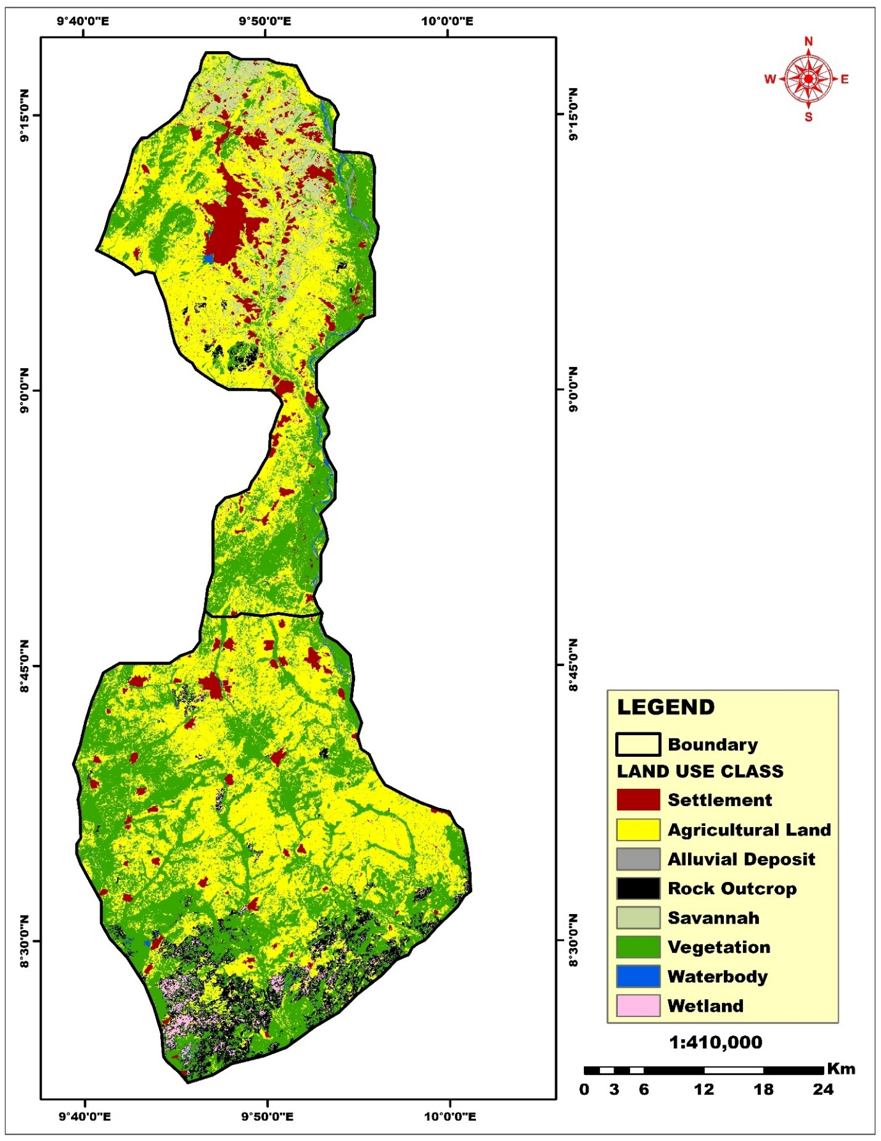
Figure 2: Land use land cover (LULC) map of the study area
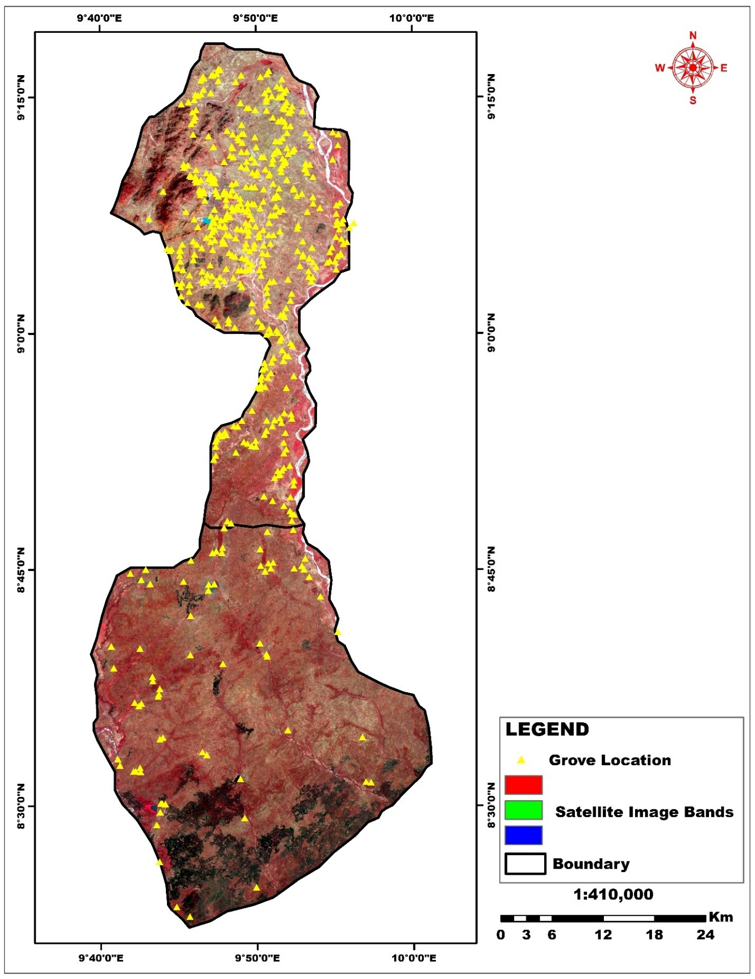
Figure 3: Sacred Grove Points Map
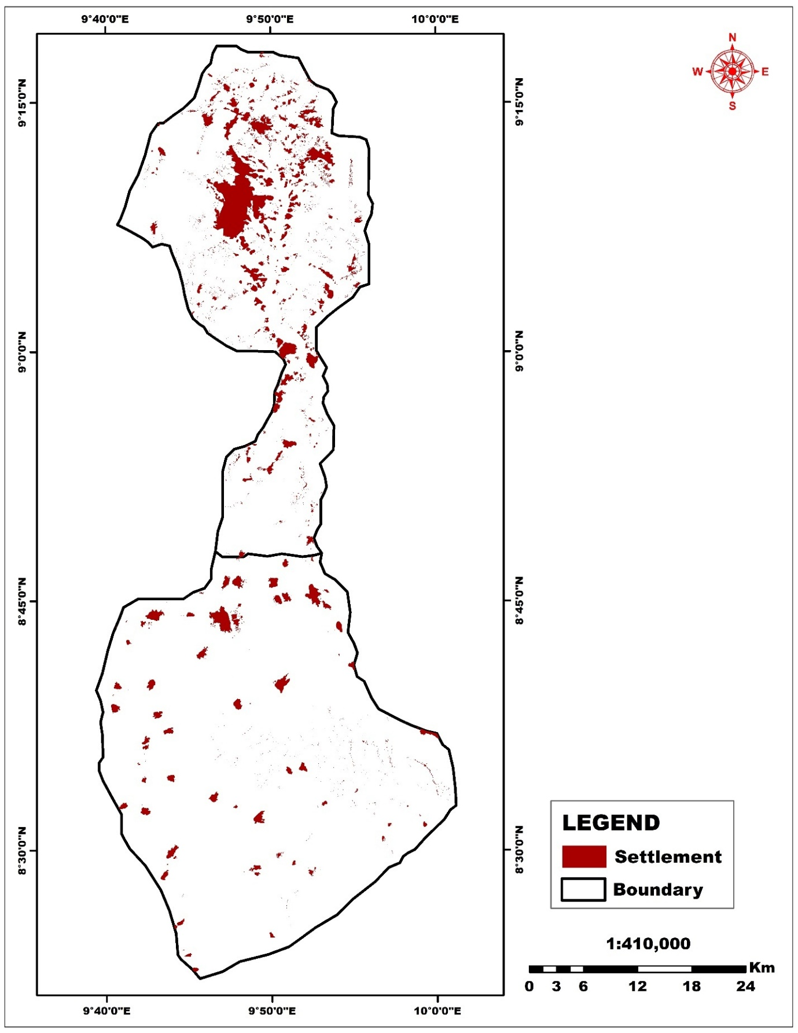
Figure 4: Settlement Map of the Study Area
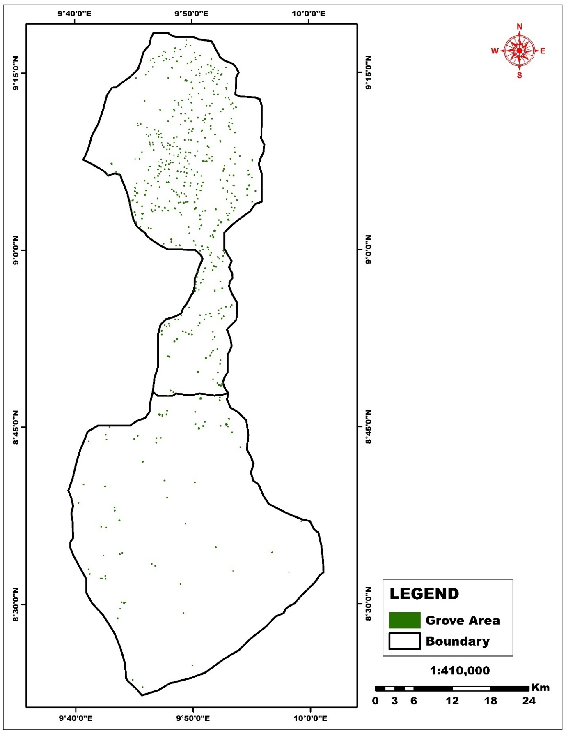
Figure 5: Spatial Distribution of Sacred Grove (Areas in Hectare)
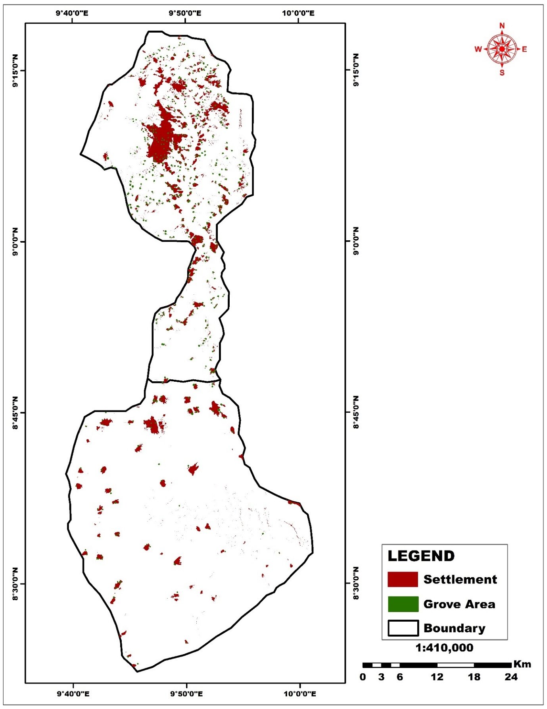
Figure 6: Settlement and Sacred Grove Map
Spatial Distribution of Sacred Groves
The spatial distribution map (Figure 5) reveals that Sacred Groves are widely dispersed across both LGAs. The geographic coordinates of all 531 Sacred Grove locations, presented as point data in the Sacred Grove Points Map (Figure 3), confirm their broad spatial extent across the study area. The northern part of the map which is Langtang North LGA had high concentration and density of Groves, while south of the map is Langtang South LGA, shows a more evenly spaced but fewer in number of Sacred Groves. This suggests that Sacred Groves are not randomly distributed, but rather are influenced by a combination of socio-cultural and environmental factors. The Land Use Land Cover (LULC) map (Figure 2) further reveals the relationship between dominant land cover types and grove distribution. Eight land cover classes were mapped — Settlement, Agricultural Land, Alluvial Deposit, Rock Outcrop, Savannah, Vegetation, Waterbody, and Wetland — and the analysis shows that Sacred Groves tend to occur predominantly within or adjacent to Vegetation and Savannah land cover classes, while areas dominated by Agricultural Land and Settlement exhibit comparatively lower grove densities, particularly in the southern part of the study area. Spatial assessment further indicates that Sacred Groves exhibit a clustered distribution pattern, with noticeable clustering in settlement-dense areas especially in the Northern part of the study area. This clustering is likely influenced by their proximity to settlements (Figure 6), as clearly depicted in the settlement map (Figure 4), which shows that most Sacred Groves are located within or at the periphery of established settlements, reinforcing the cultural and communal link between Tarok communities and their sacred landscapes. This clustering is also influenced by the nature of cultural and religious practices, historical land use patterns, and the availability of forested land (Agbo and Sokpon, 1997). Such a pattern implies that certain areas function as cultural hotspots where Sacred Groves are more densely concentrated. The implications of this spatial distribution are significant. The clustered pattern highlights areas of high cultural importance, identifies regions that may require priority conservation efforts, and suggests opportunities for spatial planning and zoning. Additionally, spatial clustering indicates that Sacred Groves may function as interconnected ecological networks, thereby contributing to biodiversity conservation. The clustering pattern aligns with the questionnaire’s finding that 86.6% of groves are clan-owned, suggesting that, Groves are established and maintained within ancestral territories, and their locations are influenced by traditional land tenure systems. This spatial clustering reinforces the idea that Sacred Groves are culturally embedded landscapes, rather than purely ecological entities. Buffer analysis (50 -100 radius) shows that many Groves are located close to human settlements but remain relatively undisturbed (Agbo and Sokpon, 1997). Taken together, figures 2, 4, 5 and 6 provide a comprehensive cartographic account of the spatial relationships among land use patterns, settlement distribution, and Sacred Grove locations across the study area, demonstrating that the Groves are not isolated features but are deeply integrated within both the physical and cultural landscape of Langtang North and South LGAs.

Analysis of Sacred Grove Areas (531 Groves)
Analysis of Sacred Groves areas (hectare data) reveals that the Groves are generally small in size, with an average of 0.856 hectares. The median value (0.709 ha) being lower than the mean indicates a positively skewed distribution, suggesting that a few larger Groves increase the average size (Oliver and Norberg, 2010). The implications of positively skewed distribution might be that smaller groves dominate, easier to protect but ecologically limited, while larger groves are higher biodiversity potential (Shashi S. B. et al., 2015). The minimum size of 0.041 hectares indicates the presence of highly fragmented groves, while the maximum size of 4.960 hectares represents relatively large and potentially well-preserved sacred sites. The exhibition of wide variation in size of Sacred Grove might be an indication of small household/clan groves and a larger community-controlled Groves. The variation also suggests that Sacred Groves exist at different levels of preservation, influenced by human activities, land use pressure, and cultural practices. Spatial analysis also reveals that the total land area occupied by Sacred Groves in the study area was 502.452 hectare.

Geodatabase Development
A geodatabase was developed to systematically integrate and manage critical spatial and attribute information relating to the Sacred Groves. This database includes precise geographic coordinates, measured area in hectares, Local Government Area (LGA) classifications, and detailed descriptive attributes such as custodianship, conservation status, and associated cultural practices. By organizing these diverse datasets into a unified geospatial framework, the geodatabase provides a reliable platform for continuous monitoring, advanced spatial analysis, and evidence-based decision-making.

Beyond its technical value, the geodatabase serves as an essential tool for long-term environmental management and cultural preservation. It enables researchers and planners to identify spatial patterns, assess conservation priorities, and track changes over time. Furthermore, it supports informed policy formulation and the development of targeted conservation strategies through accurate mapping and data visualization. Such timely and informed interventions are crucial for safeguarding these sacred landscapes, which represent an enduring “age-old tradition” and a vital component of both cultural heritage and biodiversity conservation (Shashi S. B. et al., 2015).

Data analyzed using descriptive statistics, including frequencies and percentages are presented in table 1 to 8. The results are interpreted in line with the study objectives.

Table 1: Custodianship of the Sacred Grove
Category Frequency Percentage (%)
Individual 0 0.0
Inheritance 30 13.4
Clan 194 86.6
Total 224 100

Table 2: Protection Method
Category Frequency Percentage (%)
Natural Fencing 173 77.2
Use of Block 0 0.0
Use of Barbed Wire 0 0.0
Use of Stone 51 22.8
Total 224 100

Table 3: Predominant Tree Type
Category Frequency Percentage (%)
Mango 14 6.3
Neem 66 29.5
Locust Beans 10 4.5
Shear Butter 39 17.4
Local Name 57 25.4
Others 38 17.0
Total 224 100

Table 4: Conservation Methods in Use
Category Frequency Percentage (%)
Tree Planting 16 7.1
Restriction on Tree Cutting / Thorny Plants 224 100
Prevention of Bush Burning 224 100
Ban on Farming Activities 224 100

Table 5: Assistance Received for Preservation
Category Frequency Percentage (%)
Individual 0 1.3
Community 0 0.0
Government 0 0.0
NGOs 0 0.0
Total 224 100

Table 6: Functionality of the Grove
Category Frequency Percentage (%)
In Use 217 96.9
Not in Use 7 3.1
Total 224 100

Table 7: Presence of Wildlife
Category Frequency Percentage (%)
Yes 212 94.6
No 12 5.4
Total 224 100

Table 8: Age of the Grove
Category Frequency Percentage (%)
1–30 9 4.0
31–60 23 10.3
61–90 82 36.6
91 and above 110 49.1
Total 224 100

Custodianship of the Sacred Grove
The findings reveal that custodianship of Sacred Groves is predominantly clan-based (86.6%), while inheritance accounts for a smaller proportion (13.4%). Notably, there is no record of individual ownership (table 1). This indicates that Sacred Groves are largely managed under communal traditional systems, which reinforces collective responsibility and cultural continuity. This result aligns with existing literature that emphasizes the role of indigenous institutions and kinship systems in environmental conservation (Adekunle, V. A. J. (2010); Byers, B. A., Cunliffe, R. N., & Hudak, A. T. (2001) Chandran, M. D. S., & Hughes, J. D. (2000). Dudley, N., Higgins-Zogib, L., & Mansourian, S. (2009). Clan-based custodianship enhances compliance with traditional rules and strengthens protection mechanisms through shared beliefs and values.

Protection Methods
The results for protection method indicates that, natural fencing (77.2%) is the dominant method of protection, followed by the use of stones (22.8%). Modern protection methods such as blocks, and barbed wire are completely absent (table 2). This suggests a strong reliance on indigenous knowledge systems and environmentally sustainable practices (Ormsby, A. A., and Bhagwat, S. A. 2010) Natural fencing may include the use of vegetation or landscape features, which integrates conservation with the natural ecosystem. The absence of modern infrastructure may reflect both cultural preferences and limited external intervention.

Predominant Tree Type
The findings for the predominant tree type shows, that Neem (29.5%) and locally identified species (25.4%) are the most dominant tree types. Shea butter (17.4%) and other species also contribute significantly to the vegetation composition (table 3). This diversity indicates that Sacred Groves function as biodiversity reservoirs, preserving both indigenous and economically valuable plant species (Shashi S. B. et al., 2015). The prominence of local species underscores the importance of traditional ecological knowledge in species identification and conservation.

Conservation Methods in Use
All respondents (100%) indicated the enforcement of strict conservation measures, including restrictions on tree cutting, prevention of bush burning, and prohibition of farming activities. However, only 7.1% reported tree planting as a conservation strategy (table 4). This implies that conservation efforts are largely protective rather than regenerative. While strict rules effectively preserve existing vegetation (Shashi S. B. et al., 2015), the low rate of tree planting may limit long-term ecological sustainability, especially in the face of environmental changes.

Assistance Received for Preservation
The results reveal an almost complete absence of external support, with only 1.3% of respondents indicating any form of individual assistance. There is no reported support from government agencies or NGOs (table 5). This highlights a significant gap in institutional involvement and suggests that Sacred Grove conservation is entirely community driven. The lack of external support may hinder access to modern conservation techniques, funding, and policy integration.

Functionality of Sacred Groves
Most Sacred Groves (96.9%) are still in active use. This indicates that they remain relevant in the socio-cultural and ecological life of the communities (table 6). The continued use of these groves suggests resilience of traditional practices despite modernization pressures.

Presence of Wildlife
A significant majority (94.6%) of respondents confirmed the presence of wildlife in the Groves. This underscores the ecological importance of Sacred Groves as habitats for biodiversity conservation (table 7). These findings support the view that Sacred Groves serve as mini-conservation reserves, protecting flora and fauna in otherwise human-dominated landscapes.

Age Distribution of Sacred Groves
The results show that most Sacred Groves are over 60 years old, with nearly half (49.1%) exceeding 90 years (table 8). This indicates that Sacred Groves are long-standing traditional institutions, deeply embedded in the cultural heritage of the people. Their longevity reflects the effectiveness of indigenous conservation practices over generations.

Conclusion
This study analyzed the spatial distribution and conservation of Tarok sacred Groves using GIS and descriptive statistics. The study demonstrated that Sacred Groves in Langtang North and Langtang South Local Government Areas are generally small in size and unevenly distributed, often exhibiting a clustered spatial pattern. The predominance of small-sized groves suggests a high level of fragmentation, which increases their vulnerability to external pressures such as agricultural expansion, urbanization, and deforestation.

Most of the Groves are clan-owned and conservation relies on traditional restrictions. Wildlife presence is significantly high with most groves are over 60 – 100 years old, it is a sign of stronger conservation outcomes.

The study concludes that Tarok Sacred Groves represent a highly effective indigenous conservation system, despite the absence of Government support and Non-Governmental Organizations (NGOs) intervention. These Groves continue to thrive due to cultural beliefs, spiritual significance and community enforcement. They are therefore an important model for integrating traditional knowledge into modern conservation strategies.
Recommendations
- All Sacred Groves should be mapped and documented
- A centralized geodatabase should be developed and maintained
- Sacred Groves should be incorporated into formal conservation frameworks
- Government agencies should recognize them as protected areas
- Local communities should be involved in conservation efforts
- Traditional institutions should be strengthened
- Policies should be enacted to protect Sacred Groves from encroachment
- Land use regulations should include sacred sites
- Public awareness campaigns should be conducted
- Cultural values associated with Sacred Groves should be preserved

Further Research
Future studies should focus on:
- Biodiversity assessment of sacred groves
- Socio-cultural dynamics of conservation
- Long-term monitoring using GIS and remote sensing
- Investigate the impact of climate change on sacred groves

REFERENCES
Agbo V, Sokpon N (1997). Forêts sacrées et patrimoine vital au Bénin, Abomey-Calavi, UNB/FSA, Projet CRDI 95-8170, 200 p.

Adekunle, V. A. J. (2010). Conservation of traditional sacred groves in Nigeria: A case study of Osun-Osogbo sacred grove. Journal of Environmental Extension, 9 (1), 45–52.

Aerts, R., Van Overtveld, K., November, E., Wassie, A., Abiyu, A., Demissew, S., Daye, D. D., Giday, K., Haile, M., Tewoldeberhan, S., & others. (2016). Conservation of biodiversity in sacred natural sites of Ethiopia. Biological Conservation, 201, 285–293.

Alohou E. C., Gbemavo D. S. J. C., Ouinsavi C. and Sokpon N. (2016). Local perceptions and importance of endogenous beliefs on sacred groves conservation in South Benin. International Journal of Biodiversity and Conservation. Vol. 8(5), pp. 105-112

Anderson, D. G., & Grove, R. H. (1987). The scramble for Eden: Past, present and future in African conservation. In D. Anderson & R. Grove (Eds.), Conservation in Africa: People, policies and practice (pp. 1–12). Cambridge University Press.

Bhagwat, S. A., & Rutte, C. (2006). Sacred groves: Potential for biodiversity management. Frontiers in Ecology and the Environment, 4(10), 519–524.

Blench, Roger. 2021. The language of the orim, the ancestral spirits of the Tarok of Central Nigeria. Cambridge: Kay

Byers, B. A., Cunliffe, R. N., & Hudak, A. T. (2001). Linking the conservation of culture and nature: A case study of sacred forests in Zimbabwe. Human Ecology, 29(2), 187–218.

Chandran, M. D. S., & Hughes, J. D. (2000). Sacred groves and conservation: The comparative history of traditional reserves in the Mediterranean area and in South India. Environment and History, 6 (2), 169–186.

Colding, J., & Folke, C. (2001). Social taboos: “Invisible” systems of local resource management and biological conservation. Ecological Applications, 11(2), 584–600.

Dudley, N., Higgins-Zogib, L., & Mansourian, S. (2009). The links between protected areas, faiths, and sacred natural sites. Conservation Biology, 23(3), 568–577.

Faleyimu, O. I., Agbeja, B. O., & Akinyemi, O. (2013). Sacred groves in Nigeria: A case study of their conservation values. International Journal of Biodiversity and Conservation, 5(5), 306–313.

Joppa, L. N., Loarie, S. R., & Pimm, S. L. (2008). On the protection of “protected areas”. Proceedings of the National Academy of Sciences, 105(18), 6673–6678.

Lar, Isaac B. 2015 Autochthonous Tarok Orature and Heroic Character Formation: A Neglected Link to Modernism. Inaugural Lecture 68: Autochthonous Tarok orature and Heroism.

Longtau, Selbut R. 1991. Linguistic Evidence on the Origins of Peoples: The case of the Tarok people of Plateau State (Nigeria). Afrika und Übersee, 74:191-204.

Malczewski, J. (1999). GIS and multicriteria decision analysis. John Wiley & Sons.

Millennium Ecosystem Assessment. (2005). Ecosystems and human well-being: Biodiversity synthesis. World Resources Institute.

Oliver, J., and Norberg, M.M. (2010). Positively Skewed Data: Revisiting the Box-Cox Power Transformation. International Journal of Psychological Research, vol. 3, 1. pp. 68-95

Osemeobo, G. J. (1994). The role of taboo in the management of Edo forest reserves in Benin City, Nigeria. Forest Ecology and Management, 68(2–3), 237–246.

Oyelowo, O. J., & Aduradola, A. M. (2017). Sacred groves and biodiversity conservation in Nigeria. Journal of Environmental Management and Safety, 8(1), 55–66.

Ramakrishnan, P. S. (1996). Conserving the sacred: From species to landscapes. Nature & Resources, 32(1), 11–19.

Shashi, S. B. Dwarakish G S. and Kiran K B (2015). GIS for Conservation of Sacred Groves of Kodagu District – A Traditional Culture. International Journal of Earth Sciences and Engineering. Vol. 08, No. 02. Pp 377-385.

Sheridan, M. J., & Nyamweru, C. (Eds.). (2007). African sacred groves: Ecological dynamics and social change. James Currey.

Sutton, T., Dassau, O., & Sutton, M. (2009). A gentle introduction to GIS. Chief Directorate: Spatial Planning & Information, Eastern Cape.

