Artificial Intelligence in Chemistry: Accelerating Drug and Materials Discovery.
Kamalakar K. Wavhal
Department of Chemistry, Late Ku. Durga K. Banmeru Science College Lonar,
Dist- Buldana (M.S) India-443302.
Email-ID: nccias2024@gmail.com

Abstract
Artificial Intelligence (AI) has emerged as a powerful tool in modern chemical research, significantly accelerating the discovery and development of new drugs and advanced materials. Traditional experimental approaches in chemistry are often time-consuming, expensive, and require extensive trial-and-error processes. AI techniques, particularly machine learning and deep learning, enable researchers to analyse large chemical datasets, predict molecular properties, and identify potential compounds with greater efficiency and accuracy. In drug discovery, AI helps in predicting drug–target interactions, optimizing molecular structures, and reducing the time required for lead identification. Similarly, in materials science, AI assists in designing novel materials with desired properties for applications in energy storage, catalysis, and electronics.
This paper highlights the role of AI-driven computational models in transforming chemical research, discusses key methodologies, and examines current challenges and future prospects. The integration of artificial intelligence with chemical sciences is expected to revolutionize drug development and materials innovation, making the discovery process faster, more cost-effective, and highly efficient.
Keyword; Artificial Intelligence (AI), Machine Learning, Deep Learning, Drug Discovery, Materials Discovery.

Introduction:
Chemistry has traditionally relied on experimental techniques and theoretical calculations to understand molecular structures, chemical reactions, and material properties. While these methods have led to numerous scientific breakthroughs, they are often time-consuming, costly, and require extensive laboratory experimentation. The rapid growth of digital chemical databases and computational technologies has created new opportunities to accelerate chemical research [1]. In recent years, Artificial Intelligence (AI) has emerged as a transformative tool in chemistry, enabling researchers to analyze large volumes of chemical data, identify hidden patterns, and make accurate predictions that support faster scientific discovery.
Artificial Intelligence refers to computer systems capable of performing tasks that typically require human intelligence, such as learning from data, recognizing patterns, and making decisions. In chemical research, AI techniques-particularly machine learning (ML) and deep learning (DL) are increasingly used to model complex chemical systems and predict molecular behaviour [2]. These methods can process massive datasets of chemical structures, reaction pathways, and experimental results, allowing scientists to uncover relationships that might be difficult or impossible to detect using conventional approaches. As a result, AI has become an essential tool in modern computational chemistry and chemical informatics [3].
One of the most significant applications of AI in chemistry is in drug discovery and pharmaceutical development. The traditional drug discovery process typically requires many years of research and billions of dollars in investment. Researchers must screen thousands of chemical compounds to identify a small number of promising drug candidates. AI can dramatically accelerate this process by predicting drug-target interactions, identifying potential therapeutic molecules, and optimizing molecular structures for improved efficacy and safety [4-5]. Machine learning algorithms can analyse biological and chemical datasets to identify patterns that indicate how specific molecules may interact with proteins or disease targets. By narrowing down the number of compounds that require experimental testing, AI significantly reduces both the time and cost involved in developing new medicines.
In addition to pharmaceutical research, AI is also transforming the field of materials science. The discovery of advanced materials-such as catalysts, semiconductors, battery materials, and nanomaterials-traditionally requires extensive experimental testing and theoretical modelling. AI techniques enable researchers to predict the physical and chemical properties of materials before they are synthesized in the laboratory. Through data-driven modelling and predictive analytics, scientists can design materials with specific characteristics, such as improved conductivity, stability, or catalytic efficiency. These AI-driven approaches are particularly important in areas such as renewable energy technologies, energy storage systems, and electronic devices, where the development of high-performance materials is critical [6].
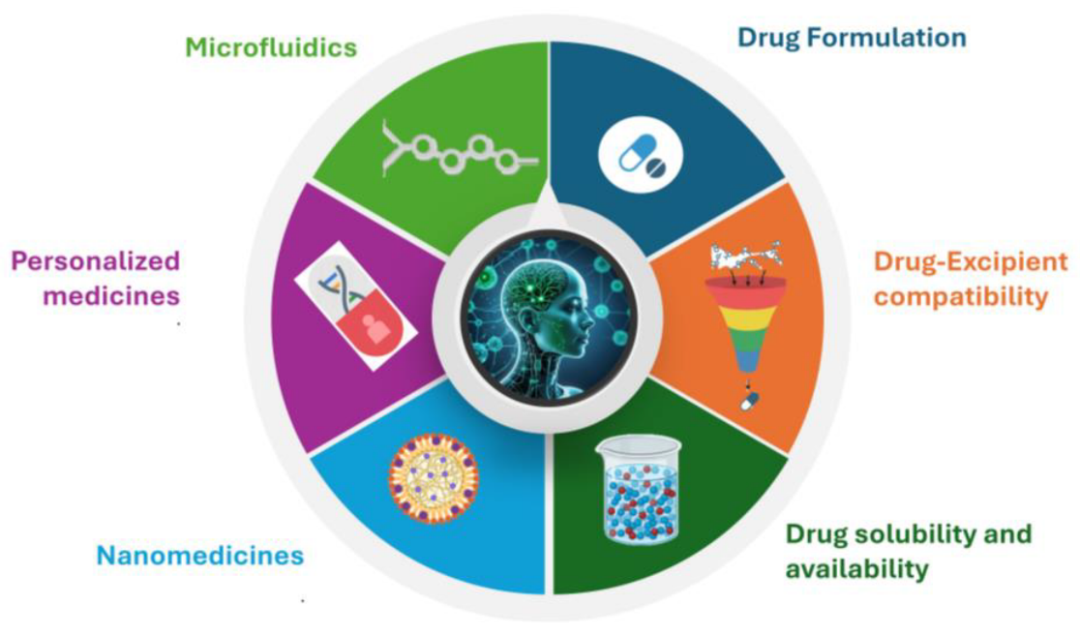
Fig-1. Application of AI in Drugs and Material Science.
Overall, the integration of artificial intelligence with chemical sciences represents a major paradigm shift in how chemical research is conducted. By combining advanced computational algorithms with large-scale chemical data, AI has the potential to significantly accelerate the discovery of new drugs and advanced materials. As computational power, data availability, and algorithmic techniques continue to improve, AI is expected to play an increasingly important role in shaping the future of chemistry, enabling faster innovation, more efficient research processes, and the development of solutions to critical global challenges in healthcare, energy, and environmental sustainability [7].
Literature Review:
Artificial Intelligence (AI) has emerged as a transformative tool in chemical sciences, particularly in drug discovery and materials design. With the rapid growth of chemical databases and computational power, machine learning (ML) and deep learning (DL) techniques are increasingly integrated into traditional research workflows to improve prediction accuracy, reduce costs, and accelerate discovery [8].
AI in Drug Discovery:
Drug discovery is traditionally a time-consuming and expensive process. Recent studies show that AI significantly enhances early-stage drug development through virtual screening, molecular property prediction, and drug–target interaction analysis. Deep learning models, including neural networks and graph-based methods, effectively analyse large molecular datasets [9]. AI also supports de novo drug design and drug repurposing, reducing development time and improving candidate selection efficiency.
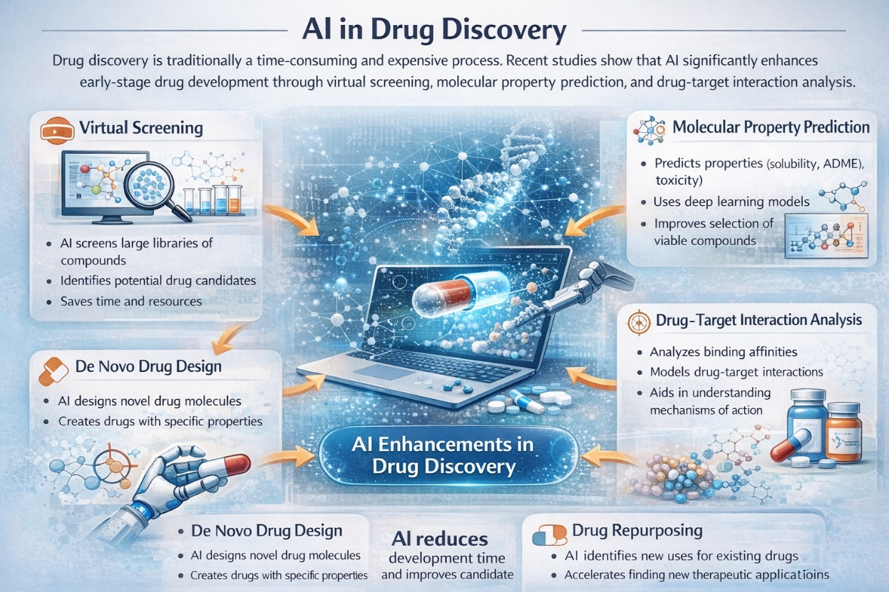
Fig-2. AI in drugs discovery
AI in Materials Discovery:
AI has also accelerated progress in materials science by predicting properties such as stability, conductivity, and mechanical strength before experimental synthesis. Machine learning models assist in discovering battery materials, nanomaterials, polymers, and catalysts, enabling structure–property analysis and high-throughput screening for efficient material design [10].
Computational Techniques Used
Common AI techniques applied in chemistry include:
- Supervised and unsupervised machine learning
- Deep neural networks
- Graph neural networks (GNNs)
- Support vector machines (SVMs)
- Random forest algorithms
- Data mining and predictive modelling.
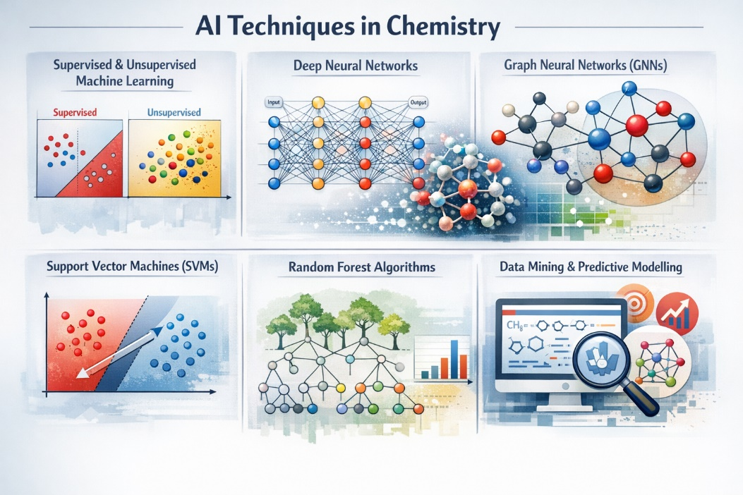
Fig-3. AI in material discovery

These approaches analyse large experimental and computational datasets to enhance chemical research efficiency.
Methodology:
Several Artificial Intelligence (AI) techniques are widely used to accelerate drug and materials discovery. Machine Learning (ML) is the most commonly applied technique in chemistry and is used for predicting molecular properties [11-12], drug-target interactions, toxicity, and material property estimation. Common ML algorithms include Random Forest, Support Vector Machine (SVM), K-Nearest Neighbours (KNN), and Gradient Boosting. Deep Learning (DL), an advanced form of machine learning based on neural networks, is extensively used for molecular structure analysis, virtual screening, drug design, and materials prediction. Popular deep learning models include Artificial Neural Networks (ANN), Convolutional Neural Networks (CNN), Recurrent Neural Networks (RNN), and Transformers. Graph Neural Networks (GNNs) are particularly important in chemistry because molecules can be represented as graph structures; they are widely used for molecular property prediction, reaction prediction, drug discovery, and materials design. Additionally, predictive modelling and data mining techniques help analyse large chemical datasets to identify structure-property relationships, screen compound libraries, and optimize materials. Generative AI models, such as Variational Autoencoders (VAE), Generative Adversarial Networks (GANs), and Transformer-based models, are used for de novo drug design and novel material generation. Finally, Reinforcement Learning (RL) is applied in optimization tasks, including reaction optimization, molecular design, and automated laboratory systems. Overall, the most commonly used techniques in research include Machine Learning, Deep Learning, Graph Neural Networks, Generative Models, and Reinforcement Learning.
Results:
The Artificial Intelligence (AI) significantly improves the efficiency of drug and materials discovery. Machine learning and deep learning models demonstrate high accuracy in predicting molecular properties, drug-target interactions, toxicity, and material characteristics. Compared to traditional methods, AI reduces the time and cost of lead identification and compound screening. In drug discovery, AI enhances virtual screening, molecular design, and drug repurposing. In materials science, AI predicts properties such as stability, conductivity, and catalytic performance, accelerating the discovery of advanced materials like batteries, nanomaterials, and semiconductors.
Overall, AI-based approaches improve prediction accuracy, reduce research time, and lower development costs in chemical research.

References:
- Burki, T. (2019). Pharma blockchains AI for drug development. The Lancet, 393, 2382. https://doi.org/10.1016/S0140-6736(19)31160-8
- Butler, K. T., Davies, D. W., Cartwright, H., Isayev, O., & Walsh, A. (2018). Machine learning for molecular and materials science. Nature, 559(7715), 547–555. https://doi.org/10.1038/s41586-018-0337-2
- Chakravarty, K., Antontsev, V. G., Khotimchenko, M., et al. (2021). Accelerated repurposing and drug development of pulmonary hypertension therapies for COVID-19 treatment using an AI-integrated biosimulation platform. Molecules, 26(7), 1912. https://doi.org/10.3390/molecules26071912
- Gallego, V., Naveiro, R., Roca, C., Ríos Insua, D., & Campillo, N. E. (2021). AI in drug development: A multidisciplinary perspective. Molecular Diversity, 25, 1461–1479. https://doi.org/10.1007/s11030-021-10213-7
- Hao, Y., Lynch, K., Fan, P., et al. (2023). Development of a machine learning algorithm for drug screening analysis on high-resolution UPLC-MSE/QTOF mass spectrometry. Journal of Applied Laboratory Medicine, 8(1), 53–66. https://doi.org/10.1093/jalm/jfac119
- Hong, E., Jeon, J., & Kim, H. U. (2023). Recent development of machine learning models for the prediction of drug–drug interactions. Korean Journal of Chemical Engineering, 40, 276–285. https://doi.org/10.1007/s11814-022-1285-4
- Jiménez-Luna, J., Grisoni, F., & Schneider, G. (2020). Drug discovery with explainable artificial intelligence. Nature Machine Intelligence, 2(10), 573–584. https://doi.org/10.1038/s42256-020-00236-4
- Liu, Z., Roberts, R. A., Lal-Nag, M., Chen, X., Huang, R., & Tong, W. (2021). AI-based language models powering drug discovery and development. Drug Discovery Today, 26(11), 2593–2607. https://doi.org/10.1016/j.drudis.2021.06.003
- Sarkar, C., Das, B., Rawat, V. S., et al. (2023). Artificial intelligence and machine learning technology driven modern drug discovery and development. International Journal of Molecular Sciences, 24(3), 2026. https://doi.org/10.3390/ijms24032026
- Schneider, G. (2018). Automating drug discovery. Nature Reviews Drug Discovery, 17(2), 97–113. https://doi.org/10.1038/nrd.2017.232
- Stokes, J. M., Yang, K., Swanson, K., et al. (2020). A deep learning approach to antibiotic discovery. Cell, 180(4), 688–702. https://doi.org/10.1016/j.cell.2020.01.021
- Vamathevan, J., Clark, D., Czodrowski, P., et al. (2019). Applications of machine learning in drug discovery and development. Nature Reviews Drug Discovery, 18(6), 463–477. https://doi.org/10.1038/s41573-019-0024-5
- Wang, Y., Xiong, H., & Liu, Z. (2020). Deep learning for drug discovery and development. Journal of Chemical Information and Modeling, 60(12), 5697–5712. https://doi.org/10.1021/acs.jcim.0c00932
- Zunger, A. (2018). Inverse design in search of materials with target functionalities. Nature Reviews Chemistry, 2, 0121. https://doi.org/10.1038/s41570-018-0121

