OPTIMUM BIODIESEL PRODUCTION FROM SHEA NUT OIL BY HETEROGENEOUS CATALYST TRANSESTERIFICATION
ABSTRACT
A renewable alternative to petroleum fuels is essential due to declining oil supplies. Bio-based diesel production from fruit peel and vegetable oil waste may reduce reliance on petroleum. Various materials, including oyster shells, rocky clay, and plantain peels, were identified as potential resources for developing bifunctional catalysts, utilized in heterogeneous catalyst transesterification. The catalyst's stability and characteristics were evaluated using thermogravimetric analysis (TGA) and differential thermal analysis (DTA). High surface area analysis through Brunauer-Emmett-Teller (BET) and various adsorption isotherms indicated its effectiveness. The catalyst primarily consisted of calcite, along with minerals like muscovite, orthoclase, and quartz, as confirmed by X-ray diffraction (XRD). Fourier Transform Infrared Spectroscopy (FTIR) revealed metal-oxide bonding, C=C stretching, and hydroxyl groups. Energy dispersive X-ray spectroscopy demonstrated that CaO constituted 66.194%, with K₂O and Al₂O₃ also present. Scanning electron microscopy (SEM) highlighted the catalyst's shape and porosity, confirming its potential for serial reuse. The optimized heterogeneous catalyst transesterification of shea nut oil resulted in ideal conditions: 8 wt% catalyst loading, 65°C reaction temperature, 8:1 methanol-to-oil molar ratio, 70-minute reaction time, and a biodiesel yield of 92.68%. Characterization showed that the produced biodiesel met key diesel fuel properties and conformed to ASTM D-675 standards. Gas chromatography/mass spectroscopy (GC/MS) analysis indicated that the biodiesel contained predominantly methyl esters, achieving 99.57% with minimal impurities, making heterogeneous catalyst transesterification a cost-effective and scalable method for biodiesel production.
Keyword: Biodiesel, Response surface methodology, renewable, molar ratio, Shea nut oil and reaction time.
NAMES OF AUTHUR 1: AKEMU ANDREW, O.
AFFLIATIONS: CHEMICAL ENGINEERING DEPARTMENT, FEDERAL UNIVERSITY OF PETROLEUM RESOURCES, EFFURUN, DELTA STATE, NIGERIA.
EMAIL ADDRESS: AKEMU.ANDREW@FUPRE.EDU.NG.
NAMES OF AUTHUR 2: OBAHIAGBON KESSINGTON,
AFFLIATIONS: CHEMICAL ENGINEERING DEPARTMENT, UNIVERSITYOF BENIN, BENIN CITY, EDO STATE, NIGERIA
EMAIL ADDRESS: KESS.OBAHIAGBON@UNIBEN.EDU
NAMES OF AUTHUR 3: EGHE AMENZE OYEDOH.
AFFLIATIONS: CHEMICAL ENGINEERING DEPARTMENT, UNIVERSITYOF BENIN, BENIN CITY, EDO STATE, NIGERIA.
EMAIL ADDRESS: EGHEOYEDOH@UNIBEN.EDU
CORRESPONDING AUTHUR EMAIL: AKEMU.ANDREW@FUPRE.EDU.NG.

INTRODUCTION
Energy is the most basic necessity for human existence. Energy sources are necessary for the production of food, transportation, and power [1]. Recently, there has been a lot of focus on using eco-friendly energy sources and protecting the environment. For several environmental reasons, clean and renewable energy will be the mainstay of the energy supply. This is where the manufacture of biodiesel—a sustainable energy source—comes into play as a workable replacement for fossil fuels. Biodiesel is a clean-burning, environmentally friendly fuel that is produced using a range of chemical processes, including direct use and blending, transesterification reaction, thermal cracking, and micro-emulsion.
To lessen the impact on the environment, a variety of catalysts have been created for the manufacture of biodiesel. Although it necessitates a high alcohol-to-oil molar ratio and longer reaction periods for full conversion, the homogeneous acid-catalyzed approach can address issues related to wastewater discharge. Rapid non-catalytic transesterification at high temperatures (350–400°C) and pressures (45–65 MPa) is made possible by an alternate supercritical technique [2]. Because of their resistance to free fatty acids and water, enzymatic methods and ion-exchange resins are becoming more popular, making the purification of glycerine and biodiesel easier [3]. However, ion-exchange resins have longer reaction times and enzymes are expensive. Widely used homogeneous catalysts, such as NaOH and KOH, are difficult to recover because of the production of water [4]. The best method for transesterifying triglycerides into biodiesel is heterogeneous base catalysis, which offers effective catalyst recovery and low environmental toxicity. However, it may have lower reaction rates because of problems with mass transfer and deactivation over time [5].
Numerous process factors, such as the methanol/oil ratio, catalyst loading, reaction duration, reaction temperature, and agitation speed, affect the generation of biodiesel. Several process factors need to be adjusted in order to develop a manufacturing method that is economical. A statistical tool called response surface methodology (RSM) is used to set up tests with multiple variables, model and optimise processes, and produce good findings with fewer trials and at a lower cost [6]. The tool creates a model to explain the process after evaluating each potential individual and combined impact of the independent process factors on the response variable or variables.
Plantain peels, oyster shells, and rocky clay soil were the three different precursors employed in this investigation to create the bifunctional catalyst. For the best biodiesel generation from shea nut oil, the following process parameters were investigated in heterogenoeus catalyst transesterification: reaction temperature (40–100°C), molar ratio of methanol to oil (4:1–12:1), catalyst loading (4–8 weight percent), and reaction duration (40–100 minutes).
The response surface approach of Box-Behnken Design (BBD) was employed in the heterogeneous catalyst transesterification processes, in this studied. The biodiesel that was created was described. Finally, the GC-MS data, yield percentages, and features of heterogeneous transesterification were analysed.
MATERIALS AND METHODS
MAERIALS
The investigation utilized plantain peels and oyster shells sourced from a local restaurant in Warri, Delta State, along with shea nut oil purchased from a market in Benin City, Edo State, Nigeria, as raw materials. These fresh materials served as sources of vegetable oils for synthesizing fatty acid methyl ester. Chemicals and reagents were supplied by both internationally accredited producers and local analytical chemical dealers, obtained under optimal terms and grades.
METHODS
Preparation of Reagents
Extraction of alumina from a rocky clay soil, potassium oxide from plantain peels and calcium oxide from oyster shells.
Calcination of Oyster Shell
The calcination procedure was employed to produce calcium oxide (CaO) from oyster shells collected from a restaurant. The shells were cleaned, sun-dried, and heated at 105°C for three hours. After pulverization and sieving through a 250 μm mesh, they were calcined at 850°C for four hours at a heating rate of 10°C per minute in a muffle furnace [7]. The final product, a white powder, was cooled in a desiccator and stored in a sealed container to avoid moisture and carbon dioxide exposure.
Extraction of Alumina
The Bayer technique was used to extract alumina [8]. After being mechanically crushed, a 100 µm mesh screen was used to filter a sample of rocky clay. The sample was calcined at 900°C for four hours. After dissolving iron and aluminium by acid leaching, around 100 g of the crushed material and a 25% HCl solution were placed in an autoclave and heated for 150 minutes. The solid residue, which is primarily composed of silica, proved easy to separate. After adding enough NaOH pellets to achieve a pH of 12 to 13, the solution was cooked in an autoclave at a high temperature and pressure for 120 minutes. The resulting solid residue was cleaned with distilled water.
${Al}_{2}O_{3}.3H_{2}O+2NaOH\frac{{250}^{O}C}{High Pressure}2Na{AlO}_{2}+ 4H_{2}O$ (1)
$2NaAlO_{2}+ H_{2}O →2NaOH+ {Al}_{2}O_{3}$ (2)
Preparation of Plantain Peel Ash
The calcination procedure was used to create the potassium oxide (K²O) found in plantain peels. Plantain peels that were taken from the trash cans of a nearby restaurant were cleaned with water, laid out in the sun, and any extra water was minimised. Afterwards, this was dried for two hours at 120°C in an oven. In a muffle furnace, the plantain peel ash was crushed and calcined at 850°C for four hours at a rate of 10°C per minute [7]. Before being used, the product was collected as ash, cooled in the desiccator, and then stored in a closed vessel to prevent reactions with carbon dioxide (CO₂) and air humidity.
Preparation of Catalyst using Wet Impregnation
Plantain peel ash, calcined oyster shells, and alumina were mixed in a 1:1 ratio. The catalyst was developed using the wet impregnation method. A slurry solution was made by combining equal amounts of alumina, plantain peel ash, and calcite oyster shells with distilled water. The final mixture was placed on a heated plate with a magnetic stirrer set at 80°C, and it was continuously mixed until all of the water had evaporated. The final particles were oven-dried at 120°C after being air-dried for a few hours. A highly active heterogeneous bifunctional catalyst was produced by further calcining the solid powdered mixture for four hours at 900°C [9]. In this study, the heterogeneous catalyst transesterification process was utilised to generate biodiesel from shea nut oil utilising the synthesised catalyst. According to earlier studies, employing a recovered catalyst from a process produced a biodiesel yield over 89 weight percent after two consecutive cycles [10].
Catalyst characterization
The Brunauer-Emmett-Teller (BET) technique was used to evaluate the catalyst's porosity, pore volume, pore diameters, and particle sizes. Using an energy-dispersive spectrometer and energy-dispersive X-ray fluorescence, the elemental composition was determined. Fourier Transform Infrared (FTIR) spectroscopy was used to determine the surface functional group. A scanning electron microscope (SEM) was used to evaluate the surface morphology, and an X-ray diffractometer (XRD) was used to investigate the solid mineral components.
Biodiesel production and characterisation by heterogeneous catalyst transesterification
Design Expert version 13.0.6 was used to improve the generation of biodiesel from shea nut oil. In a Box-Behnken Design (BBD), response surface methodology (RSM) was used. Regression and model fit analysis of the collected data were performed using the statistical program, which also estimated the regression equation's coefficient and performed an analysis of variance (ANOVA) of the chosen factors. For heterogeneous catalyst transesterification, the following factors were used: reaction temperature (40–90°C), reaction duration (40–100 minutes), catalyst load (2–8 weight percent), and methanol to oil molar ratio (4:1–12:1). The experimental design produced 29 experimental runs. yield of biodiesel (reactions as R₁ to R₂₉).
Biodiesel yield = $\frac{mass of biodiesel produced}{mass of shea nut oil} ×100 3$
The reaction was not finished in an hour, as evidenced by the methyl ester percentage yield of 92.68%. It demonstrated that some diglycerides and monoglycerides were still present in the solution. Because there were still many diglyceride molecules in the biodiesel, it was of poor quality at this point and would not burn smoothly in a diesel engine [11]. The reaction may be continued for a further 15 to 30 minutes in order to get a larger yield of 95% methyl ester [12]. Table 1 shows the actual variables in levels and the coded process parameters that were chosen to manufacture biodiesel.
Table 1: Coded and actual levels of BBD variables for heterogeneous catalyst transesterification
Name | Minimum | Maximum | Coded Low | Coded High | Mean | Std. Dev.
A: Temperature (℃) | 40.00 | 90.00 | -1 ↔ 40.00 | +1 ↔ 90.00 | 65.00 | 16.37
B: Catalyst (wt%) | 2.00 | 8.00 | -1 ↔ 2.00 | +1 ↔ 8.00 | 5.00 | 1.96
C: Mole ratio | 4.00 | 12.00 | -1 ↔ 4.00 | +1 ↔ 12.00 | 8.00 | 2.62
D: Time (minutes) | 40.00 | 100.00 | -1 ↔ 40.00 | +1 ↔ 100.00 | 70.00 | 19.64

Crude Biodiesel Purification
Following the maximum separation, a separating funnel was used to wash the crude biodiesel with warm distilled water. Due to the high-water solubility of both glycerol and methanol, crude biodiesel was combined with distilled water and carefully stirred to prevent the development of an emulsion. Water droplets then gradually percolated through the ester [13]. Until colourless cleansed water was achieved, signifying total impurity removal, the procedure was repeated.
RESULTS AND DISCUSSION
Properties of shea nut oil.
Table 2: Physiochemical properties of the Shea nut oil
S/N | Parameter | Literature Value Range | Experimental Result | Remarks
 | Density (g/cm³) | 0.90 – 0.93 | 0.9336 | This was slightly over the typical range
 | Viscosity | 50-100 | 92 | Reflects moderated thickness
 | Specify gravity | 0.91-0.92 | 0.9336 | This was the same with the density, indicating purity
 | Acid value (mg KOH/g) | 3.5-6.0 | 26.367 | It shows a High acid value, indicated a High FFA
 | FFA mgKOH/G | 1.75-3.0 | 13.184 | High FFA content,
 | Saponification value (mg KOH/g) | 160-195 | 213.567 | Higher than the typical range, this was because the oil has started ranciding
 | Peroxide value (millieequivalents O₂/kg) | 1.0-5.0 | 172 | Extremely high, indicating significant oxidation
 | Iodine value (g I₂/100g) | 50-70 | 114.21 | High unsaturation
 | Flash point | 225-245 | 230 | Within range
 | Pour point | 12-20 | 15 | Moderated pour point
 | Cloud Point | 15-22 | 17 | Between the typical range
 | Centipoise | 40-90 | 80 | Indicated a thick Consistency
 | Water content | $<$7 | 5
 | FTIR | Matches typical O-H, C=O | O-H at 3526.01 cm⁻¹ C-H at 418.65 cm⁻¹ | Confirmed the presence of Fatty acids and triglycerides characteristic of Shea nut.

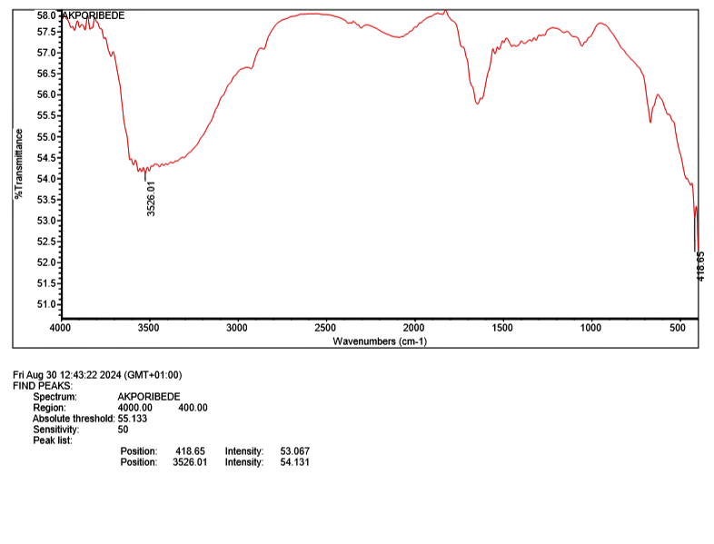
FTIR Analysis of shea nut oil
Figure 1: Shown the FTIR of the Shea nut oil
Catalyst Characterisation
The existence of functional groups in shea nut oil, especially fatty acids and triglycerides, was confirmed by FTIR spectrum analysis, which showed a peak at 3526.01 cm⁻³ for O-H stretching and a peak at 418.65 cm⁻³ for C-H bonding. Its moisturising qualities in lotions and cosmetics were supported by this combination [14].

Analysis of the Brunauer-Emmett-Teller (BET) of catalyst

Multi-point BET
Table 3: Multi-point results summary
BET (Brunauer emmett Teller), Multi-point summary analysis
Correlation co-efficient, r | 5.390 | Demonstrated a moderate degree of attraction between the surface and the adsorbate molecules, which is often observed in materials with rather uniform adsorption.
Surface area | 151.602 m²/g | An SSA of 151.602 m²/g indicated that the material was likely porous and perfect for applications needing substantial surface contact.

Using gas adsorption data, the Multipoint BET (Brunauer–Emmett–Teller) Method was used to determine the specific surface area of chemicals, often nitrogen [15].

DA (Dubini-Astakhov) Method
The DA method, which provides more flexibility in the investigation of materials with different pore size distributions, was used for micropore analysis. For heterogeneous microporous materials, it is particularly advantageous.
Table 4: DA Dubini-Astakhov summary
BET (Brunauer emmett Teller), Dubini-Astakhoy method summary
Best E | 0.819 Kj/mol | This low number indicates that physisorption, characterized by weak van der Waals forces, overshadows chemisorption in the adsorption process. Consequently, this suggests that the catalyst likely aids in the simple adsorption and desorption of reactants during biodiesel catalysis.
Best n | 1 | A uniform pore structure or surface. The adsorption energies of the catalyst's micropores or active sites were comparable.
Dubini Astakhov microporus volume | 0.136 cc/g | Showed a moderate degree of attraction between the adsorbate molecules and the surface, which is usually seen in materials with rather uniform adsorption.
Pore diameter | 2.780e + 00 nm | This pore size, which typically ranges from 2 to 50 nm, was categorised as mesoporous. Mesopores make it easier for larger molecules, like the triglycerides found in biodiesel feedstocks, to be adsorbed.

BJH Method Adsorption
The BJH (Barrett-Joyner-Halenda) approach uses adsorption data, specifically nitrogen adsorption-desorption isotherms, to evaluate pore size distribution and volume in mesoporous materials. Using low-pressure adsorption methods, porosity controls and fractal placement of organic-rich Permian shales [16].
Table 5: BJH Adsorption graph
BET (Brunauer emmett Teller), BJH method summary
Surface area | 194 m2/g | A substantial surface area indicated that the substance possessed a considerable quantity of accessible surface for potential reactions.
Pore volume | 0.095 cc/g | For the transport and diffusion of reactants and products, a suitable pore volume enables a balance between high surface area and adequate pore architecture.
Pore diameter, Dr(d) | 2.115 nm | In conclusion, these results showed that the catalyst has a structure that is adequate for producing biodiesel, with a pore network and surface area that allow for efficient reactant access and catalytic activity.

Langmuir
The adsorption of molecules or atoms from a gaseous or liquid phase onto a solid surface is explained by the Langmuir isotherm model. The Langmuir adsorption isotherm's uses and limitations in relation to the main unconventional gas resources, such as coalbed methane (CBM) reservoirs and shale gas. According to the Langmuir isotherm, adsorption occurs as a monolayer on a surface with a small number of localised, identical patches that may hold one adsorbed molecule [17].
Table 6: Langmuir Result
BET (Brunauer emmett Teller), Langmuir isotherm summary analysis
Slope | 8.0117 | The slope value signified a robust attraction of the adsorbate to the catalyst surface.
Correlation co-efficient, R² | 0.906 | An R² value of 0.91 signified a strong correlation between the experimental data and the Langmuir isotherm model.
Surface area | 434.67 m2/g | A surface area of 434.67 m²/g was considerable, suggesting that the catalyst possesses a substantial quantity of active sites for adsorption

DR (Dubinin-Radushkevich) Method
The DR approach assumes that adsorption within micropores follows a particular energy distribution and is frequently used for microporous materials with pore sizes less than 2 nm. The DR method enables the analysis of nitrogen physisorption isotherms from a variety of materials made of amorphous aluminosilicates synthesised using sol-gel hydrolysis in an acidic medium, as well as the estimation of micropore volume and specific surface area [18].

Table 7: DR data summary
BET (Brunauer emmett Teller), DR (Dubinin-Rudushkevich method) summary.
Average pore width | 5.651 nm | With an average pore diameter of 5.65 nm, the catalyst demonstrated mesoporous characteristics that allowed larger reactant molecules to pass through.
Correlation co-efficient, r | 0.9829 | A high correlation coefficient of 0.98 showed that the adsorption data had a strong relationship with the D–R model.
Adssorption energy | 4.601 KJ/mol | Reversible catalytic processes were made easier by the physical adsorption indicated by the adsorption energy of 4.6 kJ/mol.
Microporou volume | 0.063 cc/g
Microporou surface area | 178.227m2/g | With a micropore volume of 0.063 cc/g and a surface area of 178.227 m²/g, the catalyst's significant adsorption capacity increased its effectiveness by providing sufficient active surface area for reactions.

DFT (Density Functional Theory) Method
By comparing theoretical models with real adsorption data, the density functional theory (DFT) method provides detailed pore size distributions. Adsorption and desorption isotherms can be treated using a variety of DFT models, which provide reliable findings for pore size distribution studies. For precise pore structure characterisation, the DFT model selection was essential [19].
Table 8: DFT summary
BET (Brunauer emmett Teller), DR (Dubinin-Rudushkevich method) summary.
Pore volume | 0.052 cc/g | Pore Volume: 0.052 cc/g indicated a moderate total pore volume per gramme, suggesting that the material was not highly porous but had the ability to adsorb gases or liquids.
Surface area | 43.783 m2/g | The surface area of 43.78 m²/g signified a moderate capacity for surface interactions, suggesting applicability in processes such as adsorption, catalysis, or filtration.
Lower confident limit | 1.688 nm | The material's minimal pore size was suggested by the Lower Confidence Limit (1.688 nm), suggesting the presence of pores slightly smaller than 2 nm, which was essential for selective adsorption or filtration.
Fitting error | 2.526 % | Error in Fitting (2.5%). The data successfully matched the model, indicating that the findings were accurate, reliable, and barely ambiguous.
Pore width (mode) | 2.647 nm | The material was classified as mesoporous due to its average pore size of 2.65 nm, making it ideal for uses like molecular separation, gas storage, and catalysis.

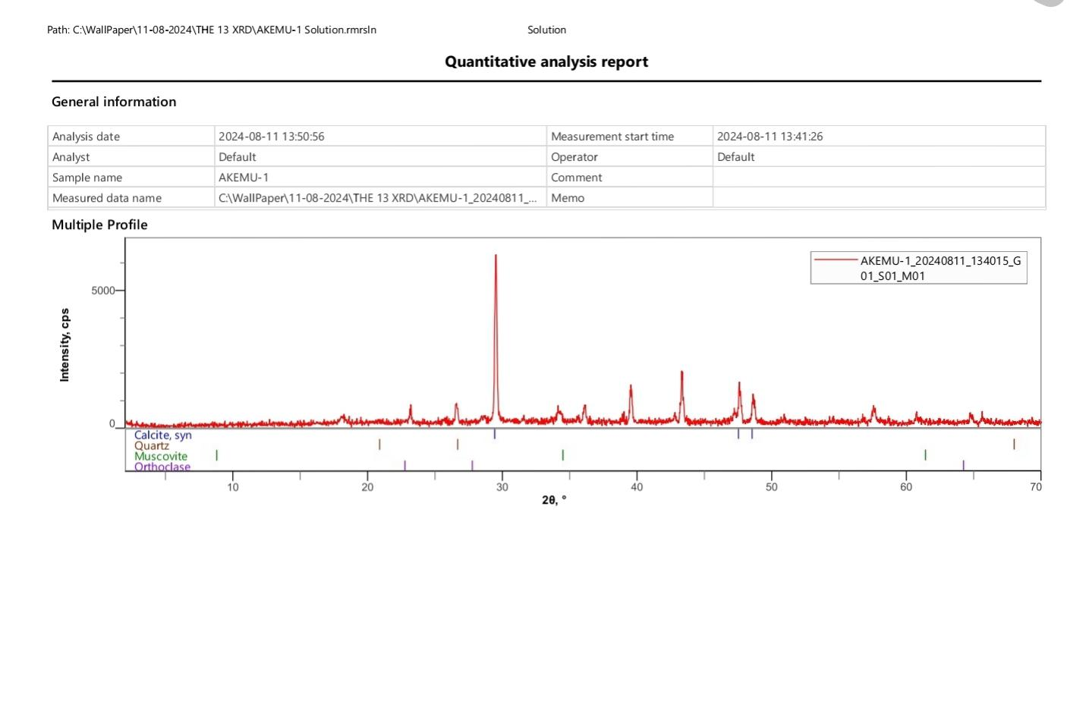
XRD (X-ray Diffraction) of catalyst
Figure 2: XRD PLOT
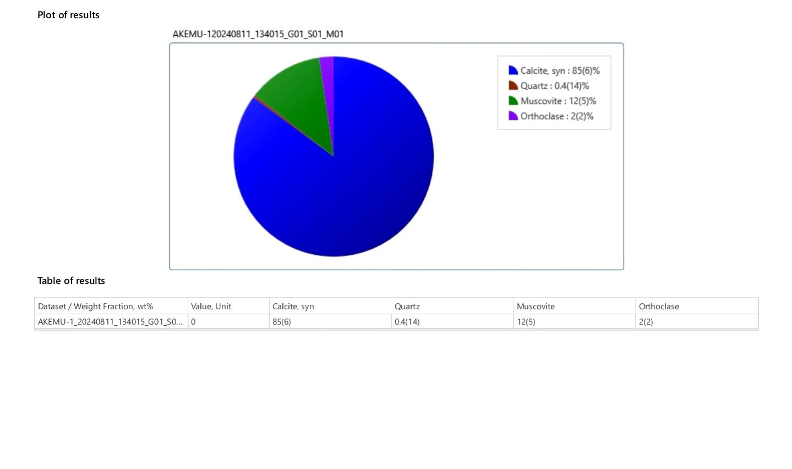
Figure 3 displays the catalyst's XRD results. The catalyst's structural properties were revealed by the diffraction pattern derived from the crystallinity investigation. The materials' crystallinity was demonstrated by the high sprectra.
The developed catalyst's composition is shown by XRD analysis (Figure 3): 85% Calcite: Calcite (CaCO3) improved the material's catalytic properties, particularly in acid-base reactions or in procedures like CO2 conversion or capture. The higher percentage (85%) suggested that the catalyst's main component is calcite.
0.4% Quartz: The silicate crystal quartz (SiO₂). Although quartz can provide structural reinforcement or alter the catalyst's surface area and pore architecture, its little presence suggested that it might be an insignificant component. Quartz serves as an inert support material rather than participating in the reaction in many catalytic systems.
12% Muscovite: The silicate mineral Muscovite (KAl₂(AlSi₃O₂¹)(OH)₂) is a mica. It affected the catalyst's surface properties, particularly its ability to interact with reactants or its stability throughout a reaction. Its presence at 12% indicates that it affected the surface structure or acidity of the catalyst.
2% orthoclase (KAlSi3O4) is a feldspar mineral that is high in potassium. It enhanced the catalyst's overall structure, particularly its stability and mechanical strength. Although orthoclase is not typically an active catalyst, it can affect the surface chemistry of materials in catalytic applications.
Calcite made up the majority of the produced heterogeneous catalyst, with trace amounts of quartz, orthoclase, and muscovite. The catalytic properties were expected to be dominated by the calcite phase, with the other minerals perhaps supporting the stability and structure of the catalyst. Because of its high percentage, calcite can be used in surface-driven reactions, CO₂-related reactions, and acid-base catalysis.
Figure 3: XRD graph

FTIR ANALYSIS (Fourier Transform Infrared Spectroscopy) of catalyst
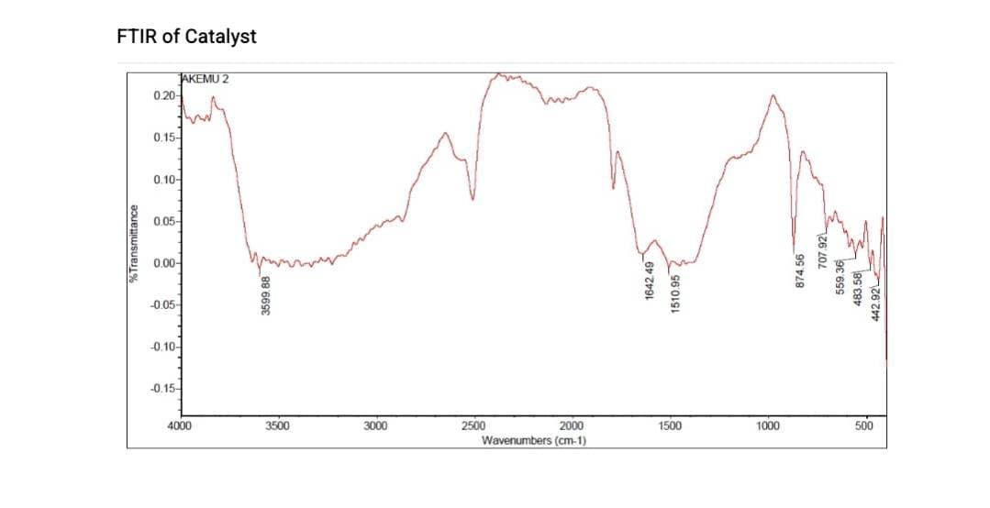
FTIR spectroscopy is a crucial analytical tool for chemical and biochemical researchers, capable of detecting unknown elements and assessing the quality and quantity of sample components.
Figure 4: FTIR of Catalyst
Several functional groups on the catalyst's surface were revealed by its FTIR measurement. Important results include a signal at 707.92 cm⁻¹ that could be an M-O stretching peak, a low-frequency peak at 442.92 and 483.58 cm⁻¹ that could be metal-oxygen bonding, and a signal at 559.36 cm⁻¹ that could be an aromatic ring C-H bond or metal-oxygen contact. Extra peaks at 874.56 cm⁻¹ indicated interactions between metals and oxygen as well as C-H bonds. C=O stretching at 1642.49 cm⁻¹ may indicate bonded water or carbonyls, while the 1510.95 cm⁻¹ signal was linked to aromatic C=C stretching. The catalyst may have contained hydroxyl groups or adsorbed water, as shown by an O-H stretching signal at 3599.88 cm⁻¹.

Energy Dispersive X-ray Spectroscopy of catalyst
Figure 5: Graph of EDXRF analyzed chemical composition of developed Bi-functional heterogenous catalyst (Akemu 1 Plantaain ash/oyster shell/Alumina).
Table 9: EDXRF Results (EDXRF Analyzer UMYU Katsina - AKEMU 1)
Elements | Concentration % | Peak (cps/mA)
Fe₂O₃ | 0.01410 | 53
SiO₂ | 0.746 | 56
Al₂O₃ | 2.758 | 43
MgO | 0.51 | 1
P₂O₅ | 0.1897 | 40
SO₃ | 0.3697 | 202
TiO₂ | 0.00388 | 14
MnO | 0.0207 | 63
CaO | 66.194 | 98368
K₂O | 4.723 | 4980
CuO | 0.00425 | 14
ZnO | 0.00472 | 26
Cr₂O₃ | 0.00171 | 14
V₂O₅ | 0.00075 | 4
Rb₂O | 0.00217 | 11
Cl | 0.1226 | 182
Ta₂O₅ | 0.00440 | 5
Br | 0.000210 | 1
SrO | 0.932 | 141
Nb₂O₅ | 0.11233
Bi₂O₃ | `0.04347 | 0
Sb₂O₃ | 0.515 | 0
Co₃O₄ | 0.28481 | 3
Ag₂O | 0.00002 | 0
CeO₂ | 0.0077 | 8
BaO | 0.47235 | 30
WO₃ | 0.06000 | 4
La₂O₃ | 0.2528 | 11
SnO₂ | 0.268 | 1
According to Table 9 showed the results of the XRF analysis of the catalyst (plantain ash/oyster shell/alumina materials). The results showed that CaO made up 66.194% of the catalyst, followed by K₂O at 4.723%, Al₂O₃ at 2.758%, and SrO at 1.932%. There were other elements found in the sample, most of which are considered contaminants. The remarkably small amounts of Pb and Th stood out. There were high concentrations of CaO, K₂O, and Al₂O₃ due to the presence of plantain peel ash, oyster shells, and rocky clay soil. By acting as dopants and substituting for a portion of the Fe and other critical atoms in the structure, these impurities enhanced the material's catalytic activity without generating any other discernible phase.

Scanning electron microscopy (SEM) of catalyst
Crucial for supplying attachment sites in the reaction process, the SEM images in Figure 5 show that the generated catalyst exhibited considerable porosity and irregular, rough pores. This is probably due, in part, to the fact that the catalyst precursor is heterogeneous, meaning that it has different compositions and surface features. Furthermore, several smaller particles around the visible particle agglomerations, suggesting a large surface area required for efficient catalysed reactions. A great deal of wasted oyster shell is produced after the edible portion of the oyster has been eaten. To replace natural calcium ores, like limestone, which have a limited supply, oyster shells contain calcium carbonate (CaCO3, more than 96% wt%), which is a limitless source that occurs naturally in living things [1], [20]. Therefore, oyster shells can be used as a base for making other calcium compounds with added value due to their high calcium concentration.
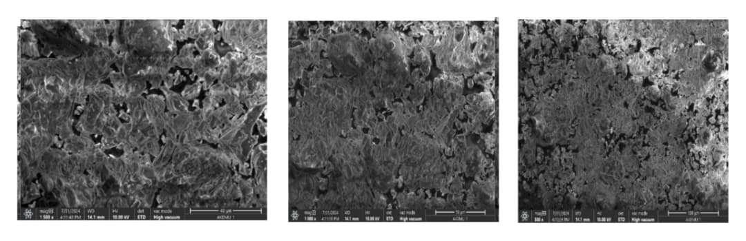
- (b) (a)
Figure 5: SEM images of catalyst (a) x 1500 (b) x 1000 (c) x 500

Reusability of developed Catalyst
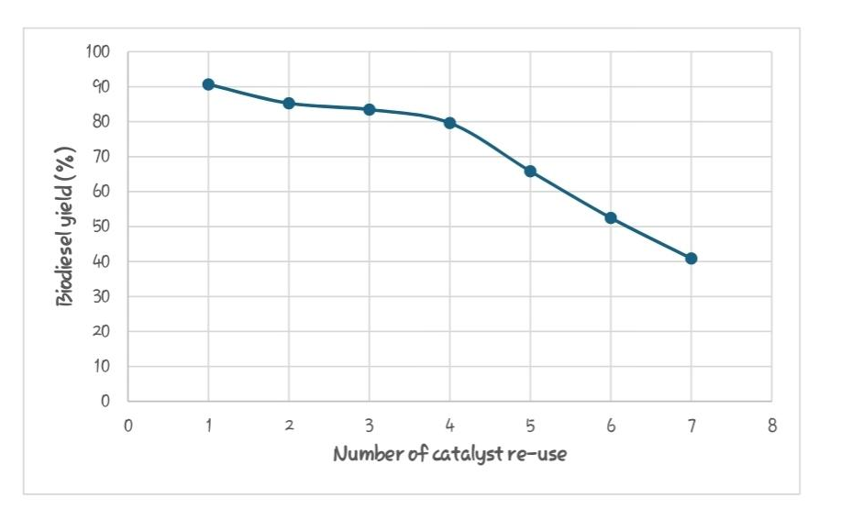
Table 10: Reusability test Conditions
Run | Weight of oil (gram) | Biodiesel yield (%) | Temperature
1 | 100 | 90.65 | 60°C
2 | 100 | 85.26 | 60°C
3 | 100 | 83.45 | 60°C
4 | 100 | 79.61 | 60°C
5 | 100 | 65.82 | 60°C
6 | 100 | 52.47 | 60°C
7 | 100 | 40.88 | 60°C
Figure 6: Catalyst Reuse Graph
In the first cycle, the catalyst showed a biodiesel output of 90.65%, indicating great starting efficiency. In succeeding cycles, though, yields fell steadily, reaching 83.45% and 79.61% in the third and fourth cycles, respectively. The yield reduces dramatically to 65.82% by the fifth cycle and reaches 40.88% by the seventh cycle, indicating that the catalyst is markedly deactivated. Despite being reusable, its effectiveness for large-scale biodiesel synthesis was severely limited after the fifth cycle, as seen by the considerable fall in yield after only a few cycles.
PROCESS MODELLING, OPTIMIZATION AND BIODIESEL SYNTHESIS FROM SHEA NUT OIL VIA HETEROGENEOUS TRANSESTERIFICATION
Tabulated in Table 11 are the experimental details of the biodiesel transesterification reaction of shea nut oil, including the experimental outcomes, RSM, and anticipated reactions. As shown in Equation 4, the quadratic model is applicable to an actual basis.
Biodiesel yield = 92.68 + 3.11 A + 8.89 B + 8.00 C $-$ 1.02 D + 0.1625 AB $-$ 2.61AC $-$ 0.6975 AD $-$ 5.24 BC $-$ 2.65 BD + 5.11 CD $-$ 27.54 A² $-$ 9.44 B² $-$ 13.42 C² $-$ 14.70 D² (4)
According to Equation 4, the percentage yield of biodiesel was positively impacted by reaction temperature (A), catalyst loading (B), methanol:oil ratio (C), interation factors (AB, and CD) while it was negatively impacted by reaction time (D), interaction factors (AC, AD, BC, and BD), and quadratic factors (A², B², C², and D²). Model terms with a p value of less than 0.05 are deemed significant at a 95% significance level. This implies that the yield of biodiesel production was significantly impacted by changes in the values of the input variable represented by that model term. On the other hand, model terms with p values higher than 0.05 are regarded as unimportant, meaning that variations in the inputted factor values won't have a major effect on the biodiesel production yield.
Biodiesel yield % respond, ANOVA for the RSM Quadratic model (heterogeneous catalyst method)
ANOVA for the RSM Quadratic model on biodiesel yield demonstrated significant results, with a p value below 0.05, indicating the model's effectiveness. The analysis yielded an F-value of 42.01, with only a 0.01% chance of randomness affecting the results. Key terms (A, B, C, BC, CD, A² B^{,2} C^{,2} and D²) had P-values under 0.0500, while values above 0.1000 were deemed insignificant [21].

Table 11: Responsed, Biodiesel Yield
Source | Sum of Squares | Df | Mean Square | F-value | p-value
Model | 7977.97 | 14 | 569.85 | 42.01 | < 0.0001 | Significant
A-Temperature | 116.31 | 1 | 116.31 | 8.58 | 0.0110
B-Catalyst | 949.27 | 1 | 949.27 | 69.98 | < 0.0001
C-Mole ratio | 768.48 | 1 | 768.48 | 56.66 | < 0.0001
D-Time | 12.53 | 1 | 12.53 | 0.9234 | 0.3529
AB | 0.1056 | 1 | 0.1056 | 0.0078 | 0.9309
AC | 27.35 | 1 | 27.35 | 2.02 | 0.1775
AD | 1.95 | 1 | 1.95 | 0.1435 | 0.7105
BC | 109.94 | 1 | 109.94 | 8.10 | 0.0129
BD | 28.14 | 1 | 28.14 | 2.07 | 0.1717
CD | 104.65 | 1 | 104.65 | 7.72 | 0.0148
A² | 4921.17 | 1 | 4921.17 | 362.81 | < 0.0001
B² | 578.09 | 1 | 578.09 | 42.62 | < 0.0001
C² | 1167.40 | 1 | 1167.40 | 86.07 | < 0.0001
D² | 1401.98 | 1 | 1401.98 | 103.36 | < 0.0001
Residual | 189.90 | 14 | 13.56
Lack of Fit | 189.90 | 10 | 18.99
Pure Error | 0.0000 | 4 | 0.0000
Cor Total | 8167.87 | 28

An R² of 0.9768, an adjusted R² of 0.9535, and a predicted R² of 0.8661 were all shown by the fit statistical data. The values of adjusted R2 and predicted R2 are congruent when the discrepancy is less than 0.2. We can therefore use this model to forecast the biodiesel production process. The signal-to-noise ratio is a good indicator of adequate accuracy. A ratio greater than four is considered optimum. A ratio of 20.648 is very indicative of a strong signal. This model can be used to explore the design space.

Table 12: Transesterification experimental design with RSM
Run | Temperature  (℃) | Catalyst Load  (wt%) | Mole ratio | Reaction Time  (minute) | Biodiesel yield  (wt%)
1 | 65 | 8 | 4 | 70 | 69.92
2 | 90 | 5 | 4 | 70 | 54.42
3 | 90 | 5 | 8 | 100 | 51.18
4 | 40 | 2 | 8 | 70 | 43.91
5 | 65 | 8 | 8 | 40 | 84.48
6 | 65 | 5 | 12 | 100 | 79.16
7 | 65 | 2 | 8 | 100 | 58.83
8 | 65 | 2 | 12 | 70 | 78.04
9 | 65 | 5 | 4 | 40 | 61.44
10 | 40 | 5 | 8 | 40 | 46.12
11 | 90 | 2 | 8 | 70 | 49.05
12 | 65 | 5 | 8 | 70 | 92.68
13 | 65 | 5 | 8 | 70 | 92.68
14 | 65 | 5 | 12 | 40 | 71.96
15 | 90 | 5 | 8 | 40 | 53.03
16 | 65 | 2 | 4 | 70 | 48.75
17 | 90 | 5 | 12 | 70 | 57.65
18 | 40 | 5 | 4 | 70 | 41.49
19 | 65 | 5 | 4 | 100 | 48.18
20 | 65 | 5 | 8 | 70 | 92.68
21 | 40 | 5 | 12 | 70 | 55.18
22 | 90 | 8 | 8 | 70 | 69.05
23 | 40 | 8 | 8 | 70 | 63.26
24 | 40 | 5 | 8 | 100 | 47.06
25 | 65 | 8 | 8 | 100 | 76.53
26 | 65 | 2 | 8 | 40 | 56.17
27 | 65 | 5 | 8 | 70 | 92.68
28 | 65 | 5 | 8 | 70 | 92.68
29 | 65 | 8 | 12 | 70 | 78.24
Effect of input variables on biodiesel yield
The effects of process parameters on biodiesel production were analyzed by three-dimensional (3D) surface plots.
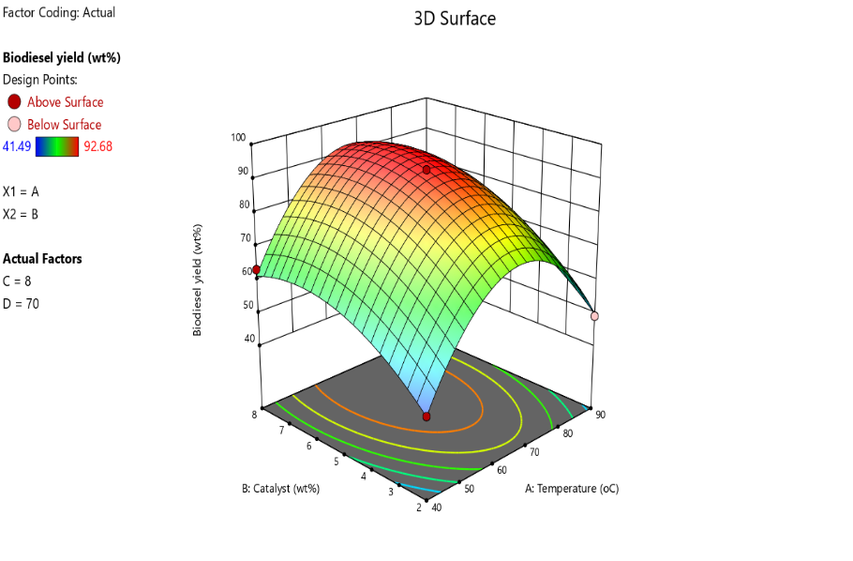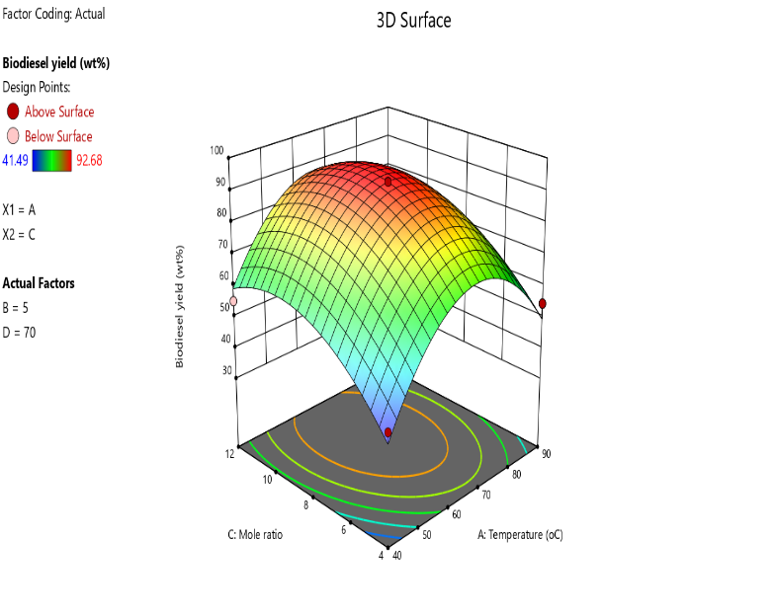
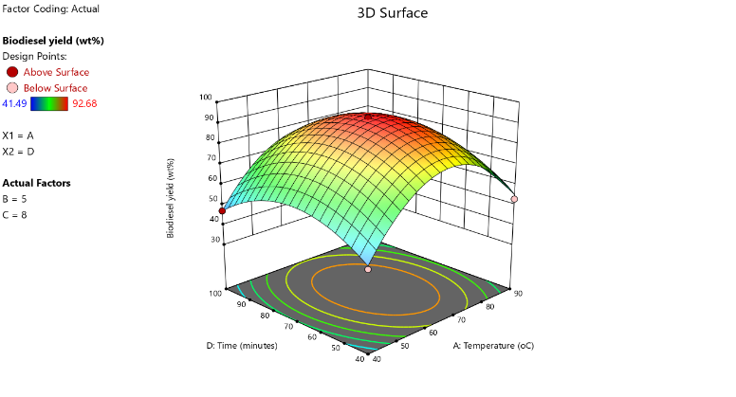
- (b)
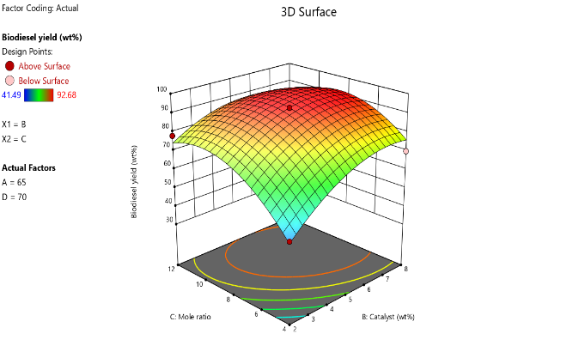
(c) (d)
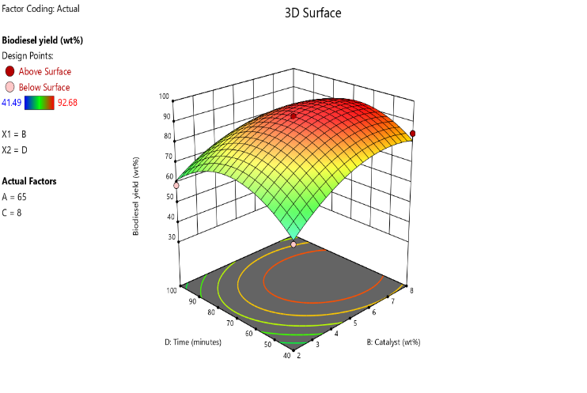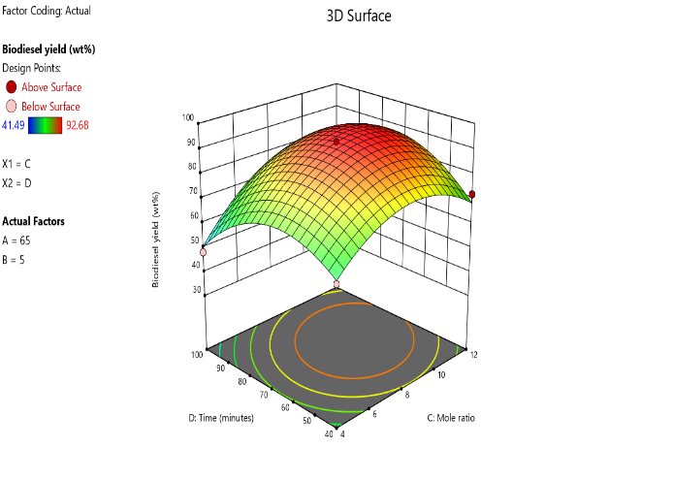
(e) (f)
Figure 7: 3D plots showing interaction between (a) Catalyst loading and reaction temperature (b) Methanol/oil ratio and reaction temperature (c) Reaction time and reaction temperature (d) Methanol/oil ratio and catalyst loading (e) Reaction time and catalyst loading (f) Reaction time and methanol/oil ratio.
The 3D surface plots in Figure 7 depict two independent variables while maintaining the same values for the other variables. Catalyst loading and the methanol oil molar ratio were found to be significant, according to Table 11, suggested that variations in their values will have a substantial impact on the output of biodiesel. Reaction time and temperature had little bearing.
The impact of the process factors on biodiesel yield is depicted in Figure 7 (a, b, c, d, e, and f). The production of biodiesel increased along with the methanol/oil ratio, reaching its maximum at 8:1. The production of biodiesel rosed with decreased catalyst loading, reaching its maximum at 5wt%. Yield of biodiesel increases as reaction temperature rises. The yield of biodiesel produced did not significantly increase or decrease once the maximum production was reached at a temperature of 65⁰C. The production of biodiesel was shown to rise as reaction time increased. At 70 minutes, the highest biodiesel output (92.68%) was attained.
PERFORMANCE OF THE RSM IN HETEROGENEOUS CATALYST TRANSESTERIFICATION METHOD.
Results for the models' anticipated accuracy for transesterification were examined based on their statistical values, and they are displayed in Table 13. The claimed R² value was achieved by heterogeneous transesterification at 0.9768. Figure 7, which displays the experimental vs predicted value charts derived from the models' R², lends credence to this assertion. The RSM model's (heterogeneous technique's) forecasted values were more in line with the reference line. The RSM model produced superior predictions for the transesterification of shea nut oil.

Table 13: Fit Statistics
 | Heterogeneous
R² | 0.9768
Adjusted R² | 0.9535
Predicted R² | 0.8661
Adeq Precision | 20.6476
Std. Dev. | 3.68
Mean | 65.74
C.V. % | 5.60
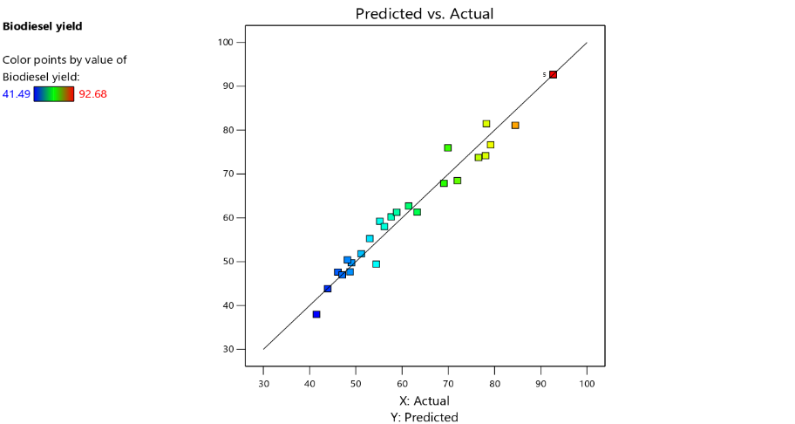
Figure 7: Predicted biodiesel yield vs actual biodiesel yield

OPTIMIZATION OF BIODIESEL YIELD
After conducting numerical optimisation studies, it was determined that a heterogeneous technique utilising an 8:1 methanol/oil ratio, a 5% catalyst loading, and a reaction temperature of 65°C produced the highest biodiesel yield 92.68%. In order to confirm these ideal conditions, the experimental runs were performed in triplicate using the optimal parameters. The average yield from the heterogeneous technique was 92.41%, which is highly correlated with the optimum yield. in triplicate using the optimal parameters.
BIODIESEL CHARACTERIZATION
An examination of the physicochemical properties of the biodiesel produced under optimal circumstances yielded the results presented in Table 14. The biodiesel's properties are within the required range when compared to those of biodiesels required by ASTM D6751 and EN14214. Both the sample findings for the heterogeneous approach (Figure 8) and the fatty acid profile of the biodiesel produced using the GC-MS test are presented in Table 15, respectively.
Table 14: Physiochemical properties of Methyl ester generated by heterogeneous method and Biodiesel Standards
Parameter/Unit | Heterogenous Catalyst Methyl Ester Values | ASTM Specifications (D6751) | EN 14214 | N0.2 DIESEL
Specific gravity | 0.9593 | 0.88 | 1.9-6.00 | 0.851
Acid Value mgKOH/g | 0.5 | 0.5 max | 0.5max | 0.5 max
Cloud point (⁰C) | 22 | -3 to 12 | _ | -15 to 5
Kinematic viscosity @40ºC (mm²/s) | 2.48 | 1.9 – 6.0 | 3.5-5.0 | 1.9 to 4.1
Pour point (⁰C) | 20 | -15 to 16 |  | -35 to 15
Density (g/ml) | 9.54 | 8.5 to 9.0 | 51minimum | 0.834
Flash point (⁰C) | 112 | 110 to 170 | >101 | >55
FFA (mg KOH/g) | 0.55 | 3 max
Table 15: Fatty acid profile of biodiesel produced by heterogeneous transesterification
Pk# | RT | Concentration % | Compound  IUPAC name | Compound  Common name | Molecular weight (g/mol) | Molecular formular
1 | 4.844 | 0.78 | Benzoic acid, methyl ester | Methyl Benzoate | 136.1479 | C₆H₅COOCH₃
2 | 5.067 | 6.02 | Octanoic acid, methyl ester | Methyl octanoate | 158.241 | C₉H₁₈O₂
3 | 7.556 | 3.35 | Decanoic acid, methyl ester | Methyl decanoate | 186.2912 | CH₃(CH₂)₈COOCH₃
4 | 9.753 | 22.55 | Dodecanoic acid, methyl ester | Methyl  Laurate | 214.3443 | C₁₃H₂₆O₂
5 | 11.710 | 4.28 | Methyl tetradecanoate | Myristate methyl ester | 242.3975 | C₁₅H₃₀O₂
6 | 13.478 | 5.49 | Pentadecanoic acid , -14-methyl-, methyl ester | Methyl 14-methylpentadecanoate. | 270.451 | C₁₇H₃₄O₂
7 | 14.897 | 28.23 | 9-Octadecenoic acid (Z)-, methyl ester | Methyl oleate | 296.5 | C₁₉H₃₂O₂
8 | 15.098 | 28.72 | Stearic acid, methyl ester | Methyl stearate | 298.504 | C₁₉H₃₈O₂
9 | 14.148 | 1.13 | 1, 2- diphenyl benzene | P-Terphenyl Benzene | 230.3 | C₁₈H₁₄ or C₆H₅C₆H₄C₆H₅

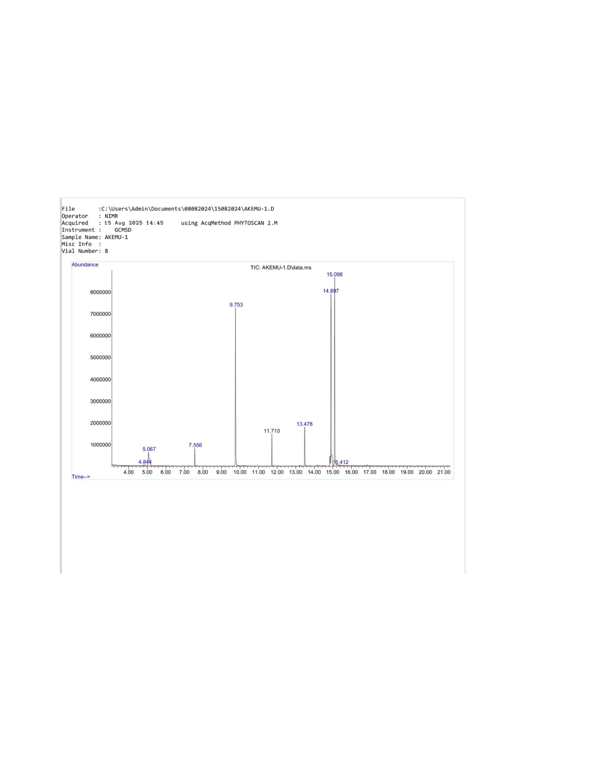
Figure 8: Chromatogram of biodiesel produced by heterogeneous transesterification
CONCLUSION
Plantain peels, oyster shells, and rocky clay soil were used as catalysts in the heterogeneous catalyst technique to manufacture biodiesel from shea nut oil. Plantain peels, oyster shells, and rocky clay soil can be used as a solid heterogeneous catalyst for the generation of biodiesel, according to the catalyst's characterisation results. Additionally, with high R² values of 0.9768 for the heterogeneous method, RSM demonstrated a good predictive capacity.
Optimum biodiesel yield by heterogeneous method of 92.68 % was obtained with a methanol/oil ratio of 8:1, catalyst loading of 5 wt%, reaction temperature of 65℃, and reaction time of 70 minutes. The properties of biodiesel produced by both processes were in conformity with ASTM D6751 and EN 14214 standards.
Gas chromatography/mass spectrometry (GC/MS) analysis resulted in 99.57% methyl esters and only 0.43% impurities.
The heterogeneous catalyst transesterification technology is the preferred method due to its low production cost, lower process parameters (temperature and pressure), and it application in industrial production of biodiesel.

REFERENCES
1.Sani, Y. M., Daud, W. M. A. W., and Abdul Aziz, A. R., Solid acid-catalyzed biodiesel production from microalgal oil-The dual advantage. J. Environ. Chem. Eng., 2013. 1, 113–121, doi: 10.1016/j.jece.2013.04.006
2.Miyuranga, K. A. V., Arachchige, U. S. P. R., Marso, T. M. M., & Samarakoon, G. (2023). Biodiesel Production through the Transesterification of Waste Cooking Oil over Typical Heterogeneous Base or Acid Catalysts. Catalysts, 13(3), 546.
3.Thinnakorn, K., & Tscheikuna, J. (2014). Biodiesel production via transesterification of palm olein using sodium phosphate as a heterogeneous catalyst. Applied Catalysis A: General, 476, 26–33. https://doi.org/https://doi.org/10.1016/j.apcata.2014.02.016
4.Ruhul, A. M., Kalam, M. A.. Masjuki, H. H., Fattah, I. M. Rizwanul and Reham, S. S. State of the art of biodiesel production processes: a review of the heterogeneous catalyst 2015.
5.Farouk, S. M., Tayeb, A. M. , Abdel-Hamid, S. M. S. and Osman, Recent advances in transesterification for sustainable biodiesel production, challenges, and prospect: a comprehensive review, published 23 january 2024, volume 31 pages 12722- 12747. (2024).
6.Obahiagbon, K., and Ahonkhai, D. O., Optimized Biodiesel Production from Waste Cooking Oil Using Poultry Droppings Catalyst: A Comparison of RSM and ANN. Petroleum Technology Development Journal, 2023. 13 (2), pp. 1-19
7.Rohim Rohazringy, Razi Ahmad, Naimah Ibrahim, Nasrul Hamidin, Che Zulzikrami Azner Abidin: Characterization of Calcium Oxide Catalyst from Eggshell Waste 2014. School of Environmental Engineering, University of Malaysia Perlis, Kompleks Pusat Pengajian Jejawi 3, 02600, Arau, Perlis, Malaysia E-mail: rohazrinyrohim@gmail.com Characterization of Calcium Oxide Catal.
8.Tantawy, M.A. and Ali Alomari, A. (2019) Extraction of Alumina from Nawan Kaolin by Acid Leaching. Oriental Journal of Chemistry,35,1013-1021.https://doi.org/10.13005/ojc/350313
9. Kessington Obahiagbon, David Ohimai Ahonkhai, Richard Omoregie, Paul Eloke, Optimum Biodiesel Production from African Oil Bean Seed Oil Using Antelope Bones and Africa Oil Bean Seed Pod as Catalyst 2020: RSM and ANN as Optimization Tools
10. Akhabue, Christopher Ehiaguina, Osa-Benedict. Evidence Osayi, Oyedoh, Eghe Amenze, Otoikhian, Shegun Kevin, Development of a Bio-based Bifunctional Catalyst for Simultaneous Esterification and Transesterification of Neem Seed Oil: Modeling and Optimization Studies, Renewable Energy (2020),https://doi.org/10.1016/j.renene.2020.01.103
11. Akhihiero, T. E. (2020). Solid Catalyzed Reaction of Jatropha Curcas Seed Oil with Methanol. European Journal of Sustainable Development Research, 4(1), em0105. https://doi.org/10.29333/ejosdr/6263.
12. Liping, Z., Boyang, S., Zhong, X., Qun, L. and Shuzhen, S. (2010). Kinetics of trans-esterification of palm oil and dimethyl carbonate for biodiesel production at the catalysis of heterogeneous base catalyst. Bioresource Technology, 101, 8144-8150. https://doi.org/10.1016/j.biortech.2010.05.069 .
13.Atadashi, M. I., M.K. Aroua, A. Abdul Aziz. Biodiesel separation and purification. https://doi.org/10.1016/j.renene.2010.07.019
14. Mohiddin, A. K. Dermatology Clinics & Research DCR, 5(1): 238-271 www.scitcentral.com ISSN: 2380-5609 Review Article: Open Access SciTech Central Inc. Dermatol Clin Res (DCR) 238 Skin Care Creams: Formulation and Use Department of Pharmacy, World University of Bangladesh, Dhaka, Bangladesh. Received May 13, 2019; Accepted May 16, 2019; Published August 20, 2019.
15. Priya Sinha, Archit Datar, Chungsik Jeong, Xuepeng Deng, Yongchul G. Chung, Li-Chiang Lin. The Journal of Physical Chemistry C Vol 123/Issue 33 July 17, 2019. Surface Area Determination of Porous Materials Using the Brunauer–Emmett–Teller (BET) Method: Limitations and Improvements
16. Hazra B., Wood D. A., Vishal V., Varma A. K., Sakha D., Ashok, Singh, 2018. Fuel –Elsevier correlation between BET SSA and average pore radius, Nitrogen adsorption-desorption-exist between pore radius and the differences in volumes.
17. Alafuan S., Awotunde A., Glatz G., Ibrahim Alaumaih S., and Gowida A. Petroleum science and energy, 2012. Elsevier Langmuir adsorption isotherm in unconvention resources. Applicability and limitation.
18. Victor G., Baldovino-Mcdrano, Viviana Nino-Celis and Rafael Isaacs Giral-do. Journal of chemical engineering Data systematic Analysis of nitrogen Adsorption-Desorption isotherms recorded for a series of materials based on microporous-mesoporous. Amorphous Alumisosilicates using classical method, 9 First September, 2023.
19. Mahayni, A. I, Wang, X., Harvey, J. P. Experimental method in chemical engineering. Density functional theory. Camadian Journal of 2021 Https:/doi.org/10.1002/cjce.24127.
20. M. Tubino, J.G.R. Junior, G.F. Bauerfeldt, Biodiesel synthesis with alkaline catalysts: a new refractometeric monitoring and kinetic study, Fuel, 2014. 125 (164e17).
21. Ayoub, M., Ullah, S., Inayat, A., Bhat, A. H., & Hailegiorgis, S. M. (2016). Process Optimization for Biodiesel Production from Waste Frying Oil over Montmorillonite Clay K-30. Procedia Engineering, 148, 742–749. https://doi.org/10.1016/j.proeng.2016.06.606

