Title: Cultural Technology and Indigenous Symbolism in Oroko Land: A Critical Re‑Examination of “iso” and Neck Beads
Abstract
African societies possess complex symbolic systems that function not only as cultural expressions but also as technologies for organizing social life, transmitting knowledge, and sustaining identity. This article critically examines two central Oroko cultural symbols—the the “iso” and the neck beads worn by Oroko chiefs through the lens of Cultural Technology. Drawing on ethnographic interviews, participant observation, and symbolic analysis, the study argues that these items function as sophisticated indigenous technologies that encode authority, identity, cosmology, and social regulation. The research demonstrates that these symbols operate as communicative devices, governance tools, and repositories of indigenous knowledge. The study further explores how modernization, Christianity, and globalization reshape their meanings and uses. Findings reveal that Oroko symbols remain dynamic cultural technologies that continue to structure leadership legitimacy, social cohesion, and cultural continuity in Oroko land. The article calls for renewed scholarly attention to African indigenous technologies as frameworks for understanding cultural resilience and innovation.
Keywords: Oroko, cultural technology, symbolism, indigenous knowledge systems, material culture
Introduction
African cultural systems are deeply embedded in symbolic practices that serve as frameworks for social organization, identity formation, and knowledge transmission. These symbolic systems are not merely decorative or ritualistic; they are functional technologies that structure everyday life and encode complex cultural logics (Geertz, 1973). Among the Oroko people of the South West Region of Cameroon, symbols such as the “iso”, and the neck beads won by chiefs play central roles in defining authority, mediating cosmological relationships, and sustaining communal cohesion. These symbols are integral to the Oroko worldview, shaping how individuals understand their place within the community and the broader spiritual universe.
This article seeks to address this gap by reinterpreting Oroko traditional symbols as cultural technologies—systems intentionally designed to solve social, spiritual, and political problems. Cultural Technology, as used in this study, refers to the symbolic, material, and ritual tools societies develop to organize life, transmit knowledge, and maintain social order (Miller, 2005). By examining the “iso” and neck beads through this lens, the study highlights the technological sophistication embedded in Oroko cultural practices.
The “iso” worn by many on important traditional events serves as a visual marker of fertility, purity, and traditional leadership identity. The colors (white and orange), patterns, and method of wearing the “iso” communicate specific messages about rank and legitimacy. The neck beads worn by chiefs function as spiritual and political technologies, offering protection, signifying lineage, and legitimizing chieftaincy authority.
These symbols are not static relics of the past; they are dynamic cultural technologies that continue to evolve in response to modernization, Christianity, and globalization. While some youths perceive them as outdated, many chiefs and elders reinterpret them to maintain relevance in contemporary contexts. This dynamic interplay between tradition and modernity underscores the resilience of Oroko cultural systems.
The central research question guiding this study is: How do Oroko traditional symbols function as cultural technologies that shape leadership, identity, and social order? To answer this question, the study employs a qualitative ethnographic approach, drawing on interviews, participant observation, and symbolic analysis. The findings reveal that Oroko symbols operate as sophisticated technologies that encode cultural knowledge, regulate social behavior, and legitimize authority.
This article contributes to three key areas of scholarship. First, it expands the field of Cultural Technology by demonstrating how indigenous African symbols function as technologies that structure social life. Second, it enriches material culture studies by highlighting the active role of objects in shaping identity and authority. Third, it advances Indigenous Knowledge Systems (IKS) scholarship by documenting the intellectual sophistication embedded in Oroko cultural practices.
The article is structured as follows. The next section provides a detailed background to the study, situating Oroko symbolism within its historical and cultural context. This is followed by a problem statement that outlines the need for scholarly reinterpretation of indigenous symbols as cultural technologies. The literature review examines key theoretical frameworks, including Cultural Technology, material culture theory, semiotics, and Indigenous Knowledge Systems. The methodology section describes the qualitative ethnographic approach used in the study. The findings and discussion section analyzes the three‑stone fire, “iso”, and neck beads as cultural technologies. The article concludes with recommendations for preserving and revitalizing Oroko cultural symbols.
By reinterpreting Oroko symbols as cultural technologies, this study challenges Western‑centric definitions of innovation and highlights the intellectual richness of African indigenous systems. It argues that understanding these symbols as technologies provides deeper insight into how the Oroko organize social life, transmit knowledge, and sustain cultural identity
Background to the Study & Problem Statement
Background to the Study
The Oroko people, located primarily in Ndian and part of Meme Divisions of the Southwest Region of Cameroon, constitute one of the oldest ethnic groups in the region, with a cultural heritage deeply rooted in symbolism, ritual practice, and indigenous knowledge systems. Their social organization, political structures, and cosmological beliefs are expressed through a rich tapestry of material and immaterial symbols that guide everyday life and encode communal values (Nkwi & Warnier, 1982). Among these symbols, the three‑stone fire, the “iso”, and the neck beads worn by chiefs stand out as central markers of identity, authority, and cultural continuity.
The iso, is another significant cultural symbol. It is made from raffia palms. It functions as a visual marker of fertility, beauty, authority, and leadership identity. The “iso”’s colors, patterns, and method of wearing communicate specific messages about rank, purity, and legitimacy. Textile symbolism has long been recognized as a powerful medium of communication in African societies, where cloth often signifies status, moral authority, and spiritual power (Picton & Mack, 1989). Among the Oroko, the “iso” is imbued with ancestral significance, linking the wearer to the family ancestors and reinforcing his/her role as the custodian of tradition.
The neck beads, or mesanga worn by chiefs serve as both spiritual and political technologies. Beads have historically played important roles in African societies as markers of wealth, lineage, and spiritual protection (Insoll, 2011). In Oroko culture, specific beads are reserved exclusively for chiefs and are believed to carry protective powers bestowed by ancestors. The beads also function as historical archives, with each bead representing a significant event, lineage, or achievement. This aligns with broader African traditions in which beads serve as repositories of memory and identity (Kreamer, 1990). These symbols are deeply embedded in Oroko cosmology and social organization. They are used in rituals, ceremonies, and everyday practices that reinforce communal values and social cohesion. They also serve as technologies of governance, regulating behavior and legitimizing authority. For example, the beads are used during chieftaincy rituals to invoke ancestral blessings. While the “iso” asserts the wearer’s fertility and beauty for especially females, the beads assert the chief’s authority and spiritual mandate.
However, the meanings and uses of these symbols have evolved over time. The introduction of Christianity, Western education, and globalization has reshaped Oroko cultural practices, leading to new interpretations and adaptations of traditional symbols. Some youths view these symbols as outdated or incompatible with modern lifestyles, while others embrace them as markers of cultural identity and resistance to cultural erosion. Chiefs and elders often find themselves negotiating between tradition and modernity, adapting symbols to maintain relevance in contemporary contexts (Geschiere, 1997).
Despite these changes, Oroko symbols remain central to the community’s identity and social organization. They continue to function as cultural technologies that encode knowledge, regulate behavior, and sustain cultural continuity. Understanding these symbols as technologies rather than mere artifacts provides deeper insight into the intellectual sophistication of Oroko cultural systems and challenges Western‑centric definitions of technology.
Problem Statement
Although Oroko traditional symbols play crucial roles in governance, identity formation, and cultural continuity, they are often misunderstood or undervalued in contemporary discourse. Western conceptions of technology tend to prioritize mechanical, industrial, or digital innovations, marginalizing indigenous symbolic systems that function as technologies in their own right (Pfaffenberger, 1992). This epistemological bias contributes to the erasure of African intellectual traditions and undermines the value of indigenous knowledge systems. Despite their significance, Oroko cultural symbols remain understudied in academic literature. Much of the existing scholarship on African symbolism focuses on broader ethnic groups or pan‑African cultural patterns, often overlooking the localized and nuanced meanings embedded in specific communities (Turner, 1967).
In academic literature, African symbols are frequently treated as decorative or ritualistic artifacts rather than functional technologies. This limited perspective fails to recognize the technological logic embedded in these symbols and their role in structuring social life. For example, the three‑stone fire is often viewed merely as a primitive cooking device, ignoring its symbolic significance and its role as a cosmological and governance technology. Similarly, the “iso” and the beads are often dismissed as cultural ornaments rather than technologies of beauty, fertility, authority, identity, and spiritual protection.
The lack of scholarly attention to Oroko symbols has practical implications for cultural preservation. As modernization, Christianity, and globalization reshape cultural practices, traditional symbols risk being misunderstood, devalued, or abandoned. Younger generations may fail to appreciate the cultural and technological significance of these symbols, leading to cultural erosion and loss of indigenous knowledge. Chiefs and elders often express concern that the meanings of traditional symbols are being lost or distorted, threatening the continuity of Oroko cultural identity. Furthermore, the absence of research on Oroko symbols limits broader academic understanding of African cultural technologies. While scholars have documented symbolic systems in other African societies, such as the Ndembu (Turner, 1967) and the Yoruba (Drewal, 1992), there is a significant gap in the literature on the Oroko. This gap not only marginalizes Oroko cultural heritage but also limits comparative studies that could enrich theoretical frameworks in anthropology, material culture studies, and Indigenous Knowledge Systems.
There is therefore a pressing need to reinterpret Oroko traditional symbols through a framework that recognizes their technological logic and cultural sophistication. By analyzing the three‑stone fire, “iso”, and neck beads as cultural technologies, this study seeks to fill a critical gap in the literature and contribute to the preservation and revitalization of Oroko cultural heritage.
Literature Review
The literature on African symbolism, cultural technology, and Indigenous Knowledge Systems (IKS) provides a rich foundation for understanding the technological logic embedded in Oroko traditional symbols. This review examines four major bodies of scholarship relevant to the study: (1) Cultural Technology, (2) Material Culture, (3) Semiotics and Symbolism, and (4) Indigenous Knowledge Systems. Together, these frameworks illuminate how symbols such as the three‑stone fire, “iso”, and neck beads function as technologies that structure social life, encode authority, and sustain cultural identity.
Cultural Technology
The concept of Cultural Technology challenges the narrow Western definition of technology as purely mechanical or digital. Instead, it expands the notion to include symbolic, ritual, and social systems that enable societies to organize themselves and solve collective problems. Pfaffenberger (1992) argues that technology is fundamentally a sociocultural phenomenon, shaped by human intentions, values, and power relations. He emphasizes that tools and symbols are embedded in social systems and cannot be understood apart from their cultural contexts. This broader understanding of technology is essential for analyzing African symbolic systems. Scholars such as Ferguson (2019) and Comaroff and Comaroff (1991) have shown that African societies employ complex cultural technologies to regulate social behavior, transmit knowledge, and maintain political authority. These technologies include ritual practices, kinship structures, initiation systems, and symbolic objects.
In the context of the Oroko, the “iso” and neck beads can be understood as cultural technologies that encode social norms, cosmological beliefs, and leadership structures. The three‑stone fire, for example, is not merely a cooking space but a technological system that organizes domestic life, mediates ancestral communication, and symbolizes social balance. This aligns with Pfaffenberger’s (1992) argument that technology is a “total social phenomenon” that integrates material, symbolic, and social dimensions. Similarly, the “iso” and beads worn by chiefs function as technologies of authority and identity. They communicate beauty, fertility, rank, legitimacy, and spiritual power, shaping how individuals perceive and interact with leadership. This reflects Ferguson’s (2019) observation that African political systems often rely on symbolic technologies to assert authority and maintain social cohesion.
Material Culture
Material culture theory provides another important lens for understanding Oroko symbols. Material culture scholars argue that objects are not passive artifacts but active participants in social life. Miller (2005) asserts that material objects “make people” by shaping identity, memory, and social relations. This perspective challenges the assumption that objects merely reflect culture; instead, they actively produce and reproduce cultural meanings. African material culture has been extensively studied, with scholars highlighting the central role of objects in expressing identity, status, and cosmology. Picton and Mack (1989) demonstrate that African textiles function as powerful communicative devices, conveying messages about social rank, moral authority, and spiritual power. Similarly, Kreamer (1990) shows that African beads serve as repositories of memory, lineage, and identity.
In Oroko society, the “iso” and beads worn by chiefs exemplify the active role of material objects in shaping social relations. The “iso”’s colors and patterns communicate specific messages about leadership status, while the beads signify lineage, spiritual protection, and political legitimacy. These objects are not merely decorative; they are technologies that structure social interactions and reinforce authority. The three‑stone fire also fits within material culture theory. As a physical structure, it shapes domestic routines, social gatherings, and ritual practices. Its arrangement of three stones symbolizes balance and interdependence, reinforcing communal values. This aligns with Miller’s (2005) argument that material objects embody cultural logics and shape human behavior.
Semiotics and Symbolism
Semiotics, the study of signs and symbols, provides a framework for decoding the meanings embedded in Oroko cultural symbols. Barthes (1972) argues that symbols function as “myths” that naturalize cultural values and power structures. They communicate layered meanings that shape how individuals perceive the world.
In African societies, symbols play central roles in expressing cosmological beliefs, social hierarchies, and moral values. Turner’s (1967) work on the Ndembu demonstrates how ritual symbols encode complex cultural meanings and mediate social transitions. He argues that symbols are multivocal, carrying multiple meanings that resonate with different members of the community. The Oroko three‑stone fire exemplifies this multivocality. It symbolizes domestic unity, ancestral presence, and social balance. Its three stones can represent gender roles, lineage branches, or cosmological forces, depending on the context. This aligns with Turner’s (1967) observation that symbols derive their power from their ability to condense multiple meanings. The “iso” and beads also function as semiotic devices. Their colors, patterns, and arrangements communicate messages about rank, purity, and legitimacy. Barthes’ (1972) concept of myth is particularly relevant here: as the beads naturalize the chief’s authority, making it appear self‑evident and culturally ordained.
Semiotics also helps explain how symbols evolve over time. As Oroko society interacts with Christianity, Western education, and globalization, the meanings of traditional symbols shift. Some youths reinterpret the symbols as cultural heritage rather than spiritual technologies, while others reject them as incompatible with modern lifestyles. This dynamic process reflects Barthes’ (1972) argument that symbols are constantly reinterpreted within changing cultural contexts.
Indigenous Knowledge Systems (IKS)
Indigenous Knowledge Systems (IKS) scholarship highlights the intellectual sophistication embedded in African cultural practices. Hountondji (1997) argues that African knowledge systems are dynamic, empirical, and deeply rooted in local contexts. They encompass ecological knowledge, healing practices, governance systems, and symbolic technologies. IKS scholars emphasize that indigenous technologies are not primitive but highly adapted to local environments and social needs. For example, fire technologies in African societies are often linked to cosmology, agriculture, and social organization (Mbiti, 1990). Textile and bead systems encode lineage, identity, and spiritual power (Insoll, 2011).
The Oroko three‑stone fire, “iso”, and beads fit squarely within IKS frameworks. The three‑stone fire is a technological system developed through centuries of cultural engineering, optimized for cooking, heating, and ritual communication. The “iso” is a technology linked with traditional beauty, fertility, and link between the living and the dead while the beads are technologies of governance and identity, linking chiefs to ancestral lineages and legitimizing their authority.
IKS also emphasizes the importance of oral traditions in transmitting knowledge. Oroko elders often explain the meanings of symbols through stories, proverbs, and rituals. This aligns with Wiredu’s (2004) argument that African knowledge systems are embedded in communal practices and transmitted through lived experience. However, IKS scholars also warn that modernization threatens the continuity of indigenous knowledge. As younger generations adopt Western lifestyles, traditional symbols risk being misunderstood or abandoned. This concern is echoed in Oroko communities, where elders worry that the meanings of symbols are being lost. Documenting and analyzing these symbols as cultural technologies is therefore essential for preserving Oroko cultural heritage.
Theoretical Framework
This study draws on three complementary perspectives—Material Culture Theory, Semiotics, and Indigenous Knowledge Systems (IKS)—to explain Oroko traditional symbols as active cultural technologies. Together, these approaches show how the three-stone fire, “iso”, and chiefs’ neck beads shape identity, authority, and social life.
Material Culture Theory
Material Culture Theory argues that objects are not passive items but active forces in society. They help shape behavior, memory, identity, and social relationships (Miller, 2005). In Oroko society, traditional symbols do more than represent culture; they organize and reinforce it. The three-stone fire structures domestic life, cooking practices, and communal interaction while symbolizing balance and interdependence. The “iso” communicates status, legitimacy, and leadership, functioning as a visible sign of authority (Picton & Mack, 1989). The neck beads signify lineage, protection, and political legitimacy, shaping how chiefs are perceived (Kreamer, 1990).
Semiotics
Semiotics studies how signs and symbols communicate meaning. According to Barthes (1972), symbols often naturalize cultural values, making them appear normal or unquestioned. In Oroko culture, the three-stone fire is a multivocal symbol with meanings linked to family unity, lineage, and cosmology (Turner, 1967). The chief’s “iso” communicates purity, legitimacy, and leadership identity, while the beads symbolize ancestry, spiritual power, and authority (Insoll, 2011). Semiotics also helps explain how these meanings change over time under Christianity, modernization, and globalization.
Indigenous Knowledge Systems (IKS)
IKS recognizes African knowledge systems as sophisticated, practical, and locally grounded (Hountondji, 1997). Indigenous technologies are adapted to environmental, social, and spiritual needs. The three-stone fire reflects practical knowledge of heat efficiency, stability, and fuel use, while also expressing beliefs about harmony and ancestral presence. The “iso” and beads function as technologies of governance, identity, and continuity, transmitting cultural knowledge through rituals and oral traditions (Wiredu, 2004). Despite modernization, these symbols remain important markers of Oroko identity.
These three theories provide a strong framework for understanding Oroko symbols as more than decorative traditions. They are functional technologies that communicate meaning, preserve knowledge, and sustain authority within Oroko society.
Methodology This study employed a qualitative ethnographic approach to examine the “iso”, and neck beads worn by Oroko chiefs as cultural technologies. Ethnography was appropriate because it allows an in-depth understanding of cultural meanings, rituals, and indigenous knowledge from the perspective of community members (Creswell & Poth, 2018).
Research Design
A qualitative ethnographic design was used to observe social practices, interpret symbolic meanings, and understand how Oroko objects function within everyday life. This approach enabled the researcher to study symbols in their natural settings rather than as isolated artifacts.
Study Area
The research was conducted in Ndian and Meme Divisions, Southwest Region of Cameroon, home to several Oroko communities. The area was selected because of its active chieftaincy institutions and continuing traditional practices.
Population and Sampling
Participants included chiefs, elders, traditional council members, women leaders, youth representatives, and cultural custodians. Purposive sampling was used to select knowledgeable participants, while snowball sampling helped identify additional informants. A total of 32 participants took part in the study: 6 chiefs, 8 elders, 5 traditional council members, 5 women leaders, 4 youth representatives, and 4 cultural custodians, not forgetting dance groups.
Data Collection Methods
Data were collected through semi-structured interviews with chiefs, elders, and custodians on meanings and uses of the symbols, focus group discussions with women, youth, and mixed community groups. Participant observation during rituals, palace meetings, and domestic activities also played a big role in data collection. Photographic documentation of the “iso”, and beads (with permission), and archival review of palace records, oral histories, and cultural documents was important as well.
Data Analysis
Data were analyzed using thematic analysis (Braun & Clarke, 2006) to identify key themes such as authority, identity, cosmology, and cultural resilience. Semiotic analysis was also used to interpret colors, patterns, and symbolic meanings, while material culture analysis examined how objects shape behavior and social relations.
Ethical Considerations
Ethical approval was obtained from local authorities and community leaders. Participants gave informed consent, confidentiality was maintained, and sacred cultural knowledge was treated with respect. Special care was taken when documenting restricted objects such as ceremonial beads.
- The “iso” as a Technology of Authority
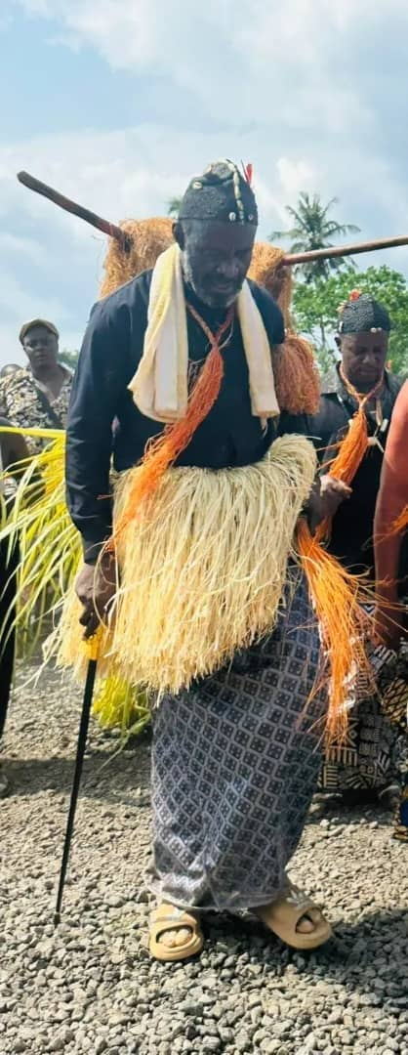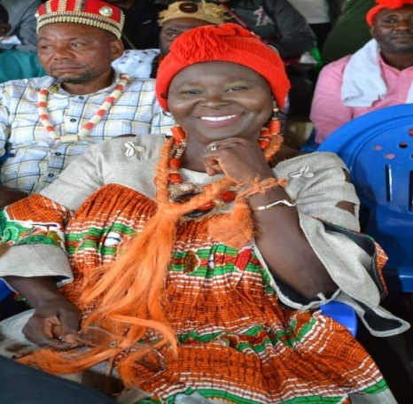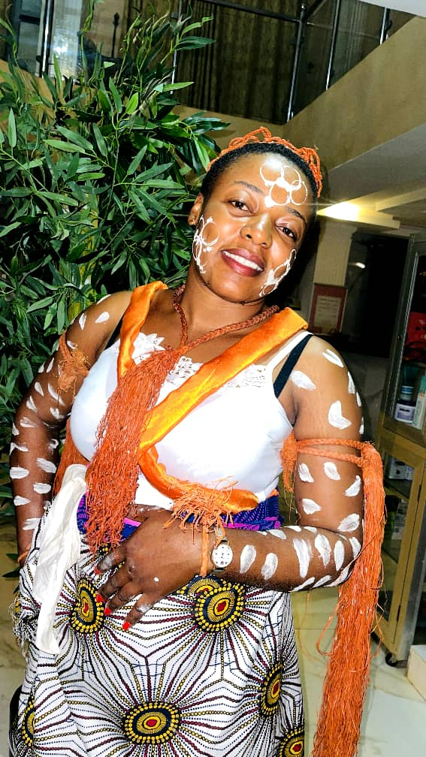
Pic 1: The City mayor of the Kumba Urban Council during his initiation to the top secret society in Bakundu Land
Pic 2: The researcher in her traditional regalia, with “nwea“on her neck. This distinguishes her from other women. This is not ordinary “iso”, reason why it is called “nwea” although it has the same colour with iso. Only the initiated women wear “nwea”.
Pic 3: A Traditional dancer adorned in her” iso”
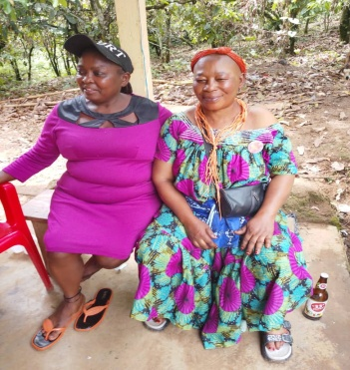
Pic 4: A woman in her mourning regalia with “iso” on her head. This indicated that even mourning attracts traditional rituals that link the living to the dead, especially if the deseased was an old person.

2.1 Material Culture and Identity
The “iso” is also worn by Oroko chiefs as a powerful material technology that communicates authority, purity, and leadership identity. The “iso” is typically woven in bold colors—red, white, blue, or yellow—each carrying symbolic meaning. Red signifies vitality and ancestral power; white represents purity and moral authority. This aligns with Picton and Mack’s (1989) argument that African textiles function as communicative devices that encode social status and moral values. The “iso”’s materiality—its texture, color, and pattern—shapes how community members perceive the chief.
2.2 Semiotic Analysis
Semiotically, the “iso” functions as a signifier of legitimacy. Barthes’ (1972) concept of myth helps explain how the “iso” naturalizes the chief’s authority. When the chief wears the “iso”, his leadership appears culturally ordained rather than socially constructed. During interviews, elders emphasized that the “iso” is not merely decorative:
“The cloth is the chief. Without it, he is just a man.” This statement reflects the material culture principle that objects actively shape identity (Miller, 2005). The “iso” transforms the chief into a symbolic figure who embodies the community’s values.
2.3 Ritual Restrictions and Protocols: The “iso” is subject to strict protocols: Firstly, only the initiated woman into the “male” sacred society and those who rank as such may wear the white colour usually called “nwea” which is used to brush the dress of the highest masquerade “njoku” during its performance. The “iso” must be blessed by elders before use. It is worn during rituals, palace meetings, and public ceremonies. It must never touch the ground, as this is believed to offend the ancestors.
These restrictions reinforce the “iso”’s sacred status and its role as a governance technology. The protocols also reflect Indigenous Knowledge Systems, where objects are imbued with spiritual power and must be handled with care (Wiredu, 2004).
2.4 Modern Transformations
Modern influences have led to new interpretations of the “iso”. Some chiefs incorporate contemporary “iso” or designs, blending tradition with modern aesthetics. Youths often view the “iso” as a symbol of cultural pride rather than spiritual authority, reason why most of them wear it during dance performances. This shift reflects Barthes’ (1972) argument that symbols evolve as cultural contexts change.
3. The Neck Beads (Mesanga) as a Technology of Power and Memory
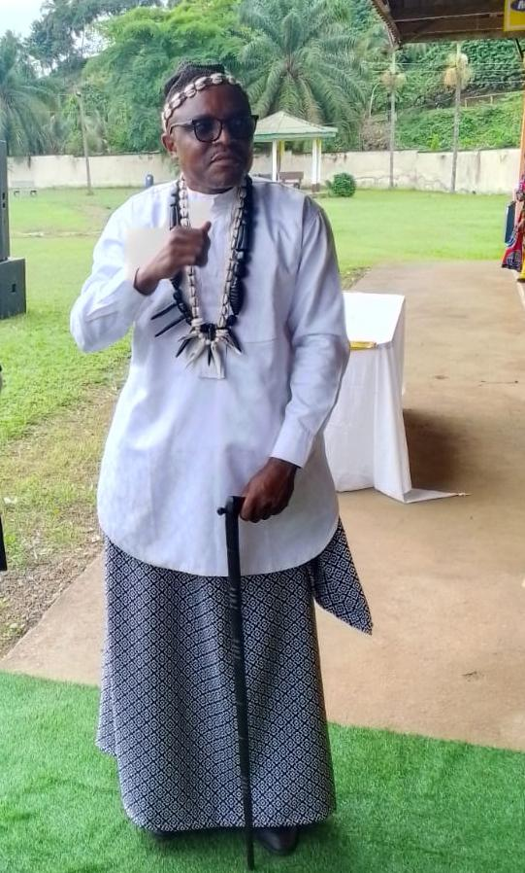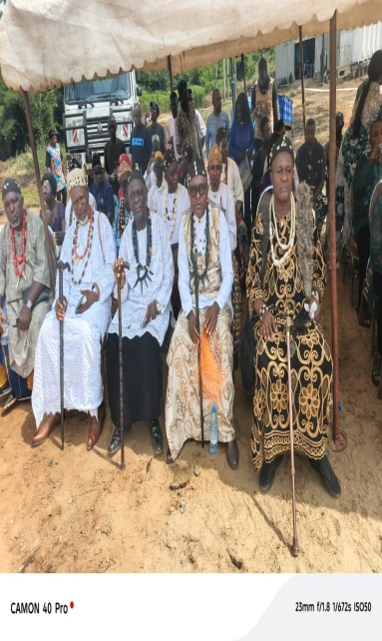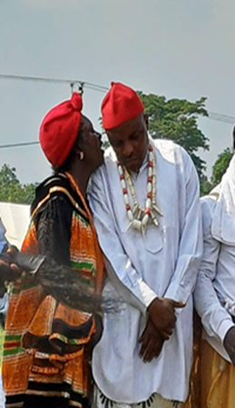
A cross section of Bakundu chiefs in their traditional neck beads (laces) during a traditional ceremony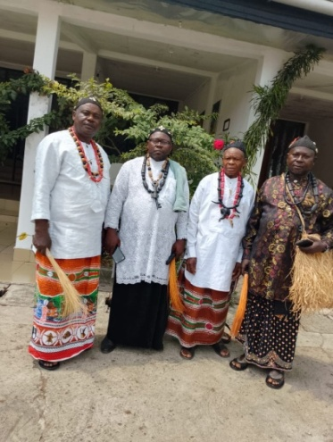
The last pic shows the researcher with one of the Bakundu chiefs.
1 Material and Historical Dimensions
The neck beads worn by Oroko chiefs are among the most sacred cultural objects in the community. Beads vary in color, size, and material, with some made from glass, bone, seeds, or imported trade beads. Each bead carries historical significance, often representing: a lineage, a major event, a spiritual achievement, a political alliance.
This aligns with Kreamer’s (1990) argument that African beads serve as repositories of memory and identity. The beads function as a material archive, preserving Oroko history through tangible objects.
2 Semiotic and Spiritual Functions
Semiotically, beads signify authority, spiritual protection, and ancestral connection. Chiefs explained that certain beads are believed to contain ancestral power, offering protection against harm. This reflects Insoll’s (2011) observation that beads in African societies often serve as spiritual technologies. One elder stated: “These beads are not for beauty. They carry the voices of those who ruled before.” This reinforces the idea that beads are technologies of memory and authority.
3 Governance and Social Regulation
Beads also function as governance technologies. Only chiefs or designated custodians may wear specific beads. Unauthorized use is considered a serious offense, believed to provoke ancestral punishment. This regulatory function aligns with Pfaffenberger’s (1992) argument that technologies are embedded in social systems and power relations.
4 Continuity and Change
While some beads are centuries old, others are newly crafted. Chiefs often combine old and new beads, symbolizing continuity and adaptation. Youths expressed admiration for the beads as cultural heritage, even if they do not fully understand their spiritual significance. This reflects Hountondji’s (1997) argument that Indigenous Knowledge Systems evolve while retaining core values.
4. Cross‑Symbol Analysis: Cultural Technology in Practice
Across the two symbols, several themes emerged:
1 Symbols as Active Agents
Consistent with material culture theory, the symbols actively shape social behavior, identity, and authority (Miller, 2005). They are not passive artifacts but technologies that structure social life.
2 Multi-vocality and Layered Meanings
The symbols carry multiple meanings that resonate with different community members, reflecting Turner’s (1967) concept of multi-vocality.
3. Governance and Legitimacy
All three symbols function as governance technologies, legitimizing authority and regulating social behavior (Pfaffenberger, 1992).
4. Cultural Resilience
Despite modernization, the symbols remain central to Oroko identity, demonstrating the resilience of Indigenous Knowledge Systems (Hountondji, 1997)
Conclusion and Recommendations
Conclusion
This study examined the “iso” (iso), and neck beads (mesanga) of the Oroko people as cultural technologies that sustain authority, identity, and social order in Ndian and Meme Divisions. Guided by Material Culture Theory, Semiotics, and Indigenous Knowledge Systems, the findings demonstrate that these symbols are not mere artifacts, but dynamic institutions that continue to shape Oroko society. The three-rock fire performs domestic, ritual, and cosmological functions, symbolizing unity, balance, interdependence, and ancestral connection. The “iso” worn by chiefs represents legitimacy, purity, leadership, and continuity, while the neck beads symbolize memory, spiritual protection, lineage, and political authority. Collectively, these symbols shape identity, regulate behavior, carry multiple meanings across domestic and political contexts, legitimize traditional authority, and show resilience through adaptation to modernization. Although Christianity, globalization, and changing youth perceptions pose challenges, many younger people still value these symbols as markers of cultural identity. Ultimately, Oroko symbols should be recognized as sophisticated indigenous technologies that address social, spiritual, and political needs. Their preservation and documentation are essential for sustaining Oroko cultural heritage and affirming the value of African knowledge systems.
Recommendations
To preserve and revitalize Oroko cultural technologies, indigenous knowledge should be integrated into school curricula across Oroko communities and the wider Southwest Region. Teaching the meanings and functions of the three-rock fire, “iso”, and neck beads can promote cultural pride among younger generations and prevent the loss of traditional knowledge. Community-based documentation should also be encouraged through collaboration between chiefs, elders, cultural associations, and researchers. Such efforts may include written records, audio-visual materials, and digital archives that accurately reflect local perspectives and cultural values.
Traditional institutions should be supported in preserving and adapting these symbols to contemporary realities. Chiefs, as custodians of culture, require institutional and community support to sustain cultural continuity. Youth participation should be promoted through festivals, workshops, and mentorship programs to ensure intergenerational knowledge transfer. In addition, cultural heritage centers in Ndian and Meme Divisions could serve as spaces for preservation, education, tourism, and research. Scholars should further pursue interdisciplinary studies on African cultural technologies, while chiefs and elders establish ethical guidelines to protect sacred knowledge and regulate what may be publicly shared.
References
Barthes, R. (1972). Mythologies. Hill and Wang.
Braun, V., & Clarke, V. (2006). Using thematic analysis in psychology. Qualitative Research in Psychology, 3(2), 77–101. https://doi.org/10.1191/1478088706qp063oa (doi.org in Bing)
Comaroff, J., & Comaroff, J. L. (1991). Of revelation and revolution: Christianity, colonialism, and consciousness in South Africa (Vol. 1). University of Chicago Press.
Creswell, J. W., & Poth, C. N. (2018). Qualitative inquiry and research design: Choosing among five approaches (4th ed.). SAGE Publications.
Drewal, H. J. (1992). Yoruba ritual: Performers, play, agency. Indiana University Press.
Ferguson, J. (2019). Give a man a fish: Reflections on the new politics of distribution. Duke University Press.
Geertz, C. (1973). The interpretation of cultures. Basic Books.
Geschiere, P. (1997). The modernity of witchcraft: Politics and the occult in postcolonial Africa. University of Virginia Press.
Hammersley, M., & Atkinson, P. (2019). Ethnography: Principles in practice (4th ed.). Routledge.
Hountondji, P. J. (1997). Endogenous knowledge: Research trails. CODESRIA.
Insoll, T. (2011). The Oxford handbook of the archaeology of ritual and religion. Oxford University Press.
Kreamer, C. M. (1990). African beads: Jewels of a continent. African Arts, 23(4), 24–39. https://doi.org/10.2307/3336563
Kvale, S., & Brinkmann, S. (2015). InterViews: Learning the craft of qualitative research interviewing (3rd ed.). SAGE Publications.
Mbiti, J. S. (1990). African religions and philosophy (2nd ed.). Heinemann.
Miller, D. (2005). Materiality. Duke University Press.
Morgan, D. L. (2019). Basic and advanced focus groups. SAGE Publications.
Nkwi, P. N., & Warnier, J. P. (1982). Elements for a history of the Western Grassfields. University of Yaoundé Press.
Noy, C. (2008). Sampling knowledge: The hermeneutics of snowball sampling in qualitative research. International Journal of Social Research Methodology, 11(4), 327–344. https://doi.org/10.1080/13645570701401305 (doi.org in Bing)
Patton, M. Q. (2015). Qualitative research & evaluation methods (4th ed.). SAGE Publications.
Pfaffenberger, B. (1992). Social anthropology of technology. Annual Review of Anthropology, 21, 491–516. https://doi.org/10.1146/annurev.an.21.100192.002423 (doi.org in Bing)
Picton, J., & Mack, J. (1989). African textiles. British Museum Press.
Spradley, J. P. (1980). Participant observation. Holt, Rinehart & Winston.
Turner, V. (1967). The forest of symbols: Aspects of Ndembu ritual. Cornell University Press.
Wiredu, K. (2004). A companion to African philosophy. Blackwell Publishing. Cultural Technology and Indigenous Symbolism among the Oroko of Konye Sub‑Division: Re‑Examining the Three‑Rock Fire, neck “iso” and Neck Beads

