Store Rationalization and Space Productivity in an Emerging Market Department Store: A Dynamic Capabilities Perspective

Hally Hanafiahª, Fitriah Dwi Mulyani^{b}, Hadi Tama Waskito^{c}, Teresha A. P.^{d}, Tony Kristhiofan^{e}
^{b,c,d} Sekolah Interdisiplin Manajemen & Teknologi, Institut Teknologi Sepuluh Nopember
Surabaya
^{a,e}Faculty of Business, President University
ª hally.hanafiah@president.ac.id, ^{b} mulyanifitriah@gmail.com, ^{c} hadie09@gmail.com, ^{d} tereshaphilberta@gmail.com, ^{e} tony.kristhiofan@student.president.ac.id

Abstract
This study examines how an incumbent department store retailer in an emerging market reconfigures its physical store network to sustain profitability under omnichannel pressure. Drawing on a longitudinal single-case study of PT Matahari Department Store Tbk between 2019 and 2024, the research analyzes the relationship between store rationalization, space productivity, and financial performance amid sustained digital disruption and shifting consumer behavior. Using archival data from audited annual reports, sustainability disclosures, and institutional sources, the study traces changes in store count, cost structures, and profitability over time. The findings show that periods of physical store expansion were associated with declining profitability despite stable revenues, while subsequent store closures coincided with improvements in net profit driven primarily by cost realignment rather than demand growth. Interpreted through Dynamic Capabilities Theory, the results suggest that store rationalization constitutes a deliberate process of asset reconfiguration involving sensing deteriorating space productivity, seizing opportunities to realign the store portfolio, and transforming the role of physical stores within an omnichannel system. By foregrounding space productivity as the mechanism linking asset reconfiguration to performance outcomes, this study challenges decline-oriented narratives of store closures and advances understanding of how incumbent retailers in emerging markets adapt physical retail space to sustain financial resilience in omnichannel environments.
Keywords: Store rationalization, Space productivity, Omnichannel retailing, Dynamic capabilities, Emerging markets

- Introduction
In the current retail landscape, the role of physical stores is being fundamentally reshaped by digital competition and the rise of omnichannel shopping, creating economic pressures that traditional store models struggle to absorb. Recent empirical research shows that widespread closures of physical retail stores continue to accelerate as online and integrated digital channels gain prominence, with structural factors related to store attributes and consumer behaviour linked to these closures in apparel and media categories in advanced economies (Kupfer et al., 2024). At the same time, omnichannel strategies that was originally conceived to blend online and offline operations have redefined how retailers manage channels, suggesting that the historical distinctions between physical and online channels are fading as firms seek seamless customer experiences across touchpoints (Hänninen et al., 2021). These shifts indicate that physical space is no longer valuable simply as a sales outlet but must be reconceived as part of a networked retail ecosystem in which experience, integration, and cross-channel interaction matter for competitiveness (Alexander & Varley, 2025). As digitalisation and the growth of ominchannel continues to alter consumer expectations and competitive dynamics, retailers face a paradox in which costly physical locations remain strategically relevant yet are increasingly vulnerable if they fail to integrate effectively with digital capabilities (Cai & Lo, 2020; Salvietti et al., 2022). Understanding how and why this transformation unfolds is therefore crucial for both retail strategy and theory, particularly as firms navigate omnichannel pressures and spatial productivity challenges in a post-digital retail environment.
Recent literature has extensively explored how omnichannel strategies enhance store performance, examining how retail technologies reshape store space production and detailing the role of physical stores in phygital, experience-driven retail environments. Similarly, integrated optimization models for assortment, inventory, and pricing in retail have been developed to maximize retailer profit and customer utility (Alexander & Varley, 2025; Vadruccio et al., 2024). The emergence of the omnichannel framework has also been studied in its relations to the growing digitalization of retail management and how it relates to the current physical store spaces (Hänninen et al., 2021; Salvietti et al., 2022). Study focusing more on the integrated and technical details of the technology has also been conducted (Mou et al., 2024). However, this body of work remains predominantly focused on developed-market contexts and on overall channel integration, leaving two critical areas under-theorized. First, the concept of space productivity, how efficiently physical store space generates sales and profit, is often treated as a secondary metric rather than a central strategic variable, especially for incumbent retailers in emerging markets. Second, store rationalization, the deliberate pruning and repositioning of physical networks, has been studied mainly in Western “retail apocalypse” scenarios (Kupfer et al., 2024), with little attention to how emerging-market incumbents rationalize their store portfolios amid digital disruption. Consequently, while existing research provides a robust understanding of omnichannel and store performance generally, it offers limited theoretical guidance on optimizing space productivity and executing store rationalization in the unique institutional, competitive, and consumer landscapes of Indonesian clothing retail stores.
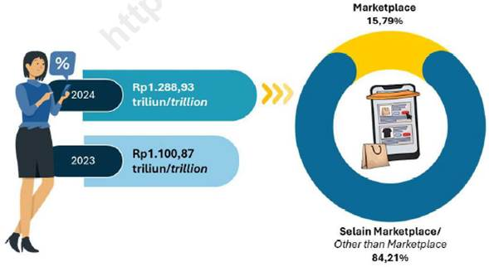
Figure 1. E-commerce transaction value 2023-2024 (Ismartini et al., 2025)
To address these gaps, an emerging market context is essential. Indonesia presents a critical and illustrative case. The post-COVID-19 economic recovery in Indonesia has been slow, with stagnant economic growth constraining household consumption (World Bank, 2025). Notably, household expenditure on clothing has shown a consistent declining trend from 2020 to 2024, with a historical deviation of -1.79%, signaling pressure on traditional apparel retail (Hartono et al., 2024). Concurrently, the digital shift accelerated by the pandemic has become entrenched. Initially driven by mobility restrictions, the preference for online shopping has persisted beyond the pandemic, solidifying as a lasting consumer behavior (Popescu et al., 2025; Sayyida et al., 2021). This is evidenced by a significant 17.08% year-on-year increase in the national e-commerce transaction value, reaching IDR 1,288.93 trillion in 2024 (Ismartini et al., 2025). The convergence of stagnant in-person demand and rapidly growing digital channel preference that is fueled by mobile apps and digital platforms creates a pressing strategic dilemma for incumbent retailers with extensive physical networks (Lisnawati et al., 2024). Therefore, Indonesia epitomizes the paradox where physical stores remain vital for customer touchpoints and experience yet are intensely vulnerable to digital competition. This makes it a potent setting to investigate the underexplored questions of how incumbent retailers in emerging markets optimize store space productivity and execute store rationalization within an omnichannel transition.
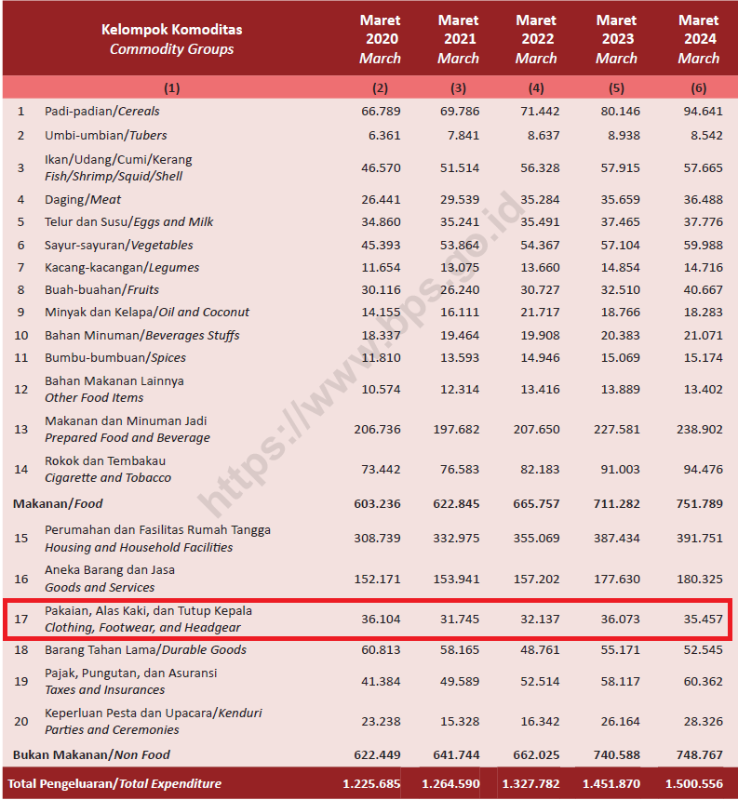
Figure 2. Apparel Commodity Trend Year 2020-2024 (Hartono et al., 2024)
Faced with these dual pressures, incumbent retailers must strategically reconfigure their physical networks. This often involves redesigning stores to maximize the productivity of retail space, recognizing that sales density is critical for profitability. Consequently, optimizing space utilization and rightsizing store formats have become key strategic levers for maintaining relevance (Fay et al., 2022; Liu et al., 2025). To empirically investigate these under-theorized processes of space productivity optimization and store rationalization in an emerging market, this study focuses on a critical case: PT Matahari Department Store Tbk (Matahari). As one of Indonesia's largest department store chains, Matahari provides a compelling research setting. Founded in 1958 and targeting the middle market with apparel, beauty, and home products, Matahari operates 142 stores across 79 cities, generating Rp 6.40 trillion in revenue and Rp 827.7 billion in net profit in 2024. Its business model relies on a mix of consignment and owned brands, with physical stores still dominating its revenue despite growing online channels. Significantly, Matahari has been actively rationalizing its store portfolio, reducing its count from 169 stores in 2019 to 142 in 2024, a clear strategic response to post-pandemic market shifts and changing consumer behavior (Matahari, 2024b). Notably, this rationalization coincided with a return to net profit growth in 2024, suggesting a critical link between portfolio optimization and financial resilience in this context. This deliberate reduction makes Matahari an ideal subject for examining how a major emerging market incumbent executes store rationalization while seeking to enhance the productivity of its remaining physical space within an evolving omnichannel strategy.
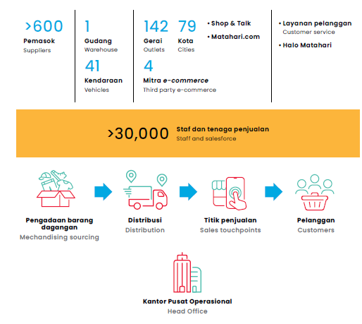
Figure 3. Matahari Department Store Business Profile (Matahari, 2024b)

Table 1. Matahari Stores Number 2019-2024
Year | Store Number | Source
2019 | 169 | Annual Report Matahari (2019)
2020 | 147 | Annual Report Matahari (2020)
2021 | 139 | Annual Report & Sustainability Report (2021)
2022 | 148 | Sustainability Report Matahari (2022)
2023 | 154 | Sustainability Report Matahari (2023)
2024 | 142 | Sustainability Report Matahari (2024)
Despite extensive research on omnichannel retailing and the evolving role of physical stores, existing studies remain largely centered on developed market contexts and emphasize channel integration rather than the strategic productivity of physical retail space (Alexander & Varley, 2025; Hänninen et al., 2021; Salvietti et al., 2022). In particular, space productivity has received limited theoretical attention as a central strategic variable, especially for incumbent retailers operating in emerging markets. Likewise, store rationalization has primarily been examined through Western “retail apocalypse” narratives, offering limited insight into how emerging-market retailers deliberately prune and reconfigure store networks amid sustained digital disruption (Kupfer et al., 2024). Addressing these gaps, this study examines how an incumbent department store retailer in an emerging market reconfigures its physical store network to sustain profitability under omnichannel pressure. Using a longitudinal case analysis of PT Matahari Department Store Tbk from 2019 to 2024, the study analyzes the relationship between store rationalization, space productivity, and financial performance within Indonesia’s evolving retail environment. By doing so, this paper contributes to retail and omnichannel theory by advancing understanding of space productivity and store rationalization as adaptive strategic mechanisms for incumbent retailers facing digital transformation in emerging markets. Accordingly, this study asks the following research question:
RQ: How do incumbent department store retailers in emerging markets reconfigure their physical store networks to sustain profitability under omnichannel pressure?

- Literature Review
Dynamic Capability
Dynamic Capabilities Theory (DCT) extends the resource-based view by explaining how firms deliberately reconfigure valuable resources to adapt to rapidly changing environments, rather than assuming resource advantages remain static over time; this extension is central to understanding competitive advantage in dynamic contexts such as digital transformation and volatile markets (Al-Moaid & Almarhdi, 2024). While the resource-based view emphasizes the role of firm-specific assets in generating competitive advantage, it has been criticized for its limited ability to explain strategic change under conditions of technological disruption and demand volatility. In contrast, DCT explicitly incorporates purposeful reconfiguration routines that enable strategic renewal and adaptation, thereby addressing this limitation by focusing on how organizations continuously reconfigure resources to sustain performance under uncertainty (Alrub & Sánchez-Cañizares, 2025). DCT addresses this limitation by focusing on firms’ abilities to sense environmental shifts, seize emerging opportunities, and transform existing asset bases in response to external pressures, a process articulated as dynamic sensing, seizing, and transforming capabilities in the extant literature on digital transformation capabilities (Anning-Dorson, 2021; Eriksson et al., 2022).
This perspective has become particularly influential in contexts characterized by digital transformation, where firms must continuously realign physical and digital resources to sustain performance. The dynamic capabilities framework has been applied widely to explain how organizations embedding digital technologies also develop strategic renewal routines that support both agility and long-term competitiveness (Čirjevskis, 2022; Roh & Xiao, 2024). In retailing, the rise of omnichannel competition represents precisely such an environment, as digital technologies disrupt traditional store-based business models and challenge the economic logic of extensive physical networks (Akbariani & Setiyowati, 2024; Hänninen et al., 2021). From a dynamic capabilities perspective, physical retail space can therefore be understood not as a fixed cost burden, but as a strategic resource whose value depends on firms’ ability to reconfigure store networks and redeploy space in line with changing market conditions. In omnichannel transformation research, dynamic capabilities are treated as critical to the stages of integrating physical channels with online platforms, illustrating how adaptive routines enable retailers to adjust both resource use and business processes in response to evolving customer and market dynamics (Febriani et al., 2025).
However, while omnichannel research has predominantly emphasized channel integration and coordination, it has paid comparatively less attention to the destabilizing effects that omnichannel competition introduces for physical store networks. The omnichannel literature largely highlights the integration of online and offline channels to improve consumer experiences and operational performance. Systematic reviews note that the field remains fragmented and that many studies focus on logistics, supply chain, or consumer decision perspectives rather than structural impacts on physical network (Thaichon et al., 2024). The coexistence of online and offline channels fragments demand across touchpoints, reduces the predictability of in-store traffic, and intensifies competitive pressure on brick-and-mortar locations, particularly in categories such as apparel where online substitution is high (De Carvalho et al., 2024). At the same time, physical retail space is characterized by high fixed costs, location specificity, and limited short-term flexibility, making it especially vulnerable when demand shifts away from in-store channels; these structural characteristics have been discussed in the broader literature on retail spatial distribution and the evolution of store networks in the context of digitalization and changing consumer behaviour (Luo et al., 2025). As a result, omnichannel transformation creates a structural mismatch between volatile demand patterns and rigid physical assets, which cannot be resolved through digital integration alone (Hübner et al., 2022). From a dynamic capabilities perspective, this condition of persistent environmental turbulence necessitates deliberate reconfiguration of physical store networks, shifting strategic attention from optimizing channel integration toward actively restructuring and redeploying physical retail space (Febriani et al., 2025).
Physical Retail Space as a Strategic Resource
Physical retail space constitutes a core strategic asset for retailers, as store networks embody substantial capital investment, location-specific advantages, and long-term commitments that shape competitive positioning; the strategic value of physical presence in omnichannel contexts has been recognized as a distinct advantage compared to purely digital resources, particularly through last-mile proximity and multifunction roles of stores. Retail infrastructure has been argued to create strategic value by leveraging geographic proximity and multifunctional roles in contemporary retail environments where online and offline channels coexist (Kappani, 2025). Unlike digital or organizational resources, physical stores are characterized by high fixed costs, geographic immobility, and limited short-term flexibility, making them difficult to redeploy once established. The complexity and cost of altering physical footprints have been noted as enduring constraints in retail strategy research, with store format and location decisions difficult to reverse due to the costs involved in changing size, layout, and proximity to consumers (Bonfrer et al., 2022). The strategic value of retail space therefore depends not only on its presence but also on its configuration across locations, formats, and market segments, as stores differ significantly in their ability to attract demand and generate returns (Senachai & Julagasigorn, 2024).
Prior retail research has shown that store networks are heterogeneous assets, with performance varying widely across individual outlets even within the same firm due to differences in catchment areas, footfall patterns, and local competitive intensity. Uneven retail distribution and clustering patterns that reflect context-dependent performance differences across stores. This heterogeneity implies that physical retail space cannot be treated as a uniform input or a neutral backdrop for retail activity. Differences in catchment characteristics, consumer access, and competitive landscapes produce distinct performance outcomes for individual outlets (Zhang et al., 2025). From a strategic perspective, store networks should instead be understood as portfolios of assets whose value is contingent on contextual alignment and managerial configuration. Strategic location decisions are long-term commitments rooted in capturing demand and optimizing accessibility, underscoring the need to view store portfolios as dynamic assets shaped by competitive and spatial considerations (Zhao et al., 2025).
Physical retail space's value depends on matching demand. Excess or poorly located stores can harm performance. Retail stores have high fixed costs like rent and labor, which hurt profitability when sales decline, especially as demand shifts online. This leads to store closures and restructuring to cut costly underperforming space amid demand volatility and digital competition. Research shows diminishing returns with more retail space without supporting demand. Stores with low patronage and high costs are at higher risk of closure, highlighting how misaligned footprints can be liabilities, especially in mature or digital markets. Extensive store networks may trap firms in unprofitable setups where fixed costs outweigh benefits, eroding performance despite digital efforts (Kupfer et al., 2024). This misalignment is further exacerbated by demand volatility introduced through omnichannel competition, as shifts toward online channels reduce the predictability of in-store traffic while fixed costs remain largely inflexible. Retailers’ ongoing struggle to balance omnichannel strategies with store-level economics such as including inventory, fulfillment, and staffing costs highlights the operational friction between volatile demand and rigid physical assets (Kupfer et al., 2024; Ma et al., 2024). Physical retail space thus must be evaluated not by scale alone but by its ability to generate sufficient economic returns relative to its embedded costs, which requires more granular performance management and strategic footprint optimization rather than simply expanding or maintaining existing store networks.
Given the strategic importance and rigidity of physical retail space, effective adaptation under conditions of omnichannel turbulence requires more than incremental operational adjustments. From a dynamic capabilities perspective, firms must engage in deliberate reconfiguration of their store networks to realign physical assets with shifting demand patterns and competitive conditions, as this reconfiguration reflects purposeful transformation rather than reactive cost cutting (Solem et al., 2023). Such reconfiguration may involve resizing store formats, relocating outlets, or selectively exiting underperforming locations, reflecting purposeful transformation rather than reactive cost cutting; in omnichannel environments, scholars have emphasized the importance of reconfiguration capabilities that go beyond simple integration, including learning, change management, and governance to adjust channel structures and asset portfolios (Ghantous et al., 2025). Dynamic Capabilities implies that store networks should be managed as adaptable portfolios rather than fixed infrastructures, with managerial attention directed toward optimizing the configuration of space rather than preserving scale, because static channel integration routines are insufficient to capture value in turbulent omnichannel markets (Febriani et al., 2025). This perspective provides a theoretical foundation for examining how retailers translate asset reconfiguration into improved performance, thereby motivating closer attention to the operational mechanisms through which space realignment generates economic returns.
Retail Space Productivity and Store Performance
Retail performance is fundamentally shaped by how efficiently physical store space is converted into economic output, making space productivity a central operational consideration in retail strategy. In the retail literature, productivity is commonly reflected through measures such as sales density, revenue per square meter, or profit per store, which capture the relationship between physical space inputs and financial outputs. These metrics recognize that physical space is not merely a venue for transactions but a cost-intensive input whose economic contribution must justify its scale and configuration (Kim et al., 2025). Prior studies have shown that higher space productivity is associated with superior store-level and firm-level performance, while low productivity increases the risk of underperformance and store closure, especially in environments affected by digital competition and declining in-store demand. This relationship is particularly salient in sectors characterized by thin margins and high fixed costs, such as apparel retailing, where insufficient sales density quickly erodes profitability and renders physical footprints economically unsustainable (Kupfer et al., 2024). As a result, productivity-oriented evaluations shift analytical attention away from store count or footprint expansion toward the efficiency and profitability of existing space, aligning retail strategy with the need to extract greater economic output from constrained physical assets rather than accumulating additional space (Luo et al., 2025).
Because physical retail space is associated with substantial fixed costs, including rent, labor, and utilities, changes in space productivity have amplified effects on profitability: fixed costs are largely inflexible, meaning that lower sales per unit area directly depress margins when demand falls (Kim et al., 2025). When sales density declines, even modest reductions in demand can disproportionately erode margins, as operating costs remain largely inflexible in the short term (Balchandani et al., 2020). Conversely, improvements in space productivity allow retailers to leverage fixed costs more effectively, translating incremental sales gains into disproportionate profit improvements; labor productivity growth in the retail sector continues to be a focus of measurement because it reflects how revenue generation interacts with labor and space input. Research has consistently demonstrated that performance differences across stores are often driven less by mere scale and more by variations in productivity across locations, formats, and catchment areas (Balchandani et al., 2020; Vadruccio et al., 2024; Zidane et al., 2025). This insight explains why retailers facing demand volatility increasingly prioritize productivity metrics when evaluating store performance; benchmarks like sales per square foot are used not only for comparing stores but also to guide decisions about space investment, resizing, and closures.
From a dynamic capabilities perspective, retail space productivity functions as the operational mechanism linking asset reconfiguration to performance outcomes. Sensing capabilities enable firms to identify declining productivity and underperforming locations, while seizing capabilities involve managerial decisions to adjust formats, resize space, or redeploy resources toward higher-performing assets. Transforming capabilities are then reflected in the reconfiguration of store networks to enhance overall productivity and restore alignment between space and demand. Rather than viewing productivity improvements as purely operational gains, this perspective conceptualizes them as outcomes of deliberate strategic adaptation. As a result, retail space productivity provides a critical lens for assessing whether and how dynamic reconfiguration of physical store networks contributes to sustained profitability.
This need for retail space productivity lead to the concept of rationalization. Rationalization in retail refers to the systematic process of evaluating and restructuring retail operations or product assortments to increase efficiency, reduce complexity and costs, and improve overall performance (Staskiewicz et al., 2021). Research has documented widespread closures and restructuring of physical retail in recent years as part of broader shifts in consumer behavior and channel integration pressures rather than purely firm decline (Kupfer et al., 2024). However, this emphasis on reactive explanations underplays the possibility that contraction and pruning can constitute proactive, value-enhancing strategies, leaving the strategic logic of store rationalization under-theorized. From a dynamic capabilities perspective, store rationalization can instead be understood as an asset reconfiguration process through which firms purposefully reshape their store portfolios to maintain alignment with evolving demand and competitive conditions; dynamic capabilities theory emphasizes the role of sensing, seizing, and transforming organizational resources in dynamic environments, which includes reconfiguring physical and digital assets to support competitive advantage (Febriani et al., 2025). Omnichannel research highlights the evolving role of stores as part of integrated retail networks, where physical presence is actively redesigned to fulfil multiple functions including fulfillment and experiential engagement, implying a strategic element to location decision (Hübner et al., 2022).
- Methodology
This study adopts a longitudinal qualitative single-case study design to examine how an incumbent department store retailer in an emerging market reconfigures its physical store network under sustained omnichannel pressure. A case study approach is appropriate because the research seeks to explain how and why strategic reconfiguration of physical retail space unfolds over time within its real-life organizational and market context, where firm decisions, digital transformation, and environmental pressures are tightly interwoven. A longitudinal design is employed to capture temporal dynamics rather than static outcomes, allowing the study to observe strategic adjustments before, during, and after major shifts in market conditions and firm performance. PT Matahari Department Store Tbk was selected as a critical and information-rich case. Matahari represents one of Indonesia’s largest and longest-established department store retailers, operating a nationwide physical store network while simultaneously pursuing omnichannel transformation. The firm experienced a visible period of store expansion, contraction, and restructuring between 2019 and 2024, making it particularly suitable for examining store rationalization and space productivity as strategic responses rather than as outcomes of firm failure. The empirical analysis covers the period 2019–2024, encompassing pre-pandemic conditions, pandemic disruption, and post-pandemic recovery. This time frame enables examination of sustained strategic responses to digitalization and changing consumer behavior, rather than short-term reactions to a single exogenous shock. The unit of analysis in this study is the firm-level physical store network of PT Matahari Department Store Tbk, examined longitudinally. The analysis focuses on changes in the size, configuration, and economic performance of the store portfolio over time, rather than on individual store-level operations or customer behavior. This level of analysis aligns with the study’s objective of understanding store rationalization and space productivity as portfolio-level strategic decisions within an omnichannel context.
The study relies exclusively on secondary archival data, drawn from multiple authoritative and publicly available sources to ensure data triangulation and reliability. Primary data sources include Matahari’s audited annual reports and sustainability reports from 2019 to 2024, corporate disclosures and official company communications, national economic and retail statistics published by the Indonesian Bureau of Statistics (BPS), industry and market reports from recognized institutions, published macroeconomic indicators from international organizations. All financial and operational data were extracted directly from official documents. Using audited and institutional sources reduces risks related to reporting bias and enhances the credibility of the empirical evidence. To examine store rationalization and performance outcomes, the study employs descriptive financial and operational indicators commonly used in retail strategy research. Store rationalization is operationalized through longitudinal changes in store count, including store openings and closures over time. Firm performance is assessed using financial indicators such as net profit and EBITDA, as reported in annual and sustainability reports. Space productivity is operationalized using financial productivity proxies, particularly net profit per store and changes in operating cost structures following store closures. While measures such as sales per square meter are frequently used to assess retail space productivity, such store-level floor area data are not publicly disclosed for Matahari. Consistent with prior archival retail research, this study therefore relies on firm-level financial proxies that capture the economic output generated relative to the scale of the physical store network and its associated costs.
The analysis followed a systematic, multi-stage process. First, all financial and operational data were organized chronologically to identify longitudinal trends in store count, profitability, and operating cost structure between 2022 and 2024. Second, year-to-year comparisons were conducted to examine changes in firm performance before and after major store rationalization decisions, with particular attention to periods of store expansion and contraction. Third, derived indicators, such as net profit per store, were calculated to assess changes in economic efficiency associated with adjustments in the physical store network. Finally, observed patterns were interpreted through the lens of Dynamic Capabilities Theory, focusing on how sensing, seizing, and transforming capabilities were reflected in Matahari’s strategic reconfiguration of its store portfolio. Rather than testing causal relationships statistically, the analysis seeks to identify theoretically meaningful patterns linking store rationalization, space productivity, and financial performance over time. Dynamic Capabilities Theory provides the analytical framework guiding interpretation of the empirical findings. Store closures, footprint optimization, and cost restructuring are interpreted as manifestations of purposeful asset reconfiguration rather than as reactive responses to decline. The longitudinal structure of the data allows examination of how strategic actions unfold across different phases of environmental turbulence. Analytical rigor is supported through data triangulation across multiple archival sources and through temporal consistency checks, ensuring that observed patterns are not driven by isolated reporting anomalies in a single year. As a longitudinal single-case study based on archival data, this research does not aim for statistical generalization or causal inference. Instead, it seeks analytical generalization, contributing theoretically grounded insights into store rationalization and space productivity in an emerging-market omnichannel context. The analysis is conducted at the firm level and does not capture heterogeneity across individual store locations or customer segments. These boundaries are consistent with the study’s explanatory objectives and data availability.
- Results
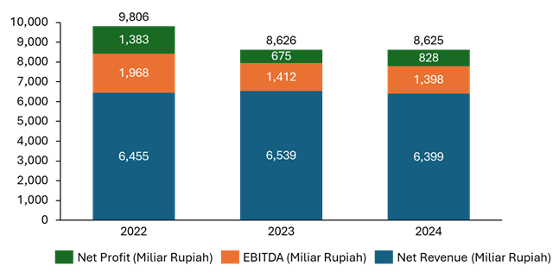
Figure 4. Net Profit, EBITDA & Net Profit Matahari 2022-2024

Between 2022 and 2024, Matahari exhibits a divergence between revenue stability and profitability dynamics. While net revenue remains relatively stable at approximately Rp 6.4 trillion, EBITDA declines substantially from Rp 1,968 billion to Rp 1,398 billion, indicating mounting cost pressures within the existing store network. Notably, net profit rebounds in 2024 despite the absence of revenue growth, suggesting that profitability improvements were driven primarily by cost-side efficiency rather than demand expansion.
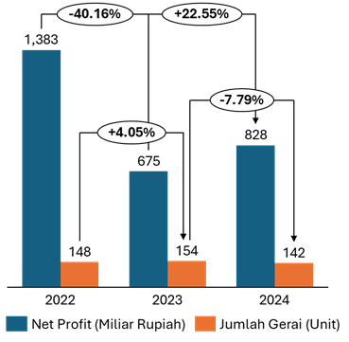
Figure 5. Net Profit Vs Store Number 2022-2024
To better understand the drivers of this profitability pattern, Figure 5 compares changes in net profit with variations in the number of operating stores. Between 2022 and 2023, Matahari expanded its store network from 148 to 154 units, yet net profit declined by 40.16% over the same period. As a result, net profit per store fell sharply, indicating that additional outlets did not generate proportional economic returns. This suggests that store expansion diluted overall profitability by increasing fixed operating costs without sufficient revenue contribution. In contrast, the reduction of 12 stores in 2024 coincided with a recovery in net profit, highlighting the financial consequences of adjusting the physical footprint.
When examined together, Figures 4 and 5 indicate that Matahari’s performance challenges were rooted in the efficiency of its physical retail network rather than sales generation. Stable revenue alongside declining profit per store implies that the economic output of retail space deteriorated during periods of network expansion. Conversely, profitability improvements following store closures suggest that remaining outlets operated more efficiently after excess capacity was removed. This pattern indicates that store rationalization improved space productivity at the portfolio level by concentrating activity in higher-performing locations. Accordingly, physical space management emerges as a critical lever for restoring profitability in the absence of revenue growth. The observed relationship between store count and profitability raises broader questions regarding cost rigidity and the strategic role of physical retail space. Because physical stores involve substantial fixed costs, including rent, labor, and utilities, misalignment between store footprint and market demand can quickly erode financial performance. The recovery of net profit following store closures suggests that Matahari was able to partially realign its cost structure with revenue levels. Subsequent analysis therefore examines how cost components and operational adjustments interacted with changes in the store network to support this recovery.

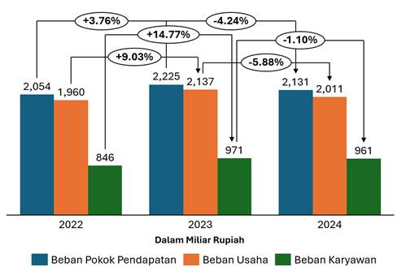
Figure 6. Matahari Operational Cost Structure 2022-2024
Further insight into the relationship between store footprint and profitability is provided by the structure of Matahari’s operational costs, as shown in Figure 3. Between 2022 and 2023, the expansion of the store network was accompanied by increases across all major cost components, including cost of goods sold, operating expenses, and employee expenses. The particularly sharp rise in employee expenses reflects the labor-intensive nature of physical retail operations, where additional stores directly translate into higher staffing costs. In contrast, the period from 2023 to 2024 shows a simultaneous decline in all cost components following the closure of 12 stores. This cost contraction indicates that store rationalization generated tangible efficiency gains by reducing fixed and semi-fixed operating costs. Taken together with earlier figures, the evidence suggests that improvements in net profit were driven by cost realignment achieved through downsizing the physical retail footprint rather than through revenue growth.
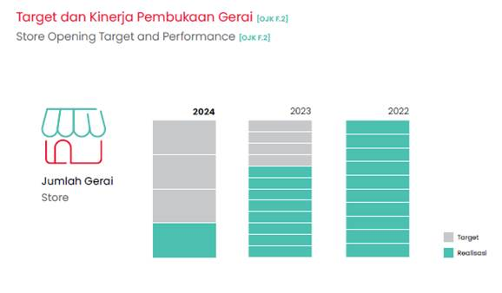
Figure 7. Target and Realization of Store Openings 2022-2024 (Matahari, 2024b)
Figure 7 illustrates the comparison between planned store opening targets and their realization from 2022 to 2024, revealing a shift in Matahari’s expansion strategy. In 2022, store opening targets were relatively aggressive and fully realized, reflecting a growth-oriented approach toward physical retail expansion. However, in 2023, the realization of new store openings declined alongside a deterioration in profitability, indicating a reassessment of the contribution of additional outlets to overall financial performance. By 2024, Matahari adjusted its store opening targets downward, and actual realizations were substantially lower than in previous years. This pattern suggests a deliberate move away from extensive physical expansion toward a more selective and cautious approach to managing the store network. When considered together with earlier evidence on profitability and cost efficiency, the figure indicates that Matahari’s strategic focus shifted from expanding physical presence to optimizing the performance of existing stores.
Comparison With Other Brands
The misalignment in category allocation that continues to challenge Matahari Department Store can be better understood by contextualizing it against category management practices observed among global apparel retailers such as H&M and UNIQLO. Prior studies and industry reports suggest that H&M adopts a trend-responsive category management approach, whereby specific product groups, particularly womenswear, are tactically prioritized as focal areas for adjustment in response to changing fashion trends and consumer preferences. This approach reflects an effort to continuously realign the category portfolio with evolving market demand, ensuring that physical store space is not disproportionately occupied by categories experiencing declining relevance or sales contribution. Through such responsiveness, category allocation functions as a mechanism for preserving space productivity in an environment characterized by rapid demand shifts.
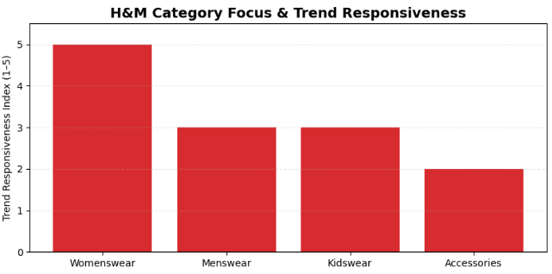
Figure 8. H&M Management Category Focus (H&M, 2024)
In contrast, UNIQLO is widely documented as emphasizing a core-product-oriented category strategy, focusing on items with relatively stable and long life-cycle demand, such as HEATTECH and AIRism. By concentrating space allocation on these core categories, UNIQLO is able to maintain sales consistency while reducing uncertainty associated with trend volatility. This approach supports more predictable inventory turnover and facilitates more efficient utilization of retail space. Taken together, these two practices illustrate that effective category management hinges on a retailer’s ability to translate customer demand signals into spatial allocation decisions, whether through heightened trend responsiveness or the strategic reinforcement of core product categories.
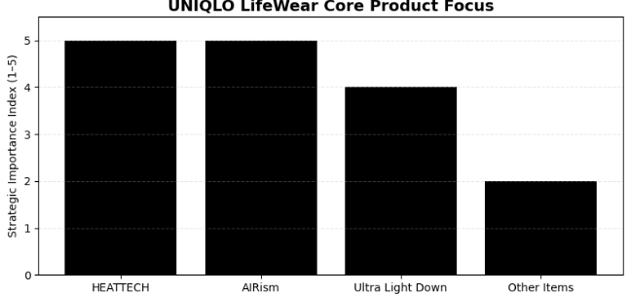
Gambar 2.2 Fokus Category Management UNIQLO (UNIQLO, 2025)
When viewed alongside these global practices, Matahari’s challenges appear less as isolated operational issues and more as symptoms of broader limitations in integrating sales performance data, supply chain coordination, and in-store space planning. Unlike international fast-fashion retailers that leverage real-time sales metrics such as sales per square meter and sales velocity to inform planogram and space allocation decisions, Matahari continues to face constraints in aligning its physical store layout with dynamic consumer behaviour. These limitations may contribute to persistently low space productivity and elevated operating costs within its physical store network, reinforcing the financial pressures and store rationalization outcomes observed in the preceding analysis.
Omnichannel Integration and the Reconfiguration of Physical Retail Space
In recent years, Matahari Department Store has operated in an increasingly complex retail environment shaped by rapid digitalization and shifts in consumer lifestyles. Advances in digital technology have altered how consumers search for products, interact with brands, and complete purchases, reducing reliance on purely in-store transactions and intensifying pressure on traditional department store formats. These changes have coincided with declining foot traffic in physical stores and heightened expectations for convenience, availability, and cross-channel consistency (Khalid, 2024). Within this context, the effectiveness of physical retail space is no longer determined solely by in-store sales performance, but by its integration within a broader omnichannel system. To address these challenges, Matahari initiated a comprehensive digital strategy aimed at strengthening omnichannel capabilities and reconfiguring its customer value proposition (Matahari, 2022b, 2022a). Key initiatives included the launch of its proprietary e-commerce platform, Matahari.com, the introduction of mobile point-of-sale (POS) systems to improve transaction efficiency, and the implementation of click-and-collect services that allow customers to order online and pick up products in-store (Matahari, 2024a, 2024b). These initiatives reflect an effort to reposition physical stores from purely transactional venues toward multifunctional nodes that support fulfillment, customer engagement, and service delivery across channels. Rather than competing directly with online channels, physical stores increasingly serve complementary roles within the omnichannel architecture.
Matahari further expanded its omnichannel integration by installing self-checkout kiosks and enhancing its loyalty program to operate seamlessly across online and offline channels. This integration enables customers to accumulate and redeem loyalty points regardless of purchase channel, facilitating data continuity and reinforcing brand engagement across touchpoints. From an operational perspective, these technologies reduce in-store waiting times and provide store employees with digital tools to support customer service and order tracking (Ananda et al., 2023; Matahari, 2023a, 2024a). Such changes indicate an organizational shift toward leveraging digital infrastructure to improve operational efficiency within existing physical space, rather than expanding the store network. In parallel, Matahari adopted a hybrid distribution approach by collaborating with major e-marketplace platforms such as Tokopedia. Through these partnerships, the company introduced selected products and stock-keeping units (SKUs) to online marketplaces and utilized tactical promotional mechanisms, including limited-time offers and flash sales (Matahari, 2023a, 2023b). This strategy allowed Matahari to increase exposure among digitally oriented consumers while preserving differentiation through curated assortments and experiential elements within physical stores. Importantly, this approach reduces pressure on physical stores to carry extensive inventories, thereby supporting more selective and efficient space allocation.
The integration of omnichannel initiatives also helps contextualize Matahari’s store rationalization strategy observed in earlier analysis. As digital channels increasingly absorb transactional demand, maintaining a large and uniform physical footprint becomes less critical for revenue generation. Omnichannel capabilities enable Matahari to sustain sales performance and customer engagement despite reductions in store count via a focus on efficiency and optimization, mitigating the risk that store closures lead to revenue decline (Matahari, 2025). In this sense, digital transformation functions not as a substitute for physical retail space, but as an enabler of space optimization, allowing the firm to align its physical presence more closely with productivity and cost efficiency considerations (Alexander & Cano, 2020; Hübner et al., 2022). Matahari’s omnichannel strategy illustrates an adaptive response to structural changes in retailing, in which physical stores are reconfigured to support integrated customer journeys rather than maximized in number. When viewed alongside evidence of store rationalization and cost adjustment, these initiatives suggest a broader process of asset reconfiguration aimed at restoring alignment between physical space, consumer behavior, and operational efficiency. This perspective reinforces the interpretation that Matahari’s strategic response reflects not merely retrenchment, but an ongoing effort to redefine the role of physical retail space within an omnichannel retail model.
Technology Adoption and Organizational Resilience as Strategic Response
In response to the structural challenges identified in the preceding analysis, Matahari has articulated a series of technology-driven and organizational initiatives aimed at optimizing the use of its remaining retail space. One such initiative is Project Sunrise, which represents a forward-looking effort to maximize the productivity of the store network through enhanced data integration and operational efficiency (Matahari, 2022b). Central to this initiative is the increasing use of artificial intelligence (AI) to support decision-making across store classification, inventory planning, and demand forecasting. Rather than expanding physical presence, the initiative reflects an emphasis on extracting greater value from existing assets through more precise alignment between store formats, local demand conditions, and merchandise composition. Under Project Sunrise, Matahari introduced differentiated store concepts designed to serve distinct consumer segments, suggesting a shift away from a standardized store model toward a more granular approach to space allocation (Matahari, 2022b). By analyzing demographic trends, purchasing behavior, and competitive intensity, data-driven tools are intended to inform where specific store concepts are deployed and how in-store space is configured. In parallel, AI-supported inventory management is reported to assist in forecasting demand fluctuations and adjusting replenishment cycles accordingly, with the aim of reducing both stockouts and excess inventory. These initiatives are consistent with the performance patterns observed earlier, where profitability improvements were achieved not through revenue expansion but through tighter cost control and more efficient utilization of physical retail space.
Alongside technology adoption, Matahari has pursued a set of strategic adjustments aimed at sustaining performance under conditions of heightened uncertainty. These include the selective expansion of private labels, the introduction of new brand concepts targeted at specific consumer segments, and the continued pruning of low-margin stores. Importantly, store closures have been framed not as isolated retrenchment measures but as part of a broader effort to improve EBITDA performance and rebalance the cost structure of the store network. Complementing these actions, the company reported substantial reductions in inventory levels between 2021 and 2023, reflecting improved purchasing discipline and seasonal planning (Matahari, 2024a, 2024b). More efficient inventory management contributes directly to lower holding costs and reduces the risk of markdowns, reinforcing the cost-side mechanisms underlying recent profitability recovery. Taken together, these initiatives suggest an emerging pattern of strategic resilience centered on flexibility and asset reconfiguration rather than scale expansion. Instead of pursuing growth through additional floor space, Matahari appears to be prioritizing adaptive capacity, adjusting store formats, merchandise mix, and inventory intensity in response to evolving consumer behavior and market volatility. While the effectiveness of these initiatives cannot be fully assessed within the scope of the present analysis, they align closely with the structural challenges identified in the firm’s recent performance and provide insight into how management is attempting to reconcile omnichannel integration, cost efficiency, and physical space optimization. As such, they reinforce the interpretation that Matahari’s strategic response reflects an ongoing transition toward a more selective, data-informed, and resilient retail model.
- Discussions
Store Rationalization as a Dynamic Capability
The findings of this study suggest that store rationalization at PT Matahari Department Store Tbk should be understood not as a reactive response to decline, but as a manifestation of dynamic capabilities exercised under sustained omnichannel pressure. Rather than signaling organizational failure, the deliberate reduction and reconfiguration of Matahari’s physical store network reflects a purposeful process of sensing, seizing, and transforming resources in response to environmental turbulence. This interpretation extends Dynamic Capabilities Theory by illustrating how physical retail assets, traditionally viewed as rigid and path-dependent, can be actively reconfigured to restore strategic alignment and economic performance. From a sensing perspective, Matahari appears to have identified a misalignment between its expanded physical footprint and the evolving demand environment. The empirical results show that periods of store expansion between 2022 and 2023 coincided with declining net profit and reduced profit per store, despite relatively stable revenues. This pattern indicates managerial recognition that additional stores were not generating proportional economic returns and that space productivity was deteriorating at the portfolio level. Such recognition aligns with the sensing function of dynamic capabilities, whereby firms detect changes in demand patterns, cost structures, and performance signals that threaten long-term competitiveness. In this case, declining profitability per store functioned as an early warning signal that the existing store network had become misaligned with omnichannel-driven demand fragmentation.
The subsequent reduction of store count in 2024 reflects the seizing dimension of dynamic capabilities, in which firms commit resources to strategic courses of action aimed at capturing value under new conditions. Matahari’s decision to close underperforming outlets and revise store opening targets represents a strategic choice to prioritize efficiency over scale. Importantly, the observed recovery in net profit following store closures suggests that these decisions were not merely cost-cutting exercises, but value-enhancing interventions that improved the economic efficiency of the remaining store network. By concentrating operations in higher-performing locations and shedding excess capacity, Matahari effectively reallocated resources toward configurations better suited to prevailing market conditions. This supports the view that store rationalization can function as a proactive strategic lever rather than a symptom of organizational distress. The transforming dimension of dynamic capabilities is evident in how store rationalization was accompanied by broader reconfiguration of Matahari’s physical and digital assets. The reduction in store count coincided with adjustments in cost structures, inventory intensity, and omnichannel integration initiatives, indicating that closures were embedded within a wider transformation process rather than isolated decisions. Physical stores were repositioned from purely transactional spaces toward multifunctional nodes supporting fulfillment, customer engagement, and omnichannel service delivery. This transformation underscores that dynamic capabilities operate not through isolated actions, but through coordinated reconfiguration of asset portfolios and organizational routines over time. Store rationalization, in this sense, reflects the transformation of the store network from a scale-driven growth model toward a productivity-oriented configuration aligned with omnichannel realities.
Space Productivity as a Strategic Performance Mechanism
The findings further indicate that space productivity functions as a critical strategic performance mechanism linking store rationalization to financial outcomes in omnichannel retail environments. Rather than treating physical store space as a fixed or passive input, the Matahari case demonstrates that the economic contribution of retail space depends on how effectively it is aligned with demand and cost structures. Improvements in profitability observed following store closures were not driven by revenue growth, but by enhanced efficiency in the utilization of remaining physical space, underscoring the central role of space productivity in restoring firm performance under conditions of demand fragmentation. Empirically, the divergence between stable revenues and declining profitability during periods of store expansion highlights the limitations of scale-based growth strategies in omnichannel contexts. The decline in net profit per store observed between 2022 and 2023 suggests that additional physical space diluted overall performance by increasing fixed operating costs without generating commensurate economic returns. This pattern reinforces the argument that store count alone is an insufficient indicator of competitive strength. Instead, the productivity of spaceemerges as a more informative metric for evaluating strategic effectiveness. In this sense, space productivity reframes performance assessment away from footprint expansion toward efficiency and economic contribution per unit of space.
From a strategic perspective, space productivity operates as the mechanism through which dynamic reconfiguration of physical assets translates into improved financial performance. Store rationalization reduces excess capacity and concentrates operations in locations better aligned with prevailing demand conditions, allowing fixed costs such as rent, labor, and utilities to be leveraged more effectively. The observed contraction in operating and employee expenses following store closures indicates that productivity gains were achieved by realigning cost structures rather than by extracting additional revenue from consumers. This cost-side mechanism is particularly salient in apparel retailing, where margins are thin and physical stores remain highly labor- and space-intensive. As such, improvements in space productivity magnify their impact on profitability by mitigating the adverse effects of cost rigidity under volatile demand conditions. Conceptualizing space productivity as a strategic mechanism also extends existing omnichannel and retail performance literature. Prior studies have often treated productivity metrics, such as sales per square meter or profit per store, as operational indicators rather than as central elements of strategic adaptation. The Matahari case suggests that these metrics serve a more fundamental role by guiding managerial decisions about asset reconfiguration, including which stores to retain, resize, or exit. In this respect, space productivity functions as both a diagnostic and evaluative tool within the dynamic capabilities framework: declining productivity signals misalignment between assets and market conditions, while subsequent improvements indicate successful realignment through strategic intervention. This interpretation elevates space productivity from a descriptive performance measure to an active component of strategic decision-making.
Implications for Dynamic Capability and Retailing in Emerging Markets
Conceptualizing store rationalization as a dynamic capability challenges dominant narratives in the retail literature that frame store closures primarily as indicators of decline, particularly within “retail apocalypse” discourses rooted in Western contexts. The Matahari case demonstrates that contraction can be strategically generative when guided by productivity metrics and embedded within a coherent omnichannel strategy. In emerging markets, where institutional conditions, consumer behavior, and digital adoption trajectories differ from those in developed economies, incumbent retailers may rely more heavily on adaptive reconfiguration of physical assets to sustain profitability. This study therefore extends existing theory by showing that dynamic capabilities in retail are not limited to digital integration or channel coordination, but also encompass the deliberate pruning and restructuring of physical networks to restore alignment between space, demand, and cost structures. This study contributes to retail and omnichannel strategy literature by reframing store rationalization and space productivity as integral components of dynamic capabilities rather than as indicators of organizational decline. First, the findings extend Dynamic Capabilities Theory by demonstrating that physical retail space, despite its rigidity and location specificity, can be purposefully reconfigured as part of an adaptive capability set. Existing applications of DCT in retailing have predominantly emphasized digital integration, data analytics, and channel coordination. By contrast, this study highlights that dynamic capabilities also encompass the deliberate pruning and restructuring of physical asset portfolios, suggesting that transformation in omnichannel environments involves both digital and spatial dimensions of resource reconfiguration.
Second, this research advances understanding of store rationalization by challenging dominant “retail apocalypse” narratives that frame store closures primarily as reactive responses to firm failure. The Matahari case illustrates that contraction can represent a proactive, value-enhancing strategy when guided by productivity considerations and embedded within a broader omnichannel transition. By conceptualizing store rationalization as an adaptive response to demand fragmentation and cost rigidity, this study contributes a more nuanced theoretical interpretation of store closures that moves beyond decline-oriented explanations. This perspective is particularly relevant for emerging market contexts, where institutional conditions and consumer behaviour differ from those typically examined in Western retail studies. Third, the study elevates space productivity from a descriptive performance metric to a central strategic mechanism within retail adaptation. While prior research has treated measures such as sales density or profit per store as operational indicators, the findings suggest that space productivity plays a critical role in linking asset reconfiguration to financial outcomes. By demonstrating how productivity improvements mediate the relationship between store rationalization and profitability, this study positions space productivity as an analytically important construct for future research on retail transformation. This insight encourages scholars to more explicitly integrate productivity-based mechanisms into theories of retail strategy and omnichannel adaptation.
For retail managers, the findings underscore the importance of reframing store closures and footprint reductions as strategic tools rather than as last-resort cost-cutting measures. The Matahari case demonstrates that expanding physical presence without sufficient attention to space productivity can dilute profitability, even when revenues remain stable. Managers should therefore evaluate store networks as portfolios of heterogeneous assets, where the performance contribution of each location is assessed relative to its cost structure and strategic role within the omnichannel system. The results also highlight the need for productivity-oriented performance metrics to guide store network decisions. Rather than focusing primarily on store count, sales growth, or market coverage, managers should prioritize indicators that capture the economic efficiency of physical space, such as profit per store or cost-adjusted productivity measures. These metrics can serve as early warning signals of misalignment between physical assets and demand conditions, enabling more timely and targeted interventions. Importantly, productivity-based evaluation supports selective pruning and resizing strategies that concentrate resources in higher-performing locations, rather than uniform expansion or contraction.
In omnichannel environments, the study suggests that physical stores should be managed as multifunctional nodes rather than purely transactional outlets. As digital channels absorb a growing share of transactional demand, the strategic value of physical space increasingly lies in its ability to support fulfillment, customer engagement, and integrated service delivery. Managers should therefore align store format, size, and layout decisions with these evolving roles, ensuring that physical space complements rather than competes with digital channels. Store rationalization can facilitate this alignment by reducing excess capacity and freeing resources for investments in technology, data integration, and service capabilities within remaining outlets. Finally, for managers operating in emerging markets, the findings highlight the importance of balancing growth ambitions with financial resilience. In contexts characterized by demand volatility and cost sensitivity, maintaining oversized physical networks can undermine profitability and organizational flexibility. A strategic emphasis on space productivity allows firms to adapt more effectively to shifting consumer behavior while preserving the strategic relevance of physical presence. By treating store rationalization as part of an ongoing adaptation process rather than as a one-time retrenchment, managers can strengthen the firm’s capacity to navigate prolonged periods of uncertainty and digital disruptions
- Conclusions
This study examined how an incumbent department store retailer in an emerging market reconfigures its physical store network to sustain profitability under omnichannel pressure. Using a longitudinal case analysis of PT Matahari Department Store Tbk between 2019 and 2024, the research explored the relationships among store rationalization, space productivity, and financial performance in the context of sustained digital disruption and shifting consumer behavior. The findings provide evidence that physical store contraction, when guided by productivity considerations and embedded within an omnichannel strategy, can function as a proactive and value-enhancing strategic response rather than as a signal of organizational decline. The analysis shows that periods of physical store expansion were associated with declining profitability despite relatively stable revenues, indicating that increases in store count diluted economic performance through heightened fixed operating costs. In contrast, subsequent store closures coincided with improvements in net profit and reductions in operating expenses, suggesting that rationalization improved the efficiency with which physical retail space was utilized. These patterns highlight that the economic challenge faced by Matahari was not insufficient demand generation, but misalignment between the scale of its physical network and prevailing demand conditions in an omnichannel environment. By concentrating operations in higher-performing locations and shedding excess capacity, the firm was able to restore profitability without relying on revenue growth.
Interpreted through the lens of Dynamic Capabilities Theory, the findings suggest that store rationalization represents a deliberate process of asset reconfiguration involving sensing deteriorating space productivity, seizing opportunities to realign the store network, and transforming the role of physical space within an integrated omnichannel system. Rather than treating physical stores as static cost centers, Matahari’s strategic response illustrates how incumbent retailers can actively reshape their physical asset base to maintain competitiveness under conditions of demand volatility and digital competition. This perspective extends existing omnichannel and retail strategy literature by demonstrating that dynamic capabilities encompass not only digital integration but also the purposeful pruning and restructuring of physical retail networks. By foregrounding space productivity as a strategic performance mechanism, this study contributes a more nuanced understanding of how asset reconfiguration translates into financial outcomes. The findings suggest that productivity-based metrics provide a critical basis for evaluating the strategic contribution of physical space and for guiding store network decisions in omnichannel contexts. In emerging markets, where cost sensitivity and uneven digital adoption intensify the risks associated with oversized physical footprints, an emphasis on space productivity offers a viable pathway for sustaining financial resilience while preserving the strategic relevance of physical presence.
This study is subject to several limitations that also point to avenues for future research. First, the analysis is based on a single longitudinal case study of one incumbent department store retailer in Indonesia, which limits the ability to generalize findings statistically across firms or markets. While the case enables in-depth examination of store rationalization and space productivity over time, future studies could employ multi-case or cross-country designs to compare how retailers in different institutional and competitive environments reconfigure physical store networks under omnichannel pressure. Second, the study relies exclusively on secondary archival data, which constrains the analysis to firm-level indicators and precludes examination of store-level heterogeneity, managerial decision-making processes, or customer responses to store closures. Future research could integrate primary data, such as interviews or internal performance metrics, to explore micro-level mechanisms underlying space productivity and rationalization decisions. Finally, although financial proxies were used to capture space productivity due to data availability constraints, future studies could incorporate more granular spatial measures, such as sales per square meter or footfall analytics, to refine understanding of how physical space utilization translates into performance outcomes. Addressing these limitations would deepen theoretical insight into the dynamic capabilities underpinning retail adaptation and extend the applicability of the findings across diverse retail formats and market contexts.
References
Akbariani, N. V., & Setiyowati, H. (2024). Digital Meets Distribution: Quantifying the Impact of Logistics Integration in Emerging Market Omnichannel Retail. Data : Journal of Information Systems and Management, 2(4), 253–263. https://doi.org/10.61978/data.v2i4.920
Alexander, B., & Cano, M. B. (2020). Store of the future: Towards a (re)invention and (re)imagination of physical store space in an omnichannel context. Journal of Retailing and Consumer Services, 55, 101913. https://doi.org/10.1016/j.jretconser.2019.101913
Alexander, B., & Varley, R. (2025). Retail futures: Customer experience, phygital retailing, and the Experiential Retail Territories perspective. Journal of Retailing and Consumer Services, 82, 104108. https://doi.org/10.1016/j.jretconser.2024.104108
Al-Moaid, N. A. A., & Almarhdi, S. G. (2024). Developing dynamic capabilities for successful digital transformation projects: The mediating role of change management. Journal of Innovation and Entrepreneurship, 13(1), 85. https://doi.org/10.1186/s13731-024-00446-9
Alrub, Y. A., & Sánchez-Cañizares, S. M. (2025). Dynamic Capabilities and Digital Transformation: Toward Strategic Planning in the Digital Age—Evidence from Palestine. Administrative Sciences, 15(1), 21. https://doi.org/10.3390/admsci15010021
Ananda, A. S., Hanny, H., Hernández-García, Á., & Prasetya, P. (2023). ‘Stimuli Are All Around’—The Influence of Offline and Online Servicescapes in Customer Satisfaction and Repurchase Intention. Journal of Theoretical and Applied Electronic Commerce Research, 18(1), 524–547. https://doi.org/10.3390/jtaer18010027
Anning-Dorson, T. (2021). Organizational culture and leadership as antecedents to organizational flexibility: Implications for SME competitiveness. Journal of Entrepreneurship in Emerging Economies, 13(5), 1309–1325. https://doi.org/10.1108/JEEE-08-2020-0288
Balchandani, A., Phillips, S., Hancock, B., & Wachinger, T. (2020). Rebooting Retail How technology will shape the future of retail (p. 23) [Report]. McKinsey & Company. https://www.mckinsey.com/industries/retail/our-insights/rebooting-retail-how-technology-will-shape-the-future-of-retail
Bonfrer, A., Chintagunta, P., & Dhar, S. (2022). Retail store formats, competition and shopper behavior: A Systematic review. Journal of Retailing, 98(1), 71–91. https://doi.org/10.1016/j.jretai.2022.02.006
Cai, Y.-J., & Lo, C. K. Y. (2020). Omni-channel management in the new retailing era: A systematic review and future research agenda. International Journal of Production Economics, 229, 107729. https://doi.org/10.1016/j.ijpe.2020.107729
Čirjevskis, A. (2022). Exploring Coupled Open Innovation for Digital Servitization in Grocery Retail: From Digital Dynamic Capabilities Perspective. Journal of Risk and Financial Management, 15(9), 411. https://doi.org/10.3390/jrfm15090411
De Carvalho, G. J., Machado, M. C., & Correa, V. S. (2024). Omnichannel and consumer and retailer perceived risks and benefits: A review. International Journal of Retail & Distribution Management, 52(3), 295–311. https://doi.org/10.1108/IJRDM-03-2023-0180
Eriksson, V., Dubois, A., & Hulthén, K. (2022). Transport in supply networks. The International Journal of Logistics Management, 33(5), 85–106. https://doi.org/10.1108/IJLM-06-2021-0350
Fay, S., Feng, C., & Patel, P. C. (2022). Staying small, staying strong? Retail store underexpansion and retailer profitability. Journal of Business Research, 144, 663–678. https://doi.org/10.1016/j.jbusres.2022.02.022
Febriani, A., Sopha, B. M., & Arif Wibisono, M. (2025). Dynamic capabilities for omnichannel transformation in MSMEs: A comparative case study of fashion and furniture sectors. Journal of Open Innovation: Technology, Market, and Complexity, 11(1), 100498. https://doi.org/10.1016/j.joitmc.2025.100498
Ghantous, N., Chaney, D., Chameroy, F., Jeanpert, S., & Schultz, M. (2025). Omnichannel Reconfiguration Capabilities in Franchising: A Meso‐Foundations Analysis. Managerial and Decision Economics, 46(4), 2431–2447. https://doi.org/10.1002/mde.4474
Hänninen, M., Kwan, S. K., & Mitronen, L. (2021). From the store to omnichannel retail: Looking back over three decades of research. The International Review of Retail, Distribution and Consumer Research, 31(1), 1–35. https://doi.org/10.1080/09593969.2020.1833961
Hartono, A., Avenzora, A., Sari, O. A., Putri, H. A. I., & Supriyanto, S. (2024). Pengeluaran untuk Konsumsi Penduduk Indonesia, Maret 2024 (Report No. 3201004; Pengeluaran Untuk Konsumsi Penduduk Indonesia 28, p. 117). Badan Pusat Statistik. https://www.bps.go.id/id/publication/2024/10/18/b392b2e96c87c090a6f8d9c2/pengeluaran-untuk-konsumsi-penduduk-indonesia--maret-2024.html
H&M. (2024). H&M Group 2024 Annual Sustainability Report (Sustainability Report No. 2024; p. 87). H&M Group. https://hmgroup.com/wp-content/uploads/2025/03/HM-Group-Annual-and-sustainability-report-2024.pdf
Hübner, A., Hense, J., & Dethlefs, C. (2022). The revival of retail stores via omnichannel operations: A literature review and research framework. European Journal of Operational Research, 302(3), 799–818. https://doi.org/10.1016/j.ejor.2021.12.021
Ismartini, P., Marhaeni, H., Andi Setiawan, Pravitasari, C., Sutarsih, T., & Sudaryani, S. (2025). E-Commerce Statistics 2024 (Report No. 8101004; E-Commerce Statistics 7, p. 112). Badan Pusat Statistik. https://www.bps.go.id/en/publication/2025/11/28/647323224ecc656c2933571b/statistik-e-commerce-2024.html
Kappani, C. L. (2025). How Brick-and-Mortar Infrastructure Is Giving Walmart a Competitive Edge Over Amazon. Journal of Information Systems Engineering and Management, 10(63s), 1118–1127. https://doi.org/10.52783/jisem.v10i63s.13988
Khalid, B. (2024). Evaluating customer perspectives on omnichannel shopping satisfaction in the fashion retail sector. Heliyon, 10(16), e36027. https://doi.org/10.1016/j.heliyon.2024.e36027
Kim, J., Miller, K., Myers Iii, C., Price, J., Robic, A., & Rudd, J. (2025). Sales versus margins: Alternative measures of output and productivity for retail trade. Monthly Labor Review. https://doi.org/10.21916/mlr.2025.5
Kupfer, A.-K., Marchand, A., & Hennig-Thurau, T. (2024). Explaining physical retail store closures in digital times. Journal of Retailing, 100(4), 512–531. https://doi.org/10.1016/j.jretai.2024.07.001
Lisnawati, L., Hurriyati, R., Disman, & Gaffar, V. (2024). Omnichannel Technology: IT Innovation in Indonesia Retail Industry. In Ratih Hurriyati, L. A. Wibowo, A. G. Abdullah, Sulastri, Lisnawati, & Y. Murtadlo (Eds.), Proceedings of the 7th Global Conference on Business, Management, and Entrepreneurship (GCBME 2022) (Vol. 255, pp. 406–420). Atlantis Press International BV. https://doi.org/10.2991/978-94-6463-234-7_40
Liu, K., Guhathakurta, S., Han, C., Hittinger, E., Phoung, S., & Williams, E. (2025). The Impact of Online Shopping on Retail Building Space and Energy Demand in the U.S. Energies, 18(23), 6178. https://doi.org/10.3390/en18236178
Luo, X., Che Rose, R. A., & Awang, A. (2025). The evolution of retail outlet distribution: A systematic review of spatial patterns, drivers, and implications for urban development and economic growth. Frontiers in Sustainable Cities, 7, 1628137. https://doi.org/10.3389/frsc.2025.1628137
Ma, B., Mao, B., Liu, S., Meng, F., & Liu, J. (2024). Managing physical inventory and return policies for omnichannel retailing. Computers & Industrial Engineering, 190, 109986. https://doi.org/10.1016/j.cie.2024.109986
Matahari. (2022a). Sambut Matahari Baru Laporan Keberlanjutan 2022 (Sustainability Report No. 2022; p. 134). PT Matahari Department Store Tbk. https://cdn.shopify.com/s/files/1/0666/9212/0727/files/SR_2022_LPPF_compressed.pdf?v=1738221063
Matahari. (2022b). Sambut Matahari Baru Laporan Tahunan 2022 (Annual Report No. 2022; p. 296). PT Matahari Department Store Tbk. https://cdn.shopify.com/s/files/1/0666/9212/0727/files/ar-2022_1_compressed.pdf?v=1738221055
Matahari. (2023a). Embracing the Changes, Moving Forward PT Matahari Department Store Tbk Laporan Tahunan 2023 (Annual Report No. 2023; p. 313). PT Matahari Department Store Tbk. https://cdn.shopify.com/s/files/1/0666/9212/0727/files/080324_AR_MDS2023.pdf?v=1742975913
Matahari. (2023b). Stronger Steps Towards a Sustainable Future PT Matahari Department Store Tbk Laporan Keberlanjutan 2023 (Sustainability Report No. 2023; p. 102). PT Matahari Department Store Tbk. https://cdn.shopify.com/s/files/1/0666/9212/0727/files/SR_MDS2023_bilingual.pdf?v=1742975912
Matahari. (2024a). On The Runway PT Matahari Department Store Tbk Laporan Tahunan 2024 (Annual Report No. 2024; p. 312). PT Matahari Department Store Tbk. https://cdn.shopify.com/s/files/1/0666/9212/0727/files/MDS_2024_AR_19032025.pdf?v=1743144929
Matahari. (2024b). PT Matahari Department Store Tbk Laporan Keberlanjutan (Sustainability Report No. 2024; p. 62). PT Matahari Department Store Tbk. https://cdn.shopify.com/s/files/1/0666/9212/0727/files/MDS_2024_SR_19032025_1.pdf?v=1743144928
Matahari. (2025). Paparan Publik (Public Expose) PT Matahari Department Store Tbk [Public Expose]. PT Matahari Department Store Tbk. https://www.idx.co.id/StaticData/NewsAndAnnouncement/ANNOUNCEMENTSTOCK/From_EREP/202503/7662ed2c62_a2d0f809e7.pdf
Mou, Y., Guan, Z., & Zhang, J. (2024). Integrated optimization of assortment, inventory and pricing considering omnichannel retailer’s risk aversion and customer’s time preference. Expert Systems with Applications, 237, 121479. https://doi.org/10.1016/j.eswa.2023.121479
Popescu, C., Gabor, M. R., & Stancu, A. (2025). E-Commerce Revolution: How the Pandemic Reshaped the US Consumer Shopping Habits: A PACF and ARIMA Approach. Systems, 13(9), 802. https://doi.org/10.3390/systems13090802
Roh, T., & Xiao, S. (2024). Extending the research agenda for supply chain management in the age of disruption: The multifaceted role and implications of dynamic capabilities. Journal of General Management, 50(1), 5–15. https://doi.org/10.1177/03063070241272373
Salvietti, G., Ziliani, C., Teller, C., Ieva, M., & Ranfagni, S. (2022). Omnichannel retailing and post-pandemic recovery: Building a research agenda. International Journal of Retail & Distribution Management, 50(8/9), 1156–1181. https://doi.org/10.1108/IJRDM-10-2021-0485
Sayyida, S., Hartini, S., Gunawan, S., & Husin, S. N. (2021). The Impact of the Covid-19 Pandemic on Retail Consumer Behavior. Aptisi Transactions on Management (ATM), 5(1), 79–88. https://doi.org/10.33050/atm.v5i1.1497
Senachai, P., & Julagasigorn, P. (2024). Retail mix instruments influencing customer perceived value and customer engagement: A conceptual framework and research agenda. Humanities and Social Sciences Communications, 11(1), 145. https://doi.org/10.1057/s41599-024-02660-y
Solem, B. A. A., Fredriksen, J. I., & Sørebø, Ø. (2023). Dynamic capabilities in the realisation of omnichannel retailing. International Journal of Retail & Distribution Management, 51(1), 21–38. https://doi.org/10.1108/IJRDM-12-2021-0599
Staskiewicz, A. M., Hvam, L., & Haug, A. (2021). The Role of SKU Management in SKU Rationalisation Projects. 2021 IEEE International Conference on Industrial Engineering and Engineering Management (IEEM), 259–263. https://doi.org/10.1109/IEEM50564.2021.9672940
Thaichon, P., Quach, S., Barari, M., & Nguyen, M. (2024). Exploring the Role of Omnichannel Retailing Technologies: Future Research Directions. Australasian Marketing Journal, 32(2), 162–177. https://doi.org/10.1177/14413582231167664
UNIQLO. (2025). UNIQLO Integrated Report 2024 LifeWear, Changing the World (p. 46). Fast Retailing. https://www.fastretailing.com/eng/ir/library/pdf/ar2024_en_sp.pdf
Vadruccio, R., Pantano, E., & Tumino, A. (2024). Space jam: How retail technologies are influencing store space production. International Journal of Retail & Distribution Management, 52(10/11), 1092–1107. https://doi.org/10.1108/IJRDM-12-2023-0709
World Bank. (2025). Indonesia Economic Prospects: People-First Housing—A Roadmap from Homes to Jobs to Prosperity in Indonesia (English). (Report No. 202459). World Bank Group. https://documents.worldbank.org/en/publication/documents-reports/documentdetail/099062225104041830
Zhang, E., Wang, G., & Zhou, Y. (2025). Spatial-temporal distribution characteristics and influencing factors of new retail stores: A case study of Freshippo stores in Shanghai. Humanities and Social Sciences Communications, 12(1), 1541. https://doi.org/10.1057/s41599-025-05851-3
Zhao, Z., Chen, G., Duan, J., & Xu, Y. (2025). Site Selection Analysis and Prediction of New Retail Stores from an Urban Commercial Space Perspective: A Case Study of Luckin Coffee and Starbucks in Shanghai. ISPRS International Journal of Geo-Information, 14(6), 217. https://doi.org/10.3390/ijgi14060217
Zidane, C., Mahyudin, F. B., Zahra, F. S., & Nurdini, A. (2025). Evaluation of Property Productivity in Creative Space Development: A Case Study of The Hallway Space in Kosambi Market, Bandung. Journal of Social Research, 4(9), 2760–2778. https://doi.org/10.55324/josr.v4i9.2803

