Assessment of Fire Service Coverage and Optimal Siting of New Fire Stations in Ibadan North Local Government Area, Oyo State, Nigeria.

¹Adeleke O.A, ²Amos Ibrahim S., ³Idris I.A ⁴Micheal A.I, ⁵Oche J.O, ⁶Adewoyin J.E, ⁷Adeyinka B. G, ⁸Ashiru S.K, ⁹Ademu Ali
¹²³⁴⁵⁶⁷⁸⁹ National Space Research and Development Agency, Cooperative Information Network, Obafemi Awolowo University, Ile- Ife, S/W Nigeria.
¹²³⁴⁵⁶⁷⁸⁹ oluwa.adeleke@gmail.com, samosibrahim@yahoo.com, adeshenaidris@gmail.com, st.michael002@gmail.com, ocjohnsta@gmail.com, adewoyin7@gmail.com, bensongrace242@gmail.com,ksahiru@gmail.com,maikudiim

Abstract
Rapid urbanization in many developing cities has placed increasing pressure on emergency response infrastructure, particularly fire-service systems, where spatial accessibility is crucial for minimizing response time and mitigating fire-related risks. This study evaluates the spatial adequacy of fire-station coverage in Ibadan North Local Government Area (LGA), Nigeria. It identifies optimal locations for additional facilities using Geographic Information System (GIS)–based spatial analysis. High-resolution satellite imagery, road-network data, and population statistics were integrated within an ArcGIS environment to conduct service-area modelling, route optimization, origin–destination cost matrix analysis, and location–allocation modelling. The road network was digitized, and classified by road hierarchy and travel speed to simulate realistic emergency vehicle movement. Results indicate that only seven operational fire stations serve the wider Ibadan metropolis, with just one located within the study area. Relative to the recommended benchmark of one station per 50,000 residents, the current configuration is inadequate for a population exceeding 300,000. Accessibility modelling shows that incidents within approximately 1.4 km of a station can be reached within 2.1 minutes under ideal conditions and 2.8 minutes under constrained scenarios; however, service-area analysis using 4-minutes, 5-minutes, and 8-minutes thresholds reveals fragmented coverage, leaving several densely populated areas beyond acceptable response limits. Location–allocation modelling identified optimal sites for additional stations, and simulated deployment significantly improved spatial equity and response coverage. These findings demonstrate the critical role of GIS-driven spatial optimization in strengthening emergency planning and highlight the urgent need for strategic fire-service expansion to enhance urban resilience in rapidly growing cities.
Keywords—geospatial; analysis; urban; emergency; assessment.; Fire Service

- INTRODUCTION
Urban emergency management systems are most effective when they operate within coordinated frameworks that enable timely decision-making, efficient communication, and rapid response to incidents (Lindell et al., 1992). Modern research emphasizes that emergency response is inherently complex, requiring the integration of data-driven planning, resource allocation models, and multi-agency coordination to manage uncertainty and reduce disaster impacts (Mukhopadhyay et al., 2020); (Costa et al., 2022). As urban populations continue to grow, particularly in developing regions, the increasing density and spatial complexity of cities place additional pressure on emergency infrastructure and response systems.
Fire service delivery represents a critical component of urban safety, as it directly influences the protection of lives, property, and the environment. The effectiveness of fire response systems is strongly influence by spatial factors including the distribution of fire response stations, road network, and proximity to high-risk areas as these determine response time and service coverage (Wang et al., 2021). Recent advancements in Geographic Information Systems (GIS), remote sensing, and spatial optimization models have significantly improved the ability to evaluate emergency service coverage and identify optimal locations for facilities (Chen et al., 2018); (Jiang et al., 2022). These tools enable planners to assess travel time, service coverage, and population demand, thereby supporting more efficient and equitable infrastructure planning.
Accessibility is a fundamental determinant of emergency response effectiveness. Studies show that spatial relationships between infrastructure—such as fire hydrants, road networks, and buildings—play a crucial role in determining response efficiency and operational success (Baik & Murray, 2024). Delays in response time are strongly associated with increased fire damage and loss, making the optimal siting of fire stations both a technical and equity concern in urban planning.
In rapidly urbanizing cities, unplanned growth, informal settlements, and inadequate infrastructure often exacerbate vulnerability to fire hazards (Adelekan I. O. 2020). High population density and poorly regulated land-use patterns contribute to increased fire risk and reduced accessibility for emergency services. Spatial analyses of fire incidents consistently demonstrate that densely built-up areas tend to exhibit higher fire occurrence and greater vulnerability, highlighting the importance of integrating land-use planning with emergency service provision (Singh et al., 2021).
Despite the growing adoption of geospatial technologies in developed regions, their application in many African cities remains limited. This gap constrains the ability of urban planners and policymakers to make informed decisions regarding emergency infrastructure deployment. Given the rapid pace of urban expansion and the associated risks, there is a pressing need to apply spatial optimization techniques to improve emergency service delivery in these contexts.
Ibadan North Local Government Area exemplifies these challenges. As a densely populated and economically significant area in Oyo State, it has experienced continuous residential, commercial, and institutional growth without a proportional expansion of emergency response infrastructure. This imbalance raises concerns regarding service coverage, accessibility, and response efficiency (Adewoyin W. A, 2025).
Therefore, this integrates spatial optimization with urban risk assessment, to provides empirical solution to improve emergency infrastructure planning and contributes to the enhancement of urban resilience in rapidly growing cities.

II. AIM AND OBJECTIVES OF THE STUDY
Aim
The study aims to assess the spatial distribution of emergency fire stations in Ibadan North Local Government Area of Oyo State, Nigeria.
Objectives
The specific objectives are to:
- assess the existing fire service coverage
- identify underserved high-risk areas, and
- determine optimal locations for additional stations

III. STUDY AREA

Ibadan North Local Government Area represents a central urban administrative entity within the Ibadan metropolis, located in southwestern Nigeria Figure 1. It is one of the eleven local government areas that comprise metropolitan Ibadan in Oyo State, functioning as a significant hub for education, commerce, and urban services. It is situated within the forest–savanna transition zone, approximately between 7.42°–7.44° N latitude and 3.89°–3.93° E longitude, encompassing an estimated area of 27–28 km², and shares boundaries with Ibadan North West, Ibadan North East, Akinyele, and Ido Local Government Areas. The terrain is predominantly characterized by gently undulating topography, with elevations ranging from approximately 180 to 260 meters above sea level, underlain by Precambrian Basement Complex rocks and ferruginous tropical soils. The climate is classified as tropical wet-and-dry, with an average annual rainfall of approximately 1,200–1,400 mm and mean temperatures ranging from 26 to 28 °C. Ibadan North is a densely developed, mixed land-use area, comprising high- and medium-density residential neighborhoods, institutional land uses dominated by the University of Ibadan and The Polytechnic, Ibadan, as well as major healthcare facilities such as the University College Hospital (UCH) and commercial corridors along the Mokola–Sango–Ojoo axis. The area has an estimated population exceeding 300,000, with significant temporal fluctuations driven by student and commuter populations. Its complex urban morphology, high population density, and concentration of critical infrastructure justified its selection for this study.
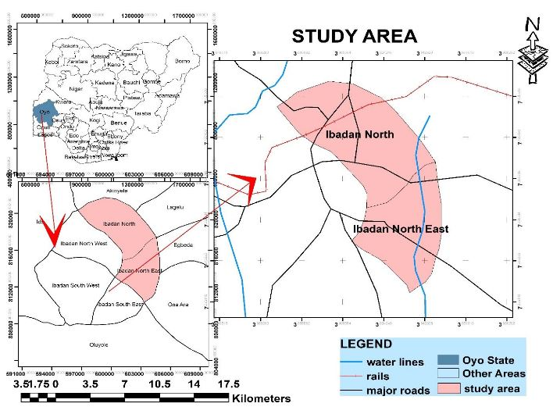
Fig. 1. Study Area Map

IV. METHODOLOGY
A. Method
GIS-based network analysis (NA) and multi-criteria spatial evaluation were used for this study’s analysis. Figure 2 shows a summarized geographic information system (GIS) workflow diagram used in this study to achieve the set objectives.
B. Data Sources
Both primary and secondary datasets were utilized:
1. Primary Data
Geographic coordinates of existing fire stations were acquired using handheld GPS receivers.
2. Secondary Data
This included the following:
i. Geo-Eye satellite imagery (0.6 m panchromatic; 2.4 m multispectral)
ii. Administrative boundaries
iii. Population data
iv. Topographic maps (1:50,000)
C. Software Applications
The study employed the following Application software packages to achieve the set objectives.
i. ArcMap 10.1
ii. CorelDRAW
iii. QGIS
D. Data Preparation and Application
The satellite imagery was geometrically rectified and processed within the ArcGIS 10.1 environment. The study area was delineated and subdivided into quadrants for systematic image extraction. Road networks were digitized using on-screen digitization techniques, and all the topology errors were corrected before network modelling, figure 3.
i. Identification and Mapping of Existing Fire Stations
The coordinates of the existing fire stations were collected using a handheld Global Positioning System (GPS) device. These coordinates were imported into the ArcGIS environment and overlaid on the satellite imagery to verify spatial accuracy (see Figure 4). Fire incident locations were mapped as point features, while road networks were represented as line features.
ii. Road Network Modelling and Accessibility Analysis
A road network dataset was developed from digitized satellite imagery figure 3. Road segments were classified into express, major, and minor roads based on functional classification standard. Average travel speeds were assigned based on National Fire Protection Association (NFPA, 2007) standards:
- Express roads: 60 km/h
- Major roads: 40 km/h
- Minor roads: 20 km/h
Travel time (impedance) was calculated using equations (1) and (2):
Speed = distance/time (m/s) (1)
Time = distance * 60 /speed (m) (2)
The ArcGIS Network Analyst extension was employed to conduct:
- Service Area Analysis: Polygons representing maximum travel-time coverage were generated for each fire station. U-turns were restricted to intersections and dead ends to reflect operational constraints of fire vehicles.

- Shortest Route Analysis: Optimal routes between fire stations and fire incident locations were determined using travel time as impedance. Alternative routes were generated where barriers existed.

- Origin–Destination (O–D) Cost Matrix: Least-cost paths were computed between multiple fire incident locations (origins) and fire stations (destinations). Parameters included: Impedance cost: Minutes; Destinations to find: All; Search tolerance: 100 meters; and U-turns: Allowed only at intersections and dead ends.
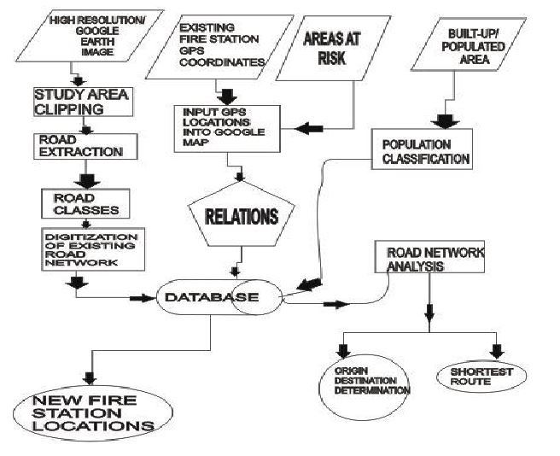
Fig. 2. Work flow diagram

V. RESULTS AND DISCUSSION
The spatial analysis assessment result shows seven functional fire stations within the entire Ibadan metropolis, figure 4. However, only one primary station lies within the study area, with limited spillover coverage from adjacent facilities (Figure 5). Given the National Fire Protection Association (NFPA) benchmark of one station per 50,000 population, the existing configuration is structurally inadequate relative to the LGA’s population exceeding 300,000 (National Population Commission [NPC], 2006; NFPA, 2011). This reveals a substantial mismatch between fire service infrastructure and population demand in Ibadan North Local Government Area (LGA).
The results from the Road Network-based accessibility modelling figures (6 and 7), demonstrate that response performance is highly location-dependent. Under unconstrained conditions, incidents within 1.4 km of a station can be reached in approximately 2.1 minutes, while simulated obstruction scenarios yield response times of approximately 2.8 minutes—both within the NFPA maximum threshold of 8 minutes. However, service-area analysis using 4minutes, 5minutes, and 8minutes travel-time thresholds reveals fragmented and uneven spatial coverage. Large portions of densely built-up neighborhoods fall outside optimal response windows, indicating spatial inequity in emergency access.
The road-network structure significantly influences response efficiency. Travel impedance calibrated by road hierarchy (Express: 60 km/h; major: 40 km/h; minor: 20 km/h) confirms that network topology—rather than Euclidean distance alone—determines accessibility outcomes. Origin–destination cost matrix evaluation further highlights disparities in cumulative response time, particularly in peripheral locations where congestion and network configuration extend travel duration.
Location–allocation modelling identifies optimal sites for additional stations (Figure 8) based on service gaps, built-up density, and network accessibility. Simulation of proposed facilities substantially improves spatial equity and achieves near-complete coverage under the 8-minute response criterion, with marked enhancements under stricter 4-minute and 5-minute thresholds. These findings demonstrate the operational value of integrating GIS-based network analysis with demographic and land-use data for evidence-based emergency planning. The results underscore a systemic infrastructure deficit driven by rapid urban growth without proportional expansion of fire-service capacity. Strategic spatial optimization of emergency facilities is therefore essential to enhance resilience, reduce vulnerability, and ensure equitable service delivery in the study area.

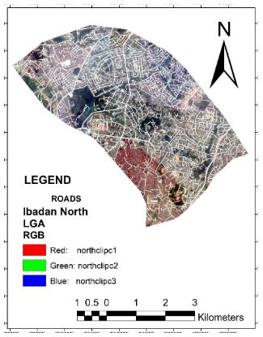
Fig. 3. Digitized Roads of Study Area

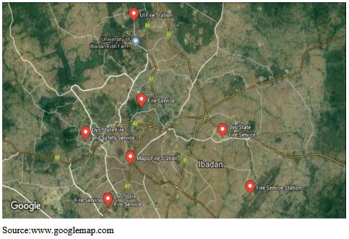
Fig. 4. Existing Fire Stations in Ibadan

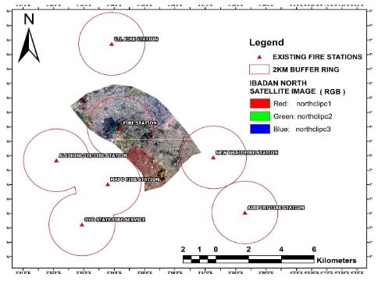
Fig. 5. Existing Fire Stations at 2km buffer

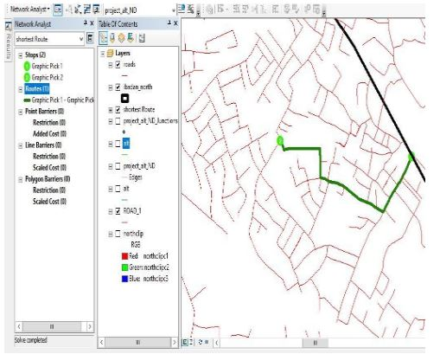
Fig.6. Shortest Route from Fire Station (1) to Incidence (2)

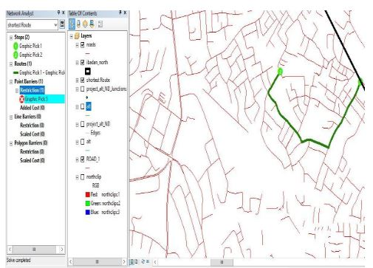
Fig.7. Alternate Route to Place/Area of incidence

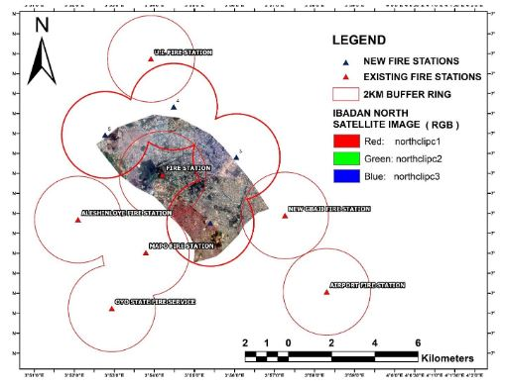
Fig. 8. The New Proposed Fire Station Locations

- RECOMMENDATIONS
The following recommendations are vital for future studies aimed at improving precision and applicability.
- Integration of Real-Time Spatio-Temporal Dynamics: Future research should incorporate dynamic variables like real-time traffic patterns, population shifts, and seasonal weather changes, moving from static distance-based buffers to stochastic travel-time modelling for a better understanding of response times.
- Advanced Heuristic and Machine Learning Approaches: To mitigate subjectivity in traditional AHP weightings, exploring Fuzzy-AHP, Artificial Neural Networks (ANN), or Random Forest algorithms is recommended. These hybrid models can effectively address the complexities of urban fire risk.
- Socio-Economic Vulnerability Mapping: Future models should integrate a Social Vulnerability Index (SVI) by overlaying fire suitability maps with demographic data, allowing planners to prioritize interventions in high-risk, low-resource areas.
- Hydraulic Infrastructure Assessment: An important extension of this research involves analyzing the distribution and reliability of hydrants, as site suitability is compromised if locations lack adequate hydraulic infrastructure for effective firefighting.

- CONCLUSION

This study underscores the critical role of spatial optimization in enhancing emergency response efficacy within rapidly urbanizing contexts. The empirical findings reveal a significant infrastructure-to-population mismatch in the Ibadan North Local Government Area (L.G.A.). Specifically, the spatial distribution analysis indicates that only one of the seven regional fire departments is situated within the study area—a deficit that suggests historical urban planning has failed to account for the spatio-temporal dynamics of Ibadan’s demographic expansion and physical growth.

REFERENCE

- Adelekan, I. O. (2020). Urban dynamics, everyday hazards and disaster risks in Ibadan, Nigeria. Environment and Urbanization, 32(1), 213-232.
- Adewoyin, W. A. (2025). Assessment of Road Transport Infrastructure and Its Impact on Development in Ibadan North Local Government Area, Oyo State, Nigeria. International Journal of Research and Innovation in Applied Science, 10(7), 1522-1530.
- Baik, J., & Murray, A. T. (2024). Emergency response planning: A framework to assess hydrant–structure access. Transactions in GIS, 28(7), 2412-2424.
- Chen, W., Zhai, G., Ren, C., Shi, Y., & Zhang, J. (2018). Urban resources selection and allocation for emergency shelters: In a multi-hazard environment. International journal of environmental research and public health, 15(6), 1261.
- Costa, D. G., Peixoto, J. P. J., Jesus, T. C., Portugal, P., Vasques, F., Rangel, E., & Peixoto, M. (2022). A survey of emergencies management systems in smart cities. IEEE Access, 10, 61843-61872.
- Jiang, Y., Guo, B., & Yan, Z. (2022). Multi-criterion spatial optimization of future police stations based on urban expansion and criminal behavior characteristics. ISPRS International Journal of Geo-Information, 11(7), 384.
- Mukhopadhyay, A., Pettet, G., Vazirizade, S. M., Lu, D., Jaimes, A., El Said, S., ... & Dubey, A. (2022). A review of incident prediction, resource allocation, and dispatch models for emergency management. Accident Analysis & Prevention, 165, 106501.
- Singh, P. P., Sabnani, C. S., & Kapse, V. S. (2021). Hotspot analysis of structure fires in urban agglomeration: A case of Nagpur City, India. Fire, 4(3), 38.
- Wang, W., Xu, Z., Sun, D., & Lan, T. (2021). Spatial Optimization of Mega-City Fire Stations Based on Multi-Source Geospatial Data: A Case Study in Beijing. ISPRS International Journal of Geo-Information, 10(5), 282. https://doi.org/10.3390/ijgi10050282

