Forensic Historiography of Israel, Palestine, and the Arabs: Evidence from Ancient Canaan to the Modern Era
Dr. Ashokaditya P. Dhurandhar
Orion Geohytech India
G-10 Brahmaputra Apartment Aakar Nagar Katol Road Nagpur
ORCID iD: https://orcid.org/0000-0002-9948-1937
WoS iD: https://www.webofscience.com/wos/author/record/D-1505-2010
Email: apdhurandhar@gmail.com
Abstract
The land of the southern Levant—historically Canaan, the Land of Israel, Judea, and Palestine—serves as a crossroads of civilizations spanning more than 5,000 years. This forensic historiography draws on archaeological artifacts, ancient inscriptions, genetic studies, demographic records, and contemporary chronicles to examine the intertwined histories of Jewish, Arab (including Palestinian), and other Levantine populations. It emphasizes empirical evidence over myth or ideology, revealing patterns of continuity, conquest, assimilation, and conflict. While Jewish and Arab Levantine groups share deep ancestral roots in the Bronze Age, modern national identities crystallized amid 19th- and 20th-century nationalism, colonialism, and geopolitical upheaval. This analysis underscores that the Israel-Palestine conflict arises from 20th-century dynamics rather than primordial enmity.
Keywords: Southern Levant, Canaanite, Bronze Age, Ancient DNA, Levantine ancestry, Continuity, Jewish, Arab, Nationalism, Israel-Palestine conflict, Archaeological artifacts / inscriptions, Demographic records, Empirical evidence / forensic historiography.
Introduction
The southern Levant has witnessed successive empires, migrations, and cultural transformations. A "forensic" approach prioritizes verifiable data: radiocarbon dating, ancient DNA (aDNA), epigraphic records, and census data. This method counters polarized narratives that portray one group as indigenous and the other as interloper. Genetic and archaeological evidence demonstrates substantial continuity among Levantine populations, with both Jews and Palestinians tracing significant ancestry to ancient Canaanites and Israelites (Agranat-Tamir et al., 2020; Haber et al., 2017). Yet, historical contingencies—conquests, exiles, and imperial partitions—shaped distinct identities.
Prehistoric and Bronze Age Foundations: The Canaanite Substrate (ca. 10,000–1200 BCE)
Human settlement in the region began with Natufian hunter-gatherers around 12,000 BCE, evolving into Neolithic farming communities at sites like Jericho (ca. 9000 BCE). By the Early Bronze Age (ca. 3000 BCE), urban Canaanite city-states emerged under Egyptian suzerainty, including Hazor, Megiddo, and Lachish. These Semitic-speaking peoples developed a distinct material culture blending local traditions with Mesopotamian influences.
Recent aDNA studies confirm that modern Levantines—Jews, Palestinians, Druze, and Lebanese—derive 50–80% of their ancestry from Bronze Age southern Levantine populations, with additional contributions from Chalcolithic Zagros (Iran-related) groups (Agranat-Tamir et al., 2020). A 2020 analysis of 93 individuals from sites across Israel, Jordan, and Lebanon modeled Canaanites as descending from local Neolithic farmers and Zagros-related migrants, with minimal external replacement (Agranat-Tamir et al., 2020, figure 1).

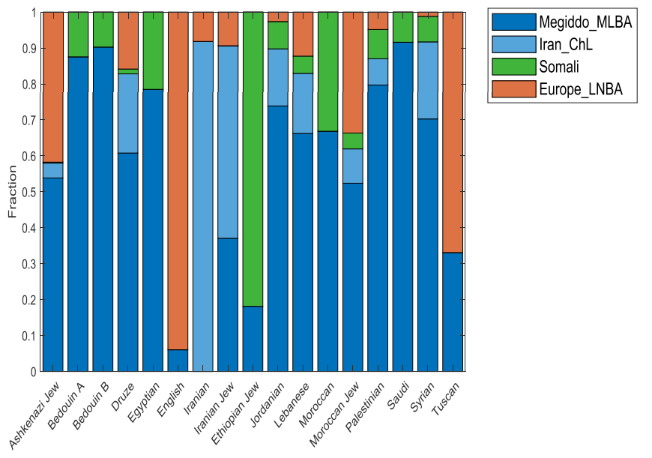
Figure 1. Genetic ancestry proportions in Levantine and related populations, showing high Bronze Age Levantine continuity in modern groups. (Adapted from Agranat-Tamir et al., 2020). More than kin, less than kind: Jews and Palestinians as Canaanite cousins.
The earliest extra-biblical reference to "Israel" appears on the Merneptah Stele (ca. 1208 BCE), an Egyptian victory inscription stating: "Israel is wasted, its seed is not" (Hasel, 1998). This depicts Israel as a people in Canaan, contemporaneous with other city-states (Figure 2).
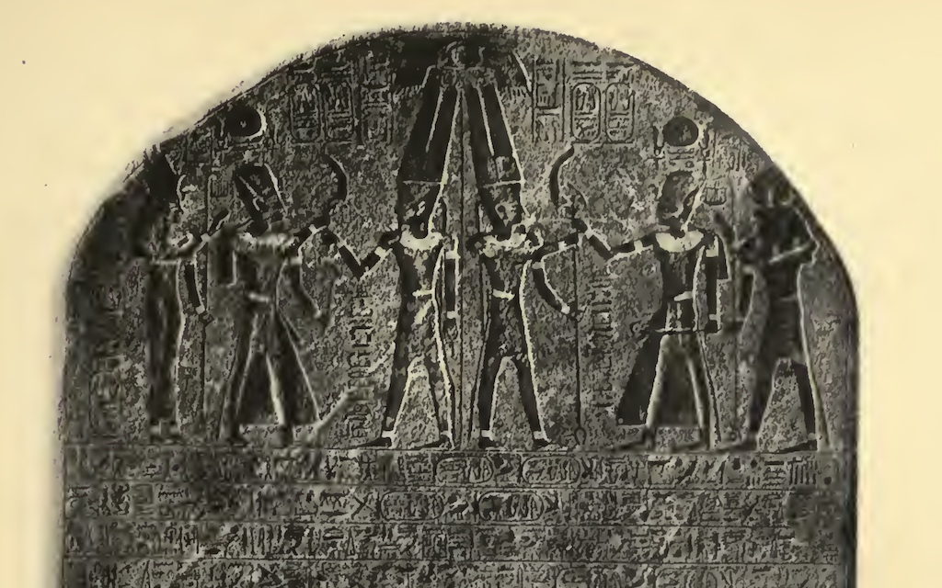
Figure 2. The Merneptah Stele, the earliest known reference to Israel outside the Bible. Israelite Origins: The Merneptah Stele - Biblical Historical Context biblicalhistoricalcontext.com

Iron Age Kingdoms: Israel and Judah (ca. 1200–586 BCE)
Highland villages with unique features—four-room houses and collared-rim jars—emerged in the central hills, marking the ethnogenesis of ancient Israel (Finkelstein & Silberman, 2001). Biblical texts describe a United Monarchy under Saul, David, and Solomon, followed by the divided kingdoms of Israel (north) and Judah (south).
Epigraphic evidence corroborates this. The Tel Dan Stele (mid-9th century BCE), an Aramaic inscription, mentions the "House of David," confirming a Judahite dynasty (Biran & Naveh, 1993, Figure 3).
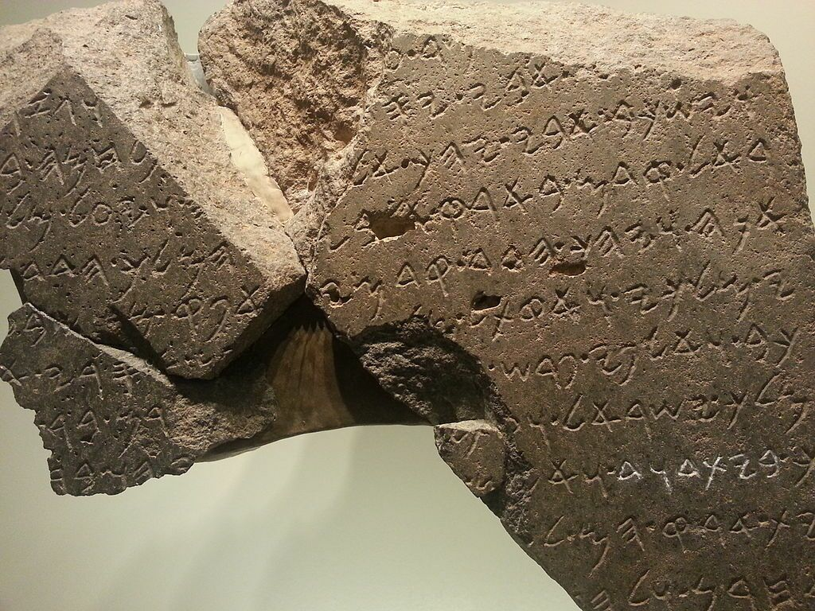
Figure 3. Fragment of the Tel Dan Stele, referencing the "House of David." Inscriptions Prove the 'House of David'. ArmstrongInstitute.org armstronginstitute.org
Assyrian records (e.g., the Black Obelisk) and the Moabite Mesha Stele (ca. 840 BCE) further attest to Israelite kings like Omri and Ahab. The northern kingdom fell to Assyria in 722 BCE; Judah to Babylon in 586 BCE, with elite deportation. Yet, archaeological layers show cultural persistence in the Persian province of Yehud (539–332 BCE).
Hellenistic, Roman, and Byzantine Eras: Diaspora and Resilience (332 BCE–636 CE) Alexander the Great's conquest (332 BCE) introduced Hellenization. The Maccabean Revolt (167–160 BCE) briefly restored Jewish sovereignty under the Hasmoneans. Roman incorporation (63 BCE) led to revolts: the First Jewish Revolt (66–73 CE) and Bar Kokhba Revolt (132–135 CE). Jerusalem was destroyed; Jews were barred from the renamed Aelia Capitolina.
Jewish communities persisted in Galilee and the diaspora, evidenced by the Dead Sea Scrolls and Byzantine synagogues (e.g., Capernaum). By the 4th century CE, Christianity dominated, but Jews, Samaritans, and others remained. Pre-Islamic Arabs, such as Nabataeans and Ghassanids, maintained a presence in the south (Hoyland, 2014).
The Arab Conquest and Early Islamic Period: Assimilation, Not Replacement (634–1099 CE)
Byzantine exhaustion from wars with the Sasanians facilitated the Rashidun Caliphate's rapid advances. Key victories included Ajnadayn (634 CE) and Yarmouk (636 CE). Jerusalem surrendered peacefully to Caliph Umar in 638 CE, who issued protections for Christians and Jews (Donner, 1981).
Contemporary non-Muslim sources, like the chronicle of Sebeos, describe treaties rather than mass displacement. Muslim historians (e.g., al-Baladhuri) emphasize pacts preserving local governance. Conversion to Islam occurred gradually over centuries, driven by socioeconomic factors. Arabic language and identity spread through assimilation, not wholesale population replacement (Hoyland, 2014).
Genetic data reinforces continuity: Palestinians show 81–87% Bronze Age Levantine ancestry, akin to other Levantines, with minor East African and European inputs (Agranat-Tamir et al., 2020; Haber et al., 2017).
Medieval to Ottoman Rule: A Provincial Backwater (1099–1917 CE):
Crusader states (1099–1187 CE) were fleeting; Saladin's Ayyubids reclaimed Jerusalem. Mamluk (1250–1517 CE) and Ottoman (1517–1917 CE) eras followed. The region remained sparsely populated and economically marginal.
Ottoman censuses reveal demographics: In the 1870s–1880s, the population totaled ~350,000–450,000, with ~85% Muslim Arabs, 10–11% Christians, and 4–5% Jews (McCarthy, 1990). By 1914, it reached ~600,000–750,000, still predominantly Arab, though Jewish numbers grew modestly via immigration (McCarthy, 1990 Table1, Figure 4).
Table 1: Population of various ethnic groups before the major Zionist immigration accelerated (Data from McCarthy, 1990)
Religious/Ethnic Group | Population | Percentage
Muslims (overwhelmingly Arab) | 4,69,750 | 85.60%
Christians (overwhelmingly Arab) | 58,987 | 10.70%
Jews (Ottoman citizens) | 20,117 | 3.70%
Total Ottoman Citizens | 5,48,854 | 100%

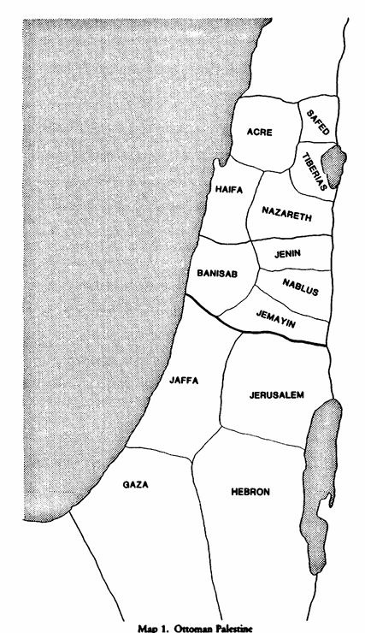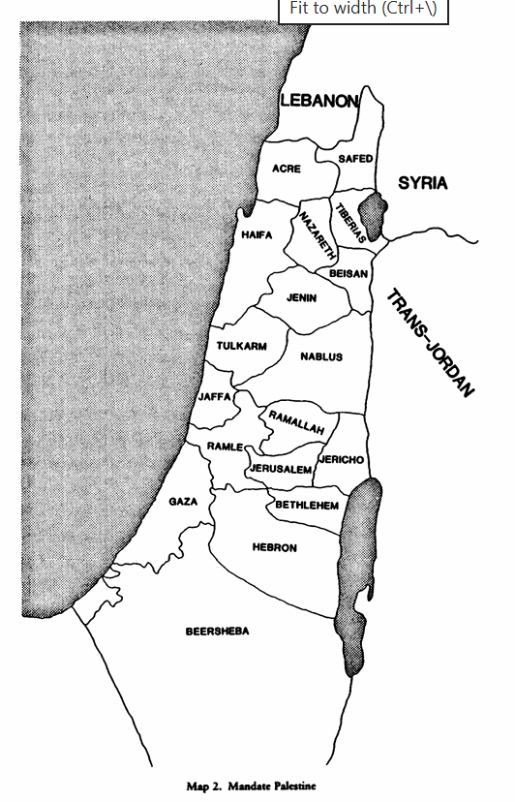Figure 4. Approximate ethnic composition of Ottoman Palestine in the late 19th century, based on census data pie chart (4a). (Data from McCarthy, 1990). The population of Palestine: Population history and statistics of the late Ottoman period and the Mandate (Map 1 and Map 2, Tables 1.4A–1.4D, pp. 7–10, and related appendices). Columbia University Press
Map 2: Mandate Palestine
Map 1: Ottoman Palestine
Modern Nationalism and the Mandate Era (1880s–1947 CE):
European anti-Semitism spurred Zionist immigration (First Aliyah, 1882). The Balfour Declaration (1917) supported a "Jewish national home" amid British wartime strategy. The British Mandate (1922) formalized this while promising Arab rights.
Palestinian national identity coalesced in the early 20th century through anti-Zionist resistance and Mandate policies. Arabic newspapers like Filastin (est. 1911) invoked "Palestine" for local Arabs (Khalidi, 2006). By 1947, the population was ~1.9 million: Jews ~32%, Arabs ~68% (Tessler, 2009).
Partition, War, and the Nakba (1947–1949 CE):
UN General Assembly Resolution 181 (November 29, 1947, Figure 5) proposed partitioning Palestine into Jewish (56% of land) and Arab (44%) states, with internationalized Jerusalem. Jews accepted; Arabs rejected it, citing violations of self-determination (United Nations General Assembly, 1947).
Civil war ensued. Israel's declaration of independence on May 14, 1948, triggered the Arab-Israeli War. Israel secured 77% of the territory; Jordan annexed the West Bank and East Jerusalem; Egypt controlled Gaza. Approximately 700,000 Palestinians became refugees (the Nakba); ~850,000 Jews fled or were expelled from Arab states (Morris, 2001).
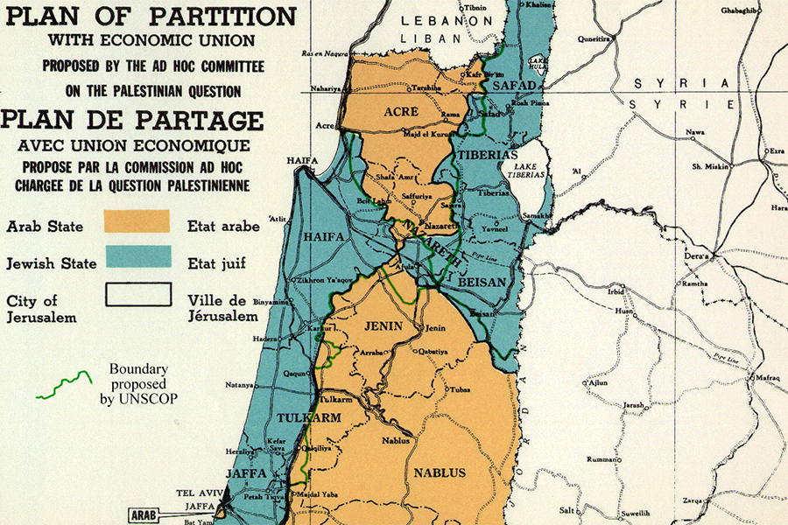
Figure 5. Map of the 1947 UN Partition Plan. Why the 1947 UN Partition Resolution Must Be Celebrated. The Washington Institute. washingtoninstitute.org
Post-1948 Conflicts: Cycles of Violence and Failed Peace (1949–Present):
Subsequent wars—the 1956 Suez Crisis, 1967 Six-Day War (leading to occupation of the West Bank, Gaza, Sinai, and Golan), 1973 Yom Kippur War, and Lebanon interventions—shaped the landscape. The Oslo Accords (1993) offered hope but collapsed amid intifadas, settlements, and Hamas's rise (Tessler, 2009). The October 7, 2023, Hamas attack and ensuing Gaza conflict underscore the enduring impasse. The modern population statistics are 51.3% Jewish, 44.5% Arabs and 4.2% others due to ethnic cleansing (Figure 6).
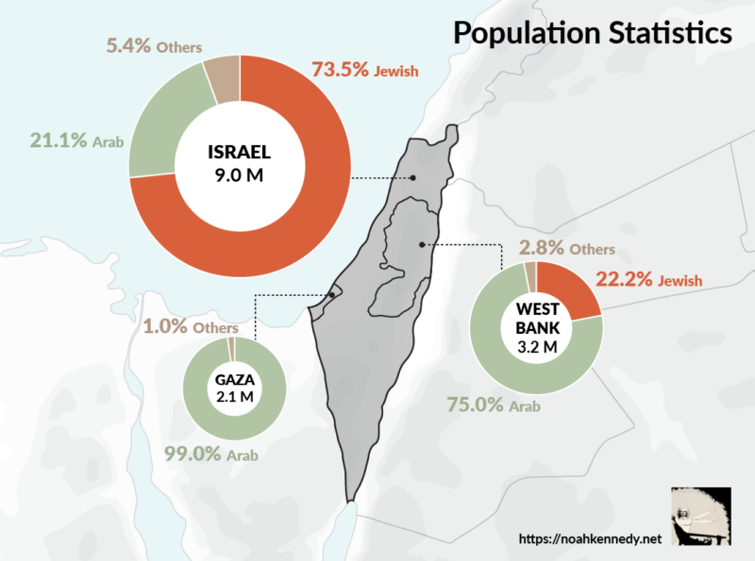
Figure 6: Present day population of various ethnic groups. Rise in the Jewish population due to ethnic cleansing.
Genetic and Archaeological Forensics: Shared Ancestry in the Levant
Ancient DNA (aDNA) analysis has revolutionized the forensic reconstruction of Levantine population history, offering direct biological evidence that complements archaeological stratigraphy, material culture, and textual records. Two pivotal whole-genome studies—Haber et al. (2017) on Bronze Age Sidon and modern Lebanese genomes, and Agranat-Tamir et al. (2020) on a broad survey of 93 individuals from nine Southern Levantine sites—demonstrate substantial genetic continuity from the mid-2nd millennium BCE “Canaanites” to present-day populations, while documenting layered admixture from northeastern sources. These findings reveal that Jewish, Palestinian, Lebanese, and other Levantine groups share deep ancestral roots in Bronze Age Canaanite populations, with both continuity and transformation shaping modern diversity.
Haber et al. (2017) sequenced five ~3,700-year-old genomes from Sidon, a major Canaanite coastal city-state, alongside 99 present-day Lebanese individuals. The ancient Sidon samples derive from admixture between local Neolithic Levantine farmers (Levant_N, ~48%) and eastern migrants related to Chalcolithic Zagros/Iranian populations (Iran_ChL, ~52%). This “Canaanite-related” ancestry was widespread, appearing in both coastal urban centers and inland groups (e.g., Early Bronze Age Jordan, Figure 7). Critically, present-day Lebanese derive the majority (~93% ± 1.6%) of their ancestry from this Bronze Age source, indicating remarkable genetic continuity since at least the Middle Bronze Age. A smaller additional component (~7% ± 1.6%) related to Eurasian Steppe populations entered the Levant later, around 2,950 ± 790 years ago, coinciding with periods of imperial upheaval and Mediterranean trade.
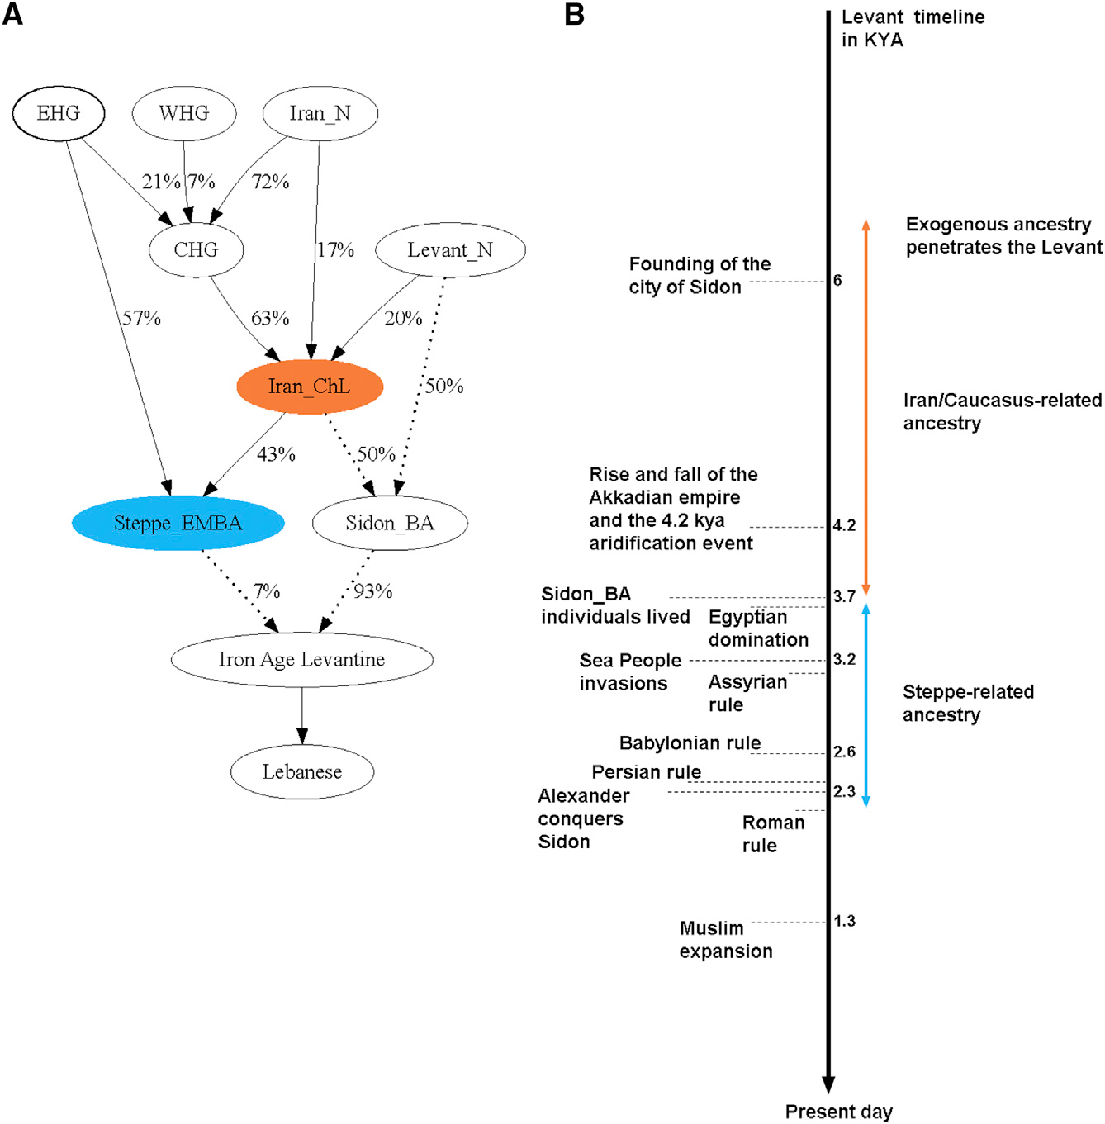

Figure 7. Timeline of Levantine genetic history showing the primary Bronze Age admixture (Levant_N + Iran_ChL) and the later Eurasian influx. The Sidon_BA individuals form the core ancestral population for modern Lebanese (Haber et al., 2017).
Functional genomic evidence reinforces this continuity. Allele frequencies at loci associated with pigmentation (e.g., SLC24A5, SLC45A2, HERC2) and certain disease risks in Sidon_BA closely match those in modern Lebanese, with correlations far higher than with Europeans, Africans, or Asians (r = 0.74, p < 10⁻¹⁵). Y-chromosome haplogroups J1-P58 and J2, which became prominent in the Bronze Age alongside the Iran_ChL-related ancestry, remain common in the modern Near East, further linking paternal lineages across millennia.
Agranat-Tamir et al. (2020) significantly expanded the dataset with 73 newly reported genomes (plus 20 previously published) from sites spanning present-day Israel, Jordan, and Lebanon: Megiddo (northern Israel), Baq‘ah (central Jordan), Yehud (central Israel), Hazor, and Abel Beth Maacah. These individuals, all associated with Canaanite material culture across ~1,500 years (Intermediate Bronze Age to early Iron Age), exhibit strong genetic homogeneity. Most groups are consistent with forming pairwise clades relative to outgroups, clustering tightly in principal component analysis (PCA) and ADMIXTURE, and can be modeled as mixtures of ~48–57% local Neolithic Levant (Levant_N) and ~43–52% Zagros/Caucasus-related ancestry (Figure 8).
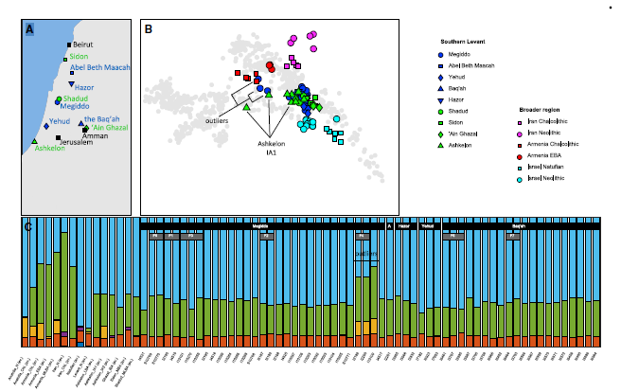
Figure 8. Map of sampled sites and PCA showing Bronze and Iron Age Southern Levantine individuals (blue/green) forming a tight cluster distinct from other ancient West Eurasians. Outliers and coastal groups (e.g., some Sidon and Ashkelon samples) show subtle differentiation (Agranat-Tamir et al., 2020).
The eastern (Zagros/Caucasus) component was already present by the Intermediate Bronze Age (~2400 BCE) and increased over time, rising by roughly 14% per millennium (linear regression β = 1.4 × 10⁻⁴, Jackknife SE). This gene flow is best proxied by either Chalcolithic Zagros (Iran_ChL) or Early Bronze Age Caucasus (Armenia_EBA) populations, consistent with archaeological evidence of Kura-Araxes cultural influences and later Hurrian linguistic elements in the region. Three Megiddo “outliers” (including a sibling pair) stand out with exceptionally high eastern ancestry (Neolithic Levant component as low as 9–27%), likely representing recent migrants or their immediate descendants from the Caucasus region during the Middle Bronze Age (Figure 9).
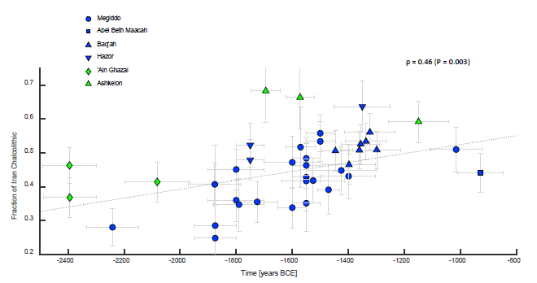
Figure 9: Temporal trend in the proportion of Chalcolithic Iran-related ancestry across dated individuals, showing a statistically significant increase from the Intermediate Bronze Age through the Late Bronze Age (Agranat-Tamir et al., 2020).
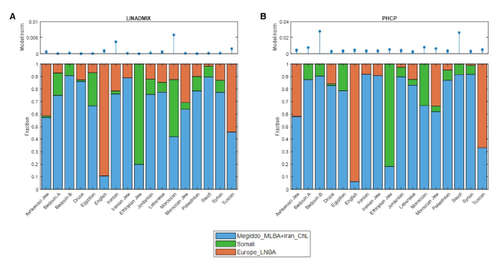
Modern Levantine populations—Jewish groups (Ashkenazi, Sephardi, Mizrahi, etc.) and Arabic-speaking Levantine communities (Palestinians, Lebanese, Druze, Bedouin)—consistently carry substantial ancestry traceable to these Bronze Age Southern Levantine and Chalcolithic Zagros sources. Using constrained least-squares modeling on ADMIXTURE output (LINADMIX) and a haplotype-based adaptation of ChromoPainter (PHCP), Agranat-Tamir et al. (2020) estimate that combined Levant_BA + Iran_ChL-related ancestry often exceeds 50% in these groups, with additional post-Bronze Age layers: an East African-related component (highest in Arabic-speaking populations and Ethiopian Jews) and a European-related component (prominent in Ashkenazi and Moroccan Jews, Figure 10).
Figure 10: Ancestry proportions in 17 present-day populations modelled with four sources (Megiddo_MLBA as Levant_BA proxy, Iran_ChL, Somali as East African proxy, and Europe_LNBA). Jewish and Levantine Arab groups show major contributions from ancient Levantine + Zagros sources, plus later admixtures (from Agranat-Tamir et al., 2020).
These genetic patterns affirm that both Jewish and Palestinian/Arab Levantine identities have deep biological roots in the ancient Levant. Jews maintained cultural and partial genetic continuity through diaspora, while Levantine Arabs reflect the demographic majority shaped by the 7th-century CE Arab expansions and gradual assimilation of local populations. Coastal heterogeneity (e.g., Sidon, Ashkelon) and inland variability (e.g., Baq‘ah) highlight that “Canaanite” was a cultural rather than strictly genetic category, yet overall affinity across sites underscores shared Levantine ancestry.
Limitations remain: sampling is still sparse for certain periods and sub-regions, and post-Bronze Age migrations (Hellenistic, Roman, Islamic, and Crusader eras) introduced components not fully captured by current ancient references. Nevertheless, the forensic genomic record decisively demonstrates that the Levant’s peoples are biological cousins, not strangers, with ancestry threads stretching continuously from the Bronze Age Canaanites through to the present. This shared heritage, alongside distinct historical trajectories, forms the biological foundation for any viable narrative of mutual recognition in the region.
Conclusion
Forensic evidence portrays the southern Levant as a tapestry of indigenous continuity. Canaanite roots underpin both Jewish and Arab Levantine identities. Jews sustained a 3,000-year connection despite exiles; Arabs became the majority through 7th-century conquest and gradual cultural integration. The modern tragedy stems from nationalism, imperial legacies, and mutual rejections of compromise—not ancient hatreds.
Sustainable peace requires acknowledging dual narratives: Jewish self-determination after millennia of persecution alongside Palestinian rights to dignity and statehood. History's forensics affirm neither side is "foreign" to this land. Mutual recognition of shared heritage offers the only path forward.
References
Agranat-Tamir, L., Waldman, S., Feldman, M., et al. (2020). The genomic history of the Bronze Age southern Levant. Cell, 181(5), 1146–1157.e11. https://doi.org/10.1016/j.cell.2020.04.024
Biran, A., & Naveh, J. (1993). An Aramaic stele fragment from Tel Dan. Israel Exploration Journal, 43(2/3), 81–98.
Donner, F. M. (1981). The early Islamic conquests. Princeton University Press.
Finkelstein, I., & Silberman, N. A. (2001). The Bible unearthed: Archaeology's new vision of ancient Israel and the origin of its sacred texts. Free Press.
Haber, M., Doumet-Serhal, C., Scheib, C., et al. (2017). Continuity and admixture in the last five millennia of Levantine history from ancient Canaanite and present-day Lebanese genome sequences. The American Journal of Human Genetics, 101(2), 274–282. https://doi.org/10.1016/j.ajhg.2017.06.013
Hasel, M. G. (1998). Domination and resistance: Egyptian military activity in the southern Levant, ca. 1300–1185 B.C. Brill.
Hoyland, R. G. (2014). In God's path: The Arab conquests and the creation of an Islamic empire. Oxford University Press.
Khalidi, R. (2006). The iron cage: The story of the Palestinian struggle for statehood. Beacon Press.
McCarthy, J. (1990). The population of Palestine: Population history and statistics of the late Ottoman period and the Mandate. Columbia University Press.
Morris, B. (2001). Righteous victims: A history of the Zionist-Arab conflict, 1881–2001. Vintage Books.
Tessler, M. (2009). A history of the Israeli-Palestinian conflict (2nd ed.). Indiana University Press.
United Nations General Assembly. (1947). Resolution 181 (II): Future government of Palestine. https://undocs.org/en/A/RES/181(II)

