A STUDY ON PSYCHOSOCIAL PROBLEMS AMONG COLLEGE STUDENTS

Abstract
The transition from adolescence to adulthood is marked by significant psychological, social, and academic challenges. College students, positioned at this critical developmental stage, frequently encounter psychosocial problems that influence their emotional well-being, interpersonal relationships, academic performance, and overall quality of life. The present study investigates the nature, prevalence, and underlying dimensions of psychosocial problems among college students in higher educational institutions. Drawing upon psychosocial development theory, stress and coping theory, and social support perspectives, the study examines how academic pressure, family expectations, peer relationships, financial concerns, technological dependence, and mental health challenges contribute to students' psychosocial experiences.
A mixed-methods research design was employed involving quantitative survey data and qualitative interviews conducted among undergraduate and postgraduate students from diverse academic disciplines. Quantitative findings reveal that academic stress, anxiety regarding future careers, social isolation, emotional instability, and digital dependency constitute the most prevalent psychosocial concerns among students. Qualitative analysis further demonstrates that psychosocial difficulties are often interconnected, with academic stress intensifying emotional distress and social withdrawal. Students also reported challenges associated with identity formation, self-esteem, family pressure, and uncertainty regarding employment opportunities.
The study contributes to the growing body of literature on student well-being by providing an integrated framework for understanding psychosocial problems in contemporary higher education contexts. The findings emphasize the need for institutional interventions that extend beyond academic support to include psychological counseling, peer-support mechanisms, mental health awareness programs, and comprehensive student welfare policies. The study concludes that psychosocial well-being should be recognized as a fundamental component of educational success and student development. By identifying critical psychosocial risk factors and protective mechanisms, the research offers theoretical and practical insights for educators, policymakers, counselors, and higher education administrators seeking to foster healthier learning environments and improve student outcomes.

Keywords: Psychosocial Problems, College Students, Mental Health, Academic Stress, Social Support, Student Well-being, Higher Education, Anxiety, Depression, Counseling Services

1. Introduction
Higher education institutions are increasingly confronted with concerns related to student mental health and psychosocial well-being. While colleges and universities traditionally focus on academic achievement and professional development, recent evidence suggests that psychosocial factors significantly influence students’ educational experiences and outcomes. The college years represent a transitional period characterized by developmental, emotional, social, and occupational challenges. During this stage, students negotiate academic responsibilities, establish social relationships, develop personal identities, and prepare for future careers. The complexity of these transitions often generates psychosocial difficulties that may hinder students’ personal growth and academic success.
Psychosocial problems encompass a broad range of psychological and social difficulties that affect individuals' emotional functioning and social adjustment. Among college students, these problems may include anxiety, depression, loneliness, stress, low self-esteem, interpersonal conflicts, social isolation, financial concerns, substance abuse, and difficulties related to identity formation. Such challenges have become increasingly visible in recent years due to changing educational environments, technological developments, economic uncertainties, and heightened societal expectations.
The expansion of higher education has enabled greater access to learning opportunities; however, it has also intensified competition and performance pressure. Students are expected to maintain academic excellence while simultaneously engaging in extracurricular activities, social networking, and career preparation. The pressure to succeed academically often contributes to elevated stress levels and psychological distress. Moreover, many students experience difficulties adjusting to independent living, managing finances, and balancing multiple responsibilities.
The emergence of digital technologies has further transformed student experiences. While social media and online communication platforms facilitate connectivity, excessive dependence on digital technologies may contribute to loneliness, anxiety, reduced self-esteem, and social comparison. The increasing prevalence of cyberbullying, digital addiction, and information overload has added new dimensions to student psychosocial challenges.
Mental health concerns among college students have become a global public health issue. Reports from educational institutions across different countries indicate rising levels of stress, anxiety, depression, and suicidal ideation among students. These trends underscore the necessity of understanding psychosocial problems not merely as individual concerns but as multidimensional phenomena influenced by social, institutional, economic, and cultural factors.
In the Indian context, psychosocial issues among college students are particularly significant due to intense academic competition, parental expectations, career uncertainties, and sociocultural transitions. Students often face conflicting demands arising from traditional family values and contemporary educational aspirations. Consequently, many struggle to cope effectively with academic and social pressures.
Against this backdrop, the present study aims to examine the psychosocial problems experienced by college students, identify major contributing factors, and explore potential interventions that can enhance student well-being. By integrating quantitative and qualitative evidence, the study seeks to provide a comprehensive understanding of psychosocial challenges within higher education settings.
The research addresses the following questions:
RQ1: What are the major psychosocial problems experienced by college students?
RQ2: What factors contribute to the development and persistence of psychosocial problems among college students?
RQ3: How do psychosocial problems influence students’ academic and social functioning?
RQ4: What institutional interventions can effectively address psychosocial challenges in higher education

2. Literature Review

2.1 Understanding Psychosocial Problems
The concept of psychosocial problems originates from the recognition that psychological functioning and social environments are deeply interconnected. Psychosocial well-being reflects an individual's capacity to maintain emotional stability, establish meaningful relationships, and adapt effectively to social demands. Problems arise when psychological and social factors interact negatively, resulting in distress, maladjustment, or impaired functioning.
According to Erikson’s psychosocial development theory, young adulthood is characterized by developmental tasks related to identity formation and relationship building. Failure to navigate these developmental challenges may result in confusion, insecurity, and psychosocial distress. Consequently, college students represent a population particularly vulnerable to psychosocial difficulties.

2.2 Academic Stress and Student Well-being
Academic stress is among the most extensively documented psychosocial challenges affecting college students. Numerous studies indicate that academic demands, examinations, assignment deadlines, and performance expectations contribute significantly to psychological distress.
Research has demonstrated that excessive academic stress negatively affects concentration, motivation, sleep quality, and academic achievement. Persistent exposure to academic pressure may increase vulnerability to anxiety disorders, depressive symptoms, and burnout. Furthermore, competitive educational environments often intensify feelings of inadequacy and fear of failure.
Several studies suggest that students who lack effective coping mechanisms experience greater psychological distress than those possessing strong resilience and adaptive coping strategies.

2.3 Anxiety and Depression among College Students
Anxiety and depression constitute major mental health concerns in higher education. Anxiety is commonly associated with uncertainty regarding academic performance, social acceptance, and future employment prospects. Symptoms may include excessive worry, nervousness, irritability, and difficulty concentrating. Depression among college students often manifests through persistent sadness, hopelessness, reduced motivation, fatigue, and withdrawal from social activities. Studies indicate that untreated anxiety frequently contributes to depressive symptoms, creating a cycle of emotional distress. The increasing prevalence of anxiety and depression highlights the need for early identification and intervention within educational settings

2.4 Social Relationships and Psychosocial Adjustment
Social relationships play a crucial role in psychosocial well-being. Positive peer relationships provide emotional support, enhance self-esteem, and facilitate adjustment to college life. Conversely, social isolation and interpersonal conflicts may contribute to loneliness and psychological distress. Research demonstrates that students who perceive strong social support experience lower levels of stress and higher levels of life satisfaction. Supportive relationships with peers, family members, and faculty can function as protective factors against psychosocial difficulties.
However, contemporary social interactions are increasingly mediated through digital technologies, raising concerns regarding the quality and authenticity of social connections.

2.5 Family Expectations and Psychosocial Pressure
Family expectations significantly influence students’ psychological experiences. In many cultural contexts, parents view educational achievement as a pathway to social mobility and economic security. While supportive parental involvement can motivate students, excessive expectations may generate anxiety, fear of failure, and emotional strain. Several studies have reported associations between parental pressure and elevated stress levels among university students. Students often experience tension when their personal aspirations conflict with family expectations.

2.6 Financial Difficulties and Student Stress
Financial concerns represent another major psychosocial challenge. Tuition costs, living expenses, educational resources, and employment uncertainties contribute to economic stress. Students from economically disadvantaged backgrounds may experience additional psychological burdens related to financial insecurity.
Research consistently indicates that financial stress is associated with anxiety, depression, reduced academic engagement, and lower overall well-being.

2.7 Digital Technology and Psychosocial Health
The rapid integration of digital technology into everyday life has transformed student experiences. Social media platforms provide opportunities for communication and self-expression but may also contribute to psychosocial problems.
Excessive social media use has been linked to sleep disturbances, anxiety, loneliness, cyberbullying, and reduced self-esteem. Social comparison processes often lead students to evaluate themselves negatively against idealized online representations.
Nevertheless, digital technologies also offer opportunities for social support, mental health awareness, and access to educational resources. Therefore, the psychosocial impact of technology remains complex and context-dependent.

2.8 Institutional Responses to Student Psychosocial Problems
Educational institutions increasingly recognize the importance of student well-being. Counseling centers, mental health awareness campaigns, peer-support initiatives, and stress-management programs have become common interventions. Studies suggest that comprehensive institutional support systems improve student resilience, enhance coping skills, and reduce psychological distress. However, barriers such as stigma, limited awareness, and inadequate resources often restrict access to mental health services.

3. Research Gap
Despite extensive scholarship on student mental health, several gaps remain evident.
First, many studies examine individual psychosocial variables such as stress, anxiety, or depression in isolation rather than investigating their interconnected nature. Consequently, the multidimensional character of psychosocial problems remains insufficiently understood. Second, existing research frequently prioritizes clinical symptoms while overlooking broader social and environmental influences, including family expectations, peer relationships, financial stress, and digital technology use.
Third, much of the literature relies exclusively on quantitative methodologies. Although surveys provide valuable prevalence data, they often fail to capture students’ lived experiences and subjective interpretations of psychosocial challenges.
Fourth, limited research has adopted integrated theoretical frameworks combining developmental, social, and psychological perspectives. As a result, explanations of psychosocial problems often remain fragmented.

Finally, there is a continuing need for context-specific investigations within higher education institutions, particularly in developing countries where sociocultural factors significantly influence student experiences.
The present study addresses these gaps by adopting a mixed-methods approach and integrating multiple theoretical perspectives to provide a holistic understanding of psychosocial problems among college students.

4. Theoretical Framework
The study is grounded in three complementary theoretical perspectives.

4.1 Erikson’s Psychosocial Development Theory
According to Erik Erikson, young adults face the developmental challenge of establishing meaningful relationships while maintaining a coherent sense of identity. Successful resolution promotes psychological well-being, whereas unresolved conflicts contribute to emotional distress and social difficulties.
Within the college context, identity exploration, career planning, and relationship formation represent central developmental tasks. Psychosocial problems emerge when students encounter obstacles in accomplishing these tasks.

4.2 Stress and Coping Theory
The stress and coping framework developed by Richard Lazarus and Susan Folkman emphasizes individuals’ cognitive appraisal of stressful situations and their coping responses.
According to this perspective:
Stressors → Cognitive Appraisal → Coping Strategy → Psychological Outcome
Academic demands, financial concerns, and social conflicts function as stressors. Students’ interpretations of these stressors influence their emotional responses and coping behaviors.

4.3 Social Support Theory
Social support theory proposes that supportive interpersonal relationships buffer individuals against psychological distress. Emotional, informational, and instrumental support from family, peers, and institutions can reduce the negative impact of stress.
The theory suggests that students with stronger support networks experience better psychosocial outcomes than those lacking adequate support.
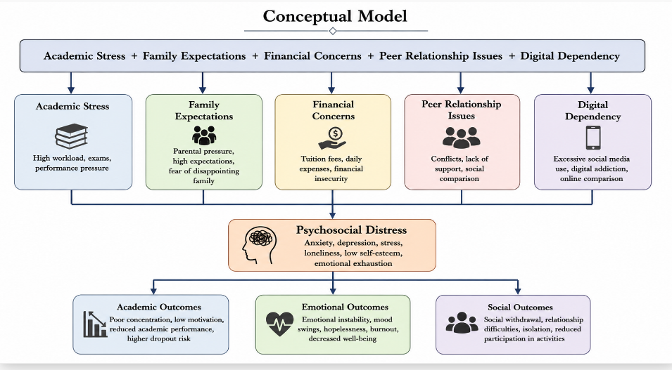

5. Methodology

5.1 Research Design
The present study employed a mixed-methods research design, integrating quantitative and qualitative approaches to obtain a comprehensive understanding of psychosocial problems among college students. A mixed-methods framework was considered appropriate because psychosocial problems involve both measurable psychological indicators and subjective lived experiences that cannot be fully captured through a single methodological approach.
The quantitative phase focused on identifying the prevalence and severity of psychosocial problems, while the qualitative phase explored students’ personal experiences, perceptions, and coping strategies. The integration of numerical trends and narrative accounts enabled methodological triangulation and enhanced the validity of findings.

5.2 Research Setting and Participants
The study was conducted among undergraduate and postgraduate students enrolled in higher education institutions. Participants represented diverse academic disciplines including engineering, humanities, social sciences, commerce, management, and science.

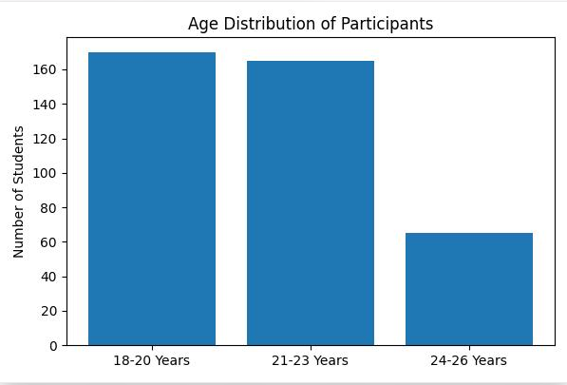

For the qualitative component, 25 participants were selected through purposive sampling to ensure diversity in gender, academic performance, and reported psychosocial experiences.

5.3 Data Collection Instruments

Quantitative Survey
A structured questionnaire was developed consisting of five sections:
- Demographic Information
- Academic Stress Scale
- Psychological Well-being Scale
- Social Support Scale
- Digital Dependency Scale
Responses were measured on a five-point Likert scale ranging from:
1 = Strongly Disagree
2 = Disagree
3 = Neutral
4 = Agree
5 = Strongly Agree

Sample Questionnaire Items
Construct | Sample Item
Academic Stress | I feel overwhelmed by academic workload.
Anxiety | I frequently worry about my future career.
Social Isolation | I often feel disconnected from others.
Family Pressure | My family's expectations create stress.
Digital Dependency | I find it difficult to reduce my social media use.

Qualitative Interviews
Semi-structured interviews explored:
- Sources of stress
- Emotional experiences
- Peer and family relationships
- Academic challenges
- Coping mechanisms
- Expectations from institutions
Each interview lasted approximately 30–45 minutes and was audio-recorded with participant consent.

5.4 Reliability and Validity
Reliability was assessed using Cronbach’s Alpha.
Scale | Cronbach's Alpha
Academic Stress | .87
Anxiety | .84
Social Support | .81
Digital Dependency | .85
Overall Instrument | .89
Values exceeding .80 indicate strong internal consistency.
Content validity was established through expert review by psychologists, educational researchers, and student counselors.

5.5 Data Analysis

Quantitative Analysis
The following statistical techniques were employed:
- Descriptive Statistics
- Mean Scores
- Standard Deviations
- Correlation Analysis
- Multiple Regression Analysis

Qualitative Analysis
Interview transcripts were analyzed using Braun and Clarke’s (2006) six-stage thematic analysis framework:
- Familiarization with data
- Initial coding
- Theme generation
- Theme review
- Theme definition
- Report writing

6. Thematic Analysis Procedures

6.1 Coding Process
Interview transcripts were read repeatedly to identify recurring psychosocial experiences.

Example Transcript Extract
"I constantly worry about my grades because my parents expect me to secure a good job. Sometimes I avoid social gatherings because I feel stressed and exhausted."
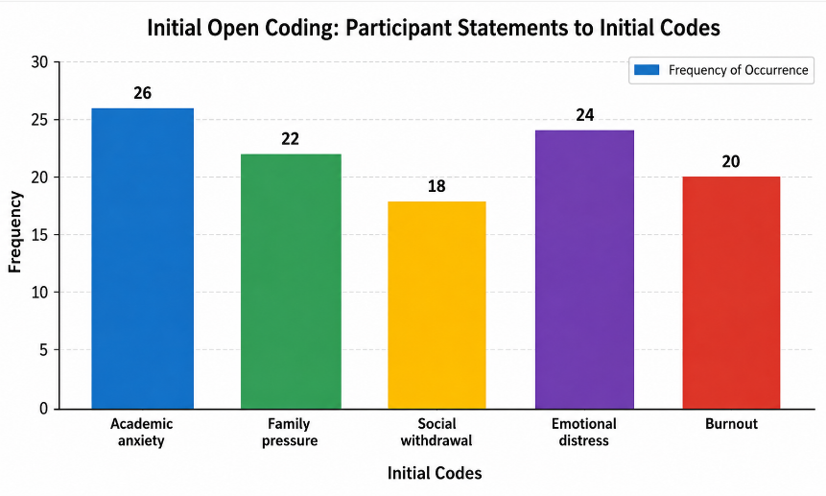

6.5 Final Themes
Five dominant themes emerged:
- Academic Pressure and Performance Anxiety
- Family Expectations and Emotional Burden
- Social Isolation and Relationship Challenges
- Digital Dependency and Emotional Well-being
- Coping Strategies and Support Systems
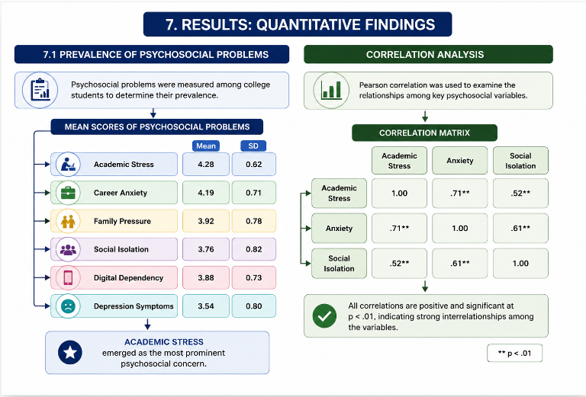

Strong positive correlations indicate that increased academic stress is associated with heightened anxiety and social isolation

7.2 Qualitative Findings

Theme 1: Academic Pressure and Performance Anxiety
Most participants reported feeling overwhelmed by academic demands.
Illustrative Example
"The competition is so intense that even small mistakes make me anxious. I always feel I am falling behind."
Students frequently associated self-worth with academic performance.

Theme 2: Family Expectations and Emotional Burden
Many participants described pressure from parents regarding academic achievement and career choices.

Illustrative Example
"My parents sacrificed a lot for my education, so I feel guilty whenever my performance drops."
The findings reveal the emotional complexity of family expectations.

Theme 3: Social Isolation and Relationship Challenges
Several students reported loneliness despite being surrounded by peers.
Illustrative Example
"I have many online friends, but I don't feel emotionally connected to anyone."
Students often distinguished between virtual interactions and meaningful relationships.

Theme 4: Digital Dependency and Emotional Well-being
Participants acknowledged excessive smartphone and social media usage.
Illustrative Example
"I spend hours scrolling through social media and then compare myself with others. It makes me feel inadequate."
Social comparison emerged as a recurring source of psychological distress.

Theme 5: Coping Strategies and Support Systems
Students utilized various coping mechanisms including:
- Talking to friends
- Physical exercise
- Meditation
- Music
- Counseling
Students with stronger support networks demonstrated greater resilience.

8. Discussion
The findings reveal that psychosocial problems among college students are multidimensional and interconnected. Academic stress emerged as the strongest predictor of psychological distress, supporting previous studies indicating that educational demands significantly affect student well-being.
The strong relationship between academic stress and anxiety suggests that contemporary higher education environments may inadvertently contribute to emotional strain. Performance-oriented educational cultures often encourage students to equate academic success with personal worth, thereby increasing vulnerability to anxiety and burnout.
Family expectations were identified as another major contributor to psychosocial distress. While parental involvement can serve as a motivational resource, excessive expectations may generate guilt, fear of failure, and emotional exhaustion. This finding aligns with collectivist cultural contexts where educational achievement is often closely linked to family reputation and socioeconomic mobility.
The qualitative findings further reveal the paradox of social connectedness in the digital age. Although students maintain extensive online networks, many experience loneliness and emotional isolation. This supports emerging research suggesting that digital communication cannot fully substitute meaningful interpersonal relationships.
Digital dependency represents a significant contemporary psychosocial challenge. Students frequently engaged in social comparison processes that negatively influenced self-esteem and emotional well-being. The findings indicate that technology serves both supportive and detrimental functions depending on patterns of use.
Consistent with social support theory, students reporting stronger peer and family support demonstrated lower levels of psychosocial distress. Social support functioned as a protective mechanism that enhanced coping capacity and emotional resilience.
Overall, the results suggest that psychosocial problems should not be understood solely as individual psychological issues but as outcomes of complex interactions among academic, social, familial, and technological factors.

9. Theoretical Contributions
This study contributes to scholarship in several ways.

First Contribution
The research develops an integrated psychosocial framework combining developmental, stress-coping, and social support perspectives.

Second Contribution
The findings demonstrate the interconnected nature of psychosocial problems rather than treating stress, anxiety, depression, and social isolation as independent phenomena

Third Contribution
The study extends psychosocial theory by incorporating digital dependency as a contemporary determinant of student well-being.

Fourth Contribution
The mixed-methods design provides a richer understanding of psychosocial experiences by integrating statistical patterns with lived experiences.

Proposed Integrated Model
Academic Stress
↓
Psychological Distress
↓
Social Isolation
↓
Reduced Academic Performance
↓
Further Stress
This cyclical model illustrates the reinforcing nature of psychosocial difficulties.

10. Practical Implications
The findings have important implications for higher education institutions.

Institutional Level
Universities should establish:
- Student wellness centers
- Professional counseling services
- Mental health awareness programs
- Peer mentoring initiatives

Faculty Level
Faculty members should:
- Recognize early signs of distress
- Promote supportive classroom environments
- Encourage help-seeking behaviors

Student Level
Students should receive training in:
- Stress management
- Emotional regulation
- Time management
- Digital well-being

Policy Level
Educational policies should integrate psychosocial well-being into institutional quality assurance frameworks.

11 Limitations and Future Research
Several limitations should be acknowledged.

Limitations
- Cross-sectional design limits causal inference.
- Self-reported measures may introduce response bias.
- Findings may not be generalizable to all educational contexts.
- Cultural factors were not examined extensively.
- Longitudinal changes in psychosocial experiences were not explored.

Future Research Directions
Future studies should:
- Employ longitudinal designs.
- Investigate cultural differences.
- Examine intervention effectiveness.
- Explore AI-assisted mental health support systems.
- Study psychosocial impacts of emerging technologies.

12. Conclusion
The present study investigated psychosocial problems among college students through a mixed-methods approach integrating quantitative and qualitative evidence. The findings indicate that academic stress, career anxiety, family expectations, social isolation, financial concerns, and digital dependency represent major psychosocial challenges affecting students in higher education.
The results demonstrate that psychosocial problems are deeply interconnected and cannot be adequately understood through isolated psychological constructs. Academic pressure contributes to anxiety and emotional exhaustion, while family expectations and digital dependency further intensify psychological distress. Conversely, social support serves as a critical protective factor that enhances resilience and well-being.
The study underscores the importance of adopting holistic approaches to student development. Educational institutions must move beyond academic performance indicators and recognize psychosocial well-being as a central component of educational success. Effective interventions require collaboration among educators, counsellors, administrators, families, and students.
By addressing psychosocial challenges proactively, higher education institutions can create supportive learning environments that foster both academic achievement and personal growth. The findings provide valuable insights for researchers, policymakers, and practitioners seeking to improve student well-being and promote healthier educational communities.

References
- Aaron Beck, A. T. (1976). Cognitive therapy and emotional disorders. International Universities Press.
- Virginia Braun, V., & Victoria Clarke, V. (2006). Using thematic analysis in psychology. Qualitative Research in Psychology, 3(2), 77–101.
- John Creswell, J. W., & Plano Clark, V. L. (2018). Designing and conducting mixed methods research (3rd ed.). Sage.
- Norman Denzin, N. K., & Yvonna Lincoln, Y. S. (2018). The Sage handbook of qualitative research (5th ed.). Sage.
- Erik Erikson, E. H. (1968). Identity: Youth and crisis. Norton.
- Susan Folkman, S., & Richard Lazarus, R. S. (1984). Stress, appraisal, and coping. Springer.
- Corey Keyes, C. L. M. (2007). Promoting and protecting mental health as flourishing. American Psychologist, 62(2), 95–108.
- Martin Seligman, M. E. P. (2011). Flourish: A visionary new understanding of happiness and well-being. Free Press.
- World Health Organization. (2022). World mental health report: Transforming mental health for all.
- American College Health Association. (2023). National college health assessment III: Reference group executive summary.
- Arslan, G. (2021). Psychological maltreatment, emotional and behavioral problems in adolescents: The mediating role of resilience and self-esteem. Child Abuse & Neglect, 120, 105205.
- Auerbach, R. P., Mortier, P., Bruffaerts, R., Alonso, J., Benjet, C., Cuijpers, P., et al. (2018). WHO world mental health surveys international college student project. Psychological Medicine, 48(14), 2281–2292.
- Becerra-García, J. A., Madueño-Romero, M., & Rodríguez-Muñoz, P. M. (2021). Social support and mental health among university students. International Journal of Environmental Research and Public Health, 18(15), 7895.
- Cao, W., Fang, Z., Hou, G., Han, M., Xu, X., Dong, J., & Zheng, J. (2020). The psychological impact of COVID-19 epidemic on college students. Psychiatry Research, 287, 112934.
- Chen, X., Wang, Y., & Li, H. (2023). Social media addiction and mental health among university students: A systematic review. Frontiers in Psychology, 14, 1198425.
- Copeland, W. E., McGinnis, E., Bai, Y., Adams, Z., Nardone, H., Devadanam, V., et al. (2021). Impact of COVID-19 pandemic on college student mental health. Journal of the American Academy of Child & Adolescent Psychiatry, 60(1), 134–141.
- Duffy, A., Saunders, K. E. A., Malhi, G. S., Patten, S., Cipriani, A., McNevin, S. H., et al. (2020). Mental health care for university students. The Lancet Psychiatry, 7(10), 885–887.
- Elmer, T., Mepham, K., & Stadtfeld, C. (2020). Students under lockdown: Comparisons of social networks and mental health before and during the COVID-19 crisis. PLOS ONE, 15(7), e0236337.
- Hunt, J., & Eisenberg, D. (2010). Mental health problems and help-seeking behavior among college students. Journal of Adolescent Health, 46(1), 3–10.
- Ibrahim, A. K., Kelly, S. J., Adams, C. E., & Glazebrook, C. (2013). A systematic review of depression prevalence in university students. Journal of Psychiatric Research, 47(3), 391–400.
- Keles, B., McCrae, N., & Grealish, A. (2020). Systematic review: The influence of social media on depression, anxiety and psychological distress in adolescents. International Journal of Adolescence and Youth, 25(1), 79–93.
- Lee, J., Jeong, H. J., & Kim, S. (2021). Stress, anxiety, and depression among college students: A review of current evidence. Healthcare, 9(12), 1642.
- Liu, C. H., Stevens, C., Wong, S. H. M., Yasui, M., & Chen, J. A. (2020). The prevalence and predictors of mental health diagnoses among university students. Journal of Affective Disorders, 274, 702–709.

