Dimensional Weight Arbitrage and Revenue Leakage in Courier

Abstract
Courier firms often price parcels by the space they occupy rather than by physical weight alone. This practice, known as dimensional or volumetric weight billing, becomes financially important when a parcel is light but bulky. The present study examines how such billing can create weight arbitrage and revenue leakage for shippers, sellers, and logistics partners. Using survey-based insights from logistics professionals together with carrier-policy comparisons and shipment examples, the paper explains where billing gaps arise, which sectors are most exposed, and how companies can reduce avoidable cost. The findings show that leakage is highest in categories that ship low-density products, especially fashion, e- commerce retail, and B2B freight. The paper also proposes a practical governance model built around measurement, packaging optimisation, invoice audit, and contract negotiation.

Keywords
Dimensional weight; volumetric billing; freight audit; chargeable weight; courier pricing; revenue leakage; packaging efficiency; logistics cost control; e-commerce logistics.

Introduction
Courier billing looks simple from the outside: a parcel is weighed and the customer pays freight. In practice, the chargeable weight is often not the actual weight of the box. Carriers normally compare actual weight with dimensional weight and bill whichever is higher. Dimensional weight is calculated from parcel size, usually by multiplying length, breadth, and height and then dividing the result by a carrier-specific divisor.
This rule is commercially reasonable because trucks, aircraft, and warehouses have limited space. A large carton filled with light goods may occupy the same space as several smaller heavy parcels. However, the same rule can also create a billing gap when packaging is oversized, dimensions are measured differently, divisors are low, or invoice checks are weak. That billing gap is the core concern of this paper.
In fast-growing e-commerce and courier networks, millions of parcels move every day. Even a small error in measurement, rounding, or divisor application can become a major financial issue at scale. For shippers, this appears as higher freight spend. For carriers, inaccurate under-billing can also mean lost revenue.
Therefore, dimensional weight arbitrage is best understood as a two-sided billing risk, not merely a customer complaint.

1.1 Research Objectives
The study is guided by five objectives: to estimate the scale of leakage caused by dimensional weight billing, compare DIM divisor policies used by selected carriers, understand dispute and audit practices, examine the role of packaging and customer awareness, and present a practical framework that improves billing accuracy.

Literature Review
Existing work on freight pricing shows that transport cost is influenced not only by distance and weight but also by shipment density, packaging, handling effort, and network capacity. Dimensional weight pricing is one way carriers recover the cost of space consumed by low-density parcels. Earlier studies on logistics cost control also highlight that invoice errors, duplicate charges, incorrect tariff application, and weak audit processes can create avoidable expense for shippers.
The issue can also be explained through information asymmetry. Carriers usually control the measurement system, rate card, and billing logic, while many customers or smaller sellers have limited access to the same level of proof. This imbalance can make it difficult to challenge invoices, especially when the amount per shipment is small but the total annual impact is large.
Packaging research adds another important point: carton size directly affects volumetric weight. When a product is packed in a box larger than necessary, the shipper may pay for empty air. Better carton selection, right-sized packaging, and automated dimension capture can therefore reduce both logistics cost and billing disputes.

Research Methodology
The study follows a descriptive and analytical approach. It combines survey-based responses from logistics and supply-chain professionals with secondary information such as carrier tariff structures, industry audit observations, and shipment examples. The purpose is not only to describe the problem but also to identify where practical correction is possible.
Respondents were selected from industries where courier and parcel movement is frequent, including e- commerce retail, fashion and apparel, electronics, FMCG or grocery, healthcare logistics, and B2B freight. The survey focused on awareness of DIM billing, freight audit frequency, dispute experience, packaging practices, and perception of overcharging.
Revenue leakage was understood as the difference between the freight actually charged and the estimated freight that would have applied under actual-weight billing, especially in cases where parcel size increased the chargeable weight. The analysis used simple comparisons, percentage estimates, and carrier-wise benchmarking.

Data Analysis and Interpretation
The analysis shows that the impact of dimensional billing is uneven across sectors. Product density and packaging behaviour are the main reasons for this difference. A dense shipment, such as heavy electronics packed compactly, is less affected. A bulky but light shipment, such as footwear, apparel, toys, or home décor, is more exposed because the box occupies more space than its physical weight suggests.
Fashion and apparel show the highest estimated leakage because many items are packed in air-filled cartons or protective boxes that increase volume without adding much weight. E-commerce retail is also highly exposed because sellers ship a wide mix of product sizes and may not always use optimal packaging. FMCG and grocery show lower leakage because many products are relatively dense, so actual weight often remains close to or higher than dimensional weight.

Sector-wise Leakage
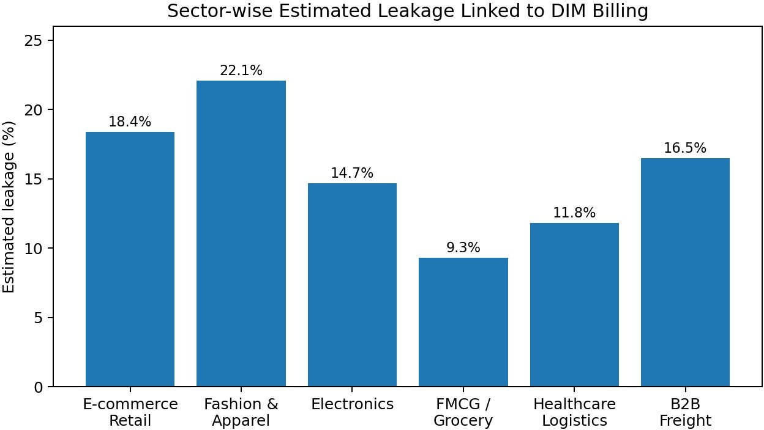

Figure 1. Estimated leakage due to dimensional billing by sector.
Table 1. Awareness and audit practices among respondents

Response / practice | No. of respondents | Percentage
Aware of carrier DIM weight policy | 89 | 74%
Conduct regular freight audits | 27 | 23%
Have filed a DIM weight dispute | 41 | 34%
Use automated audit software | 19 | 16%
Engaged third-party audit firm | 14 | 12%
Report significant overcharges above 10% | 63 | 53%

Actual Weight versus Billed Weight
A simple example makes the problem clear. A carton of 50 cm x 40 cm x 30 cm has a volume of 60,000 cubic centimetres. If the carrier uses a divisor of 5,000, the dimensional weight becomes 12 kg. If the item inside weighs much less, the invoice may still be based on the higher dimensional weight. In the sample comparison used in this study, a lightweight bulky box weighing 1.2 kg was billed at 4.8 kg, creating a large gap between physical and chargeable weight.
Irregular packages can make the issue worse because carriers generally measure the longest point on each side. A non-uniform parcel may therefore be billed as if it were a full rectangular box, even when some of that space is empty.

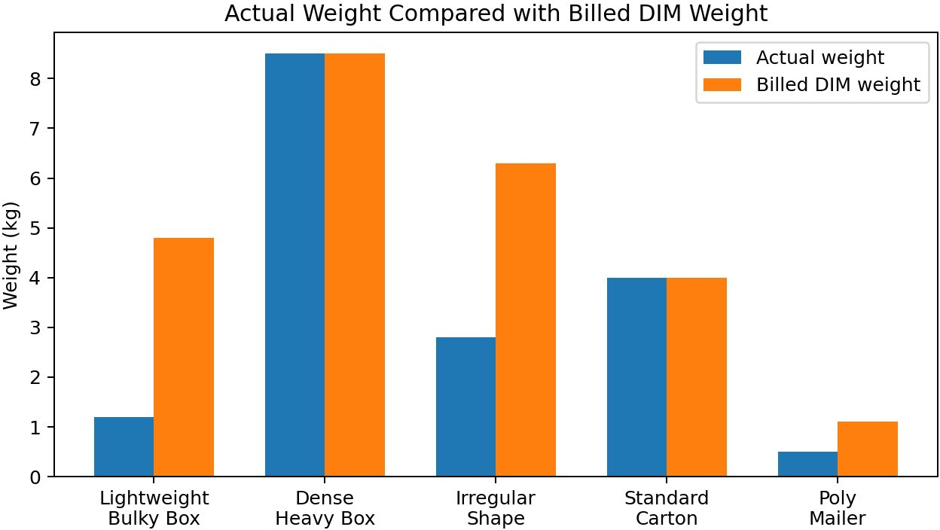

Figure 2. Actual weight compared with billed dimensional weight for selected package types.

Carrier Divisor Benchmarking
The DIM divisor is a key driver of final billing. A lower divisor results in a higher chargeable weight for the same parcel. For example, a box with the same dimensions will be billed heavier when divided by 4,000 than when divided by 5,000. This is why carrier selection and divisor negotiation can materially affect freight spend.
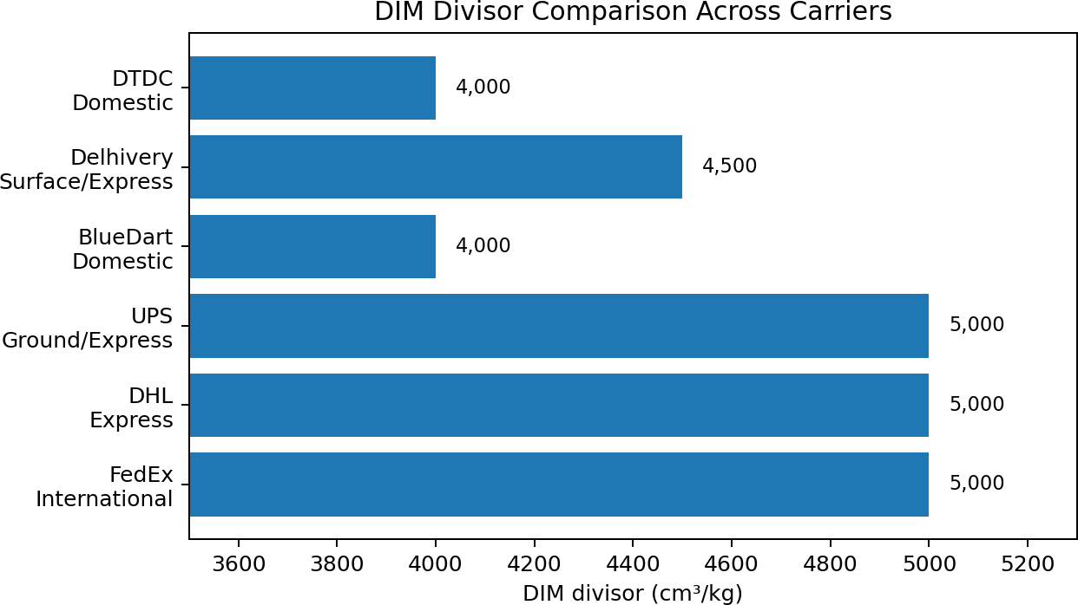

Figure 3. Comparison of DIM divisors across selected carriers.

Carrier | Service type | DIM divisor (cm³/kg) | Minimum billable weight | Measurement method
FedEx | International Express | 5,000 | 0.5 kg | Physical + DIM
DHL | Express | 5,000 | 0.5 kg | Physical + DIM
UPS | Ground / Express | 5,000 | 0.5 kg | Physical + DIM
BlueDart | Domestic Priority | 4,000 | 0.5 kg | Physical + DIM
Delhivery | Surface / Express | 4,500 | 0.5 kg | Physical + DIM
DTDC | Domestic Standard | 4,000 | 0.5 kg | Physical + DIM

Dispute Resolution and Audit Outcomes
Dispute handling is another source of practical difficulty. When a shipper challenges dimensional billing, the carrier may ask for proof of package size, photographs, scan records, or shipment-level documentation. Many smaller firms do not maintain such evidence for every parcel. As a result, disputes may be rejected or abandoned even when the shipper believes the bill is incorrect.
Audit methods also produce different results. Manual spot checking can identify obvious errors but may miss repeated patterns. Automated audit tools and predictive audit systems are more effective because they compare invoice data with shipment records at scale. The highest recovery in the study is associated with AI or machine-learning based audits, followed by automated freight audit software and third-party audit firms.
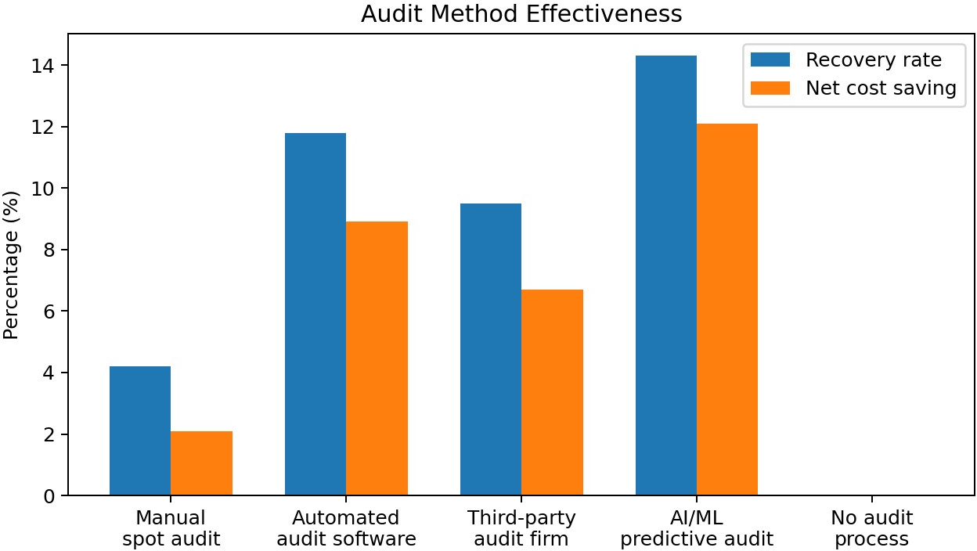

Figure 4. Recovery rate and net saving across audit approaches.

Results and Discussion
The findings confirm that dimensional weight arbitrage is not limited to one carrier or one type of shipper. It appears wherever three conditions meet: the parcel is low-density, the packaging is not right-sized, and the billing process is not independently verified. In such cases, the final invoice can be significantly higher than what a seller expects from actual weight alone.
The study also shows that awareness alone does not solve the problem. Many respondents knew about DIM weight policies, but only a small share conducted regular freight audits. This gap between awareness

and action is important. It suggests that companies may understand the rule but still lack the systems, time, or evidence required to control its financial impact.
Carrier divisor differences also matter. A shipper moving large parcel volumes should not treat all carrier rate cards as equal. The base freight rate may look attractive, but a lower DIM divisor can increase the effective cost for bulky products. Therefore, procurement teams should compare carriers on total chargeable-weight impact rather than only headline rates.

Proposed Framework: Integrated DIM Weight Governance
A practical solution requires four connected actions. First, the shipper must measure package dimensions at the source before dispatch. Second, packaging should be optimised so that products are protected without wasting space. Third, invoices should be audited using shipment-level data instead of random manual checks alone. Fourth, carrier contracts should include clear clauses on divisors, tolerance limits, evidence sharing, and dispute timelines.
This four-step governance model turns dimensional billing from a reactive dispute issue into a controllable cost-management process. It also creates a data trail that helps both shippers and carriers reduce avoidable disagreements.

Pillar | Key action | Technology / process support | Expected benefit | Indicative timeline
Measure | Capture package dimensions before shipment | 3D dimensioning scanner or WMS entry | Fewer invoice errors | 0-6 months
Optimise | Use the smallest safe  carton | Cartonisation logic  and packaging rules | Lower DIM weight | 3-9 months
Audit | Match invoice with shipment records | Freight audit software  / exception reports | Overcharge recovery | 6-12 months
Negotiate | Improve billing terms with carriers | Contract clauses and data-backed benchmarking | Lower effective rate | 6-18 months

Conclusion and Recommendations
Dimensional weight billing is a normal part of courier logistics, but it becomes a financial concern when measurement, packaging, and audit controls are weak. The research indicates that the sectors most affected are those shipping bulky and lightweight products. The highest-cost risk is not a single invoice error; it is the repeated occurrence of small billing gaps across thousands or millions of shipments.
Companies can reduce this risk by measuring parcels before dispatch, improving carton selection, auditing invoices regularly, and negotiating fair DIM divisor terms with carriers. For academic research, the topic is useful because it connects logistics operations, pricing transparency, packaging design, and financial control in one measurable problem area.

Scope for Future Research
Future studies can test the relationship between packaging innovation and chargeable weight reduction, compare carrier measurement systems across regions, and build predictive models that identify shipments most likely to face DIM-based overcharging before the invoice is generated.

References
Bar-Gill, O. (2012). Seduction by Contract: Law, Economics, and Psychology in Consumer Markets. Oxford University Press.
Cavinato, J. L. (1992). A total cost/value model for supply chain competitiveness. Journal of Business Logistics, 13(2), 285-301.
Christopher, M. (2016). Logistics & Supply Chain Management (5th ed.). Pearson.
Hobfoll, S. E. (1989). Conservation of resources: A new attempt at conceptualizing stress. American Psychologist, 44(3), 513-524.
Jensen, M. C., & Meckling, W. H. (1976). Theory of the firm: Managerial behavior, agency costs and ownership structure. Journal of Financial Economics, 3(4), 305-360.
Mentzer, J. T., DeWitt, W., Keebler, J. S., Min, S., Nix, N. W., Smith, C. D., & Zacharia, Z. G. (2001).
Defining supply chain management. Journal of Business Logistics, 22(2), 1-25.
Pålsson, H., Finnsgård, C., & Wänström, C. (2017). Selection of packaging systems in supply chains from a sustainability perspective. Packaging Technology and Science, 30(4), 125-141.
Swenseth, S. R., & Gorders, M. R. (2002). Incorporating transportation costs into inventory replenishment decisions. International Journal of Production Economics, 77(3), 253-262.
Williamson, O. E. (1985). The Economic Institutions of Capitalism. Free Press.

