EMPOWERING BEST PRACTICES IN SCIENTIFIC ARGUMENTATION REASONING IN SCIENCE EDUCATION: WHAT LIES AHEAD?

ABSTRACT
Artificial Intelligence (AI)-based assessment is increasingly being adopted in educational contexts. One area that remains challenging is scientific reasoning in Science Education, which has been identified as a major constraint among secondary school students in mastering argumentation skills. The inability to systematically connect claims and evidence to scientific principles not only reduces the quality of arguments but also hinders the development of holistic scientific literacy. Therefore, this paper aims to discuss the best practices of the Strength-Based Science Education (SBSE) approach, a pedagogical approach that focuses on identifying, activating, and developing students’ cognitive and socio-emotional strengths to enhance their reasoning abilities. In addition, this paper discusses future directions, particularly in AI-based assessment. The implementation of best practices encompasses three main strategies: identifying students’ reasoning strengths, constructing Claim–Evidence–Reasoning (CER) strength profiles, and facilitating strength-based peer reasoning dialogues. These strategies enable students to understand their personal reasoning styles, utilize them in constructing arguments, and improve weaknesses through peer collaboration. Reflective observations indicate that integrating argumentation frameworks into teaching and learning activities enhances conceptual clarity, confidence in argumentation, and active student collaboration. These findings support the effectiveness of the CER model in improving scientific literacy and the quality of classroom discourse. To ensure the sustainability of these practices, a generic conceptual model is proposed as a practical reference for educators. This initiative not only promotes more holistic and inclusive Science learning but also empowers students’ potential in accordance with contemporary educational needs. Future studies should further explore effective adaptations of scientific reasoning in Science Education through contemporary AI-based assessment practices. The proposed framework provides a practical reference for educators and a conceptual foundation for future research on AI-enhanced scientific reasoning assessment in Science Education.
Keywords: artificial intelligence (AI); cognitive; scientific argumentation; scientific reasoning; science education; students’ socio-emotional development

1.0 INTRODUCTION
Scientific argumentation is a fundamental component of science learning as it involves students constructing, evaluating, and defending knowledge based on evidence and justified reasoning. The role of argumentation as an essential mechanism in scientific knowledge construction has been consistently emphasized in contemporary science education literature (Allchin & Zemplén, 2020). Despite the growing emphasis on scientific argumentation in science curricula, its implementation in classrooms continues to face numerous challenges, particularly regarding students’ reasoning abilities. In general, students are often capable of making claims and identifying evidence; however, they experience difficulties in explicitly and systematically connecting evidence to scientific concepts or principles. Such limitations in reasoning result in arguments that are largely descriptive and insufficiently justified, consequently affecting students’ deep conceptual understanding of science (Gültepe & Kılıç, 2021).

Recent studies further highlight that explicit instruction focusing on reasoning processes, together with teachers’ roles as facilitators of scientific dialogue, are critical elements in strengthening the quality of students’ argumentation. When students are guided to explain the relationship between evidence and scientific concepts in a structured manner during discussions, both the clarity of reasoning and the accuracy of arguments improve significantly (Tian & Osman, 2025). Although previous studies have extensively discussed instructional strategies for enhancing scientific argumentation in Science Education, such discussions have generally focused on reporting students’ skill levels. Less attention has been given to how reasoning can be strengthened through authentic pedagogical practices, including dialogue facilitation, reflective teacher support, and active student engagement in argumentation processes. Therefore, this study contributes to the literature by providing practical and contextualized guidance, particularly for science teachers seeking to strengthen the reasoning component within scientific argumentation instruction.

- METHODOLOGY

This paper adopts a best-practice approach grounded in classroom reflection to describe the empowerment of reasoning in scientific argumentation within Science Education. This approach emphasizes exploring how authentic pedagogical practices support the development of students’ reasoning during argumentation processes, rather than testing the effectiveness of an intervention or conducting statistical comparisons. Through reflective practice, teachers act as reflective practitioners who evaluate and refine instructional approaches based on systematic observations of student learning (Allchin & Zemplén, 2020; Guilfoyle & Erduran, 2021).

2.1 Research Questions

This study is guided by four main research questions focusing on reasoning as a core construct in scientific argumentation:

- How does the practice of identifying students’ reasoning strengths support their ability to connect claims and evidence in a scientifically justified manner during scientific argumentation?
- How does the development of a strength-based Claim–Evidence–Reasoning (CER) profile help improve the coherence and clarity of students’ reasoning?
- How do structured peer reasoning dialogues contribute to student engagement and the quality of scientific justifications?
- What are the future directions of students’ reasoning in Science Education, particularly in AI-based assessment?

These questions are theoretically significant because they focus on the epistemic processes of argumentation, particularly the role of reasoning in scientific knowledge construction (Allchin & Zemplén, 2020). From a practical perspective, they assist teachers in understanding how reasoning can be strengthened through instructional strategies that can be effectively implemented in authentic classroom settings (Hendratmoko et al., 2023; Tian & Osman, 2025).

2.2 Research Framework

This study is grounded in the view that scientific argumentation is a socio-epistemic practice involving the construction of claims, the selection of relevant evidence, and the provision of reasoning that logically connects the two. Within this framework, reasoning is regarded as a critical element that determines the quality of an argument, as it explains why evidence supports a particular claim. Previous studies have shown that meaningful argumentation occurs when students are provided with opportunities to evaluate alternative ideas, defend their arguments, and refine their reasoning through structured discussions (Nejla & Kılıç, 2021; Mulyani et al., 2024). Therefore, this research framework places classroom pedagogical practices as the primary focus rather than the quantitative measurement of learning outcomes.

2.3 Data Collection Methods

Data were collected through reflective classroom observations conducted during the implementation of scientific argumentation activities. These observations focused on how students constructed arguments, selected evidence, and articulated reasoning through both oral and written interactions. In addition, student learning artefacts, including argumentation responses, group discussion notes, and teachers’ reflective records, were used as supporting sources to understand qualitative changes in students’ reasoning processes. This approach is consistent with recommendations in the literature suggesting that studies of scientific argumentation should examine learning processes and interactions rather than focusing solely on the final argumentative product (Allchin & Zemplén, 2020; Guilfoyle & Erduran, 2021b). Reflective observations were employed to evaluate the influence of pedagogical practices on how students justified their ideas within authentic classroom contexts.

2.4 Best-Practice Implementation Procedures

The implementation of best practices in this study involved three main strategies. First, identifying students’ reasoning strengths, which refers to the process of recognizing students’ tendencies in evaluating evidence and making inferences so that instructional support can be tailored to their reasoning needs. Second, developing strength-based Claim–Evidence–Reasoning (CER) profiles aimed at helping students organize claims, evidence, and reasoning in a more coherent and justified manner. Third, facilitating strength-based peer reasoning dialogues, in which students engaged in structured discussions to defend arguments, evaluate their peers’ arguments, and refine their reasoning through social interaction. These strategies are supported by previous studies demonstrating that peer dialogue and explicit instruction on reasoning can improve the quality of students’ argumentation and increase engagement in science learning (Hendratmoko et al., 2023; Tian & Osman, 2025).

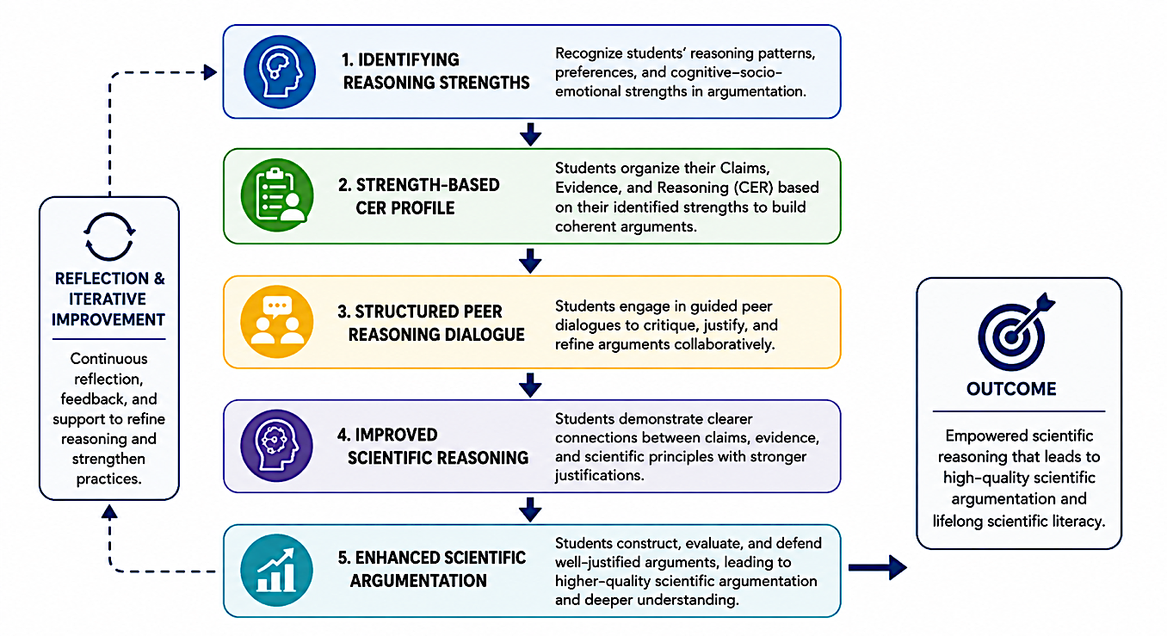
Figure 1. Best-Practice Framework for Empowering Scientific Reasoning in Science Education

Figure 1 presents the proposed best-practice framework for empowering scientific reasoning in Science Education. The framework illustrates how the identification of students’ reasoning strengths serves as the foundation for developing strength-based CER profiles. These profiles subsequently support structured peer reasoning dialogues that encourage students to justify claims, evaluate evidence, and refine reasoning through collaborative interactions. Through continuous reflection and engagement, these practices contribute to improved scientific reasoning, enhanced scientific argumentation, and ultimately the development of scientific literacy.

Table 1. Summary of Best-Practice Strategies for Empowering Scientific Reasoning in Science Education
Best-Practice Strategy | Description | Expected Contribution
Identifying Students’ Reasoning Strengths | Recognizing students’ reasoning patterns, cognitive tendencies, and strengths in constructing scientific arguments. | Enables targeted instructional support and promotes self-awareness of reasoning processes.
Strength-Based Claim–Evidence–Reasoning (CER) Profile | Organizing claims, evidence, and reasoning according to students’ identified strengths. | Improves coherence, justification quality, and the logical structure of scientific arguments.
Structured Peer Reasoning Dialogue | Engaging students in guided discussions to defend, evaluate, and refine arguments collaboratively. | Enhances critical thinking, scientific justification, and active participation in classroom discourse.

Table 1 summarizes the three key best-practice strategies proposed in this study. Together, these strategies provide a practical framework for supporting the development of scientific reasoning by combining individual strengths identification, structured argument construction, and collaborative reasoning opportunities within Science classrooms.
2.5 Data Analysis Methods

Data were analyzed using a descriptive qualitative approach, focusing on reasoning indicators within students’ arguments, such as the clarity of connections between evidence and claims and the accuracy of scientific concept application. The analysis also considered patterns of student interaction and the role of teacher facilitation in supporting reasoning during argumentation activities. This approach is consistent with the literature recommending the use of qualitative indicators and rubrics as appropriate means for evaluating the quality of scientific argumentation in classroom contexts (Mulyani et al., 2024).

2.6 Rationale for Methodological Selection

The selection of a best-practice-based methodology is appropriate for addressing the central issue of this study, namely students’ difficulties in connecting evidence and scientific concepts through justified reasoning. Such issues cannot be fully understood through quantitative measurement alone; instead, they require close examination of the argumentation processes occurring within classroom social interactions. Therefore, a descriptive qualitative practice-based approach was adopted to enable this study to contribute to the literature by providing practical and contextualized guidance that Science teachers can utilize to strengthen students’ reasoning in scientific argumentation.

- DISCUSSION
This discussion elaborates on the findings regarding the implementation of best practices for empowering reasoning in scientific argumentation within science education and compares them with previous studies and existing knowledge in the field. Overall, the findings indicate that when reasoning is explicitly emphasized through structured pedagogical support, students demonstrate improvements in the clarity of their justifications and their ability to link evidence to scientific claims. Reflective observations show that students began to produce more coherent arguments when argumentation activities were structured to focus on the reasoning process, rather than merely stating answers or using isolated pieces of evidence. This pattern aligns with the findings of Putri et al. (2025), who reported that the primary weakness in student argumentation lies not in the absence of evidence, but in the failure to explain the rationale behind the relationship between evidence and claims.
Furthermore, the implementation of structured, guided peer reasoning dialogues was found to support more active student engagement in scientific discussions. Students showed increased confidence in defending their arguments, questioning their peers' ideas, and refining their justifications through social interaction. This finding is consistent with studies by Wangmo et al. (2025) and Evagorou et al. (2023), which assert that collaborative discussions and issue-based dialogues have the potential to enrich student reasoning by providing a space for the exchange of ideas and the collective evaluation of arguments.
In this regard, several improvements can be considered for future research. These include incorporating data triangulation through student reflections, peer teacher observations, or the use of more detailed reasoning indicators to strengthen the validity of the findings. Additionally, future studies could integrate a limited quantitative approach to complement the qualitative findings without compromising the core focus on best practices. Overall, this discussion demonstrates that empowering reasoning through focused and reflective pedagogical practices has the potential to strengthen students' scientific argumentation in science education. These findings contribute to the literature by offering a practical perspective on how teachers can meaningfully support the development of student reasoning, in line with current and future demands of science education. When discussing the future direction of student reasoning in science education, particularly within artificial intelligence (AI)-based assessment environments, three key strategies emerge for strengthening students' reasoning abilities.
First strategy: The Authentic and Dynamic Assessment of Scientific Reasoning
The first strategy involves shifting from traditional multiple-choice tests to complex, digital performance-based assessment systems. AI is utilized to analyze not only the students' final answers but also their thought processes and the sequential steps taken to solve scientific problems. For example, in assessing the topic of Ecosystems, students no longer simply memorize food chains. Instead, they are presented with an environmental crisis scenario within an AI software. The AI then evaluates the students' ability to formulate hypotheses, correlate variables, and predict long-term impacts based on environmental data that changes in real-time.
Second strategy: The Visual and Computational AI-Based Simulation Learning
The second strategy involves integrating AI-powered interactive simulations that allow students to explore abstract scientific concepts or those invisible to the naked eye. Through this method, AI acts as a scaffolding mechanism that challenges students' inductive and deductive reasoning. For example, in a Chemistry experiment on Rates of Reaction, students can use an AI virtual lab simulation to alter temperatures or reactant concentrations. The AI will then prompt students to justify "why" and "how" particle changes occur at the sub-microscopic level, thereby directly assessing the sharpness of their scientific reasoning as the simulation unfolds.
Third strategy: The Adaptive and Personalized Diagnostic Feedback
The third strategy leverages AI data analytics to provide personalized formative feedback that instantly corrects scientific misconceptions. Future AI systems will do more than just assign grades; they will be capable of detecting gaps in a student's logical reasoning. For example, in Physics (Force and Motion), if a student confuses the concepts of mass and weight, the AI will detect this flawed thinking pattern based on their responses. The AI will then generate tailored follow-up questions designed to guide students in bridging their own reasoning gaps, ensuring that assessment is both continuous and high impact.

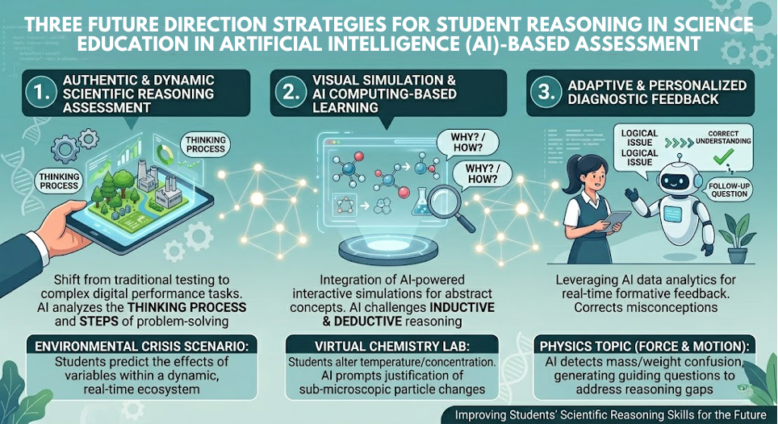
Figure 2. Future Directions for Enhancing Students’ Scientific Reasoning Through AI-Based Assessment in Science Education

Figure 2 illustrates three potential directions for strengthening scientific reasoning assessment through AI-enhanced educational environments. These directions emphasize process-oriented assessment, simulation-based learning experiences, and adaptive feedback mechanisms capable of supporting continuous reasoning development among students.

4.0 PRACTICAL IMPLICATIONS

The proposed framework offers meaningful implications for science educators seeking to strengthen students’ scientific reasoning and argumentation skills within contemporary learning environments. By emphasizing the identification of students’ reasoning strengths, teachers are better positioned to understand individual cognitive tendencies and provide instructional support that is responsive to students’ learning needs. Such an approach encourages greater self-awareness among students regarding how they construct and justify scientific ideas. The incorporation of strength-based CER profiles further provides a practical mechanism for monitoring the development of students’ reasoning processes. Through the systematic organization of claims, evidence, and reasoning, teachers can identify areas requiring additional support while guiding students toward constructing more coherent, scientifically grounded, and logically justified arguments. Consequently, reasoning development becomes more visible and can be supported through ongoing formative assessment practices.
Equally important is the role of structured peer reasoning dialogue in fostering collaborative knowledge construction. Opportunities to engage in evidence-based discussions enable students to challenge alternative viewpoints, defend their own positions, and refine their reasoning through social interaction. Such experiences contribute not only to the development of higher-order thinking skills but also to the cultivation of a classroom culture that values scientific discourse, reflection, and intellectual engagement. Considering the growing influence of artificial intelligence (AI) in education, the proposed framework also offers potential pathways for future classroom implementation. AI-enhanced assessment systems may assist educators in identifying reasoning patterns, detecting misconceptions, and providing adaptive feedback that supports continuous learning improvement. As a result, the framework presented in this paper extends beyond current pedagogical practice and provides a foundation for future innovations in scientific reasoning assessment within science education.
5.0 CONCLUSION
This study highlights the importance of empowering scientific reasoning as a fundamental component of scientific argumentation in Science Education. The proposed best-practice framework demonstrates how the identification of students’ reasoning strengths, the development of strength-based CER profiles and structured peer reasoning dialogues can collectively support the development of more coherent, evidence-based, and scientifically justified arguments. These practices contribute not only to the enhancement of scientific reasoning but also to the broader goal of developing scientifically literate learners.
Several limitations should be acknowledged. The findings are derived from reflective classroom observations and are therefore contextual in nature. Furthermore, the proposed framework has yet to be empirically validated across diverse educational settings. As a result, caution should be exercised when generalizing the findings beyond similar learning environments. Future studies are encouraged to examine the applicability, effectiveness, and scalability of the framework through broader classroom implementations, data triangulation, and mixed-method research designs.
The findings of this study reinforce the position of reasoning as a core epistemic construct in scientific argumentation that develops through pedagogical support, reflection, and social interaction. Looking ahead, the integration of artificial intelligence (AI) into assessment practices presents promising opportunities for supporting more dynamic, personalized, and process-oriented scientific reasoning assessment. Ultimately, empowering scientific reasoning should not be viewed merely as an instructional objective but as a pathway toward preparing scientifically literate individuals capable of making informed, evidence-based decisions in an increasingly complex and technology-driven world.

REFERENCES

Allchin, D. & Zemplén, G. 2020. Finding the place of argumentation in science education: Epistemics and Whole Science. Science Education 104(5): 907–933.
Cetin & Pinar Seda. 2014. Explicit Argumentation Instruction to Facilitate Conceptual Understanding and Argumentation Skills. Research in Science & Technological Education 32(1): 1–20.
Evagorou, M., Papanastasiou, E. & Vrikki, M. 2023. What do we really know about students’ written arguments? Evaluating written argumentation skills. European Journal of Science and Mathematics Education 11(4): 615–634.
Guilfoyle, L. & Erduran, S. 2021a. Recalibrating the evolution versus creationism debate for student learning: towards students’ evaluation of evidence in an argumentation task. International Journal of Science Education 43(18): 2974–2995.
Guilfoyle, L. & Erduran, S. 2021b. Recalibrating the evolution versus creationism debate for student learning: towards students’ evaluation of evidence in an argumentation task. International Journal of Science Education 43(18): 2974–2995. https://doi.org/10.1080/09500693.2021.2004330.
Gültepe, N. & Kılıç, Z. 2021. The Effects of Scientific Argumentation on High School Students’ Critical Thinking Skills. International Journal of Progressive Education 17(6): 183–200. http://ijpe.inased.org/makale/2667.
Hendratmoko, A.F., Madlazim, M., Widodo, W., Suyono, S. & Supardi, Z.A.I. 2023. Inquiry and Debate in Science Learning: Potential Strategy for Improving Students’ Scientific Argumentation Skills. International Journal of Education in Mathematics, Science and Technology 12(1): 114–138.
Mulyani, A., Hartono, H. & Subali, B. 2024. Literature Review: A Snapshot of Research on the Argumentation of Bibliometric Analysis in the Period 2015-2023. International Journal of Cognitive Research in Science, Engineering and Education 12(2): 451–465.
Nejla, G. & Kılıç, Z. 2021. The Effects of Scientific Argumentation on High School Students’ Critical Thinking Skills. International Journal of Progressive Education 17(6): 183–200.
Putri, T.S., Suyanta & Rohaeti, E. 2025. Scientific Argumentation in Chemistry Education: A Literature Review of Practices. Challenges, And Solutions. Tarbiyah: Jurnal Ilmiah Kependidikan 14(1): 127–142. https://creativecommons.org/licenses/by/4.0/.
Short, R.A., Van der Eb, M.Y. & McKay, S.R. 2020. Effect of productive discussion on written argumentation in earth science classrooms. The Journal of Educational Research 113(1): 46–58.
Tian, Z. & Osman, K. 2025. Enhancing Scientific Argumentation Skills in the Classroom: Strategies for Fostering Critical Thinking in Science Education. Foro de Educación 23(1): 270–288.
Wangmo, R., Giri, N., Ghalley, L.R., Jamtsho, Y. & Zangmo, T. 2025. Using of claim, evidence, and reasoning strategy in scientific explanation and argumentative writing skills of grade nine chemistry students. Journal of Pedagogical Sociology and Psychology

