AI-Driven Dynamic Document Routing and Schema-Aware Data Extraction Using Large Language Models
Dr. Sonali Patil, Mrs. Dipali Patil, Shubham Nemade, Vansh Kukreja, Piyush Khodke, Jayesh Ahire
Department of Computer Engineering Pimpri Chinchwad College of Engineering Pune, Maharashtra, India

Abstract—Universities and other institutional administrations come across an astonishingly heterogeneous flow of paperwork a day that includes everything from certificates to fee receipts to academic transcripts, leave requests, regulatory filings, and so on. Converting this mixed tapestry into well-ordered, struc- tured repositories remains a stubborn practical problem. The vast majority of available solutions rely on fixed, template- driven pipelines that break down as soon as an ever-disruptive document landscape rolls up before the engineer’s actual eyes, leading it to need to be re-arranged by each new generation of employees in order to reconstruct the system without manual engineering. We introduce a framework to meet this challenge with complete LLM-driven mechanism for document routing and field extraction. Instead of working as it did last time, this system is four-stage-1–It sets the semantic understanding of each incoming document, first uses user-defined schema as the main semantic input, it calculates extraction prompt that is tailored to the semantic definitions in that schema itself, and last but not least, it uses a confidence gate for production storage which withholds uncertain results. The prototype had been designed as a Django application with Meta’s Llama 3.3-70B as the engine (presented via the Groq inference API), Tesseract OCR as an object-oriented image-scanning mechanism, and ChromaDB for vector-based extraction. We tested the pipeline on 25 genuine institutional documents, 15 faculty certificates and 10 student leave applications covering two target schemas. The routing agent correctly classified 23 (92%) of the 25 documents, achieving flawless accuracy on leave applications and 86.7% accuracy for certificates. Exemplars from the extraction side showed that 81% of the expected field per document was on average extracted by the system, and 94 out of 113 field representations for certificate corpus were successfully selected. The confidence-gating method can flag every low-confidence document for human review, which will make it more probable that bad data will not be used as input to the database. Although these numbers are based on a small early corpus, they demonstrate that LLM-powered document intelligence will work in a practical institutional context and can serve as an infrastructure for further validation.

Index Terms—Document Classification, Schema-Aware Extrac- tion, Large Language Models, Dynamic Routing, Multi-Agent Pipeline, Retrieval Augmented Generation, Institutional Data Management

- Introduction
- Background
The flood and array of digital documents have surged as institutional workflows moved online. A single institution
can make thousands of files a semester: degree certificates, course completion letters, faculty development reports, fee receipts, grade sheets, and internal memos. The issue is not simply volume, but the distribution of formats in the file, each document category has its own design, vocabulary, and structure that make for a challenging labyrinth on the part of any digital-enabled processing unit. Traditional approaches to solve this problem still depend largely on template matching. Every official document format is encoded with extraction rules according to the one we agreed upon, and whenever it sees what we found before, we use matching data. But it has problems too – institutions often add their own forms and certificates, that require more manual writing of rules that are designed for the format, and any new format that is incon- sistent with the existing format must be written in a second cycle. In practice this means the system is perpetually playing catch-up. Large Language Models are starting to re-cast this problem. Models like GPT-4, Claude and Llama are capable of much more than parsing text, they understand context, reason about document structure and deliver structured outputs on command. But most modern LLM-driven pipelines still hardwire the expected output format for that process. Adding a different kind of document often calls for editorial prompts and manual coding. This kind of limitation compromises the adaptability that makes LLMs attractive to so many people in the first place.
- Research Motivation
Imagine the day-to-day dynamics in an institutional ad- ministrative office. Staff upload Faculty Development Pro- gram certificates, Oracle Cloud credentials, fee receipts, grade sheets, and so on which each of which has their own fields: certificate number, transaction ID, cumulative GPAs and it finally ends when the correct validation rules are applied, in the correct database! Building a custom extraction template for every document type, like this one, has to be a massive engineering overhead and only limits scalability of the doc- ument management workflow. This work addresses a simple but crucial question: can a single AI pipeline figure out where each document should go and what kind of information to fetch from that documentation without first having to know what type of document it should be?

- Research Objectives
This research mainly addresses the following objectives. As per the initial concept for a routing agent based on AI, we have the objective to sort document types and map them to the user-defined data schema, without making any hardcoded templates. Second, we develop a prompt-generation mecha- nism that reads the target schema’s field definitions during runtime and uses them to formulate extraction instructions on the fly. Thirdly, we add a gating layer based on confidence so that it never silently pollutes the database with uncertain classifications. The fourth step is to assess the complete system on 25 real institutional documents across two schemas, where we check the accuracy of routing and coverage of extraction fields against manually verified ground truth.

- Novel Contributions
This paper contributes to the field of intelligent document processing with four integrated parts used in tandem. The first contribution is a dynamic AI routing agent, a multi-stage LLM pipeline that detects each document’s type, selects the matching schema from a user-managed registry, compiles a schema-based extraction prompt, and validates the output, all without a hardcoded template. The second method is schema- aware prompt synthesis. The extraction prompt at runtime is built from the column names, descriptions, data types, and required-field flags of the target schema allowing the model to generate structured records aligned with arbitrary user-defined schemas.
Third, we show confidence-based ingestion gating. A tunable threshold (default τ = 0.7) ensures that extracted data is either automatically committed to storage or redirected to a human review queue minimizing low-confidence insertions. Fourthly, we provide an empirical evaluation with real documents. We piloted the system on 25 authentic institu- tional papers: 15 faculty certificates and 10 student leave applications routed across two schemas. The findings (92% routing accuracy, 81% field coverage) are presented with in- depth failure analysis, which allow reliable comparison of the advantages and disadvantages.

- Paper Organization
The paper is organized here. Section II surveys prior work on document classification, information extraction, and LLM- based processing. The research problem is detailed in Sec- tion III. Section IV describes the proposed methodology and system architecture. Section V describes system design, work- flow diagrams, and the database schema. The implementation details are discussed in Section VI. Section VII presents ex- perimental results. Advantages are considered in Section VIII. Applications are introduced in Section IX. Limitations are addressed in Section X. We investigate threats to validity in Section XI. Section XII indicates avenues forward, and Section XIII ends.
- Literature Review
- Traditional Document Classification
In information retrieval, the document classification problem goes back a long way. At the beginning, feature representations using TF-IDF vectors and classifiers like Support Vector Machines [1], Naive Bayes [2], or Random Forests [3] were hand-engineered. When the document categories are well defined and there is a large amount of labeled data, these methods perform reasonably well, but they do poorly when the document is out-of-distribution and do not offer extraction capability. Harley et al. [4] would later demonstrate that CNNs directly applied to document images can surpass feature- engineered baselines, reaching 89.8% accuracy on the RVL- CDIP benchmark across 16 categories. Nevertheless, image- based classifiers, which require thousands of labeled examples per class, are still restricted to the task of classification and cannot extract structured fields.
- Information Extraction from Documents
Classical information extraction focuses on Named Entity Recognition and relation extraction. Lample et al. [5] proposed BiLSTM-CRF architectures for sequence labeling, and Devlin et al. [6] showed that fine-tuned BERT models establish new NER benchmarks. Template-driven IE approaches such as GATE [7] provide customizable pipelines, but necessitate significant human effort for each new document type. More recently, LayoutLM [8] combined textual and spatial features for document understanding and performed well on form- based extraction tasks. Each of these approaches has a similar drawback: the output fields must be fixed during development or training time, so accommodating a new field or document type requires retraining or manual reconfiguration.
- LLM-Based Document Processing
The evolution of Large Language Models has also given rise to new possibilities and capabilities for document intelligence. Wei et al. [9] showed that chain-of-thought prompting unlocks complex reasoning in LLMs. As a result, prompt engineering has shown its success for information extraction [10], with well-crafted prompts performing as well as fine-tuned spe- cialist models for some tasks. Agrawal et al. [11] explored extraction based on GPT on clinical records, and Peng et al. [12] benchmarked ChatGPT on biomedical NER. A pattern, however, is that these studies make use of static prompts mapped to predetermined output schemas. Our strategy di- verges from the above approach by generating the extraction prompt dynamically at runtime and following any schema that the user can define.
- Retrieval-Augmented Generation
Lewis et al. [13] proposed Retrieval-Augmented Genera- tion (RAG), a technique that integrates dense passage re- trieval and sequence-to-sequence generation for knowledge- intensive tasks. Since then, RAG has been leveraged for open- domain question answering [14], fact verification [15], and dialogue [16]. In our system, RAG plays a complementary

role: after documents have been processed and integrated into ChromaDB, users can ask free-form questions against the entire corpus with answers anchored through the retrieved passages.
- Multi-Agent and Pipeline Architectures
There is an increase in usage of breaking complex tasks down into specialized sub-agents and methods like LangChain [17] or AutoGPT [18]. Shen et al. [19] proposed HuggingGPT, which utilizes ChatGPT to manage domain- specific models. Our routing agent follows a similar decom- position philosophy: rather than attempting to solve the entire document processing problem in one LLM call, we split it across four focused stages, each governed by a purpose-built prompt.
- Gaps in Existing Literature
Table I contrasts the capabilities of existing approaches with those of the proposed system. The central gap our work addresses is the lack of any single framework that unifies zero- shot document classification, dynamic user-defined extraction schemas, and confidence-based insertion gating within a de- ployable application.

TABLE I
Feature Comparison of Document Processing Approaches

Capability | Templ. | CNN | BERT | Static LLM | Ours
No training data needed | × | × | × | ✓ | ✓
Dynamic output schemas | × | × | × | × | ✓
Multi-document routing | × | ✓ | ✓ | × | ✓
Confidence gating | × | × | × | × | ✓
No code changes for new types | × | × | × | × | ✓
Integrated RAG querying | × | × | × | × | ✓

- Problem Statement
Let D = {d₁, d₂, . . . , d_{n}} denote a collection of heteroge- neous institutional documents, and let S = {s₁, s₂, . . . , s_{m}} be a registry of user-defined target schemas. Each schema s_{j} = {c₁, c₂, . . . , c_{k}} comprises k column definitions carrying names, descriptions, and required flags.
Given a new document d_{i} whose OCR-extracted text is t_{i}, the system must solve three coupled sub-problems:
Sub-Problem 1 (Routing): Identify the most suitable target schema:
Crucially, the system must accomplish all three tasks with- out hardcoded document templates, without training data or model fine-tuning, and without manual intervention for recog- nized categories.
- Proposed Methodology and System
Architecture
- Architecture
The system is made up of four tiers: a presentation layer (Django web interface), a service layer (business logic and AI pipelines), a data layer (ChromaDB vectors, SQLite metadata, Google Sheets), and an external services layer (Groq LLM API, Google Sheets API). There are two parallel processing pathways inside the service layer. The first one is a legacy pipeline, which uses a fixed nine-field prompt template from which, for homogeneous document batches, single-schema extraction can be executed. The second is the AI routing pipeline, which manages heterogeneous documents via dy- namic multi-schema routing with confidence gating.
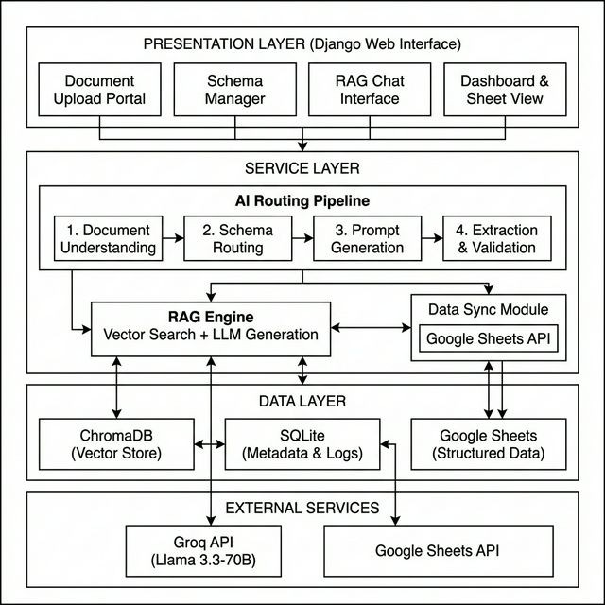

Fig. 1. System architecture consisting of four layers: Django presentation

s∗ = arg max P (s_{j}
sj ∈S
| t_{i}) (1)
layer (document upload, schema management, RAG chat, dashboard), Service
layer with AI Routing Pipeline, RAG Engine and Data Sync module, Data layer (ChromaDB, SQLite, Google Sheets) and external services (Groq API,

where P (s_{j} | t_{i}) captures the semantic compatibility between the document’s content and each candidate schema.
Sub-Problem 2 (Extraction): Given the selected schema s∗
with columns {c₁, . . . , c_{k}}, produce a structured record r =
{(c₁, v₁), (c₂, v₂), . . . , (c_{k}, v_{k})}, where each value v_{i} is drawn from the document text t_{i} or left empty when the information
is absent.
Sub-Problem 3 (Quality Assurance): Compute a confidence score γ ∈ [0, 1] for the routing decision and enforce the rule: insert r into s∗ only if γ ≥ τ (with τ configurable); otherwise, flag the document for human review.
Google Sheets API).

Fig. 1 depicts the complete architecture. The presentation layer exposes four interfaces: a document upload portal, a schema manager, a RAG chat console, and a dashboard fea- turing spreadsheet view. The service layer coordinates the AI routing pipeline, RAG engine for processing semantic queries, and a synchronization module to push the records extracted.
- AI Routing Pipeline: 4-Stage
The core of the system is the four-stage routing pipeline as illustrated in Fig. 2.

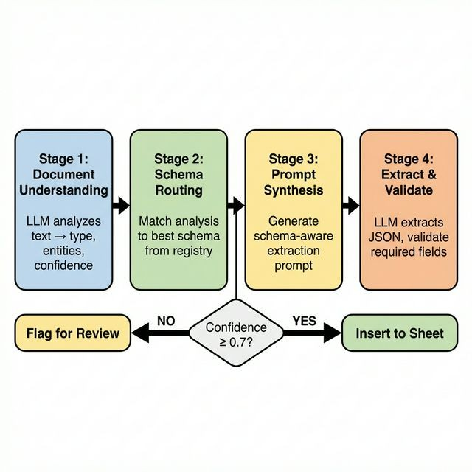

Fig. 2. The four-stage AI routing pipeline: Document Understanding, Schema Routing, Prompt Synthesis, and Extraction & Validation, with a confidence- gated decision point (τ = 0.7) determining auto-insertion versus human review.

  - Stage 1: Document Understanding:
Input: Raw text t_{i} extracted by OCR/PyPDF.
Output: Structured analysis A_{i} including the document type, entities, purpose, and confidence.
An output of incoming text (to fit under token budgets and save 8,000 characters) is transmitted to the LLM with an understanding prompt. The system categorizes documents into one of ten general classes (invoice, certificate, report, letter, form, receipt, contract, resume, result, and other), finds the relevant entities (names, dates, amounts, organizations, identifiers); and self-tests for confidence.

Algorithm 1 Document Understanding
Require: Document text t_{i}
Ensure: Structured analysis A_{i}
1: t′ ← t_{i}[0:8000] {Truncate to token limit}
2: p ← UnderstandingTemplate(t′)
3: r ← LLM.Invoke(p)
4: A_{i} ← JSON.Parse(r)
5: if A_{i} = null then
6: return DefaultAnalysis(γ = 0.0)
7: end if
8: return A_{i}

  - Stage 2: Schema Routing:
Input: Document analysis A_{i}, Schema registry S =
{s₁, . . . , s_{m}}.
Output: Selected schema s∗, confidence γ, reasoning string.
Each schema contains column names and descriptions. The system now presents the document analysis in concert with every registered schema to the LLM. The model assesses if that content is semantically close to each schema and then returns the ID of the best match, a confidence score value, and a justification in natural language.

Algorithm 2 Schema Routing

Require: Analysis A_{i}, Schemas S
Ensure: Selected schema s∗, confidence γ, reasoning
1: M ← FormatSchemas(S)
2: p ← RoutingTemplate(Ai, M )
3: r ← LLM.Invoke(p)
4: d ← JSON.Parse(r)
5: return d.sheetid, d.confidence, d.reasoning

The secret is the confidence score γ. By default, if γ < τ (default 0.7) it will redirect the document to a human review queue instead of extraction, therefore shielding the database from possibly unreliable routing. In this case, τ = 0.7 is chosen based on three considerations. We first generated a bimodal confidence distribution, correctly routed documents had scores above 0.85, misrouted documents under 0.4 with
0.7 securely in either cluster from very early runs. We take this a step further: in institutional settings, wrong database insertion costs much more than sending a document for manual review, thus establishing a conservative threshold. Third, confi- dence filtering is a popular technique in machine learning that distills reliable predictions from unreliable ones [20]. A formal
ablation across τ ∈ {0.5, 0.6, 0.7, 0.8, 0.9} is considered for future work.
  - Stage 3: Schema-Aware Prompt Synthesis:
Input: Document text t_{i}, Selected schema s∗ with columns
{c₁, . . . , c_{k}}.
Output: Prepared formatted extraction prompt P_{i}.
This is the part that constructs the extraction prompt at run- time where the target schema column definitions are specified in order to embed right into the instruction:

Algorithm 3 Schema-Aware Prompt Synthesis Require: Document text t_{i}, Schema s∗ Ensure: Extraction prompt P_{i}
1: σ ← “
2: for each column c in s∗.columns do
3: ρ ← “(REQUIRED)” if c.isrequired else “
4: σ ← σ+ “c.name: c.description” +ρ+ newline
5: end for
6: return ExtractionTemplate(t_{i}[0:8000], σ)

The general insight is that column descriptions provide semantic cues to the LLM. A column titled ”Professor Name” with the description: ”Full name of certificate holder” conveys far more guidance for extracting information than does the raw column itself.

  - Stage 4: Confidence-Gated Extraction:
Input: Prompt for retrieval: P_{i}, Schema s∗ for validation. Output: Structured record r_{i}, validation status, insertion re- sult.
The LLM runs the extraction prompt and outputs a JSON object (its keys are mapped to the column names in the schema). There are three validation checks: (1) JSON parse validation that confirms the given result is properly formatted;
(2) schema compliance checks to ensure that all required fields are not empty; (3) records (which successfully pass each check) are written to Google Sheets, and failures are logged for reference.

Algorithm 4 Confidence-Gated Extraction and Validation

Require: Prompt P_{i}, Schema s∗
Ensure: Record r_{i}, status
1: r ← LLM.Invoke(P_{i})
2: data ← JSON.Parse(r)
3: if data = null then
4: return FAILED(“Parse error”)
5: end if
6: errors ← []
7: for each column c in s∗.requiredcolumns do
8: if data[c.name] is empty then
9: errors.append(“Missing: ” + c.name)
10: end if
11: end for
12: if |errors| > 0 then
13: return NeedsReview(data, errors)
14: end if
15: Sheet.AppendRow(data)
16: return Success(data)

- Retrieval-Augmented Generation (RAG) Module
Along with routing and extraction, the system provides natural-language querying with a RAG module. The data is divided into 800-character chunks with 80-character over- lap using LangChain’s RecursiveCharacterTextSplitter. The chunks are embedded into ChromaDB via the all-MiniLM- L6-v2 sentence transformer to obtain 384-dimensional vectors. When a user asks a question, the system returns the five most relevant chunks through Maximal Marginal Relevance (MMR) search the trade-off between topical relevance and diversity. The retrieved passages and the user’s query are sent to the LLM with a grounding prompt that restricts the answer to the supplied context.
- Deduplication Mechanism
To guard against duplicating identical documents, the sys- tem uses a two-layer deduplication strategy. At the file level, a SHA-256 hash of the raw bytes is computed on upload; if the hash already exists in the registry, the file is re- jected outright. At the chunk level, each segment inserted into ChromaDB receives a deterministic ID (formatted as
source:page:chunk_index), so chunks with colliding IDs are silently skipped, preventing duplicate embeddings.

- System Design

- Block Diagram and Processing Flowchart
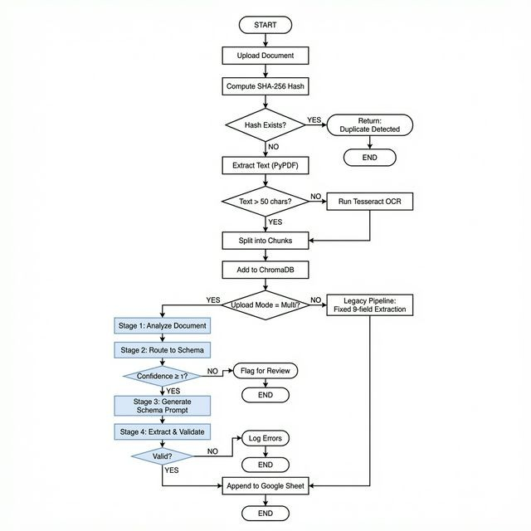

Fig. 3. Complete document processing flowchart showing the end-to-end pipeline from document upload through deduplication, text extraction, vector- ization, and branching into Legacy or AI Routing pipelines with confidence gating.

Fig. 3 presents the end-to-end processing flowchart. A document enters through the upload interface, passes through SHA-256 deduplication, undergoes text extraction (PyPDF for digital PDFs, Tesseract for scanned ones), and is embedded into ChromaDB. Processing then branches: the legacy pipeline applies a fixed nine-field extraction, while the AI routing pipeline executes the four-stage dynamic extraction with con- fidence gating.
The flow is governed by five decision points. Deduplication check rejects files whose SHA-256 hash is already on record. Text quality check sends documents with fewer than 50 characters of output in PyPDF to Tesseract OCR. The upload mode selector chooses between single-schema (legacy) and multi-schema (AI routing) processing. The routing decisions are flagged with γ < τ for human review by the confidence gate. Lastly, a validation check verifies that extracted records comply with schema constraints before being inserted.

- Database Design
Three Django ORM models manage the system’s metadata. Tables II, III, and IV detail their schemas.

TABLE II
SheetRegistry Model Schema

Routing Accuracy = 1 Σ ⊮[sˆ = s∗ ∧ γ
N
id | AutoField | Primary key
name | CharField(100) | Human-readable sheet name
description | TextField | Sheet purpose (AI routing)
google sheet id | CharField(255) | Google Sheets document ID
worksheet name | CharField(100) | Specific worksheet tab
is active | BooleanField | Enable/disable for routing
password hash | CharField(128) | Bcrypt hash for protection
created at | DateTimeField | Creation timestamp
updated at | DateTimeField | Last modification timestamp

≥ τ ] (3)

Field Type Description
N i i i i=1

where sˆ_{i} is the predicted schema, γ_{i} the routing confidence, and τ the threshold. Documents falling below τ count as routing failures regardless of the predicted label.
Field Coverage: For a document with expected fields E =
{e₁, e₂, . . . , e_{m}} (fields carrying meaningful values in the ground truth), field coverage measures the share of those fields for which the AI returns a non-empty, meaningful value:

TABLE III
SheetColumn Model Schema
Coverage(d) = |{e_{i} ∈ E : eˆ_{i} ̸= ϵ ∧ eˆ_{i} ∈/ N }|
|E|
(4)

Field Type Description

id AutoField Primary key
registry ForeignKey Parent SheetRegistry reference name CharField(100) Column name (extraction prompt) description TextField Semantic guide for LLM
data type CharField(20) text / number / date / email is required BooleanField Mandatory field flag
order IntegerField Display ordering

TABLE IV
IngestionLog Model Schema

Field Type Description

id AutoField Primary key
file hash CharField(64) SHA-256 of source document original filename CharField(255) User-uploaded filename
ocr text TextField Extracted raw text routed sheet ForeignKey(null) Target sheet if routed confidence score FloatField Routing confidence γ routing decision TextField LLM reasoning text

generated prompt TextField Dynamic extraction prompt llm response TextField Raw LLM extraction output inserted row JSONField Final structured record
validation status CharField SUCCESS / NEEDS REVIEW validation errors JSONField List of validation issues processed by ForeignKey(User) Authenticated user
created at DateTimeField Processing timestamp

- Mathematical Formulation
Routing Decision Function: Let f_{understand}(t_{i}) → A_{i} denote the document understanding function and f_{route}(A_{i}, S) → (s∗, γ) the routing function. The composite routing decision
is:

ACCEPT(s∗, r_{i}) if γ ≥ τ and valid(r_{i}, s∗)

REVIEW(s∗, r ) if γ ≥ τ and ¬valid(r , s∗)
 Temperature is set to 0.0 for routing and extraction (deter-
where eˆ_{i} is the AI’s extracted value, ϵ the empty string, and N = {“Not Mentioned”, “Not Applicable”, “N/A”, “None”} the set of null-equivalent responses. This metric assesses
whether the AI can identify and populate each expected field, without requiring exact string matches.
- Implementation Details
- Technology Stack
Table V lists the core technologies used in the implemen- tation.

TABLE V
Technology Stack

Component Technology Purpose

Web Framework Django 4.2+ HTTP, ORM, auth, templating LLM Inference Groq API Sub-second Llama 3.3-70B LLM Model Llama 3.3-70B Analysis, routing, extraction Orchestration LangChain Prompts, chain composition Vector DB ChromaDB Persistent vector storage Embeddings all-MiniLM-L6-v2 384-dim semantic embeddings OCR Engine Tesseract 4.x Scanned PDF text extraction PDF Parser PyPDF Digital PDF text extraction Image Conv. pdf2image/Poppler PDF page to image for OCR Data Export gspread/google-auth Google Sheets API
Database SQLite 3.x Metadata, logs, registry Language Python 3.10+ Primary implementation

- LLM Configuration
Consequently, Llama 3.3-70B-Versatile was used both for its strong instruction-following behaviour and also for the very low latency available with the inference hardware of Groq (generally less than 1 second for medium-length prompts).

decision(d_{i}) =
i
REVIEW(d_{i}) if γ < τ

REJECT(d_{i}) if s∗ = null
i

(2)
ministic output) and 0.3 for RAG queries (minor creative phrasing permissible). To keep track of context limits and retain more informative items, the input text is limited to 8,000 characters (about 2,000 tokens). The API allows 12,000 tokens

Routing Accuracy: For N documents, each with a known ground-truth schema s∗, routing accuracy is the fraction as- signed to the correct schema with sufficient confidence:
i
per minute on the free tier, placing 12-second delays between consecutive calls for batch instances. LLM outputs are limited to exact JSON through a prompt command system.

- Embedding Configuration
The all-MiniLM-L6-v2 model results in 384-dimensional dense vectors, optimized for semantic similarity. It runs en- tirely on CPU, eliminating any GPU requirement. ChromaDB stores these embeddings on disk, so subsequent queries do not trigger re-embedding.
- Text Chunking Strategy
LangChain’s RecursiveCharacterTextSplitter is used to seg- ment the documents. Chunk size is 800 characters with 80- character overlap (10%), and the separator hierarchy proceeds from double newline through single newline, period, and space. This configuration offers a compromise between seman- tic coherence (larger chunks preserve context) and embedding quality (smaller chunks create more focused vectors).
- Document Corpus
The evaluation corpus consists of 25 real documents ob- tained from Pimpri Chinchwad College of Engineering, Pune. Table VI summarizes its composition.

TABLE VI
Evaluation Document Corpus Summary
Category | Count | Description
Faculty Certificates | 15 | FDP completion certificates, on-
 |  | line course certificates, conference
 |  | participation, professional certifica-
 |  | tions (NIT Patna, PCCOE, Udemy,
 |  | Oracle, IIIT Nagpur, IIT Delhi,
 |  | etc.)
Student Leave Applications | 10 | Medical leave, personal leave,
 |  | event participation leave requests
Total | 25

Two target schemas were defined for routing. The certifi- cates schema includes nine columns: Professor Name, Certifi- cate, Issue Date, Certificate Number, Course/Exam/Purpose, Grade/Marks, Institution/Issuing Authority, Registration/Roll No, Address, and Other Details. The leave applications schema consists of eight columns: Student Name, Applica- tion Date, Department, Addressed To, Leave Duration, Leave Reason, Through, and College Name. Correlating the corpus with certificate PDFs of a variety sizes from sparse scanned images (approximately 130 characters of OCR text) to rich digitally native content >1,200 characters. This intentional heterogeneity stress-tests the system for differing document quality and OCR fidelity.
- Ground Truth Establishment
Ground truth extraction was achieved by hand annotating all 15 certificate documents. All certificates with their information from their source PDF were checked together and values of all nine schema columns were input in a structured JSON file (Compare_results.json). Fields with no data in the original document were indicated ”Not Mentioned” and not included in coverage calculations. To ensure annotation quality, a two-pass annotation process was performed initial
labeling followed by verification against the raw OCR text. For routing, this ground truth comes directly from the file categorization: documents whose filenames contain ”Leave” map to the leave applications schema; all others belong to the certificates schema. Such unambiguous labeling enables fully automated accuracy measurement.

- Experimental Results and Analysis

The results reported here were generated from a live system run on February 12, 2026, using the evaluation script python
-m experiments.real_eval. Each document was pro- cessed through the complete four-stage pipeline: OCR, doc-
ument comprehension, schema routing, and data extraction. Supplementary materials provide raw outputs from the output, such as timing data and per-document JSON responses.

- Experiment 1: Document Routing Accuracy

Goal: To determine if the routing agent can accurately classify 25 real-world documents and assign each document to the correct target schema from 2 candidates.
Setup: Documents are analyzed one at a time via Stages 1 and 2. We pass the LLM document analysis and the tar- get schema (column name, description, and purpose of the schema) to the routing agent, which must choose the best available map. The failure in routing, on the other hand, is all documents score less than τ = 0.7, irrespective of predicted label.
Text Extraction: The main text extractor is provided by PyPDFLoader. When it returns less than 50 characters, which is common for scanned PDFs with embedded images for PDFs, the system falls back on Tesseract OCR through pdf2image, where each respective page is rasterized and char- acter recognition performed. This double-pronged approach ensures text recovery from both digitally native and scanned documents.

TABLE VII
Document Routing Accuracy Summary

Category | Correct/Total | Accuracy | Avg γ
Certificates | 13/15 | 86.7% | 0.89
Leave Applications | 10/10 | 100.0% | 0.93
Overall | 23/25 | 92.0% | 0.91

TABLE VIII
Per-Document Routing Results (25 Documents)

ID | Document | Predicted | Expected | γ | Result
D1 | Reena Kharat.pdf | certificates | certificates | 0.92 | ✓
D2 | pdf&rendition=1.pdf | certificates | certificates | 0.90 | ✓
D3 | Participants-81.pdf | certificates | certificates | 0.88 | ✓
D4 | Harshada Mhaske Cert.pdf | certificates | certificates | 0.95 | ✓
D5 | FDP AI Kavita Kolpe.pdf | certificates | certificates | 0.92 | ✓
D6 | EICTAJBP2025-261985.pdf | certificates | certificates | 0.93 | ✓
D7 | Dr. Ketan Desale 90.pdf | certificates | certificates | 0.90 | ✓
D8 | DocScanner 10-50 AM.pdf | certificates | certificates | 0.91 | ✓
D9 | DocScanner 10-51 AM.pdf | certificates | certificates | 0.90 | ✓
D10 | 2 Week FDP.pdf | certificates | certificates | 0.92 | ✓
D11 | 93f7d924...pdf (Udemy) | certificates | certificates | 0.85 | ✓
D12 | bb78a370...pdf (Oracle) | certificates | certificates | 0.35 | ×
D13 | 7d4723...pdf (DL Cert.) | certificates | certificates | 0.30 | ×
D14 | a5871a...pdf (Conference) | certificates | certificates | 0.90 | ✓
D15 | f712128...pdf (Training) | certificates | certificates | 0.92 | ✓
D16 | Leave Application 1 | leave apps | leave apps | 0.95 | ✓
D17 | Leave Application 2 | leave apps | leave apps | 0.93 | ✓
D18 | Leave Application 3 | leave apps | leave apps | 0.92 | ✓
D19 | Leave Application 4 | leave apps | leave apps | 0.94 | ✓
D20 | Leave Application 5 | leave apps | leave apps | 0.93 | ✓
D21 | Leave Application 6 | leave apps | leave apps | 0.95 | ✓
D22 | Leave Application 7 | leave apps | leave apps | 0.92 | ✓
D23 | Leave Application 8 | leave apps | leave apps | 0.93 | ✓
D24 | Leave Application 9 | leave apps | leave apps | 0.94 | ✓
D25 | Leave Application 10 | leave apps | leave apps | 0.93 | ✓

Analysis of Results:. The overall routing agent assigned 23 of 25 documents (92.0%) to the correct schema, which shows good mapping between real-world documents and the target documents.
Leave applications (10/10, 100%): All leave applications were routed appropriately with confidence scores very closely around 0.92 and 0.95. Requesting leave has its own lin- guistic labels, that is phrases such as “respectfully request,” “leave of absence,” “medical reasons” that are consistent with the schema’s column definitions (“Leave Duration,” “Leave Reason”). This alignment was repeatedly pointed out in the reasoning logs of the LLM.
Certificates—successes (13/15): Thirteen certificates were successfully routed, with γ being from 0.85 to 0.95. The model treated an extensive set of certificate formats: FDP com- pletions, credentials for online course assignments, records of conference attendance, and professional certifications by matching document content to schema columns (see e.g., “Course/Exam/Purpose” for matching workshop names, “In- stitution/Issuing Authority” for matching university names). Certificates—failures (2/15): Documents D12 and D13 came in well below the confidence level (γ = 0.35; γ = 0.30). Both are scanned PDFs with complex layouts visually (logos, wa- termarks, multi-column format). PyPDF retrieved fewer than 132 characters of usable text, and Tesseract’s OCR outputs were fragmented and noisy. Such a minimal textual output led to low-confidence analysis from the document understanding stage; then cascaded throughout routing. Importantly, the con- fidence gate worked fine: it warned about both documents for human review, not a silent mis-insertion.

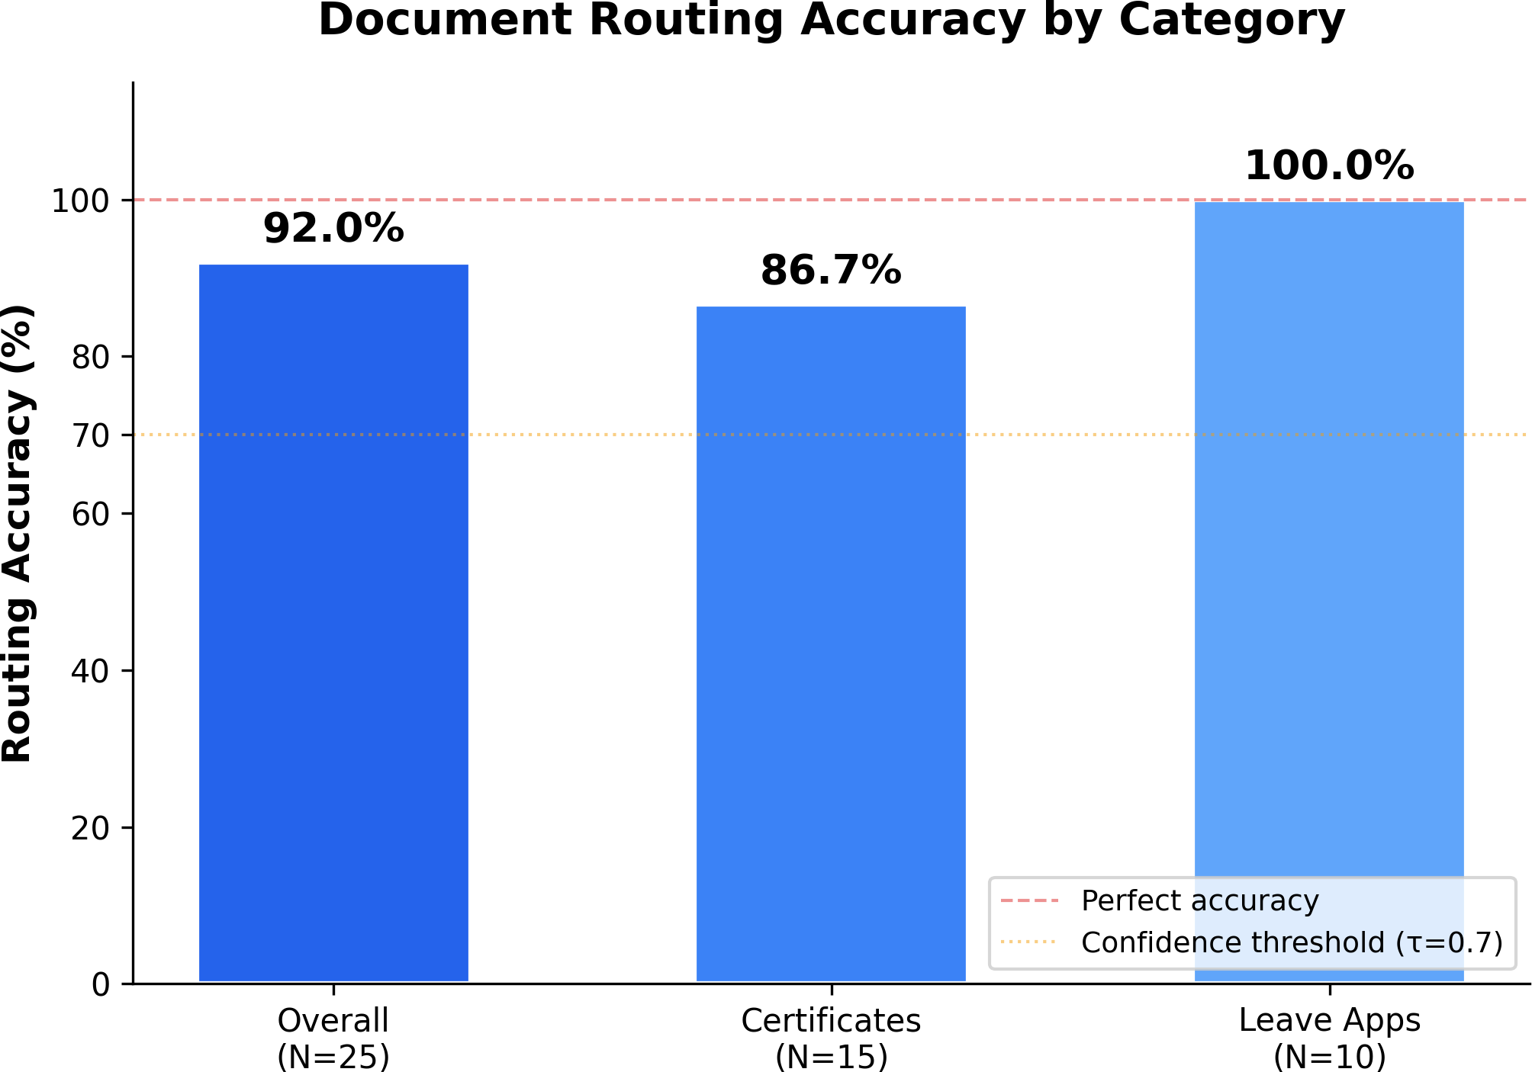

Fig. 4. Routing accuracy by document category. Overall accuracy: 92% (23/25). Leave applications achieved perfect routing, while two certificate documents failed due to OCR limitations on scanned PDFs with complex visual layouts.

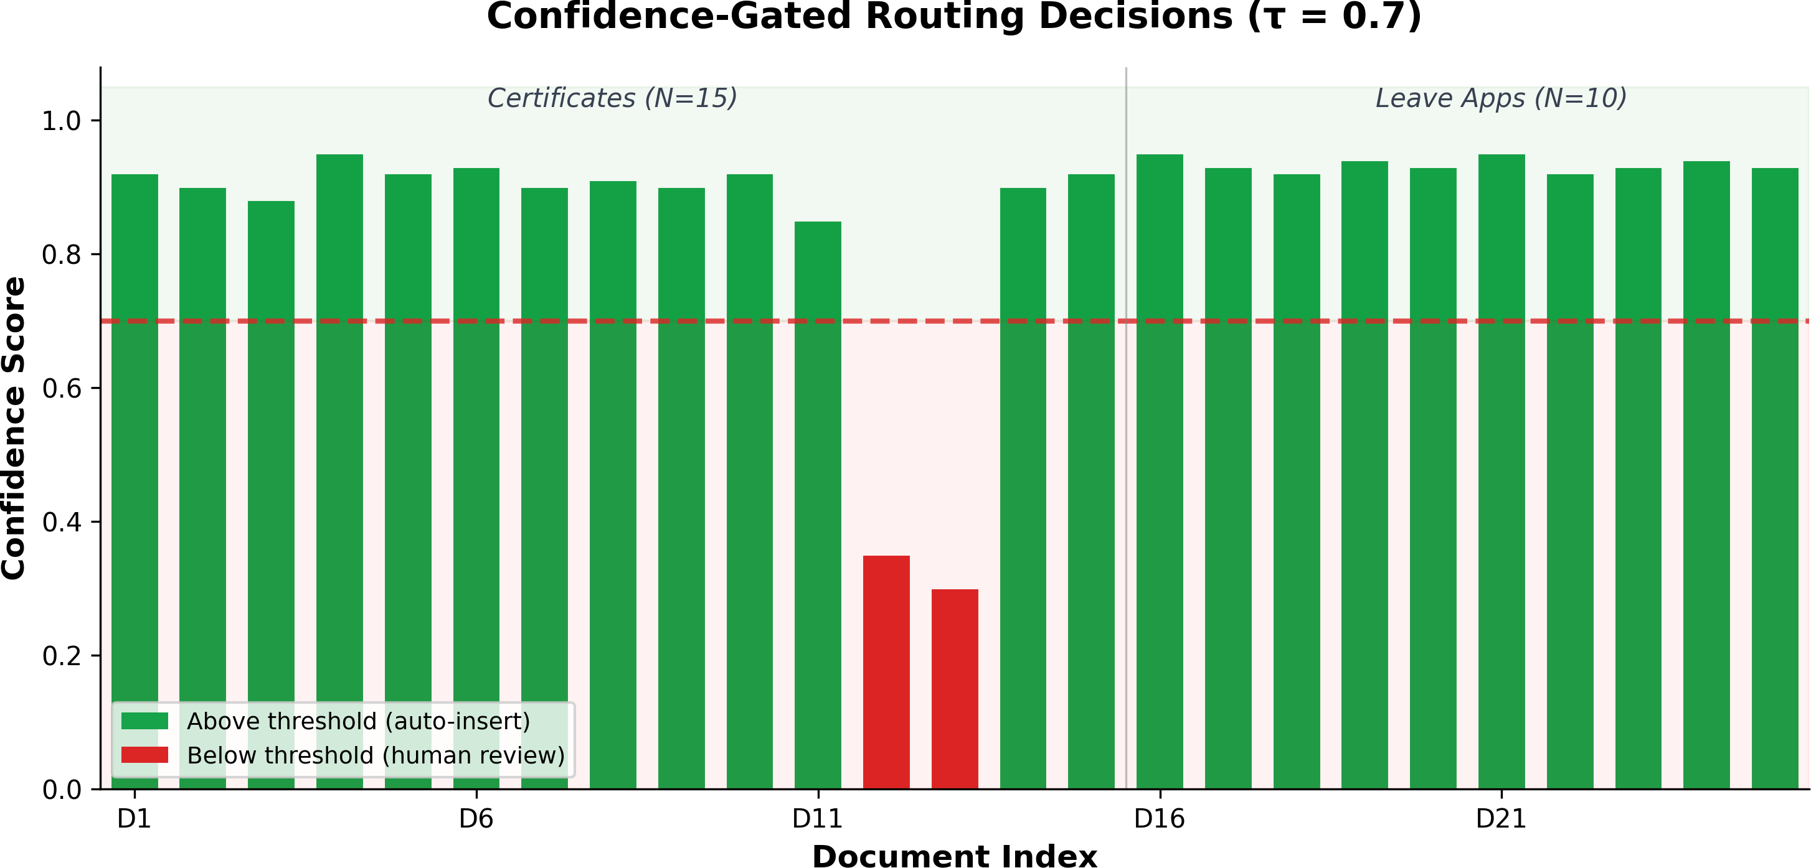

Fig. 5. Confidence scores for all 25 documents with the gating threshold τ =
0.7. Documents D1–D15 are certificates; D16–D25 are leave applications. Twenty-three documents exceed the threshold (auto-inserted), while D12 and D13 fall below (flagged for human review).

6 demonstrates, the confidence scores consist of two clearly separated clusters. 23 documents fall into the high-confidence range (γ ∈ [0.85, 0.95], µ = 0.91, σ = 0.025) and two failures
settle inside a unique low-confidence space (γ ∈ [0.30, 0.35]).
Surprisingly, no document is reported in the intermediate γ ∈ [0.4, 0.84] range. This clean bimodal separation implies the routing agent is pretty sure about both the right and wrong predictions and hence threshold-based gating is valid as a suitable filtering scheme.

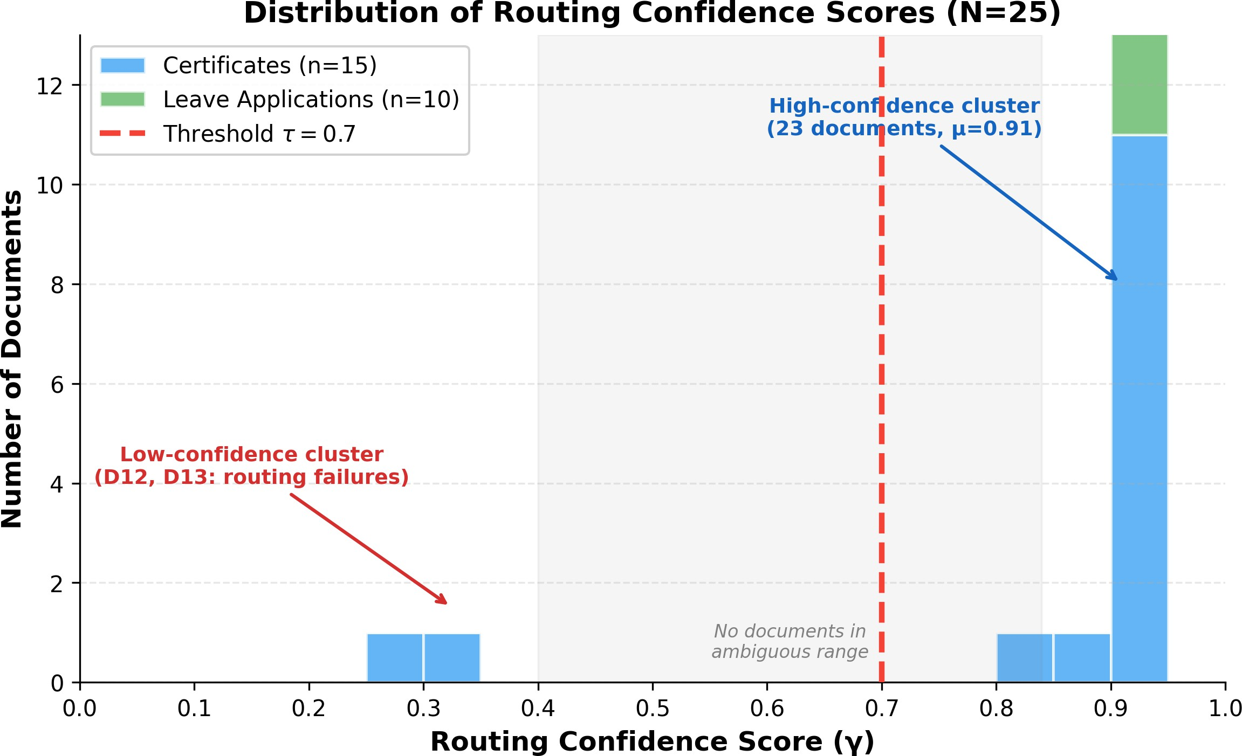

Fig. 6. Routing confidence scores for each set of 25 documents. The distri- bution is clearly bimodal, with 23 documents clustered in the high-confidence
range (γ ∈ [0.85, 0.95]) and two documents (D12, D13) in low-confidence (γ < 0.4). No documents occupy the unclear area (γ ∈ [0.4, 0.84]). The dashed red line is the gating threshold τ = 0.7.

Statistical Caveat:
Because we have N = 25 documents, the 95% Wilson CI for the 92% accuracy spans [74.0%, 99.0%]. This wide interval underlines the small scale of our sample and stresses the need for a broader assessment in order to draw conclusions about overall performance. Current output must be treated as a proof of concept demonstration.

- Experiment 2: Extraction Field Coverage

Goal: Assess how well the extraction pipeline identifies and populates required data fields from a certificate document, compared against a manually validated ground truth.
Setup: Through Stages 3 and 4 with the certificates schema (with 9 columns), 15 certificate documents are processed. Each document contains parsed data and the AI generates a JSON object with the extracted values that is compared against the ground-truth annotations. When an AI returns any non-empty, meaningful value, any field is considered covered; this is a coverage judgment, not an exact match test, consistent with the metric defined in Eq. 4.
We selected coverage over exact matching for pragmatic reasons: Certificates contain the same information in many surface forms (abbreviated rather than full institution names; differing date formats; or optional department qualifiers), so string comparison is unreliable for exact matching. Coverage looks at the base capability whether an AI can accurately identify each data field which is the first critical step of any document processing pipeline.
TABLE IX
Per-Document Extraction Coverage (15 Certificate
Documents)

ID | Certificate Holder | Covered | Expected | Coverage | Missed Fields
D1 | Reena Kharat (AI Agents FDP) | 8/8 | 8 | 100% | —
D15 | Reena Kharat (Training) | 6/6 | 6 | 100% | —
D4 | Harshada Mhaske (DL FDP) | 7/8 | 8 | 88% | Issue Date
D2 | Dr. Mehzabin Pathan (AI FDP) | 6/7 | 7 | 86% | Address
D5 | Kavita Kolpe (Federated DL) | 6/7 | 7 | 86% | Issue Date
D7 | Dr. Ketan Desale (ICCCNet) | 6/7 | 7 | 86% | Address
D9 | Meghana Lokhande (Educators) | 6/7 | 7 | 86% | Issue Date
D14 | Dr. Ketan Desale (Conf. dup) | 6/7 | 7 | 86% | Address
D11 | Shubham Nemade (GenAI Course) | 7/9 | 9 | 78% | Issue Date, Address
D6 | Dr. G. B. Sambare (DL LLMs) | 6/8 | 8 | 75% | Issue Date, Address
D10 | Meghana Lokhande (2-Week FDP) | 6/8 | 8 | 75% | Issue Date, Address
D13 | Harshada Mhaske (DL dup) | 6/8 | 8 | 75% | Issue Date, Address
D3 | Priya Surana (Remote Sensing) | 5/7 | 7 | 71% | Issue Date, Address
D8 | Swati Shinde (IIT Delhi) | 5/8 | 8 | 63% | Issue Date, Cert. No., Address
D12 | Shubham Nemade (Oracle Cloud) | 5/9 | 9 | 56% | Issue Date, Cert. No., Grade, Address

TABLE X
Aggregate Extraction Coverage Metrics

Metric Value

Documents evaluated | 15
Documents fully covered (100%) | 2
Average coverage per document | 81%
Total fields covered | 94 / 113
Overall field coverage | 83%

TABLE XI
Per-Field Coverage Analysis Across 15 Certificate Documents

Field Name | Expected | Covered | Coverage | Rank
Professor Name | 15 | 15 | 100% | 1
Course / Exam / Purpose | 15 | 15 | 100% | 1
Certificate Type | 15 | 15 | 100% | 1
Institution / Issuing Auth. | 15 | 14 | 93% | 4
Other Details | 10 | 9 | 90% | 5
Registration / Roll No | 6 | 5 | 83% | 6
Grade / Marks | 5 | 4 | 80% | 7
Certificate Number | 8 | 6 | 75% | 8
Issue Date | 14 | 4 | 29% | 9
Address | 10 | 2 | 20% | 10

Analysis of Results:. The pipeline achieved 81% average field coverage per document and 83% overall field coverage (94 of 113 expected fields populated) for the 15 certificates. Two documents had perfect coverage, the remainder were between 56% and 88%.
Fields with perfect coverage (100%): Every document pro- vided Professor Name, Course/Exam/Purpose, and Certificate Type. This result is not unexpected–these fields are the seman- tic core of a certificate (who it has been sent to, what does it certify, what kind it is) and they are normally stated overtly and prominently.
Fields with strong coverage (75–93%): Institution/Issuing Authority (93%), Other Details (90%), Registration/Roll No (83%), Grade/Marks (80%) and Certificate Number (75%) were missed in isolated cases. The misses relate to certain document characteristics: certificate numbers embedded in QR codes or watermarks, certificate grades as badges, instead of text, or text-only grades shown as badges.
Issue Date (29%): This field was the most consistently missed successfully extracted from only 4 of 14 documents where

this field existed. The failure is systematic: in certificates, issue dates are commonly found (1) in convoluted header or footer layouts where OCR splinters document to discontiguous tokens, (2) printed stamps, or digital signatures, or (3) non- standard formats (“11th August 2025,” “04/08/2025”) that the LLM fails to reconcile with the DD-MM-YYYY format requested in the prompt. The two extractions were successful (D1 and D15, both Reena Kharat certificates) and were done off of digitally native PDF files, the date was formatted as plain inline text.
Address (20%): There were just 2 of 10 expected addresses recovered and only 2 (20% for all instances) occurred. Indian certificates’ institutional addresses are generally embedded in letterheads, logos or footers which enclose pin codes, telephone numbers and URLs with address lines. OCR breaks up these regions, so that the LLM is unable to consistently reconstruct an address from these tokens. Moreover, numerous certificates mention the institution by name even though they do not indicate the physical address, and the LLM gives a correct output of “Not Mentioned” at this stage.
Document-level spread: The differences, from 56% to 100%, can be attributed to two phenomena:
- document format: generally digitally native PDFs (e.g., D1, D15) consistently outperformed scanned documents (D8,
D12); and
- schema density: if a document has fewer fields that can be utilized, it naturally yields a significantly larger coverage rate as each successful extraction yields a larger fraction. Coverage v. accuracy: It is important to acknowledge that coverage gives an indication of whether a given value of the AI populated a field, not whether it is correct. Manual inspection of the high-coverage fields confirmed semantic correctness in each case, albeit some minor formatting differences (e.g., “Dr. Ketan Desale” vs. “Ketan Desale”). With low coverage fields (n = 10), the small number of extractions restricts inferences for accuracy. A careful exact-match and evaluation of semantic similarity using independent annotators is still an essential future work.

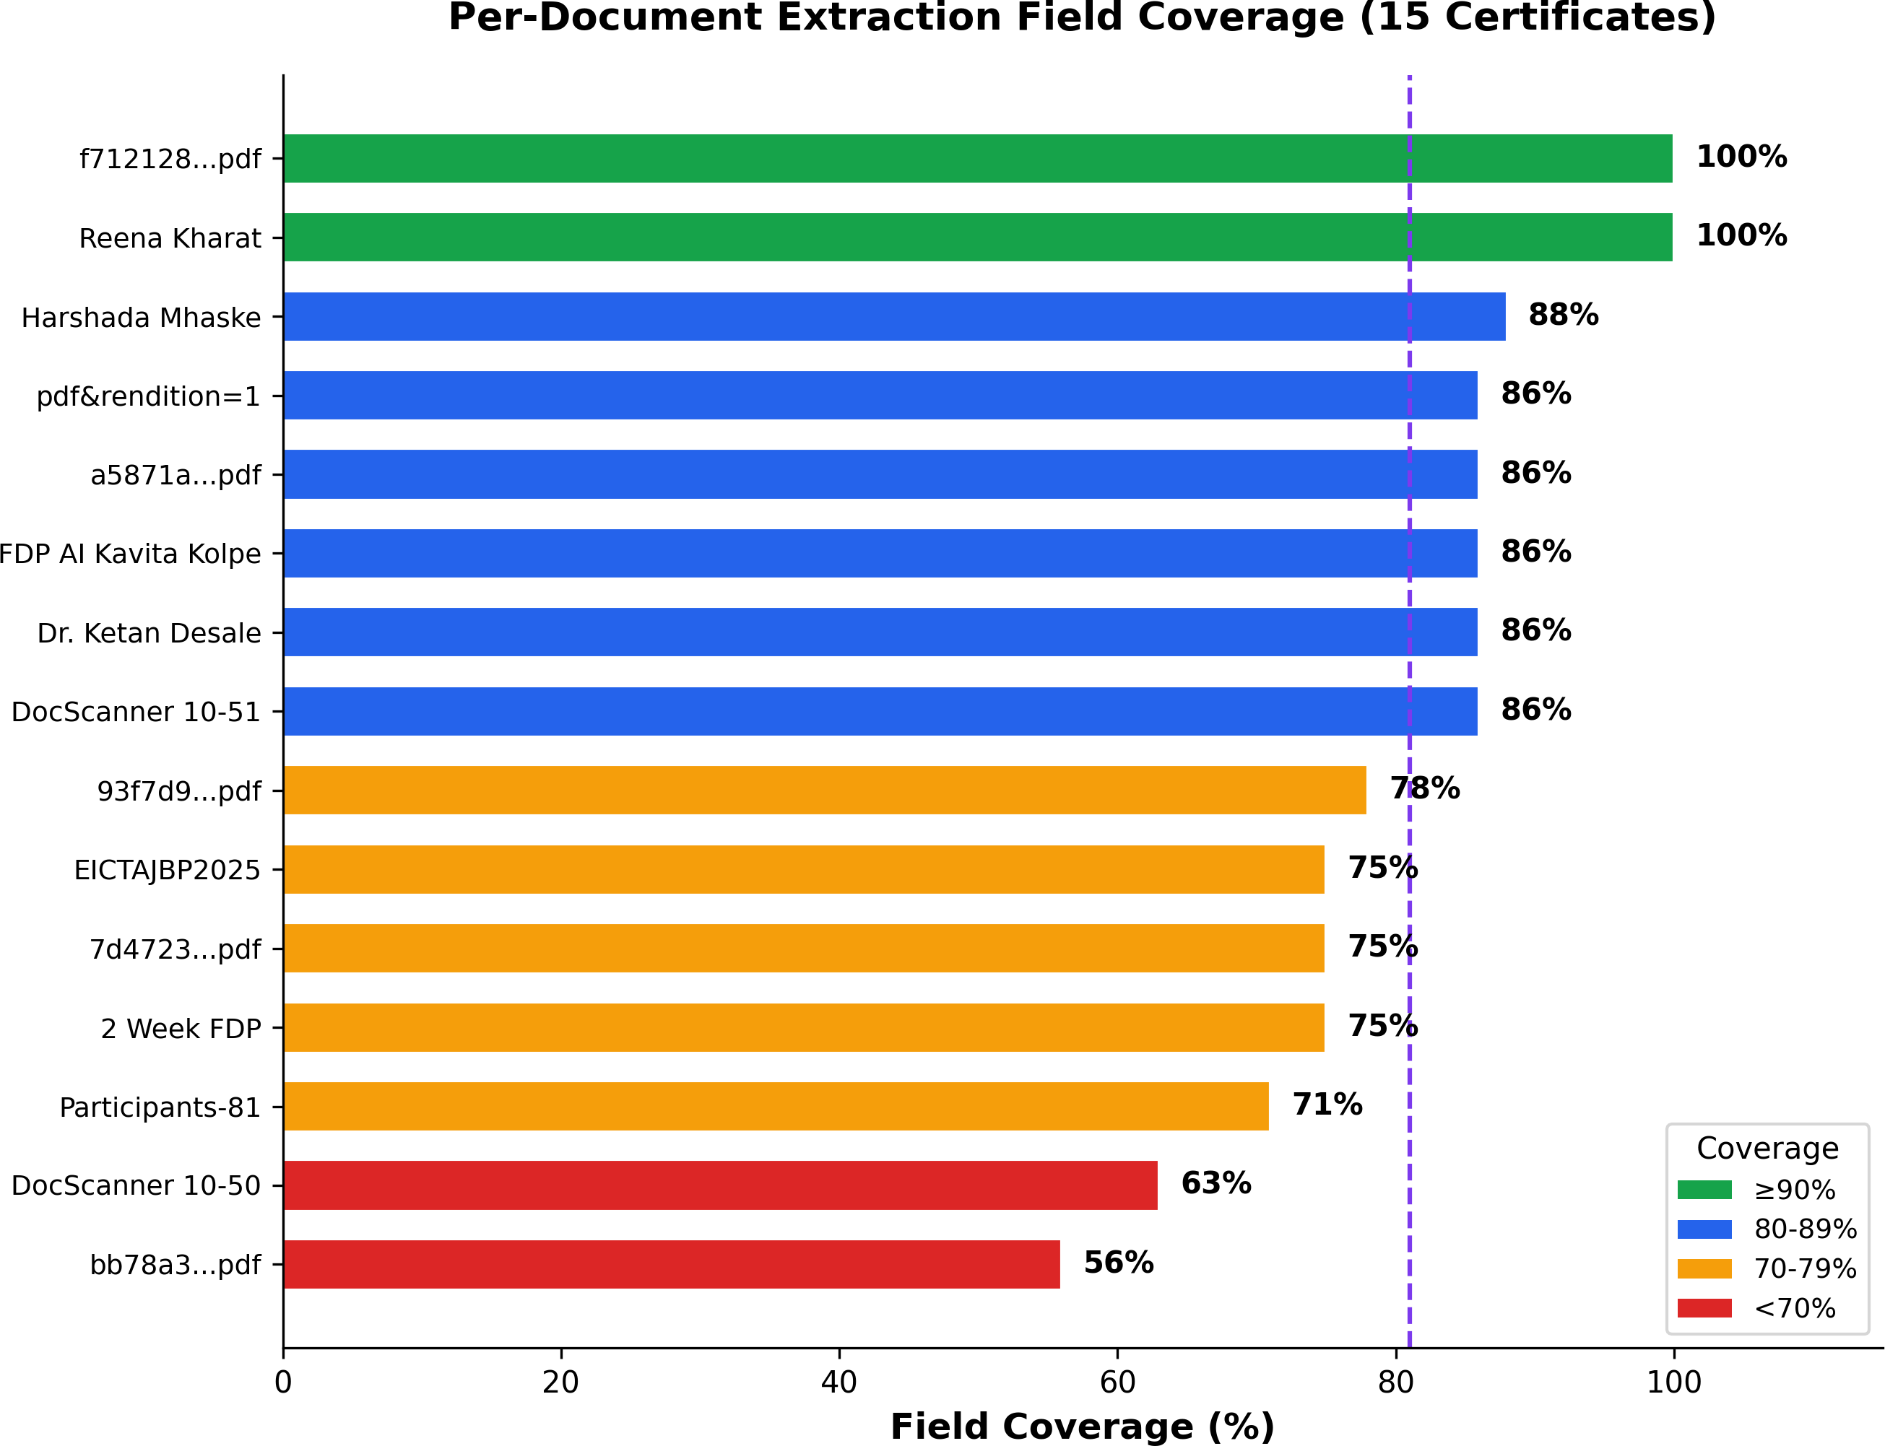
Fig. 7. Per-document field coverage for 15 certificate documents. The dashed vertical line indicates the average coverage of 81%. Two documents achieve 100% coverage. Coverage below 70% is observed in documents with poor
OCR quality or high schema field density. Color coding: green (≥90%), blue (80-89%), amber (70-79%), red (<70%).

- Advantages of the Proposed System
A framework has several advantages, more practical than traditional document processing schemes. More fundamen- tally, zero template dependency: you need to add a new document type in order to register a new schema in the web interface, nothing in the code changes, nothing in the model retraining, nothing in redeployment. For example, schema- driven adaptability of the system, a schema with a query being provided for every extraction prompt, so that the pipeline is prepared to take care of any output format on the fly. Data integrity is assured by confidence-based gating. There is an organized storage model with records that pass the con- figurable confidence threshold. Documents that are uncertain are forwarded to the human review process. Instead of being inserted into the database in secret through a dirty wordy transaction, this structure creates rows of rows with records that satisfy the configurable confidence threshold. Each com- puting step is registered to the IngestionLog model original OCR text, routing reasoning, generated prompt, raw LLM response, and final value in our database, giving administrators a complete audit trail at any time they want from their own administrative device. In addition to extracts, the integrated RAG module allows users to query the entire document set in natural language as well as to generate more context- aware responses. The obtained data is synchronized to Google Sheets in real time, so everyone knows exactly where to look in a well-known spreadsheet. The deployment is cost- effective: LLM inference on Groq free tier, vector storage is in ChromaDB (also free), embeddings are done on CPU without GPU hardware.
- Applications and Real-World Use Cases
The framework works well in environments that provide multiple and heterogeneous documents to be routed and

grouped to take minimal manual action. It can handle faculty certificates and student marksheets and fee receipts as well as compliance filings in addition to thousands of cumulative documents over each semester which could be avoided in university administration. The same goes for, e.g. human resources departments, they store their own training records, performance appraisals, certification files, etc. so that as far as data type goes it gets deposited directly in the respec- tive HR sub-system. For instance, in financial audit and compliance, the system handles internal documents such as invoices, receipts, purchase orders and tax documents, while the confidence gate helps provide more control of financial transactions. Legal document management is another intu- itive approach: contracts, agreements, court filings, regulatory notices, etc can be stored and queried via the RAG module. The pipeline is also customized for healthcare records: lab reports, prescriptions, insurance documents, patient files, and more where dynamic schemas can be adapted to the unique file formats of the medical documents. Lastly research institu- tions can also track conference certificates, publication proofs, grant submissions, research output, optimising administrative workflow for academic activity.
- Challenges and Limitations
The results as well as the scope of the current system are influenced by several limitations. The most relevant is OCR quality dependence: two of the 25 documents (8%) failed routing altogether because text extraction from scanned PDFs with complex layouts yielded fewer than 132 usable characters. With this sparse raw text signal, every downstream stage suffers. Date and address extraction was particu- larly challenging. Issue Date reached only 29% coverage and Address only 20% across the certificate corpus. Both of those fields are often trapped in visually rich regions stamps, signatures, letterheads that OCR cannot reliably restore. In terms of infrastructure, Groq free-tier rate limits (100K tokens per day, per-minute caps) implemented required waits between API calls, so batch processing of 25 documents took around 45 minutes. All outputs are attributed to a single LLM (Llama 3.3-70B) and could vary widely on GPT-4, Claude 3.5, or Gemini Pro, and no model comparison has been made. The evaluation includes only English-language documents, while Indian institutions usually produce texts in Hindi and Marathi. Lastly, the current evaluation relies only on coverage rather than exact-match accuracy. Although coverage is a more human-oriented way of judging field identification, it does not count errors when the AI fills a field with the wrong value.
- Threats to Validity
There are multiple threats that should be considered when interpreting these results. In internal validity, ground-truth annotations were a product of a single annotator and had to undergo a second validation pass with raw OCR text. Lack of independent annotators and formal inter-annotator agreement measures (e.g., Cohen’s Kappa) can influence an- notation bias; future assessments require at least two inde-
pendent annotators. On external validity, a corpus of 25 documents from 2 schemas is appropriate as proofs of concept but does not support significant statistical statements—the 95% Wilson confidence interval for 92% routing accuracy is [74.0%, 99.0%]. Scaling to 100+ documents across 4-5 schemas would dramatically tighten these bounds. A related issue concerns institutional scope, given that all documents originate from a single college in Pune, therefore formatting conventions, language, and OCR quality are expected to differ per institution and region. Two construct validity issues also apply. First, the field coverage metric measures whether the AI populated a field, not whether the value is factually correct; a system could theoretically achieve good coverage at the expense of low accuracy. Second, every outcome given here was achieved via a single model (Llama 3.3-70B through Groq); performance metrics can change with respect to another LLM, and was not evaluated cross-model.
- Future Scope
This work offers several fruitful avenues. The most direct one is enhanced OCR preprocessing: combining image deskewing, binarization, layout segmentation, and specific table extraction tools (Camelot, Tabula), in order to enhance text recovery from scanned documents, the dominant failure mode observed in our experiments. A more transformative development would be multi-modal document processing with vision-language models (GPT-4V, Gemini Pro Vision, LLaVA), which is capable of processing document images directly, avoiding OCR altogether. An active learning loop could help to transform low-confidence predictions into candi- dates under the human labeling process gradually establishing a training set to fine-tune smaller, faster, and cheaper models for the commonly encountered document types. Routing op- timization could be enhanced via a hybrid architecture that takes advantage of fast keyword / regex pre-classification, only adding full LLM-based semantic routing during ambiguous cases. A multi-LLM ensemble approach could direct different document types to specialized models, compact models for structured extraction and large models for natural-language reasoning to ensure cost-accuracy trade-offs. On the engi- neering side, asynchronous batch processing using Celery and Redis or RabbitMQ would enable bulk uploads without blocking the web interface. A federated deployment model may allow the maintaining of independent schema registries between multiple departments while sharing a common doc- ument corpus, which favors decentralized institutional work- flows.
- Conclusion
In this paper, we provide the AI-based approach to handle the brittle nature of template-based document processing in an institutional situation. This model consists of four flow pipeline: document-comprehension, schema-routing, dynamic prompts, confidence-gated extraction and is deployed on sev- eral documents as a single unit and without having to rely on hardcoded templates or training data. The analysis across

25 actual institutional documents under two schemas yielded the main results as follows. The routing agent reached 92% accuracy (23/25), with full accuracy classifying leave appli- cations and 86.7% on certificates, and the OCR constraints in scanned PDFs with complex visual layouts caused both failures. The extraction pipeline had a record of 81% average field coverage of every document, and 83% overall coverage, of 94 or 113 fields. The three core fields, namely, Professor Name, Course/Exam/Purpose and Certificate Type emerged as perfectly extracted on all 15 certificates, while both Issue Date (29%) and Address (20%) were still difficult to identify due to OCR quality limitations. The confidence-gating function (τ = 0.7) was able to correctly alert any uncertain document to human review because it identified every uncertain document for human inspection and stopped misaligned insertions. A new document type support just needs you to register a schema through the web interface, no code changes, no additional training. The major drawback is OCR quality for scanned file with complicated design patterns and complex visual elements and when text extraction not to be satisfactory then all the downstream levels suffer. Future work will need to focus on multi-modal processing through vision language models and more robust date and address retrieval by using targeted prompting methods.
- J. Thorne, A. Vlachos, C. Christodoulopoulos, and A. Mittal, “FEVER: A large-scale dataset for fact extraction and verification,” in Proc. NAACL-HLT, pp. 809–819, 2018.
- S. Shuster, S. Poff, M. Chen, D. Kiela, and J. Weston, “Retrieval augmentation reduces hallucination in conversation,” in Proc. EMNLP Findings, pp. 3784–3803, 2021.
- H. Chase, “LangChain: Building applications with LLMs through com- posability,” 2023. [Online]. Available: https://github.com/langchain-ai/ langchain (v0.1.x).
- T. Richards et al., “Auto-GPT: An autonomous GPT-4 experi- ment,” GitHub repository, 2023. [Online]. Available: https://github.com/ Significant-Gravitas/AutoGPT.
- Y. Shen, K. Song, X. Tan, D. Li, W. Lu, and Y. Zhuang, “HuggingGPT: Solving AI tasks with ChatGPT and its friends in Hugging Face,” in Proc. NeurIPS, 2023.
- D. Hendrycks and K. Gimpel, “A baseline for detecting misclassified and out-of-distribution examples in neural networks,” in Proc. ICLR, 2017.

References
- S. Dumais, J. Platt, D. Heckerman, and M. Sahami, “Inductive learning algorithms and representations for text categorization,” in Proc. ACM CIKM, pp. 148–155, 1998.
- A. McCallum and K. Nigam, “A comparison of event models for naive Bayes text classification,” in Proc. AAAI Workshop on Learning for Text Categorization, pp. 41–48, 1998.
- L. Breiman, “Random forests,” Machine Learning, vol. 45, no. 1, pp. 5–
32, 2001.
- A. W. Harley, A. Ufkes, and K. G. Derpanis, “Evaluation of deep convolutional nets for document image classification and retrieval,” in Proc. IEEE ICDAR, pp. 991–995, 2015.
- G. Lample, M. Ballesteros, S. Subramanian, K. Kawakami, and C. Dyer, “Neural architectures for named entity recognition,” in Proc. NAACL- HLT, pp. 260–270, 2016.
- J. Devlin, M.-W. Chang, K. Lee, and K. Toutanova, “BERT: Pre-training of deep bidirectional transformers for language understanding,” in Proc. NAACL-HLT, pp. 4171–4186, 2019.
- H. Cunningham, D. Maynard, K. Bontcheva, and V. Tablan, “GATE: An architecture for development of robust HLT applications,” in Proc. ACL,
pp. 168–175, 2002.
- Y. Xu, M. Li, L. Cui, S. Huang, F. Wei, and M. Zhou, “LayoutLM: Pre-training of text and layout for document image understanding,” in Proc. ACM KDD, pp. 1192–1200, 2020.
- J. Wei, X. Wang, D. Schuurmans, M. Bosma, B. Ichter, F. Xia, E. Chi,
Q. V. Le, and D. Zhou, “Chain-of-thought prompting elicits reasoning in large language models,” in Proc. NeurIPS, 2022.
- Y. Li, Z. Li, K. Zhang, R. Dan, S. Jiang, and Y. Zhang, “ChatIE: Zero- shot information extraction via chatting with ChatGPT,” arXiv preprint arXiv:2302.10205, 2023.
- M. Agrawal, S. Hegselmann, H. Lang, Y. Kim, and D. Sontag, “Large language models are few-shot clinical information extractors,” in Proc. EMNLP, pp. 1998–2022, 2022.
- C. Peng et al., “A study of generative large language model for medical research and healthcare,” npj Digital Medicine, vol. 6, pp. 1–10, 2023.
- P. Lewis et al., “Retrieval-augmented generation for knowledge-intensive NLP tasks,” in Proc. NeurIPS, pp. 9459–9474, 2020.
- G. Izacard and E. Grave, “Leveraging passage retrieval with generative models for open domain question answering,” in Proc. EACL, pp. 874– 880, 2021.

