2×25 kV up gradation in Indian Railway Traction for Heavy-Haul Traffic and High-Speed Operations

Abstract

The limits of the traditional 25 kV AC traction system has been brought to light by Indian Railways' growing need for heavy-haul freight operations and quicker passenger services. The application of the 2x25 kV AC traction system, which offers improved voltage stability, reduces line losses, and increased hauling capacity is examined in this study. International practices, economic benefits, operational viability, and technical advantages are all examined. According to the study's findings, India's high-speed passenger train operations and long-distance heavy-haul freight lines depend on a 2x25 kV upgrade.
Keywords: 2×25 kV, Indian Railways, heavy-haul, traction, auto-transformer, high-speed trains, electrification.

- Introduction

In order to satisfy rising freight and passenger needs, Indian Railways is rapidly electrifying. Long-distance heavy-haul operations present difficulties for conventional 25 kV AC traction systems because of voltage dips and line losses. Stable voltage features are also necessary for high-speed passenger trains to continue operating reliably. A technically and financially feasible option to these problems is the 2×25 kV AC traction system, which is based on auto-transformer.

II. Overview of Traction Systems

A. Conventional 25 kV AC System
The 25 kV single-phase systems are widely used for electrification due to its simplicity and low installation costs. However, its limitations include:
- Voltage drop over major distances (>50 km).
- Limited nature for heavy-haul freight trains.
- Reduced efficiency for high-speed train operations.

B. 2×25 kV AC System
The 2×25 kV system uses an auto-transformer (AT) configuration where the neutral of the line is connected to the centre point between two feeders. Advantages include:
- Reduced potential drop across high distances.
- Increased power transfer capacity.
- Better voltage stability for maximum-speed and heavy-haul trains.
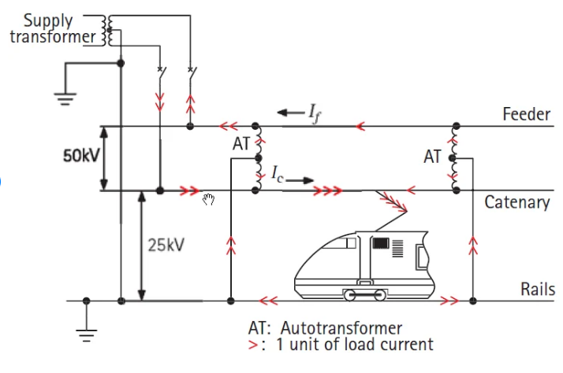
Figure 1: Schematic diagram of 2×25 kV auto-transformer fed traction system

III. Technical Advantages for Heavy-Haul Operations

A. Reduced Line Losses
Line losses are proportional to the square of current. By maintaining effective voltage at 50 kV through 2×25 kV operation, current is reduced by nearly 50%, significantly lowering losses.

B. Enhanced capacity Handling
- Capable of supporting trains with axle loads up to 32.5 tones.
- Supports multiple locomotives for longer freight trains.

C. Voltage Stability
- Auto-transformer sections maintain voltage within ±5% for distances up to 120 km.
- Reduces traction transformer stress and minimizes locomotive downtime.
Table I: Comparison of 25 kV vs 2×25 kV System

Parameter | 25 kV System | 2×25 kV System
Maximum Distance Without AT | ~50 km | 100–120 km
Line Loss | Higher | Lower
Maximum Train Load | Moderate | High
Voltage Stability | Moderate | High

IV. High-Speed Train Operations

A. Improved Voltage Regulation
- Maintains supply voltage under high acceleration conditions.
- Reduces locomotive transformer heating loss, ensuring longer operational life.

B. Speed Potential
- Supports speeds of 110–160 km/h with minimal voltage drop.
- Aligns with semi-high-speed corridor requirements and Dedicated Freight Corridors (DFC).

V. Implementation in Indian Railways

A. Current Status
- Several sections, including Delhi–Mumbai and Howrah–Mumbai, have been upgraded to 2×25 kV operation.

B. Challenges
- More installation cost (~2–3 times conventional 25 kV).
- Infrastructure change such as bridges, OHE (overhead equipment), and signaling.
- Training manpower for operation and maintenance.

C. Solutions
- Gradual up gradation with dual-voltage locomotives.
- Phased installation along freight corridors to minimize disruption.

VI. International Case Studies
- Germany and France: Successfully implemented 2×25 kV AC for high-speed and freight lines.
- Switzerland: Used auto-transformer schemes for mountainous terrain with heavy trains.
- Lessons: Phased integration, proper AT spacing and modern monitoring systems are crucial.

VII. Economic and Environmental Benefits
- Energy Efficiency: Line losses reduced by ~20–25%.
- Reduced Carbon Emissions: Supports India’s green energy economy targets.
- Operational Efficiency: Higher hauling features and faster trains improve overall network throughput.

VIII. Future Prospects
- Complete up gradation along Dedicated Freight Corridors (DFC) for heavy-haul efficiency.
- Integration with semi-high-speed and high-speed passenger Rail Route.
- Future research into 3×25 kV or hybrid systems for extreme heavy-haul operations.

IX. Conclusion

The heavy-haul freight and high-speed passenger operations in India, the 2×25 kV AC traction system offers a sustainable option. It increases operational efficiency, lowers losses, supports greater loads, and improves voltage stability. Both freight and passenger mobility may be greatly enhanced by gradual deployment throughout Indian Railways, supporting both environmental sustainability and economic prosperity.

References
[1] Indian Railways Electrification Manual, Ministry of Railways, India.
[2] CIGRÉ Technical Brochure No. 276, Auto-Transformer Feeding of 25 kV AC Railways, 2010.
[3] Bhattacharya, S., Railway Traction and Electrification, 2nd Edition, 2020.
[4] International Railway Journal, “Double-section 25 kV Systems for Heavy Freight,” 2019.
[5] Ministry of Railways, India, Annual Report 2022–23 on Electrification Projects.

