Adaptive Collaborative Implementation of Urban Poverty Alleviation Policy in Bandung City, Indonesia NVivo-Based Evidence and Policy Novelty

ABSTRACT
Urban poverty alleviation requires more than the adoption of local regulations and social assistance programs. It depends on how policy content is translated into field operations, how institutional actors coordinate across levels, and how beneficiaries experience the results of policy implementation. This article analyses the implementation of poverty alleviation policy in Bandung City, Indonesia, using a qualitative case-study design supported by NVivo. Data were obtained from interviews, policy documents, poverty statistics, and implementation evidence. The analysis used word-frequency queries, thematic coding, and matrix coding to examine three core issues: the content of implementation, the context of implementation, and policy effectiveness. The results show that the most dominant NVivo themes include policy, program, community, assistance, benefits, coordination, resources, implementers, data, targeting, and service responsiveness. The content dimension emphasizes benefit types, intended change, decision-making, implementing actors, and resources, while the context dimension highlights actor strategies, institutional characteristics, compliance, responsiveness, and cross-sector coordination. Policy effectiveness is visible in reduced expenditure burdens and better access to basic services, but it remains constrained by dynamic poverty data, uneven targeting, fragmented coordination, and the limited integration between social assistance and economic empowerment. The novelty of this study lies in developing an adaptive collaborative implementation model that integrates Grindle's content-context framework with NVivo-based empirical evidence, continuous poverty data validation, community-based verification, service responsiveness, and empowerment-oriented poverty reduction. The study contributes to urban governance literature by demonstrating that effective poverty alleviation in dense urban areas requires adaptive collaboration rather than purely administrative program delivery.
Keywords: Poverty Alleviation, Policy Implementation, Collaborative Governance, NVivo Analysis, Bandung City.

INTRODUCTION
Poverty remains a central challenge in public governance because it is multidimensional, dynamic, and closely connected to social vulnerability, economic insecurity, access to public services, and institutional capacity. In urban areas, poverty is often complicated by high living costs, informal employment, population mobility, spatial inequality, and pressure on public services. These characteristics require local governments not only to distribute assistance, but also to build integrated, responsive, and sustainable policy implementation systems supported by modern public administration and robust local governance dynamics [1], [2], [3], [4]. In the context of developing nations, modern governance requires a comprehensive understanding of state administrative systems to ensure local policies align with broader national frameworks [5]. Under decentralized systems, local governments are granted the authority to manage their own affairs, yet this decentralization introduces complex dynamics in executing social welfare initiatives [6].
Indonesia has made progress in reducing poverty at the national level. However, urban poverty continues to present specific challenges. Urban households face volatile income, rental and food-price pressures, and changing eligibility status that may not be fully captured by periodic administrative data. For this reason, the effectiveness of poverty alleviation policy must be evaluated not only from aggregate poverty rates but also from the quality of implementation, the accuracy of targeting, and the ability of programs to create sustained improvements in household welfare [7], [8].
Bandung City provides an important case for analysing urban poverty governance. In March 2025, the number of poor people in Bandung City reached 99.12 thousand people or 3.78 percent of the population, decreasing from 101.10 thousand people or 3.87 percent in March 2024. At the same time, data on extreme poverty showed a sharp increase from 87,402 individuals in 2022 to 143,534 individuals in 2023 and 184,360 individuals in 2024. This creates an urban governance paradox: aggregate poverty indicators show improvement, while extreme poverty and vulnerability remain urgent in several subdistricts [9], [10].
The municipal government has responded through various policy instruments, including Regional Regulation No. 4 of 2020 on Poverty Alleviation and Mayor Regulation No. 23 of 2024 on the Regional Poverty Alleviation Plan for 2024-2028. These policy instruments emphasize reducing the expenditure burden of poor households, increasing household income, minimizing poverty pockets, strengthening social assistance and social security, empowering communities and micro-enterprises, and improving program integration, budgeting, targeting, monitoring, and evaluation [11], [9].
Previous studies on poverty alleviation in Indonesia have generally focused on program barriers, social assistance effectiveness, planning documents, and poverty indicators. Fewer studies have examined how the content of policy, the context of implementation, and effectiveness interact in a dense urban setting using systematic qualitative software evidence. This article addresses that gap by using NVivo-supported thematic analysis to identify dominant narratives, coding patterns, and implementation relationships in Bandung City [12], [13], [14].
Table 1. Key poverty indicators in Bandung City
Indicator | 2023 | 2024 | 2025 / latest available
Number of poor people (thousand) | 102.80 | 101.10 | 99.12 (March 2025)
Poverty rate (%) | 3.96 | 3.87 | 3.78 (March 2025)
Poverty line (IDR per capita per month) | - | 614,707 | 644,417 (March 2025)
Extreme poor individuals | 143,534 | 184,360 | P3KE data, latest used in the study

LITERATURE REVIEW
Poverty Alleviation and Urban Governance
Poverty is commonly understood as the inability to meet minimum living standards. Contemporary poverty studies emphasize that poverty is not limited to income or consumption; it also includes limited access to education, health, housing, employment, social protection, and political voice. The multidimensional approach is important for urban poverty because households may be located near economic opportunities while still experiencing insecure work, unstable income, and limited access to affordable services [1], [2], [15]. In Indonesia, poverty measurement by the Central Statistics Agency uses the basic needs approach. A person is classified as poor when per capita monthly expenditure falls below the poverty line, which consists of food and non-food components. This approach provides a clear statistical boundary, but implementation of poverty alleviation requires more than measurement. Local governments must ensure that data, targeting, service delivery, and empowerment programs correspond to the changing condition of poor and vulnerable households [8], [16]. Urban poverty governance requires a combination of social protection and empowerment. Social assistance can reduce short-term expenditure burdens, while empowerment programs can strengthen income generation, skills, micro-enterprise capacity, and access to productive resources. A policy that relies only on assistance risks creating temporary relief without building the capability of poor households to move out of vulnerability [17], [18], [19].
Policy Implementation and Effectiveness
Policy implementation theory explains why policies that appear clear in formal documents may produce different results in practice. Grindle's model is particularly relevant because it views implementation as a political and administrative process shaped by the content of policy and the context of implementation. Policy content includes interests affected, types of benefits, degree of change expected, decision-making location, program implementers, and resources committed. Implementation context includes the power, interests, and strategies of actors, institutional characteristics, and compliance and responsiveness of implementers [12], [13], [20]. Policy effectiveness refers to the extent to which implementation produces intended outcomes and solves public problems. In this article, effectiveness is analysed through four dimensions: policy impact, targeting accuracy, public problem solving, and achievement of policy objectives. This framework is suitable for poverty alleviation because effectiveness cannot be measured only by program completion; it must be assessed through actual benefits, fairness of targeting, responsiveness to public problems, and the sustainability of improvements in household welfare [21], [22]. NVivo-supported qualitative analysis strengthens policy implementation research by making coding, thematic organization, and cross-informant comparison more transparent. Word clouds help identify dominant narratives, while matrix coding helps compare how different actors emphasize different dimensions of policy implementation and effectiveness [23], [24].

METHODOLOGY
This study uses a qualitative case-study design to understand the implementation of poverty alleviation policy in Bandung City. A qualitative approach was selected because the research problem concerns institutional processes, actor interaction, field-level responsiveness, and beneficiary experience. The case-study design allows the researcher to examine policy implementation within its real governance context [25], [26]. Data were collected through documentation, observation, and semi-structured interviews. Documentation included local regulations, planning documents, poverty statistics, program reports, and institutional documents related to poverty alleviation. Interviews involved government actors, territorial implementers, community institutions, and beneficiaries who had direct knowledge or experience of poverty alleviation programs in Bandung City [27], [28].
Informants were selected through purposive sampling at the initial stage because they had authority, knowledge, or direct involvement in poverty alleviation. Snowball sampling was then used to identify additional relevant informants. This approach enabled the study to capture views from planning actors, implementing agencies, territorial officials, local community institutions, and beneficiary households [28], [29]. Data analysis followed open coding, axial coding, and selective coding. NVivo was used to organize transcripts and documents, conduct word-frequency analysis, create nodes, perform matrix coding, and compare patterns across informant groups. The analytical process moved from identifying repeated words and statements, to grouping them into themes, and then to developing a synthesis of implementation content, implementation context, and policy effectiveness. Credibility was strengthened through triangulation of sources, comparison between primary and secondary data, and review of the consistency of coding results [23], [30], [31], [32].
Table 2. Data sources and analytical procedures
Component | Description | Analytical purpose
Primary data | Semi-structured interviews with government actors, territorial apparatus, community institutions, and beneficiaries | To capture policy formulation, coordination, implementation practices, and beneficiary experience
Secondary data | Regulations, planning documents, poverty statistics, program reports, and institutional documents | To compare formal policy design with implementation evidence
NVivo analysis | Word cloud, open coding, axial coding, selective coding, source classification, and matrix coding | To identify dominant themes, relationships among actors, and implementation gaps
Validation | Triangulation, member checking, audit trail, and peer discussion | To strengthen credibility, dependability, and confirmability

RESULTS
Urban Poverty and the Policy Setting in Bandung City
Bandung City's poverty problem shows an urban paradox. The city has relatively strong economic activity and a lower aggregate poverty rate than many districts and cities in West Java, but several subdistricts continue to experience extreme poverty and social vulnerability. The increase in extreme poor individuals between 2022 and 2024 indicates that poverty alleviation must be sensitive to spatial concentration, household vulnerability, and the risk of falling back into poverty [10], [4].
The formal policy framework provides a strong basis for implementation. Regional Regulation No. 4 of 2020 and Mayor Regulation No. 23 of 2024 define strategies for reducing expenditure burdens, increasing income, and minimizing poverty pockets. The policies also direct programs toward social assistance, social security, community empowerment, micro and small business strengthening, and other activities that can improve household welfare. However, the effectiveness of these policies depends on the accuracy of data, the consistency of coordination, the responsiveness of implementers, and the integration of short-term assistance with long-term empowerment [11], [9].
NVivo-Based Results: Word Cloud, Coding Matrix, and Thematic Patterns
The NVivo analysis was used to display the empirical structure of the data rather than relying only on narrative interpretation. Three types of NVivo output are central to the results: word cloud analysis, thematic coding, and matrix coding. Word cloud analysis identified the most frequently discussed terms in the interviews and documents. Thematic coding organized these terms into dimensions and indicators derived from the implementation framework. Matrix coding compared how different informants emphasized different dimensions according to their roles and experiences.
The first NVivo word cloud for the policy implementation variable shows that the dominant words are policy, program, community, assistance, government, implementation, coordination, data, target, benefit, resources, and implementers. This pattern indicates that informants understood poverty alleviation primarily as a practical governance process involving programs, beneficiaries, coordination, and administrative data rather than as an abstract regulatory issue.
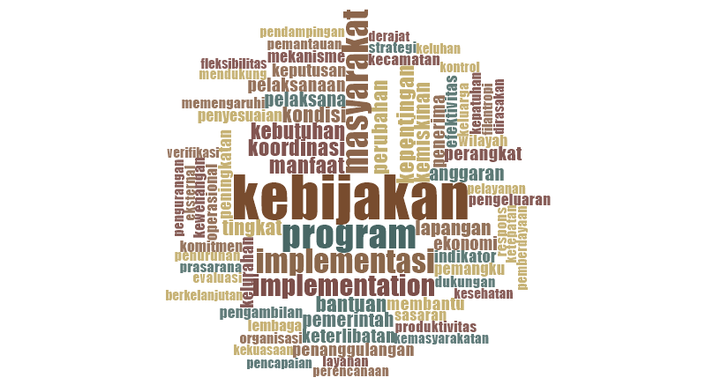
Figure 1. NVivo word cloud for the policy implementation variable
Table 3. NVivo-based results displayed in the article
NVivo output | Main empirical pattern | Interpretation for policy implementation
Word cloud: implementation variable | Dominant terms include policy, program, community, assistance, government, implementation, coordination, data, target, benefit, resources, and implementers. | Implementation is understood as a concrete program-delivery process involving beneficiaries, actors, data, and coordination.
Word cloud: Content of Implementation | Dominant terms include policy, program, implementation, community, assistance, benefits, coordination, interests, resources, implementers, decision-making, and degree of change. | Policy substance is assessed through benefits, intended changes, decision-making, implementers, and supporting resources.
Matrix coding: Content of Implementation | Coding is strongest among territorial and technical actors, especially subdistrict, social service, and village/kelurahan actors, while beneficiaries emphasize benefits and change. | Policy content is operationalized by implementers but evaluated through the lived experience of beneficiaries.
Word cloud: Context of Implementation | Dominant themes include government, coordination, supervision, strategy, local conditions, compliance, response, and community complaints. | Implementation success depends on actor strategies, institutional arrangements, compliance, responsiveness, and adaptive field coordination.
Matrix coding: Context of Implementation | The most prominent coding is related to power, interests, actor strategy, compliance, and implementer responsiveness. | Context is not neutral; it is shaped by actor interaction, bureaucratic authority, local problem solving, and the capacity to respond to changing needs.
Word cloud and matrix coding: effectiveness | Dominant themes include policy, program, community, assistance, services, health, education, targets, data, evaluation, problem solving, and change. Beneficiaries contribute strongly to all effectiveness dimensions. | Effectiveness is experienced through tangible benefits and access to services, but is constrained by data accuracy, targeting, procedures, and uneven sustainability.
Content of Implementation: Benefits, Change, Decision-Making, Actors, and Resources
The content dimension is a major component of the implementation process. NVivo results show that the content of implementation is represented by interests affected by policy, type of policy benefits, degree of change expected, decision-making location, program implementers, and resources used. The word cloud on this dimension shows the dominance of policy, program, implementation, community, assistance, benefits, coordination, interests, resources, implementers, decision-making, and degree of change. These words reflect the substance of the policy and the operational concerns faced by implementers.
The strongest content indicator is the degree of change expected. The interviews show that the intended change is not limited to reducing poverty statistics, but includes reducing household expenditure burdens, improving access to basic services, increasing productivity, strengthening economic independence, and improving quality of life. This finding is important because poverty alleviation will remain incomplete when it only distributes temporary assistance without creating a pathway toward household resilience.
The type of policy benefits is also important. Beneficiaries and territorial implementers emphasize food assistance, cash assistance, access to health services, education support, and reduction of household expenses. These benefits are meaningful for short-term protection, especially for vulnerable households. However, the data also show that the benefits must be connected to productive empowerment to prevent continuous dependence on social assistance.
Decision-making is implemented through a combination of city-level strategic decisions and local-level technical adjustments. Strategic decisions are made by the municipal government and related agencies, while subdistricts and villages/kelurahan carry out verification, coordination, information delivery, and complaint handling. This pattern shows that implementation combines top-down policy direction with field-level adaptation, which is the core of effective regional government management [33].
Resources remain a decisive issue. The policy requires financial resources, human resources, information systems, service infrastructure, and intergovernmental support. The NVivo analysis indicates that human-resource capacity is especially important for data verification, complaint services, and cross-sector coordination. Without adequate resources, even a well-designed policy may not produce the expected benefits.
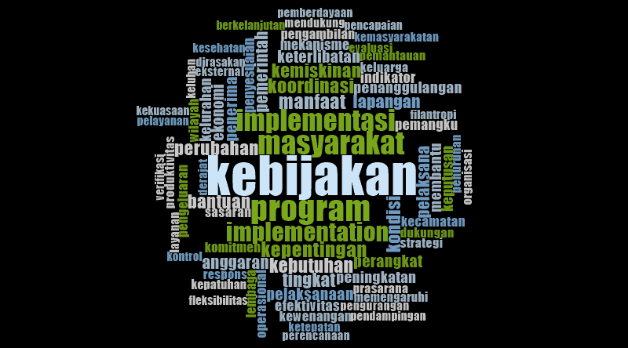
Figure 2. NVivo word cloud for the Content of Implementation dimension
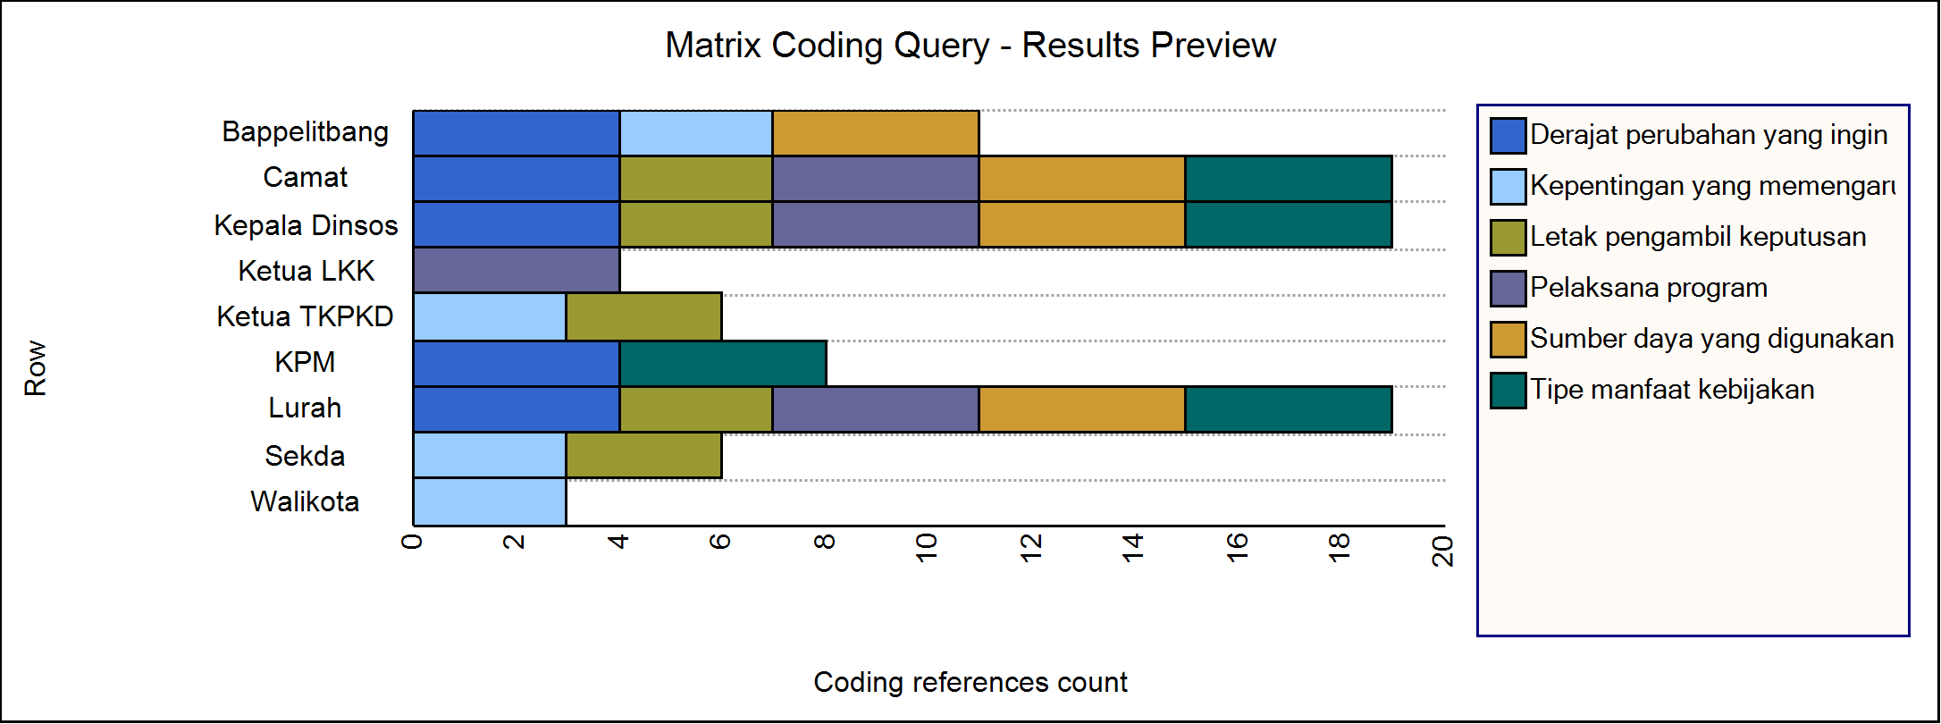
Figure 3. NVivo matrix coding for the Content of Implementation dimension
Context of Implementation: Leadership, Institutions, Actor Strategy, and Adaptive Compliance
The context of implementation shapes how policy content is translated into practice. The NVivo word cloud for the context dimension highlights government, program, community, policy, coordination, supervision, response, strategy, local needs, administrative procedures, and field conditions. These themes show that implementation takes place within a network of actors and institutions rather than within a single agency.
The matrix coding of context shows that power, interests, and actor strategies are prominent among planning and territorial actors, while compliance and responsiveness are strongly associated with Bappelitbang, subdistricts, the Social Affairs Office, and village/kelurahan implementers. This finding indicates that the success of poverty alleviation depends on the ability of actors to coordinate roles, share information, respond to complaints, and adapt programs to changing socio-economic conditions.
Compliance in this study should not be interpreted as rigid administrative obedience. The interviews show that implementers follow planning documents and technical guidelines, but they also need room for adjustment when household conditions change more quickly than the planning cycle. This adaptive compliance is essential in urban poverty governance because poverty data, employment conditions, and household vulnerability can change rapidly.
The findings also show that community complaints and field verification are important parts of implementation. Village/kelurahan actors and community institutions often receive direct complaints from residents. Their ability to verify information, coordinate with subdistricts and agencies, and provide clear responses affects public trust and the perceived fairness of poverty alleviation programs.
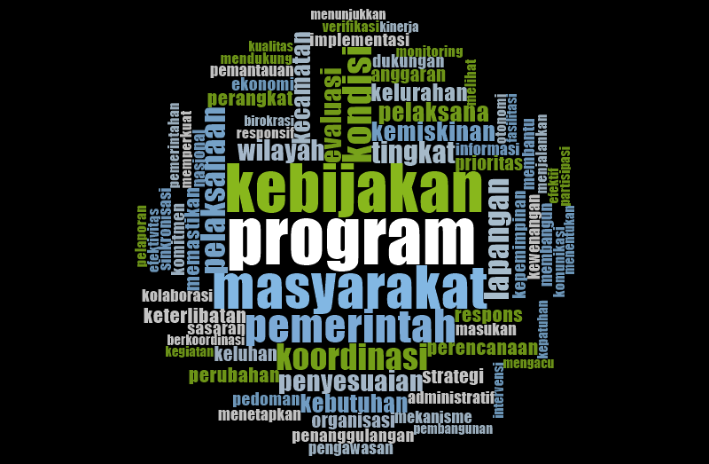
Figure 4. NVivo word cloud for the Context of Implementation dimension
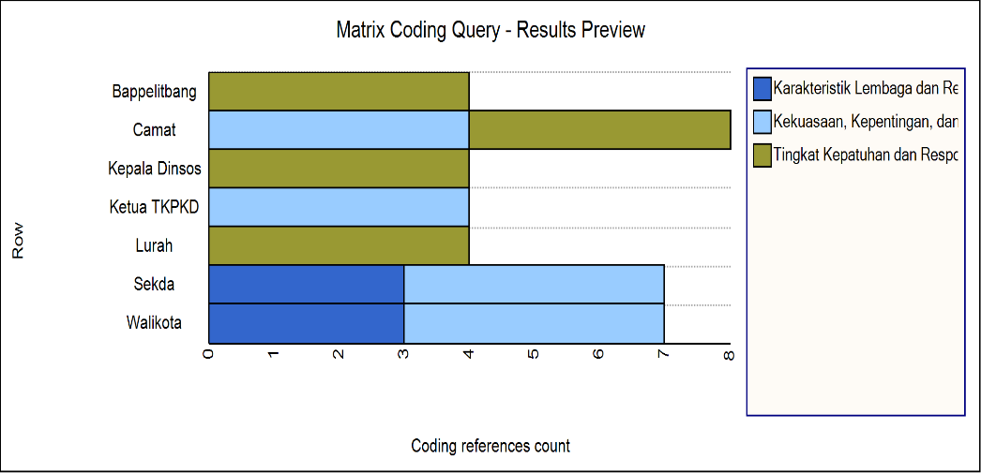
Figure 5. NVivo matrix coding for the Context of Implementation dimension
Effectiveness of Poverty Alleviation Policy
The effectiveness of poverty alleviation policy in Bandung City is reflected in four dimensions: policy impact, targeting accuracy, public problem solving, and achievement of policy objectives. The NVivo word cloud for effectiveness shows that informants frequently discuss policy, program, community, assistance, services, health, education, targets, data, evaluation, problems, change, and improvement. This indicates that effectiveness is evaluated through tangible benefits and service access rather than only through administrative implementation.
The policy impact dimension shows that programs have helped reduce household expenditure burdens and improve access to basic services. Beneficiaries report that assistance contributes to daily needs, food security, health access, and education-related expenses. Territorial actors also view the programs as helpful in reducing pressure on poor households.
Targeting accuracy remains the most critical issue. Programs rely on social-economic data and verification processes, but field findings indicate that the data are not always up to date. Some eligible residents may not be included, while some listed recipients may no longer meet the criteria. This problem weakens effectiveness because poverty alleviation depends on public confidence that benefits reach the correct households.
The public problem-solving dimension shows that poverty alleviation must address more than immediate consumption needs. Assistance helps in the short term, but sustainable poverty reduction requires employment access, skills development, micro-enterprise support, affordable services, and strengthened social resilience.
The achievement of objectives has begun to appear in reduced poverty rates and better program access, but the persistence and increase of extreme poverty indicate that the objectives have not been fully achieved.
The NVivo matrix coding for effectiveness indicates that beneficiaries provide strong information across all four dimensions. This is important because policy effectiveness should not be judged only from the government perspective. Beneficiaries provide evidence of whether benefits are meaningful, whether targeting is fair, whether problems are actually solved, and whether the policy creates real change in household welfare.
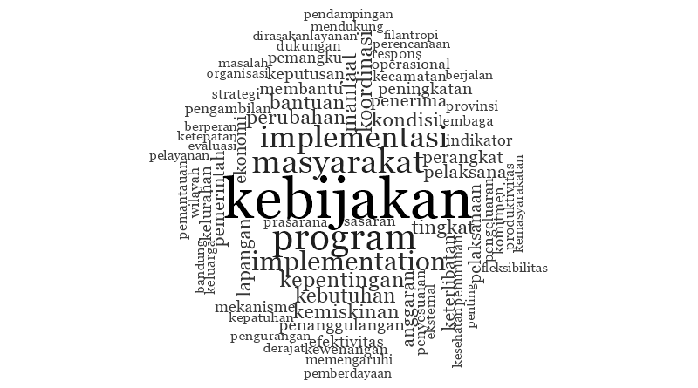
Figure 6. NVivo word cloud for the policy effectiveness variable
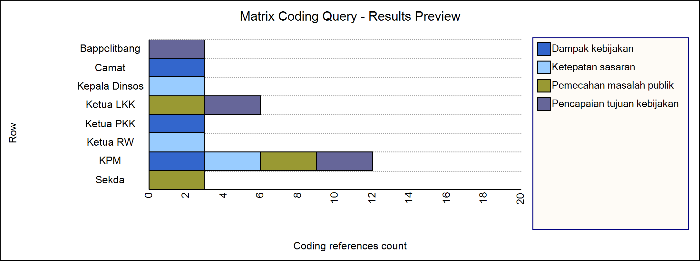
Figure 7. NVivo matrix coding for policy effectiveness
Table 4. NVivo-based interpretation of policy effectiveness
Effectiveness dimension | NVivo-based evidence | Main constraint | Required improvement
Policy impact | Assistance reduces expenditure burdens and improves access to basic services such as food, health, and education. | Impact tends to be short term when not connected to productive empowerment. | Link social protection with livelihood support, skills, micro-enterprise assistance, and income opportunities.
Targeting accuracy | Data, verification, and field checking appear repeatedly in interviews and coding. | Poverty data are not always dynamic; inclusion and exclusion errors remain possible. | Apply continuous data updating, community validation, and transparent complaint mechanisms.
Public problem solving | Programs respond to household needs and service access problems. | Administrative procedures, limited understanding, and technical field obstacles reduce effectiveness. | Simplify procedures, strengthen facilitation, and provide responsive local service channels.
Achievement of objectives | Poverty rate declines and program access improves. | Extreme poverty persists and increases in several areas. | Prioritize spatial poverty pockets and integrate assistance with long-term empowerment.
Existing and Recommended Implementation Model
The existing model of poverty alleviation implementation in Bandung City shows that policy has a formal regulatory basis and involves multiple actors. Programs are implemented through city agencies, subdistricts, village/kelurahan offices, and community institutions. However, the existing model still tends to be administrative and program-based. It has not fully integrated dynamic data validation, beneficiary complaints, empowerment continuity, and cross-sector collaboration into a single adaptive implementation system.
Based on the results, this article proposes an adaptive collaborative implementation model. The model begins with strategic inputs: local regulations, poverty alleviation plans, accurate data, budget support, and institutional commitment. It then strengthens the two implementation dimensions. On the content side, the model emphasizes clear benefits, realistic intended change, integrated decision-making, capable implementers, and sufficient resources. On the context side, it emphasizes leadership commitment, actor strategy, institutional coordination, compliance, responsiveness, and community participation.
The recommended model contains six strategic actions: continuous updating and validation of poverty data; integration of social assistance with economic empowerment; strengthening of community-based verification and complaint handling; cross-sector collaboration among government, community institutions, private actors, universities, and civil society; improvement of service quality and simplified procedures; and monitoring and evaluation based on impact, targeting accuracy, problem solving, and achievement of objectives.

DISCUSSION
Bridging the Implementation Gap
The findings of this study demonstrate a significant gap between policy design (content) and practical outcomes (effectiveness) in Bandung City’s poverty alleviation efforts. This gap is not unique to Bandung; it reflects a common challenge in public policy implementation where top-down designs encounter complex local contexts [38], [20]. However, in an urban setting like Bandung City, this gap is intensified by rapid demographic changes, spatial disparities, and bureaucratic silos.
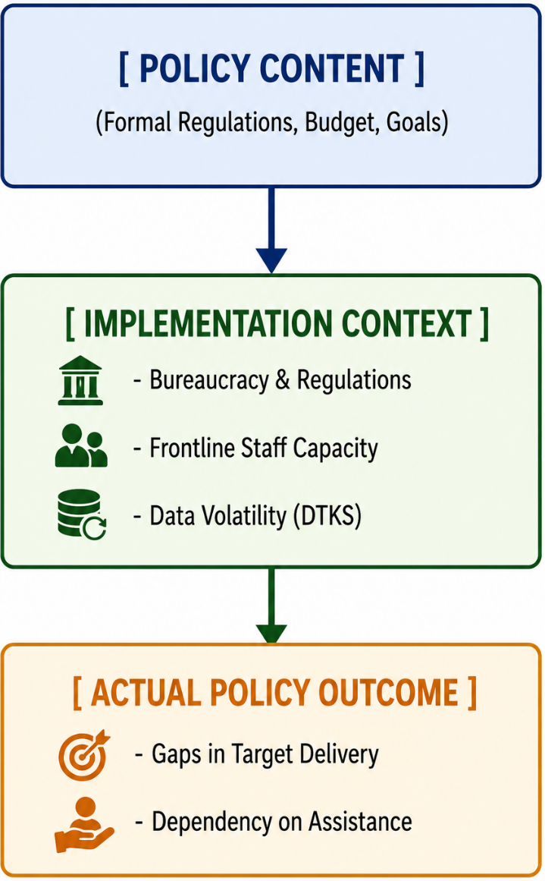
Figure 8: Conceptual Flow of the Policy Implementation Gap
The thematic analysis shows that while the content of Local Regulation No. 4 of 2020 is comprehensive and multidimensional, its execution remains highly sectoral and welfare-dependent. This combination shows that poverty alleviation effectiveness is shaped by both institutional delivery and lived experience [1], [10]. This finding creates a new empirical argument that urban poverty governance must pay attention to spatial concentration, data volatility, household vulnerability, and the mismatch between aggregate indicators and field-level poverty dynamics [10], [34].
The Role of Collaborative Governance
A critical factor shaping the context of implementation is the quality of interaction among actors. Public policy literature argues that complex social problems cannot be solved by government agencies working in isolation [35], [36]. Policy content, such as benefits, resources, and intended change, becomes effective only when the context supports coordination, responsiveness, data updating, local adaptation, and community participation through a robust collaborative governance framework [37], [35], [36], [38].
In Bandung, the lack of effective collaboration across government departments and with non-state actors (such as NGOs, universities, and the private sector) limits the sustainability of poverty alleviation programs. For instance, vocational training programs managed by the Manpower Agency are rarely connected to the micro-finance initiatives of the Cooperative Agency or the social support systems of the Social Agency. This lack of integration reduces the likelihood of poor households transitioning from welfare dependency to economic independence. Additionally, involving village-level administrators and community-based organizations in the formulation of localized regulations can serve as a catalyst for socio-economic empowerment and worker protection [39].
This theoretical contribution helps explain why poverty policies that are formally complete may still face effectiveness gaps in the field, often due to inadequate e-government integration and internal governmental governance [20], [22], [40]. Ensuring that public complaints are processed digitally and that government operators maintain high standards of service delivery is vital for building public trust and keeping poverty databases up to date [41], [42].
Policy Novelty: "Adaptive Collaborative Implementation"
To address the limitations identified in Bandung City, this study proposes a new conceptual framework: Adaptive Collaborative Implementation (ACI). ACI integrates classic policy implementation theory with contemporary collaborative governance and adaptive management principles [37], [35], [36].
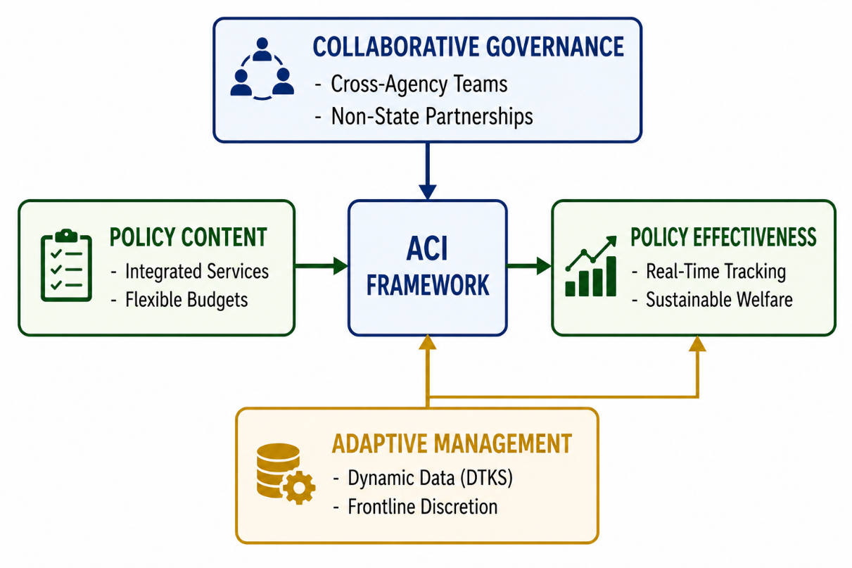
Figure 9: The Adaptive Collaborative Implementation (ACI) Framework
The ACI framework consists of three core components:
- Dynamic Data Integration: Rather than relying on static, semi-annual database updates (such as DTKS), ACI utilizes local digital administrative systems to track household vulnerability in real time, allowing for rapid adjustments in program targeting [40], [43].
- Horizontal and Vertical Collaboration: Establishing cross-functional teams that bring together different government agencies, subdistrict offices, and community leaders to coordinate interventions, replacing bureaucratic silos with shared goals [38], [39].
- Discretionary Flexibility for Frontline Implementers: Empowering subdistrict and ward officers with structured discretion to make immediate, context-specific decisions when addressing urgent cases of extreme poverty, within a transparent accountability framework [44], [45].
By adopting the ACI framework, local governments can transform poverty alleviation from a set of rigid, fragmented programs into an integrated, responsive system capable of adapting to the dynamic needs of vulnerable urban populations.

CONCLUSION
The implementation of poverty alleviation policy in Bandung City has been supported by a relatively systematic policy framework, including local regulations, regional poverty alleviation planning, social assistance programs, and institutional coordination. NVivo-based analysis shows that implementation is dominated by themes of policy, program, community, assistance, benefits, coordination, data, resources, targeting, and responsiveness.
The content of implementation emphasizes benefit type, intended change, decision-making, implementers, and resources. The context of implementation emphasizes leadership, actor strategies, institutional characteristics, compliance, responsiveness, and cross-sector coordination. Policy effectiveness is visible in reduced expenditure burdens and improved access to services among beneficiaries. However, effectiveness remains constrained by data accuracy, targeting gaps, administrative procedures, fragmented coordination, and the limited connection between assistance and empowerment.
The article proposes an adaptive collaborative implementation model as the main novelty. The model emphasizes continuous poverty data validation, community-based verification, integration of social assistance and empowerment, cross-sector collaboration, improved service quality, and impact-based monitoring and evaluation. This model is relevant not only for Bandung City but also for other urban governments facing the challenge of reducing poverty in dense, dynamic, and socially diverse environments.

REFERENCES
- Alkire, S., & Foster, J. (2011). Counting and multidimensional poverty measurement. Journal of Public Economics, 95(7-8), 476-487.
- Sen, A. (1999). Development as freedom. Oxford University Press.
- United Nations. (2015). Transforming our world: The 2030 Agenda for Sustainable Development. United Nations General Assembly Resolution A/RES/70/1.
- World Bank. (2025). Poverty and equity brief. World Bank Group.
- Saputra, G. W., Zairusi, Andhani, D., Triadi, R., Suarha, C., & Kurniawati. (2026). Sistem Administrasi Negara Indonesia: Konsep, Dinamika, dan Praktik Tata Kelola Pemerintahan Modern. Mafy Media Literasi Indonesia.
- Saputra, G. W., Nurwanda, A., Sahadi, Susilawati, & Kurniawati. (2025). Desentralisasi dan Dinamika Pemerintahan Lokal. Mafy Media Literasi Indonesia.
- World Bank. (2020). Poverty and shared prosperity 2020: Reversals of fortune. World Bank Group.
- Badan Pusat Statistik. (2025). Profil Kemiskinan di Indonesia Maret 2025. BPS RI.
- Pemerintah Kota Bandung. (2024). Peraturan Wali Kota Bandung Nomor 23 Tahun 2024 tentang Rencana Penanggulangan Kemiskinan Daerah Kota Bandung Tahun 2024-2028.
- Badan Pusat Statistik Kota Bandung. (2025). Kota Bandung dalam Angka 2025. BPS Kota Bandung.
- Pemerintah Kota Bandung. (2020). Peraturan Daerah Kota Bandung Nomor 4 Tahun 2020 tentang Penanggulangan Kemiskinan.
- Grindle, M. S. (1980). Politics and policy implementation in the Third World. Princeton University Press.
- Hill, M., & Hupe, P. (2022). Implementing public policy: An introduction to the study of operational governance (4th ed.). SAGE Publications.
- Howlett, M., & Ramesh, M. (2021). Studying public policy: Policy cycles and policy subsystems (4th ed.). Oxford University Press.
- United Nations Development Programme. (2022). Human development report 2021/2022: Uncertain times, unsettled lives. UNDP.
- Haughton, J., & Khandker, S. R. (2009). Handbook on poverty and inequality. World Bank Publications.
- Barrientos, A. (2013). Social assistance in developing countries. Cambridge University Press.
- Devereux, S., & Sabates-Wheeler, R. (2004). Transformative social protection. IDS Working Paper 232.
- Todaro, M. P., & Smith, S. C. (2020). Economic development (13th ed.). Pearson.
- Van Meter, D. S., & Van Horn, C. E. (1975). The policy implementation process: A conceptual framework. Administration & Society, 6(4), 445-488.
- Dunn, W. N. (2018). Public policy analysis: An integrated approach (6th ed.). Routledge.
- Peters, B. G. (2015). Advanced introduction to public policy. Edward Elgar Publishing.
- Bazeley, P., & Jackson, K. (2013). Qualitative data analysis with NVivo. SAGE Publications.
- Nowell, L. S., Norris, J. M., White, D. E., & Moules, N. J. (2017). Thematic analysis: Striving to meet the trustworthiness criteria. International Journal of Qualitative Methods, 16(1).
- Creswell, J. W., & Poth, C. N. (2018). Qualitative inquiry and research design: Choosing among five approaches. SAGE Publications.
- Yin, R. K. (2018). Case study research and applications: Design and methods. SAGE Publications.
- Bowen, G. A. (2009). Document analysis as a qualitative research method. Qualitative Research Journal, 9(2), 27-40.
- Patton, M. Q. (2015). Qualitative research & evaluation methods: Integrating theory and practice. SAGE Publications.
- Palinkas, L. A., Horwitz, S. M., Green, C. A., Wisdom, J. P., Duan, N., & Hoagwood, K. (2015). Purposeful sampling for qualitative data collection and analysis in mixed method implementation research. Administration and Policy in Mental Health, 42(5), 533-544.
- Lincoln, Y. S., & Guba, E. G. (1985). Naturalistic inquiry. SAGE Publications.
- Miles, M. B., Huberman, A. M., & Saldaña, J. (2014). Qualitative data analysis: A methods sourcebook. SAGE Publications.
- Strauss, A., & Corbin, J. (1998). Basics of qualitative research. SAGE Publications.
- Saputra, G. W., Kurniawati, & Susilawati. (2025). Manajemen Pemerintahan Daerah dan Desa: Konsep Dinamika dan Implementasi di Indonesia. Dewa Publishing.
- Ravallion, M. (2016). The economics of poverty: History, measurement, and policy. Oxford University Press.
- Ansell, C., & Gash, A. (2008). Collaborative governance in theory and practice. Journal of Public Administration Research and Theory, 18(4), 543-571.
- Emerson, K., Nabatchi, T., & Balogh, S. (2012). An integrative framework for collaborative governance. Journal of Public Administration Research and Theory, 22(1), 1-29.
- Sabatier, P. A. (1986). Top-down and bottom-up approaches to implementation research: a critical analysis and suggested synthesis. Journal of Public Policy, 6(1), 21-48.
- Saputra, G. W., & Santosa, P. (2026). Assessing the Impact of Collaborative Governance on Urban Waste Management Effectiveness: Evidence from Bandung City, Indonesia. International Journal of Research and Innovation in Social Science, 10(5).
- Andhani, D., Rachmawati, E., Saputra, G. W., Yusri, A., Mulyasana, D., & Santosa, P. (2025). Kolaborasi Governance dalam Penyusunan Regulasi Desa Tentang Pelindungan Pekerja Migran Indonesia di Kecamatan Ngamprah. Jurnal Pengabdian Tri Bhakti, 7(2), 66-77.
- Destriana, W. H., Sugandi, Y. S., & Saputra, G. W. (2023). Pengaruh Implementasi Kebijakan E-Government dan Tata Kelola Pemerintah Terhadap Kinerja Pegawai Pada Dinas Kependudukan Dan Pencatatan Sipil Kabupaten Garut. ALIGNMENT: Journal of Administration and Educational Management, 6(2), 303-313.
- Saputra, G. W., & Santosa, P. (2025). Improving the quality of public services through e-government implementation: A case study of the public complaint services section of the Civil Servants Police Unit (Satpol PP) Bandung. Proceeding International Conference on Sustainable Environment and Public Policy, 1(1).
- Saputra, G. W., Suarha, C., & Triadi, R. (2026). Effectiveness of Digital Identity (IKD) Services in Public Administration: A Case Study of Bandung City. JKMP (Jurnal Kebijakan dan Manajemen Publik), 14(1), 13-21.
- Saputra, G. W., Kurniawai, Susilawati, C. Suarha, & R. Triadi. (2024). Administrasi Publik. PT Mafy Media Literasi Indonesia.
- Lipsky, M. (2010). Street-level bureaucracy: Dilemmas of the individual in public service (30th anniversary ed.). Russell Sage Foundation.
- Hill, M., & Hupe, P. (2014). Implementing public policy: An introduction to the study of operational governance (3rd ed.). SAGE Publications.

