ASSESSMENT OF LAND USE/LAND COVER DYNAMICS USING REMOTE SENSING AND GIS IN ENUGU URBAN

ABSTRACT
Urbanization is important in changing how we use and cover land around the world. One of the most notable effects of this trend is urban sprawl, which refers to the often chaotic and unplanned spread of cities into the nearby rural areas. This study assessed the spatial extent and pattern of urban sprawl in Enugu Urban between 2013 and 2025 using Remote Sensing (RS) & Geographic Information System (GIS) techniques. The aim was achieved through the following objectives; to classify land use and land cover (LULC) and detect changes over time; to quantify the spatial extent and growth rate of urban areas; to analyze the change detection of urban sprawl; to identify the implications of urban sprawl on sustainable urban development in Enugu. The methodology involved acquiring Landsat 8 imagery (2013, 2017, 2021, and 2025) from Google Earth Engine, followed by preprocessing (geometric correction, boundary clipping, cloud and shadow masking), and supervised classification using the Maximum Likelihood algorithm into four classes: built-up, vegetation, water bodies, and bare land. Post-classification change detection was applied to quantify transitions and evaluate urban growth. The results revealed significant transformations: bare land declined by −169.64 km² (−60%) and vegetation decreased by −75.67 km² (−52%), while built-up areas increased by +173.26 km² (+299%) and water bodies expanded by +72.06 km² (+103%). Change detection showed that bare land and vegetation served as donor classes, feeding into the expansion of built-up and water bodies. These changes reflect rapid urbanization, infrastructural development, and environmental pressures, with implications for biodiversity loss, flooding, and land degradation. The study recommends sustainable urban planning, afforestation and urban greening, rehabilitation of degraded lands, and effective water resource management.
Keywords: Urbanization, Land Use, Land Cover, Remote Sensing (RS), Geographic Information System (GIS)

INTRODUCTION
Urbanization plays a crucial role in changing how we use and cover land all around the world. One of the most notable effects of this trend is urban sprawl, which refers to the often chaotic and unplanned spread of cities into the nearby rural areas. This kind of growth typically results in low-density, fragmented neighborhoods that rely heavily on cars, and it can have serious impacts on the environment, economy, infrastructure, and the social dynamics of the regions involved. Sprawl can be defined as rapid expansion of the built-up area into suburbs in a discontinuous low-density and uneven pattern causing inefficient use of land resources and encroachment into agricultural land and natural covers [1].
Sprawl remains a well-documented phenomenon with diverse forms and antecedents, which occur due to societal, cultural, economic, historical background, and governance differences across the continent [3]. Some cities are witnessing uncontrolled sprawl, with the expansion occurring in peri-urban and coastal areas because of lax planning standards, enforcement, and informal real estate markets [4]. This contrast underscores the need to compare and disaggregate the different urban centers to understand how governance and economic systems help delineate urban sprawl across diverse some region [2]. Moreover, Remote Sensing (RS) and Geographic Information Systems (GIS) are useful for monitoring issues within urban areas, but the utilization of these techniques to analyze the urban sprawl is relatively limited [5].
Integrating remote sensing and GIS provides a comprehensive and objective approach for understanding urban sprawl, its impacts, and the planning strategies needed for sustainable urban development, hence, this study.

THE STUDY AREA
Enugu Urban is the capital city and administrative hub of Enugu State, located in the southeastern geopolitical zone of Nigeria. It is situated approximately between latitude 6°21'N to 6°30'N and longitude 7°26'E to 7°37'E, covering a total area of about 85 square kilometers. The city lies on the Udi, which gives it a unique undulating topography, and it is bounded by Ngwo hills to the west and the Idaw River to the east. Enugu Urban comprises three major Local Government Areas Enugu North, Enugu South and Enugu East.
It comprises three main Local Government Areas Enugu North, Enugu South, and Enugu East which together make up the core urban region of Enugu State. As of the 2006 National Population Census, the combined population of these LGAs was approximately Enugu North LGA: 244,852, Enugu South LGA: 198,723, Enugu East LGA: 279,089 sum total of: 722,664.
The area is characterized by two distinct seasons rainy season, which typically lasts from April to October, and dry season, from November to March. During the dry season, the Harmattan winds, which blow from the northeast, cause a drop in humidity and visibility, and often bring dusty and dry conditions. The average annual temperature ranges from 26°C to 31°C, with slight variations between day and night. Relative humidity is generally high, especially during the rainy months, averaging 60% to 80%.

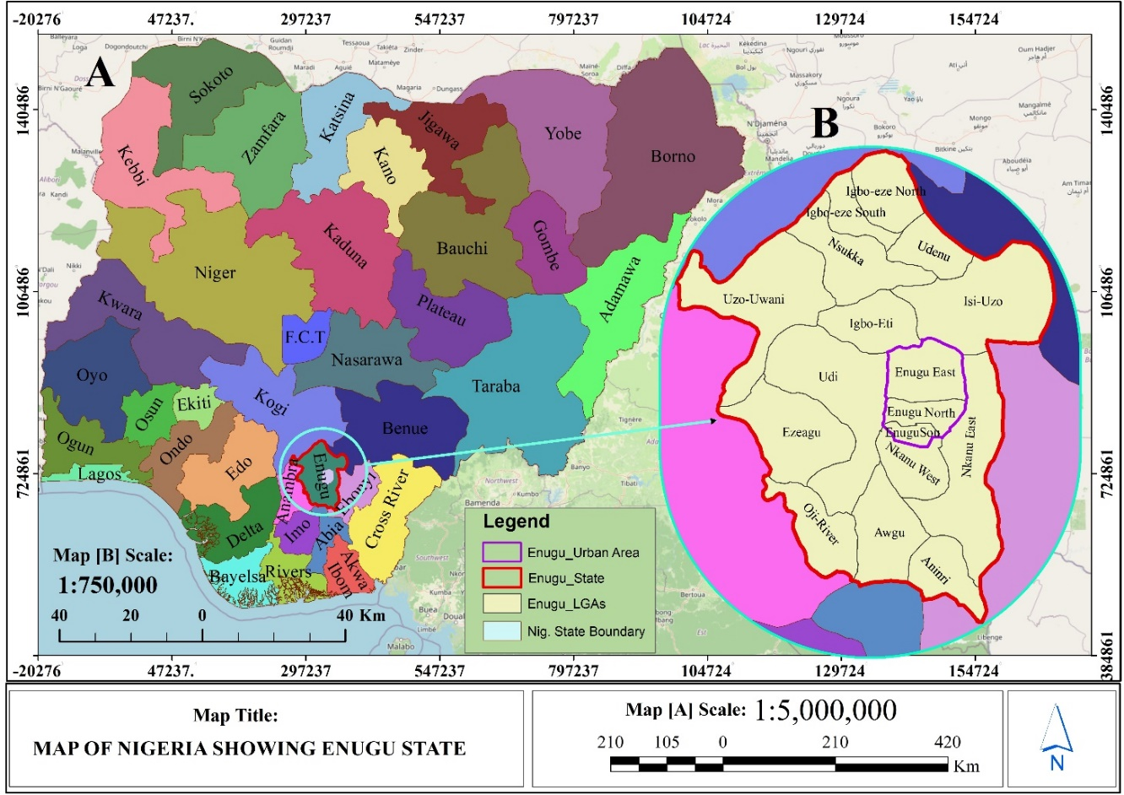
Fig 2.1 Map of Nigeria Showing Enugu State, Showing the Study Area
Source: Author(2026), Administrative boundary shapefile of Nigeria from OSGOF Enugu State and NGM Base map

Fig 2.2 Satellite Imagery of the Study Area
Source: Author’s GIS Work (2026), Google Earth Pro

MATERIALS AND METHODS
3.1 Flowchart
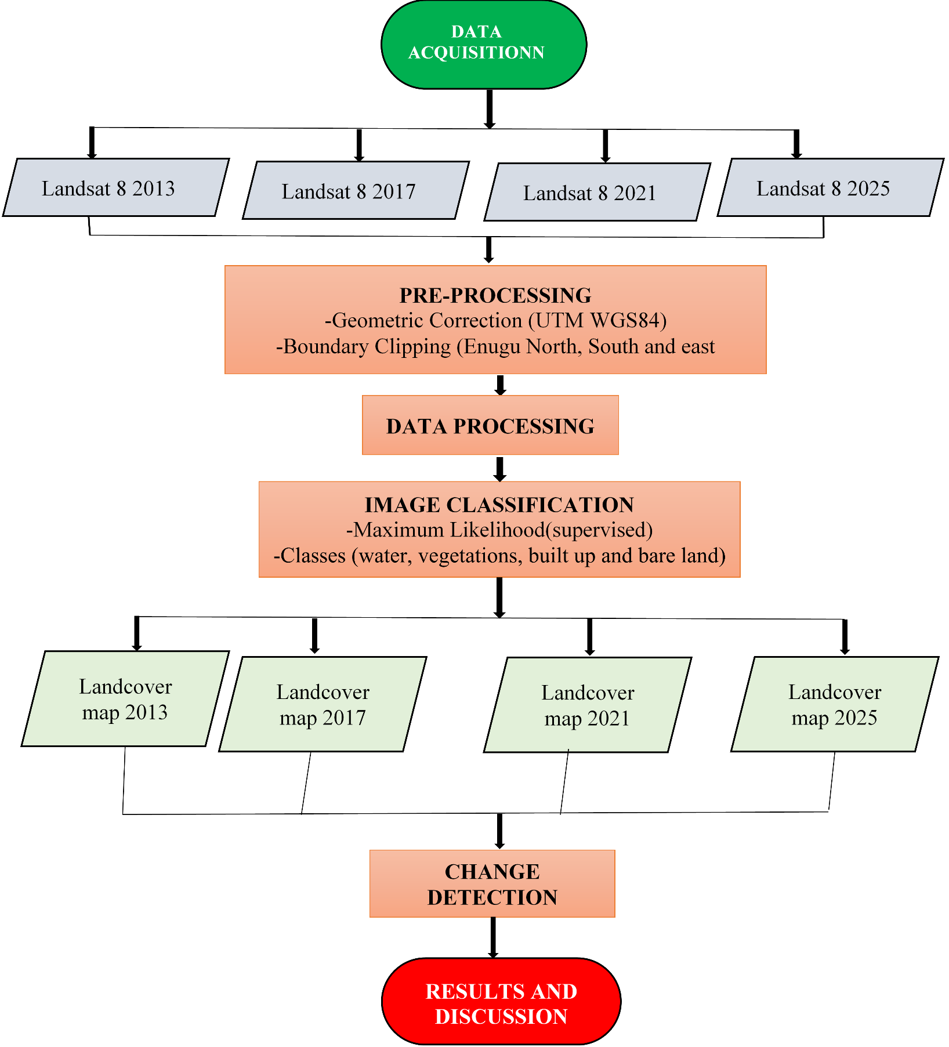
Fig 3.1 Methodology Flowchart utilized in the study
Source: Author’s Design (2026)

Research Design
This study adopts a quantitative, geospatial approach integrating multi-temporal remote sensing and GIS analyses to assess the extent, direction and pattern of urban sprawl in Enugu urban. The workflow combines image preprocessing, supervised classification and post-classification change detection,
Data Acquisition
Satellite imagery obtained from the Landsat 8 Operational Land Imager (OLI) and Thermal Infrared Sensor (TIRS) were employed to monitor land use and land cover (LULC) changes within Enugu Urban State over selected years.
Datasets Used from Google Earth Engine
(a) Landsat 8 Operational Land Imager (OLI) / Thermal Infrared Sensor (TIRS)
- Dataset ID: LANDSAT/LC08/C02/T1_L
- Spatial Resolution: 30 m (for multispectral), 15 m (for panchromatic).
- Temporal Resolution: Revisit time of 16 days.
- Years Used: 2013, 2017, 2021, 2025.
(b) Administrative Boundaries (GAUL Dataset)
- Dataset ID: FAO/GAUL/2015/level2
- Literature: Academic publications, planning regulations, and government reports.
Pre-processing of Data in Google Earth Engine
Pre-processing is an essential step in ensuring the accuracy and reliability of satellite imagery before analysis. Although Google Earth Engine (GEE) provides access to atmospherically and geometrically corrected datasets (e.g., Landsat Surface Reflectance), additional processing was carried out to further refine the data for assessing urban sprawl in Enugu State. The main pre-processing steps are outlined.

PRESENTATION AND DISCUSSION OF RESULTS
Result and Discussion
This chapter presents the results of the data analysis carried out to assess the spatial and temporal dynamics of urban sprawl in Enugu Urban between 2013 to 2025. Multi-temporal satellite imagery was classified into land use/land cover (LULC) categories, and subsequent change detection analyses and growth models were applied to understand the trends and patterns of sprawl.

Extent of Urbanization in Enugu Urban Based on 2013 Remote Sensing Data

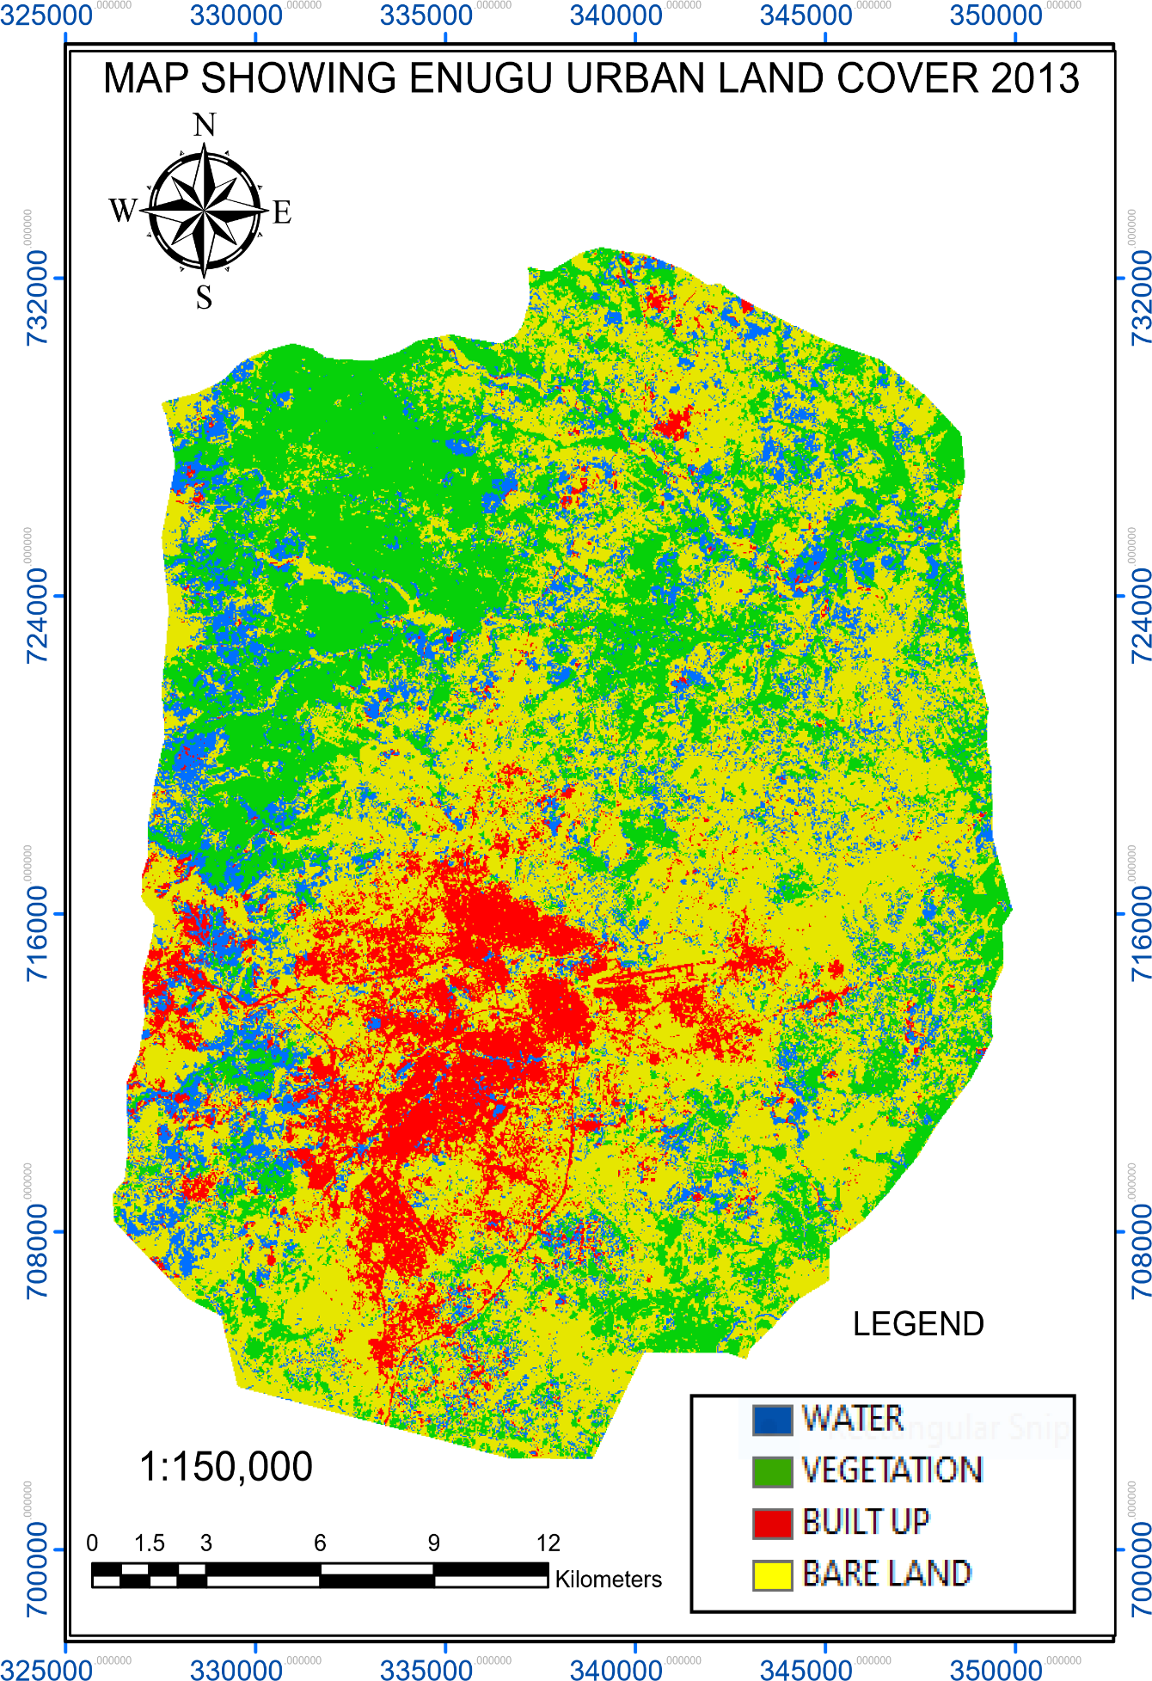

Fig 4.1 Land Cover Map of 2013
Source: Author’s Data Processing, 2026

Extent of Urbanization in Enugu Urban Based on 2017 Remote Sensing Data

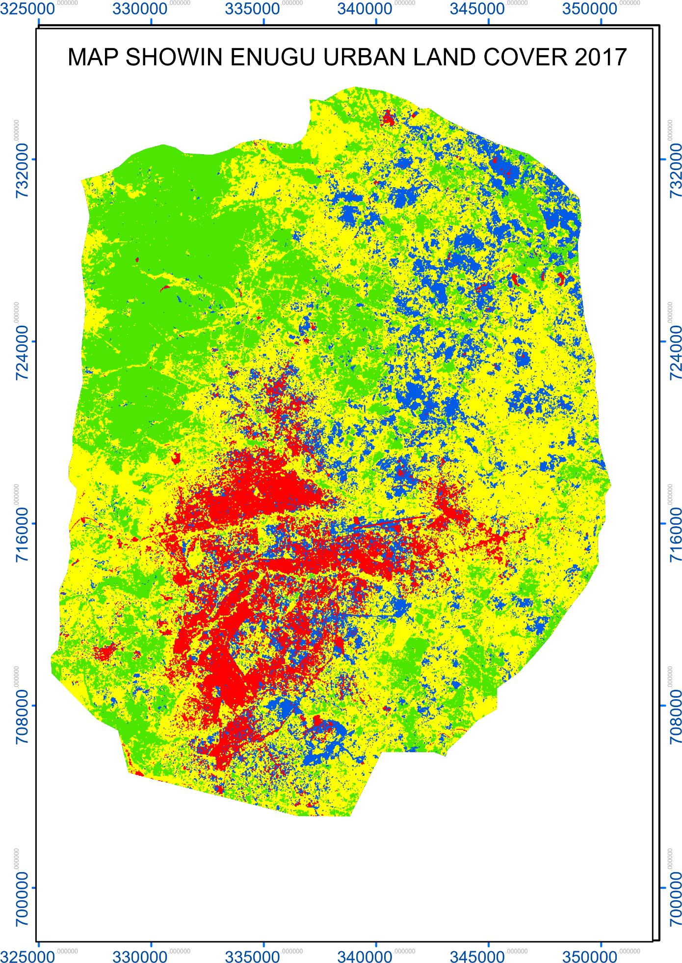

Fig 4.2 Land Cover Map of 2017
Source: Author’s Data Processing, 2026

Extent of Urbanization in Enugu Urban Based on 2021 Remote Sensing Data

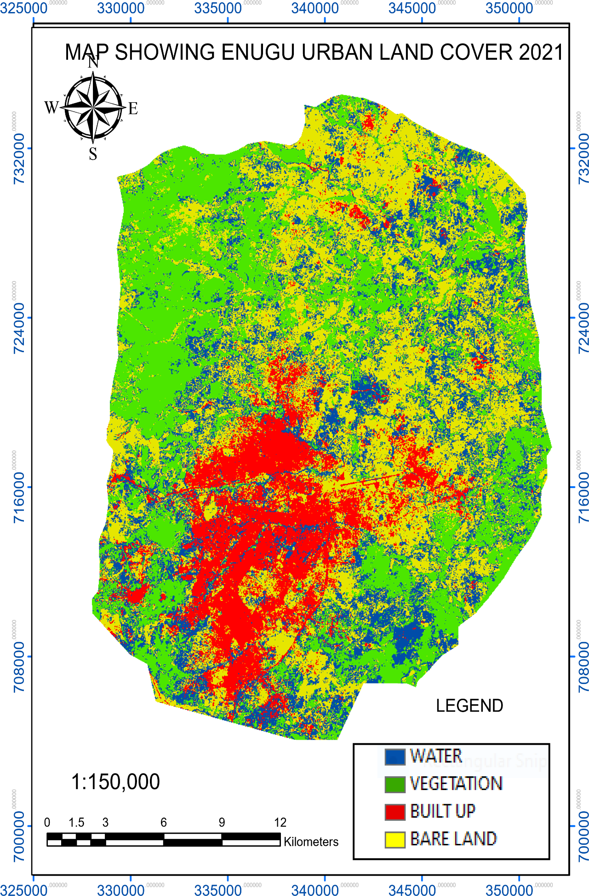

Fig 4.3 Land Cover Map of 2021
Source: Author’s Data Processing, 2026

Extent of Urbanization in Enugu Urban Based on 2025 Remote Sensing Data

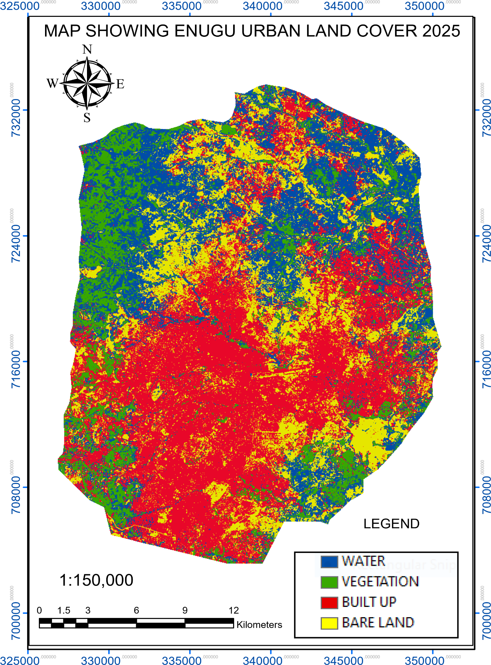
Fig 4.4 Land Cover Map of 2025
Source: Author’s Data Processing, 2026

Discussion of Results
Change Detection
The analysis of land use and land cover dynamics between 2013 and 2025 reveals significant spatial and environmental transformations within the study area. Four major classes bare land, built-up, vegetation, and water bodies were examined, and the results indicate profound shifts that reflect the influence of rapid urbanization, human activities, and environmental changes.
Table 4.1: Change detection of land cover classes in 2013 and 2025

LULC CLASSES | Area (km²)
LULC CLASSES | 2013 | 2025 | NET CHANGE | PERCENTAGE | TREND
BARE LAND | 282.9395155 | 113.3003 | -169.639252 | -60% | LOSS
BUILT UP | 57.87786923 | 231.1391 | 173.2612366 | 299% | GAIN
VEGETATION | 146.61083 | 70.93674 | -75.67408779 | -52% | LOSS
WATER | 70.12999498 | 142.1871 | 72.05708872 | 103% | GAIN

- Bare Land (−169.64 km²; −60%)
Change detection results show a dramatic decline in bare land, shrinking from 282.94 km² in 2013 to 113.30 km² in 2025. The −169.64 km² reduction (−60%) indicates that a large portion of open or undeveloped land was converted into built-up areas and possibly reclaimed by water bodies. This transition highlights the pressure of urban expansion and increasing land consumption for human activities. However, the reduction of bare land also reduces natural buffers against soil erosion and flooding, which could worsen environmental vulnerability.
- Built-up (+173.26 km²; +299%)
The most pronounced positive change occurred in built-up areas, which expanded by +173.26 km² from 57.88 km² in 2013 to 231.14 km² in 2025. This +299% increase reflects rapid urbanization and infrastructural growth. Change detection analysis shows that this gain came largely at the expense of bare land and vegetation. While this growth signifies socio-economic development, it also implies challenges such as loss of arable land, habitat destruction, urban flooding, and increased demand for resources (water, energy, waste management).
- Vegetation (−75.67 km²; −52%)
Vegetation cover decreased by −75.67 km² (−52%), from 146.61 km² in 2013 to 70.94 km² in 2025. The change detection highlights the ongoing deforestation, agricultural encroachment, and urban conversion of green areas. This reduction contributes to loss of biodiversity, microclimate alteration, and reduced carbon sequestration capacity. It also suggests increasing ecological stress due to the dominance of built-up areas, underscoring the need for afforestation and green urban planning.
- Water (+72.06 km²; +103%)
Water bodies experienced a +72.06 km² increase (+103%), rising from 70.13 km² in 2013 to 142.19 km² in 2025. Change detection indicates the creation of new water bodies or the expansion of existing ones, which could result from construction more drainage and changes in drainage patterns, or flood-related inundations. Although this increase can enhance water availability for domestic and agricultural use, it may also reflect flooding hazards due to poorly managed urban drainage and loss of vegetation.

CONCLUSION AND RECOMMENDATIONS
Conclusion
The change detection analysis has shown that the study area is undergoing rapid transformation characterized by urban expansion, vegetation loss, and water body growth. Built-up areas emerged as the dominant land cover due to population growth, infrastructural development, and socio-economic activities. At the same time, bare land and vegetation have been significantly depleted, reflecting unsustainable land use practices. Although the increase in built-up and water bodies signals development and improved water availability, it also raises serious concerns about deforestation, land degradation, biodiversity loss, flooding, and climate-related risks. The findings highlight the urgent need for balanced land management strategies that integrate development with environmental protection.
Recommendations
Based on the findings, the following recommendations are made:
- Authorities should adopt sustainable land use planning policies to control uncontrolled urban sprawl and ensure provision of adequate infrastructure.
- Large-scale afforestation and urban greening programs should be initiated to counter the 52% decline in vegetation cover.
- Rehabilitation of degraded bare lands through soil conservation, erosion control, and agricultural improvements is essential.
- Collaboration among government agencies, town planners, and environmental managers is necessary to implement sustainable land use policies.
- Regular use of GIS and remote sensing should be institutionalized for ongoing monitoring and early warning on land use/ land cover changes.

REFERENCES
[1] Antalyn, B., and Weerasinghe, V. P. A. (2020). Assessment of Urban Sprawl and Its Impacts on Rural Landmasses of Colombo District: A Study Based on Remote Sensing and GIS Techniques. Asia-Pacific Journal of Rural Development, 30(1-2), 139–154. https://doi.org/10.1177/1018529120946245
[2] Chettry, V. (2022). Geospatial measurement of urban sprawl using multi-temporal datasets from 1991 to 2021: case studies of four Indian medium- sized cities. Environmental Monitoring and Assessment, 194(12), 860. https://doi.org/10.1007/s10661-022-10542-6
[3] Fuladlu, K., Riza, M., and Ilkan, M. (2021). Monitoring Urban Sprawl Using Time-Series Data: Famagusta Region of Northern Cyprus. SAGE Open, 11(2), 21582440211007464. https://doi.org/10.1177/21582440211007465
[4] Loret, E., Martino, L., Fea, M., and Sarti, F. (2023). Remote Sensing and GIS Techniques for Studying the Large Roman Urban System Expansion during the Last Twenty Years: A Combined Approach. Research Highlights in Mathematics and Computer Science Vol. 7, 7, 133–155. https://doi.org/10.9734/bpi/rhmcs/v7/18867D
[5] Virtanen Juho-Pekka, Jukka Alander, Heli Ponto, Ville Santala, and Renske Martijnse-Hartikka (2024). Contemporary development directions for urban digital twins. The International Archives of the Photogrammetry, Remote Sensing and Spatial Information Sciences, XLVIII-4/W, 177– 182. https://doi.org/10.5194/isprs-archives-XLVIII-4-W10-2024-177-2024

