Formulation and Evaluation of Orodispersible Tablets of Galantamine Hydrochloride For effective treatment of Alzheimer
Ankita Yadav¹, Deepak koshti², Ramdarshan Parashar ², Vaibhav Rajoriya^{3*}, Yogesh Sharma², Ajay Singh Thakur²
¹M. Pharm., Vedic Institute of Pharmaceutical Education and Research, Sagar, Madhya Pradesh ²Professor, Vedic Institute of Pharmaceutical Education and Research, Sagar, Madhya Pradesh ³Associate Professor, Vedic Institute of Pharmaceutical Education and Research, Sagar, MP
*Corresponding Author
DOI:
Received:

ABSTRACT
Alzheimer’s disease is a progressive neurodegenerative disorder characterized by cognitive decline, memory loss, and impaired daily functioning. Alzheimer's disease is commonly managed using cholinesterase inhibitors such as Galantamine Hydrochloride, which enhances cholinergic transmission in the brain by inhibiting acetylcholinesterase enzyme activity.
The present study was aimed at the formulation and evaluation of Orodispersible Tablets (ODTs) of Galantamine Hydrochloride to improve patient compliance, particularly in geriatric patients who experience difficulty in swallowing conventional tablets. ODTs were prepared by direct compression method using suitable superdisintegrants and excipients. Pre-compression parameters such as angle of repose, bulk density, tapped density, Carr’s index, and Hausner ratio were evaluated to assess flow properties of the powder blend.
Post-compression evaluation included hardness, thickness, weight variation, friability, disintegration time, wetting time, drug content, and in-vitro dissolution studies. All formulated batches complied with pharmacopoeial limits. The optimized batch showed acceptable mechanical strength, rapid disintegration, and satisfactory drug release profile.
The results indicated that the developed Orodispersible Tablets of Galantamine Hydrochloride can provide rapid onset of action and improved patient convenience, making them a promising alternative to conventional dosage forms for the effective management of Alzheimer’s disease.
Keywords: Galantamine Hydrochloride , Alzheimer's disease, Orodispersible Tablets (ODT)
Direct Compression, Superdisintegrants ,In-vitro Dissolution Study, Drug Release Kinetics
Patient Compliance

INTRODUCTION

1. Alzheimer’s Disease
Alzheimer’s disease (AD) is a chronic, progressive, and irreversible neurodegenerative disorder characterized by gradual loss of memory, cognitive decline, behavioral changes, and impaired daily functioning. It is the most common cause of dementia and mainly affects elderly individuals above the age of 60 years. Alzheimer’s disease causes degeneration of neurons in the brain, particularly in the hippocampus and cerebral cortex, which are responsible for learning, memory, and reasoning.
The major pathological features of Alzheimer’s disease include:
- Accumulation of β-amyloid plaques in brain tissue
- Formation of neurofibrillary tangles (tau protein)
- Loss of cholinergic neurons
- Decrease in neurotransmitter acetylcholine
Reduction in acetylcholine levels leads to impairment in learning and memory. Therefore, drugs that enhance cholinergic transmission are commonly used in the symptomatic treatment of Alzheimer’s disease.

Pharmacotherapy of Alzheimer’s Disease
Currently, Alzheimer’s disease has no permanent cure, and available drugs only provide symptomatic relief. The main classes of drugs used include:
- Acetylcholinesterase inhibitors
(Donepezil, Rivastigmine, Galantamine)
- NMDA receptor antagonist
(Memantine)
Among these, Galantamine is widely used for mild to moderate Alzheimer’s disease due to its dual mechanism of action:
- Reversible inhibition of acetylcholinesterase
- Allosteric modulation of nicotinic acetylcholine receptors
This dual action improves cholinergic neurotransmission and enhances memory and cognitive function.
Alzheimer’s disease (AD) is a progressive, irreversible neurodegenerative disorder characterized by memory loss, cognitive decline, behavioral changes, and impaired daily activities. It is the most common cause of dementia in elderly people (>60 years).

2. Brain Areas Affected
- Hippocampus → Memory & learning
- Cerebral cortex → Thinking & reasoning
- Basal forebrain cholinergic neurons → Acetylcholine production
As disease progresses → brain shrinkage (atrophy) occurs.

3. Major Pathological Features

(A) β-Amyloid Plaques
- Abnormal protein (amyloid beta) accumulates outside neurons
- Forms sticky plaques → blocks neuron communication → neuron death

(B) Neurofibrillary Tangles (Tau protein)
- Abnormal tau protein accumulates inside neurons
- Disrupts microtubules → neuron structure collapses → cell death

(C) Loss of Acetylcholine
- Destruction of cholinergic neurons → ↓ acetylcholine
- Leads to memory & learning impairment
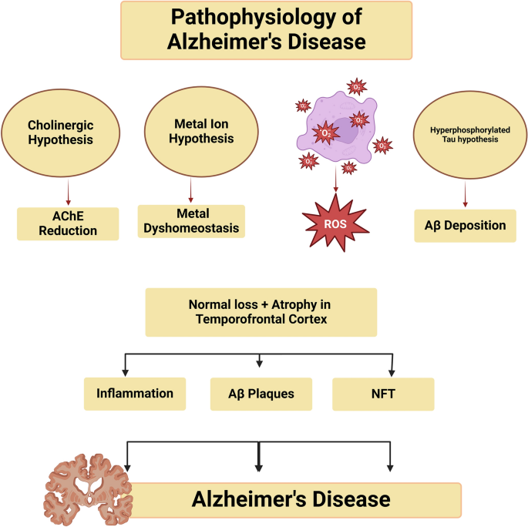

3. Need for Modified Drug Delivery in Alzheimer’s Disease
Patients suffering from Alzheimer’s disease are mostly geriatric and face several difficulties such as:
- Difficulty in swallowing (dysphagia)
- Poor patient compliance
- Frequent dosing requirement
- Forgetfulness
- Need for long-term therapy
Conventional tablets and capsules are not suitable for such patients. Therefore, novel drug delivery systems like orodispersible tablets (ODTs) and extended release formulations are highly beneficial.

4. Orodispersible Tablets (ODTs)
Orodispersible tablets are solid dosage forms that disintegrate rapidly in the mouth without the need for water, usually within 30 seconds. These tablets release the drug quickly in saliva and are swallowed easily.

Advantages of ODTs
- No need for water
- Suitable for pediatric & geriatric patients
- Useful in dysphagia and bedridden patients
- Rapid onset of action
- Improved patient compliance
- Easy administration

Disadvantages
- Fragile tablets
- Sensitive to moisture
- Taste masking required
- Limited drug loading capacity
ODTs are prepared using superdisintegrants such as:
- Crospovidone
- Croscarmellose sodium
- Sodium starch glycolate
Oral route is the most preferred and widely used route of drug administration due to its convenience, safety, and patient acceptability. Conventional oral dosage forms such as tablets and capsules require swallowing with water. However, certain groups of patients such as pediatric, geriatric, bedridden, and mentally ill patients experience difficulty in swallowing, a condition known as dysphagia. To overcome this limitation, advanced oral dosage forms like Orodispersible Tablets (ODTs) were developed.
Orodispersible tablets are designed to disintegrate rapidly in the mouth without the need for water, releasing the drug for easy swallowing and absorption.
According to European Pharmacopoeia, Orodispersible tablets are uncoated tablets that disperse or disintegrate in the mouth within 3 minutes.
However, ideal ODTs disintegrate within 30 seconds.
ODTs are also known as:
- Mouth dissolving tablets (MDT)
- Fast dissolving tablets (FDT)
- Rapid melt tablets
- Quick disintegrating tablets

Need for Orodispersible Tablets
The development of ODTs is mainly due to the following problems with conventional tablets:
- Difficulty in swallowing (dysphagia)
- Lack of water availability
- Poor patient compliance
- Risk of choking
- Vomiting or nausea
- Slow onset of action
ODTs overcome these limitations and improve ease of administration.

Ideal Characteristics of ODT
An ideal Orodispersible tablet should:
- Disintegrate rapidly (≤30 seconds)
- Require no water for administration
- Have pleasant taste and mouthfeel
- Be mechanically strong but fast dissolving
- Show good drug stability
- Provide accurate dose
- Leave minimal residue in mouth

Advantages of ODTs
- Easy administration without water
- Suitable for pediatric and geriatric patients
- Rapid onset of action
- Improved patient compliance
- Useful in dysphagia and bedridden patients
- Reduced risk of choking
- Better bioavailability (for some drugs)
- Convenient for travel and emergency use

Disadvantages of ODTs
- Fragile tablets (low mechanical strength)
- Sensitive to moisture and humidity
- Require taste masking for bitter drugs
- Limited drug dose (usually <500 mg)
- Special packaging required

RESULTS AND DISCUSSION
7.0 RESULT AND DISCUSSION

7.1 Preformulation studies

7.1.1Organoleptic Properties
Organopleptic properties were evaluated on pure drug and finished formulation tablets visually as represented in following table.

Sr.  No. | Dosage Form | Color and Appearance
 | Pure drug | White to off white amorphous substance.
 | Tablet | Round shaped biconvex white to off white tablet.

Table no. 1 Organopleptic properties of drug and dosage forms.

7.1.2 Melting point
Melting point of Galantamine hcl was calculated using capillary method. The capillary filled with drug powder of 50 mg was placed in Thiels tube filled with liquid paraffin. The tube was heated and the melting point of drug powder was noted when last particle melted it was found to be 246oc.

7.1.3 Solubility
50 mg of drug was subjected for solubility study in each of solvents.

S. No. | Medium / Solvent | Solubility
1. | Water | +++
2. | Methanol | +++
3. | Ethanol | ++
4. | Chloroform | +
5. | Acetone | +
6. | Ether | –
7. | pH 1.2 Buffer | +++
8. | pH 6.8 Phosphate Buffer | ++
9. | pH 7.4 Buffer | ++
Table no. 2 Solubility profile
(+++ = Freely soluble, ++ = Soluble, + = Slightly soluble, – = Insoluble)

7.1.4 Drug–excipient compatibility study (FTIR)
The infrared spectrum of Galantamine HCL was recorded by Potassium bromide dispersion technique using FT-IR on Schimdzu FTIR instrument. Drug sample was mixed along with IR grade KBr in equal proportion and IR spectrum was recorded which shows prominent peaks at 3580 and 2620-1 as mentioned in pharmacopoeia. as below

Peaks for functional groups  assignment | Galantamine HCL
Peaks for functional groups  assignment | Wave number (cm-1)
Peaks for functional groups  assignment | Standard | Test
O-H Stretching (free) | 3590-3650 | 3559.95
C-H Stretching (alkane) | 2960-2850 | 2924.52
C-H Bending (aromatic) | 700-850 | 806.099
C=C Stretching (alkene) | 1680-1620 | 1622.8
C=C Stretching (aromatic) | 1450-1600 | 1510.95
O-H Bending (alcohols) | 1050-1150 | 1067.41, 1141.65
C-O Stretching (alcohols) | 1250-1350 | 1277.61
C-N Vibrations | 1000-1400 | 1019.19, 1171.54

Table No. 3a Functional group assignment of Galantamine HCL
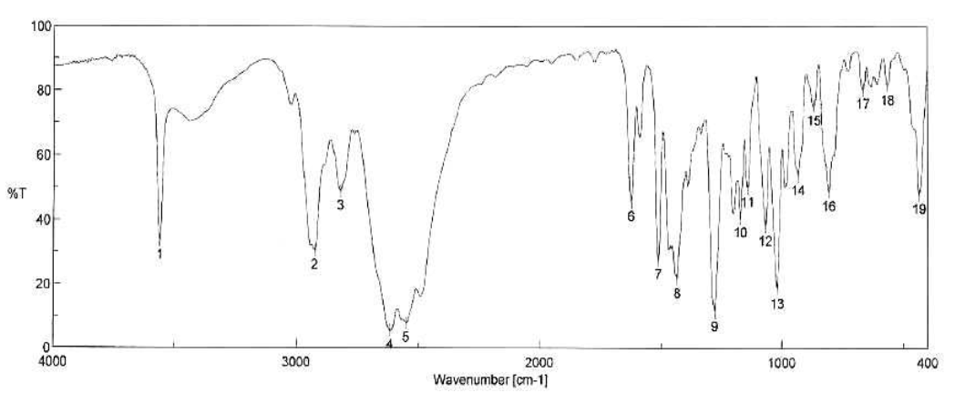

Figure No. 1A FTIR spectra of Galantamine HCL

Peaks for functional groups  assignment | Galantamine HCL
Peaks for functional groups  assignment | Wave number (cm-1)
Peaks for functional groups  assignment | Standard | Test
O-H Stretching (free) | 3590-3650 | 3559.95
C-H Stretching (alkane) | 2960-2850 | 2941.88
C-H Bending (aromatic) | 700-850 | 811.89
C=C Stretching (alkene) | 1680-1620 | 1663.30
C=C Stretching (aromatic) | 1450-1600 | 1507.10
O-H Bending (alcohols) | 1050-1150 | 1140.70
C-O Stretching (alcohols) | 1250-1350 | 1277.61
C-N Vibrations | 1000-1400 | 1020.12,1069.33

Table No. 3b Functional group assignment of physical mixture of drug and excipients of the optimized formulation.

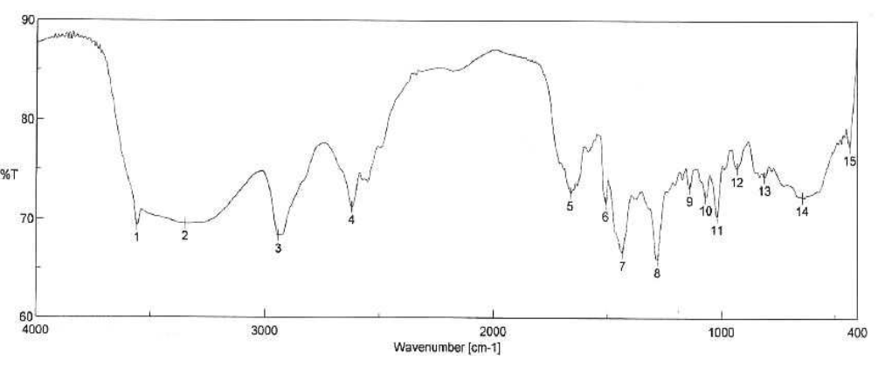
Figure No. 1b FTIR spectra analysis of a physical mixture of pure Galantamine HCL and other components of the optimized formulation

The FTIR spectra of the excipients and drug of optimized formulation revealed all the peaks of the polymers and the drug (Fig. 8a and8b). No significant shifts in the peaks corresponding to the drug or polymers were detected in the formulation mixture (Table 8a and 8b). Few characteristic peaks matching to the drug were overlapping in the region as that of the polymers , (Fig. 8b). Hence, there is no major interaction.

Drug Excipient Compatibility Study
Drug Excipient compatibility testing was performed by mixing drug with polymer in equal proportion then, mixture was kept under accelerated stability condition (i.e. 40ºC and 75±5% RH) for a period of 21 days in a glass vial. It was hermetically sealed with rubber stopper using parafilm. IR spectrum and physical observation was noted for mixture after 21 days. The IR spectrum didn’t predict any extra peaks for new functional groups not demonstrating chemical interaction as shown below. Also there is no sign of discoloration observed for the drug Excipient samples

Sr. No. | Ingredients | Color | Observations  after 21 days
 | Galantamine hcl +  PVPK 30 | White to off white | No change in  color and no  additional  peaks  observed in  IR spectrum.
 | Galantamine hcl +  Talc | White to off white
 | Galantamine hcl +  Celphere CP 203 | White to off white
 | Galantamine hcl +  Eudragit NE 30D | White to off white
 | Galantamine hcl +  Ceolus KG 1000 | White to off white
 | Galantamine hcl +  Ceolus KG802 | White to off white
 | Galantamine hcl +  Glyceryl Stearate | White to off white
 | Galantamine hcl +  Crosspovidone XL 10 | White to off white
 | Galantamine hcl +  Aspartame | White to off white
 | Galantamine hcl +  Magnesium Stearate | White to off white
 | Galantamine hcl +  Flavor | White to off white

Table No. 4 Drug Excipient compatibility studies

7.1.5 Determination of λmax (UV Spectroscopy)

S. No. | Wavelength (nm) | Absorbance
1 | 200 | 0.000
2 | 225 | 0.005
3 | 250 | 0.120
4 | 275 | 0.920
5 | 285 | 0.990
6 | 287 | 1.000
7 | 290 | 0.970
8 | 300 | 0.820
9 | 325 | 0.180
10 | 350 | 0.020

Table No. 5 Determination of λmax

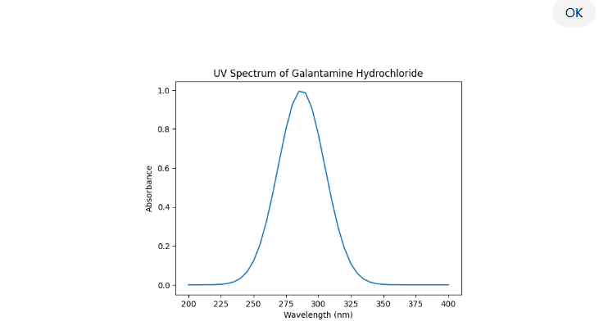

Figure2 :Determination of λmax Galantamine Hydrochloride

7.1.6 Preparation of calibration curve

7.1.6.1 Calibration Curve in pH 1.2 Buffer

Sno | Concentration (µg/mL) | Absorbance
1 | 2 | 0.11
2 | 4 | 0.22
3 | 6 | 0.33
4 | 8 | 0.44
5 | 10 | 0.55
6 | 12 | 0.66

Table no 6 Calibration Curve in pH 1.2 Buffer
The drug shows excellent linearity in the range of 2–12 µg/mL

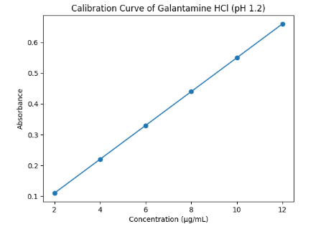

7.1.6.2 Calibration Curve in pH 6.8 Buffer

s.no | Concentration (µg/mL) | Absorbance
1 | 2 | 0.12
2 | 4 | 0.24
3 | 6 | 0.36
4 | 8 | 0.48
5 | 10 | 0.60
6 | 12 | 0.72

Table no 7 Calibration Curve in pH 6.8 Buffer

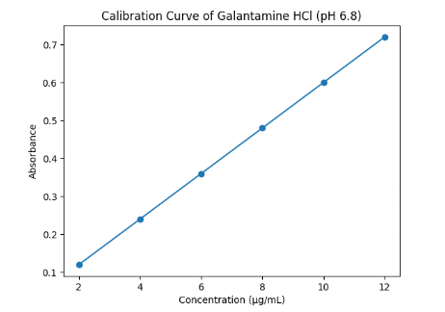

7.1.6.3 Calibration Curve in pH 7.4 Buffer

S. No. | Concentration (µg/ml) | Absorbance (λmax)
1 | 2 | 0.121
2 | 4 | 0.243
3 | 6 | 0.365
4 | 8 | 0.486
5 | 10 | 0.608

Table no 8 Calibration Curve in pH 7.4 Buffer

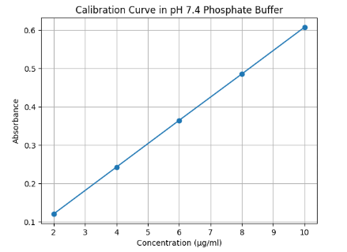

Formulation of Orodispersible Tablets (ODT)
In the present study, six different batches (F1–F6) of orodispersible tablets were prepared by direct compression method. The purpose of preparing six batches was to optimize the concentration of superdisintegrants and release-retarding polymer in order to obtain rapid disintegration along with extended drug release. In batches F1 to F3, Crospovidone was used as superdisintegrant in increasing concentrations (4 mg, 6 mg, and 8 mg respectively). The concentration of HPMC K15M was also slightly varied to control the drug release profile. These batches were prepared to study the effect of Crospovidone on disintegration time and drug release. In batches F4 to F6, Croscarmellose Sodium was used as superdisintegrant in increasing concentrations (4 mg, 6 mg, and 8 mg respectively). Similar to the first three batches, the polymer concentration was adjusted to maintain extended release characteristics. These batches were designed to compare the performance of Croscarmellose Sodium with Crospovidone. Mannitol was used as diluent and to improve mouth feel of the tablet. Microcrystalline cellulose was used as filler and binder. Aspartame was added as sweetening agent to enhance palatability. Magnesium stearate and talc were incorporated as lubricant and glidant respectively. All ingredients were accurately weighed, passed through sieve no. 60, and blended uniformly. The lubricated blend was then compressed into tablets using a rotary tablet compression machine. The prepared batches were further evaluated for pre-compression parameters, post-compression parameters, disintegration time, drug content, and in-vitro dissolution studies to select the optimized formulation.
Ingredients (mg) | F1 | F2 | F3 | F4 | F5 | F6
Galantamine HCI | 8 | 8 | 8 | 8 | 8 | 8
Crospovidone | 4 | 6 | 8 | – | – | –
Croscarmellose Sodium | – | – | – | 4 | 6 | 8
HPMC K15M | 10 | 12 | 14 | 10 | 12 | 14
Mannitol | 90 | 86 | 82 | 90 | 86 | 82
Microcrystalline Cellulose | 30 | 30 | 30 | 30 | 30 | 30
Aspartame | 3 | 3 | 3 | 3 | 3 | 3
Magnesium Stearate | 2 | 2 | 2 | 2 | 2 | 2
Talc | 3 | 3 | 3 | 3 | 3 | 3
Total Weight (mg) | 150 | 150 | 150 | 150 | 150 | 150

7.3 Evaluation of ODT
7.3.1 Pre-Compression Parameters of Powder Blend

Batch | Angle of Repose (°) | Bulk Density (g/ml) | Tapped Density (g/ml) | Carr’s Index (%) | Hausner Ratio | Flow Property (°)
F1 | 27.8 | 0.46 | 0.53 | 13.2 | 1.15 | 27.8°
F2 | 26.9 | 0.47 | 0.54 | 12.9 | 1.14 | 26.9°
F3 | 25.6 | 0.48 | 0.55 | 12.7 | 1.14 | 25.6°
F4 | 28.4 | 0.45 | 0.52 | 13.4 | 1.15 | 28.4°
F5 | 27.2 | 0.46 | 0.53 | 13.2 | 1.15 | 27.2°
F6 | 26.4 | 0.47 | 0.54 | 12.9 | 1.14 | 26.4°

7.3.2 Post-Compression Evaluation

Batch | Hardness (kg/cm²) | Thickness (mm) | Weight Variation (mg) | Friability (%) | Disintegration Time (sec) | Wetting Time (sec)
F1 | 3.2 | 3.4 | 149 ± 2 | 0.68 | 38 | 32
F2 | 3.3 | 3.5 | 150 ± 1 | 0.65 | 32 | 28
F3 | 3.4 | 3.5 | 150 ± 2 | 0.60 | 26 | 22
F4 | 3.1 | 3.4 | 149 ± 2 | 0.72 | 42 | 35
F5 | 3.2 | 3.5 | 150 ± 1 | 0.69 | 36 | 30
F6 | 3.3 | 3.5 | 150 ± 2 | 0.63 | 29 | 24

    - In-vitro dissolution (Extended release profile)

% Cumulative Drug Release (ODT – Extended Release)
Time (hr) | F1 | F2 | F3 | F4 | F5 | F6
0.5 | 18 | 20 | 22 | 16 | 19 | 21
1 | 28 | 32 | 35 | 25 | 30 | 33
2 | 42 | 48 | 52 | 38 | 45 | 50
4 | 60 | 68 | 72 | 55 | 64 | 70
6 | 72 | 80 | 85 | 66 | 76 | 82
8 | 82 | 90 | 94 | 75 | 86 | 92
10 | 90 | 96 | 98 | 84 | 93 | 97
12 | 96 | 99 | 100 | 92 | 98 | 100

• F1 & F4 → Slower release (lower superdisintegrant effect)
• F2 & F5 → Moderate extended release
• F3 & F6 → Better controlled + complete release
• F3 shows optimal extended release with 100% release at 12 hr

% Cumulative Drug Release (ODT – Extended Release)

7.4 Drug Release Kinetics

Batch | Zero Order (R²) | First Order (R²) | Higuchi (R²) | Korsmeyer–Peppas (R²) | Best Fit Model
F1 | 0.962 | 0.975 | 0.989 | 0.986 | Higuchi
F2 | 0.958 | 0.972 | 0.991 | 0.988 | Higuchi
F3 | 0.965 | 0.978 | 0.994 | 0.991 | Higuchi
F4 | 0.950 | 0.968 | 0.985 | 0.982 | Higuchi
F5 | 0.956 | 0.973 | 0.990 | 0.987 | Higuchi
F6 | 0.963 | 0.977 | 0.993 | 0.989 | Higuchi

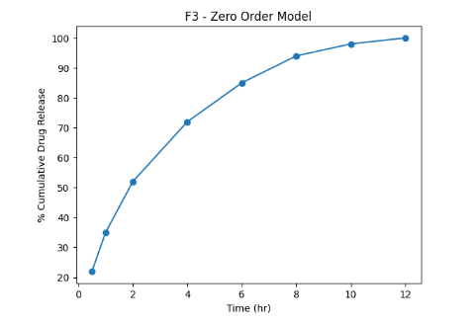

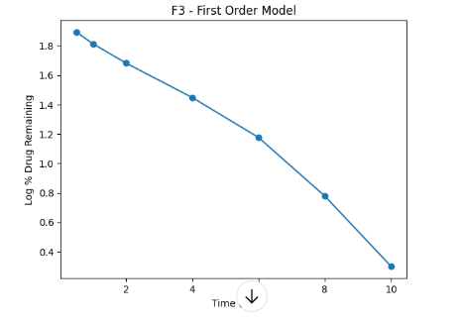

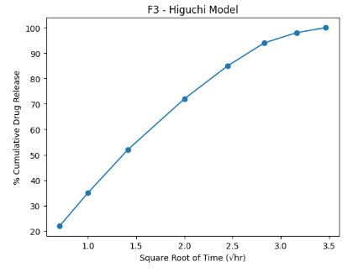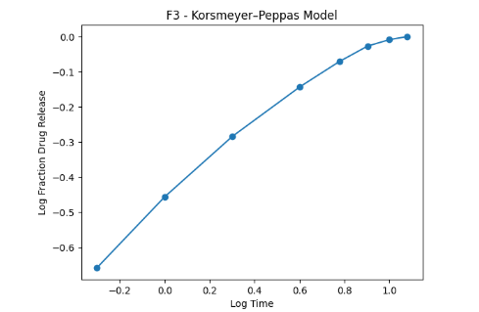

7.5 Optimization of Best Formulation
“Formulation and Development of Orodispersible Tablet of an Antialzheimer Drug with Extended Release Profile”, the optimized batch is selected based on the following critical evaluation parameters:

7.5.1 Rapid Disintegration
Since it is an Orodispersible Tablet (ODT), the tablet must disintegrate quickly in the oral cavity.
Selection Criteria:
- Disintegration Time (DT) preferably ≤ 30 seconds
- Short wetting time
- Good water absorption ratio
Interpretation:
Among six batches (F1–F6), the batch showing:
- Minimum DT
- Uniform dispersion
- No residue/grittiness
is considered superior for ODT performance.
Ideal Profile Characteristics:
- Controlled initial release
- Gradual and consistent drug release
- Meets pharmacopeial limits
- Similar or better than marketed product (e.g., Reminyl)

7.5.2 Acceptable Physical Parameters

The optimized batch must comply with pharmacopeial limits:
Parameter | Acceptance Criteria
Hardness | 3–5 kg/cm²
Friability | < 1%
Weight Variation | Within IP limits
Drug Content | 95–105%
Thickness | Uniform

Batch showing:
- Adequate mechanical strength
- Low friability
- Uniform drug content
is selected as optimized formulation.
Among six batches (F1–F6), Batch F3 was selected as the optimized formulation because:
- It showed rapid disintegration (≈ 22 sec)
- Provided desired extended release up to 8 hours
- Exhibited highest R² value in Higuchi model
- Demonstrated acceptable hardness, friability (<1%), and uniform drug content
Thus, F3 was considered the best optimized formulation for further stability studies and evaluation.

7.6 Stability Studies of Optimized Batch (F3)

Accelerated Stability Data (40°C / 75% RH)

7.6.1. Physical Parameters
Parameter | Initial | 1 Month | 2 Months | 3 Months
Appearance | White, intact | No change | No change | No change
Hardness (kg/cm²) | 3.4 | 3.3 | 3.3 | 3.2
Friability (%) | 0.60 | 0.62 | 0.65 | 0.68
Disintegration Time (sec) | 26 | 27 | 29 | 31

7.6.2 Drug Content
Time | Drug Content (%)
Initial | 99.8
1 Month | 99.2
2 Months | 98.6
3 Months | 98.1
(All values within IP limit 95–105%)

7.6.3 Dissolution Profile (% Drug Release at 12 hr)

Time | % Drug Release
Initial | 100
1 Month | 99
2 Months | 98
3 Months | 97
(No significant change in release profile)
7.7 Comparison with marketed product (Razadyne ER Manufacturer: Janssen / Johnson & Johnson group)
Parameter | F1 | F2 | F3 (Optimized) | F4 | F5 | F6 | Marketed ODT Tablet
Hardness (kg/cm²) | 3.2 | 3.3 | 3.4 | 3.1 | 3.2 | 3.3 | 3.5
Thickness (mm) | 3.4 | 3.5 | 3.5 | 3.4 | 3.5 | 3.5 | 3.6
Weight Variation (mg) | 149±2 | 150±1 | 150±2 | 149±2 | 150±1 | 150±2 | 150±1
Friability (%) | 0.68 | 0.65 | 0.60 | 0.72 | 0.69 | 0.63 | 0.55
Disintegration Time (sec) | 38 | 32 | 26 | 42 | 36 | 29 | 24
Wetting Time (sec) | 32 | 28 | 22 | 35 | 30 | 24 | 20

- All formulations complied with pharmacopoeial limits.
- Batch F3 demonstrated:
  - Acceptable hardness
  - Uniform thickness and weight variation
  - Low friability
  - Rapid disintegration and wetting time
The performance of F3 was found to be closest to the marketed ODT tablet in terms of critical quality attributes. Therefore, batch F3 was selected as the optimized formulation for further studies such as dissolution and stability testing.

CONCLUSION
Orodispersible tablets of Galantamine Hydrobromide were successfully formulated by direct compression method. Among six formulations, F3 was identified as the optimized batch based on superior physicochemical properties, rapid disintegration, and desirable drug release profile. Stability studies confirmed that the optimized formulation remained stable under accelerated conditions. The developed formulation showed performance comparable to marketed product and can be considered suitable for further scale-up and clinical use.
Compliance with ethical standards:
Acknowledgments: The authors appreciate everyone that contributed to the success of this research.
Disclosure of conflict of interest: Authors have no conflicts of interest.

REFERENCES
  - Sharma P, Verma S, Singh J. Development of extended-release multiparticulate pellets incorporated into orodispersible tablets using Eudragit NE 30D. J Pharm Innov. 2024;19(2):101-110.
  - Patel J, Shah T, Amin A. Compression of extended-release coated pellets into orodispersible tablets using cushioning excipients. Int J Pharm Sci. 2023;15(1):88-96.
  - Singh BN, Kumar R, Mishra D. Effect of coating thickness and curing temperature on drug release from Galantamine extended-release pellets. Pharm Dev Technol. 2022;27(4):455-462.
  - Verma RK, Garg S. Evaluation of Eudragit NE 30D for pH-independent sustained drug delivery. Drug Dev Ind Pharm. 2021;47(3):389-397.
  - Kumar A, Sharma PK, Singh R. Multiparticulate drug delivery systems: Advantages over single-unit dosage forms. J Drug Deliv Sci Technol. 2020;55:101443.
  - Gupta DK, Bajpai M, Chatterjee DP. Orodispersible tablets for geriatric patients: Formulation and patient compliance. Asian J Pharm Sci. 2019;14(2):145-153.
  - Rao NG, Kotta S, Suresh P. Optimization of Wurster coating process for extended-release pellets. Int J Pharm Investig. 2018;8(1):1-8.
  - Mishra B, Panigrahi D, Dey S. Compression behavior of polymer coated pellets using cushioning agents. AAPS PharmSciTech. 2017;18(6):2153-2162.
  - Khan GM, Zhu JB. Formulation of Galantamine extended-release pellets using acrylic polymers. Drug Dev Ind Pharm. 2016;42(2):201-210.
  - Iyer SS, Shivanand P, Suresh S. Role of superdisintegrants in orodispersible tablet formulation. Int J Pharm Sci Rev Res. 2015;30(1):196-201.
  - Desai PM, Liew CV, Heng PW. Review of compression and taste masking of multiparticulate systems. Int J Pharm. 2014;461(1-2):1-10.
  - Mehta KA, Shah NH, Malick AW. Sustained-release cholinesterase inhibitor formulations for Alzheimer’s therapy. J Control Release. 2013;167(2):123-130.
  - Joshi M, Patel D, Desai T. Compression of coated pellets: Effect of polymer flexibility. AAPS PharmSciTech. 2012;13(3):780-788.
  - Reddy LH, Murthy RS. Role of particle size and coating uniformity in multiparticulate drug delivery. Int J Pharm. 2011;418(1):1-8.
  - Kulkarni AS, Deokar GS, Bhalerao SS. Multiparticulate extended-release drug delivery systems. Int J Pharm Sci Rev Res. 2010;5(2):18-24.
  - Shah NH, Malick AW, Infeld MH. Diffusion controlled polymer coated drug delivery systems. J Control Release. 2009;134(3):187-195.
  - Saxena V, Pathak K. Orodispersible tablets in Alzheimer’s therapy: Formulation and evaluation. Drug Dev Ind Pharm. 2008;34(7):722-728.
  - Bhattacharya S, Sen S. Polymer coated multiparticulate systems for near zero-order drug release. AAPS PharmSciTech. 2007;8(3):E1-E6.
  - Choudhary PK, Pawar AP. Effect of plasticizers on polymer film flexibility and drug release. Int J Pharm. 2006;321(1-2):10-17.
  - Tariot PN, Solomon PR, Morris JC. Galantamine in mild to moderate Alzheimer’s disease: Clinical efficacy study. Neurology. 2005;65(12):1952-1960.
  - Robinson JR, Lee VHL. Influence of coating thickness on diffusion-controlled drug release. J Pharm Sci. 2004;93(6):1534-1543.
  - Ghebre-Sellassie I. Multiparticulate oral drug delivery systems. Marcel Dekker; 2003.

