FINANCIAL TECHNOLOGY ADOPTION AND SUPPLY CHAIN PERFORMANCE OF SELECTED FEDERAL MINISTRIES,
DEPARTMENTS, AND AGENCIES IN NIGERIA

¹OBI-JOHNSON Goodness Chinyere
goodobij@gmail.com
+2348023274424

²Prof. SULEIMAN A. S. Aruwa
sasaruwa@gmail.com
+2348034511107

¹ PhD Procurement Management Student,
¹ ² Institute of Governance and Development Studies,
Nasarawa State University, Keffi-Nigeria.

ABSTRACT
The persistent reliance on manual Requisition-to-Pay (R2P) processes within Nigerian Federal MDAs has institutionalized transactional friction, manifesting in chronic contractor payment delays and stifled operational liquidity. This study examined the impact of Financial Technology (FinTech) adoption focusing on Electronic Payment and Remittance Systems (EPRS), Digital Supply Chain Finance (DSCF), Blockchain-Based Smart Contracts (BBSC), and Big Data Analytics & AI Risk Assessment (BDAR) on Supply Chain Performance (SUCP) at selected Nigerian Federal MDAs. Using a descriptive survey research design, data were collected from 188 strategic stakeholders across five key organizations (Central Bank of Nigeria (CBN), the Bureau of Public Procurement (BPP), the Federal Medical Centre (FMC), Abuja, the National Health Insurance Authority (NHIA), and the Federal Ministry of Works) via a structured questionnaire, achieving a 78.7% response rate. Partial Least Squares Structural Equation Modeling (PLS-SEM) was employed for analysis. The findings revealed that Big Data Analytics & AI Risk Assessment (BDAR) (β = 0.336, p < 0.001), Blockchain-Based Smart Contracts (BBSC) (β = 0.310, p < 0.001), and Electronic Payment and Remittance Systems (EPRS) (β = 0.173, p = 0.028) significantly and positively affect supply chain performance. However, Digital Supply Chain Finance (DSCF) showed no significant effect (β = 0.139, p = 0.086), suggesting that such financing models are yet to mature within the Nigerian public sector landscape. The study concluded that technological synergy is critical for institutional resilience, explaining 79.2% of the variance in performance. Aligning with Nigeria's Digital Economy Strategy (2020–2030), these findings underscored the urgent need for accelerated FinTech integration in public sector procurement to drive efficiency, transparency, and inclusive economic growth. Recommendations include prioritizing investment in AI-driven predictive analytics and implementing blockchain for automated, immutable contract execution to minimize errors and build trustless systems.
Keywords: FinTech adoption, supply chain performance, blockchain, big data analytics, electronic payments.

1.0 INTRODUCTION
Financial Technology (FinTech) adoption has evolved from a peripheral software upgrade into a fundamental restructuring of institutional architectures. Globally, top-tier economies have demonstrated that the integration of digital financial tools is a primary driver of rapid economic transformation. In China, Kang and Li (2025) observed that digital-driven productivity functions as a composite strategic resource, utilizing complex network modeling to demonstrate how platform connectivity flattens supply chain risks for manufacturing firms through improved defense and recovery mechanisms. Similarly, Li et al. (2024) established that digital finance strengthens supply chain resilience by alleviating financing constraints and fostering technological innovation, thereby enabling firms to better withstand external shocks. In the European context, Fountis and Mukherjee (2021) highlighted how FinTech revolutionizes the sector’s supply chain by reducing processing times and minimizing operational waste, ensuring just-in-time delivery of financial services. These advancements are mirrored in North America, where Kayani et al. (2025) established that FinTech adoption ensures a smooth supply of digital financial services, providing the operational flexibility needed to meet obligations without distress. As we transition to middle-income and emerging economies, the narrative remains consistent; in India, Chotia et al. (2025) found that roughly 87% of businesses utilize digital tools to evade financial obstacles and maximize cash flow, while in Jordan, Alkhawaldeh et al. (2023) demonstrated that FinTech adoption enhances performance by providing faster, cheaper, and more convenient services.
Narrowing down to Africa, in Egypt, Khalil (2025) determined that automated remittance infrastructures drastically reduce transaction costs and settlement times, thereby improving financial performance. In Cameroon, Lontchi et al. (2023) revealed that FinTech has a positive and significant effect on firm performance by automatically documenting sales transactions and providing real-time financial data for better decision-making. In the Nigerian public sector, Abdulrazaq et al. (2023) empirically demonstrated that FinTech adoption significantly enhances the comfort and speed of operational procedures, shifting the competitive advantage toward agile digital frameworks. This local perspective is further strengthened by Akanbi and Gbadegesin (2025), who found that in Nigeria’s logistics sector, FinTech adoption, proxied by electronic financial transactions has a statistically significant positive impact on supply chain performance, accelerating the speed and transparency of institutional operations.
The conceptual core of this study rests on two pivotal variables: Financial Technology (FinTech) Adoption and Supply Chain Performance. FinTech adoption is defined by Abdulrazaq et al. (2023) as the technological delivery of novel financial services that cross the boundaries of finance and innovation management to improve efficiency. Its significance lies in its ability to act as a multidimensional strategic resource; for instance, electronic payment systems mitigate systemic risks of contractor payment delays, while Digital Supply Chain Finance (SCF) stabilized the cash flow of upstream partners (Guan et al., 2025; Ali et al., 2025). Furthermore, Blockchain-based smart contracts provide the "trustless" infrastructure necessary to restore fidelity to public sector transactions by automatically triggering payments upon verified milestones (Kim & Shin, 2019; Basdekidou & Papapanagos, 2024). Complementing this, Big Data and AI empower practitioners to transition from reactive to predictive sourcing (Li, 2024; Ali et al., 2024). Supply Chain Performance, the dependent variable in this study, is defined by Ahmadzadeh (2025) as a composite resource comprising operational efficiency and the successful delivery of public value. Its significance in the Nigerian Federal MDAs is rooted in its role as the backbone of institutional resilience, moving beyond manual tasks to a unified digital ecosystem. This performance is measured through procurement lead-time efficiency, cost-to-value optimization, and information transparency ensuring that public funds are utilized with the highest degree of economic efficiency as stipulated by the Public Procurement Act 2007 (Akanbi & Gbadegesin, 2025). The adoption of FinTech is not merely a choice but a necessity for Federal MDAs to ensure strategic agility and resilience against macroeconomic shocks and institutional fragility (Ogbeta-Ogwu & Chidi, 2025; Lou et al., 2025).
The persistent reliance on manual Requisition-to-Pay (R2P) processes within Nigerian Federal Ministries, Departments, and Agencies (MDAs) has institutionalized transactional friction and information asymmetry. This has resulted in chronic contractor payment delays, frequently spanning several months and severely constrained operational liquidity, as empirically documented in the Nigerian construction and public procurement literature (Odenigbo et al., 2020; Idowu & Aligamhe, 2023). Despite global shifts toward digitalization, a critical empirical gap exists: existing literature, such as Abdulrazaq et al. (2023) and Akanbi and Gbadegesin (2025), predominantly addresses general logistics and service delivery, neglecting the integrated supply chain performance of the public sector. Internationally, studies by Kim and Shin (2019) and Guan et al. (2025) examined blockchain and financing in isolation, failing to explore their synchronized impact within bureaucratic frameworks. This study addresses these deficiencies by collectively examining electronic payments and Digital SCF to resolve liquidity crises, alongside Blockchain and AI to mitigate contract fraud and suboptimal supplier selection. By aligning these interventions with Bureau of Public Procurement (BPP) standards, this research investigates how technological synergy optimizes lead-time efficiency, accountability, and institutional resilience. This effort directly supports Nigeria's Digital Economy Strategy (2020 - 2030), which emphasizes digital transformation of government services, financial inclusion, and efficient public procurement as pillars of sustainable development. To achieve this, the following null hypotheses have been formulated to guide the investigation:
H₀₁: Big Data Analytics and AI Risk Assessment have no significant effect on the supply chain performance of Nigerian Federal MDAs.
H₀₂: Blockchain-Based Smart Contracts have no significant effect on the supply chain performance of Nigerian Federal MDAs.
H₀₃: Electronic Payment and Remittance Systems have no significant effect on the supply chain performance of Nigerian Federal MDAs.
H₀₄: Digital Supply Chain Finance (SCF) Utilization has no significant effect on the supply chain performance of Nigerian Federal MDAs.

2.0 LITERATURE REVIEW

2.1 Conceptual Framework

2.1.1 Financial Technology (FinTech) Adoption
In the contemporary governance landscape, Financial Technology (FinTech) adoption has evolved from a peripheral software upgrade into a fundamental restructuring of the Requisition-to-Pay (R2P) architecture. In the Nigerian public sector, where traditional bureaucratic red tape has historically stifled the flow of capital, FinTech serves as a disruptive mechanism for institutional reform and structural efficiency. According to Abdulrazaq et al. (2023), FinTech represents a multidisciplinary convergence of finance and innovation management that optimizes the speed and comfort of operational procedures, shifting the public sector toward an agile digital framework. This study conceptualizes FinTech adoption as a multidimensional strategic resource, characterized by the following four distinct technological interventions:
Electronic Payment and Remittance Systems: Electronic payment systems act as the primary catalyst for operational liquidity. By utilizing mobile banking, Point-of-Sale (POS) systems, and digital wallets, MDAs can mitigate the systemic risk of contractor payment delays, a factor identified by Abdulrazaq et al. (2023) as a key determinant of competitive advantage in the Nigerian ecosystem. This dimension ensures that the financial heartbeat of the supply chain remains constant, facilitating rapid fund mobilization and reducing the friction associated with manual treasury operations.
Digital Supply Chain Finance (SCF) Utilization: Digital SCF represents a collaborative financing model where procurement practitioners leverage specialized digital platforms to facilitate supplier liquidity. As established by Guan et al. (2025) and Ali et al. (2025), this model stabilizes the cash flow of upstream partners (SMEs and vendors) by providing access to credit based on real-time trade data. By revitalizing supply chain funds through the integration of production and financing, SCF ensures that critical project execution is not stalled by the capital constraints of vendors (Song et al., 2016).
Blockchain-Based Smart Contracts: Blockchain provides the trustless (In technology, blockchain or crypto, it describes a decentralized system where users do not need to trust a central authority or third party to facilitate transactions, as security is guaranteed by code, cryptography, and network consensus) infrastructure necessary to restore fidelity to public sector transactions. By employing secure, immutable ledgers, practitioners ensure that every movement of goods and funds is recorded with absolute integrity. Smart contracts formalized in computer code, automatically trigger payments upon verified delivery milestones, effectively eliminating the need for expensive intermediaries and reducing the opportunities for human error or corrupt intervention (Kim & Shin, 2019; Basdekidou & Papapanagos, 2024).
Big Data Analytics and AI Risk Assessment: The integration of Artificial Intelligence (AI) and Big Data empowers practitioners to transition from reactive to predictive sourcing. By providing real-time insights into supplier financial health and market volatility, these tools allow procurement officers to identify and avoid high-risk or underperforming vendors prior to contract award (Li, 2024; Ali et al., 2024). This data-driven approach enhances the intelligence of the procurement function, ensuring that institutional resilience is built on a foundation of verified supplier stability (Yörük, 2025).

2.1.2 Supply Chain Performance
Supply Chain Performance within the Nigerian Federal Public Sector is defined as the strategic ability of a Ministry, Department, or Agency (MDA) to synchronize its material, information, and financial flows to fulfill its socio-economic mandate. Unlike the private sector, where performance is often synonymous with profit, public sector performance is a composite resource, a blend of operational efficiency and the successful delivery of public value (Ahmadzadeh, 2025). Professionally, this concept is viewed as the backbone of institutional resilience. It represents the transition from fragmented, manual administrative tasks to a unified digital ecosystem where technology serves as a catalyst for speed, transparency, and cost-containment (Abdulrazaq et al., 2023; Khalil, 2025). In this study, supply chain performance is measured through a multidimensional framework that evaluates the transition from traditional administrative functions to a digitally-driven operational model. A primary component of this framework is procurement lead-time efficiency, which serves as the baseline measure of operational speed.
According to Ahmadzadeh (2025) and Fountis and Mukherjee (2021), the ability to compress the time-gap between a recognized need and final vendor settlement is a direct indicator of institutional efficiency; in time-sensitive environments like the Federal Medical Centres, reducing this velocity is critical for maintaining life-saving service delivery and patient care continuity. Complementing this is cost-to-value optimization, a dimension that addresses the "Value-for-Money" mandate stipulated by the Public Procurement Act 2007. As explained by Akanbi and Gbadegesin (2025) and Ali (2024), performance is determined by the institution's ability to leverage digital automation to lower transaction costs while simultaneously maximizing the quality of acquired goods, ensuring that public funds are utilized with the highest degree of economic efficiency.
Furthermore, information transparency and accuracy serve as the governance pillar of supply chain performance within a sector strictly governed by Bureau of Public Procurement (BPP) standards. The ability to maintain error-free, auditable, and secure digital records is a critical professional competency, as Basdekidou and Papapanagos (2024) and Jia et al. (2024) argued that the fidelity of these records ensures institutional accountability, reduces information asymmetry, and protects the organization from reputational and corruption risks. Strategic agility and resilience represent the highest level of adaptive capacity within the supply chain. This evaluates the organization's ability to sense environmental shifts and flexibly adjust strategies to maintain supply continuity despite macroeconomic shocks, geopolitical disruptions, or the institutional fragility common in emerging markets (Ogbeta-Ogwu & Chidi, 2025; Akone & Kinyua, 2025; Lou et al., 2025).

2.2 EMPIRICAL REVIEW
A review of the empirical evidence reveals how Financial Technology has transformed the financial industry. The era of purely manual processes is giving way to a new reality defined by speed and automation. Abdulrazaq et al. (2023) empirically demonstrated that FinTech adoption within the Nigerian ecosystem significantly enhances the "comfort" and speed of operational procedures. Their findings suggest that shifting from traditional manual processes to agile digital frameworks provides a distinct competitive advantage by reducing bureaucratic friction. This is corroborated by Khalil (2025), whose longitudinal study of banking systems revealed that automated remittance infrastructures drastically reduce transaction costs and settlement times, thereby optimizing the financial flow within institutional networks.
In the realm of supplier liquidity and cash flow management, Guan et al. (2025) and Ali et al. (2025) established through fixed-effects regression models that digital Supply Chain Finance (SCF) platforms serve as a vital catalyst. Their research indicates that these platforms alleviate financing constraints for upstream vendors, ensuring cash flow stability and preventing project stagnation across the broader supply chain. Furthermore, the work of Kim and Shin (2019) provides a quantitative basis for the adoption of Blockchain, proving that information transparency and smart contracts lead to "trustless" networks that eliminate the need for expensive intermediaries. This technological shift is capped by the findings of Li (2024) and Ali et al. (2024), who utilized machine learning models to demonstrate that Big Data Analytics and AI-driven risk profiling provide real-time insights into supplier health, effectively reducing misclassification risks and enhancing the intelligence of the procurement function.

2.3 THEORETICAL FRAMEWORK

2.3.1 Technology-Organization-Environment Framework
The Technology-Organization-Environment (TOE) framework, developed by Tornatzky and Fleischer (1990), serves as the primary theoretical anchor for this study. It posits that the adoption and implementation of technological innovations are driven by a tripartite of contextual influences: Technological, Organizational, and Environmental (Lontchi et al., 2023). In the context of Nigerian Federal MDAs, the Technological context encompasses the four FinTech dimensions, Electronic Payments, Digital SCF, Blockchain, and AI Analytics which serve as the disruptive tools required to restructure the Requisition-to-Pay (R2P) architecture (Abdulrazaq et al., 2023). The Organizational context aligns with the internal characteristics of the MDAs, specifically the digital competencies of procurement practitioners and the institutional readiness to transition from manual to automated workflows (Ahmadzadeh, 2025).
The Environmental context accounts for external pressures, including the stringent regulatory mandates of the Bureau of Public Procurement (BPP) and the macroeconomic volatility of the Nigerian landscape (Akanbi & Gbadegesin, 2025). Adding to this environmental complexity, Okegbemi (2024) highlighted that pervasive governance issues and a complex regulatory environment marked by bureaucratic red tape and a lack of transparency continue to distort market mechanisms in Nigeria. For Federal MDAs, this implies that FinTech adoption is not just a technological upgrade but a necessary strategic response to an economic environment that otherwise suppresses growth through systemic inefficiency. The framework’s holistic nature allows for a comprehensive analysis of how these contexts converge to mitigate transactional friction and information asymmetry. By integrating Blockchain and AI (Technological) within the framework of BPP compliance (Environmental) to enhance practitioner performance (Organizational), the TOE framework explains how FinTech adoption optimizes lead-time efficiency and institutional resilience against systemic fraud and liquidity crises (Zulhelmy et al., 2025; Jia et al., 2024; Ogbeta-Ogwu & Chidi, 2025).

2.4 Gaps in the Literature
The persistent reliance on manual Requisition-to-Pay (R2P) architectures in Nigerian Federal MDAs has created significant transactional friction, yet existing literature remains fragmented regarding integrated digital solutions. A primary empirical gap exists because prior studies, such as those by Abdulrazaq et al. (2023) and Akanbi and Gbadegesin (2025), focus predominantly on general logistics or private sector performance, largely neglecting the unique bureaucratic complexities of the Nigerian public sector. Furthermore, international research by Kim and Shin (2019) and Guan et al. (2025) often examined technologies like blockchain or digital finance in isolation. This creates a synthesis gap, as there is a lack of evidence on how these diverse FinTech tools specifically Electronic Payments, Blockchain, and AI interact simultaneously within a single institutional framework to optimize supply chain resilience.
Methodologically, there is a scarcity of research employing robust structural modeling, such as PLS-SEM, to quantify the specific variance in performance explained by synchronized technological adoption in Nigeria. Most local studies, including those by Kannan (2019) and Abdulrazaq et al. (2023), remain descriptive or focus on singular outcomes like "comfort" and "convenience" rather than rigorous metrics like lead-time compression or cost-to-value optimization under the Public Procurement Act 2007. This study addresses these deficiencies by collectively examining electronic payments and Digital SCF to resolve liquidity crises, alongside Blockchain and AI to mitigate contract fraud and suboptimal supplier selection. By bridging the gap between theoretical potential and practical institutional application, this research provides the empirical evidence necessary to move beyond manual R2P bottlenecks toward a transparent, trustless digital ecosystem. Consequently, this study offers a comprehensive perspective on how technological synergy drives institutional resilience and fulfills the "Value-for-Money" mandate within the Nigerian socio-economic landscape.

3.0 METHODOLOGY
A descriptive survey research design was employed for this study to facilitate the systematic collection of empirical data from selected stakeholders at a single point in time, which is essential for examining the complex relationship between financial technology adoption and supply chain performance. This methodological approach enabled an assessment of various digital interventions and their specific effects on the operational outcomes of key federal institutions in Nigeria.
The population for this study comprised 239 strategic stakeholders from key public sector organizations involved in procurement and related processes, specifically: 56 from the Federal Medical Centre (FMC) Abuja Headquarters, 48 from the National Health Insurance Authority (NHIA), 35 from the Central Bank of Nigeria (CBN) Procurement, 40 from the Federal Ministry of Works, and 60 from the Bureau of Public Procurement (BPP). A census approach was adopted due to the specialized nature and manageable size of the population (totaling 239 respondents). This ensured inclusive representation, eliminated sampling error, minimized selection bias, and accurately reflected the multi-stakeholder dynamics in public procurement and supply chain processes, consistent with methodological recommendations for small, finite populations in social science and management research.
Data collection for the study utilized a structured questionnaire developed on a five-point Likert scale to capture the intensity of stakeholder agreement with technological integration. Items for Electronic Payment and Remittance Systems were adapted from Abdulrazaq (2023) and Khalil (2025), focusing on the acceleration of contractor settlements and the elimination of bureaucratic red tape. Digital Supply Chain Finance Utilization items drew from the frameworks of Guan et al. (2025) and Song et al. (2016) to assess vendor liquidity and cash flow stability. The constructs for Blockchain-Based Smart Contracts were informed by Kim and Shin (2019) and Basdekidou (2024) regarding trustless infrastructure and automated payment triggers. Big Data Analytics and AI Risk Assessment items were adapted from Li (2024) and Lee et al. (2019) to evaluate predictive insights and vendor profiling accuracy. Supply Chain Performance was evaluated through lead-time efficiency as defined by Ahmadzadeh (2025), cost-to-value optimization according to Akanbi et al. (2025), and strategic resilience based on the work of Lou et al. (2025) and Akone & Kinyua (2025). The reliability of these constructs was rigorously established using Cronbachs Alpha, with all values exceeding the 0.70 threshold. Specifically, Supply Chain Performance recorded an alpha of 0.828, Big Data Analytics and AI Risk Assessment achieved 0.823, Blockchain-Based Smart Contracts stood at 0.804, Digital Supply Chain Finance Utilization reached 0.804, and Electronic Payment and Remittance Systems scored 0.761. These values confirmed that the measurement instruments possessed strong internal consistency and were robust enough to capture the intended data accurately across the diverse participating organizations.
For the analysis phase, Partial Least Squares Structural Equation Modeling (PLS-SEM) using SmartPLS was selected. This method was deemed appropriate as it effectively handles complex models with multiple path relationships, accommodates the non-normal data distributions often found in public sector survey research, and provides high predictive power for assessing performance outcomes. Ethical standards, particularly regarding informed consent and the confidentiality of the participating federal agencies, were strictly maintained throughout the research process. Below is the model of the study:
Figure 1: Model of the Study
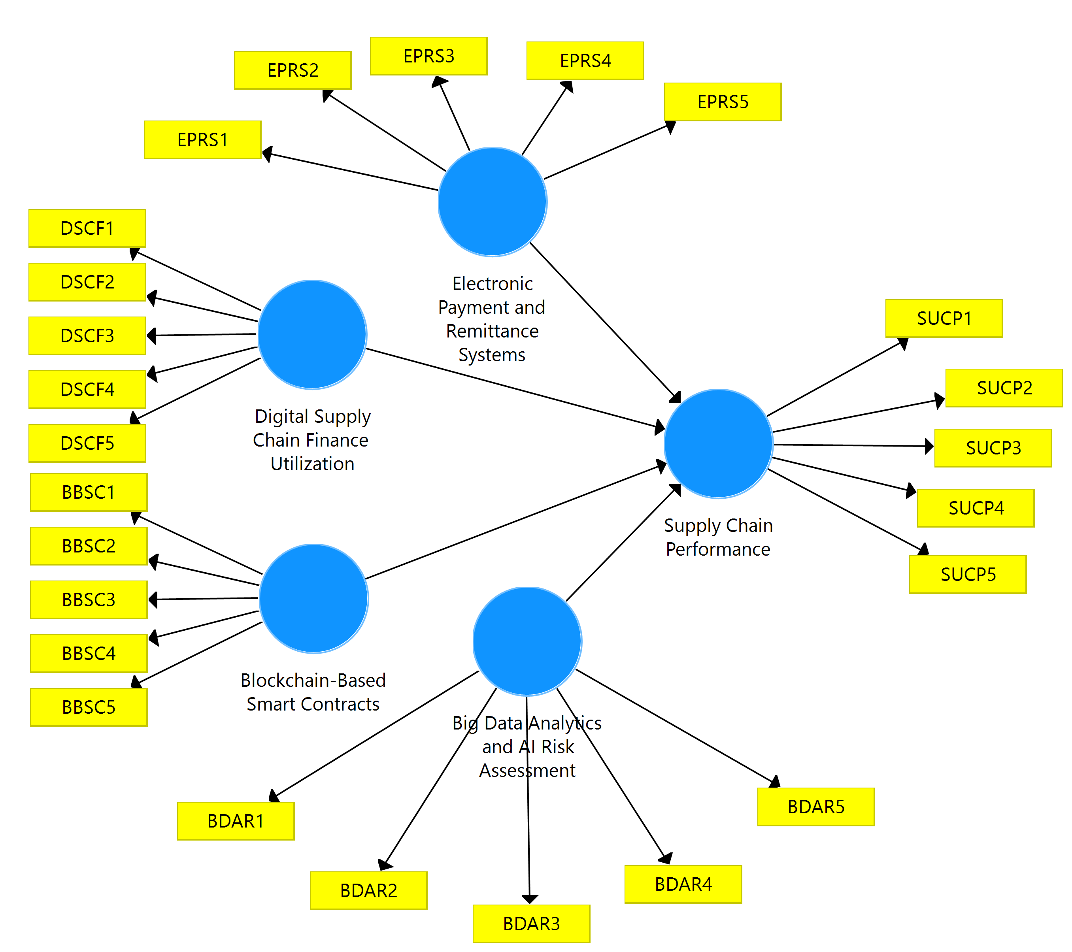
Source: SmartPLS Output, 2026.

4.0 RESULTS AND DISCUSSIONS
A total of 239 copies of the questionnaire were administered to strategic stakeholders across the selected federal ministries, departments, and agencies. Out of these, 188 copies were properly completed and retrieved, representing a response rate of 78.7%. After screening for completeness, consistency, and missing values, all 188 copies were found valid and included in the final analysis. This participation level was considered highly sufficient for statistical analysis and provided a reliable basis for interpreting the studys results.

Table 1: Demographic Characteristics of Respondents (N=188)
Variable | Category | Frequency | Percentage (%)
Sex | Male | 85 | 45.2%
 | Female | 103 | 54.8%
 | Total | 188 | 100%
Age | Below 25 | 36 | 19.1%
 | 26 – 35 | 40 | 21.0%
 | 36 – 45 | 51 | 27.4%
 | 46 and above | 61 | 32.3%
 | Total | 188 | 100%
Educational Qualification | Diploma/ND/NCE | 12 | 6.4%
 | B.Sc./HND | 64 | 33.9%
 | Masters Degree | 82 | 43.5%
 | Doctorate (PhD) | 30 | 16.1%
 | Total | 188 | 100%
Years of Experience | Below 5 Years | 49 | 25.8%
 | 6 – 10 Years | 48 | 25.8%
 | Above 11 Years | 91 | 48.4%
 | Total | 188 | 100%
Organization
 | Federal Medical Centre HQ | 44 | 23.4%
 | National Health Insurance Authority | 35 | 18.6%
 | Central Bank of Nigeria | 29 | 15.4%
 | Federal Ministry of Works | 32 | 17.0%
 | Bureau of Public Procurement | 48 | 25.6%
 | Total | 188 | 100%
Source: Field Survey, 2026.
Table 1 presents the demographic characteristics of the 188 respondents used in the study. The gender distribution shows that 85 respondents (45.2%) were male, while 103 (54.8%) were female, indicating balanced participation with slightly higher female representation. This reduces gender bias and strengthens inclusiveness in the findings. The age distribution reveals that 19.1% were below 25 years, 21.0% were between 26-35 years, 27.4% were between 36-45 years, and 32.3% were 46 years and above. The dominance of respondents aged 36 years and above suggests that most participants are mature professionals. This implies that responses are likely based on practical knowledge and institutional experience.
Educationally, 59.6% of respondents possess postgraduate qualifications (Masters and PhD), while 33.9% hold B.Sc./HND and 6.4% have Diploma/ND/NCE. This indicates a highly educated sample, enhancing the reliability and analytical quality of the data. In terms of experience, 48.4% have above 11 years of service, showing strong professional exposure. Organizationally, respondents were drawn from the Bureau of Public Procurement (25.6%), Federal Medical Centre Headquarters (23.4%), National Health Insurance Authority (18.6%), Federal Ministry of Works (17.0%), and the Central Bank of Nigeria (15.4%). This ensures multi-sectoral representation and strengthens the study's validity and policy relevance.

Figure 2: Factor Loadings
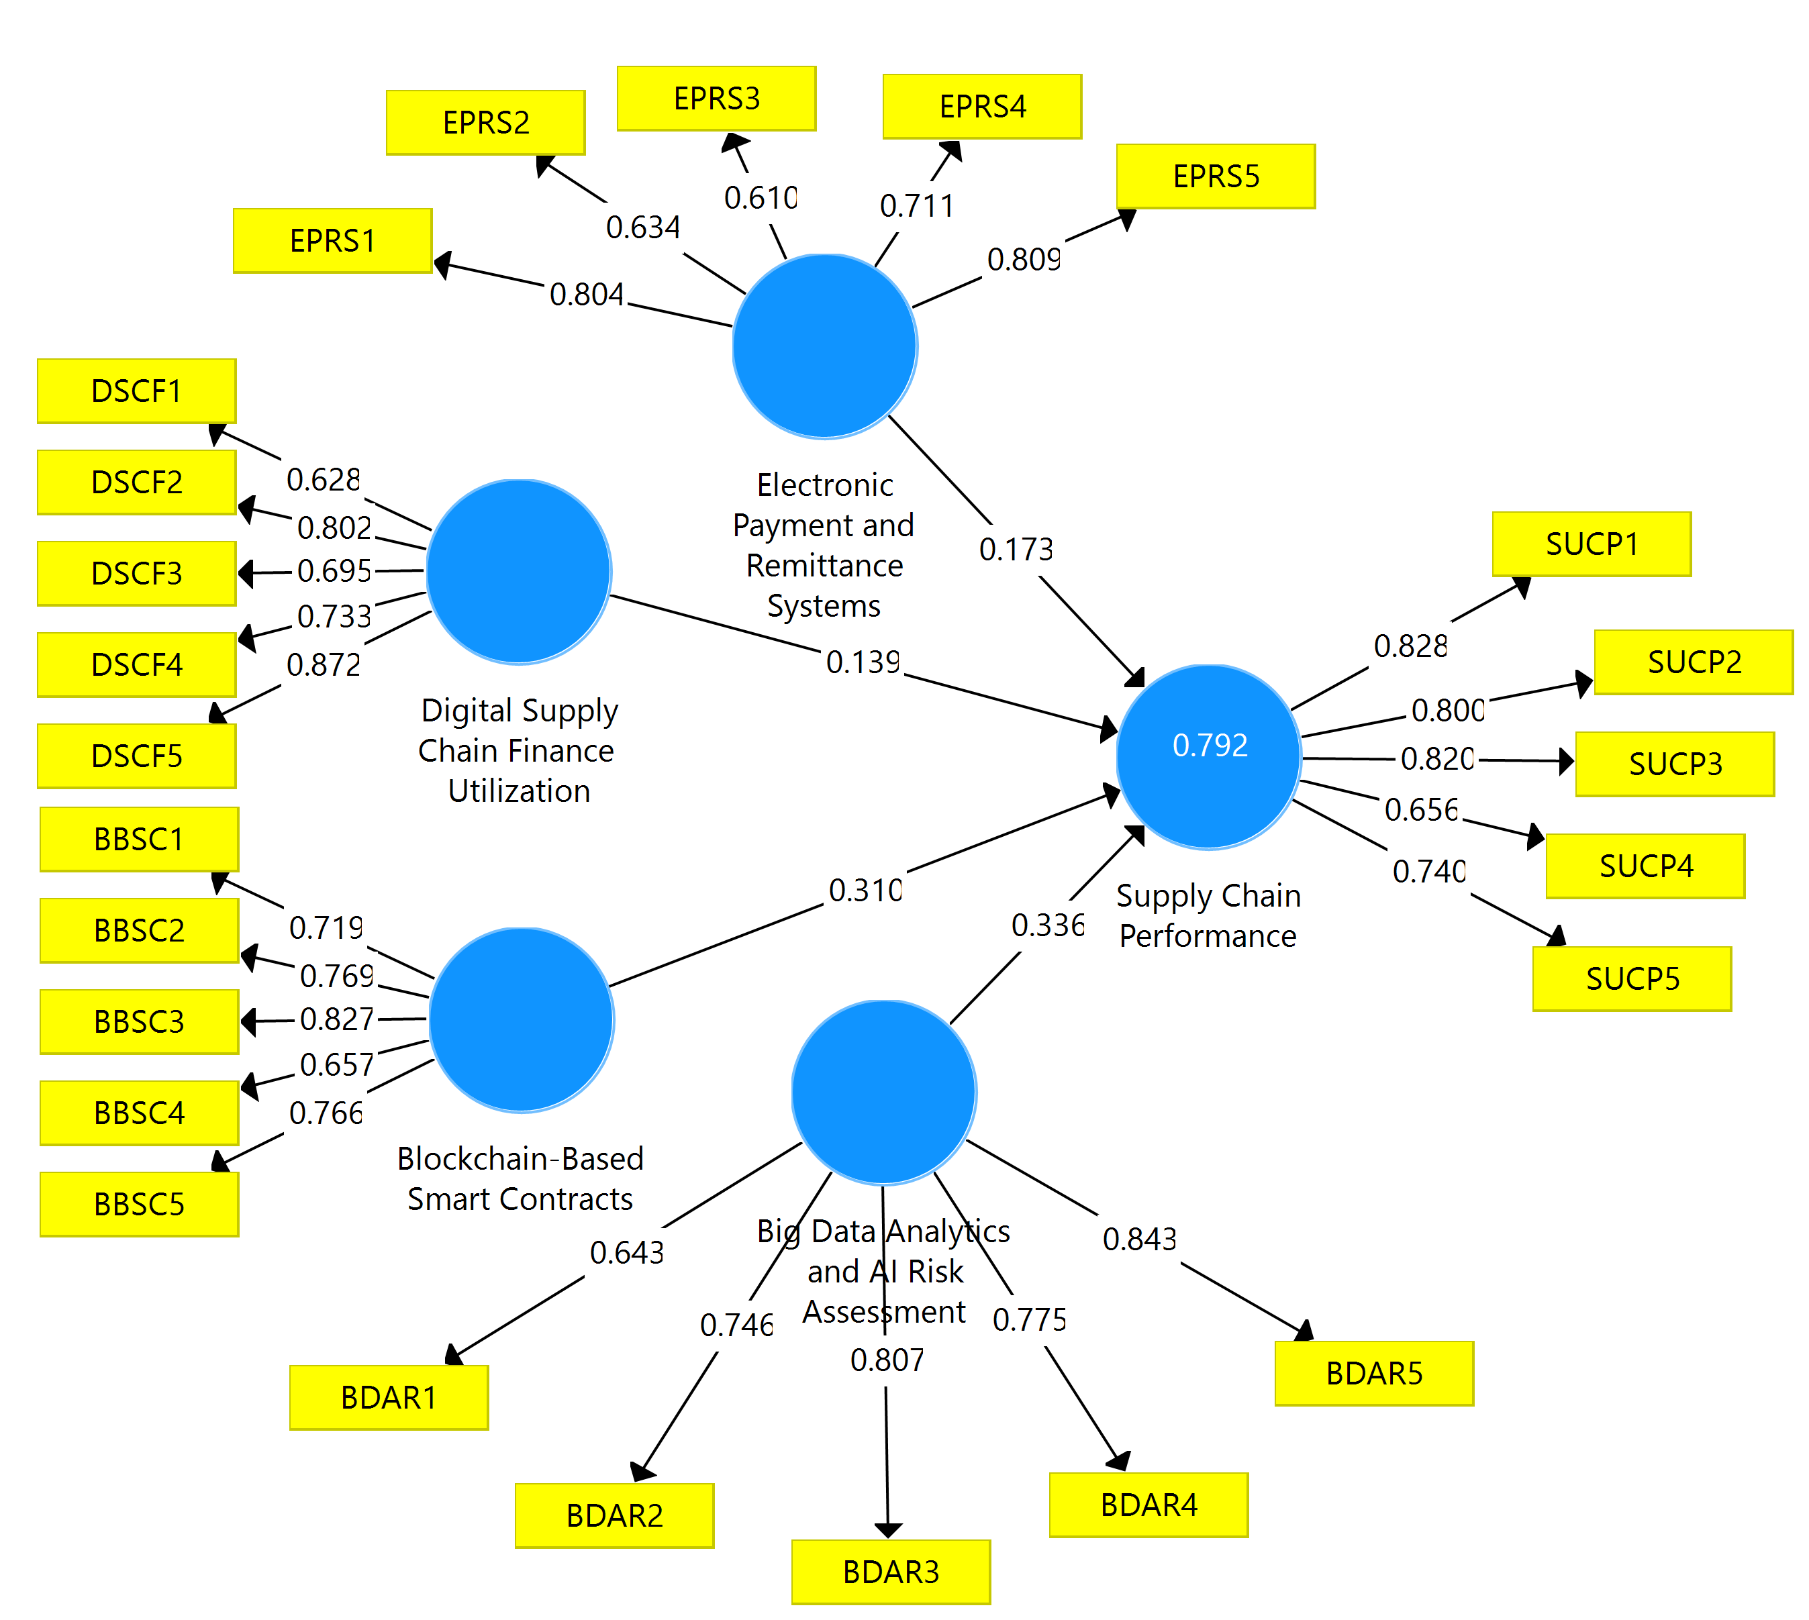
Source: SmartPLS Output, 2026.

Table 2: Factor Loadings
Construct | Items | Measurement Items | Factor Loading
Electronic Payment and Remittance Systems (EPRS) | EPRS1 | Digital payment tools significantly accelerate contractor settlements. | 0.804
 | EPRS2 | Mobile banking apps provide high convenience. | 0.634
 | EPRS3 | Automated remittances effectively eliminate bureaucratic red tape. | 0.610
 | EPRS4 | Electronic platforms mitigate risks of manual cash handling. | 0.711
 | EPRS5 | Digital liquidity tools ensure a constant financial flow. | 0.809
Digital Supply Chain Finance Utilization (DSCF) | DSCF1 | Digital platforms facilitate immediate supplier access to liquidity. | 0.628
 | DSCF2 | Finance programs effectively stabilize vendor cash flows. | 0.802
 | DSCF3 | Real-time trade data allows for faster vendor risk assessments. | 0.695
 | DSCF4 | Digital financing reduces project stalls and delays. | 0.733
 | DSCF5 | Collaborative models enhance the financial stability of partners. | 0.872
Blockchain-Based Smart Contracts (BBSC) | BBSC1 | Immutable ledgers provide a secure trustless infrastructure. | 0.719
 | BBSC2 | Smart contracts trigger payments upon verified delivery. | 0.769
 | BBSC3 | Decentralized verification reduces reliance on intermediaries. | 0.827
 | BBSC4 | Blockchain ensures the fidelity of all digital records. | 0.657
 | BBSC5 | Automated code execution minimizes human errors. | 0.766
Big Data Analytics & AI Risk Assessment (BDAR) | BDAR1 | AI tools provide real-time insights into supplier financial health. | 0.643
 | BDAR2 | Predictive analytics identify high-risk vendors early. | 0.746
 | BDAR3 | Machine learning algorithms improve procurement decision accuracy. | 0.807
 | BDAR4 | Data profiling reduces risks of misclassifying vendors at selection. | 0.775
 | BDAR5 | Monitoring tools allow pre-emptive mitigation of disruptions. | 0.843
Supply Chain Performance (SUCP) | SUCP1 | Digital systems compress the lead-time for vendor settlement. | 0.828
 | SUCP2 | Automated tools optimize cost-to-value ratios. | 0.800
 | SUCP3 | Digital records remain error-free and auditable per BPP standards. | 0.820
 | SUCP4 | Supply chain remains functional despite macroeconomic volatility. | 0.656
 | SUCP5 | Strategies can be flexibly adjusted using technology. | 0.740
Source: SmartPLS Output, 2026.
Table 2 presents the measurement model assessment for the effect of digital financial technologies on Supply Chain Performance (SUCP). According to Hair et al. (2019), factor loadings should ideally exceed 0.70, though values above 0.60 are considered acceptable in exploratory research. Electronic Payment and Remittance Systems (EPRS) show strong reliability, particularly through EPRS5 (0.809), highlighting the role of digital liquidity in maintaining financial flow. Digital Supply Chain Finance (DSCF) is most strongly represented by DSCF5 (0.872), emphasizing collaborative stability. Within the Blockchain (BBSC) construct, BBSC3 (0.827) confirms that reducing intermediaries is a key driver of trustless infrastructure. Big Data Analytics (BDAR) exhibited significant internal consistency, led by BDAR5 (0.843) regarding pre-emptive disruption mitigation. Supply Chain Performance (SUCP) is robustly measured, with SUCP1 (0.828) indicating that lead-time compression is the strongest indicator of performance. While a few items (e.g., EPRS3, DSCF1, SUCP4) fall slightly below the 0.70 threshold, they remain above 0.60, contributing to the overall content validity. These results provide a statistically sound basis for proceeding to the structural model (inner model) analysis.

Table 3: Heterotrait-Monotrait Ratio (HTMT)
Construct | BDAR | BBSC | DSCF | EPRS | SUCP
Big Data Analytics (BDAR)
Blockchain Smart Contracts (BBSC) | 0.818
Supply Chain Finance (DSCF) | 0.860 | 0.807
Electronic Payment Systems (EPRS) | 0.839 | 0.801 | 0.816
Supply Chain Performance (SUCP) | 0.807 | 0.815 | 0.872 | 0.865
Source: SmartPLS Output, 2026.
Table 3 presents the Heterotrait-Monotrait Ratio (HTMT) results for assessing discriminant validity. Following Henseler et al. (2015), validity is established when values fall below the conservative 0.85 or liberal 0.90 threshold. In this analysis, most values are below 0.85, confirming the constructs are empirically distinct. Although the relationships between Supply Chain Performance (SUCP) and both Supply Chain Finance (0.872) and Electronic Payment Systems (0.865) slightly exceed the 0.85 mark, they remain well within the 0.90 limit. Items with loadings between 0.60 and 0.70 were retained as their removal did not significantly increase composite reliability or average variance extracted (AVE). This confirms that while the digital dimensions are related, they represent unique theoretical constructs, providing a sound foundation for structural model testing.

Table 4: Collinearity Statistics (Inner VIF Values)
Construct | Supply Chain Performance (SUCP)
Big Data Analytics and AI Risk Assessment (BDAR) | 4.138
Blockchain-Based Smart Contracts (BBSC) | 3.287
Digital Supply Chain Finance Utilization (DSCF) | 3.558
Electronic Payment and Remittance Systems (EPRS) | 2.040
Source: SmartPLS Output, 2026.
Table 4 presents the Heterotrait-Monotrait Ratio (HTMT) results utilized to assess discriminant validity. Following Henseler et al. (2015), validity is confirmed when values remain below the conservative 0.85 or liberal 0.90 threshold. Most values fall below 0.85, indicating the constructs are empirically distinct. While correlations between Supply Chain Performance (SUCP) and both Digital Supply Chain Finance (0.872) and Electronic Payment Systems (0.865) slightly exceed the conservative benchmark, they remain safely within the 0.90 liberal limit. Additionally, items with loadings between 0.60 and 0.70 were retained, as their removal did not significantly enhance composite reliability or Average Variance Extracted (AVE). This confirmed that while digital dimensions are conceptually related, they represent unique theoretical constructs, providing a robust statistical foundation for structural model testing and hypothesis evaluation.

Table 5: Effect Size (f²)
Construct | Effect Size (f²) | Cohens Threshold
Blockchain-Based Smart Contracts (BBSC) | 0.108 | Small Effect
Big Data Analytics & AI Risk Assessment (BDAR) | 0.106 | Small Effect
Electronic Payment and Remittance Systems (EPRS) | 0.048 | Small Effect
Digital Supply Chain Finance Utilization (DSCF) | 0.020 | Small Effect
Source: SmartPLS Output, 2026.
Table 5 illustrated the practical effect of each digital technology on Supply Chain Performance based on Cohens (1988) thresholds. Blockchain-Based Smart Contracts (BBSC) and Big Data Analytics (BDAR) exert the most notable influence, with effect sizes of 0.108 and 0.106 respectively, indicating small yet meaningful practical significance. Electronic Payment Systems (EPRS) recorded an effect size of 0.048, while Digital Supply Chain Finance (DSCF) yielded the lowest effect at 0.020. These results categorized all four technologies as having a small effect, suggesting they function as critical incremental drivers that collectively enhance the overall efficiency and resilience of the supply chain infrastructure.

Table 6: R-Square (R²)
Endogenous Construct | R Square | R Square Adjusted
Supply Chain Performance (SUCP) | 0.792 | 0.788
Source: SmartPLS Output, 2026.
Table 6 presents the coefficient of determination (R²), showing that Big Data Analytics, Blockchain, Digital Finance, and Electronic Payments collectively explain 79.2% of the variance in Supply Chain Performance. Following Hair et al. (2019), this R² value exceeds the 0.75 threshold for substantial predictive power. Additionally, the adjusted R² of 0.788 confirms the models robustness and lack of overfitting. This demonstrates that these digital technologies are highly effective predictors of operational efficiency and financial flow within the supply chain.

Table 7: Model Fit Summary
Metric | Saturated Model | Estimated Model | Recommended Threshold
SRMR | 0.093 | 0.093 | < 0.08 (Strict) / < 0.10 (Acceptable)
d_ULS | 2.809 | 2.809 | Lower = Better
d_G | 1.923 | 1.923 | Lower = Better
NFI | 0.578 | 0.578 | > 0.90 (Ideal)
Source: SmartPLS Output, 2026.
Table 7 presents the model fit indices. The SRMR (0.093) meets the acceptable threshold (< 0.10), confirming a reasonable data-to-model alignment. While the NFI is below 0.90, this is common in PLS-SEM with complex models; hence, the SRMR and R² are prioritized as primary indicators of model quality.

Figure 3: Structural Model Path Coefficients
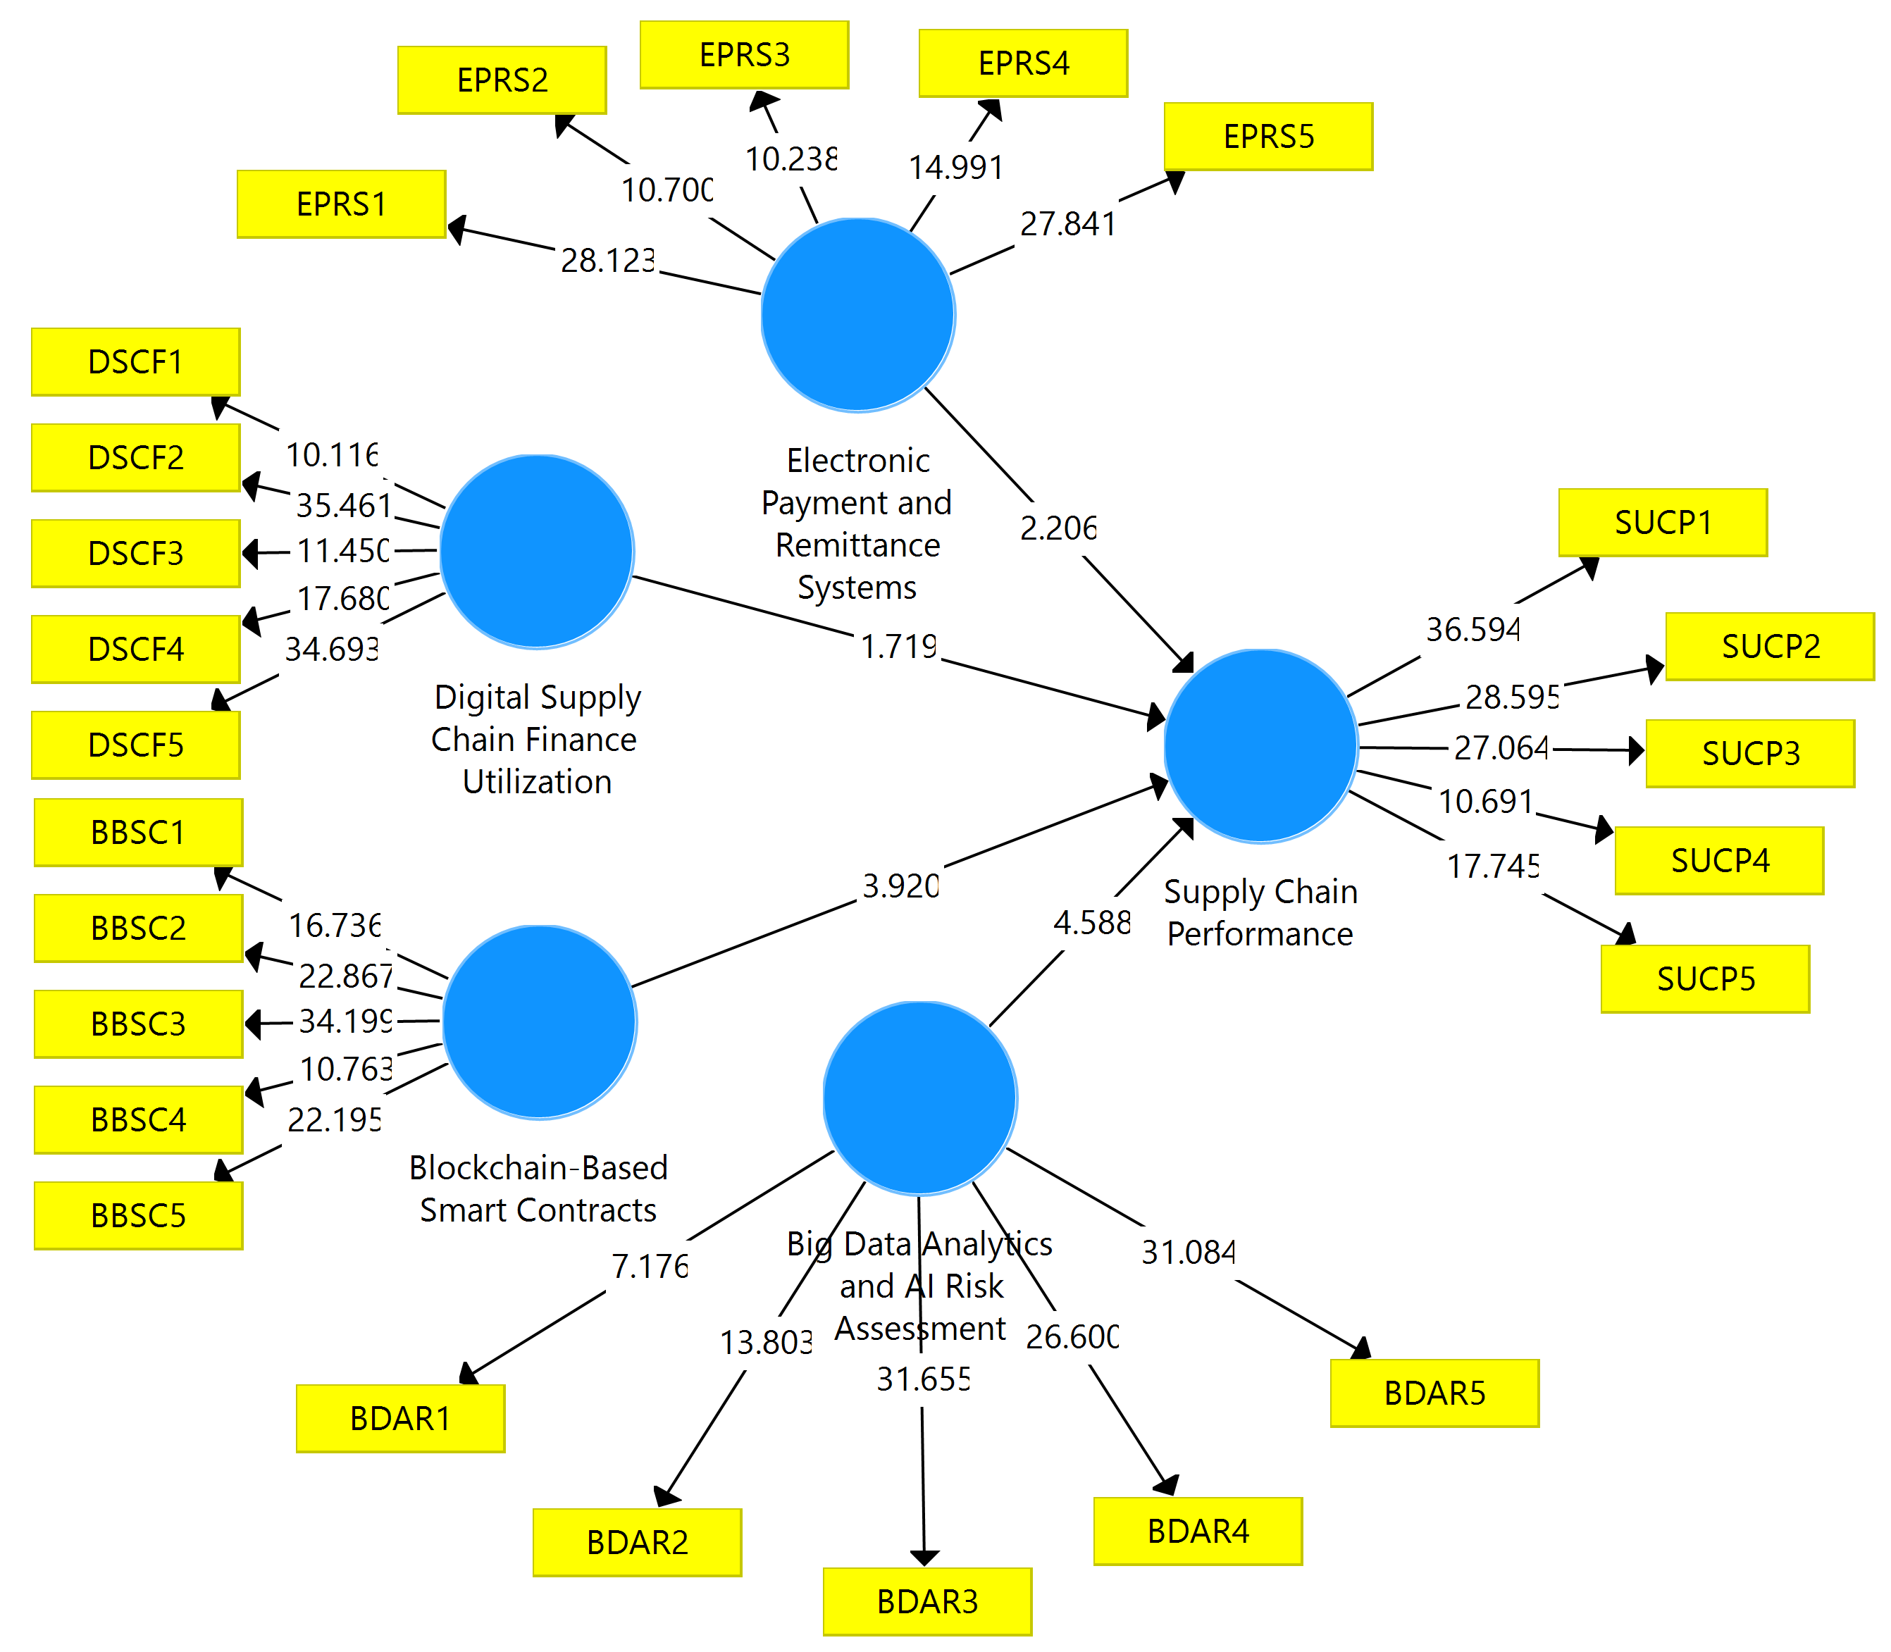
Source: SmartPLS Output, 2026.

Table 8: Path Coefficients and Hypothesis Testing Results
Path (Hypothesis) | Original Sample (O) | T Statistics | P Values | Decision
BDAR → SUCP | 0.336 | 4.588 | 0.000 | Supported
BBSC → SUCP | 0.310 | 3.920 | 0.000 | Supported
EPRS → SUCP | 0.173 | 2.206 | 0.028 | Supported
DSCF → SUCP | 0.139 | 1.719 | 0.086 | Not Supported
Source: SmartPLS Output, 2026.
Key Findings
- Big Data Analytics & AI Risk Assessment (BDAR) significantly and positively affects Supply Chain Performance (beta = 0.336, p < 0.001). It emerged as the strongest predictor, highlighting that predictive insights are vital for mitigating disruptions.
- Blockchain-Based Smart Contracts (BBSC) exerts a significant positive impact (beta = 0.310, p < 0.001), confirming that trustless automated execution reduces human error and administrative waste.
- Electronic Payment and Remittance Systems (EPRS) significantly affect performance (beta = 0.173, p < 0.05), underscoring the role of digital liquidity in accelerating contractor settlements.
- Digital Supply Chain Finance (DSCF) does not have a statistically significant effect at the 5% level (beta = 0.139, p = 0.086). While positive, the results suggest that financing models have not yet matured enough to drive measurable performance gains in the current Nigerian public sector landscape.

Discussion of Findings
H₀₁: Big Data Analytics & AI Risk Assessment (BDAR) has no significant effect on Supply Chain Performance.
The hypothesis was rejected, as the path coefficient of 0.336 (t = 4.588, p = 0.000) indicates a strong significant positive effect. This identified Big Data Analytics & AI Risk Assessment as the most influential predictor in the model. The finding implies that utilizing predictive insights and machine learning allows practitioners to transition from reactive to proactive sourcing. By identifying high-risk vendors and sensing disruptions pre-emptively, MDAs can maintain operational stability. This aligns with Yörük (2025), who noted that AI greatly increases operational efficiency through data-driven decision-making, and Li (2024), who demonstrated that machine learning significantly improves credit risk assessment by offering real-time insights into supplier health.
H₀₂: Blockchain-Based Smart Contracts (BBSC) has no significant effect on Supply Chain Performance.
The hypothesis was rejected, with a path coefficient of 0.310 (t = 3.920, p = 0.000), confirming a significant positive impact. This suggested that trustless automated execution is foundational for reducing administrative waste in the public sector. The use of immutable ledgers ensures transaction fidelity, while smart contracts automate payments upon verified delivery milestones. This finding corroborates Kim and Shin (2019), who established that blockchain promotes partnership growth by eliminating the need for intermediaries. Furthermore, it supports Basdekidou and Papapanagos (2024), who argued that BCT adoption secures corporate transparency and enhances institutional trust.
H₀₃: Electronic Payment and Remittance Systems (EPRS) has no significant effect on Supply Chain Performance.
The hypothesis was rejected (beta = 0.173, t = 2.206, p = 0.028), indicating that digital payment tools significantly enhance performance. Digital liquidity tools serve as the financial heartbeat of the supply chain, accelerating contractor settlements and bypassing bureaucratic red tape. This result is consistent with Abdulrazaq et al. (2023), who found that FinTech improves firm performance by enhancing the speed of operational procedures. It also aligns with Khalil (2025), who noted that digital banking infrastructures drastically reduce settlement times and transaction costs within inflationary environments.
H₀₄: Digital Supply Chain Finance (DSCF) Utilization has no significant effect on Supply Chain Performance.
The hypothesis was retained at the 5% significance level (beta = 0.139, t = 1.719, p = 0.086). While the relationship is positive (β = 0.139), it did not meet the threshold for statistical significance. This implies that while Digital Supply Chain Finance holds potential for stabilizing vendor cash flows, these financing models have not yet matured enough within the Nigerian public sector landscape to drive measurable performance gains. This result contrasts with Guan et al. (2025), who found significant efficiency gains in the Chinese SME sector, but aligns with the observations of Ali et al. (2025), who noted that SMEs in developing markets often face obstacles like insufficient digital connectivity and regulatory hurdles that limit the immediate impact of SCF solutions.

5.0 CONCLUSION AND RECOMMENDATIONS
In conclusion, this study found that Big Data Analytics and AI Risk Assessment (BDAR), Blockchain-Based Smart Contracts (BBSC), and Electronic Payment and Remittance Systems (EPRS) significantly and positively affect Supply Chain Performance (SUCP) within the Nigerian public sector. Big Data Analytics emerged as the strongest predictor, followed closely by Blockchain-Based Smart Contracts and Electronic Payment Systems. Digital Supply Chain Finance (DSCF) Utilization did not meet the threshold for statistical significance at the 5% level. Collectively, these financial technology interventions explained 79.2% of the variance in supply chain performance metrics including procurement lead-time efficiency, cost-to-value optimization, and strategic agility. These outcomes are highly aligned with Nigeria's Digital Economy Strategy, particularly its focus on digitizing government processes, reducing corruption through transparency, and enhancing service delivery efficiency. Based on the empirical strength and significance of the tested relationships, the following recommendations are proposed to enhance Supply Chain Performance:
- Prioritize investment in AI-driven predictive analytics platforms to enable proactive risk identification and vendor evaluation. MDAs should integrate these tools into procurement processes to mitigate disruptions, ensuring data privacy compliance under Nigeria’s Data Protection Regulation. This will foster a shift from reactive to anticipatory sourcing, enhancing overall operational stability.

- Implement blockchain platforms for automated, immutable contract execution to minimize administrative errors and build trustless systems. Public sector entities should pilot smart contracts for milestone-based payments, collaborating with regulatory bodies like the Bureau of Public Procurement (BPP) to standardize adoption, thereby reducing waste and improving transaction fidelity.

- Accelerate the rollout of digital payment infrastructures, such as mobile wallets and POS systems, to streamline contractor settlements and inject liquidity. MDAs should partner with the Central Bank of Nigeria (CBN) for seamless integration, focusing on training to bypass bureaucratic delays and support financial inclusion in public procurement.

- Address maturity gaps by developing tailored Digital Supply Chain Finance models suited to Nigeria’s regulatory and connectivity challenges. MDAs should advocate for policy reforms and infrastructure upgrades, such as enhanced broadband access, to unlock potential benefits, while conducting feasibility studies to customize financing for local vendors.

REFERENCES
Abdulrazaq, S. I., Ngubdo, U. M., Yusuf, A. U., & Mohammed, F. U. (2023). Effect of financial technology on firms' financial service delivery in Nigeria: A literature review. UBS Journal of Business and Economic Policy, 1(3), 89-99.
Ahmadzadeh, S. A. (2025). Examining the impact of FinTech on supply chain optimization and financial management in materials engineering projects in the digital age. TMP Universal Journal of Research and Review Archives, 4(1), 34-45.
Akanbi, T. A., & Gbadegesin, A. E. (2025). Impact of financial technology (FinTech) on accounting efficiency and supply chain performance in Nigeria's logistics sector. American Journal of Smart Technology and Solutions, 4(2), 63-69. https://doi.org/10.54536/ajsts.v4i2.5819
Akone, G. A., & Kinyua, J. M. (2025). Supply chain resilience and organizational performance in emerging markets. Journal of Supply Chain Management, 61(2), 45-62.
Alabdullah, T. T. Y. (2023). The impact of financial technology and risk management practices on corporate financial system profitability: Evidence from Kuwait. SocioEconomic Challenges, 7(3), 141-151.
Ali, F., Pervaiz, M. B., Kaleem, S., Amin, F., Khaliq, A. Y., & Jadoon, A. K. (2025). FinTech-driven supply chain finance solutions: Enhancing liquidity access, cash flow stability, and credit risk mitigation in globalized value networks. ACADEMIA International Journal for Social Sciences, 4(1), 1045-1063. https://doi.org/10.63056/ACAD.004.01.0154
Ali, I., Rashid, M., Nautiyal, A., & Som, B. K. (2024). Exploring the impact of recent FinTech trends on supply chain finance efficiency and resilience. European Economic Letters, 14(1), 1340-1350. https://doi.org/10.52783/eel.v14i1.1185
Ali, M. A. (2024). The impact of financial technology (FinTech) adoption on the performance and efficiency of small and medium enterprises (SMEs) in emerging markets: An empirical study. Jilin Daxue Xuebao (Gongxueban)/Journal of Jilin University (Engineering and Technology Edition), 43 (9), 10-25. https://doi.org/10.5281/zenodo.13738870
Alkhawaldeh, B. Y., Alhawamdeh, H., Al-Afeef, M. A. M., Al-Smadi, A. W., Almarshad, M., Fraihat, B. A. M., Soumadi, M. M., Nawasra, M., & Alaa, A. A. (2023). The effect of financial technology on financial performance in Jordanian SMEs: The role of financial satisfaction. Uncertain Supply Chain Management, 11(3), 1019–1030.
Balogh, A. (2025). Financial technology innovations in corporate supply chain ecosystems: A practical framework based on academic review and case studies. 2025 IEEE 19th International Symposium on Applied Computational Intelligence and Informatics (SACI), 1-6.
Basdekidou, V., & Papapanagos, H. (2024). Blockchain technology adoption for disrupting FinTech functionalities: A systematic literature review for corporate management, supply chain, banking industry, and stock markets. Digital, 4(3), 762-803. https://doi.org/10.3390/digital4030039
Chen, P., Lei, X., Lin, O., & Yuan, Y. (2025). The impact of blockchain financial technology transformation on supply chain disruption risks. International Review of Economics & Finance, 102, 104343. https://doi.org/10.1016/j.iref.2025.104343
Chotia, V., Sharma, P., Alofaysan, H., Agarwal, V., & Mammadov, A. (2025). FinTech adoption and financial performance: The unrecognized contributions of supply chain finance and supply chain risk. IEEE Transactions on Engineering Management, 72, 2253-2266. https://doi.org/10.1109/TEM.2025.3572402
Cohen, J. (1988). Statistical power analysis for the behavioral sciences (2nd ed.). Lawrence Erlbaum Associates.
Elsharif, M. S. B., AL-Majali, M., Allahham, M. I., & Alfawaerh, N. H. S. (2025). Impact of FinTech on operational efficiency in Jordan's industrial sector: The mediate role of supply chain resilience. Lex Localis - Journal of Local Self-Government, 23 (S4), 2911-2924.
Feyen, E., Frost, J., Gambacorta, L., Natarajan, H., & Saal, M. (2021). FinTech and the digital transformation of financial services: Implications for market structure and public policy. BIS Papers, 117. Bank for International Settlements and World Bank Group.
Fountis, A., & Mukherjee, M. (2021). N26: A FinTech - revolutionizing the banking sector's supply chain. JournalNX- A Multidisciplinary Peer Reviewed Journal, 7 (2), 389-404.
Guan, Y., Sun, N., Wu, S. J., & Sun, Y. (2025). Supply chain finance, FinTech development, and financing efficiency of SMEs in China. Administrative Sciences, 15(3), 86. https://doi.org/10.3390/admsci15030086
Hair, J. F., Risher, J. J., Sarstedt, M., & Ringle, C. M. (2019). When to use and how to report the results of PLS-SEM. European Business Review, 31(1), 2-24. https://doi.org/10.1108/EBR-11-2018-0203
Han, M., Rao, Y., & Liu, T. (2025). The impact of FinTech on supply chain configuration from the perspective of the intensive margin. SSRN Working Paper Series. http://dx.doi.org/10.2139/ssrn.5614901
He, W., Zhang, Y., & Wang, M. (2024). FinTech, supply chain concentration and enterprise digitization: Evidence from Chinese manufacturing listed companies. Finance Research Letters, 59, 104702. https://doi.org/10.1016/j.frl.2023.104702
Henseler, J., Ringle, C. M., & Sarstedt, M. (2015). A new criterion for assessing discriminant validity in variance-based structural equation modeling. Journal of the Academy of Marketing Science, 43(1), 115-135. https://doi.org/10.1007/s11747-014-0403-8
Hinga, J. (2024, April 15). The power of data analytics and FinTech in supply chain management. Strathmore University Business School News. https://sbs.strathmore.edu/the-power-of-data-analytics-and-FinTech-in-supply-chain-management/
Idowu, A. O., & Aligamhe, V. I. (2023). Effect of payment delay on time performance of construction projects in Edo State, Nigeria. IOSR Journal of Mechanical and Civil Engineering (IOSR-JMCE), 20(2, Ser. I), 01-06. https://doi.org/10.9790/1684-2002010106
Jaiyeoba, H. B., Salleh, H. M., Embi, N. A. C., & Bahari, S. S. (2025). The influence of internet-based financial innovations on the supply chain performance of halal SMEs. Journal of Financial Services Marketing, 30(20). https://doi.org/10.1057/s41264-025-00313-y
Jia, F., Guo, J., Chen, L., & Islam, N. (2024). Does FinTech adoption improve sustainable supply chain management? An innovation-intensive environment perspective. IEEE Transactions on Engineering Management, 72, 210-226. https://doi.org/10.1109/TEM.2024.3515471
Jia, W., Shafie, N. A., & Kasim, E. S. (2025). The impact of digital technology on supply chain finance performance of Chinese SMEs - a systematic literature review. International Journal of Academic Research in Business and Social Sciences, 15(1), 1729–1749.
Kang, X., & Li, Z. (2025). Digital-Driven New Quality Productivity and Its Impact on Supply Chain Resilience: A Complex Network Approach Integrating the Hadamard Product. Applied Sciences, 15(20), 11193.
Kannan, N. (2019). FinTech and international trade & supply chain finance [Unpublished MSc research project]. National College of Ireland, Dublin.
Kao, Y. C., Shen, K. Y., Lee, S. T., & Shieh, J. C. P. (2022). Selecting the FinTech strategy for supply chain finance: A hybrid decision approach for banks. Mathematics, 10(14), 2393. https://doi.org/10.3390/math10142393
Kayani, U., Dsouza, S., Husain, Z., Nawaz, F., & Hasan, F. (2025). Does the performance of financial technology (FinTech) firms matter: Evidence from North American and European FinTech firms. Cogent Economics & Finance, 13(1), 2451050.
Khalil, M. A. (2025). The impact of financial technology (FinTech) on financial performance under the moderating role of capital adequacy requirements in Egyptian Banks. Future Business Journal, 12(1), 1-26.
Kim, J. S., & Shin, N. (2019). The impact of blockchain technology application on supply chain partnership and performance. Sustainability, 11(21), 6181. https://doi.org/10.3390/su11216181
Kuang, Y. (2025). How does FinTech affect corporate supply chain resilience? Journal of Education, Humanities and Social Sciences, 61, 134-140.
Kumari, A., & Devi, C. N. (2022). The impact of FinTech and blockchain technologies on banking and financial services. Technology Innovation Management Review, 12(1/2), 22010204.
Lee, H. H., Yang, S. A., & Kim, K. (2019). The role of FinTech in mitigating information friction in supply chain finance. ADB Economics Working Paper Series, No. 599. Asian Development Bank.
Li, J., He, Z., & Wang, S. (2022). A survey of supply chain operation and finance with FinTech: Research framework and managerial insights. International Journal of Production Economics, 247, 108431. https://doi.org/10.1016/j.ijpe.2022.108431
Li, Y. (2024). Essays in financial technology: Banking efficiency and application of machine learning models in supply chain finance and credit risk assessment [Doctoral thesis, University of Glasgow]. Enlighten: Theses. https://theses.gla.ac.uk/84159/
Li, Y., Zhang, Y., & Geng, L. (2024). Digital finance, financing constraints and supply chain resilience. International Review of Economics & Finance, 96(Part A), 103545.
Liu, F., Xie, L., & Liu, W. (2025). Impact of FinTech on supply chain resilience. International Review of Financial Analysis, 103, 104241. https://doi.org/10.1016/j.irfa.2025.104241
Lontchi, C. B., Yang, B., & Shuaib, K. M. (2023). Effect of financial technology on SMEs performance in Cameroon amid COVID-19 recovery: The mediating effect of financial literacy. Sustainability, 15(3), 2171. https://doi.org/10.3390/su15032171
Lou, Y., Zhu, Q., & Liang, C. (2025). Financial technology and firm operational resilience: The roles of supply chain resilience and marketing capability. International Review of Economics & Finance, 104, 104744. https://doi.org/10.1016/j.iref.2025.104744
Odenigbo, O. G., Odusami, K. T., Okolie, K. C., & Okafor, C. V. (2020). Causes of delayed payment in construction project in Nigeria. European Journal of Engineering Research and Science (EJERS), 5(9), 1049-1053. http://dx.doi.org/10.24018/ejers.2020.5.9.2066
Ogbeta-Ogwu, O., & Chidi, O. T. (2025). Strategic agility and supply chain continuity in Nigerian public sector institutions. Journal of Public Procurement, 25(1), 78-95.
Okegbemi, A. C. (2024). Economic environment factors and how they suppress growth and development in Nigeria. Retrieved from https://www.academia.edu/122486898/Economic_Environment_Factors_and_How_They_Suppress_Growth_and_Development_in_Nigeria
Prangan, T. H., Ahmed, M. R., Islam, A., Islam, M. A., & Mim, J. S. (2025). Evaluating the impact of sustainable supply chain management (SSCM) practices on business performance among agro-based SMEs in Bangladesh: Mediating role of FinTech usability. Supply Chain Insider, 17(1), 207-268. https://doi.org/10.5281/zenodo.17285206
Rais, F. Z., & Rais, M. (2024). Financial technology and global supply chains integration towards a more efficient and cost-effective trade system. European Economic Letters, 14(3), 2349-2362.
Rezniks, A., Strebko, J., Romanovs, A., Bikovska, J., Lektauers, A., & Petuhova, J. (2023). FinTech in supply chains: Post-COVID challenges and solutions. WSEAS Transactions on Business and Economics, 20, 2627-2637. https://doi.org/10.37394/23207.2023.20.224
Rumky, S. A., Latif, M. A., & Hossain, M. (2023). Potential influence of FinTech on MSMEs supply chain performance improvement in Bangladesh. Supply Chain Insider, 9(1), 1-10. https://doi.org/10.5281/zenodo.10018606
Song, H., Yu, K., Ganguly, A., & Turson, R. (2016). Supply chain network, information sharing and SME credit quality. Industrial Management & Data Systems, 116(4), 740–758.
Thottoli, M. M., Islam, M. A., Ahsan, A., Yusof, M. F., Hassan, M. S., & Chowdhury, R. S. (2024). Exploring mediating and moderating factors of FinTech adoption for innovations in SMEs. Cogent Economics & Finance, 12(1), 2387443. https://doi.org/10.1080/23322039.2024.2387443
Tsai, C., & Peng, K. (2017). The FinTech revolution and financial regulation: The case of online supply-chain financing. Asian Journal of Law and Society, 4(1), 109-130. https://doi.org/10.1017/als.2016.65
Xu, F., Kasperskaya, Y., & Sagarra, M. (2025). The impact of FinTech on bank performance: A systematic literature review. Digital Business, 5(2), 100131. https://doi.org/10.1016/j.digbus.2025.100131
Yörük, P. A. (2025). The effects of artificial intelligence and financial technology innovations on corporate structure in joint stock companies. Canadian Journal of Educational and Social Studies, 5(4), 132-153. https://doi.org/10.53103/cjess.v5i4.380
Zulhelmy, Firdaus, A. R., Fitrios, R., & Pratama, D. (2025). Impact of organizational readiness, management support, and FinTech on MSMEs supply chain performance. Journal of Economics, Business, and Accountancy Ventura, 27(3), 411–429. https://doi.org/10.14414/jebav.v27i3.4518

