Mapping Research Trends on Black Soldier Fly Larvae Oil as Animal Feed: A Bibliometric Analysis from 2021 to 2026

Hanafi Abdillah¹, Muhammad Badar¹, Ahmad Naufal Jauhari¹, Ega Finnegan¹, Diding Latipudin¹, Nahrowi², Agung Irawan³, Mohammed Abdelbagi ^{1,4}, Yulianri Rizki Yanza^{1,}*

¹ Department of Animal Nutrition and Feed Technology, Faculty of Animal Husbandry, Universitas Padjadjaran, Sumedang 45363, Indonesia
² Department of Animal Nutrition and Feed Technology, Faculty of Animal Science, IPB University, Bogor 16680, Indonesia
³ Vocational School, Universitas Sebelas Maret, Surakarta 57126,Central Java, Indonesia
⁴ Department of Animal Nutrition, Khartoum University, Shambat, 1402, Khartoum, Sudan

* Corresponding author: y.r.yanza23@unpad.ac.id

ABSTRACT
The growing demand for sustainable and cost-effective animal feed has spurred research into alternative feed ingredients such as black soldier fly larvae oil. This study sought to delineate the development, intellectual structure, and research trends of black soldier fly larvae oil as animal feed through a bibliometric approach. Scientific publications were sourced from the Scopus database and restricted to English-language articles published between 2021 and 2026. A total of 643 articles from 235 sources were analyzed using Bibliometrix, Biblioshiny, and VOSviewer software. The analysis encompassed annual publication trends, pertinent publication sources, influential documents, country contributions, keyword co-occurrence, thematic structures, and thematic evolution. These findings indicate that research on black soldier fly larvae oil is a nascent yet rapidly advancing field. The Journal of Insects as Food and Feed emerged as the most prolific source, while highly cited documents were predominantly published in Aquaculture, Fish and Shellfish Immunology, and Sustainability. Country contribution analysis revealed that this topic has developed on a global scale, with significant participation from China, European countries, the United States, and several Southeast Asian nations. Keyword analysis demonstrated that the research field remains closely linked to the black soldier fly, black soldier fly larvae, insect meal, growth performance, sustainability, bioconversion, and circular economy. However, recent thematic evolution has highlighted the emergence of insect oil as a specific research focus. These findings suggest that black soldier fly larvae oil holds considerable promise as an alternative lipid source in animal feed. Future research should focus on fatty acid profiles, optimal inclusion levels, animal performance, product quality, gut health, immune responses, and environmental and economic assessments.
Keywords: black soldier fly larvae oil, animal feed, bibliometric analysis, sustainable feed
INTRODUCTION
The escalating demand for high-quality, sustainable, and cost-effective animal feed has spurred research on alternative feed ingredients (Chia et al., 2019). One such material garnering increased attention is the black soldier fly larvae (Hermetia illucens), primarily because of their capacity to transform organic waste into biomass with substantial nutritional value (Spranghers et al., 2017). In recent years, black soldier fly larvae have been investigated not only as an alternative protein source but also as a potential source of lipids and oil for incorporation into animal feed formulations (Lu et al., 2022). Oil derived from black soldier fly larvae has strategic potential as a source of energy and fatty acids in animal feed (Schiavone et al., 2018). Its lipid content can partially substitute conventional oil sources, such as soybean, palm, or fish oil, contingent upon the livestock species and production objectives (Fawole et al., 2021). Within the realm of animal nutrition, the utilization of black soldier fly larvae oil may be linked to growth performance, feed efficiency, nutrient digestibility, fatty acid profile of animal products, gastrointestinal health, and physiological responses in livestock (Kim et al., 2020). Consequently, this topic is pertinent not only from a nutritional standpoint but also for the advancement of more sustainable livestock production systems (Surendra et al., 2016).
Interest in black soldier fly larvae oil aligns with the expanding concept of the circular bioeconomy within the livestock sector (Singh & Kumari, 2019). Black soldier fly larvae can be cultivated on diverse organic substrates, thereby offering the potential to mitigate waste while generating value-added feed ingredients (Meneguz et al., 2018). This positions black soldier fly larvae oil as a significant innovation in efforts to reduce reliance on conventional feed ingredients, which are frequently associated with land-use competition, price volatility, and environmental sustainability challenges (Malcorps et al., 2019). Although research on the black soldier fly as a feed ingredient has progressed rapidly, studies specifically mapping the development of research on black soldier fly larvae oil as animal feed remain limited (Lu et al., 2022). Most prior studies have predominantly focused on larval meal or whole larvae as protein sources, while aspects related to larval oil or lipids remain dispersed across various fields, such as poultry nutrition, aquaculture, swine, ruminants, animal product quality, lipid metabolism, and feed sustainability (Barragan-Fonseca et al., 2017). This underscores the need for systematic scientific mapping to comprehend research development trends, contributions of authors and countries, leading journals, dominant keywords, and emerging research themes.
Bibliometric analysis is a suitable method for addressing this issue. This approach enables the quantitative and visual mapping of the intellectual structure of a research field, encompassing publication trends, collaboration networks, keyword relationships, influential articles, and the evolution of research themes. It is extensively employed in scientific mapping studies because of its ability to provide a comprehensive overview of a topic’s development and identify research gaps and future research directions (Donthu et al., 2021). A review of bibliometric articles further corroborates that bibliometrics can effectively map trends, major sources, collaborations, dominant themes, and research directions within the field of animal nutrition (Aria & Cuccurullo, 2017). Against this backdrop, the present study aimed to analyze the development of scientific publications concerning black soldier fly larvae oil as animal feed, focusing on English-language articles indexed in Scopus from 2021 to 2026. Specifically, this study seeks to identify annual publication trends, the most relevant journals, the most productive authors and institutions, country contributions, the most influential articles, collaboration patterns, dominant keywords, and the evolution of research themes. The findings are anticipated to offer a comprehensive overview of the research development on black soldier fly larvae oil in the context of animal feed, while also serving as a foundation for researchers in formulating future research opportunities.
MATERIALS AND METHODS
Scientific Database Selection
This study utilized a bibliometric methodology to chart the progression of scientific publications concerning black soldier fly larvae (Hermetia illucens) oil as an animal feed component. The Scopus database was employed in this research because of its extensive coverage of scientific literature, comprehensive bibliographic metadata, and prevalent use in bibliometric analyses. The choice of Scopus as the data source aligns with the methodology adopted in a bibliometric article, which also used Scopus as the primary database for literature mapping in the domain of animal nutrition. The literature search was performed using Scopus’ advanced search feature. The articles included in this study were restricted to publications from 2021 to 2026, document-type articles, and English-language publications. A temporal restriction was applied to provide a current overview of research advancements on black soldier fly larvae oil as an alternative lipid source in animal feed. The search strategy was formulated by integrating keywords related to black soldier fly, larval oil or lipids, and animal feed. The search string employed was as follows: TITLE-ABS-KEY (“black soldier fly” OR “Hermetia illucens”) AND (oil OR lipid OR fat OR “insect oil”) AND (feed OR “animal feed” OR “livestock feed”) AND PUBYEAR > 2020 AND PUBYEAR < 2027 AND DOCTYPE (ar) AND LANGUAGE (English). Based on the established search criteria, 643 articles were retrieved from the Scopus database. The bibliographic metadata of these articles were subsequently exported from Scopus in BibTeX and/or CSV formats for further bibliometric analysis.
Data Analysis
The bibliographic data sourced from Scopus were analyzed using R software, specifically employing the Bibliometrix package and Biblioshiny interface. Bibliometrix facilitated the examination of bibliometric indicators, whereas Biblioshiny was used to enhance data processing and the visual representation of analytical outcomes. VOSviewer was used to produce bibliometric network visualizations, with a particular focus on collaboration analysis and keyword relationship mapping.
The analyses encompassed annual scientific production, identification of the most relevant journal sources, the most prolific authors, the most active affiliations, contributions by country, the most cited documents, the most frequently occurring keywords, author and country collaboration networks, and keyword co-occurrence analyses. Co-occurrence analysis was instrumental in identifying relationships among terms and forming thematic clusters pertinent to research on black soldier fly larvae oil as animal feed. Thematic mapping and evolution analyses were conducted to discern major themes, emerging themes, and shifts in research focus during 2021–2026.
Prior to conducting the keyword analysis, a data cleaning process was implemented to standardize terms with similar meanings but different expressions. For instance, the terms “black soldier fly,” “Hermetia illucens,” and “BSF” were examined to prevent semantic redundancy from the visualization. Similarly, terms such as “larval oil,” “insect oil,” “lipid,” “fat,” and “oil” were adjusted according to analytical requirements. General terms not specific to the research topic were excluded to ensure a more focused mapping.
Data visualization was performed using graphs, tables, collaboration maps, and bibliometric networks. In VOSviewer visualizations, the node size indicates the frequency of occurrence or the level of contribution of an element, while the connecting lines represent the strength of the relationships between elements. Different colors denote the clusters or thematic groups. The analysis results were interpreted to elucidate the development, intellectual structure, and research trajectory of black soldier fly larvae oil as an animal feed ingredient. Data from 2026 were interpreted with caution, as the number of publications from that year may continue to increase depending on the timing of data retrieval.
RESULTS AND DISCUSSION
General Overview and Publication Development
As presented in Table 1, research examining the use of black soldier fly larvae oil as animal feed remains a relatively emerging field, with publications recorded between 2021 and 2026. During this timeframe, 643 articles were identified, distributed across 235 publication sources, including journals and other scientific outlets. All analyzed documents were classified as articles, indicating that this topic has evolved into an active empirical research field. The relatively high number of publications within a short period suggests that black soldier fly larvae oil or Hermetia illucens oil has garnered significant attention as an alternative feed ingredient. This aligns with the perspective of Mangindaan et al. (2022), who posited that BSF larvae are promising organisms for linking waste management, feed production, and the sustainability of food-energy systems. Consequently, the development of research on BSF oil pertains not only to animal nutrition but also to issues of circular economy and organic waste utilization.
The average document age of 2.37 years indicates that most of the analyzed articles are recent. This contrasts with the bibliometric study on fat supplementation in ruminants reported by Wardiman et al. (2025), which covered a much longer period, from 1964 to 2024, with an average article age of 22.8 years. This comparison suggests that research on BSF larvae oil as animal feed remains relatively younger than the field of fat supplementation in ruminants, which has developed over several decades. In terms of scientific impact, the average number of citations per document in this study was 14.38. This figure suggests that publications on BSF larvae oil are beginning to attract academic attention, although the citation rate remains lower than that reported in the study on fat supplementation in ruminants by Wardiman et al. (2025), which recorded an average of 48.09 citations per article. This discrepancy is understandable, as articles on BSF larvae oil are relatively recent and thus have had a shorter period for citation accumulation.
Table 1. Summary of the main information on publications were collected
Description | Results
Timespan | 2021:2026
Sources (Journals, Books, etc) | 235
Documents | 643
Annual Growth Rate % | -2.01
Document Average Age | 2.37
Average citations per doc | 14.38
References | 32174
Keywords Plus (ID) | 2804
Author's Keywords (DE) | 1430
Authors | 3074
Authors of single-authored docs | 6
Single-authored docs | 6
Co-Authors per Doc | 6.6
International co-authorships % | 29.86
Article | 643
From the perspective of authorship, this study involved 3,074 authors, with an average of 6.6 authors per paper. Only six articles were authored by a single individual, indicating that research on BSF larvae oil as animal feed is predominantly collaborative. The high number of authors per document suggests that this topic is multidisciplinary, encompassing animal nutrition, feed technology, entomology, microbiology, environmental science, and sustainability.
The percentage of international collaboration, which reached 29.86%, further indicates that this research area has a relatively strong global dimension. This value surpasses that reported by Wardiman et al. (2025) on fat supplementation in ruminants, which recorded international collaboration at 20.44%. This suggests that research on BSF larvae oil has developed through cross-country collaboration from an early stage, possibly because of its relevance to global issues such as the demand for alternative feed resources, organic waste reduction, and sustainability of livestock production.
The annual publication trend depicted in Figure 1 reveals an increase in the number of articles from approximately 80 in 2021 to nearly 150 in 2024–2025 (projected). This upward trend indicates heightened research interest in BSF larvae oil in recent years. A contributing factor to this increase may be the growing focus on insect-based feed ingredients in aquaculture. For instance, in the European Union, Commission Regulation (EU) 2021/1372 authorized the use of processed animal protein derived from insects in poultry and pig feed, thereby expanding the opportunities for research and application of insect-based feed ingredients within the livestock industry.
Nevertheless, the annual growth rate presented in Table 1 is -2.01%. This figure should be interpreted with caution, as it is likely to be influenced by incomplete data for 2026. Figure 1 illustrates a sharp decline in 2026, whereas publications in 2024 and 2025 reached their peak. Consequently, the observed decrease in 2026 should not be prematurely concluded as a decline in research interest; rather, it should be understood as a result of the publication year still being ongoing or not yet indexed.
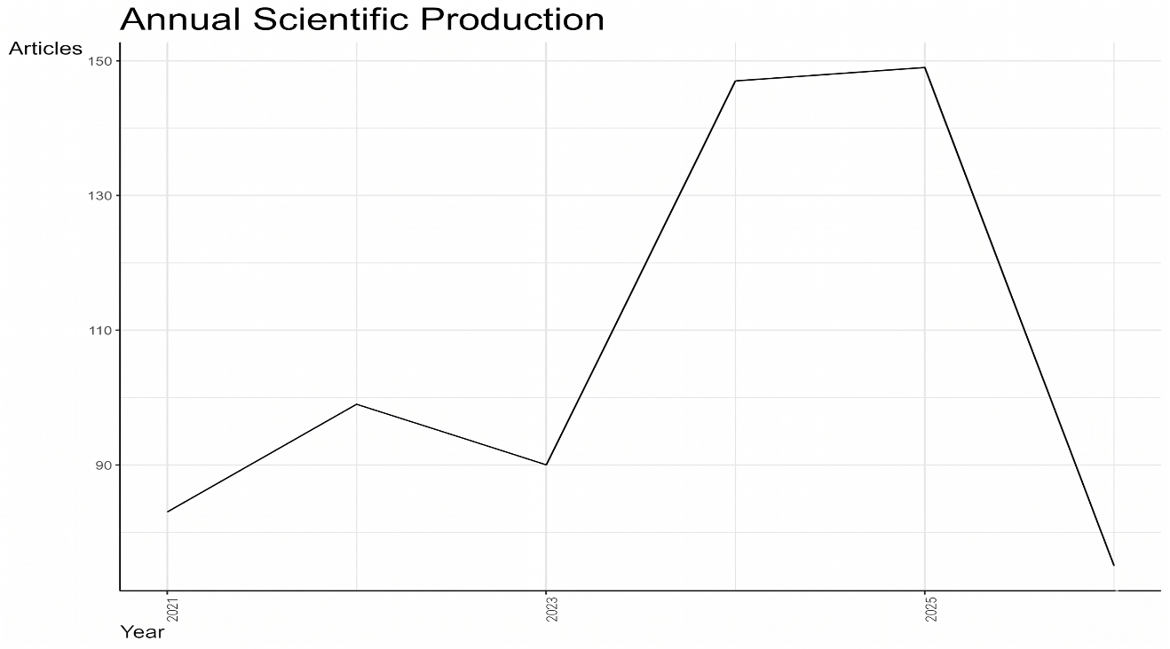
Figure 1. Trend in annual scientific production on black soldier fly larvae oil as animal feed during 2021 to 2026
In comparison with other bibliometric analyses on BSF, this upward trend aligns with global patterns. Mangindaan et al. (2022) demonstrated that BSF research has proliferated owing to its potential applications in waste management, biodiesel production, and the development of alternative feed. Concurrently, Odoi-Yorke et al. (2025), in their bibliometric study on BSF larvae for biofuel production, reported a 23.83% annual growth rate in publications, signifying that BSF is an increasingly prominent topic across diverse fields of application, extending beyond animal feed to include bioenergy.
These findings suggest that research on black soldier fly larvae oil as animal feed is a nascent yet rapidly evolving domain. The substantial volume of publications within a brief timeframe, participation of numerous authors, and significant degree of international collaboration underscore the strong scientific interest in this area. This trend also signifies a transition in animal feed research from traditional feed ingredients to alternative resources that are more sustainable, efficient, and conducive to circular economy-based livestock production.
Publication Sources and The Most Influential Documents
As indicated in Table 2, studies on black soldier fly larvae oil as animal feed have been published in numerous journals, reflecting coverage across a broad range of disciplines. The Journal of Insects as Food and Feed featured the highest number of articles (76). This journal’s prominence suggests a strong association between research on BSF larvae oil and the advancement of insects as alternative food and feed resources for humans and animals. As a journal dedicated to insect utilization, it serves as a primary publication venue for studies related to Hermetia illucens, larval oil, insect meal, and their applications in livestock nutrition.
The second most prolific journal was Animals, with 49 articles. This journal’s standing indicates that BSF larvae oil is examined not only from the perspective of insects as feed ingredients but also in relation to livestock biological responses, production performance, health, and quality of animal products. In contrast to the Journal of Insects as Food and Feed, which has a more specific focus on insects, Animals encompasses a broader scope within the animal sciences. Consequently, the articles published in this journal generally connect the use of BSF larvae oil or BSF-derived products with overall livestock performance.
Table 2. Most relevant sources publishing articles on black soldier fly larvae oil as animal feed
Sources | Articles
JOURNAL OF INSECTS AS FOOD AND FEED | 76
ANIMALS | 49
AQUACULTURE | 28
POULTRY SCIENCE | 22
INSECTS | 20
AQUACULTURE NUTRITION | 14
JOURNAL OF ENVIRONMENTAL MANAGEMENT | 13
WASTE MANAGEMENT | 10
ANIMAL | 9
ANIMAL FEED SCIENCE AND TECHNOLOGY | 9
Aquaculture ranked third with 28 articles, followed by Poultry Science with 22 articles. This suggests that fish and poultry are the two primary livestock groups frequently used as research subjects in studies on BSF larvae oil. The substantial number of publications in Aquaculture and Aquaculture Nutrition indicates that BSF larvae oil has been extensively investigated as an alternative to fish oil or as a lipid source in fish diet. Meanwhile, publications in Poultry Science demonstrate that research on BSF oil has also progressed in poultry, particularly concerning growth performance, feed efficiency, meat quality, egg quality, and the fatty acid profile of animal products.
The presence of the journal “Insects,” with 20 articles, underscores the significance of insect biology, larval production, nutrient composition, and BSF oil characteristics as critical components of this research domain. Furthermore, the inclusion of the “Journal of Environmental Management” with 13 articles and “Waste Management” (10 articles) suggests that BSF larvae oil extends beyond animal nutrition to encompass organic waste management and the circular economy. This highlights a distinctive aspect of BSF research compared to conventional feed research, as BSF larvae serve a dual function as agents of waste bioconversion and nutrient sources for feed.
In comparison to the bibliometric study on fat supplementation in ruminants by Wardiman et al. (2025), notable differences emerged in the characteristics of the dominant journals. In the study on ruminant fat supplementation, the leading journals were predominantly the “Journal of Dairy Science,” with 164 publications, followed by “Journal of Animal Science” with 64 publications, “British Journal of Nutrition” with 22 publications, and “Animal Feed Science and Technology”, with 12 publications. This pattern indicates that research on fat supplementation in ruminants is more concentrated in journals related to animal nutrition, dairy production, and lipid metabolism. In contrast, research on BSF oil is more broadly distributed across the fields of insects, aquaculture, poultry, environment, and waste management. Consequently, the field of BSF larvae oil appears to be more multidisciplinary than the more established field of ruminant fat research, which is more focused on traditional animal nutrition.
According to Table 3, the article by Hua (2021), published in Aquaculture, emerged as the most influential document in this study, with 158 citations and an average of 26.3 citations per year. This article has the highest total citation count and is thus considered a pivotal reference in the advancement of BSF-based feed ingredients, particularly in the aquaculture sector. The second most influential work was by Weththasinghe et al. (2021), also published in Aquaculture, with 148 citations and 24.7 citations per year. The prominence of these two articles in Aquaculture underscores the rapid scientific interest in the application of BSF oil or BSF-derived products in fish feed.
Table 3. Most globally cited documents related to the topic based on citation indicators
Paper | DOI | Total Citations |  | TC per Year | Normalized TC
Hua K., 2021, aquaculture | 10.1016/j.aquaculture.2020.735732 |  | 158 | 26,3 | 3,78579677
Weththasinghe P, 2021, Aquaculture | 10.1016/j.aquaculture.2020.735785 |  | 148 | 24,7 | 3,54618938
Amrul N.F., 2022, Sustainability | 10.3390/su14084565 |  | 146 | 29,2 | 5,59581882
Zulkifli N.M., 2022, Plos One | 10.1371/journal.pone.0263924 |  | 127 | 25,4 | 4,86759582
Kumar V., 2021, Fish Shellfish Immunol | 10.1016/j.fsi.2020.12.008 |  | 122 | 20,3 | 2,92321016
Dorper A., 2021, J Insects Food Feed | 10.3920/JIFF2020.0064 |  | 118 | 19,7 | 2,82736721
Chen Y., 2023, Fish Shellfish Immunol Rep | 10.1016/j.fsirep.2023.100111 |  | 117 | 29,2 | 6,89136126
Heuel m, 2021, Poult Sci | 10.1016/j.psj.2021.101034 |  | 110 | 18,3 | 2,63568129
Huang B., 2022, Fish Shellfish Immunol | 10.1016/j.fsi.2021.12.027 |  | 102 | 20,4 | 3,90940767
Hender A., 2021, Biology | 10.3390/biology10060505 |  | 100 | 16,7 | 2,3960739
The article by Amrul et al. (2022), published in Sustainability, ranked third, with 146 citations and an average of 29.2 citations per year. Despite not being published in a journal specifically dedicated to animal nutrition, its substantial citation count highlights the significance of sustainability in BSF research. This aligns with the characteristics of BSF, which is perceived not only as a nutrient source but also as an integral component of sustainable feed production systems and organic waste management.
Other notable articles include Zulkifli et al. (2022) in PLOS ONE with 127 citations, Kumar et al. (2021) in Fish & Shellfish Immunology with 122 citations, and Dörper et al. (2021) in the Journal of Insects as Food and Feed with 118 citations. Notably, several highly cited articles originate from journals that are not necessarily among the most prolific publication sources. For instance, Fish & Shellfish Immunology is absent from the list of journals with the highest number of articles in Table 2, yet several of its articles, such as those by Kumar et al. (2021), Chen et al. (2023), and Huang et al. (2022), rank among the most highly cited documents. This suggests that the number of articles published in a journal does not always correlate directly with its citation impact.
A comparison between Tables 2 and 3 reveals two significant patterns. First, the Journal of Insects as Food and Feed emerged as the most prolific publication source; however, the most frequently cited documents predominantly appeared in Aquaculture, Fish and Shellfish Immunology, and Sustainability. Second, the aquaculture field exhibits a notably strong citation impact, as several top-ranked articles are published in journals focusing on fish and aquatic organism health. This suggests that the academic impact of using BSF larvae oil as an alternative feed ingredient has proliferated more rapidly in the aquaculture sector than in other livestock sectors.
In contrast to the bibliometric study by Wardiman et al. (2025), the pattern of influential documents in this study displays distinct characteristics. In the study on ruminant fat supplementation, the most highly cited articles predominantly addressed topics such as lipid metabolism, milk production, biohydrogenation, and fatty acid composition in ruminants, with journals such as the Journal of Dairy Science, British Journal of Nutrition, and Animal Feed Science and Technology serving as primary publication venues. Conversely, influential documents in BSF larvae oil research are more frequently associated with fish feed, fish immunology, sustainability, poultry, and insect utilization as feed. This distinction underscores that research on BSF larvae oil has evolved not only as a study of dietary lipids but also as part of broader research on alternative feed resources, animal health, aquaculture, and sustainable production systems.
hese findings indicate that research on black soldier fly larvae oil as animal feed has a broad and multidisciplinary publication base. The Journal of Insects as Food and Feed was the most productive journal, whereas journals such as Aquaculture, Fish & Shellfish Immunology, and Sustainability played a crucial role in disseminating articles with a high citation impact. Consequently, the development of BSF larvae oil research transcends the confines of animal nutrition, encompassing aquaculture, animal health, waste management and the sustainability of feed systems.
Country Contributions to Research on BSF Larvae Oil
Research on the utilization of black soldier fly larvae oil as animal feed has been undertaken in numerous countries globally, as illustrated in Figure 2. The color distribution on the map demonstrates that this research topic has not been confined to a specific region but has emerged as a global research interest in recent years. Countries depicted in darker shades represent higher contributions to publication output, whereas those in lighter shades indicate lower contributions. Notably, China has emerged as a leading contributor to this research domain. This prominence reflects China’s significant interest in advancing black soldier fly as a source of alternative feed ingredients, potentially driven by the high demand for feed resources, the extensive scale of its aquaculture and livestock industries, and the increasing focus on organic waste utilization through insect bioconversion. This observation aligns with the findings of Liu et al. (2023), who reported that during the 1994–2021 period, Italy, the United States, and China were the foremost countries in terms of publications, centrality, and research collaboration in BSF studies. In addition to China, several European countries, particularly Italy, Germany, France, the Netherlands, Spain, and the United Kingdom, have actively engaged in this field. Europe’s substantial contribution is likely associated with advances in insect feed research, alternative feed regulations, and the growing emphasis on the circular economy and sustainability of food systems. This trend is corroborated by Wardiman et al. (2025) in a bibliometric study on edible insect research, which reported that Europe led the research output on edible insects, particularly through contributions from Italy, Belgium, and the Netherlands.
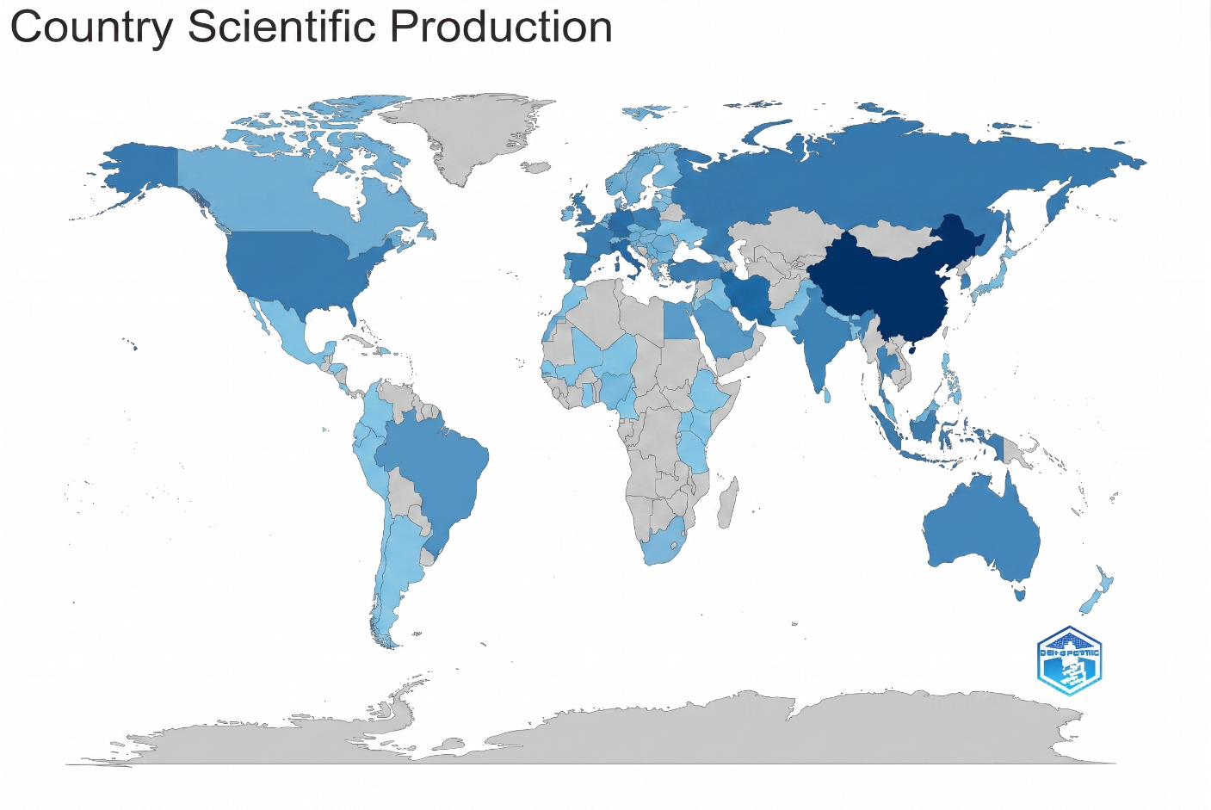
Figure 2. Global distibution of scientific production on black soldier fly larvae oil as animal feed by country
The United States has a significant presence in the research landscape, particularly as a leading center in the domains of animal nutrition, aquaculture, feed technology, and sustainability. According to a bibliometric analysis by Kavle et al. (2022) on edible insects, the United States emerged as the most prolific contributor, with 163 publications, followed by Italy, South Korea, and the Netherlands. This underscores the active engagement of the United States in research on insects as food and its pivotal role in advancing insects as alternative feed resources.
Notably, several Southeast Asian nations, including Indonesia, Malaysia, Thailand, and the Philippines, feature prominently on the publication contribution map. This suggests that tropical regions possess substantial potential for Black Soldier Fly (BSF) research, attributed to favorable climatic conditions for insect cultivation, abundant organic waste, and the demand for alternative feed ingredients for poultry, fish, and other livestock. The contributions from these countries are significant, as BSF is perceived not only as a source of oil or protein but also as an integral component of an economically valuable organic waste management system in these countries.
In comparison to the bibliometric study on fat supplementation in ruminants by Wardiman et al. (2025), the pattern of country contributions to BSF larvae oil research exhibits distinct differences. In the realm of ruminant fat supplementation, the United States was the predominant contributor, with 592 publications, representing approximately 41.8% of the total, followed by France, Brazil, the United Kingdom, Spain, Australia, Canada, and Germany. This indicates that the field of ruminant fat supplementation is largely dominated by countries with established traditions in dairy cattle research, meat production, and nutrition. Conversely, research on BSF oil reflects a more geographically diverse contribution, encompassing Asia, Europe, North America, and several developing nations.
The observed variation suggests that research on black soldier fly (BSF) larvae oil is multidisciplinary and cross-regional. In contrast, research on ruminant fat has predominantly been conducted in countries with established ruminant livestock industries. Conversely, BSF oil research has expanded in nations with diverse interests, including alternative feed production, aquaculture, organic waste processing, and circular economy development. Consequently, countries with significant organic waste production and substantial feed demand are well positioned to become key contributors to this field.
Figure 2 illustrates that research on BSF as animal feed has achieved global development, with significant contributions from Asia, Europe, and North America. The prominence of China and the active participation of European countries suggest that this research is increasingly associated with strategic issues such as feed self-sufficiency, livestock production efficiency, sustainability and waste management. In comparison to the more established and geographically concentrated field of ruminant fat supplementation, which is centered in countries with advanced livestock industries, research on BSF larvae oil appears to be more recent, widely distributed, and closely aligned with the global agenda of alternative feed resources and the circular economy.
Keyword Analysis and Thematic Structure of Research
The keyword “black soldier fly” appeared 276 times, making it the most frequently used term in this study (Table 4). This was followed by “black soldier fly larvae” with 106 occurrences, “growth performance” with 52 occurrences, “insect meal” with 48 occurrences, “sustainability” with 42 occurrences, “insect” with 40 occurrences, “bioconversion” with 35 occurrences, “circular economy” with 28 occurrences, “fatty acids” with 27 occurrences, and “black soldier fly larvae meal” (25 occurrences). The prevalence of these keywords suggests that research on black soldier fly larvae oil is closely linked to broader investigations concerning BSF larvae, insect meal, livestock growth performance, and the sustainability of feed systems. The keywords “black soldier fly” and “black soldier fly larvae” served as central terms, representing the biological identity of the research subject. Meanwhile, the presence of keywords such as “growth performance,” “insect meal,” and “black soldier fly larvae meal” indicates that most studies continue to focus on the utilization of BSF as a general feed ingredient, particularly in the form of larval meal. This implies that research on BSF larvae oil has not yet been fully distinguished from studies on BSF as a feed ingredient or insect meal. In essence, BSF larvae oil is still evolving as part of a broader research domain concerning the utilization of BSF larvae in animal nutrition.
Table 4. Most frequent keywords identified in publications on black soldier fly larvae oil as animal feed
Words | Occurrences
black soldier fly | 276
black soldier fly larvae | 106
growth performance | 52
insect meal | 48
sustainability | 42
insect | 40
bioconversion | 35
circular economy | 28
fatty acids | 27
black soldier fly larvae meal | 25
The keyword “fatty acids” appeared 27 times, indicating that lipid- or oil-related aspects are gaining significant attention in this research domain. However, its frequency is still lower than that of keywords such as “growth performance” and “insect meal.” This suggests that studies on BSF larvae oil are more frequently associated with production performance and feed formulation rather than an in-depth exploration of BSF larvae oil as a distinct lipid source for aquafeeds. Nonetheless, in the keyword network map depicted in Figure 3, terms such as “fatty acids,” “lauric acid,” “lipid,” “insect oil,” and “black soldier fly larvae oil” are beginning to establish connections with topics related to nutrition, digestion, product quality, and metabolism. This indicates that research on BSF larvae oil has the potential to evolve into more specific investigations into fatty acid profiles and their effects on the quality of animal products.
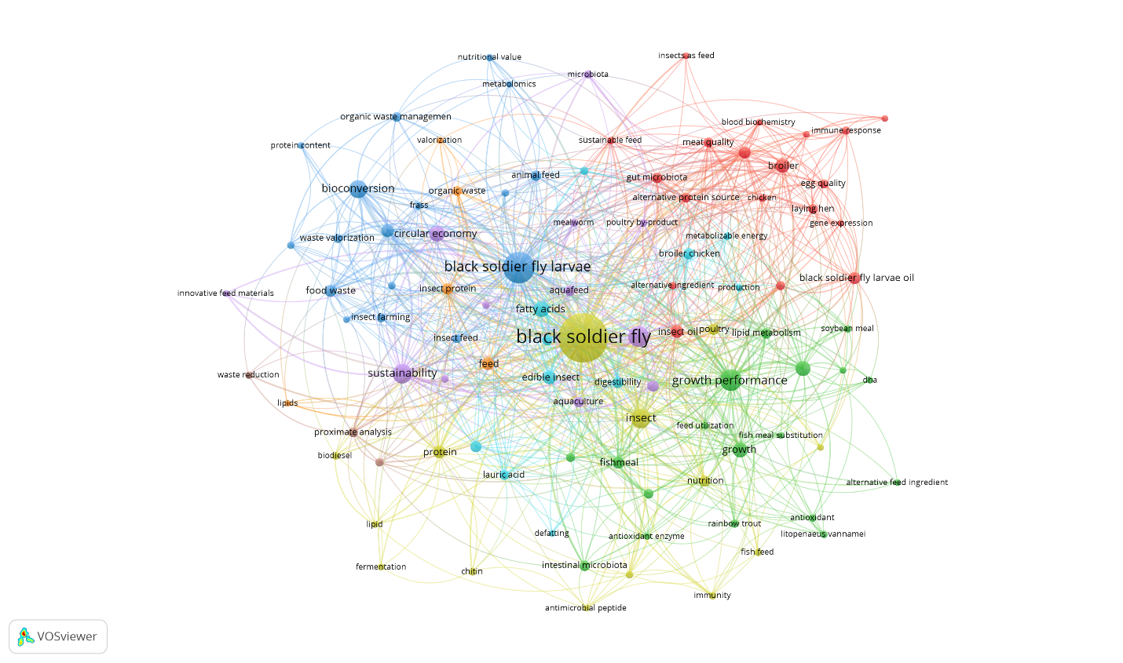
Figure 3. Co-occurence network visualization of keywords in research on black soldier fly larvae oil as animal feed
Figure 3 indicates that within the keyword co-occurrence network, “black soldier fly” was the largest and most central node. This node is interconnected with various other keywords, including “black soldier fly larvae,” “growth performance,” “insect,” “sustainability,” “fatty acids,” “aquaculture,” “feed,” and “digestibility.” This centrality suggests that research on black soldier flies (BSF) serves as a nexus among diverse themes encompassing animal nutrition, aquaculture, poultry, product quality, waste management, and sustainability.
The thematic structure of the network can be categorized into several clusters. The first cluster pertains to feed ingredients and nutrient composition, as evidenced by keywords such as “black soldier fly,” “black soldier fly larvae,” “protein,” “lipid,” “fatty acids,” “lauric acid,” and “proximate analysis.” This cluster demonstrates that numerous studies have assessed the nutritional content of BSF larvae, including the potential of their oil as a source of fatty acids. In the context of BSF larvae oil, the presence of lauric acid is significant because of its association with antimicrobial activity and potential enhancement of animal health.
The second cluster relates to growth performance and feed efficiency, characterized by keywords such as “growth performance,” “growth,” “feed utilization,” “digestibility,” “nutrition,” and “fishmeal substitution.” This cluster indicates that BSF research predominantly focuses on evaluating the capacity of BSF-derived products, including larval oil and larval meal, to replace conventional feed ingredients such as fish meal, fish oil, and soybean meal. The strong association with keywords such as “aquaculture,” “fish feed,” “rainbow trout,” and “Litopenaeus vannamei” suggests that the aquaculture sector is one of the most prominent areas of application.
The third cluster pertains to the quality of poultry and animal products, as evidenced by keywords such as “broiler,” “chicken,” “laying hen,” “egg quality,” “meat quality,” “blood biochemistry,” “immune response,” “gene expression,” and “gut microbiota.” This cluster indicates that research on BSF not only assesses growth performance but also explores its impact on meat quality, egg quality, health status, and physiological responses in livestock. The emergence of the keyword “black soldier fly larvae oil” within the poultry cluster suggests that BSF larvae oil is increasingly being considered an alternative lipid source in broiler and laying hen diets. The fourth cluster is associated with bioconversion, organic waste, and the circular economy, as indicated by keywords such as “bioconversion,” “circular economy,” “food waste,” “organic waste management,” “waste valorization,” “insect farming,” and “sustainability.” This cluster highlights a distinctive feature of BSF research compared with conventional feed ingredient studies. BSF larvae have been investigated not only as a nutrient source but also as bioconversion agents capable of transforming organic waste into high-value biomass. This aligns with Kavle et al. (2022), who reported that in edible insect research, keywords such as “bioconversion,” “circular economy,” “food waste,” “environmental impact,” and “sustainability” formed a significant cluster related to environmental and sustainability issues. In comparison to the bibliometric study on BSF by Liu et al. (2023), the findings of this study revealed a similar pattern but with a more applied focus on animal feed. Liu et al. (2023) identified that keywords in BSF research were predominantly centered on biological terms such as “larvae,” “Diptera,” “fly,” and “black soldier fly,” as well as the application of BSF as animal feed. They also noted that topics such as “food waste,” “nutrient digestibility,” “nutrient composition,” and “optimization” have become increasingly popular in recent years. In the present study, these themes also emerged, but they were more strongly oriented toward animal performance, product quality, aquaculture, poultry, and the fatty acid composition of products.
In comparison to the bibliometric study on fat supplementation in ruminants by Wardiman et al. (2025), the keyword structure in the present study revealed a distinct divergence. In the domain of ruminant fat supplementation research, the prevalent keywords include “fatty acids,” “dairy cows,” “dietary fat,” “conjugated linoleic acid,” and “biohydrogenation.” This suggests that investigations in this area have predominantly focused on lipid metabolism, rumen fermentation, milk production, and fatty acid profiles of animal products. Conversely, the primary keywords in research concerning black soldier fly (BSF) larvae oil are “black soldier fly,” “black soldier fly larvae,” “growth performance,” “insect meal,” “sustainability,” and “bioconversion.” This distinction indicates that BSF larvae oil research is more closely aligned with studies on alternative feed resources and sustainability, whereas ruminant fat research has evolved into a field that is primarily concerned with animal lipid metabolism.
Keyword analysis suggests that research on BSF larvae oil as animal feed encompasses a broad multidisciplinary thematic framework. The principal themes extend beyond oils or fatty acids to include growth performance, feed ingredient substitution, animal product quality, livestock health, waste bioconversion, and the circular economy. This underscores the strategic position of BSF oil as an alternative feed ingredient that bridges animal nutrition and environmental sustainability. Future research should focus on the specific fatty acid profile of BSF larvae oil, its impact on animal lipid metabolism, meat and egg quality, and its potential to replace vegetable or fish oils. Such investigations would enable the study of BSF larvae oil to transcend the general scope of insect feed research and establish itself as a distinct field in dietary lipid research.
Thematic Evolution and Future Research Directions
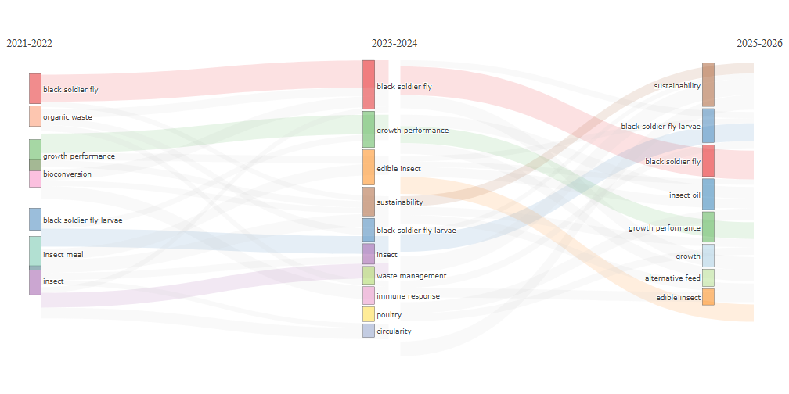
Figure 4. Thematic evolution of research topics on black soldier fly larvae oil as animal feed across three periods: 2021-2022, 2023-2024, and 2025-2026
The thematic progression of research on black soldier fly (BSF) larvae oil as animal feed, as depicted in Figure 4, is delineated into three distinct periods: 2021–2022, 2023–2024, and 2025–2026. The thematic transitions across these periods reflect a shift in research emphasis from general investigations of BSF and waste utilization to more focused studies on sustainability, alternative feed ingredients, livestock performance, and insect oils.
During the 2021–2022 period, predominant themes included black soldier fly, organic waste, growth performance, bioconversion, black soldier fly larvae, insect meal, and insects. These themes suggest that initial research concentrated on the general utilization of BSF larvae, particularly as agents of organic waste bioconversion and alternative feed ingredients. At this juncture, research has not yet prioritized BSF larvae oil as a central focus but rather situated it within the broader context of BSF larvae and insect meal utilization. This pattern aligns with Liu et al. (2023), who noted that BSF research from 1994 to 2021 evolved from biological studies of BSF to the application of larvae as animal feed, waste-processing agents, and sources of nutrient composition.
During the 2023–2024 period, research themes began to diversify. In addition to the black soldier fly and growth performance, themes such as edible insects, sustainability, waste management, immune response, poultry, and circularity emerged. This period indicates that research expanded beyond evaluating BSF solely as a feed ingredient, beginning to associate it with livestock physiological responses, health, poultry production systems, and the concept of a circular economy. The emergence of themes such as immune response and poultry suggests a shift towards more applied aspects, including the effects of BSF-based feed ingredients on the immune system, poultry performance, and animal product quality.
During the 2025–2026 period, research themes prominently shifted towards sustainability, black soldier fly (BSF) larvae, insect oil, growth performance, alternative feed, and edible insects. The emergence of insect oil as a focal point in recent studies is noteworthy, as it signifies a transition from the general use of BSF larvae or meal to the specific utilization of oil fractions. Consequently, BSF larvae oil is increasingly being recognized as a viable feed ingredient, serving as an alternative lipid source, rather than merely a component of BSF larvae products.
These thematic developments suggest that research on BSF larvae oil has evolved along three primary paths. Initially, research focused on organic waste bioconversion and larval biomass production. Subsequently, investigations have expanded to explore the use of BSF as a feed ingredient and its impact on livestock performance. Recently, research has begun to emphasize sustainability, insect oil, and alternative feed ingredients. This progression indicates that BSF larvae oil is gaining a more defined role in animal nutrition.
Compared to the bibliometric study on BSF by Mangindaan et al. (2022), the current findings demonstrate thematic continuity. Mangindaan et al. (2022) elucidated the role of BSF larvae within the waste–food–energy nexus, emphasizing their function as agents linking waste processing, feed production, and energy potential (e.g., biodiesel). In the present study, themes such as organic waste, bioconversion, waste management, circularity, and sustainability are also prominently featured, although the ultimate focus is more strongly oriented towards animal feed applications and insect oil.
In comparison to the study conducted by Kavle et al. (2022) on edible insects, there are notable similarities in the themes of sustainability and the use of insects as alternative sources of food and feed. Kavle et al. (2022) identified that research on edible insects is multidisciplinary, encompassing themes such as food security, food neophobia, functional properties, food processing and sustainability. However, the present study’s focus on BSF larvae oil is more specifically oriented towards animal feed, growth performance, bioconversion, and insect oil, whereas the broader scope of edible insect research includes human consumption, food safety, consumer acceptance, and processing technology.
In contrast to the bibliometric study on fat supplementation in ruminants by Wardiman et al. (2025), the thematic evolution of BSF larvae oil research has exhibited a distinct character. Research on ruminant fat supplementation has evolved towards alternative fat sources and methane mitigation, reflecting a transition from lipid metabolism studies to the sustainability of ruminant production. Conversely, BSF larvae oil research also emphasizes sustainability through different avenues, such as waste bioconversion, the circular economy, alternative feed ingredients, and insect oil. Thus, while both fields are advancing towards sustainability, ruminant fat research is more focused on metabolism and the environmental impacts of ruminants, whereas BSF larvae oil research is more concerned with the development of insect-based alternative lipid sources.
In light of this thematic progression, future research should focus on several key areas. First, more detailed investigations into the fatty acid composition of black soldier fly (BSF) larvae oil are needed, with particular emphasis on its lauric acid content and its implications for livestock health. Second, further studies should explore the feasibility of using BSF oil as an alternative to fish oil, vegetable oils, or other conventional lipid sources in the diets of poultry, fish, swine, and other livestock species. Third, additional research is necessary to assess the impact of these additives on meat quality, egg quality, the fatty acid profile of animal products, gut health, and immune responses. Fourth, future investigations should consider the economic and environmental dimensions to facilitate the commercial and sustainable implementation of BSF larvae oil. Figure 4 illustrates that research on BSF larvae oil as animal feed is transitioning from general themes to more specific and applied research topics. The emergence of insect oil as a recent theme suggests that BSF larvae oil holds significant potential as a focal point for future alternative feed research. Consequently, this field presents substantial opportunities for development as an independent area of study in animal nutrition, particularly in terms of sustainable lipid sources, feed efficiency, animal product quality, and the circular economy.
CONCLUSIONS
This bibliometric study illustrates that research on black soldier fly larvae oil as animal feed is an emerging and increasingly pertinent field within sustainable animal nutrition. Based on 643 Scopus-indexed articles published between 2021 and 2026, the topic exhibits growing scientific interest, although the apparent decline in annual growth should be interpreted with caution because of incomplete data for 2026. The research landscape is multidisciplinary, with significant contributions from journals related to feed, aquaculture, animal health and sustainability. Global publication patterns indicate that black soldier fly larvae oil has gained substantial relevance in addressing feed resource limitations, organic waste valorization, and circular-economy-based livestock production. Keyword and thematic analyses reveal a gradual shift from general studies on black soldier fly larvae, insect meal, and bioconversion toward more specific investigations of lipid fractions, fatty acids, insect oil, lauric acid, and their application as alternative feed ingredients. Overall, black soldier fly larvae oil holds promise as a sustainable lipid source for animal feed. Future studies should focus on fatty acid composition, optimal inclusion levels, animal performance, product quality, gut health, immune responses, and economic and environmental feasibility for commercial applications.
ACKNOWLEDGEMENT
The authors would like to thank Universitas Padjadjaran for supporting this study through the Riset Kolaborasi Indonesia (RKI) Skema A and Riset Melibatkan Mahasiswa Pascasarjana (RMMP) programs. This support contributed to the completion of this bibliometric study.
REFERENCES
- Amrul, N. F., Ahmad, I. K., Basri, N. E. A., Suja, F., Jalil, N. A. A., & Azman, N. A. (2022). A review of organic waste treatment using black soldier fly (Hermetia illucens). Sustainability, 14(8), 4565. https://doi.org/10.3390/su14084565
- Aria, M., & Cuccurullo, C. (2017). Bibliometrix: An R-tool for comprehensive science mapping analysis. Journal of Informetrics, 11(4), 959–975. https://doi.org/10.1016/j.joi.2017.08.007
- Barragan-Fonseca, K. B., Dicke, M., & van Loon, J. J. A. (2017). Nutritional value of the black soldier fly (Hermetia illucens L.) and its suitability as animal feed: A review. Journal of Insects as Food and Feed, 3(2), 105–120. https://doi.org/10.3920/JIFF2016.0055
- Chen, Y., Lawson, R., Shandilya, U., Chiasson, M. A., Karrow, N. A., & Huyben, D. (2023). Dietary protein, lipid and insect meal on growth, plasma biochemistry and hepatic immune expression of lake whitefish (Coregonus clupeaformis). Fish and Shellfish Immunology Reports, 5, 100111. https://doi.org/10.1016/j.fsirep.2023.100111
- Chia, S. Y., Tanga, C. M., van Loon, J. J. A., & Dicke, M. (2019). Insects for sustainable animal feed: Inclusive business models involving smallholder farmers. Current Opinion in Environmental Sustainability, 41, 23–30. https://doi.org/10.1016/j.cosust.2019.09.003
- Donthu, N., Kumar, S., Mukherjee, D., Pandey, N., & Lim, W. M. (2021). How to conduct a bibliometric analysis: An overview and guidelines. Journal of Business Research, 133, 285–296. https://doi.org/10.1016/j.jbusres.2021.04.070
- Dörper, A., Veldkamp, T., & Dicke, M. (2021). Use of black soldier fly and house fly in feed to promote sustainable poultry production. Journal of Insects as Food and Feed, 7(5), 761–780. https://doi.org/10.3920/JIFF2020.0064
- European Commission. (2021). Commission Regulation (EU) 2021/1372 of 17 August 2021 amending Annex IV to Regulation (EC) No 999/2001 as regards the prohibition to feed non-ruminant farmed animals, other than fur animals, with protein derived from animals. Official Journal of the European Union.
- Fawole, F. J., Labh, S. N., Hossain, M. S., Overturf, K., Small, B. C., Welker, T. L., Hardy, R. W., & Kumar, V. (2021). Insect black soldier fly larvae oil as a potential substitute for fish or soy oil in the fish meal-based diet of juvenile rainbow trout (Oncorhynchus mykiss). Animal Nutrition, 7(4), 1360–1370. https://doi.org/10.1016/j.aninu.2021.07.008
- Hender, A., Siddik, M. A. B., Howieson, J., & Fotedar, R. (2021). Black soldier fly, Hermetia illucens, as an alternative to fishmeal protein and fish oil: Impact on growth, immune response, mucosal barrier status, and flesh quality of juvenile barramundi, Lates calcarifer. Biology, 10(6), 505. https://doi.org/10.3390/biology10060505
- Heuel, M., Sandrock, C., Leiber, F., Mathys, A., Gold, M., Zurbrügg, C., & Terranova, M. (2021). Black soldier fly larvae meal and fat can completely replace soybean cake and oil in diets for laying hens. Poultry Science, 100(4), 101034. https://doi.org/10.1016/j.psj.2021.101034
- Hua, K. (2021). A meta-analysis of the effects of replacing fish meals with insect meals on growth performance of fish. Aquaculture, 530, 735732. https://doi.org/10.1016/j.aquaculture.2020.735732
- Huang, B., Zhang, S., Dong, X., Chi, S., Yang, Q., Liu, H., Tan, B., & Xie, S. (2022). Effects of fishmeal replacement by black soldier fly on growth performance, digestive enzyme activity, intestine morphology, intestinal flora and immune response of pearl gentian grouper (Epinephelus fuscoguttatus ♀ × Epinephelus lanceolatus ♂). Fish & Shellfish Immunology, 120, 497–506.
- Kavle, R. R., Pritchard, E. T. M., Bekhit, A. E.-D. A., Carne, A., & Agyei, D. (2022). Edible insects: A bibliometric analysis and current trends of published studies (1953–2021). International Journal of Tropical Insect Science, 42, 3335–3355. https://doi.org/10.1007/s42690-022-00814-6
- Kim, Y. B., Kim, D. H., Jeong, S. B., Lee, J. W., Kim, T. H., Lee, H. G., & Lee, K. W. (2020). Black soldier fly larvae oil as an alternative fat source in broiler nutrition. Poultry Science, 99(6), 3133–3143. https://doi.org/10.1016/j.psj.2020.01.018
- Kumar, V., Fawole, F. J., Romano, N., Hossain, M. S., Labh, S. N., Overturf, K., & Small, B. C. (2021). Insect black soldier fly, Hermetia illucens, meal supplementation prevents the soybean meal-induced intestinal enteritis in rainbow trout and health benefits of using insect oil. Fish & Shellfish Immunology, 109, 116–124. https://doi.org/10.1016/j.fsi.2020.12.008
- Malcorps, W., Kok, B., van ’t Land, M., Fritz, M., van Doren, D., Servin, K., van der Heijden, P., Palmer, R., Auchterlonie, N. A., Rietkerk, M., Santos, M. J., & Davies, S. J. (2019). The sustainability conundrum of fishmeal substitution by plant ingredients in shrimp feeds. Sustainability, 11(4), 1212. https://doi.org/10.3390/su11041212
- Mangindaan, D., Kaburuan, E. R., & Meindrawan, B. (2022). Black soldier fly larvae (Hermetia illucens) for biodiesel and/or animal feed as a solution for waste-food-energy nexus: Bibliometric analysis. Sustainability, 14(21), 13993. https://doi.org/10.3390/su142113993
- Meneguz, M., Schiavone, A., Gai, F., Dama, A., Lussiana, C., Renna, M., & Gasco, L. (2018). Effect of rearing substrate on growth performance, waste reduction efficiency and chemical composition of black soldier fly (Hermetia illucens) larvae. Journal of the Science of Food and Agriculture, 98(15), 5776–5784. https://doi.org/10.1002/jsfa.9127
- Odoi-Yorke, F., Abbey, A. N. A., Asante, E., Ansah, K. K., Asare, D. B., Mensah, G., Adjei, E. A., & Atepor, L. (2025). Harnessing black soldier fly larvae for sustainable biofuel: Bibliometric analysis and prospects. Journal of Energy Research and Reviews. https://doi.org/10.1155/er/8032373
- Schiavone, A., Dabbou, S., De Marco, M., Cullere, M., Biasato, I., Biasibetti, E., Capucchio, M. T., Bergagna, S., Dezzutto, D., Meneguz, M., Gai, F., Dalle Zotte, A., & Gasco, L. (2018). Black soldier fly larva fat inclusion in finisher broiler chicken diet as an alternative fat source. Animal, 12(10), 2032–2039. https://doi.org/10.1017/S1751731117003743
- Singh, A., & Kumari, K. (2019). An inclusive approach for organic waste treatment and valorisation using black soldier fly larvae: A review. Journal of Environmental Management, 251, 109569. https://doi.org/10.1016/j.jenvman.2019.109569
- Spranghers, T., Ottoboni, M., Klootwijk, C., Ovyn, A., Deboosere, S., De Meulenaer, B., Michiels, J., Eeckhout, M., De Clercq, P., & De Smet, S. (2017). Nutritional composition of black soldier fly (Hermetia illucens) prepupae reared on different organic waste substrates. Journal of the Science of Food and Agriculture, 97(8), 2594–2600. https://doi.org/10.1002/jsfa.8081
- Surendra, K. C., Olivier, R., Tomberlin, J. K., Jha, R., & Khanal, S. K. (2016). Bioconversion of organic wastes into biodiesel and animal feed via insect farming. Renewable Energy, 98, 197–202. https://doi.org/10.1016/j.renene.2016.03.022
- Wardiman, B., Natsir, A., Syahrir, S., Dianasari, U., & Ardianto. (2025). Country-level bibliometric analysis of edible insect research: Geographic distribution and contributions to advancing sustainable alternatives for food and feed. International Journal of Food Science, 2025, Article 8837527. https://doi.org/10.1155/ijfo/8837527
- Wardiman, B., Syahrir, S., & Natsir, A. (2025). Mapping the intellectual structure and thematic evolution of dietary fat research in ruminants: A comprehensive bibliometric analysis. International Journal of Design & Nature and Ecodynamics, 20(12), 2909–2925. https://doi.org/10.18280/ijdne.201215
- Weththasinghe, P., Hansen, J. Ø., Nøkland, D., Lagos, L., Rawski, M., & Øverland, M. (2021). Full-fat black soldier fly larvae (Hermetia illucens) meal and paste in extruded diets for Atlantic salmon (Salmo salar): Effect on physical pellet quality, nutrient digestibility, nutrient utilization and growth performances. Aquaculture, 530, 735785. https://doi.org/10.1016/j.aquaculture.2020.735785
- Zulkifli, N. F. N. M., Seok-Kian, A. Y., Seng, L. L., Mustafa, S., Kim, Y. S., & Shapawi, R. (2022). Nutritional value of black soldier fly (Hermetia illucens) larvae processed by different methods. PLOS ONE, 17(2), e0263924. https://doi.org/10.1371/journal.pone.0263924

