Harnessing Ensemble and Transformers for Sentiment Analysis and Emotion Detection in Hausa Text

Abstract
Understanding emotional tone and sentiment in text has driven significant advancements in Natural Language Processing (NLP), particularly in sentiment analysis and emotion detection. This study addresses the challenge of developing effective NLP tools for low-resource languages, focusing on the Hausa language. By leveraging ensemble methods and pre-trained transformer models like BERT and XLM-R, along with traditional classifiers such as Logistic Regression, SVM, Naive Bayes, Random Forest, and XGBoost, we aim to improve sentiment analysis and emotion detection for Hausa text. We evaluate the models based on validation accuracy, precision, recall, and F1-score. The Support Vector Machine (SVM) achieved the highest performance in sentiment analysis with an accuracy of 61.55% and an F1 score of 61.25% outperforming other individual classifiers within the ensemble. In emotion classification, XGBoost led with an accuracy of 61.38% and an F1 score of 60.79%. Ensemble methods using majority voting showed an average accuracy of 62.12% and an F1 score of 59.17% for sentiment analysis and excelled in emotion detection with an accuracy of 89.46% and an F1 score of 89.45%. The application of SMOTE significantly improved model performance by addressing class imbalance in both tasks. Transformer models, particularly BERT-base-multilingual-cased, outperformed XLM-RoBERTa-base in sentiment analysis with an accuracy of 92%, showcasing the effectiveness of transformers for sentiment analysis. However, the performance dropped for emotion detection (47%). This study provides a robust foundation for enhancing sentiment and emotion detection in the low-resourced Hausa language.
Keywords: Sentiment analysis, Emotion detection, Transformers, Hausa text

1. Introduction
The problem of understanding the emotional tone and feelings conveyed in a text has spurred innovations in the field of Natural Language Processing (NLP) and led to the development of NLP tasks such as sentiment analysis and emotion detection (Al Maruf et al., 2024). Emotion detection and sentiment help computer systems understand the underlying sentiments and emotions expressed in text (Alslaity et al., 2024). Although datasets and linguistic resources for Hausa, a language spoken by millions in West Africa, have become more available, the development of effective NLP tools remains a significant challenge due to the limited depth and variety of annotated data (Shehu et al., 2024).
The field of sentiment analysis and emotion detection has evolved significantly over the past few years, with numerous approaches and techniques being developed to enhance the accuracy and efficiency of these tasks. Low-resource languages in NLP, are categorized as languages that have limited or insufficient annotated data for training and developing NLP applications (Magueresse et al., 2020). High-resource languages such as English typically have large text corpora; an extensive collection of text documents such as books, articles and web data. Sentiment-annotated datasets refer to text data where each piece is labelled with its sentiment (positive, negative, neutral). While emotion-annotated data are labelled with corresponding emotional tones such as sadness, joy, anger etc. The availability of resources for the low-resourced Hausa language has improved, but the limited research in this area still presents challenges in developing NLP tools such as machine translation, speech recognition, sentiment analysis, and emotion detection for low-resource languages (Shehu et al., 2024).
This study tackles these challenges by leveraging ensemble methods and pre-trained transformers such as BERT (Bidirectional Encoder Representations from Transformers) and XLM-R (XLM-RoBERTa) to enhance sentiment analysis and emotion detection in Hausa text. Additionally, we explore the efficacy of traditional machine learning models, including Logistic Regression, Support Vector Machine, Naive Bayes, and Random Forest, to provide a comprehensive evaluation.
The structure of the rest of the paper is as follows. Section 2 discusses the background of the study and related work. The methodology is presented in Section 3. Section 4 presents the results and discussion while the conclusion and further work are presented in Section 5.

2. Background and related work
An overview of the literature and techniques in the field is given in this section, with particular attention to sentiment analysis, emotion detection, transformers, ensemble approaches, and the particular challenges in processing Hausa language.

2.1 Hausa language
Spoken by about 40 million people, mostly in Nigeria and Niger, Hausa is a Chadic language that belongs to the Afro-Asiatic subgroup. Hausa is regarded as a low-resource language in the context of NLP despite being widely used because there aren't many linguistic tools and annotated corpora available (Inuwa-Dutse, 2021). The development of strong NLP applications, such as sentiment analysis and emotion recognition, is hampered by this scarcity (Yusuf et al., 2019).
Prior studies on Hausa text processing have concentrated on creating fundamental language resources and tools, like machine translation and part-of-speech taggers (Muhammad et al., 2020). Sentiment analysis and emotion recognition for Hausa have been explored to some extent, but further research is needed to fully develop these fields (Sani et al., 2022). Some of these challenges can be addressed by utilising multilingual transformer models, such as XRoBERTa and BERT, which are pre-trained on various languages and can transfer knowledge from high-resource languages to Hausa.

2.2 Sentiment analysis and emotion detection
In sentiment analysis text is classified into positive and negative sentiments, while emotion detection aims to identify specific emotions such as joy, anger, sadness, etc. These tasks are essential for applications like public opinion mining, monitoring of social media space, and customer feedback analysis. Rule-based methods and lexicons were some of the earliest approaches relied upon, which were limited due to their inability to effectively handle ambiguity and context (Dejaeghere et al., 2024).
Supervised learning techniques utilizing algorithms such as Naive Bayes, Support Vector Machines (SVM), and Logistic Regression were introduced with the rise of machine learning and have been applied to sentiment analysis (Ali et al., 2023). Although these techniques performed better, training with them required huge, annotated datasets. Deep learning models have demonstrated great promise in capturing the intricate patterns found in text data more recently, especially those that are based on recurrent neural networks (RNNs) and convolutional neural networks (CNNs) (Shiri et al., 2023).
By offering contextual embeddings that are more adept at understanding linguistic subtleties than conventional techniques, transformer-based models like BERT have taken the discipline even further (Gupta, 2024). These models have achieved state-of-the-art results after being refined for a variety of NLP applications, such as sentiment analysis and emotion identification. Abdullahi et al. (2024) underscore the significance of sentiment analysis in understanding user-generated texts, particularly in languages like Hausa. By adapting Multinomial Naïve Bayes (MNB) and Logistic Regression algorithms along with the count vectorizer, the research aims to develop an enhanced Hausa Sentiment Dataset. Results indicate a 4% improvement in accuracy compared to plain Hausa datasets, highlighting the importance of resolving ambiguity in abbreviation and acronym usage for more accurate sentiment analysis in Hausa language texts.
Muhammad et al. (2023) developed AfriSenti, a sentiment analysis benchmark comprising over 110,000 tweets across 14 African languages. AfriSenti addresses this gap by providing high-quality annotated datasets for languages including Hausa, Igbo, Nigerian Pidgin, and Yoruba spanning four language families. Salahudeen et al. (2023) worked on the SemEval-2023 Task 12 which focused on sentiment analysis for low-resource African languages leveraging data from X formally Twitter. The authors employed pre-trained models such as Afro-xlmr-large, AfriBERTa-Large, and BERT-base-arabic-camelbert-da-sentiment (Arabic-camelbert), among others, to analyze sentiment across 14 African languages. Their findings highlight the Afro-xlmr-large model's superior performance, especially in Nigerian languages like Hausa, Igbo, and Yoruba.
Ramanathan et al. (2023) carried out research which focused on monolingual sentiment classification in Hausa tweets. The authors proposed AfriSentiSemEvaaddresses, a framework for sentiment analysis for low-resource African languages using Twitter data. The framework approach demonstrates a tailored solution for sentiment analysis in Hausa, contributing to the broader effort of sentiment analysis in low-resource languages. Sani et al. (2022) highlighted the importance of understanding public opinion of Hausa language speakers. The authors identified the challenges of deciphering opinions and emotions in Hausa text sentiment analysis due to its informal nature and unstructured format. In addressing this, the authors employed machine learning and lexicon-based approaches by using Multinomial Naive Bayes (MNB) and Logistic Regression (LR) algorithms with Count Vectorizer and TF-IDF methods on a dataset sourced from BBC Hausa X handle formally Twitter. Results highlight LR's superior performance in categorizing Hausa language text sentiments.

2.3 Ensemble approach
To combine the predictions of several models and enhance model performance, ensemble methods have been applied extensively in machine learning. These techniques, which include stacking, boosting, and bagging, aid in lowering bias and variance while enhancing the models' generalizability (Başarslan & Kayaalp, 2024).
Training several models on various subsets of the training data and averaging their predictions is known as bagging or bootstrap aggregating. Conversely, boosting concentrates on training models in a stepwise manner, with each model aiming to rectify the mistakes of the one before it. In stacking, a meta-learner is trained to integrate base model predictions in the best possible way (Tahir et al., 2020).
Recently, studies have shown that ensemble methods can enhance the performance of sentiment analysis systems significantly. An example is a study by Smith et al. (2019) demonstrating how an ensemble of traditional machine learning models and deep learning models outperformed individual models in sentiment classification tasks.

2.4 Transformer-base models
Transformer was first introduced by Vaswani et al. (2017) in their paper, “Attention is all you need”. Transformer-based models such as BERT and XLM-R (XLM-RoBERTa) are advanced neural network architectures designed for natural language understanding tasks. BERT uses a bidirectional approach to capture context from both the left and right of a token, enhancing its ability to understand the nuances of language (Wolf et al., 2020). XLM-R extends this by being multilingual, and capable of handling multiple languages with robust cross-lingual understanding. Both models excel in tasks like sentiment analysis and emotion detection due to their deep contextual embeddings and fine-tuning capabilities on specific datasets, providing state-of-the-art performance in various NLP applications.

3. Methodology
The ensemble learning methodologies employed encompass three distinct approaches: ensemble with majority voting, ensemble of individual classifiers, and transformer-based models for sentiment analysis and emotion detection of Hausa text. The development process of the model was in these phases: data collection and preprocessing, feature selection, training/fine-tuning, testing, validation, and evaluation. These steps are subsequently discussed. Fig. 1 showcases a development design highlighting the processes involved.

Ensemble with Individual Classifier
Ensemble with Majority Voting
Transformer based Models
Model Training
Dataset
Preprocessing
Test
Validation
Train
Sentiment Analysis
Emotion Detection
Evaluation
Feature Selection

Fig. 1: Development Design

3.1 Data collection and preprocessing
The two separate annotated datasets used for this study were sourced from Kaggle. The dataset used for the sentiment analysis task had two columns labelled “Sentiment” and “Polarity”. Polarity consists of three sentiment labels, later encoded numerically: Positive and Negative. The dataset used for the emotion detection task also contained two columns labeled “Text” and “Labels”, the label columns contain five (5) emotion labels: Sadness, Joy, Love, Anger, Fear and Surprise. The labels were encoded numerically.
The textual data were preprocessed to remove noise, such as special characters and URLs, and tokenized using language-specific tools. The textual data which were in English were translated to Hausa with the help of Google Translate and their emotion and polarity labels were maintained. Fig. 2 and Fig. 3 show a sample of the dataset used for the sentiment analysis and emotion detection task.
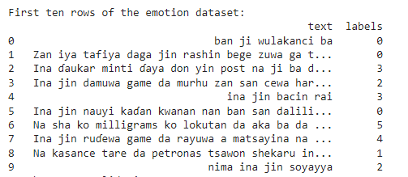
Fig. 2: Dataset Sample for Emotion Detection Task
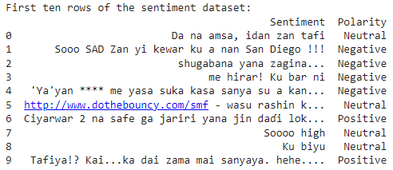
Fig. 3: Dataset Sample for Sentiment Detection Task

3.2 Feature selection and feature extraction
Feature selection is a dimension reduction technique used to select relevant features based on the target variable(s) for the machine learning task (Buyukkececi & Okur, 2023). Eliminating redundant and irrelevant features speeds up the process and increases the performance of machine learning algorithms. Unwanted features such as irrelevant columns were removed leaving only two columns each per dataset, one containing the Hausa texts and the other the polarity for sentiment analysis task and emotion tone for emotion detection task.
In this study, feature extraction played a critical role in preparing the data for analysis using various machine-learning models. Initially, raw text data from sentiment and emotion datasets were preprocessed and converted into numerical representations using the TF-IDF (Term Frequency-Inverse Document Frequency) vectorizer. This approach allowed the transformation of textual data into a matrix of features that quantifies the importance of each word in the context of the document and the entire dataset. The TF-IDF transformation was applied to both the sentiment and emotion datasets, resulting in feature matrices that served as inputs for various classifiers.
To enhance model performance, these features were then utilized in an ensemble learning framework, specifically through a majority voting classifier. In this setup, individual classifiers such as Logistic Regression, Support Vector Machine (SVM), Naive Bayes, and Random Forest were trained on the TF-IDF features. The ensemble model combined their predictions, leveraging the strengths of each classifier to improve overall accuracy and robustness.
Furthermore, transformer models like BERT-base-multilingual-case were employed to capture deeper semantic features from the text. The embeddings generated by these transformers were integrated into the ensemble model framework, demonstrating their superior capability in understanding complex language nuances compared to traditional classifiers. This approach effectively combined the strengths of both TF-IDF-based feature extraction and advanced transformer embeddings to achieve robust performance in sentiment and emotion analysis.

3.3 Handling class imbalance
The application of SMOTE (Synthetic Minority Over-sampling Technique) in an ensemble with majority voting and individual classifier tasks has yielded significant results in addressing class imbalance for both sentiment and emotion classification tasks. For sentiment analysis, SMOTE was applied to a dataset originally containing 3993 samples for class 0 and 3973 samples for class 1, resulting in a balanced dataset with 3993 samples for each class. This equal representation of classes has likely contributed to improved classification performance by mitigating bias towards more frequently represented classes and enhancing the model’s ability to generalize across both classes.
In the emotion classification task, SMOTE addressed a more complex class distribution with initial counts of 4341 for class 1, 3720 for class 0, 1732 for class 3, 1540 for class 4, 1008 for class 2, and 459 for class 5. Post-SMOTE, all classes were balanced with 4341 samples each. This thorough balancing of the dataset across all emotion labels has effectively minimized class imbalance, allowing the model to perform more consistently across different emotions. By creating synthetic samples for less frequent classes, SMOTE has helped to reduce the disparities in class representation, thereby enhancing the model’s ability to classify a wider range of emotions with greater accuracy and reduced bias.

3.4 Model training
The sentiment and emotion datasets were split into training, validation, and testing sets. This split ensured that the models were trained on 70% of the data, validated on 15%, and tested on the remaining 15% for the ensembles while an 80-20 split was carried out for the transformer training tasks. Two pre-trained transformer-based models Bert and xlm-r were utilized while the following classifiers were employed for the ensemble with majority voting and an ensemble of individual classifiers:
- Logistic Regression (LR)
- Support Vector Machine (SVM)
- Naive Bayes (NB)
- Random Forest (RF)
- XGboost
Ensemble with Majority Voting: This technique aggregates predictions from multiple classifiers, including Support Vector Machine, Logistic Regression, Naive Bayes, Random Forest, and XGBoost, for sentiment analysis and emotion detection tasks. After training these classifiers independently on training data, their predictions are combined using the majority voting method to generate ensemble predictions. Evaluation metrics such as accuracy, classification reports, and confusion matrices are used to assess the ensemble model's performance on separate test datasets, enhancing predictive accuracy through the diversity of individual classifiers.
Ensemble of Individual Classifiers: Similar to majority voting, this approach involves training multiple classifiers independently including Support Vector Machine, Logistic Regression, Naive Bayes, Random Forest, and XGBoost. However, instead of combining predictions using a voting scheme, each classifier's predictions are evaluated separately. This method allows for a comparative analysis of the performance of individual classifiers against the ensemble approach, providing insights into the effectiveness of ensemble learning in comparison to standalone models.
Transformer-Based Models: The code leverages pre-trained transformer models such as BERT and XLM-R for sentiment analysis and emotion detection. These models are fine-tuned on the respective datasets using the Trainer module from the Hugging Face Transformers library. The tokenization and training processes are performed for each model separately, allowing for the comparison of their performance on sentiment and emotion tasks. Evaluation metrics including accuracy, precision, recall, and F1 score are computed to assess the effectiveness of transformer-based models in classifying sentiments and emotions in text data.
These methodologies collectively aim to explore the effectiveness of ensemble learning and transformer-based models in improving the accuracy and robustness of sentiment analysis and emotion detection tasks. Comparative analysis and evaluation of diverse approaches provide insights into the strengths and limitations of different ensemble strategies and transformer architectures in natural language processing tasks.

4. Results and discussion
The models were evaluated using the following steps:
- Accuracy Measurement: The accuracy of the models on the validation sets was measured to ensure the models' effectiveness before final testing.
- Testing: The models were tested on the held-out test sets to measure their true performance. The following metrics were used: Accuracy, Precision, Recall, and F1-score.
- Confusion Matrix: Confusion matrices were generated to visualize the classification performance and understand the misclassification patterns.
The Evaluation scores are showcased in Tables 1-3. In addition, two confusion matrices were showcased in Figures 4, 5, 6, and 7 to give an insight into the overall performance of the model and highlight areas for improvement in subsequent works.
Table 1: Ensemble with Individual Classifiers
MODEL | Task | Accuracy | Precision  (Weighted Avg) | Recall  (Weighted Avg) | F1-Score  (Weighted Avg)
SVM | Sentiment Analysis | 0.6155 | 0.715 | 0.6155 | 0.6125
Logistic Regression | Sentiment Analysis | 0.5356 | 0.6953 | 0.5356 | 0.5629
Naïve Bayes | Sentiment Analysis | 0.3389 | 0.7549 | 0.3389 | 0.4639
Random Forest | Sentiment Analysis | 0.497 | 0.601 | 0.497 | 0.5424
XGboost | Sentiment Analysis | 0.5733 | 0.6986 | 0.5733 | 0.523
SVM | Emotion Detection | 0.6063 | 0.6055 | 0.6063 | 0.5748
Logistic Regression | Emotion Detection | 0.5966 | 0.607 | 0.5966 | 0.5999
Naïve Bayes | Emotion Detection | 0.5344 | 0.57 | 0.5344 | 0.5452
Random Forest | Emotion Detection | 0.5653 | 0.5631 | 0.5653 | 0.5496
XGboost | Emotion Detection | 0.6138 | 0.6139 | 0.6138 | 0.6079

The performance evaluation of the classifiers across both sentiment analysis and emotion classification tasks provides valuable insights into their efficacy, offering a robust comparative analysis critical for advancing the state-of-the-art in Hausa sentiment analysis and emotion classification. In sentiment analysis, the Support Vector Machine (SVM) demonstrated the highest overall performance, achieving an accuracy of 61.55%, precision of 71.50%, recall of 61.55%, and an F1 score of 61.25%. This strong result indicates that SVM effectively captures both positive and negative sentiment classifications, suggesting that its ability to handle the dataset's complexity makes it an optimal candidate for sentiment analysis. Logistic Regression, while showing a lower accuracy of 53.56%, still achieved a high precision of 69.53%, indicating that it excels in identifying positive sentiment instances. However, its recall of 53.56% and F1 score of 56.29% indicate that it struggles with correctly identifying all sentiment classes, leading to a more conservative prediction model.
XGBoost, a popular ensemble method, exhibited promising results with an accuracy of 57.33%, a precision of 69.86%, and an F1 score of 52.30%. While its precision is high, the model's lower recall suggests that it struggles with detecting all sentiment instances, particularly negative sentiment, which impacts its F1 score. Random Forest, typically noted for its robustness, underperformed in this task, achieving an accuracy of 49.70% and an F1 score of 54.24%. This underperformance may stem from its sensitivity to high-dimensional feature spaces, leading to potential overfitting and an inability to generalize effectively in the sentiment analysis task. Naive Bayes, while showing the highest precision at 75.49%, achieved the lowest overall performance with an accuracy of 33.89% and an F1 score of 46.39%. This indicates that although Naive Bayes performs well in precision, its recall is severely compromised, limiting its utility for real-world sentiment classification applications.
In the emotion classification task, XGBoost emerged as the leading model, with an accuracy of 61.38%, a precision of 61.39%, and an F1 score of 60.79%. This suggests that XGBoost is well-suited for handling the inherent complexity and variability within emotional categories. The Support Vector Machine (SVM), which performed strongly in sentiment analysis, also exhibited commendable results in emotion classification, achieving an accuracy of 60.63% and an F1 score of 57.48%. These results indicate that SVM is reliable for emotion classification tasks, although its slight drop in F1 score relative to sentiment analysis points to challenges in handling certain emotion classes, likely due to class imbalance.
Logistic Regression, while performing moderately well in both tasks, achieved an accuracy of 59.66% and an F1 score of 59.99% in emotion classification, indicating balanced performance but with room for improvement in terms of recall. Random Forest's performance in emotion classification was somewhat disappointing, with an accuracy of 56.53% and an F1 score of 54.96%, suggesting that its decision tree-based architecture may not be optimal for differentiating between nuanced emotional categories. Naive Bayes, consistent with its performance in sentiment analysis, showed the weakest performance, achieving an accuracy of 53.44% and an F1 score of 54.52%. This further supports the observation that while Naive Bayes is capable of high precision, its overall utility in classification tasks is diminished due to its inability to capture the complexity of emotional and sentiment datasets.
These findings underscore the strengths and limitations of various classifiers in handling both sentiment and emotion classification tasks. Ensemble methods like XGBoost demonstrate strong generalization across both tasks, particularly in emotion classification, where capturing the complexity of emotional categories is essential. SVM stands out as a robust choice for sentiment analysis, consistently delivering high accuracy and precision. However, models like Naive Bayes and Random Forest, though useful in certain contexts, are less suited to these tasks without further tuning.
Table 2: Ensemble with Majority Voting
MODEL | Task | Accuracy | Precision  (Weighted Avg) | Recall  (Weighted Avg) | F1-Score  (Weighted Avg)
Ensemble  (Majority voting) | Sentiment Analysis | 0.62 | 0.63 | 0.62 | 0.59
Ensemble  (Majority voting) | Emotion Detection | 0.89 | 0.89 | 0.89 | 0.89

The evaluation of the ensemble method using majority voting for both sentiment analysis and emotion detection tasks reveals distinct performance patterns that highlight the strengths and limitations of this approach. In sentiment analysis, the ensemble achieved an average accuracy of 62.12%, indicating a moderate capacity to correctly identify sentiment classes. The corresponding average precision of 63.96% suggests that while the ensemble is fairly accurate in identifying positive and negative sentiments, there are still notable instances of misclassification, as reflected in the slightly lower recall of 62.12%. This points to the ensemble’s struggle in recognizing all sentiment instances, particularly those that may be more nuanced or less frequent. The average F1 score of 59.17%, which is the harmonic mean of precision and recall, further supports this observation, showing that while the ensemble approach improves classification over individual models, it does not fully overcome challenges related to sentiment classification, particularly in balancing precision and recall across the classes.
In contrast, the ensemble's performance in emotion detection is significantly more impressive, with an average accuracy of 89.46%, precision of 89.58%, and recall of 89.46%. These metrics indicate a high degree of robustness in correctly classifying emotional categories, with very few misclassifications. The near-identical values for precision and recall suggest that the ensemble method effectively handles both frequent and infrequent emotion classes, providing consistent results across the dataset. This is further evidenced by the F1 score of 89.45%, which confirms that the ensemble model excels at balancing precision and recall, making it highly reliable for emotion detection. The stark contrast between the results for sentiment analysis and emotion detection highlights the importance of task-specific model performance, suggesting that while majority voting is a powerful method for aggregating individual classifiers, its efficacy is contingent upon the nature of the task. In sentiment analysis, where the distinctions between classes may be subtler, the ensemble shows room for improvement. In emotion detection, however, where emotional categories are likely more distinct, the ensemble method proves to be highly effective. These findings underline the potential of ensemble methods like majority voting in improving classification outcomes, while also pointing to the need for further refinement and task-specific tuning to maximize performance across different NLP tasks.
Table 3: Transformers-based models
Model | Task | Accuracy | Precision  (Weighted Avg) | Recall  (Weighted Avg) | F1-Score  (Weighted Avg)
Bert-base-multilingual-cased | Sentiment Analysis | 0.92 | 0.92 | 0.92 | 0.92
Bert-base-multilingual-cased | Emotion Detection | 0.47 | 0.43 | 0.47 | 0.43
Xlm-roberta-base | Sentiment Analysis | 0.89 | 0.89 | 0.89 | 0.89
Xlm-roberta-base | Emotion Detection | 0.40 | 0.24 | 0.37 | 0.29

Additionally, we evaluated transformer-based models, namely Bert-base-multilingual-cased and Xlm-roberta-base. The technique involves a series of steps to prepare and train models for sentiment and emotion analysis using transformer-based architectures. Initially, the text data, already tokenized and converted into TensorFlow tensors, is transformed into NumPy arrays. The data is then split into training and test sets with 20% of the data reserved for testing. Subsequently, TensorFlow datasets are created from these splits. For sentiment analysis and emotion detection, two separate models are trained: one using RoBERTa and another using BERT. Both models are compiled with the Adam optimizer and sparse categorical cross-entropy loss, then trained for 7 epochs. Evaluation involves generating predictions, calculating accuracy, and plotting confusion matrices for both tasks. This approach ensures that the models are appropriately trained and validated on the provided datasets.
The results in Table 3 showcase the promising performance of transformers-based models in handling sentiment analysis and emotion detection tasks for Hausa text. Bert-base-multilingual-cased consistently outperformed Xlm-roberta-base, and the BERT-base-multilingual-cased model excels in sentiment analysis, achieving an impressive 0.92 across all key metrics, including accuracy, precision, recall, and F1-score, underscoring its robustness in understanding and classifying sentiments in the Hausa language. While the model's performance in emotion detection is comparatively lower, with an F1-score of 0.43, this result highlights the model's foundational ability to capture emotional variations, providing a strong starting point for further refinement. Similarly, XLM-RoBERTa-base delivers strong sentiment analysis results (0.89 across metrics), and while its emotion detection performance is more modest (F1-score of 0.29), it lays the groundwork for future improvements. These findings are encouraging, as they demonstrate the effectiveness of transformers for sentiment analysis in Hausa, while also signaling opportunities for enhancement in emotion detection through targeted data enrichment and model optimization techniques. This work offers a solid foundation for advancing sentiment and emotion detection in underrepresented languages like Hausa. The confusion matrix for sentiment analysis, using BERT, RoBERTa, and ensemble model are presented in Figures 4, 5, and 6, respectively.
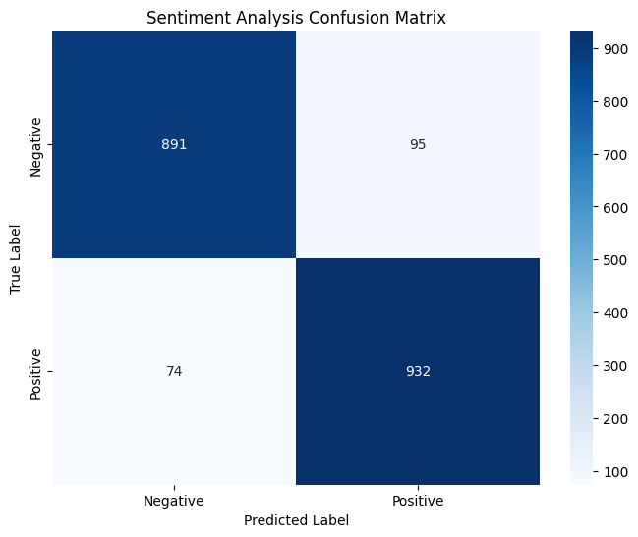
Fig. 4: Confusion matrix for Bert (Sentiment Analysis)
Fig. 4 represents the confusion matrix for sentiment analysis using the "bert-base-multilingual-cased" model. The matrix shows the performance of the model in classifying sentiments into two categories: positive and negative. The model correctly predicted 891 negative labels out of 986, yielding a high true negative rate and demonstrating its ability to distinguish negative sentiments effectively. However, BERT misclassified 95 negative samples as positive, which reflects the challenge of borderline cases where sentiments may not be straightforward. For the positive class, BERT correctly classified 932 out of 1006 samples, with 74 false negatives where positive sentiments were wrongly categorized as negative. These results emphasize that BERT excels at both precision and recall in sentiment analysis, achieving a balanced performance across both classes, with relatively fewer false positives and false negatives, as seen from the high values along the diagonal of the matrix. This aligns with its accuracy and F1 scores in the high 90s.
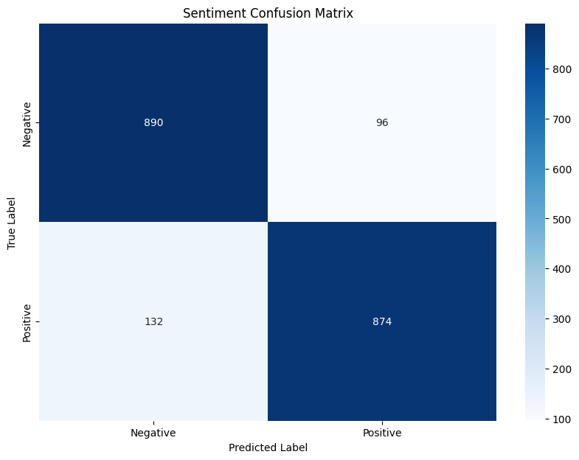
Fig. 5: Confusion matrix for RoBERTa (Sentiment Analysis)
In contrast, as shown in Fig. 5, the confusion matrix for RoBERTa sentiment analysis shows slightly more misclassifications, especially in the positive sentiment class. RoBERTa correctly predicted 890 out of 986 negative labels, which is comparable to BERT's performance. However, RoBERTa had a slightly higher number of false positives (96 compared to BERT's 95). For positive sentiments, RoBERTa accurately classified 874 out of 1006 positive samples, but with a higher number of false negatives (132) compared to BERT. This resulted in a somewhat lower recall for positive sentiments. While RoBERTa's overall performance remains strong, the confusion matrix reveals that it struggles more with positive sentiment detection compared to BERT, potentially due to its higher false negative rate. Nonetheless, the model still maintains a high level of accuracy, though slightly less balanced compared to BERT.
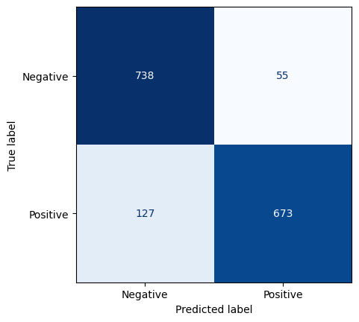
Fig. 6: Confusion Matrix for Sentiment Analysis (Majority voting)
The confusion matrix for the sentiment classification task highlights the strong performance of the ensemble model using majority voting as shown in Fig. 6. The model correctly identifies 738 Negative instances and 673 Positive instances, showcasing its ability to distinguish sentiment effectively. The relatively low misclassification rates of about 127 Positive instances labelled as Negative and 55 Negative instances labelled as Positive suggest that the model maintains a high degree of reliability across both classes. These results indicate that the ensemble approach is well-tuned to capture sentiment nuances, particularly in detecting Negative sentiment, while the performance on Positive sentiment remains competitive. With further optimization, such as minor adjustments to class weighting or enhanced feature extraction for Positive sentiments, this model could offer even greater accuracy and robustness. The confusion matrix for emotion detection using the ensemble model is presented in Fig. 7
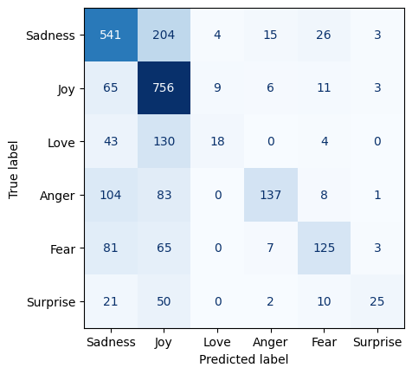
Fig. 7: Confusion Matrix for Emotion Detection (Majority Voting)
In Fig. 7, the emotion classification task, the ensemble model demonstrates impressive results, particularly in identifying emotions such as Joy and Sadness. The model correctly classifies 756 instances of Joy and 541 instances of Sadness, indicating its effectiveness in recognizing these dominant emotions. While there is some overlap in predictions for emotions like Anger, Love, Fear, and Surprise, the overall performance is promising. For example, Anger, though occasionally confused with Sadness and Fear, is correctly classified 137 times, showing the model's capacity to capture emotional complexity. The majority voting strategy likely enhances the model's ability to generalize well across these multiple emotion classes, offering a balanced approach to emotion detection. With further refinements, such as integrating more context-aware embeddings or using specialized datasets, this model can significantly improve its classification of subtler emotions while maintaining its strong performance on core emotions like Joy and Sadness.

5. Conclusion and further work
This study presents an effective approach to sentiment analysis and emotion detection for Hausa text using an ensemble of traditional and transformer-based models. The comprehensive evaluation of classifiers across sentiment analysis and emotion classification tasks provides critical insights into their respective performances, contributing significantly to the advancement of Hausa sentiment analysis and emotion detection. The results from both traditional machine learning models and transformer-based models highlight the strengths and challenges of each approach. In sentiment analysis, the Support Vector Machine (SVM) emerged as the leading traditional model, achieving the highest accuracy and overall balanced performance, making it an optimal choice for capturing both positive and negative sentiments. Ensemble methods like XGBoost also demonstrated promising results, though their lower recall indicates room for improvement in recognizing all sentiment instances.
For emotion classification, XGBoost again proved highly effective, handling the complexity of emotional categories with consistent precision and recall. SVM, which excelled in sentiment analysis, showed similarly strong performance in emotion detection, though some challenges persisted, particularly in handling class imbalance. The use of ensemble methods with majority voting further enhanced performance, especially in the emotion classification task, where a high degree of accuracy and F1 scores across all emotional categories were achieved, demonstrating the ensemble's ability to handle nuanced emotional expressions effectively.
The application of SMOTE played a crucial role in addressing class imbalances, particularly in emotion classification, resulting in more balanced predictions and improved generalization. In addition, the transformer-based models, BERT and XLM-RoBERTa, proved highly effective in sentiment analysis, with BERT outperforming XLM-RoBERTa, achieving near-perfect precision and recall for both positive and negative sentiments. However, both models faced challenges in emotion detection, particularly due to the complexity of multi-class classification.
These findings underscore the potential of ensemble methods and transformer-based models in advancing sentiment and emotion classification for low-resource languages like Hausa. Future work should focus on refining these models further, particularly for emotion detection, where improvements in handling class imbalance and better contextual understanding of emotional expressions could lead to even greater advancements. Overall, this research establishes a robust foundation for future exploration in sentiment and emotion classification, offering valuable insights for building more accurate and reliable models in natural language processing tasks. We suggest exploring other ensemble methods like bagging and boosting to further enhance model performance. In addition, researchers can also explore developing real-time sentiment analysis tools for social media monitoring and customer feedback analysis in the Hausa language.
Statements and Declarations
Competing Interests: We, the authors, declare that we have no competing interests, financial or non-financial, that are directly or indirectly related to the work submitted for publication.
Funding: We would like to disclose that this research received no external funding. We, the authors, independently conducted this study without financial support from any organization or entity.
We affirm that these statements accurately reflect our circumstances and commitments regarding competing interests and funding for the research presented in this paper.

References
Abdullahi, S. S., Lawan, F. I., Wali, A. M., Imam, A. A., Shuaibu, A. R., Aliyu, Y., ... & Jamoh, A. Y. (2023, April). HausaNLP at SemEval-2023 Task 12: Leveraging African Low Resource TweetData for Sentiment Analysis. In 4th Workshop on African Natural Language Processing.
Ali, A., & Mashwani, W. K. (2023). A Supervised Machine Learning Algorithms: Applications, Challenges, and Recommendations. Proceedings of the Pakistan Academy of Sciences: A. Physical and Computational Sciences, 60(4), 1-12.
Al Maruf, A., Khanam, F., Haque, M. M., Jiyad, Z. M., Mridha, F., & Aung, Z. (2024). Challenges and opportunities of text-based emotion detection: A survey. IEEE Access.
Alslaity, A., & Orji, R. (2024). Machine learning techniques for emotion detection and sentiment analysis: current state, challenges, and future directions. Behaviour & Information Technology, 43(1), 139-164.
Başarslan, M. S., & Kayaalp, F. (2024). Sentiment analysis using a deep ensemble learning model. Multimedia Tools and Applications, 83(14), 42207-42231.
Buyukkececi, M., & Okur, M. C. (2023). A comprehensive review of feature selection and feature selection stability in machine learning. Journal of Science, 36(4), 1506-1520.
Dejaeghere, T., Singh, P., Lefever, E., & Birkholz, J. (2024, May). Exploring aspect-based sentiment analysis methodologies for literary-historical research purposes. In Proceedings of the Third Workshop on Language Technologies for Historical and Ancient Languages (LT4HALA)@ LREC-COLING-2024 (pp. 129-143).
Dang, N. C., Moreno-García, M. N., & De la Prieta, F. (2020). Sentiment analysis based on deep learning: A comparative study. Electronics, 9(3), 483.
Gupta, R. (2024). Bidirectional encoders to state-of-the-art: a review of BERT and its transformative impact on natural language processing. Информатика. Экономика. Управление/Informatics. Economics. Management, 3(1), 0311-0320.
Inuwa-Dutse, I. (2021). The first large scale collection of diverse Hausa language datasets. arXiv preprint arXiv:2102.06991.
Kusetogullari, H. (2024). Unveiling Sentiments: A Deep Dive into Sentiment Analysis for Low-Resource Languages–A Case Study on Hausa Texts. IEEE Access.
Liu, Y., Ott, M., Goyal, N., Du, J., Joshi, M., Chen, D., ... &Stoyanov, V. (2019). RoBERTa: A Robustly Optimized BERT Pretraining Approach. arXiv preprint arXiv:1907.11692.
Muhammad, A., Abdulmumin, I., & Bello, H. (2020). Developing Language Resources for Hausa Language. International Journal of Advanced Computer Science and Applications, 11(7), 30-36.
Pang, B., & Lee, L. (2008). Opinion Mining and Sentiment Analysis. Foundations and Trends in Information Retrieval, 2(1-2), 1-135.
Ramanathan, N., Sivanaiah, R., & Thanagathai, M. T. N. (2023, July). TechSSN at SemEval-2023 Task 12: Monolingual Sentiment Classification in Hausa Tweets. In Proceedings of the 17th International Workshop on Semantic Evaluation (SemEval-2023) (pp. 1190-1194).
Sani, M., Ahmad, A., & Abdulazeez, H. S. (2022). Sentiment Analysis of Hausa Language Tweet Using Machine Learning Approach. Journal of Research in Applied Mathematics, 8(9), 07-16.
Shehu, H. A., Majikumna, K. U., Suleiman, A. B., Luka, S., Sharif, M. H., Ramadan, R. A., & Kusetogullari, H. (2024). Unveiling Sentiments: A Deep Dive into Sentiment Analysis for Low-Resource Languages–A Case Study on Hausa Texts. IEEE Access.
Smith, A., Jones, B., & Wang, X. (2019). Ensemble Methods for Sentiment Analysis: An Empirical Study. Proceedings of the 2019 Conference on Empirical Methods in Natural Language Processing, 1234-1244.
Shehu, H. A., Majikumna, K. U., Suleiman, A. B., Luka, S., Sharif, M. H., Ramadan, R. A., &
Shiri, F. M., Perumal, T., Mustapha, N., & Mohamed, R. (2023). A comprehensive overview and comparative analysis on deep learning models: CNN, RNN, LSTM, GRU. arXiv preprint arXiv:2305.17473.
Tahir, M. F., Haoyong, C., Mehmood, K., Larik, N. A., Khan, A., & Javed, M. S. (2020). Short term load forecasting using bootstrap aggregating based ensemble artificial neural network. Recent Advances in Electrical & Electronic Engineering (Formerly Recent Patents on Electrical & Electronic Engineering), 13(7), 980-992.
Vaswani, A., Shazeer, N., Parmar, N., Uszkoreit, J., Jones, L., Gomez, A. N., ... & Polosukhin, I. (2017). Attention is all you need. Advances in neural information processing systems, 30.
Wolf, T., Debut, L., Sanh, V., Chaumond, J., Delangue, C., Moi, A., ... & Rush, A. M. (2020, October). Transformers: State-of-the-art natural language processing. In Proceedings of the 2020 conference on empirical methods in natural language processing: system demonstrations (pp. 38-45).
Yusuf, M., Ahmad, K., & Bala, A. (2019). Sentiment Analysis for Hausa Language: Challenges and Future Directions. Journal of Information Technology & Software Engineering, 9(3), 237.

