Deep Learning-Based Classification and Segmentation of Thyroid Nodules in Ultrasound Images

Haritha Harikumar
Department of Mathematics, Amrita School of Physical Sciences, Coimbatore Amrita Vishwa Vidyapeetham, India
Email: cb.ps.p2asd24013@cb.students.amrita.edu

Dr. P. Kavitha*
Department of Mathematics, Amrita School of Physical Sciences, Coimbatore Amrita Vishwa Vidyapeetham, India
Email: p kavitha@cb.amrita.edu
*Corresponding Author

ABSTRACT

Thyroid cancer is one of the most common endocrine malignancies and early detection and characterization of nodules in its diagnosis and management is ultrasound images is necessary. Current diagnostic procedures show dependence on radiologist expertise which creates two main problems for patient outcomes because it leads to both observer differences and extended time needed for report generation. The work presented here proposes a deep learning method which addresses the existing gap by providing thyroid nodule classification and seg- mentation solution for ultrasound images. The dataset used in this experiment was the Thyroid-TNUS-dataset which was split into three datasets, training set, validation set and test set in the ratio of 70:15:15 to evaluate model’s effectiveness well. In this study, we used VGG16 and ResNet CNN models to perform classification tasks through transfer learning implementation. Cross entropy loss showed its effectiveness in distinguishing between benign and malignant nodules during the classification process. Dice loss function estimated the nodule boundary for both ResNet50UNet and Hybrid model. The VGG16 model shows 99.24% accuracy during classi- fication which demonstrates its ability to differentiate between malignant and non-malignant cases. The model ResNet50UNet achieved dice score of 0.9319 and intersection over union score of 0.8727 which show the model can accurately estimate nodule boundaries. Our experiments demonstrate that deep learning methods show high potential for thyroid ultrasound analysis through their ability to enhance clinical operations while decreasing diagnosis duration and improving consistency between different medical professionals.
Keywords: Thyroid ultrasound, deep learning, Convolutional neural networks, segmentation, U-Net.

INTRODUCTION

The common endocrine disorder of thyroid nodules occurs frequently because medical professionals need to es- tablish accurate diagnostic methods which will allow them to discover cancer in a small number of nodules. The major goal for thyroid nodule diagnosis seeks to identify thyroid nodules which present no danger to patients despite their potential for developing cancer. Doctors commonly use ultrasound to diagnose thyroid nodules because it provides them with detailed non-invasive thyroid imaging at a low cost. Ultrasound enables medi- cal professionals to examine the details of the nodule through its various characteristics which include both its physical attributes and its ambient environment. Medical professionals experience difficulties when they try to understand ultrasound images because of their complex nature. Radiologists need to understand the common characteristics of benign and malignant nodules because the medical images exhibit similar features between these two types of nodules. Medical professionals developed computer systems which use ultrasound images to help them interpret medical data. Deep learning technology allows the system to create new features through system expansion. The Convolutional neural network (CNN) system provides an effective method for image

classification because it can automatically extract image features from visual data. Medical image classification methods commonly use CNNs which researchers trained on extensive image data collections from VGG and ResNet; these methods achieve high classification accuracy through transfer learning when they work with lim- ited data. The classification of ultrasound images as pertaining to benign or malignant thyroid nodules, however, is a difficult task as the visual cues between them are subtle and indistinct. The ultrasound image characteristics make it hard to differentiate between these two types of lesions. The presence of low contrast and blurred edges and excessive noise make it difficult to view ultrasound images. The problems which affect the thyroid nodule segmentation process and its diagnosis as either benign or malignant show their most severe impact through this method. The current research presents a deep learning framework that combines classification and segmentation into a single system to address existing problems. The system uses CNNs to extract essential characteristics from thyroid ultrasound images which improves diagnostic precision that enables doctors to make accurate thyroid ul- trasound diagnoses.

RELATED WORK

Clinical Background and Ultrasound-Based Diagnosis

Thyroid cancer is one of the most common endocrine cancers, and its occurrence has been increasing over the years [1]. Although most thyroid nodules are harmless, a small number can be cancerous, so early and accurate diagnosis is very important [2]. Correctly distinguishing between benign and malignant nodules is essential for deciding on biopsies, treatment, and patient care. Ultrasound imaging is the most widely used method for evaluating thyroid nodules because it is safe, non-invasive, affordable, and provides real-time images [3]. It helps doctors examine important features such as brightness, edges, shape, internal structure, which are useful for estimating cancer risk [4]. However, ultrasound analysis depends heavily on the doctor’s experience and can vary between observers, which may lead to inconsistent interpretations [5],[6]. Radiologists may have different levels of experience, and the evaluation of ultrasound images can be subjective. In addition, ultrasound images often contain noise, low contrast, and unclear boundaries, which make accurate interpretation difficult [7]. These limitations have created a need for computer-aided diagnosis systems to support doctors and improve diagnostic accuracy.

Deep Learning for Thyroid Nodule Classification

Early computer-aided diagnosis systems based on manually designed feature extraction techniques combined with traditional machine learning methods such as support vector machines and random forests [8], [9] as well as broader machine learning based signal and image processing architectures [32]. The feature extraction meth- ods were based on image texture, intensity, and shape features. Although they produced acceptable results, the methods were highly dependent on manual design and human expertise. The development of deep learning espe- cially convolutional neural networks (CNNs), greatly improved the performance of medical image classification tasks [10]. CNNs can automatically learn useful features directly from raw images, without the need for manual feature extraction. In thyroid ultrasound image analysis, transfer learning approaches using pretrained models such as VGGNet, ResNet, AlexNet have been widely applied [11]– [13]. Transfer learning allows models trained on large datasets to be adapted to medical imaging tasks, even when only limited training data. Various stud- ies have shown that classification accuracies above 90% for predicting thyroid malignancy using CNN-based models [14], [15]. More recent research, use of hybrid models, ensemble techniques, and attention mechanisms to further enhance classification performance [16],[31]. However, most of these studies focus only on image- level classification and do not include detailed boundary or structural information. In addition, some studies use image-level data splitting instead of strict patient-wise splitting, which can cause data leakage and lead to overly optimistic performance estimates [17].

Segmentation of Thyroid Nodules

Thyroid nodule segmentation is an important task for quantitative analysis, including measuring nodule size, estimating volume, and studying shape characteristics. Accurate Pixel-level segmentation of the nodule boundary is very important because it helps doctors accurately identify the nodule area, which supports diagnosis, treatment decisions, and monitoring of the disease [18]. The U-Net model is widely used for medical image segmentation because of its encoder–decoder design and skip connections, which help preserve spatial details [19]. U-Net and its variants have been effectively used for thyroid ultrasound image segmentation and have produced good results based on evaluation measures such as the Dice coefficient and IoU [20]. To improve feature learning, pretrained encoders like ResNet and VGG are often used as the backbone of U-Net, leading to better feature extraction and segmentation performance [21]. Attention mechanisms have also been introduced to help models focus on important regions while reducing the influence of background noise. This is particularly useful for ultrasound images, which commonly contain speckle noise [22]. In addition, DeepLab-based models use atrous convolutions to capture information at multiple scales, improving segmentation robustness [23]. Despite these advances, challenges specific to ultrasound imaging, such as varying brightness patterns and unclear boundaries, still exist. Moreover, segmentation and classification tasks are still often treated separately rather than within a single integrated framework.

Transformer-Based Architectures in Medical Imaging

Transformer models have recently been introduced as an alternative to traditional CNN models in computer vision. Unlike CNNs, transformers use self-attention mechanisms that capture relationships across the entire image, allowing them to model global patterns more effectively [24]. Vision Transformer (ViT) models have demonstrated strong performance on large image classification tasks. In medical image segmentation, hybrid CNN–Transformer models such as TransUNet and Swin-UNet combine the strengths of convolutional layers and transformers. These models use CNNs for local feature extraction and transformers for capturing global context [25]. They have shown improved results on datasets with complex structures and irregular lesion boundaries, where understanding long-range dependencies is beneficial. However, transformer-based models usually require larger datasets and higher computational resources compared to CNNs. Their performance can be sensitive to data quality, particularly when working with noisy ultrasound images. Additionally, direct comparisons between CNN and transformer models under the same experimental conditions are still limited in thyroid ultrasound research.

Research Gaps and Motivation

Despite the significant progress in thyroid ultrasound analysis using CNN models, several limitations remain in existing research. Most studies focus on classification and segmentation as separate tasks in single framework. In practice, predicting cancer and identifying nodule boundaries are closely related tasks, and integrating them can improve the clarity and usefulness of the results. Most studies do not provide a fair comparison of different CNN and transformer models under the same preprocessing steps and training settings. This makes it difficult to judge which methods truly perform better. Some studies do not use strict patient-wise data splitting, which can lead to data leakage and unreliable performance estimates. Although major progress has been achieved in the analysis of thyroid ultrasound images. These issues show the importance of developing a designed dual-task approach that combines binary classification and pixel-wise segmentation within single experimental framework. Proper evaluation using clinically meaningful metrics and strict patient-wise data partitioning is essential for developing reliable and clinically interpretable computer-aided diagnosis systems for thyroid ultrasound imaging.

METHODOLOGY

Framework Overview

This work presents a sequential dual-stage deep learning framework for automatic thyroid ultrasound image, where malignancy classification is performed before thyroid nodule segmentation. The system design is inspired by clinical diagnosis where the diagnosis is primarily directed toward the probability of cancer of the detected nodule and subsequently the structural analysis and delimitation of the nodule. The proposed framework will achieve its diagnostic prediction objectives through its classification-first approach which still maintains its abil- ity to create spatially interpretable segmentation results. The suggested system has two separate functional parts fulfilling two main tasks: classification and segmentation. The classification part classifies if the nodule is be- nign or malignant whereas the segmentation part locates down to the pixel level the nodule boundary. The proposed system enables the modules of the two parts to learn specialised task representations leading to better optimisation and the possibility to easier interpret the system. The framework establishes better transparency through its two separate processes which handle diagnostic predictions and nodule localization. The proposed framework starts its computation process by applying multiple standard preprocessing techniques to process the input ultrasound image. The preprocessing steps involve performing intensity normalization to create an ultrasound image that deep learning frameworks can use. The proposed framework’s classification module re- ceives the pre-processed ultrasound image as its input which employs hierarchical feature extraction to produce a probability prediction about the nodule’s malignancy status. The proposed framework’s segmentation mod- ule receives the same preprocesses ultrasound image, which yields detection of the nodule’s boundary, to learn the dense spatial representations necessary for precise boundary detection. Segmentation maintains pixel-level connections which enable complete area reconstruction of the nodule while classification reduces spatial data to one overall label. The classification system produces a binary mask which shows the area of the thyroid nod- ule. The two-stage framework which includes classification and segmentation provides multiple benefits for its methodological implementation. The network information flow process follows the way people naturally think. The system prevents representation conflicts which often happen in systems that share their entire design. This method allows model evaluation because different tasks use different optimization methods which help assess performance; this method is especially useful for ultrasound images because texture defines classification while boundary and shape determine segmentation. The thyroid ultrasound image enters the framework which pro- duces two distinct results. The development of trustworthy computer-aided thyroid imaging diagnosis systems is aided by the combination of these outputs.

Dataset Description

The problem addressed uses the Thyroid-TNUS-dataset as it is the source for the primary data for the project. The data source provides a thyroid ultrasound image set that contains extensive annotations which support both classification and segmentation tasks. The dataset enables deep learning model development because it provides sufficient annotated data for supervised learning through labelled content. The set of data is useful for the task of classification, since for each image there exists an image level annotation that states the type of nodule being imaged within the thyroid image. The classification problem can be solved via binary classification: the classi- fication of a benign or malignant nodule image. The data with labelled annotations enables model development which automatically identifies two nodule types through the analysis of extracted features from model images. The data set includes segmentation masks which identify every pixel in addition to the classification labels. The segmentation masks show the specific locations of nodules which exist in the ultrasound scan images. The sys- tem assigns labels to every pixel which distinguishes between background pixels and nodule pixels. The task requires machine learning models to perform supervised binary semantic segmentation which needs this specific data to learn how to track nodule shapes and their boundary lines. The collection contains 4,376 ultrasound scan images. The distribution of malignant and benign nodule cases shows almost equal amounts of data. The process needs essential elements because they help develop a strong classification system which needs to eliminate all

types of distinction errors. The researchers established three data segments for evaluation purposes which needed patient wise selection to enhance data accuracy and overall results. The model will use 70% of the images for training while the remaining two data segments will serve as testing and validation resources which constitute 15% of all images. The proposed framework uses this method to evaluate data which helps determine nodule malignancy through ultrasound imaging of nodule edges.

Preprocessing and Normalization

Ultrasound images often contain intensity variations, speckle noise, and irregular spatial dimensions. Using raw images directly for deep learning may lead to unstable training and reduced model performance. In order to train models, a series of preprocessing steps were used to normalize and prepare the input data. To maintain dimen- sional uniformity across all ultrasound images, the first step was to scale them to a fixed spatial resolution 224 × 224 pixels. Resizing ensures dimensional consistency across samples and compatibility with convolutional neu- ral networks (CNNs). It also enables efficient batch processing during GPU-based training. After resizing, the images were converted into tensor format suit- able for deep learning frameworks. Tensor conversion enables the mathematical operations required for forward and backward propagation. For the segmentation task, the corre- sponding ground truth masks were binarized to ensure correct label representation. The original masks contained pixel values in the set 0, 255, where 255 represents the nodule region. The values were converted into binary format 0, 1 which enabled the segmentation problem to be solved through supervised binary classification. The researchers executed intensity normalization on all images to achieve two objectives which included improving numerical stability and decreasing training time. The normalization process is defined as:
I − µ

Inorm = σ
(1)

The input image is represented by the variable I which shows the pixel intensity values with their mean value represented by µ and their standard deviation represented byσ. The normalization process eliminates illumi- nation differences while it supports the optimization process through improved gradient updates. The above preprocessing steps help to ensure uniform representation of the inputs.

Classification Model

    - Problem Formulation

The classification component of the proposed framework aims to automatically predict the malignancy status of thyroid nodules identified in ultrasound scans This task operates as a supervised binary classification system which assigns a diagnostic label to every ultrasound image that indicates whether the nodule present in the image is benign or malignant. The classification neural network learns a mapping function:
f_{cls} : X → y (2)

where X ∈ R^{H×W×3} denotes the input ultrasound image and y ∈ {0, 1} represents the corresponding diagnostic label. The model calculates the conditional probability through its probabilistic approach:
P (y | X) (3)
which estimates the probability of malignancy based on the input ultrasound image The system generates its final output through the following classification process:
yˆ = arg max P (y | X) (4)
y

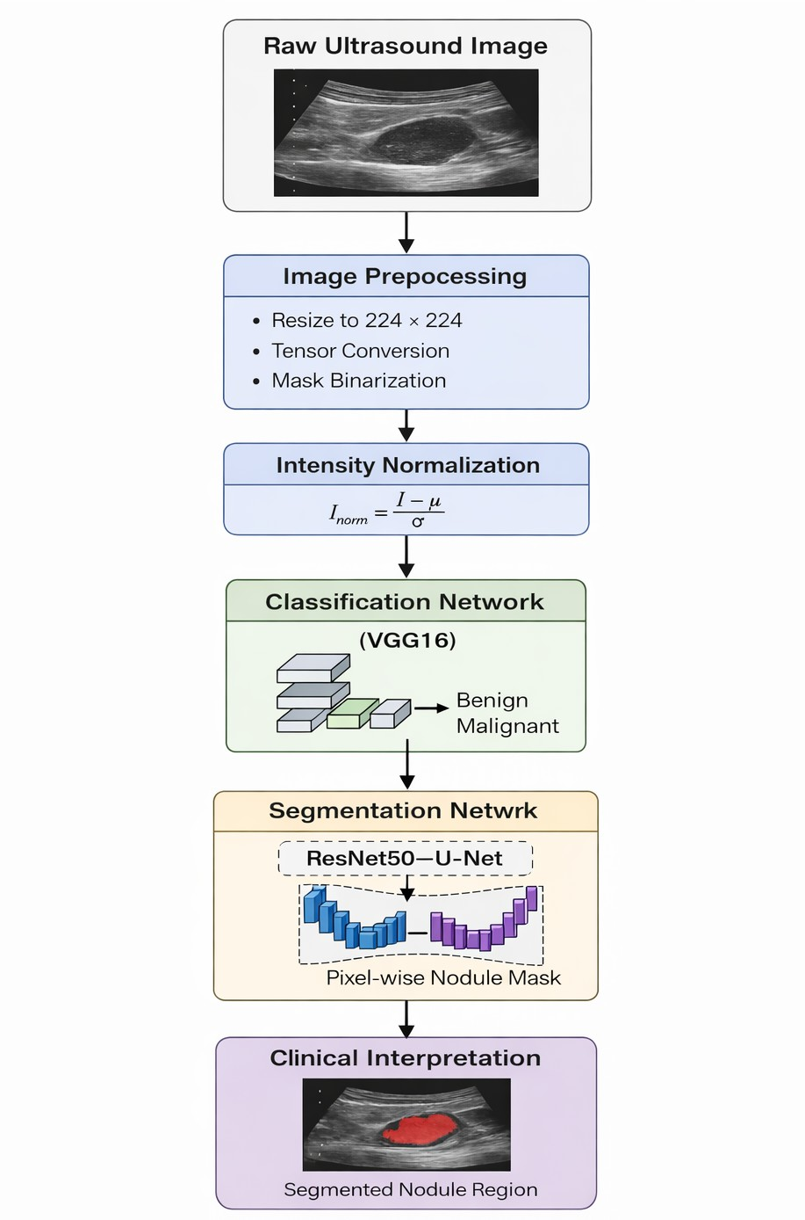
Figure 1: Architecture of the proposed sequential dual-stage framework for thyroid ultrasound image analysis. The pipeline performs malignancy classification followed by pixel-wise thyroid nodule segmentation.

which uses yˆ to display the predicted class label. The process of interpreting ultrasound images becomes com- plex because the images contain speckle noise and show poorly defined boundaries and multiple texture patterns and the boundaries of lesions remain unclear. The system needs to develop strong feature extraction abilities be- cause these elements make it hard for humans to analyze the data. The application of convolutional architectures enables the extraction of hierarchical feature abstractions from ultrasound images to address these existing chal- lenges. This data-driven representation learning approach eliminates the need for handcrafted descriptors and allows the model to learn malignancy-related intensity and structural variations through its automatic learning process.

Feature Representation

Thyroid nodule classification performance is limited by the ability of the model to learn the features in the ultrasound images. Classical machine learning approaches employed handcrafted features which were designed with knowledge of the image areas like intensity, texture, and shape. However, these manually designed features are domain knowledge-dependent and are not necessarily efficient in describing very complex visual patterns. Deep learning models mainly comprising of CNNs are the solution to these particular problems since CNNs learn the most important features from the image by themselves. CNNs learn features from images through multiple processing layers that use a convolution operation in order to find the relevant features for the classification problem. Early stages of a CNN learn basic visual features like brightness variation and edge contours of an image. CNNs use their information processing system to identify multiple advanced visual elements which include specific textural details and specific characteristics that belong to thyroid nodules. The analysis of the visual information may help decide how it can be classified. Ultrasound image analysis benefits from feature extraction because the unique characteristics which define a specific ultrasound type emerge through texture analysis and region brightness differences. The CNN model achieves increased prediction accuracy through image feature extraction without relying on additional features.

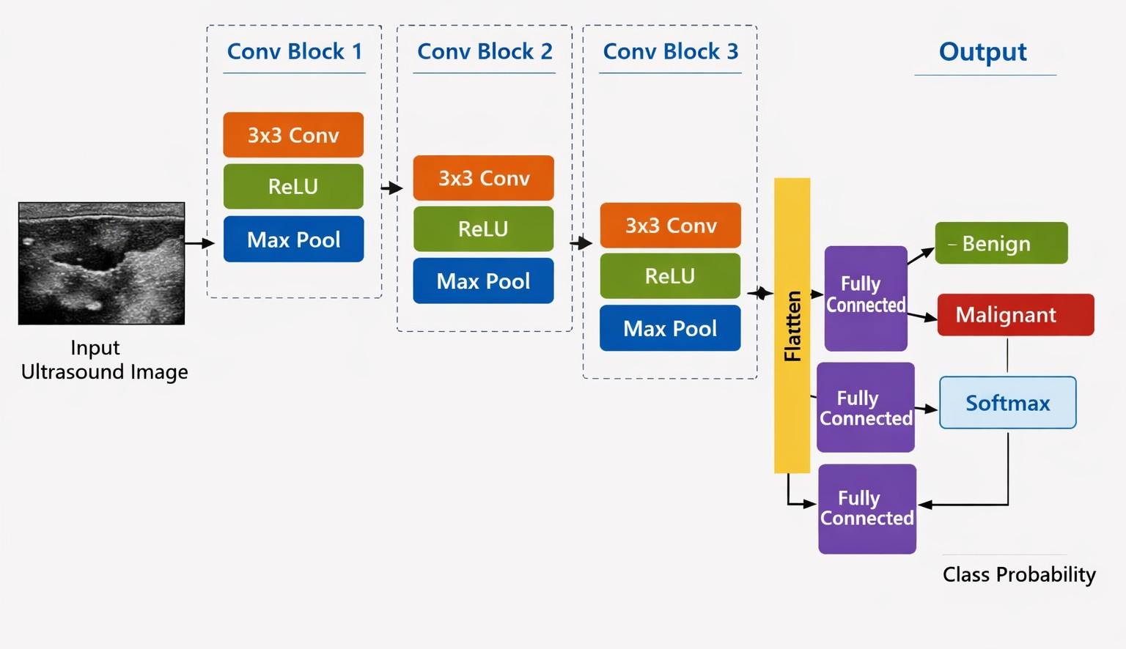
Figure 2: Architecture of the classification network based on the VGG16 model used in the thyroid nodule anal- ysis. The classification network uses a feature extraction process at multiple levels with successive convolutional blocks and dense fully connected layers to make predictions on benign and malignant classes.

Architecture

The classification module is built over the VGG16 architecture This specific architecture of CNN has been reg- ularly used for image classification due to its high performance. The CNN VGG16 image recognition model processes images through multiple convolutional layers which identify basic image features including thyroid nodule boundaries and variations in brightness across the nodules. The system will use blocks to extract high- level image features which include texture and structural patterns from thyroid nodules as the system increases its depth. Pooling layers serve their function to decrease image resolution which occurs after each convolutional layer. The architecture uses small filters during convolution operations because this design choice better high- lights the texture elements present in visual content. The CNN architecture processes image texture which serves as an important characteristic of the visual material. The design of the architecture requires different methods because the natural image pathway uses intensity fluctuations as its main element. The design of the architecture provides an easy to use and effective system for categorizing images. The design of the architecture provides an easy to use and effective system for categorizing images. The architecture design demonstrates effective perfor- mance for processing images which use ultrasound imaging technology. The architecture design shows effective performance for ultrasound imaging processing because its design includes hierarchical learning capabilities.

Mathematical Model

Images are passed through many convolution network layers of the classification network. Activation functions that non-linear are used in these convolution network layers. The convolution network layers perform their filter on the input feature map within the image. Visual features within the image are obtained through the convolution network layers. Mathematical representation for convolution operation provides below:
F_{l} = ReLU(W_{l} ∗ F_{l−1} + b_{l}) (5)
Combination of bias term with the weighted value of non-linear activation function, that is ReLU is features map after convolution operation. The system requires this component to introduce non-linear behaviour because it enables gradient propagation throughout the system. The image undergoes processing through various layers of convolution networks.
P_{l} = Pool(F_{l}) (6)
The system converts feature maps into their complete global representation through the process of flattening after convolutional operations.
z = Flatten(F ) (7)

The final classification prediction is calculated through the SoftMax function.
yˆ = Softmax(W_{f} z + b_{f} ) (8)
This transformation maps converts the learned feature representations into class probabilities corresponding to benign and malignant categories.

Loss Function

The Cross-Entropy Loss framework functions as the standard objective function for categorical tasks so it serves as the basis for optimizing the classification network. The method measures how much the predicted class probabilities differ from the actual ground truth annotations. The specific loss is formulated as:

C
Σ
L_{cls} = − y_{i} log(yˆ_{i}) (9)
i=1
The equation uses y_{i} as the actual label for the sample, while model predicts category probabilities through yˆ_{i} . The function needs minimization because it causes the model to predict correct classes with maximum confidence while it requires the model to pay penalties for every wrong prediction. The method works optimally with SoftMax-based architectures because it enables direct learning of output probability distribution through the learning process.

Evaluation Metrics

The evaluation of the classification framework used five diagnostic standards which included accuracy and preci- sion and F1-score and recall and the area under the ROC curve (ROC-AUC) metric. The assessment of the model used various metrics which delivered a complete evaluation of its prediction skills and its capacity to distinguish between different categories. The system’s accuracy metric measures all correct predictions made by the system which it calculates using the following formula.

Accuracy = TP + TN
TP + TN + FP + FN
(10)

In this context the abbreviations TP and TN and FP and FN represent true positives and true negatives and false positives and false negatives. Precision measures the trustworthy nature of positive predictions which the system makes.

Precision = TP TP + FP
(11)

Recall, frequently referred to as sensitivity, evaluates the network’s proficiency in accurately identifying all positive instances.

Recall = TP TP + FN
(12)

The F1-score combines precision and recall through its harmonic mean which produces a measurement that evaluates both false positive and false negative errors in the classification results.

F1-score = 2 · Precision · Recall
Precision + Recall

(13)

The ROC-AUC metric allowed the evaluation of classifier performance through various decision thresholds while using metrics that depend on defined thresholds. The model’s ability to differentiate between malignant and benign cases improves when the ROC-AUC score reaches higher values.

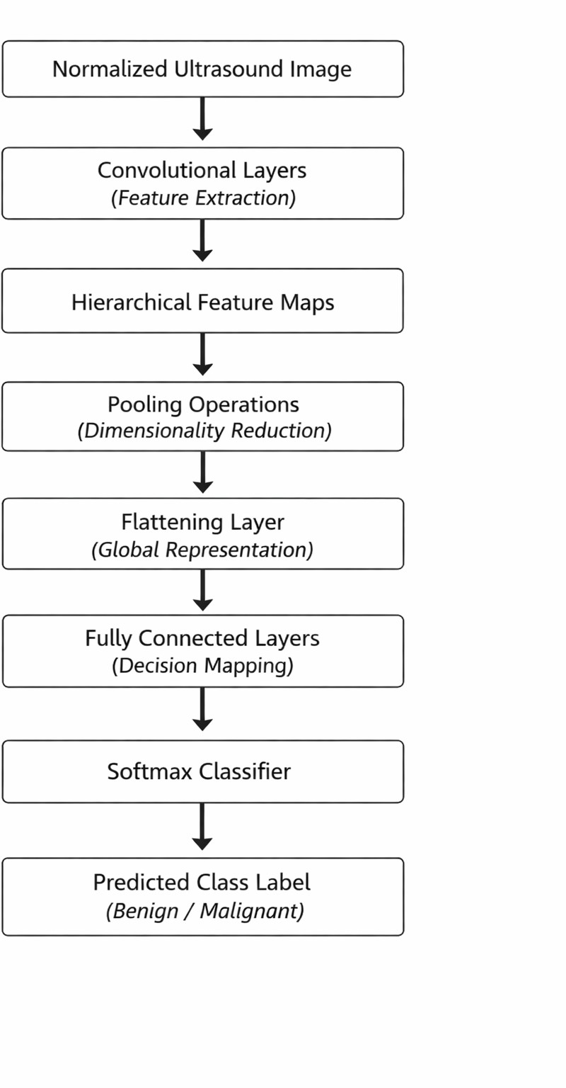
Figure 3: Conceptual workflow of the classification module. The pipeline includes feature extraction, dimen- sionality reduction, and SoftMax-based classification for benign and malignant prediction.

Classification Workflow

The classification module takes the normalized ultrasound images and feeds them into a system that extracts features and makes decisions. First, the ultrasound images are processed through a neural network which uses a CNN architecture. The CNN structure contains several layers which use filters to find important features in the ultrasound image. The training process uses multiple convolutional layers to create different levels of image features. The deeper layers of the model identify abstract semantic features whereas the shallower layers detect low-level features that include contrast and textures and edges which show the presence of thyroid nodules in the image. The system uses pooling layers between convolutional layers to decrease feature map sizes which helps to cut down processing costs while keeping essential diagnostic features. The process begins when the system combines all obtained features into one comprehensive feature map. The process required the conversion of multidimensional feature maps into one complete feature vector which main function was to enable processing through dense layers. The dense layers use their non-linear transformations to convert input features into decision space representation. The network outputs received SoftMax activation as the final step. The network outputs were changed into probabilities which indicated the presence of two diagnosis classes: benign and malignant nodules. The class with the highest probability will be considered as the final prediction of the model.
    - Classification Procedure Input: Normalized ultrasound image X
Output: Predicted class label yˆ
Step 1:Initialization The pre-processed ultrasound image,X is rescaled in order to attain a standard spatial dimension. The image is then rescaled, which standardizes the distribution of pixels.
Step 2: Feature Extraction The input image is forwarded through the forward propagation of the VGG16

classification network. Convolutional layers are utilized in order to attain hierarchical representations of features using nonlinear activation functions.
Step 3: Dimensionality Reduction The pooling layers remove spatial redundancy, retaining discriminative structural information.
Step 4: Feature Representation The obtained feature representation is converted into a singular global feature vector, z , which contains the abstract semantic features of the input image. Step 5: Classification The global feature vector,z , is forwarded through the dense layers in order to enable the classification. The SoftMax operator is utilized in order to attain the final probability distributions:

yˆ = arg max P (y | X) (14)
y

The class label is determined as the maximum value of the posterior probability.

Learning Strategy

The Adam optimizer will train the network parameters because it serves as the standard optimization method used in deep learning research for all classification tasks which requires faster convergence through its adaptive learning rate capabilities. The Adam optimizer updates network weights by using current and past gradient information. We need to minimize the cross-entropy loss, where loss is defined as the deviation between the prediction probabilities of network and the ground truth label of training sample, in training phase. The system will provide a comparison of the actual thyroid nodule labels with the predicted thyroid nodule probabilities from the model. The back-propagation algorithm will calculate all network parameters by computing loss function gradients. The Adam optimizer would use the back-propagation method to calculate gradients which it will use to update the training parameters of the network. Additionally, the network will be subjected to the validation data set to determine when the network has completed the learning through generalization and also to identify the necessity of parameter tuning of the network.

Segmentation Model

    - Problem Formulation

The segmentation part of the proposed framework tries to identify and locate the thyroid nodules at the pixel level from ultrasound images. Unlike image-level classification, which involve assigning a single label to an entire image, segmentation involves assigning a label to each pixel in the image. This allows accurate definition of the boundaries of the nodules. The segmentation problem is framed as a supervised binary learning problem. Doctors use ultrasound technology to create images which need ground truth masks that show which pixels belong to nodules and which pixels belong to background. The segmentation network uses a mapping function for its learning process.
f_{seg} : X → Y (15)
The ultrasound input image of our study is combined with the binary mask image. The mask image displays pix- els which show value 1 at locations of nodule detection and display value 0 at background tissue locations. The segmentation model needs to learn spatially dense representations which enable it to extract both structural ele- ments and boundary data of thyroid nodules. Image segmentation serves an essential function in clinical settings because it enables precise measurement of object dimensions. The process of segmenting ultrasound thyroid images presents significant challenges because ultrasound images exhibit speckle disturbances and display low

contrast and show diverse tissue echogenicity and present unclear boundaries of lesions. The model requires both local textural information and global contextual information to achieve successful image segmentation.

Feature Representation

The network requires training to recognize image features which enable precise thyroid nodule segmentation. The features provide information about both the object’s position and its physical appearance. Segmentation requires complete understanding of all features which differs from the needs of classification. The network must learn every pixel’s value in the image because this information establishes the nodule boundaries. Convolutional neural networks learn features directly from images which are not human-defined. The network first learns to detect basic features through its filters which identify edges and intensity changes and texture variations. The network enables the extraction of intricate thyroid nodule structural features through its advanced learning ca- pabilities developed from basic feature components. Feature representation is essential for ultrasound images because their basic visual elements provide necessary information for complete diagnostic evaluation. The ab- normal nodule shows three features which include different echogenicity patterns and texture mix-up across its boundary and fuzzy borderline characteristics. The deep learning models have learned to represent all the missing features through their training process which enables them to learn from data. The segmentation process requires feature representation to develop spatial information which matches the original image because the models need to achieve accurate nodule localization. We have used the ResNet50-UNet architecture in our proposed system in order to enhance the feature learning in image segmentation. The residual learning strategy allows deep network training because it prevents gradient problems which results in better feature learning for accurate mask image prediction.

Architecture

A ResNet50-U-Net was adopted as the segmentation module, which integrates the deep residual features ex- tracted with an encoder-decoder structure. The hybrid design establishes precise thyroid nodule segmentation through its dual ability which combines ResNet50 with U-Net spatial reconstruction functions. Encoder Net- work use ResNet50 for encoder. ResNet50 is a deep convolutional neural network. It makes use of residual learning. The network makes use of residual learning in order to get identity function, which will play a crucial part in maintaining the flow of gradient during the process of training the network of depth. The encoder network processes ultrasound image input through progressive spatial dimensionality reduction while it simultaneously builds deeper feature extraction capabilities. The process establishes high-level semantic understanding together with complete contextual knowledge about thyroid structures. The concept of U-Net is the main idea on which the decoder network is established. Different methods of up sampling are applied by the decoder network to restore the resolution. The output of the decoder network is pixel-level one obtained by the combining of se- mantic information. This information is taken by the decoder network from the encoder network. Through the creating of connection the structure information is exchanged between encoder and decoder network for precise boundary detection. Extraction of features by the utilization of residuals through skip connections results in sev- eral advantages in segmentation of ultrasound images. Challenges in ultrasound images are speckle noises, low contrast images and blurry edges of the lesions. Through deep learning, robust features in the form of residuals are produced and boundary is accurately detected using transversal mechanism of skip connections.

Mathematical Model

The segmentation network processes the input image of the ultrasound by a series of operations such as convo- lution, non-linear activation functions, and spatial reconstruction. Convolutional layers use learnable kernels to

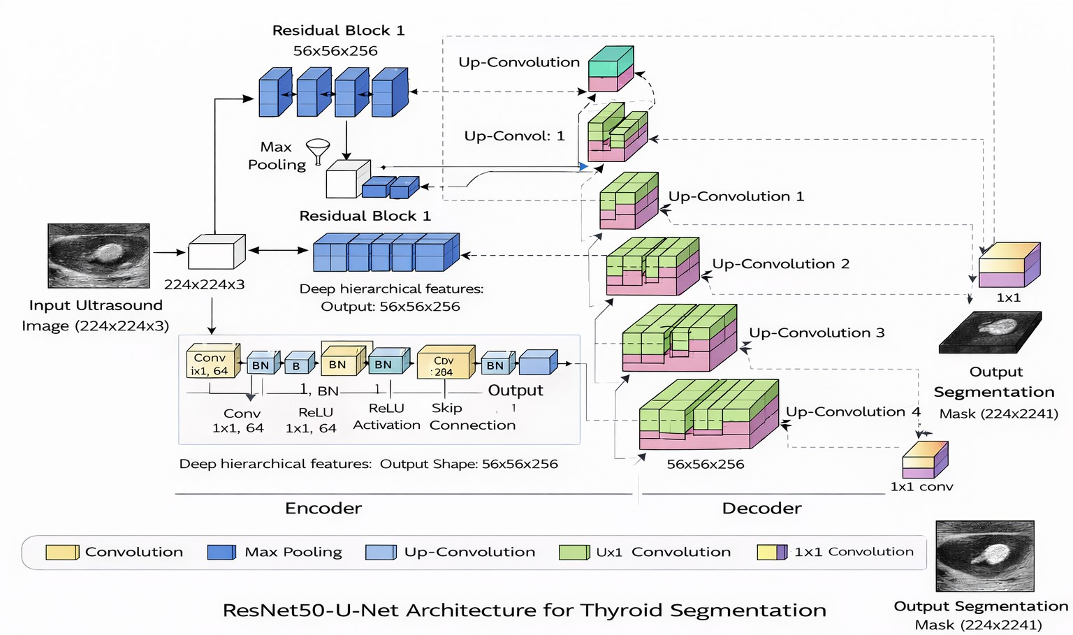
Figure 4: The structure of the ResNet50 U-Net that is used for image segmentation of thyroid nodule images. Deep residual feature extraction is used by the encoder of the network, followed by a decoder that uses up- convolution.

generate a hierarchy of spatial feature maps.
F_{l} = ReLU(W_{l} ∗ F_{l−1} + b_{l}) (16)

where W_{l} and b_{l} denote the convolution kernel and bia. The ReLU activation function introduce nonlinearity in the network, helping in gradient propagation. The encoder takes in the feature, making the depth deeper, decreasing the spatial resolution. The decoder takes in the features and makes the spatial resolution deeper with the help of up sampling:
U_{l} = Up(F_{l}) (17)
The encoder and decoder representations could be concatenated together in order to retain the structural infor- mation.
S_{l} = Concat(U_{l}, F_{l}) (18)

Final segmentation masks are obtained when the reconstructed feature representation is passed through a sigmoid- activated layer.
Yˆ = σ(W_{f} S + b_{f} ) (19)
where Yˆ is a pixel-wise probability map for the foreground andσ(·)is the sigmoid function. Each value indicates the probability that the location of that pixel is within the area of the thyroid nodule. A binary result is obtained by testing the probability of each pixel using a threshold value of 0.5.

Ybin
(x) = 1, if Yˆ(x) ≥ 0.5
0, otherwise
(

(20)

Loss Function

The identification of thyroid nodules is specific to the use of direct observation. However, this is a problem because of the difference in the brightness of the respective pixels. The model has utilized a combination of objective functions that is based on the utilization of Dice Loss and Binary Cross-Entropy (BCE) as the main method of measurement.
Lseg = LBCE + LDice (21)

The utilization of Binary Cross-Entropy Loss is considered to be a measurement of the classification of the image in a precise manner. This is because it is defined as:
1 Σ
N
L_{BCE} = − [y log(yˆ ) + (1 − y ) log(1 − yˆ )] (22)
i=1
N
i
i
i
i
Where, in the equation above y_{i} represents the actual target, while yˆ_{i} represents the likelihood of the class. The system has utilized Dice Loss to provide a perfect match between the expected output and the respective mask. The Dice coefficient is defined as:

Dice Loss is given by:
Dice = 2|Y ∩ Yˆ|
|Y | + |Yˆ|
(23)

L_{Dice} = 1 − Dice (24)
The combination of BCE Loss and Dice Loss is beneficial for improving the stability of image segmentation through the optimization of pixel-level classification and region-level classification. The method is beneficial for image segmentation under ultrasound imaging with noisy textures and imbalanced foreground regions.

Evaluation Metrics

To evaluate the segmentation model, the team employs several performance measurements which are applicable to pixel level and regional level. They are Dice, IoU, precision, recall and F1-score. With those measurements of performance, it would be able to perform a precise evaluation of the segmentation model based on accuracy in boundary detection and regional complete coverage. The Dice Similarity Coefficient computes the overlap in space between ground truth data and segmented mask.

Dice = 2|Y ∩ Yˆ|
|Y | + |Yˆ|
(25)

The ground truth mask is indicated as Y, and the system output yˆ. The output of the system has the same symbol indicating the predicted segmentation mask. IoU is a validation metric for image segmentation that gives the overlap ratio with respect to the total region. This is called Jaccard Index.

IoU = |Y ∩ Yˆ|
|Y ∪ Yˆ|
(26)

These steps are intended to be performed in concert to carry out the entire evaluation process that will demon- strate the accuracy of the boundary detection while at the same time evaluating the entire region overlap.

Segmentation Workflow

The segmentation module uses hierarchical feature extraction and spatial reconstruction to transform the normal- ized ultrasound image into a pixel-level prediction mask. The normalized image is first input into the segmen- tation network. This ensures the intensity distribution in the image. ResNet50 is the encoder network used in the model. Convolutional layers are used in the model to implement the feature extraction model. Convolutional layers can be used in the implementation of the feature extraction model. Convolutional layers can be used in

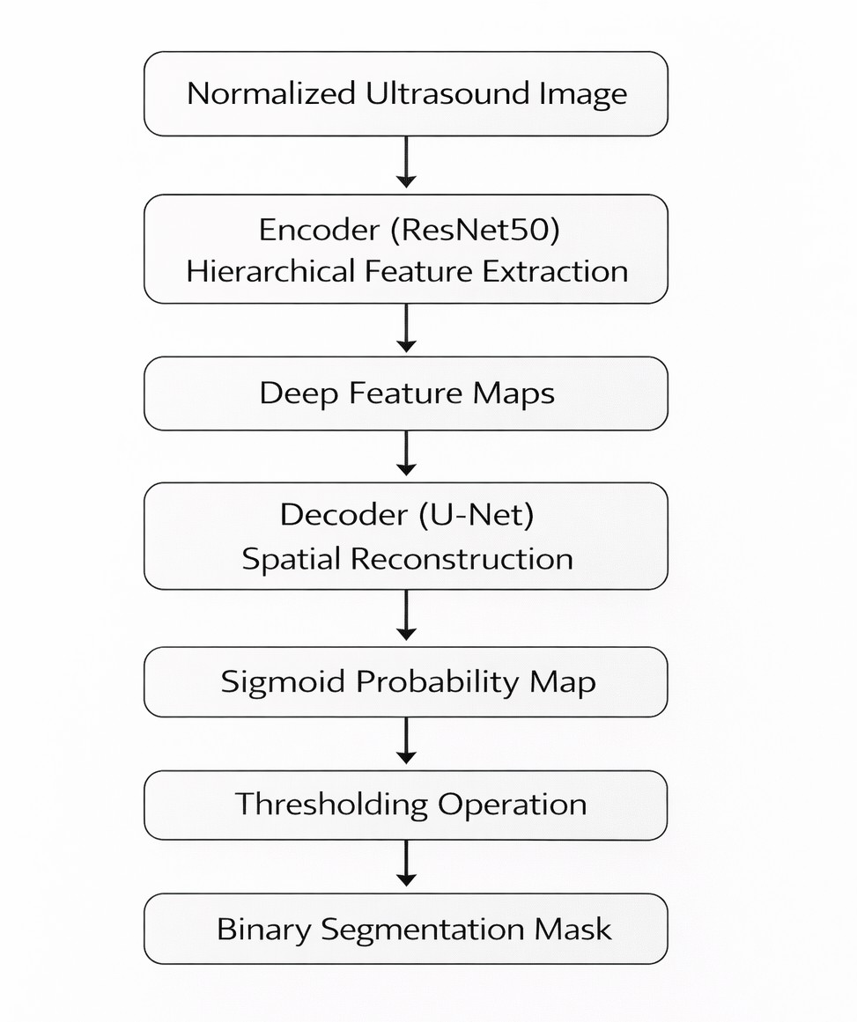
Figure 5: Logical workflow of the segmentation module. This pipeline illustrates the process of hierarchical feature extraction through a ResNet50 encoder, followed by a spatial reconstruction process through a decoder, and finally a prediction process through a sigmoid function to create a pixel-wise mask of the thyroid nodule

the implementation of the feature extraction model. Convolutional layers can be used in the implementation of the feature extraction model. Convolutional layers can be used in the implementation of the feature extraction model. Convolutional layers can be used in the implementation of the feature extraction model. Convolutional layers can be used in the implementation of the feature extraction model. Convolutional layers can be used in the implementation of the feature extraction model. Convolutional layers can be used in the implementation of the feature extraction model. Convolutional layers can be used in the implementation of the feature extraction model. Convolutional layers can be used in the implementation of the feature extraction model. Convolutional layers can be used in the implementation of the feature extraction model. Convolutional layers can be used in the implementation of the feature extraction model. Convolutional layers can be used in the implementation of the feature extraction model. The network produces a probability map using the sigmoid activation function. The sigmoid activation function has an advantage over other activation functions because it converts the pixels in the image to a probability value that lies within the region of the thyroid nodule. A binary segmentation mask is created using a decision threshold on the probability distribution. This separates the pixels within the image into two classes. The logical flowchart of the segmentation module is as follows in Fig.5.

Segmentation Procedure

  - Segmentation Procedure

Input: Normalized ultrasound image X
Output: Binary mask Y_{bin}
Step 1: Initialization The input image X is spatially downscaled to a specific resolution. This ensures that all images have consistent values.
Step 2: Feature Extraction (Encoder) The input image X is forward propagated through the ResNet50 En- coder. The convolutional layers are used to extract spatial hierarchies while down sampling spatially to obtain semantic features from the image.
Step 3: Spatial Reconstruction (Decoder) The convolutional layers are used to obtain spatial hierarchies while

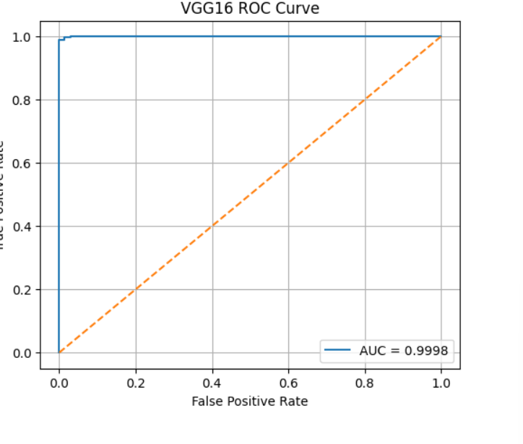
Figure 6: Receiver Operating Characteristic (ROC) curve of the VGG16 classification network. up sampling. Skip connections are used to obtain detailed boundary features.
Step 4: Probability Map Estimation To estimate the likelihood of each pixel belonging to a nodule, a sigmoid
activation is applied to produce a continuous probability mapYˆ ,where each pixel represents the likelihood of belonging to the thyroid nodule region.
Step 5: Binary Mask Generation A discrete binary segmentation output is then generated by applying a specific decision threshold to this probability map:

Ybin
(x) = 1, if Yˆ(x) ≥ 0.5
0, otherwise
(

(27)

The output Y_{bin} represents the predicted pixel-wise segmentation of the thyroid nodule.

RESULTS

Classification Results

We used standard performance indicators to assess diagnostic performance which computed the accuracy of the system along with its precision and recall and F1 score. The VGG16 architecture classifier achieved a 99.24% test accuracy which showed excellent generalization ability when it processed new ultrasound data. The model achieved 99.69% precision and 98.78% recall which demonstrated its strong ability to distinguish between benign and malignant cases with very high accuracy The class separation achieved better results through system testing which produced an Area Under the Curve (AUC) score of 0.9998 that approached the perfect score of 1.0 according to classifier sensitivity and specificity measurements.
The loss curves shown in Fig.7. display how the classification network learns during training. The convergence patterns demonstrate stable learning progress because the learning process maintained its efficiency throughout the training period. The network demonstrates numerical stability because its loss curve does not show any

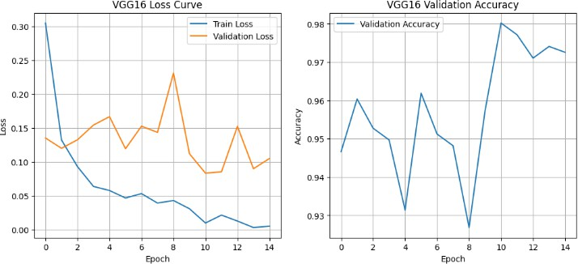

Figure 7: Loss curves for the VGG16 network of the training and validation phases, that validate stable opti- mization and learning efficiency of the model.
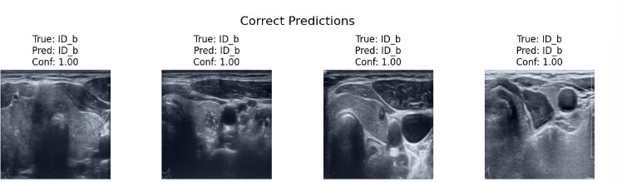
Figure 8: Correctly classified thyroid ultrasound images.

significant high-frequency fluctuations. Qualitative assessment of the model was performed by displaying repre- sentative correctly classified ultrasound image examples in Fig.8. Such results also prove the network’s ability to recognize the structural and textural features related to malignancy in the ultrasound images despite the variations in the ultrasound imaging environments. A limited number of misclassifications were observed during testing. Since only five samples were incorrectly classified, all failure cases are presented in Fig. 9 for completeness. These cases primarily involve nodules with heterogeneous echogenicity, diffuse texture distributions, or poorly defined boundaries, which increase diagnostic ambiguity.

Classification Model Comparison

The researchers conducted a performance metric analysis to evaluate the diagnostic capabilities of their clas- sification model through the use of Accuracy and Precision and Recall and F1-score evaluation methods. The researchers developed a classification model which needs every evaluation metric to be tested for complete per- formance assessment. The developed VGG16 network classifier achieved an accuracy of 99.24% through testing with unknown ultrasound data images. The developed classifier achieves a precision rate of 99.69% and a recall rate of 98.78%, which demonstrates the system’s ability to accurately predict thyroid cancer cases while making very few false predictions.

Segmentation Results

The performance of our proposed segmentation framework gets measured through standard overlapping region metrics which include IoU and DSC. The study employs standard precision and recall measurement methods together with overlapping region measurements which include IoU and DSC. The segmentation performance

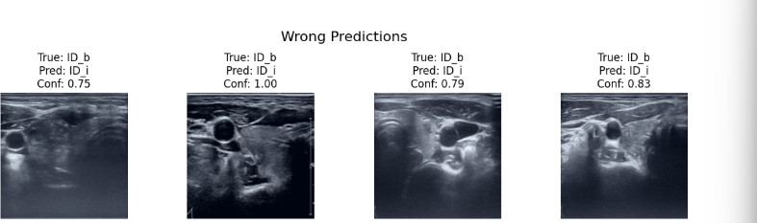
Figure 9: Incorrectly classified thyroid ultrasound images Table 1: Quantitative Analysis and Model Comparison
Model | Accuracy (%) | Precision (%) | Recall (%) | F1-score (%)
VGG16 | 99.24 | 99.69 | 98.78 | 99.24
ResNet18 | 98.94 | 99.09 | 98.78 | 98.93
Hybrid ResNet18-Transformer | 97.11 | 96.41 | 97.87 | 97.13
ResNet34 | 96.20 | 96.06 | 96.35 | 96.21
VGG19 | 94.83 | 98.36 | 91.19 | 94.64
AlexNet | 92.86 | 90.52 | 95.74 | 93.06

metrics provide complete assessment of segmentation results because they show how much the segmented area matches the target area and they measure how well the segmentation model identifies boundaries. The training process uses validation Dice and IoU metrics to track segmentation model development which shows through Fig. 10 that the metric values achieve their best performance during initial training before the model starts to reach its final state. The model demonstrates its capacity to recognize spatial patterns. The Dice coefficient shows continuous improvement because it shows high accuracy for thyroid nodules’ regional segmentation. The IoU values keep showing better results as the training process continues. The system demonstrates strong bound- ary prediction performance according to this measurement. The thyroid nodule segmentation model develops through training which enhances both its area and boundary detection skills. Fig.11 displays the results from eval- uating how well the thyroid nodules segmentation model performs its task. The comparison between predicted masks and actual ground truth masks demonstrates that the thyroid nodules segmentation model can accurately identify thyroid nodules positions. The system has the ability to reconstruct the thyroid nodule boundaries. The thyroid nodules segmentation model successfully acquires essential thyroid nodule characteristics according to this evidence. The segmentation performance results demonstrate that the proposed framework successfully identifies thyroid nodules together with their corresponding segmentation masks. The proposed deep learning method for thyroid ultrasound image segmentation demonstrates effective performance through its quantitative and qualitative segmentation results.

Segmentation Model Comparison

The comparative segmentation performance of the evaluated models is summarized in Table 2. Among all the models, the best results have been achieved by the ResNet50-UNet model, with the highest values of Dice and IoU. This could be related to the better ability of this model to learn residual features at deeper levels, thus providing a more accurate representation of the image’s structural and textural features. The VGG-based models, which use the VGG encoder, have achieved high values of segmentation accuracy, as seen with the VGG19- UNet and VGG16-UNet models. This could be related to the better ability of deep convolutional hierarchies to represent ultrasound images. The variants of architectures that use the Transformer, as with the TransUNet model, have achieved relatively good results, although slightly lower compared to the best results. This could be related to the unique characteristics of this type of architecture, which allows for better processing of the complex features of ultrasound images. The conventional architectures, as with the U-Net and Attention U-Net, have achieved relatively lower values of Dice and IoU compared to the other architectures.

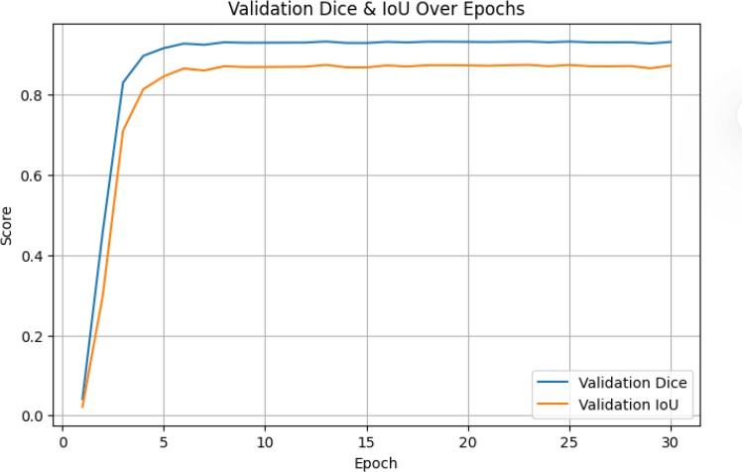

Figure 10: Validation dice and IoU scores for the training epochs showing stable convergence behaviour.

Image Ground Truth Mask Prediction Overlay
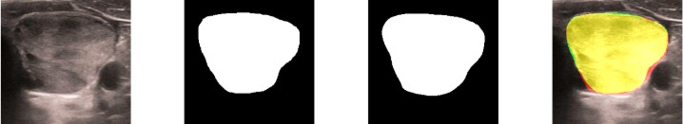
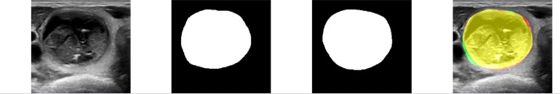

Figure 11: Qualitative segmentation outcome of the four representative thyroid US images, the ground truth masks, the predicted masks and the overlay visualizations.

CONCLUSION

The study developed a deep learning system to perform automatic analysis of thyroid ultrasound images. The de- veloped system combines both classification and segmentation tasks into a single framework to support computer- aided diagnosis. The classification module enables users to distinguish between benign and malignant thyroid nodules while the segmentation module enables users to identify the exact borders of nodules through pixel-by- pixel analysis. The thyroid ultrasound image analysis application requires users to solve two problems which must be solved inside a single framework. The experimental results demonstrated that deep convolutional en- coder networks deliver exceptional performance for thyroid ultrasound image analysis. The pretrained convolu- tional encoders achieved successful results which allowed them to extract important thyroid nodule ultrasound image features. Deep learning-based features have demonstrated their effectiveness for thyroid ultrasound im- age segmentation. The proposed deep features for thyroid ultrasound image segmentation showed effectiveness because they worked even when speckle noise and low contrast images were present. The proposed framework achieves good performance results but still needs additional testing for certain components. The development of better attention systems together with multi-scale feature discovery methods will lead to better results in boundary identification tasks. Clinical decision-making systems will benefit from improved prediction accuracy through the integration of uncertainty estimation methods. The proposed method requires additional data sets for testing because this will help researchers understand how well the system performs across different scenarios.

ETHICAL STATEMENTS

Ethical Approval: This study is based on a publicly available dataset (Thyroid TNUS dataset) obtained from Kaggle. The research does not involve any direct interaction with human participants or animals.

Table 2: A detailed comparison of the performance metrics achieved by various segmentation architectures

Model | Dice | IoU | Precision | Recall
ResNet50-UNet | 0.9319 | 0.8727 | 0.9423 | 0.9346
VGG19-UNet | 0.9305 | 0.8703 | 0.9154 | 0.9466
VGG16-UNet | 0.9254 | 0.8614 | 0.9066 | 0.9457
DeepLabV3+ | 0.8180 | 0.6981 | 0.8410 | 0.8035
TransUNet | 0.8069 | 0.6835 | 0.8061 | 0.8162
Attention U-Net | 0.7718 | 0.6382 | 0.7596 | 0.8005
U-Net | 0.7666 | 0.6310 | 0.7497 | 0.7982

Conflict of Interest: The authors declare that there are no conflicts of interest related to this work.
Data Availability Statement: The dataset used in this study is publicly available on Kaggle under the name ”Thyroid TNUS Dataset”. It can be accessed for research purposes at: https://www.kaggle.com/datasets/divyammjainn/thyroid-tnus-dataset.

REFERENCES

- Ito, Y., Miyauchi, A., & Oda, H. (2018). Low-risk papillary microcarcinoma of the thyroid: A review of active surveillance trials. European Journal of Surgical Oncology, 44(3), 307–315.
- Shen, Y. T., Chen, L., Yue, W. W., & Xu, H. X. (2021). Artificial intelligence in ultrasound. European Journal of Radiology, 139, 109717.
- Yang, W. T., Ma, B. Y., & Chen, Y. (2024). A narrative review of deep learning in thyroid imaging: Current progress and future prospects. Quantitative Imaging in Medicine and Surgery, 14(2), 2069–2088.
- Liu, T., Guo, Q., Lian, C., Ren, X., Liang, S., Yu, J., . . . & Shen, D. (2019). Automated detection and classification of thyroid nodules in ultrasound images using clinical-knowledge-guided convolutional neural networks. Medical Image Analysis, 58, 101555.
- Song, R., Zhang, L., Zhu, C., Liu, J., Yang, J., & Zhang, T. (2020). Thyroid nodule ultrasound image classification through hybrid feature cropping network. IEEE Access, 8, 64064–64074.
- Moussa, O., Khachnaoui, H., Guetari, R., & Khlifa, N. (2020). Thyroid nodules classification and diag- nosis in ultrasound images using fine-tuning deep convolutional neural network. International Journal of Imaging Systems and Technology, 30(1), 185–195.
- Shankarlal, B., Sathya, P. D., & Sakthivel, V. P. (2023). Computer-aided detection and diagnosis of thyroid nodules using machine and deep learning classification algorithms. IETE Journal of Research, 69(2), 995– 1006.
- Guo, M., & Du, Y. (2019). Classification of thyroid ultrasound standard plane images using ResNet-18 networks. In Proceedings of IEEE ASID (pp. 324–328).
- Mohan, E., Saravanan, P., Natarajan, B., Kumer, S. A., Sambasivam, G., Kanna, G. P., & Tyagi, V. B. (2023). Thyroid detection and classification using DNN based on hybrid meta-heuristic and LSTM tech- nique. IEEE Access, 11, 68127–68138.
- Yadav, N., Dass, R., & Virmani, J. (2024). Deep learning-based CAD system design for thyroid tumor characterization using ultrasound images. Multimedia Tools and Applications, 83(14), 43071–43113.

- Ronneberger, O., Fischer, P., & Brox, T. (2015). U-Net: Convolutional networks for biomedical image segmentation. In Proceedings of MICCAI (pp. 234–241).
- Zhou, Z., Siddiquee, M. M. R., Tajbakhsh, N., & Liang, J. (2020). U-Net++: Redesigning skip connections to exploit multiscale features in image segmentation. IEEE Transactions on Medical Imaging, 39(6), 1856–1867.
- Chu, C., Zheng, J., & Zhou, Y. (2021). Ultrasonic thyroid nodule detection method based on U-Net network. Computer Methods and Programs in Biomedicine, 199, 105906.
- Zheng, T., et al. (2023). Segmentation of thyroid glands and nodules in ultrasound images using improved U-Net architecture. BMC Medical Imaging, 23, 56.
- Gong, H., et al. (2022). Thyroid region prior guided attention for ultrasound segmentation of thyroid nodules. Computers in Biology and Medicine, 155, 106389.
- Gulame, M. B., Dixit, V. Y., & Suresh, M. (2021). Thyroid nodules segmentation methods in clinical ultrasound images: A review. Materials Today: Proceedings, 45, 2270–2276.
- Li, Y., et al. (2025). Deep learning methods for thyroid imaging segmentation: A systematic review. In
Proceedings of ICDSA (pp. 418–426).
- Chi, J., et al. (2022). Hybrid transformer U-Net for thyroid segmentation from ultrasound scans. Comput- ers in Biology and Medicine, 153, 106453.
- Wu, Y., Huang, L., & Yang, F. (2025). Thyroid nodule ultrasound image segmentation based on improved Swin transformer. IEEE Access, 13, 19788–19802.
- Banerjee, T., et al. (2025). A novel hybrid deep learning approach combining deep feature attention and statistical validation for enhanced thyroid ultrasound segmentation.
- He, K., Zhang, X., Ren, S., & Sun, J. (2016). Deep residual learning for image recognition. In Proceedings of CVPR (pp. 770–778).
- Chen, L.-C., Zhu, Y., Papandreou, G., Schroff, F., & Adam, H. (2018). Encoder-decoder with atrous separable convolution for semantic image segmentation. In Proceedings of ECCV (pp. 801–818).
- Badrinarayanan, V., Kendall, A., & Cipolla, R. (2017). SegNet: A deep convolutional encoder-decoder architecture for image segmentation. IEEE Transactions on Pattern Analysis and Machine Intelligence, 39(12), 2481–2495.
- Long, J., Shelhamer, E., & Darrell, T. (2015). Fully convolutional networks for semantic segmentation. In
Proceedings of CVPR (pp. 3431–3440).
- Dosovitskiy, A., et al. (2021). An image is worth 16×16 words: Transformers for image recognition at scale. In ICLR.
- Vaswani, A., et al. (2017). Attention is all you need. In NeurIPS (pp. 5998–6008).
- Goodfellow, I., Bengio, Y., & Courville, A. (2016). Deep learning. MIT Press.
- Litjens, G., et al. (2017). A survey on deep learning in medical image analysis. Medical Image Analysis, 42, 60–88.
- Esteva, A., et al. (2019). A guide to deep learning in healthcare. Nature Medicine, 25, 24–29.
- Topol, E. (2019). High-performance medicine: The convergence of human and artificial intelligence.
Nature Medicine, 25, 44–56.

- Lilhore, N. K., Kavitha, P., Hussien, S. A., et al. (2026). Early detection of potato leaf diseases with PotatoNet-X: A deep learning model combining ResNet, DenseNet, and attention mechanisms. Potato Research, 69.
- Mishra, P., Porwal, R., Parthasarathy, R., Singh, S., Raizada, A., & Kavitha, P. (2026). Secure signal and image processing architectures based on machine learning for next-generation cyber defense, 12(1). DOI: 10.29284/g9h4gh73.

