Digital Marketing Outreach and Training for MSME Actors in Girikerto, Sleman Regency, Yogyakarta Special Region, Indonesia

Erni Saharuddin
(ernisaharuddin@unisayogya.ac.id, Universitas 'Aisyiyah Yogyakarta, Indonesia)
Setya Putri Rahayu
(setyaputri20@unisayogya.ac.id, Universitas 'Aisyiyah Yogyakarta, Indonesia)
Olla Agustia Leriani
(ollaagustia@unisayogya.ac.id, Universitas 'Aisyiyah Yogyakarta, Indonesia)
Muhammad Fajrus Shodiq
(muhammadfajrusshodiq@unisayogya.ac.id, Universitas 'Aisyiyah Yogyakarta, Indonesia)
Louvill Manangan Ozarraga
(louvill.ozarraga@msumain.edu.ph, Mindanao State University, Philippines)
Marecon C. Viray
(marecon.viray@msumain.edu.ph Mindanao State University, Philippine)

Abstract
This community service activity aims to enhance the knowledge and understanding of Micro, Small, and Medium Enterprise (MSME) actors in Turi District, Sleman Regency, regarding the importance of digital marketing in business development. The activity was motivated by the condition of the partners, who already possess business potential, good production quality, and adequate product packaging, but still face challenges in the marketing aspect. Based on field identification, MSMEs in the Girikerto area are organized into an MSME forum consisting of clusters, including snake fruit-based products, goat milk products, batik, crafts and waste processing. To address these issues, the activity was conducted in the form of outreach and training on digital marketing. The materials provided include an introduction to digital marketing, the benefits of digital marketing for MSMEs, differences between digital and traditional marketing, and the core elements of marketing strategy, namely model, market, message, and media. The evaluation of the activity was conducted through observation, participant feedback, and pre-test and post-test to measure changes in participants’ knowledge before and after the activity. The results presented an increase in participants’ knowledge and awareness of the importance of digital marketing as a means of promotion and market expansion for MSME products. This activity demonstrates that digital marketing outreach and training can serve as a relevant initial step in strengthening MSME capacity, particularly in the marketing aspect.
Keywords: digital marketing, MSMEs, outreach, training
A. INTRODUCTION
Turi District, particularly the Girikerto area, has significant potential for MSME development. Based on field identification results, an MSME forum has been established in this area, encompassing four business clusters: snake fruit processing, goat milk processing, batik, and crafts, as well as waste processing. The existence of these clusters demonstrates that partner communities have a diverse business base with the potential to be developed as a local economic force. Furthermore, MSMEs in this area have received various forms of assistance from various parties, such as the development of goat milk processing products by the Indonesian Institute of Sciences (LIPI), snake fruit processing by the Sleman National Zakat Agency (BAZNAS), business coaching by the Sleman Cooperatives and SMEs Office, and halal certification assistance from SEHATI. This demonstrates that support for production and product strengthening is sufficient.
However, field identification results indicate that the main challenge facing partners is not the production process, but rather marketing. While product production and packaging are considered adequate, marketing remains a challenge for MSMEs. This situation indicates a gap between product readiness and market expansion capabilities. In the context of increasingly open business competition, a good product will not develop optimally without the support of an appropriate marketing strategy.
One relevant approach to addressing this issue is digital marketing. The training materials used in this activity explain that digital marketing refers to the use of digital platforms, tools, and technologies to promote products, services, or ideas to target audiences online. Compared to traditional marketing, digital marketing offers several advantages, including broader audience reach, more specific targeting capabilities, cost efficiency, faster feedback, and ease of measuring results. For MSMEs, digital marketing has the potential to be an effective means of expanding market reach and increasing business competitiveness.
Theoretically, digital marketing is understood not only as the use of online media for promotion, but as part of a marketing transformation that changes the way businesses interact with customers, manage market information, and build value. Verhoef et al. (2021) explain that digital transformation has changed consumer expectations and behavior, putting pressure on traditional businesses and driving changes in business models. In this context, MSMEs need more than just good products; they also need to be prepared to understand changing market behavior and strategically utilize digital media.
From an organizational capability perspective, Held, Heubeck, and Meckl (2025) explained that dynamic capabilities play a crucial role in driving MSME digital transformation, particularly through the development of digital leadership and a digital culture that supports businesses’ ability to adapt to technological and market changes. In this context, digital marketing can be seen as part of MSMEs’ adaptive capabilities, as it requires the ability to understand the market, select appropriate media, craft relevant messages, and respond quickly to changes in consumer behavior. Therefore, strengthening digital marketing knowledge through community service activities can be positioned as a first step in building MSMEs' readiness to adapt to changes in the business environment.
Furthermore, Morgan (2019) emphasizes that marketing capabilities are a crucial factor bridging strategic decisions with effective marketing actions. For MSMEs, which generally have limited resources, marketing effectiveness is determined not only by the amount of promotional costs but also by the accuracy of the strategy and understanding of the market. Thus, providing digital marketing materials to MSMEs is relevant as a form of strengthening conceptual capacity, thereby enabling them to develop a more systematic and comprehensive understanding of marketing principles and strategies.
Studies on social media adoption in small businesses also show that the main barrier does not always lie in the availability of technology, but rather in knowledge, perceived benefits, and organizational readiness to use it strategically. Nazir, Rizwan, and Zhu (2025) showed that social media marketing adoption in SMEs is influenced by technological, organizational, and environmental factors, including perceived benefits, performance tracking capabilities, and internal business support. These findings confirm that outreach and training activities such as those in this community service program can be understood as early interventions to reduce cognitive barriers to digital marketing adoption.
From an innovation diffusion perspective, these outreach and training activities can be understood as the knowledge stage, the initial phase when participants begin to become familiar with innovation, understand its benefits, and develop initial readiness to adopt it in their business practices. In the context of this community service, digital marketing is not simply introduced as a promotional medium, but as a marketing innovation that requires prior understanding before it can be gradually implemented by MSMEs. Thus, the training serves not only as a means of transferring information but also as an initial mechanism to encourage the adoption of digital marketing innovations at the micro and small business level.
Beyond knowledge transfer, digital marketing training can also be understood as a form of capacity building for MSMEs. Through this activity, participants not only receive material but are also encouraged to begin understanding the market, designing promotional messages, and selecting media that align with the characteristics of their businesses. In this sense, the training serves as an initial capacity-building process to ensure that MSMEs become more independent in managing their marketing strategies and better prepared to respond to changes in the increasingly digitalized business environment.
The digital marketing materials used in this activity also emphasized the importance of four core elements of a marketing strategy: model, market, message, and media. The model relates to the clarity of the product being offered; the market relates to the target consumer; the message relates to the main message to be conveyed to potential consumers; and the media relates to the channels used to reach the market. Furthermore, participants were introduced to various supporting aspects of digital marketing, such as social media algorithms, promotional videos, captions, hashtags, and the differences between organic and paid marketing. Understanding these concepts is crucial as a foundation for MSMEs to understand the direction of their business marketing development.
Based on these conditions, the problems faced by partners in this activity can be formulated as follows: (1) MSMEs still have limited knowledge of digital marketing; (2) MSMEs do not yet understand targeted digital marketing strategies; and (3) MSMEs do not yet have adequate insight into the use of digital media as a means of business promotion. To address these issues, the community service team conducted activities in the form of digital marketing outreach and training. These activities aimed to increase MSMEs’ knowledge, understanding, and awareness of the importance of digital marketing for business development. The expected outcome of this activity was to increase participant insight into digital marketing strategies as a starting point for MSME business development.
B. IMPLEMENTATION AND METHODS
This community service activity was conducted in Turi District, Sleman Regency, targeting MSMEs members of the Girikerto MSME Forum. Participants came from several business clusters, including snake fruit processing, goat milk processing, batik, and crafts, as well as waste processing. Participants were micro and small business owners who already had products and were operating their businesses, but still faced marketing challenges, particularly in utilizing digital media for promotion and market expansion. This situation aligns with initial identification results, which indicated that production and packaging aspects were relatively good, but marketing remained a major challenge for partners. The activity took place on January 22, 2026, in Girikerto, Turi District, Sleman Regency, with 25 participants.
The methods used in this activity were counseling and theoretical training. The counseling method was implemented by strengthening participants’ insight and raising awareness about the importance of digital marketing in MSME business development. Meanwhile, the training method involved material presentations, interactive discussions, and a question-and-answer session on basic digital marketing concepts relevant to the participants’ needs. This method was chosen based on the initial needs of the partners, which emphasized strengthening a basic understanding of digital marketing strategies before moving on to more practical applications.
Picture 1. Theoretical Training Enforcement
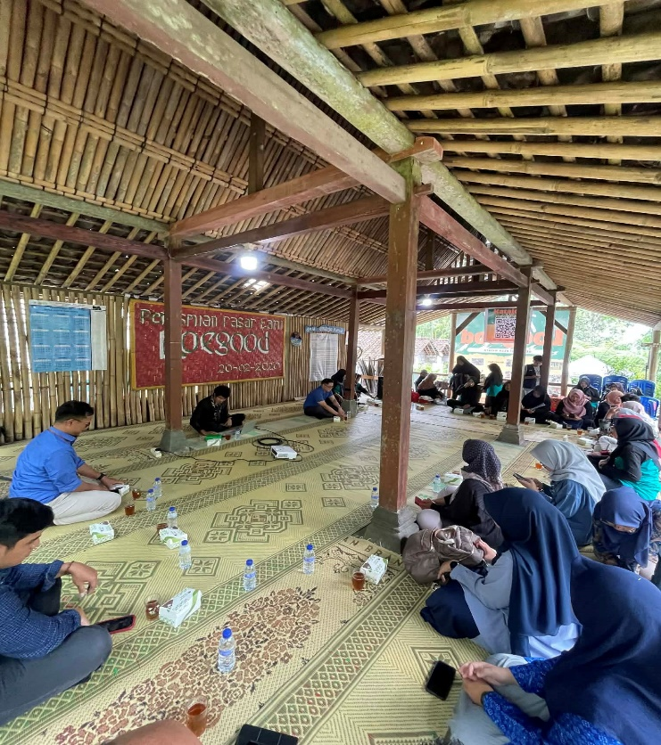


Source: Author’s documentation
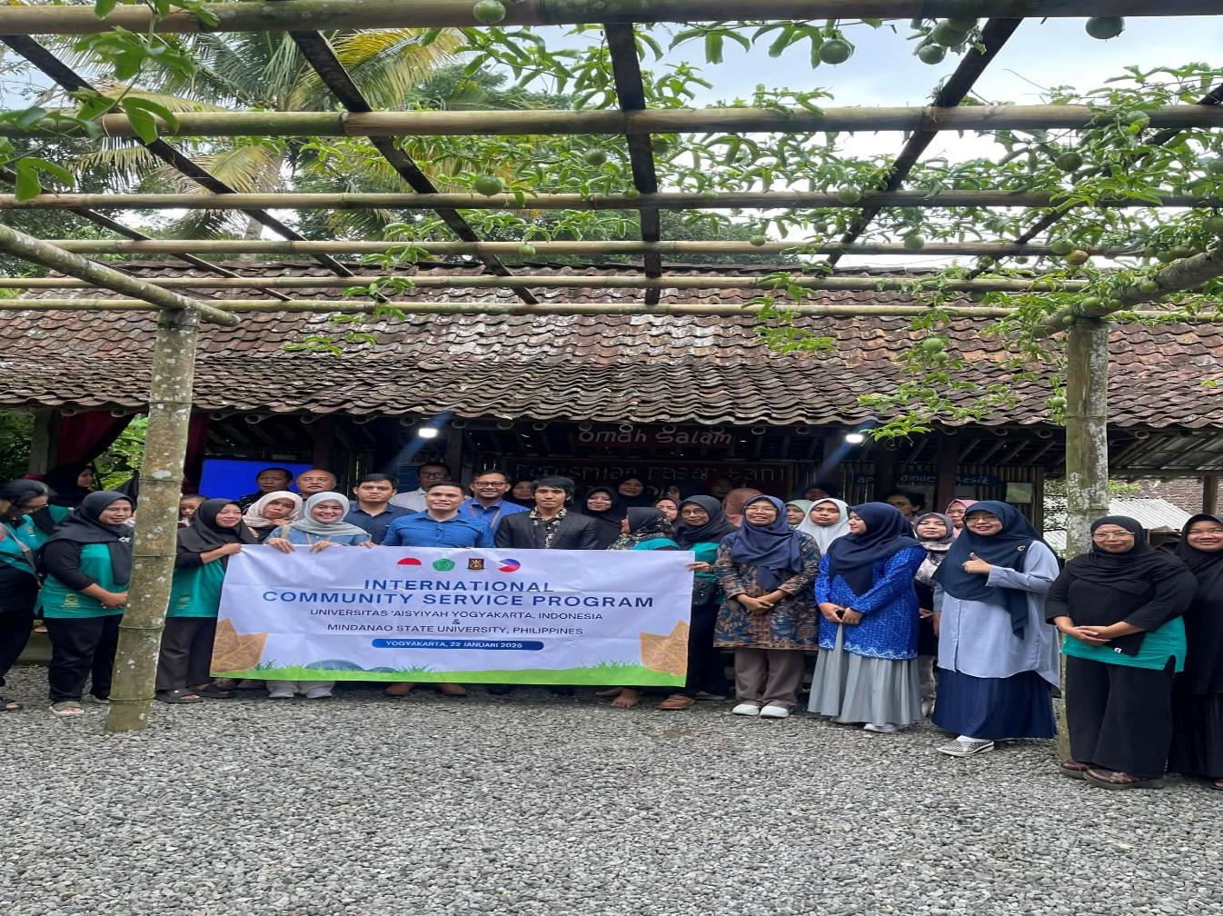
Picture 2. Training Participants



Source: Author’s documentation
The material presented in the training included an introduction to digital marketing, the differences between digital marketing and traditional marketing, the benefits of digital marketing for MSMEs, and the core elements of marketing strategy, including models, markets, messages, and media. Participants were also introduced to various digital marketing components, such as social media algorithms, the function of video in promotions, captions, hashtags, and the differences between organic and paid marketing. This material was provided to broaden participants’ understanding of the importance of well-planned promotions and marketing developments in the digital era.
The training consisted of four steps. The first step was the initial identification of partner problems through observation and discussions with relevant parties. The second step was the development of training materials based on the needs of MSMEs at the service locations. The third step was the implementation of digital marketing outreach and training through lectures, discussions, and a question-and-answer session. The fourth step was an evaluation of the training to determine participants’ responses and knowledge enhancements to the material provided. Evaluation was conducted through observations during the activity, participant feedback, as well as pre- and post-test instruments to assess changes in participant knowledge before and after the training. The pre- and post-test instruments were designed based on indicators of basic digital marketing understanding that aligned with the training material. The pre- and post-test data were then analyzed descriptively by comparing pre- and post-training scores to determine any improvement in participant understanding of the material.
C. RESULTS AND DISCUSSION
The implementation of this community service activity demonstrated that the digital marketing material provided was relevant to the needs of the participants, particularly MSMEs in Girikerto, who continue to face marketing challenges. This relevance was evident both in the activity implementation process and in the evaluation results obtained after the training. The activity evaluation was conducted through three elements: observations during the activity, participant feedback, and lastly, pre- and post-test instruments to assess changes in participant knowledge before and after the training. These three evaluation elements provided a complementary picture of the activity's achievements, both in terms of the process and the participants’ learning outcomes.
Based on observations during the activity, participants demonstrated a positive enthusiasm for the material presented. This was evident in the participants’ active participation in the presentation sessions, their attentiveness during the material, and their involvement in the discussion and Q&A sessions. In the initial stages of the activity, most participants still viewed marketing as a conventional activity, such as selling directly to consumers, consigning products in stores, or relying on a network of known buyers. The use of digital media was not yet understood as a marketing strategy that could be systematically designed to expand market reach. However, throughout the activity, there was a visible improvement in understanding, especially as participants began to relate the material to their respective business situations. This observation indicated that the activity was not merely administrative but also encouraged an active and reflective learning process.
Based on participant feedback, it was clear that the material presented in this training was deemed to be aligned with the real needs of MSMEs. Participants responded positively, believing the digital marketing material could provide new insights into the importance of promotion through digital media. Participants began to understand that digital marketing is not solely about using social media, but also encompasses determining target markets, developing promotional messages, and selecting appropriate media. This feedback indicates that this activity successfully built participants’ initial awareness that business promotion needs to be more focused and no longer rely solely on traditional marketing methods. Thus, this training contributed to a shift in participants' perspectives on business marketing strategies.
The evaluation results were further reinforced through pre- and post-test instruments administered to 25 participants to measure changes in knowledge before and after the training. These instruments were developed based on six indicators of basic digital marketing understanding relevant to the training material. The results are presented in Table 1.
Table 1. Pre-test and Post-test Results
No | Assessed Indicators | Pre-test | Post-test
1 | Understanding basic digital marketing concepts | 48% | 88%
2 | Understanding the differences between conventional and digital marketing | 52% | 92%
3 | Understanding target market | 60% | 96%
4 | Understanding promotional messages | 56% | 88%
5 | Understanding promotional media selection | 56% | 88%
6 | Understanding the function of digital content, such as videos, captions, and hashtags | 56% | 88%
 | Mean | 54% | 90%
Source: primary data from pre-test and post-test results, processed by the author.
Based on Table 1, all indicators showed improvement after the training. During the pre-test, participants' understanding was still at a moderate level and relatively uneven. The lowest score was found in the indicator of understanding the basic concept of digital marketing at 48%, while the highest score was in the indicator of understanding the target market at 60%. This condition indicates that participants already have initial experience in recognizing consumers due to their direct involvement in business activities, however, they have not yet understood digital marketing conceptually and strategically.
After the training, all indicators improved, with post-test scores ranging from 88% to 96%, and the overall average increasing from 54% to 90%. These findings indicate that the training activity was effective in strengthening participants’ basic knowledge of digital marketing.
More deeply, the increase in scores not only reflect the successful transfer of knowledge but also indicates a shift in participants’ mindset regarding the role of marketing in business. Before the training, marketing tended to be understood as simply selling available products. After the training, participants began to understand that marketing is a strategic process that requires the ability to identify the market, formulate appropriate promotional messages, and select suitable communication media. In other words, the increase from 54% to 90% shows that this activity successfully strengthened participants’ cognitive foundation, enabling them to shift from intuitive marketing practices to more structured, systematic, and market-oriented approaches.
From the perspective of innovation diffusion, the increase in participants’ knowledge after the training indicates that this activity successfully fulfilled its role at the initial stage of innovation adoption, namely building participants’ knowledge and cognitive readiness to use digital marketing. This is important, as MSME actors generally do not immediately reach the stage of technical implementation, but need to go through a process of understanding the benefits, functions, and relevance of the innovation for their businesses. Therefore, the improvement in knowledge achieved in this activity can be understood as an initial foundation that enables participants to move toward the implementation stage of digital marketing in a more gradual and structured manner.
From an empowerment perspective, the training results showed that strengthening digital marketing knowledge not only increases individual insight but also has the potential to enhance MSME actors’ capacity to manage business promotion more independently. When participants begin to understand target markets, promotional messages, media, and the function of digital content, they are essentially building the foundation for making more planned marketing decisions. Thus, this activity can be positioned as an initial stage of empowering MSME marketing capacity, rather than simply delivering training materials.
These results are consistent with the study by Wu et al. (2024), which shows that digital marketing strategies in MSMEs were associated with business performance and were supported by factors such as innovativeness, proactiveness, organizational agility, and managerial capability. In the context of this activity, training on basic digital marketing concepts, target markets, promotional, and media selection can be understood as an initial effort to build these capabilities among MSME actors. Although this activity has not yet reached the stage of intensive technical practice, the improvement in participants’ understanding remains important as a foundation for developing more mature digital strategies in the future.
These findings are also relevant when viewed from the perspective of market orientation and integrated marketing communication. A study by Butkouskaya et al. (2024) showed that integrated marketing communication strengthens the positive effect of market orientation on customer and market performance, with even stronger effects in the context of MSMEs in developing countries. This is important in explaining the results of this activity, as the training materials not only introduced digital media but also emphasized the importance of aligning promotional messages with target markets. Therefore, the increase in participants’ knowledge represents not only an expansion of technical understanding but also the early formation of a more integrated marketing mindset by linking target consumers, key messages, and the most effective media channels.
In the target market indicator, the relatively highest pre-test score of 60% suggested that some participants already had initial intuition about their customers. However, after the training, this score increased to 96%, indicating that this intuition developed into a more structured understanding. This improvement is important because, in digital marketing, understanding the target market involves not only identifying who buys the product but also understanding consumer preferences, digital behavior patterns, and appropriate communication approaches. Thus, the training results show that participants are moving from everyday practical knowledge toward a more analytical understanding of the market.
In the assessment of promotional (message) and media selection, pre-test scores of 56% indicated that participants had a general understanding of promotion but had not yet realized that message and media must be designed in alignment. Previously, promotion was seen as simply delivering general product information. After the training, both indicators increased to 88%, showing that participants began to understand the importance of aligning message content with the chosen communication channels. This understanding aligns with Butkouskaya et al. (2024), who emphasized that marketing success depends not only on digital presence but also on the ability to deliver targeted and consistent communication.
The indicators related to digital content functions, such as videos, captions, and hashtags, also increased from 56% to 88%. This improvement is significant because one common weakness among MSMEs is viewing social media solely as a display platform rather than as a space for interaction and relationship building with customers. Matosas-López (2024) shows that customer engagement on social media can predict MSMEs’ operational revenue. This finding reinforces that understanding videos, captions, and hashtags should not be seen as merely technical additions, but as part of a broader strategy to increase business visibility, reach more relevant audiences, and build sustained customer engagement.
From a business transformation perspective, these results can also be explained by Amin et al. (2025), who found that digital transformation positively affects MSME marketing performance, with social media marketing acting as an important mediator. In this context, the high post-test results indicated that participants have developed better conceptual readiness to enter this transformation stage. Although the training did not include advanced technical mentoring, the increase from pre-test to post-test showed that participants have gained the initial foundation to understand how digital media can be integrated into their marketing strategies.
Furthermore, recent studies on MSME digital transformation highlight the importance of dynamic capabilities in supporting organizational change. Held et al. (2025) showed that dynamic capabilities help build digital leadership and digital culture in MSMEs. This finding is relevant in explaining that the increase in participants' knowledge is not only an individual outcome but also has the potential to become a starting point for cultural change within businesses. When MSME actors begin to understand market analysis, appropriate media selection, and message formulation, they are building the foundation for a more adaptive business culture.
This is further supported by Teoh et al. (2024), who found that digital capability positively influences digital business model innovation and MSME competitiveness. In relation to this activity, the increase in understanding from 54% to 90% can be seen not only as short-term knowledge improvement but also as a prerequisite for future business model innovation. In other words, digital marketing training is not only important for current product promotion but also as an entry point for strengthening overall business competitiveness.
Evaluation results from observation, feedback, and knowledge tests indicate that this activity is appropriately positioned as an initial awareness-building and capacity-strengthening stage. This is important because participants' digital literacy levels vary. In many cases, training that directly focuses on technical practice without strengthening conceptual understanding tends to be less effective. The pre-test result of 54% confirms the need for foundational understanding, while the post-test result of 90% indicates that participants are now more prepared for further practical and applied training.
Supporting factors of this activity include the existence of an established MSME forum, the diversity of business types enriching discussions, and the relevance of the materials to participants' real needs. However, the limitation lies in the focus on strengthening basic knowledge, without intensive technical practice or implementation mentoring. Differences in participants' technological proficiency also posed challenges. Therefore, although the results show significant knowledge improvement, changes in actual marketing behavior cannot be optimally measured at this stage.
Overall, the results indicate that digital marketing training had a positive impact on improving participants’ knowledge and awareness. Observations show active participation, feedback indicates that the materials were relevant and useful, and pre-test and post-test results demonstrated measurable improvement from 54% to 90%. Thus, this activity can be considered successful as an initial step in strengthening MSME capacity in understanding digital marketing strategies. However, to ensure more tangible behavioral changes, follow-up activities such as practical training, content creation simulations, social media management mentoring, and field implementation evaluation are necessary.
D. CONCLUSION
Conclusion
This community service activity in Turi District was carried out in the form of outreach and theoretical training on digital marketing for MSME actors. The activity was motivated by the condition of the partners, who already have business potential, good production quality, and adequate product packaging, but still face major challenges in the marketing aspect.
The implementation of the activity showed that participants experienced an increase in knowledge, insight, and awareness regarding the importance of digital marketing for MSME business development. Participants also began to understand the basic elements of digital marketing strategy, such as model, market, message, and media, as well as various components of digital promotion that can be utilized in product marketing.
Thus, this activity can be concluded as successful as an initial step in strengthening participants’ knowledge capacity, although it has not yet reached the stage of technical practice or implementation mentoring. Supporting factors include the existence of an MSME forum, the diversity of business clusters, and the relatively good readiness of products. The limitations of this activity included its focus on strengthening basic knowledge without covering technical practice or intensive implementation mentoring, as well as differences in participants’ levels of digital literacy.
Recommendations
Based on the results of the activity, follow-up actions are needed in the form of practical training and continuous mentoring so that the knowledge gained by participants can develop into applicable skills. Future activities can focus on business social media utilization, simple promotional content creation, caption writing, product photography, and the development of digital promotion strategies tailored to the characteristics of each MSME.
Acknowledgment
Gratitude is extended to the Girikerto MSME forum, MSME actors in Turi District, the local government, and all parties who have supported the implementation of this community service activity.
E. REFERENCES
Verhoef, P. C., Broekhuizen, T., Bart, Y., Bhattacharya, A., Dong, J. Q., Fabian, N., & Haenlein, M. (2021). Digital transformation: A multidisciplinary reflection and research agenda. Journal of Business Research, 122, 889–901. https://doi.org/10.1016/j.jbusres.2019.09.022
Held, P., Heubeck, T., & Meckl, R. (2025). Boosting SMEs’ digital transformation: The role of dynamic capabilities in cultivating digital leadership and digital culture. Review of Managerial Science. https://doi.org/10.1007/s11846-025-00919-5
Morgan, N. A. (2019). Researching marketing capabilities: Reflections from academia. AMS Review, 9(3–4), 381–385. https://doi.org/10.1007/s13162-019-00158-4
Nazir, M. A., Rizwan, H., & Zhu, X. (2025). A thematic analysis of factors influencing small and medium enterprise adoption of social media marketing: A TOE framework perspective. Qualitative Market Research: An International Journal, 28(1), 178–205. https://doi.org/10.1108/QMR-10-2023-0143
Wu, C.-W., Botella-Carrubi, D., & Blanco-González-Tejero, C. (2024). The empirical study of digital marketing strategy and performance in small and medium-sized enterprises (SMEs). Technological Forecasting and Social Change, 200, 123142. https://doi.org/10.1016/j.techfore.2023.123142
Butkouskaya, V., Llonch-Andreu, J., & Alarcón-del-Amo, M. del C. (2024). Market orientation, integrated marketing communications, and small and medium-sized enterprises (SMEs) performance: A comparison between developed and developing economies. European Research on Management and Business Economics, 30(3), 100260. https://doi.org/10.1016/j.iedeen.2024.100260
Matosas-López, L. (2024). Can customer engagement in social media be used as a predictor of operating revenue in SMEs? Journal of Open Innovation: Technology, Market, and Complexity, 10, 100380.
Amin, M., Gohar, M., & Ali, I. (2025). Impact of digital transformation on SME’s marketing performance: Role of social media and market turbulence. Discover Sustainability, 6, 378. https://doi.org/10.1007/s43621-025-01228-3
Teoh, M. F., Ahmad, N. H., Abdul Halim, H., Iqbal, Q., & Ramayah, T. (2024). Pathway towards SME competitiveness: Digital capability and digital business model innovation. Technology in Society, 79, 102728. https://doi.org/10.1016/j.techsoc.2024.102728

