A Mixed-Methods Assessment of Green Initiatives among Staycation Properties in Quezon City: Basis for a Sustainability Action Plan
Romeo D. Lim, DBA
Faculty, College of Hospitality and Tourism Management
Eulogio “Amang” Rodriguez Institute of Science and Technology

Abstract
This mixed-methods study assessed the implementation and challenges of green initiatives among selected staycation properties in Quezon City. Quantitative data were collected from 60 respondents, consisting of local government unit (LGU) employees, staycation property employees, and guests. In contrast, qualitative data were obtained through interviews with hotel managers and LGU environmental officers. Findings revealed that green initiatives such as recycling programs, waste reduction, and composting were generally practiced (overall mean = 3.45), with recycling ranking highest (mean = 3.82) and renewable energy use lowest (mean = 3.06). ANOVA results (F = 0.33, p > 0.05) showed no significant difference among respondent groups, indicating shared perceptions of sustainability implementation. Qualitative insights highlighted operational barriers, including limited budgets for renewable energy systems, inconsistent monitoring mechanisms, and minimal guest participation in eco-friendly programs. The study was grounded in the Triple Bottom Line Theory, Theory of Planned Behavior, and Systems Approach, which together explain the environmental, behavioral, and managerial dimensions of sustainability. It concludes that while sustainability is recognized as a valuable operational goal, its effectiveness depends on organizational commitment and systemic support. Recommendations include LGU–hotel collaborations, continuous sustainability audits, guest engagement strategies, and the use of digital monitoring tools to promote accountability. The study aligns with Sustainable Development Goals (SDGs) 11, 12, and 13 on sustainable cities, responsible consumption, and climate action.
Keywords: Green initiatives, mixed methods, sustainability, staycation, hospitality industry, Quezon City, Philippines

BIOGRAPHY

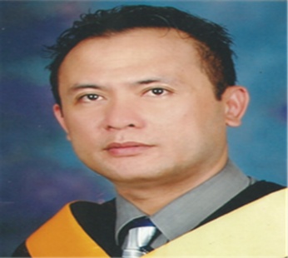
Romeo D. Lim, DBA
Contact: +63 9088819539 | Email: rowielab_2006@yahoo.com
Address: Lot 9 Block 5, Beegees St., Hillsdale Summit Subd., B. Francisco Avenue, Barangay San Isidro, Angono, Rizal
Mobile No. +63 09088819539
Current Employment Information
- Associate Professor IV - EARIST
- Chair – MBA Program, EARIST
- Chief of Internship-Local and International OJT
Office of International Affairs & Linkages Management Services - EARIST

Category: Oral Presentation
Presenter Category: Delegate
Name for the Certificate: Romeo D. Lim

Reason(s) to attend the conference - Please give a number 1 – 10 (1 is the highest priority and 8 is the lowest priority)

Reason | Priority
Publish my research paper in a journal or in the conference proceeding | 10
To build a professional network | 10
Finding a research partner | 8
Presenting my research to an International Audience | 10
To get feedbacks to my research findings | 8
Participate to workshops and other career development programs | 10
To meet internationally recognized resource persons (conference keynoters, chair etc.) | 10
Travel and have a fun | 8
Win awards and certificates | 8
Increase the knowledge about the field by listening to other presenters | 10
Other (Write your requirement) | N/A

