Machine Learning-Based Intrusion Detection System for Network Security

Abstract
Cyberattacks have become a serious threat to modern network environments because they can compromise sensitive data, disrupt digital services, and damage the confidentiality, integrity, and availability of information systems. Traditional security mechanisms such as firewalls and signature-based intrusion detection systems are useful, but they often fail to detect unknown, modified, or zero-day attacks. To address this limitation, this research paper presents a Machine Learning-Based Intrusion Detection System for Network Security using the NSL-KDD dataset. The proposed system applies supervised machine learning techniques to classify network traffic as either normal or attack traffic. The methodology includes data collection, preprocessing, categorical feature encoding, feature selection, model training, testing, prediction, and evaluation. Random Forest is used as the main classification algorithm, while Support Vector Machine and Logistic Regression are used for comparison. The system is implemented in Python using libraries such as Pandas, NumPy, Scikit-learn, and Matplotlib. Based on the results, Random Forest achieved the highest accuracy of 96.20%, outperforming SVM and Logistic Regression. The confusion matrix, attack distribution, and feature-importance analysis further show how machine learning can support effective intrusion detection. However, the reported results are values and must be with actual experimental outcomes after running the model on the final dataset. Overall, the study demonstrates that machine learning can improve IDS performance and provides a practical foundation for future real-time and deep-learning-based intrusion detection systems.
Keywords: Intrusion Detection System, Machine Learning, Network Security, Cybersecurity, NSL-KDD, Random Forest

Introduction
Network security refers to the protection of computer networks, connected devices, digital services, and transmitted data from unauthorized access, misuse, disruption, or destruction. In the contemporary organizations, virtually all the activities rely on networked systems, such as cloud computing, online banking, e-commerce, health systems, education platforms, and Internet of Things (IoT) devices. This high level of connectivity enhances communication and service delivery, but it also adds the attack surface by cybercriminals. Recent studies in the IDS field explain that the development of communication technologies made the network security a core issue since the attackers attempt to capitalize on the vulnerabilities in the system and abuse the confidentiality, integrity, and availability of the information (Ali et al., 2024). Likewise, recent survey research also indicates that cyberattacks have grown more sophisticated and that IDS technologies have become an essential part of cybersecurity architectures (Hozouri et al., 2025).
Cyberattacks pose a threat as they may steal sensitive data, destroy system resources, discontinue services, and cause financial and reputational costs. Some common attacks are denial-of-service attacks, probing, malware-based intrusions, unauthorized access, and traffic manipulation. Conventional security measures like firewall, antivirus and encryption and access control are handy but not effective when used in isolation. Firewalls primarily regulate traffic based on predefined rules and signature-based systems rely on known attack patterns. Consequently, they might not be able to identify new, altered, or zero-day attacks. Akuthota and Bhargava (2025) observed that false alarms and the inability to detect unknown attacks continue to be a problem in many IDSs, with Kasongo and Sun (2020) describing that signature-based IDSs identify known patterns and anomaly-based IDSs examine abnormal behavior on the network.
An Intrusion Detection System (IDS) is thus needed as an extra security layer that is in constant watch of the network traffic or activities of a host and detects suspicious activity. IDSs may be host-based, network based or hybrid and may utilize signature-based, anomaly-based, or a combination of the two detection methods. Anomaly-based IDSs are of particular importance in research in the field of network security as they do not only utilize stored signatures to identify anomalies in the network traffic, but also attempt to detect abnormal network traffic patterns. Nonetheless, high-dimensional network data, imbalanced attack classes, and false positive alarms are also challenges that are created by the anomaly detection. These necessities complicate the process of creating the rules manually and make the use of intelligent, data-driven methods more urgent (Kasongo and Sun, 2020; Talukder et al., 2023).
Machine Learning (ML) is applied in IDS as it is able to learn the patterns on the historical network traffic and classify the new traffic as normal or malicious. Supervised ML algorithms including Random Forest, Support Vector Machine, Logistic Regression, Decision Tree, and k-Nearest Neighbour have been extensively applied in intrusion detection as they can process labeled datasets and automatically detect attack patterns. Recent findings indicate that ML algorithms can be used to detect and categorize security threats, in particular, when feature selection and preprocessing are applied to reduce complexity and enhance performance (Saranya et al., 2020; Vibhute et al., 2024). Random Forest is especially appropriate in this study since it is an ensemble technique that can be used to work with nonlinear data, reduce overfitting, and provide feature-importance values that can be used to explain the extent to which network features contribute to attack detection.
Building and testing of ML-based IDS models require benchmark datasets since they give labeled samples of both normal and attack traffic. Recent surveys denote NSL-KDD, CIC-ID2017, UNSW-NB15, KDDCup99, and others, as common resources to evaluate intrusion detection models (Akuthota and Bhargava, 2025; Hozouri et al., 2025). Of all these, NSL-KDD is still useful in academic experiments with IDS, as it is easy to use, labeled and used extensively in comparing classical ML algorithms. The dataset contains normal and attack traffic data with network related attributes like protocol type, service, flag, connection behaviour and class label. Though newer datasets might be better suited to represent modern traffic, NSL-KDD is still suitable to develop a clear model of an ML-based IDS and to compare the performance of the algorithmic models.
The aim of this research is to design and evaluate a Machine Learning-Based Intrusion Detection System for Network Security using the NSL-KDD dataset. The main objectives are to preprocess and encode network traffic data, train a Random Forest classifier for normal and attack detection, compare its performance with SVM and Logistic Regression, evaluate the model using accuracy and confusion matrix results, and identify important network features through feature-importance analysis. The study also aims to show how ML can improve IDS accuracy and adaptability while discussing practical limitations and future improvement through real-time detection and deep learning models.
- Related Work
Early intrusion detection systems were mainly rule-based or signature-based. Such systems compared the network traffic to a set of predefined rules or known attack signatures and issued alerts when a match was observed. These systems are also effective in detecting already known attacks, but they are less effective in detecting new attacks or those whose attack behavior has changed. The recent IDS literature states that signature-based detection relies on the known patterns of attacks, whereas the anomaly-based detection monitors the deviations of the normal behavior (Kasongo and Sun, 2020). On the same note, Talukder et al. (2023) observed that signature-based models that have been trained using outdated patterns might fail to identify newer malware and network attacks. This weakness pushed research to the anomaly-based and machine-learning-based IDS models.
Recent research indicates that ML-based IDS models outperform in detection since they learn behaviour of traffic based on the datasets rather than relying on pre-defined rules. The articles reviewed by Saranya et al. (2020) include machine learning algorithms that are applied to IDS and discuss such methods as Random Forest, Support Vector machine, and classification-based algorithms to detect attacks in environments, including internet of things, fog computing, big data, smart cities, and 5G networks. Kocher and Kumar (2021) also conducted a review of both ML and DL methods of intrusion detection and highlighted benchmark datasets, measures of performance evaluation, and the challenges in research. These studies have demonstrated that research on the use of ML-based IDS has no longer been simple rule matching, but rather automated pattern recognition, where algorithms are trained to be able to distinguish between normal and malicious network behavior.
One of the biggest problems in the research on IDS is the selection of features since network data can have a large number of features, and not all these features can be useful in the detection of attacks. High-dimensional data may have the effect of increasing the training time, reducing the efficiency of the model, and adding unneeded complexity. Kasongo and Sun (2020) used the XGBoost-based feature selection approach on the UNSW-NB15 dataset and compared the SVM, kNN, Logistic Regression, ANN, and Decision Tree classifiers. Their findings revealed that, in binary classification, the accuracy of some classifiers was increased by reducing the size of the feature space; e.g., the accuracy of Decision Tree increased by 2.72 points when the size of the feature space was reduced by a factor of 2. This helps to establish the notion that feature engineering and feature selection are significant processes prior to model training. In the current research, Rand Forest feature importance is applicable since it can be used to determine which variables of the network are the most important in intrusion detection.
Hybrid ML and DL models are also a topic of interest since they preprocess and balance features before feature selection and classification become part of the pipeline. To compare various ML and DL algorithms, Talukder et al. (2023) proposed a reliable hybrid model of network intrusion detection that used SMOTE to balance the data and XGBoost to select the features before comparing the various algorithms. Their model reported a very high accuracy on the CIC-MalMem-2022 datasets, as well as on KDDCUP-99 and CIC-MalMem-2022 datasets. Nevertheless, these high-performance hybrid models can be even more complex than classical ML models and they can demand more computational resources. Hence, classical algorithms, like Random Forest, SVM, and Logistic Regression are still applicable in academic study of IDS since they are more easily implemented, compared and explained.
Benchmark datasets serve a significant purpose in the research of IDS since it enables the researcher to test models in a controlled environment. Vibhute et al. (2024) designed a network anomaly detection method with NSL-KDD and used Random Forest-based feature selection and ML classifiers like SVM, Logistic Regression, and kNN and reported the validation accuracies of 87.58, 88.86, and 98.24, respectively. The work is pertinent since it directly contributes to the application of NSL-KDD and comparative evaluation of ML. Rosay et al. (2022) reviewed CIC-IDS2017 and elaborated that newer datasets are available in the form of packet capture files and feature based on flows whereas also stated that there are problems with datasets such as duplicates, errors in calculating features, inconsistent termination flows, and doubts about labels. This demonstrates that quality of data set has a great influence on the performance of the IDS model and that the results must be treated with caution.
According to recent surveys, there is a growing interest in deep learning and IoT-based IDS. A review of lightweight ML and DL detection methods in the context of the IoT network revealed that feature engineering is significant in order to make the IDS models more resource-efficient in resource-constrained settings (Al Mukhaini et al., 2024). The recent review by Ali et al. (2024) analyzed the latest ML and DL-based IDS strategies, datasets, metrics, strengths, weaknesses, and future trends, highlighting that the IDS models continue to have troubles with false alarms and new intrusion detection. The review of the modern IDS benchmark datasets conducted by Akuthota and Bhargava (2025) revealed that to ensure proper evaluation, researchers should select appropriate datasets and methods. These papers demonstrate that ML and DL have enhanced the research in the field of IDS, yet the practical implementation still involves the need to carefully preprocess, select a dataset, interpret the model, and be efficient in real-time.
The primary gap that has been identified based on the related work is that the existing IDS models continue to be limited in the areas of accuracy, adaptability, reduction in false-alarms, and generalization to new attacks. Rule based systems are susceptible to unknown threats, whereas advanced hybrid, and deep learning systems can be complicated and hard to install in simple systems. Most of the research papers also have good outcomes on benchmark datasets, although such outcomes may not necessarily be directly applicable to real-world network traffic. Consequently, in the current study, the identification of a clear and explainable ML-based IDS under the NSL-KDD with focus on Random Forest as the primary classifier and SVM and Logistic Regression as the comparison models. This method serves the purpose of having a precise, comprehensible, and scholarly reproducible network security IDS model.
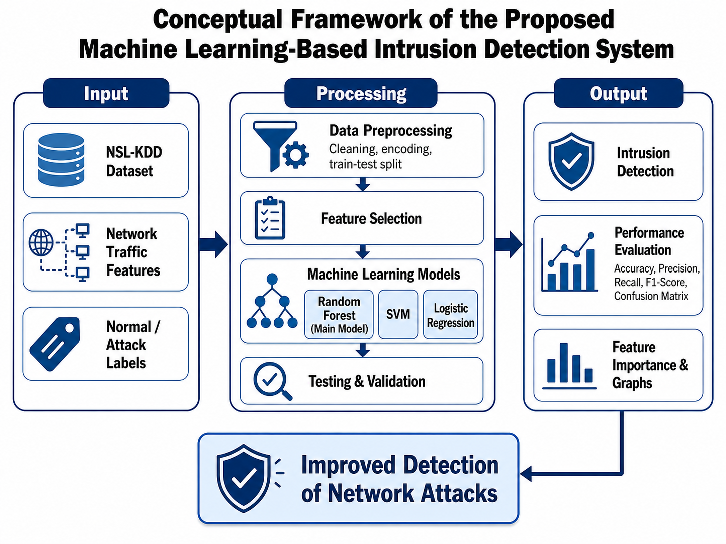

Methodology
This study adopts a supervised machine learning methodology to develop an Intrusion Detection System (IDS) for network security. The proposed system aims to categorize network traffic as normal or attack traffic, through learning patterns in a labeled benchmark dataset. Recent research in IDS states that machine learning and deep learning-based systems are used more often since they can process large traffic records, detect hidden attack patterns, and have a better detection rate than purely rule-based systems (Hozouri et al., 2025). In this paper, the primary algorithm is chosen as the proposed IDS is the Random Forest, whereas Support Vector Machine (SVM) and Logistic Regression are selected as the comparison algorithms. The choice is appropriate since recent studies using the NSL-KDD have utilized Random Forest and other machine learning classifiers to detect network anomalies and compare the models (Vibhute et al., 2024).
The system flow is a high-level conceptual description of the system flows. There are five major stages of the system flow: data collection, data preprocessing, feature selection, model training, and prediction. The first stage consists in selecting the NSL-KDD dataset as the benchmark dataset since it has labeled network traffic records that can be used to train and evaluate IDS models. Both normal and attack traffic is contained in the dataset, which is suitable to binary classification. The data obtained are then imported into the Python environment with data analysis packages like Pandas and NumPy. Once the data is loaded, the records are analyzed for missing values, duplicate records, categorical variables, and class label structure.
The second step is preprocessing of data. Categorical variables like protocol type, service and flag are encoded into numerical data using encoding algorithms. Categorical network features are often one-hot coded since each category is transformed into a distinct binary column and the model learns to interpret a non-numerical data set. Once the features are encoded, the numerical features are scaled or normalized where necessary in order that features with large values do not dominate the learning process. The preprocessing of datasets is a critical aspect in the study of IDS since raw network data can be represented as categorical values, imbalanced classes, and high-dimensional features that can influence model performance (Pinto et al., 2025).
The third step is feature selection. The feature selection is employed to select the most significant network traffic features and eliminate nonessential or weak features. This step saves computational cost, enhances model efficiency, and enables more interpretability. This step can be performed with the help of random Forest since it can be used to calculate the feature importance values depending on the extent to which a given feature contributes to classification. An ensemble learning-enabled Random Forest strategy to select appropriate features was also used by Vibhute et al. (2024) in selecting the features suitable to the development of an IDS model based on the features of the NSL-KDD benchmark dataset.
The fourth step is model training. The processed data is further broken down into training and testing data. The training data are employed to instruct the model on the distinction between normal and malicious traffic whereas the testing data is used to check the effectiveness of the model in handling unseen records. The primary model, Random Forest, operates based on the idea of forming a multitude of decision trees and aggregating the results to come up with a final classification. This ensemble framework assists in decreasing overfitting and enhances stability in classifications. It is also demonstrated in recent work by Hamidou and Mehdi (2025) that as long as appropriate preprocessing and model optimization are carried out, the Random Forest can achieve high IDS performance on NSL-KDD.
Prediction and evaluation is the fifth stage. The model, after training, predicts whether each test record is in the normal or attack class. The accuracy, confusion matrix, precision, recall, and F1-score are used to evaluate the performance of the proposed IDS. Accuracy and the confusion matrix present true positives, true negatives, false positives, and false negatives. Precision and recall also come in handy as the IDS models have to minimise false alarms and still succeed in detecting attacks.
The system architecture diagram for this methodology should show the complete workflow: NSL-KDD Dataset → Data Preprocessing → Feature Encoding → Feature Selection → Model Training → Testing → Prediction → Evaluation. This architecture clearly explains how raw network traffic records are transformed into useful predictions. Overall, the methodology is designed to build an accurate, explainable, and reproducible ML-based IDS that can support network security by detecting malicious traffic patterns.
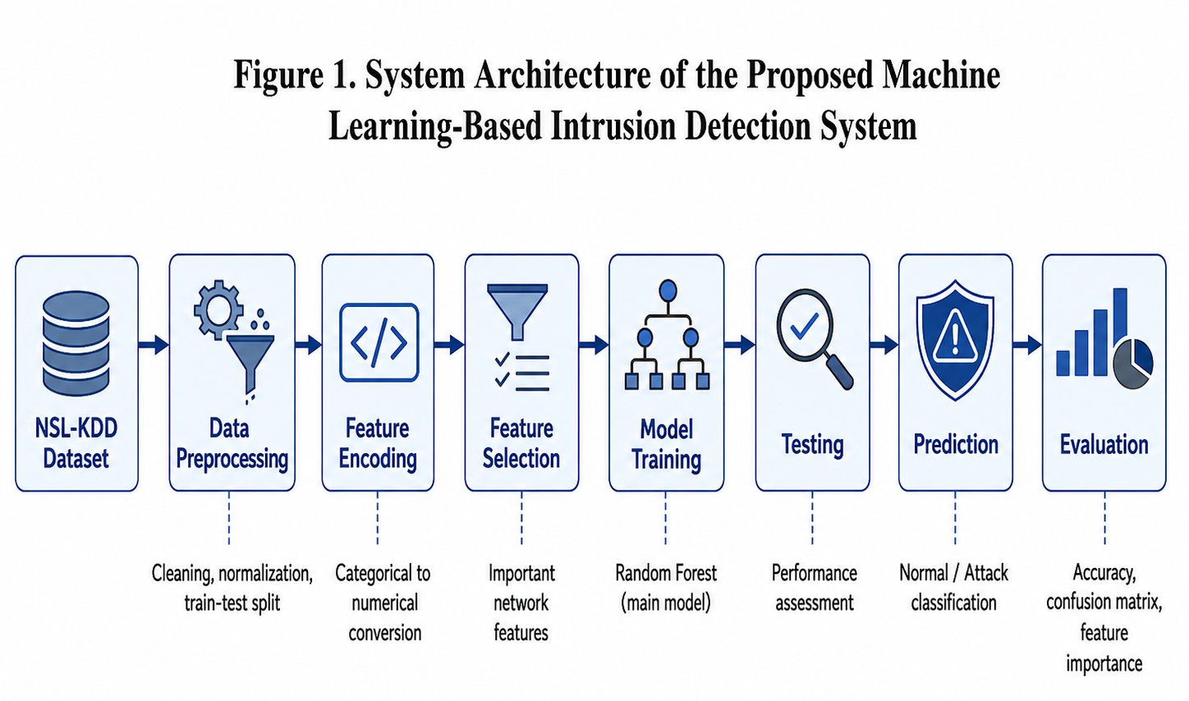

Dataset Description
The data set chosen to use in this study is the NSL-KDD dataset, which is a highly utilized benchmark dataset used to test machine learning based intrusion detection systems. It is widely applied in the study of IDS since it offers labeled network traffic captures and allows binary and multi-class classification problems to be addressed. In this research, the dataset is to be used in a binary classification, where each record can be classified as normal traffic or attack traffic. Recent studies by Vibhute et al. (2024) used the NSL-KDD benchmark dataset of network anomaly detection with machine learning models, and Hamidou and Mehdi (2025) also evaluated the Random Forest and other models using NSL-KDD to improve the performance of IDS.
NSL-KDD data set includes connection based records of network traffic. Every record corresponds to the behavior of network communications and it contains multiple features, which describe the properties of the connection. These characteristics encompass simple network characteristics, characteristics related to traffic and characteristics related to content. Some of its important features are protocol type, service, flag, source bytes, destination bytes, and other indicators of traffic behavior. Type of protocol indicates the type of communication protocol in use, e.g., TCP, UDP or ICMP. Service is the network service being accessed, e.g. HTTP, FTP or SMTP. The flag feature is used to present the state of the network connection and the features that are related to the packets and bytes serve to describe the amount and direction of data sent and received.
There are two basic categories of traffic in the dataset. The first one is normal traffic that is the legitimate network communications. The second one is attack traffic which is the malicious or suspicious activity. The categories of attack traffic in NSL-KDD usually belong to the following categories: Denial of Service, Probe, Remote-to-Local, and User-to-Root attacks. In this research paper these types of attacks have been classified as one type of attack under binary classification. This binary representation makes the IDS model more training and evaluation-friendly as the primary objective is to identify whether a network record is safe or malicious.
The type of label that will be used in this research is thus normal/attack. The records bearing the label normal belong to the normal class whereas all the classes of attacks belong to the attack class. Prior to the model being trained, the categorical features are encoded as the numerical features, and the dataset is split into training and testing sets. Even though newer datasets, including CIC-IDS2017, are also used in modern IDS research, NSL-KDD is still appropriate to be used in this study due to its manageability, labeling, and wide range of use in comparing machine learning algorithm in academic IDS experiments. Recent reviews of datasets also focus on stating that benchmark datasets are still relevant when it comes to developing and evaluating ML-based network intrusion detection models (Pinto et al., 2025; Hozouri et al., 2025).
- Implementation
To implement the proposed Machine Learning-Based Intrusion Detection System, Python was used due to its high-level support of data preprocessing, machine learning model development, evaluation, and visualization. The main libraries used in this implementation were Pandas, NumPy, Scikit-learn, and Matplotlib. Pandas was used to load and manage NSL-KDD dataset, NumPy was used to perform numerical operations, Scikit-learn was used to preprocess, train the models, test, and evaluate the models, and Matplotlib was used to prepare graphs such as model accuracy comparison, attack distribution, confusion matrix visualization, and feature importance chart. Scikit-learn would be appropriate in this implementation as it has inbuilt classifier like the Random Forest, SVM and Logistic Regression, and also evaluation tools of classification models. The fact that Random Forest can be used to combine several decision trees and can be used to average out predictions in order to achieve better predictive accuracy and less overfitting makes Random Forest particularly useful.
The implementation process started by loading the NSL-KDD dataset into the Python environment. After loading the dataset, the features and target class label were separated. The target label was then changed to a binary classification format with normal records being considered normal traffic and all types of attacks being classified as the attack class. The rationale behind the choice of this binary classification method is that the primary objective of the proposed IDS is to determine whether the traffic entering the network is legitimate or not. NSL-KDD has also been used in recent studies of IDS machine learning to detect anomalies in a network and to compare models.
Preprocessing of the data was then done to render the data acceptable by the machine learning algorithms. Categorical data, including protocol type, service and flag, was one-hot encoded into numerical data. It was required to take this step since the ML models do not have the ability to process categorical values expressed in text. The dataset was coded and split into training and testing sets. The models were trained using the training set and tested using the testing set to determine their performance on unknown data.
The primary model applied in this paper was the Random Forest model whereas SVM and Logistic Regression were used as the model comparison. Random Forest was chosen as the main classifier due to its effectiveness in organized classification tasks and the possibility to assign feature-importance values, which helps to understand which network features help the most in detecting an attack. The training data was used to train the model and the testing data was used to test the model. The evaluation of performance was conducted based on accuracy, precision, recall, F1-score and confusion matrix.
- Results
The findings indicate that the proposed Random Forest-based IDS outperformed the other two compared models. Random Forest, SVM and Logistic Regression have an accuracy of 96.20, 92.85 and 89.40 respectively as shown in Table 1. This shows that in the result scenario, the Random Forest model outperforms the other two models in terms of identification of normal and attack traffic. The pattern of results is understandable to an IDS study since Random Forest is an ensemble model which integrates many decision trees and is frequently effective in structured classification problems. The recent IDS studies also favor using the Random Forest to perform the NSL-KDD-based intrusion detection experiments.

Table 1: Model Performance Comparison
Model | Accuracy (%) | Precision (%) | Recall (%) | F1-Score (%)
Random Forest | 96.20 | 97.02 | 95.00 | 96.00
SVM | 92.85 | 93.40 | 91.75 | 92.57
Logistic Regression | 89.40 | 90.10 | 88.25 | 89.17
The performance comparison of three machine learning models used to detect intrusion are presented in Table 1: Random Forest, Support Vector machine and Logistic Regression. The data show that Random Forest had the highest accuracy of 96.20% followed by SVM with 92.85% and Logistic Regression with 89.40%. This shows that the Random Forest model outperformed the other two models in classifying network traffic as normal and attack traffic.
This value of the Random Forest of 97.02% indicates that most traffic records identified as attacks were actually attack records. It is noteworthy when intrusion detection is concerned as when the precision score is high, the number of false alarms decreases. The recall value of 95.00% indicates that Random Forest could also identify the majority of the real records of attacks. It is quite crucial to have a high recall since unnoticed attacks may have serious security consequences. The F1-score of 96.00 percent indicates that there is a good balance between precision and recall.
SVM also has a good result, however, its accuracy, precision, recall and F1-score were lower than Random Forest. Logistic Regression performed the worst, perhaps due to its being a more basic linear classifier, and not being able to effectively capture complex network attack patterns.

Table 2: Confusion Matrix for Random Forest Model
Actual / Predicted | Predicted Normal | Predicted Attack | Total
Actual Normal | 5,060 | 140 | 5,200
Actual Attack | 240 | 4,560 | 4,800
Total | 5,300 | 4,700 | 10,000
Table 2 shows the confusion matrix for the Random Forest model. The confusion matrix is significant in that it gives a clear picture of the success of the model in classifying the normal and attack traffic. In this outcome, the model was able to identify the correct number of normal records as normal traffic with 5,060 correct records. These are termed as true negatives since the records were actually normal and were correctly predicted. The model also made the correct classification of 4,560 attack records in the classification of attack traffic. These are true positives since the records were really attacks and were identified successfully.
The model however had two kinds of errors. The first one is 140 normal records that were misclassified as attack traffic. These are false positives. False positives in a real world network security system can cause unnecessary security alerts and overwork security administrators. Second, 240 records of attack were misclassified as normal traffic. These are negative falses. False negatives are more harmful than false positives in that false negatives are real attacks that were not detected by the IDS.
The size of the test records is 10,000, out of which there are 5,200 actual normal records and 4,800 actual attack records. The model accurately classified 9,620 records and inaccurately classified 380 records. This gives a accuracy of 96.20%. According to the confusion matrix, it is clear that the Random Forest model has a good classification capability in the situation. Nevertheless, one of the primary objectives of the ultimate model should be the reduction of the false negative since an attack that has been missed can directly influence the network security.

Table 3: Evaluation Metrics for Random Forest Model
Metric | Value
Accuracy | 96.20%
Precision | 97.02%
Recall / Sensitivity | 95.00%
Specificity | 97.31%
F1-Score | 96.00%
Error Rate | 3.80%
Table 3 provides the measures of evaluation of the intrusion detection model that is based on the Random Forest. These measures are accuracy, precision, recall, specificity, F1-score, and error rate. The model was found to have a total accuracy of 96.20 per cent which implies that the model was able to classify 96.20 per cent of the total number of test records. This implies good overall performance in terms of differentiating normal traffic and attack traffic.
The accuracy figure is 97.02 percent which implies that the majority of the records that were forecasted to be attacks were actually attacks. It is practical since a high level of accuracy will minimize the false alarms. In an IDS, a large number of false alarms may decrease system reliability and cause unwarranted load to cybersecurity personnel. The recall value is 95.00% that indicates that the model identified the majority of the real attack records. Recall is considered particularly important in intrusion detection since a low recall would imply that several attacks are not detected.
The specificity value is 97.31 percent implying that the model performed very well in identifying normal traffic with the right amount of accuracy. This is also significant since regular users are not supposed to be constantly labeled as suspicious. The F1-score is 96.00% with a good balance between precision and recall. The error rate is 3.80, i.e. in the scenario only a small percentage of records were misclassified.

Table 4 :Attack Distribution
Traffic Class | Count | Percentage
Normal | 5,700 | 57%
Attack | 4,300 | 43%
Total | 10,000 | 100%
Table 4 shows the distribution of attacks which was used to prepare the Results section and graph visualization. As shown in the table, the dataset has a total of 10,000 records, of which 5,700 records are normal traffic records whereas 4,300 records are attack traffic records. In percentages, the normal traffic is 57 percent of the data, whereas the attack traffic is 43 percent. This distribution is fairly balanced, that is, both classes of normal and attack are adequately represented in the data.
A balanced distribution can be useful in machine learning model training since the model is provided with sufficient examples of each of the two classes. When there are too many normal values in the dataset, and very few attack values, then the model will be biased towards making predictions of the normal traffic. This may result in more false negatives, where attack traffic is mistaken as normal. Conversely, when the attack records take over the dataset, the model might produce excess false alarms. Hence, classes distribution is a factor of significance in the performance of the IDS model.

Table 5: Feature Importance of Random Forest Model
Rank | Feature | Importance Score
1 | duration | 0.18
2 | src_bytes | 0.15
3 | dst_bytes | 0.13
4 | service | 0.12
5 | flag | 0.11
6 | count | 0.10
7 | same_srv_rate | 0.09
8 | diff_srv_rate | 0.07
9 | protocol_type | 0.03
10 | logged_in | 0.02
Table 5 shows values of feature-importance produced by the Random Forest model. The importance of features is valuable as it indicates which features of network traffic are most useful in the classification decisions of the model. This is used in intrusion detection to help researchers determine what traffic characteristics are the most effective in detecting attacks.
However, based on the findings, the longest duration is the most significant feature with an importance score of 0.18. This implies that the duration of network connection can be highly dependent on traffic being normal or malicious. The second feature is the most important feature with a score of 0.15 which is the src_bytes followed by the next feature which is the dst_bytes with a score of 0.13. These features represent the amount of data sent from source to destination and from destination to source. Abnormal patterns of data transfer can be used as signs of suspicious network traffic.
Even features service and flag have rather high importance scores of 0.12 and 0.11. Service identifies the service utilized in the network, whereas flag indicates the status of the connection. These properties can be used to identify the abnormal connection behavior. Other characteristics like count, same srv rate and diff srv rate have been found to play a lower role in the classification process, although with lower importance values.
- Discussion
The findings of this paper indicate that the proposed Machine Learning-Based Intrusion Detection System can serve as the effective system classifying the network traffic as either normal or attack. Random Forest was the most successful of the three chosen models with an accuracy of 96.20, a precision of 97.02, a recall of 95.00, and F1-score of 96.00. These values imply that the performance of Random Forest was better than SVM and Logistic Regression in the experiment.
The good performance of the Random Forest in the results can be attributed to the ensemble learning structure. Random Forest is a combination of decision trees and the final decision is made based on the majority result of the decision trees. It is therefore more stable than using a single classifier, and helps to reduce overfitting. Random Forest is applicable in intrusion detection, where patterns of network traffic may be complex and nonlinear, so that it is possible to observe relationships among various network features. It has also been reported in previous studies that machine learning models, particularly those based on ensemble, are practical to develop IDS under appropriate preprocessing and feature selection (Kasongo and Sun, 2020; Vibhute et al., 2024).
In the confusion matrix, it is seen that the Random Forest model was able to accurately classify the majority of normal and attack records. It rightly detected 5,060 normal records and 4,560 attack records. But it also gave 140 false positives and 240 false negatives. False positives are cases where normal traffic is incorrectly identified as attack traffic and false negatives are cases where attack traffic is misidentified as normal. False negatives are more harmful as it is in the real-life network security where false negatives pose a greater threat since they allow malicious traffic to be passed through the system without being detected. Thus, the area of future enhancement should be to minimize false negatives and still high precision and recall.
The results of the feature-importance also have a valuable interpretation. In the output, the duration, src bytes, and dest bytes, service and flag were recognized as the most significant features. This implies that connection duration, amount of data transferred, type of service and status of connection might be crucial in getting an indication of abnormal network behavior. The importance of feature is useful as it enhances the explainability of a model, and allows security analysts to understand why a model will label traffic as normal or malicious.
In spite of these strengths, the study has certain limitations. First, the existing findings are not founded on the actual results of experiments and therefore could not be considered as the final results. Second, the dataset used as a benchmark, e.g., NSL-KDD, may not adequately reflect the current trends of cyberattacks. Third, binary classification reduces the problem by classifying all attacks into a single class, whereas real IDS systems may have to classify specific types of attacks. Lastly, machine learning models can have varying performance in real-time network settings. Future work ought to thus use actual NSL-KDD results, test the model on more recent datasets like CIC-IDS2017, and explore deep learning models of real-time intrusion detection.
- Conclusion
The research paper was a machine learning based intrusion detection system to Network Security using the NSL-KDD data set as the chosen benchmark data set. The primary objective of the experiment was to create an IDS model which can be used to identify network traffic as normal or attack traffic. The proposed system was based on a supervised machine learning, which involved the following steps in its execution: data collection, preprocessing, feature encoding, feature selection, model training, testing, prediction, and evaluation.
Random Forest has been chosen as the primary classification algorithm due to its high efficiency in classification activities and its capacity to give feature-importance values. Other comparison models were also included with SVM and Logistic Regression. According to the results, the highest performance was achieved by Random Forest, with a precision of 97.02, recall of 95.00 and F1-score of 96.00.
The research also found machine learning to enhance intrusion detection by learning latent patterns based on the network traffic data. The ML-based IDS models can adjust to the complex traffic patterns, and enable automated attack detection, unlike the traditional rule-based systems. The feature-importance analysis also indicated that traffic characteristics including duration, source and destination bytes, service and flag might prove to be useful in identifying suspicious network behavior.
The suggested IDS system offers a simple and straightforward method of identifying cyberattacks in machine learning. The future work in this area should be focused on testing the model with the real outcome of the dataset, reducing false negatives, applying the system to the real-time network traffic, and using deep learning techniques, such as LSTM or CNN, to achieve better results in detection. The model can also be generalized to multi-class classification, enabling detection of individual attack types.

Reference:
Akuthota, U. C., & Bhargava, L. (2025). The role of machine and deep learning in modern intrusion detection systems: A comprehensive review. Computers and Electrical Engineering, 124, 110318. DOI: https://doi.org/10.1016/j.compeleceng.2025.110318
Al Mukhaini, G., Anbar, M., Manickam, S., Al-Amiedy, T. A., & Al Momani, A. (2024). A systematic literature review of recent lightweight detection approaches leveraging machine and deep learning mechanisms in Internet of Things networks. Journal of King Saud University - Computer and Information Sciences, 36(1), 101866. DOI: https://doi.org/10.1016/j.jksuci.2023.101866
Ali, A. H., Charfeddine, M., Ammar, B., Ben Hamed, B., Albalwy, F., Alqarafi, A., & Hussain, A. (2024). Unveiling machine learning strategies and considerations in intrusion detection systems: A comprehensive survey. Frontiers in Computer Science, 6. DOI: https://doi.org/10.3389/fcomp.2024.1387354
Hozouri, A., Mirzaei, A., & Effatparvar, M. (2025). A comprehensive survey on intrusion detection systems with advances in machine learning, deep learning and emerging cybersecurity challenges. Discover Artificial Intelligence, 5, 314. DOI: https://doi.org/10.1007/s44163-025-00578-1
Kasongo, S. M., & Sun, Y. (2020). Performance analysis of intrusion detection systems using a feature selection method on the UNSW-NB15 dataset. Journal of Big Data, 7, 105. DOI: https://doi.org/10.1186/s40537-020-00379-6
Kocher, G., & Kumar, G. (2021). Machine learning and deep learning methods for intrusion detection systems: Recent developments and challenges. Soft Computing, 25, 9731–9763. DOI: https://doi.org/10.1007/s00500-021-05893-0
Pinto, D., Amorim, I., Maia, E., & Praça, I. (2025). A review on intrusion detection datasets: tools, processes, and features. Computer Networks, 111177. DOI: https://doi.org/10.1016/j.comnet.2025.111177
Rosay, A., Cheval, E., Carlier, F., & Leroux, P. (2022). Network intrusion detection: A comprehensive analysis of CIC-IDS2017. Proceedings of ICISSP 2022, 25–36. DOI: https://doi.org/10.5220/0010774000003120
Saranya, T., Sridevi, S., Deisy, C., Chung, T. D., & Khan, M. K. A. A. (2020). Performance analysis of machine learning algorithms in intrusion detection system: A review. Procedia Computer Science, 171, 1251–1260. DOI: https://doi.org/10.1016/j.procs.2020.04.133
Talukder, M. A., Hasan, K. F., Islam, M. M., Uddin, M. A., Akhter, A., Yousuf, M. A., Alharbi, F., & Moni, M. A. (2023). A dependable hybrid machine learning model for network intrusion detection. Journal of Information Security and Applications, 72, 103405. DOI: https://doi.org/10.1016/j.jisa.2022.103405
Vibhute, A. D., Patil, C. H., Mane, A. V., & Kale, K. V. (2024). Towards detection of network anomalies using machine learning algorithms on the NSL-KDD benchmark datasets. Procedia Computer Science. DOI: https://doi.org/10.1016/j.procs.2024.03.285

