A STUDY AN IMPACT OF 3D DESIGN, DISCIPLINE, DYNAMIC INVOLVEMENT: THE DYNAMIC INTERACTION OF CLASSROOM SEATING ARRANGEMENTS AND ITS ROLE IN PROMOTING EFFECTIVE DEMOCRATIC LEARNING

Authors: Sathish Kumar K, Guhan S, Milind Mallikarjun Kawachale
Bengaluru North University
Master of Business Administration (MBA)
Patel Institute of Science and Management (PISM)
Bengaluru, India
ABSTRACT
In this study, comparisons will be made between graduate students' reactions to semicircle seating and row seating, and an exploration will be made of the implications of each seating arrangement for participation, engagement, and democratic learning. This study will apply an evaluation of learning based on a 3D learning model that includes design, discipline, and participation. The primary data was collected from postgraduate students using a structured Google Forms survey. The research was descriptive in nature and centered on the meanings, experiences, and preferences of students in relation to seating arrangement configurations. In the questionnaire, students were asked questions concerning visibility of the teacher, interaction with other students, opportunity to speak with other students, degree of comfort to share ideas, and opportunity to work with other people. Most postgraduates reported a semicircular configuration of seating to be preferred to the conventional row setting. They indicated an improvement in the view of both the teacher and teaching aids, and thus understanding of a discussion topic was facilitated. Semi-circle seating made students talk more easily. It sparked more class discussion and made the room feel inclusive. It felt more democratic, one student said, and several others also said they now were more comfortable sharing their own thoughts in lectures and even classes. Some students mentioned limited classroom space for larger groups, yet they still preferred semi-circle seating. Participants said strong engagement and interaction outweighed the study’s limits. The study links semi-circle seating for postgraduates to stronger engagement, more participation, and better group learning. In grad seminars, flexible seating helps students join talks and decisions as equals. It helps instructors choose methods that boost participation and learning.
Keywords: seating arrangement, semi-circle seating, postgraduate students, classroom engagement.
INTRODUCTION
The classroom setting is one of the most important determining factors of effective learning and teaching since it directly impacts students’ engagement, interaction, motivation, and learning outcomes. In institutions of higher learning, particularly at the postgraduate level, learning becomes more than just the passive reception of information. It becomes active engagement with the learning process through class participation, group work, discussions, and collaborative undertakings.
Though classroom design and lesson plan designs have long attracted much attention in most learning research undertakings, the layout of the classroom class seat arrangement has not attracted much attention in spite of its profound impacts on learning behavior.
Seating arrangement is an essential element in the design and setup of a classroom, influencing communication patterns, socialization, and the power and authority structure in the teaching and learning environment. The classical design and arrangement in the classroom, characterized by students sitting in a straight line facing the teacher, has for a long time been created to promote teacher-cantered teaching and the lecture method as a teaching approach. This setup is greatly effective for controlling a classroom and the effective transfer of information, but not so for students to interact with one another in the classroom, as students in the classroom communicate in a one-way traffic flow without the capability for student-peer communication.
On the flip side, however, there are teachers who are embracing different seating arrangements in class in order to create an interactive and class cantered environment. In college classrooms specifically, semi-circular seating arrangements are commonly applied. This is based on the fact that semi-circular seating allows students to view one another in class in addition to viewing the lecturer. This particular seating arrangement reduces both physical and psychological barriers between different students in class. This culture in class encourages students to participate in class sessions frequently and voice their opinions freely.
Rearranging seating is of more importance in postgraduate and management classes, like MBA, wherein not only conceptual understanding but also skills related to management, leadership, decision-making, team working, and communication skills have been made part of the objectives. This requires different teaching strategies, including case study, class discussions, lecturing, and problem-solving exercises, wherein higher levels of interactions among students are required. In this context, conventional row seating could obstruct learning objectives, whereas semi-circle seating arrangement could be more helpful with respect to teaching objectives.
Class seating arrangements also play an important role in democratization learning in the class. The strategies used in democratic learning involve a lot of stress on equality, shared responsibility, and mutual respect. A democratic classroom setup that reduces hierarchical aspects and enables a high degree of communication also helps in democratic involvement to a huge extent. The semi-circle seating arrangement in the classroom is one such strategy that enables equal opportunities to be in the spotlight.
This research attempts to explore the perceptions of postgraduate students towards semi-circle seating systems and traditional row seating systems. The study intends to address and understand the impact of various seating systems on learning parameters such as visibility, interaction, confidence, engagement, comfort, and democratic participation. For the purpose of carrying out the study, data was collected using the structured questionnaire administered to postgraduate students via Google Forms. The research intends to explore the perceptions of postgraduate students toward various classroom seating systems.
The paper is anchored within a 3D learning model that focuses on the three folds of Design, Discipline, and Participation that interact with each other. This model focuses on how classroom design can affect students in terms of discipline, attention, and desire to participate in any learning session. By this process, this research attempts to measure the degree to which classroom seating can affect a learning process.
Through the examination of the seat arrangement-learning experience association for postgraduate students, the study seeks to make its contribution to existing research concerning seat arrangements and learning. Existing studies discuss seating arrangements and engagement, but limited empirical research applies the 3D learning model (Design, Discipline, Dynamic Involvement) to compare semi-circular and row seating specifically among postgraduate MBA students in promoting democratic, student-led learning. The expected outcomes will provide significant insights and practical application for all stakeholders, especially learning institutions and lecturers dealing with MBAs and postgraduates, considering the essence of participatory learning for students’ success at the postgraduate level. Through the research, the need for the consideration of seat arrangement as an important learning strategy for enhancing learning outcomes is established.
OBJECTIVES OF THE STUDY
- To look at how the seaters set up in a classroom based on the 3D learning Model which is about Design, Discipline and Dynamic Involvement. This is to see how the way a classroom is physically set up affects the way students learn and pay attention.

- To compare semi-circular seating and traditional row seating in terms of their effectiveness to support collaborative learning and group discussions, as well as inclusive classroom environments at a postgraduate level.
SCOPE OF THE STUDY
The scope of the study defines the boundaries within which the research has been conducted. The scope of this research involves:
- The study concentrates particularly on these two types of seating: Semi-circle seating, Traditional row seating.

- It has a descriptive type of research design. This design targets the opinions of the students.
Despite the limitations in such areas as the capacity of the classroom and the seating capacity, the extent of the research shows the important role of flexible seating in enhancing participation and democratic learning in postgraduate students.
LITERATURE REVIEW
Haghighi, M. M., & Jusan, M. M. (2012). Reviewed studies on seating configuration in the classroom setting and proved the impact of seating configurations on students' interaction and performance. They concluded that integrating cultural factors through the Means–End Chain model can strengthen classroom design, align seating with student values, and enhance effective learning environments.
Astuti, K. W., Suarnajaya, I. W., & Suputra, P. E. D. (2020). In some conventional row-seating classrooms, eighth-graders feel comfortable, they have flexibility and peers with whom to collaborate, but the price they pay is they cannot concentrate or participate well and there's limited interaction between teacher and student. The findings show the seating arrangement is significant in determining the amount of learning the students will do and needs to be done in consideration of the teaching goal.
Camacho, M. (2024). Examined the effects of rows, groups, and semicircle seating on elementary students’ on-task behavior and disruption. The effect of semicircle-seated group arrangement is strong and positive to better on task, less likely to distract but the group seating arrangements have no or minimal effect with lower quality of student’s work accuracy and completion.
HYPOTHESIS OF THE STUDY
H1:
The seating arrangement of the classrooms makes difference in the effectiveness of the learning of the postgraduate students in terms of the 3D learning model: Design, Discipline, and Dynamic Involvement.
H2:
Postgraduate students seated in a semi-circular arrangement demonstrate significantly higher levels of interaction and peer communication compared to those seated in traditional row-based configurations. The semi-circle layout facilitates better eye contact, encourages active participation, and promotes collaborative discussion, thereby enhancing overall classroom engagement.
RESEARCH METHODOLOGY
This research adopted a descriptive research design to examine the impact of classroom seating arrangements on postgraduate students’ learning experiences. The study was conducted in a natural classroom setting among MBA students, as participatory and discussion-based learning is central to management education. A sample size of 96 was selected, comprising postgraduate students. For primary data collection, the researcher has used a structured online questionnaire with the help of Google Forms. This questionnaire reflects the perceptions of students related to visibility, interaction, comfort, confidence, and participation for different seating arrangements. The collected data was analyzed using descriptive analysis to interpret students’ preferences and experiences related to democratic and student-centered learning.

DATA ANALYSIS AND INTERPRETATION
The data were obtained through a structured questionnaire using Google Forms and collected from 96 postgraduate students pursuing an MBA degree. According to this study, students exhibited positive feedback regarding their choice of seating. The students believed they could see their teacher and teaching aids, their interaction among themselves, and their opportunity to express their opinions while seated in a semi-circular fashion, making them more dynamic. Furthermore, the seating pattern also exuded democracy by breaking the hierarchical cycle. Despite the limited available space, students preferred interaction. Thus, it is deemed appropriate to conclude the following: seating patterns play a significant influence on learning behaviors of postgraduate students.

Figure 1. Would you prefer the Semi circle seating arrangement over traditional rows?
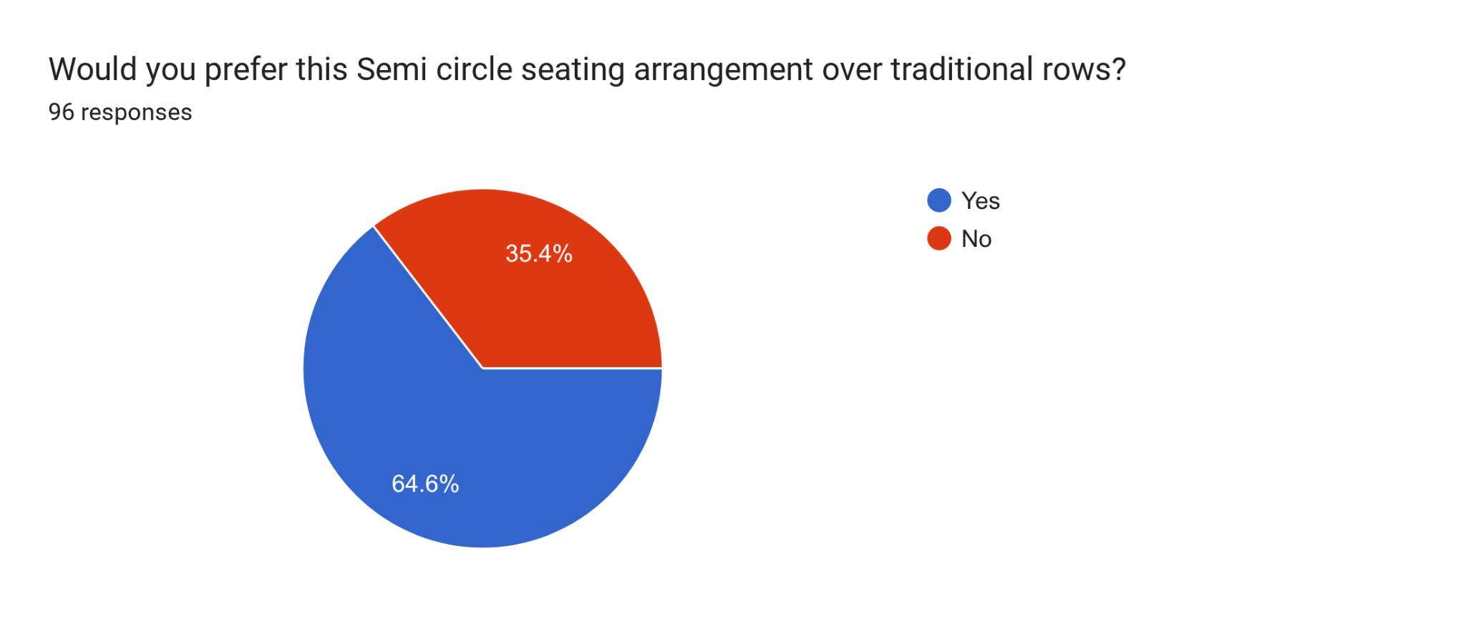

Table 1. Would you prefer the Semi circle seating arrangement over traditional rows?
Sl. No. | Description | Responses | Percentage
1 | Semicircle seating arrangement | 62 | 64.6
2 | Favored linear seating | 34 | 35.4
Total |  | 96 | 100
The above figure 1 and table 1. Out of 96 people 64.6% liked the semicircle seating arrangement while 35.4% liked the favored linear seating arrangement. This shows that semicircle seating arrangement works better for comfort, interaction and student engagement, in the classroom.
Figure 2. Does your classroom seating arrangement allow clear visibility of the teacher?
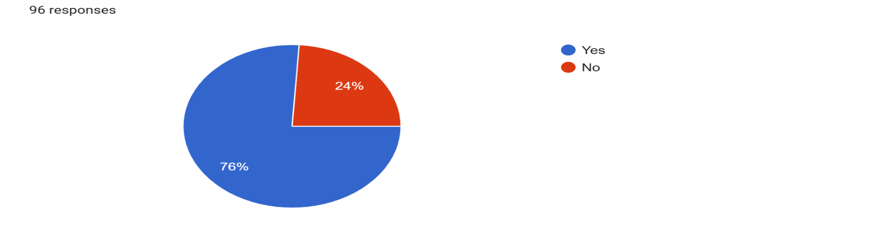
Table 2. Does your classroom seating arrangement allow clear visibility of the teacher?
Sl. No. | Description | Responses | Percentage
1 | Clear Visibility | 73 | 76
2 | Visibility Issues | 23 | 24
Total |  | 96 | 100
The above figure 2 and table 2 clearly indicate that 76% of students have clear visibility of the teacher. However, there are 24% who face issues of visibility as they seat in class.
Figure 3. you more likely to share your opinions in the current seating setup
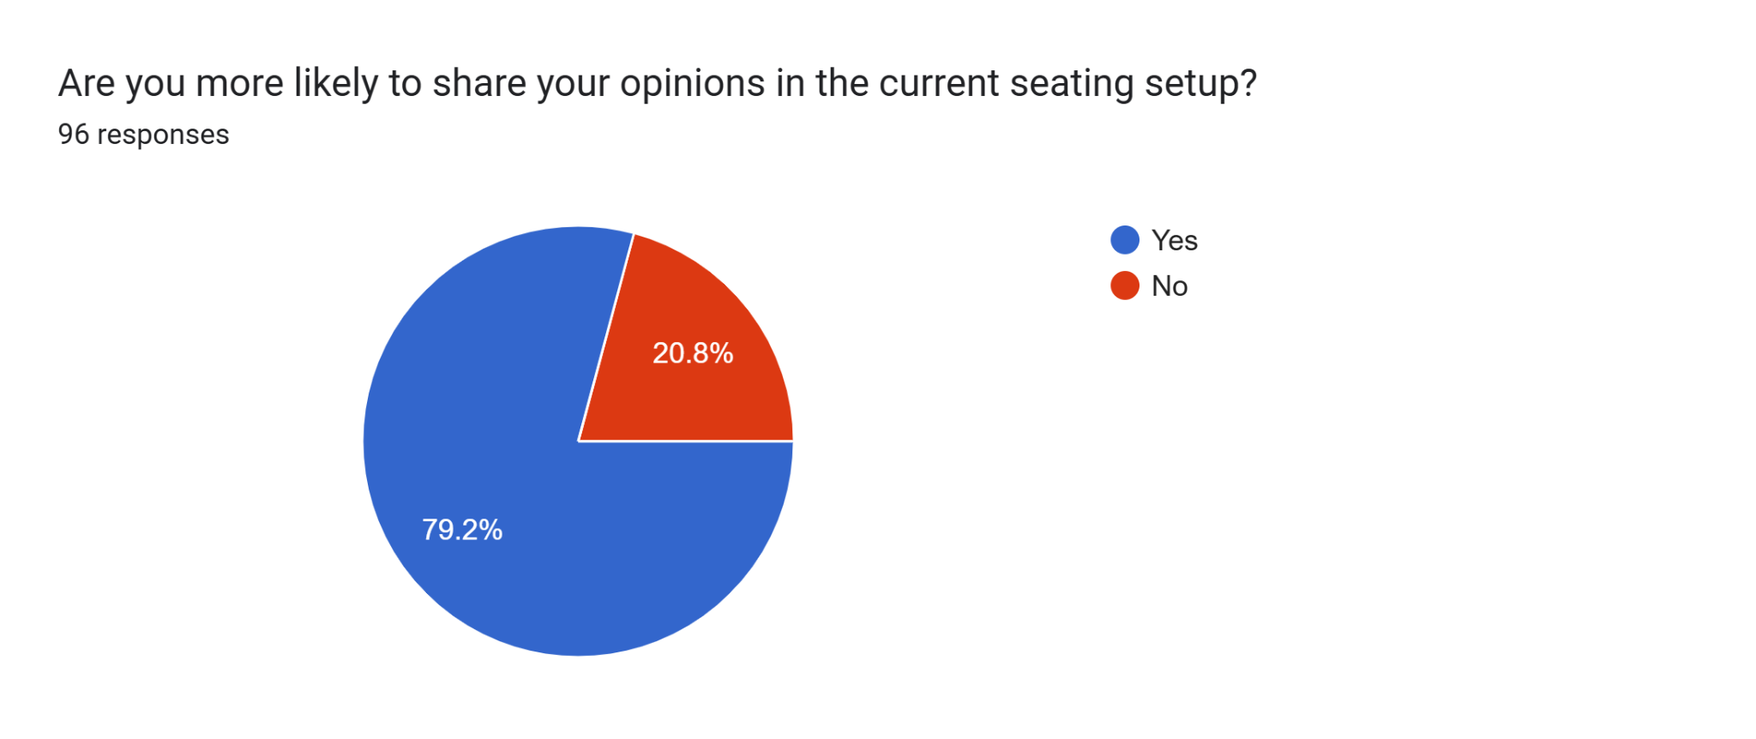

Table 3. Are you more likely to share your opinions in the current seating setup?
Sl. No. | Description | Responses | Percentage
1 | Likely to share their opinions | 76 | 79.2
2 | Not likely to share their opinions | 20 | 20.8
Total |  | 96 | 100
From the figure 3 and table 3 presented, it is quite evident that while 79.2% of participants are more likely to share their opinions under the seating arrangement, 20.8% do not, and the only conclusion to derive from the above mentioned percentages is that the seating arrangement is quite conducive to the free expression of opinions among the students of the classroom to a certain extent.
FINDINGS
• The 3D learning model (Design, Discipline, Dynamic Involvement) was positively supported by semi-circle seating arrangements.
• Semi-circular seating arrangement is more effective in encouraging classroom interactions when compared with row seating arrangement in accommodating postgraduate students.
• Traditional row seating was found to support control and structure but limited peer interaction and student-led engagement.
SUGGESTIONS
• Classroom design as can be implemented by considering the 3D learning model, focusing on physical design, student discipline, and dynamic involvement.
• Institutions can also use modular or movable furniture to address the constraints of space.
• A larger sample and comparisons across different institutions can be part of future research.
CONCLUSION
The present study shows particular attention to the role of classroom seating arrangements for the learning experiences of postgraduate students. Through employing the 3D learning model of design, discipline, and dynamic involvement, the present study demonstrated the positive impact of semi-circular seating arrangements on peer interactions, engagements, and learning. The findings show that semi-circular arrangements improve visibility, confidence, peer interaction, and discussion key elements of postgraduate and management education. Although space constraints were noted, students valued the learning environment created by this layout. Although much literature is available on the topic of seating and engaging the class, there is a scarcity of empirical research on the comparison between semi-circle and rows of seats on postgraduate MBA students based on the 3D model, highlighting the need for this study. In order to increase the study’s generalizability, research could be conducted on a larger sample group or could involve cross-institutional data. The outcome of this research confirmed that the aspect of classroom design, as it relates to seating, does contribute to the formation of an effective, democratic, student-centered concept of postgraduate learning.
REFERENCES
- Haghighi, M. M., & Jusan, M. M. (2012). Exploring Students Behavior on Seating Arrangements in Learning Environment: A Review, 36, 287 - 294.

- Astuti, K. W., Suarnajaya, I. W., & Suputra, P. E. D. (2020). A case study of the seating arrangement of the eighth grade students, 4(2), 81-94.

- Camacho, M. (2024). Take a Seat: The Impact of Three Classroom Seating Arrangements on Individual Student Performance, 8, 1-55.

