A Study on Work-Life Balance of Employees Working in Malls at Metro City Mall

Abstract The rapid expansion of the mall culture in India has transformed the retail landscape, creating significant employment opportunities while simultaneously introducing unique workplace stressors. This study utilizes a descriptive research design to examine the work-life balance (WLB) of 106 mall employees at "Metro City Mall". By analyzing socio-economic profiles and psychological pressures such as shift work, sales targets, and emotional labor, the research identifies a fragile but moderately positive balance. Findings indicate that while management support is perceived positively by 59.5% of staff, structural issues like "boundary erosion" and long shifts remain significant barriers.

1. Introduction

1.1 Overview and Context
The retail industry has undergone a paradigm shift driven by globalization, urbanization, and changing consumer lifestyles. Shopping malls have emerged as integrated commercial hubs that combine retail, entertainment, and services under one roof. In India, cities like Mumbai, Delhi, and Bangalore have spearheaded this expansion. While malls drive economic growth, they demand a high-performance workforce that must navigate irregular schedules and constant customer interaction. Maintaining a healthy WLB is now one of the most critical challenges for these retail professionals.

1.2 Concept and Evolution of WLB
Work-life balance is defined as the effective management of professional duties alongside personal, family, and social obligations. It is not merely an equal division of time but the achievement of harmony and satisfaction in both domains. Historically, the concept evolved from the integrated home-based activities of the pre-industrial era to the rigid factory systems of the Industrial Revolution, which created clear physical and temporal separations between work and life. In the late 20th century, the rise of service industries and dual-income households brought WLB to the forefront of organizational psychology. Today, the "boundary erosion" caused by constant digital connectivity has redefined the debate, making it a strategic necessity rather than an optional benefit.

2. Research Methodology

2.1 Research Design
This study employs a descriptive research design, acting as a blueprint to document the current state of WLB without manipulating variables. This design is ideal for identifying trends and patterns as they naturally occur in the retail environment.

2.2 Nature of the Study and Data Sources
The research adopts a mixed-method approach, combining quantitative numerical analysis with qualitative descriptive insights.
- Primary Data: Collected via structured questionnaires using a 5-point Likert scale and informal interviews with employees at "Metro City Mall".

- Secondary Data: Sourced from existing literature, academic journals, and theoretical frameworks from scholars like Greenhaus and Allen.

2.3 Population and Sampling
The study's population includes a diverse range of roles: sales staff, cashiers, supervisors, security personnel, and housekeeping. A sample of 100+ participants was analyzed to ensure representative findings across the mall's functional departments.

3. Literature Review and Theoretical Framework

3.1 Key Theoretical Models
- Greenhaus & Allen Model (2011): Emphasizes three dimensions: time balance, involvement balance, and satisfaction balance. For mall employees, time balance is often the most compromised due to weekend and festive shifts.
- Clark’s Border Theory (2000): Suggests individuals navigate "borders" between work and family. In malls, while physical borders are clear, temporal borders are weak, leading to high "border permeability" where work stress spills into home life.
- Emotional Labor Theory (Grandey, 2003): Explains the stress caused by the requirement to display positive emotions regardless of internal feelings, a constant demand in retail roles.

4. Detailed Data Analysis and Findings

4.1 Socio-Economic and Demographic Profile
The data analysis reveals a workforce characterized by youth and moderate educational attainment:
- Age: The majority are young, with 53.3% aged 18–24 and 24.8% aged 26–35. This reflects retail's status as an entry-level sector for fresh graduates.
- Gender: A near-equal split with 53.3% female and 46.7% male.
- Education: High literacy rates, with 46.7% undergraduates and 31.4% postgraduates.
- Tenure: Most respondents (75.7%) are relatively new, with less than 3 years of experience in their current roles.
Figure 1: Age Distribution
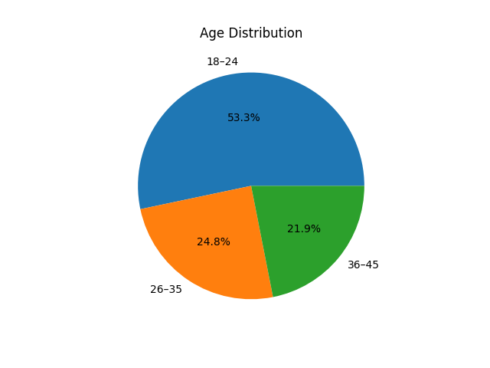
The workforce is predominantly young, indicating early career workforce exposure to stress.
Figure 2: Educational Qualification
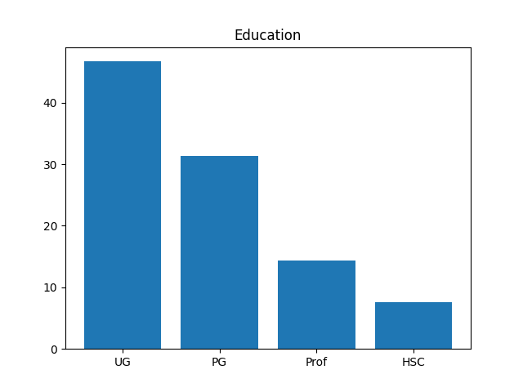
Employees show relatively high educational attainment.
Figure 3: Shift Work Distribution
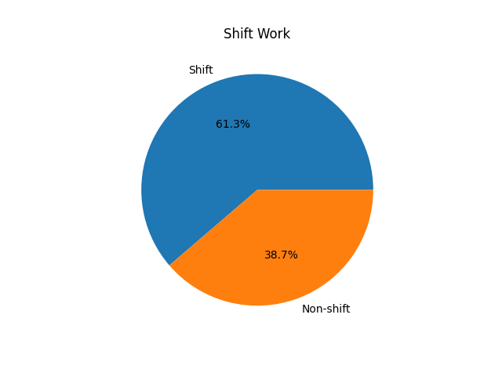
Majority employees work in shifts, impacting routine stability.

4.2 Workplace Stressors and Impact
The study quantified several critical factors affecting employee well-being:
- Routine Disruption: 62.9% of respondents explicitly stated that work factors interfere with their personal routines.
- Health and Fatigue: 43.3% of employees agreed that their job negatively affects their physical and mental health. Physical fatigue from long hours of standing is a primary contributor.
- Performance Pressure: Stress is intensified by the constant monitoring of sales targets and the use of real-time digital tracking systems.
- Emotional Exhaustion: The social demand to be "always on" and polite to difficult customers contributes significantly to burnout.
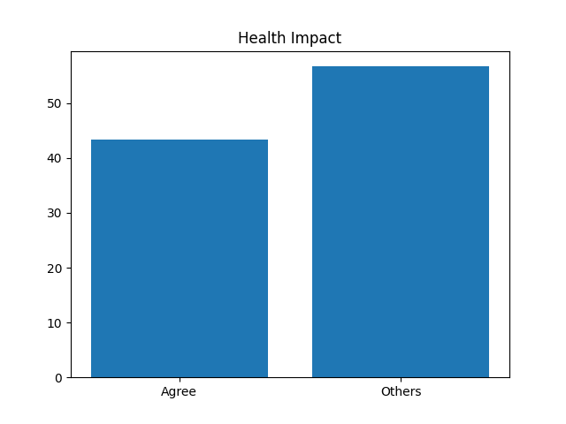

4.3 Support Systems and Aspirations
- Supervisory Support: A positive finding was that 59.5% of employees feel their management is understanding of their personal responsibilities.
- Desire for Flexibility: 62.3% of the workforce expressed a strong preference for flexible working hours as a solution to WLB issues.

5. Discussion: The Post-Pandemic Retail Environment
The COVID-19 pandemic added layers of complexity to mall work. Lockdown-induced job insecurity and the subsequent introduction of strict health protocols (temperature checks, sanitization) increased psychological stress. Post-pandemic, the rise of hybrid retail models—integrating online and offline sales—has added new responsibilities and uncertainties for frontline staff.

6. Conclusion and Strategic Recommendations

6.1 Conclusion
The study concludes that while mall employees strive for balance, the inherent structure of the retail industry—long hours, weekend work, and performance-based pressure—creates significant work-life conflict. The balance is currently "moderately positive" but remains highly susceptible to burnout.

6.2 Recommendations for Organizations
- Flexible Scheduling: Implementing rotational shifts and respecting weekend rest to reduce time-based conflict.
- Wellness Initiatives: Providing health check-ups and counseling to address the physical and mental toll of retail work.
- Gender-Sensitive Policies: Addressing safety concerns for late shifts and providing support for employees with caregiving responsibilities.
- Technological Management: Using technology to enhance efficiency without allowing it to encroach on employee's private time.

7. References
- Ali, S. I., & Sarkar, A. K. (2025). A study on work–life balance among employees working in malls: A case study of shopping malls in the Bareilly region.
- Clark, S. C. (2000). Work/Family Border Theory: A New Theory of Work/Family Balance.
- Greenhaus, J. H., & Allen, T. D. (2011). Work-Family Balance.
- Maslach, C., & Leiter, M. P. (2008). Burnout theory and practice
- Parasuraman, S., & Simmers, C. A. (2001). Type of Employment, Work–Family Conflict and Well‐Being.
- Kalleberg, A. L. (2011). Good Jobs, Bad Jobs: The Rise of Polarized and Precarious Employment Systems in the United States, 1970s to 2000s.
- Russell Sage Foundation. (Contextualizes the "job insecurity" reported by your respondents in organized retail).
- Hochschild, A. R. (1983). The Managed Heart: Commercialization of Human Feeling. University of California Press.

