A NEW WORLD ON ANOTHER PLANET: HUMAN SETTLEMENT AND ARCHITECTURAL DESIGN ON MARS WITH ARTIFICIAL INTELLIGENCE
*Serdar KASAP¹, Gizem SERİ YEŞİL²
1. Associate Professor, Faculty of Fine Arts and Design, Bilecik Şeyh Edebali University, Bilecik, Türkiye, serdar.kasap@bilecik.edu.tr, 0000-0002-7847-3284
2. M.Sc. Architect, Philadelphia, United States, gizem.serii@gmail.com, 0000-0002-4226-7024
*Corresponding author: serdar.kasap@bilecik.edu.tr

ABSTRACT
Exploration of living possibilities on different planets, such as the Moon and Mars, has become one of the primary focuses of current scientific and technological research. Humanity's quest to understand the universe, combined with the desire to explore the limits of nature, encourages the development of new approaches that could make life in space possible. In this context, a detailed examination of the physical and chemical properties of planets, an analysis of atmospheric conditions, and the design of sustainable life support systems are among the fundamental elements of these studies.
Space missions, continuously conducted since the 1950s, have deepened humanity's knowledge of the universe, marking significant milestones in the exploration processes of this field. Initially limited to the exploration of Earth's orbit and the goal of reaching the Moon, these endeavors have taken on a much more comprehensive and sophisticated dimension with the rapid advancement of technology. Technological developments in spacecraft and observation systems, the widespread use of artificial intelligence-supported analytical methods, and increasing international cooperation have significantly accelerated progress in space research, allowing for the collection of more detailed and comprehensive data about the depths of the universe. Systematic research aimed at examining the conditions of space has led to large-scale innovations in the fields of science and engineering.
In the context of expanding human habitation, Mars is predicted to be the next target. However, building a sustainable living environment on Mars requires the coordinated and integrated efforts of many disciplines beyond architecture, including engineering, biotechnology, material science, and others.
This article will evaluate possible life scenarios and living conditions on Mars in line with predictions of living in space. It will also comprehensively analyze the architectural and engineering principles when designing human settlements and sustainable living spaces on Mars.
Keywords: Space Architecture, life on Mars, sustainability in space, Mars Architecture

1. INTRODUCTION
Humanity's interest in space exploration has continued since the 1950s and has grown with contemporary technological and scientific advancements. Organizing manned missions to Mars and establishing permanent habitats are important in plans. The possibility of life on Mars has become one of the main topics of modern space research, leading to a concentrated scientific focus on examining the planet as a potential settlement site.
Mars stands out as the first extraterrestrial location due to its potential to harbor many essential resources for sustaining human life [1]. In this context, one of the primary objectives of human-crewed missions to Mars is the comprehensive analysis of the planet's geophysical features and extreme environmental conditions. Such research is critical for assessing the possibilities of sustainable life on Mars and determining whether suitable infrastructure for human habitation can be developed.
Robots that have conducted various research on Mars from the past to the present have provided valuable data on the planet's surface conditions, atmospheric structure, and other natural features. Considering the success of these robots over the years, it is anticipated that modern robotic technologies will play a supporting role in future human missions to Mars. In this context, this study aims to analyze Mars' structural and environmental conditions and propose architectural design principles for sustainable living spaces to be built there.
Land conditions, energy supply methods, the selection of building materials, and the development of structures resistant to extreme environmental factors are among the key topics to be considered. The study analyzes the architectural and engineering strategies necessary for designing sustainable structures on Mars that meet human comfort and ergonomic needs over the long term. Various design approaches and evaluations regarding construction techniques and material choices that could be integrated into the Martian surface are presented.

2. MARS AND HUMANITY'S VISION: THE PATH TO SPACE
The origins of space travel date back to the mid-20th century, particularly the 1950s. Human-crewed space missions gained momentum in the 1960s, marking a significant turning point in scientific and technological terms. Humanity's adventure into space began in 1957 when the Soviet Union (USSR) successfully launched the artificial satellite Sputnik 1 into Earth's orbit. This step is regarded as a historical milestone in space exploration and laid the foundation for increasing global competition in subsequent years.
Following the USSR's success, the United States (US) took an active role in the space race by launching its first satellite, Explorer 1, into orbit in 1958. This deepening competition in the 1960s accelerated both countries' space exploration efforts and increased space travel's importance. In 1961, Yuri Gagarin, a participant in the Soviet space program, became the first human to orbit Earth during the successful mission of the Vostok 1 spacecraft. After this historic achievement, the US made a significant leap in the space race by achieving the first manned landing on the Moon with the Apollo 11 mission in 1969. Neil Armstrong and his team stepping onto the lunar surface marked the beginning of a new era in humanity's space exploration endeavors.
The only celestial body where humans have physically landed is Earth's natural satellite, the Moon. Despite being dry, devoid of atmosphere, and unsuitable for life, the Moon also limits mobility due to its low gravity conditions. Other planets and moons possess entirely different and challenging environmental conditions for human life that are incompatible with human biology. However, there is potential to restructure such environments to make life possible. This requires the development of life support systems and reshaping celestial bodies to provide suitable conditions [2].
Given current technological developments and existing capabilities, Mars is the most rational option for human settlement. This assessment is tied to Mars' similar gravity conditions to Earth and its potential access to essential resources necessary for sustainable settlement. Notably, the presence of water is a critical factor that increases the planet's colonization potential. Additionally, the presence of various minerals that could be considered structural materials and the availability of local resources for construction processes are key advantages for establishing a long-term, sustainable settlement on Mars.
Today, the first human-crewed missions to Mars will occur between 2027 and 2032. Innovations in rocket technology shape these plans, the durability of spacecraft, and advances in scientific research conducted on Mars. The exploration robots and satellites on Mars provide critical data on the planet's surface conditions, atmospheric structure, potential water sources, and local mineral resources. This information enables the identification of safe landing sites for future manned missions and the development of strategies for establishing sustainable life support systems. Furthermore, such missions to Mars are designed to explore the planet and support long-term colonization plans. Therefore, technological advancements and international cooperation play a crucial role in the success of these missions.
With his investments in advanced technologies and space research, Elon Musk aims to carry out manned missions to Mars. Through SpaceX, Musk envisions transporting one million people to Mars in the long term and establishing a sustainable colony there. He views this endeavor as an opportunity to open Mars, the most habitable planet in the Solar System beyond Earth, to human settlement. In this regard, Musk's vision is an important initiative for establishing the infrastructures that will make life in space possible and for humanity's future presence on other planets [3].
2.1. Conditions on Mars and Comparison with Earth
Scientific studies on Mars show that the planet, named after the mythological god of war, is also called the "Red Planet" due to its distinctly reddish surface tones.
Mars is located approximately 55 million kilometers from Earth and is the fourth planet closest to the Sun, at an average distance of 229 million kilometers. Its surface appears red due to the presence of iron oxide. Like Earth, Mars orbits the Sun, getting closer and farther from it during its journey. A year on Mars equals 687 Earth days, while a day lasts 24 hours and 37 minutes. With a diameter of approximately 6,800 kilometers, Mars exhibits similarities and differences compared to Earth [4].

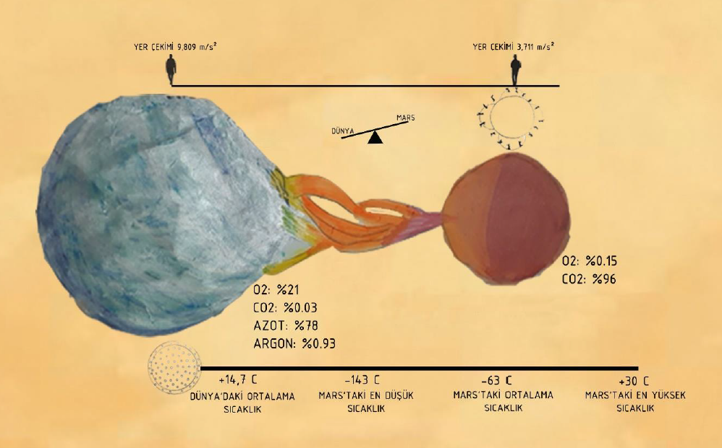
Fig. 1. Comparison of Earth and Mars [5].
2.1.1. Water
It has been observed that water on the surface of Mars exists only in solid and volatile phases. Mars’ low atmospheric pressure leads to sublimation, where water transitions directly from solid to gas, which is a factor that could affect the construction component production process. Ice plays an important role in life support systems necessary for crew survival. However, from a space architecture perspective, minimizing water consumption during production is considered a more efficient approach [6].
Compared to Earth, Mars has a desert-like environment across the entire planet. No matter where on the surface, except for the polar regions, Mars is even drier than the driest desert on Earth, the Atacama Desert in Chile, where the annual average precipitation is less than 15 millimeters [7].
2.1.2. Temperature
The average temperature on Mars is around -60°C (-76°F). Significant temperature fluctuations are observed on the planet's surface; temperatures can drop to -140°C (-220°F) during the coldest winter months and rise to 27°C (80°F) on the hottest summer days. The temperature difference between day and night can also reach 100°C (180°F) [6].
2.1.3. Gravity
Due to the planet's lower mass and radius, Mars’ gravity is about one-third that of Earth (3.69 m/s² or ~0.376g). Mars has only 10.7% of Earth's mass (6.4171 x 10²³ kg) and 53.2% of Earth's radius. When planning for permanent settlements or manned missions on Mars, the potential effects of prolonged exposure to this reduced gravity on human health should be carefully considered, particularly the likelihood of muscle atrophy and a decrease in bone mineral density. Studies on astronauts aboard the International Space Station (ISS) have shown muscle performance losses of up to 30% and muscle mass losses of up to 15% during missions of 4-6 months [8].
2.1.4. Radiation
Due to Mars's thin atmosphere, cloud formation is limited, allowing sunlight to reach the planet's surface directly. On Earth, dense layers of gases and water vapor clouds reflect white light, creating a protective barrier that ensures only a small fraction of radiation from orbit reaches the surface. However, Mars lacks this protective layer, leading to higher radiation levels on the surface [9].
Mars' atmosphere lacks the dense cloud cover found on Earth, but the surface is coated with a thin layer of dust that partially blocks sunlight from reaching the ground. Strong winds keep this dust suspended in the atmosphere for extended periods, and severe dust storms can plunge the surface into darkness for months. Additionally, because Mars lacks an ozone layer like Earth, harmful ultraviolet (UV) radiation reaches the surface, posing a serious threat to human health. The thin atmosphere and absence of an ozone layer mean that Mars is exposed to significant levels of UV radiation [10].
2.1.5. Atmosphere
Mars has a thin atmosphere primarily composed of carbon dioxide, nitrogen, and argon gases. Unlike the blue sky on Earth, the dust particles in Mars' atmosphere give the sky a reddish hue. Due to its thin atmosphere, Mars provides limited protection against impacts from meteoroids and asteroids. The planet's surface temperature can rise as high as 20°C (68°F) and drop as low as -153°C (-243.4°F). The low density of the atmosphere means that heat gained from the sun quickly dissipates, causing large temperature fluctuations [11].
At sea level on Earth, the standard atmospheric pressure is 1.013 millibars, while the average surface pressure on Mars is only between 6 and 7 millibars—less than 1% of Earth's sea level pressure. Mars' pressure varies depending on surface elevation. For example, in the Hellas impact basin, which has the planet's lowest elevation, the pressure averages 14 millibars. In contrast, at the peak of Olympus Mons, which is 22 kilometers high, the pressure drops to 0.7 millibars. Mars also experiences seasonal pressure fluctuations, with the highest pressure observed during the southern hemisphere's summer and the lowest pressure during the northern hemisphere's summer. These fluctuations are caused by temperature differences in the polar regions, with the northern polar winters being relatively short and mild, while the southern polar winters are longer and colder. When temperatures drop below -123°C, carbon dioxide freezes and accumulates on the surface as snow or ice, leading to a 25-30% reduction in air pressure across the planet [12].
Mars's atmosphere lacks an ozone layer that filters ultraviolet radiation. This allows harmful rays from the Sun and other astronomical sources to reach the surface, adversely affecting organic compounds. The absence of an ozone layer also prevents Mars' atmosphere from having a warm stratosphere like Earth’s. In addition to dust storms, clouds of water ice and carbon dioxide (CO2) ice particles exist in the Martian atmosphere [12].
2.1.6. Wind
Although the essential source of energy driving winds on Earth and Mars is the Sun's heat, there are significant differences between the two planets' atmospheres and surface characteristics. Earth's surface is covered mainly by oceans, which provide a significant source of heat and water vapor for the atmosphere. In contrast, Mars lacks open bodies of water; only traces of water vapor are in its atmosphere. On Earth, water in various forms—vapor, rain, snow—cycles through the atmosphere, transporting large amounts of energy and causing intense storms. Mars' low levels of water vapor mean that the energy carried in its atmosphere is limited, resulting in much calmer atmospheric movements than Earth [6].
Mars' surface is rocky due to extensive lava flows, but solid rock surfaces are limited. Instead, the surface is covered with dust, sand, and fine-grained sediment. Under the largely cloudless atmosphere, these sedimentary layers heat up during the day and cool rapidly at night. Near the Martian equator, the daily temperature difference can reach as high as 100°C (180°F). As warm air rises, cooler ground-level air fills the gaps, creating wind movements. Differences in temperature between various regions on Mars also contribute to wind formation [13].
Research on dust storms, cloud movement, and wind patterns on Mars shows that wind speeds can reach up to 100 kilometers per hour. Despite Mars' thin atmosphere, this speed is strong enough to move sand and small rock particles on the surface. These wind-driven particles erode rocks through a process known as "saltation," where particles hop, slide, or bounce across the surface. This process also contributes to the formation of dunes [13].
2.1.7. Regolith
Mars’ regolith is the planet's complex outer layer of rocks and soil. The structure that will support astronauts and rovers on the surface derives from this layer. "soil" refers to the fine-grained, loose accumulations of material found on a planet's surface. On Mars, this term includes a mixture of fine dust accumulated in the atmosphere and larger, sand-sized grains. Chemical analyses conducted at three different landing sites have revealed that soil composition is similar across these widely spaced areas [14] [15].
Research into the mineralogical properties of Martian soil indicates that it generally contains a mixture of amorphous, low-crystalline clay minerals, iron oxides, and other components resulting from volcanic rock weathering, making it similar in composition to palagonite [16]. "atmospheric dust" and "suspended dust" describe fine particles suspended in Mars’ atmosphere. Multispectral imaging analysis has revealed that the average diameter of these dust particles is 3.4 microns [17]. Magnetic analyses have shown that some dust particles contain magnetic iron oxide components. The reddish appearance of the soil indicates the high oxidation level in this dust [18].
2.1.8. Structure Physics
Mars’ surface features formations similar to those found on Earth, with specific geomorphological characteristics comparable to those observed on our planet. However, Mars lacks hydrological features such as water barriers, seas, or rivers. Its surface state results from millions of years of geological processes, including wind and water movement, volcanic eruptions, and meteor impacts. Today, Mars' surface is largely considered stable, with wind movements reshaping dunes to some extent. Current findings suggest that water on Mars evaporated long ago, and the surface has remained stable, making the likelihood of significant changes low [2].
In this context, Mars is considered a celestial body that could potentially provide the essential infrastructure for human life, and it is emerging as humanity's next target.

Table 1. Comparison of Mars and Earth Conditions and Characteristics [19][20]
 | Mars | Earth
Year Length  (The time it takes for the planet to complete a full orbit around the Sun) | 687 Earth days | 65 Days
Day Length  (The time it takes for the planet to complete a full rotation on its axis) | 24 hours, 37 minutes | Just under 24 hours
Equatorial Radius  (The radius of the planet is measured at the equator.) | 3,397 kilometers | 6,378 kilometers
Average Distance from the Sun  (The average distance between the planet and the Sun) | 227,936,637 kilometers | 149,597,891 kilometers
Water  (Availability and presence of water on the planet) | Traces found. | %79
Temperature  (General conditions of heat on the planet) | -153°C / +20°C (minimum/maximum)  or  -243°F / +68°F (minimum/maximum) | -88°C / 58°C (minimum/maximum)  or  -126°F / 136°F (minimum/maximum)
Surface Temperature  (The average temperature measured on the planet's surface) | 63°C  or  145.4°F | 14 °C  or  57.2 °F
Gravity  (The force of gravity on the planet compared to Earth) | Approximately 37.5% of Earth's gravity (3.71 m/s²) | Approximately 2.66 times that of Mars  (9.81 m/s²)
Atmospheric Pressure  (A measure of the force that the atmosphere of the planet exerts on its surface) | 7.5 millibars (average) | 1.013 millibar  (Deniz seviyesinde)
Atmospheric Components  (The gases and other substances that make up the planet's atmosphere) | Carbon dioxide (95.32%)  Nitrogen (2.7%)  Argon (1.6%)  Oxygen (0.13%)  Water vapor (0.03%)  Nitric oxide (0.01%) | Nitrogen (77%)  Oxygen (21%)  Argon (1%)  Carbon dioxide (0.038%)

2.2. Survival Conditions and Challenges
Mars is an unusual planet for humans, with conditions and characteristics that are significantly different from Earth. These differences pose serious challenges to the sustainability of human life, raising questions about the possibility of humans residing on Mars. The harsh conditions on Mars can be systematically analyzed under the following headings:
- The atmosphere of Mars is too thin to be suitable for human breathing, with an extremely low oxygen content, significantly limiting the possibility of establishing a sustainable human life on Mars.
- The low humidity levels in the atmosphere may cause skin to dry out rapidly, leading to various dermatological problems.
- The insufficient availability of liquid water prevents humans from meeting their basic drinking and hygiene needs.
- Low temperatures and sudden temperature fluctuations can expose the body to hypothermia, thus reducing physiological resilience.
- Mars dust, which is composed of microscopic, abrasive particles, has the potential to penetrate the lungs via inhalation and cause serious damage to internal organs.
- Electrically charged dust particles moving at high speeds during dust storms can damage the skin and may also lead to undesirable electrostatic effects.
- It is known that staying on the surface of Mars during solar storms poses a risk of exposure to lethal doses of radiation or radiation sickness, constituting a significant life-threatening danger.
- Long-term exposure to cosmic radiation on the surface of Mars, especially at high altitudes, has the potential to cause radiation sickness and increase the risk of cancer development [2].
2.3. Human Survival Strategies on Mars
Mars is not considered a habitable planet for human life under its current conditions. Factors such as the thin atmosphere, extreme temperature fluctuations, and high radiation levels present significant threats to human health and sustainable living. Therefore, before humans can reach Mars, the planet must be made habitable. This transformation process must be supported by various scientific and technical studies. Specifically, goals should be set to create sustainable living habitats on Mars, ensure access to water resources, and regulate the atmosphere. Additionally, these conditions differ significantly between short-term missions and long-term residency projects. Short-term missions are research and exploration-focused, designed to meet the basic needs that would allow astronauts to survive for a set period. On the other hand, long-term residency projects require more comprehensive strategies and infrastructure planning to enable humans to live permanently on Mars. In this context, topics such as the integration of life support systems, the development of agricultural practices, and the organization of healthcare services should be addressed [21].

3. ARCHITECTURAL APPROACHES SUPPORTING HUMAN LIFE IN SPACE
To date, no permanent living habitat has been built on Mars, and only unmanned missions have been carried out on the planet. These missions, conducted via space vehicles such as Curiosity, Insight, Perseverance, and Zhurong, have aimed to gather information about the planet's surface features, atmospheric composition, and potential living conditions. These robotic systems sent to the surface of Mars have provided valuable data on the planet's physical structure, climate features, and water reserves, but the construction of a habitat suitable for human life on Mars has not yet been practically realized. The idea of sustaining human presence on Mars has triggered a comprehensive research process that brings together scientists, architects, and engineers to develop resilient living habitats that can withstand the planet's harsh environmental conditions. Mars research, ongoing since the 1960s, has advanced with more sophisticated planning and cutting-edge technological solutions, necessitating the development of innovative habitat designs to counter the planet's challenging conditions, such as low atmospheric pressure, high radiation levels, and oxygen deficiency. Despite Mars’ harsh nature, the development of innovative materials and construction techniques offers hope that habitats capable of supporting human life may be built, ensuring a growing increase in technical and scientific work in this field.
3.1. Architectural and Settlement Planning Compatible with Mars Terrain
Human history has been shaped by discoveries and the search for new living spaces. In this process, the human instinct for survival and development has guided exploration efforts throughout every era. The constant drive to push forward in the quest for new resources and fertile lands has been the primary driving force for humanity. However, this search has not only involved overcoming physical boundaries but has also taken on a dimension that questions the very purpose of human existence. Today, the Earth's limited resources and the planet's ecological imbalance have pushed humans into space, in search of establishing life on other planets. In this context, the possibility of life on another planet is not merely a curiosity-based thought but carries deeper scientific and philosophical dimensions. As Yuval Noah Harari states, "For thousands of years, Homo sapiens has been the most decisive factor in the changes in the global ecosystem [22]. This observation highlights the necessity of overcoming the insufficiencies on our current planet and developing new strategies for the future of the planet.
Currently, Mars is the focal point of space exploration. Because of its physical characteristics, which are the closest to Earth's living conditions, it is considered humanity’s new potential habitat. The conditions on Mars, which resemble those of Earth’s life forms, have been confirmed through numerous scientific studies and observations, increasing its importance as a potential settlement for humanity. Establishing permanent settlements on Mars has become not only a scientific endeavor but also a vital priority for the sustainability of the planet and the survival of humanity.
The construction of permanent settlements on Mars requires a multidisciplinary approach that goes beyond advancements in engineering and technology, incorporating architectural and urban planning disciplines. Mars’ physical conditions, including gravity, atmospheric composition, radiation levels, and local resources, are decisive factors in the design of settlements. In this context, architecture and settlement planning on Mars must develop structures that are resilient to the planet’s harsh environmental conditions, sustainable, and functional.
3.2. Suitable Material Selection for Building Design on Mars
The choice of materials for the planned living spaces on Mars is of great importance, considering the planet’s unique extreme conditions. A structure designed to support long-term human life on Mars must be made of layers that are resistant to radiation, capable of withstanding the low pressure created by the thin atmosphere, and resilient to large temperature fluctuations. This selection of construction materials must meet not only safety standards but also technical and logistical requirements such as cost, transportability, and sustainability.
The process of constructing suitable settlements on Mars offers a strategic advantage in terms of cost-effectiveness by considering the use of local materials that can be sourced on Mars in addition to Earth-sourced materials. In this context, regolith, which is abundantly available on the surface of Mars, stands out as a key component of building elements, while stones obtained from the rocky surface of Mars could function as additional construction materials. The use of local resources has the potential to reduce labor and transportation costs, thus increasing the operational efficiency of the projects.
Due to the limited transportation capacity for sending building components from Earth, selecting fault-free, pre-tested materials is mandatory. The limited launch capacity and logistical constraints encountered during the transportation process make modular construction designs essential. These designs not only facilitate transportation and ease of assembly on the Martian surface but also support the durability of the structures. Therefore, material and design preferences should be selected with a focus on not only durability but also ensuring the efficiency of construction processes on Mars.
3.2.1. Structural Materials Available from the Martian Surface
The use of local resources on Mars for the construction of buildings is considered a fundamental component of sustainable construction processes. Given the high costs and logistical challenges of transporting materials from Earth, efficiently utilizing the natural resources available on the Martian surface is viewed as a strategic approach to overcoming these challenges. The use of local materials in construction not only reduces costs from an economic standpoint but also plays a crucial role in accelerating the construction processes on Mars and making settlements sustainable.
Another advantage of using local materials is that it enables the construction processes on Mars to be carried out more quickly and efficiently. Producing materials that are resistant to the harsh environmental conditions, low atmospheric pressure, and high radiation levels on Mars will contribute to the creation of sustainable settlements. Thus, systematically researching the local resources on Mars and utilizing them effectively in construction processes will be a decisive factor in ensuring the success of long-term settlement projects.
3.2.1.1. Sulfur Concrete
The use of local resources in construction on outer planets such as Mars and the Moon is a significant area of research under NASA’s In-Situ Resource Utilization (ISRU) strategies. Sulfur concrete stands out as a promising composite material for building structures on the surfaces of both the Moon and Mars [23]. Specifically, sulfur concrete used with the Contour Crafting (CC) method, which is produced from a combination of natural sulfur and Martian or lunar regolith, can be manufactured on-site as a building material. This material aims to maximize the use of local materials in line with NASA’s ISRU goals [24] [25].
Sulfur-based concrete products are produced by combining sulfur and hot aggregate. In this process, sulfur initially crystallizes as monoclinic sulfur (Sβ), and as the mixture cools, sulfur changes into a stable orthorhombic polymorph (Sα). This phase transition serves as a critical mechanism that enhances the structural reliability of sulfur-based concrete and ensures its durability [25]. Sulfur concrete, particularly when used in manufacturing processes like Contour Crafting (CC), enables on-site material use, making construction processes faster and more economical.
Sulfur concrete compatible with Martian conditions stands out for its quick curing time, high strength, recyclability, and stability in low temperatures. The abundance of sulfur on the Martian surface and the well-graded particle structure of regolith make this mixture a durable and functional construction material. Additionally, the low pressure and temperature conditions on Mars support the long-term durability of sulfur-based structures [25].
3.2.1.2. Regolith
Regolith, which is abundantly found on the Martian surface, is significant due to its ability to create protective barriers against external factors such as radiation, meteorite impacts, and debris generated during launch. However, regolith has structural limitations, particularly in terms of its brittleness when compacted at high slope angles and its tendency to lose stability under light dynamic loads. When uncompressed, the natural angle of repose of regolith is 40°, and beyond this limit, it loses stability. Under these conditions, unprocessed regolith shows limited structural durability for complex structures to be built on Mars.
The use of regolith as a building material can be made feasible by collecting it in loose form, placing it into specific molds, compressing it, and sintering it. The sintering process, applied using microwaves or solar energy, allows regolith to be transformed into building elements such as bricks or blocks. Sintered regolith products offer an application similar to bricklaying in terrestrial construction systems and can be used in pressurized environments with appropriate locking and reinforcement methods. However, while it is theoretically possible to produce prestressed beams and floors with sintered regolith, practical limitations arise due to the variable mechanical properties of the material.
Current research indicates that the tensile strength of sintered regolith ranges from 9-18 MPa, and its compressive strength values align with this range. The low mechanical strength and heterogeneous structure of regolith limit its contribution to sophisticated structural designs. However, the material offers a suitable solution for simpler, safety-oriented applications such as outer shells and barriers that provide protection against radiation and debris [26].
3.2.2. Structural Materials Obtainable from Earth Resources
The selection of suitable materials for construction on Mars can resemble those commonly used in construction and engineering on Earth. In space research and long-duration space missions, materials sourced from Earth have often been preferred in structural components such as spacecraft, rockets, and exploration vehicles. These materials have shown high durability and functionality in the harsh conditions of space and have been effectively used in various applications. Given Mars' atmospheric, thermal, and gravity conditions, similar materials may be appropriate for building structures on Mars. However, factors such as the use of local resources, material performance, durability, and long-term sustainability will play critical roles in material selection for construction on Mars.
3.2.2.1. Steel
Steel is widely preferred as a construction material due to its superior properties, such as its sensitivity to heat treatments, resistance to corrosion, and high temperature durability, as well as its ability to be brought to the desired hardness level. This material, which is classified into three main categories based on its chemical composition, can be transformed into the desired form through processing techniques:
• Carbon Steel
• Alloy Steel
• Stainless Steel
Low carbon steel, with carbon content ranging from 0.05% to 0.26%, is one of the most commonly preferred types of steel due to its economic advantages and the suitability of its material properties for a wide range of applications. However, the high specific gravity of steel presents a logistical and cost disadvantage when transporting it to Mars. Nevertheless, steel remains a preferred and reliable material in the construction industry for many years, enhancing its potential usage advantages despite this drawback [27].
3.2.2.2. Aluminum
Aluminum is a versatile metal with a wide range of applications due to its flexibility in shaping through various industrial processes and its high machinability. This metal can be shaped using methods such as casting, rolling, stamping, drawing, bending, rolling, and forging, and can also be adapted into various cross-sections through the extrusion process. Furthermore, it can be easily processed through turning, milling, and drilling, and shows excellent compatibility with joining processes like riveting, welding, soldering, and adhesive bonding.
Although the mechanical strength of aluminum alloys decreases at high temperatures (around 200-250°C), they retain strength at low temperatures while maintaining ductility. This property makes aluminum an alloy of choice, especially in low-temperature conditions [26]. Aluminum, which is commonly used in the space industry, finds its place in space suits and other related components and is a well-known and preferred material in space exploration. In this context, aluminum shows potential for use in structural or material-based components of space habitats.
3.2.2.3. Titanium
Titanium is a metal that is approximately 40% lighter than steel and 60% lighter than aluminum. This low-density, high-strength combination makes titanium highly suitable for structural applications, particularly in fields such as aerospace and the space industry, where weight savings play a critical role. However, titanium production is technically complex due to its sensitivity to gas impurities such as oxygen, nitrogen, and hydrogen. To prevent the diffusion of these gases into the metal, production processes must be carried out under high-temperature conditions with special protective measures. Commercial titanium products are often available in forms such as sheets, pipes, wires, extrusions, and forgings. Due to its reactive nature, titanium casting must be performed in vacuum furnaces. The challenges in the production process significantly increase the cost of titanium products. However, its low specific gravity makes it competitive with steel in terms of cost when transportation costs are taken into account [26].
3.2.2.4. Glass
Glass offers superior optical properties compared to other transparent materials, such as plastics, for use in space environments. For example, glass demonstrates high resistance to atomic oxygen attacks, providing significant impermeability to these abrasive effects. On the other hand, most plastics become cloudy within just a few days in the space environment due to the effects of atomic oxygen and become brittle when exposed to ultraviolet radiation, losing their structural integrity. Glass stands out as a preferred material due to its durability against degradation.
As a building material, glass has negative properties such as high sensitivity to static fatigue, brittleness, and small damage. Space environments, like those on Mars and the Moon, present various challenges for glass; factors such as humidity, loads under continuous tension, long-term service life, and impacts on internal and external surfaces are some of the stress factors limiting glass durability.
Despite the structural disadvantages of glass, proper design approaches can ensure its longevity and structural integrity. For example, in the International Space Station’s window system, an additional protective glass layer has been placed to protect the outer pressure glass. This protective glass is positioned at a certain distance from the pressure glass, with a void space between the two layers to act as a buffer against external impacts. A similar protective layer is also found on the inner surface, where this protective layer, in addition to protecting the pressure glass from impacts, contains an integrated heating system to prevent fogging on the glass surface [28].
While glass has some limitations in terms of transport, it has positive effects on the psychological health of crews living in habitats for extended periods, thus contributing to improved interior comfort and quality of life.
3.2.2.5. Membrane
Architectural membrane fabrics, foils, and similar materials are among the innovative materials that are gaining attention in contemporary architecture due to their high-performance physical properties, adaptable structural performance, and suitable load-bearing capacity. These materials, which are notable for their lightweight structures and ability to be produced in various forms, can meet the high structural demands of large-span structures and exhibit reliable durability even under environmental loads such as snow, rain, and wind. Membrane materials used in buildings are produced in both composite and homogeneous forms. Composite structures, which provide higher strength and stability compared to homogeneous ETFE foils, are more commonly preferred in large-span engineering structures [29]. However, the limited resistance of membrane materials to bending and compression requires their design in a way that can carry the loads under stress in the structural design process. Unlike traditional building systems, the analysis process for membrane systems includes phases like shape determination, load analysis, and shear modeling. During this process, the shape-finding stage, formed by elements like internal pressure, initial stress, and curve shape, is of fundamental importance [29].
Membrane materials, as external protective layers for Mars habitats, are among the potential construction materials that can be used in conjunction with natural resources such as regolith. Membrane fabrics made with fibrous structures can be strengthened with surface coatings; materials such as synthetic fibers, silica-based materials, high-strength polymers, polyamide yarns, and aramid fibers offer suitable options for these types of structures. Kevlar, with its low density and high strength, is particularly preferred for Moon and Mars applications. Final fabric properties, such as tear resistance, are directly related to the arrangement of fibers in the weave. Coating materials such as polyvinyl chloride and PTFE are commonly used, while polyethylene membranes may not be preferred due to the potential release of toxic gases in case of fire. The multi-layered membrane structure not only provides structural strength but also meets safety and insulation requirements, making it a promising solution for long-term habitat projects in the Mars environment [26].

3.2.2.6. Plastics or Plastic-Based Materials
Fiber-reinforced plastics, which are among composite materials, consist of reinforcement fibers within a matrix material. This structure typically results in a material profile that is different and superior to the individual properties of the components. The properties of this new material type can be designed as lighter and more efficient alternatives compared to commonly used building materials.
Carbon nanotubes, an emerging research area, are composed of graphite layers wrapped around cylindrical structures. These nanotubes have diameters of only a few nanometers but can reach lengths of up to one millimeter, providing a high length-to-width ratio. This structure is unique for macroscopic devices due to molecular-level properties. Thanks to these features, the application field of carbon nanotubes is rapidly expanding, allowing for the creation of high-strength, low-specific-weight tubes. This makes it possible to construct structures that were previously thought to be impossible in engineering [26]. Modern plastics are notable for their enhanced durability characteristics. Composite elements, which are lighter than metals, exhibit similar or superior resistance properties. Therefore, plastics provide an effective material solution for building structures in harsh environments such as Mars. Polymer fibers are produced with polymer modifications to enhance their mechanical strength, and these modifications enable the production of copolymers with superior properties compared to original polymers. These modified polymer fibers significantly improve the mechanical resistance of the polymers, thereby strengthening the overall performance of composite materials [26].
3.3. Structural Models and Typologies for Mars Habitats
One of the main design challenges in Martian architecture is the necessity of constructing pressurized structures safely due to the planet’s atmosphere being only 1% of Earth's density. This reflects a situation similar to the risk of explosion in pressurized aircraft at high altitudes and requires special engineering solutions to ensure the safety of pressurized structures in the Martian environment. Since Mars' gravity is about one-third of Earth's, this allows for lighter structural designs. However, the idea of designing the architectural shell in a dome shape also serves an additional safety function while protecting the inhabitants of the pressurized structure. Current research and projects propose the use of inflatable and telescopic structures alongside rigid metal structures. These types of structures provide great efficiency in terms of volume-to-mass ratio and function effectively as reliable containment systems. Additionally, these structures offer significant advantages in terms of ease of transportation and simplicity in the construction process. However, inflatable structures are vulnerable to the effects of micro-meteoroids due to Mars' thin atmosphere, as objects that burn up in Earth's atmosphere will not be protected in the same way upon impact with Mars. The psychological impacts of inflatable habitats' architecture have not yet been extensively studied and represent an important area for future research. In this regard, inflatable and metal structures will play a critical role in the construction of modules that house life support systems, circulation areas, greenhouses, and social spaces necessary for sustainable living on Mars [30].
3.3.1. Regolith and Stone-Based Construction Systems
Structures made from regolith share structural similarities with earthen buildings made from soil materials on Earth. In both cases, it is possible to construct buildings using similar materials. The brittle nature of soil materials allows such structures to withstand only compressive loads. Therefore, tension and tensile stress should be avoided in structural designs. The form of regolith-based structures is typically designed to withstand only compressive stresses and often resembles an inverted catenary form. When constructing such structures, semi-circular shapes, domes, and freeform shell structures are considered ideal examples [6].
Building with regolith can be achieved by shaping the material into blocks or through a piling method. Developing and ensuring the reliability of production processes on Mars will improve the effectiveness of these construction techniques. One of the most suitable methods for Martian structures today is on-site production based on 3D printing technology. This process can involve autonomous or semi-autonomous robots processing regolith into usable materials for construction. Such methods offer significant economic and operational advantages in the construction of Martian settlements.
3D printing offers a pioneering and forward-looking production process aimed at producing building elements or modules on-site using local soil materials (regolith), integrating multidisciplinary technologies like robotics, networks, and sensing. NASA, focusing on the development of key technologies for building extraterrestrial habitats, places great emphasis on 3D printing techniques. In space environments, the sintering of local materials stands out as an effective production method. Sintering involves heating the material to a temperature below its melting point, allowing the particles to bond by reducing the porosity of the structure in a synchronized manner [31].
3.3.2. Expandable Structural Systems
Expandable structures can be defined as structural designs that can increase or decrease their volumes. These structures can be classified as systems that are foldable, inflatable, capable of being stiffened after inflation, and have shape memory features. Unlike traditional buildings, expandable structures can be folded back into a smaller volume after expansion, and this process can be repeated. This feature provides significant advantages in terms of load-bearing and storage; after expansion, they often offer much larger volumes compared to other structures, while having low mass and volume ratios, making them highly suitable for space technologies and applications [2].
These structures are multi-component systems built with numerous elements. They are generally created using rigid rods and sometimes multi-faced components made from plastic or metallic materials. Structural elements are connected with simple joints, which allows for the construction of various geometric shapes (e.g., circular, square, spherical, domed, curtain, partition, and tent forms) with different connection types (movable and rigid). When expanded, these structures gain strength and durability. Additionally, they can be covered with membranes, fabrics, nets, or foils to provide extra protection and stability. These characteristics make expandable structures highly suitable for modular base configurations and construction in space environments like Mars.
3.3.3. Metal and Plastic-Based Structural Systems
Most structures used in space missions are built from metal constructions. These structures have been successfully used in harsh external conditions multiple times and are recognized for their high reliability. The most significant disadvantage of metal constructions is their weight, often associated with large masses. Steel is one of the heaviest materials used for these structures. Therefore, lighter metals such as aluminum and titanium-aluminum alloys are preferred for space structures instead of steel. Titanium, which has the lowest density among metal alloys, stands out as an expensive option due to the complexity and high cost of the production and processing processes [2].
It is predicted that the essential alloy components required for steel production will be available on Mars. By combining these components in suitable proportions, necessary carbon steels and stainless steels can be produced. Additionally, aluminum production on Mars is also possible, as this element is thought to be available on the planet. Mars' low gravity conditions will allow for a more homogeneous mixing of elements during alloy production, thus resulting in superior alloys [32].
Today’s plastic materials have significantly improved durability properties. Composite materials are much lighter than metal structures while maintaining similar or even higher strength. This makes the use of composite materials more efficient in the design of habitats to be built on Mars. Resistant polymer fibers are produced through polymer modifications and reinforced with additives. These modifications allow for the production of copolymers with superior properties compared to the raw materials used. It is known that polymer fibers have a significant impact on the mechanical strength of polymers. In this context, the use of composite materials in habitats to be built on Mars may be a more advantageous option in terms of portability and ease of construction compared to metal materials. Although composite material production on Mars is theoretically possible, it is stated that this process is quite complex and producing high-quality materials remains a challenging goal with current technologies [33].
3.3.4. Modular Structural Systems
In space exploration, modular systems represent a design concept that was built in the past, is still in use today, and is planned to be expanded in the future. These systems have undergone an evolutionary process starting with the Apollo and Soyuz spacecraft, and today, they are based on the combination of spacecraft modules in a linear arrangement with specific functions. Cylindrical geometries are commonly preferred in the design of these structures. Future space habitats and research systems are expected to integrate additional placement ports, reconfigurable structures, and highly efficient structural and volumetric arrangements to meet the requirements for functional flexibility and reconfigurability [34].
3.3.5. Drilled Structural Systems in Underground Areas
Drilling methods are generally defined as mechanical processes that involve the physical fragmentation of the material and removal of cuttings. Although gas-based drilling methods are considered, the most commonly used method for interplanetary applications is auger technology. Small drills operate with rotational motion, while hammer drills use impact motion with varying frequencies. The combination of these drills provides high efficiency in drilling materials like hard rock and concrete. The rotary impact drill, developed during the 2011 Mars Science Laboratory Mission, is an innovative design that integrates an actuator with coil technologies used in percussion instruments to provide rotational motion [35].
Large amounts of material movement are required in the mining and construction sectors, often necessitating the use of unloading or excavation equipment. The design of excavation systems suitable for the harsh environmental conditions of planets like the Moon and Mars involves derivatives of terrestrial excavation systems. It is expected that potential mining systems on Mars will be designed with autonomous or semi-autonomous technologies from Earth. The experiences of surface mining systems that automate operations such as drilling and ore transport can guide mining operations on Mars. Autonomous mining on Mars should encompass all stages of mining and processing, including resource evaluation, drilling, blasting, loading, transportation, crushing, and enrichment [35].
Drilling a hole in a rock mass affects the stress distribution in that environment, causing changes. When a piece of rock is removed, the remaining part adjusts to the new conditions. During excavation operations on Mars, basalt rocks may form self-sufficient structural walls without additional support. In such mining excavations, rocks can transform into self-supporting arch formations. However, where the rocks are unstable or have unfavorable laminations, structural habitats are required. These habitats consist of a support and casing system. The support, adjacent to the rock, increases stability, while the casing is the structural complement. Materials such as air gaps or felt are placed between the support and casing [2]. These structures can be built using local resources such as regolith or Martian concrete, or with materials sourced from Earth. Current semi-autonomous robot technologies can be applied to drilling operations for such structures.
3.4. Interior Layouts and Design Approaches in Mars Structures
Structures on Earth are traditionally designed in cubic forms, with ease of construction and cost-effectiveness being key factors in this preference. The widespread use of these geometric forms has led to the evolution of interior furniture in similar shapes. However, modern design thinking increasingly emphasizes that architectural forms should take on curved shapes in accordance with environmental and functional factors. In this context, it becomes essential that interior design should align with the curvature of the outer form.
When it comes to interior layouts for a habitat to be built on Mars, the primary issue is how to design curved forms and arrange interior spaces accordingly. Various design solutions have been developed to accommodate interior layouts for Mars habitats. The first solution involves building the interior independent of the outer shell form, allowing the outer curvature to be maintained while the interior remains a separate structure. In the second solution, the exterior form is associated with internal framework structures, flattening the curves and creating more conventional, cubic spaces. The third solution proposes excluding the curves from the interior design, thereby allowing larger, open spaces. In this design, for example, curved transitions at the junctions of multiple spheres can be eliminated to create large, open spaces. Finally, it is suggested that innovative and functional interiors be created by using elements other than traditional forms [36].
Various design proposals for interior layouts in Mars habitats offer specific advantages but also contain certain limitations. The interior design solutions presented by Imhof demonstrate an innovative approach to meeting the functional and aesthetic needs of Mars habitats. However, the feasibility of these proposals must be evaluated, considering the potential challenges of each solution.

4. AI-ASSISTED ARCHITECTURAL DESIGN APPROACHES IN POSSIBLE LIFE SCENARIOS ON MARS
Constructing habitats on Mars is not possible using traditional architectural methods, given the planet's harsh environmental conditions. In this context, AI-assisted architectural design approaches offer a significant solution for creating sustainable living spaces on Mars. AI ensures that structures adapt to environmental factors through parametric design algorithms and data analysis methods, optimizing designs in terms of energy efficiency and durability.
The use of AI plays a critical role in selecting materials suitable for conditions like low gravity and high radiation on Mars. By analyzing local materials, AI can propose solutions that reduce construction costs and increase resource efficiency. Additionally, through parametric design, structures can dynamically reshape to adapt to environmental variables (sunlight, wind speed), enhancing the potential to create the most suitable spaces for survival in Mars's challenging conditions.
4.1. Definition of AI: Its Role as a Technology in Mars Designs
AI was first addressed at a conference at Dartmouth College in 1956 by John McCarthy and his colleagues, who defined it as "the science of creating intelligent systems and computer programs similar to human intelligence." While this definition outlines AI's fundamental goals, McCarthy described intelligence as "a computational component of the ability to achieve goals" [36]. AI has evolved rapidly with advancing technology and has gained broad applications today, adding an innovative dimension to architectural design processes. Initially focused on mimicking human thought processes, AI has transformed into a tool aimed at understanding human-machine interactions. This transformation has significantly contributed to the development of knowledge-based, intelligent, and sustainable design approaches in architecture [38].
By introducing knowledge-based and innovative approaches to architectural design processes, AI brings about a significant transformation at every stage of design. Applications like parametric design and generative algorithms optimize the functionality and aesthetic values of structures, enabling the assessment of environmental impacts and sustainability criteria through simulation. In this context, AI emerges as a strategic technology, particularly in colonization efforts on planets with extreme conditions, such as Mars. To address challenges like low gravity, thin atmosphere, and extreme temperature fluctuations on Mars, AI-based algorithms analyze environmental data to develop optimal design solutions and select suitable materials.
Autonomous robotic systems integrated with AI are bringing about a revolutionary transformation in construction processes. Especially with the use of 3D printing technologies, it becomes possible to construct durable and sustainable habitats on Mars's surface without human intervention. These systems optimize resource use, allowing the planet's limited natural resources to be efficiently utilized. Sustainability goals such as energy management, water recycling, and air quality control can also be effectively achieved with the contributions of AI-based models. Thus, AI is not just a tool that contributes to the architectural design process; it is gaining importance as a strategic technology that will make human life on Mars possible. In this context, the role of AI in Mars designs represents not only a technical transformation but also a new vision for humanity's future existence.
4.2. Mars Design Experiments with AI
AI stands out as a technology that offers innovative methods for designing habitats on Mars and can be used at every stage of architectural processes. AI-based visualization tools, parametric design software, generative algorithms, and simulation systems play critical roles in both the conceptual phase and the detailing processes of habitats on Mars's surface. These experiments provide solutions based not only on aesthetics and functionality but also on environmental adaptation and sustainability principles.

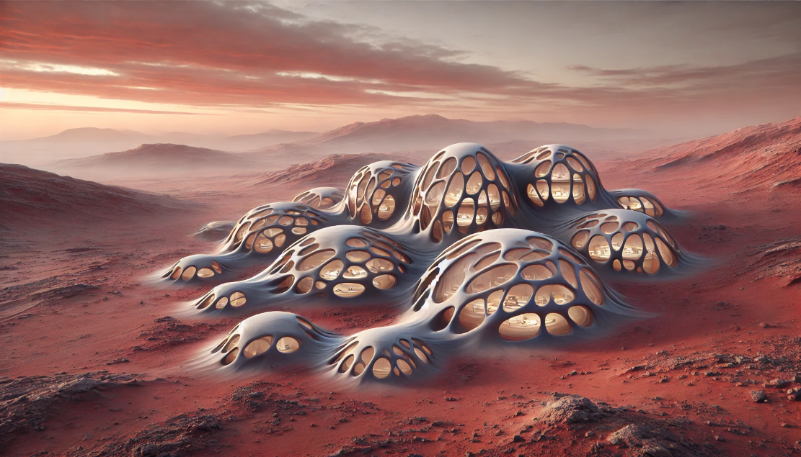
Fig. 2. Biomimetic Mars Settlement [39].
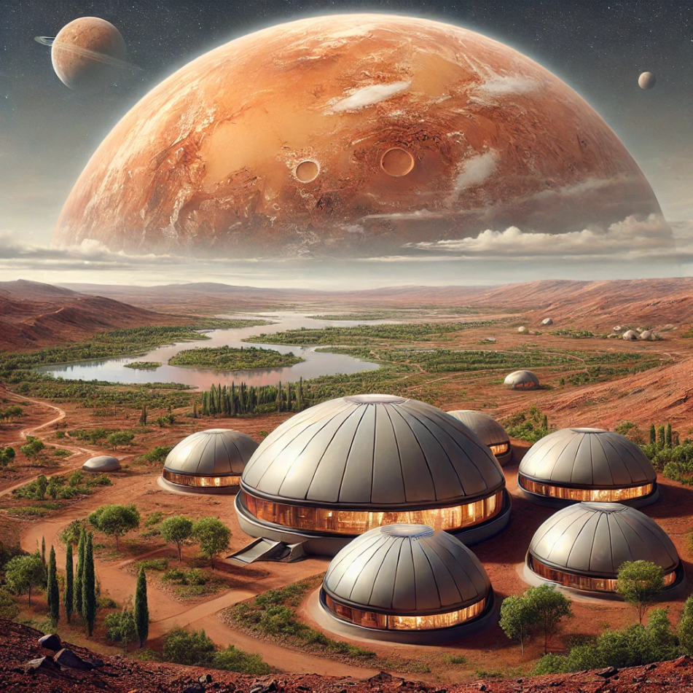
Fig. 3. Dome-Shaped Mars Structure [40].

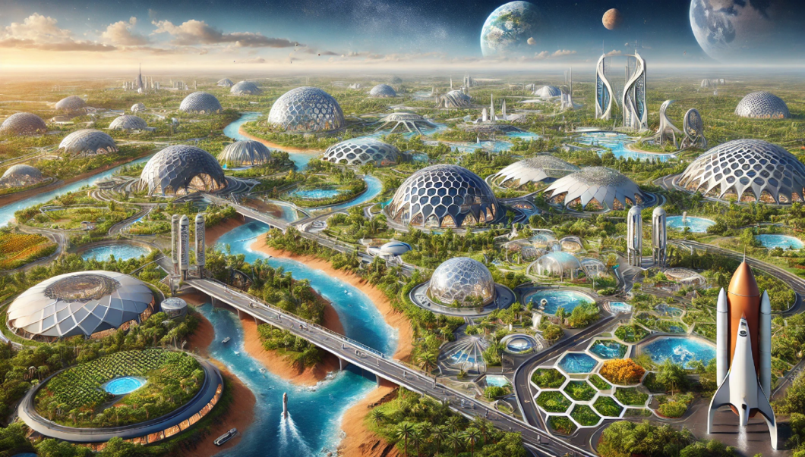
Fig. 4. Futuristic Architectural Mars Structures [41].
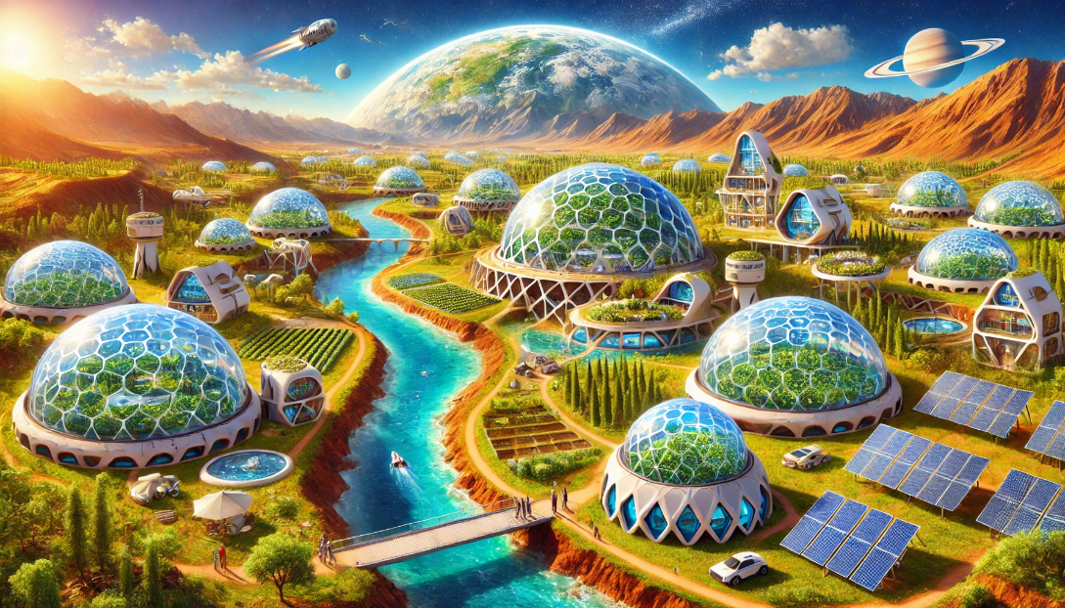
Fig. 5. Renewable Mars Colony [42].
These AI-assisted experiments for constructing sustainable living spaces on Mars represent not only a technology-driven advancement but also the potential for humanity to establish a presence on a new planet. In this process, AI stands out as a fundamental element shaping the future of design and engineering fields.

5. CONCLUSION
Space research, which began in the 1950s, has reached an increasingly comprehensive and sophisticated level with the rapid advancement of technology. In particular, the deployment of semi-autonomous robots equipped with modern technologies to different planets provides the scientific world with detailed and unique data about the physical and chemical properties of these planets. This enables a deeper examination of these environments, creating a valuable information infrastructure for future explorations, such as detailed surface mapping, atmospheric condition analysis, and planned missions.
The scientific and technological interest in Mars has encouraged many researchers, especially architects, engineers, and scientists, to study the planet's structural and environmental conditions. The goal of this study is to offer guiding information on the design and construction of habitats on the Martian surface. In this scope, Mars’s surface structure, atmospheric and climatic conditions have been analyzed in detail. This information serves as a guide for architects and engineers in developing solutions to the challenges that may be encountered in future Martian projects.
The main research sources of this study include up-to-date literature and data from various scientific disciplines. The critical elements that must be considered for a building project on Mars include the analysis of the planet's surface and suitable terrain conditions, the selection of structural systems, the identification of materials resistant to atmospheric conditions, and the planning of building models and interior layouts.
The ultimate aim of this study is to present ideas for the development of structural systems and architectural concepts that could be applied on the Martian surface. The dynamic nature of space architecture and advances in technology make it feasible for humans to construct safe, sustainable, and comfortable living spaces on Mars in the near future. Structural systems supported by new technological possibilities will play a crucial role in the development of habitats that will enable human life on Mars and other planets.
In conclusion, the data provided by this study offers a comprehensive framework for building projects on Mars and makes valuable contributions to the planning of future Martian settlements for humanity.

Funding
This research received no external funding.

Conflicts of interest
The authors declare no conflict of interest.

REFERENCES
[1] Özçakı M. Dünya’nın Yansıması Olarak Mars’ ta Yaşam Alanı Tasarlamak. KAPU Trakya Mimarlık ve Tasarım Dergisi, 2023;3.1:62-79.
[2] Kozicka J. Low-cost solutions for Martian base. Advances in Space Research, 2008;41.1:129-137.
[3] Support the Guardian. Elon Musk: SpaceX can colonise Mars and build moon base. 2017. https://www.theguardian.com/technology/2017/sep/29/elon-musk-spacex-can-colonise-mars-and-build-base-on-oon
[4] Çiçek A. Mars ve Dünya Kıyaslamaları. 2021. https://bilimseven.tr.gg/Mars-ve-D.ue.nya-K%26%23305%3Byaslamalar%26%23305%3B.htm
[5] Özçakı M. Başka Bir Gezegendeki Yaşamda, Yol Gösterici Olarak Dünya. Kırklareli Üniversitesi Mimarlık Fakültesi Dergisi, 2023;2.1:31-56.
[6] Mintus A. Building on Mars: Experimental research on efficient and sustainable production process and construction method. 2019.
[7] Mars Education | Developing the Next Generation of Explorers. Water. 2021. https://marsed.asu.edu/mep/water
[8] Williams M, Today U. How strong is the gravity on Mars?. 2022. https://phys.org/news/2014-12-strong-gravity-mars.html
[9] Mieszkowski Z. Elementy projektowania architektonicznego. Wydawnictwo Arkady, 1973.
[10] Kozicka J. Architectural Problems of a Martian Base Design as a Habitat in Extreme Condition. 2008. PhD Thesis. Dissertation, Department of Technical Aspects of Architectctural Design, Gdnask University of Technology, Gdansk, Poland.
[11] In Depth Mars. NASA Solar System Exploration. 2019. https://solarsystem.nasa.gov/planets/mars/in-depth
[12] Mars Education | Developing the Next Generation of Explorers. Atmosphere. 2021. https://marsed.asu.edu/mep/atmosphere
[13] NASA Mars Education | Developing the Next Generation of Explorers. Wind. 2021. https://marsed.asu.edu/mep/wind
[14] Clark Benton C. et al. Chemical composition of Martian fines. Journal of Geophysical Research: Solid Earth, 1982;87. B12:10059-10067.
[15] Rieder R. et al. The chemical composition of Martian soil and rocks returned by the mobile alpha proton X-ray spectrometer: Preliminary results from the X-ray mode. Science. 1997;278.5344:1771-1774.
[16] Bell III, J. F. et al. Mineralogic and compositional properties of Martian soil and dust: Results from Mars Pathfinder. Journal of Geophysical Research: Planets. 2000;105.E1:1721-1755.
[17] Tomasko M. G., et al. Properties of dust in the Martian atmosphere from the Imager on Mars Pathfinder. Journal of Geophysical Research: Planets. 1999;104.E4:8987-9007.
[18] Madsen M B. et al. The magnetic properties experiments on Mars Pathfinder. Journal of Geophysical Research: Planets. 1999;104.E4: 8761-8779.
[19] Gönülal Doğukan H. Mars Habitatlarının Yapısal Açıdan İrdelenmesi. 2022. Master's Thesis. Dokuz Eylul University (Turkey).
[20] Phoenix Mars Mission Education Mars 101. Mars/Earth Comparison Table. 2021. http://phoenix.lpl.arizona.edu/mars111.php
[21] Taştan Karataş S, Mumcu Uçar, Ü. Ö. Mars' taki Yaşam Kurguları Üzerine Mekânsal Bir İnceleme. Online Journal of Art & Design. 2022;10.3.
[22] Harari Y. N. Homo Sapiens. Kolektif Kitap. 2012. İstanbul
[23] Aksoy Ü. Dünya, Mars ve Ay'da yerel kaynaklar ile üretilen betonlardan yapılmış yapıların sonlu elemanlar yöntemi ile tasarlanması ve karşılaştırılması. 2022. Master's Thesis. Karamanoglu Mehmetbey University (Turkey).
[24] Yuan X. et al. Performance of sulfur concrete in planetary applications of contour crafting. 2016.
[25] Wan L, Wendner, R, Cusatis, G. A novel material for in situ construction on Mars: experiments and numerical simulations. Construction and Building Materials. 2016;120:222-231.
[26] Ruess F, Schaenzlin J, Benaroya H. Structural design of a lunar habitat. Journal of Aerospace Engineering, 2006;19.3:133-157.
[27] Moss S. Steelmaking on Mars. Mars Society Australia, June, 2006.
[28] Benaroya H. Turning dust to gold: building a future on the Moon and Mars. Praxis: Springer. 2010.
[29] Hu J. et al. Safety and serviceability of membrane buildings: A critical review on architectural, material and structural performance. Engineering Structures, 2020;210:110292.
[30] Trover Craig A. Martian Modules: Design of a Programmable Martian Settlement. 2009.
[31] Kalapodis N, Kampas G, Ktenidou, O. J. A review towards the design of extraterrestrial structures: From regolith to human outposts. Acta Astronautica, 2020, 175: 540-569.
[32] Stefanescu D. M, Grugel R. N, Curreri P. A. In situ resource utilization for processing of metal alloys on lunar and Mars bases. In: Space. 98. 1998. p. 266-274.
[33] Zubrin R, Wagner R, Mckay C. P. The case for Mars: the plan to settle the red planet and why we must. Nature. 1996;383.6603:780-780.
[34] De Weck O. et al. Modular structures for manned space exploration: The truncated octahedron as a building block. In: 1st Space Exploration Conference: Continuing the Voyage of Discovery. 2005. p. 2764.
[35] Bar-Cohen Y, Zacny K. Drilling and Excavation on Mars for Construction and In Situ Resource Utilization (ISRU). In: Earth and Space 2010: Engineering, Science, Construction, and Operations in Challenging Environments. p. 1074-1083.
[36] Imhof B. [Interior] Configuration options, habitability and architectural aspects of the transfer habitat module (THM) and the surface habitat on Mars (SHM)/ESA's AURORA human mission to Mars (HMM) study. Acta Astronautica. 2007;60.4-7: 571-587.
[37] McCarthy J. What is artificial intelligence?. 2004. https://cse.unl.edu/~choueiry/S09-476-876/Documents/whatisai.pdf
[38] Yeşil Seri G. Mimari Tasarım Sürecinde, Eskizin Önemini ve Katkılarını Yapay Zekâ Desteği Üzerinden Değerlendirmek. 2024. Master's Thesis. Istanbul Beykent University (Turkey).
[39] Yeşil Seri G. It was created by entering the prompt 'A biomimetic Mars settlement that imitates natural organic forms' through artificial intelligence. 2025. Pennsylvania (USA).
[40] Yeşil Seri G. It was created by entering the 'living spaces in the form of radiation-resistant domes made of Martian soil' through artificial intelligence. 2025. Pennsylvania (USA).
[41] Yeşil Seri G. It was created by entering the prompt 'A Mars colony designed with geometric shapes inspired by futuristic architecture' through artificial intelligence. 2025. Pennsylvania (USA).
[42] Yeşil Seri G. It was created by entering the prompt ‘A self-sustaining habitat equipped with a water recycling system and solar panels for a Mars colony.' through artificial intelligence. 2025. Pennsylvania (USA).

