Assessment of Waste Management Practices and Challenges in Sokoto Metropolis in Relation to the integral part of SDG indicator 6.2.1 (a) “Sanitation services”

Abstract
This study assessed solid waste management practices and challenges in Sokoto Metropolis with a view to promoting sustainable sanitation and attainment of Sustainable Development Goal (SDG) Target 6.2 [6.2.1 a]). Primary data were collected through questionnaires, field observations, and interviews with residents and relevant waste management stakeholders. The findings revealed that the existing waste management system is inadequate to cope with the increasing volume of waste generated by the rapidly growing urban population. Waste collection and disposal services provided by the Sokoto Environmental Protection Agency (SEPA) and BIOFIL Technologies Nigeria Limited are constrained by insufficient refuse collection facilities, limited authorized dumpsites, and irregular waste evacuation. As a result, open dumping and open burning remain the predominant waste disposal practices, leading to the proliferation of unauthorized dumpsites in residential areas, drainage channels, roadsides, and vacant lands. These practices contribute to blockage of drainage systems, flooding, offensive odour. The study further established that organized recycling activities and sanitary landfill facilities are virtually absent, with material recovery occurring mainly through informal scavenging. It concludes that the existing waste management system in Sokoto Metropolis is inadequate and incapable of effectively addressing the increasing volume of solid waste generated by the growing urban population. The study recommends the provision of additional waste collection facilities, establishment of more transfer stations and improvement in waste collection frequency, and development of recycling centres to enhance sustainable waste management and support the attainment of SDG 6.2 in Sokoto Metropolis.
Keywords: Solid waste management, waste disposal, sanitation, recycling, SDG 6.2, Sokoto Metropolis, environmental sustainability.

Introduction
Countries across the globe have adopted diverse approaches to waste management, such as recycling and reuse, biological treatment, incineration, waste minimization, and prevention strategies. However, the consequences of ineffective waste management practices highlight the need for sustainable waste management. In developing countries, effective management of waste is limited by problems like poor infrastructure and limited resources (Isiorho & Omole, 2013 and Omole & Ndambuki, 2015). Several publications on waste management practices in different states in Nigeria have shown that more work needs to be done regarding waste management in the country (Imam et. al., 2008 and Kankara, 2013).
It has been established by researchers that poor municipal solid waste (MSW) management is one of the major problems confronting Nigerian or African towns and cities with no remarkable headway by the government in solving the problem (Amusan, 2023). Waste have become a common feature of Nigeria’s urban landscape due to poor waste management with growing heap of solid waste often found along our major roads and streets (Amusan, 2020). This notable feature of most Nigerian urban areas is described as “Refuse Mountains” which breeding ground for pathogenic agents and foul odour. This menace of waste has posed great environmental problems in most urban and rural areas in Nigeria with MSW management agencies battling with the challenges of indiscriminate disposal of refuse on streets, drainages and water bodies in many Nigerian cities.
Despite the broader challenges of solid waste management in Nigeria, Lagos State stands out as a leading example due to its strong commitment to sustainable practices, making it a model for other states. Waste management in Nigeria is guided by several key national laws, including the Harmful Waste Act (1988), the National Environmental Standards and Regulations Enforcement Agency (NESREA) Act (2007), and the Environmental Impact Assessment Act (1992).
In Nigeria, different types of waste are typically mixed together and stored in bags, containers, or plastic bins. Waste collection is largely handled by the public sector, although some states involve private partners through Public-Private Partnerships (PPP). Informal collectors using push carts also provide door-to-door services in many urban areas. Collection usually occurs once or twice a week, but this can be inconsistent, especially in densely populated areas where delays are common. Nigeria lacks a comprehensive national waste management plan, and existing state-level efforts are often limited (Omokaro et. al., 2025). Although a draft policy on municipal and agricultural waste was reviewed in 2012, effective implementation remains a major challenge, largely due to weak enforcement of existing policies.
Sokoto metropolis, one of the fastest-growing urban centers in northwestern Nigeria, faces mounting waste management challenges (Abubakar et. al., (2025). With a population that continues to grow and urban infrastructure under significant pressure, the city has witnessed an increase in the volume and diversity of waste generated from residential, commercial, and institutional sources. However, reconnaissance survey conducted for this study depicts that current waste management practices in Sokoto is characterized by indiscriminate dumping of refuse, inefficient collection systems and inadequate disposal facilities. The metropolis, have the lowest levels of access to sanitation (Abubakar & Abdulkadir, 2025). Linked to these are high unauthorized waste disposal points in Sokoto metropolis (Kasarawa et. al., 2020). These unauthorized waste disposal points are often open spaces and even water channels where illegal dumping and burning of waste are carried out, causing environmental degradation. Traditional disposal methods, such as open dumping and burning, not only pose environmental threats through air, soil, and water pollution but also endanger the health and safety of residents.
The 6th Goal of Sustainable Development aims to ensure the availability and sustainable management of water and sanitation for all. More specifically, Indicator 6.2.1(a), which measures the proportion of the population using safely managed sanitation services, is expected to be attained by 2030. The 2025 progress assessment reveals that the world remains far off track from achieving the 2030 Agenda. Of the 169 SDG targets, 139 could be assessed using global trend data from the 2015 baseline to the most recent year, supplemented by custodian agency analyses. Among these, only 35 per cent show adequate progress, 18 per cent are on track and 17 per cent are making moderate progress. In contrast, 48 per cent of targets show insufficient progress, including 31 per cent with only marginal gains and 17 per cent with no progress at all. Most concerning, 18 per cent of targets have regressed below 2015 baseline levels. The 2025 Sustainable Development Goals Report finds that only 35 per cent of SDG targets are on track or making moderate progress. Nearly half are moving too slowly and, alarmingly, 18 per cent are in reverse.
The UNICEF (2025) Sanitation and Hygiene Report highlight that one of Africa’s major challenges is the slow rate of progress in providing access to basic sanitation services. Since 2000, access to these services has improved by only 6 percent, and projections indicate that by 2030, just 36 percent of the population will have access to adequate sanitation facilities. A large number of households still remain at the lower levels of the sanitation service ladder, with a significant likelihood of remaining there. In rural communities, people often depend on unimproved sanitation facilities, whereas in urban areas, shared sanitation facilities are commonly used. It is against this background; this study attempted to assess waste management practices and challenges in relation to SDG indicator 6.2.1 (a) “sanitation services”.
Statement of Research problems
Sokoto metropolis is experiencing significant urbanization driven by population growth, changes in activity distribution, and the expansion of the built environment, (Abubakar, 2021). This have significantly increased the generation of municipal solid waste (MSW), creating major environmental, public health, and urban management issues (Dangulla & Kasimu, 2016). Although local authorities have made efforts to address these problems, current waste management systems remain largely unsustainable, marked by inefficient collection, open dumping, and poor disposal practices. Additionally, the absence of scientific analysis in selecting waste disposal sites has led to the establishment of dumps without proper consideration of environmental and social factors.
The Sokoto Environmental Protection Agency (SEPA) serves as the primary government body responsible for managing the evacuation and disposal of solid waste within the metropolis. Its duties involve deploying personnel and providing waste collection trucks for this purpose. SEPA is also tasked with establishing, overseeing, and maintaining refuse bunkers and skips across the city. Despite the presence of numerous unauthorized waste dumps, the agency operates only one official solid waste disposal site where it collects and disposes of waste. There are also a total of 100 refuse skips and 12 refuse collection bunkers that are strategically placed by SEPA for solid waste collection in the metropolis (SEPA, 2021). According to the Sokoto State Environmental Protection Agency (SEPA), a total of 1125 metric tons of solid waste is disposed on daily basis in the metropolis. However, this does not include waste collected by farmers and that collected by individuals for construction and other purposes. Current waste management practices in Sokoto metropolis remain largely unsustainable (Abubakar, 2025).

Literature Review
Solid waste management affects every person in the world. By 2050, the world is expected to increase waste generation by 70 percent, from 2.01 billion tonnes of waste in 2016 to 3.40 billion tonnes of waste annually. Individuals and governments make decisions about consumption and waste management that affect the daily health, productivity, and cleanliness of communities. Poorly managed waste is contaminating the world's oceans, clogging drains and causing flooding, transmitting diseases, increasing respiratory problems, harming animals that consume waste unknowingly, and affecting economic development. Unmanaged and improperly managed waste from decades of economic growth requires urgent action at all levels of society (World Bank, 2015).
While the issue of waste has been on the urban agenda for decades, management of waste continues to be a challenge for many cities, both in the developed and the developing world. Indeed, waste management has a massive influence on a wide range of related infrastructure challenges; poor waste management impacts health, economic growth, environmental sustainability and land values. In the developed world, advances in recycling and waste diversion have reduced the strain on existing waste facilities and provided some much needed breathing room for urban planners. Even so, it seems clear that waste management will continue to influence the overall sustainability of developed cities as land-fills begin to hit capacity and are forced further and further out of the city centers. At the same time, the continuing debate around incineration will likely increase as landfill options become more expensive and environmentally unacceptable.
Waste management involves the use of strategies and techniques designed to handle waste in ways that reduce environmental harm, preserve natural resources, and maintain ecological balance over time. Its primary aim is to minimize waste generation, manage waste efficiently and safely, and encourage practices such as recycling, reuse, and resource recovery. This could be viewed as part of a generation, collection and disposal system (Seadon, 2010). The conventional waste management methods of "burning, dumping, or discarding" are outdated practices that have contributed to an unsustainable way of life. A systems approach that reveals its relationship to other parts of the system is examined in the light of producing more sustainable practice. Conventionally, waste is treated as irrelevant to production, only to be managed when the pressure to handle the problem is greater than the convenience of disposal. The catalyst to manage the problem eventuates when the waste disposal impacts (polluted air, water or full landfills) affect people. The idea of sustainable waste management emerged in response to concerns raised by environmental scientists about the growing volume of waste and the lack of source segregation in its management. This situation has led to heightened pollution, contamination of non-renewable resources, environmental degradation, and rising costs associated with waste processing and management (Baldin, 2023).
More specifically, Marshall & Riddle, (2023) describes sustainable waste management as a shift from the traditional linear production model characterized by making, using, and disposing to a circular economy. In this system, waste is reintegrated into the production cycle as raw materials, energy, or new products, ultimately benefiting society, conserving natural resources, mitigating climate change, and reducing the volume of solid waste generated annually. The organization emphasizes that this transition is guided by a waste hierarchy comprising six key steps: prevention, reduction, reuse, recycling, recovery, and disposal. According to Udobia, (2023), sustainable waste management involves the collection, transportation, recovery, and disposal of various waste types in a manner that safeguards the environment, protects human health, and considers the well-being of future generations. Its goal is to minimize the depletion of natural resources by promoting the reuse of materials for societal benefit.
Omole et. al., (2016), described burial of waste, open air burning and open dumping as the most common practices of waste disposal methods. In developing countries, waste management is often hindered by challenges such as inadequate infrastructure, limited financial resources, weak legal and policy systems, public apathy, and corruption among government officials (Wilson et. al., 2006; Longe et al., 2010; Isiorho & Omole, 2013 and Omole & Ndambuki, 2015). Numerous studies on waste management practices across various Nigerian states indicate that significant improvements are still needed in this sector (Imam et. al., 2008 and Kankara et.al., 2013).
Dangulla & Kasimu, (2016) observed that the widespread presence of unauthorized waste disposal sites is primarily due to the absence of designated waste collection areas. This issue is further exacerbated by insufficient waste management infrastructure and a general lack of public awareness. The predominant methods of waste disposal in Sokoto Metropolis are open dumping and burning. Ibrahim et. al., (2021) reported that majority disposed waste through open dumping, and resorted to burning. These practices pose significant environmental and health risks, including air pollution and the proliferation of vector-borne diseases.​
The Study Area
Sokoto Metropolis lies between latitudes 12°46′N and 13°08′N and longitudes 5°14′E and 5°30′E, with an average elevation of 272 meters above sea level. By 2035, half of the region’s population will be city dwellers and by 2050 six out of ten will live in urban areas (UN-Habitat, 2022). Based on a massive influx of people into Sokoto, its population as of the year 2020 rose to 641,249, and the projected figure for the year 2035 indicates that Sokoto metropolis will have a population of 1,082,496 (Macrotrend, 2021). The population is predominantly Hausa-Fulani, alongside other ethnic groups such as Gobirawa, Zabarmawa, Kabawa, Adarawa, Nupes, Yorubas, and Igbos (Mamman, 1989). Hausa is the main language spoken, and residents are engaged primarily in trade, livestock rearing, and employment in both public and private sectors. Geographically, the metropolis spans Sokoto North and South Local Government Areas, extending into peripheral zones of Kware, Wamakko, Dange-Shuni, and Bodinga LGAs. The indigenous people adopted nucleated settlement patterns typical of Hausa/Fulani in Northern Nigeria.
Methodology
Data for this study were collected from both primary and secondary sources. Primary data was obtained through an interview schedule using a questionnaire and observations. Secondary data was obtained from Sokoto Environmental Protection Agency. A Structured Questionnaire were administered on selected residents around dumped sites and to the staff of Sokoto Environmental protection Agency (SEPA). The study involved a two-stage sampling procedure. The first stage involved a purposive sampling of six residential areas where authorized dumpsites are located in Sokoto metropolis. The second stage involved a random selection of 120 participants for the study. The data were analyzed with the use of frequency counts and percentage.
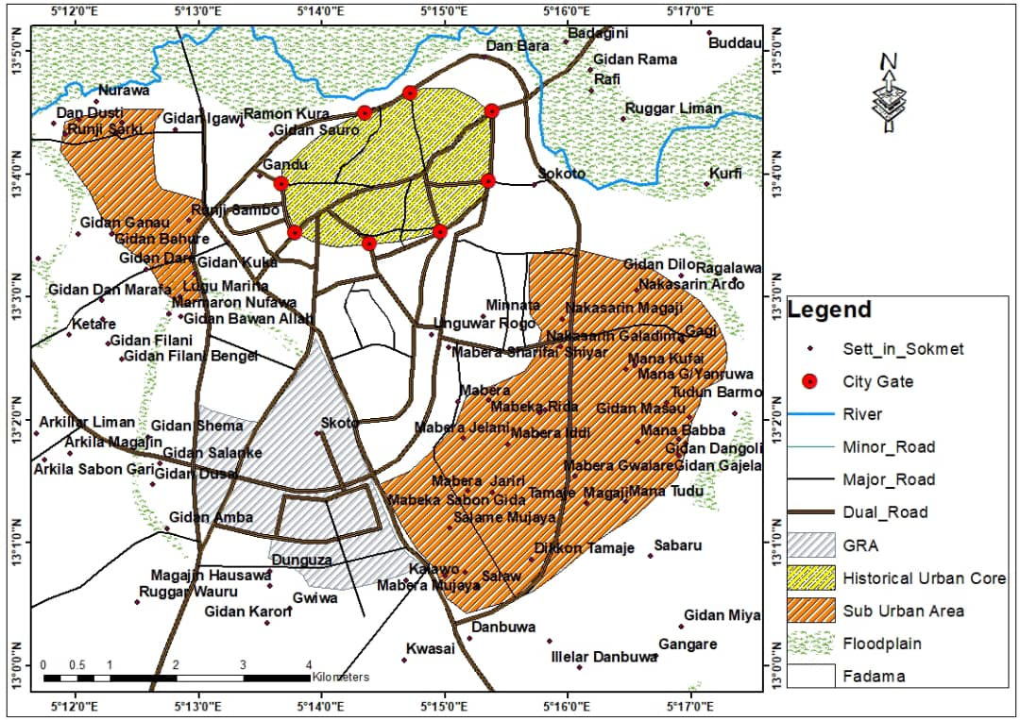
Figure 1: Map of Sokoto metropolis
Source: Adapted from Abubakar, 2020
Figure 1 classified the study area into three zones: Government Reservation Areas, historical urban core areas delineated by city gates and the sub-urban areas depicting its proximity to Fadama land. Historically, the study area has an excellent regional location combined with a strategic defensive position. A common feature of cities in Northern Nigeria is a defensive wall, and a number of city gates denoting entry points from other neighboring areas. In fact, all the known gates have been preserved in their original locations which show an indication of how rapidly the city grew.
Results and Discussions
The study revealed that majority of respondents were within the economically active age group of 31–50 years, indicating that waste generation and management practices are closely linked with household and commercial activities. Most respondents were male, although women were also actively involved in household waste handling and disposal. The educational background of respondents varied, with a significant proportion possessing primary and secondary education, while only a few had tertiary educations. Occupationally, respondents were mainly traders, civil servants, artisans, and farmers, reflecting the dominant socio-economic activities within Sokoto metropolis. These findings correlated with study of population growth and housing demand in Sokoto metropolis conducted by Audu & Badema, (2022). Household size was relatively high among respondents, which contributes significantly to the volume of waste generated. Larger households were found to produce more organic and domestic waste, especially food remnants, plastics, polythene materials, and ash from cooking activities. This finding was also confirmed by a study conducted on waste management and control problems in Sokoto metropolis by Ahmed et. al., 2021.
In Sokoto metropolis, solid waste is being mainly managed by 3 waste management organs. These are the State Ministry of Environment through the Sokoto Environmental Protection Agency (SEPA), and a private company BIOFIL TECHNOLOGIES NIGERIA LIMITED. Most respondents claimed BIOFIL TECHNOLOGIES NIGERIA LIMITED provided refuse bunkers and metal skip that are distributed at strategic locations within the metropolis, but are grossly inadequate and located at far distances from most residents. This however has made the residents of the metropolis to adopt the method of designating an open space as household solid waste dump site. Other residents have equally cultivated the habit of dumping their waste in nearby bushes and uncompleted buildings or open plots of land, and in front of drainage along major streets. Some residents indiscriminately dump waste in front of their houses while some rich individuals among them organized for the services of private firms or local scavengers who go about with wheel barrows to collect household solid wastes from homes on payment services. It is worthy to note that the study area has six approved authorized dump sites for waste collection services (figure 2, 3, 4, 5 6 & 7), for eventual transfer to disposal site. This is grossly inadequate for the for the rapidly increasing urban population of Sokoto metropolis as indicated by SEPA, 2025 report. The inadequate provision of refuse collection facilities and irregular evacuation of waste by BIOFIL contribute significantly to the proliferation of unauthorized dumpsites across the metropolis. This finding supports the observations of Dangulla & Kasimu, (2016), who linked indiscriminate waste disposal in Sokoto to the absence of designated and accessible waste collection points.
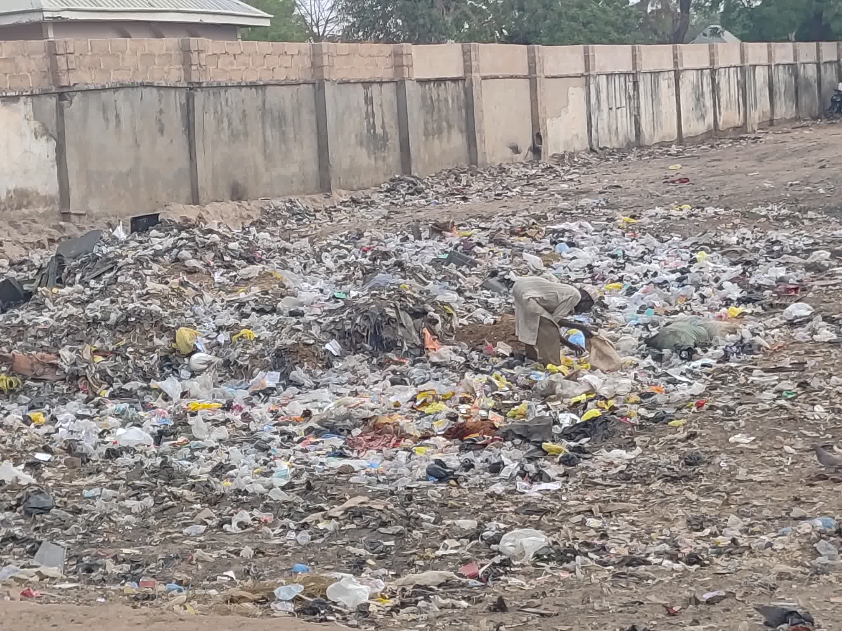

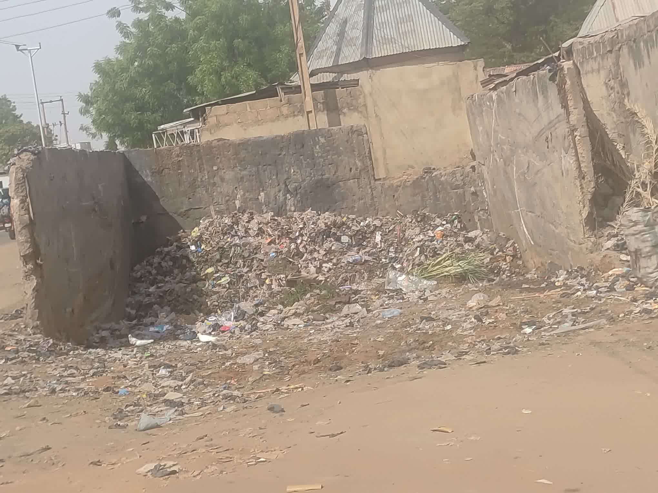

Figure 2: Waste Dumpsite at Diplomat Area, Sokoto.
Figure 3: Waste Dumpsite at Kanwuri Area, Sokoto.

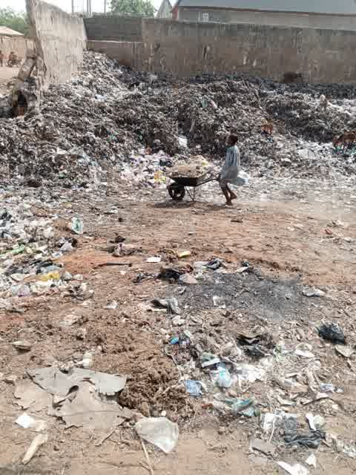

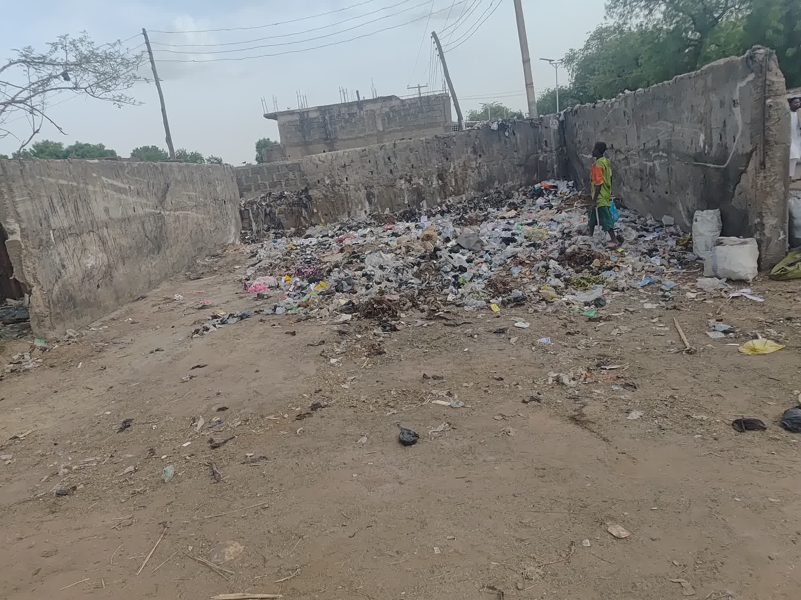

Figure 5: Waste Dumpsite at Almustapha Road, Sokoto.
Figure 4: Waste Dumpsite at Dallatu Road, Sokoto.

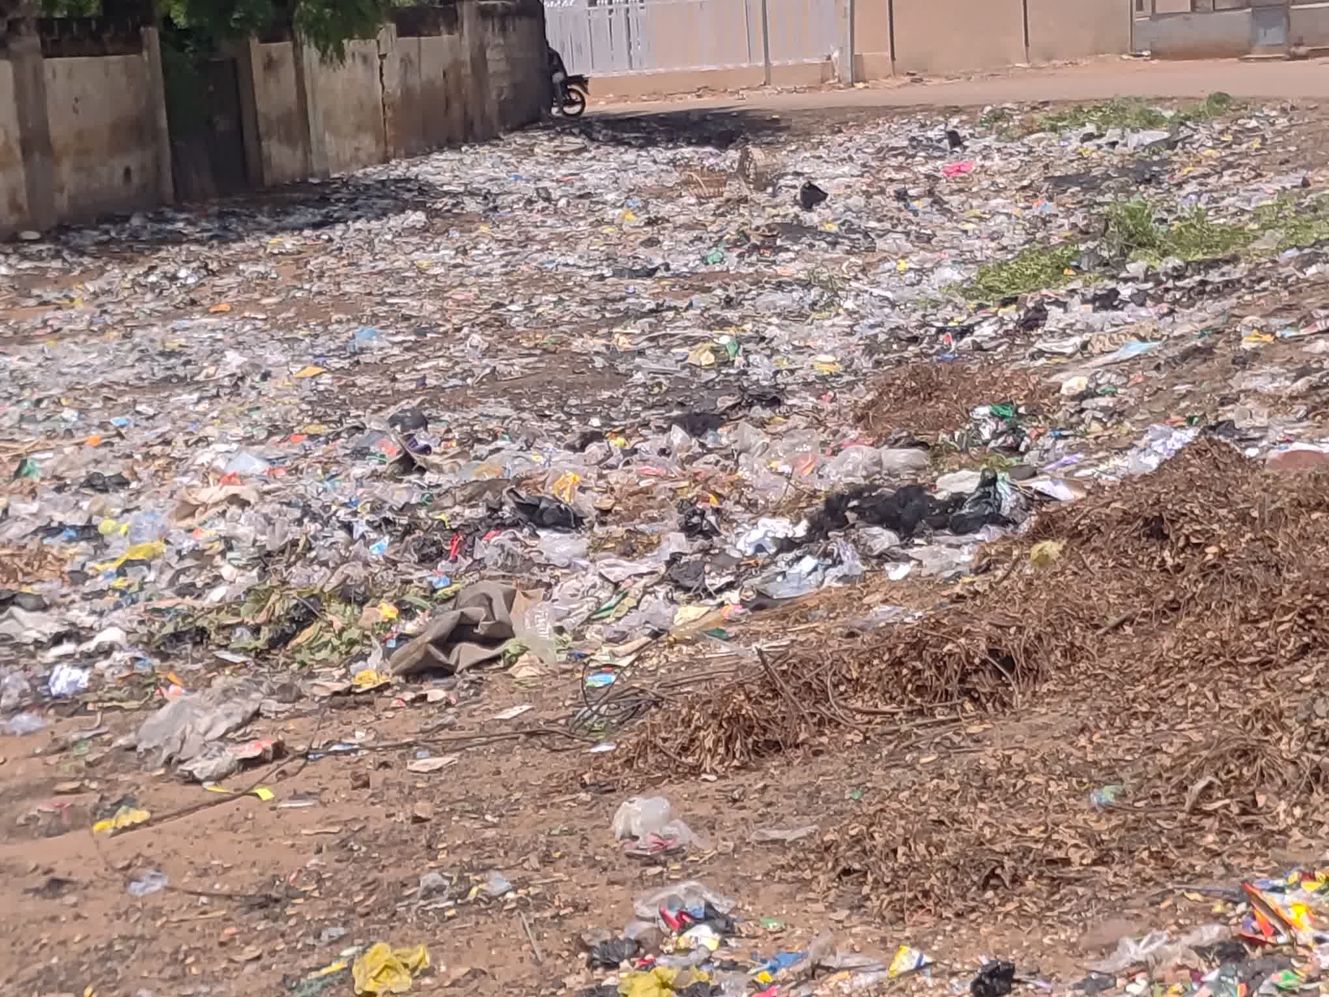

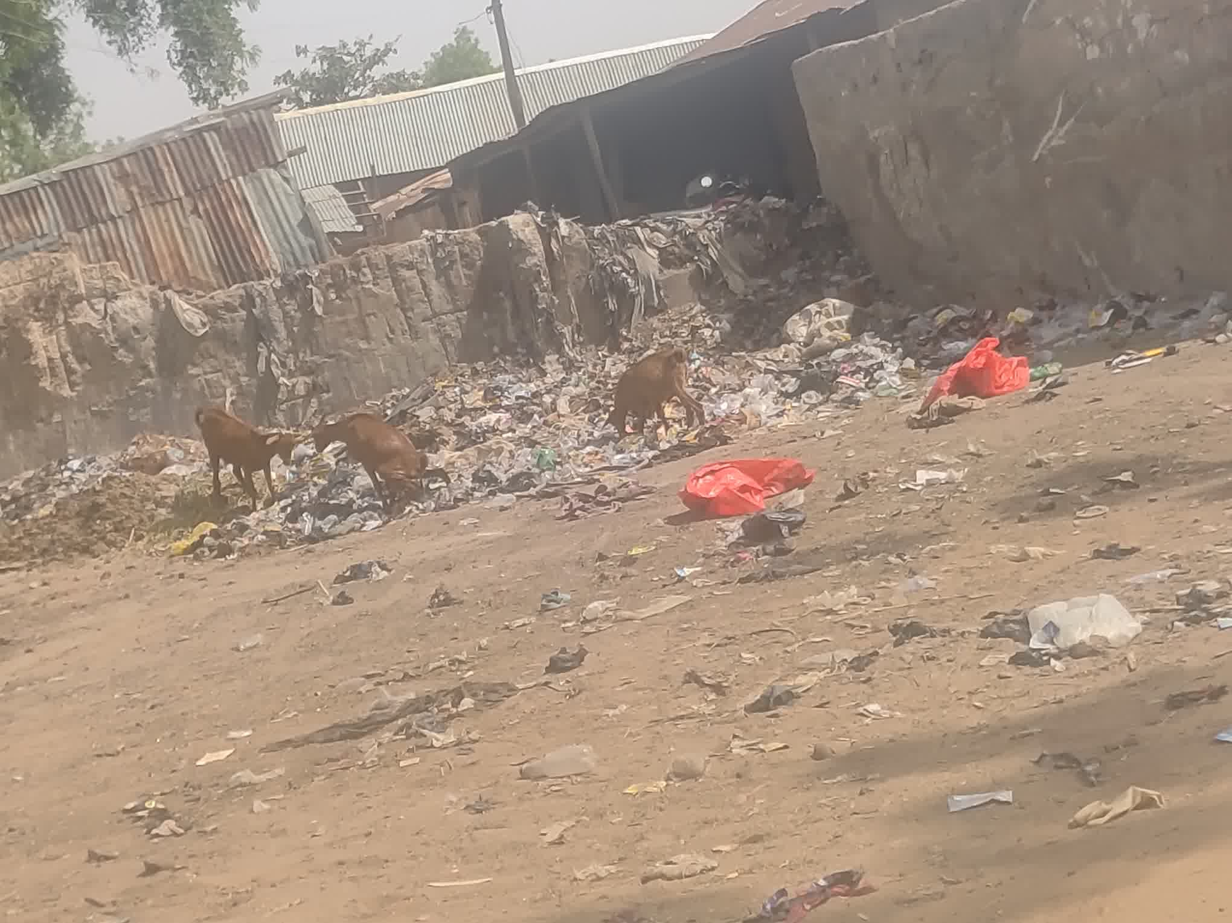

Figure 7: Kanta road, Sokoto.
Figure 6: Waste Dumpsite at Sultan Abubakar Road, Sokoto.

Findings of the study further reveal that majority of the respondents have no designated waste disposal site. This is because, four out of the six authorized dumpsites are located in the sub-urban area of the Sokoto metropolis. Leaving the traditional urban core areas of the metropolis with only two, and Government reservation areas with none. Impliedly, the agencies entrusted with managing waste in Sokoto metropolis had not taken in to cognizance how the city grew. This is highly inadequate given that the population of Sokoto urban area has reached 903,328, with an annual growth rate of 3.01%, and considering the limited capacity of the existing dumpsites as well as their inability to meet the standards required for designation as proper dumpsites under United Nations guidelines.
By the designated waste disposal sites, the study is referring to government approved sites, whereas areas without designated site as are classified as illegal dumpsites. Dumps sites otherwise known as landfills or tips are usually for burning of wastes to dispose them. Waste disposal sites are typically located away from densely populated areas, water bodies, and environmentally sensitive areas to minimize the risk of contamination. Designated waste disposal sites, are facilities specifically designed and authorized for the disposal of waste materials. These sites are carefully engineered to minimize the impact on the environment and human health. For instance, the Sokoto metropolis has only one approved waste disposal site (figure 8).
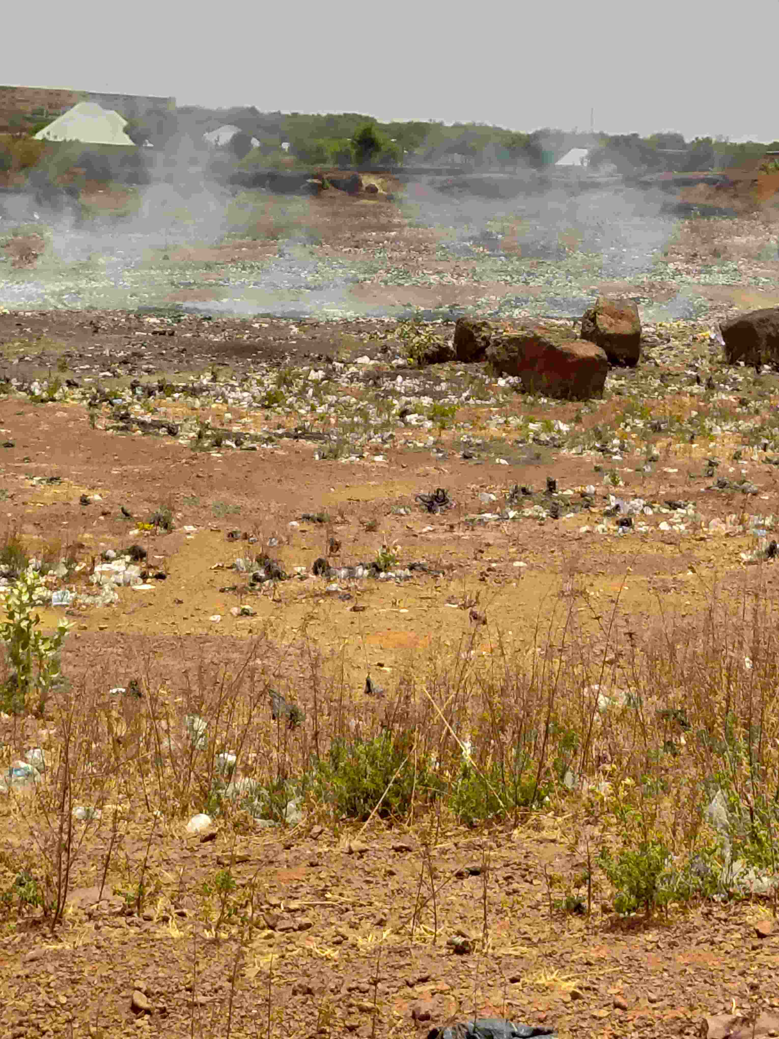

Figure 8: Waste Disposal site at Kwannawa area, Sokoto.
The study showed that waste storage practices among residents were largely inadequate. Many households used sacks, baskets, old containers, and polythene bags for temporary storage before disposal. Only a limited number of households had access to proper waste bins supplied by the private company employed by Sokoto state government. Open dumping emerged as the most common waste disposal method among respondents. Many residents disposed of waste in unauthorized open spaces, drainage channels, road sides, and vacant lands. Open burning was also widely practiced, especially in suburban and peri-urban communities where access to waste collection services was limited. The findings further revealed that waste collection by SEPA and BIOFIL was irregular in several areas, causing delays in waste evacuation, leading to accumulation of refuse around collection points.

Figure 9: Household Waste Evacuation Periods
Source: Fieldwork, 2024
The study identified several environmental problems associated with unsustainable waste management practices in Sokoto metropolis. These include: Blockage of drainage channels leading to flooding during the rainy season ad offensive Oduor from decomposing waste. Field observations confirmed that unauthorized dumpsites were commonly located near residential areas and water channels. During rainfall, waste materials were often washed into drainage systems and nearby water bodies, thereby increasing environmental contamination and health risks. Desilting of drainages is another component of waste management, it involves the removal of accumulated sediments, debris, and other materials from drainage channels to ensure the free flow of stormwater, thereby reducing the risk of flooding and environmental degradation. In many communities of the study area, these activities are largely coordinated by the communities themselves and supported by the Sokoto Environmental Protection Agency (SEPA) through evacuation of the desilted debris.
Respondents indicated that poor waste management contributes significantly to the spread of diseases such as malaria, typhoid fever, cholera, diarrhea, and respiratory infections. Open dumpsites were identified as breeding grounds for mosquitoes and other harmful organisms. Smoke generated from burning waste was also reported to cause respiratory discomfort, especially among children and elderly residents. The presence of accumulated waste around residential areas negatively affected the general sanitation and aesthetic quality of the environment. Residents expressed concern over the increasing health hazards associated with indiscriminate waste disposal practices.
This study also revealed that organized recycling activities are largely absent in Sokoto Metropolis. Nevertheless, the recovery of useful materials from waste through scavenging is widespread. Scavengers operate at both designated and unauthorized disposal sites, where they routinely collect recyclable items such as metals, plastics, and bottles for reuse or sale to scrap merchants and other buyers (Ahmed et al., 2017). Furthermore, open dumping and indiscriminate burning of waste remain the predominant waste disposal practices in residential neighborhoods as well as at both legal and illegal dump sites across the metropolis. The study also found that the use of approved sanitary landfill facilities is virtually non-existent.
Conclusion
This study examined the solid waste management practices and concludes that the existing waste management system in Sokoto Metropolis is inadequate and incapable of effectively addressing the increasing volume of solid waste generated by the growing urban population. Although waste management responsibilities are shared between the Sokoto Environmental Protection Agency (SEPA) and BIOFIL Technologies Nigeria Limited, the available refuse collection facilities, authorized dumpsites, and disposal sites are grossly inadequate relative to the population and spatial expansion of the city. The study further established that open dumping and open burning remain the dominant methods of waste disposal among residents due to limited access to designated waste collection points and irregular waste evacuation services. Consequently, recycling activities are virtually absent in Sokoto Metropolis, and unauthorized dumpsites have proliferated across residential neighborhoods, drainage channels, vacant plots, and roadside locations. These practices have resulted in environmental problems such as blockage of drainage systems, flooding and offensive odour. The absence of sanitary landfill facilities and modern waste treatment technologies further undermines the quest for the emergence of sustainable wastes management and sanitation for all by the year 2030 as enshrined in SDG indicator 6.2.1 (a).

Recommendations
- The Sokoto State Government, through SEPA and its private partners, should provide additional refuse bunkers, waste bins, metal skips, and collection points across all residential areas, particularly within the traditional urban core and densely populated neighborhoods.
- More government-approved waste transfer stations and disposal sites should be established
- Existing open dumping practices should be gradually replaced with properly engineered sanitary landfill systems that meet national and international environmental standards.
- SEPA and BIOFIL Technologies Nigeria Limited should increase the frequency and reliability of waste collection operations to prevent the accumulation of refuse at collection points and within residential areas.
- The Sokoto state government should establish recycling centres within the metropolis.
References
Abubakar, I. R., Onyebueke, V. U., Lawanson, T., Barau, A. S., & Bununu, Y. A. (2025). Urban planning strategies for addressing climate change in Lagos megacity, Nigeria. Land use policy, 153, 107524.
Abubakar, R. (2021). Socio economic status of slums dwellers in Sokoto metropolis, Nigeria.Sokoto journal of Geography and the Environment 3(1), 19-32.
Abubakar, R. I., & Abdulkadir, U. (2025). Challenges of slums dwellers in Sokoto metropolis: towards a sustainable city. Sokoto Journal of Geographical Studies, 2(1), 1-14.
Ahmed, Nathaniel Bayode Eniolorunda, Yakubu Fakai Musa & Samuel Igra (2021) Waste Management and Control Problems in Sokoto Metropolis: Projected Mitigation on the Syndrome Athens Journal of Sciences, 8: 1-20 https://doi.org/10.30958/ajs.X-Y-Z 1
Audu, I. A., & Badema, A. (2022). Assessment of Population Growth on Housing Demand in Sokoto Metropolis. Journal homepage: www. ijrpr. com ISSN, 2582, 7421.
Baldin, M. (2023). A sustainable view on entrepreneurial ecosystems: The study of the Lagos context.
Creemers, D., van Gemert, T., & Vancauteren, M. (2021). Macrotrends en handel tijdens de coronacrisis en Brexit: een tijdreeksanalyse.
Dangualla, M. & Kasimu M. Yabo. (2016). A Systematic Analysis of Urban Solid Waste Management in Nigeria. A Case of Sokoto Metropolis. Sokoto Journal of the Social Sciences. 6(2), 348-361.
Ibrahim, M. F., Hod, R., Toha, H. R., Mohammed Nawi, A., Idris, I. B., Mohd Yusoff, H., & Sahani, M. (2021). The impacts of illegal toxic waste dumping on children’s health: A review and case study from Pasir Gudang, Malaysia. International journal of environmental research and public health, 18(5), 2221.
Imam, A., Mohammed, B., Wilson, D. C., & Cheeseman, C. R. (2008). Solid waste management in Abuja, Nigeria. Waste management, 28(2), 468-472.
Isiorho, D. (2011). Chris Shannahan, Voices from the Borderland: Re-imagining Cross-cultural Urban Theology in the Twenty-first Century.
Isiorho, S. A., & Omole, D. O. (2013). Municipal Solid Wastes and Water Quality Issues in Nigeria.
Kankara, R. S., Mohan, R., & Venkatachalapathy, R. (2013). Hydrodynamic modelling of Chennai coast from a coastal zone management perspective. Journal of Coastal Research, 29(2), 347-357.
Kasarawa, A. B., Salau, I. A., & Dangaladima, W., (2020). Microbiological Quality of Air and Soil of Refuse Dump Site Areas in Sokoto Metropolis. African Journal of Environment and Natural Science Research.3(3), 92-97.
Longe, O., Maratos, F. A., Gilbert, P., Evans, G., Volker, F., Rockliff, H., & Rippon, G. (2010). Having a word with yourself: Neural correlates of self-criticism and self-reassurance. NeuroImage, 49(2), 1849-1856.
Marshall, S., & Riddle, J. (2023). A tale of hazards: Ingenium’s industrial collections move. Conservar Património, 44, 15-29.
Omokaro, G. O., Nafula, Z. S., Iloabuchi, N. E., Chikukula, A. A., Osayogie, O. G., & Nnoli, E. C (2025). Sustainable Chemistry for Climate Action.
Omole, D. O., & Isiorho, S. A. (2011). Waste management and water quality issues in coastal states of Nigeria: The Ogun State experience. Journal of sustainable Development in Africa, 13(6), 207-217.
Omole, D. O., Isiorho, S. A., & Ndambuki, J. M. (2015). Waste management practices in Nigeria: Impacts and mitigation.
Omole, D. O., Isiorho, S. A., & Ndambuki, J. M. (2016). Waste management practices in Nigeria: Impacts and mitigation.
Seadon, J. K. (2010). Sustainable waste management systems. Journal of cleaner production, 18(16-17), 1639-1651.
SEPA – Sokoto Environmental Protection Agency (2021). SEPA annual report, 2021.
SEPA – Sokoto Environmental Protection Agency (2025). SEPA annual report, 2025.
Udobia, U. J., & Akpan, I. M. (2023). Sustainable waste management and socio-economic development in Uyo Metropolis, Akwa Ibom State. AKSU J. Administr. Corpor. Gover., 3(3), 216-227.
UN Habitat. (2022). National Trend in Housing Production Practices (Vol. 4, pp. 60–69). Nigeria: United.
UNICEF. (2025). Informe Annual 2025.
Wilson, A. J., Pemberton, J. M., Pilkington, J. G., Coltman, D. W., Mifsud, D. V., Clutton-Brock, T. H., & Kruuk, L. B. (2006). Environmental coupling of selection and heritability limits evolution. PLoS biology, 4(7), e216.
World Bank. "Nigeria: Country Profile." 2015 24.10.2015]; Available from: http://bit.ly/1pyiTLE.

