Survey Paper on Predicting Drug Combination Risk Levels

Anna Rose Baiju - FIT22CS038
Department of Computer Science and Engineering FISAT, Angamaly, India

Anupama K J - FIT22CS043
Department of Computer Science and Engineering FISAT, Angamaly, India

Ierin Babu
Department of Computer Science and Engineering FISAT, Angamaly, India

Ann Maria Paul - FIT22CS039
Department of Computer Science and Engineering FISAT, Angamaly, India

Chesna Johnson - FIT22CS059
Department of Computer Science and Engineering FISAT, Angamaly, India

Abstract—Polypharmacy, the simultaneous use of multiple medications, significantly increases the risk of adverse Drug-Drug Interactions (DDIs), posing serious challenges to patient safety and healthcare systems. Traditional DDI detection methods are often binary and lack clinical interpretability, failing to provide actionable risk assessments for healthcare professionals. This survey comprehensively reviews computational approaches for DDI prediction, with a focus on Graph Neural Network (GNN) architectures and their integration with Large Language Models (LLMs) for enhanced clinical decision support. We analyze ten representative works spanning relational graph convolutional networks, meta path based heterogeneous networks, multimodal fusion frameworks, and hybrid approaches. Our analysis reveals that while GNN based methods show superior performance in capturing molecular relationships, significant gaps remain in clinical interpretability, risk level classification, and real world deployment. Building on these insights, we propose an integrated framework combining GNNs for molecular analysis with LLMs for contextual reasoning and recommendation refinement. The proposed system categorizes DDI risks into low, moderate, and high levels and suggests safer alternative drugs. We discuss the societal relevance of DDI prediction systems in promoting sustainable healthcare and their alignment with Sustainable Development Goals (SDGs). Finally, we outline future research directions including real time clinical integration, multimodal data fusion, and enhanced explainability for non-technical users.

Index Terms—Drug-Drug Interactions, Graph Neural Net- works, Polypharmacy, Clinical Decision Support, Large Lan- guage Models, Risk Prediction

- Introduction
Polypharmacy,the simultaneous use of multiple medica- tions has become increasingly common in modern healthcare, particularly for managing chronic conditions and complex treatment regimens. While clinically necessary in many cases, this practice significantly increases the risk of adverse DDIs, where medications interact in ways that can reduce treatment effectiveness, cause harmful side effects, or even lead to life
threatening complications. DDIs represent a serious challenge to patient safety and are among the leading causes of pre- ventable medication related harm in clinical settings.
Traditional methods for detecting DDIs through laboratory testing are often slow, expensive, and impractical for screening the vast number of possible drug combinations. This has led to growing interest in computational prediction methods that can analyze potential interactions more efficiently. However, most existing computational tools have a critical limitation: they typically only indicate whether an interaction exists, without providing information about how severe it might be or what its clinical implications could be. This binary approach offers insufficient support for healthcare professionals who need detailed, actionable information to make safe prescribing decisions.
To address these limitations, this paper presents a compre- hensive review of advanced computational approaches for DDI prediction, with a particular focus on GNN methods that excel at modeling molecular relationships. We examine how these approaches can be enhanced by integrating them with LLMs to improve clinical interpretability and decision support. This survey makes several key contributions:
- A thorough analysis of ten recent DDI prediction meth- ods, examining their technical approaches and identify- ing their strengths and limitations
- A comparison showing how the field has progressed from simple models to sophisticated multimodal systems
- Identification of important gaps in current research, par- ticularly regarding clinical usability and risk assessment
- Proposal of an integrated framework that combines GNNs for molecular analysis with LLMs for clinical reasoning
- Discussion of how such systems can contribute to safer healthcare practices and support sustainable develop- ment goals

By synthesizing current research and proposing new direc- tions, this work aims to advance the development of intelligent systems that can help healthcare professionals make safer, more informed decisions about medication combinations, ul- timately improving patient outcomes and healthcare quality. In recent years, the rapid growth of digital health records and biomedical databases has created new opportunities for intelligent DDI prediction systems. Large scale drug databases such as DrugBank and PubChem provide structured molecular information that can be analyzed using machine learning techniques. At the same time, advancements in graph based deep learning have improved the ability to capture complex structural relationships between drug molecules.
Despite these advancements, many available clinical tools still provide only alert based systems that do not clearly explain the level of danger associated with a drug combina- tion. Excessive alerts may also lead to alert fatigue among healthcare professionals. Therefore, there is a growing need for systems that not only detect interactions but also classify their severity and provide meaningful recommendations. This motivates the integration of graph learning methods with reasoning based models for safer and more practical clinical decision support.
- Literature Review
This section reviews ten representative studies that have sig- nificantly influenced the advancement of computational DDI prediction. The selected works are categorized based on their underlying methodologies, including graph neural networks, multi-modal learning frameworks, knowledge graph–based models, and clinically integrated approaches.
- Graph Neural Network Approaches
  - Relational Graph Convolutional Networks with Multi- Head Attention: A multi class DDI risk prediction model based on Relational Graph Convolutional Networks (RGCN) enhanced with multi head attention mechanisms was proposed in [1]. In this approach, DDI events are modeled as relation- specific edges within a heterogeneous graph, allowing explicit modeling of interaction types.
Methodology: Molecular representations are generated us- ing Morgan fingerprints, followed by dimensionality reduc- tion via Principal Component Analysis (PCA). Relation-aware message passing is performed using RGCN layers, and multi head attention is employed to distinguish and classify DDI severity levels.
Significance: This study demonstrates the effectiveness of relational graph modeling for interpretable and fine grained DDI risk prediction, establishing a foundation for severity- aware DDI classification.
  - Meta-path-Based Heterogeneous Graph Neural Net- works: A heterogeneous graph neural network framework for predicting combinatorial drug side effects using meta-path- based semantic aggregation was introduced in [2]. The model explicitly captures diverse biological relationships among drugs, proteins, and diseases.
Methodology: Meta-path-specific neighbor graphs are con- structed and processed using MAEM-SSHIN and GCN- CSHIN architectures. Performance evaluation on the dataset highlights the benefit of incorporating semantic paths in het- erogeneous biomedical networks.
Significance: This work illustrates how metapath based aggregation enhances contextual representation learning, im- proving the modeling of complex biological interactions.
  - Drug Repurposing with DTD-GNN: A hybrid graph neural network integrating GCN, GAT, and adaptive gating mechanisms to model drug–target–disease relationships was proposed in [3].
Methodology: The model introduces event nodes of the form ⟨Drug, Target, Disease⟩, enabling ternary relationship modeling. Information flow is regulated through gated graph encoders to balance heterogeneous feature contributions.
Significance: This approach demonstrates the utility of higher order relational modeling in biomedical graphs, con- tributing to both drug repurposing and interaction analysis.

- Multi-modal and Cross-modal Frameworks
  - MOSAIC: Multi-Granularity Cross-Modal Framework: A multi-granularity cross-modal learning framework designed to predict synergistic drug effects was developed in [4]. The framework jointly leverages molecule level and fragment level information.
Methodology: Molecular fragments are generated via de- composition techniques, and contrastive learning is applied to align representations across granularities. Bilinear attention mechanisms are used to capture fragment level interactions.
Significance: This framework highlights the importance of multi scale molecular representations and cross-modal feature fusion in drug interaction modeling.
  - HMMF: Hybrid Multi-Modal Fusion Framework: A Hybrid Multi-Modal Fusion (HMMF) framework integrating molecular structures, biomedical text, and attribute-based sim- ilarities was proposed in [5].
Methodology: Data sources from PubChem and biomedical literature are fused using a hybrid strategy that combines feature level and decision level integration.
Significance: Incorporating heterogeneous biomedical data sources improves the prediction of frequency specific adverse drug effects.
  - SCATrans: Semantic Cross-Attention Transformer: A se- mantic cross-attention transformer architecture for DDI predic- tion using multimodal biomedical embeddings was introduced in [6].
Methodology: Structural, textual, and contextual embed- dings derived from Graph2Vec, BioBERT, and Doc2Vec are processed using BiGRU layers and cross-attention mecha- nisms.
Significance: The model demonstrates the effectiveness of attention based multimodal fusion for capturing complex drug interaction patterns.

- Knowledge Graph and Rule-Based Approaches
TABLE I: Comparison of Reviewed DDI Prediction Ap- proaches

  - DDIs-Graph: Knowledge Graph Framework: A large-

scale knowledge graph framework for DDI detection and safer
Paper (Method) Strengths Limitations

drug recommendation was presented in [7].
Methodology: The knowledge graph contains over 26,000 nodes and 641,000 interaction edges, enabling efficient rule based querying.
He et al. (RGCN + MHA)
Tian et al. (Meta- path GNN)
Severity-aware multi- class modeling Semantic heterogeneous aggregation
High computational complexity Computational cost

Significance: Structured knowledge representations en- hance interpretability and safety aware drug recommendations.
  - Metapath Based Heterogeneous Information Networks: A metapath based heterogeneous information network model capturing semantic dependencies among drugs, proteins, and
Li et al. (DTD-GNN) Ternary
drug–target–disease modeling
Zhang et al. (MO- Multi-granularity SAIC) cross-modal fusion Liu et al. (HMMF) Multi-modal biomed-
ical integration
Large-scale data re- quirement

Complex preprocess- ing
Scalability issues

diseases was proposed in [8].
Methodology: Hierarchical attention mechanisms are ap- plied at node and meta-path levels.
Significance: Explicit modeling of semantic paths improves interpretability and performance.
Zhang et al. (SCA- Trans)
Jalali et al. (DDIs- Graph)
Tanvir et al. (Meta- path HIN)
Cross-attention explainability Knowledge-graph in- terpretability Hierarchical semantic modeling
High compute cost Ontology dependency Noise sensitivity

Abdu et al. (Clinical
Study)
Real world validation Limited automation

- Clinical and Integrated Approaches
  - Clinical Analysis of Polypharmacy in Older Adults: A large scale clinical study analyzing polypharmacy prevalence and potential DDIs among older adults was conducted in [9].
Omer et al. (Imaging
+ GCN)
Clinical and imaging data fusion

- Objectives
Data-intensive frame- work

Methodology: STOPP/START version 3 criteria and regression-based statistical analysis were employed.
Significance: The study underscores the real world impact of DDIs and the need for computational decision-support systems.
  - Medical Imaging with Graph Convolutional Networks: A multimodal framework integrating medical imaging, EHRs, and DDI networks using Graph Convolutional Networks was proposed in [10].
Methodology: Imaging features and clinical data are em- bedded into a unified graph structure.
Significance: Graph based learning enables integration of diverse biomedical data modalities in DDI analysis.
Overall, the reviewed studies demonstrate significant progress in computational DDI prediction. Graph based mod- els effectively capture structural and relational information, while multimodal approaches improve representation by com- bining molecular, textual, and clinical data. However, most systems focus either on prediction accuracy or data integration, with limited emphasis on practical usability in real healthcare environments.
Another common limitation observed across the reviewed works is the lack of clear risk stratification and recommen- dation mechanisms. Many studies report performance metrics such as accuracy and F1 score, but fewer discuss how the predictions can be directly used by healthcare professionals. This highlights the need for systems that combine predictive performance with practical interpretability and actionable out- puts.
The primary objective of this project is to develop a system that predicts DDI risks and assists healthcare professionals in making safer prescription decisions. The specific objectives are as follows:
- Predict Drug-Drug Interaction Risks: Develop a model that can analyze the molecular structure of two drugs and accurately determine the level of interaction risk, categorized as low, moderate, or high.
- Suggest Safer Alternate Drugs: When a potential high-risk interaction is detected, the system identifies alternative drugs that provide similar therapeutic effects but with a lower interaction risk.
These objectives aim to bridge the gap between computational drug interaction research and real world clinical needs. By focusing on both risk prediction and safer alternative sugges- tions, the system is designed to function as a supportive tool rather than a simple alert generator.

- System Architecture
The overall architecture of the proposed DDI risk prediction system is shown in Fig. 1. The system is designed to predict the interaction risk between two drugs and suggest safer alter- natives when necessary. It combines a GNN for risk prediction and a LLM for refining alternative drug recommendations.
First, the chemical formulas of Drug A and Drug B are processed using RDKit to generate canonical SMILES repre- sentations. SMILES provide a standard way to describe the structure of a molecule in text form. These representations are then converted into numerical feature vectors, such as molecular fingerprints, so that they can be used as input

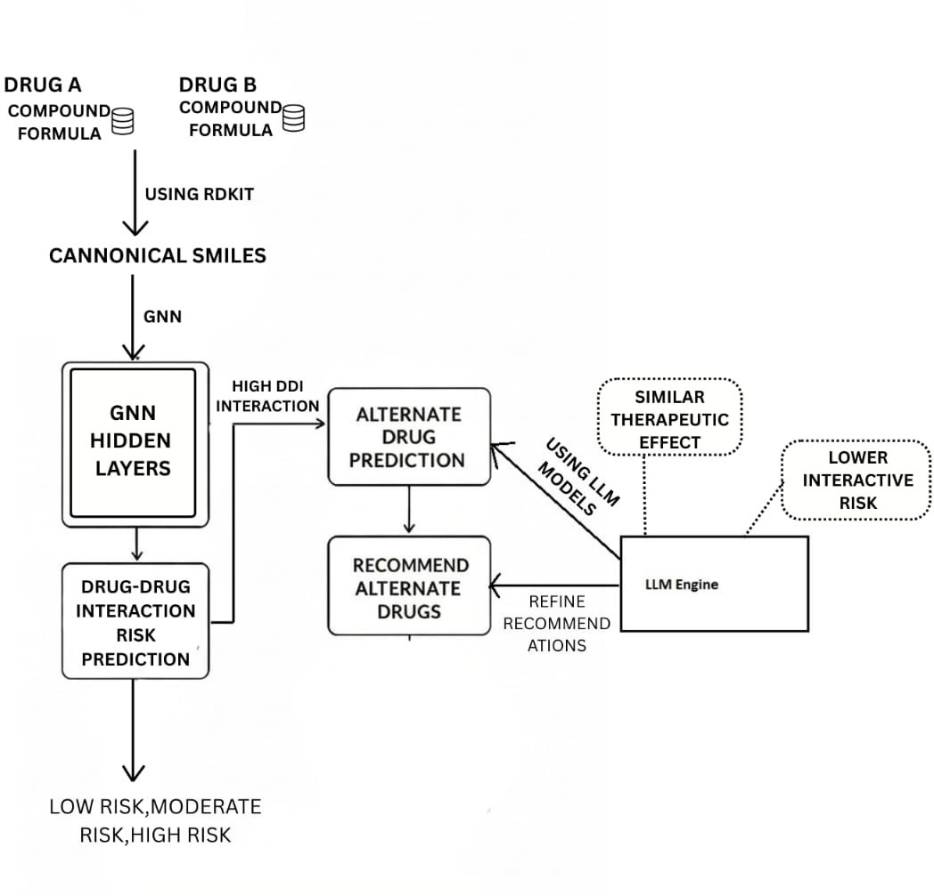
Fig. 1: System Architecture for Drug–Drug Interaction Risk Prediction and Alternative Drug Recommendation

for the learning model. This step ensures that the structural information of each drug is properly captured.
The processed features are then given to the GNN model. In this stage, each drug is treated as a graph, where atoms are nodes and chemical bonds are edges. The GNN learns patterns from the structural properties of both drugs and analyzes how they may influence each other when taken together. After learning these patterns through its hidden layers, the model predicts the DDI risk level. The output is classified into three categories: low risk, moderate risk, or high risk.
If the predicted interaction is low or moderate, the system directly reports the risk level to the user. However, if a high risk interaction is detected, the system activates the alternate drug prediction module. This module searches a drug database to find substitute drugs that provide similar therapeutic effects. The goal is to maintain the same treatment purpose while reducing the possibility of harmful interactions.
The selected candidate drugs are then passed to the LLM based reasoning module. This component reviews the sug- gested alternatives and checks whether they are suitable and safer options. It considers therapeutic similarity and interaction safety before finalizing the recommendation.
Finally, the system presents the predicted risk level along with recommended alternative drugs . This structured output helps healthcare professionals make safer and more informed prescribing decisions.
The modular design of the architecture ensures flexibility and scalability. Each component, including molecular pre- processing, graph learning, and recommendation refinement, operates as an independent unit. This design allows future
improvements, such as adding new drug databases or updating learning models, without restructuring the entire system. Such flexibility is important for adapting to evolving biomedical knowledge and expanding clinical requirements.
- Algorithm
The DDI prediction system follows a structured, rule based, and learning-driven algorithm that aligns with the system architecture and logical design.

Algorithm 1 DDI Risk Prediction and Alternative Drug Recommendation Require: Drug A, Drug B (chemical compound formulas)
Ensure: DDI risk level and safer alternative recommendation
(if required)

1: Step 1: Molecular Representation
2: Process Drug A and Drug B using RDKit 3: Generate canonical SMILES representations 4: Normalize molecular structures

5: Step 2: Graph Neural Network Processing
6: Convert SMILES into graph-based molecular structures
7: Feed molecular graphs into GNN
8: Extract interaction feature representations

9: Step 3: Risk Prediction
10: Predict DDI risk level
11: Classify risk as Low, Moderate, or High

12: if Risk = High then
13: Trigger alternate drug prediction module
14: Identify drugs with similar therapeutic properties
15: Refine recommendations using LLM engine
16: Return safer alternative drugs
17: else
18: Return predicted risk level
19: end if

- Results
The implemented system demonstrates the effectiveness of a GNN based approach for classification of drug interaction severity. Molecular structures are converted from SMILES into graph representations, where atoms and bonds are encoded as nodes and edges. Structural features are extracted through graph convolution layers, enabling the model to learn mean- ingful patterns related to drug interaction behavior.
The trained GNN model classifies drug pairs into risk categories . The use of graph based learning ensures that interaction prediction is grounded in molecular structure rather than surface level similarity.
To enhance safety, a cascaded decision framework is ap- plied. If the GNN predicts a high risk interaction, this re- sult is prioritized over other reasoning outputs. This ensures conservative decision making in safety critical scenarios. The integration of LLM based reasoning further refines alternative drug suggestions .

Overall, the experimental observations indicate that com- bining molecular graph learning with contextual reasoning improves both prediction reliability and interpretability. The system produces structured outputs that are easier for health- care professionals to understand and apply in clinical decision making.
- Conclusion
This work addressed the important healthcare challenge of polypharmacy and DDIs through a computational framework for risk prediction and safer drug recommendation. Unlike traditional binary interaction detection methods, the proposed approach focuses on multilevel risk classification, providing clinically meaningful insights.
The study identified key limitations in existing DDI pre- diction models, including limited interpretability and lack of contextual reasoning. To overcome these challenges, a hybrid framework integrating GNNs and LLMs was proposed. The GNN component analyzes molecular structures and relational drug information, while the LLM enhances contextual reason- ing and supports refined alternative drug recommendations.
The architecture combines RDKit based molecular pro- cessing, graph based interaction modeling, and intelligent recommendation mechanisms to classify interactions as low, moderate, or high risk. When high-risk interactions are de- tected, the system suggests safer alternative drugs with similar therapeutic effects.
Overall, the proposed framework provides a structured and intelligent approach to DDI risk assessment and clinical de- cision support. It has strong potential to improve prescription safety and reduce adverse drug reactions.
Future work can focus on implementing and validating the system using large scale real world clinical datasets. The model can be further improved by incorporating patient spe- cific factors such as age, medical history, and dosage informa- tion. Enhancing explainability, expanding drug databases, and performing clinical validation studies will further strengthen the reliability and practical applicability of the proposed system.
- A. Jalali, P. Johannesson, and E. Perjons, “DDIs-Graph: An approach to identify drug-drug interactions and recommend alternative drugs,” in Recent Advances in Drug Discovery and Bioinformatics. Cham, Switzerland: Springer, 2024.
- F. Tanvir, K. Saifuddin, M. Islam, and E. Akbas, “DDI prediction with heterogeneous information network: Meta-path based approach,” IEEE/ACM Transactions on Computational Biology and Bioinformatics, 2024.
- N. Abdu, S. Idrisnur, and H. Said, “Inappropriate medication prescribing, polypharmacy, potential drug-drug interactions, and medication regimen complexity in older adults,” BMC Geriatrics, 2025.
- O. N. Dara, A. Ibrahim, and T. Mohammed, “Advancing medical imaging: Detecting polypharmacy and adverse drug effects with graph convolutional networks,” Journal of Medical Imaging and Health Infor- matics, 2025.

References
- W. Zhang, C. Li, and M. Zhao, “Accurate prediction of drug combination risk levels based on relational graph convolutional network and multi- head attention,” IEEE Access, 2024.
- L. Tian, Q. Wang, and Z. Zhou, “Predicting drug combination side ef- fects based on a meta-path-based heterogeneous graph neural network,” BMC Bioinformatics, 2025.
- W. Li, W. Ma, M. Yang, and X. Tang, “Drug repurposing based on the DTD-GNN graph neural network: Revealing the relationships among drugs, targets, and diseases,” BMC Genomics, 2024.
- L. Zhang, X. Kang, and X. Yang, “MOSAIC: A multi-granularity cross- modal framework for predicting synergistic drug combinations,” IEEE Journal of Biomedical and Health Informatics, 2025.
- W. Liu, J. Zhang, and G. Qiao, “HMMF: A hybrid multi-modal fusion framework for predicting drug side effect frequencies,” BMC Bioinformatics, 2024.
- S. Zhang, C. Yu, and C. Zhang, “SCATrans: Semantic cross-attention transformer for drug-drug interaction prediction through multimodal biomedical data,” BMC Bioinformatics, 2025.

