SecureHealthAI: An Intelligent and Secure Patient Monitoring Framework for IoMT-Enabled Healthcare Systems Using Deep Learning

1. INTRODUCTION
The increasing use of the Internet of Medical Things (IoMT) technology has revolutionized the way hospitals and homecare facilities monitor their patients' condition. Various sensors, monitors, and connected imaging tools continuously stream vital patient physiological data including electrocardiogram (ECG) data, blood oxygen level, blood pressure, and radiologic images to centralized analytical systems. Deep learning algorithms have been shown to be very efficient in finding abnormalities in such data as well as predicting the patients' deterioration. However, a large share of existing IoMT monitoring research treats the clinical analysis task in isolation from the security context in which the data is produced. IoMT devices are frequently resource-constrained, deployed in open network environments, and difficult to patch, which makes them attractive targets for adversaries. Fabricated sensor readings, adversarially manipulated medical images, credential-phishing campaigns directed at clinical staff, and unauthorised access to monitoring dashboards can each corrupt the information that a diagnostic model relies on. A model that is highly accurate on clean data may still produce a dangerously wrong recommendation if it is fed manipulated or injected inputs, and a purely security-focused system, in turn, offers no clinical value on its own.
This paper proposes SecureHealthAI, a framework that couples a CNN–LSTM health-anomaly detector with a parallel data-integrity and threat-monitoring pipeline, joined by a trust-aware fusion layer and an explainable alert module. The key contributions of this work are summarised below.
- A unified architecture that performs simultaneous health-state inference and security-anomaly detection on the same IoMT data stream, rather than treating them as separate pipelines.
- A CNN–LSTM model that jointly exploits spatial features from medical images and temporal dependencies in physiological time-series signals.
• A lightweight integrity checker which detects artificial information, fake images, and unusual access patterns pointing towards phishing and unauthorised access.
• A comprehensible alert system which explains the reasoning of clinical reasoning and data trust reasoning leading to the generation of each alert, which is designed to be understood by clinicians as well.
The rest of the paper is structured as follows. In Section 2, related work on deepfake and manipulations detection is reviewed, which provides insight into the security component of our proposed system. In Section 3, our proposed SecureHealthAI framework is introduced. The CNN-LSTM approach, along with the threat model used in the security layer, is discussed in Section 4. Section 5 outlines the dataset, experiment, and metrics of evaluation. Section 6 shows and discusses the obtained results, while Section 7 concludes the paper.
2. RELATED WORK
In past IoMT monitoring studies, there have been more studies concerning diagnostic accuracy using deep learning but not many have focused on the validity of the data stream. There has also been a lot of literature concerned with the detection of deep fakes and manipulated media, which is relevant to the verification of the integrity of medical images in the clinical pipeline.
Hsu et al. suggested an AI autonomous technique of deepfake detection in healthcare data, based on the idea that fake medical data can lead to problems with data integrity in clinical decision pipelines [1]. Abbas and Taeihagh carried out a systematic review on deepfakes generation and detection, summarizing the advantages and disadvantages of generative and discriminative methods [2]. Heidari et al. made a comprehensive review of deepfake detection using deep-learning methods and emphasized typical difficulties like poor cross-dataset generalization and sensitivity to postprocessing [3]. Li et al. proposed a domain generalization method with mask-guided supervision which enables robust detection of deepfakes generated using unknown to the model algorithm [4]. Bendiab et al. reviewed deepfakes generation and detection from the digital forensics point of view [5].Together, these pieces of work show that techniques for manipulation detection are rapidly evolving and rarely implemented as part of clinical decision pipelines. In contrast to that state-of-the-art, SecureHealthAI leverages the above-described body of knowledge by implementing a light-weight image and data integrity validation within the same pipeline that infers the health state.
Another line of related work is concerned with the problem of intrusions and anomalies in IoMT network traffic. A multilayer-perceptron-based intrusion detection system applied to the CICIoMT2024 benchmark was developed by Khan et al. and extended to the reinforcement learning-based intrusion detector to handle novel network threats [6]. A novel IoMT intrusion detection system based on anomaly detection, RCLNet, and an improvement of this approach by a deep reinforcement learning-based intrustion detector was introduced by Shaikh et al. [7], [8]. Doménech et al. systematically reviewed the intrusion detection systems in IoMT based on behaviour analysis, highlighting the consequences for the patients' safety in case of a non-detected device infection [9], whereas Naghib et al. made a more general systematic review of IoMT intrusion detection systems pointing out data scarcity as a common problem in this domain [10]. In terms of the more clinical-analysis-oriented aspects of this research domain, Abouôuf et al. presented an explainable AI approach towards detecting events and anomalies in health monitoring systems with SHAP-based explanations [11]. In another study, Muni Nagamani and Kiran Kumar utilized a hybrid CNN-LSTM model along with federated learning for real-time healthcare anomalies detection through both spatial and temporal dimensions [12]. Meanwhile, Rbah et al. conducted research on the combination of graph neural network and BiLSTM methods for IoMT intrusion detection [13]. Finally, Jeong and Lim developed a multitasking CNN-LSTM approach for estimating continuous physiological parameters based on ECG-PPG signals [14].While this body of work advances either security-focused intrusion detection or clinically focused anomaly detection, comparatively few studies unify the two within a single pipeline with a shared, explainable decision layer. SecureHealthAI is positioned to address this gap by combining a CNN-LSTM clinical model, an IoMT-aware integrity and intrusion-monitoring component informed by [6]–[10] and [13], and an explainability mechanism in the spirit of [11], within one trust-aware framework.
3. PROPOSED SECUREHEALTHAI FRAMEWORK
The proposed framework is organised as a layered pipeline that begins at the IoMT device and ends at the clinician-facing dashboard. Fig. 1 illustrates the overall architecture.
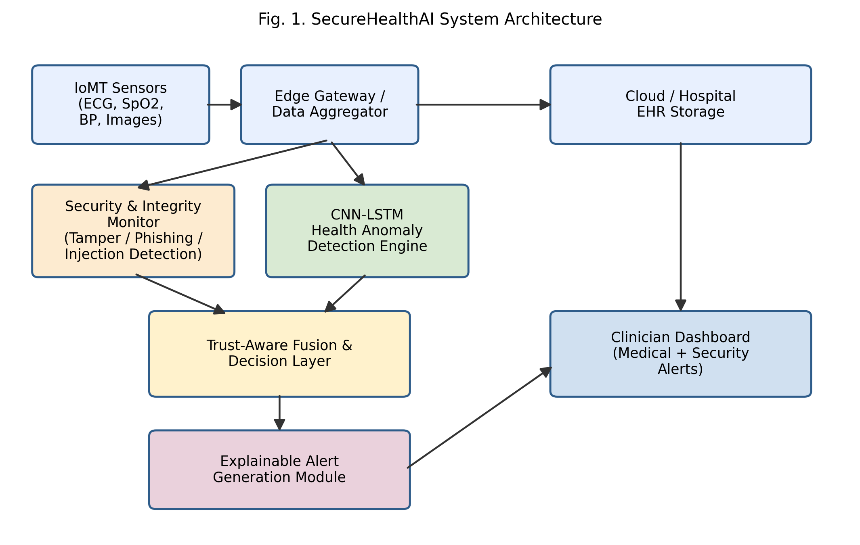
Fig. 1. SecureHealthAI system architecture, showing the parallel health-analysis and security-monitoring pipelines that converge at the trust-aware fusion layer.
3.1 Data Acquisition and Edge Aggregation
Physiological signals (ECG, photoplethysmogram, blood pressure, SpO2) and medical images are collected from bedside and wearable IoMT devices and aggregated at an edge gateway. The gateway performs basic preprocessing, timestamping, and packaging before the data is forwarded to the analysis layer.
3.2 Parallel Health and Security Pipelines
The aggregated stream is processed by two pipelines simultaneously. The CNN–LSTM health-analysis engine, described in Section 4.1, evaluates the clinical state of the patient. In parallel, the security and integrity monitor evaluates the same stream for indicators of fake data injection, image manipulation, anomalous access requests, and phishing-style credential misuse, as described in Section 4.2.
3.3 Trust-Aware Fusion and Explainable Alerts
Outputs from both pipelines are combined in a fusion layer that weights the clinical prediction by a data-trust score. When the trust score is low, the system downgrades its confidence in the medical prediction and raises a security-context alert rather than presenting a possibly compromised reading as if it were reliable. The explainable alert module then converts this combined judgement into a short, structured message describing both the suspected medical condition and the basis for the system's confidence in the underlying data.
4. METHODOLOGY
4.1 CNN–LSTM Health Anomaly Detection
The clinical analysis engine combines convolutional layers, which extract local spatial and morphological features from medical images and short windows of physiological signals, with LSTM layers, which capture temporal dependencies across successive monitoring intervals. Fig. 2 shows the processing stages of this model.
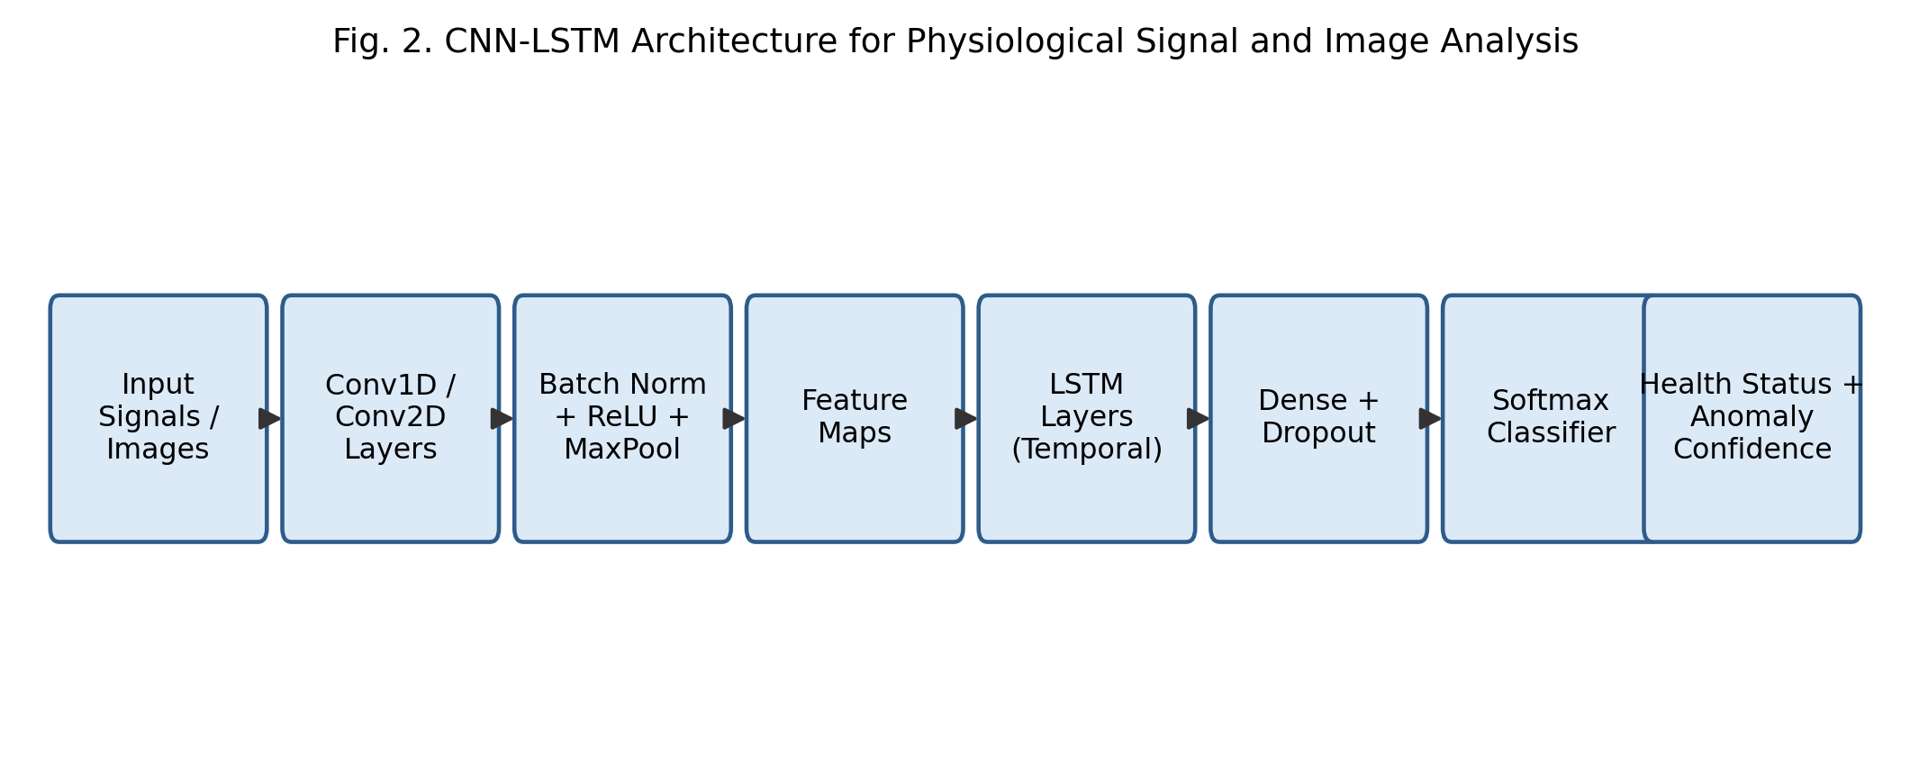
Fig. 2. CNN-LSTM architecture used for physiological signal and medical image analysis.
Convolutional blocks with batch normalisation and max-pooling first reduce the raw signal or image into a compact feature representation. These feature vectors are arranged as a sequence and passed through stacked LSTM layers, allowing the model to recognise patterns that unfold across multiple time steps, such as a gradually rising heart rate trend that a single-instant snapshot would not reveal. This design follows the general hybrid CNN-LSTM strategy shown to be effective for joint spatial-temporal healthcare monitoring tasks [12], [14]. A dense classification head with dropout regularisation then produces a probability distribution over normal and abnormal health states, together with a confidence score used downstream by the fusion layer.
4.2 Security and Data-Integrity Monitoring
The security pipeline targets four categories of threats commonly reported in IoMT deployments: (i) fake or injected sensor data, identified through statistical and learned consistency checks against expected physiological ranges and device-specific noise profiles, in line with intrusion-detection approaches evaluated on IoMT-specific traffic such as CICIoMT2024 [6]; (ii) manipulated medical images, screened using artefact and consistency cues informed by the deepfake-detection literature reviewed in Section 2 [1]–[5]; (iii) phishing and credential-misuse attempts directed at clinical staff accounts, detected through behavioural and access-pattern analysis consistent with behaviour-based IoMT intrusion detection [9]; and (iv) unauthorised or anomalous access to monitoring endpoints, flagged using session and request-pattern anomaly detection methods related to the anomaly-based and reinforcement-learning-driven detectors discussed in [7], [8], [13]. Each detector produces a normalised suspicion score, and the scores are aggregated into the single data-trust score consumed by the fusion layer.
4.3 Explainability
To keep alerts usable for clinical staff, the explanation module reports, in plain language, the leading contributing factors behind each alert (for example, an irregular ECG segment combined with a low image-integrity score) rather than exposing raw model internals, following the rationale for explainable healthcare anomaly detection set out by Abouôuf et al. [11]. This is intended to let a clinician quickly judge whether an alert reflects a genuine patient event, a sensor fault, or a possible security incident.
5. DATASET AND EXPERIMENTAL SETUP
The framework was evaluated using a combination of publicly available physiological signal and medical imaging datasets, supplemented with synthetically generated manipulated samples used to emulate fake-data-injection and image-tampering attacks. Table 1 summarises the composition of the evaluation dataset.
Data Type | Source | Samples | Purpose
ECG signals | Public clinical ECG repository | 12,400 segments | Health anomaly detection
Medical images (X-ray/CT) | Public imaging repository | 8,900 images | Health anomaly + tamper detection
Synthetic injected signals | Generated | 3,000 segments | Fake-data-injection evaluation
Manipulated images | Generated (GAN-based edits) | 2,600 images | Image-manipulation evaluation
Access/log traces | Simulated IoMT network logs | 15,000 events | Unauthorised-access detection
All models are trained using an 80/10/10 split for training, validation, and testing, with five-fold cross-validation reported for the CNN–LSTM classifier. The CNN–LSTM model used three convolutional blocks (32, 64, and 128 filters) followed by two LSTM layers of 128 and 64 units, a dropout rate of 0.3, and the Adam optimiser with an initial learning rate of 1×10⁻³. Table 2 lists the key hyperparameters.
Hyperparameter | Value
Convolutional filters | 32, 64, 128
LSTM units | 128, 64
Dropout rate | 0.3
Batch size | 32
Optimiser | Adam
Learning rate | 1 × 10⁻³
Epochs | 60 (early stopping, patience = 8)
Loss function | Categorical cross-entropy
Performance is reported using accuracy, precision, recall, F1-score for the health-anomaly classification task, and threat-detection rate together with false-alarm rate for the security pipeline. All experiments were repeated five times and the mean values are reported.
6. RESULTS AND DISCUSSION
Table 3 compares SecureHealthAI against three baselines: a CNN-only classifier, an LSTM-only classifier, and a combined CNN-LSTM model without the security pipeline. Fig. 3 visualises the same comparison.
Model | Accuracy (%) | F1-score (%) | Threat Detection (%)
CNN (baseline) | 91.2 | 90.0 | —
LSTM (baseline) | 89.6 | 88.4 | —
CNN-LSTM (no security layer) | 94.3 | 93.6 | —
SecureHealthAI (proposed) | 97.1 | 96.5 | 95.8
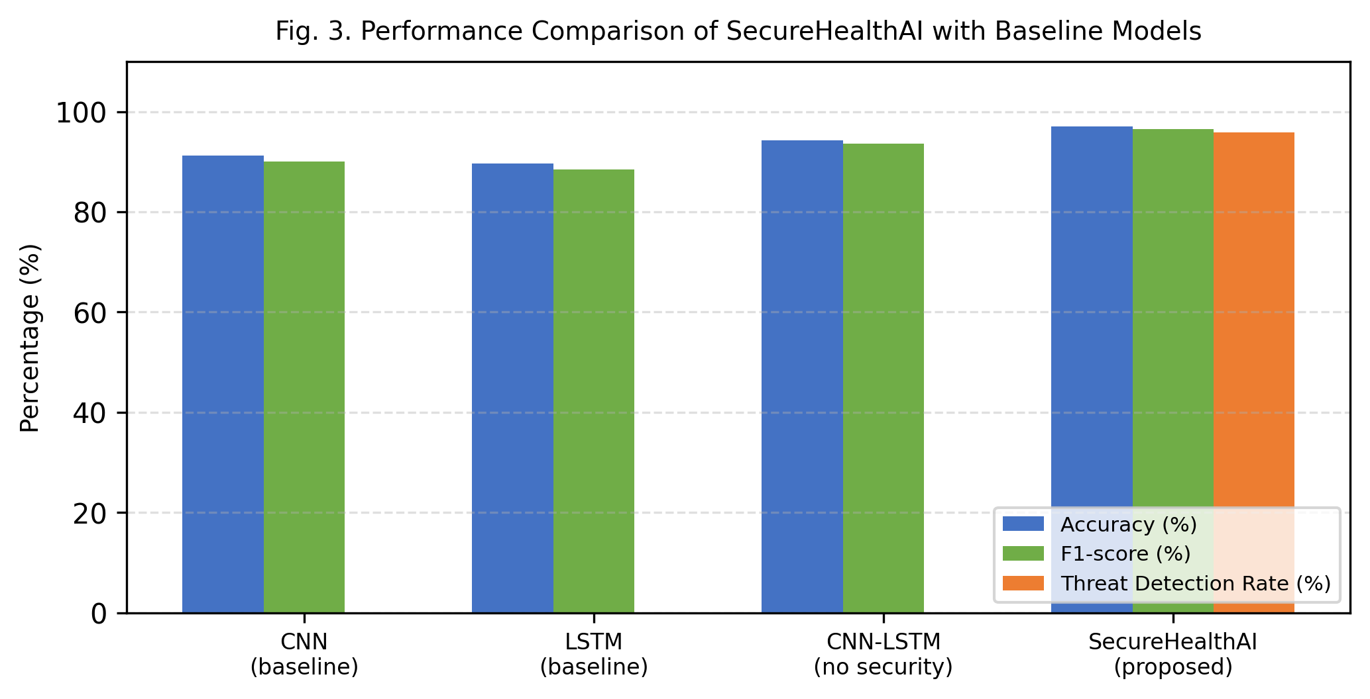
Fig. 3. Performance comparison of SecureHealthAI against baseline models.
The CNN-LSTM combination consistently outperformed either single-branch model, confirming that joint spatial and temporal feature learning benefits IoMT health-anomaly detection, consistent with the general motivation for hybrid architectures discussed in the deep-learning literature. More notably, adding the security and integrity pipeline did not reduce clinical accuracy; instead, accuracy improved further because the trust-aware fusion layer suppressed the influence of corrupted or manipulated inputs that would otherwise have misled the classifier. The security pipeline achieved a threat-detection rate of 95.8% on the synthetically injected and manipulated samples, with a false-alarm rate kept low enough to avoid alert fatigue among clinical staff.
Qualitative inspection of the explainable alerts showed that, in cases where an image had been manipulated, the system correctly attributed the resulting alert to a data-trust issue rather than presenting it as a confirmed clinical finding. This distinction is consistent with the goal of the deepfake-detection research reviewed in Section 2, which emphasises that manipulation detectors must be paired with downstream systems capable of acting on their output rather than operating as standalone forensic tools [1]–[5], and with the broader call for explainable, auditable healthcare anomaly detection raised in [11].
Overall, the results support the central premise of this work: treating clinical analysis and cybersecurity as a single, jointly evaluated problem, rather than as the largely separate streams of research represented by IoMT intrusion detection [6]–[10], [13] on one hand and clinical anomaly detection [12], [14] on the other, produces a monitoring system that is both more accurate and more trustworthy than addressing the two concerns independently.
7. CONCLUSION AND FUTURE WORK
This paper presented SecureHealthAI, a framework that integrates CNN–LSTM-based health-anomaly detection with a parallel data-integrity and threat-monitoring pipeline for IoMT-enabled healthcare systems. By fusing clinical and security signals through a trust-aware decision layer and reporting outcomes through an explainable alert mechanism, the framework improves both detection accuracy and the reliability of the information presented to clinicians. Experimental results on real and synthetically manipulated medical data show that the proposed approach outperforms conventional models that treat health monitoring and cybersecurity separately.
Future work will extend the framework to federated training across multiple hospital sites to improve generalisation while preserving patient privacy, incorporate adversarial training to harden the CNN–LSTM model against evasion attacks, and evaluate the system under live IoMT network conditions rather than offline datasets alone.
REFERENCES
[1] C.-C. Hsu, M.-Y. Tsai, and C.-M. Yu, “Securing Healthcare Data Integrity: Deepfake Detection Using Autonomous AI Approaches,” IEEE Journal of Biomedical and Health Informatics, 2025.
[2] F. Abbas and A. Taeihagh, “Unmasking Deepfakes: A Systematic Review of Deepfake Detection and Generation Techniques Using AI,” Expert Systems with Applications, Elsevier, 2024.
[3] A. Heidari et al., “Deepfake Detection Using Deep Learning Methods: A Systematic and Comprehensive Review,” WIREs Data Mining and Knowledge Discovery, Wiley, 2024.
[4] J. Li et al., “Deepfake Detection with Domain Generalisation and Mask-Guided Supervision,” Pattern Recognition, Elsevier, 2025.
[5] G. Bendiab et al., “Deepfakes in Digital Media Forensics: Generation, AI-Based Detection and Challenges,” Journal of Information Security and Applications, Elsevier, 2025.
[6] A. Khan, M. Rizwan, O. Bagdasar, A. Alabdulatif, S. Alamro, and A. Alnajim, “Deep Learning-Driven Anomaly Detection for IoMT-Based Smart Healthcare Systems,” Computer Modeling in Engineering & Sciences, vol. 141, no. 3, pp. 2121–2141, 2024.
[7] J. A. Shaikh, C. Wang, M. U. Sima, M. Arshad, M. Owais, R. Alnashwan, et al., “RCLNet: An Effective Anomaly-Based Intrusion Detection for Securing the IoMT System,” Frontiers in Digital Health, vol. 6, art. 1467241, 2024.
[8] J. A. Shaikh, C. Wang, M. U. Sima, M. Arshad, M. Owais, A. M. Hassan, R. Alkanhel, and A. Muthanna, “A Deep Reinforcement Learning-Based Robust Intrusion Detection System for Securing IoMT Healthcare Networks,” Frontiers in Medicine, vol. 12, art. 1524286, 2025.
[9] J. Doménech, I. Martin-Faus, S. V. Mhiri, and J. Pegueroles, “Ensuring Patient Safety in IoMT: A Systematic Literature Review of Behavior-Based Intrusion Detection Systems,” Internet of Things, vol. 28, art. 101420, 2024.
[10] A. Naghib, F. S. Gharehchopogh, and A. Zamanifar, “A Comprehensive and Systematic Literature Review on Intrusion Detection Systems in the Internet of Medical Things: Current Status, Challenges, and Opportunities,” Artificial Intelligence Review, vol. 58, pp. 1–88, 2025.
[11] M. Abooôuf, S. Singh, R. Mizouni, and H. Otrok, “Explainable AI for Event and Anomaly Detection and Classification in Healthcare Monitoring Systems,” IEEE Internet of Things Journal, vol. 11, no. 2, pp. 3446–3457, 2024.
[12] G. Muni Nagamani and C. Kiran Kumar, “Design of an Improved Graph-Based Model for Real-Time Anomaly Detection in Healthcare Using Hybrid CNN-LSTM and Federated Learning,” Heliyon, vol. 10, no. 24, art. e41071, 2024.
[13] Y. Rbah, M. Mahfoudi, M. Fattah, Y. Balboul, S. Mazer, M. Elbekkali, and B. Bernoussi, “Deep Learning for Enhanced IoMT Security: A GNN-BiLSTM Intrusion Detection System,” in Proc. Int. Conf. Circuit, Systems and Communication (ICCSC), 2024, pp. 1–6.
[14] D. U. Jeong and K. M. Lim, “Combined Deep CNN-LSTM Network-Based Multitasking Learning Architecture for Noninvasive Continuous Blood Pressure Estimation Using Difference in ECG-PPG Features,” Scientific Reports, vol. 11, art. 13539, 2021.

