EFFECTS OF MIGRATION ON PUBLIC UTILITIES IN EKPOMA, EDO STATE NIGERIA.

ABSTRACT
The study examined the effects of migration on public utilities in Ekpoma. The aim of this study is to examine the effects of migration on public utilities in Ekpoma, Edo State. The specific objectives are to: Identify the factors contributing to migration in Ekpoma, assess the impact of migration on public utilities in Ekpoma, examine the consequences of overstretched public utilities in Ekpoma and to Suggest strategies for improving the efficiency and management of public utilities in Ekpoma. Both primary and secondary data collection methods were employed in the study. Descriptive statistics, such as frequencies, tables, percentages, and charts, were utilized to summarize responses from the questionnaires distributed. Inferential statistical techniques (Chi-square test), was used to examine relationships between migration and the effects of migration on public utilities. Correlation analysis was also applied to measure the strength of the relationship between migration and utility demand. Ekpoma has a total of 92,217 population (NPC, 2006), one quarter of the population were taken as sample size which is 21738.5 and 1% as sample frame which gives us a total of 230 respondents. A simple random sampling method was then applied within each stratum (ward) to select respondents. The study found that, rural-urban migration significantly affects public utilities in Ekpoma and recommends: Government investment more in Public Utilities development and improvement in Ekpoma, encourage Public-Private Partnerships (PPP), government to initiate and encourage affordable Housing Policies, improved Urban Planning, involve in Public Transport Development, encourage Community Awareness and Participation in utility management, Strengthening Rural Development Initiatives, Implementing a Systems Approach to Migration Management, Promoting Inclusive Urban Planning, Enhancing Data Collection and Research, Fostering Economic Opportunities in Rural Area as well as Strengthening Institutional Frameworks. These will in no small measure reduce the effects of migration on public utilities in Ekpoma.
Key words: Effects, Migration, Public, Utilities, Ekpoma.
1. INTRODUCTION
The study of migration is not new in geographic literatures. Much of the economics literatures in the past focused on voluntary migrations responding to labor market conditions. There is now increasing realization among economists, sociologist and geographers that migration choices are not solely driven by differences in labor market outcomes between destination and origin areas and that other factors, such as amenity differences, war, draught, insecurity etc are also important considerations. Involuntary migration due to climate change, wars and conflicts is also becoming increasingly more frequent in developing countries like Nigeria. It is no longer news that most of the migrants in Ekpoma apart from students’ populations are those from Benue, Plateau and Kogi state who fled their home land as a result of insecurity.
A surge of involuntary migration is expected in Nigeria and in the Africa region due to droughts, insecurity and across Asia due to sea level rise (Hauer et al., 2020). Conflicts around the world produced a sizeable number of internally displaced population with 50.8 million internally displaced persons at the end of 2019, 45.7 million due to conflict and 5.1 million due to disasters, the highest figures ever recorded (Internal Displacement Monitoring Centre and Norwegian Refugee Council, 2020). How these involuntary migrations are affecting the urbanization and structural transformation processes in Ekpoma is thus a serious policy concern and has motivated this study.
Ekpoma, a semi-urban town in Edo State, Nigeria, has experienced a significant increase in rural-urban migration in recent time. This influx is primarily due to the presence of Ambrose Alli University (AAU), which attracts students and workers from various parts of the country (Okosun, 2018); and the recent surge of insecurity in the country coupled with the fact that Ekpoma is strategically located along truck ‘A’ road connecting Abuja and Benin city. It thus provides a stopover base or’ harvest zone’ of migrants from the north to the south.
2.0 STATEMENT OF THE PROBLEM
The rapid urbanization of Ekpoma, driven by migration, has placed immense pressure on public utilities in the town. The demand for water, electricity, sanitation, and transportation services has risen exponentially, while the capacity of these utilities to withstand the pressure has remained largely unchanged. The result is a significant gap between demand and supply, leading to poor service delivery, frequent power outages, transport problem and general inefficiency. For instance, Ekpoma experiences frequent electricity blackouts, irregular and inadequate water supply, and an overburdened transportation system, all of which are critical issues for residents (Eromosele, 2019). This problem not only affects the quality of life for residents but also hampers the economic development of the town.
The lack of effective infrastructure planning and management to meet the increasing demand in the face of increasing migration has exacerbated these challenges. Local authorities often struggle to keep up with the demands placed on public utilities, leading to a decline in service quality. This study, therefore, aims to investigate the effects of migration on public utilities in Ekpoma, focusing on the implications for the residents and possible solutions to these challenges. This paper therefore addresses the following questions:
a. What are the main factors driving rural-urban migration in Ekpoma?
b. How has rural-urban migration affected the quality of public utilities such as (water supply, electricity, and transportation) service delivery in Ekpoma?
c. What are the implications of the strain on public utilities for the residents of Ekpoma?
d. What measures can be taken to improve the management of public utilities in the face of increasing rural-urban migration?
Research Hypothesis
For the purpose of this study, the hypothesis below is put forward
H₀: There is no significant effect of rural-urban migration on public utilities in Ekpoma.
H₁: There is significant effect of rural-urban migration on public utilities in Ekpoma.
3.0(a) PURPOSE OF THE STUDY
The aim of this study is to examine the effects of migration on public utilities in Ekpoma, Edo State. The specific objectives are to:
I. Identify the factors contributing to migration in Ekpoma.
ii. Assess the impact of migration on public utilities in Ekpoma.
Iii. Examine the consequences of overstretched public utilities in Ekpoma.
Iv. Suggest strategies for improving the efficiency and management of public utilities in Ekpoma.
b. Geographic location of the study area

Geographically, Ekpoma is situated at coordinates 6º45’N 6º08’E, covering an area of approximately 1,023 square kilometers (395 square miles). Ekpoma is bordered by several towns and villages. To the north, by Owan east, to the south west by, Uhunmhode and Igueben local government areas and, to the east by Esan central local government area of Edo State. The strategic location of Ekpoma, along a major transportation route and within the Esan region, has contributed to its growth as a commercial and educational hub in the state. It is the administrative headquarters of Esan West Local Government Area of Edo State, Nigeria. Ekpoma lies within the humid tropical region, characterized by a mix of rainforest vegetation and derived savannah. The town experiences a tropical climate with distinct wet and dry seasons, which significantly influence its agricultural and economic activities. Ekpoma has many physical characteristics that make it unique. The area is characterized by rolling hills and valleys within the Esan plateau, with numerous natural features like rivers and streams flowing through the region. See Ekpoma map in Edo State and Ekpoma in Esan west.

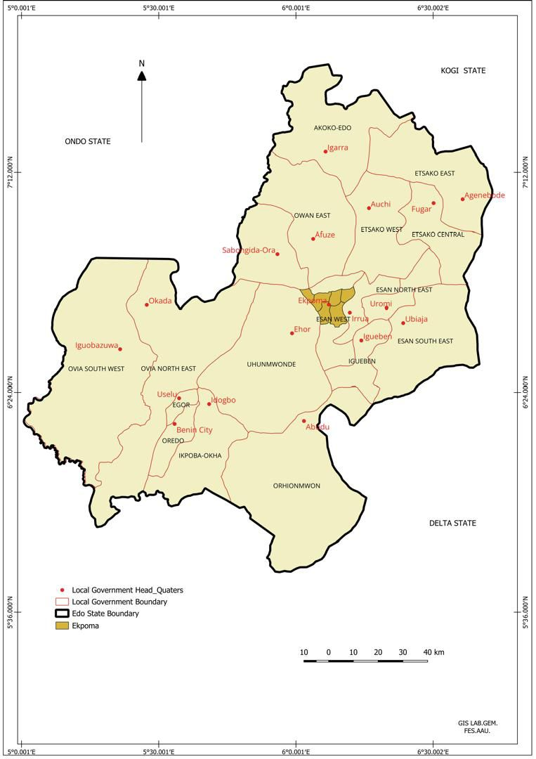
Fig 1.1 Edo state map

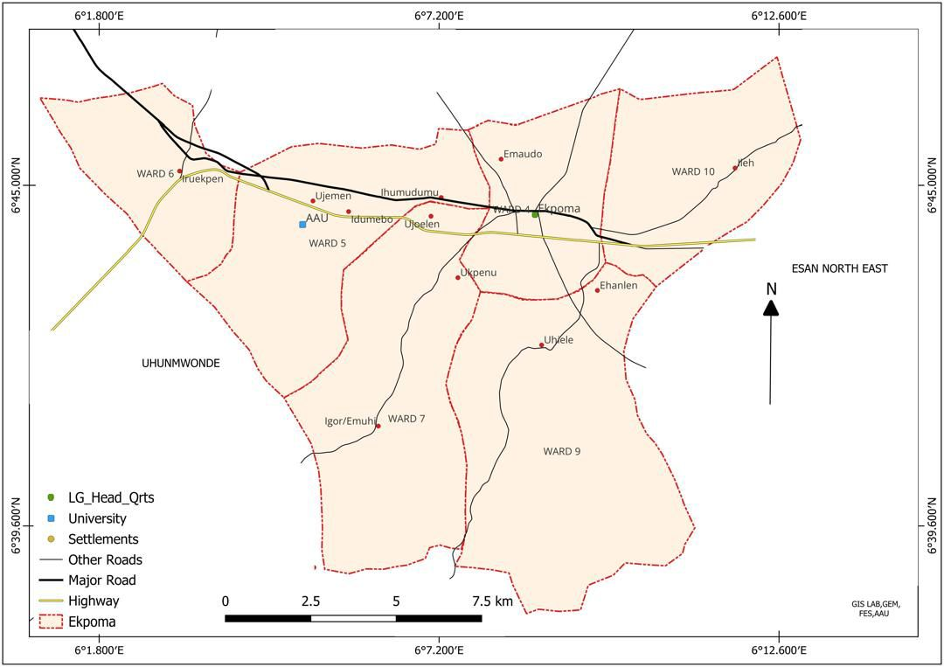

Fig 1.2 Map of Ekpoma the Study Area
4.0. LITERATURE REVIEW
Economic disparities are the primary drivers of rural-urban migration. Rural areas often lack employment opportunities, forcing individuals to seek jobs in urban centers (World Bank, 2018).Rural-urban migration is a significant socio-economic process that shapes the development of urban areas, particularly in developing regions. It refers to the crave for better living conditions, employment, education, and social mobility. This phenomenon is driven by a combination of "push" factors, such as rural poverty, draught, insecurity, land degradation, and lack of access to basic amenities, and "pull" factors, including better job prospects, improved infrastructure, and access to social services in urban areas (Lee, 1966; Todaro, 1976).
Historically, rural-urban migration has been a critical driver of urbanization globally. In Africa, this trend has been accelerated by colonial and post-independence policies that concentrated development efforts in urban centers, often neglecting rural areas (Mabogunje, 1970). Consequently, the disparity in development levels between rural and urban areas has remained a significant factor fueling migration. The United Nations (2022), notes that urbanization in Africa is occurring at an unprecedented rate, with rural-urban migration accounting for a substantial portion of this growth.
From literatures, the number of international migrants (272 million people or 2.8 percent of the global population in 2019 according to the International Office for Migration) is dwarfed by the number of internal migrants, which could be at least 3 or 4 times larger. To the best of my knowledge, the most recent figure published in the literature on internal migration at the global scale dates back to 2005, with 763 million internal migrants or 11.7 percent of the world’s population at the time (Bell and Charles-Edwards 2013).
The figure is based on a measure of lifetime migration (defined by current residence in an area that differs from the area of birth). It is reasonable to assume, however, that it probably underestimates the true extent of internal migration given that the calculation uses areas of residence defined at large administrative subdivision levels. With the steady increase in global population and intensification of some drivers of internal migration such as climate change, Bell and Charles-Edward (2013) explain that their global estimate was obtained by calculating a population weighted average of migration intensities across four broad regions using the migration intensities from 66 countries for which data were available. The lack of a recent data on internal migration at the global scale reflects the relative scarcity of measures of internal migration at national levels too, especially in developing countries. This is understandable in the light of conceptual issues and data gaps.
Ekpoma provides a microcosm for examining the dynamics of rural-urban migration. The town's growth has been largely influenced by its status as a host to Ambrose Alli University, which attracts students, academics, and support staff from various parts of Nigeria as well as its status as a local government headquarters. The influence of these two institutions is mainly responsible for this influx of people seeking educational and economic opportunities which has led to a steady population increase in Ekpoma, transforming it from a predominantly rural settlement into an emerging urban center.
However, the rapid growth associated with rural-urban migration has created significant challenges for Ekpoma, particularly in the area of public utilities. The existing infrastructure, originally designed for a smaller population, is increasingly under strain or stress. For instance, the town experiences frequent water shortages, erratic electricity supply, and inadequate waste management systems, all of which are exacerbated by the rising population (Oni et al., 2020). These challenges highlight the need for sustainable urban planning and investment in public infrastructure to accommodate the growing population.
The phenomenon of rural-urban migration is not only a demographic event but also a socio-economic transformation with far-reaching implications. On the one hand, it contributes to urban economic growth by providing a labor force and stimulating demand for goods and services. On the other hand, it often leads to the proliferation of informal settlements, congestion, and overburdened public services, particularly in towns and cities that lack the capacity for effective urban management (World Bank, 2018).
In Ekpoma, economic migration is fueled by the presence of small-scale industries, business opportunities, commercial enterprises, and educational institutions. For instance, migration has increased the demand for water in Ekpoma. Public water systems are insufficient, forcing residents to rely on alternative sources such as boreholes and wells and underground tank. This development has led to the depletion of groundwater resources, affecting the quality and availability of water (Oni et al., 2020).
A number of recently published studies presents migration as equilibrating force and estimates how internal migration flows responds to local labor market differences. Imbert and Papp (2019) for instance, show that a large workfare program which hired rural adults during the agricultural off-season in India; a scheme likely to reduce the income gap between rural and urban areas; had a significant impact on deterring seasonal migration to cities. Two other papers, Détang-Dessendre, Partridge and Piguet (2016) investigate how internal migration across China’s roughly 300 employment zones responded to local employment growth. This is also supported by McKenzie, Stillman and Gibson (2010) and Dahl’s (2002).
Similarly, Cadena and Kovak (2016) find that local labor demand shocks during the Great Recession in the United States have led to internal migration responses. Interestingly, they find a greater migration response from Mexican-born low-skill workers than from natives, a pattern which they attribute to the greater labor-force attachment of Mexican-born workers and their large social networks that could have helped them more easily acquire information on where to relocate.
First, internal migration patterns are heterogeneous and in folds, with migration simultaneously occurring from rural to urban areas but also between rural areas and from urban to rural areas. The patterns observed in a given country seem to reflect the country’s development stage as initially theorized in human geography by Zelinsky (1971). In large developing countries undergoing urbanization, especially in South Asia and Sub-Saharan Africa; where the rural population is still disproportionately large, there are significant internal migration flows from rural to urban areas (Brueckner and Lall, 2015). Although internal migration between rural areas is much less documented given the lack of data and lack of attention paid to the phenomenon (until recently), rural-rural flows are likely to also be very large and could even exceed urban-rural flows as a few studies seem to indicate (Lucas, 1997). On the contrary, in the relatively more urbanized countries of Latin America and East Asia, it is urban-to-urban migration which predominates (Lucas, 2016). As for urban-to-rural migration, it is much less studied in the literature but could also represent sizeable flows, especially in countries at earlier phases of economic development as in Sub-Saharan Africa (Cattaneo and Robinson, 2020). Urban-rural migration is also an emerging phenomenon in developed countries where it could be occurring as part of a broader movement of relocation away from densely populated areas and in response to a renewed attraction by the rural lifestyle.
Second, the measure of internal migration is further complicated by the duration of migration spells, which may be temporary or permanent. In this respect, internal migration is more likely to be permanent when reflecting a trend towards urbanization in the country and seasonal in contexts where internal migrants keep an activity in the rural area during the agricultural season. It is worth to note that temporary migration often takes the shape of return migration, a phenomenon that remains insufficiently studied but which is increasingly attracting the attention of demographers and economists (Cattaneo and Robinson, 2020) Using Demographic and Household Surveys for 31 developing countries in different regions, Cattaneo and Robinson (2020) find that a significant fraction of internal migration from rural areas to cities results in return migration to a rural area. They find that it is highest in Sub-Saharan African countries where between 7 and 51 percent of male and between 3 and 32 percent of female rural-urban migrants end up returning to a rural area at some stage of their life cycle.
Third, data constraints also significantly affect measures of internal migration. As already mentioned, the geographic level at which data is collected and the temporal horizon over which migration flows are measured have significant impacts on internal migration estimates (Bell et al., 2018). Because of the lack of harmonized data, comparison of migration flows across countries is rather a difficult exercise. Internal migration estimates can indeed be obtained from heterogeneous sources: They can be calculated from population censuses or at birth. Alternatively, household surveys may ask the same questions or collect more precise information on past migration history. Administrative data may also be used to estimate migration stocks and flows. Interestingly, cell phone data (Call Detail Records) offer new avenues to measure migration at different spatial and temporal scale as demonstrated by Blumenstock, Chi and Tan (2019) for Rwanda and Lai et al. (2019) for Namibia.
In brief, migration particularly in-situ migration can have adverse effect on public utilities such as electricity, cost of rent healthcare, transportation systems and water system. It can manifest in road congestion, power supply, water supply among others (Eze, et al., 2021). Migration is a multifaceted phenomenon that reflects the interplay between socio-economic, environmental, and political factors. Its impacts are particularly pronounced in emerging towns like Ekpoma; where the influx of migrants has created both opportunities and challenges. This paper seeks to explore these dynamics in greater detail and to emphasize the need for targeted interventions to address the challenges associated with migration and urbanization in Ekpoma.
4.2 Theoretical Framework
Two theoretical frameworks were used in this paper which are:
(a). Push-Pull Theory and
(b). Harris-Todaro Model
The push-pull theory by Lee (1966) explains migration as a result of push factors (unfavorable conditions) in rural areas, such as unemployment and poor infrastructure and pull factors (better job opportunities, education, and healthcare in urban centers). This theory is particularly relevant in Ekpoma, where better educational facilities such as Ambrose Alli University, attract migrants. The theoretical underpinnings of rural-urban migration provide valuable insights into its drivers and consequences Lee's (1966). Push-pull theory, for example, explains how individuals weigh the benefits and obstacles of migration before making decisions. Similarly, the Harris-Todaro model (1970) highlights the economic rationale behind migration, emphasizing the role of expected income differentials between rural and urban areas. These frameworks are instrumental in understanding the migration patterns observed in Ekpoma and their implications for public utilities and urban development.
In summary, previous Studies such as(Aworemi et al 2011, Obinna, 2020, Mabogunje, 1970, Lee, 1966, Todaro, 1970 and World Bank, 2018) revealed that many cities experience infrastructural strain due to unplanned urban growth .However, such study has not been carried out in Ekpoma an emerging urban centre welcoming the influx of migrants on a daily basis known to the researcher, hence this study is apt.
5.0 METHODOLOGY
Both primary and secondary data collection methods were employed in the study. Descriptive statistics, such as frequencies, tables, percentages, and charts, were used to summarize responses from the questionnaires distributed. Inferential statistical techniques (Chi-square test), was used to examine relationships between migration and the effects of migration on public utilities. Correlation analysis was also applied to measure the strength of the relationship between migration and utility demand. Data analysis was conducted using SPSS (Statistical Package for the Social Sciences) to ensure accuracy and efficiency. The study adopted a descriptive survey research design, which allowed for collecting data from a sample representing the larger population. The sample size and sample frame is tabulated.
S/N | Wards | Population | Sample size (¼) | Sample frame (1%)
4 | Eguare/Emudo | 24,786 | 6196.5 | 62
5 | Ihumudumu/Ujemen/Idumebo/Uke | 24,842 | 6210.5 | 62
6 | Iruekpen | 20,924 | 5231 | 52
7 | Ukpenu/Emuhi/Ujoelen | 10,529 | 2632.25 | 26
9 | Uhiele | 5,263 | 1315.75 | 13
10 | Ileh | 5,873 | 1468.25 | 15
Total | 6 Wards | 92,217 | 21,738.5 | 230
Source: Ekpoma political wards and their population (NPC, 2006)

Ekpoma has a total of 92,217 population (NPC, 2006), one quarter of the population were taken as sample size which is 21738.5 and 1% as sample frame which gives us a total of 230 respondents which were distributed to the 6 wards as tabulated above. A stratified random sampling technique was used to ensure fair representation of different wards and groups in Ekpoma. A simple random sampling method was then applied within each stratum to select respondents. . Each question is presented using tables followed by interpretations and analysis of the results. After which the hypothesis were tested using Chi- Square and Correlation coefficient analysis to examine relationships between key variables.
6.0 RESULTS AND DISCUSSION
This section presents the analysis of data collected from 230 respondents across different wards in Ekpoma with regard to the effect of migration on public utilities
6.1 Reasons for Migration
Reason for Migration | Frequency | Percentage (%)
Work | 90 | 39.1%
Education | 120 | 52.2%
Others | 20 | 8.7%
Total | 230 | 100%
Source: (field work) 2025
Table 6.1. deals with the reasons for migration, The majority of migrants 120 (52.2%) moved for educational reasons, while 110(47.8% migrated for work and other purposes.
6.2. Water supply Functionality
Response | Frequency | Percentage (%)
Yes | 100 | 43.5%
No | 130 | 56.5%
Total | 230 | 100%
Source: (field work) 2025
From Table 6.2., 130 respondents (56.5) out of 230 opined that they don't have functional water system such as pipe borne water but relied on other means such as boreholes, wells and underground tanks while only 43.5% had functional water supply.
6.3. Overstretched water supply
Response | Frequency | Percentage (%)
Yes | 150 | 65.2%
No | 80 | 34.8%
Total | 230 | 100%
Source: (field work) 2025
On the question of whether the water system is overstretched or not, table 6.3 shows that 150 respondents (65.2%) have their water system overstretched while 89 respondents (34.8%) reported that their water system was not stretched with no major evidence of frequent breakdown.
6.4 Electricity supply availability
Response | Frequency | Percentage (%)
Yes | 180 | 78.3%
No | 50 | 21.7%
Total | 230 | 100%
Source: (field work) 2025
As per electricity supply, 180 respondents (78.3%) reported having electricity supply, while 50 respondents (21.7%) opined that they do not enjoy electricity supply. In other word majority of the wards in Ekpoma have electricity even though epileptic.
6.6 Epileptic power supply
Response | Frequency | Percentage (%)
Yes | 160 | 69.6%
No | 70 | 30.4%
Total | 230 | 100%
Source: (field work) 2025
From Table 6.6, 160 respondents (69.6%) experience epileptic power supply, while 70respondents (30.4%) report a more stable power situation. This is an indication that though most of the respondents have electricity in their homes, they do not enjoy it, either as a result of low voltage or no supply at all.
6.7 Ease of Transportation to Work or School
Response | Frequency | Percentage (%)
Yes | 140 | 60.9%
No | 90 | 39.1%
Total | 230 | 100%
Source: (field work) 2025
From Table 6.7, which deals with ease of transportation to work or school, 140 respondents (60.9%) find it easy to get transportation, while 90 respondents (39.1%) do not. This suggests that although the majorities have accessible transport, a significant number still struggle with mobility, possibly due to bad roads, high transport fares, or insufficient transport options in certain areas.
6.8 Cost of rent
Response | respondents | Percentage (%)
High | 120 | 52.2%
Moderate | 80 | 34.8%
Low | 30 | 13.0%
Total | 230 | 100%
Source: (field work) 2025
On cost of rent table 6.8, 120 respondent (52.2%) rate rent to be high while 47.8 % opined that rent is moderate or low. This implies that rent is high in Ekpoma. Higher rent is associated with migrants moving in, while some residents have free housing. Indigenes and high-income workers tend to be homeowners.
6.9. Utility Problems in Ekpoma
Utility problems | Frequency | Percentage (%)
Water | 80 | 34.8%
Housing | 60 | 26.1%
Electricity | 65 | 28.3%
Crime | 23 | 10.9%
Total | 230 | 100%
Source: (field work) 2025
From Table 6.9, which deals with social/utility problems in Ekpoma, 80 respondents (34.8%)identified water as the major issue, followed by electricity (28.3%), and housing (26.1%). Crime (10.9%) was the least reported problem. This indicates that water and electricity shortages are the most pressing challenges faced by residents, followed closely by housing issues, particularly due to high migrant rate, giving rise to high cost of rent .
6.10 Economic Problems in Ekpoma
Economic Problem | Frequency | Percentage (%)
Food shortage | 75 | 32.6%
Shortage of farmland | 50 | 21.7%
Shortage of housing | 70 | 30.4%
Revenue decrease | 35 | 15.2%
Total | 230 | 100%
Source: (field work) 2025
From the table above, which deals with economic problems in Ekpoma, the most reported issue is food shortage (32.6%), followed by shortage of housing (30.4%). Shortage of farmland (21.7%) is another concern, while revenue decrease (15.2%) is the least reported economic problem. This suggests that high food prices, limited farming land, and housing shortages are key economic challenges faced by residents.
6.11. Availability of Recreational Centers in Ekpoma
Response | Frequency | Percentage (%)
Yes | 85 | 37.0%
No | 145 | 63.0%
Total | 230 | 100%
Source: (field work) 2025
From table 6.11, which deals with the availability of recreational centers in Ekpoma, 85 respondents (37.0%) stated that there are recreational centers, while 145 respondents (63.0%) indicated that there are none. This suggests that recreational facilities are insufficient in Ekpoma, which may affect residents' leisure activities and social well-being. The absence of such centers could also contribute to reduced quality of life, especially for youths and families looking for places to relax and socialize
6.12. Adequacy of Water Supply in Ekpoma
Response | Frequency | Percentage (%)
Yes | 55 | 23.9%
No | 175 | 76.1%
Total | 230 | 100%
Source: (field work) 2025
From Table6.12, which deals with the adequacy of water supply in Ekpoma, 175 respondents (76.1%) reported that water supply is not adequate, while 55 respondents (23.9%) believe it is sufficient. This confirms that water scarcity is a major problem in Ekpoma,
6.13. Satisfaction with Power Supply in Respondents Wards
Response | Frequency | Percentage (%)
Yes | 90 | 39.1%
No | 140 | 60.9%
Total | 230 | 100%
Source: (field work) 2025
From the table above, which deals with satisfaction with power supply, 140 respondents (60.9%) expressed dissatisfaction, while 90 respondents (39.1%) said they were satisfied. This suggests that those not enjoying power supply in Ekpoma are more and there is need for more power supply since Ekpoma is an emerging urban center.
6.14 Opinions on the Present Transport Infrastructure Development in Ekpoma
Response | Frequency | Percentage (%)
Yes | 120 | 52.2%
No | 110 | 47.8%
Total | 230 | 100%
Source: (field work) 2025
From Table 6.14, which deals with opinions on transport infrastructure development in Ekpoma, 120 respondents (52.2%) expressed satisfaction, while 110 respondents (47.8%) were not satisfied This indicates that while some improvements have been made, a significant proportion of residents still find the transport system inadequate, possibly due to poor road conditions, traffic congestion, or lack of proper transportation planning.
6.15. Residential House Occupier Status in Ekpoma
Occupier Status | Frequency | Percentage (%)
Owner | 50 | 21.7%
Rent | 140 | 60.9%
Free | 40 | 17.4%
Total | 230 | 100%
Source: (field work) 2025
From table6.15, which deals with residential house occupier status in Ekpoma, 140 respondents (60.9%) are on rent, while 50 respondents (21.7%) are house owners, and 40 respondents (17.4%) live in free accommodation. This indicates that the majority of migrants and residents rely on rented housing, give rise tohigh cost of rent, especially for those who are in Ekpoma for educational purpose(s).House ownership is mostly among indigenes and high-income workers, while some residents benefit from free accommodation possibly from family support or houses provided by their employer.
7.0 Hypothesis Testing
Chi square test and correlation analysis were used to examine our data.
1. Chi-Square Test to examine the relationship between rural-urban migration and public utilities availability.
2. Correlation Analysis to measure the strength of the relationship between migration rates and utility demand.
Hypothesis Statement:
- H0: There is no significant effect of rural-urban migration on public utilities in Ekpoma.
- H1: There is a significant effect of rural-urban migration on public utilities in Ekpoma.
Chi-Square Test
Observed variables | Expected | Observed | (0 –E) | (0 – E)² | (0 – E)² /E
Adequate Water Supply | 60 | 90 | -30 | 900 | 10.00
Inadequate Water Supply | 170 | 140 | 30 | 900 | 6.43
Stable Electricity | 50 | 85 | -35 | 1225 | 14.41
Unstable Electricity | 180 | 145 | 35 | 1225 | 8.45
Good Transport System | 70 | 100 | -30 | 900 | 9.00
Poor Transport System | 160 | 130 | 30 | 900 | 6.92
Total | 690 | 690 |  | 6050 | 55.21
Using the Chi-Square formula:
X² = ∑ (0 – E) ²
E
Substituting Values:
X²= 10.00 +6.43 +14.41 + 8.45 + 9.00 + 6.92
X²= 55.21
Using a degree of freedom (df) = (rows - 1) × (columns - 1) = (2 - 1) × (3 - 1) = 2, the critical value from the Chi-square table at df = 2 and α = 0.05 is 5.99.
Since 55.21 > 5.99,
we reject H₀, confirming a significant effect of rural-urban migration on public utilities
Conclusion:
There is a significant effect of rural-urban migration on public utilities in Ekpoma.
Correlation Analysis
The correlation coefficient (r) measures the strength of the relationship between migration rate (X) and public utility demand (Y).
r = N (∑ XY) – (∑ X) (∑ Y)
√[N∑X² – (∑X) ²] [N∑Y² – (∑Y) ²]
Where:
• X = Migration rate
• Y = Utility demand
• n = Number of observations
Given Data:
Migration Rate (X) = {50, 60, 70, 80, 90}
Utility Demand (Y) = {200, 220, 250, 280, 300}
N = 5
ΣX = 350, ΣY = 1250
ΣXY = (50×200 + 60×220 + 70×250 + 80×280 + 90×300) = 87600
ΣX² = (50² + 60² + 70² + 80² + 90²) = 25500
ΣY² = (200² + 220² + 250² + 280² + 300²) = 318000
SUBSTITUTING VALUE
r = (5 x 87600) – (350 x 1250)
√ [5 x 2550 – (350) ²] [5x 318000 – (1250) ²]
r = 438000 - 437500
√ [127500 - 122500] [1590000 - 1562500]
r = 500
√ 5000 x 27500
r = 500
√ 137500000
r = 500
11726.89
r = 0.72
Results:
Since r = 0.72, there is a strong positive correlation between migration rates and public utility demand.
Final Conclusion
- Chi-Square Test: Significant relationship (X² = 55.21, p < 0.05).
- Correlation Analysis: Strong positive relationship (r = 0.72).
Thus, rural-urban migration significantly affects public utilities in Ekpoma.
8.0 conclusion and recommendation
Conclusion
This study examined the effects of migration on public utilities in Ekpoma. Based on the analysis of the data collected from 230 respondents, key findings were drawn in alignment with the research objectives.
The study found that the primary reasons for migration to Ekpoma varies from, Education, Work and other Factors such as family relocation, farming, marriage, and business expansion.
On the impact of migration on Public Utilities, the study revealed that rural-urban migration has significantly affected the availability and quality of public utilities: such as (Water, Electricity, Housing, health care and Transportation). Water Supply is grossly inadequate in Ekpoma coupled with the lack of portable pipe borne water supply and even the ones supplied through boreholes, water tankers from nearby river are grossly inadequate. The Power supply is found to be overstretched, with frequent outages affecting both residential and business activities.
The study observed that the influx of migrants has driven up rental costs, particularly for those moving to Ekpoma for education, job and business while house owners are mostly indigenes and high-income earners. The shylock landlords are taking undue advantage of the university community to hike the cost of rent. In fact, the activities of ‘yahoo boys’ in Ekpoma is making housing and food cost unattainable for the average income earners in the study area particularly in wards 5,6, 7 and partly ward 4 .
With regard to transportation, Respondents reported challenges with public transport availability and infrastructure, making commuting difficult.
This study concludes that rural-urban migration has a significant impact on public utilities in Ekpoma. The increase in population has led to an overstretched of essential services such as water supply, electricity, housing, healthcare and transportation. The findings confirm that without proper planning and investment, the quality of life for both migrants and residents will continue to decline. The study also highlights the urgent need for government and stakeholders to implement sustainable solutions to improve public utility management in Ekpoma.
Recommendations
Based on the findings, the following recommendations are proposed:
i. Government to investment more in Public Utilities in Ekpoma: Authorities should prioritize the expansion of water supply systems, electricity infrastructure, health-care, housing and road networks to meet the growing population’ needs in Ekpoma.
ii. Public-Private Partnerships (PPP): Collaborations between the government and private sector can help improve the efficiency and reach of public services in Ekpoma.
iii. Affordable Housing Policies: this involves building materials, Rent control measures and incentives for real estate development to make housing more accessible to low-income migrants both at the level of building and rent cost.
iv. Improved Urban Planning: Local government should implement proper zoning regulations to control overcrowding and ensure equitable distribution of public utilities in Ekpoma
V.Public Transport Development: Development of an efficient public transport system to ease commuting challenges in Ekpoma is highly recommended
Vi.Community Awareness and Participation: Encouraging community involvement in utility management through sensitization programs and local government engagements will go a long way in achieving sustainable development goals in Ekpoma.
Vii.Strengthening Rural Development Initiatives: To mitigate the push factors driving rural-urban migration, it’s essential to enhance the quality of life in rural areas. Aworemi et al. (2011) emphasize that improving rural infrastructure, such as roads, schools, and healthcare facilities, can reduce migration pressures. By providing better amenities and services in rural communities, residents may find fewer incentives to relocate to urban centers.
viii. Implementing a Systems Approach to Migration Management: Mabogunje (1970) advocates for a systems approach to understanding and managing rural-urban migration. This perspective views migration as a dynamic process influenced by various socio-economic and environmental factors. By adopting this approach, policymakers can develop more holistic strategies that address the root causes of migration, rather than merely its symptoms.
Ix.Promoting Inclusive Urban Planning: The World Bank (2018) highlights the importance of inclusive urban planning to accommodate the influx of migrants. This involves designing cities that can sustainably support growing populations by ensuring access to essential services, affordable housing, and employment opportunities. Such planning can alleviate the strain on public utilities and enhance the overall well-being of urban residents.
X.Enhancing Data Collection and Research: Accurate data is crucial for effective policy formulation. Investing in comprehensive data collection and research on migration patterns can provide insights into the specific needs and challenges of both rural and urban populations. This information can guide targeted interventions and resource allocation.
xi. Fostering Economic Opportunities in Rural Areas: Creating economic opportunities in rural regions can serve as a deterrent to migration. This includes supporting agricultural development, promoting small and medium-sized enterprises, and facilitating access to markets. By boosting rural economies, residents may choose to remain in their communities, reducing the pressure on urban centers.
xii. Strengthening Institutional Frameworks: Developing robust institutional frameworks is essential for managing migration effectively. This includes establishing agencies dedicated to rural development, urban planning, and migration management. Such institutions can coordinate efforts across sectors and ensure that policies are implemented efficiently.
REFERENCES
Aworemi, J. R., Abdul-Azeez, I. A., &Opoola, N. A. (2011). An appraisal of the factors influencing rural-urban migration in some selected Local Government Areas of Lagos State Nigeria. Journal of Sustainable Development, 4(3), 136-141.
Bell, M., Charles-Edwards, E.,(2013) Cross-National Comparisms of internal migration: an update of global patterns and trends. United Nation Department of economic and social affairs, technical paper no. 2013/1.
Bell, M., Charles-Edwards, E., Bernard, A., & Ueffing, P. (2018). Global trends in internal migration. Chapter 4 (p. 76-97) in Internal migration in the developed world: Are we becoming less mobile, Champion,
Brueckner, J. K., & Lall, S. (2015) Cities in Developing Countries: Fueled by Rural-Urban Migration, Lacking in Tenure Security, and Short of Affordable Housing, in G. Duranton, J.V. Henderson and W.C. Strange, eds., Handbook of Regional and Urban Economics, Vol. 5B, Elsevier, pp. 1399-1455
Cadena, B.C & Kovak, B.K.(2016)Immigrants Equilibrate Local Labour markets. Evidence from the Great Recession. American Economic Journal: Applied Economics 8(1)257-290.
Cattaneo, A., & Robinson, S.(2020) Multiple moves and return migration within developing countries: A comparative analysis. Population, space and place, 21 pages.
Dahl, G.B.(2002)Mobility and the return to education. Testing a Roy model with multiple markets. Econometrica,70(6),2367-2420.
Eromosele, G. (2019). Challenges of public utilities in urbanizing Nigerian towns: The case of Ekpoma. African Journal of Urban and Regional Planning, 10(1), 54-65.
Eze, J. C., Okonkwo, A. M., &Nwankwo, P. O. (2021). Urbanization and its effects on transportation in Nigeria. Journal of Urban Studies, 15(3), 45-59.
Imbert, C., & Papp, J. (2019). Short-term Migration, Rural Public Works, and Urban Labor Markets: Evidence from India. Journal of the European Economic Association, 18(2), 927-963.
Lai, S., Erbach-Schoenberg, E.z., Pezzulo, C., Ruktanonchai, N. W., Sorichetta, A., Steele, J., . & Tatem, A. J. (2019). Exploring the use of mobile phone data for national migration statistics. Palgrave communications, 5(1), 1-10.
Lee, E. S. (1966). A theory of migration. Demography, 3(1), 47-57.
Lucas, R. E. (1997). Internal migration in developing countries. In Handbook of Population and Family Economics, 1, 721-798.
Lucas, R. E. B. (2016). Internal migration in developing economies: an overview of recent evidence. Geopolitics, History, and International Relations, 8(2), 159-191.
McKenzie, D., & Rapoport, H. (2007). Network effects and the dynamics of migration and inequality: Theory and evidence from Mexico. Journal of development Economics, 84(1), 1-24.
McKenzie, D., Stillman, S., & Gibson, J. (2010). How important is selection? Experimental vs. non-experimental measures of the income gains from migration. Journal of the European Economic Association, 8(4), 913-945.
Mabogunje, A. L. (1970). Systems approach to a theory of rural-urban migration. Geographical Analysis, 2(1), 1-18.
National Population Commission(NPC,2006).
Obinna, I. (2020). Infrastructure development and the strain of urban growth in Nigeria. Journal of Urban Studies, 18(4), 89-103.
Okosun, E. (2018). The dynamics of population growth in Ekpoma: Implications for urban infrastructure. Journal of Nigerian Demographic Studies, 12(2), 27-39.
Oni, O., Akinola, A., &Oladipo, K. (2020). Water resources management in Nigeria: Challenges and prospects. African Journal of Water Science, 12(2), 77-90.
Todaro, M. P. (1976). Internal migration in developing countries: A review of theory, evidence, methodology, and research priorities. Geneva: International Labour Office.
United Nations. (2022). World urbanization prospects 2022. New York: United Nations Department of Economic and Social Affairs.
World Bank. (2018). Migration and remittances: Recent developments and outlook. Washington, DC: World Bank.
Hauer ,M.E.,Fussell,E., Mueller, V.,Burkett,M., Call,M.,Abel, K.,…& Wrathall, D(2020). Sea . level rise and human migration. Nature Review Earth and Environment, 1(1),28-39.
International Displacement Monitoring Centre and Norwegian Refugee Council(2020).Global . . Report on Internal Displacement, 36 pages.

