A QBD APPROACH BASED RP-HPLC METHOD DEVELOPMENT AND VALIDATION FOR SIMULTANEOUS ESTIMATION OF DAPAGLIFLOZIN PROPANEDIOL MONOHYDRATE AND SACUBITRIL-VALSARTAN SODIUM COMPLEX SALT IN ITS SYNTHETIC MIXTURE
Hinal Patel^{l,} Dr. Avani Doshi ²

¹, PG Student, K. B. Raval College of Pharmacy, Kasturinagar, Shertha, Gandhi agar, Gujarat
² Professor, Dept. of Quality Assurance, K. B. Raval College of Pharmacy, Kasturinagar, Shertha, Gandhinagar, Gujarat
ABSTARCT: A robust, sensitive, and reproducible reverse-phase high-performance liquid chromatography (RP-HPLC) method was developed and validated using a Quality by Design (QbD) approach for the simultaneous estimation of dapagliflozin propanediol monohydrate and sacubitril–valsartan sodium complex in a synthetic mixture. Critical method parameters were systematically optimized through experimental design to ensure optimal separation, peak symmetry, and resolution. The chromatographic separation was achieved using a suitable C18 column with an optimized mobile phase composition under isocratic conditions. The method demonstrated excellent linearity, precision, accuracy, and specificity within the tested concentration ranges. Validation was performed in accordance with regulatory guidelines, confirming the reliability of the method for routine analysis. The QbD framework enabled a thorough understanding of method variability and robustness, ensuring consistent performance. This developed method can be effectively applied for quality control and simultaneous quantification of these drugs in combined pharmaceutical formulations.
KEYWORDS: Quality by Design (QbD), RP-HPLC, Dapagliflozin propanediol monohydrate, Sacubitril–Valsartan sodium complex, Method development, Method validation, Simultaneous estimation, Analytical optimization, Robustness, Pharmaceutical analysis
- INTRODUCTION:
The increasing use of combination therapies in the management of cardiovascular and metabolic disorders has created a need for reliable analytical methods for simultaneous drug estimation. Dapagliflozin propanediol monohydrate, a sodium–glucose co-transporter 2 (SGLT2) inhibitor, and sacubitril–valsartan sodium complex, an angiotensin receptor–neprilysin inhibitor (ARNI), are widely prescribed for the treatment of heart failure and related conditions. Accurate quantification of these drugs in combined formulations is essential to ensure quality, safety, and therapeutic efficacy.
Reverse-phase high-performance liquid chromatography (RP-HPLC) is commonly employed for such analyses due to its precision and sensitivity. Incorporating a Quality by Design (QbD) approach enhances method development by systematically evaluating critical factors affecting performance. This study focuses on developing a robust and validated RP-HPLC method using QbD principles for the simultaneous estimation of these drugs in a synthetic mixture.
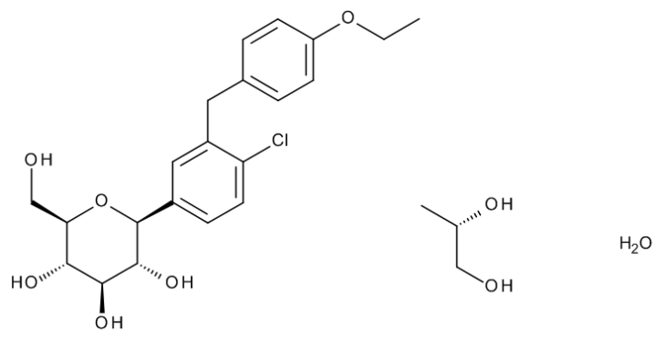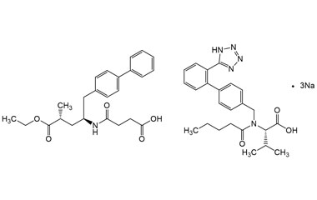
Figure1: Structure of Dapagliflozin Propanediol Monohydrate Figure 2: Stucture of Sacubitril-Valsartan

2. MATERIALS AND METHODS
- Materials:
Dapagliflozin propanediol monohydrate (API), Sacubitril–valsartan sodium complex salt (API), HPLC grade methanol, acetonitrile, water, analytical gradents.
- Analytical grade reagents Buffer Preparation:
A 0.02 M Potassium Dihydrogen Phosphate buffer was prepared by dissolving 2.72 g of potassium dihydrogen orthophosphate in 1 L of Milli-Q water using sonication. The pH was adjusted to 2.5 with diluted orthophosphoric acid.
- Instrumentation:
Chromatographic analysis was carried out using a Shimadzu HPLC system (LC-2010 CHT) equipped with a 100 µL fixed loop injector and LC Solution software. Spectral analysis was performed using a Shimadzu UV-1800 double-beam UV–Visible spectrophotometer with UV Probe software. Additional instruments included a Sartorius analytical balance, Lab India digital pH meter, ultrasonic bath (Athena Technology), hot air oven (Patel Scientific), and micropipettes (Eppendorf).
- Chromatographic Conditions:
Separation was achieved on a Cosmosil C18 column (250 mm × 4.6 mm, 5 µm) using a mobile phase of Buffer: ACN (40:60 % v/v) at a flow rate of 1.0 mL/min. Detection was performed at 233 nm, the injection volume was 30 µL, and the column temperature was maintained at 25 °C.

- Preparation of Solutions
Dapagliflozin Stock solution (50 µg/ml): 5 mg working standard of dapagliflozin propanediol monohydrate was transferred into 100 ml flask. 30 ml methanol added. Sonicated for 5 minutes. Volume made with methanol. Further 5 mL diluted to 50 mL using methanol.
Sacubitril-Valsartan stock solution (500 µg/ml):50 mg working standard of sacubitril-valsartan sodium complex salt was taken in 100 ml volumetric flask. Approximately 50 ml methanol added. Sonicated for 5 minutes. Volume made with methanol.
Mixed standard solution (5 µg/ml Dapagliflozin + 50 µg/ml Sacubitril-Valsartan): 1 ml dapagliflozin stock solution + 1 ml sacubitril-valsartan stock were taken into 10 ml volumetric flask. Volume made with diluent.

- SAMPLE PREPARATION:
Sample Stock: Synthetic mixture 200 mg (equivalent to 5 mg dapagliflozin +50 mg Sacubitril-valsartan) was weighed on butter paper. Powder was then transferred to 50 mL volumetric flask. To this 30 mL methanol was added and active contents were extracted in sonication for 15 minutes. The flask was allowed to cool down on room temperature and then the volume was made with methanol. The solution was then filtered through 0.45 µ Whatman PVDF syringe filter.
Sample (5 µg/ml Dapagliflozin + 50 µg/ml Sacubitril-valsartan):1 mL of clear filtrate was then further diluted to 10 ml with diluent and used as a sample solution.
3. RESULTS AND DISCUSSION:
  - IR identification and wavelength selection
The individual standard drugs Dapagliflozin propanediol monohydrate &Sacubitril-valsartan were mixed with KBr and KBr pallets were prepared. These KBr pallets of drugs were used for FTIR analysis. And then FTIR spectra were interpreted and results were co-related with M.P., UV spectra and solubility to confirm identity of individual drugs. Wavelength was selected from the overlay spectra of above solutions.

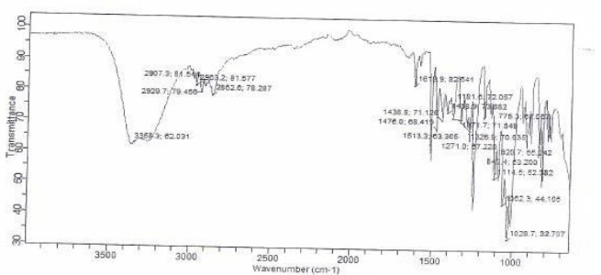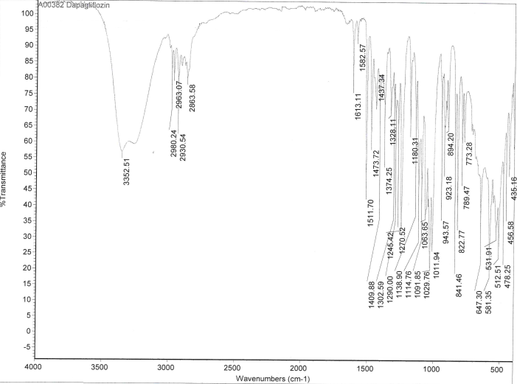
Figure 3:IR spectrum of Dapagliflozin (API) Figure 4:IR Spectrum of Sacubitril-Valsartan (API)

Table: 3.1 IR spectrum of Dapagliflozin

SR.  NO. | Functional group | Observed value | Standard value
1 | O–H stretching vibration | 3352.51 | 3500–3100
2 | Aliphatic C–H stretching vibration | 2980.24, 2930.54, 2863.58 | 2900–2700
3 | C–O–C stretching vibration | 1138.90 | 1150–1085
4 | C–Cl stretching vibration | 841.46 | 850–550

Table:3.2 IR spectrum of Sacubitril-Valsartan

Sr. No. | Functional group | Observed value | Standard value
1 | O–H stretching vibration | 3057.01 | 3600–3000
2 | Aliphatic C–H stretching vibration | 2954.85 | 2960–2850
3 | Carbonyl (C=O) stretching vibration | 1710.71 | 1750–1600
4 | Aromatic C=C stretching vibration | 1636.53 | 1660–1450

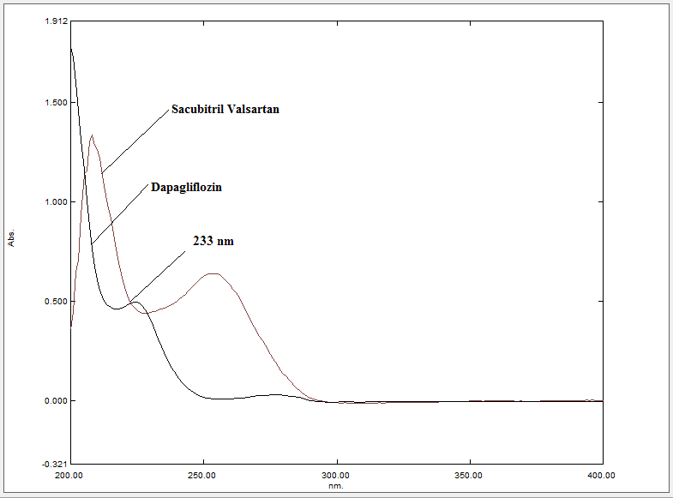

Figure 5: Determination of wavelength maxima(233nm)

3.2 METHOD DEVELOPMENT

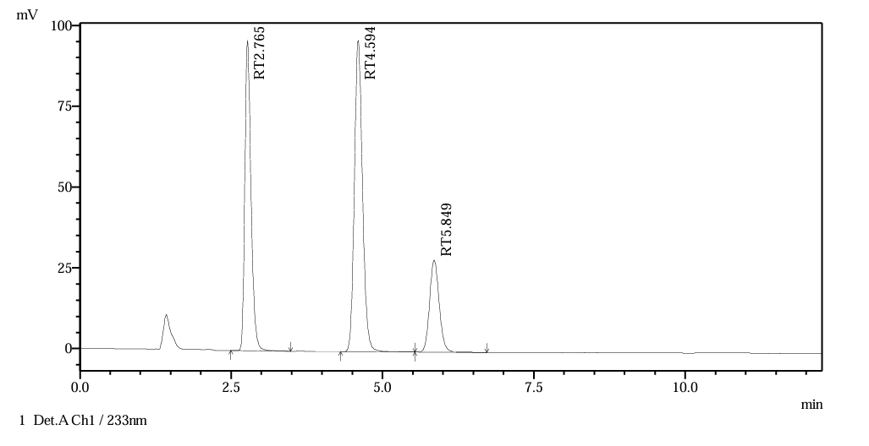

Fig 6: Final HPLC Chromatogram of 5 µg/mL Dapagliflozin + 50 µg/mL Sacubitril–Valsartan

QbD APPROACH TO RP-HPLC METHOD DEVELOPMENT
3.3.1 Analytical Target Profile (ATP)

The Analytical Target Profile (ATP) for the present study was established to develop a robust, accurate, and reproducible RP-HPLC method for the simultaneous quantitative estimation of Dapagliflozin propanediol monohydrate and Sacubitril–Valsartan sodium complex salt in synthetic mixture

3.3.2 Selection of Critical Analytical Attributes (CAA)
The Critical Analytical Attributes (CAA) identified for this method included:
Retention time of Dapagliflozin and Sacubitril–Valsartan
Resolution between adjacent peaks
Theoretical plate count
Tailing factor
These attributes were selected because they directly reflect chromatographic efficiency, peak symmetry, selectivity, and reproducibility, which are essential for the accurate and precise quantification of both analytes in a combined formulation.

3.3.3 Selection of Critical Method Variables (CMV)
Based on preliminary chromatographic trials and a review of relevant literature, the following parameters were identified as Critical Method Variables (CMVs):
Mobile phase composition
Percentage of organic modifier (acetonitrile)
Flow rate
Buffer pH

3.3.4 Risk Identification
Risk identification was carried out using an Ishikawa (fishbone) diagram to systematically evaluate potential sources of variability that could affect the critical analytical attributes. The impact and criticality of each input factor were assessed based on prior literature, experimental knowledge, and structured brainstormi
3.3.5 ANOVA Interpretation for Dapagliflozin and Sacubitril and Valsartan
Source | Sum of Squares | df | Mean Square | F-value | p-value
Model | 12.58 | 9 | 1.40 | 1963.3 | < 0.0001 | significant
A-MP Ratio | 0.0014 | 1 | 0.0014 | 1.93 | 0.2076
B-Column Temperature | 7.254E-07 | 1 | 7.254E-07 | 0.0010 | 0.9754
C-Flow Rate | 0.3269 | 1 | 0.3269 | 459.30 | < 0.0001
AB | 0.0011 | 1 | 0.0011 | 1.52 | 0.2575
AC | 0.1791 | 1 | 0.1791 | 251.65 | < 0.0001
BC | 0.0005 | 1 | 0.0005 | 0.6971 | 0.4313
A² | 0.0336 | 1 | 0.0336 | 47.24 | 0.0002
B² | 0.0005 | 1 | 0.0005 | 0.7356 | 0.4195
C² | 0.2169 | 1 | 0.2169 | 304.75 | < 0.0001
Residual | 0.0050 | 7 | 0.0007
Lack of Fit | 0.0050 | 5 | 0.0010 | 80.39 | 0.0123 | significant
Pure Error | 0.0000 | 2 | 0.0000
Cor Total | 12.58 | 16
Source | Sum of Squares | df | Mean Square | F-value | p-value
Model | 0.0695 | 3 | 0.0232 | 5.15 | 0.0145 | significant
A-MP Ratio | 0.0689 | 1 | 0.0689 | 15.31 | 0.0018
B-Column Temperature | 0.0002 | 1 | 0.0002 | 0.0555 | 0.8174
C-Flow Rate | 0.0004 | 1 | 0.0004 | 0.0800 | 0.7818
Residual | 0.0585 | 13 | 0.0045
Lack of Fit | 0.0576 | 11 | 0.0052 | 12.09 | 0.0788 | not significant
Pure Error | 0.0009 | 2 | 0.0004
Cor Total | 0.1280 | 16

Table 3.3 ANOVA Table for reduced linear model of Rt of Dapagliflozin Table 3.4: ANOVA Table for reduced linear model of Tf of Dapagliflozin
Source | Sum of Squares | df | Mean Square | F-value | p-value
Model | 92.35 | 9 | 10.26 | 707.73 | < 0.0001 | significant
A-MP Ratio | 0.0193 | 1 | 0.0193 | 1.33 | 0.2870
B-Column Temperature | 0.0010 | 1 | 0.0010 | 0.0694 | 0.7998
C-Flow Rate | 0.4766 | 1 | 0.4766 | 32.87 | 0.0007
AB | 0.0102 | 1 | 0.0102 | 0.7003 | 0.4303
AC | 2.71 | 1 | 2.71 | 186.98 | < 0.0001
BC | 0.0020 | 1 | 0.0020 | 0.1391 | 0.7203
A² | 0.5543 | 1 | 0.5543 | 38.23 | 0.0005
B² | 0.0022 | 1 | 0.0022 | 0.1519 | 0.7083
C² | 1.09 | 1 | 1.09 | 75.30 | < 0.0001
Residual | 0.1015 | 7 | 0.0145
Lack of Fit | 0.1011 | 5 | 0.0202 | 91.73 | 0.0108 | significant
Pure Error | 0.0004 | 2 | 0.0002
Cor Total | 92.45 | 16

Source | Sum of Squares | df | Mean Square | F-value | p-value
Model | 1.284E+07 | 3 | 4.281E+06 | 8.16 | 0.0026 | significant
A-MP Ratio | 2.778E+06 | 1 | 2.778E+06 | 5.29 | 0.0386
B-Column Temperature | 4.376E+05 | 1 | 4.376E+05 | 0.8338 | 0.3778
C-Flow Rate | 9.628E+06 | 1 | 9.628E+06 | 18.34 | 0.0009
Residual | 6.823E+06 | 13 | 5.249E+05
Lack of Fit | 6.462E+06 | 11 | 5.875E+05 | 3.26 | 0.2583 | not significant
Pure Error | 3.607E+05 | 2 | 1.804E+05
Cor Total | 1.967E+07 | 16

Table 3.5: ANOVA Table for reduced linear model of Rt of Sacubitril Table 3.6: ANOVA Table for reduced linear model of Theoretical Plate Count of Dapagliflozin
Source | Sum of Squares | df | Mean Square | F-value | p-value |  |  | Source | Sum of Squares | df | Mean Square | F-value | p-value
Model | 0.0350 | 3 | 0.0117 | 15.21 | 0.0002 | significant |  | Model | 3.231E+07 | 3 | 1.077E+07 | 6.28 | 0.0072 | significant
A-MP Ratio | 0.0319 | 1 | 0.0319 | 41.55 | < 0.0001 |  |  | A-MP Ratio | 7.756E+06 | 1 | 7.756E+06 | 4.52 | 0.0532
B-Column Temperature | 0.0017 | 1 | 0.0017 | 2.20 | 0.1617 |  |  | B-Column Temperature | 1.603E+05 | 1 | 1.603E+05 | 0.0935 | 0.7647
C-Flow Rate | 0.0014 | 1 | 0.0014 | 1.87 | 0.1949 |  |  | C-Flow Rate | 2.439E+07 | 1 | 2.439E+07 | 14.22 | 0.0023
Residual | 0.0100 | 13 | 0.0008 |  |  |  |  | Residual | 2.230E+07 | 13 | 1.715E+06
Lack of Fit | 0.0099 | 11 | 0.0009 | 33.06 | 0.0297 | significant |  | Lack of Fit | 2.175E+07 | 11 | 1.977E+06 | 7.22 | 0.1278 | not significant
Pure Error | 0.0001 | 2 | 0.0000 |  |  |  |  | Pure Error | 5.477E+05 | 2 | 2.738E+05
Cor Total | 0.0450 | 16 |  |  |  |  |  | Cor Total | 5.460E+07 | 16

Table 3.7 ANOVA Table for reduced linear model of Tailing Factor of Sacubitril Table 3.8 ANOVA Table for reduced linear model of Theoretical Plate Count of Sacubitril
ANOVA Interpretation for Valsartan
Source | Sum of Squares | df | Mean Square | F-value | p-value
Model | 49.89 | 9 | 5.54 | 570.88 | < 0.0001 | significant |  | Source | Sum of Squares | df | Mean Square | F-value | p-value
A-MP Ratio | 0.0043 | 1 | 0.0043 | 0.4395 | 0.5286 |  |  | Model | 3.292E+07 | 3 | 1.097E+07 | 27.60 | < 0.0001 | significant
B-Column Temperature | 0.0004 | 1 | 0.0004 | 0.0372 | 0.8525 |  |  | A-MP Ratio | 8.477E+06 | 1 | 8.477E+06 | 21.33 | 0.0005
C-Flow Rate | 0.4796 | 1 | 0.4796 | 49.39 | 0.0002 |  |  | B-Column Temperature | 1.308E+06 | 1 | 1.308E+06 | 3.29 | 0.0928
AB | 0.0020 | 1 | 0.0020 | 0.2044 | 0.6649 |  |  | C-Flow Rate | 2.313E+07 | 1 | 2.313E+07 | 58.19 | < 0.0001
AC | 1.26 | 1 | 1.26 | 129.85 | < 0.0001 |  |  | Residual | 5.168E+06 | 13 | 3.975E+05
BC | 0.0031 | 1 | 0.0031 | 0.3214 | 0.5885 |  |  | Lack of Fit | 4.655E+06 | 11 | 4.232E+05 | 1.65 | 0.4371 | not significant
A² | 0.2264 | 1 | 0.2264 | 23.31 | 0.0019 |  |  | Pure Error | 5.127E+05 | 2 | 2.564E+05
B² | 0.0045 | 1 | 0.0045 | 0.4598 | 0.5195 |  |  | Cor Total | 3.808E+07 | 16
C² | 0.7083 | 1 | 0.7083 | 72.95 | < 0.0001
Residual | 0.0680 | 7 | 0.0097
Lack of Fit | 0.0677 | 5 | 0.0135 | 111.95 | 0.0089 | significant
Pure Error | 0.0002 | 2 | 0.0001
Cor Total | 49.96 | 16

Table 3.9 ANOVA Table for reduced linear model of Rt of Valsartan Table 3.10 ANOVA Table for reduced linear model of Theoretical Plate Count of Valsartan

3.3.6 Fit Summaries of selected models

Source | Sequential p-value | Lack of Fit p-value | Adjusted R² | Predicted R²
Linear | < 0.0001 | 0.0002 | 0.9332 | 0.8952
2FI | 0.3595 | 0.0002 | 0.9361 | 0.7399
Quadratic | < 0.0001 | 0.0123 | 0.9991 | 0.9963 | Suggested
Cubic | 0.1345 | 0.0164 | 0.9997 | 0.9077 | Aliased
Source | Sequential p-value | Lack of Fit p-value | Adjusted R² | Predicted R²
Linear | 0.0145 | 0.0788 | 0.4374 | 0.0822 | Suggested
2FI | 0.1012 | 0.1032 | 0.5968 | -0.1727
Quadratic | 0.8885 | 0.0715 | 0.4709 | -1.0593
Cubic | 0.0137 | 0.7306 | 0.9611 | 0.1492 | Aliased

Table 3.11 Response 1: Rt of Dapagliflozin Table 3.12 Response 2: Tf of Dapagliflozin
Source | Sequential p-value | Lack of Fit p-value | Adjusted R² | Predicted R²
Linear | 0.0026 | 0.2583 | 0.5730 | 0.3517 | Suggested
2FI | 0.3795 | 0.2550 | 0.5864 | -0.3594
Quadratic | 0.6205 | 0.2100 | 0.5341 | -1.1270
Cubic | 0.0993 | 0.4848 | 0.8668 | -9.5395 | Aliased
Source | Sequential p-value | Lack of Fit p-value | Adjusted R² | Predicted R²
Linear | < 0.0001 | 0.0004 | 0.9141 | 0.8574
2FI | 0.1255 | 0.0005 | 0.9354 | 0.7300
Quadratic | < 0.0001 | 0.0108 | 0.9975 | 0.9911 | Suggested
Cubic | 0.0057 | 0.1340 | 0.9999 | 0.9773 | Aliased

Table 3.13 Response 3: Theoretical Plates of Dapagliflozin Table 3.14 Response 1: Retention Time of Sacubitril
Source | Sequential p-value | Lack of Fit p-value | Adjusted R² | Predicted R²
Linear | 0.0002 | 0.0297 | 0.7271 | 0.6181 | Suggested
2FI | 0.6397 | 0.0255 | 0.6980 | 0.2849
Quadratic | 0.9571 | 0.0167 | 0.5864 | -0.4395
Cubic | 0.0303 | 0.0641 | 0.9479 | -12.5751 | Aliased
Source | Sequential p-value | Lack of Fit p-value | Adjusted R² | Predicted R²
Linear | 0.0072 | 0.1278 | 0.4975 | 0.3443 | Suggested
2FI | 0.9810 | 0.0963 | 0.3577 | -0.4922
Quadratic | 0.4448 | 0.0870 | 0.3589 | -1.1280
Cubic | 0.0923 | 0.1677 | 0.8259 | -34.8922 | Aliased

Table 3.15 Response 2: Tailing Factorof Sacubitril Table 3.16 Response 3: Theoretical Plates of Sacubitril

Source | Sequential p-value | Lack of Fit p-value | Adjusted R² | Predicted R²
Linear | < 0.0001 | 0.0004 | 0.9194 | 0.8682
2FI | 0.1633 | 0.0005 | 0.9358 | 0.7387
Quadratic | < 0.0001 | 0.0089 | 0.9969 | 0.9890 | Suggested
Cubic | 0.0070 | 0.0934 | 0.9999 | 0.9645 | Aliased
Source | Sequential p-value | Lack of Fit p-value | Adjusted R² | Predicted R²
Linear | 0.0002 | 0.0606 | 0.7092 | 0.5800 | Suggested
2FI | 0.4919 | 0.0557 | 0.6997 | 0.2625
Quadratic | 0.9283 | 0.0374 | 0.5964 | -0.4646
Cubic | 0.0226 | 0.1887 | 0.9583 | -7.1582 | Aliased

Table 3.17 Response 1: Retention Time of Valsartan Table 3.18 Response 2: Tailing Factor of Valsartan
Source | Sequential p-value | Lack of Fit p-value | Adjusted R² | Predicted R²
Linear | < 0.0001 | 0.4371 | 0.8330 | 0.7804 | Suggested
2FI | 0.9174 | 0.3559 | 0.7931 | 0.4884
Quadratic | 0.4142 | 0.3393 | 0.7985 | 0.3653
Cubic | 0.1405 | 0.8407 | 0.9263 | 0.4236 | Aliased

Table 3.19 Response 3: Theoretical Plates of Valsartan

3.2.5.1 Three dimensional response surface plots
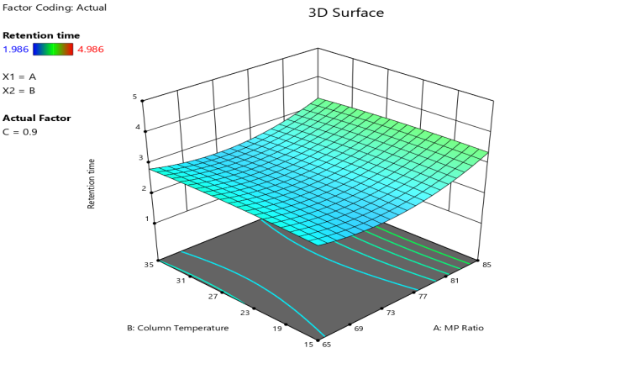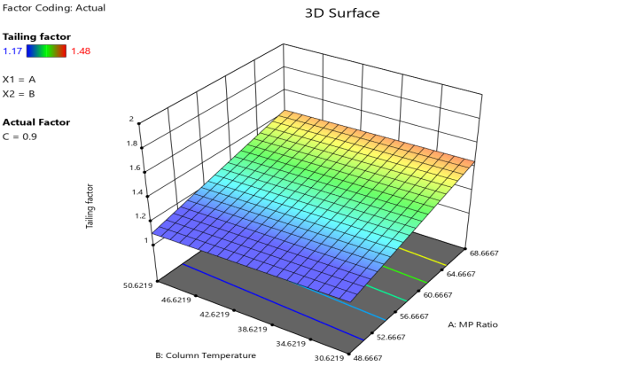

Fig 7: 3D plots Dapagliflozin (Rt) Fig 8: 3D plots Dapagliflozin (Tf)

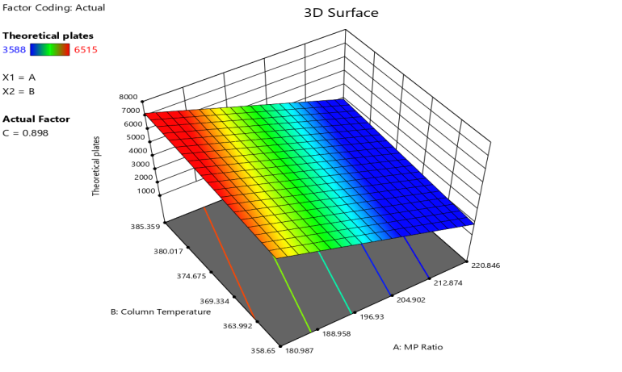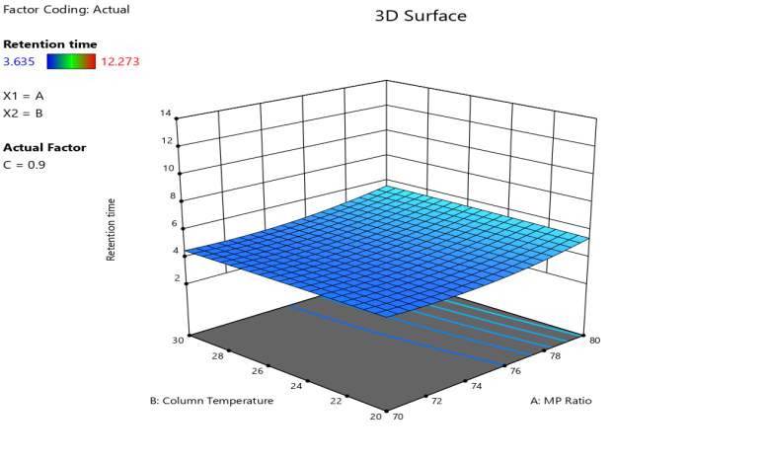

Fig 9: 3D plots Dapagliflozin(Theoretical plate) Fig 10: 3D plots Sacubitril (Rt)

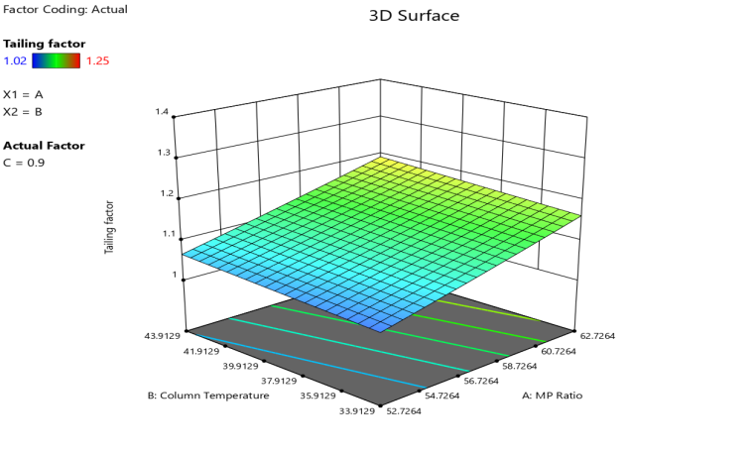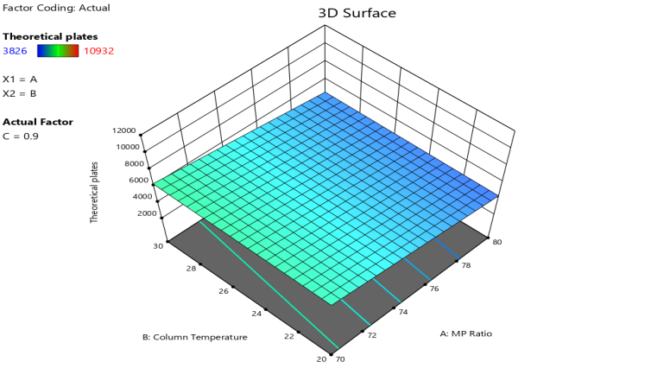

Fig 11:3D plots Sacubitril (Tf) Fig 12: 3D plots Sacubitril(Theoretical plate)

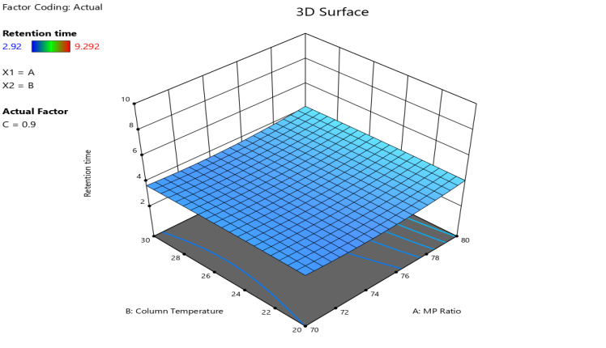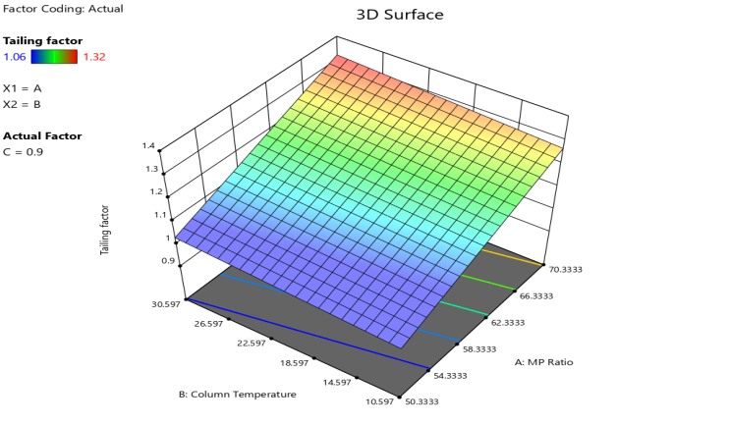

Fig 13: 3D plots Valsartan (Rt) Fig 14: 3D plots Valsartan (Tf)

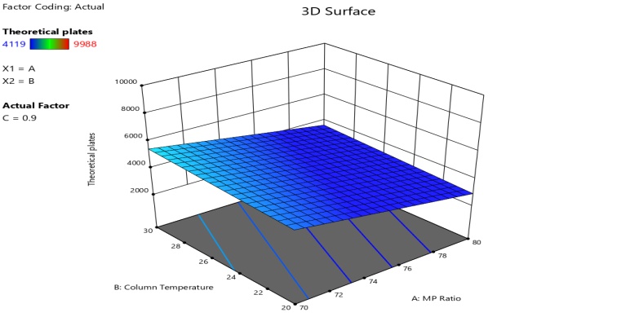
Fig 15: 3D plots Valsartan(Theoretical plate)

3.3.7 Contour plots
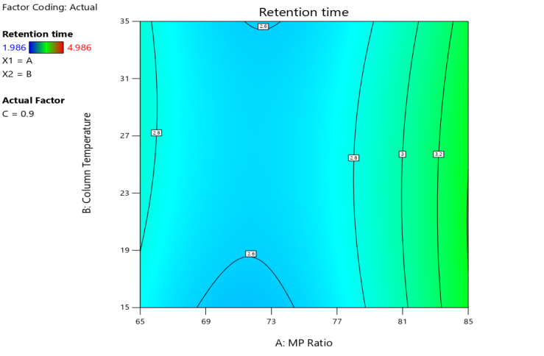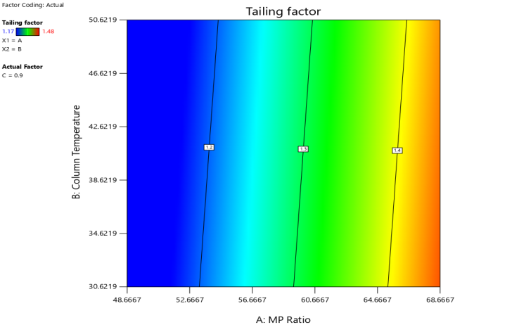
Fig 16: Contour plots Dapagliflozin (Rt) Fig 17: Contour plots Dapagliflozin(Tf)
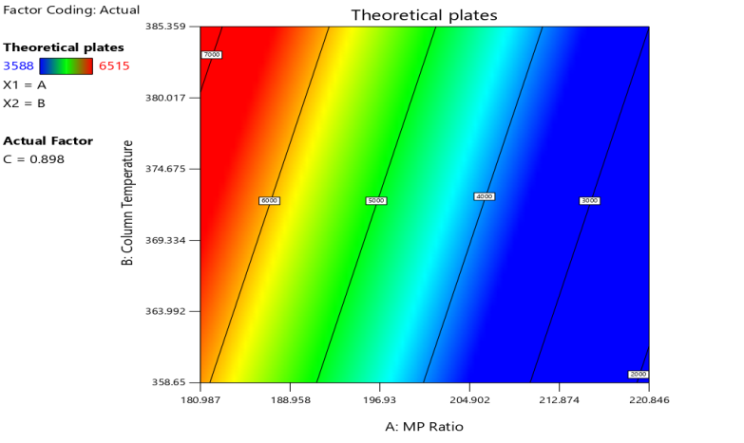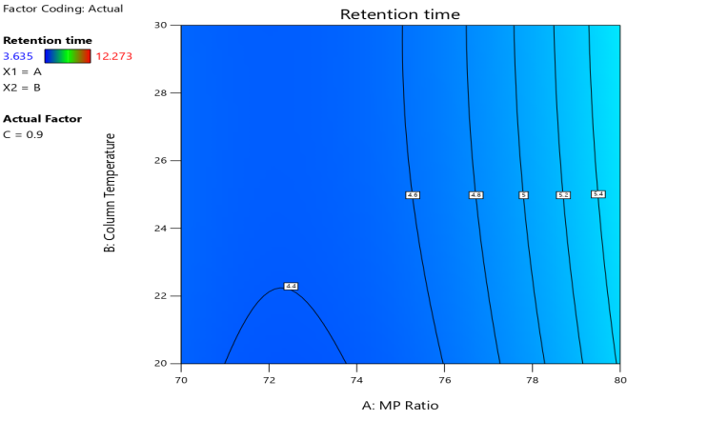
Fig 18: Contour plots Dapagliflozin (Theoretical Plate) Fig 19: Contour plots Sacubitril (Rt)

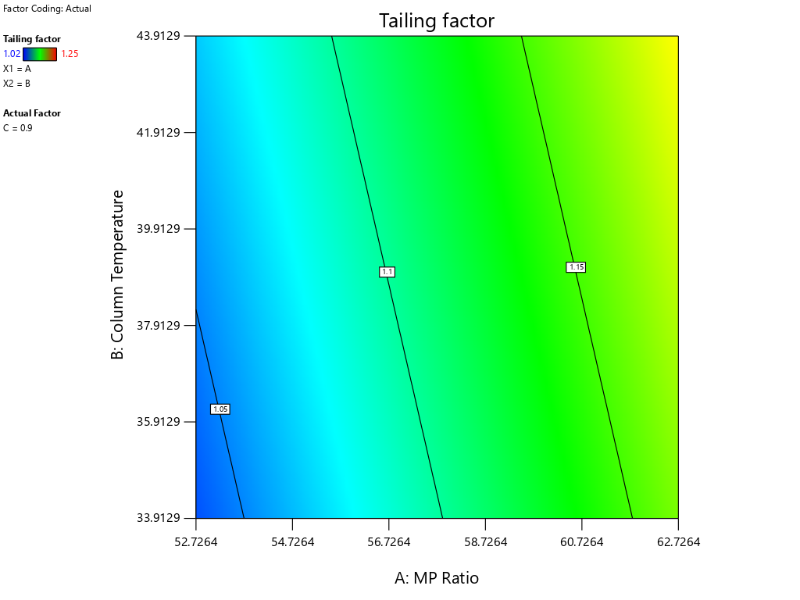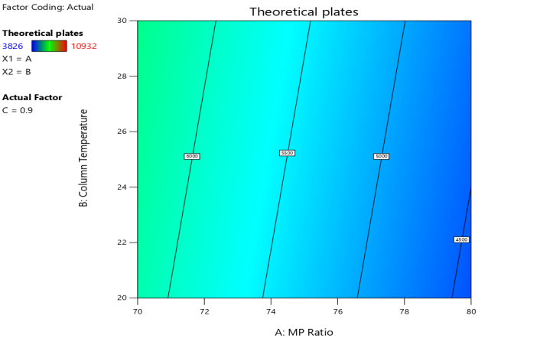

Fig 20: Contour plots Sacubitril (Tf) Fig 21: Contour plots Sacubitril (Theoretical Plate)
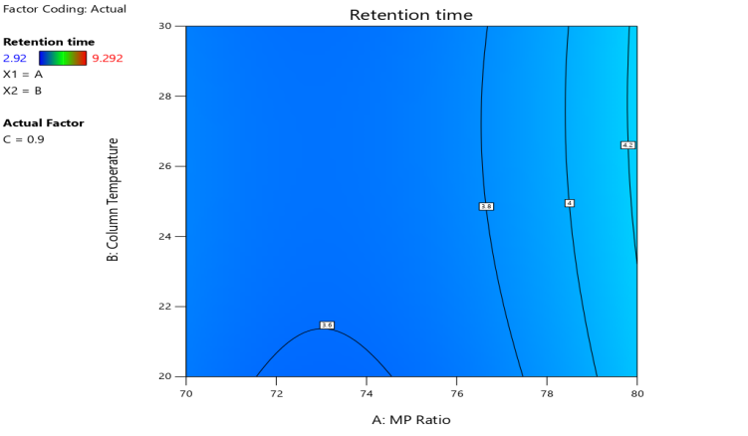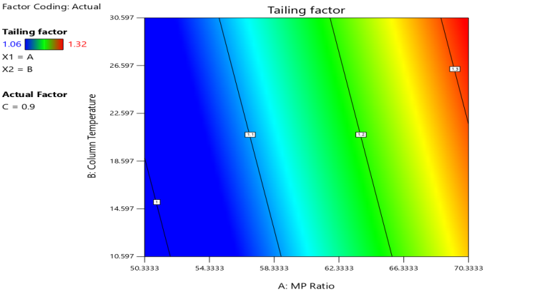
Fig 22: Contour plots Valsartan (Rt)Fig 23: Contour plots Valsartan (Tf)
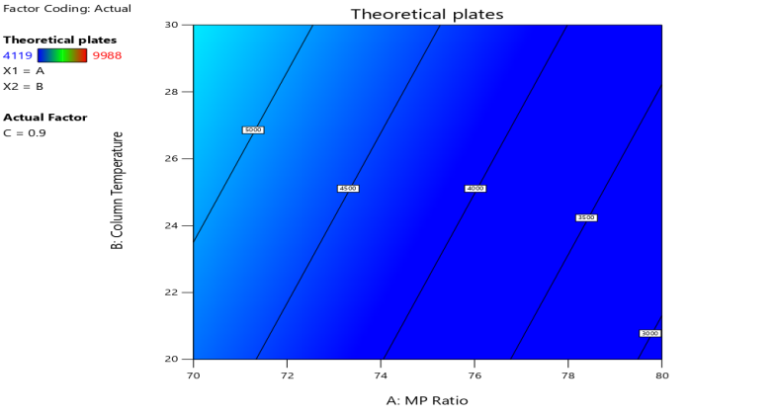
Fig 23: Contour plots Valsartan (Theoretical Plate)
3.3.8 Desirability Function
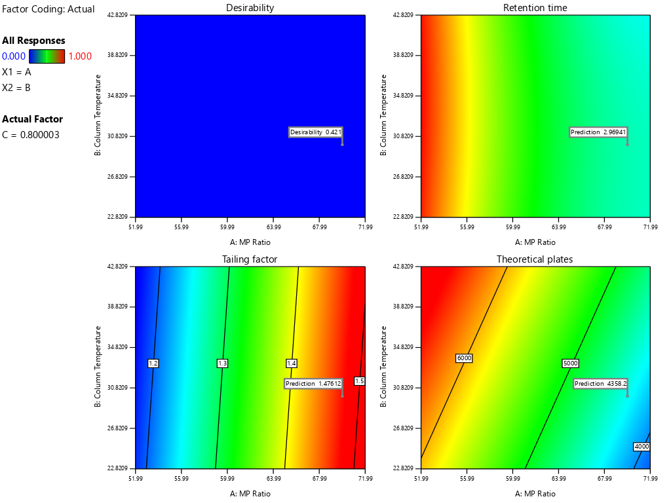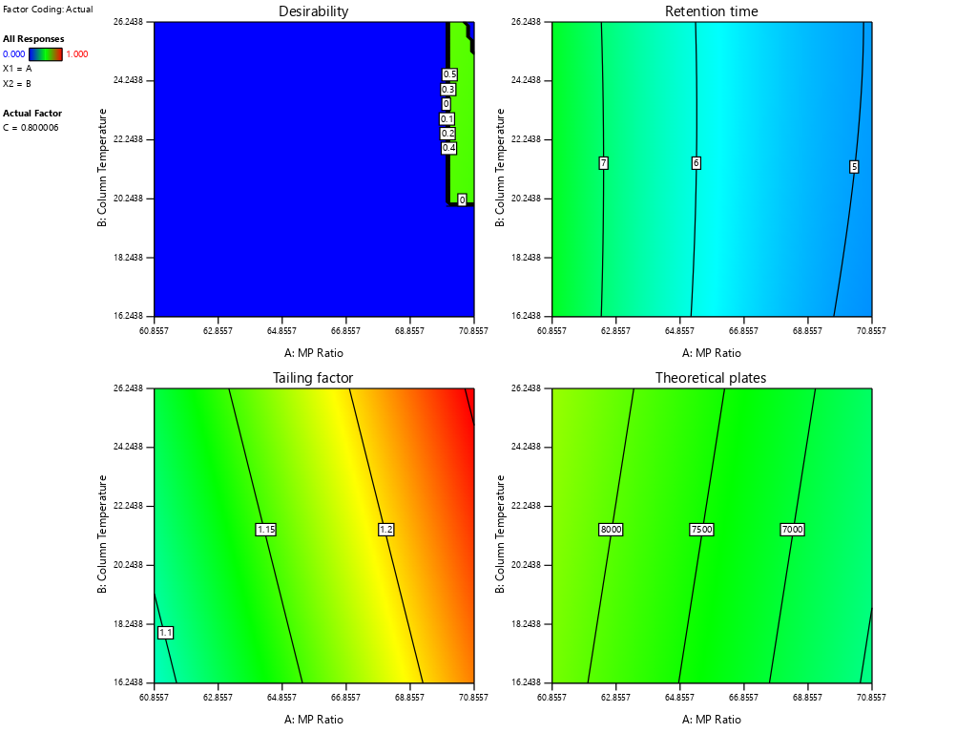
Fig 24: Desirability Function Dapagliflozin Fig 25: Desirability Function Sacubitril
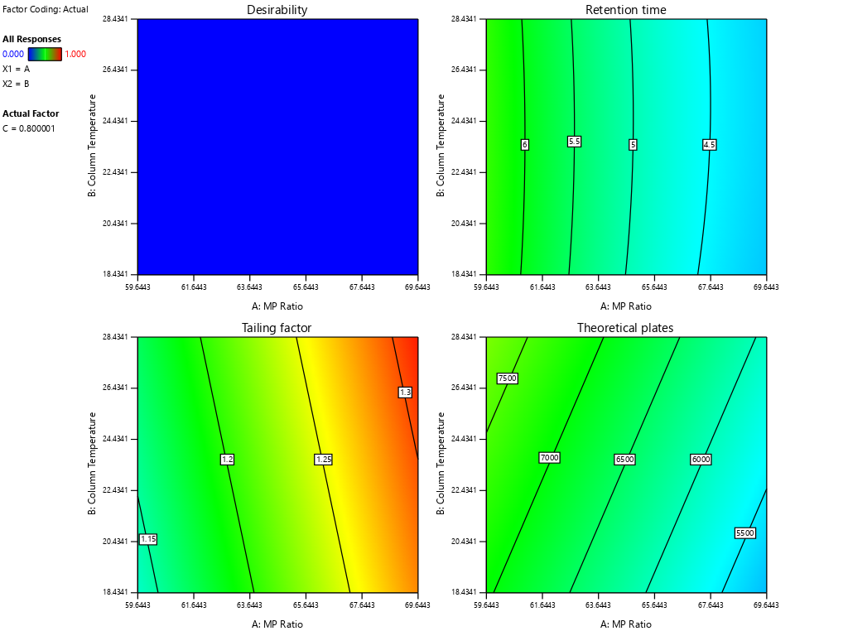
Fig 26: Desirability Function Valsartan

3.3.9 Based on Overlay Plot:
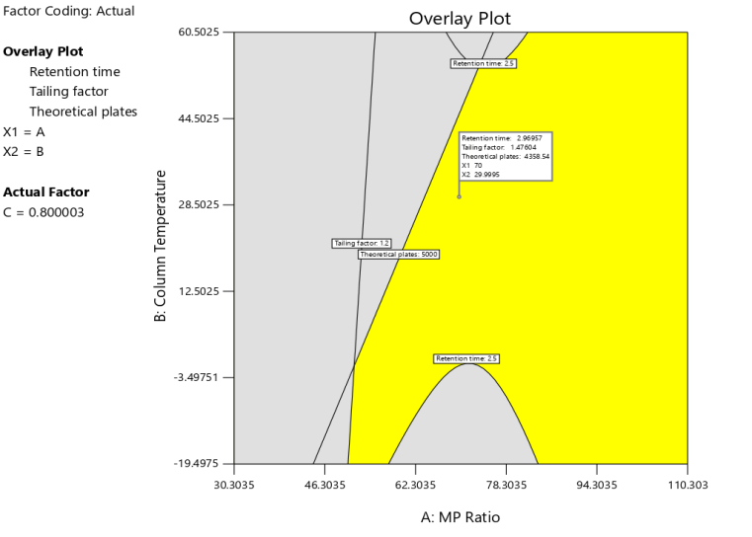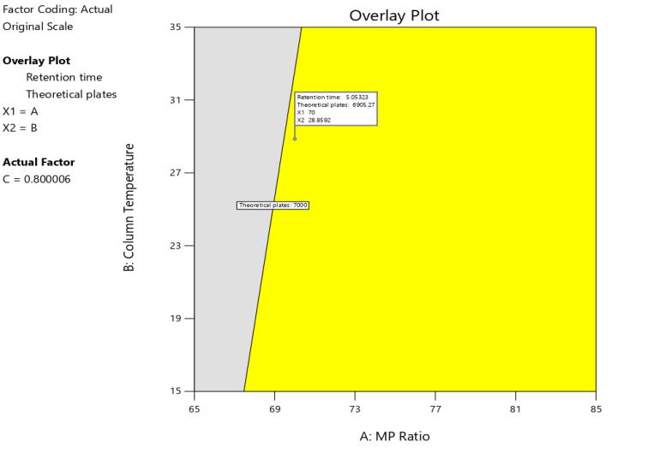
Fig 27: Overlay plot analysis Dapagliflozin Fig 28: Overlay plot analysis Sacubitril

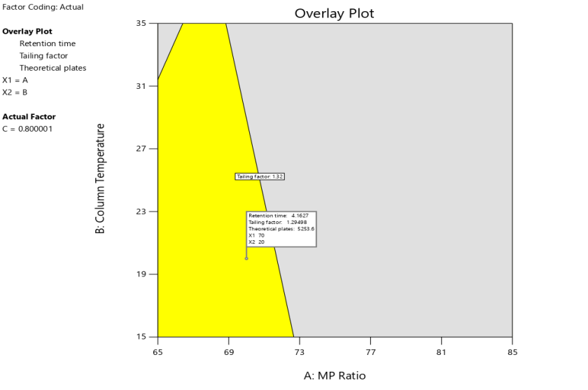
Fig 29: Overlay plot analysis Valsartan

3.4 ANALYTICAL METHOD VALIDATION

- System Suitability:

System suitability was evaluated using a mixed standard solution containing 5 µg/mL of Dapagliflozin Propanediol Monohydrate and 50 µg/mL of Sacubitril–Valsartan Sodium Complex Salt prepared in the diluent. The solution was injected six consecutive times into the RP-HPLC system.
Chromatograms were assessed for parameters such as retention time, peak area, theoretical plates, tailing factor, and resolution between the analyte peaks. The percentage relative standard deviation (%RSD) of peak areas was calculated for both analytes and was found to be within the acceptable limit of ≤ 2.0%, indicating proper performance of the chromatographic system.
Table 3.20: System suitability study

Sr. No. | System Suitability Parameter | Dapagliflozin Mean ± SD | %RSD | Valsartan Mean ± SD | %RSD | Sacubitril Mean ± SD | %RSD
1 | Retention Time (min) | 2.908 ± 0.0039 | 0.13 | 4.767 ± 0.0040 | 0.08 | 6.145 ± 0.0043 | 0.07
2 | Theoretical Plates (N) | 5194 ± 52.18 | 1.00 | 7110 ± 61.23 | 0.86 | 8299 ± 70.47 | 0.85
3 | Tailing Factor | 1.29 ± 0.006 | 0.46 | 1.13 ± 0.005 | 0.44 | 1.08 ± 0.004 | 0.37
4 | Resolution | — | — | 9.61 ± 0.07 | 0.73 | 5.55 ± 0.05 | 0.90

- Specificity:
Specificity of the developed method was examined by injecting blank (diluent), standard solution, and sample solution individually into the chromatographic system.
The obtained chromatograms were carefully evaluated to confirm that no interfering peaks were observed at the retention times corresponding to Dapagliflozin Propanediol Monohydrate and Sacubitril–Valsartan Sodium Complex Salt, demonstrating the selectivity of the method for the analytes.
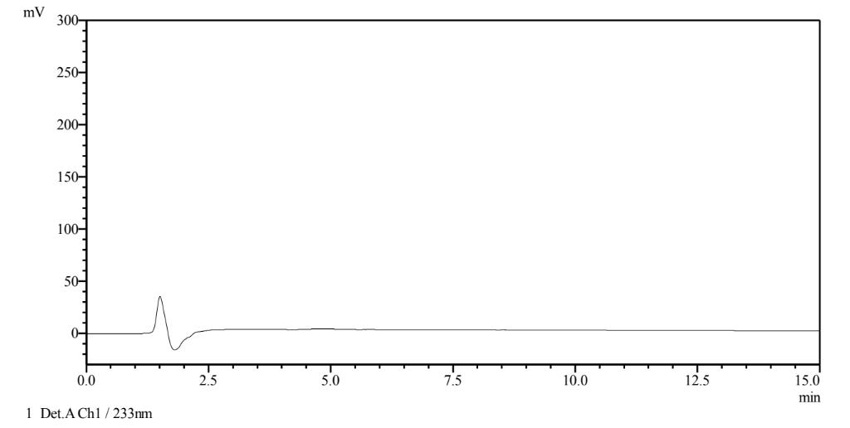
Fig 30: Chromatogram of Diluent

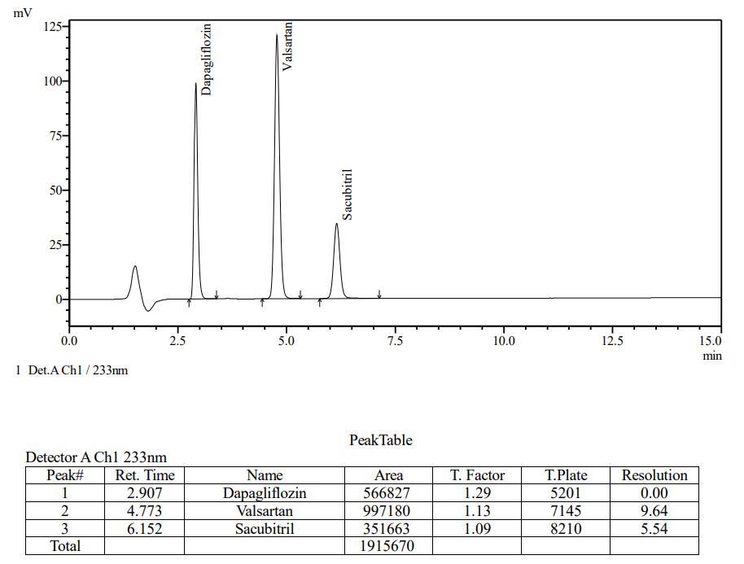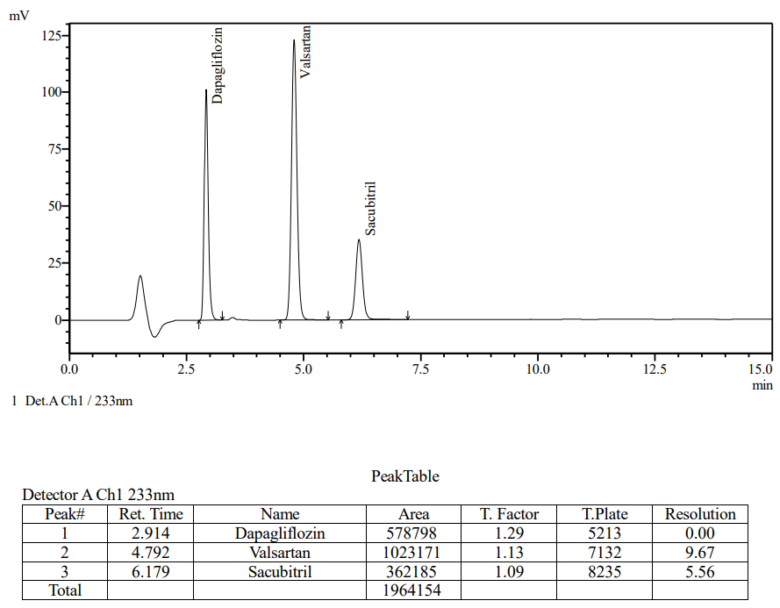
Fig 31: Standard of Dapagliflozin and Sacubitril–Valsartan Fig 32: Sample of Dapagliflozin and Sacubitril–Valsartan

Linearity
Linearity of the method was determined by analyzing five concentration levels ranging from 50% to 150% of the working concentration for both analytes.
Each level was injected three times, and calibration plots were constructed by plotting peak area versus concentration. The correlation coefficient (r²) values were found to be greater than 0.999, confirming excellent linearity over the selected concentration range.
Sr. No. | Conc. (µg/mL) | Mean Area (n=3) | SD | % RSD
1 | 2.50 | 298358 | 338 | 0.11
2 | 3.75 | 432349 | 141 | 0.03
3 | 5.00 | 567766 | 326 | 0.05
4 | 6.25 | 716437 | 405 | 0.05
5 | 7.50 | 865624 | 1282 | 0.14

Table 3.21: Linearity Data for Dapagliflozin Fig 33: Calibration Curve of Dapagliflozin

Sr. No. | Concen.  (µg/mL) | Mean Area (n=3) | SD | % RSD
1 | 25.00 | 687446 | 463 | 0.06
2 | 37.50 | 983545 | 3243 | 0.32
3 | 50.00 | 1341881 | 1017 | 0.07
4 | 62.50 | 1668541 | 915 | 0.05
5 | 75.00 | 2008874 | 118 | 0.005

Fig 34: Calibration Curve of Dapagliflozin Table 3.22: Linearity Data for Sacubitril–Valsartan

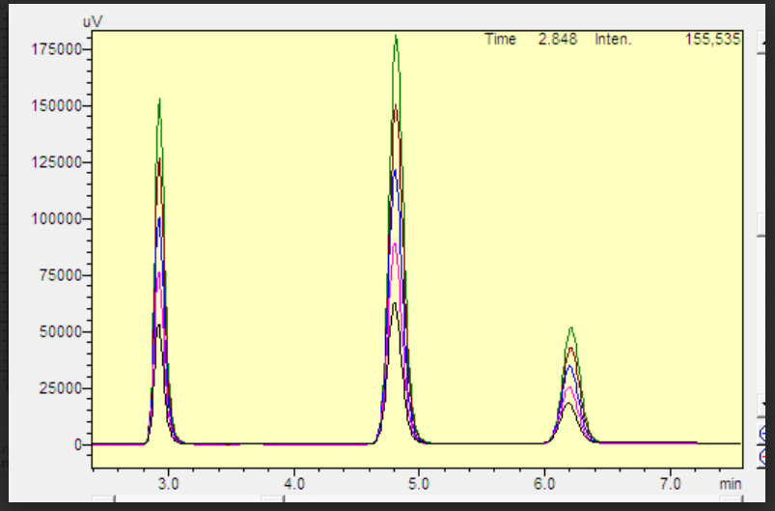

Fig 35: Linearity Chromatogram of Dapagliflozin and Sacubitril–Valsartan

Precision
Precision of the developed method was evaluated in terms of repeatability, intraday precision, and inter day precision for both analytes.

Repeatability (n = 6)
Table3.23 : Repeatability Data of Dapagliflozin and Sacubitril–Valsartan

Conc of Dapagliflozin | Peak area | Conc of Sacubitril–Valsartan | Peak area
5 µg/ml | 566908 | 50 µg/ml | 1333371
5 µg/ml | 566827 | 50 µg/ml | 1348843
5 µg/ml | 567200 | 50 µg/ml | 1347447
5 µg/ml | 567273 | 50 µg/ml | 1350239
5 µg/ml | 566868 | 50 µg/ml | 1350657
5 µg/ml | 567295 | 50 µg/ml | 1352234
Mean | 567062 | Mean | 1347132
SD | 216.5321377 | SD | 6935.435745
% RSD | 0.03 | % RSD | 0.51

Intraday Precision
Table 3.24 Intraday Precision

Drug | Concentration (µg/mL) | Mean Peak Area ± SD (n=3) | %RSD
Dapagliflozin | 2.5 | 288922 ± 628.70 | 0.22
Dapagliflozin | 5 | 569028 ± 1611.43 | 0.28
Dapagliflozin | 7.5 | 864205 ± 447.03 | 0.05
Sacubitril–Valsartan | 25 | 664669 ± 1908.54 | 0.29
Sacubitril–Valsartan | 50 | 1343329 ± 7193.18 | 0.54
Sacubitril–Valsartan | 75 | 2004894 ± 3784.72 | 0.19

- Inter day Precision
Table 3.25: Inter day Precision
Drug | Concentration (µg/mL) | Mean Peak Area ± SD (n=3) | %RSD
Dapagliflozin | 2.5 | 292836 ± 4006.42 | 1.37
Dapagliflozin | 5 | 573882 ± 2961.20 | 0.52
Dapagliflozin | 7.5 | 871510 ± 3307.61 | 0.38
Sacubitril–Valsartan | 25 | 669175 ± 7055.57 | 1.05
Sacubitril–Valsartan | 50 | 1350839 ± 8496.08 | 0.63
Sacubitril–Valsartan | 75 | 2017251 ± 7452.69 | 0.37

Limit of Detection and Limit of Quantitation
The LOD and LOQ values for Dapagliflozin Propanediol Monohydrate and Sacubitril–Valsartan Sodium Complex Salt were calculated from the calibration curve data.
The calibration curves were prepared in triplicate, and the standard deviation of the intercept (σ) and slope (S) were determined. The values were calculated using the following equations:
- LOD = 3.3 × σ / S
- LOQ = 10 × σ / S
The obtained values confirmed that the developed method possesses adequate sensitivity for detection and quantification of both analytes.

Drugs | LOD (µg/mL) | LOQ (µg/mL)
Dapagliflozin | 0.45 | 1.36
Sacubitril–Valsartan | 4.36 | 13.2
Table 3.26: Limit of Detection and Limit of Quantitation data for Dapagliflozin and Sacubitril–Valsartan

Accuracy
Accuracy was evaluated using the standard addition method at three levels: 50%, 100%, and 150% of the target concentration.The pre-analyzed synthetic mixture solution was spiked with known quantities of the standard drugs.

Each level was prepared in triplicate and analyzed using the optimized chromatographic conditions. The percentage recovery was calculated, and the mean recovery values for both drugs were found within 98–102% with %RSD < 2%, confirming good accuracy of the method.

Table 3.27: Accuracy Data Dapagliflazoin & Sacubitril–Valsartan

Level% | Set | Dapagliflazoin |  |  |  |  | Sacubitril–Valsartan
Level% | Set | Amount  Added  (µg) | Amount  Found  (µg) | %Recovery | Mean %  Recovery | %RSD | Amount  Added  (µg) | Amount  Found  (µg) | %Recovery | Mean %  Recovery | %RSD
50% | 1 | 2.500 | 2.490 | 99.60 | 99.2 | 0.4 | 25.000 | 24.830 | 99.30 | 98.8 | 0.5
50% | 2 | 2.500 | 2.470 | 98.80 | 99.2 | 0.4 | 25.000 | 24.600 | 98.40 | 98.8 | 0.5
50% | 3 | 2.500 | 2.480 | 99.20 | 99.2 | 0.4 | 25.000 | 24.670 | 98.70 | 98.8 | 0.5
100% | 1 | 5.000 | 4.930 | 98.60 | 98.8 | 1.1 | 50.000 | 49.520 | 99.00 | 99.9 | 0.9
100% | 2 | 5.000 | 5.000 | 100.00 | 98.8 | 1.1 | 50.000 | 50.340 | 100.70 | 99.9 | 0.9
100% | 3 | 5.000 | 4.890 | 97.80 | 98.8 | 1.1 | 50.000 | 50.040 | 100.10 | 99.9 | 0.9
150% | 1 | 7.500 | 7.390 | 98.50 | 98.1 | 0.8 | 75.000 | 74.370 | 99.20 | 98.5 | 1.2
150% | 2 | 7.500 | 7.390 | 98.50 | 98.1 | 0.8 | 75.000 | 74.370 | 99.20 | 98.5 | 1.2
150% | 3 | 7.500 | 7.290 | 97.20 | 98.1 | 0.8 | 75.000 | 72.890 | 97.20 | 98.5 | 1.2

- Robustness:

Robustness of the developed method was studied by introducing small, deliberate changes in chromatographic parameters.
The following variations were applied:
- Flow rate: ±0.1 mL/min from the optimized value
- Column temperature: ±5 °C
- Organic phase composition: ±2% of the mobile phase ratio
A standard solution containing 5 µg/mL of Dapagliflozin and 50 µg/mL of Sacubitril–Valsartan was injected under each modified condition. Chromatograms were evaluated for system suitability parameters such as retention time, peak area, theoretical plates, and tailing factor.
The %RSD values obtained under all conditions were within acceptable limits, indicating that the method is robust and reliable.

Parameter | Drug | Area at Tem.  (-5°C) | Area at Tem.  (+5°C) | Area at Flow  (-1%ml/min) | Area at Flow (+1%ml/min) | Area at Organic Phase-2% | Area at  Organic Phase+2%
Mean Peak Area | Dapagliflozin | 569439 | 571227 | 633750 | 517748 | 569588 | 569026
Mean Peak Area | Sacubitril–Valsartan | 1347018 | 1344871 | 1490324 | 1232106 | 1345127 | 1384884
% RSD | Dapagliflozin | 0.1 | 0.0 | 0.1 | 0.3 | 0.1 | 0.1
% RSD | Sacubitril–Valsartan | 0.1 | 0.5 | 0.3 | 1.1 | 0.0 | 0.6
Theoretical Plates | Dapagliflozin | 5079 | 5266 | 5868 | 4853 | 5404 | 5044
Theoretical Plates | Sacubitril | 7845 | 8265.00 | 8971 | 7983 | 8362 | 7884
Theoretical Plates | Valsartan | 6858 | 7198.00 | 7766 | 6815 | 7305 | 6685
Tailing Fator | Dapagliflozin | 1.12 | 1.13 | 1.12 | 111 | 1.12 | 1.12
Tailing Fator | Sacubitril– | 1.07 | 1.09 | 1.08 | 1.08 | 1.05 | 1.09
Tailing Fator | Valsartan | 1.11 | 1.14 | 1.14 | 1.14 | 1.10 | 1.14
Table 3.28: Robustness Data Dapagliflazoin & Sacubitril–Valsartan

Assay of Synthetic Mixture

Table 3.29: Assay of Synthetic Mixture

Drug | Label Claim (mg) | Mean Amount Found  (mg) | Assay (% Mean ± SD) | % RSD
Dapagliflozin | 5.0 | 5.05 | 101 ± 1.450 | 1.44
Sacubitril–Valsartan | 50.0 | 50.8 | 101.6 ± 1.759 | 1.73

- Conclusion

The present study successfully developed and validated a QbD-based RP-HPLC method for the simultaneous estimation of Dapagliflozin Propanediol Monohydrate and Sacubitril–Valsartan Sodium Complex Salt in a synthetic mixture. The application of the QbD approach allowed systematic optimization and identification of a robust design space, ensuring consistent chromatographic performance.
The validated method demonstrated excellent linearity, precision, accuracy, sensitivity, and robustness, with all validation parameters meeting acceptable analytical criteria. The overlay plot confirmed a stable method operable design region, indicating that the method can tolerate small variations in chromatographic conditions without affecting performance.
Therefore, the developed RP-HPLC method is simple, rapid, precise, and reliable, making it suitable for routine quality control analysis and simultaneous estimation of Dapagliflozin and Sacubitril–Valsartan in pharmaceutical formulations or synthetic mixtures.

5. REFERENCE

- Reddy PKC, Mathur P. QbD driven analytical method development and validation of metformin and dapagliflozin by RP-HPLC. International Journal of Health Sciences. 2022;6(S2):12345–12352.
- Kadam GM, Puyad AL, Kalyankar TM. RP-HPLC method development and validation for estimation of sacubitril and valsartan in pharmaceutical dosage form. Research Journal of Pharmacy and Technology. 2021;14(11):6032–6038
- Alluri NR, Bandlamudi MR, Kuppusamy S, et al. Implementation of quality by design approach to analytical method development and validation by RP-HPLC. ACS Omega. 2025;10(5):1234–1245.
- Mandhare S, Godge R, Vikhe A, et al. Development and validation of a QbD-based RP-HPLC method: a lifecycle approach. Journal of Applied Pharmaceutical Research. 2024;12(2):1–10.
- Sebaiy MM, El-Adl SM, Baraka MM, Hassan WS. Quality by design approach for development and validation of RP-HPLC method for simultaneous estimation of xipamide and valsartan. BMC Chemistry. 2022;16(1):1–14.\
- Kasichayanula S, et al., Clinical pharmacokinetics and pharmacodynamics of dapagliflozin, Clinical Pharmacokinetics, 2014; 53(1): 17–27.
- McMurray JJV, et al., Angiotensin–neprilysin inhibition versus enalapril in heart failure, New England Journal of Medicine, 2014; 371: 993–1004.
- Drug Profile For Dapagliflozin Propanediol Monohydrate 2021, https://go.drugbank.com/salts/DBSALT001101
- https://pubchem.ncbi.nlm.nih.gov/compound/Dapagliflozin-Propanediol
- Drug profile for sacubitril” https://go.drugbank.com/drugs/DB09292#:~:text=Sacubitril%20is%20a%20neprilysi n%20inhibitor,IV)%20and%20reduced%20ejection%20fraction. (Cited Aug 2025)

- “Drug profile for valsartan” https://go.drugbank.com/drugs/DB00177

