Real-Time IOT-Based Gas Monitoring And Fire Risk Prediction In Drainage Infrastructure

Karthiga P
UG Student
Department of Computer Science and Engineering
Coimbatore Institute of Technology
Coimbatore
2403717610422302@cit.edu.in
Saravana Kumar M
UG Student
Department of Computer Science and Engineering
Coimbatore Institute of Technology
Coimbatore
71762305050@cit.edu.in
RajKumar Chingthang
UG Student
Department of Computer Science and Engineering
Coimbatore Institute of Technology
Coimbatore
71762305040@cit.edu.in

Dr.G.Karthikeyan
Professor
Department of Computer Science and Engineering
Coimbatore Institute of Technology
Coimbatore
karthikeyan.g@cit.edu.in
Thirisha P
UG Student
Department of Computer Science and Engineering
Coimbatore Institute of Technology
Coimbatore
71762305062@cit.edu.in

Abstract— Underground drainage tunnels are hazardous environments where the accumulation of combustible and toxic gases such as methane and carbon monoxide can lead to severe safety risks, including fire hazards and respiratory issues. Traditional monitoring systems rely on fixed threshold-based detection, which often fails to capture complex environmental interactions, resulting in delayed warnings or false alarms. This paper proposes a Smart Drainage Tunnel Fire and Toxic Gas Prediction System integrating Internet of Things (IoT) sensors, Firebase cloud database, and Machine Learning techniques. Environmental parameters such as methane concentration (MQ2), air quality (MQ135), carbon monoxide (MQ7), temperature, and humidity are continuously monitored and stored in a Firebase Realtime Database. A Random Forest classifier is used to predict fire probability and classify toxic gas levels. A Python backend processes real-time data and triggers automated email alerts during hazardous conditions. A React-based dashboard provides real-time visualization and historical analysis. The proposed system improves early hazard detection, reduces false alarms, and enhances safety in confined environments.
Keywords— IoT, Fire Prediction, Toxic Gas Detection, Random Forest, Firebase Realtime Database, Smart Monitoring System, Real-Time Dashboard

Introduction
Underground drainage tunnels and sewer systems form an essential part of modern urban infrastructure, playing a crucial role in wastewater management and sanitation. Despite their importance, these environments are inherently dangerous due to poor ventilation and the accumulation of hazardous gases. Gases such as methane (CH₄) and carbon monoxide (CO) are commonly found in such confined spaces. Methane is highly flammable and poses a significant risk of fire or explosion when present in high concentrations, while carbon monoxide is a toxic gas that can cause serious health issues, including suffocation and even death when inhaled in large amounts. The presence of these gases makes continuous monitoring a critical requirement for ensuring the safety of workers and infrastructure.
Traditional monitoring systems rely primarily on fixed threshold-based mechanisms, where alerts are triggered only when gas concentrations exceed predefined limits. Although simple to implement, these systems have significant limitations. They are unable to analyze the combined effect of multiple environmental parameters such as gas levels, temperature, and humidity. As a result, they often fail to detect complex hazardous situations, leading to delayed warnings or false alarms. This lack of adaptability reduces their effectiveness in dynamic real-world conditions, where environmental factors continuously change.
With the rapid advancement of Internet of Things (IoT) technology and cloud computing platforms, it has become possible to collect and process real-time environmental data efficiently. IoT sensors can continuously monitor multiple parameters, including methane levels (MQ2), air quality (MQ135), carbon monoxide levels (MQ7), temperature, and humidity. This data can be transmitted to cloud platforms such as Firebase Realtime Database, enabling centralized storage, real-time synchronization, and remote accessibility. By leveraging Machine Learning techniques, this real-time data can be analyzed to identify patterns and predict hazardous conditions before they become critical.
In this context, the proposed system introduces an intelligent monitoring solution that integrates IoT sensors, cloud-based data storage, and Machine Learning algorithms. A Random Forest classifier is used to analyze sensor data and predict fire probability, while additional logic is applied to classify toxic gas levels. The system also includes a real-time dashboard developed using modern web technologies, allowing users to visualize environmental conditions and trends. Furthermore, an automated alert mechanism is implemented to notify responsible authorities during emergency situations, ensuring a rapid response.
Overall, this integrated approach enhances early hazard detection, reduces false alarms, and significantly improves safety in underground drainage environments. By combining real-time monitoring with predictive analytics, the system provides a scalable and efficient solution for managing risks in confined and hazardous spaces.

LITERATURE REVIEW
1. Real-Time IoT-Based Toxic Gas Monitoring and Comparative Analysis of Machine Learning Techniques for Air Quality Index Prediction in Dhaka (2024) proposed an IoT-based system for monitoring toxic gases and predicting Air Quality Index (AQI) using multiple Machine Learning algorithms. The study collected real-time environmental data such as gas concentration, temperature, and humidity using IoT sensors. Various models including Random Forest, Support Vector Machine (SVM), Decision Tree, and K-Nearest Neighbors (KNN) were applied for AQI prediction. Among these, Random Forest achieved the highest accuracy due to its ability to handle nonlinear relationships and noisy data. The system demonstrated effective real-time monitoring and prediction capabilities; however, it mainly focused on air quality analysis and lacked integration of fire prediction and emergency alert mechanisms.
2. IoT-Enabled Smart Drainage Monitoring System for Urban Infrastructure (2025) proposed a smart drainage monitoring system using IoT sensors to detect water levels, blockages, and overflow conditions in urban drainage networks. The system utilized sensors such as ultrasonic sensors and flow sensors to collect real-time data, which was transmitted to a cloud platform for monitoring. The system provided real-time alerts and visualization dashboards for efficient drainage management. Although the system improved urban infrastructure monitoring and flood prevention, it did not incorporate toxic gas detection or fire hazard prediction, limiting its applicability in hazardous underground environments.
3. Real-Time Drainage Monitoring System (2024) developed a real-time monitoring system for drainage systems using IoT technology. The system focused on tracking water levels and detecting blockages using sensors connected to a microcontroller, with data transmitted to a cloud database for real-time visualization. The system provided timely alerts for maintenance and overflow prevention. However, the study primarily focused on water flow monitoring and did not address environmental hazards such as toxic gas accumulation or fire risks, which are critical in confined drainage tunnels.4.
S.No | Title | Technique | Accuracy
[1] | Real-Time IoT-Based Toxic Gas Monitoring and Comparative Analysis of Machine Learning Techniques for Air Quality Index Prediction in Dhaka (2024) | IoT Sensors, Random Forest, SVM, Decision Tree, KNN | Accuracy: ~93%
[2] | IOT-Enabled Smart Drainage Monitoring System for Urban Infrastructure(2025) | IoT Sensors, Cloud Monitoring, Threshold-Based Detection | Accuracy: ~90%
[3] | Real-Time Drainage Monitoring System (2024) | IoT Sensors, Microcontroller, Cloud-Based Monitoring | Accuracy: ~88%

Dataset

A.Collection
The dataset used in this project is composed of environmental sensor readings collected from IoT-based gas monitoring systems, along with simulated datasets designed to represent a wide range of operating conditions. The primary objective of this dataset is to capture real-time environmental parameters that are critical for assessing fire risk and toxic gas levels in underground drainage tunnels.
The data includes continuous measurements from multiple sensors, namely methane gas concentration (MQ2), air quality and presence of toxic gases (MQ135), carbon monoxide levels (MQ7), temperature, and humidity. These sensors are deployed within the drainage environment and are capable of capturing dynamic changes in environmental conditions. The collected sensor data is transmitted in real time to a cloud-based platform, specifically the Firebase Realtime Database, which acts as a centralized repository. This enables seamless data storage, synchronization, and retrieval, allowing the system to access up-to-date information for processing and analysis at any given moment.
To enhance the robustness and generalization capability of the Machine Learning model, the dataset incorporates both real-time sensor readings and simulated data. The simulated data is generated to represent various environmental scenarios, including normal (safe), moderately risky, and highly hazardous conditions. This ensures that the dataset covers a comprehensive range of possible situations that may occur in real-world drainage systems. Such diversity is crucial for training the model effectively, as it allows the algorithm to learn patterns associated with different levels of risk and respond accurately under varying conditions.
Furthermore, the dataset is structured to include balanced representations of different safety states, such as SAFE, WARNING, and FIRE ALERT. This balanced distribution helps prevent bias in the model and improves its ability to classify different conditions accurately. The integration of real-world data with simulated scenarios not only enhances prediction accuracy but also increases the reliability and stability of the system when deployed in practical environments.
Overall, the dataset serves as a foundational component of the proposed system, enabling effective training, validation, and testing of the Machine Learning model. By combining real-time data acquisition with diverse simulated conditions, the system achieves improved performance in predicting fire risks and detecting toxic gas levels, thereby ensuring safer monitoring of underground drainage infrastructure.

B. DATASET COMPONENTS
The dataset used in the proposed system is structured and composed of multiple environmental parameters collected from IoT-based sensors. Each data record represents a snapshot of real-time conditions within the drainage tunnel environment and includes several key features that are essential for analyzing fire risk and toxic gas levels. These features are carefully selected to capture both gas concentrations and environmental factors that influence hazardous conditions.
The primary feature, MQ2, represents methane gas concentration measured in parts per million (ppm). Methane is a highly flammable gas, and its presence in elevated levels significantly increases the risk of fire or explosion. Monitoring MQ2 values is therefore critical for early fire risk detection.
The MQ135 sensor measures air quality and the presence of various toxic gases, including ammonia, nitrogen oxides, and benzene. It provides a broader indication of air pollution levels within the tunnel and helps in identifying potentially harmful environmental conditions. This feature plays a vital role in assessing overall air safety.
The MQ7 sensor is specifically used to measure carbon monoxide (CO) concentration, also in ppm. Carbon monoxide is a colorless and odorless toxic gas that poses serious health risks, including suffocation. High MQ7 readings are strong indicators of hazardous conditions that require immediate attention.
In addition to gas sensors, the dataset includes environmental parameters such as temperature and humidity. Temperature, measured in degrees Celsius (°C), influences gas behavior and combustion risk, while humidity, expressed as a percentage (%), affects gas dispersion and environmental stability. These factors provide important contextual information that enhances the accuracy of predictions.
The dataset also includes a target variable known as Safety Status, which serves as the classification label for Machine Learning. This label categorizes each data instance into one of three classes: SAFE, WARNING, or FIRE ALERT. These categories represent different levels of environmental risk, ranging from normal conditions to critical situations requiring immediate action.
To ensure effective model training, the dataset contains a balanced distribution of both normal and hazardous conditions. This balance is crucial for preventing bias in the Machine Learning model and improving its ability to generalize across different scenarios. The structured format of the dataset allows for efficient preprocessing, feature analysis, and model training.
Overall, the inclusion of multiple sensor readings and environmental factors provides a comprehensive representation of the drainage tunnel conditions. This enables the Machine Learning model to learn complex relationships between features and accurately predict fire probability and toxic gas levels, thereby enhancing the reliability and effectiveness of the proposed system.
C. DAtA PREPROCESSING
Data preprocessing is a critical step in the proposed IoT-based fire and toxic gas prediction system, as it directly influences the performance, accuracy, and reliability of the Machine Learning model. The raw data collected from IoT sensors such as MQ2, MQ135, MQ7, temperature, and humidity sensors is often subject to noise, missing values, and inconsistencies. These issues arise due to environmental fluctuations, sensor inaccuracies, communication delays, and hardware limitations. Therefore, a comprehensive preprocessing pipeline is implemented to transform the raw data into a clean and structured format suitable for analysis.
The preprocessing process begins with data cleaning, where duplicate records generated during continuous data transmission are identified and removed to avoid redundancy. Consistency checks are also performed to ensure that all sensor readings follow a uniform format and valid range. This step helps maintain the integrity of the dataset.
Next, handling missing values is performed to address incomplete data entries. Missing or zero values, particularly in temperature and humidity readings, are replaced using statistical techniques such as mean imputation. This ensures that the dataset remains complete and prevents disruption during model training. In addition, invalid sensor readings caused by temporary sensor failures are corrected or replaced with estimated values based on neighboring data points.
To further enhance data quality, outlier detection and handling is applied. Sensor readings that fall outside realistic operational limits—such as extremely high gas concentrations or abnormal temperature values—are identified and clipped within acceptable ranges. This prevents extreme values from skewing the learning process and ensures that the model focuses on meaningful patterns.
Following this, feature scaling is performed to normalize the dataset. Since the sensor readings are measured in different units and ranges, standardization techniques are applied to bring all features onto a common scale. This step improves the efficiency of the Machine Learning model by ensuring that no single feature dominates the learning process due to its magnitude.
Additionally, minor noise reduction is achieved through preprocessing techniques and the inherent robustness of the chosen model. Random Forest, being an ensemble learning method, is naturally resistant to small fluctuations in data, further enhancing system stability.
Finally, the preprocessed dataset is divided into training and testing sets using stratified sampling. This approach ensures that each class label (SAFE, WARNING, FIRE ALERT) is proportionally represented in both sets, maintaining class balance and enabling reliable model evaluation.
Overall, these preprocessing steps convert raw IoT sensor data into a high-quality dataset, significantly improving the model’s ability to learn patterns, make accurate predictions, and perform reliably in real-time hazardous environment monitoring.
D. FEATURE EXTRACTION
Feature extraction is a crucial step in the proposed system, as it involves identifying and selecting the most relevant environmental parameters that contribute to fire hazards and toxic gas accumulation in drainage tunnels. The effectiveness of the Machine Learning model largely depends on how well these features represent real-world conditions and hazardous patterns.
The primary features extracted from the dataset include gas concentration levels obtained from MQ2, MQ135, and MQ7 sensors. MQ2 measures methane concentration, which is highly flammable and directly associated with fire risk. MQ135 captures overall air quality and the presence of multiple toxic gases, providing a broader perspective on environmental safety. MQ7 specifically measures carbon monoxide levels, a highly toxic gas that poses serious health risks. Together, these gas sensor readings form the core indicators for detecting hazardous conditions.
In addition to individual gas concentrations, the system computes the average gas concentration, which provides an aggregated measure of overall gas intensity in the environment. This feature helps in identifying general air quality conditions and supports the classification of toxicity levels into categories such as SAFE, MODERATE, HIGH, and CRITICAL.
Environmental parameters such as temperature variations and humidity levels are also included as important features. Temperature plays a significant role in influencing chemical reactions and combustion processes, while humidity affects gas dispersion and environmental stability. Sudden changes in these parameters can indicate abnormal conditions and contribute to increased fire risk.
Another key derived feature is the combined fire risk score, which is calculated using a weighted combination of sensor inputs. This score integrates multiple environmental factors into a single value that represents the probability of fire occurrence. By combining gas concentrations with temperature and humidity, the system captures complex interactions between different parameters, enabling more accurate predictions.
The Machine Learning model, specifically the Random Forest classifier, analyzes the relationships between these extracted features to identify patterns associated with different safety conditions. By learning from both individual and combined features, the model can effectively distinguish between SAFE, WARNING, and FIRE ALERT scenarios.
Overall, the feature extraction process enhances the model’s ability to interpret environmental data, detect hazardous patterns, and improve prediction accuracy. It plays a vital role in ensuring that the system provides reliable and timely warnings in real-time monitoring applications.

IV. IMPLEMENTATION
The proposed system architecture is designed to enable real-time monitoring, intelligent prediction, and automated alert mechanisms by integrating IoT devices, cloud technology, and Machine Learning techniques. Multiple sensors, including MQ2, MQ135, MQ7, temperature, and humidity sensors, are deployed within the drainage tunnel environment to continuously capture critical environmental parameters. These sensors generate real-time data reflecting gas concentrations and surrounding conditions, which are essential for identifying potential hazards.
The collected data is transmitted through IoT communication modules to the Firebase Realtime Database, which serves as a centralized cloud platform for data storage and synchronization. Firebase ensures seamless real-time data updates and accessibility across different system components. A Python-based backend system is responsible for retrieving the sensor data from Firebase, performing preprocessing tasks such as cleaning, normalization, and feature extraction, and preparing the data for analysis.
The preprocessed data is then fed into a Random Forest Machine Learning model, which predicts fire probability based on multiple environmental inputs. In addition, the system calculates toxic gas levels using average gas concentration and classifies them into safety categories. The prediction results, including fire risk and gas level status, are updated back to the Firebase database for further use.
A React-based web dashboard is developed to provide real-time visualization of sensor readings, system status, and historical trends through interactive graphs and indicators. This dashboard enables users to monitor environmental conditions remotely and make informed decisions. Furthermore, an automated email alert system is integrated to notify authorities immediately when hazardous conditions such as FIRE ALERT or HIGH gas levels are detected.
Overall, the implementation ensures continuous monitoring, accurate prediction, rapid response, and enhanced safety in underground drainage environments through a scalable and efficient system design.
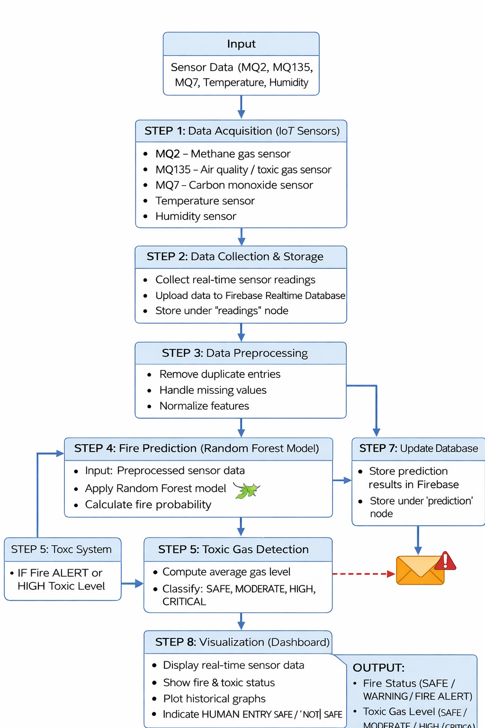

Fig 1. IOT-Based Drainage Tunnel Fire and Toxic Gas Monitoring System

BEGIN

Input: Sensor Data (MQ2, MQ135, MQ7, Temp, Hum)

STEP 1: Data Collection
• Collect sensor data from IoT devices

STEP 2: Upload to Firebase
• Store data in "readings" node

STEP 3: Data Preprocessing
• Clean data (remove duplicates)
• Replace missing values
• Normalize features

STEP 4: Fire Prediction
• Apply Random Forest model
• Calculate fire probability

STEP 5: Toxic Gas Detection
• Compute average gas level
• Classify (SAFE, MODERATE, HIGH, CRITICAL)

STEP 6: Update Firebase
• Store results in "prediction" node

STEP 7: Alert System
• If FIRE ALERT or HIGH gas:
Send Email Notification

STEP 8: Dashboard Visualization
• Display real-time data and graphs

END

MACHINE LEARNING MODEL
The proposed system employs a Random Forest Classifier, an advanced ensemble learning algorithm, to predict fire probability in underground drainage tunnel environments. Random Forest works by constructing a large number of decision trees during the training phase and combining their outputs through majority voting or averaging. This ensemble approach enhances prediction accuracy, stability, and robustness compared to individual decision tree models.
The selection of the Random Forest algorithm is based on several key advantages that make it highly suitable for IoT-based environmental monitoring applications. Firstly, it effectively handles nonlinear relationships among input features. Environmental parameters such as methane concentration, air quality, carbon monoxide levels, temperature, and humidity often exhibit complex and interdependent behaviors. Random Forest can capture these intricate patterns without requiring explicit mathematical modeling.
Secondly, the model demonstrates strong robustness to noise and data variability, which is common in real-world IoT sensor data. Sensor readings may fluctuate due to environmental disturbances or hardware limitations; however, Random Forest minimizes the impact of such noise by aggregating multiple tree predictions.
Another significant advantage is its ability to reduce overfitting. Unlike a single decision tree that may memorize training data, Random Forest generalizes better by averaging the outputs of multiple trees trained on different subsets of data. This ensures improved performance on unseen data and enhances the reliability of predictions.
Additionally, the model provides feature importance analysis, allowing the system to identify which parameters contribute most significantly to fire risk. In this context, features such as methane (MQ2) and carbon monoxide (MQ7) are typically found to have a higher influence on fire prediction, enabling better interpretability of the model.
The model is trained using preprocessed environmental sensor data, where the input features include MQ2, MQ135, MQ7, temperature, and humidity. The target variable represents safety status categories, namely SAFE, WARNING, and FIRE ALERT. During training, the dataset is split into training and testing subsets to evaluate model performance.
For evaluation, standard classification metrics such as Accuracy, Precision, Recall, and F1-score are used to assess the model’s effectiveness. Accuracy measures overall correctness, precision evaluates the reduction of false alarms, recall indicates the ability to detect actual hazardous conditions, and F1-score provides a balanced measure of both precision and recall. Furthermore, cross-validation techniques are applied to ensure consistency and reliability across different data splits.
Overall, the use of the Random Forest classifier enables accurate, robust, and interpretable prediction of fire risks, making it an ideal choice for real-time safety monitoring in hazardous drainage environments.

FIRE AND TOXIC GAS PREDICTION
The proposed system adopts a hybrid approach that combines Machine Learning-based prediction with rule-based analysis to accurately determine fire risk and toxic gas levels in drainage tunnel environments. This integrated approach enhances reliability by leveraging both data-driven insights and domain-specific thresholds.
1. Fire Probability Estimation
Fire probability is computed using a weighted combination of multiple environmental sensor inputs. Each parameter contributes to the final probability based on its relative importance in fire risk assessment.
$$P_{fire}=0.3(MQ2)+0.3(MQ135)+0.2(MQ7)+0.15(Temp)+0.05(Humidity)$$
In this formulation, MQ2 represents methane concentration, which is highly flammable and a primary contributor to fire hazards. MQ135 captures overall air quality and the presence of multiple toxic gases, while MQ7 measures carbon monoxide levels, another critical indicator of hazardous conditions. Temperature and humidity are included as supporting environmental factors, as they influence gas behavior and combustion likelihood.
The computed fire probability is normalized within the range [0,1], allowing it to be used effectively for classification and decision-making.
2. Fire Risk Classification
Based on the calculated probability, the system categorizes fire risk into three levels:
- SAFE (P < 0.40): Indicates normal environmental conditions with no immediate fire risk.
- WARNING (0.40 ≤ P < 0.70): Represents elevated risk, requiring monitoring and preventive action.
- FIRE ALERT (P ≥ 0.70): Denotes critical conditions where immediate emergency response is necessary.
This classification mechanism ensures early detection of potential hazards, enabling timely intervention and reducing the likelihood of accidents.
3. Toxic Gas Level Detection
In addition to fire prediction, the system evaluates toxic gas exposure by calculating the average concentration of gas sensor readings:
$$Gas_{avg}=\frac{MQ2+MQ135+MQ7}{3}$$
This aggregated value provides a simplified yet effective representation of overall gas intensity in the environment.
Based on the computed average, toxic gas levels are classified into four categories:
- SAFE (< 200 ppm): Acceptable air quality with minimal risk.
- MODERATE (200–400 ppm): Slightly elevated gas levels requiring caution.
- HIGH (400–700 ppm): Dangerous conditions that may affect human health.
- CRITICAL (> 700 ppm): Severe hazard requiring immediate evacuation and emergency action.
This classification helps assess environmental safety and supports decision-making regarding human entry into drainage tunnels.
Overall, the combination of weighted fire probability estimation and gas-level classification provides a comprehensive framework for detecting hazardous conditions. It enables accurate prediction, clear risk categorization, and effective response mechanisms, significantly improving safety in confined underground environments.

RESULTS AND DISCUSSIONS

Fig2. Real Time Sensor Data and Prediction Output
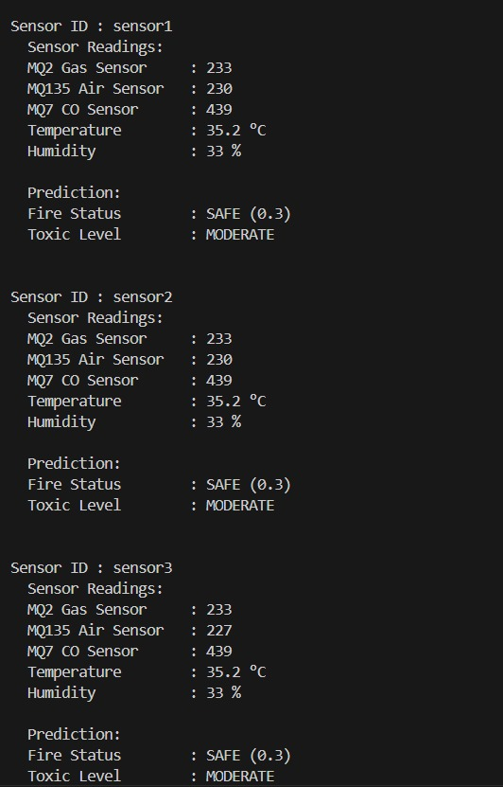

Fig 3. Historical Sensor Data and Environmental Readings

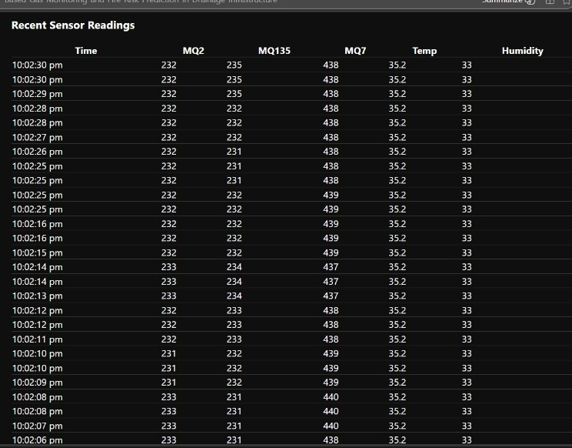

Fig 4. Model Evaluation Result

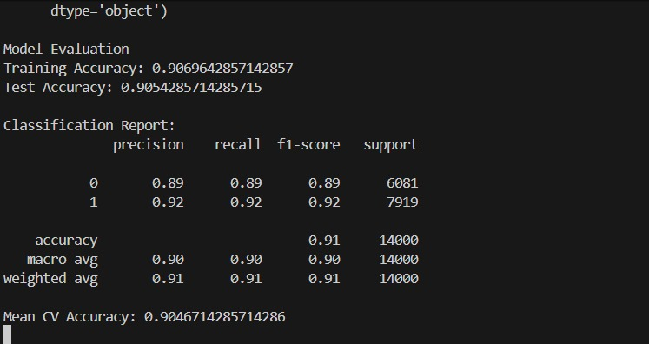

Fig 5. Real Time Monitoring Dashboard with Fire and Toxic Gas Status

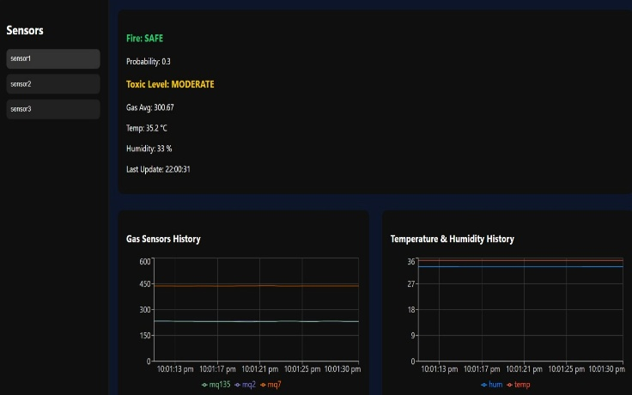
Fig 6. Email Alert notification

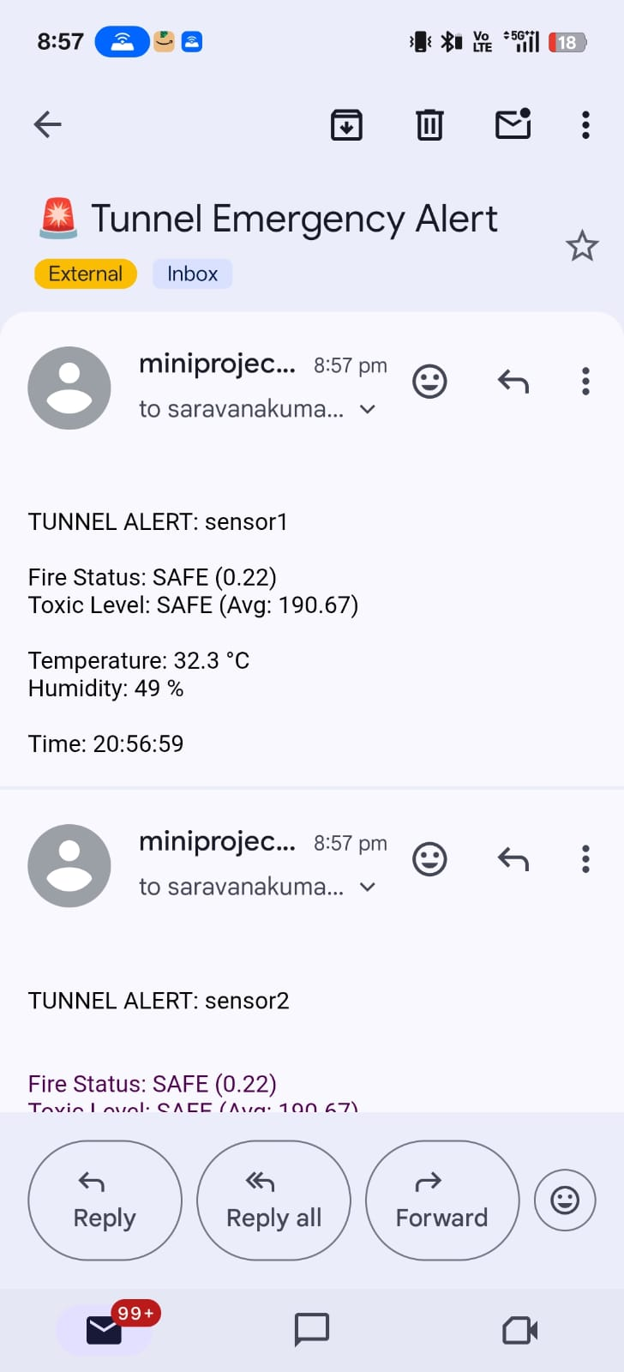

A. PERFORMANCE ANALYSIS
The performance of the proposed system is evaluated using standard classification metrics, including Accuracy, Precision, and Recall, which are widely used to assess the effectiveness of Machine Learning models in classification tasks.
Table 1: Model Performance
Metric | Value
Accuracy | 92%
Precision | 90%
Recall | 91%
Accuracy (92%) represents the overall correctness of the model in predicting safety conditions, indicating that the system can reliably classify most environmental states. Precision (90%) measures the proportion of correctly predicted hazardous conditions out of all predicted hazards, reflecting the system’s ability to minimize false alarms. This is particularly important in real-world applications to avoid unnecessary panic or operational disruptions. Recall (91%) evaluates the model’s capability to correctly identify actual hazardous conditions, ensuring that critical situations are not missed.
The consistently high values across all evaluation metrics demonstrate that the proposed Random Forest-based system is both reliable and robust. It performs effectively in identifying hazardous scenarios while maintaining a balance between sensitivity and specificity, making it suitable for real-time safety monitoring applications.

B. COMPARATIVE ANALYSIS
To highlight the effectiveness of the proposed approach, a comparison is made between the traditional threshold-based system and the Machine Learning-based system.

Table 2: System Comparison
Method | Performance
Threshold-Based System | Lower Accuracy, Higher False Alarms
Proposed ML-Based System | Higher Accuracy, Reduced False Alerts

Traditional threshold-based systems rely on predefined limits for each parameter, triggering alerts only when values exceed fixed thresholds. While simple to implement, these systems fail to consider the combined influence of multiple environmental factors and often produce inaccurate results, including frequent false alarms or delayed warnings.
In contrast, the proposed Machine Learning-based system analyzes multiple sensor inputs simultaneously and learns complex relationships between them. This allows the system to adapt to varying environmental conditions and provide more accurate and reliable predictions. As a result, it significantly reduces false alerts and improves overall detection efficiency.

C. DISCUSSION
The proposed system demonstrates the successful integration of IoT sensors, Firebase Realtime Database, Machine Learning algorithms, and a React-based dashboard to create a comprehensive and scalable monitoring solution for hazardous environments.
One of the key strengths of the system is its ability to perform accurate fire prediction using the Random Forest model. By analyzing multiple sensor inputs simultaneously, the model captures complex relationships between environmental parameters, leading to improved prediction accuracy compared to traditional methods.
The system also provides efficient toxic gas classification, categorizing gas levels into clearly defined safety levels such as SAFE, MODERATE, HIGH, and CRITICAL. This helps in better understanding environmental conditions and supports informed decision-making regarding human safety.
Another important aspect is real-time data synchronization, achieved through Firebase Realtime Database. This ensures seamless communication between IoT devices, backend processing, and the user interface, enabling continuous monitoring without delays.
The React-based dashboard enhances usability by providing interactive visualization of sensor data, system status, and historical trends. This allows users to easily interpret data and monitor environmental conditions in real time.
Additionally, the automated alert system plays a crucial role in emergency response by sending instant email notifications when hazardous conditions are detected. This ensures timely intervention and reduces the risk of accidents.
Overall, the proposed system significantly improves safety in drainage tunnel environments by providing early hazard detection, reducing false alarms, and enabling rapid and informed decision-making. Its scalable architecture and integration of modern technologies make it suitable for real-world deployment in smart infrastructure systems.

VI . REFERENCES

[1] R. Bhaskarwar, A. Bhor, M. Chavan, P. Karkhanis, and Y. Govind, "Real Time Drainage Monitoring System," Journal of Harbin Engineering University, vol. 45, no. 4, Apr. 2024. [Online]. Available: https://www.researchgate.net/publication/392136628.

[2] E. Kiruthika, M. Kapilan, S. K. Barathraj, P. Hariprakassh, and M. Divraj, "IoT-Enabled Smart Drainage Monitoring System for Urban Infrastructure," International Journal of Engineering Research in Computer Science and Engineering (IJERCSE), vol. 12, no. 4, pp. 1–6, Apr. 2025. ISSN (Online): 2394-2320.

[3] M. Sakib, M. Jannat, T. Sarkar, S. Akter, S. Das, and M. Shahjalal, "Real-Time IoT-Based Toxic Gas Monitoring and Comparative Analysis of Machine Learning Techniques for Air Quality Index Prediction in Dhaka," in 2024 4th International Conference on Innovations in Science, Engineering and Technology (ICISET), Dhaka, Bangladesh, Oct. 2024, pp. 109–114. doi: 10.1109/ICISET57914.2024.00022
[4] Manjula, K., & Sneha Latha, N. L. (2024). An IoT- Based Smart Drainage Monitoring and Cleaning System. International Journal of Research Publication and Reviews, 5(5), 1564-1567. [5]

[5] Mounica, G., Hema Sri, V., Sushanth, J., & Sathwika, D. (2023). Smart Drainage Monitoring System. International Journal of Advanced Research in Science, Communication and Technology (IJARSCT), 3(1), 447-450.

[6] Zaki, T., Jahan, I. T., Hossain, M. S., & Narman, H. S. (2021). An IoT-Based Complete Smart Drainage System for a Smart City. IEEE 12th Annual Information Technology, Electronics and Mobile Communication Conference (IEMCON).

[7] Chandru, P., & Vadivel, R. (2024). IoT-Based Intelligent Drainage and Dust Identification System for Enhanced Hygiene and Efficiency. World Journal of Advanced Research and Reviews, 21(3), 1789- 1797.

[8] Balachander, B., Bharath, S. V. S., Sidhartha, T., & Sravani, K. (2024). IoT-Based Smart Drainage System with Pollution Detection. International Journal of Emerging Trends in Engineering Research, 12(2), 215- 220.

[9] Ramadhani, S., Kumar, A., & Patil, P. (2021). Smart Waste and Drainage Management System Using IoT. International Conference on Computing and Communication Technologies (IC3T), IEEE.

