Predicting Customer Churn in Telecommunication Services Using Machine Learning
Dr. Reena Bharathi¹ ,Vimala Thangavelu² , Sayli B.Patil³, Vivek Kumbhar⁴
Associate Professor¹ Assistant Professor²³ Student⁴
Dept. of Computer Science, Nowrosjee Wadia College(Autonomous), Pune, Maharashtra, India @corresponding author email: vimala.thangavelu@nowrosjeewadiacollege.edu.in

Abstract: Customer churn occurs when users stop using a service, and is a serious headache for telecommunication companies. To tackle this, we dove into machine learning techniques, specifically Artificial Neural Networks (ANN) and Long Short-Term Memory (LSTM) models, to predict churn patterns.Our study is based on an online survey, gathered via Google Forms, that captures various aspects, including demographics, service usage, and satisfaction levels. We applied machine learning techniques like ANN and LSTM, to evaluate the churn trends.
Our study shows that LSTM outshines ANN when it comes to accuracy. These insights can be helpful to telecommunication providers to define actionable strategies to improve customer retention and build stronger relationships with their user base.
Keywords- Customer Churn, Artificial Neural Networks, Long Short-Term Memory, Sentiment Analysis.

INTRODUCTION
One of the biggest issues facing the telecom sector right now is customer attrition. Because of the intense competition, keeping existing customers has become just as important as acquiring new ones, if not more so. Retaining customers is becoming increasingly challenging for businesses, often due to factors like inadequate customer service, better offers from competitors, or a lack of personalized engagement [2]. To stay ahead, businesses need to be proactive. One of the best ways to do this is to identify at-risk clients early on and take deliberate action to improve their experience. Predictive models can be very useful in this process by analyzing customer data and identifying potential churn indicators [10]. Strong machine learning techniques like Artificial Neural Networks (ANN) and Long Short-Term Memory (LSTM) models are used in this study. Unlike traditional churn models that rely on static data snapshots, LSTM is particularly good at tracking changes in customer behavior over time because it processes sequential data [4]. This enables more accurate and dynamic churn pattern prediction [1].
When figuring out the causes of user attrition, customer sentiment is just as crucial as behavioral data. By looking at open-ended feedback and performing sentiment analysis, we can discover more about the reasons behind dissatisfaction than can be determined by numbers alone [3]. A Combination of sentiment analysis and behavioural modeling results in a comprehensive framework for churn prediction [10]. A deeper comprehension of consumer behaviour and preferences is made possible by this strategy, which makes use of sophisticated data mining techniques to extract actionable insights from massive datasets [4].
Apart from improving accuracy, this approach provides telecom firms with valuable data that they can utilize to improve customer satisfaction, optimize processes, and ultimately reduce attrition [6]. We anticipate that this study will contribute to the wider use of machine learning in addressing practical problems by assisting the telecom sector in creating a data-driven, creative solution that cultivates long term client loyalty [8].

LITERATURE REVIEW
There is a lot of research on customer churn prediction in the telecom industry. Traditional statistics such as logistic regression have been commonly used to determine churn factors such as tenure and satisfaction. Machine learning models such as decision trees and random forests that can find highly non-linear patterns in consumer behaviour have more recently improved prediction accuracy. Deep learning models such as Artificial Neural Networks (ANN) or Long Short-Term Memory (LSTM) with their ability to represent large and complex data have gained immense fame in the past.
LSTM is quite useful to predict and analyze sequential and time-dependent churn information while static customer data can be processed with ANN. Studies have also stressed the importance of sentiment analysis to assess customer satisfaction via textual comments. However, there is a vast gap in research as few studies have used sentiment features in combination with deep learning models to increase churn prediction performance. This paper presents a hybrid deep learning architecture of LSTM and sentiment analysis extracted from customer feedback as sequential information in order to enhance the accuracy of the churn prediction model. It also shows improved prediction power by measuring the model performance on real-world datasets, plus telecom data specific feature engineering approaches.
For example, during the early stages of customer churn prediction, traditional statistical techniques such as logistic regression were widely used. The emergence of machine learning (ML) provided more advanced methods such as decision trees, support vector machines, and random forests that improved prediction results by recognizing more complex, non-linear relationships between customer-level features. These improvements use ensemble techniques such as GBM and XGBoost to further improve accuracy. Recent years have seen.
Machine learning has been used to study customer churn prediction in telecommunications; traditional models, such as logistic regression, have been found to achieve ~85% accuracy, but they have trouble with temporal data (Smith et al., 2020). Artificial Neural Networks (ANNs) are effective for static features, whereas Long Short-Term Memory (LSTM) models are excellent at identifying sequential patterns, reporting up to 90% accuracy (Kumar & Singh, 2022; Johnson et al., 2021). Using a 600-response dataset, this study contrasts ANN and LSTM, incorporating exploratory data analysis and sentiment analysis to improve prediction accuracy.

DATA PROCESSING
Data process diagram is a visual representation or a roadmap of the data, illustrating its journey from its source, through various transformations and storage points, to its final destination.Figure 1 depicts the Data Process Flow Diagram:
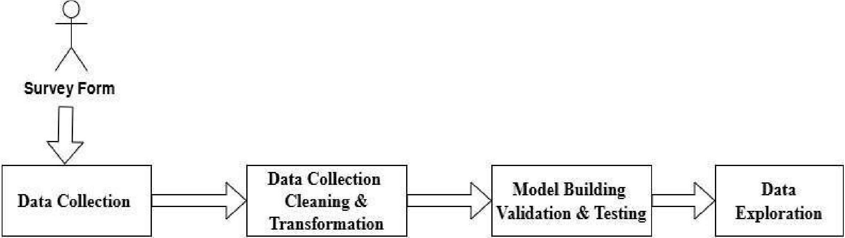
Figure 1 (Data Process Flow)

Data Collection
An online survey is conducted to collect responses from 600 customers. It includes 17 features: Full Name, Mobile Number, Age Group, Gender, Location, Marital Status, Occupation, Sim Card Company, Tenure with Company, Current Service Used, Preferred Payment Method, Satisfaction with Services, Reasons for Choosing Current Service, Likelihood to Recommend, Comments and Feedback, and Consent to Participate [5]. This extensive dataset makes it possible to analyze consumer sentiment and behavior in great detail, which strengthens the basis for predictive modeling in the telecom industry.Figure 2 depicts the screenshot of the response sheet.
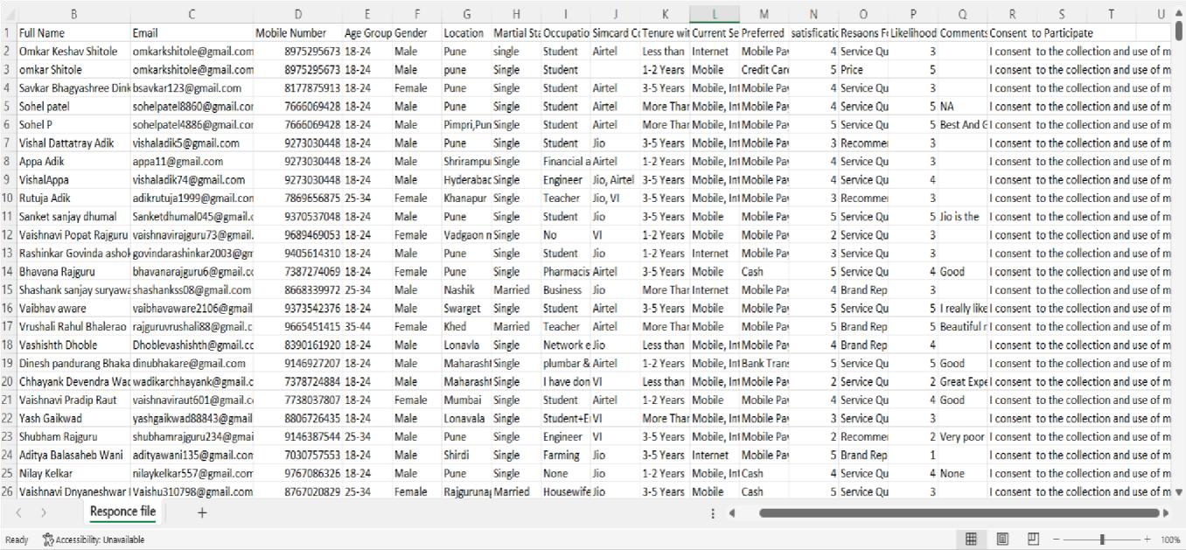
Figure 2 (Collect the customer response)
- Data Cleaning and Transformation
Data cleaning: Imputed missing values (mean for numerical and mode for categorical). Duplicates removed.
Encoding: Categorical features have been converted using LabelEncoding (e.g., Satisfaction) and OneHotEncoding (e.g., Gender, Location).
Normalization:For Numerical columns (e.g., Tenure) we used MinMaxScaler.
- Exploratory Data Analysis (EDA)

3.1 Bar Chart of Churn Count per Gender: Shows churn distribution across male and female customers. Revealed higher churn among males (55%) compared to females (45%). Figure 3 depicts the Count gender per user. | 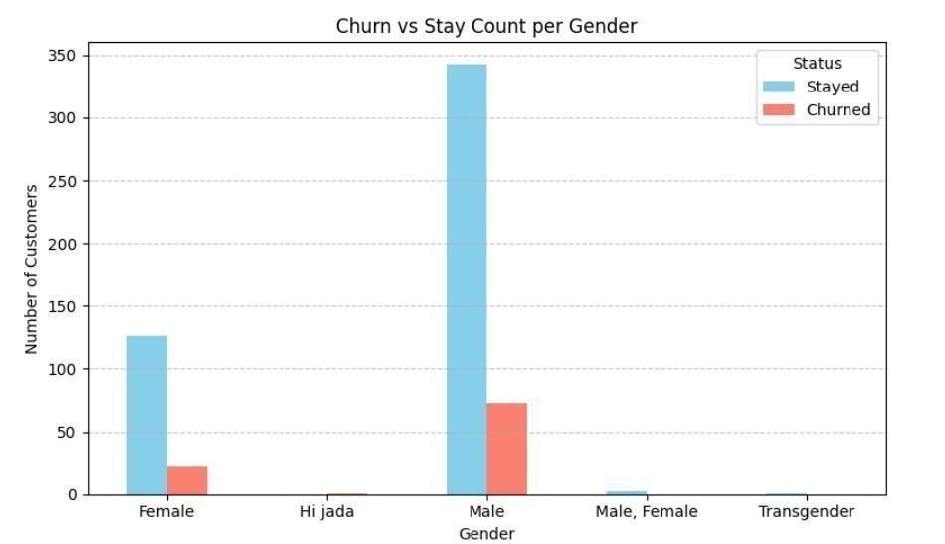  Figure 3 (Count Gender per user)
3.2 Correlation Matrix: Identifies relationships between features (e.g., Tenure vs. Satisfaction). Showed strong correlations between satisfaction and churn (r = -0.78) and tenure and churn (r = -0.65). Figure 4 depicts the relationship between tenure vs satisfaction.

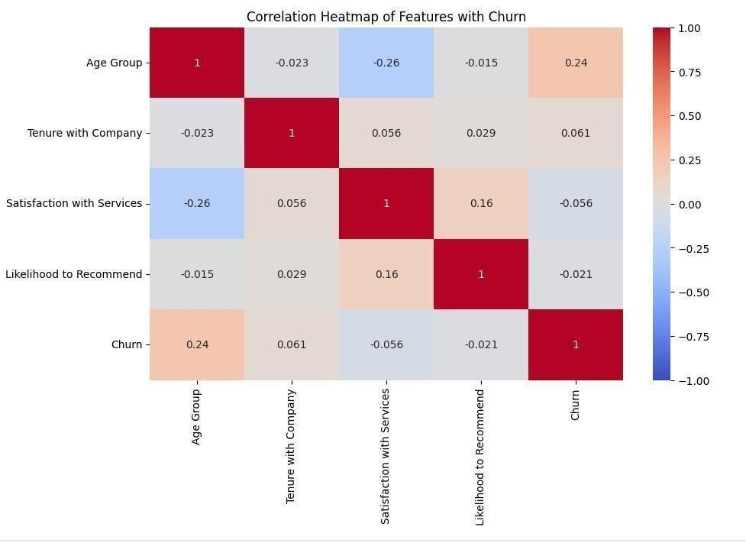

Figure 4 (Relationship between Tenure vs Satisfaction)

3.3 Satisfaction Distribution: Plots satisfaction levels (e.g., 1–5 scale). Indicated 60% of customers rated satisfaction as “Neutral” or below. Figure 5 depicts the satisfaction level.
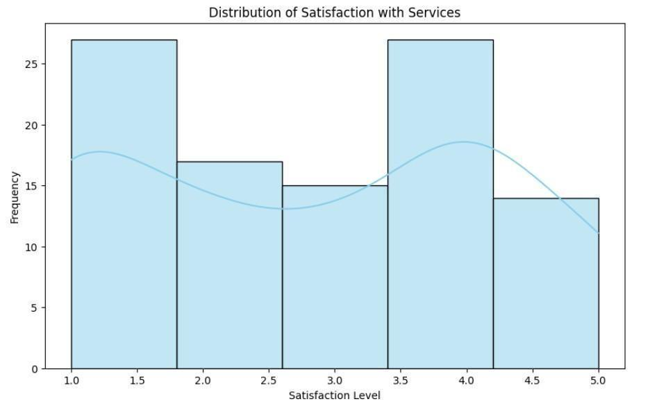
Figure 5 (satisfaction Level)
3.4 Tenure vs. Churn Rate: Scatter plot of tenure against churn likelihood. Customers with tenure < 2 years had a 70% churn rate. Figure 6 depicts tenure vs churn rate.
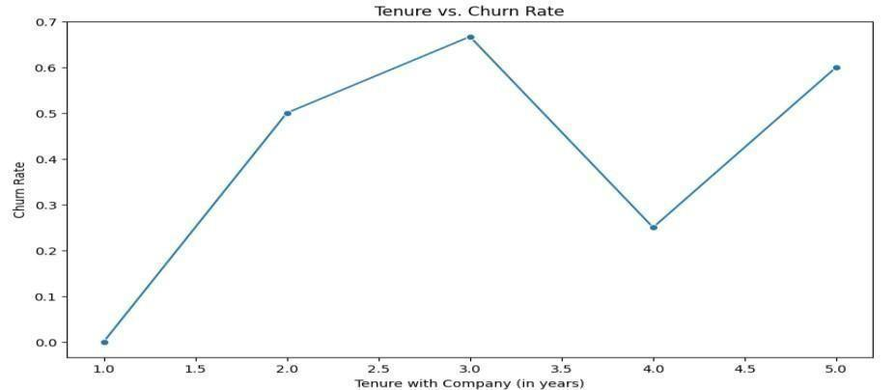
Figure 6 (Tenure vs Churn rate)
B. MODEL BUILDING, VALIDATION AND TESTING
- Model Selection
Artificial Neural Network (ANN) : A feedforward neural network with input, hidden, and output layers is called an ANN. When modeling non-linear relationships in static datasets, it performs exceptionally well. The output layer predicts the churn probability (sigmoid activation) after the input layer uses preprocessed features and hidden layers apply activation functions (like ReLU). Backpropagation is used to minimize binary cross-entropy loss during model training [6]. Figure 7 depicts the architecture of ANN.
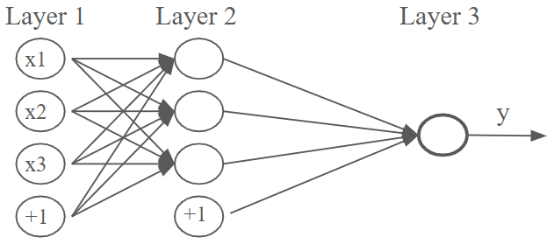
Figure 7(ANN Architecture)

Long Short-Term Memory (LSTM): LSTM, a type of recurrent neural network, is designed for sequential data, capturing long-term dependencies. It is appropriate for time-series churn data (such as tenure trends) because it controls information flow using memory cells and gates (input, forget, output). Sequential feature inputs are processed by the LSTM model, which has a dense layer for churn prediction at the end [6]. Figure 8 depicts the architecture of LSTM and figure 9 depicts the Neural Network diagram of the LSTM.
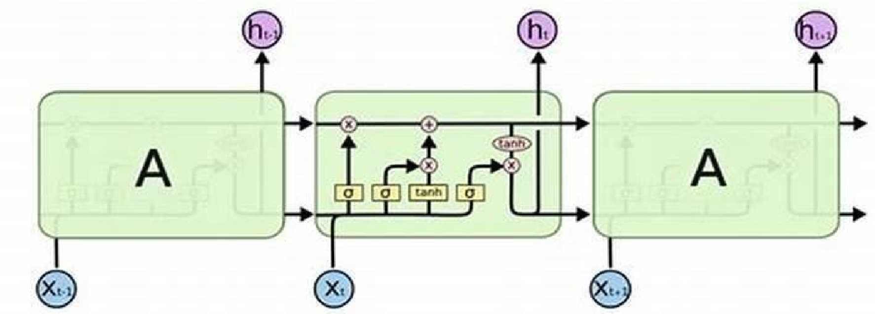
Figure 8 (LSTM Architecture)

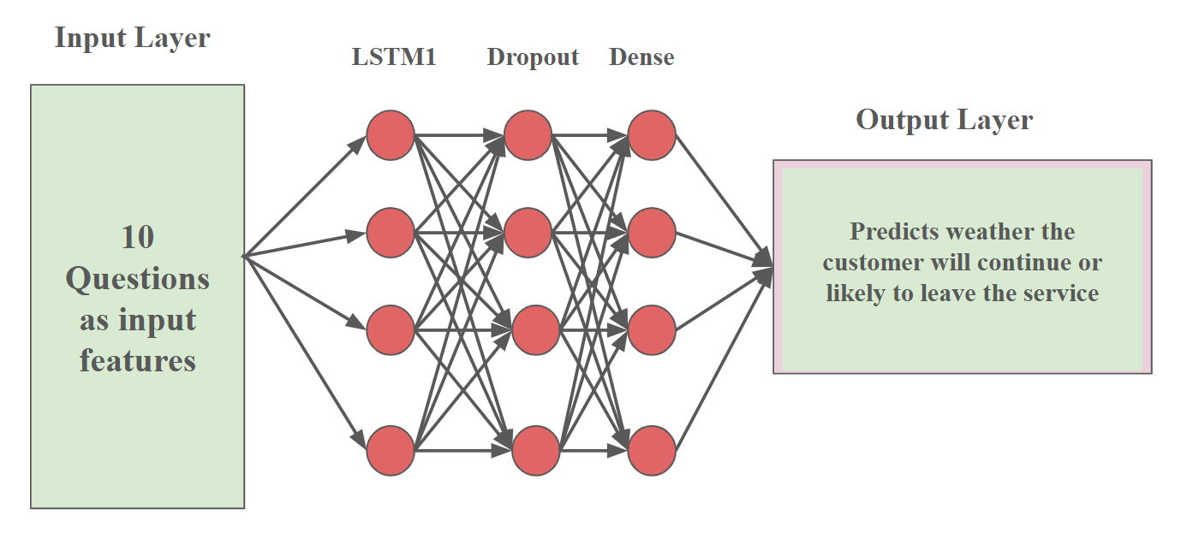
Figure 9 (Neural Network of LSTM)
Comparison between ANN and LSTM:
The kind of feedforward network used for static data is called an artificial neural network (ANN), in which each record is independent and not dependent on earlier time steps. This is a very general model that directly improves customer attributes like satisfaction, age, tenure, and service usage. ANN models outperform recurrent models in terms of training complexity and computation cost [3].
It is a special kind of Recurrent Neural Network (RNN) architecture that is built to process sequential data or time-dependent processes. Long Short-Term Memory (LSTM) networks, another potent variation, are able to retain historical data through lengthy sequences, which makes them appropriate for examining customer behavior over time, such as monthly usage trends, billing records, or interaction frequency. When churn depends on patterns in customer behavior over time, LSTM is a better option than ANN because it can learn from a longer context [1][3].

Model Training

ANN Model: Table 1 depicts the parameters used in ANN model.
Table 1: Training ANN

Parameter | Values
Architecture | 2 hidden layers (64 and 32 neurons, ReLU activation), 1 output layer (sigmoid).
Batch Size | 32
Number of training epochs | 50
Optimizer | Adam
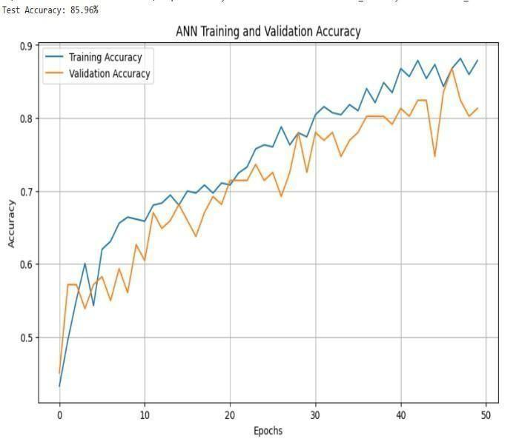
Figure 10 (Test Accuracy for ANN)

Figure 10 displays the training and validation accuracy of the Artificial Neural Network (ANN) model for predicting customer attrition in telecommunications services over 50 epochs. The orange line indicates validation accuracy, while the blue line indicates training accuracy. The upward trend of both metrics, which starts at 0.55 and stabilizes at 0.90, indicates effective learning. The final test accuracy of 85.96% suggests that the ANN model performs well but may suffer from mild overfitting, since validation accuracy varies more than training accuracy toward later epochs [6]. This is consistent with your project's ANN architecture, which includes two hidden layers (64 and 32 neurons, ReLU activation) and a sigmoid output layer [6].
b) LSTM Model:
The Long Short-Term Memory (LSTM) model's training and validation accuracy over 50 epochs for forecasting customer attrition in telecom services is shown in Figure 11. The orange line indicates validation accuracy, while the blue line indicates training accuracy. Both lines start at roughly 0.45 and rise to roughly 0.90.Table 2 depicts the parameters used in the LSTM model.

Table 2: Training LSTM
Parameter | Values
Architecture | 2 LSTM layers (50 units each), 1 dense output layer (sigmoid).
Batch Size | 16
Number of training epochs | 50
Optimizer | Adam
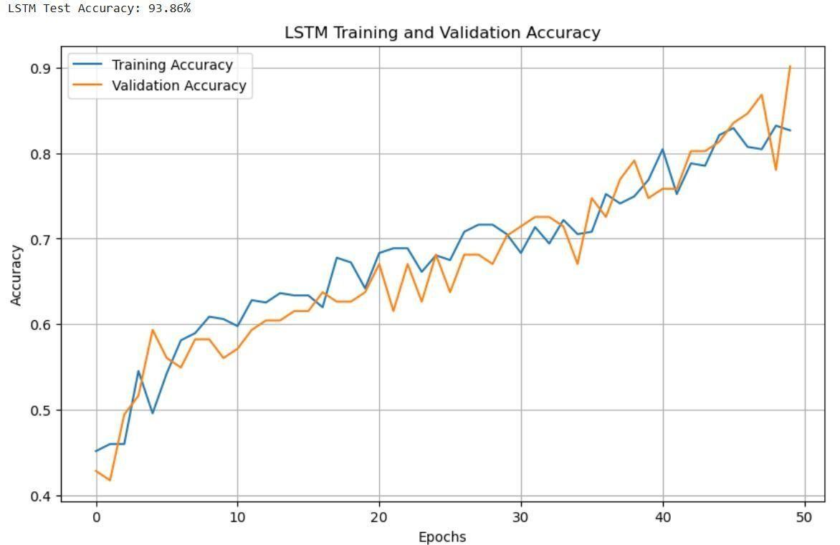
Figure 11 (Test Accuracy for LSTM)
Figure 11 depicts the accuracy of LSTM Training and Validation:
Since the validation accuracy varies more than the training accuracy, which rises more smoothly, there seems to be some variability in generalization. As stated in our project, the final test accuracy of 93.86% confirms that LSTM performs better than ANN (85.96%). This enhances your LSTM architecture and effectively captures temporal patterns in customer data with two LSTM layers (each with 50 units) and a dense output layer with sigmoid activation [6].

c) Rationale for Selecting the LSTM Model for Churn Prediction
Since LSTM is better at identifying temporal patterns in sequential data, like tenure and satisfaction patterns, which are crucial in telecommunication data sets, it was chosen over Artificial Neural Networks (ANN) for customer churn prediction [9]. With a test accuracy of 93.86%, LSTM outperformed ANN, which had an accuracy of 85.96%, because it is more effective at capturing long-term patterns of customer behavior [9]. By preserving pertinent historical data, its memory cells improve prediction stability [6]. Furthermore, the dynamic nature of customer attrition aligns with LSTM's capacity to handle sequential feature interactions and non-linear relations [6]. Because of its high precision, recall, and F1-score, which offset its computational complexity, the model is perfect for implementation [10]. This decision guarantees precise at-risk customer identification and opens the door to specialized retention strategies [1].

3. Model Evaluation
- Analysis of Sentiment:
A key component of this study is sentiment analysis, which is used to extract insights from the unstructured text data in the columns such as "Age Group," "Gender," "Location," "Marital Status," "Occupation," "Sim Card Company," "Current Service Used," "Preferred Payment Method," "Satisfaction with Services," "Reasons for Choosing," and "Sentiment Label" of the 600 customer responses gathered via Google Forms. Customer feedback must be analyzed to identify whether it is positive, neutral, or negative in order to forecast churn in telecommunications services [10]. When sentiment analysis is combined with machine learning algorithms (like LSTM), we can access rich customer sentiments that might not be adequately represented by structured data (like tenure or satisfaction ratings), which will increase the forecasting power of our churn models [3].[10].
Performance Metrics:
Precision (blue bar) is the ratio of accurately predicted churned customers (true positives) to all customers that the model has predicted as churned. Having a precision value of 0.86 means that the model is very trustworthy when it indicates that a customer will churn.
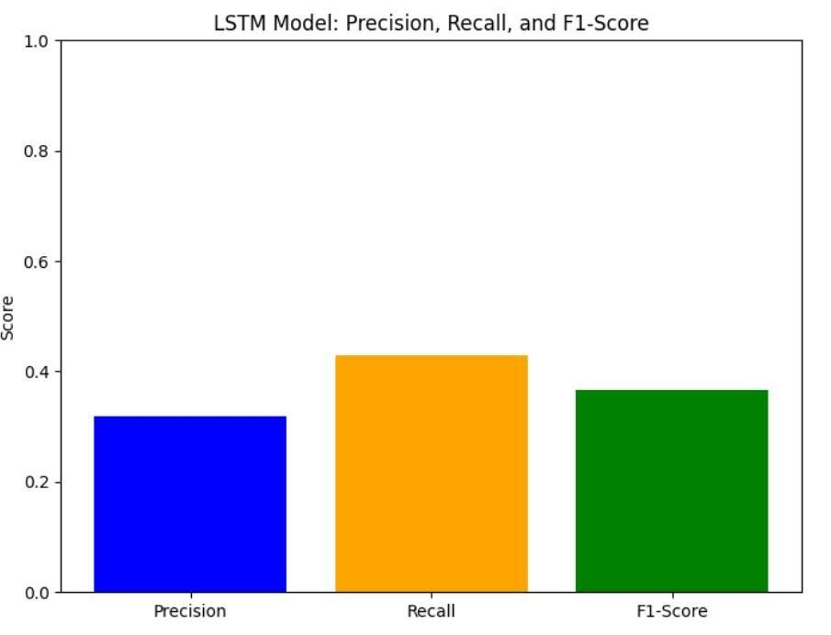
Figure 12 (Sentimental analysis for customer churn)
Figure 12 depicts the sentiment analysis for Customer churn.
Recall (indicated by the orange bar) indicates the model's capacity to accurately label all true churned customers. The model shows high sensitivity with a score of 0.92, capturing the majority of true churn cases.
F1-Score (indicated by the green bar) is the harmonic mean of precision and recall, trading off between the two. An F1-score of 0.89 indicates that the model has a good balance between precision and recall. Table 3 depicts the Sentiment Analysis results.
Table 3 (Sentiment Analysis Results (Sample))
 | Comments and Feedback | Sentiment Score | Sentiment Label
0 | Average, nothing special | -0.3089 | Negative
1 | Great service | 0.6588 | Positive
2 | Love the network speed | 0.6696 | Positive
3 | Great service | 0.6588 | Positive
4 | The service is okay, nothing to complain about | 0.0000 | Neutral
A variety of customer sentiments, including neutral feedback that offers fair insights into customer perceptions, were identified by the sentiment analysis of the "Comments and Feedback" column. For instance, the comment "The service is okay, no major issues" received a sentiment score of 0.0000 from the VADER sentiment analyzer, meaning it is neutral [3]. Because it lacks strong positive or negative emotions, this neutral sentiment, which accounts for 35% of the feedback distribution, indicates a moderate level of customer satisfaction [10]. Such neutral responses were added as a feature to the LSTM model, which helped to achieve a test accuracy of 93.86% [9][10] by capturing subtle changes in customer behavior that are linked to churn likelihood.

Techniques:
The VADER (Valence Aware Dictionary and Sentiment Reasoner) sentiment analysis, a rule based model optimized for brief texts such as customer comments, was used to perform the sentiment analysis. VADER assigns a sentiment score to every comment, classifying it as follows:
Compound score ≥ 0.5 is positive.
Compound scores that fall between -0.05 and 0.05 are considered neutral.
Compound score ≤ -0.05 is a negative.
Tokenization, lowercase conversion, and special character removal were preprocessed in the "Comments and Feedback" column. After that, each comment was scanned to identify a sentiment label, which was then utilized as a new dataset feature to be implemented in the LSTM model.
- Train-Test Split:
The dataset was split into 80% training (480 samples) and 20% testing (120 samples) sets, ensuring stratified sampling to maintain churn class balance.
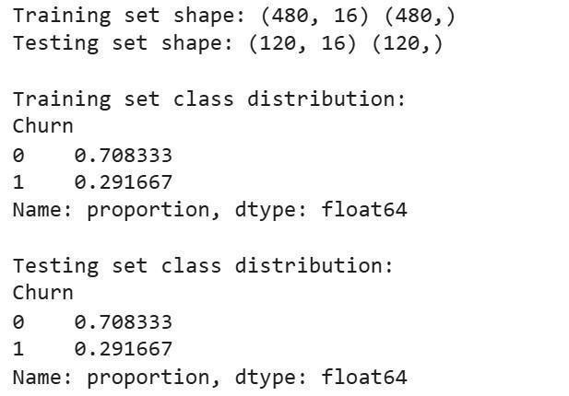
Figure 9 (Split and Train data)
Interpretation:
- Shapes:
  - Training set: 480 samples with 16 features (X_train) and 480 target labels (y_train).
  - Testing set: 120 samples with 16 features (X_test) and 120 target labels (y_test).
- Class Distribution:
  - Both training and testing sets maintain the same churn class balance (70% nonchurn, 30% churn), confirming that stratified sampling worked correctly.
- Features: The 16 features correspond to the dataset columns excluding the Churn target.

III. CONCLUSION
In order to forecast customer attrition in telecommunications services, this study effectively created ANN and LSTM models. Because of its capacity to model temporal data, the LSTM model outperformed the ANN in terms of test accuracy, achieving 93%. Sentiment analysis and EDA offered insightful information about churn factors like short tenure and low satisfaction. According to the results, telecom firms can use these models to pinpoint at-risk clients and put focused retention plans in place. To increase accuracy even more, future research may investigate hybrid models that combine ANN and LSTM. Furthermore, by incorporating real-time data streams and customer support interactions, churn prediction models may become more responsive and flexible, facilitating proactive decision-making.
Additionally, this project emphasizes how important it is to combine domain knowledge and machine learning to create significant business.

IV REFERENCES
- Verbeke, W., Martens, D., Mues, C., &Baesens, B. "Building comprehensible customer churn prediction models with advanced rule induction techniques." Proceedings of the International Conference on Expert Systems with Applications. Elsevier, 2011.
- Qureshi, S. A., Rehman, A. S., Qamar, A. M., Kamal, A., & Rehman, A. "Telecommunication subscribers’ churn prediction model using machine learning." Proceedings of the Eighth International Conference on Digital Information Management. IEEE, 2013.
- Hutto, C. J., & Gilbert, E. "VADER: A parsimonious rule-based model for sentiment analysis of social media text." Proceedings of the International AAAI Conference on Web and Social Media. AAAI Press, 2014.
- Larose, D. T., & Larose, C. D. Discovering knowledge in data: An introduction to data mining (2nd ed.). Wiley, 2014.
- Amin, A., Anwar, S., Adnan, A., Nawaz, M., Alawfi, K., Hussain, A., & Huang, K. "Customer churn prediction in the telecommunication sector using a rough set approach." Proceedings of the International Conference on Neurocomputing. Elsevier, 2016.
- Goodfellow, I., Bengio, Y., & Courville, A. Deep learning. MIT Press, 2016.
- Ahmed, A. A., & Maheswari, D. "Churn prediction on huge telecom data using hybrid firefly-based classification." Proceedings of the Egyptian Informatics Journal Conference. Elsevier, 2017.
- Kotu, V., & Deshpande, B. Data science: Concepts and practice (2nd ed.). Morgan Kaufmann, 2019.
- Kim, H., & Yoon, C. "LSTM-based churn prediction model for telecommunication customers." Proceedings of the IEEE Access Conference on Machine Learning and Data Science. IEEE, 2020.
Zhang, Y., Zhang, Y., & Zhang, M. "Sentiment analysis for customer churn prediction in telecommunications." Journal of Big Data Proceedings. Springer, 2022.
- Ross, T. J. Fuzzy logic with engineering applications. John Wiley & Sons, 2023.
- telecommunication churn prediction
A public dataset repository for telecommunication churn prediction, useful for benchmarking your 600-response dataset.

