Abstract—Mental health issues such as stress, anxiety, and depression are increasingly affecting higher education students, particularly in engineering institutions. Existing support systems are often limited, fragmented, and underutilized due to stigma and accessibility barriers. This project proposes an AI-driven multi-modal mental health detection and support system that enables early identification, assessment, and intervention. The system utilizes technologies such as natural language processing, machine learning, and deep learning to analyze text, facial expressions, and behavioral patterns. It integrates clinical assessment, AI-based therapy, peer support, and professional counseling into a unified platform. The proposed solution enhances accessibility, improves early detection, and promotes overall student well-being.
Keywords—Mental health, Higher Education Students, AI Intervention, Digital Therapeutics, Blockchain, Multi-modal Detection, Scalable Systems, Students Well-being, Health Tech.
I. INTRODUCTION
Mental health has become a major concern in higher education, especially among students in engineering institutions. The demands of academic work, competition among peers, financial pressures, and challenges in adapting to new environments often lead to increased levels of stress, anxiety, and depression. These issues not only affect students’ emotional well-being but also influence their academic performance and overall quality of life.
Despite the growing need for support, mental health services within many institutions remain insufficient. Limited availability of counselors and the high ratio of students to mental health professionals make it difficult to provide timely and personalized care. In addition, many students hesitate to seek help due to social stigma, fear of judgment, and concerns about privacy. As a result, mental health problems are often identified only at later stages, reducing the effectiveness of intervention.
Advancements in digital technology and artificial intelligence have created new opportunities to improve mental health support systems. Techniques such as natural language processing, machine learning, and deep learning enable the analysis of user behavior, emotional patterns, and communication data. While several digital tools such as chatbots and emotion detection systems have been developed, most of them operate independently and do not provide a complete solution that integrates detection, assessment, and intervention.

To overcome these limitations, this project proposes an AI-driven multi-modal mental health detection and support system. The system combines multiple data sources, including text inputs, facial expressions, and behavioral patterns, to provide a more accurate understanding of a user’s mental state. It integrates various modules such as assessment, therapeutic support, peer interaction, and professional counseling into a single platform. By offering continuous monitoring and personalized support, the proposed system aims to improve accessibility, encourage early intervention, and create a more supportive environment for students in higher education.
II. RELATED WORK
Research in digital mental health has grown rapidly in recent years, with various technologies being developed to improve the detection and management of psychological conditions. One of the widely explored approaches involves text-based analysis, where machine learning techniques are applied to user-generated content such as messages and social media posts. Methods using feature extraction techniques and classification algorithms have demonstrated that textual data can effectively reveal patterns related to stress, anxiety, and depression.
Another important area of research focuses on facial emotion recognition. Deep learning models, particularly convolutional neural networks, have been successfully used to analyze facial expressions and identify emotional states. These systems are capable of detecting subtle visual cues that may indicate mental distress, making them useful for non-invasive monitoring.
Advancements in natural language processing have further enhanced the ability to understand user emotions by capturing context and sentiment from text inputs.
Modern models can identify complex linguistic patterns associated with psychological conditions, enabling more accurate analysis compared to traditional methods.
In addition to detection, several studies have explored AI-based intervention methods. Digital therapeutic systems that provide techniques such as cognitive behavioral therapy and mindfulness exercises have shown positive outcomes in improving user engagement and emotional well-being. Peer support platforms have also been recognized as valuable tools for reducing loneliness and encouraging open communication among users.
However, a significant limitation of existing solutions is that they often focus on individual functionalities rather than providing a unified system. Many applications specialize in either detection, therapy, or monitoring, but lack integration with other essential components such as professional counseling and continuous tracking. This gap highlights the need for a comprehensive system that combines multiple approaches into a single platform.
The proposed project addresses this limitation by integrating various technologies into a cohesive and scalable framework. By combining detection, assessment, intervention, and support mechanisms, the system aims to provide a more effective and practical solution for mental health management in educational environments.
III. PROPOSED SYSTEM ARCHITECTURE
A. Overall Architecture Design
The proposed system is built using a modular and scalable architecture that supports efficient processing of mental health data and services.

The design follows a layered approach, which separates the system into different functional levels to improve performance, flexibility, and maintainability. This structure allows the system to handle multiple users and services without affecting overall efficiency.
The architecture is divided into three main layers: presentation layer, application layer, and data layer. Each layer performs a specific role while working together to provide a complete and integrated solution. This separation ensures that updates or changes in one part of the system do not disrupt other components.
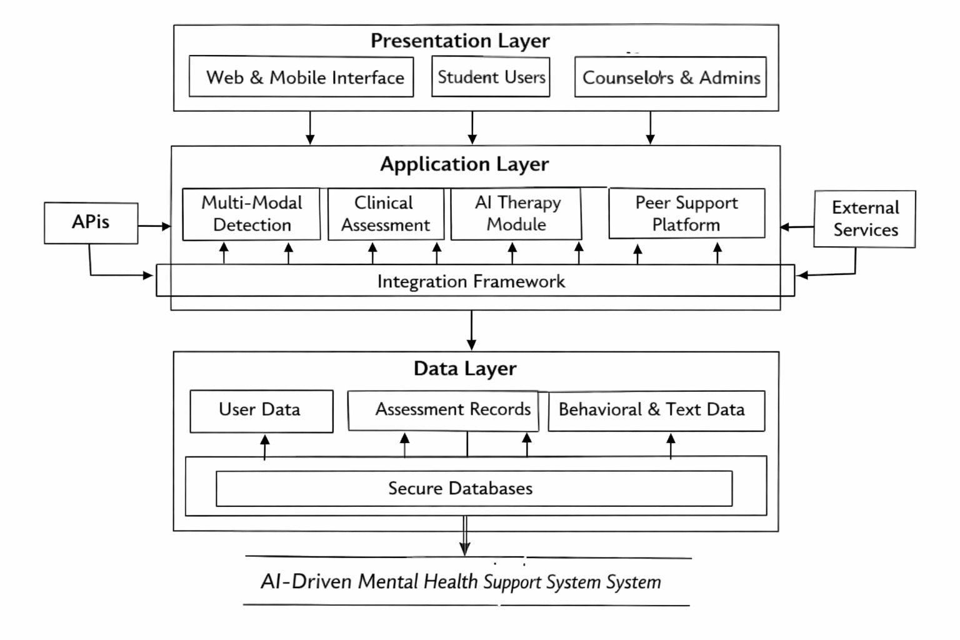
Figure.1: Architecture Diagram for Proposed System
B. Presentation Layer
The presentation layer acts as the interface between the system and its users. It includes web and mobile applications designed for students, counselors, and administrators. This layer focuses on delivering a smooth and user-friendly experience, allowing users to easily interact with the system.
Users can perform various activities such as entering text inputs, uploading images, completing assessments, interacting with the chatbot, and viewing reports. The interface is designed to be responsive and accessible across different devices, ensuring convenience and usability for all users.

C. Application Layer
The application layer contains the core logic and functionalities of the system. It includes several modules such as multi-modal detection, clinical assessment, therapeutic intervention, peer support, and counseling management. Each module operates independently, allowing the system to be flexible and easy to maintain.
Communication between modules is handled through APIs, ensuring smooth data exchange and real-time processing. This layer is responsible for analyzing user inputs, generating insights, and delivering appropriate responses based on the system’s intelligence.
D. Data Layer
The data layer is responsible for storing and managing all types of data used in the system. It handles both structured and unstructured data efficiently. Structured data includes user profiles, assessment results, and appointment schedules, while unstructured data includes chat logs, behavioral data, and multimedia inputs.
Efficient database systems are used to ensure quick access to data and secure storage of sensitive information. Proper data management helps improve system performance and supports accurate analysis.
E. Integration Framework
The system supports integration with existing institutional services to enhance functionality and usability. It can connect with systems such as authentication services, scheduling platforms, and notification systems.
An event-driven communication approach is used to ensure efficient interaction between modules. This enables smooth data flow and real-time updates, allowing the system to provide accurate and timely responses.

IV. SYSTEM MODULES AND METHODOLOGY
A. Multi-Modal Detection System
The multi-modal detection module plays a central role in identifying early signs of mental health issues by analyzing different types of user data. Instead of depending on a single input source, the system combines textual data, facial expressions, and behavioral patterns to achieve more accurate results.
Text-based analysis is performed using natural language processing techniques, which evaluate the sentiment, context, and emotional tone of user inputs. Facial emotion recognition uses deep learning models to interpret expressions and identify emotional states such as stress or sadness. Behavioral analysis focuses on monitoring user activity patterns, including engagement levels and interaction frequency, to detect unusual changes that may indicate mental distress.
By combining insights from these multiple sources, the system provides a comprehensive and reliable understanding of the user’s mental condition.
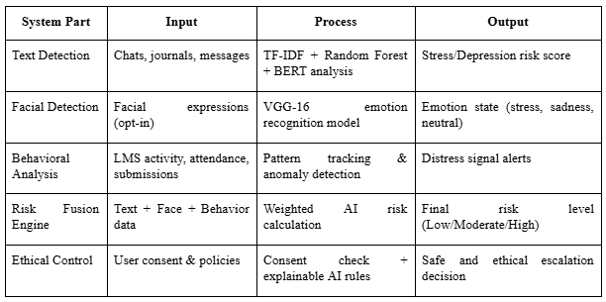
Table.1: Multi-Modal Detection System Overview
B. Clinical Assessment and Monitoring
This module is responsible for evaluating mental health conditions using structured and standardized assessment methods.
Users are guided through a series of questions designed to measure different aspects of their psychological state.
The system adapts the assessment process based on user responses, ensuring that the evaluation remains relevant and efficient. Continuous monitoring allows the system to track changes in mental health over time, helping to distinguish between temporary stress and long-term issues.
The results are presented in a clear and easy-to-understand format, enabling users to gain insights into their condition and take appropriate actions.
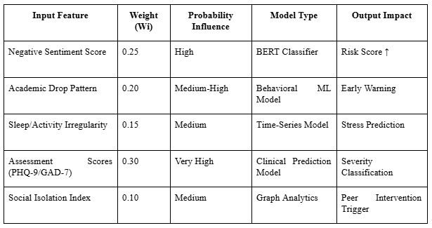
Table.2: Probability-Based Risk Prediction Model
C. AI-Driven Therapeutic Intervention Module
The therapeutic intervention module provides personalized support based on the user’s mental health status. It offers a range of techniques, including cognitive behavioral therapy exercises, mindfulness practices, and guided self-help activities.
Artificial intelligence is used to tailor these interventions according to individual needs. The system continuously learns from user interactions and adjusts its recommendations to improve effectiveness over time. This adaptive approach ensures that users receive relevant and meaningful support.

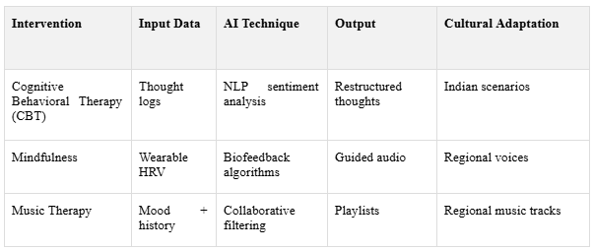

Table.3: AI Therapeutic Interventions
D. Peer Support Platform with AI Moderation
The peer support module creates a safe and supportive environment where users can connect with others facing similar challenges. It allows users to share experiences, discuss concerns, and provide mutual support in an anonymous setting.
To maintain a healthy environment, the platform uses AI-based moderation techniques to detect inappropriate or harmful content. These techniques include sentiment analysis and keyword filtering.
In addition, human moderation can be incorporated to ensure ethical standards and user safety.This feature helps reduce feelings of isolation and encourages open communication among users.
E. Professional Counseling Workflow Integration
This module connects users with professional mental health counselors through the platform. It provides features such as counselor matching, appointment scheduling, and secure communication channels.
The system identifies suitable counselors based on user needs and preferences, ensuring effective support. Counselors can monitor user progress and update treatment plans accordingly. This integration ensures that users receive expert assistance when required.
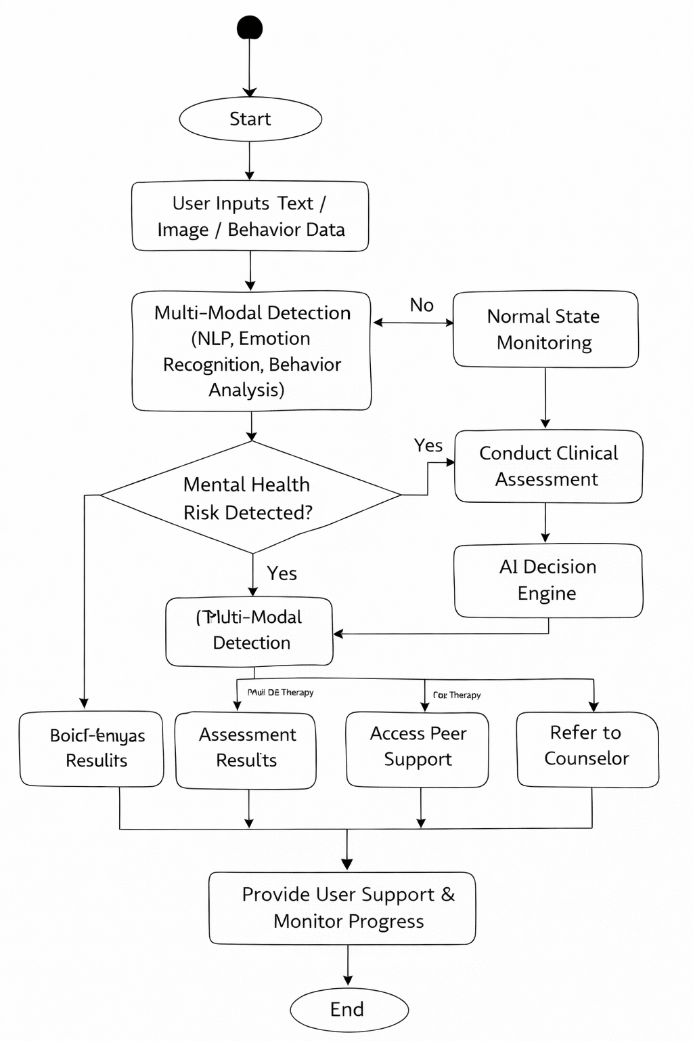
Figure.2: Flow Diagram of Proposed System
V. PROJECTED OUTCOMES AND EVALUATION FRAMEWORK
A. Expected Impact Metrics
The proposed system is expected to significantly improve the effectiveness of mental health support within educational institutions. By enabling early detection of psychological issues, the system can help prevent the escalation of stress, anxiety, and depression among students. This early identification allows timely intervention, which is essential for better mental health outcomes.
The platform is also designed to encourage more students to seek help by providing accessible and stigma-free support through digital interaction. Features such as anonymous peer support and AI-driven assistance can increase user engagement and participation. As a result, the number of students utilizing mental health services is expected to rise.
In addition, the system aims to improve academic performance and overall well-being by addressing mental health challenges at an early stage. Continuous monitoring and personalized recommendations help students manage their emotional state more effectively, leading to better focus and productivity.
B. Comprehensive Evaluation Framework
To measure the effectiveness of the system, a comprehensive evaluation approach is adopted. This includes both quantitative and qualitative methods to ensure accurate assessment of performance and impact.
Quantitative evaluation involves measuring system performance using metrics such as detection accuracy, response time, and system reliability. It also includes analyzing user engagement levels, frequency of system usage, and the number of successful interventions.
Qualitative evaluation focuses on user feedback and satisfaction. Students, counselors, and administrators provide insights into usability, effectiveness, and overall experience. This feedback helps in identifying areas for improvement and refining system features.

C. Ethical and Performance Considerations
The evaluation process also considers ethical aspects such as data privacy, fairness, and transparency. Since the system handles sensitive mental health data, it is essential to ensure that user information is protected and used responsibly.
Efforts are made to minimize bias in AI models by using diverse datasets and continuously monitoring system outputs. Human oversight is also included to validate critical decisions and ensure reliability.

Overall, the evaluation framework ensures that the system performs efficiently while maintaining ethical standards and delivering meaningful benefits to users.
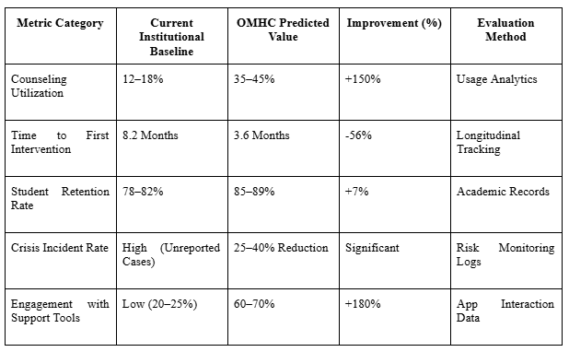
Table.4: Predicted Outcomes and Performance Metrics
VI. CHALLENGES AND LIMITATIONS
The proposed system offers advanced mental health support, but it also faces certain challenges related to technology, data, and ethical concerns that must be addressed for effective implementation.
- Technical Challenges: Difficulty in integrating multiple AI modules and maintaining real-time performance.
- Data Limitations: Accuracy depends on the quality and diversity of training data.
- Privacy Concerns: Ensuring secure handling of sensitive user information.
- Technology Dependency: The system cannot replace professional medical diagnosis.
VII. FUTURE DIRECTIONS
The system can be further improved by incorporating advanced technologies and expanding its capabilities to provide more effective and inclusive mental health support.
- Wearable Integration: Use of sensors to collect real-time health data.
- Voice-Based Analysis: Adding speech emotion detection for better interaction.
- Improved AI Models: Enhancing accuracy using larger and diverse datasets.
- Multilingual Support: Supporting regional languages for wider accessibility.
- System Expansion: Extending the platform across multiple institutions.
VIII. CONCLUSION
The proposed system provides a comprehensive and technology-driven approach to improving mental health support for students. By integrating AI-based detection, assessment, and intervention into a single platform, it enhances accessibility, encourages early help-seeking, and supports overall well-being.
- Early Detection: Identifies mental health issues at an initial stage.
- Integrated Platform: Combines detection, assessment, and support in one system.
- Improved Accessibility: Provides easy and stigma-free access to services.
- Personalized Support: Delivers tailored recommendations based on user data.
- Scalable Solution: Can be implemented across different institutions.
- Enhanced Well-being: Supports students in maintaining better mental health.

REFERENCES
- Zhang, X., Liu, Y., Yao, X., Ma, B., & Zhao, X. (2010). Design and development of mental health education system for university students based on B/S structure. 2010 International Conference on E-Health Networking, Digital Ecosystems and Technologies (EDT). https://ieeexplore.ieee.org/document/5496489/

- Kusumawati, Y. A., Michaelia, N. P. A., & Sidharta, S. (2023). Mobile application-based psychological support to improve college student mental health. 2023 International Conference on Informatics, Multimedia, Cyber and Informations System (ICIMCIS). https://ieeexplore.ieee.org/document/10349067/
- Song, X., Zheng, J., & He, J. (2025). Study on promoting college students' mental health by AI music therapy based on big data analysis. 2025 IEEE/IEIE International Conference on Consumer Electronics-Asia (ICCE-Asia). https://ieeexplore.ieee.org/document/11263737/
- Zhang, L. (2025). Development and Algorithm Optimization of Intelligent Educational Psychological Assessment Tool. 2025 International Conference on Digital Analysis and Processing, Intelligent Computation (DAPIC). https://ieeexplore.ieee.org/document/10989134/
- Aswal Krishna, P., Deepa Nivethika, S., Rooban Kumar, R., & Senthilpandian, M. (2025). Intelligent System for Mood and Depression Detection and Analysis. 2025 11th International Conference on Communication and Signal Processing (ICCSP). https://ieeexplore.ieee.org/document/11088514/
- Zheng, H., & Zhou, H. (2024). Design of a Digital Archive System for Positive Emotions of University Students Based on Blockchain Technology. 2024 IEEE 7th Eurasian Conference on Educational Innovation (ECEI). https://ieeexplore.ieee.org/document/10510859/

- Harianto, K., Kusumawati, Y. A., Krisnawati, A. A. A. M., Gunawan, E. P., & Angkawijaya, Y. (2024). The Development of Mobile App Adaptify: Enhancing College Students' Cultural Adjustment. 2024 International Conference on Informatics, Multimedia, Cyber and Information System (ICIMCIS). https://ieeexplore.ieee.org/document/10957409/
- Ming, F. J., Anhum, S. S., Islam, S., & Keoy, K. H. (2023). Facial Emotion Recognition System for Mental Stress Detection among University Students. 2023 3rd International Conference on Electrical, Computer, Communications and Mechatronics Engineering (ICECCME). https://ieeexplore.ieee.org/document/10252617/
- Emadulla, M. A., Shariff, T., Siddique, S. A., Zaid, S., R, D. N., & B, O. (2025). Harnessing Random Forest Classifiers and TF-IDF Vectorization: A Text-Based Approach to Detect Stress and Analyze Mental Health Using Artificial Intelligence. 2025 3rd International Conference on Smart Systems for applications in Electrical Sciences (ICSSES). https://ieeexplore.ieee.org/document/11009238/
- Charanya, P., Nidhish, M., Prajesh, U. R., Saktheeswar, K., & Sanjana, S. Pillai. (2025). Enhancing Career Development: An AI-Driven Mentorship Platform for Student-Mentor Connections. 2025 International Conference on Computational, Communication and Information Technology (ICCCIT). https://ieeexplore.ieee.org/document/10928077/
- Thakur, S., Prabakaran, N., & Gupta, P. V. (2025). Emotion Recognition Through Handwriting Analysis in Examination Contexts: A Study on Student Emotions. 2025 IEEE 6th India Council International Subsections Conference (INDISCON). https://ieeexplore.ieee.org/document/11253664/
- Kanagaraj, S., Sandhra, V., Thamanna, K., & Threyambaka, S. (2025). Reducing Academic Anxiety through Mindfulness-Based Cognitive Intervention: A Rural Adolescent Study with Recommendations for Technology-Enabled School Mental Health Systems. 2025 2nd International Conference on New Frontiers in Communication, Automation, Management and Security (ICCAMS). https://ieeexplore.ieee.org/document/11234073/

