A Structural-Relational Taxonomy for Integrating Safety and Quality Cost Components for Indonesian Public Apartment Construction: A Validation Study

ABSTRACT
Cost of Safety (CoS) and Cost of Quality (CoQ) are usually planned and estimated as separate cost domains in construction projects, although both are closely related to prevention, inspection, control, and failure management activities. Previous studies have discussed the conceptual relationship between safety and quality, but limited research has provided a validated component-level structure explaining how CoS and CoQ components should be integrated in construction cost estimation. This study aims to develop a structural and relational taxonomy for integrating safety and quality cost components in Indonesian public apartment construction. The research employed literature-based component identification, expert validation using the Item-Level Content Validity Index (I-CVI), modified kappa analysis, a Domain Mapping Matrix, and integrated Cost Breakdown Structure (CBS) development. From 70 cost components identified from prior studies, 30 components were retained after expert validation, consisting of 20 CoS components and 10 CoQ components. The validated components were then mapped into 200 cross-domain relationships. The results show that 185 relationships were classified as independent, 10 as complementary, 5 as partial, and none as full overlap. The overlapping relationships were concentrated in three integration zones: planning and documentation, inspection and appraisal, and training. These findings were translated into an integrated CBS and illustrated through a hypothetical estimation case to clarify which components should be merged, coordinated, or maintained separately. The study contributes a structured and expert-validated basis for reducing potential double counting and improving the transparency of safety-quality cost integration in construction projects.
Keywords: Cost of safety, cost of quality, domain mapping matrix, content validity, relational taxonomy.
INTRODUCTION
Safety and quality are often managed as separate responsibilities in construction projects. Safety is generally associated with accident prevention, occupational health, emergency response and compliance with construction safety management requirements. Quality is generally associated with conformance to specifications, inspection, testing, documentation and corrective action. The separation is administratively convenient, but it does not fully reflect the way projects are executed. At the field level, the same planning meetings, method statements, supervision routines, toolbox sessions, inspection walks and document-control processes often support both safety and quality objectives.
The issue becomes more important when the 2 domains are translated into cost estimates. Cost of Safety (CoS) is the cost required to provide and implement safety resources, programs, and control measures in construction projects to prevent work accidents, reduce safety risks, and support the implementation of the construction safety management system (Danilovic & Browning, 2007). CoQ is usually embedded in specifications, overhead, work item unit prices, quality supervision activities or corrective allowances (Barber et al., 2000; Love & Li, 2000). This imbalance means that an integrated estimate cannot be developed by simply adding all CoS and CoQ items together. Without a clear relational rule, shared resources such as joint training sessions, inspection platforms and document-control activities may be counted twice, while hidden quality-related costs may remain unrecognised.
The literature already supports the conceptual relationship between safety and quality. Studies have reported that construction safety and quality performance are associated, and that defects, non-conformances and safety events may share common organizational and operational precursors (Love et al., 2018; Love & Li, 2000). ISO 9001:2015 defines requirements for quality management systems, These standards reinforce the need for controlled processes, documented information, performance evaluation and continuous improvement. However, standards and prior empirical studies do not specify how one safety cost item should be related to one quality cost item in an integrated construction budget.
This paper addresses that gap by developing an expert-validated relational taxonomy and an integrated cost breakdown structure (CBS) for Indonesian public apartment construction. The contribution is deliberately structural. The paper does not claim to prove cost accuracy using completed project data. Instead, it provides a validated classification logic that defines whether a CoS-CoQ pair should be merged, coordinated or kept separate. The proposed taxonomy is intended to become a defensible starting point for future cost calibration, probabilistic estimation and project-level validation.
3 limitations remain in the existing literature. First, studies that establish the safety-quality relationship tend to focus on performance outcomes rather than cost structure (Love et al., 2015, 2018). Second, safety-cost and quality-cost studies generally develop their own component lists without reconciling the overlap between the 2 domains (Ikpe et al., 2012; Love & Li, 2000). Third, conceptual integration frameworks argue that CoS and CoQ can be integrated but do not provide a validated pairwise decision rule for budget treatment (Friatmojo et al., 2025). Consequently, the field lacks a component-level taxonomy that can say whether a CoS item and a CoQ item are identical, partially overlapping, complementary or independent.
This study responds to that gap by using a domain mapping matrix. A domain mapping matrix is appropriate because it relates elements from 2 distinct domains rather than elements within one domain (Danilovic & Browning, 2007). In this paper, the rows represent validated CoS components and the columns represent validated CoQ components. Each cell therefore represents one cross-domain pair that can be assessed, classified and validated.
LITERATURE REVIEW
Cost of safety
Construction safety cost includes resources allocated to prevent accidents and resources associated with the consequences of accidents. Safety-cost studies have shown that prevention costs are often treated as additional expenses unless they are linked to clear work activities, hazards and control measures (Ikpe et al., 2012; Kim & Kim, 2023; Lee et al., 2022). Activity-based safety-cost estimation is particularly relevant because construction hazards differ across work packages, building height, project schedule and site conditions (Ikpe et al., 2012). In apartment construction, safety costs may also include security-related items such as security personnel, access control and CCTV, especially where project location and security exposure influence the risk profile (Danilovic & Browning, 2007).
The challenge is not only estimating the total amount of safety cost. A project team also needs to identify which safety resources are generic, which are specific to a work package, and which are linked to security or site-control requirements. If the cost structure is too broad, safety costs become hidden inside general overhead. If it is too detailed without a relational rule, future integration with quality cost becomes difficult. Therefore, a component-level structure is needed before any numerical estimation model can be considered reliable.
Cost of quality
The cost of quality is commonly explained through the prevention-appraisal-failure model. Prevention costs are spent to avoid non-conformance, appraisal costs are spent to inspect or verify conformance, and failure costs arise when the work does not meet requirements (Garg & Misra, 2022). In construction, quality cost is often substantial but under-recorded because many quality-related activities are absorbed into supervision, work item prices, overhead or rework allowances (Love & Li, 2000). This makes CoQ less visible than CoS, even though quality failures can generate significant direct and indirect cost consequences (Barber et al., 2000).
For the purpose of integration, the most relevant CoQ components are not only failure items such as rework and warranty. Prevention and appraisal activities are also important because they overlap operationally with safety activities. Training, planning, site layout coordination, inspection, supervision, testing and documentation are the practical points where the 2 domains may share personnel time, meeting time, templates, checklists, digital platforms or reports. These shared activities do not automatically imply that every cost item should be merged. They imply that a rule is needed to determine the appropriate budgetary treatment.
METHODOLOGY
Figure 1 clarifies that the study proceeds in three sequential stages. The first stage validates the component pool through expert judgement. The second stage converts the validated components into a pairwise domain mapping matrix. The third stage transforms the validated relationship classes into an integrated CBS. This flow is important because the CBS is not manually assumed; it is derived from validated pairwise relationships.
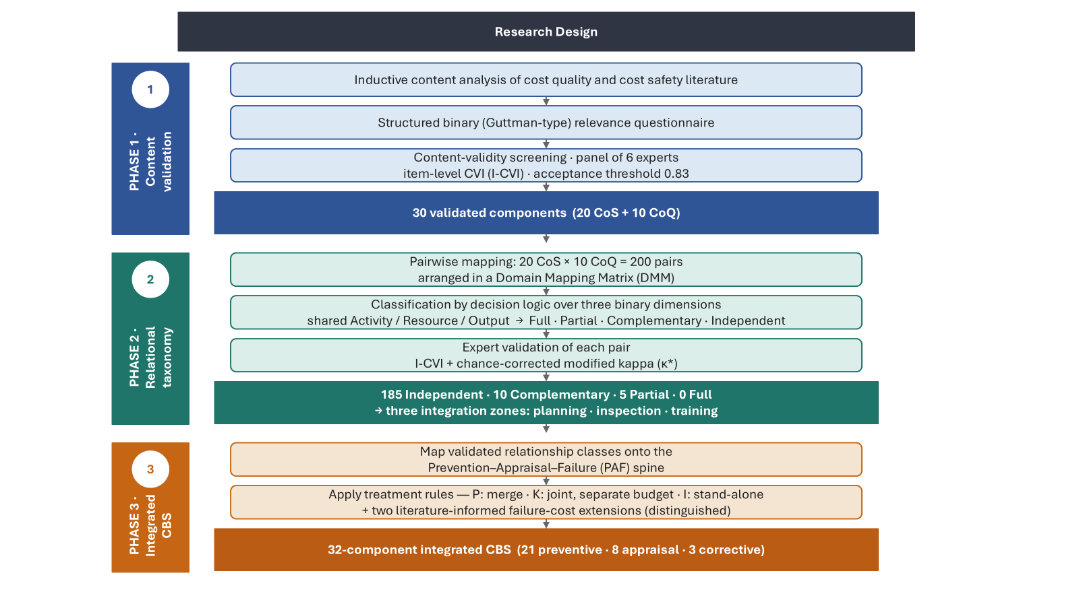
Figure 1: Research design used to validate components, classify CoS-CoQ relationships and construct the integrated CBS.
Research design and component compilation
The study used a qualitative, instrument-based and artefact-oriented design. The objective was to validate the structure of CoS-CoQ relationships rather than to estimate their monetary values. This design is appropriate because integrated cost estimation requires a reliable classification structure before numerical project data can be applied.
An initial inventory of 70 cost components was compiled from safety-cost, quality-cost, risk-management and Indonesian construction studies. The components were grouped into seven categories: generic safety cost, specific safety cost, security cost, quality prevention cost, quality appraisal cost, internal failure cost and external failure cost. Table 1 summarizes the component inventory used for expert screening. The table is written at category level to keep the manuscript concise while still showing the content basis of the validation instrument.
Table 1: CoS and CoQ component identification used for expert screening.
Cost type | Category | Cost components used for expert screening | Main literature basis
CoS | Generic safety cost (A) | Safety personnel; safety training, orientation and induction; Health and Safety Plan and work procedures; safety monitoring, inspection and audit; safety documentation and toolbox meeting; safety promotion media; insurance; site support facilities; safety budget management; heavy equipment and operator licenses; hygiene and health care; external safety consultation; HSE staff salaries; basic PPE. | (Ferakhim & Latief, 2019; Fitriani et al., 2022; Friatmojo et al., 2025; Gurcanli et al., 2015; Han et al., 2022; Ikpe et al., 2012; Lee et al., 2022; Muntiyono et al., 2021; Yang et al., 2021)
CoS | Specific safety cost (B) | Collective protective measures; fall protection; specific safety signs; hazard-control mitigation; equipment inspection, load testing, maintenance and safety devices; emergency response; site safety monitoring; fire-hazard control; crane and lifting operation safety; specific PPE.
CoS | Security cost (C) | Security personnel and patrol; CCTV/security camera; theft, vandalism and social-conflict control; material and equipment protection; access control.
CoQ | Prevention cost (D) | Training, education and motivation; quality planning and QA/QC documentation; design review and verification; QMS implementation; quality staff salaries; supplier/contractor evaluation; procurement quality planning; calibration and maintenance; process control; continuous improvement; quality data planning; site layout and movement planning. | (Abdelsalam & Gad, 2009; Garg & Misra, 2022; Khadim et al., 2023; O’Connor & McDermott, 2023; Shafiei et al., 2023; Sharma & Laishram, 2025; Thabet et al., 2024)
CoQ | Appraisal cost (E) | Site and process inspection/testing; material laboratory testing; site supervision and quality monitoring; internal and external audits; document review and control; quality record storage; incoming material evaluation; final inspection and commissioning; reinspection and retesting; data acquisition, analysis and reporting; product/process performance evaluation.
CoQ | Internal failure cost (F) | Rework, repair and corrective actions; scrap, demolition and material wastage; redesign due to quality failure; reassessment and retesting; variations and additional costs due to failures; productivity loss and downtime; failure analysis; waste generated due to rework; NCR handling.
CoQ | External failure cost (G) | Warranty and post-handover repair; complaints and claims; legal cost, arbitration and litigation; penalties due to non-conformance; revenue and reputational loss; delay due to quality failures; loss of future business; public image damage.
Table 1 shows that the initial inventory deliberately covered both visible and hidden cost positions. Safety components were more directly associated with regulatory and site-control requirements, whereas quality components covered prevention, appraisal and failure-related cost positions. This broad starting point was necessary to avoid validating only the items that were already visible in conventional project budgets.
Expert panel and content validity procedure
6 experts were purposively selected from state-owned contractors, the Ministry of Public Works and academia. Their experience ranged from 15 to 30 years. The six-member panel is compatible with content-validity guidance, where an item-level content validity index (I-CVI) of 0.83 is commonly used as an acceptance threshold (Polit et al., 2007; Yusoff, 2019).
The validation instrument used a binary relevance scale. Experts scored each component as 1 if it was relevant and essential for the proposed taxonomy, and 0 if it was not. Binary scoring is suitable for I-CVI analysis because it avoids post-hoc conversion of ordinal ratings (Gurcanli et al., 2015). The I-CVI was calculated as the proportion of experts who approved an item. Components that reached the threshold were retained for mapping; components below the threshold were eliminated from the validated core.
Table 2: Expert panel profile.
Expert | Affiliation type | Education | Experience (yr)
E1 | Contractor | Master | 30
E2 | Contractor | Master | 20
E3 | Ministry of Public Works/regulator | Master | 15
E4 | Ministry of Public Works/regulator | Master | 20
E5 | Ministry of Public Works/regulator | Bachelor | 30
E6 | Academia | Doctorate | 20
Table 2 indicates that the panel combined implementation, regulatory and academic perspectives. This composition is important because safety and quality cost components are not purely technical items; they are also shaped by contract administration, regulatory compliance and practical budgeting behaviour.
Relational taxonomy and mapping rules
After component validation, each retained CoS component was paired with each retained CoQ component. Because twenty CoS components and ten CoQ components were retained, the mapping produced 200 cross-domain pairs. Each pair was evaluated using three binary dimensions: shared resource, shared output and shared function. These dimensions were selected because cost integration is meaningful only when a pair has a traceable basis for sharing, coordination or separation.
The taxonomy contains four mutually exclusive classes. Independent pairs have no sufficient shared function and remain separate budget items. Complementary pairs share a function but do not share the same jointly usable resource or output, so they should be coordinated but budgeted separately. Partial pairs share a function and a jointly usable resource but do not produce an identical output, so the shared portion may be merged while the different outputs remain traceable. Full pairs would share resource, output and function, but no full pair was validated in this study.
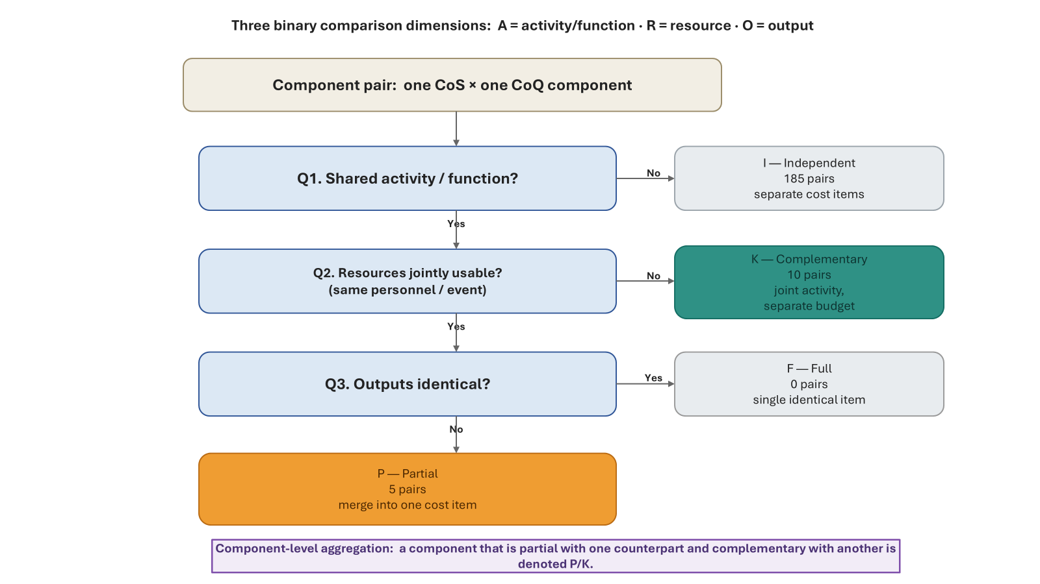
Figure 2: Relational taxonomy for classifying one CoS component and one CoQ component.
Figure 2 presents the decision logic used by the taxonomy. The first gate is the shared function test because a budget line should not be integrated merely because 2 items use similar words. The second gate is resource sharing because double counting occurs most directly when the same person, meeting, platform or field event is budgeted twice. The third gate is output identity, which distinguishes a true full overlap from a partial overlap.
Integrated CBS construction
The validated pairwise relationships were translated into an integrated CBS using the following treatment rules. Partial relationships were converted into merged or shared-resource cost positions. Complementary relationships were retained as separate cost positions but marked for joint coordination. Independent relationships remained stand-alone items. Corrective and failure positions that are normally contingent rather than planned as direct budget lines were treated as literature-informed extensions and clearly distinguished from the expert-validated planned-cost core.
This approach preserves traceability. It does not collapse the safety and quality domains into one undifferentiated budget. Instead, it creates a relationship-aware CBS in which every component carries a budgeting instruction: merge, coordinate or separate.
RESULTS
Component validation outcome
Of the 70 cost components, thirty met the retention threshold. The retained set consisted of twenty CoS components and ten CoQ components. The result indicates that experts were more likely to retain safety cost components than quality cost components. Appendix A reports the component-level I-CVI results for the full cost components pool, including the retained and eliminated items.
The elimination of most failure-cost components should not be interpreted as evidence that failure costs are theoretically unimportant. The expert comments clarified that these items were less suitable as planned components in the validated CBS core. Representative comments were: “failure cost is a consequence after non-conformance has occurred, not a planned resource to be budgeted at the beginning of the project” and “rework, productivity loss and accident consequences should be treated as contingency or corrective extensions, not as routine prevention or appraisal items.” Therefore, failure costs remain relevant to the broader cost model, but most of them are positioned outside the expert-validated planned-cost core and should be estimated separately when project cost records become available (Barber et al., 2000).
Table 3: Validation outcome by cost type and category.
Category | Cost components | Retained | Eliminated | Mean I-CVI
Safety - Generic | 14 | 9 | 5 | 0.81
Safety - Specific | 10 | 8 | 2 | 0.83
Safety - Security | 5 | 3 | 2 | 0.70
Quality - Prevention | 12 | 4 | 8 | 0.50
Quality - Appraisal | 12 | 5 | 7 | 0.57
Quality - Internal failure | 9 | 0 | 9 | 0.33
Quality - External failure | 8 | 1 | 7 | 0.31
All safety | 29 | 20 | 9 | 0.79
All quality | 41 | 10 | 31 | 0.45
Total | 70 | 30 | 40 | 0.59
Table 3 explains why the final mapping was based on thirty components rather than the full list of seventy. The higher retention of safety components reflects their stronger visibility in project safety cost structures, while the lower retention of quality components reflects the fact that many quality costs are indirect, hidden or contingent. This screening stage protected the mapping matrix from being overloaded by items that experts did not consider sufficiently relevant for the target project context.
Distribution of relational classes
The validated thirty components produced 200 CoS-CoQ pairs. The classification results showed 185 independent relationships, 10 complementary relationships, 5 partial relationships and no full relationship. At first glance, the dominance of independent relationships may appear to weaken the integration argument. In fact, it strengthens it. The taxonomy is not designed to maximize overlap; it is designed to identify defensible overlap and prevent artificial merging.
The overlap was concentrated in three zones: planning/documentation, inspection/appraisal and training. These zones are operationally plausible because they represent routine project processes where safety and quality teams interact, share documents, attend the same meetings, use related checklists or perform field verification in the same work areas.
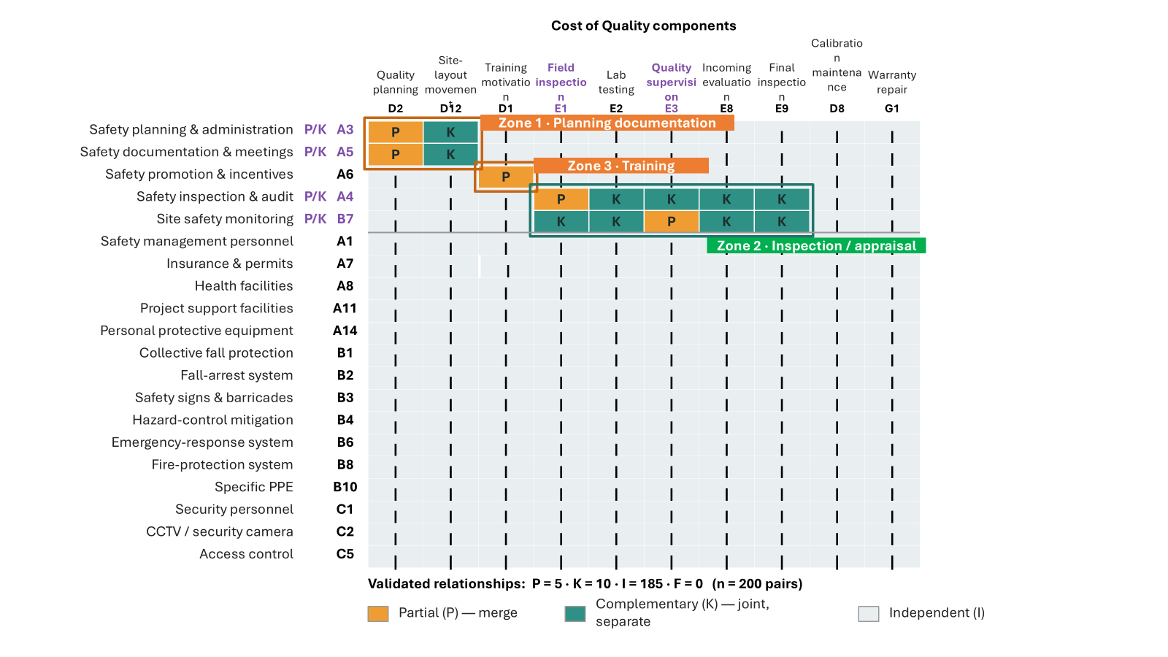
Figure 3: Domain mapping matrix showing validated partial and complementary relationships.
Figure 3 displays the mapping matrix after independent relationships are visually de-emphasised. The orange cells indicate partial relationships that may justify a merged/shared-resource cost treatment. The green cells indicate complementary relationships that should be coordinated but budgeted separately. The matrix shows that integration is concentrated rather than universal.
Table 4: Distribution of the 200 validated pairwise classifications.
Relationship class | n | Share | Budgetary treatment | Meaning in integrated estimation
Independent (I) | 185 | 92.5% | Separate stand-alone item | No sufficient shared function; forced integration would be artificial.
Complementary (K) | 10 | 5.0% | Jointly coordinated, separately budgeted | Activities interact, but resources or outputs remain distinct.
Partial (P) | 5 | 2.5% | Merged into one cost position | Shared activity and resource justify a merged/shared cost basis.
Full (F) | 0 | 0.0% | Single identical item | No pair was identical across activity, resource and output.
Total | 200 | 100% | - | -
Table 4 converts the visual pattern in Figure 3 into numerical evidence. Only 7.5% of pairs were classified as partial or complementary, which confirms that most CoS and CoQ components should remain independent. The value of the taxonomy is therefore selective: it isolates the limited set of relationships that matter for integrated budgeting.
Example of integration based on cross-mapping results
To make the taxonomy operational, selected validated pairs from the cross-mapping sheet were translated into budgeting examples. The examples in Table 5 follow the same logic as the full matrix: D1 indicates shared resource, D2 indicates shared output and D3 indicates shared function. A partial pair is not interpreted as a total merger of safety and quality obligations. It means that the shared resource portion may be costed once, while separate outputs remain traceable. A complementary pair means that coordination is required, but the budget should remain separate because the resources or outputs are not the same.
This distinction is important for estimators. For example, safety inspection and quality field inspection can share a site walk, attendance time and checklist platform, but their findings, sign-offs and compliance consequences remain different. By contrast, laboratory material testing may be coordinated with safety inspection schedules, but it uses different resources and produces different outputs, so it should not be merged.
Table 5: Examples of CoS-CoQ integration based on the cross-mapping logic.
CoS-CoQ pair | D1 resource | D2 output | D3 function | Class | Budget implication
A3 Safety planning and administration × D2 Quality planning | Yes | No | Yes | P | Shared coordination, template preparation and document-control resources may be costed once, while the safety plan and QA/QC plan remain separately traceable.
A3 Safety planning and administration × D12 Site layout planning | No | No | Yes | K | Both influence site arrangement, but safety planning and movement/layout planning produce different outputs; they should be coordinated but not merged.
A4 Safety inspection and audit × E1 Field inspection/testing | Yes | No | Yes | P | A joint field inspection can share personnel time, checklist platform and visit logistics; the safety and quality findings remain separate records.
A4 Safety inspection and audit × E2 Laboratory material testing | No | No | Yes | K | Safety inspection may coordinate with material testing schedules, but laboratory resources and test outputs remain distinct.
A6 Safety promotion and incentives × D1 Training, education and motivation | Yes | No | Yes | P | Induction or toolbox sessions may jointly deliver safety and quality messages; shared trainer time and attendance administration should not be double counted.
B7 Site safety monitoring × E3 Quality supervision and monitoring | Yes | No | Yes | P | Daily field observation may share site observation resources; safety observations and quality non-conformance records should still be coded separately.
A4 Safety inspection and audit × D12 Ease of movement and project site layout planning | No | No | No | I | This component does not have sufficiently strong similarities in resources, outputs, or functions; therefore, it is more appropriately treated as an independent component.
Table 5 demonstrates that the taxonomy can be used as an estimation rule rather than only as a classification label. The practical question is not merely whether 2 components are related, but how the relationship should change the budget. The table shows that partial pairs control double counting by merging only shared resources, while complementary pairs maintain separate budget accountability while requiring planning coordination.
Hypothetical application in cost estimation
A hypothetical estimation case was added to demonstrate how the taxonomy can be used by an estimator. Assume that a public apartment project prepares an early QHSE budget and identifies four overlapping CoS-CoQ pairs from the validated matrix. If the estimator budgets each safety and quality item independently, several shared resources may be counted twice. The taxonomy changes the treatment by merging only the shared-resource portion for partial pairs, while complementary pairs remain separately budgeted but coordinated.
Table 6: Hypothetical application of the taxonomy in early cost estimation.
Pair | Class | Taxonomy-based treatment
A6 × D1: safety promotion and quality training | P | Merge shared trainer time, room, attendance administration and learning media; keep separate safety and quality outputs.
A4 × E1: safety inspection and field quality inspection | P | Cost one joint walkdown platform and shared inspection logistics once; keep safety findings and quality findings separately coded.
A3 × D2: safety planning and QA/QC planning | P | Merge shared document-control resources and coordination meeting time; maintain safety plan and quality plan as separate deliverables.
A4 × E2: safety inspection and laboratory material testing | K | Coordinate schedule and site access, but do not merge because laboratory testing uses different resources and outputs.
Total illustrative estimate | - | Potential double-counted shared resources are removed only where a partial relationship is validated.
Table 6 is not intended to provide a universal percentage or a validated project price. It only illustrates the budgeting consequence of the taxonomy. Partial pairs reduce potential double counting because shared resources are costed once, whereas complementary pairs protect accountability because related but different resources are not merged.
Integrated CBS
The validated relationships were converted into a 32-component integrated CBS. The CBS is organized into preventive, appraisal/detection and corrective/failure categories. The first 2 categories mainly represent planned cost positions that were derived from the expert-validated component set. The corrective/failure category includes warranty and post-handover repair as a retained item and 2 literature-informed extensions: internal quality failure cost and occupational accident cost.
The extensions are intentionally separated from the validated core. This avoids the misleading claim that accident cost and internal failure cost were fully expert-validated as planned budget items. They are included because the literature consistently recognizes failure and accident consequences as relevant cost positions, but they should be calibrated separately when actual project data become available.
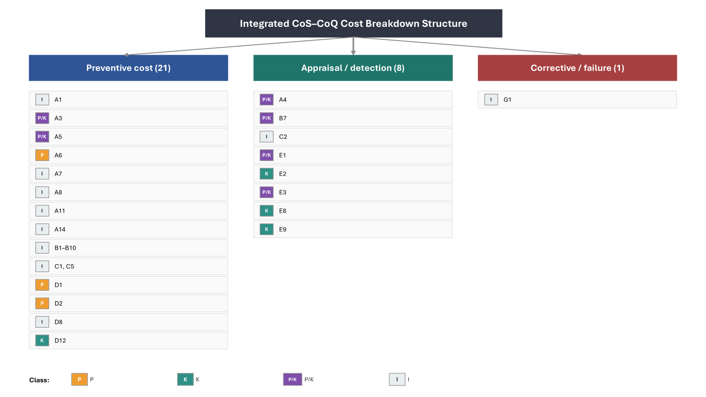
Figure 4: Integrated CoS-CoQ cost breakdown structure derived from the validated taxonomy.
Figure 4 shows the final structure of the integrated CBS. The figure does not combine all safety and quality components into a single list without logic. Instead, each component retains a relationship class. The class label functions as a budgeting instruction: I means stand-alone, K means jointly coordinated but separately budgeted, P means merge the shared-resource portion, and P/K means the component has different relationships with different counterparts.
Table 7: Integrated CoS-CoQ CBS and budget treatment rules.
Code | Integrated CBS component | Domain | Class | Budget rule
A1 | Safety management personnel | CoS | I | Stand-alone safety cost
A3 | Safety planning and administration | CoS | P/K | Merge shared planning resources only; coordinate separate outputs
A5 | Safety documentation and meetings | CoS | P/K | Coordinate with QA/QC documentation and layout records
A6 | Safety promotion and incentives | CoS | P | Merge shared training/promotion event resources where applicable
A7 | Insurance and permits | CoS | I | Stand-alone contractual/regulatory cost
A8 | Health facilities | CoS | I | Stand-alone welfare and health provision
A11 | Project support facilities | CoS | I | Stand-alone project facility provision
A14 | Personal protective equipment | CoS | I | Stand-alone PPE line item
B1-B10 | Specific safety provisions: collective protection, fall arrest, signage, hazard mitigation, emergency response, fire protection and specific PPE | CoS | I | Stand-alone activity-specific controls
C1, C5 | Security personnel and access control | CoS | I | Stand-alone security cost
D1 | Training, education and motivation | CoQ | P | Merge shared training resources with A6 when the event is joint
D2 | Quality planning and QA/QC documentation | CoQ | P | Merge shared document-control resources with A3 where overlapping
D8 | Calibration and maintenance | CoQ | I | Stand-alone quality prevention item
D12 | Site layout and movement planning | CoQ | K | Coordinate with safety planning but budget separately
A4 | Safety inspection and audit | CoS | P/K | Merge field inspection resources where shared; coordinate specialized audits
B7 | Site safety monitoring | CoS | P/K | Merge monitoring resources with E3 where jointly usable
C2 | CCTV/security camera | CoS | I | Stand-alone monitoring/security equipment
E1 | Field inspection and testing | CoQ | P/K | Merge or coordinate depending on shared inspection resource and output
E2 | Laboratory material testing | CoQ | K | Coordinate timing with safety inspection but budget separately
E3 | Quality supervision and monitoring | CoQ | P/K | Merge site monitoring resources with B7 when jointly usable
E8 | Incoming material evaluation | CoQ | K | Coordinate with safety inspection of material handling/storage
E9 | Final inspection and commissioning | CoQ | K | Coordinate with safety acceptance checks but retain quality outputs
G1 | Warranty and post-handover repair | CoQ | I | Stand-alone post-handover cost
Table 7 provides the operational CBS. The table is deliberately rule-based: the same component is not treated the same way in every relationship. A3, A4, A5, B7, E1 and E3 are marked as P/K because each may be partial with one counterpart and complementary with another. This prevents overgeneralisation and keeps the CBS traceable at the component-pair level.
DISCUSSION
The findings refine the safety-quality integration argument. Integration is not a general instruction to combine 2 cost domains. It is a selective budgeting rule that applies only where a validated relationship exists. The predominance of independent relationships shows that most safety and quality cost components should remain separate. This is a useful result because it prevents the integrated CBS from becoming a broad and ambiguous cost pool.
The planning/documentation zone is meaningful because safety planning and administration, quality planning and QA/QC documentation rely on related project information and document-control routines. The inspection/appraisal zone is meaningful because safety inspection, site monitoring, quality inspection and quality supervision often occur in the same work areas and may use overlapping field observation resources. The training zone is meaningful because safety induction and quality awareness can be delivered through shared sessions, communication media and attendance administration.
The taxonomy also clarifies the difference between coordination and merger. Complementary relationships are important because they show that 2 components can be related without being financially identical. A laboratory test may be coordinated with inspection schedules, but it should not be merged with safety inspection. This distinction protects both cost accuracy and accountability.
The Indonesian context strengthens the practical value of the taxonomy. Because safety cost is more explicitly itemised through construction safety management requirements (Danilovic & Browning, 2007; Fitriani et al., 2022)while quality cost is more often embedded in work items, supervision routines or organisational quality-management practices (Love & Li, 2000). integrated estimation could create either double counting or omission if it is not governed by a clear rule. The proposed taxonomy gives estimators a defensible basis for deciding which resources can be shared, which outputs must remain separate and which components should not be integrated at all.
Empirically testable propositions
Although this study is structural rather than predictive, the taxonomy can be converted into propositions for future empirical testing. These propositions do not introduce a new grand theory; they simply translate the validated decision logic into testable statements that can be examined using future project data, expert surveys or experimental estimating tasks.
Table 8: Propositions derived from the validated relational taxonomy.
Proposition | Statement | Operational implication
P1 | CoS-CoQ pairs with a shared activity/function are more likely to require integration treatment than pairs without a shared activity/function. | The shared-function test should be the first screening gate in future empirical replications.
P2 | Pairs with shared activity and jointly usable resources should be treated as partial relationships and should be merged only at the shared-resource level. | Merging should be limited to trainer time, joint inspection time, shared checklist platforms or shared document-control resources.
P3 | Pairs with shared activity but different resources or outputs should be treated as complementary rather than merged. | Complementary components need coordination rules, not a single budget line.
P4 | An integrated CBS that distinguishes independent, complementary and partial relationships will produce higher traceability than a CBS that lists CoS and CoQ items without relationship labels. | Future studies can compare auditability, double-counting detection and expert usability between labeled and unlabeled CBS structures.
Table 8 addresses the need for empirical follow-up without overstating the present findings. The propositions are directly derived from the classification rules and can be tested using future project data. For instance, future researchers can compare whether partial pairs are more frequently associated with shared personnel time or shared digital inspection platforms than independent pairs.
Limitations and future research
Several limitations must be acknowledged. First, the study validates structure rather than monetary magnitude. It does not use completed project bills of quantities, actual safety-cost reports or actual quality-cost ledgers. Therefore, the output should be read as an expert-validated CBS foundation, not as a fully calibrated estimation model. Second, although Appendix A improves transparency by reporting the I-CVI for each cost component, the values represent content validity judgements rather than empirical cost magnitudes.
Second, the expert panel is appropriate for content validity but remains limited to the Indonesian public apartment context. Revalidation is needed before the taxonomy is applied to infrastructure projects, private developments, design-build contracts or other national regulatory systems. Third, the 2 literature-informed corrective/failure extensions should be estimated separately using actual project data. Future work should connect the integrated CBS with WBS, risk registers, project schedules and actual cost records so that the structural rule can be tested quantitatively.
CONCLUSION
This study developed an expert-validated relational taxonomy for integrating CoS and CoQ components in Indonesian public apartment construction. 70 cost components were screened by six experts using I-CVI, resulting in thirty retained components. These components were then mapped into 200 CoS-CoQ pairs and classified using three binary dimensions: shared resource, shared output and shared function.
The results identified 185 independent, 10 complementary and 5 partial relationships, with no full relationship. The overlap was concentrated in planning/documentation, inspection/appraisal and training. The validated relationship classes were then converted into a 32-component integrated CBS in which partial relationships are merged at the shared-resource level, complementary relationships are coordinated but separately budgeted, and independent components remain stand-alone.
The contribution of the paper is a transparent and reproducible component-level structure for integrated safety-quality cost estimation. The taxonomy does not replace project-specific cost calibration, but it provides the necessary logic for preventing double counting, preserving accountability and improving traceability when CoS and CoQ are planned together.
ACKNOWLEDGEMENTS
The authors acknowledge the expert validators and construction practitioners who contributed professional judgement to the validation of the component taxonomy and integrated CBS structure.
REFERENCES
- Abdelsalam, H. M. E., & Gad, M. M. (2009). Cost of quality in Dubai: An analytical case study of residential construction projects. International Journal of Project Management, 27(5), 501–511. https://doi.org/10.1016/j.ijproman.2008.07.006
- Barber, P., Graves, A., Hall, M., Sheath, D., & Tomkins, C. (2000). Quality failure costs in civil engineering projects. International Journal of Quality & Reliability Management, 17(4/5), 479–492. https://doi.org/10.1108/02656710010298544
- Danilovic, M., & Browning, T. R. (2007). Managing complex product development projects with design structure matrices and domain mapping matrices. International Journal of Project Management, 25(3), 300–314. https://doi.org/10.1016/j.ijproman.2006.11.003
- Ferakhim, D., & Latief, Y. (2019). Development of Safety Cost for Architectural Works in Rental Apartments Building Construction Project Based on Work Breakdown Structure. International Journal of Engineering and Advanced Technology, 8(5c), 16–27. https://doi.org/10.35940/ijeat.E1003.0585C19
- Fitriani, R., Latief, Y., & Marhayudi, P. (2022). The Security Cost as Part of Construction Safety Cost: Case Study of Flats Construction. International Journal of Safety and Security Engineering, 12(1), 47–53. https://doi.org/10.18280/ijsse.120106
- Friatmojo, E. K., Latief, Y., & Utomo, A. B. (2025). A CONCEPTUAL FRAMEWORK FOR INTEGRATING COST OF QUALITY AND COST OF SAFETY IN CONSTRUCTION PROJECT.
- Garg, S., & Misra, S. (2022). Understanding the components and magnitude of the cost of quality in building construction. Engineering, Construction and Architectural Management, 29(1), 26–48. https://doi.org/10.1108/ECAM-08-2020-0642
- Gurcanli, G. E., Bilir, S., & Sevim, M. (2015). Activity based risk assessment and safety cost estimation for residential building construction projects. Safety Science, 80, 1–12. https://doi.org/10.1016/j.ssci.2015.07.002
- Han, B., Na, Y., & Son, S. (2022). Analysis of the Impact of Building Shape on Safety Management Cost. Sustainability, 14(21), 14171. https://doi.org/10.3390/su142114171
- Ikpe, E., Hammon, F., & Oloke, D. (2012). Cost-Benefit Analysis for Accident Prevention in Construction Projects. Journal of Construction Engineering and Management, 138(8), 991–998. https://doi.org/10.1061/(ASCE)CO.1943-7862.0000496
- Khadim, N., Thaheem, M. J., Ullah, F., & Mahmood, M. N. (2023). Quantifying the cost of quality in construction projects: An insight into the base of the iceberg. Quality & Quantity, 57(6), 5403–5429. https://doi.org/10.1007/s11135-022-01574-8
- Kim, S., & Kim, Y. (2023). Allocating Safety Cost using in Construction Site. Tehnički Glasnik, 17(4), 594–597. https://doi.org/10.31803/tg-20230104151203
- Lee, J., Jeong, J., Soh, J., & Jeong, J. (2022). Quantitative Analysis of the Accident Prevention Costs in Korean Construction Projects. Buildings, 12(10), 1536. https://doi.org/10.3390/buildings12101536
- Love, P. E. D., & Li, H. (2000). Quantifying the causes and costs of rework in construction. Construction Management and Economics, 18(4), 479–490. https://doi.org/10.1080/01446190050024897
- Love, P. E. D., Teo, P., Carey, B., Sing, C.-P., & Ackermann, F. (2015). The symbiotic nature of safety and quality in construction: Incidents and rework non-conformances. Safety Science, 79, 55–62. https://doi.org/10.1016/j.ssci.2015.05.009
- Love, P. E. D., Teo, P., & Morrison, J. (2018). Unearthing the nature and interplay of quality and safety in construction projects: An empirical study. Safety Science, 103, 270–279. https://doi.org/10.1016/j.ssci.2017.11.026
- Muntiyono, Herawati, Sufyani, R., Sartika, I., & Fadriani, H. (2021). Determination of Construction Safety Costs in Industrial Projects. Journal of Physics: Conference Series, 1845(1), 012059. https://doi.org/10.1088/1742-6596/1845/1/012059
- O’Connor, C., & McDermott, O. (2023). Cost of Quality in Construction. In O. McDermott, A. Rosa, J. C. Sá, & A. Toner (Eds.), Lean, Green and Sustainability (Vol. 668, pp. 307–317). Springer International Publishing. https://doi.org/10.1007/978-3-031-25741-4_26
- Polit, D. F., Beck, C. T., & Owen, S. V. (2007). Is the CVI an acceptable indicator of content validity? Appraisal and recommendations. Research in Nursing & Health, 30(4), 459–467. https://doi.org/10.1002/nur.20199
- Shafiei, I., Eshtehardian, E., Nasirzadeh, F., & Arabi, S. (2023). Dynamic modeling to reduce the cost of quality in construction projects. International Journal of Construction Management, 23(1), 24–37. https://doi.org/10.1080/15623599.2020.1845425
- Sharma, N., & Laishram, B. (2025). Understanding the relevance and impact of the cost of quality in the construction industry: A systematic literature review using PRISMA. Construction Innovation, 25(6), 1707–1726. https://doi.org/10.1108/CI-08-2023-0197
- Thabet, S. O., Ragab, A. A., & Yehia, N. A. (2024). Optimizing cost of quality in commercial projects using fuzzy expert system. HBRC Journal, 20(1), 679–699. https://doi.org/10.1080/16874048.2024.2369457
- Yang, K., Kim, K., & Go, S. (2021). Towards Effective Safety Cost Budgeting for Apartment Construction: A Case Study of Occupational Safety and Health Expenses in South Korea. Sustainability, 13(3), 1335. https://doi.org/10.3390/su13031335
- Yusoff, M. S. B. (2019). ABC of Content Validation and Content Validity Index Calculation. Education in Medicine Journal, 11(2), 49–54. https://doi.org/10.21315/eimj2019.11.2.6

