GIS-BASED MULTI-CRITERIA ENVIRONMENTAL RISK ASSESSMENT FOR ENVIRONMENTAL DUE DILIGENCE IN REAL ESTATE PROPERTIES IN DAVAO CITY, PHILIPPINES
Reigina Mascariñas
University of San Carlos reigina_mascarinas@yahoo.com
Maria Tangcay
University of San Carlos
mariatangcay7@gmail.com
Glenn Pepito
University of San Carlos
gbpepito@usc.edu.ph

ABSTRACT
This study presents a GIS-based multi-hazard risk assessment framework for evaluating environmental risks in residential properties in Davao City, Philippines. Hazard datasets from official sources, including UP NOAH, PHIVOLCS, PAGASA, and DENR-MGB, were processed and standardized within a Geographic Information System (GIS) environment. Eight hazard factors were considered: volcanic proximity, active fault distance, flooding, landslide susceptibility, liquefaction, ground shaking, tsunami exposure, and earthquake-induced landslide (EIL).
Spatial analysis techniques were applied to extract hazard values for each property, including raster sampling, spatial intersection, and proximity analysis. Distance-based thresholds for fault lines and volcanoes were established based on hazard attenuation principles and zonation practices. All hazard values were reclassified into standardized scores and integrated using the Analytic Hierarchy Process (AHP), with equal weighting applied across all criteria.
A composite risk score was computed for each property and classified into low, moderate, and high-risk categories. Results indicate that most properties fall under moderate risk due to consistent ground shaking exposure, while high-risk classifications were associated with multiple overlapping hazards and proximity to fault lines. An automated workflow using QGIS ModelBuilder and a prototype web-based interface was developed to facilitate efficient hazard assessment.
The study demonstrates that integrating GIS and AHP provides a practical and reproducible decision-support tool for environmental due diligence and real estate risk evaluation.
KEYWORDS
Geographic Information Systems, Multi-Hazard Assessment, AHP, Environmental Risk, QGIS

1 Introduction
Davao City's rapid urban development has raised demand for residential real estate, frequently without taking environmental risks into account. Hazard maps are provided by government organizations like PHIVOLCS, PAGASA, and UP NOAH, however these datasets are usually shown separately and are difficult to understand for property-level decision-making.

A thorough evaluation of the various risks affecting a property is necessary for environmental due diligence. Nevertheless, current methods lack automation, integration, and user-friendliness for non-experts. By creating a GIS-based multi-hazard assessment system that integrates spatial data processing with the Analytic Hierarchy Process (AHP) to assess property-level risk, this study fills this gap.

Developing a decision-support framework that incorporates several danger layers, calculates composite risk scores, and displays findings via an automated and user-friendly method is the aim of this study.
2 Methodology
2.1 Data Sources
Official government sources, such as UP NOAH for hazard maps, PHIVOLCS for seismic and volcanic data, PAGASA for meteorological information, and DENR-MGB for land-related datasets, provided the hazard and spatial datasets. Google Maps' high-resolution satellite imagery was used for additional validation.

2.2 Data Processing and Treatment
The treatment of data in this study follows a structured workflow to ensure consistency and accuracy in GIS-based multi-hazard assessment. Spatial datasets from UP NOAH, PHIVOLCS, PAGASA, DENR-MGB, and Google Maps were collected, standardized to a common coordinate system, and cleaned to resolve inconsistencies. All layers were clipped to the study area and aligned for spatial analysis.
Hazard data were processed according to their type. Polygon-based hazards (flood and landslide) were assigned to properties using spatial intersection, while raster-based hazards (liquefaction, ground shaking, tsunami, and EIL) were extracted through raster sampling. Distance-based hazards (fault lines and volcanoes) were analyzed using proximity calculations and classified into risk levels based on predefined thresholds.
All hazard values were reclassified into standardized scores and integrated using AHP weighting. The processed data were validated using satellite imagery to ensure spatial accuracy. These steps enabled reliable overlay analysis, risk computation, and visualization for property-level hazard assessment.
2.3 Hazard Scoring
All hazard factors were standardized into a scoring system:
- 1 = Low
- 2 = Moderate
- 3 = High
Polygon-based hazards (flood and landslide) were assigned using spatial intersection, while raster-based hazards were extracted through raster sampling. Distance-based hazards (fault and volcano) were computed using proximity analysis and classified using predefined thresholds.
2.4 AHP Weighting
Hazard criteria were integrated using the Analytic Hierarchy Process (AHP). All dangers were given the same weight based on expert opinion, yielding uniform weights of 0.125. As a result, the consistency ratio (CR) was 0, meaning that the pairwise comparison matrix was fully consistent.

2.5 Risk Computation
The overall risk score for each property was calculated using:
$R = \frac{V+F+FL+LS+LIQ+GS+Tsu+EIL​ }{8}$
where each variable represents a hazard score.
Risk levels were classified as:
- Low: 1.00–1.67
- Moderate: 1.68–2.33
- High: 2.34–3.00
2.6 System Implementation
A QGIS ModelBuilder workflow was developed to automate hazard extraction and scoring. A prototype web-based application using Python (Flask) and Leaflet was also implemented to allow users to input property locations and visualize hazard risk interactively.
3 Results and Analysis
3.1 Hazard Extraction Results
Hazard values were successfully extracted for all properties using the integrated GIS workflow. Each property was assigned scores across all eight hazard criteria.

Property | Volc | Fault | Flood | LS | Liq | GS | Tsunami | EIL | AHP Score | Final Category
1 | 2 | 2 | 1 | 1 | 1 | 3 | 1 | 1 | 1.5 | Moderate
2 | 2 | 3 | 1 | 1 | 1 | 3 | 1 | 2 | 1.75 | Moderate
3 | 2 | 2 | 1 | 1 | 2 | 3 | 1 | 1 | 1.625 | Moderate
4 | 2 | 3 | 1 | 1 | 1 | 3 | 1 | 1 | 1.625 | Moderate
5 | 2 | 2 | 1 | 1 | 1 | 3 | 1 | 1 | 1.5 | Moderate
6 | 2 | 3 | 3 | 1 | 1 | 3 | 1 | 1 | 1.875 | Moderate
7 | 2 | 2 | 1 | 1 | 3 | 3 | 2 | 1 | 1.875 | Moderate
8 | 1 | 1 | 1 | 1 | 2 | 3 | 1 | 1 | 1.375 | Low
9 | 2 | 2 | 1 | 1 | 1 | 3 | 1 | 1 | 1.5 | Moderate
10 | 1 | 1 | 1 | 1 | 2 | 3 | 1 | 1 | 1.375 | Low
11 | 2 | 2 | 3 | 1 | 2 | 3 | 1 | 2 | 2 | High
12 | 3 | 1 | 1 | 1 | 1 | 3 | 1 | 1 | 1.5 | Moderate
13 | 2 | 3 | 2 | 1 | 1 | 3 | 1 | 1 | 1.75 | Moderate
14 | 2 | 2 | 2 | 1 | 3 | 3 | 3 | 1 | 2.125 | High
15 | 2 | 3 | 1 | 1 | 1 | 3 | 1 | 1 | 1.625 | Moderate
Property | Volc | Fault | Flood | LS | Liq | GS | Tsunami | EIL | AHP Score | Final Category

3.2 Risk Scores
The computed results indicate that the majority of properties fall under the moderate-risk category, primarily due to consistently high ground shaking values. Only a few properties were classified as high risk, typically influenced by proximity to fault lines and the presence of multiple hazard factors.
3.3 Visualization
Hazard maps and composite risk maps were generated in QGIS. Additionally, the web application provided an interactive interface where users can input a location and receive hazard assessments in real time.
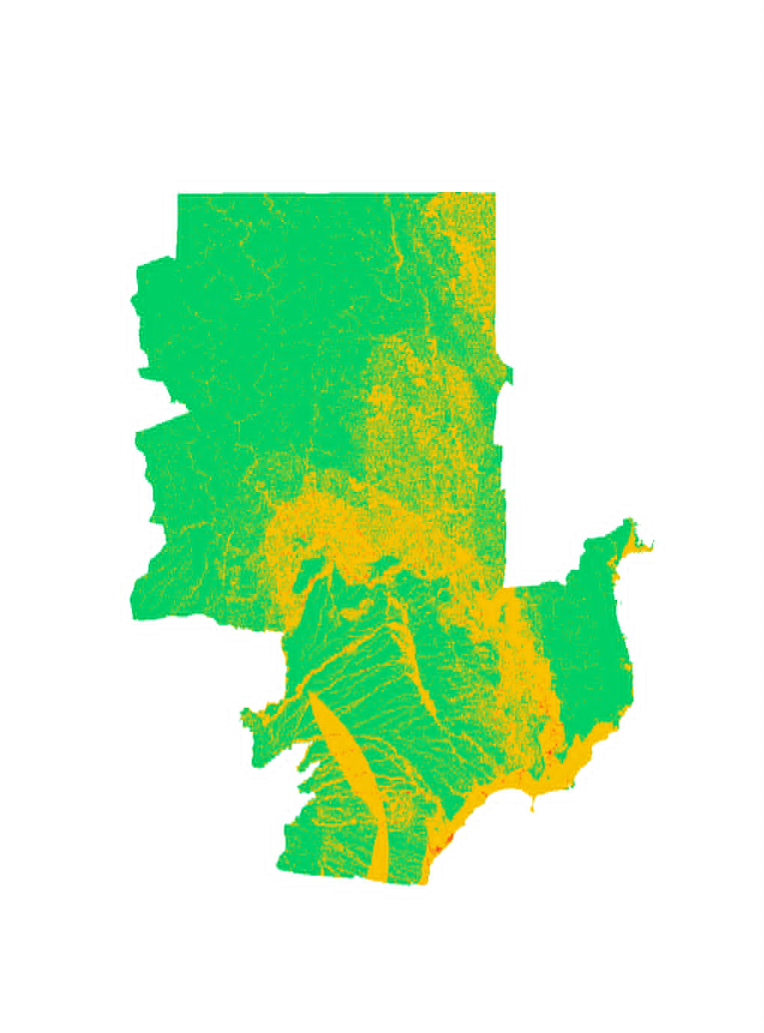
4 Conclusion
The usefulness of combining GIS and AHP for multi-hazard risk assessment in real estate applications is demonstrated by this study. The created method offers a useful decision-support tool for property assessment and permits the systematic evaluation of environmental concerns.
Automation with web-based visualization and QGIS ModelBuilder improves scalability, reproducibility, and usability. Based on hazard exposure, the framework can help developers, planners, and real estate purchasers make well-informed judgments.
ACKNOWLEDGMENTS
The researchers would like to thank the University of San Carlos, their research adviser, and government agencies such as PHIVOLCS, PAGASA, UP NOAH, and DENR-MGB for providing essential datasets.
REFERENCES
Burrough, P. A., & McDonnell, R. A. (1998). Principles of geographical information systems. Oxford University Press.
Cutter, S. L., Boruff, B. J., & Shirley, W. L. (2003). Social vulnerability to environmental hazards. Social Science Quarterly, 84(2), 242–261. https://doi.org/10.1111/1540-6237.8402002
DENR-MGB. (2023). Geohazard maps and land classification data. Department of Environment and Natural Resources – Mines and Geosciences Bureau. https://mgb.gov.ph
Eastman, J. R. (2012). IDRISI Selva tutorial: GIS and image processing. Clark Labs.
Goodchild, M. F. (2007). Citizens as sensors: The world of volunteered geography. GeoJournal, 69(4), 211–221. https://doi.org/10.1007/s10708-007-9111-y
Jensen, J. R. (2015). Introductory digital image processing: A remote sensing perspective (4th ed.). Pearson.
Kappes, M. S., Keiler, M., von Elverfeldt, K., & Glade, T. (2012). Challenges of analyzing multi-hazard risk: A review. Natural Hazards, 64(2), 1925–1958. https://doi.org/10.1007/s11069-012-0294-2
Lillesand, T., Kiefer, R. W., & Chipman, J. W. (2015). Remote sensing and image interpretation (7th ed.). Wiley.
Malczewski, J. (1999). GIS and multicriteria decision analysis. John Wiley & Sons.
Malczewski, J. (2006). GIS-based multicriteria decision analysis: A survey of the literature. International Journal of Geographical Information Science, 20(7), 703–726. https://doi.org/10.1080/13658810600661508
PAGASA. (2023). Meteorological and hydrological data services. Department of Science and Technology. https://bagong.pagasa.dost.gov.ph
PHIVOLCS. (2023). Hazard maps and active fault systems in the Philippines. Department of Science and Technology. https://phivolcs.dost.gov.ph
Saaty, T. L. (1980). The analytic hierarchy process. McGraw-Hill.
Saaty, T. L. (2008). Decision making with the analytic hierarchy process. International Journal of Services Sciences, 1(1), 83–98. https://doi.org/10.1504/IJSSCI.2008.017590
UNDRR. (2015). Sendai framework for disaster risk reduction 2015–2030. United Nations Office for Disaster Risk Reduction. https://www.undrr.org/publication/sendai-framework-disaster-risk-reduction-2015-2030
UP NOAH. (2022). Nationwide operational assessment of hazards (NOAH). University of the Philippines. https://noah.up.edu.ph

