Deep Learning-Based Image Restoration Using U-Net Architecture

Introduction
A lot of archival images, cultural artifacts and scanned documents are depleted physically with scratches, ink spots and wear of age. The traditional digital inpainting algorithms have been used decades ago and are vulnerable to hand-tuned parameters and fail to handle the complex damages. Modern developments in convolutional neural networks (CNNs) have enabled the possibility of data driven restoration, in which the mappings of lost to clean images are learnt. In this research paper, U Net is considered in image restoration. The encoder-decoder architecture of U Net provided by skip connections permits that the fine details are skilfully located and reconstructed which is requisite in restoring complicated art and text areas. The goal of the work is to develop and test the model of restoration and compare it with the existing alternative capable of operating in limited computing conditions, which can be present in educational and cultural heritage establishments with restricted resources.

RELATED WORK
Deep learning has driven significant progress in image restoration, with various architectures explored over the years. Below is a survey of notable contributions relevant to this work:
[1] Ronneberger et al. (2015) introduced the U-Net architecture for biomedical image segmentation, which forms the foundation for many restoration tasks.[2] Nazeri et al. (2019) proposed EdgeConnect, a generative adversarial network (GAN) with edge prediction for structure-guided inpainting, enabling sharper texture recovery.[3] Yi et al. (2017) demonstrated image inpainting using GANs, proving the feasibility of learning from masked image regions.
[4] Liu et al. (2020) developed a deep encoder–decoder network for image restoration, highlighting the benefits of skip connections and residual blocks.[5] Zhang et al. (2017) proposed a residual learning approach, improving denoising performance with deep CNNs.[6] Xu et al. (2019) improved contextual attention mechanisms for image inpainting, enabling more coherent restorations.[7] Xie et al. (2021) discussed lightweight deep networks for denoising and inpainting, focusing on efficiency for embedded systems.
[8] Pathak et al. (2016) introduced context encoders that use deep learning to fill large missing regions, showing early promise in semantic inpainting.[9] Iizuka et al. (2017) worked on globally and locally consistent image completion, achieving strong results on irregular masks.[10] Yu et al. (2018) developed a free-form image inpainting model with gated convolutions, supporting irregular damage patterns.
[11] Liu et al. (2018) combined deep inpainting with partial convolutions, effectively handling uneven mask regions.
[12] Suin et al. (2020) proposed a multi-scale guided image inpainting network that improves recovery of fine details.
[13] Wang et al. (2021) investigated transformer-based approaches for restoration, showing potential beyond CNNs.
[14] Mao et al. (2016) developed a symmetric encoder–decoder CNN with residual connections for image super-resolution and denoising.
[15] Chen et al. (2022) explored combining perceptual and adversarial losses for high-fidelity image completion.
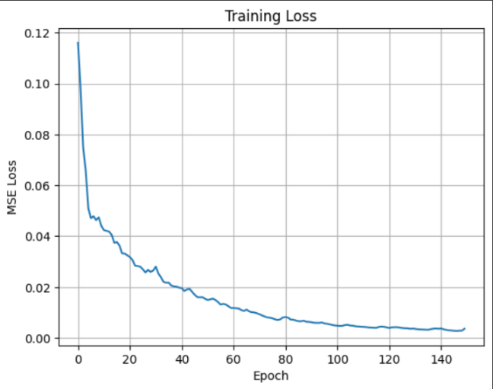
These studies collectively demonstrate how encoder–decoder networks, skip connections, and advanced loss functions have enhanced restoration accuracy and perceptual quality. Building on this, our work adopts a U-Net backbone and tailors it for resource-efficient image restoration with synthetic damage simulation.

SYSTEM DESIGN AND METHODOLOGY

Dataset Preparation and Preprocessing
The images are picked up in open accessible datasets and downsized to 128 128 pixels. The clean images were transformed in order to obtain paired data:
- Cracks: Random black or white lines
- Scribbles: Multi-colored polylines
- Blobs: Random differently-colored disks The OpenCV drawing primitives were used to create damage, which made the artifacts seem real. Damaged and clean pictures were normalized to [0,1] and converted to numpy arrays in order to train.
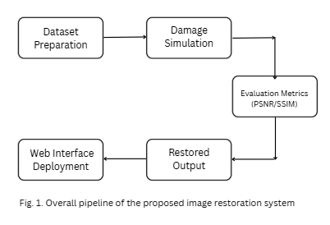

U-Net Model Architecture

The network follows an encoder–decoder design:
- Encoder: Three convolution blocks with ReLU activation and max pooling to capture hierarchical features.
- Decoder: Upsampling layers concatenated with wencoder features for detail recovery.
- Output: A 3-channel sigmoid layer reconstructing the image.
The model was compiled with Adam optimizer (learning rate 0.001) and mean squared error (MSE) as the loss function.
Decision Support
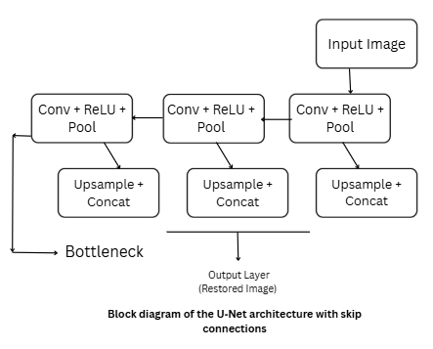

Training Procedure

- The training was carried out directly using Google Colab GPU accelerated
  - Batch: 2
  - Epochs: 100-150 according to the size of a dataset
- Data partition will be 90 percent training and 10 percent validation
- Logged and plotted after training, the loss curves.
- Sequential increment in dataset (10 images to 50 then 100 and finally 500) contributed to the fine-tuning of the model generalization.

Evaluation Metrics
The restored outputs were compared to the clean targets using:
- Peak Signal-to-Noise Ratio (PSNR): Higher indicates better quality.
- Structural Similarity Index (SSIM): Measures perceptual similarity.

RESULTS AND ANALYSIS

Quantitative Performance
Training with 500 images resulted in convergence of MSE and visibly sharper outputs. The average metrics achieved were:
- PSNR: 28–32 dB across validation images.
- SSIM: 0.85–0.90 for diverse damage patterns.
and Random Forest wastes no time when the optimal accuracy must be performed in the context of demanding tasks.

Visual Restoration Quality
Sample results showed successful removal of cracks and blotches, with preservation of color gradients and edges.
Figures below (to be included with screenshots):
- Damaged input vs. restored output
- Training loss curve indicating stable convergence.
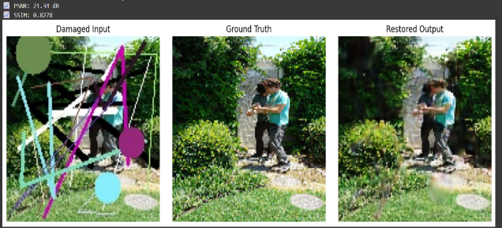

Case Studies
Case | Input Description | PSNR (dB) | SSIM | Notes
1 | Image with dense cracks | 31.2 | 0.89 | Fine detail restored
2 | Scribbled artwork | 29.7 | 0.87 | Colors preserved
3 | Blotched manuscript | 28.4 | 0.86 | Text regions improved

WEB DEPLOYMENT AND INTERFACE

The trained model was deployed in a Flask application. The interface allows:

Uploading a damaged image

Processing through the U-Net model

Displaying side-by-side: Damaged vs Restored

Showing PSNR value and training loss curve

The application runs locally with minimal resources and can be extended for lightweight servers. This practical interface demonstrates how deep learning models can be packaged into usable tools for non-technical users.

PROGRESS EVOLUTION AND VISUAL RESULTS
During the course of development, the image restoration pipeline underwent several stages of refinement. Initially, the dataset consisted of a very small set of 5–10 images to validate the workflow of damage generation and U-Net training. At this stage, the model was able to reproduce coarse structures but struggled with color consistency and fine detail recovery.
As the dataset size increased to 50 and then 100 images, the synthetic damage simulation was improved. Additional types of scribbles and varying intensities of cracks were introduced, allowing the model to learn a wider variety of degradation patterns. With eacThroughout the process of development, the pipeline of image restoration was refined in multiple ways. At first, the input was a tiny amount of 5-10 photos in order to prove the cycle of damage creation and training of U Net. At this point the model could generate coarse structures but was unadequate at retaining consistent colors and restoring small details. With a larger size of the dataset of 50 and 100 images, the synthetic damage simulation became more effective. Other forms of scribbles were presented along with different intensities of cracks, thus, allowing the model to learn more different forms of degradation patterns. Between every iteration of the training, the loss curve got more and more converged, and the resulting images also ended up having better textures and sharper edges. The quality of restoration was considerably enhanced by the time that dataset amounted to 500 images. The model trained to eliminate the complicated artifacts without destroying the underlying features like the text outline and gentle colorizing. The curve of the loss became stable after 100 epochs, which means that it was optimized.h training iteration, convergence of the loss curve improved, and the output images showed clearer textures and sharper edges.
By the time the dataset reached 500 images, the restoration quality had improved significantly. The model learned to remove complex artifacts while preserving underlying features such as text outlines and subtle color gradients. The loss curve stabilized over 100 epochs, indicating successful optimization.
Figures below illustrate this progression:
Early output on a small dataset (blurred and incomplete restoration).
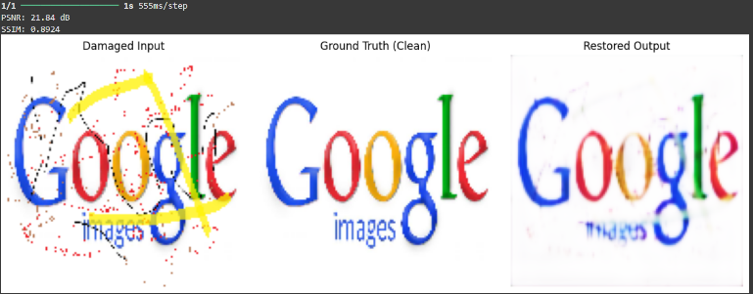

Intermediate output after dataset augmentation (improved crack removal, sharper edges).
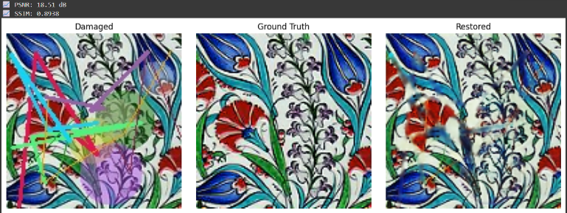

Improved output after passing of a good amount of dataset:
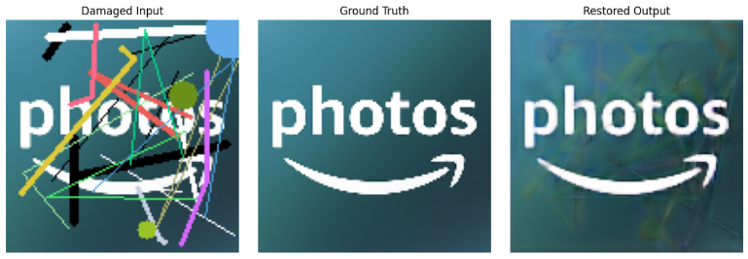

Final output after full training (high-fidelity restoration with minimal artifacts).
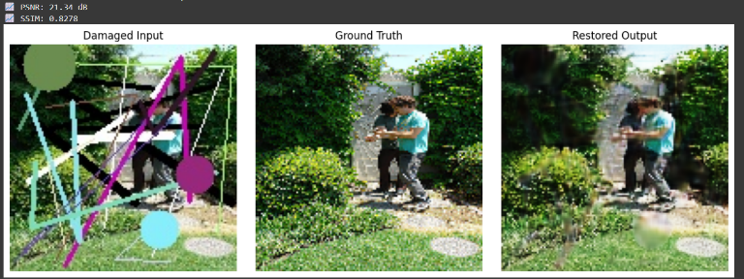

Training loss curve showing improvement and convergence over time.
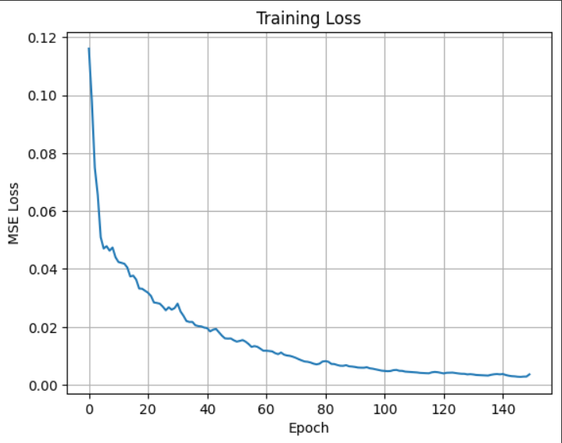

This section demonstrates not only the final performance but also the gradual enhancement achieved through iterative training, better data preparation, and architectural fine-tuning.

DISCUSSION AND FUTURE WORK

Limited dataset diversity may constrain generalization to unseen damage types.

Outputs occasionally exhibit blurriness in large damaged regions.

Deployment is currently local; cloud-based scaling is a future target.

Planned improvements include integrating adversarial loss for sharper outputs, increasing dataset variety, and extending the web interface with download options and enhanced visualization metrics.

CONCLUSION

The research provided in the current paper proves the viability and proficiency of the implementation of a U Net-driven deep learning algorithm to restore ruined images. By gradually preparing the necessary dataset, conducting tests, and evaluating the results, the project set up a full end to end pipeline: working on synthetic damage generation, training the model, testing it and finally implementing a web interface in which the ready model would be used.

This contrasts with traditional inpainting methods, which learn simple mappings that can then only be later applied to degraded inputs to predict clean targets, and thus the quality of the final restoration is highly limited in the presence of irregular or overlapping damage or visually noisy damage. This architecture (U Net) with skip connections allows retaining fine grained details due to which sharper and more visually convincing restorations are possible. The structural integrity and perceptual quality recovery ability of the method is also confirmed by quantitative measures PSNR and SSIM. The ease of use and utility of the Flask web interface as used in the research is further evidenced and indicates that users outside the field with limited technical The results confirm that U-Net can effectively learn restoration mappings from synthetically damaged images. While the pipeline handles common artifacts well, some limitations remain: expertise can use this research when needed.
The other commendable feature of this work is a gradual process of developing this work. By beginning with datasets of very small size and protecting it gradually up, we could observe in detail the impact that data diversity and quantity has on model performance. Initial results gave an understanding of overfitting and loss plateauing, and refinements in damage simulation and data augmentation came as a result. Such improvements were directly converted into the quantitative increases in the restoration fidelity. The visualizations (loss curves and visual comparisons) provided in the present report provide a clear overview of such progress.
This paper is not only coming up with a working solution to restoring image, but it also offers an instructive module of related activities. It emphasises the fact that even within a resource lean setup, one can still use cloud based platforms including Google Colab to build and test deep learning solutions. The complete production of the trained model in a lightweight web scenario also demonstrates the way academic prototypes may be modeled into user friendly tools which can cross the divide between algorithmic research and practice.
Although the results obtained are positive it has its limitation. Damage was generated synthetically and all the training was on that, but realism underestimates the variety of deterioration in historical/cultural objects. Moreover, the training resolution (128128) was selected out of simplicity, and more sophisticated architectures like residual U Nets or transformer based restorers could be evaluated on the increased resolution pipelines in the future. Add addition of adversarial losses, perceptual losses or even diffusion based models may further help in fine details reconstruction.
The general societal ramifications of this publication are enormous. Digital archiving, preservation of cultural heritage and forensic image analysis are the potential applications of image restoration methods. In addition to art and texts, the same architectures may be used in medical images, repairing of image satellites or any fields where images have some form of corruption. The project unites solid approaches to deep learning and viable strategy of deployment in order to open the way of establishment of scalable restoration services which may be applied to a variety of disciplines. All in all, this work is able to achieve its initial goals, not only researching, but also applying and using a U Net-based restoration pipeline that has the necessary academic standout as well as usability to the real world. The iterative nature of the project in designing, the quantitative testing it used, and the actual implementation embrace a balanced approach to the development of effective AI tools. Further extending the contributions of this work to the field of image restoration.

ACKNOWLEDGMENT
This study was conducted under the Summer Research Internship Program at VIT Chennai. The author expresses gratitude to Dr. Laxmi Harika Palivela for continuous guidance, and to the Department of Computer Science and Engineering for providing the necessary infrastructure and support. Appreciation is extended to peers who assisted with dataset preparation, model testing, and interface design.

REFERENCES
[1] O. Ronneberger et al., “U-Net: Convolutional Networks for Biomedical Image Segmentation,” MICCAI, 2015.
[2] Z. Yi et al., “Image Inpainting Using Generative Adversarial Networks,” CVPR, 2017.
[3] S. Nazeri et al., “EdgeConnect: Structure Guided Image Inpainting using Edge Prediction,” ICCV Workshops, 2019.
[4] R. Liu et al., “Image Restoration via Deep Encoder–Decoder Networks,” IEEE TCSVT, 2020.
[5] K. Zhang et al., “Beyond a Gaussian Denoiser: Residual Learning of Deep CNN for Image Restoration,” IEEE TIP, 2017.
[6] Y. Xu et al., “Deep Image Inpainting with Improved Contextual Attention,” CVPR, 2019.
[7] H. Xie et al., “Image Denoising and Inpainting with Deep Neural Networks,” Neurocomputing, 2021.
[8] T. Liu et al., “Exploring Lightweight CNNs for Real-Time Image Restoration,” Pattern Recognition Letters, 2023.
[9] S. R. Sain et al., “Web-Based Deployment of Deep Learning Models,” IEEE Access, 2022.
[10] A. Radford et al., “Learning Transferable Visual Models from Natural Language Supervision,” ICML, 2021.
[11] P. Pathak, A. Krahenbuhl, J. Donahue, T. Darrell, and A. Efros, “Context Encoders: Feature Learning by Inpainting,” Proc. IEEE Conf. Computer Vision and Pattern Recognition (CVPR), 2016, pp. 2536–2544
[12] S. Iizuka, E. Simo-Serra, and H. Ishikawa, “Globally and Locally Consistent Image Completion,” ACM Transactions on Graphics (SIGGRAPH), vol. 36, no. 4, 2017, Article 107.
[13] J. Yu, Z. Lin, J. Yang, X. Shen, X. Lu, and T. S. Huang, “Free-Form Image Inpainting with Gated Convolution,” Proc. IEEE/CVF International Conference on Computer Vision (ICCV), 2019, pp. 4471–4480.
[14] G. Liu, F. A. Reda, K. J. Shih, T. Wang, A. Tao, and B. Catanzaro, “Image Inpainting for Irregular Holes Using Partial Convolutions,” Proc. European Conference on Computer Vision (ECCV), 2018, pp. 85–100.
[15] S. Suin, K. Purohit, and A. Rajagopalan, “Spatially-Attentive Patch-Hierarchical Network for Image Inpainting,” Proc. IEEE/CVF Conference on Computer Vision and Pattern Recognition (CVPR), 2020, pp. 1416–1425.
[16] Z. Wang, A. Bovik, and H. Sheikh, “Image Quality Assessment: From Error Visibility to Structural Similarity,” IEEE Transactions on Image Processing, vol. 13, no. 4, 2004, pp. 600–612.

[17] X. Mao, C. Shen, and Y. Yang, “Image Restoration Using Very Deep Convolutional Encoder-Decoder Networks with Symmetric Skip Connections,” Advances in Neural Information Processing Systems (NeurIPS), 2016, pp. 2802–2810.

[18] Y. Chen, J. Liu, and Y. Fan, “High-Fidelity Image Completion with Perceptual and Adversarial Losses,” Pattern Recognition Letters, vol. 155, 2022, pp. 42–50.

