From Earth to Eternity: Symbolism and Religious Meaning in Terracotta Icons of Kashi and Indian Traditions

Abstract
The present Research article deals with the deep symbolism and religious meaning of terracotta figures of Kashi (Varanasi) in the larger framework of Indian spirituality. As one of the most ancient artistic forms of humanity, terracotta art can be viewed as a material connection of the world to the divine in the sacred topography of Kashi. Due to the archaeological evidence, the references existing in the Vedic, Puranic, Buddhist, and Jain literature, and some observations made by ethnographers, this paper discusses how clay-based religious iconography reflects the philosophical concept of "Māta Bhūmi Putro'ham Pṛthivyāḥ" (Earth is my mother, I am her son). Symbolic motifs that are analyzed in the research consist of Mother goddess figurines, ritual objects (diyas, kalash), and decorative patterns that demonstrate cosmic principles, symbolic representations of fertility, and transcendence. Great focus is made on the way that the terracotta icons mediated between the material and spiritual worlds, as the means of devotion, ritual efficacy, and cultural continuity between prehistoric and modern practices. The paper has demonstrated that the Kashi tradition of terracotta is a singular synthesis of various religious currents of thought- Śaiva, Śākta, Vaiṣṇava, Buddhist, and Jain- which form a syncretic language of images that still influences the religious consciousness and sense of identity. Present analysis adds to the interpretation of the interplay of materiality and spirituality in Indian religious art, with a sense of how timeless earth-based iconography can be relevant in the era of technological shifts happening so fast.
Keywords: Terracotta art, Kashi, religious symbolism, Mother Goddess, sacred iconography, Vedic traditions, Buddhist art, material culture, ritual objects, spiritual symbolism.
Introduction
The city of Kashi, the immortal city positioned on the banks of the sacred Ganga, is not only a geographical location but also a cosmic axis between the world of the earth and the world of deities (Eck, 1982). In this religious landscape, terracotta art becomes one of the most expressive art forms of religious messages that contain thousands of years of wisdom and cultural traditions. The same element of clay, pulled out of the soil, formed by human hands, remodeled by fire, reflects the process of spiritual awakening on consciousness on the earth and in the heavens (Singh and Jaiswal, 2018).
The philosophy of the terracotta art of Indian tradition is based on the idea expressed in the Atharva Veda (12.1.12): "Māta Bhūmi Putro'ham Pṛthivyāḥ" (Earth is my mother, I am her son). This statement makes clay more than an art form; a divine material that portrays the powers of the creative mother (Coomaraswamy, 1934). This philosophy is represented in the material world in the form of icons in the tradition of the terracotta of Kashi, and it represents a bridge between the material world and the spiritual realms.
The findings of archaeological excavation showed that the terracotta production in the Kashi area started as early as 800 BCE and up to this day (Narain and Roy, 1976). These discoveries reveal that terracotta iconography in Kashi is not only an expression of artistic taste, but also a part of religious life, including domestic cult, ceremonies in the temple, and ceremonies of the city. The Northern Black Polished Ware (NBPW) found in Rajghat is one of the high-tech and aesthetic accomplishments of the terracotta craftsmen in ancient Kashi (Singh, 1992).
Present paper is intended to to evaluate the encode of symbolism in the terracotta religious statues of Kashi through the archaeological evidence and written sources; to study how the earthly sacred art can be still relevant in the modern religious practice; and to investigate how the material and the spiritual can be connected to each other through the prism of the terracotta iconography. These aims address the deficiencies of the current research, which generally regards the arts of terracotta as an expression of decorative but not theological values (Kumar, 2016).

The study of Indian terracotta art has been an academic endeavor that has since taken a significantly different form from early archaeological surveys. The theological basis of Indian art was first developed by Coomaraswamy (1934), who maintains that material forms are supports (ālambana) to spiritual realization. His interpretation of the form and meaning in religious iconography will give the necessary theoretical background to the terracotta symbolism.

A thorough examination of the sacred geography of Kashi, presented by Eck (1982), reveals that the material culture of the city, such as the terracotta icons used in the city, takes part in producing sacred space. Her work throws light on the use of religious objects to organize the experience of devotion and community. Further referring to terracotta, Ghosh (1974) listed key archaeological finds, and Singh and Jaiswal (2018) offered the geographical backgrounds to the unique traditions of terracotta at Kashi.

The more recent scholarship has started analyzing the gendered aspects of terracotta iconography. Jayakar (1989) discussed the figurines of Mother Goddess as the disclosures of the theology of Śakta, and Marglin (2014) examined the role of clay icons in the ritual activities of domestic worship. Nevertheless, little to no analysis has been done on the terracotta symbolism within the multi-religious setting in Kashi, and this is where the current study can help provide new information.

Present study consists of an interdisciplinary approach that involves the analysis of archaeology, textual interpretation, and ethnography. Primary archeological evidence comes in the form of published excavation reports at Rajghat, Sarnath, and other Kashi sites, with support provided by museum holdings of the Bharat Kala Bhavan and Sarnath Archaeological Museum. The study of the sources of reference to clay icons and purée pottery in the Vedic and Puranic, Buddhist Jatakas, and Jain canon literatures.

The interpretive approach is based on iconographical criticism, which Coomaraswamy (1934) formulated and used to analyse iconography in India itself (Kramrisch 1976). This mode appreciates that religious images do not represent but rather manifest as presence forms where the divine can be approached by the worshippers. Symbolic analysis thus wants to take care of both formal properties (shape, decoration, proportions) and contextual ones (ritual use, textual connotations, cultic practices).

Philosophical Foundations: Earth as Sacred Substance
The theological importance of terracotta iconography to Indian tradition can be traced to the interpretation of earth that the cosmology of Vedic tradition understands as original creative matter. The hymn to Pritthivii (Earth) of the Atharva Veda describes soil as the origin of all life, the origin of cosmic order (rta), and the body of a divine mother (Panikkar, 1977). This idea views clay as not an inanimate matter, but as the living matter that has the power to create (śakti).
The ritual meaning of earth is explained in the Śatapatha Brāhmaana (7.2.1.4), with clay vessels that are used during Vedic ceremonies personifying cosmic values. It is written: The earth is the base, the atmosphere is the body, and heaven is the head. This three-world cosmology is reflected in the terracotta icons in which the earthly material is transformed into the celestial forms (Staal, 1983). Creation by the use of clay images in such a way recreates divine creation, where the artisan is the universal creator (Viśvakarman) who uses primordial matter.
This philosophical system gains new layers to its functional context in the case of Kashi, where it is linked to the geography of the cosmos that is associated with the concept of the entire universe in relation to the role of the deity known as Śiva. Kashi is found as Ananda vana (Forest of Bliss) according to Kashi-ka-shaasta Kasi, as per the Purana, and others, the material and spiritual worlds are in contact (Eck, 1982). The terracotta figures made in this holy spot are part of the Kashi liminal ontology: both earthly and transcendent, a space in between, transient and enduring.
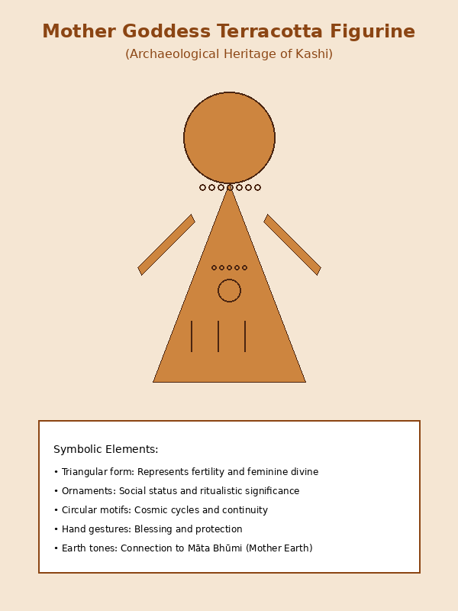
Figure 1. Mother Goddess Terracotta Figurine showing symbolic elements

Mother Goddess Icons: Embodying Feminine Divine

The Mother goddess figurines of terracotta are perhaps the oldest and most prevalent religious iconography in the Indian subcontinent, which goes back to the Harappan civilization and even the modern folk iconography (Jayakar, 1989). The architectural history of Kashi records that these figurines occur throughout the early historic period, displaying a remarkable uniformity of shape and symbolic content despite changes in the style of art.

Kashi in the Mother Goddess terracottas, the accentuated breasts, broad hips, and the triangular shape with ornate ornamentation of the body represent the multi-strata of symbolism (Narain & Roy, 1976). On the most concrete level, these figures symbolize the biological fruitfulness and generative strength. The body in the form of a triangle directly addresses the yoni, which is a representation of the creative feminine energy (shakti) out of which all manifest existence comes. This iconographic rule links the terracotta Mother Goddess images to the knowledge of the goddess of the Shakta theology as the ultimate creative principle (Kinsley, 1986).

In addition to fertility, those figurines represent cosmic ideas. According to the Devi Mahaprabhu, the goddess is said to symbolize the whole universe out of her own matter11825- line combines both material nature and divine form of the figurines, symbolizing earthly matter and goddesses respectively. Ornamental objects, necklaces, waist bands, and headdresses not only indicate the social status, but also symbolize cosmic order (ṛta) overwhelming primordial chaos (Coburn, 1991). All the ornamental elements are mantras of a visual character, and these ornaments code the sacred knowledge in the material world.

Notably, the multireligious environment created in Kashi created syncretic goddess iconography. The goddesses in Buddhist terracottas of Sarnath are redefined as Tara or other female bodhisattvas but are formally related to previous Hindu goddess forms (Mitra, 1971). Religious fluidity. This shows that terracotta art allowed theological discourse and interreligious influence between spiritual traditions.

Ritual Objects: Mediating Sacred and Profane
In addition to anthropomorphic icons, terracotta ritual items such as diyas (lamps), kalash (sacred pots), incense holders, and offering vessels are all important parts of the religious practice in Kashi. These items serve as mediating materials, whereby they facilitate communication between the human and divine worlds by use of their ritual application (Parry, 1994). Their materiality is significant: Clay vessels preserve the generative connections of the earth, whereas caring about the impermanence and rebirth as opposed to metal or stone alternatives.
An example of the ritual symbolic power of terracotta is the diya (clay lamp). The use of clay lamps in the Hindu, Jain, and Buddhist ceremonies is at the heart of a symbolic action of illumination that dispels ignorance (avidyA). The Kashmiri Kaasih purposely refers to the merit of producing lamps in the temples of Kashi, as such activities eliminate darkness in the external and internal worlds (Sherring, 1868). The five wicks on the lamp can symbolically represent the five elements (pañca mahābhūta) or the five senses, and the convergent flames are symbolic of unified consciousness.
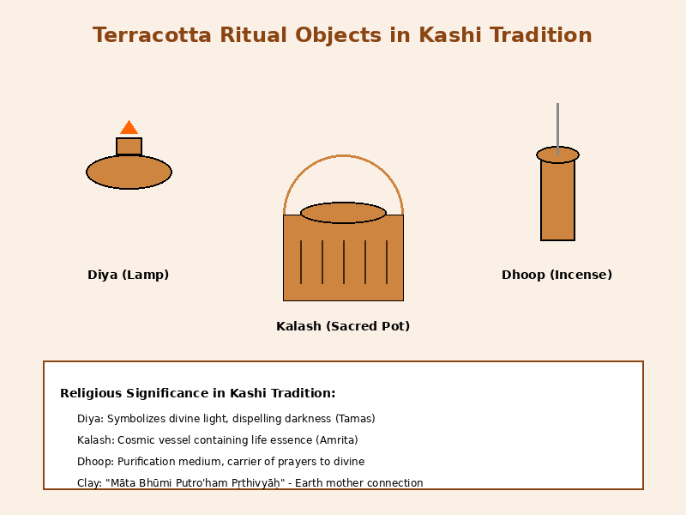
Figure 2. Terracotta Ritual Objects: Diya, Kalash, and Dhoop
Even more complicated in symbolism is the kalash (sacred pot). According to textual sources in the Gryhya Sutras up to medieval Purana, the kalash is something which symbolizes the whole universe: the bottom of the kalash is the earth, the middle part is the atmosphere, and the neck is the sky, and the water inside the kalash is the primordial ocean (Apte, 1970). Kalash is used as a container of divine presence in rituals when it is full of water and adorned with mango leaves and topped by a coconut. The Liṅga Purana (1.17.10) can categorically refer to the goddess as the kalash that has been properly consecrated, and thus it is not only a symbol, but the direct expression of divine power.
Incense standers and offering bowls show the same level of symbolism. The smoke that has been rising out of terracotta incense holders symbolizes prayers that are ascending towards heavenly levels, but at the same time, cleansing the ritual space. Giving vessels (pātra) to be distributed at prasada represents the concept of the divine grace that circulates in material matter. Bhagavad Gita (9.26) focuses on the value of devotion rather than material ones, and so simple clay vessels would suffice as the offerings to the divine, and because of its earthly nature, it would actually work more to increase the divine power, but not to diminish its sacred power.

Decorative Motifs: Encoding Cosmic Principles
The pattern of decoration of the terracotta icons of Kashi represents a complex form of symbolic language that reflects cosmological, philosophical, and theological ideas. Rather than one of decoration, these motives can be understood as the visual scripture: these themes convey the divine knowledge not by word but by form. Archaeological evidence of terracotta pieces of the Rajghat and Sarnath shows that certain motifs were used through the years, and this implies that there were standardized symbolic conventions (Singh, 1992).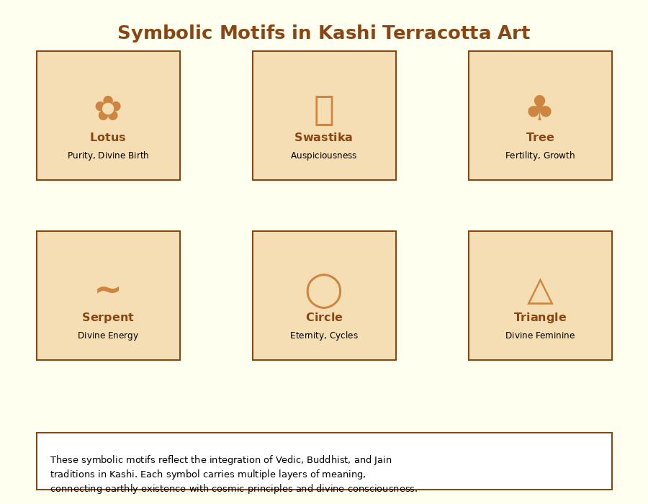
Figure 3. Symbolic Motifs in Kashi Terracotta Art

The lotus motifs are used everywhere on the terracotta icons, and they have multiple meanings. According to Hindu culture, the lotus is used to portray the purity that is formed out of muddy waters- spiritual awakening out of materialistic life (Zimmer, 1946). Sarnath Buddhist terracottas use lotus pedestals on the figures of Buddha and bodhisattvas in order to signify how the enlightened one has surpassed saamsara. The Lalitavistara Sutta tells of the Buddha being born with lotus flowers, which is often a subject on Buddhist terracottas in Kashi.

Regardless of ill contemporary connotations, the swastika motif is one of the oldest and most lucky Indian motifs. The swastika on terracotta objects signifies the cyclic character of time, the four directions of space, and the eternal movement of the order in the cosmos. Swastika symbols in religious art are prescribed by the ViSHNU Dharmottara Purana in definite proportions and orientations, suggesting that they are intrinsic to the religious art as a form of sacred geometry instead of decorative (Kramrisch, 1976).

Circular motifs represent ideas of eternity, completeness, and cyclic time (kala-cakra). The perfection of the circle, which knows no beginning or no end, symbolizes the ultimate reality (Brahman) beyond time. Patterns of concentric circles frequently found on the surfaces of terracotta can symbolize successive levels of cosmological space or developmental levels of the spiritual. The exposition of om in the Maṇdukya Upaniṣad as consisting of all of the states with time has visual actions involving the usage of circular patterns.

The triangular shapes, especially the down-pointing triangle, represent the feminine creative force (yoni) and the falling of the divine grace into matter. Triangles with their points upwards depict the rising consciousness (Eliade, 1958). The upward and downward triangle constituting the ṣaṭkoṇa (hexagram) is seen in other advanced terracotta works, and they signify the merger of the consciousness and energy, transcendence and immanence of Śiva and Śakti.

Religious Synthesis: Buddhist and Jain Contributions

The fact that Kashi was a great center of various religious traditions created unique syncretic trends in terracotta iconography. The Buddhist temples located at Sarnath manufactured large amounts of terracotta plaques, votive tablets, and figurines of Buddha, bodhisattva, and Jataaka scenes (Mitra, 1971). These Buddhist terracottas show a continuation of the previous folk traditions, as well as introducing other iconographic elements.

Of special interest are the terracotta figures of Buddha in the teaching gesture (dharmacakra mudra) in memory of the First Sermon at Sarnath. The Buddhist dharma is coded in material fashion in these images, hence making sacred knowledge available to visual access. Meritorious activities involving the production of Buddha images are outlined in the Divyavadaana and other Buddhist readings, and form the theological grounds of terracotta Buddhist icons (Schopen, 1997).

Similar patterns of adaptation and synthesis are traced in Jain terracotta traditions in Kashi that remain the least explored. Terracotta votive tablets with images of Tirathanikaras observe the formal conventions of the Buddhist ones, but still have specific Jain iconographic attributes. Jain non-violence (ahiṁsā) and non-violence towards all forms of life are reminiscent of the materialism of earth of terracotta, which does not use violence to obtain stone or the metals used in making metals.

The influence of cross-religion is best seen in the iconography of goddesses. Images of Buddhist Tara have formal features similar to those of Hindu deity images, and Jain Yaksi images have the same features. Such an iconographic overlap indicates that the terracotta craftsmen worked together in similar visual vocabularies that cut across sectarian lines. Worshippers of various traditions can assign diverse meanings to related terracotta shapes based on theological traditions, and in this way, it is easy to establish religious pluralism, and art has the ability to coexist.

The terracotta religious art continues playing a crucial role in modern Kashi, even though the economic trends and modernization in the technological aspect are being experienced. In festivals such as Diwali, Navaratri, and Ganesh Chaturthi, clay icons still have ritual purposes. The concept of biodegradability, when the images can be dissolved into the earth or water after usage, is a sign of ecological wisdom that is becoming more and more topical in the modern environmental discussion (Kumar, 2016).

The traditional neighbourhoods in Kashi have potter communities (kumhār jāti) that preserve knowledge of crafts that are transmitted over generations. An ethnographic study can show that modern potters conceptualize their activity in directly religious styles not only with regard to the work as a commercial activity but also as engagement in cosmic creativity. Preliminary rituals, such as recognition of clay as a sacred medium that must be treated with respect, are still practiced by older artisans before getting down to work (Bhattacharya, 2019).

Nevertheless, modern terracotta manufacture is experiencing great challenges. The economic forces are inclined towards the use of inexpensive industrial products, and the trend of the younger generation to leave the traditional crafts to other means of livelihood is on the increase. State programs in accordance with the Ātmanirbhar Bhārat program are aimed at helping traditional craftsmen, but the structural issues have remained. What arises then is the question of whether terracotta religious art will remain as a living tradition or will become a museum artifact: a question which has implications beyond the field of aesthetics to the question of cultural continuity, community identity, and theological expression.

Conclusion

This study of the iconography of terracotta in Kashi shows how the art of the earth has significant theological foundations as well as being valuable for ritual purposes. Since the earliest figurines of Mother Goddesses all the way to modern-day festival images, the terracotta icons have served as an easy way to connect with the divine world, to share the feeling of devotion, and to preserve the knowledge of the sacred in generations.

The symbolism that is coded in the terracotta religious objects of Kashi works at several levels at the same time. On the immediate level of sense, these icons are a visual and tactile pleasure. At the symbolic level, ornamental patterns are coded with the cosmological laws and philosophical ideas. Theologically, the theologically consecrated terracotta figures become the holder of a divinity, not a reflection of it, but a very real manifestation of divine power. This multivaried meaning is one of the reasons why terracotta has remained significant even with the technological better substitutes.

The unique role of Kashi is the synthesis of a variety of religious traditions using common terracotta vocabulary. Hindu, Buddhist, and Jain communities formulated iconographic conventions, which helped to not only provide tradition-specific meanings but also cross-religious dialogue. This synthesis indicates the more general nature of Kashi as sacred geography in which there are many ways of transcendence that exist and overlap.

In the future, the future of terracotta religious art lies in the appreciation of its value beyond the aesthetic or antiquarian value of such art. These are living theological objects, which serve the work of the artisan and offer greener and ecologically friendly options to industrial products. To maintain the practices of terracotta, it is not the museum preservation, but rather the ongoing use of rituals that should be encouraged to maintain the continuation of the earth to keep its movement through the materiality into the sacredness, the ephemeral form to the permanent meaning.

This research is called From Earth to Eternity, the paradox of terracotta iconography in a nutshell: the impermanent objects made of clay that are going to carry timeless truths. The modest terracotta icon is included in the sacred topography of Kashi, where all actions have a cosmic meaning and where even earth and eternity intertwine in the hands of the artisans who keep the ancient traditions of transforming clay into consciousness, mud into meaning, earth into eternity.
Acknowledgment

The study was funded under the Minor Project, sponsored by the Indian Council of Social Science Research (ICSSR), named “Impact of Urbanization on Heritage Conservation: A Case Study of Historical Monuments in Andhra Pradesh” (Project Reference File No: 114/2024-25 ICSSR/RP/MN/SC). This research was carried out because of the financial assistance provided by ICSSR, which the author appreciates.

References

Apte, V. M. (1970). Social and religious life in the Gṛhya Sūtras. Popular Prakashan.

Bhattacharya, B. (2019). Living traditions of terracotta artisans in Varanasi. Journal of Indian Anthropology, 14(2), 45-62.

Coburn, T. B. (1991). Encountering the goddess: A translation of the Devī-Māhātmya and a study of its interpretation. State University of New York Press.

Coomaraswamy, A. K. (1934). The transformation of nature in art. Harvard University Press.

Eck, D. L. (1982). Banaras: City of light. Alfred A. Knopf.

Eliade, M. (1958). Patterns in comparative religion. Sheed & Ward.

Ghosh, A. (1974). The city in early historical India. Indian Institute of Advanced Study.

Jayakar, P. (1989). The earth mother: Legends, ritual arts, and goddesses of India. Penguin Books India.

Kinsley, D. (1986). Hindu goddesses: Visions of the divine feminine in the Hindu religious tradition. University of California Press.

Kramrisch, S. (1976). The Hindu temple (Vols. 1-2). Motilal Banarsidass.

Kumar, R. (2016). Contemporary challenges in the traditional terracotta crafts of Uttar Pradesh. Journal of Arts and Humanities, 5(3), 78-94.

Marglin, F. A. (2014). Wives of the god-king: The rituals of the devadasis of Puri. Oxford University Press India.

Mitra, D. (1971). Buddhist monuments. Sahitya Samsad.

Narain, A. K., & Roy, T. N. (1976). Excavations at Rajghat (1957-1959, 1960-1965). Banaras Hindu University.

Panikkar, R. (1977). The Vedic experience: Mantramañjari. University of California Press.

Parry, J. P. (1994). Death in Banaras. Cambridge University Press.

Schopen, G. (1997). Bones, stones, and Buddhist monks. University of Hawai'i Press.

Sherring, M. A. (1868). The sacred city of the Hindus. Trubner & Co.

Singh, P. (1992). Neolithic cultures of north India. In A. H. Dani & V. M. Masson (Eds.), History of civilizations of Central Asia (Vol. 1, pp. 175-193). UNESCO.

Singh, S. K., & Jaiswal, R. K. (2018). Archaeological evidence of terracotta art traditions in the Kashi region. Indian Journal of History and Archaeology, 12(4), 234-256.

Staal, F. (1983). Agni: The Vedic ritual of the fire altar (Vols. 1-2). Asian Humanities Press.

Zimmer, H. (1946). Myths and symbols in Indian art and civilization. Princeton University Press.

**********

