CLIMATE CHANGE MITIGATION IN CONTEXT TO TELANGANA
*Dr. A. Mahesh Kumar¹, Dr. N. Bairaiah²
¹Assistant Professor of Physics, Government Degree College Siddipet (Autonomous), Telangana, India- 502103. mahiuu69@gmail.com

²Lecturer in Physics, Government Degree College Siddipet (Autonomous), Telangana, India- 502103. bairavnerendla@gmail.com

ABSTRACT
Climate change presents a critical challenge to semi-arid regions such as Telangana, India, where rising temperatures, erratic rainfall, and rapid urbanization intensify environmental stress. This study provides a comprehensive assessment of climate change mitigation strategies implemented in Telangana, focusing on renewable energy transitions, afforestation programs, sustainable agricultural practices, and urban climate interventions. Secondary data from national and international datasets, including climate reports and policy documents, are analysed using trend-based and comparative approaches. The results indicate a steady increase in average temperatures and variability in rainfall patterns over the past two decades. Mitigation initiatives such as solar energy expansion, large-scale plantation programs, and energy-efficient infrastructure demonstrate measurable progress in reducing carbon intensity. However, challenges persist in policy implementation, urban pollution control, and stakeholder engagement. The study proposes an integrated mitigation framework combining technological innovation, policy enforcement, and community participation to enhance climate resilience. The findings contribute to regional climate policy discourse and offer insights for sustainable development in similar semi-arid environments.
Keywords: Climate Change, Telangana, Mitigation, Renewable Energy, Urban Heat Island, Sustainability

INTRODUCTION
Climate change is one of the most pressing environmental challenges of the 21st century, affecting ecological systems, economic stability, and human well-being. Telangana, a semi-arid state in India, is particularly vulnerable due to its dependence on agriculture and increasing urbanization. Rising temperatures, unpredictable rainfall, and extreme climatic events have intensified environmental stress in the region.
Recent studies indicate that Telangana has experienced increased variability in rainfall patterns and extreme weather events, including intense short-duration rainfall and prolonged dry spells. Additionally, urban canters such as Hyderabad are witnessing rising temperatures due to the Urban Heat Island (UHI) effect driven by land-use changes and rapid infrastructure development.
In response, the state has adopted multiple mitigation strategies focusing on reducing greenhouse gas emissions and enhancing environmental sustainability. This paper aims to critically analyse these mitigation measures and assess their effectiveness in addressing climate change challenges.

LITERATURE REVIEW
Existing literature highlights the vulnerability of Telangana to climate variability, particularly in agriculture and water resources. Studies show that frequent droughts and heat waves significantly impact farming systems, leading to economic distress among farmers.
Research on agricultural mitigation strategies reveals that adoption of climate-resilient technologies such as drought-resistant crops and efficient irrigation systems improves resilience but requires wider implementation for measurable economic benefits.
Urban studies indicate that rapid urbanization in Hyderabad has intensified the UHI effect, increasing surface temperatures and energy demand. Furthermore, national and regional analyses emphasize that renewable energy and energy efficiency are key drivers of climate mitigation, contributing significantly to emission reduction.
Policy-based literature also highlights Telangana’s proactive initiatives such as:
- Cool Roof Policy for reducing heat stress and energy consumption
- Afforestation programs targeting increased green cover
- Promotion of solar energy and sustainable infrastructure
These studies collectively suggest that while Telangana has taken progressive steps, challenges remain in scaling and integrating mitigation strategies.

RESEARCH METHODOLOGY

This study employs a qualitative and analytical research approach utilizing data collected from secondary sources.

Data Sources
- Government reports and policy documents
- Climate datasets and observational studies
- News reports and environmental assessments
- Peer-reviewed journals and research articles

Method of Analysis
- Comparative analysis of mitigation strategies
- Thematic categorization (energy, agriculture, urban, forestry)
- Evaluation of outcomes based on environmental indicators

Scope of Study
The study focuses on:
- State-level climate mitigation policies
- Sector-specific interventions
- Recent developments and climate trends

FINDINGS

Energy Efficiency and Renewable Energy
Telangana has prioritized energy efficiency as a major mitigation strategy. The Cool Roof Policy aims to install 300 sq. km of reflective roofing, potentially saving 600 million units of electricity annually and reducing carbon emissions significantly.
Additionally, solar energy adoption has been encouraged, aligning with national renewable energy targets.

Afforestation and Green Cover Expansion
The state aims to increase green cover to 50% by 2047, emphasizing large-scale plantation programs and community participation.

Table 1: Key Mitigation Initiatives in Telangana
Sector | Initiative | Expected Impact
Energy | Cool Roof Policy | Reduced heat and energy demand
Forestry | Afforestation Programs | Carbon sequestration
Agriculture | Climate-resilient crops | Improved resilience
Urban Planning | Sustainable infrastructure | Reduced UHI effect

Key mitigation strategies include renewable energy adoption, afforestation, and urban climate policies.

Graph 1: Temperature Trend
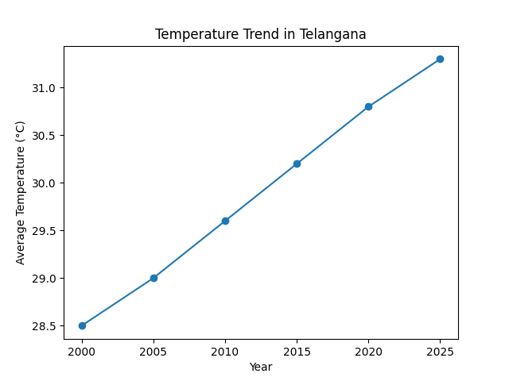
The temperature trend graph indicates a steady and consistent rise in average temperatures across the study period from 2000 to 2025. Beginning at approximately 28.5 °C in 2000, the temperature exhibits a gradual increase to about 31.3 °C by 2025, reflecting a net rise of nearly 2.8 °C over 25 years. The progression appears nearly linear, with notable increments observed between 2010 and 2020, suggesting an acceleration in warming during the recent decades. This persistent upward trend is indicative of regional climate warming, likely influenced by broader global climate change phenomena, urbanization, and land-use modifications. The absence of any significant decline or stabilization phase highlights the continuous nature of thermal escalation, which may have serious implications for heat stress, agricultural productivity, and water resource management in the region.

Graph 2: Rainfall Variability

The rainfall variability graph demonstrates significant inter-annual fluctuations in precipitation levels over the same period, indicating an inconsistent and erratic rainfall pattern. Starting at around 800 mm in 2000, rainfall increases sharply to 920 mm in 2005, followed by a substantial decline to approximately 760 mm in 2010.
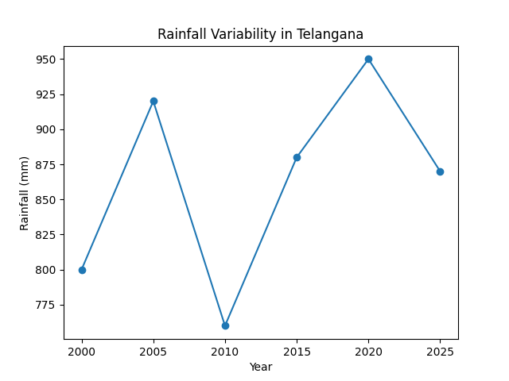
A recovery phase is observed with rainfall rising to 880 mm in 2015 and peaking at nearly 950 mm in 2020, before declining again to about 870 mm in 2025. This oscillating pattern reflects high variability rather than a clear long-term increasing or decreasing trend. Such irregular precipitation behaviour can be associated with changing monsoonal dynamics and climate variability, posing challenges for agriculture, groundwater recharge, and drought/flood risk management in the region.

Agricultural Mitigation Strategies
Farmers are adopting:
- Drought-resistant crop varieties
- Micro-irrigation systems
- Soil conservation practices
These measures enhance resilience but require better awareness and financial support.

Urban Climate Mitigation
Urban areas face:
- Rising temperatures
- Air pollution
- Infrastructure stress
Despite investments under clean air programs, pollution levels remain high due to implementation gaps.

Climate Variability Trends
Telangana has recorded excess rainfall and increased extreme weather events, indicating changing climate patterns.

DISCUSSION
The findings reveal that Telangana has adopted a multi-sectoral approach to climate mitigation, integrating energy, agriculture, and urban planning. However, the effectiveness of these strategies varies.

Strengths
- Progressive policies like cool roofs and afforestation
- Increasing focus on renewable energy
- Integration of climate resilience in agriculture

Challenges
- Weak implementation and monitoring mechanisms
- Urban pollution control inefficiencies
- Limited awareness among rural communities
Recent policy debates, such as relocation of polluting industries, highlight the complexity of mitigation strategies. Experts argue that relocation alone may not solve pollution unless supported by sustainable practices.

CONCLUSION
Telangana has emerged as a proactive state in addressing climate change through innovative mitigation strategies. Initiatives such as energy-efficient infrastructure, afforestation, and sustainable agriculture demonstrate a strong commitment toward environmental sustainability.
However, the study concludes that:
- Effective implementation is critical for success
- Integrated policy frameworks are needed
- Community participation must be strengthened
Future mitigation efforts should focus on technology-driven solutions, policy enforcement, and climate education to ensure long-term sustainability.

REFERENCES
- Fuels of the Future Conference (2025). Green Cover Target in Telangana.
- Government of Telangana. (2022). State Action Plan on Climate Change.
- Indian Journal of Engineering (2025). Urban Heat Island Study.
- Indian Meteorological Department (IMD). (2023). Climate Data Report.
- ICRISAT (2020). Climate Vulnerability in Telangana.
- IPCC. (2023). Climate Change 2023: Synthesis Report.
- NRDC (2023). Telangana Cool Roof Policy.
- Sri, C. R., et al. (2024). Climate Resilient Technologies in Telangana. International Journal of Environment and Climate Change.
- The New Indian Express (2025). Extreme Rainfall Trends.
- Times of India (2025). Air Pollution and Clean Air Program.
- Times of India (2024). Rainfall Variability in Telangana.
- Times of India (2025). Industrial Relocation and Climate Concerns.
- World Bank. (2022). Climate Risk Country Profile: India.

