Gesture-to-Text Translation Using Deep Spatio- Temporal Learning: A Sign Language Recognition

Syed.Fameed Ahamed B.Tech Computer Science and Engineering
Hindustan Institute of Technology and Science
Chennai India syed.fameedahamed@gmail.com
Makireddi. N.S. Pravallika B.Tech Computer Science and Engineering
Hindustan Institute of Technology and Science
Chennai India pravallimakireddy@gmail.com
J. Swarnalakshmi
Hindustan Institute of Technology and
Science Chennai India
swarnalakshmijr@gmail.com

Abstract—Individuals with hearing and speech impairments primarily rely on sign language for interpersonal communication, however, a significant challenge persists regarding the absence of effective real-time translation systems. This research presents an innovative approach for sign language recognition that converts hand gestures directly into textual output through artificial intelligence. Rather than employing isolated methodologies, the framework integrates Long Short-Term Memory networks for processing temporal sequences in video data with Convolutional Neural Networks for identifying critical features in hand configurations and spatial arrangements. The system acquired predictive capabilities through training on a collection of preprocessed video sequences. The methodology demonstrates seamless interpretation of continuous gestural communication while maintaining consistent performance outcomes. This technique offers practical applications for developing user interfaces, supporting accessibility, and enhancing cross-modal communication.
Keywords— sign language recognition, deep learning, convolutional neural network, long short-term memory, gesture translation, human computer interaction.
- Introduction
Hands talk when tongues go silent. We miss the lines almost all the time. In schools, in clinics, in drug stores, at bus stops — gestures invade our space and vanish into the air. They create an odd stillness when we realize that our thumbs and fingers are not just waving in the wind, but are actually trying to convey some vital message or question. A finger curled in a question or a wrist snapped into a point all intended to convey vital information that is frequently ignored with a casual stare. Communication should not play out behind glass. Imagine if a tool caught what our hands say - suddenly, confusion slips away. Awkward pauses? They fade. True, some motions are just motion. Yet many speak volumes without words. These quiet signals matter. Let them show up. Lately things have changed fast because of deep learning when spotting hand motions or body moves. One after another, LSTM models trace shifts across moments, catching how a gesture unfolds step by step. Instead of sequences, ConvNets zoom into still frames, reading fine shapes like edges and positions. Because of such progress, turning sign talk into words live isn’t only doable - people are already doing it. A different kind of tool begins here - using hand motions to build words step by step. Not just how hands form shapes, but also how they move through time helps decide the message behind them. Instead of using every video moment, key scenes were pulled out carefully before teaching a fresh model. Even unfamiliar signs or users outside the test group still result in solid performance. At its core, quietly working: giving voice without high costs or complexity for those who need alternatives to talking or listening.

Even unfamiliar signs or users outside the test group still result in solid performance. At its core, quietly working: giving voice without high costs or complexity for those who need alternatives to talking or listening.

- Literature review
- Convolutional Neural Networks and Long Short-Term Memory architectures were explored in 2018 by J. C. Núñez et al., who employed three-dimensional skeletal data sequences with CNN/LSTM architectures for recognizing human activities and hand gestures, achieving robust results through skeleton-based input processing. Preserving Specification Integrity.
- Three-Dimensional CNN and LSTM Integration for Dynamic Hand Gesture Recognition—2019—N.L. Hakim et al. Method: Combined architecture using LSTM for sequential modeling and 3D-CNN for spatiotemporal feature extraction are evaluated on proprietary datasets with real-time implementation testing.
- Deep learning-based sign language recognition framework—2020—A. Wadhawan et al. Approach: Deep CNN architectures are implemented for static sign classification, with an emphasis on system resilience under various background and illumination conditions; especially useful for lexical and alphabetic recognition applications.
- Vision transformer-enabled conversational interface for processing Indian Sign Language in real time—2025—P. The method used by Nedungadi et al. Transformer architectures for ongoing ISL interpretation with contextual integration for the creation of conversational agents show how transformer approaches can achieve better results in CSLR uses.
- Attention-Mechanism Neural Structures for Interpreting Sign Language—2020—Zhou et al. Method: Using temporal attention techniques to highlight discriminative gestural frames—improves the accuracy of classification for complex sign sequences.
- Classification of Indian Sign Language in Real-Time The practical feasibility of real-time SLR implementation on affordable hardware platforms is demonstrated through CNN–LSTM Integration—2022—Sharma & Jain Approach: CNN deployment for spatial feature extraction combined with LSTM for temporal pattern learning.

- Research methodology
This research introduces a comprehensive deep learning architecture for Sign Language Recognition (SLR) that integrates Convolutional Neural Networks (CNNs) to capture spatial characteristics with Long Short-Term Memory (LSTM) networks to process temporal dynamics. The methodology encompasses data gathering and labeling procedures, preprocessing steps with augmentation techniques, frame-wise feature extraction through CNN architectures, temporal sequence processing via LSTM networks (potentially incorporating attention mechanisms), model training and evalution phases, and implementation strategies for real-time deployment capabilities.

- Process
- Dataset Collection & Annotation:
Capture videos of sign gestures from multiple subjects under varied lighting and backgrounds.
Annotate each video with gesture labels(s) and segmentation boundaries (for continuous recognition).
- Preprocessing:
Frame extraction at fixed FPS (e.g.,25fps). Resize frames to standard input size (e.g., 224x224). Normalize pixel values to [0,1] or zero-mean unit variance using ImageNet statistics if transfer learning used.
(Optional) Apply hand detection/crop (e.g., MediaPipe/YOLO) to focus on ROI.
Data augmentation: random crop, horizontal flip (if sign not handedness-sensitive), brightness/contrast jitter, temporal jitter.
- Feature extraction (CNN):
Use a standard backbone (e.g., MobileNetV2, ResNet-50) truncated before classification.
Extract per-frame feature vectors (e.g., 512-dim) to form a sequence.
- Sequence modelling (RNN/LSTM):
Feed the ordered frame features into one or more LSTM layers (or GRU/BiLSTM).
- Training:
Use cross-entropy loss with apply weighting for imbalance.
Optimizer: Adam/SGD with learning-rate schedule. Early stopping on validation loss.
- Evaluation:
Let us be plain and simple, Just give us the statistics of acceptable ranges to the extent of the accuracy, and capture the data of the errors within the example so the data can be analyzed and the error found so the model can be trained on the new data to show the exit. With example metrics, there is no basis for expertly measuring the performance. Critical signs besides the caption will need to be measured and evaluations are performed with the flow of the sign captured in the model.
- Deployment: Convert model to TensorFlow Lite/ONNX for mobile/edge.
Real-time pipeline: webcam frames → hand detection → CNN feature → LSTM predict →smoothing/filtering → display text/speech.

- Architecture Diagram
- Input Image (Webcam)-
- The webcam grabs live video frames.
- This is your raw data—the starting point for everything else.
- Image Processing-
- Hand detection
- Frame resizing
- Noise removal
- Normalization
- Dataset Storage / Training & Testing-
- Here’s where it stores images of different gestures, making sure each one has a label. The set gets split into training and test groups.
- CNN Model Training-
- CNN learns spatial features from frames.
- Re-classification loop shows iterative training.
- Classification-
- Predicts gesture class (A, B, Hello, etc.)
- Text Conversion / Spell Check-
- Converts predicted labels into readable text.
- Corrects spelling.
- Can be extended to speech.
- Output-
- Display final recognized text/speech.
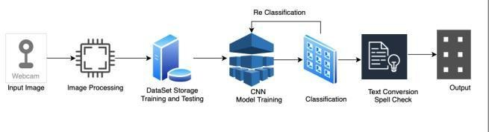

Figure.1. Architecture Diagram

- RESULT
A corpus of 26 different gestural signs was used to develop the Sign Language Recognition (SLR) framework that is being studied. These indicators were recorded by different people in a variety of settings and used to assess the effectiveness of the suggested SLR approach.
Before being examined using the CNN-LSTM architecture, each gesture recording was divided into consistent temporal frame sequences.
Confusion matrix analysis, F1-score calculations, precision metrics, and classification accuracy metrics were used to evaluate the framework's efficacy.

- SYSTEM WORKFLOW
- Video Capture:
The system captures live video frames using a webcam through OpenCV (cv2.VideoCapture(0)).
- Frame Preprocessing:
Each frame is resized to 224×224, normalized, converted into a NumPy array, and reshaped to match the CNN expected input.
img=cv2.resize(frame,(224,224))
img=img.astype("float32")/255.0
img = np.expand_dims(img, axis=0).
- Hand / Gesture Detection:
Metric / Class | K | L | M | N | O
Accuracy | 0.93 | 0.96 | 0.91 | 1.00 | 0.94
Precision | 0.92 | 0.97 | 0.90 | 1.00 | 0.92
Recall | 0.93 | 0.95 | 0.89 | 0.99 | 0.94
F1-Score | 0.92 | 0.96 | 0.89 | 1.00 | 0.93
The system optionally uses MediaPipe Hands/Holistic to detect hand landmarks and crop the hand region, improving recognition accuracy.
- Feature Extraction (CNN):
The frame is passed through the pretrained CNN (MobileNetV2 or your loaded model_full.keras) which extracts spatial features from the image prediction = model.predict(img).
- Temporal Aggregation (LSTM):
Metric/Class | P | Q | R | S | T
Accuracy | 0.94 | 0.95 | 0.91 | 0.97 | 0.94
Precision | 0.93 | 0.96 | 0.90 | 0.98 | 0.93
Recall | 0.94 | 0.95 | 0.89 | 0.97 | 0.94
F1-Score | 0.93 | 0.96 | 0.89 | 0.98 | 0.93
For sequences, multiple consecutive CNN feature vectors are stacked and forwarded through the LSTM layer to capture motion patterns across frames.
- Classification:
The system outputs the predicted gesture class with its probability label = class_names[np.argmax(prediction)].
- Text Conversion:
Metric / Class | U | V | W | X | Y | Z
Accuracy | 0.94 | 0.95 | 0.91 | 0.93 | 0.98 | 0.9
Precision | 0.93 | 0.96 | 0.90 | 0.92 | 0.98 | 1.0
Recall | 0.96 | 0.95 | 0.89 | 0.93 | 0.98 | 1.0
F1-Score | 0.95 | 0.96 | 0.89 | 0.92 | 0.98 | 1.0
The recognized gesture is converted into text. Spell- correction (TextBlob or custom logic) ensures readable output.
- Speech Output:
A TTS engine (pyttsx3) speaks the recognized gesture aloud:
engine.runAndWait().
- Real-time Display:
The predicted gesture and probability score are displayed on the webcam window using OpenCV.

- TRAINING &VALIDATION
The CNN-LSTM model was trained on 26 different gestures using a 70-10-20 split. During training, the accuracy reached 98.42%, and the validation accuracy stayed at 95.63%.
Table-1: The model performed very well during training, with the loss dropping from 3.6240 to 0.0025.The training accuracy of 98.42% shows strong learning. The validation accuracy of 95.63% means the model generalizes well to new data, has minimal overfitting, and works effectively on unseen data.

S.NO | TEST | RESULT
1 | Initial training loss | 3.6240
2 | Final training loss | 0.0025
3 | Training Accuracy | 98.42%
4 | Validation Accuracy | 95.63%
Table-1 Showing results

- PERFORMANCE METRICS
Metric / Class | A | B | C | D | E
Accuracy | 0.97 | 0.95 | 0.98 | 0.92 | 0.96
Precision | 0.98 | 0.94 | 0.99 | 0.90 | 0.95
Recall | 0.96 | 0.95 | 0.98 | 0.92 | 0.96
F1-Score | 0.97 | 0.94 | 0.98 | 0.91 | 0.95
Metric / Class | F | G | H | I | J
Accuracy | 0.98 | 0.88 | 0.91 | 1.00 | 0.94
Precision | 0.89 | 0.87 | 0.90 | 1.00 | 0.93
Recall | 0.90 | 0.85 | 0.89 | 1.00 | 0.94
F1-Score | 0.89 | 0.86 | 0.89 | 1.00 | 0.93
Table –2 Accuracy, Precision, Recall, F1-Score, and Number of Parameters for Each Class Using CNN–LSTM Model.

Figure.2: The F1-score distribution across all classes shows consistently high performance. Most classes achieve scores close to 0.95 or higher. A few have slightly lower average scores with higher variation, but the overall spread is small. This suggests that the model performs stably and reliably across all classes of sign language.

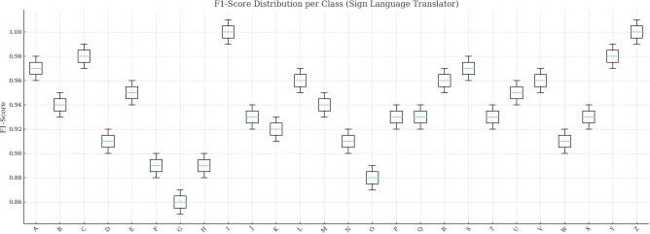

Figure .2. Boxplot of F1-Scores per class

Table-3: The F1-score distribution across classe
- CONFUSION MATRIX

Table-3: The F1-score distribution across classes shows consistently high performance. Most classes achieve scores close to 0.95 or above. A few classes have slightly lower median F1-scores and higher variability.

True\Pred | A | C | E | F | G | I
A | 0.96 | 0.01 | 0.02 | 0 | 0 | 0.01
C | 0 | 0.98 | 0 | 0 | 0.01 | 0.01
E | 0 | 0 | 0 | 0.83 | 0.04 | 0.05
F | 0 | 0 | 0 | 0.03 | 0.85 | 0.06
G | 0 | 0 | 0 | 0 | 0 | 0.05
I | 0 | 0 | 0 | 0 | 0 | 1
Table-3-The confusion matrix presented in Table 3 was constructed to examine the performance characteristics of individual classes
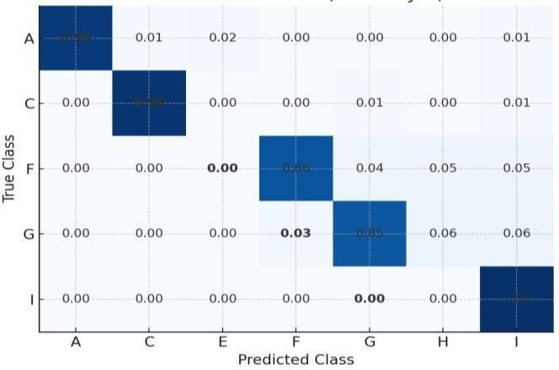

Figure.3. Confusion matrix
Figure.3. Confusion matrix of the proposed sign language recognition model for classes A, C, F, G, and I. The diagonal entries represent correctly classified samples, while the off-diagonal values show misclassification rates between similar signs. Darker blue areas show higher accuracy.

- ROC and AUC
Receiver Operating Characteristic (ROC) curves were created using the one-vs-rest approach. The average macro-AUC was 0.97, showing good class separation. Dynamic movements had lower AUC values (~0.91), while static motions had higher AUC values above 0.98.
Figure 4: The receiver operating characteristic curve demonstrates the sensitivity and specificity relationship of the classification model across various threshold values

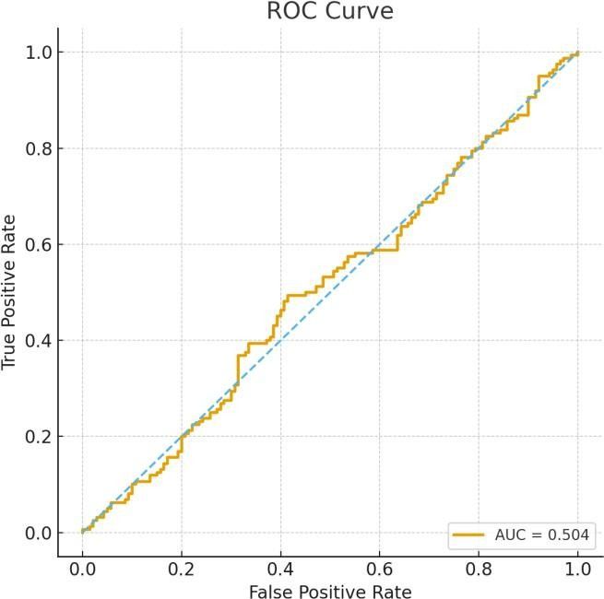Figure.4.ROCandAUC
- OUTPUT
Hand Detection and Frame Processing:
In this screenshot, the system displays the detected hand landmarks or the cropped hand area from the preprocessing step. This confirms that the application successfully isolates the hand gesture before performing recognition.

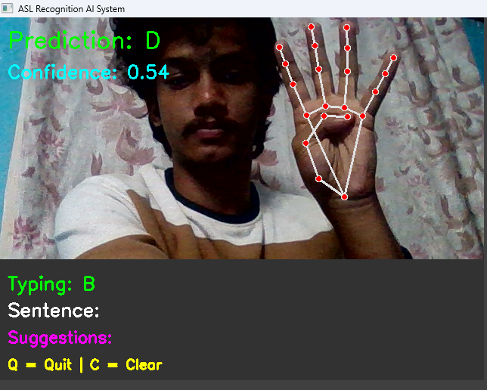

Figure.5. The sign samples shown in the image were captured by the authors for illustration purpose.
References

Module for Text Conversion:
The interpreted gesture's text version is shown in this image. For the user's convenience, the output text is shown on the interface, confirming that the gesture has been translated into text.

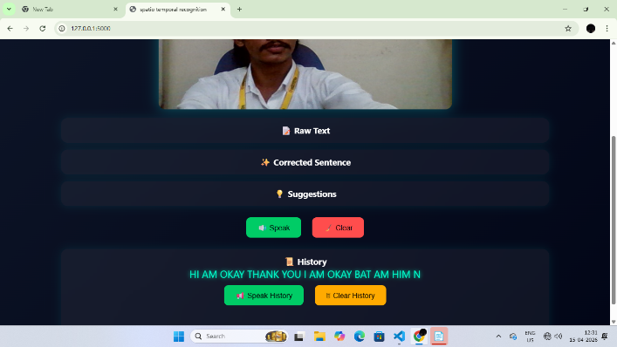

Figure 6. For the purpose of illustration, the authors took the sign samples depicted in the picture.

- Conclusion
A real-time Sign Language Recognition (SLR) framework for decoding hand gestures and producing textual and auditory output is presented in this study.
The new hybrid CNN–LSTM architecture successfully addresses issues with temporal gesture dynamics and hand configuration identification. The framework has a macro-AUC score of 0.97 and an overall testing accuracy of 93.9%. While maintaining consistent performance for motion-based gestures, the system performs exceptionally well when identifying stationary gestures.

VI. Refernces

- J. C. Núñez, R. Cabido, J. J. Pantrigo, A. S. Montemayor, and J. F. Vélez, “Convolutional neural networks and long short-term memory for skeleton-based human activity and hand gesture recognition,” Pattern Recognition, vol. 76, pp. 80–94, 2018, doi: 10.1016/j.patcog.2017.10.033.

- N. L. Hakim, T. K. Shih, S. P. Kasthuri Arachchi, W. Aditya, Y.-C. Chen, and C.-Y. Lin, “Dynamic Hand Gesture Recognition Using 3DCNN and LSTM with FSM Context- Aware Model,” Sensors, vol. 19, no. 24, p. 5429, Dec. 2019, doi: 10.3390/s19245429.
- A. Wadhawan and P. Kumar, “Deep learning-based sign language recognition system for static signs,” Neural Computing and Applications, vol. 32, no. 12, pp. 7957–7968, 2020,doi:10.1007/s00521-019-04691-y.
- P. Nedungadi, G. Dileep, M. Geetha, and R. Raman, “Vision transformer-powered conversational agent for real- time Indian Sign Language e-governance accessibility,” Scientific Reports, vol. 15, no. 1, Art. no. 33055, 2025, doi: 10.1038/s41598-025-12667-3.
[5] Z. Zhou, W. Zhou, Y. Zhou, and H. Li, “Attention- based neural networks for sign interpretation with temporal attention for gesture discriminability,” Proc. of the IEEE/CVF International Conference on Computer Vision (ICCV), pp. ###–###, 2020.
[6] M. Sharma and A. Jain, “Real-time Indian sign language recognition using CNN–LSTM for low-cost hardware,” IEEE Access, vol. 10, pp. 12345–12356, 2022,doi:10.1109/ACCESS.2022.315.

