Effect of Stress on Endocrine system related to Reproduction on Higher Educated Women in Pre, Reproductive and Post Reproductive Period
Dr Gantaloo Uma Sukaiya E mail I’d: usgantaloo@gmail.com
Department of Zoology SPMM Affiliated to Savitribai Phule Pune University M.S
Abstract
Stress is Defined as a state of worry caused by sudden unexpected difficult situations is either normally or purposefully .It can lead to many health problems . Stress directly effects to endocrine system leading to imbalance in Hormones specially to cortisol and Adrenalin levels . Acute stress last for only few hours and Chronic stress(long term) if the stress is continues for weeks ,Months ,Years it can lead to Nervous Cardiovascular , gastrointestinal ,Reproductive and Endocrine system that is Hormones. The body physiological needs like Mood Temperature and Stress plays important role in daily life particularly in Reproductive period. Prolonged exposure to stress can cause a maladaptive response that adversely affects physiological process such as growth Behavior, Reproduction and Immunity (Rousseau et al 2021). The primary stress hormone Cortisol Inhibits Insulin production leading to Diabetes II caused by stress. The Hypothalamus an organ in brain plays important role in reproduction that regulates the hormones
In work in Academicians tare very familiar with issues of academia physical, Mental ,In Croatia for example Assistant and Associate professors showed greater stress at work place than full professors ( Slis kovic and Sersic 2011)and this trend consistent with has found in Institutions of higher Education in Asia (Safaria et .al 2012) Research have shown that female faculty members can experience various levels of stress at work place with without the necessary support to mitigate these challenges ,these include time demand evaluations and harassment ( within an institution or supervisor ) that may or may not be supportive in acknowledge the difficulty and providing the assistance when require to improve or resolve the situation ( Kern and Erickson 1998) .The stress mostly effect to women Health and Reproductive comparative to that of Men . Across the globe High Education institution have become more stressful(Brown et al 2016,Kresh 2018,Winefield 2008) So the Research was carried out to find the effect of stress on Pre Reproductive females ,Reproductive females and post Reproductive female of Higher Educated women working in different fields by carrying survey .
Key words: Cause of stress, Effect of stress on Pre reproductive female Reproductive females and post Reproductive females.
Material Method: A questionnaire was prepared of 10 points indicating the stress is present
A sample survey was prepared considering their Reproductive pattern in Two forms Reproductive and Post Reproductive sample survey Among Assistant Professor and students Including cause of stress like A sample survey was prepared considering their Reproductive pattern in Two forms Reproductive and Post Reproductive sample survey Among Assistant Professor and students Including cause of stress like Pressure, Deadline, Lots of workload, Long hours of Focus etc for Reproductive and Post Reproductive Assistant and Associate professor and Less numbers of sleep Acute stress, Chronic stress , consumption of food items more or less lac of focus etc .

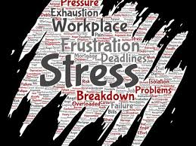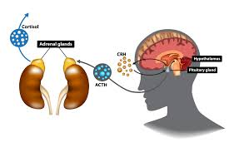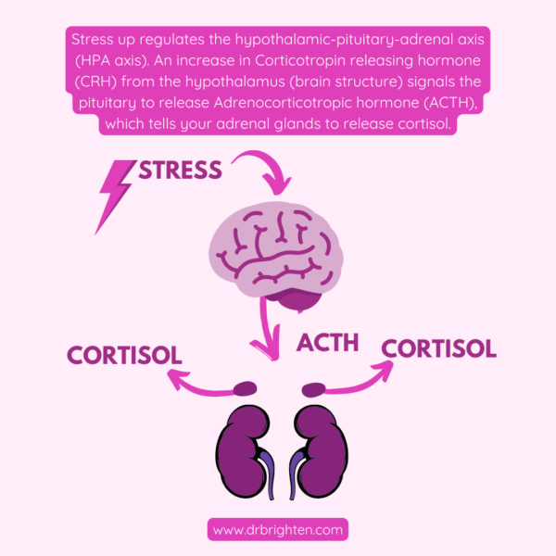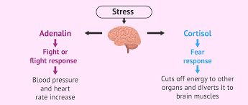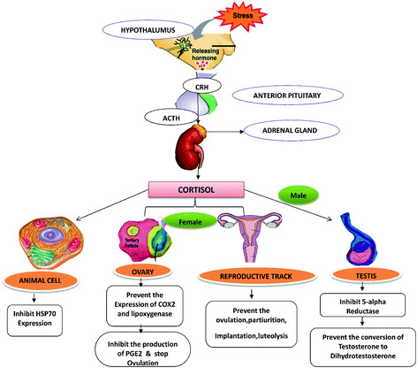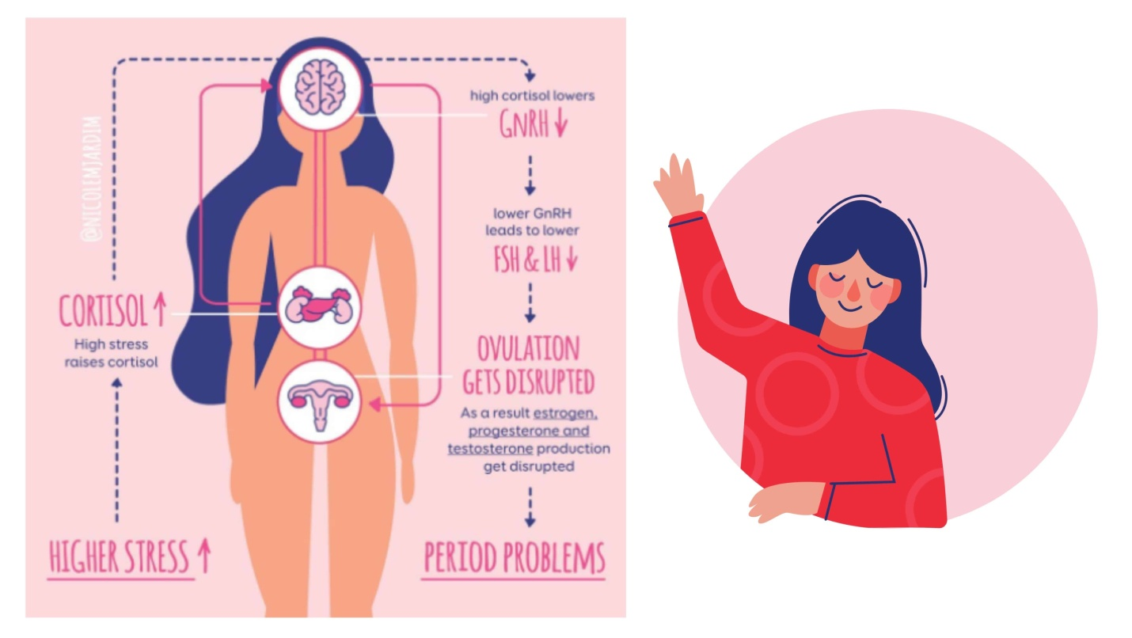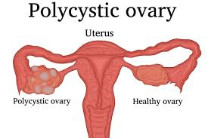
adrenal gland
HORMONES

Sr.no | Sample 1 Pre Reprod | Sample 2 Reprod | Sample 3 Post Reprod
1 | 6 | 3 | 9
2 | 7 | 2 | 10
3 | 6 | 7 | 9
4 | 7 | 6
5 | 6 | 6
6 | 5 | 7
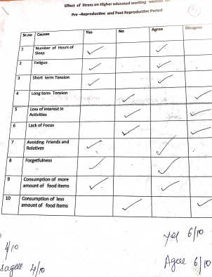

Result : During the Questionnaire conducted on Pre -Reproductive Reproductive and Post Reproductive females The count of maximum yes and Agree were taken into consideration so the table was prepared on the questionnaire like if there was lots of Pressure, if there is heavy workload if there was tight deadline, if there were long hours and lac of focus in Reproductive and post reproductive females. While in Pre Reproductive females the Questionnaire was on how many hours of sleep , whether they were fatigue with studies, either they were having short term or Long term tensions ,food items were less or more and lack of focus. By considering these three samples with continuous variable like (Menstrual cycle and Reproduction ) one way An nova test was performed .
Step 2 k=3 n=15
Df between=2 df within =12 df total =14
Step 3 Using F distribution table link df=2 df= 12 α=0.05
Step 4 µ1=6.16 , µ2 =5.16 , µ3 =9.33 µgrand=6.4
Step 5 SS total 66.4 SS within 30.129 SS between 36.271
Step 6 S² between =18.13 S²within 2.51
Step 7= 7.22 > 0.05
In sample 1 as the females were in Reproductive age so they were having symptoms like pains ,Irregular Menstrual cycles were experienced by many during menstrual cycle etc while group second were Reproductive age Stress had negative impact on pregnancy plans and some were suffering from PCOD with abortions etc One of the sample is different from others that means it had lots of stress which might affect their reproductive like Menopause hormones fluctuate with either heavy Bleeding or completely stopped at 45 age or others with menopause at the age of 52.

References

1 Allworth JE Clarke j peipert JF Herebet R ,Cooper A ,Boardman LA The influence of stress on Menstrual cycle on newly incarerated women Women Health Issue 2007;17:2002-9
2 Stress and the female Reproductive system
S N Kalantaridou ¹, A Makrigiannakis, E Zoumakis, G P Chrousos
3 Stress-related reproductive failure. J In Vitro Fertil Embryo Transf
Barnea ER, Tal J. 2001; 8:15–23
4 Neuroendocrinology of stress and female reproductive function.
Chrousos GP Proceedings of the 5th European Congress of Reproductive Immunology, 2007, Berlin4

5 How stress affects female reproduction: An overview
Amar Chatterjee* and Rita Chatterjee Biomedical Research (2009) Volume 20, Issue 2
6 Stress and reproductive failure: past notions, present insights and future directions
Katrina Nakamura sam sheps petra clara Arck Journal of Assisted Reproductive Genetics 2008 Mar; 25(2-3): 47–62.
7 Impact of stress on female reproductive health disorders: Possible beneficial effects of shatavari (Asparagus racemosusAjai k Pandey”,Anumegha Gupta”, Meenakshi Tiwari”,Shilpa Prasad”,Ashutosh N Pandey”,Pramod K.Yadav”.Alka Sharma”,Kankshi Sahu”,Syed Asrafuzzaman”,Doyil . Vengayil”, Tulsidas G.Shrivastav”, Shail K Chaube
8 Dorn LD Chrousos GP The Endocrinology of stress and stress system disorders in adolescence Endocrinology Metabolic clinic North America 1993:22:685-700
9 Chrousos GP Gold PW The concept of stress and stress system disorder overview of physical and behavioral haemostasis JAMA.1992-267:1244-1252
10 Kyrou I,Tsigos .C Stress hormones Physiological stress and regulation ofMetabolism current optimum pharmacology 2009;9;787-793
11 How stess effects your Health American Psychological Association https.//www .apa.org/topic/stress/health Acessed march 19 2021.

