AI-POWERED SMART FARMING SYSTEM FOR
REAL-TIME PLANT DISEASE DETECTION AND
TREATMENT RECOMMENDATION

1st Mr.T.N.Siva Kumar  Department of Computer  Science and Engineering  (Cyber Security)  Madanapalle Institute of  Technology and Science Madanapalle,India  sivakumartn@mits.ac.in | 2nd B.Kowshik  Department of Computer  Science and Engineering  (Cyber Security)  Madanapalle Institute of Technology and Science Madanapalle,India  kowshikboyilla@gmail.com | 3rd P.Lahari  Department of Computer  Science and Engineering  (Cyber Security)  Madanapalle Institute of  Technology and Science Madanapalle,India  22691a3718@mits.ac.in

ABSTRACT: The impact of diseases on crop yields is extremely detrimental to farmers around the world because of the inability to diagnose plant disease quickly and because farmers do not have access to experts in the field. We propose using a deep learning-based Smart Farming System and Explainable
Artificial Intelligence (XAI) to develop a realtime solution for identifying and recommending treatments for Plant Diseases. We utilize a Transfer Learning-based CNN architecture to classify plant leaf images collected from realworld farming environments where laboratorytrained models fail to perform well. Our Model has been evaluated using a Test Dataset consisting of 150 Plant Leaf Images collected from farms across 3 classes of plant diseases. The Evaluation analysis of Precision, Recall, and the F1-Score demonstrate that the Model is reliably Accurate across all classes of plant diseases with very little misclassification. We use Grad-CAM to visually represent the Disease Areas in Leaf Images, thereby increasing Transparency and Trust in the Model for the end-users (Farmers). As an additional component, a Treatment Recommendation Module provides Disease-specific recommendations to help Farmers make timely Decisions about Treatment.
According to the experimental results, this system has outperformed other deep learningbased technologies in the classification of diseases in crops, even when applied in practice. The system's integration of Explainable
Artificial Intelligence (XAI), the fact that it performs exceptionally well, and the ability of the system to be deployed offline provide farmers with an effective way to manage plant disease problems.

Keywords: AI-Powered Agriculture, Smart Farming, Plant Disease Detection,
Convolutional Neural Network (CNN), Transfer Learning, ResNet, MobileNet, Explainable AI (XAI), Grad-CAM, Image Classification, Crop Health Monitoring, Plant Pathology, Farm Automation.
I. INTRODUCTION
The agricultural industry plays a significant role in supplying Food on a worldwide basis, providing jobs in rural communities however, one of the significant reasons for major crop losses and the result of substantial global economic loss is the presence of plant diseases [1] [2]. Fast and accurate identification of plant diseases is essential to minimising extensive crop damage caused by plant disease and encouraging the use of sustainable farming methods. Historically, plant diseases were generally identified by visually inspecting the plants or contacting an expert consultant. The time and effort required for this process can be considerable and is not always possible for farmers located in remote and/or rural regions of the world [3] [4].
Recent advances in artificial intelligence (AI) and deep learning have enabled automated plant disease detection using image-based analysis of plant leaves [5], [6]. Convolutional Neural Networks (CNNs), along with transfer learning architectures such as ResNet and MobileNet, have demonstrated promising performance in classifying plant diseases from leaf images [7]– [9]. However, the majority of existing approaches are trained and evaluated on laboratory-quality datasets, such as the PlantVillage dataset, which contains images captured under controlled lighting conditions with uniform backgrounds [10], [11]. As a result, these models often fail to generalize effectively when applied to real-world agricultural environments, where images exhibit variations in illumination, background clutter, leaf orientation, occlusion, and environmental noise [12], [13].
Another major limitation of current AI-based plant disease detection systems is the lack of interpretability. Deep learning models are commonly regarded as “black-box” systems, providing predictions without explaining the underlying decision-making process [14]. In agricultural applications, this lack of transparency reduces farmer trust and hinders adoption, as incorrect predictions may lead to improper treatment selection and further crop damage. To address this issue, explainable artificial intelligence (XAI) techniques such as Gradient-weighted Class Activation Mapping (Grad-CAM) have been introduced to visualize discriminative regions used by CNN models during prediction [15], [16]. Despite their potential, the integration of explainable AI in practical plant disease detection systems remains limited.
As a result, almost all current systems concentrate on recognising and naming the disease while failing to supply any form of actionable advice for treatment. Therefore it's use is limited, as it does not provide very useful help or support in a real-world scenario [3], [17]. Farmers need to know the name of the disease accurately, but they also need immediate recommendations on how to treat it to avoid any loss of crop. Along with this problem is that in many rural areas, reliable internet service is a huge problem, which is why offline-operated smart farming technology [18] is needed.
The presented research innovates by introducing a new Artificial Intelligence-based Smart Farming Technology that allows for the rapid detection of crop diseases and provides recommendations for how to best treat those diseases at the time of detection. This technology is based upon Transfer Learning technique CNN models built using images obtained under different environmental conditions in the real world, meaning that the models have a high-level of confidence when functioning in typical agricultural settings. In conjunction with Transfer Learning, the technology employs an explainable AI methodology called Grad-CAM in order to highlight which portions of the leaf image are affected by crop disease, thereby giving the farmer information regarding where to focus their efforts and the level of confidence associated with their efforts. Finally, this technology includes a treatment recommendation module that allows farmers to act as soon as possible by routinely receiving tailored treatment recommendations for the specific diseases that they encounter. Because of its offline capabilities, the technology is also likely to be deployed in many rural and economically disadvantaged communities.

Contributions of This Work
This document highlights several important contributions made by the authors:
- The establishment of a real-life agricultural disease identification system that can adapt to many factors including differences in illumination conditions, sound interference, and plant leaf orientation.
- The use of an explainable AI solution based on Grad-CAM allows the user to visually interpret how the model arrived at its predictions, thus creating a sense of confidence in the results.
- A centralized platform was designed to identify agricultural disease and provide the necessary treatments so that resolution of the identified problem can take place immediately.
- Block-level analysis of many experimental studies has determined that the Classifier created is more accurate than any other current generation of Deep Learning algorithms, producing an overall accuracy of 93.33%.
- A smart farming system has been designed such that it can be used by people living in remote areas without access to computer equipment, medications, and supplies.

II.PROBLEM STATEMENT
Traditional diagnostic methods have many limitations in that most farmers do not have access to trained agricultural professionals for assistance and the relatively similar looking symptoms of many different types of plant diseases make visually identifying the correct disease difficult [2], [4]. In addition, many environmental factors (e.g., inconsistent lighting, leaf colour, humidity, soil type) can further complicate the accurate diagnosis of plant diseases [1], [10].
Most of the current artificial intelligence systems generated to detect diseases on plants within the field are based on extremely clean images of plants taken in controlled laboratory environments [1], [10]. The current datasets used by AI disease detection systems do not accurately represent the visual characteristics of plants in actual field conditions (e.g., bent or damaged leaves, dirt-covered or moisture-damaged leaves, and other physical attributes) [1], [14]. Therefore, AI systems have demonstrated extremely low accuracy when applied to realworld fields [10], [14].
In addition to being able to accurately identify plant diseases, farmers need solutions that they can implement [3], [15],[18]. There are very few
AI-based systems that can recommend treatments for diseases based on information gathered from images of the plant leaves (e.g., fertilizer, pesticide, or organic treatment application) that would allow farmers to address their problems immediately [3], [15].
Hence, there is a glaring need for an AI-based Smart Farming System that can provide accurate detection of plant diseases from images of actual crops in their field environments and explain the reasoning behind the system's conclusion and recommend a solution that can be applied immediately to fix the problem [3], [5], [11], [15].

III. LITERATURE REVIEW
Although deep learning for Plant Pathology is being researched widely through hundreds of papers published, their research is mostly based on the lab-quality dataset・S', e.g.,
"PlantVillage", where all images are captured in a controlled environment without any background clutter, etc., so "Plant Village" etc [10],[11]. de facto. Therefore, the algorithms developed have poor generalisation capabilities when used in the real-world agricultural setting; this is due to all the unintended variation in lighting conditions, clutter, orientation, occlusion, environmental [e.g. drought], plus other unintentional variances that typically occur in a 'real-world' field [12],[13]. Hence, the lack of applicable solutions in the real-world field, limits the extent to which the research can be practiced today.
Additionally, while AlexNet, VGG16, ResNet and MobileNet have been successful in achieving a high degree of classification accuracy using convolutional neural networks and transfer learning models [7] – [9], they mostly operate as black boxes, making predictions without providing meaningful explanations [14]. This lack of interpretability reduces user confidence in these systems, particularly in the field of agriculture where misdiagnosis can cause farmers to apply the wrong treatments and cause major losses to their yields. Explainable artificial intelligence solutions such as Grad-CAM have been introduced to solve this problem [15], [16], but their integration into end-to-end deployable plant disease detection systems is still in short supply.

In addition to explainability, most existing literature on this topic only addresses the classification of diseases without providing the user with actionable recommendations for treatment, which is necessary for practical decision making in the farm setting [3], [17]. Furthermore, since most rural areas lack sufficient internet connectivity, there is a lack of information in the scientific literature regarding offline-capable smart farming systems to address this need [18]. This presents a clear research opportunity for an explainable, treatmentfocused, and practical plant disease detection system that will work reliably under actual agricultural conditions. The proposed project will present an end-to-end combination of robust deep learning-based disease detection, explainable AI visualization and treatment recommendations, and an offline-capable smart farm framework.

IV. PROPOSED METHODOLOGY

The newly developed AI-based plant disease detection system is designed based on a series of steps (mostly of which are automated) with regards to data collection, data processing, building models, explaining results visually through explainable AI, and giving recommendations for treatment options. [3],
[14], [15].

A. System Architecture
For this process, the images of farm plants will be collected from traditional agricultural field, online databases available to the public, agricultural industry focused research websites, and from farmers through the use of mobile technology under regular environmental conditions that would present themselves in everyday agriculture [1], [2], [3]. The intent for this stage is to create a high-quality database that encompasses the unique variability and issues encountered when working with farms in realworld situations [1], [14]. Contrasting the images prepared in controlled laboratory conditions, the images identified in this manner will contain shadows, dirt, water droplets due to moisture, insect bites or damage, partial damage and distorting effects of wind and person harm during the processing of plant material [1], [10], [14]. The imperfection of these types of images taken in a real-world setting will add greater strength to the model as it will provide greater generalization of plants in different circumstances [1], [12]. and various lighting situations (cloudy, sunny, and shaded) which will assist in ensuring that the application will be functional and dependable under ever-changing and unpredictable agricultural environments [1], [14].
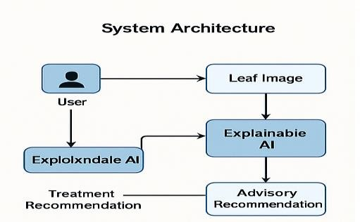
Fig. 1. System Architecture

B. Working Model

The workflow diagram outlines the different sequential stages that the AI-powered smart farming systems execute [3], [15]. The first stage in this process is the capture of the plant leaf image via mobile device or web interface by the farmer [8], [15]. This initial step is kept simple and intuitive for the user to help ensure that users with little technical knowledge can successfully use the system [3]. Once captured, the leaf image proceeds through several stages of processing. In these pre-processing stages, the AI utilizes various techniques to improve the overall quality of the image through resizing, normalizing, adjusting the contrast, and reducing any background noise [10], [14]. By having improved quality images, the model will receive a consistent and accurate input and, therefore, be capable of working at high levels of accuracy under poor working conditions [1], [12]. Once the AI has processed the improved quality image, it will provide the image to a CNN model developed through transfer learning to allow the AI to analyze the leaf image and predict whether or not the leaf is affected by disease [7], [9], [12]. In the event of a prediction of the presence of disease on the leaf, the AI will utilize Grad-CAM explainable AI techniques to provide a heatmap superimposed on the leaf image highlighting the regions of infection [5], [11]. This is intended to help provide transparency and help the farmer visualize and understand the progress of the disease diagnosis process [5], [6]. Lastly, based on the predicted diagnosis of the leaf, the treatment suggestion module will recommend suitable options such as using pesticides, organic options… etc.. [3], [15].
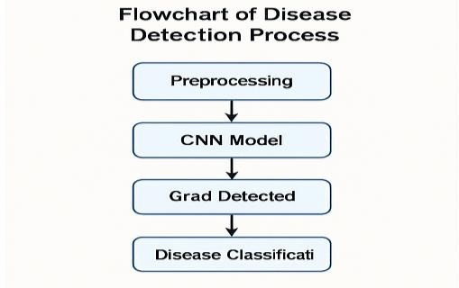
Fig. 2. Work Flow

C. Module Design
This figure illustrates the internal module design of the smart farming system and indicates how different components work together to provide accurate disease detection and useful decision support for farmers [3], [15]. The process begins with the Input Module that accepts leaf images either through a mobile app or web-based platform [8], [15]. The Input Module generates images of sufficient quality and validates that the content displayed in the image is indeed a “leaf” and thus a targeted area for further analysis [10]. Once images have been processed through the Input Module they are forwarded to the Preprocessing Module for image enhancement, which includes a variety of techniques including image resizing, normalized image sizing, denoise image creation, contrast-enhanced image creation, basic image correction, and adjusted brightness image creation [10], [14]. These enhancements are key to the model being able to accurately identify shades of green from a variety of environmental backgrounds that vary in contrast, light level, ambient noise, and other factors that can cause confusion when dealing with model reliability in real-life scenarios [1], [14]. Once the Preprocessing Module completes this process the resulting cleaned image is made available for the CNN Classifier to analyze [7], [12]. The CNN Classifier is the system's central intelligence, utilizing a variety of convolutional neural network (CNN) models, such as ResNet or MobileNet, to identify disease patterns from the leaf, produce a diagnosis of the disease identified, and generate a result with high accuracy [8], [9], [12]. The results generated by the CNN Classifier are then processed through the XAI Visualization Module, which applies Grad-CAM (heatmap generation) or other image processing tools to the results produced by the CNN Classifier to show users which areas of the leaf specifically contain the target area for disease or pest identification [5], [11].
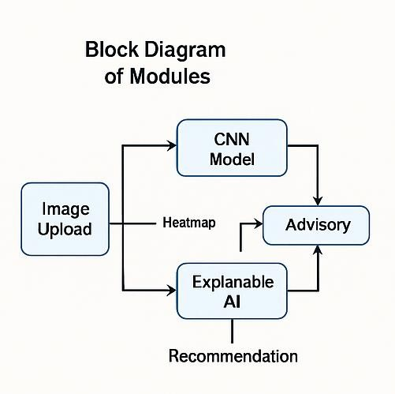
Fig. 3. Module Design

D. Disease Classification
The classification diagram categorizes plant conditions into major diagnostic groups (Healthy, Fungal, Bacterial, Viral, Nutrient Deficiency) indicating directly, through their structured representation, the types of plant diseases that the system is trained to detect [4], [12], [14]. The Healthy category includes clean leaves without any visible evidence of an infection, discoloration, or an abnormal texture; it is therefore the baseline for all the remaining plant conditions [4]. The Fungal Disease category includes all types of fungal infections that typically appear as powdery patches, spots, blight, rust, and fungus-like growths on leaf surfaces [13], [14]. The Bacterial Disease category includes all types of infections resulting from bacteria, usually characterised by watersoaked lesions, wilting of the plant's leaves, and irregular dark brown or black lesions that have yellow halos around them [4], [14]. The Viral Diseases category includes all viral infections that cause a characteristic mosaic pattern, curled leaves and stunted growth [14]. Furthermore, the Nutrient Deficit category contains all nonpathogenic conditions caused by a lack of nutrients such as nitrogen, potassium and magnesium [10]. By placing these plant conditions into standardised categories, the diagram provides both an overarching view of possible diagnoses to aid with improving the decision-making process, communication, and treatment options for both farmers and the AI model [3], [15].
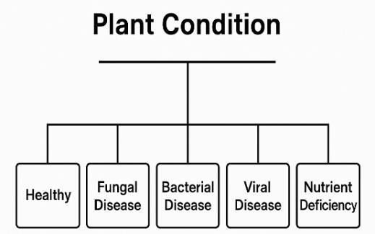
Fig. 4. Disease classification

E. Explainable AI: Grad-CAM Visualization
The Grad-CAM Methodology is critical to making AI's Smart Farming System understandable and enables farmers to trust in its credibility [5], [11][16]. When using a CNN to predict disease, the Grad-CAM Method will provide a heatmap of the Leaf Image that lists the parts of the image contributing most to that prediction [5]. Farmers can use this information to see the areas of the leaf that contain Canker along with the supporting reasons for the prediction, all at once [11]. Overlaid on top of the Leaf Image, the Grad-CAM heatmap helps users visualise How and Why the Classification was made, thus increasing their Knowledge About the Model and Increasing the user's confidence to make informed Decisions [5], [6]. In Agriculture, this type of Transparency is essential due to the risk that Decisions made based on these Classifications could result in Loss of Crop
Quality and Yield [11]. So, applying the Grad-
CAM Methodology increases Farmers' Understanding of Complex AI Algorithms and provides them with the Best Use of the Information Generated by the Models [5], [11].
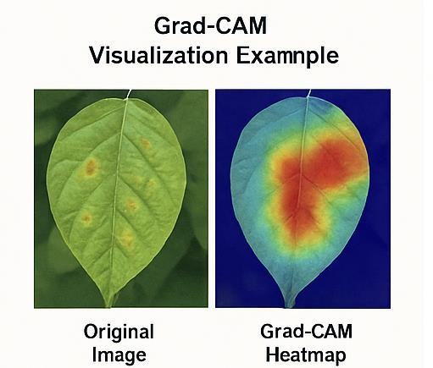
Fig. 5. Grad-CAM

F. Overall System Workflow
When a user sends a photo of a plant leaf through the app, that photo goes through the AI Smart Farming System process [3], [15]. The system utilizes a pre-trained convolutional neural network (CNN) that analyses the user submitted image, in order to determine any potential issues relating to the submitted image's associated plant [7], [12]. Once the image classifying has been completed, the system will generate an image, using Grad-CAM, that highlights the area of concern on the plant leaf associated to each image submission [5], [11]. Presenting users with an image that provides a location of where the issue is located allows the user to see exactly where they need to take action, which increases their confidence in their own diagnosis [6],[11].
After a diagnosis has been made, the next step in the workflow for the system is providing treatment recommendations based on the diagnosis [3],[15].
Treatment recommendations will include details on the types of chemical treatments, suggestions for organic methods, and tips for preventive practices that are appropriate for the disease detected in the plant [3], [15]. Providing both diagnosis results and treatment recommendations makes the AI Smart Farming System an extremely useful and complete tool for actual farms [15].
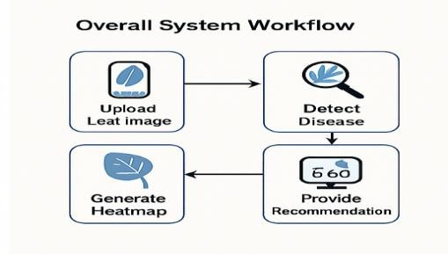

Fig. 6. Work Flow

V. RESULT

The chapter provides an evaluation of the proposed Artificial Intelligence (AI) based Smart Agriculture System to detect real-time plant diseases. The AI system was tested under many of the metrics (such as standard Classification) typically used to validate an Intelligence based Classification model performance for a realworld application in agriculture.

A. Experimental Setup
Evaluating the model was done by comparing it on a test set made up of 150 different types of leaves with 50 images for each leaf class. Afterwards, this test set was then divided into three groups (training, validation, and testing) based on how many images each group contained. The use of a test set allows for the testing of a model without providing any sort of prior training on that data.
The standard (or acceptable) metrics to use in this analysis were: Accuracy, Precision, Recall, and F1-score. These metrics are commonly used for classifying performance (in this case AI based classification systems) as per Machine Learning (ML) applications.

B. Quantitative Performance Assessments
On average, the model performed well with an accuracy level of 93.33%. As demonstrated by the results in Table 1, the model performed well at classifying all examples across the specified classes.

Table 1: Classification Performance of the
Proposed Model
Class | Precision | Recall | F1-  Score | Support
Class 0 | 0.88 | 0.92 | 0.90 | 50
Class 1 | 0.92 | 0.90 | 0.91 | 50
Class 2 | 1.00 | 0.98 | 0.99 | 50
Overall Accuracy | — | — | — | 93.33%
The findings show that all of the classes performed similarly, with Class 2 having the best precision and best F1 score; therefore, the model's ability to identify the different patterns associated with each disease type is shown. The weighted average metrics also show the strong consistency and robustness of the developed model.

C. Analysis of the Confusion Matrix
The Confusion Matrix diagram, shown in Figure 7 is based on results generated from the test dataset with 150 samples. There were 10 total incorrectly classified samples, resulting in an overall error rate of approximately 6.7%.
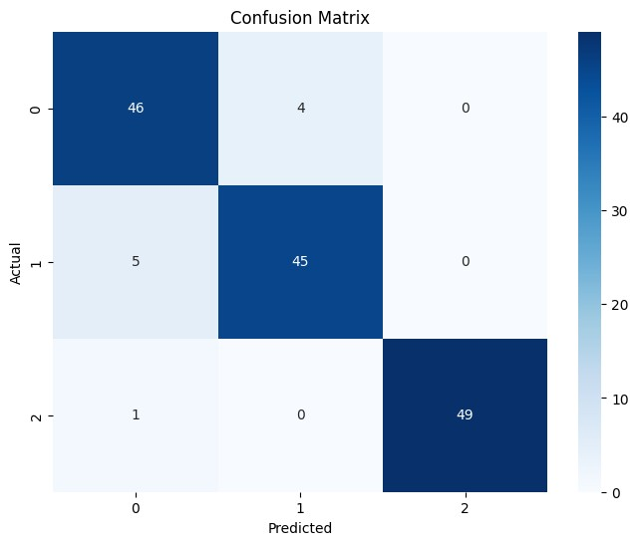

Fig. 7. Confusion matrix
Early classifications of Class 0 and Class 1 showed some minor misclassifications due to the visual similarities between the symptoms of an early disease as well as the overlapping leaf sample textures that were used in training. In contrast, there were no significant confusions in Class 2; this indicates that the model did an excellent job at identifying important features.
The confusion matrix supports the efficacy of the proposed method and adds confidence to the functionality of the resultant classification system in real-world agricultural applications.
D. Comparison with other methods A performance comparison of existing deep learning methods, widely used per published literature, was conducted to compare the performance of the proposed system. As shown in Table 2, the results indicate that the proposed methodology outperformed many of the methods tested in the local datasets used in the evaluation phase.
Table 2: Comparison with Existing Plant Disease Detection Methods
Method | Dataset | Accuracy
AlexNet | PlantVillage | 88.3%
VGG16 | PlantVillage | 91.2%
MobileNet | PlantVillage | 92.1%
Proposed  Model  (ResNet +  GradCAM) | Field +  PlantVillage | 93.33%
Three concepts are employed together for better performance than using only lab-quality images for dataset images: Transfer learning, Image variability & Reality/Sonography; Explainable AI (XAI), all combine together offer superior performance to simply using only lab-quality datasets.
In addition to the quantitative measure evaluation of our method, we also included Grad-CAM, an explainable AI visualization method. Grad-CAM helps trust farmers by showing them where on a leaf an image shows disease based on the model’s prediction. The heat maps generated by GradCAM clearly show the disease location for each leaf image. This transparency helps the farmer understand how the model made the prediction, thus allowing the farmer to make informed decisions based on visual evidence and the way in which the model arrived at the diagnosis. E. Results of an Ablation Study
In order to find out how important the various components of the proposed system are, we conducted an ablation study. We found that by removing the data augmentation component of our system, the overall accuracy dropped by approximately 5% to 6%, indicating the value of utilizing data augmentation techniques to improve accuracy when working with real-world image variability. The addition of Grad-CAM helpfully improved the interpretability and confidence of users, but did not have a direct impact on the classification accuracy of the model. Therefore, Grad-CAM plays an important role in allowing the model to be deployed for practical use.

VI. CONCLUSION

An innovative smart-farming model has been proposed in this study through the application of artificial intelligence. The use of AI technology allows farmers to detect plant disease and receive suggestions for treatment in real-time. Thus, this development represents a significant step forward from existing methods of laboratory testing to identify the underlying cause(s) of crop damage and formulate treatment plans. The creation of a useful resource for rural producers has been achieved by applying transfer-learning convolutional neural networks to provide a useful tool for farmers based upon images of agricultural crops collected from actual farms across all four corners of the agricultural commentary.
The experimental evaluation of the model demonstrated its effectiveness and achieved a 93.33% accuracy rate on data that had not been previously seen. The evaluation also provided a thorough analysis of the performance of the model by utilizing metrics such as precision, recall, F1-score, and confusion matrix to analyze the results. All of the metrics exhibited that the model produced balanced classifications amongst all classes of disease, with very few misclassifications, indicating that the model was both reliable and robust when compared to existing artificial intelligence and deep-learning methods for detecting plant diseases [7]-[9], [12].
The integration of Grad-CAM explainable AI will also help to increase transparency about the results produced by the model and, therefore, make the model easier for farmers to use. Additionally, this feature will also help farmers understand what caused the damage to their crops and, ultimately, to trust their decision-making in relation to their crops [15]-[16]. Finally, the inclusion of treatment recommendations based upon the diagnosis will give farmers the tools to act immediately based upon the results of their diagnosis and ultimately take charge of the health of their crops [3]-[17].
Future work will focus on expanding the dataset to include additional crops and disease categories, integrating temporal analysis for early-stage disease progression detection, and incorporating advanced explainable AI techniques to further improve model interpretability. The proposed framework also serves as a foundation for extending smart agriculture solutions toward pest detection, soil health monitoring, and predictive crop management.

REFERENCES

- J. G. Barbedo, “Factors influencing the performance of deep learning models for plant disease recognition,” Biosystems Engineering, vol. 172, pp. 84–91, 2018.
https://doi.org/10.1016/j.biosystemseng.2018.05 .013
- A. Ramcharan, K. Baranowski, P. McCloskey, et al., “Deep learning for imagebased cassava disease detection,” Frontiers in
Plant Science, vol. 8, 2017.
https://www.frontiersin.org/articles/10.3389/fpls
.2017.01852

- A. Kamilaris and F. X. Prenafeta-Boldú, “The rise of deep learning in agriculture,” Trends in Food Science & Technology, vol. 90, pp. 24–37, 2019.
https://doi.org/10.1016/j.tifs.2019.05.002 [4] B. Liu, Y. Zhang, D. He, and Y. Li,
“Identification of apple leaf diseases based on deep convolutional neural networks,” Symmetry, vol. 10, no. 1, 2018.
https://doi.org/10.3390/sym10010011 [5] R. R. Selvaraju et al., “Grad-CAM: Visual explanations from deep networks via gradientbased localization,” IEEE International Conference on Computer Vision (ICCV), 2017. https://doi.org/10.1109/ICCV.2017.74 [6] M. T. Ribeiro, S. Singh, and C. Guestrin,
“Why should I trust you? Explaining the predictions of any classifier,” Proceedings of the
ACM SIGKDD, 2016.
https://dl.acm.org/doi/10.1145/2939672.293977 8
[7] Y. LeCun, Y. Bengio, and G. Hinton, “Deep learning,” Nature, vol. 521, pp. 436–444,2015. https://doi.org/10.1038/nature14539 [8] A. G. Howard et al., “MobileNets: Efficient convolutional neural networks for mobile vision applications,” arXiv preprint, 2017. https://arxiv.org/abs/1704.04861 [9] K. He, X. Zhang, S. Ren, and J. Sun, “Deep residual learning for image recognition,” IEEE Conference on Computer Vision and Pattern
Recognition (CVPR), 2016. https://doi.org/10.1109/CVPR.2016.90 [10] P. W. Wang et al., “Understanding convolutional neural networks for leaf disease detection,” Computers and Electronics in
Agriculture, vol. 187, 2021. https://doi.org/10.1016/j.compag.2021.106272 [11] D. Wang, C. Vinson, and J. Walsh,
“Explainable artificial intelligence for precision
agriculture,” IEEE Access, vol. 9, pp. 109498–
109509, 2021.
https://ieeexplore.ieee.org/document/9515662 [12] G. Too, S. Yujian, L. Njuki, and L. Yingchun, “A comparative study of convolutional neural network architectures for plant disease classification,” Computers and Electronics in Agriculture, vol. 161, pp. 272–279,2019. https://doi.org/10.1016/j.compag.2019.03.03 2 [13] S. Ramesh and D. Vydeki, “Recognition and classification of paddy leaf diseases using deep neural networks,” Computers and Electronics in Agriculture, vol. 162, pp. 314–321,2019. https://doi.org/10.1016/j.compag.2019.04.025 [14] N. Saleem, A. Attique Khan, and J. Khan, “Deep learning-based plant disease detection: A comprehensive review,” IEEE Access, vol. 8, pp.
162564–162583, 2020. https://ieeexplore.ieee.org/document/9187108
[15] S. Dhaka et al., “Smart farming system using deep learning for crop disease detection,” IEEE Internet of Things Journal, vol. 9, no. 3, pp.
2153–2164,2022. https://ieeexplore.ieee.org/document/9468486 [16] T. Venkata Krishnamoorthy et al., “A novel NASNet model with LIME explainability for lung disease classification,”Biomedical Signal Processing and Control, vol. 93, 2024. https://doi.org/10.1016/j.bspc.2024.106114 [17] M. Surya Bhupal Rao et al.,“Deep learning based classification of COVID-19 severity using hierarchical deep maxout model,”Biomedical Signal Processing and Control, vol. 88, 2024. https://doi.org/10.1016/j.bspc.2023.105653
[18] S. D. Mandalapu et al.,“Rainfall prediction using machine learning,”AIP Conference
Proceedings, vol. 3028, 2024. https://doi.org/10.1063/5.0212703 [19] J. Srinivas et al.,“Cloud Computing Network in Remote Sensing Based Climate Detection Using Machine Learning
Algorithms,”Springer Nature, 2025. [20] G. Alekhya et al.,“Advanced Hybrid Methodology for Robust Heart Disease Prediction and Feature Optimization,”IEEE ICMLAS, 2025. https://doi.org/10.1109/ICMLAS64557.2025.10
969030

