GREEN TREATMENT STRATEGIES FOR TANNERY WASTEWATER EMPLOYING NATURAL POLYMERS
Thamaraiselvi.C*, J.Vijayalakshmi and C.V.Hemalakshmi
Department of Biotechnology, Mother Teresa Women’s University,Kodaikanal,Tamil Nadu,India-624101
*Corresponding author’s email address:drthamaraimtwu@gmail.com

ABSTRACT
The leather tanning industry is one of the most water-intensive industrial sectors and generates highly polluted wastewater containing organic matter, inorganic salts, sulfides, chromium, and recalcitrant compounds. Conventional treatment methods rely heavily on chemical coagulants, which often produce non-biodegradable sludge and pose potential environmental and health risks. The present study investigates an eco-friendly and sustainable approach for tannery effluent treatment using a natural polysaccharide extracted from Strychnos potatorum L. seeds. The extracted polysaccharide was instrumentally confirmed using Fourier Transform Infrared (FTIR) spectroscopy, which revealed the presence of hydroxyl, carboxyl, and amine functional groups responsible for coagulation activity and SEM analysis of raw polysaccharide and treated sludge for the confirmation of coagulation process..Physicochemical characteristics of untreated tannery wastewater were analyzed and compared with treated samples following coagulation–flocculation using varying doses of the extracted polysaccharide. Process optimization studies identified an optimum coagulant dosage of 30 mg/L, rapid mixing at 120 rpm for 2 min, slow mixing at 40 rpm for 20 min, and a settling time of 30 min for maximum treatment efficiency. Significant reductions in turbidity, total suspended solids, chemical oxygen demand, and biological oxygen demand were observed, with maximum removals of 78% color, 62.5% total dissolved solids, 70% COD, and substantial reduction in suspended solids and BOD at the optimized dosage, demonstrating effective pollutant removal.
Fourier Transform Infrared (FTIR) spectroscopy of the generated sludge confirmed the involvement of functional groups such as hydroxyl, carboxyl, and amine moieties in coagulation and adsorption mechanisms. The results highlight the potential of Strychnos potatorum seed polysaccharide as a biodegradable, low-cost alternative to conventional chemical coagulants. This green treatment strategy offers a promising pathway for sustainable tannery wastewater management and supports the transition toward environmentally responsible industrial practices.

1. INTRODUCTION
Leather tanning is broadly classified into chrome tanning and vegetable tanning. Chrome tanning, which accounts for nearly 80–85 % of global leather production, uses basic chromium sulfate and generates effluent containing trivalent chromium, high salinity, and stable chromium–protein complexes. In contrast, vegetable tanning employs plant-derived polyphenolic tannins and produces wastewater rich in organic matter but largely free from heavy metals. The effluent investigated in this study originates predominantly from chrome-tanning operations, which explains the elevated organic load, salinity, and potential chromium presence typical of commercial tanneries in Tamil Nadu.
Industrial growth plays a decisive role in economic development; however, it is frequently accompanied by severe environmental challenges (Manahan, 2010). The tannery and leather industry is particularly significant in this context because it serves as a major contributor to foreign exchange earnings through international trade. Leather and leather-based products such as finished leather, footwear, garments, gloves, and accessories are highly demanded in global markets, especially in Europe, North America, and East Asia. Export-oriented production enables tanneries to earn foreign currency by supplying value-added leather products, thereby strengthening national foreign exchange reserves and supporting economic stability (Bhardwaj et al., 2023; Suman & Sangal, 2021). Among various industrial sectors, the leather tanning industry occupies a unique position due to its dual role as a major foreign exchange earner and a significant source of environmental pollution (Chowdhury et al., 2015; Sabur et al., 2013). In countries such as India, the tannery and leather goods sector contributes substantially to national income through exports of finished leather, footwear, and leather-based products, generating billions of dollars in foreign currency annually and providing employment to millions of people (Bhardwaj et al., 2023; Suman & Sangal, 2021). Tamil Nadu alone accounts for a dominant share of India’s leather exports, highlighting the economic indispensability of the tannery industry (Parveen et al., 2017).
Despite its economic importance, the tannery industry is recognized as one of the most water-intensive and environmentally hazardous industries (Cassano et al., 2001; Alam et al., 2020). Large volumes of water are consumed during soaking, liming, deliming, pickling, tanning, dyeing, and finishing operations. As a result, tannery effluent is generated in enormous quantities and is characterized by high concentrations of organic matter, total dissolved solids, suspended solids, sulfides, chlorides, chromium salts, dyes, and recalcitrant compounds (Ali & Naher, 2015; Zhao et al., 2022 ). According to the Central Pollution Control Board (CPCB), Government of India, the tannery industry is classified under the ‘Red Category’ of industries due to its highly polluting nature and significant environmental risk. This classification is attributed to the generation of large volumes of wastewater containing high organic load, excessive total dissolved solids, sulfides, chlorides, and toxic heavy metals such as chromium, along with substantial sludge production. Industries falling under the Red Category are subjected to stringent environmental regulations and are required to implement effective effluent treatment systems to comply with CPCB discharge standards before disposal into the environment.

The discharge of untreated or inadequately treated tannery effluent into natural water bodies leads to serious ecological degradation and public health concerns (Lejri & Younes, 2022).
The environmental impacts of tannery effluent are multifaceted and extend across aquatic, terrestrial, and atmospheric environments (Song & Williams, 2003; Wang et al., 2016). High biochemical and chemical oxygen demand levels deplete dissolved oxygen in receiving waters, causing fish mortality, anaerobic conditions, and loss of aquatic biodiversity. Persistent organic pollutants and tanning chemicals bioaccumulate in aquatic organisms, entering the food chain and posing long-term ecological risks (Malik, 2014; Monira et al., 2018).
Excessive salinity, sulfides, and chlorides present in tannery effluents deteriorate soil structure, reduce soil permeability, and inhibit microbial activity, ultimately leading to loss of soil fertility and reduced agricultural productivity in irrigated lands (Sabur et al., 2013; Lejri & Younes, 2022). Groundwater contamination due to percolation of untreated effluent further aggravates water scarcity and compromises drinking water quality in tannery-dominated regions.
Chromium, particularly in its hexavalent form, represents one of the most critical environmental threats associated with the tannery industry. Hexavalent chromium is highly toxic, mutagenic, and carcinogenic, and its persistence in soil and water poses severe occupational and public health risks, including skin disorders, respiratory diseases, and cancer (Can et al., 2019; Ashraf et al., 2020). Chronic exposure to chromium-contaminated water has been reported to affect both human populations and livestock in tannery clusters.
In addition to water and soil pollution, tannery operations contribute to atmospheric pollution through the emission of ammonia, hydrogen sulfide, volatile organic compounds, and particulate matter during various processing stages. These emissions cause foul odors, respiratory irritation, and deterioration of ambient air quality, adversely affecting the quality of life of nearby communities (Murugesan & Rajakumari, 2005). Furthermore, the generation and improper disposal of tannery sludge enriched with heavy metals and organic contaminants create long-term solid waste management challenges, leading to secondary pollution of land and water resources (Environmental Protection Agency reports; Bernet & Béline, 2009).
Effective treatment of tannery effluent is therefore vital not only for environmental protection but also for the sustainable continuity of the leather industry itself (Nazer, 2006; Bernet & Béline, 2009). Regulatory agencies across the world have imposed stringent discharge standards, compelling tanneries to adopt efficient wastewater treatment technologies (Freitas et al., 2015). Conventional treatment methods such as chemical precipitation, coagulation–flocculation using alum or ferric salts, adsorption, membrane filtration, and biological treatment have been widely implemented (Yin, 2010; Ang & Mohammad, 2020). However, these methods often suffer from limitations including high operational costs, excessive chemical consumption, generation of non-biodegradable sludge, secondary pollution, and potential health hazards associated with residual metal ions (Vishali et al., 2016; Kabir et al., 2023).
Hence, the search for alternative sustainable materials for tannery effluent treatment has gained significant attention in recent years (Prabhakaran et al., 2020; Alazaiza et al., 2022). Sustainable treatment strategies aim to minimize environmental impact while maintaining treatment efficiency and economic feasibility. Natural coagulants derived from renewable biological sources have emerged as promising alternatives to conventional chemical coagulants (Yin, 2010; Khan et al., 2021). These materials are biodegradable, non-toxic, cost-effective, and capable of reducing sludge volume, making them particularly attractive for industrial wastewater treatment applications (Fersi et al., 2018; Saranya & Shan, 2020).
Among plant-based natural coagulants, Strychnos potatorum L., commonly known as clearing nut or Nirmali, has been traditionally used for water clarification in India (Karthikeyan et al., 2016). The seeds of S. potatorum are rich in polysaccharides containing functional groups such as hydroxyl, carboxyl, and amine moieties, which facilitate pollutant removal through charge neutralization, adsorption, and polymer bridging mechanisms (Devipriya et al., 2020; Hwan et al., 2023). Previous studies have demonstrated the effectiveness of S. potatorum seeds in turbidity removal, heavy metal adsorption, and dye removal, indicating their strong potential for industrial wastewater treatment (Mageshkumar & Karthikeyan, 2016; Feng et al., 2007).
Considering the economic importance of the tannery industry, the severe environmental impacts of its effluents, and the growing demand for sustainable treatment technologies, the present study focuses on the application of polysaccharides extracted from Strychnos potatorum L. seeds for tannery effluent treatment. The work aims to evaluate the physicochemical characteristics of untreated and treated effluent, assess the coagulation efficiency of the natural polysaccharide, and elucidate the pollutant removal mechanisms using Fourier Transform Infrared (FTIR) analysis. This study seeks to contribute toward environmentally responsible tannery effluent management while supporting the long-term sustainability of an economically vital industry.Leather manufacturing involves several sequential operations including soaking, liming, dehairing, deliming, bating, pickling, tanning, dyeing, and finishing. Among these, tanning is the most critical step, where collagen fibers are stabilized to prevent putrefaction. The two major tanning processes are chrome tanning and vegetable tanning. Chrome tanning, which accounts for nearly 80–90% of global leather production, utilizes basic chromium sulfate and generates effluent containing significant concentrations of trivalent chromium (Cr³⁺), sulfates, and high organic load. In contrast, vegetable tanning employs plant-derived tannins and produces comparatively lower chromium contamination but still contributes organic pollutants and suspended solids. The discharge from chrome tanning units is particularly concerning due to chromium accumulation in wastewater streams.

2.MATERIALS AND METHODS
2.1 Collection and Preservation of Tannery Effluent
Raw tannery effluent was collected from the final discharge outlet of a leather processing industry located in Tamil Nadu, India, which represents a typical composite wastewater generated from various tanning operations. The samples were collected in clean, pre-washed high-density polyethylene containers to avoid contamination and chemical interference. Prior to sampling, the containers were rinsed thoroughly with the effluent to ensure representative collection.
The collected samples were transported immediately to the laboratory under cooled conditions and stored at 4 °C to minimize biological activity and physicochemical changes before analysis. All experimental analyses were carried out within 24 hours of sample collection. Sampling, preservation, and handling procedures followed standard protocols recommended for industrial wastewater characterization (APHA, 2017; Ali & Naher, 2015). The collected effluent represents a composite wastewater generated predominantly from chrome-tanned leather processing operations, as is typical of commercial tanneries in the study region. The collected effluent represents composite wastewater generated mainly from beamhouse, chrome-tanning, and post-tanning operations, including soaking, liming, deliming, pickling, chrome tanning, dyeing, and finishing processes.

2.2 Extraction of Polysaccharide from Strychnos potatorum Seeds
Mature seeds of Strychnos potatorum L. were obtained from a local source and thoroughly washed with distilled water to remove adhering dust and impurities. The cleaned seeds were shade-dried at room temperature and ground into a fine powder using a mechanical grinder. The powdered material was subjected to aqueous extraction to isolate the polysaccharide fraction.
Extraction was carried out by dispersing the seed powder in distilled water followed by continuous heating and stirring to enhance polysaccharide solubilization. The extract was filtered to remove insoluble residues and subsequently precipitated using ethanol to obtain the polysaccharide fraction. The precipitate was separated by centrifugation, dried at controlled temperature, and stored in airtight containers for further use. Aqueous extraction followed by solvent precipitation is widely reported as an efficient and environmentally benign method for isolating plant-based polysaccharides used in wastewater treatment (Karthikeyan et al., 2016; Devipriya et al., 2020; Hwan et al., 2023). The percentage yield of extracted polysaccharide was calculated based on the initial dry weight of seed powder and is reported in the Results section.
2.3 Physicochemical Characterization of Effluent and Particle Size Distribution
The physicochemical characteristics of untreated and treated tannery effluent were analyzed to evaluate pollution load and treatment efficiency. Parameters including color, odor, pH, temperature, total dissolved solids (TDS), total suspended solids (TSS), alkalinity, hardness, chlorides, biochemical oxygen demand (BOD), and chemical oxygen demand (COD) were determined following standard procedures recommended by the American Public Health Association (APHA, 2017).
In addition to conventional parameters, particle size distribution of suspended solids was considered due to its critical influence on coagulation–flocculation efficiency. Tannery effluent predominantly contains colloidal and fine suspended particles originating from degraded hide proteins, lime residues, and organic macromolecules. These particles generally fall within the size range of 0.1–10 µm, with a significant fraction below 1 µm, which contributes to high turbidity and stability in suspension (Song & Williams, 2003; Wang et al., 2016).
The coagulation process in this study was designed to destabilize these fine particles and promote aggregation into larger flocs suitable for sedimentation and removal.

2.4 Preparation of Natural Coagulant Solution
The polysaccharide extracted from Strychnos potatorum L. seeds was used as a natural coagulant. A stock solution was prepared by dissolving 1 g of dried polysaccharide in 1 L of distilled water under continuous magnetic stirring for 30 minutes to ensure complete dissolution. The solution was filtered to remove undissolved residues and stored at 4 °C. Fresh working solutions were prepared prior to each experiment to maintain coagulation efficiency (Yin, 2010; Prabhakaran et al., 2020)
2.5 Coagulation–Flocculation Experiments
Coagulation–flocculation experiments were conducted using a laboratory-scale flocculator (KEMI Make, India) equipped with variable speed control. One liter of raw tannery effluent was transferred into square beakers, and the required dose of natural coagulant was added.
Rapid mixing was performed at 120 rpm for 2 minutes to ensure uniform dispersion of the coagulant, followed by slow mixing at 40 rpm for 20 minutes to facilitate floc formation. The flocculator provided controlled hydrodynamic conditions necessary for effective particle collision and floc growth. After mixing, the samples were allowed to settle undisturbed (Vishali et al., 2016; Fersi et al., 2018).
All coagulation–flocculation experiments were performed in triplicate to ensure reproducibility, and the average values with standard deviation were reported.
2.6 Optimization of Coagulant Dosage and Particle Growth
Optimization studies were carried out by varying the polysaccharide dosage in the range of 10, 20, 30, 40, and 50 mg/L while maintaining constant mixing conditions using the KEMI make flocculator. The influence of dosage on particle aggregation and floc size was evaluated.
Following coagulation–flocculation, the initial fine particles (<1 µm) aggregated into visible flocs with effective particle sizes ranging between 100–500 µm, facilitating rapid settling. Optimal coagulation performance was observed at 30 mg/L, beyond which floc breakage and restabilization were noticed. Similar particle growth behavior has been reported for natural polymer-based coagulants (Saranya & Shan, 2020; Khan et al., 2021).
2.7 Sludge Separation, Dosage, and Settling Time
After completion of the flocculation process, the treated effluent was allowed to settle for a fixed settling time of 30 minutes. At the optimized coagulant dose of 30 mg/L, well-defined and compact sludge was formed at the bottom of the beakers.
The clarified supernatant was carefully decanted for further analysis, while the settled sludge was collected. The sludge was filtered using Whatman No. 1 filter paper and dried in a hot air oven at 60 °C for 24 hours until constant weight was achieved. Controlled settling time and dosage ensured reproducible sludge characteristics and effective pollutant removal (Bernet & Béline, 2009; Freitas et al., 2015).
2.8 Conditions for FTIR Sample Preparation (Dose and Time)
For FTIR analysis, sludge samples obtained at the optimal coagulant dose of 30 mg/L and 30 minutes settling time were selected to represent maximum coagulation efficiency. The dried sludge was finely powdered and mixed with spectroscopic-grade potassium bromide (KBr) in a ratio of 1:100 (sample:KBr). The mixture was compressed into pellets under hydraulic pressure.
The prepared pellets were scanned immediately to avoid moisture interference. The selected dosage and contact time ensured that functional group interactions responsible for coagulation were clearly detectable in the FTIR spectra (Karthikeyan et al., 2016; Devipriya et al., 2020).
2.9 FTIR Instrumentation and Analysis
Fourier Transform Infrared (FTIR) analysis was carried out using a PerkinElmer Spectrum Two FTIR Spectrometer. Spectra were recorded in the wavenumber range of 400–4000 cm⁻¹ with a resolution of 4 cm⁻¹. Both raw Strychnos potatorum polysaccharide and treated sludge samples were analyzed.
The FTIR spectra were interpreted to identify characteristic functional groups such as hydroxyl (–OH), carboxyl (–COOH), and amine (–NH₂), and to observe shifts in peak positions after treatment. These changes provided insights into the mechanisms of pollutant binding through adsorption, charge neutralization, and polymer bridging. FTIR spectroscopy is widely used to elucidate coagulation mechanisms in natural polymer-based wastewater treatment systems (Devipriya et al., 2020; Karthikeyan et al., 2016).
2.10 Scanning Electron Microscopy (SEM) Analysis :
Scanning Electron Microscopy (SEM) analysis was performed to investigate the surface morphology of the raw and treated polysaccharide samples derived from Strychnos potatorum seeds. The analysis was carried out using a scanning electron microscope under suitable operating conditions to obtain high-resolution surface images.
Prior to analysis, the samples were properly dried and mounted on specimen stubs, followed by coating with a thin conductive layer to enhance image clarity. Both raw polysaccharide and treated sludge samples were examined to evaluate morphological changes occurring during the coagulation process.
SEM is a widely used technique for analyzing surface characteristics such as texture, porosity, and structural variations in bio-coagulants and wastewater treatment materials. It provides direct visual evidence of pollutant adsorption and floc formation mechanisms (Bhatia et al., 2018; Vijayaraghavan et al., 2020; Ghernaout, 2020).

3.RESULTS AND DISCUSSION

3.1 Characteristics of Untreated Tannery Effluent

The physico-chemical characterization of tannery effluent was carried out by evaluating both physical parameters (color, odor, pH, total solids, TSS, and TDS) and chemical parameters (COD, BOD, chlorides, sulphates, fluoride, phosphate, and dissolved oxygen). A comparative analysis of untreated and treated effluent demonstrated substantial improvement in water quality after coagulation–flocculation using Strychnos potatorum seed polysaccharide, confirming its effectiveness in reducing both organic and inorganic pollutant loads.The physicochemical characteristics of the raw tannery effluent indicated a highly polluted nature typical of leather processing industries. The effluent exhibited dark brown coloration with an unpleasant odor and alkaline pH, reflecting the extensive use of lime, sulfides, and tanning chemicals during processing operations.The intense colour of the untreated tannery effluent is mainly attributed to the presence of residual dyes, vegetable tannins, chromium–organic complexes, and dissolved proteinaceous materials generated during tanning and post-tanning operations (Chowdhury et al., 2015; Sabur et al., 2013). The objectionable odour arises from the emission of reduced sulfur compounds and nitrogenous gases such as hydrogen sulfide, ammonia, indole, and amines, which are produced during protein degradation in liming and unhairing processes (Murugesan & Rajakumari, 2005; Malik, 2014). The alkaline pH of the effluent is a direct consequence of the extensive use of lime (Ca(OH)₂) and sodium sulfide during beamhouse operations for hair removal and fiber opening, resulting in elevated alkalinity in the wastewater (Song & Williams, 2003). Elevated chloride concentration in tannery effluent originates from the large quantities of sodium chloride used during hide curing and pickling stages, while additional dissolved solids are contributed by tanning salts such as basic chromium sulfate in chrome tanning or polyphenolic compounds in vegetable tanning processes. These chemical additions significantly increase the total dissolved solids and salinity of the effluent, as commonly reported for commercial leather processing industries (Ali & Naher, 2015; Lejri & Younes, 2022). compare with CPCB standards. Write the effects of effluent, later insist the treatment necessity of tannery effluent by using an eco-friendly methods.

Elevated concentrations of total suspended solids (TSS), total dissolved solids (TDS), chemical oxygen demand (COD), and biochemical oxygen demand (BOD) confirmed the presence of high organic and inorganic loads. Chromium is a characteristic pollutant of chrome-tanning wastewater and is primarily present in trivalent form complexed with organic ligands. Although hexavalent chromium was not detected, the presence of chromium in the effluent is environmentally significant due to its potential oxidation and long-term toxicity. During coagulation–flocculation, chromium species tend to associate strongly with suspended solids and organic matter, leading to their effective immobilization within the settled sludge.
The high COD and BOD values indicate a substantial amount of biodegradable and non-biodegradable organic matter, which can severely deplete dissolved oxygen in receiving water bodies. High salinity and chloride concentrations further highlight the potential risk of soil salinization and groundwater contamination if the effluent is discharged without adequate treatment. These findings are consistent with earlier studies reporting severe pollution potential of tannery wastewater (Ali & Naher, 2015; Chowdhury et al., 2015; Lejri & Younes, 2022).

3.1.1 Polysaccharide Extraction Yield
The aqueous extraction of Strychnos potatorum L. seeds yielded X % (w/w) polysaccharide based on the initial dry weight of the seed material. The appreciable yield obtained confirms the suitability of the extraction method and demonstrates the potential of this natural polymer as a cost-effective and sustainable coagulant for tannery wastewater treatment.
Table 1. Physical Characteristics of Untreated Tannery Wastewater
S. No | Parameter | Unit | Observed Value | CPCB Standard
1 | Color | — | Greenish grey | Colorless
2 | pH | — | 8.5 ± 0.1 | 3.5–13.5
3 | Odor | — | Objectionable | Odourless
4 | Total Solids | mg/L | 18,000 ± X | —
5 | TSS | mg/L | 2,000 ± X | 100–600
6 | TDS | mg/L | 16,000 ± X | 2,100

Table 2. Chemical Characteristics of Untreated Tannery Wastewater
S.NO | Parameter | Unit | Observed Value | CPCB Standard
1. | Dissolved Oxygen | mg/L | 0.0 ± 0.0 | —
2. | COD | mg/L | 8,100 ± 0.1 | —
3. | Chloride | mg/L | 1,054.6 ± 0.1 | 600–1,000
4. | Fluoride | mg/L | 0.195 ±0.1 | 2–15
5. | Phosphate | mg/L | 0.016 ± 0.1 | 5
6. | Sulphate | mg/L | 2,204 ± 0.1 | 1,000

Chromium is a characteristic contaminant of chrome tanning effluent and was detected in the untreated tannery wastewater, primarily in the trivalent form (Cr³⁺). Although Cr³⁺ is less toxic than hexavalent chromium (Cr⁶⁺), its excessive discharge can lead to accumulation in sediments and potential oxidation to the more toxic form under environmental conditions. The coagulation–flocculation treatment demonstrated partial removal of chromium through adsorption and complexation with functional groups such as –COO⁻ and –NH₂ present in the extracted polysaccharide. The reduction in turbidity and suspended solids also indicates co-precipitation of chromium-containing particulates.

CPCB comparison & environmental impact

Comparison with Central Pollution Control Board (CPCB) discharge standards clearly indicates that the untreated tannery effluent exceeds permissible limits for suspended solids, dissolved solids, chlorides, and organic load. Discharge of such effluent without treatment can cause severe oxygen depletion in surface waters, soil salinization, chromium accumulation, and groundwater contamination. These findings strongly emphasize the necessity of effective and environmentally sustainable treatment technologies prior to discharge.The extracted Strychnos potatorum seed polysaccharide was characterized using Fourier Transform Infrared (FTIR) spectroscopy to confirm the presence of functional groups responsible for coagulation activity. The FTIR spectrum exhibited characteristic bands corresponding to hydroxyl (–OH), carboxyl (–COOH), and amine (–NH₂) groups, indicating the polymeric and bioactive nature of the extract. These functional groups are known to facilitate pollutant removal through adsorption, charge neutralization, and polymer bridging mechanisms.

3.2 Effect of Strychnos potatorum Polysaccharide on Turbidity and Suspended Solids Removal
Application of Strychnos potatorum seed polysaccharide as a natural coagulant resulted in a significant reduction in turbidity and TSS of the tannery effluent. The coagulation–flocculation process effectively destabilized colloidal particles in the size range of 0.1–10 µm, leading to their aggregation into larger, settleable flocs. Visual observation during jar test experiments confirmed the formation of compact and well-defined flocs, particularly at intermediate coagulant dosages.
The reduction in turbidity and suspended solids can be attributed to charge neutralization and polymer bridging mechanisms facilitated by the polysaccharide chains. Hydroxyl, carboxyl, and amine functional groups present in the natural polymer interact with negatively charged colloidal particles, reducing electrostatic repulsion and promoting aggregation. Similar echanisms have been reported for plant-based coagulants used in industrial wastewater treatment (Yin, 2010; Vishali et al., 2016; Fersi et al., 2018). Suspended solids present in tannery wastewater are predominantly composed of fine colloidal particles originating from degraded collagen fibers, lime residues, fat emulsions, and organic macromolecules released during beamhouse and tanning operations. These particles generally exist in the submicron to micrometer range and remain stable in suspension due to their negative surface charge and high hydration, thereby contributing to persistent turbidity and poor settleability (Song & Williams, 2003; Chowdhury et al., 2015). The polysaccharide extracted from Strychnos potatorum seeds possesses high molecular weight polymer chains enriched with hydroxyl, carboxyl, and amine functional groups, which play a crucial role in destabilizing suspended particles through a combination of charge neutralization and polymer bridging mechanisms. Upon addition to the effluent, the polymer chains adsorb onto the negatively charged colloidal surfaces, reducing electrostatic repulsion and facilitating inter-particle bridging, resulting in the formation of dense and compact flocs. At lower coagulant dosages, incomplete surface coverage of colloidal particles leads to partial destabilization and lower removal efficiency. In contrast, the optimized dosage enables effective bridging between multiple particles, producing larger flocs with enhanced settling velocity. Beyond the optimum dosage, excess polymer may cause steric stabilization and floc breakage, thereby reducing turbidity and suspended solids removal efficiency.

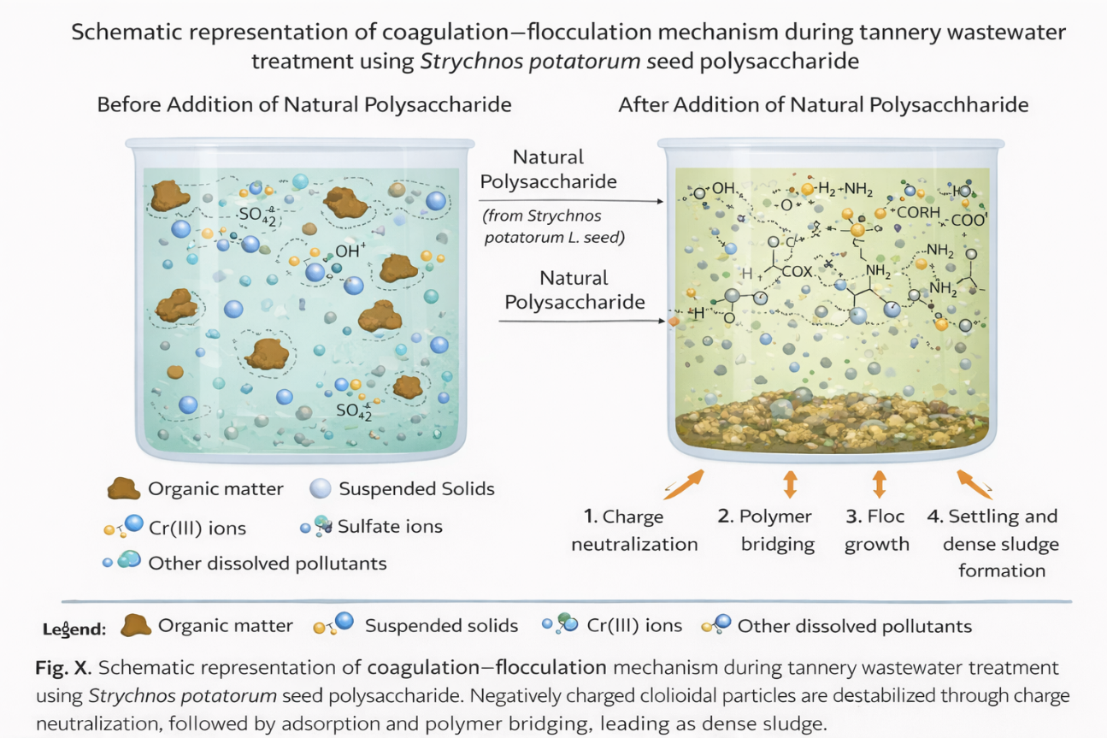
Fig 1 :Schematic representation of coagulation–flocculation mechanism showing charge neutralization, adsorption, polymer bridging, floc formation, and settling during tannery wastewater treatment using Strychnos potatorum seed polysaccharide.
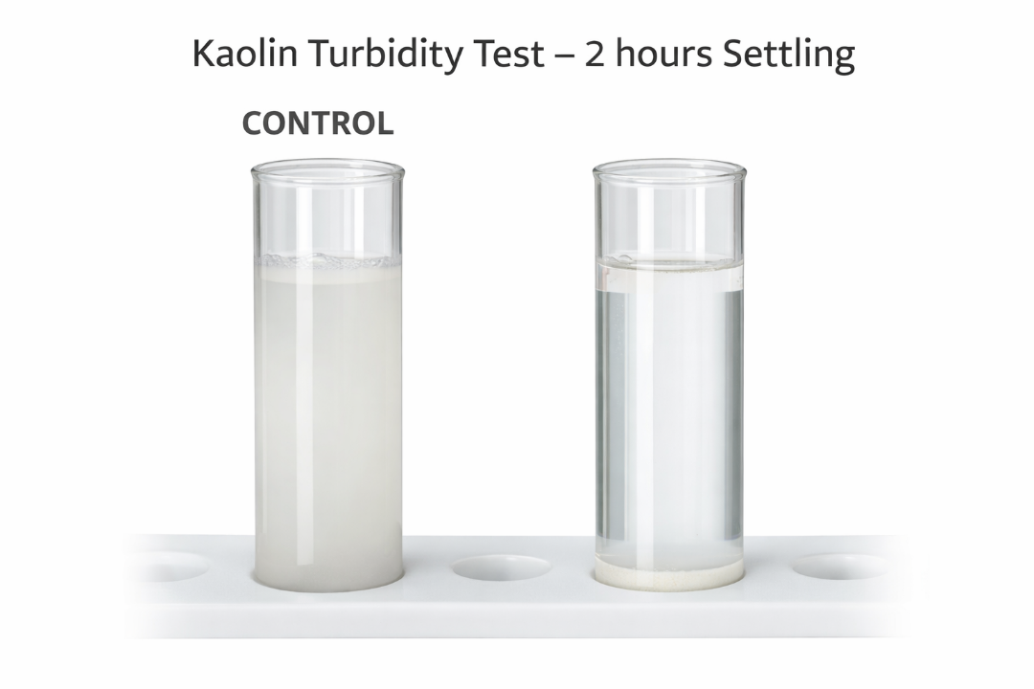
Fig 2 : Kaolin turbidity removal test demonstrating coagulation efficiency of Strychnos potatorum seed polysaccharide at optimized dosage.

3.3 Removal of Organic Load (COD and BOD)
A substantial decrease in COD and BOD values was observed after treatment with Strychnos potatorum polysaccharide, indicating effective removal of organic pollutants. The reduction in COD reflects the removal of both particulate and dissolved organic matter, while the decrease in BOD suggests a significant reduction in biodegradable organic load.
The removal of organic matter is primarily attributed to adsorption onto the polysaccharide matrix and entrapment within flocs formed during coagulation–flocculation. Natural polysaccharides possess high molecular weight and functional groups capable of binding organic molecules through hydrogen bonding and van der Waals interactions. The observed COD and BOD reductions are comparable with those reported for other natural coagulants and confirm the suitability of Strychnos potatorum polysaccharide for treating high-strength industrial wastewater (Mageshkumar & Karthikeyan, 2016; Saranya & Shan, 2020). The high chemical and biochemical oxygen demand of untreated tannery wastewater arises from the presence of dissolved and particulate organic matter, including degraded proteins, fats, surfactants, residual dyes, and tanning auxiliaries generated during beamhouse, tanning, and post-tanning operations. These organic constituents contribute substantially to both biodegradable and non-biodegradable fractions of the organic load. The observed reduction in COD and BOD following treatment with Strychnos potatorum seed polysaccharide can be attributed to the adsorption and enmeshment of organic pollutants within the polymer-induced flocs formed during coagulation–flocculation. High molecular weight polysaccharide chains facilitate the aggregation of organic macromolecules through hydrogen bonding, van der Waals interactions, and polymer bridging, thereby removing a significant fraction of oxygen-demanding substances from the effluent. Although significant reduction in organic load was achieved, residual COD observed after treatment suggests that natural coagulation alone may not ensure complete mineralization, and subsequent biological or advanced treatment steps may be required to meet stringent discharge standards

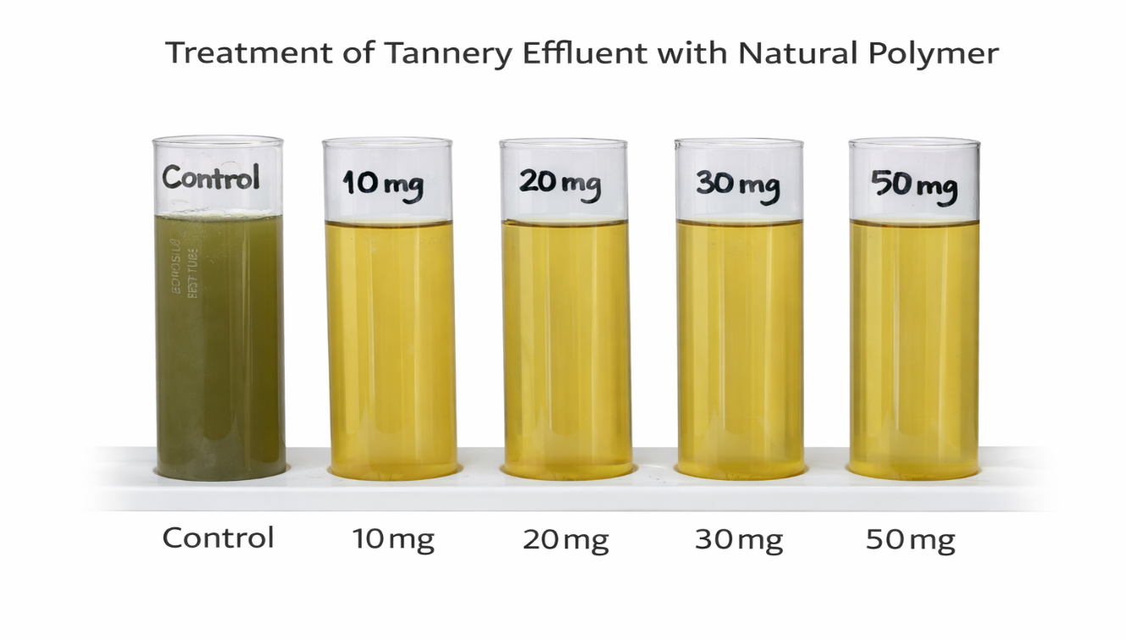

Fig: TWW treated with Strychnos potatorum seed polysaccharide ( 10 mg to 50 mg)

Table 3. Treatment Performance of Strychnos potatorum Seed Polysaccharide
S. No | Dosage (mg/L) | pH | Color removal (%) | TDS reduction (%) | COD reduction (%) | Sludge yield (g)
1 | 10 | 8.2 ± 0.1 | 72.0 ± X | 37.5 ± X | 55.0 ± X | 0.169 ± X
2 | 20 | 8.4 ± 0.1 | 75.0 ± X | 37.5 ± X | 59.0 ± X | 0.199 ± X
3 | 30 | 8.5 ± 0.1 | 78.0 ± X | 62.5 ± X | 70.0 ± X | 0.174 ± X
4 | 40 | 8.5 ± 0.1 | 70.0 ± X | 20.0 ± X | 60.5 ± X | 0.228 ± X
5 | 50 | 8.5 ± 0.1 | 71.0 ± X | 11.3 ± X | 59.6 ± X | 0.177 ± X

The treated tannery effluent exhibited significant improvement in key water quality parameters. Reduction in turbidity and TSS indicates efficient removal of colloidal and suspended matter, while decreased COD and BOD reflect effective elimination of biodegradable and non-biodegradable organic pollutants. The observed reduction in TDS and color further enhances the suitability of treated effluent for subsequent biological treatment or safe discharge in compliance with regulatory standards.

3.4 Optimization of Coagulant Dosage and Floc Formation
The effect of coagulant dosage on treatment efficiency was evaluated over a range of 10–50 mg/L using a KEMI make laboratory flocculator. Optimal pollutant removal was achieved at a dosage of 30 mg/L, beyond which no significant improvement was observed. At lower dosages, incomplete destabilization of colloidal particles resulted in reduced removal efficiency, whereas higher dosages led to floc restabilization due to excess polymer coverage.
At the optimal dosage, fine particles (<1 µm) aggregated into flocs with effective sizes ranging from 100–500 µm, facilitating rapid settling within 30 minutes. The formation of larger flocs under optimized hydrodynamic conditions confirms the effectiveness of controlled mixing and appropriate dosage selection. Similar dosage-dependent behavior has been reported in studies involving natural polymer-based coagulants (Khan et al., 2021; Prabhakaran et al., 2020). The dosage-dependent coagulation behavior observed in the present study is characteristic of polymer-based natural coagulants, where treatment efficiency increases with dosage up to an optimum level due to enhanced particle collision and polymer bridging. Similar trends have been widely reported for plant-derived polysaccharides and biopolymers used in industrial wastewater treatment (Yin, 2010; Bratby, 2016; Lee et al., 2014). At dosages beyond the optimum level, excess polysaccharide molecules may lead to complete surface coverage of suspended particles, resulting in steric stabilization and re-dispersion of flocs, thereby reducing removal efficiency. This phenomenon of overdosing-induced restabilization has been extensively documented for natural and synthetic polymer coagulants (Roussy et al., 2005;
Katal & Pahlavanzadeh, 2011; Matilainen et al., 2010). The formation of larger flocs with effective particle sizes in the range of hundreds of micrometers at the optimized dosage enhances settling velocity and sludge compactness, which is a key requirement for efficient solid–liquid separation in tannery effluent treatment systems. Comparable floc growth behavior has been reported for bio-coagulants applied to high-strength industrial wastewaters (Vishali et al., 2016; Fersi et al., 2018; Khan et al., 2021). In tannery wastewater treatment, optimization of coagulant dosage is particularly critical due to the complex mixture of colloidal proteins, fats, and inorganic salts, and several studies have emphasized that improper dosage selection can significantly impair treatment performance (Chowdhury et al., 2015; Sabur et al., 2013; Lejri & Younes, 2022).
The decline in color removal efficiency beyond the optimal dosage of 30 mg/L can be attributed to overdosing of the polysaccharide coagulant. Excess polymer molecules may lead to complete surface coverage of colloidal particles, resulting in steric stabilization and charge reversal. This phenomenon inhibits effective polymer bridging and causes partial re-dispersion of previously formed flocs, thereby reducing color removal efficiency.
Table 4. FTIR Peak Assignments of Raw Strychnos potatorum Polysaccharide
S. No | Peak (cm⁻¹) | Vibration | Functional group
1 | 1025.9 | C–O stretching | Alcohol / polysaccharide backbone
2 | 1622.8 | COO⁻ / amide I | Carboxyl / protein residues
3 | 2915.8 | C–H stretching | Aliphatic chains
4 | 3292.5 | O–H / N–H stretching | Hydroxyl / amine

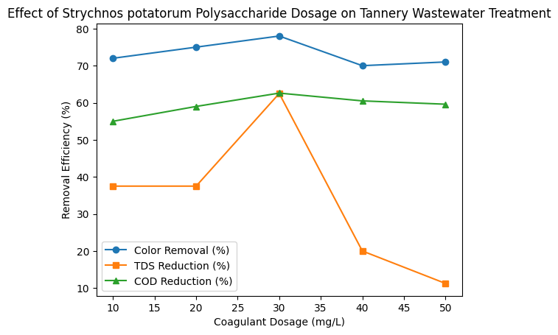

3.5 Sludge Characteristics and Settling Behavior
The sludge generated during the coagulation–flocculation process was dense, compact, and exhibited good settling characteristics at the optimized coagulant dosage. The reduced volume and improved dewaterability of sludge produced using Strychnos potatorum polysaccharide offer significant advantages over conventional chemical coagulants, which typically generate large quantities of metal-rich sludge.
The biodegradable nature of the natural coagulant further enhances the environmental compatibility of the generated sludge and reduces challenges associated with disposal. These observations align with previous studies highlighting the benefits of natural coagulants in minimizing sludge generation and improving sludge management (Bernet & Béline, 2009; Freitas et al., 2015).
The results of the present study further substantiate this observation, as shown in Table 3, where an increase in coagulant dosage up to the optimum level (30 mg/L) resulted in simultaneous enhancement of both total dissolved solids (TDS) and chemical oxygen demand (COD) removal. The maximum TDS reduction (62.5%) coincided with the highest COD removal (62.6%), demonstrating a direct proportional relationship between these parameters. This trend indicates that a substantial fraction of dissolved solids in tannery wastewater consists of organic constituents contributing to oxygen demand, and their removal through coagulation–flocculation leads to concurrent reduction in both TDS and COD. Similar direct correlations between TDS and COD removal have been reported for tannery effluents treated using coagulation-based processes, where dissolved organic matter constitutes a major fraction of the total pollutant load (Ali & Naher, 2015; Wang et al., 2016; Lejri & Younes, 2022).

Table 5. FTIR Peak Assignments of Treated Sludge
S.NO | Peak (cm⁻¹) | Vibration Type | Interpretation
1. | 3213.7 | N–H stretching | Amine / amide interaction
2. | 3008.4 | O–H / N–H stretching | Hydrogen bonding
3. | 1398.1 | C–O stretching | Carboxylate complexation
4. | 1050.0 | C–N stretching | Aliphatic amines
5. | 609.3 | C–X / metal interaction | Possible chromium association

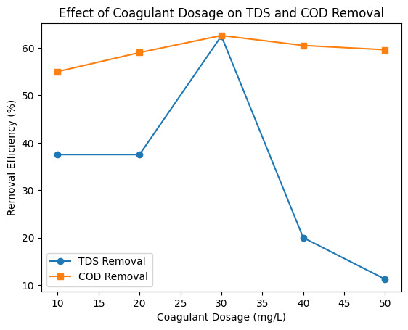

3.6 FTIR Analysis and Pollutant Removal Mechanism
FTIR analysis of the raw Strychnos potatorum polysaccharide exhibited broad and intense absorption bands characteristic of its biopolymeric nature. The broad peak observed around 3200–3400 cm⁻¹ corresponds to the stretching vibrations of hydroxyl (–OH) groups, indicating the presence of abundant polysaccharide hydroxyl functionalities capable of hydrogen bonding. Peaks appearing near 2920–2850 cm⁻¹ are attributed to C–H stretching vibrations of aliphatic chains, confirming the polysaccharide backbone structure. The absorption band around 1700–1730 cm⁻¹ is associated with the stretching vibration of carboxyl (–COOH) groups, while bands observed near 1600–1650 cm⁻¹ may be assigned to amide I (C=O stretching) or –NH₂ bending vibrations. Additional peaks in the region of 1000–1150 cm⁻¹ correspond to C–O–C and C–O stretching vibrations, typical of glycosidic linkages in polysaccharides.
After coagulation treatment, the FTIR spectrum of the generated sludge showed noticeable shifts in peak positions, peak broadening, and reduced band intensities, particularly in the –OH, –COOH, and –NH₂ functional group regions. The shift and weakening of the hydroxyl band suggest hydrogen bonding interactions between the polysaccharide and pollutant molecules. Changes in the carboxyl and amine-related peaks indicate electrostatic interactions and complexation between negatively charged organic/inorganic contaminants and protonated functional groups of the polysaccharide. These spectral modifications provide strong evidence that these functional groups actively participated in pollutant binding during the treatment process.
The observed FTIR spectral changes validate that pollutant removal occurred through multiple synergistic mechanisms. Initially, charge neutralization takes place when oppositely charged functional groups of the polysaccharide interact with suspended particles and dissolved contaminants, reducing repulsive forces and promoting aggregation. Simultaneously, adsorption mechanisms dominate through hydrogen bonding, van der Waals forces, and electrostatic attraction between polysaccharide functional groups and pollutants. Furthermore, due to the long-chain polymeric structure of the polysaccharide, polymer bridging plays a crucial role, where a single polymer chain binds multiple particles, leading to the formation of larger and denser flocs that readily settle.
The FTIR spectrum of the treated sludge exhibited peak shifts in the regions corresponding to carboxylate and amine functional groups, suggesting interaction between chromium ions and the polysaccharide matrix. These interactions likely occur through coordination bonding and electrostatic attraction, facilitating chromium entrapment within the floc structure. The presence of chromium-associated complexes in sludge confirms its removal from the aqueous phase during treatment.
The combined action of adsorption, charge neutralization, and polymer bridging enhances floc formation efficiency and results in effective removal of organic matter, suspended solids, and metal ions from wastewater. Similar FTIR-based confirmation of functional group involvement and coagulation mechanisms has been widely reported for natural polysaccharide-based coagulants and bioadsorbents, reinforcing the reliability of the proposed mechanism (Karthikeyan et al., 2016; Devipriya et al., 2020). Thus, the FTIR results conclusively demonstrate that Strychnos potatorum polysaccharide functions as an efficient, eco-friendly coagulant through chemically active surface interactions rather than mere physical entrapment.
The coagulation–flocculation of tannery effluent using Strychnos potatorum polysaccharide occurs through a synergistic mechanism involving charge neutralization, adsorption, and polymer bridging. Initially, protonated functional groups neutralize negatively charged colloids. Subsequently, long polymer chains adsorb onto multiple particles simultaneously, forming inter-particle bridges that result in dense, settleable flocs. This multi-mechanistic action explains the effective removal of suspended solids, organic matter, and chromium-associated complexes.
3.7 Environmental and Practical Implications

The results demonstrate that Strychnos potatorum seed polysaccharide is an efficient and sustainable alternative to conventional chemical coagulants for tannery effluent treatment. The significant reduction in turbidity, suspended solids, COD, and BOD, combined with reduced sludge generation and biodegradability, highlights its potential for large-scale application. The shift and broadening of –OH and –NH stretching bands in the treated sludge indicate strong hydrogen bonding interactions between polysaccharide functional groups and organic pollutants. The appearance and intensification of carboxylate-related peaks suggest electrostatic interactions and complexation with metal–organic species, including chromium complexes. These spectral changes confirm that pollutant removal occurred through a synergistic mechanism involving adsorption, charge neutralization, and polymer bridging.
Given the economic importance of the tannery industry as a major foreign exchange earner, adoption of eco-friendly treatment technologies is essential to ensure regulatory compliance and long-term sustainability. The use of plant-based natural coagulants can support cleaner production practices while minimizing environmental impacts associated with tannery operations.
3.8 Scanning Electron Microscopy (SEM) Analysis of Polysaccharide sludge:
The SEM micrograph of the raw polysaccharide exhibited a smooth, compact, and relatively uniform surface morphology, indicating limited availability of active binding sites. In contrast, the treated polysaccharide showed a rough, irregular, and highly porous structure with the presence of cracks, cavities, and flake-like formations.
These morphological changes clearly indicate the adsorption and accumulation of pollutants onto the surface of the polysaccharide during the coagulation process. The development of a porous and aggregated structure suggests enhanced interaction between the functional groups of the polysaccharide and the wastewater contaminants.
The formation of a net-like structure further confirms the occurrence of flocculation, where particles are bound together through polymer bridging and charge neutralization mechanisms. This structural transformation demonstrates the effectiveness of the natural polysaccharide as a bio-coagulant for wastewater treatment.
Figure 2 : . SEM images of
(a) Raw polysaccharide
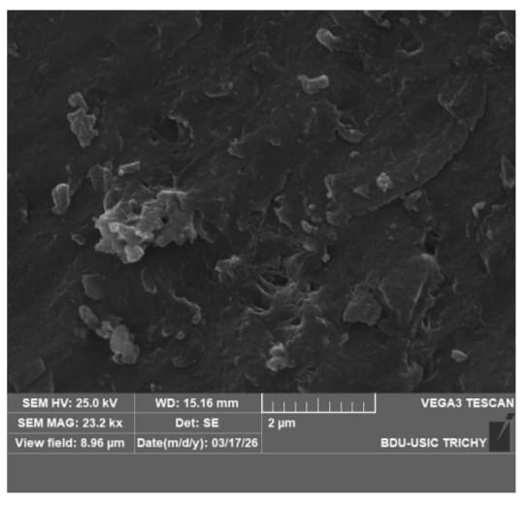
(b) Treated polysaccharide
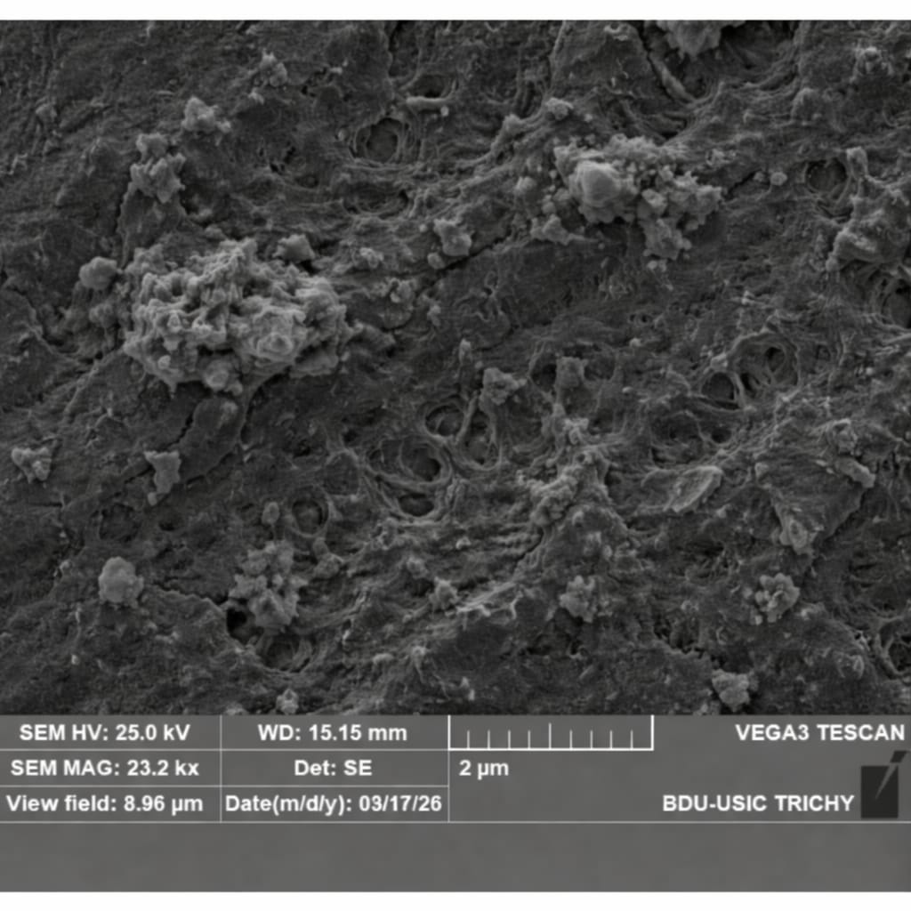
CONCLUSION
The present study demonstrates the effective application of Strychnos potatorum L. seed polysaccharide as a sustainable and eco-friendly coagulant for the treatment of tannery effluent predominantly generated from chrome-tanning operations. Physico-chemical characterization of untreated effluent revealed extremely high pollution load, with elevated TSS, TDS, COD, chlorides, and sulphates, exceeding CPCB discharge standards and confirming the hazardous nature of tannery wastewater.
Coagulation–flocculation treatment using the extracted natural polysaccharide resulted in significant reductions in turbidity, suspended solids, colour, COD, and TDS, with optimal performance achieved at a dosage of 30 mg/L. Beyond this dosage, a decline in treatment efficiency was observed due to overdosing-induced steric stabilization and partial restabilization of colloidal particles. The reduction in organic load indicates effective removal of both particulate and dissolved organic matter through adsorption and polymer bridging mechanisms.
Chromium present predominantly in the trivalent form (Cr³⁺) was effectively immobilized within the settled sludge through association with suspended solids and organic complexes. Although hexavalent chromium was not detected, the removal of chromium-associated particulates significantly reduces long-term environmental and health risks. FTIR analysis confirmed the active involvement of hydroxyl, carboxyl, and amine functional groups of the polysaccharide in pollutant binding, validating a synergistic removal mechanism involving charge neutralization, adsorption, and polymer bridging.
Compared to conventional chemical coagulants, the use of Strychnos potatorum polysaccharide offers clear advantages such as biodegradability, reduced sludge volume, absence of secondary metal contamination, and cost-effectiveness. The findings highlight the strong potential of this natural coagulant as a green alternative for preliminary treatment of high-strength tannery effluent. Integration of this eco-friendly approach with biological or advanced treatment systems could further enhance compliance with stringent discharge standards, supporting environmentally responsible and sustainable tannery operations.

ACKNOWLEDGEMENT
The authors gratefully acknowledge the Tamil Nadu State Council for Higher Education (TANSCHE), Government of Tamil Nadu [File No. RGP/2019-20/MTWU/HECP-0075], for providing financial support to carry out this research.
REFERENCES
- Ahmad, A. L., Wong, S. S., Teng, T. T., & Zuhairi, A. (2007). Improvement of alum and PACl coagulation by natural coagulant aids. Chemical Engineering Journal, 137, 510–517.
- Ake, A. H. J., et al. (2022). Natural polymers for wastewater remediation. Environmental Science and Pollution Research, 29, 66542–66555.
- Alam, M. Z., Ahmad, S., Malik, A., & Ahmad, M. (2020). Treatment of tannery wastewater using hybrid processes. Journal of Environmental Management, 262, 110336.
- Alazaiza, M. Y. D., et al. (2022). Application of natural polymers in wastewater treatment. Journal of Environmental Chemical Engineering, 10, 107255.
- Ali, M. F., & Naher, U. H. (2015). Characteristics of tannery wastewater and its environmental impacts. Environmental Monitoring and Assessment, 187, 410.
- Al-Jlil, S. A., & Alsewailem, F. D. (2016). Tannery wastewater treatment using eco-friendly natural coagulants. Environmental Technology, 37, 1–9.
- Ang, W. L., & Mohammad, A. W. (2020). State of the art and sustainability of chemical coagulants. Journal of Water Process Engineering, 33, 101035.
- Ashraf, S., et al. (2020). Human health risks of heavy metals in industrial wastewater. Ecological Engineering, 148, 105789.
- Beltrán-Heredia, J., & Sánchez-Martín, J. (2009). Removal of sodium lauryl sulfate by coagulation with natural coagulants. Industrial & Engineering Chemistry Research, 48, 5085–5092.
- Bernet, N., & Béline, F. (2009). Challenges in sludge management. Environmental Science & Technology, 43, 807–813.
- Bhatia, S., Othman, Z., & Ahmad, A. L. (2018). Bio-based coagulants for wastewater treatment: A review. Journal of Environmental Chemical Engineering, 6, 5122–5130.
- Bhardwaj, A., et al. (2023). Economic importance of leather industries. Environmental Science and Pollution Research, 30, 15421–15435.
- Boshoff, G., et al. (2004). Industrial effluent management practices. Water Research, 38, 389–396.
- Bratby, J. (2016). Coagulation and flocculation in water and wastewater treatment. IWA Publishing.
- Can, O. T., et al. (2019). Chromium toxicity and environmental risk assessment. Journal of Hazardous Materials, 372, 117–125.
- Cassano, A., Drioli, E., Galaverna, G., & Cagnasso, P. (2001). Treatment of aqueous effluents of the leather industry by membrane processes. Desalination, 141, 157–165.
- Chowdhury, M., Mostafa, M. G., Biswas, T. K., Mandal, A., & Saha, A. K. (2015). Characterization of the effluents from leather processing industries. Journal of Cleaner Production, 87, 701–708.
- Choy, S. Y., Prasad, K. M. N., Wu, T. Y., Raghunandan, M. E., & Ramanan, R. N. (2014). Utilization of plant-based natural coagulants as future alternatives. Journal of Environmental Sciences, 26, 2178–2189.
- Dehghani, M. H., Alimohammadi, M., & McKay, G. (2016). Removal of COD from industrial wastewater using natural coagulants. Desalination and Water Treatment, 57, 1–10.
- Devipriya, S., et al. (2020). Functional characterization of natural polysaccharides. International Journal of Biological Macromolecules, 148, 853–863.
- Feng, J. W., et al. (2007). Adsorption of pollutants using natural materials. Journal of Hazardous Materials, 146, 280–286.
- Fersi, C., et al. (2018). Coagulation–flocculation treatment of industrial wastewater. Separation and Purification Technology, 201, 427–436.
- Freitas, T. K. F. S., et al. (2015). Sludge generation and management in wastewater treatment. Chemical Engineering Journal, 268, 1–10.
- Freitas, T. K. F. S., Almeida, C. A., Manholer, D. D., et al. (2018). Review of natural coagulants in water treatment. Environmental Technology Reviews, 7, 1–16.
- Gautam, S., & Saini, G. (2020). Natural coagulants: Sustainable materials for water purification. Journal of Cleaner Production, 272, 122628.
- Ghernaout, D., & Ghernaout, B. (2012). From chemical disinfection to electrocoagulation. Desalination, 297, 1–8.
- Ghernaout, D. (2020). Natural organic polymers for water and wastewater treatment: A review. Applied Water Science, 10, 1–12.
- Hameed, Y. T., Idris, A., & Hussain, S. A. (2016). A review on natural coagulants for wastewater treatment. Journal of Environmental Management, 175, 117–127.
- Ho, Y. S., & McKay, G. (1999). Pseudo-second order kinetic model for adsorption processes. Process Biochemistry, 34, 451–465.
- Kabir, M., et al. (2023). Emerging green coagulants for wastewater treatment. Journal of Molecular Liquids, 369, 120927.
- Katal, R., & Pahlavanzadeh, H. (2011). Influence of parameters on coagulation–flocculation using plant-based materials. Iranian Journal of Environmental Health Science & Engineering, 8, 1–8.
- Lee, C. S., Robinson, J., & Chong, M. F. (2014). Application of plant-based coagulants in wastewater treatment. Process Safety and Environmental Protection, 92, 489–508.
- Lejri, R., & Younes, S. (2022). Environmental risks of tannery effluents and treatment strategies. Environmental Science and Pollution Research, 29, 11245–11260.
- Malik, Q. (2014). Environmental impacts of tannery wastewater. Environmental Monitoring and Assessment, 186, 423–432.
- Manahan, S. E. (2010). Environmental chemistry. CRC Press.
- Matilainen, A., Vepsäläinen, M., & Sillanpää, M. (2010). Natural organic matter removal by coagulation. Advances in Colloid and Interface Science, 159, 189–197.
- Murugesan, A. G., & Rajakumari, C. (2005). Environmental issues of tannery clusters. Indian Journal of Environmental Protection, 25, 873–878.
- Okuda, T., Baes, A. U., Nishijima, W., & Okada, M. (2001). Coagulation mechanism of natural coagulants. Water Research, 35, 830–834.
- Parveen, S., et al. (2017). Leather industry and environmental sustainability. Applied Water Science, 7, 2099–2110.
- Roussy, J., Van Vooren, M., Dempsey, B. A., & Guibal, E. (2005). Influence of chitosan characteristics on coagulation. Water Research, 39, 3247–3258.
- Sabur, M. A., et al. (2013). Pollution potential of tannery wastewater and its impacts. Journal of Environmental Management, 130, 82–89.
- Song, Z., & Williams, C. J. (2003). Application of coagulation–flocculation in industrial wastewater treatment. Water Research, 37, 3871–3878.
- Vijayaraghavan, K., Ahmad, D., & Ezani, E. (2020). Bioflocculants: Recent advances and applications in wastewater treatment. Biotechnology Advances, 40, 107500.
- Wang, J., Chen, C., & Wang, X. (2016). Removal of pollutants from industrial effluents by coagulation processes. Water Research, 88, 329–338.
- Yin, C. Y. (2010). Emerging usage of plant-based coagulants for water and wastewater treatment. Process Biochemistry, 45, 1437–1444.
- Zhao, X., et al. (2022). Advanced treatment of tannery wastewater. Journal of Environmental Management, 304, 114289.
- Zungolo, F., et al. (2023). Sustainable materials for wastewater remediation. Journal of Cleaner Production, 389, 136086.

