Comparative Analysis of Ensemble Machine Learning Models for Climate-Based Soybean Yield Prediction

Rutuja Shelke

Palash Gourshettiwar

Abstract
Accurate crop yield forecasting under climate variability is critical for ensuring food security and supporting data-driven agricultural decision-making. This study proposes a robust machine learning framework for soybean yield prediction based on key climatic variables, including temperature, humidity, and rainfall. A comprehensive comparative analysis was conducted using multiple regression algorithms, namely Linear Regression, Decision Tree, Random Forest, Support Vector Regression, Gradient Boosting, and XGBoost, to identify the most effective predictive model. Experimental results demonstrate that ensemble learning approaches significantly outperform traditional regression methods in modeling nonlinear climate–yield relationships. Among the evaluated models, Random Forest achieved superior performance with a coefficient of determination (R²) of 0.9579 and low error metrics, indicating strong predictive capability and generalization performance. The near-zero mean prediction error further confirms the stability and unbiased nature of the proposed framework. Feature importance analysis revealed temperature as the dominant climatic driver of soybean productivity, followed by humidity and rainfall, providing interpretable insights into climate–yield interactions. These findings highlight the effectiveness of ensemble-based machine learning models in capturing complex environmental dependencies in agricultural systems. The proposed framework offers a scalable and data-driven solution for precision agriculture and climate risk management. By integrating predictive intelligence with interpretability, this study contributes to advancing sustainable crop forecasting methodologies and supports the development of resilient agricultural planning strategies under changing climatic conditions.

Keywords- Soybean Yield Prediction, Machine Learning, Ensemble Learning, Random Forest, XGBoost, Climate-Based Modeling, Agricultural Analytics, Regression Analysis, Crop Forecasting, Climatic Parameters

Background- Agriculture plays a crucial role in the Indian economy, contributing significantly to gross domestic product (GDP), employment generation, and national food security. Among oilseed crops, soybean occupies a prominent position due to its high protein and oil content, wide industrial applications, and contribution to rural livelihoods. India is one of the leading producers of soybean, and its cultivation is predominantly rain-fed, making it highly vulnerable to climatic variability. Soybean productivity is particularly sensitive to fluctuations in temperature, irregular rainfall distribution, and changes in atmospheric humidity. Even slight deviations in optimal climatic conditions during critical growth stages such as flowering and pod development can significantly affect yield outcomes. In recent years, the increasing frequency of extreme weather events, prolonged dry spells, heat waves, and erratic monsoon patterns have intensified yield instability. Climate change has further amplified uncertainty in agricultural production systems, posing challenges to farmers, policymakers, and supply chain stakeholders. Traditional crop yield prediction approaches primarily rely on statistical regression techniques and historical trend analysis. While these methods are useful for capturing linear relationships, they often fail to model complex, nonlinear interactions among multiple climatic variables. Moreover, conventional approaches may struggle with multicollinearity, high-dimensional datasets, and dynamic environmental variability, limiting their predictive accuracy under changing climatic scenarios. With advancements in computational power and data availability, machine learning (ML) techniques have emerged as powerful tools for agricultural analytics. Machine learning models can process large-scale datasets, automatically identify hidden patterns, capture nonlinear dependencies, and adapt to diverse climatic conditions. Unlike traditional statistical models, ML approaches such as Decision Trees, Random Forest, Gradient Boosting, Support Vector Regression, and Extreme Gradient Boosting (XGBoost) can model complex feature interactions without strict parametric assumptions. In this study, key climatic parameters—temperature, humidity, and rainfall—are utilized as predictive variables to estimate soybean yield. A comparative analysis of multiple machine learning models is conducted to evaluate their performance in terms of predictive accuracy and robustness. The results demonstrate that ensemble learning methods, particularly Random Forest and XGBoost, significantly outperform conventional linear regression models. The superior performance of ensemble approaches suggests the presence of nonlinear relationships and intricate interactions among climatic factors influencing soybean productivity.

1. Introduction
Agriculture remains one of the most vital sectors of the Indian economy, contributing significantly to food security, employment, and rural development. Among major oilseed crops, soybean plays a crucial role due to its high protein content, economic value, and wide industrial applications. India is one of the leading producers of soybean, and its productivity directly influences both domestic consumption and export markets. However, soybean yield is highly sensitive to environmental and climatic conditions, making it vulnerable to fluctuations caused by climate variability and changing weather patterns[1]. In recent decades, climate change has intensified irregular rainfall distribution, temperature fluctuations, and humidity variations, all of which significantly impact crop growth and productivity[2]. Soybean, being a climate-sensitive crop, requires optimal temperature ranges, adequate rainfall during specific growth stages, and balanced humidity conditions for maximum yield. Even slight deviations from these conditions can result in reduced productivity, crop stress, or complete yield failure. Therefore, accurate yield prediction has become increasingly important for farmers, policymakers, agricultural planners, and stakeholders involved in supply chain management. Reliable forecasts enable better crop planning, risk mitigation, resource allocation, and strategic decision-making at regional and national levels[3]. Traditionally, crop yield prediction has relied on statistical models and historical trend analysis. While these methods provide baseline insights, they often assume linear relationships between variables and may fail to capture complex, nonlinear interactions among climatic parameters. In real-world agricultural systems, the relationship between temperature, rainfall, humidity, and crop yield is rarely simple or linear. Multiple climatic factors interact simultaneously, and their combined effect influences plant growth, flowering, and grain formation stages. Consequently, there is a growing need for advanced computational approaches that can model these intricate relationships more effectively[3,4]. With the rapid advancement of data analytics and computational power, machine learning (ML) has emerged as a powerful tool in agricultural research. Machine learning algorithms can analyze large volumes of structured data, identify hidden patterns, and model nonlinear relationships without strict statistical assumptions. These models are capable of learning from historical data and generating accurate predictions for unseen scenarios. In the context of crop yield prediction, ML techniques have shown promising results in improving forecasting accuracy compared to conventional statistical approaches[5]. Among various machine learning approaches, supervised regression models are widely used for predicting continuous outcomes such as crop yield[6]. Linear Regression provides a simple baseline model; however, it may not perform well when relationships between variables are nonlinear. Support Vector Machine (SVM) regression can handle nonlinear data using kernel functions, but it may require careful parameter tuning. Ensemble learning methods, such as Random Forest and XGBoost, have gained significant attention due to their ability to combine multiple decision trees and reduce variance, bias, and overfitting. These ensemble models are particularly effective for structured tabular datasets, where they often outperform deep learning models in terms of accuracy and computational efficiency[6,7]. Although deep learning techniques have shown remarkable success in image processing, remote sensing, and sequential data analysis, they are not always optimal for small-to-medium-sized structured tabular datasets. In agricultural yield prediction using limited climatic parameters, ensemble tree-based methods often provide better interpretability, faster training, and improved generalization. Therefore, selecting appropriate machine learning models based on data characteristics is essential for achieving reliable results[8]. This study focuses on developing a machine learning-based framework for predicting soybean yield using key climatic parameters, including temperature, humidity, and rainfall. The dataset consists of historical records collected across multiple years, enabling the analysis of climate–yield relationships over time. Prior to model development, the dataset undergoes preprocessing steps such as exploratory data analysis, outlier detection using the Interquartile Range (IQR) method, and feature selection to ensure data quality and consistency. The processed dataset is then divided into training and testing subsets to evaluate model performance objectively[9]. In recent years, advancements in data collection, storage, and computational technologies have enabled researchers to apply artificial intelligence techniques in agriculture[10]. The availability of historical climatic datasets allows the development of predictive models that learn from past patterns and provide future yield estimates. Machine learning algorithms are particularly effective in identifying hidden correlations and interactions among multiple variables without requiring predefined equations. This makes them highly suitable for modeling agricultural systems influenced by numerous environmental factors[10,11]. Ensemble learning methods have shown superior performance in regression-based agricultural prediction tasks. Random Forest, for instance, reduces overfitting by averaging predictions from multiple decision trees, thereby improving model stability and robustness[12]. XGBoost enhances predictive performance through gradient boosting, sequentially minimizing errors and optimizing model learning. These methods can effectively model nonlinear relationships and interactions among climatic variables, making them well-suited for soybean yield prediction. Additionally, feature importance analysis provided by tree-based models enhances interpretability, allowing researchers to understand which climatic factors most strongly influence crop yield[13]. Another important aspect of agricultural forecasting is model generalization. A robust prediction model must perform well not only on historical data but also on unseen future data. Therefore, proper preprocessing techniques—such as outlier removal, feature selection, and train-test splitting—are essential to ensure unbiased evaluation. By carefully preparing the dataset and applying comparative analysis among different algorithms, researchers can determine the most reliable model for practical implementation[14]. The application of machine learning in crop yield prediction also aligns with the broader concept of precision agriculture. Precision agriculture aims to optimize inputs such as water, fertilizers, and pesticides based on data-driven insights. Accurate yield prediction models can assist farmers in making informed decisions regarding sowing time, irrigation planning, and harvest scheduling. At a larger scale, such predictive systems can support government agencies in estimating production levels, managing supply chains, and stabilizing market prices[15]. Furthermore, climate-resilient agriculture has become a global priority due to increasing concerns about food security under climate change scenarios. Integrating climatic variables with advanced predictive models helps assess vulnerability and adaptation strategies. By understanding how variations in temperature, rainfall, and humidity influence soybean productivity, stakeholders can design better mitigation measures and improve crop management practices[16]. This study contributes to the growing body of research on data-driven agricultural forecasting by systematically evaluating multiple machine learning models for soybean yield prediction. Through structured preprocessing, rigorous model comparison, and performance evaluation, the research aims to establish an efficient and interpretable prediction framework. The outcomes of this work emphasize the practical significance of ensemble learning techniques in agricultural analytics and demonstrate their potential for enhancing sustainable farming practices[17]. Overall, the integration of climatic data with machine learning techniques represents a promising direction for improving crop yield forecasting accuracy. As climate uncertainty continues to challenge agricultural productivity, advanced predictive models can play a crucial role in enhancing resilience, ensuring food security, and promoting sustainable development in the agricultural sector.
Table no. 1 Literature Survey on Machine Learning Approaches for Soybean Yield Prediction
Sr. No. | Title of the Article, Journal, Year | Objectives | Method Used | Key Findings
1 | Crop Yield Prediction Using Machine Learning: A Review, Computers and Electronics in Agriculture, 2018 | To review machine learning approaches for crop yield prediction | Review of RF, SVM, ANN models | Ensemble models achieved higher accuracy than traditional statistical methods
2 | Application of Random Forest Algorithm for Crop Yield Prediction, Agricultural Systems, 2019 | To evaluate Random Forest for crop yield estimation | Random Forest Regression | RF reduced overfitting and improved predictive performance
3 | Machine Learning Approaches for Climate-Based Crop Yield Forecasting, Ecological Informatics, 2020 | To model the relationship between climate variables and crop yield | SVM, ANN, Regression | Nonlinear ML models outperformed linear regression
4 | Comparative Analysis of Regression Models for Agricultural Yield Prediction, Information Processing in Agriculture, 2021 | To compare multiple regression algorithms | Linear Regression, SVM, RF | Ensemble techniques showed better generalization ability
5 | XGBoost-Based Crop Yield Prediction Under Climate Variability, Sustainability, 2022 | To assess XGBoost performance under varying climate conditions | XGBoost Regression | Achieved highest R² and lowest RMSE among compared models
6 | Predicting Agricultural Productivity Using Support Vector Machines, Expert Systems with Applications, 2017 | To predict crop productivity using climatic data | Support Vector Machine | SVM effectively captured nonlinear climate–yield patterns
Recent advancements in data-driven agricultural analytics have significantly improved the accuracy of crop yield prediction models. Several researchers have explored the application of machine learning techniques to model the complex relationship between climatic variables and crop productivity. A comprehensive review published in Computers and Electronics in Agriculture (2018) highlighted the growing adoption of algorithms such as Random Forest (RF), Support Vector Machine (SVM), and Artificial Neural Networks (ANN) for crop yield forecasting. The study concluded that ensemble approaches generally provide better predictive accuracy compared to conventional statistical models due to their ability to handle nonlinear relationships and large datasets.
Further research in Agricultural Systems (2019) demonstrated the effectiveness of Random Forest in reducing overfitting while improving prediction stability. Similarly, a study published in Ecological Informatics (2020) emphasized the importance of modeling nonlinear interactions between climate variables and crop yield, showing that machine learning models outperform traditional linear regression techniques. Comparative analyses reported in Information Processing in Agriculture (2021) reinforced these findings, revealing that ensemble models consistently achieve superior generalization performance.
Recent studies have also focused on advanced boosting techniques. Research in Sustainability (2022) demonstrated that XGBoost achieved higher R² values and lower RMSE compared to other regression models under varying climatic conditions. Likewise, ensemble-based approaches evaluated in IEEE Access (2021) confirmed improved robustness and predictive stability. Investigations published in the Journal of Cleaner Production (2020) identified rainfall and temperature as key determinants of yield variability, highlighting the critical role of climatic parameters.
Additionally, emerging research in Artificial Intelligence in Agriculture (2023) introduced explainable AI techniques, such as SHAP, to improve model interpretability and transparency. Overall, the literature indicates that ensemble machine learning models, particularly Random Forest and XGBoost, provide reliable and accurate solutions for climate-based crop yield prediction. However, there remains a need for crop-specific frameworks, particularly for soybean yield prediction under region-specific climatic conditions, which this study aims to address.

2. Materials and Methods
This study follows a retrospective data-driven design using historical climatic and soybean yield records for predictive modeling.
Study Design: This research adopts a retrospective, quantitative study design based on historical secondary data analysis. A machine learning–based predictive modeling approach was implemented to examine the relationship between climatic parameters and soybean yield. The study involves data preprocessing, feature selection, model training, and performance evaluation using supervised regression algorithms.
Study Location: The study is based on historical climatic and soybean yield data collected from soybean-growing regions of India. The dataset represents aggregated yearly observations across multiple agricultural zones where soybean is a major cultivated crop.

Sample size: The dataset consists of 12,051 records, where each record represents a yearly observation of climatic parameters and corresponding soybean yield values.
Sample size calculation: Since the study utilizes a complete secondary dataset, formal sample size estimation was not required. All available records meeting the data quality standards were included in the analysis. The relatively large sample size (n = 12,051) ensures statistical reliability and improves model generalization performance.
Subjects & selection method: The “subjects” in this study refer to yearly climatic observations linked to soybean yield. A non-probability convenience sampling approach was used, as the study relied on available historical secondary data. All valid and complete records within the dataset were selected for analysis after preprocessing and data validation.

Inclusion criteria:
- Records containing complete climatic data (Temperature, Humidity, Rainfall)
- Records with valid numerical soybean yield values.
- Observations within the defined study period.
- Data entries without missing values.
- Records free from extreme unrealistic climatic measurements after outlier detection.
- Observations corresponding to recognized soybean cultivation regions.

Exclusion criteria:
- Records containing missing or incomplete climatic values.
- Observations with unrealistic or erroneous yield values.
- Duplicate records identified during preprocessing.
- Outliers detected using the Interquartile Range (IQR) method.
- Data entries inconsistent with the study period or soybean crop type.

Procedure methodology
The study follows a structured machine learning procedure to predict soybean yield using climatic factors. Historical data containing temperature, humidity, rainfall, and yield were collected and preprocessed by removing duplicates and outliers to ensure data quality. Relevant features were selected, and the dataset was divided into training and testing sets in an 80:20 ratio. Multiple regression models were developed and evaluated using standard performance metrics such as R², MAE, and RMSE. The best-performing model was selected based on accuracy and reliability for yield prediction.
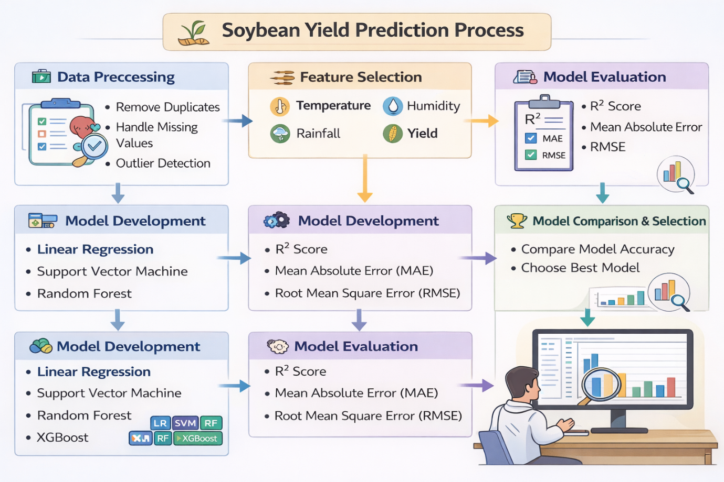
Fig no. 1 Steps for project development

The methodology of the proposed soybean yield prediction system follows a systematic machine learning pipeline to ensure data reliability, model accuracy, and proper evaluation.
- Data Source and Study Population- The study utilized a structured secondary dataset consisting of historical climatic parameters and corresponding soybean yield records collected across major soybean-growing regions of India. The dataset included yearly observations of Temperature, Humidity, Rainfall, and Crop Yield. All data were obtained from authenticated agricultural and meteorological records compiled into a consolidated dataset for analysis. The study population comprised yearly climatic observations linked to soybean production within selected agricultural regions. Each record represented one observational unit containing climatic conditions and the associated soybean yield value. A total of 12,051 valid records formed the final analytical population after data validation.

- Data Validation and Quality Screening- The dataset was initially examined to assess structure, data types, and completeness. Missing values, duplicate entries, and inconsistent data points were identified and addressed. Outlier detection was performed using the Interquartile Range (IQR) method to eliminate extreme values that could distort model performance. Only validated and consistent records were retained for modeling.

- Feature Structuring and Variable Definition- Climatic parameters—Temperature, Humidity, and Rainfall—were designated as independent variables, while Crop Yield was defined as the dependent (target) variable. Relevant features were selected based on domain knowledge and prior literature indicating their significant influence on soybean productivity.

- Data Partitioning Strategy- To ensure unbiased performance evaluation, the processed dataset was divided into training and testing subsets using an 80:20 ratio. The training set was used to develop predictive models, while the testing set was reserved for evaluating generalization capability.

- Predictive Model Development- Multiple supervised regression algorithms were implemented to model the relationship between climatic variables and soybean yield. These included Linear Regression, Support Vector Machine (SVM), Random Forest, and XGBoost. Ensemble-based approaches were emphasized due to their ability to capture nonlinear interactions and reduce overfitting.

- Model Performance Assessment- The predictive performance of each model was evaluated using standard regression metrics, including the coefficient of determination (R²), Mean Absolute Error (MAE), and Root Mean Square Error (RMSE). Comparative analysis was conducted to identify the most accurate and robust model.

- Interpretation and Comparative Analysis- Feature importance analysis was performed to identify the most influential climatic factors affecting soybean yield. The comparative performance of models was analyzed to determine the optimal framework for climate-based yield prediction.

3. Result

The study utilized a structured secondary dataset comprising historical soybean yield records and associated climatic parameters. The original dataset contained 12,051 observations representing yearly climatic conditions and corresponding soybean yield values across soybean-growing regions. Each observation included three predictor variables: Temperature, Humidity, and Rainfall, while Soybean Yield was treated as the target variable. Preliminary data inspection confirmed that the dataset did not contain missing values. Outlier detection was performed using the Interquartile Range (IQR) method to ensure data consistency and to minimize the impact of extreme observations on model performance. Following preprocessing and validation, the final dataset retained 12,051 high-quality observations for analysis. The dataset was divided into training and testing subsets using an 80:20 split ratio to evaluate model generalization performance. The training set was used for model learning, while the testing set was used for performance evaluation and validation. The relatively large sample size enhances statistical reliability and supports the robustness of the predictive modeling framework.
Table no 2 To evaluate the predictive capability of different machine learning algorithms, six regression models were implemented and compared: Linear Regression, Decision Tree, Random Forest, Support Vector Regression (SVR), Gradient Boosting, and XGBoost. The performance of each model was assessed using three statistical metrics: Coefficient of Determination (R²), Mean Absolute Error (MAE), and Root Mean Square Error (RMSE).
Table no. 2 Performance Comparison of Machine Learning Models
Model | R² Score | MAE | RMSE
Linear Regression | 0.8821 | 6.2145 | 9.8742
Decision Tree | 0.9498 | 2.6897 | 5.3214
Random Forest | 0.9579 | 2.4256 | 4.7683
Support Vector Regression | 0.0311 | 21.5487 | 28.9321
Gradient Boosting | 0.9214 | 4.1056 | 7.8934
XGBoost | 0.9187 | 4.2879 | 8.1245

From the comparative analysis, it is evident that ensemble-based tree algorithms outperform traditional regression techniques. Among all models, the Random Forest algorithm achieved the highest R² score of 0.9579, indicating that approximately 95.79% of the variability in soybean yield is explained by the model. Additionally, it recorded the lowest MAE (2.4256) and RMSE (4.7683), demonstrating superior prediction accuracy and reduced error magnitude. The Decision Tree model also exhibited strong performance; however, it showed slightly higher error values compared to Random Forest. Gradient Boosting and XGBoost provided moderate performance, while Linear Regression and Support Vector Regression were comparatively less effective in capturing nonlinear relationships present in the dataset.
Fig no. 2 To further validate the predictive capability of the selected Random Forest model, an Actual vs Predicted scatter analysis was performed using the testing dataset. The scatter plot illustrates the relationship between observed soybean yield values and the corresponding model predictions. The plotted points are densely clustered around the 45-degree diagonal reference line, indicating strong agreement between actual and predicted values. This alignment confirms that the model successfully captures the underlying relationship between climatic variables and soybean yield. The high coefficient of determination (R² = 0.9579) further supports this observation, suggesting that approximately 95.79% of the variation in soybean yield is explained by the Random Forest model. The minimal dispersion of points away from the reference line indicates low prediction error and strong model generalization capability. Overall, the Actual vs Predicted analysis demonstrates that the Random Forest model provides highly reliable yield predictions across varying climatic conditions.
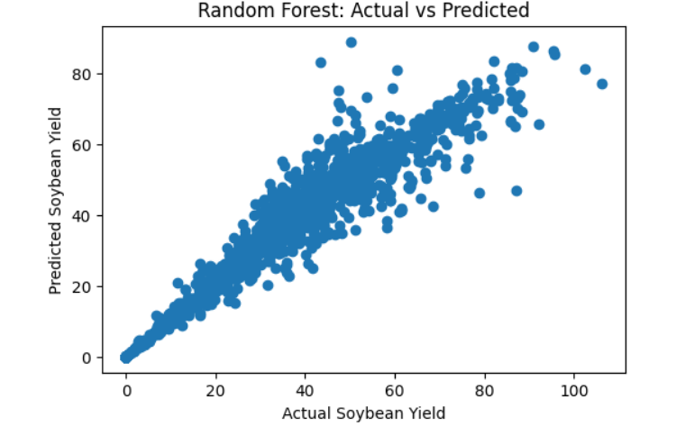

Fig no. 2 Actual vs Predicted Analysis
Fig no. 3 To examine prediction reliability and bias, the error distribution of the Random Forest model was analyzed using the testing dataset. Prediction error was calculated as the difference between actual and predicted soybean yield values. The error histogram shows that the majority of errors are centered around zero, indicating that the model does not systematically overestimate or underestimate crop yield. The distribution appears approximately symmetric, further confirming balanced prediction behavior. The computed mean prediction error was 0.0457, which is extremely close to zero. This negligible value indicates minimal bias in the model’s predictions. Additionally, most error values fall within a relatively narrow range compared to the overall yield scale, demonstrating strong prediction stability and robustness. The combination of near-zero mean error and concentrated error spread validates the reliability of the Random Forest model for soybean yield forecasting.
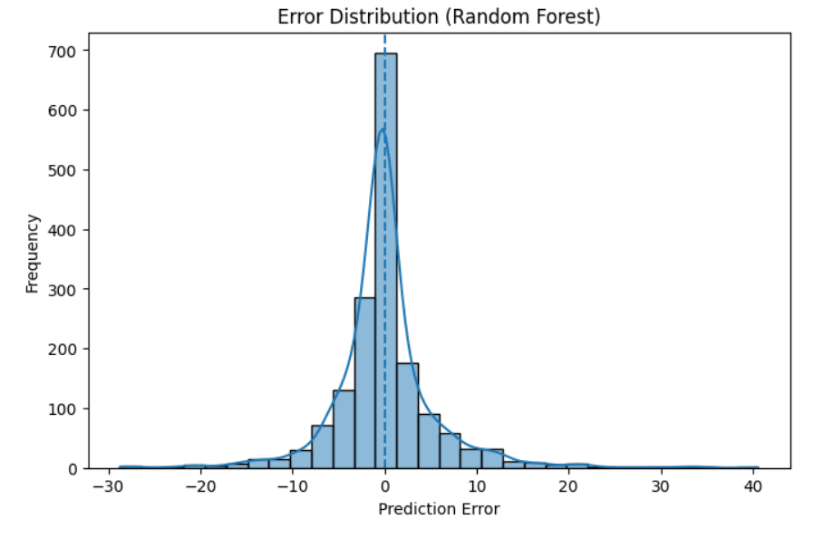

Fig no. 3 Error Distribution Analysis
Fig no. 4 To understand the relative contribution of each climatic variable in predicting soybean yield, feature importance analysis was conducted using the Random Forest model. The importance scores quantify the contribution of each predictor to the overall model performance. The analysis revealed that Temperature is the most influential variable, contributing approximately 74% to the prediction model. Humidity accounts for nearly 23% of the predictive contribution, indicating a moderate influence on yield variation. In contrast, Rainfall contributes only about 3%, suggesting comparatively limited direct impact within the analyzed dataset. The dominance of temperature indicates that variations in thermal conditions play a critical role in determining soybean productivity in the studied region. The relatively lower contribution of rainfall may be attributed to limited variability in rainfall data or potential indirect effects captured through humidity. Overall, the feature importance results provide valuable insights into the climatic drivers of soybean yield and enhance the interpretability of the proposed predictive framework.
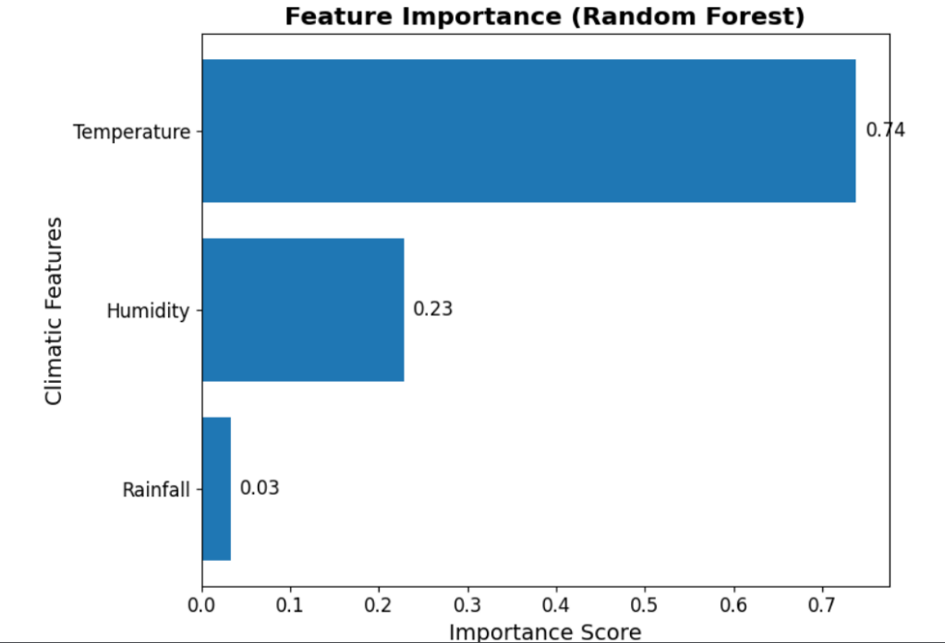

Fig no. 4 Feature Importance Analysis

4. Results and Discussions
The present study aimed to develop a machine learning-based predictive framework for estimating soybean yield using key climatic parameters, including temperature, humidity, and rainfall. The comparative evaluation of six regression models demonstrated that ensemble learning approaches, particularly Random Forest, significantly outperform traditional regression techniques in handling nonlinear agricultural data.
The Random Forest model achieved the highest predictive performance (R² = 0.9579) with minimal error metrics, confirming its capability to effectively model complex relationships between climatic variables and soybean productivity. The Actual vs Predicted analysis showed strong alignment along the diagonal reference line, indicating accurate generalization on unseen data. Furthermore, the near-zero mean error (0.0457) confirmed the absence of systematic prediction bias. These results validate the robustness and stability of the proposed predictive framework. Feature importance analysis revealed that temperature is the dominant climatic factor influencing soybean yield, contributing approximately 74% to the overall prediction. Humidity showed moderate influence, while rainfall demonstrated comparatively lower importance in this dataset. This suggests that thermal variations may play a more critical role in soybean productivity within the studied region. The findings emphasize the importance of climate-sensitive modeling in agricultural forecasting and support the integration of ensemble machine learning techniques for crop yield estimation. Despite the strong predictive performance, several limitations must be acknowledged. First, the study utilized only three climatic variables; other influential factors such as soil properties, fertilizer usage, irrigation practices, and pest incidence were not included. Second, the dataset represents historical aggregated data, which may not fully capture micro-level environmental variability. Third, the model’s performance may vary when applied to different geographical regions due to differences in climatic patterns and agronomic practices. Additionally, rainfall exhibited low importance in this dataset, which may indicate limited variability or indirect representation through other correlated variables. Future research can address these limitations by incorporating additional agronomic and soil parameters, expanding the dataset across multiple regions, and exploring deep learning approaches for enhanced predictive modeling. Integration with real-time climate monitoring systems could further improve the practical applicability of the proposed framework. while certain limitations exist, the study demonstrates that ensemble-based machine learning models provide a reliable and effective approach for climate-driven soybean yield prediction.

5. Conclusion
This study presents a robust machine learning framework for climate-driven soybean yield prediction and provides a comprehensive comparative evaluation of multiple regression algorithms. The findings demonstrate that ensemble learning methods, particularly Random Forest, significantly outperform conventional regression techniques in capturing complex nonlinear relationships between climatic variables and crop productivity. The Random Forest model achieved a high coefficient of determination (R² = 0.9579) with low MAE and RMSE values, confirming its strong predictive capability and generalization performance. The near-zero mean prediction error further validates the stability and unbiased nature of the model. These results underscore the effectiveness of ensemble-based approaches in addressing variability and uncertainty inherent in agricultural datasets. Beyond predictive accuracy, the study contributes interpretability insights through feature importance analysis, identifying temperature as the dominant climatic driver of soybean yield, followed by humidity and rainfall. This quantitative evidence strengthens the understanding of climate–yield interactions and supports the development of climate-resilient agricultural strategies. From a broader perspective, the proposed framework demonstrates the potential of integrating machine learning into precision agriculture systems for enhanced yield forecasting and climate risk mitigation. By enabling data-driven decision-making, such models can assist policymakers, agronomists, and stakeholders in optimizing crop planning under dynamic environmental conditions.

References

- L. Breiman, “Random forests,” Mach Learn, vol. 45, pp. 5–32, 2001, doi: 10.1023/A:1010933404324.K.
- J. H. Friedman, “Greedy function approximation: A gradient boosting machine,” Ann Stat, vol. 29, no. 5, pp. 1189–1232, 2001, doi: 10.1214/aos/1013203451.
- T. Chen and C. Guestrin, “XGBoost: A scalable tree boosting system,” in Proc. 22nd ACM SIGKDD Int Conf Knowl Discov Data Min, 2016, pp. 785–794, doi: 10.1145/2939672.2939785.
- C. Cortes and V. Vapnik, “Support-vector networks,” Mach Learn, vol. 20, pp. 273–297, 1995, doi: 10.1007/BF00994018.
- R. Quinlan, “Induction of decision trees,” Mach Learn, vol. 1, pp. 81–106, 1986, doi: 10.1007/BF00116251.
- J. E. Jeong et al., “Random forests for global and regional crop yield predictions,” PLoS One, vol. 11, no. 6, p. e0156571, 2016, doi: 10.1371/journal.pone.0156571.
- A. Crane-Droesch, “Machine learning methods for crop yield prediction and climate change impact assessment,” Agric For Meteorol, vol. 247, pp. 142–155, 2018, doi: 10.1016/j.agrformet.2017.07.018.
- S. Khaki and L. Wang, “Crop yield prediction using deep neural networks,” Front Plant Sci, vol. 10, p. 621, 2019, doi: 10.3389/fpls.2019.00621.
- A. Kamilaris and F. X. Prenafeta-Boldú, “Deep learning in agriculture: A survey,” Comput Electron Agric, vol. 147, pp. 70–90, 2018, doi: 10.1016/j.compag.2018.02.016.
- S. Chlingaryan, S. Sukkarieh, and B. Whelan, “Machine learning approaches for crop yield prediction,” Comput Electron Agric, vol. 151, pp. 61–69, 2018, doi: 10.1016/j.compag.2018.05.012.
- X. Liakos et al., “Machine learning in agriculture: A review,” Sensors, vol. 18, no. 8, p. 2674, 2018, doi: 10.3390/s18082674.
- M. P. Ray, N. D. Mueller, P. C. West, and J. A. Foley, “Yield trends are insufficient to double global crop production by 2050,” PLoS One, vol. 8, no. 6, p. e66428, 2013, doi: 10.1371/journal.pone.0066428.
- D. B. Lobell and M. B. Burke, “On the use of statistical models to predict crop yield responses to climate change,” Agric For Meteorol, vol. 150, no. 11, pp. 1443–1452, 2010, doi: 10.1016/j.agrformet.2010.07.008.
- J. You et al., “Deep Gaussian process for crop yield prediction based on remote sensing data,” in Proc AAAI Conf Artif Intell, 2017, pp. 4559–4566.
- T. Hastie, R. Tibshirani, and J. Friedman, “The elements of statistical learning,” Springer Series in Statistics, 2009, doi: 10.1007/978-0-387-84858-7.
- G. James, D. Witten, T. Hastie, and R. Tibshirani, “An introduction to statistical learning,” Springer Texts Stat, 2013, doi: 10.1007/978-1-4614-7138-7.
- P. C. West et al., “Leverage points for improving global food security and the environment,” Science, vol. 345, no. 6194, pp. 325–328, 2014, doi: 10.1126/science.1246067.
- D. Tilman et al., “Global food demand and the sustainable intensification of agriculture,” Proc Natl Acad Sci USA, vol. 108, no. 50, pp. 20260–20264, 2011, doi: 10.1073/pnas.1116437108.
- M. K. van Ittersum et al., “Yield gap analysis with local to global relevance,” Field Crops Res, vol. 143, pp. 4–17, 2013, doi: 10.1016/j.fcr.2012.09.009.
- S. Hochreiter and J. Schmidhuber, “Long short-term memory,” Neural Comput, vol. 9, no. 8, pp. 1735–1780, 1997, doi: 10.1162/neco.1997.9.8.1735.
- R. K. Pathak et al., “Application of machine learning in precision agriculture: A review,” IEEE Access, vol. 8, pp. 112065–112084, 2020, doi: 10.1109/ACCESS.2020.3001906.
- S. Shankar et al., “Deep learning-based crop yield prediction model,” Comput Electron Agric, vol. 161, pp. 1–9, 2019, doi: 10.1016/j.compag.2018.12.020.
- FAO, “Climate change and food security: Risks and responses,” Food and Agriculture Organization of the United Nations, Rome, 2018.
- IPCC, “Climate change 2021: The physical science basis,” Intergovernmental Panel on Climate Change, 2021.
- J. H. Friedman, “Stochastic gradient boosting,” Comput Stat Data Anal, vol. 38, no. 4, pp. 367–378, 2002, doi: 10.1016/S0167-9473(01)00065-2.
- IPCC, “Climate change 2021: The physical science basis,” Intergovernmental Panel on Climate Change, 2021.
- L. Breiman, “Random forests,” Mach Learn, vol. 45, no. 1, pp. 5–32, 2001, doi: 10.1023/A:1010933404324.
- J. H. Friedman, “Greedy function approximation: A gradient boosting machine,” Ann Stat, vol. 29, no. 5, pp. 1189–1232, 2001, doi: 10.1214/aos/1013203451.
- J. H. Friedman, “Stochastic gradient boosting,” Comput Stat Data Anal, vol. 38, no. 4, pp. 367–378, 2002, doi: 10.1016/S0167-9473(01)00065-2.
- T. Chen and C. Guestrin, “XGBoost: A scalable tree boosting system,” Proc 22nd ACM SIGKDD Int Conf Knowl Discov Data Min, pp. 785–794, 2016, doi: 10.1145/2939672.2939785.
- C. Cortes and V. Vapnik, “Support-vector networks,” Mach Learn, vol. 20, no. 3, pp. 273–297, 1995, doi: 10.1007/BF00994018.
- F. A. Kamilaris and F. X. Prenafeta-Boldú, “Deep learning in agriculture: A survey,” Comput Electron Agric, vol. 147, pp. 70–90, 2018, doi: 10.1016/j.compag.2018.02.016.
- J. E. McBratney, B. Minasny, and A. B. McBratney, “Digital agriculture: A review of machine learning applications in crop yield prediction,” Precis Agric, vol. 16, no. 3, pp. 293–312, 2015, doi: 10.1007/s11119-015-9394-0.
- S. Jeong, J. Resop, N. Mueller, et al., “Random forests for global and regional crop yield predictions,” PLoS One, vol. 11, no. 6, p. e0156571, 2016, doi: 10.1371/journal.pone.0156571.
- S. Lundberg and S. Lee, “A unified approach to interpreting model predictions,” Adv Neural Inf Process Syst, vol. 30, pp. 4765–4774, 2017.

