REDUCING THE EFFECTS OF TOXIC HEAVY METALS CONTAMINATION ON HUMAN PHYSIOLOGICAL PROCESSES BY OPTIMIZING THE USE OF LOW-COST AGRICULTURAL BY-PRODUCT FOR BIOSEPARATION

¹Agbai, Johnson U., ^{2*}Igwe Jude C., ³Mbanaso Ebere L., ⁴Nosiri Chidi I., and ⁵Iwuagwu Mary O.
¹Department of Human Anatomy; ²Department of Industrial Chemistry,
³Department of Human Physiology; ⁴Department of Biochemistry; ⁵Department of Plant Science and Biotechnology,
Abia State University, P.M.B. 2000, Uturu, Abia State Nigeria.
*Corresponding Author E mail: jude.igwe@abiastateuniversity.edu.ng
Tel: +234-803-675-2059
ORCID ID: https://orcid.org/0000-0002-2832-0191
ABSTRACT
Access to abundant clean water is a serious issue affecting the physical and economic health of world communities. Wastewater treatment is important to prevent disease and renew precious fresh water resources. The optimum application of an agricultural by product-cocoa pod husk-in the bioremediation of Al (III), Cr (VI) and Ni (II) metal ions was studied. The effects of particle sizes of adsorbent, weight of adsorbent, agitation speed and initial concentration of metal ions solution on the adsorption process were investigated. The amount of metal ions adsorbed increased as the initial concentrations of metal ions solution were increased. Al (III) was adsorbed more than Cr (VI), and then followed by Ni (II) ion. The adsorption process was fitted to the Langmuir, Freundlich, Dubinin-Radushkevich, Temkin and Harkins-Jura isotherm models. The Freundlich isotherm gave a better fit to the adsorption process with linear correlation coefficient (R²) values ranging from 0.8164 to 0.9980. A two-way analysis of variance (ANOVA) without replication at p < 0.5 was used to determine the significance of the fitness of the isotherms to the sorption process. Therefore, cocoa pod husk was capable of removing Al (III), Cr (VI) and Ni (II) ions from aqueous solution, hence making cocoa pod husk a feasible low-cost agricultural by-product adsorbent for heavy metal removal. Also, the results of this work could serve as design parameter for treatment plant used in bioremediation which in return is likely a profitable technology for water and wastewater treatment and re-use, hence effecting the reduction of the toxic effects of these metals on human physiological processes.
Keywords: Bioremediation, cocoa pod husk, contamination, environment, heavy metals, wastewater,
INTRODUCTION
The study of heavy metals and related elements, have drawn a lot of the attention of environmental health research for more than two decades now as a result of their persistence, bioaccumulation, and toxicity. Many of these metals are carcinogenic or neurotoxic, posing hazards to both ecosystems and human populations (Jaishankar et al., 2014). Top on the list of these metals are aluminum (III), chromium (VI), and nickel (III) because of their distinct, yet severe health effects. The contamination of the environment by these heavy metals has been on the increase because of increasing urbanization and industrialization. Heavy metals are mostly discharged and distributed in the environment through both natural and anthropogenic sources. The natural sources include natural disasters such as volcanic eruptions, flood and so on. The anthropogenic sources of these heavy metals may include industries that manufacture paints, fertilizers, ceramics, herbicides and pesticides, semiconductors, pigments, pharmaceuticals, etc. (Balali-Mood et al., 2021). The adverse environmental effects of these heavy metals on man and the environment have received extensive attention in the past twenty-five years, because of the hazards posed by these metals. These metals accumulate in soils, water, and biota, leading to chronic human exposures that manifest in multiple organ toxicities, including renal, hepatic, pulmonary, cardiovascular, and neurological disorders (Jaishankar et al., 2014).
The effect of these metals on human physiological processes cannot be overemphasized. Aluminium is widely recognized for its neurotoxic potential, causing degeneration of astrocytes (Zhang et al., 2024; Ijomone et al., 2025; Hayat et al., 2025) and interferes with the metabolism of the neuronal cytoskeleton (Huat et al., 2019; Dey and Singh, 2022a). This it does by promoting tau protein accumulation and neuritic degeneration (Zhang et al., 2019). Tau protein which is a microtubule-associated protein found primarily in neurons, plays a crucial role in stabilizing microtubules, essential components of the cell's internal transport and structural system. While healthy, hyperphosphorylated tau is normal, in certain neurological conditions, such as Alzheimer’s disease caused by alumimum poisoning, tau becomes abnormally modified, forming neurofibrillary tangles that disrupt neuronal function and lead to neurodegeneration (Zhang et al., 2019). It also shifts neural progenitor differentiation away from neurons toward astrocytic lineages, contributing to reactive astrogliosis. Mechanistic studies further demonstrate that aluminum induces oxidative stress, mitochondrial dysfunction, and neuro-inflammation (Kaur & Sharma, 2015; Zhang et al., 2019). Cerebral dysfunction was reported in people exposed to drinking water that had been contaminated with Al sulphate (Igbokwe et al., 2020; Coulson and Hughes, 2022; Kondaiah et al., 2024). Animal studies indicate that oral exposure to Al leads to accumulation in the brain, bone, muscle, kidney and other organs (Bittencourt et al., 2022; Dey and Singh, 2022b)
Hexavalent chromium (Cr (VI)) is one of the most toxic forms of Chromium and it is highly soluble and mobile. Once inside cells, Cr (VI) undergoes reduction to lower valence states, generating reactive oxygen species (ROS) that cause DNA mutation, oxidative damage, and chromosomal instability (Balali-Mood et al., 2021). Hexavalent Chromium has been classified by the International Agency for Research on Cancer (IARC) as a Group 1 human carcinogen, strongly linked to lung and nasal cancers in occupationally exposed workers. Chromium (Cr VI) toxicity is one of the major causes of environmental pollution emanating from tannery effluents (Acousta-Rodriguez et al., 2012). Acute exposure to Cr (VI) causes nausea, diarrhea, liver and kidney damage, dermatitis, internal hemorrhage and respiratory problems (Sharma et al., 2022; Shin et al., 2023). Ingested Cr(VI) has also been associated with gastrointestinal and oral cancers in polluted communities (Sazakli, 2024). Environmentally, Cr(VI) contaminates groundwater near industrial, mining, and tanning operations (OEHHA, 2025). It is toxic to plants (inhibiting germination and growth) (Singh et al., 2021) and aquatic organisms (causing oxidative stress and gill damage) (Sharma et al., 2022), thereby posing threats to food security and biodiversity (Jaishankar et al., 2014). In humans, beyond carcinogenicity, Cr(VI) exposure causes respiratory irritation, dermatitis, liver and kidney damage (Shin et al., 2023).
Nickel commonly occurs as Ni (II), but Ni (III) can form during industrial processes or intracellular redox cycling. Nickel compounds are established Group 1 carcinogens (IARC), with occupational exposure linked to lung and nasal cancers. Ni (II) complexes, being strong oxidants, exacerbate oxidative stress, cause DNA damage, inhibit DNA repair, and promote epigenetic dysregulation (Das et al., 2019). Environmentally, nickel contamination of soils and water is associated with smelting, electroplating, and battery industries. Chronic exposure impairs plant growth and enzyme systems, while in humans it provokes dermatitis, asthma, gastrointestinal distress, renal dysfunction, and developmental effects. The WHO guideline value for nickel in drinking water is 0.07 mg/L, reflecting its high toxicity even at low concentrations (WHO, 2021).
Generally, aluminum (III), chromium (VI), and nickel (III) are very good examples of the diversity of heavy-metal hazards, while chromium and nickel are strongly carcinogenic, aluminum primarily affect the nervous system. All these metals persist in the environment, bioaccumulate, and threaten ecological balance. While carcinogenic metals such as cadmium and arsenic remain a major concern globally, aluminum deserves continued scrutiny due to its unique neurotoxic potential. Importantly, data from Nigeria indicate that aluminum levels in some community water sources already exceed WHO’s practical targets, underscoring the need for routine monitoring, optimization of water treatment, and health surveillance. For instance, hand-dug wells in Ogun State contained aluminium in the range of 0.093–0.134 mg/L (Oluwafemi et al., 2019), exceeding the recommended 0.1 mg/L target. Similar findings have been reported in Anambra and Enugu States, raising concerns about chronic low-level exposure (Ezeabasili et al., 2014). The combination of mechanistic, epidemiological, and field evidence suggests that maintaining aluminium concentrations in drinking water as low as practicable (<0.1 mg/L) is a critical preventive measure, especially in vulnerable populations such as children and the elderly. For chromium and nickel, industrial sources remain the principal concern, and preventive strategies should combine emission controls, safe waste disposal, and strict adherence to occupational standards.
The removal of metal ions from effluents is of importance to many countries of the world both environmentally and for water re-use. The conventional methods of heavy metal removal, which includes, filtration, oxidation, coagulation, precipitation, have been found to have some flaws. The use of activated carbon is expensive and also has problems of regeneration. Therefore, more effective methods of heavy metal removal have been sought. The sorption of pollutants from aqueous solution plays an important role in wastewater treatment because it eliminates the need for huge sludge-handing processes. Well-designed sorption processes have high efficiency resulting in a high-quality effluent after treatment which can be recycled (Liu et al., 2022; Adegoke et al., 2023; Karzegar et al., 2024).
Furthermore, if low-cost sorbents or sorbent regeneration is feasible then the sorbent material cost can be kept low. It is therefore understandable why the search for low-cost sorbents for bioremediation of heavy metals from wastewater. The application of low-cost sorbents including carbonaceous materials, agricultural products and waste by-products has been studied. In recent years, agricultural by-products have been widely studied for metal removal from wastewater. These include bone char (Ranjbar et al., 2018; Medellín Castillo et al., 2020; Piccirillo, 2023); date palm (Shafiq et al., 2018); shrimp-based chitosan (Rahman, 2023; Rahman et al., 2024). rice husk (Rahman et al., 2020; Zhang et al., 2023); sugar beet pulp (Zolgharnein et al., 2011); sugarcane bagasse fly ash (Praipipat et al., 2023); waste egg shell (Rajendran and Mansiya, 2011), almond green hull (Sharanavard et al., 2011), modified corn stalks (Chen et al., 2011).
Therefore, it is of utmost importance to investigate cheap and affordable method for the removal of these metal ions from the environment to mitigate their effects on human physiological processes. In this work, the goal was to study the possibility of the utilization of cocoa pod husk for the sorption of chromium aluminum and nickel ions from aqueous solution. The system variables studied include sorbent particle size, agitation speed, sorbent weight and initial concentration of metal ion solutions. The suitability of the isotherms, Freundlich, Langmuir, Dubnin-Radushkevich, Temkin, Harkins-Jura and Flurry-Huggins; were also determined.

MATERIALS AND METHODS
Materials
The cocoa pod husk used was obtained from a local farm in Umuahia, Abia State, Nigeria. It was thoroughly washed with deionized water, ground into a meal and then air-dried. The dried husk was sieved using a test sieve shaker (EFL 1MK3 model made by Endecotts England) to obtain particle sizes of <125, 125, 250, 425, 500, 600 and >850 μm. It was then soaked in 2% (v/v) dilute nitric acid for 24 h filtered and washed copiously with deionized water, air dried and kept in an air-tight plastic container ready for use. The treatment of the adsorbent with HNO₃ solution aids the removal of any debris or soluble biomolecules that might interact with metal ions during sorption. The process is called chemical activation of the cocoa pod husk.
All reagents used were of analytical grade and used as purchased without further purification. The stock solutions of Chromium (VI), Aluminum (III) and Nickel (II) (2000 mg/l) were prepared in deionized water using Chromium sulphate, Aluminum sulphate and Nickel sulphate respectively. All working solutions were prepared by diluting the stock solution with deionized water.

Methods
Adsorbent Characterization
The cocoa pod husk was characterized in terms of Bulk density, particle density, pore volume, porosity, cation exchange capacity (CEC), specific surface area (S_{AA}) and the surface charge density (SCD). The bulk density was determined as the ratio of the bulk mass of the test sample to its bulk volume. A clean dry density bottle was weighed and its weight was recorded (W₁). The density bottle was fully filled up to the stopper with the husk and measured (W₂). By difference (W₂ - W₁), the bulk weight of the husk was calculated. Then, the weighed sample in the sample bottle was carefully decanted into a clean dry measuring cylinder and the volume (V) was red from the calibration. The bulk density (BD) was then calculated from the equation.
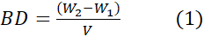
The particle density was determined by the specific gravity bottle method and the pore volume was obtained as the inverse relation of particle density (Horsfall et al., 2004). The porosity was calculated as the percentage ratio of the difference between the bulk volume (BV) and the gram volume (GV) to the bulk density (BD). It is given by the equation below.
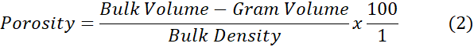

The cation exchange capacity (CEC) of the cocoa pod husk was determined by the ammonium acetate saturation procedure (Horsfall et al., 2004). In this method, a 1.0g sample of the husk was dispersed in 1M sodium acetate solution. The resulting suspension was mixed with 1M ammonium acetate and mechanically stirred at room temperature for 1h and centrifuged at 2800 –xg for 5 minutes to extract the N_{a}⁺ ions. The extracted N_{a}⁺ concentration of the solution was determined by flame atomic adsorption spectroscopy (FAAS).
The specific surface area (S_{AA}) of the adsorbent was determined using the methylene blue absorption test (MBT) method (Santamarian et al., 2002). 2.0g of the adsorbent was dissolved in 200 mL of deionized water and 10ppm of the methylene blue solution was added to the adsorbent suspension and agitated in a shaker for 2h. Thereafter, it was kept for 24h to reach equilibrium, after which 10ml aliquot was taken and centrifuged. The centrifuged aliquot was then analyzed using a UNICAM 8700 UV/visible spectrophotometer to determine the amount of methylene blue absorbed. Also, 20, 30, 40, 50, 60 and 70 ppm solutions of methylene blue were then added sequentially and the previous steps repeated. A graph of concentration of methylene blue added versus the amount of absorbed methylene blue was used to identify the point. The specific surface area was calculated from the amount of absorbed methylene blue at the optimum point of cation replacement as follows:
Where; mM_{B} is amount of methylene blue absorbed at the point of complete cation replacement; Ms is mass of adsorbent; Av is Avogadro’s number, 6.02 x 10²³; AMB is area covered by one methylene blue (assumed to be 130Å²). Then, the surface charge density (SCD) was calculated from the value of CEC and specific surface area as the ratio of the two given by:

The FT-IR spectra of cocoa pod husk (CPH) adsorbents were carried out by a method reported by Faramarzi, et al., (2023) and the morphology of cocoa pod husk (CPH) adsorbents was examined with a Scanning Electron Microscopy (SEM) according to the method reported by Tsai et al., (2020)

Equilibrium sorption of metal ions
Effect of particle size of adsorbent
Batch sorption tests were done using seven different particle sizes of <125, 125, 250, 425, 500, 600 and +850 μm. 1 gram of the adsorbent of a particular size was mixed with 100ml of metal ion solution of initial concentration 1000 mg/L. The mixture was left at 30ºC and pH of 7.5 on a rotary shaker at 100rpm for 1hr. The mixture was then filtered rapidly and the filtrate was analyzed for metal ion concentration.
Effect of Weight of adsorbent
Batch sorption tests were done at five different weights of 4, 6, 8, 10 and 15 grams of adsorbent of one particle size of 250μm. The initial concentration of metal ions was 1000 mg/L. The mixture was left at 30ºC and pH of 7.5 on a rotary shaker at 100rpm for 1hr. The mixture was then filtered rapidly and the filtrate was analyzed for metal ion concentration.
Effect of agitation speed
Batch sorption tests were done at four different speeds of agitation 100, 200, 300 and 400 rpm. The initial metal ion concentration was 1000 mg/L, weight of adsorbent used was 1gram and particle size was 250 μm. The mixture was left at 30ºC and pH of 7.5 on a rotary shaker at 100rpm for 1hr. The mixture was then filtered rapidly and the filtrate was analyzed for metal ion concentration.
Effect of Initial Concentration
Batch sorption experiments were performed at various initial metal ion concentration ranges of 50, 100, 200, 400, 600, 800, 1000 mg/L. The particle size used was 250µm of unmodified adsorbent. Weight of adsorbent used was 1 gram. 100 mL of the metal ion solution was added to 1 gram of the adsorbent and left in a rotary shaker at 100rpm for 1hr at pH of 7.5 and temperature of 30ºC. The mixture was filtered and the metal ion concentration in the filtrate was determined.
In each set of experiments, the metal ion concentration was determined using a UNICAM 919 solar atomic absorption spectrophotometer (AAS). Blank solutions without sorption process were also prepared and analyzed. The concentration of the metal ion was determined by the difference, using average values of triplicate readings.

RESULTS AND DISCUSSION
The amount of metal ions adsorbed per gram of adsorbent at equilibrium qe, (mg/g), was calculated using Equation (5).
Where, qe is the amount adsorbed (mg/g); V is the volume of the solution (L); C_{o} is the initial metal ion concentration (mg/L); C_{e} is the metal ion concentration in the filtrate (mg/L) and m is the mass of adsorbent used (g).

Surface characterization
The results of the surface characteristics of the cocoa pod husk are presented on Table 1. From Table 1, it was observed that the specific surface area (S_{AA}) and the surface charge density (SCD) of the cocoa pod husk are very high, having values of 1.367 x 10²⁶ m²/g and 6.43 x 10²⁴ meq/m² respectively. These shows expected high adsorption capacity, especially if the mechanism of sorption is by ion exchange. An overview of experimental studies using biochar to adsorb ammonium and analysis of physical and chemical characteristics to determine the most important factors that influence adsorption capacity have been reported (Shenk et al., 2022).
Table 1: Surface Characteristics of Cocoa pod husk
Parameter | Value | Parameter | Value
Particles size | 250-600µm | Cation exchange capacity (CEC) | 88.0mg/100g
Bulk density (BD) | 0.398g/cm³ | Specific Surface Area (S_{AA}) | 1.367 x 10²⁵m²/g
Particle density (PD) | 0.426g/cm³ | Surface charge density (SCD) | 6.43 x 10²⁴ Meq/m²
Pore volume | 2.10cm³/g | pH | 7.12 (6.25*)
Porosity | 9.77%
*Value of pH after 24 hours.

The FT-IR spectra of dried unloaded and metal-loaded- cocoa pod husk adsorbents were carried out to obtain information on the nature of possible interactions between the functional groups of the cocoa pod husk and the metal ions. These spectra displayed a number of absorption peaks which indicates the complex nature of the adsorbents. The results of the possible functional groups are shown in Table 2.

Table 2: IR absorption bands and corresponding possible groups in the unmodified cocoa pod husk
Wave number (cm⁻¹) | Possible functional groups
3200-3600 | -OH and –NH
2850 -3100 | -CH
2240-2400 | -SH
1690-1760 | -C=O
1630-1680 | COO-and C=C
1080-1300 | -C-O and C-N

Adsorption in the IR region takes place due to the rotational and vibrational movements of the molecular groups and chemical bond of a molecule. The two fundamental vibrations are stretching, where the atoms stay in the same bound axis but the distance between atoms increases or decreases and deformation, where the positions of the atoms change relative to the original bond axis (Anagaw et al., 2025). The broad and strong band ranging from 3200-3600cm⁻¹ indicates the presence of -OH and -NH groups stretching frequency (Dai et al., 2023; Kassem et al., 2023; Pasieczna-Patkowska et al., 2025). The peaks observed at 2850-3100 cm⁻¹ can be assigned to asymmetric and symmetric-CH groups respectively (Faramarzi, et al., 2023; Portaccio et al., 2023). The peak at 2240-2400cm⁻¹ is characteristic of -SH group. The peaks located around 1690-1760cm⁻¹ is a characteristic of carbonyl –C=O stretching from carboxylic acid. The absorption bond around 1630-1680cm⁻¹ corresponds to the carboxylate (COO-) and C=C stretching that can be attributed to the aromatic C-C bond (Hadjiivanov et al., 2021; Shukla, 2025). The absorption bands around 1400-1600cm⁻¹ are assigned to aromatic skeletal vibration. The intense band at 1080 cm⁻¹ corresponds to the C-O of alcohols and carboxylic acids, while peaks around 1150-1250cm⁻¹ corresponds to phenolic hydroxyl group in lignin and the C-N of amides (Tew et al., 2022; Blindheim and Ruwoldt, 2023).
The results of SEM of the unmodified and Al ion loaded ummodified cocoa pod husk are shown in Figure 1a and b, respectively. The result shows a change in the surface morphology of the cocoa pod husk because of adsorption of the metal ions. The scanning electron micrographs of the unmodified cocoa pod husk (CPH) revealed a heterogeneous, fibrous surface with a combination of smooth and slightly rough texture characteristic of lignocellulosic biomass. The surface exhibited irregular pores, cavities, and inter-fibrillar spaces, which are typical of the structural arrangement of cellulose, hemicellulose, and lignin in natural plant materials (Tsai et al., 2020; Abou et al., 2024). These surface features indicate that the raw CPH possesses active sites and surface voids capable of accommodating adsorbate species, even though their accessibility and uniformity may be limited by the presence of natural waxes and bound organic matter.
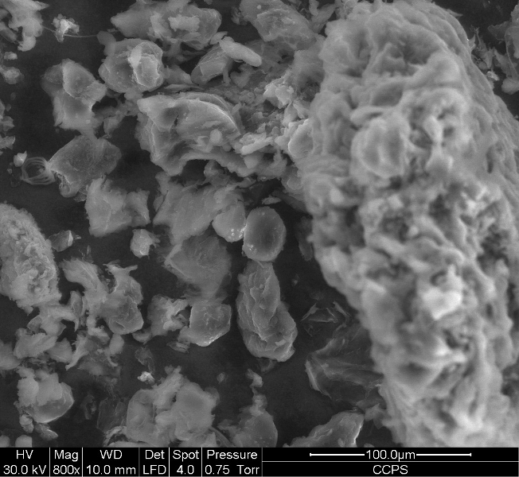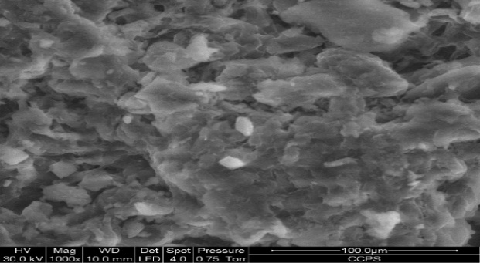
(a) (b)
Figure 1: Scanning Electron Microscopy (SEM) picture of (a) unmodified and unloaded cocoa pod husk; (b) Unmodified and Al (III) ion loaded cocoa pod husk.

After adsorption of Al³⁺ ions, distinct morphological changes were observed on the surface of the CPH. The SEM images of the Al³⁺-loaded CPH showed a reduction in surface roughness and partial clogging or blockage of pores, suggesting that aluminum ions had been successfully adsorbed onto the adsorbent surface and possibly deposited within available pores. The formerly clear fibrous and porous texture of the unmodified CPH became more compact and smoother after metal uptake, implying surface coverage by Al species and the formation of metal–ligand complexes between Al³⁺ ions and surface functional groups such as hydroxyl (–OH), carbonyl (C=O), and carboxyl (–COOH) moieties (Anoraga et al., 2024; Gomez et al., 2025). The visible alteration in morphology confirms that Al³⁺ adsorption was not merely a surface phenomenon, but likely involved both surface complexation and micro-pore diffusion. The formation of small agglomerates or bright patches observed on the loaded sample can be attributed to localized aluminum deposition. This observation supports FT-IR evidence that revealed shifts in O–H and C=O stretching bands, further confirming coordination of Al³⁺ ions to oxygen-containing functional groups on the biomass (Tsai et al., 2020).
Overall, the SEM results demonstrate that adsorption of Al³⁺ ions induces pronounced structural and textural changes on the cocoa pod husk surface. The observed differences between the unmodified and Al-loaded samples provide strong morphological evidence of successful adsorption and surface interaction between the metal ions and the CPH matrix. Such microstructural transformations are consistent with previous reports on metal-loaded lignocellulosic adsorbents, where metal binding leads to pore blockage, surface densification, and reduction in available adsorption sites (Anoraga et al., 2024; Abou et al., 2024).
Effect of particle size
The amount of metal ions adsorbed (mg/g) is plotted against the particle sizes (µm) of the adsorbent and is presented in Figure. 2.
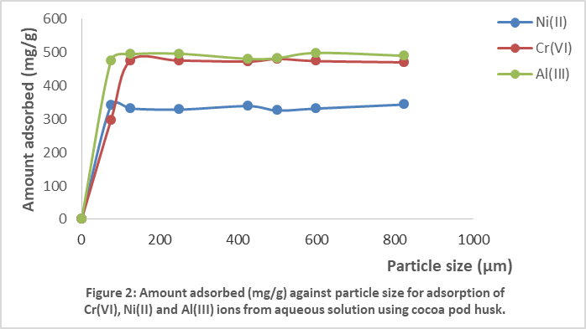
The amount of Al (III) ion adsorbed was higher followed by Cr (VI) ion and then Ni (II) ion. The range of particle sizes used did not have a significant influence on the amount adsorbed. Although this is contrary to expected for an intraparticle diffusion controlled process, it is necessary to point out that the thickness of the different particle sizes did not differ so much (dimension which determines the diffusion distance). This is so because size grading of ground biomass particle by standard sieves works on the length and width dimensions (He et al., 2022; Musheer et al., 2024). This behavior and effect of particle size on adsorption capacity has been reported by others (Kumkum and Kumar, 2024; Ullah and Rahman, 2024; Gence and Erdem, 2025). It has been reported that smaller particle size gives higher adsorption capacity. This can be attributed to the fact that as the size of the adsorbent decreases, the surface area of the adsorbent increases, thereby increasing the extent of adsorption (Rajendran and Mansiya, 2011; Rabiee Abyaneh et al., 2024).

Effect of weight (g) of adsorbent
The effect of adsorbent dose on the sorption process is shown on Figure 3. The amount adsorbed (mg/g) was plotted against the weight (g) of the adsorbent used. Again, Al (III) ion was adsorbed more than Cr (VI) followed by Ni (II) ion. Also, the weight of adsorbent had a slight influence on the amount adsorbed. As the weight of adsorbent was increased, the amount adsorbed increased slightly. The effect was more noticeable with the least ion adsorbed, which was Ni (II). Thus, we reasoned that the increase in weight of adsorbent did not have appreciable effect on the amount adsorbed because the initial dose of adsorbent (4 g) was enough to adsorb the concentration (1000 mg/l) of the metal ions used. Therefore, increase in adsorbent dose leaves some of the adsorbent sites in excess of what was required. Thus, no appreciable effect was observed in the amount adsorbed as adsorbent weight was increased beyond 6 g. Similar trends have been reported (Nasir et al., 2019; Ramkumar et al., 2021; Kinoti et al., 2024).

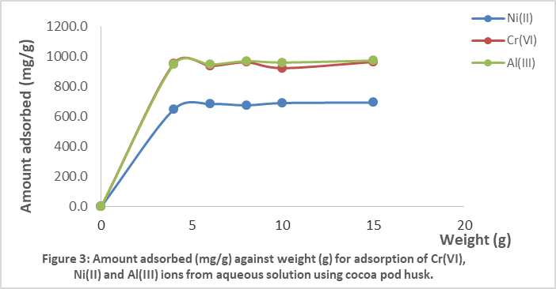

However, when adsorption capacity was converted to amount adsorbed per unit mass, adsorption density, it was found that as the adsorption dose was increased, the amount adsorbed per unit mass decreases. Similar results have been reported (Al-Ghouti & Da'ana, 2020; Li et al., 2022; Youssif et al., 2024; Saidi et al., 2025). The decrease in adsorption density with increase in the adsorbent dose is mainly because of unsaturation of adsorption sites through the adsorption process (Nasir et al., 2019; Ramkumar et al., 2021; Kinoti et al., 2024).

Effect of agitation speed
The influence of varying the agitation speed range was investigated for the sorption of Al (III), Cr (VI) and Ni (II) ions on cocoa pod husk. The other process variables were kept constant, while a series of experiments were undertaken with different agitation speeds of 100, 200, 300 and 400rpm. Figure 4 shows the plot of amount adsorbed (mg/g) for the metal ions against agitation speed for the sorption process. The variation in agitation speed appears to have only a small influence on the amount adsorbed for the metal ions. This could be due to the fact that better and more uniform mixing is achieved with increasing agitation or there may possibly be some boundary layer resistance to reaction which is decreased by increasing the agitation. The more agitation the greater is the shear on the boundary layer surrounding the particle (Chouchane et al., 2023, 2024). Generally, from Figure 4, Al (III) was adsorbed higher followed by Cr (VI) and then Ni (II) ion.
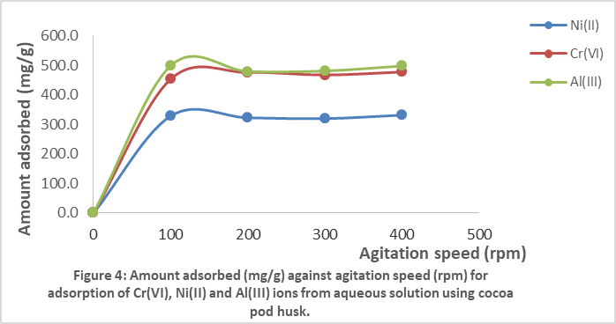

Effect of initial concentration
The experimental results for the effect of initial concentration is shown as amount adsorbed (mg/g) against initial concentration (mg/L) in Figure. 5. The results for two particle sizes of adsorbent (250 and 500 µm) are also shown.
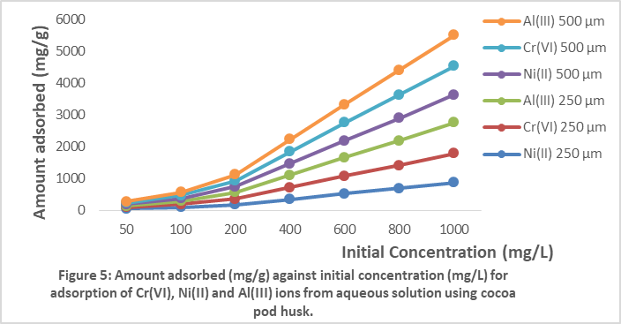

From this figure, it was observed that:
(i) Al (III) ion was adsorbed more than Cr (VI) ion, and then followed by Ni (II) ion.
(ii) The two particle sizes investigated had on significant influence on the amount adsorbed. This confirms the result obtained from effect of particle size above.
(iii) The amount adsorbed increased steadily from 50 mg/L to 200 mg/L initial concentration, then sharply from 200 mg/L to 1000 mg/L.
(iv) There was very high removal efficiency of the metal ions by the cocoa pos husk, as high as 94%.
(v) When converted into percentage, the amount adsorbed increases with initial concentration but percent removal actually decreases with increase in initial concentration.
The increase in amount adsorbed as initial metal ion concentration was increased has been reported (Acosta-Rodriguez et al., 2012; Dan et al., 2021). The increased uptake capacity and decreased percentage of metal ions removal as initial concentration was increased have been attributed to increase in the number of metal ions competing for the available functional groups or binding sites on the surface of the adsorbent (Li et al., 2022; Raji et al., 2024). The pattern of results obtained with the sorption of Al (III), Cr (VI) and Ni (II) ions on cocoa pod husk could be explained based on the modes of uptake of metal ions by cellulosic materials. The ionic diameters of the metal ions are given as Al³⁺ (67.0 pm), Cr³⁺ (75.0 pm) and Ni²⁺ (83.0 pm). It has been noted that the smaller the ionic diameter, the higher the adsorption rate (Li et al., 2022; Raji et al., 2024). This means that Al (III) ion which has the smallest ionic diameter will have the highest amount adsorbed and Ni (II) ion with the highest ionic diameter will have the least amount adsorbed. This is in agreement with the results of this study. Therefore, we can put the trend of sorption as Al (III) > Cr (VI) > Ni (II).
Also, the trend of sorption could be explained based on the trend of hydration energies of the metal ions (∆H_{hyd}). This is given as -4660 KJ/mol for Al³⁺, -4402 KJ/mol for Cr³⁺ and -2106 KJ/mol for Ni²⁺ (Fan et al., 2021; Long et al., 2023; Lee et al., 2025). Again, the trend of hydration energies confirms the trend of sorption of the metal ions on cocoa pod husk. Let the hydrolysis reaction of the metal ions be represented by the equation below:
The above equation is an overall equation for a reaction that essentially takes place in two steps which may be given as:
Where, n is 2 for Ni, 3 for Al and 6 for Cr. This means that in aqueous solutions before adsorption takes place, these reactions will occur. Therefore, the heavy metal that becomes more hydrolyzed will be the least adsorbed. Going by the hydration enthalpies of the metal ions given above, we expect and rightly too, that Ni²⁺ will be hydrolyzed more than Cr⁶⁺ and then Al³⁺, hence Al³⁺ is the more adsorbed followed by Cr⁶⁺ and then by Ni²⁺.

Adsorption Isotherm
Equilibrium adsorption isotherm is fundamentally important in the design of adsorption systems. Equilibrium studies in adsorption give the capacity of the sorbent. It is described by adsorption isotherm characterized by certain constants whose values express the surface properties and affinity of the adsorbent. Equilibrium relationships between adsorbent and adsorbate are described by adsorption isotherms, usually the ratio between the quantity adsorbed and that remaining in the solution at a fixed temperature at equilibrium (Abiodun et al., 2023). Therefore, in order to investigate the adsorption isotherm, the experimental results were fitted to six isotherms, which includes Langmuir (Guo and Wang, 2019) (Eq. 9), Freundlich (Al-Ghouti and Da'ana, 2020) (Eq. 10), Dubunin-Radushkevich (Wang and Guo, 2020) (Eq. 11), Temkin (Eq. 12) Harkins and Jura (H-J) (Eq. 13), and Flory-Huggins (F-H) (Eq. 14), (Hu et al., 2023) isotherms.

Langmuir isotherm
The Langmuir adsorption isotherm is one of the earliest isotherms to be used to model many pollutant sorption processes. It represents the equilibrium distribution of metal ions between the solid and liquid phases. The Langmuir isotherm is based on the following assumptions:
- Metal ions are chemically adsorbed at a fixed number of well-defined sites,
- Each site can hold one ion, that is monolayer coverage,
- All sites are energetically equivalent, and
- There is no interaction between the ions (Raji et al., 2023; Waqar et al., 2023)
When the initial metal concentration rises, adsorption increases while the binding sites are not saturated. The linearized Langmuir isotherm allows the calculation of adsorption capacities and the Langmuir constant and it is given as: 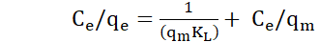 (9)
The linear plots of C_{e}/q_{e} against C_{e} are shown in Figure 6.
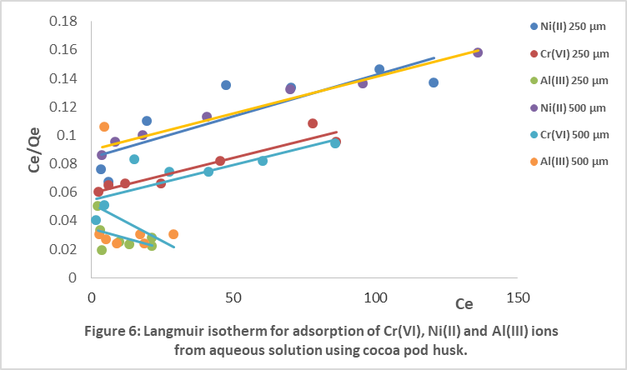

Freundlich isotherm
The Freundlich isotherm is an empirical equation after Freundlich (1906) (Hu et al., 2023). It was chosen to estimate the adsorption intensity and the linear form is given by Eq. (10):
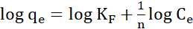 (10)
Where; K_{F} is the Freundlich isotherm constant; n is Freundlich exponent; C_{e} is equilibrium liquid phase concentration; q_{e} is equilibrium solid phase concentration. The plots of log q_{e} against log C_{e} for the sorption process is shown on Figure 7.
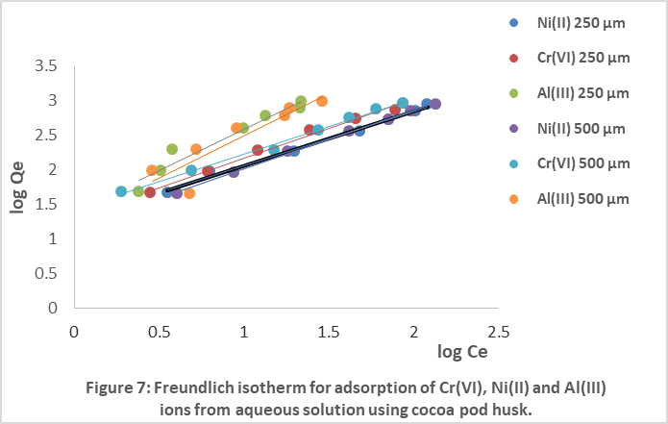
Dubinin-Radushkevich isotherm
This isotherm was chosen to estimate the characteristic porosity of the biomass and the apparent energy of adsorption. The linear form of the equation is given as (Wang and Guo, 2020):
(11)
Which is the same as:
(12)
Where; ; is defined as the Polanyi potential; β is related to the free energy of sorption per mole of the adsorbate as it migrates to the surface of the adsorbent from infinite distance in the solution; q_{m} is the Dubinin-Radushkevich isotherm constant related to the degree of sorbate sorption by the sorbent surface. The plots of ln q_{e} against [RT ln (1+1/C_{e}]² (ε²) is shown in Figure 8.
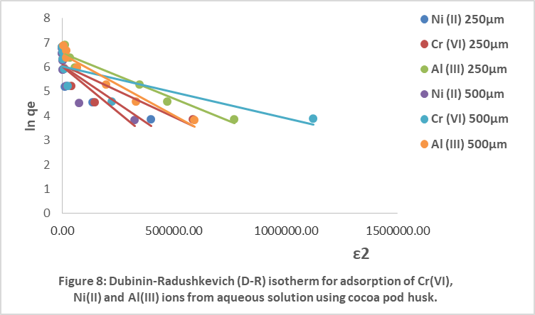
The values of q_{m} and β, calculated from the intercepts and slopes of the plots respectively were used to calculate the apparent energy of adsorption (E) from the Dubinin-Radushkevich isotherm, using equation (13) below;
E= 1/ (2β) ^{½} (13)
Temkin isotherm
The Temkin isotherm assumes that the fall in the heat of adsorption is linear rather than logarithmic as implied by the Freundlich equation. The linearized Temkin equation is given as (Hu et al., 2023):
(14)
Where; B = (RT/b); q_{e} (mg/g) and C_{e} (mg/L) are the amount adsorbed at equilibrium and the equilibrium effluent concentration respectively. Also, T is the absolute temperature (K) and R is the universal gas constant. The constant b is related to the heat of adsorption. The plot of q_{e} versus ln C_{e} for the Temkin isotherm is shown in Figure 9.
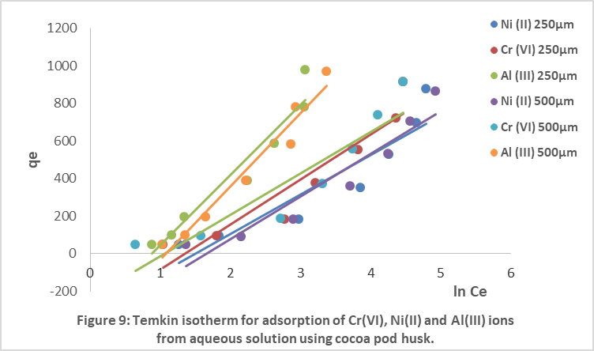
Harkins and Jura (H-J) isotherm
Another isotherm that was used in analysis of the experimental results is the Harkins and Jura (H-J) isotherm. The H-J isotherm accounts for multilayer adsorption and can be explained based on the existence of a heterogeneous pore distribution (Hu et al., 2023). The linear equation is given as:
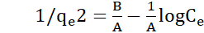 (15)
The plot of 1/q_{e}² versus log C_{e} for the H-J isotherm is shown in Figure 10.
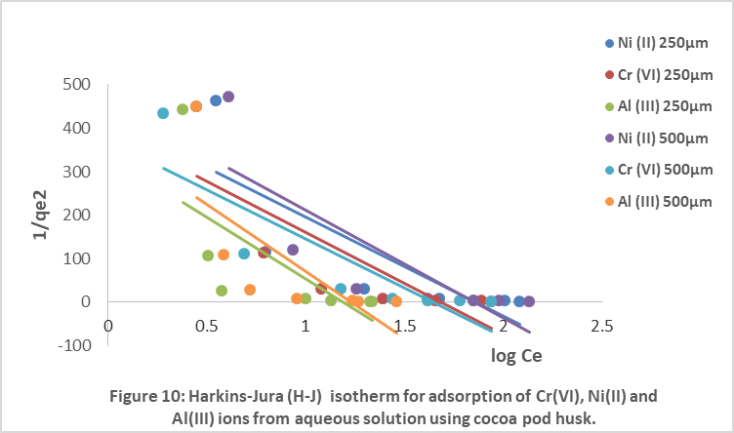

The constants for all the isotherms employed were evaluated and are shown on Table 2. The Langmuir constants q_{max} and K_{L} values for Al (III) are all negative. The values of K_{L} are greater for Cr (VI) ion than Ni (II) ion. The Freundlich isotherm constant (K_{F}) and exponent (n) were calculated from the intercept and slopes of the plots respectively, and are shown in Table 2. It could be seen from the isotherm model results, that Al (III) ion which was adsorbed more, had n values less than unity while Cr (VI) and Ni (II) had n values greater than unity. The n values between 1 and 10 shows easy separation beneficial adsorption. Oloo et al., (2024), obtained n values ranging from 1 to 4. Also, the magnitude of K_{F} and n shows easy separation of metal ions from wastewater and high adsorption capacity. The value of n, which is related to the distribution of bonded ions on the sorbent surface (Li et al., 2022), was found to be greater than unity for Cr (VI) and Ni (II) ions indicating that their adsorption was favourable. Again, the higher the K_{F} value, the higher the adsorption intensity.
Also shown on the same Table 2 is the sorption capacity (q_{m}) from the Dubinin-Radushkevich isotherm. The higher the value of q_{m,} the higher the sorption capacity. The experimentally derived (qm) values for Al(III) was higher than those of Ni(II) and Cr(VI), indicating a higher sorption capacity and suggesting that the sorbent has a more favorable coordination or affinity toward Al(III) species under the operational conditions. Again, shown on Table 2 is the apparent energy of adsorption (E) from the Dubinin-Radushkevich isotherm. The corresponding apparent adsorption energies are extraordinarily large (ranging from ~250 to ~500 kJ mol⁻¹), far above conventional thresholds commonly used to distinguish physisorption or simple ion exchange (e.g. < 8 kJ mol⁻¹ for physisorption, 8–16 kJ mol⁻¹ for ion exchange, > 40 kJ mol⁻¹ for chemisorption) (Aziam et al., 2024; Youssif et al., 2024). According to such a scheme, the results of this study fall into the chemisorption regime. However, given that these magnitudes approach or exceed typical energies of strong chemical bonds, it is sensible to interpret them as apparent values reflecting contributions from more complex interactions; such as surface complexation, ligand exchange, or structural reorganization; rather than purely classic chemisorption (Youssif et al., 2024). Therefore, this date strongly suggests that that adsorption steps are not governed by weak van der Waals forces. The use of D-R isotherm to model sorption of metal ions using different adsorbents has been reported (Aziam et al., 2024; Youssif et al., 2024).
From the plots of the Temkin and the H-J isotherms, the isotherm constants were calculated from the slopes and intercepts of linear regression line of the plots. The values of the various isotherm constants for the two isotherms are also shown on Table 2. The values of A, the sorption capacity obtained from the Temkin isotherm were higher than those obtained from the H-J isotherm. Also, the values of B were higher for the Temkin isotherm than the H-J isotherm. It has been reported that the Temkin and H-J isotherm are suitable for multilayer adsorption. Especially, the fitting of these equations can be seen in heterogeneous solids. These isotherms have been used to model sorption experimental data (Garbalińska et al., 2021; Rajahmundry et al., 2021; Magdy et al., 2024; Suwannahong et al., 2024). The values of A, the sorption capacity obtained from the Temkin isotherm were higher than those obtained from the H-J isotherm. Also, the values of B were higher for the Temkin isotherm than the H-J isotherm. It has been reported that the Temkin and H-J isotherm are suitable for multilayer adsorption, especially; the fitting of these equations can be seen in heterogeneous solids. These isotherms have been used to model sorption experimental data (Garbalińska et al., 2021; Rajahmundry et al., 2021).
The coefficients of determination (R²) for the six isotherms are also shown in Table 2. The R² values from the Langmuir model for Al (III) ion are very poor; 0.2035 and 0.114 for 250 μm and 500 μm cocoa pod husk respectively. The R² values for the Freundlich isotherm, are all above 94% except for Al(III) on particle size of 500 µm, which gave 81%, hence, this means that the Freundlich isotherm gave a good fit to the experimental adsorption data. The results of these isotherm models show that the Freundlich isotherm, gave the best fit to the sorption data, comparing favourable with the experimental plots. Many authors have found and reported Freundlich isotherm model as giving a best fit to sorption experimental data (Kowanga et al., 2016; Li et al., 2022). The Freundlich isotherm has been reported to be used to describe non-monolayer adsorption that occurs on the non-uniform surface of the adsorbent (Afroze et al., 2016; An et al., 2017). The coefficient of linear regression (R²) for all the isotherms and the isotherm constants were calculated from the slopes and intercepts of the linear plots and are shown in Table 2. The R² values from Table 2 confirm that the Freundlich isotherm gave the best fit. Therefore, the trend of fitness of the isotherm models was found as Freundlich> Temkin >Dubinin-Radushkevich (D-R) > Langmuir > Harkins-Jura (H-J) > Flurry-Huggins (F-H).

Table 2: Adsorption isotherm constants for Ni (II), Cr (VI) and Al (III) ions from aqueous solution using cocoa pod husk
S/N | Isotherm constants | 250 μm |  |  | 500 μm
S/N | Isotherm constants | Ni (II) | Cr (VI) | Al (III) | Ni (II) | Cr (VI) | Al (III)
1  2  3  4  5 | Freundlich  K_{F} (L g⁻¹)  n  R²  Langmuir  q_{max} (mg/g)  K_{L}  R²  D-R  β  q_{m}  E (KJmol⁻¹)  R²  Temkin  A  B  R²  H-J  A  B  R² | 18.74  1.28  0.9925  1666.67  7.13x10⁻³  0.7260  6.0x10⁻⁶  433.50  288.68  0.7263  0.22  210.61  0.8560  4.35x10⁻³  1.86  0.6663 | 20.88  1.18  0.9916  2000.00  8.48x10⁻³  0.9052  4.0x10⁻⁶  442.17  353.55  0.6932  0.26  241.31  0.8857  4.27x10⁻³  1.69  0.6479 | 24.84  0.84  0.9453  -1666.67  -0.017  0.2035  4.0x10⁻⁶  709.32  353.55  0.9483  0.42  373.57  0.9366  3.52x10⁻³  1.19  0.4939 | 14.67  1.18  0.9980  2000.00  5.58x10⁻³  0.9773  8.0x10⁻⁶  417.72  250.00  0.6804  0.19  227.91  0.9075  4.01x10⁻³  1.85  0.6653 | 26.80  1.26  0.9913  2000.00  9.21x10⁻³  0.6491  2.0x10⁻⁶  419.35  500.00  0.6350  0.35  220.96  0.8484  4.42x10⁻³  1.65  0.7393 | 18.80  0.82  0.8164  -1000.00  -0.019  0.1140  5.0x10⁻⁶  691.25  316.23  0.9400  0.34  391.69  0.9598  3.25x10⁻³  1.23  0.5114

Surface Coverage (θ)
The surface coverage was used to investigate the extent of coverage on the surface of the adsorbent by the adsorbate during adsorption studies. It is given by Equation (16).
θ = (1 – Ce/Co) (16)
The plot of surface coverage (θ) versus initial concentration (C_{o}) is shown in Figure 11.
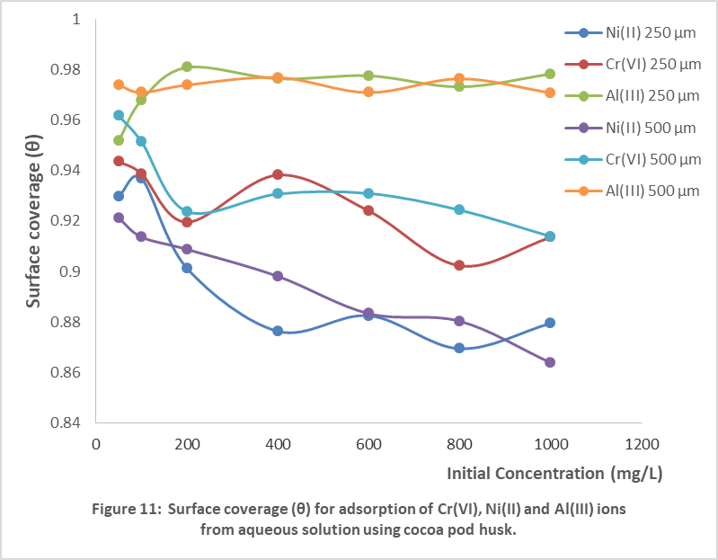
Surface coverage was affected by initial concentration. At lower concentrations, the surface coverage was higher than at higher concentrations. This means that as the initial concentration was increased, the surface coverage decreases. This is because, as the initial concentration was increased, there will be available, more adsorbate molecules but less surface for the adsorption as most of the adsorbent surface would have been covered. Al (III) had higher values followed by Cr (VI) and the Ni (II). Also, for any particular metal, there was not much difference between the particle sizes of 250 µm and 500 µm. The concept of surface coverage (θ), defined as the fraction of adsorption sites or surface area occupied by adsorbate; has been widely repprted in adsorption studies of metal ions (Tehrani et al., 2021; Morrison et al., 2022; Piasecki and Lament, 2024).
Generally, adsorption isotherm equations have been employed in the modeling of equilibrium adsorption data (Al-Ghouti and Da'ana, 2020; Alacabey, 2022; Murtala et al., 2022; Harabi et al., 2024; Sunartaty, et al., 2024). The non-linear equations of these isotherms as shown below, were used to model the equilibrium data to confirm the isotherm that best fits the data and predict the variation of amount adsorbed and amount remaining in solution.

STATISTICAL ANALYSIS
Furthermore, to investigate the significance of the various isotherms used in the sorption studies, the heavy metals were taken as objects or blocks and R² values for the isotherms as variables or treatments (Suwannahong et al., 2024). A two-way analysis of variance (ANOVA) without replication at the 5% level of significance was used to describe the relationships (1) between the five isotherms in describing the adsorption of the three metal ions on the biomass and the three metal ions on the biomass and (2) between the three metal ions for binding sites on the biomass; for both 250 μm and 500 μm particle sizes. The results are shown in Table 3.

Table 3: Two-way analysis of variance (ANOVA) without replication at p < 0.05 for Ni (II), Cr (VI) and Al (III) ions from aqueous solution using cocoa pod husk
Source of variation | df | ss | ms | F_{cal} | F_{Tab}
250 μm
Isotherm models  Metal ions  Error | 4  2  8 | 0.27864627  0.091157209  0.308288393 | 0.069661567  0.045578604  0.038536049 | 1.808  1.183 | 3.11  3.74
Total | 14 | 0.678091872
500 μm
Isotherm models  Metal ions  Error | 4  2  8 | 0.29674795  0.145509081  0.342878786 | 0.074186987  0.07275454  0.042857848 | 1.731  1.700 | 3.11  3.74
Total | 14 | 0.785135817

The data from Table 3 shows that there is no significant difference in the fitness of the various isotherms to the sorption studies for both 250 μm and 500 μm particle sizes. Also, from Table 3, it could be seen that there is no significant difference in the sorption affinity of the metal ions onto the two particle sizes of the adsorbent. Therefore, in as much as one can say that the isotherms are appropriate in their own merits in describing the potential of cocoa pod husk for removal of Al (III), Cr (VI) and Ni (II) ions, we can also conclude from the R² values that the fitness of the isotherms could be given as Freundlich > Temkin> D-R > Langmuir > H-J > F-H isotherms, and that the differences in the isotherm performance were not significant.

CONCLUSION
Cocoa pod husk is an agricultural by-product, a waste in the processing of cocoa fruit. In this study, it has been found to be a good adsorbent for the removal of Al (III), Cr (VI) and Ni (II) ions from aqueous solutions. It was found out that the adsorption capacity of this adsorbent for these metal ions were very high. Among the five adsorption isotherms tested, and according to the average R² values, Freundlich isotherm gave the best fit, followed by the Temkin isotherm, followed by the D-R isotherm, followed by the Langmuir isotherm, followed by H-J isotherm and then the F-H isotherm. The ability to recover the metal ions from the loaded adsorbent, hence regenerating the adsorbent is another important aspect of this research that is to be investigated. This will help to reduce the discharge of the metal loaded adsorbent into the environment and also, maximize the process efficiency and minimize the cost of the remediation process. Also the use of these adsorbents can be extended to other heavy metals not studied here.

ACKNOWLEDGEMENT
The authors wish to thank the Tertiary Education Trust Fund (TETFUND), Federal Ministry of Education, Nigeria for the support of this research through IBRF research intervention fund (TETFund/IBR/ABSU/2024/033) to Agbai, Johnson U.

REFERENCE
Abiodun, O.-A. O., Oluwaseun, O., Oladayo, O. K., Abayomi, O., George, A. A., Opatola, E., Orah, R. F., Isukuru, E. J., Ede, I. C., Oluwayomi, O. T., Okolie, J. A., & Omotayo, I. A. (2023). Remediation of Heavy Metals Using Biomass-Based Adsorbents: Adsorption Kinetics and Isotherm Models. Clean Technologies, 5(3), 934-960. https://doi.org/10.3390/cleantechnol5030047.
Abou Alfa, K., Meza-Sepulveda, D. C., Vaulot, C., Le Meins, J.-M., Ghimbeu, C. M., Tonini, L., Cubillos, J. A., Moynault, L., Platel, V., Paredes, D., & Hort, C. (2024). Cocoa Pod Husk Carbon Family for Biogas Upgrading: Preliminary Assessment Using the Approximate Adsorption Performance Indicator. J. of Carbon Research, 10(4), 100. https://doi.org/10.3390/c10040100.
Acosta-Rodriquez 1., R. Martinez-Perez, J.F. Cardenas-Gonzalez, M. Moctezuma- Zarate and V.M. Martinez-Juarez (2012). Hexavalent chromium Removal by litchi chinensis sonn peel. American Journal of Biochemistry and Biotechnology 8(1): 7-13.
Adegoke, K.A., Akinnawo, S.O., Adebusuyi, T.A., Ajala, O.A., Adegoke, R.O., Maxakato, N. W. and Bello, O.S. (2023). “Modified biomass adsorbents for removal of organic pollutants: a review of batch and optimization studies.” International Journal of Environmental Science and Technology, 2, 11615–11644.
Afroze, S., Sen, T.K. & Ang, H.M. (2016). Adsorption removal of zinc (II) from aqueous phase by raw and base modified Eucalyptus sheathiana bark: Kinetics, mechanism and equilibrium study. Process Saf. Environ. Prot., 102, 336–352.
Alacabey İ. (2022). Endosulfan Elimination Using Amine-Modified Magnetic Diatomite as an Adsorbent. Front. Chem. 10, 907302. doi: 10.3389/fchem.2022.907302.
Al-Ghouti M.A. & Da'ana D.A. (2020). Guidelines for the use and interpretation of adsorption isotherm models: A review, Journal of Hazardous Materials, 393, 122383.
An, F.-Q., Wu, R.-Y., Li, M., Hu, T.-P., Gao, J.-F. & Yuan, Z.-G. (2017). Adsorption of heavy metal ions by iminodiacetic acid functionalized D301 resin: Kinetics, isotherms and thermodynamics. React. Funct. Polym., 118, 42–50.
Anagaw, Y.K., Bizuneh, G.K., Feleke, M.G., Limenh, LW., Geremew, D.T., Worku, M.C., Mitku, M.L., Dessie, M.G., Mekonnen, B.A. and Ayenew, W. (2025). Application of Fourier transform infrared spectroscopy on Breast cancer diagnosis combined with multiple algorithms: A systematic review, Photodiagnosis and Photodynamic Therapy, 53, 104579. https://doi.org/10.1016/j.pdpdt.2025.104579.
Anoraga SB, Shamsudin R, Hamzah MH, Sharif S, Saputro AD. (2024). Cocoa by-products: A comprehensive review on potential uses, waste management, and emerging green technologies for cocoa pod husk utilization. Heliyon. 10(16), e35537. doi: 10.1016/j.heliyon.2024.e35537.
Aziam, R., Stefan, D. S., Nouaa, S., Chiban, M., & Boșomoiu, M. (2024). Adsorption of Metal Ions from Single and Binary Aqueous Systems on Bio-Nanocomposite, Alginate-Clay. Nanomaterials, 14(4), 362. https://doi.org/10.3390/nano14040362.
Balali-Mood, M., Naseri, K., Tahergorabi, Z., Khazdair, M. R., & Sadeghi, M. (2021). Toxic mechanisms of five heavy metals: Mercury, lead, chromium, cadmium, and arsenic. Frontiers in Pharmacology, 12, 643972.
Bittencourt LO, Damasceno-Silva RD, Aragão WAB, Eiró-Quirino L, Oliveira ACA, Fernandes RM, Freire MAM, Cartágenes SC, Dionizio A, Buzalaf MAR, Cassoli JS, Cirovic A, Cirovic A, Maia CDSF, Lima RR. (2022). Global Proteomic Profile of Aluminum-Induced Hippocampal Impairments in Rats: Are Low Doses of Aluminum Really Safe? Int J Mol Sci. 23(20), 12523. doi: 10.3390/ijms232012523.
Blindheim, F. H., & Ruwoldt, J. (2023). The Effect of Sample Preparation Techniques on Lignin Fourier Transform Infrared Spectroscopy. Polymers, 15(13), 2901. https://doi.org/10.3390/polym15132901
Chen S., Q. Yue, B. Gao, Q. Li and X. Xu (2011). Removal of Cr (VI) from aqueous solution using modified corn stalks: Characteristics, equilibrium, kinetic and thermodynamic study, Chem. Eng. J., 168, 909-917.
Chouchane, T. , Abedghars, M. T. , Chouchane, S. and Boukari, A. (2024). Synthesis of hydroxyapatite-zeolite from blast furnace slag and its application for the removal of copper, lead and copper-lead mixture by adsorption. Advances in Environmental Technology, 10(4), 339-359. doi: 10.22104/aet.2024.1464
Chouchane, T., Boukari, A., Khireddine, O., Chibani, S., & Sabiha Chouchane. (2023). Equilibrium, kinetics, and thermodynamics of batch adsorption of Mn(II) ions on blast furnace slag (BFS) and kaolin (KGA). J. Eng. Appl. Sci. 70, 58. https://doi.org/10.1186/s44147-023-00218-4.
Coulson J.M, Hughes B.W. (2022). Dose-response relationships in aluminium toxicity in humans. Clin Toxicol (Phila). 60(4), 415-428. doi: 10.1080/15563650.2022.2029879.
Dai F, Zhuang Q, Huang G, Deng H, Zhang X. (2023). Infrared Spectrum Characteristics and Quantification of OH Groups in Coal. ACS Omega. 8(19):17064-17076. doi: 10.1021/acsomega.3c01336
Dan, Y., Xu, L., Qiang, Z., Dong, H.& Shi, H. (2021). Preparation of green biosorbent using rice hull to preconcentrate, remove and recover heavy metal and other metal elements from water. Chemosphere, 262, 127940.
Das, K. K., Das, S. N., & Dhundasi, S. A. (2019). Nickel, its adverse health effects & oxidative stress. Indian Journal of Medical Research, 128(4), 412–425.
Dey M. and Singh R.K. (2022a). Neurotoxic effects of aluminium exposure as a potential risk factor for Alzheimer's disease. Pharmacol Rep. 74(3), 439-450. doi: 10.1007/s43440-022-00353-4.
Dey M. and Singh RK. (2022b). Chronic oral exposure of aluminum chloride in rat modulates molecular and functional neurotoxic markers relevant to Alzheimer's disease. Toxicol Mech Methods 32(8), 616-627. doi: 10.1080/15376516.2022.2058898.
Ezeabasili, A. C. C., Anike, O. L., Okoro, B. U., & Obiadi, I. I. (2014). Assessment of heavy metals in drinking water sources in Anambra State, Nigeria. Journal of Environmental Science, Toxicology and Food Technology, 8(7), 20–29.
Fan, X., Liu, H., Anang, E., & Ren, D. (2021). Effects of Electronegativity and Hydration Energy on the Selective Adsorption of Heavy Metal Ions by Synthetic NaX Zeolite. Materials, 14(15), 4066. https://doi.org/10.3390/ma14154066.
Faramarzi, B., Moggio, M., Diano, N., Portaccio, M., & Lepore, M. (2023). A Brief Review of FT-IR Spectroscopy Studies of Sphingolipids in Human Cells. Biophysica, 3(1), 158-180. https://doi.org/10.3390/biophysica3010011
Garbalińska, H., Bochenek, M., & Stasiak, M. (2021). Experimental and Modeling Investigations on the Water Sorption Behaviors of Autoclaved Aerated Concrete. Materials, 14(21), 6235. https://doi.org/10.3390/ma14216235.
Gence, C. Ç., & Erdem, H. (2025). Determination of NH₄⁺ and NO₃⁻ Adsorption and Desorption Capacities of Biochars Produced at Different Temperatures. Turkish Journal of Agriculture-Food Science and Technology, 13(4), 985–990. https://doi.org/10.24925/turjaf.v13i4.985-990.7409.
Gomez, P., Reyes, C., & Figueroa, J. G. (2025). Microwave-Assisted Extraction of Phenolic Compounds from Cocoa Pod Husk: Process Optimization and Impact of Drying Temperature on Bioactive Recovery. Molecules, 30(17), 3497. https://doi.org/10.3390/molecules30173497.
Guo, X. & Wang, J. (2019). Comparison of linearization methods for modeling the Langmuir adsorption isotherm, Journal of Molecular Liquids, 296, 111850.
Hadjiivanov K.I, Panayotov D.A, Mihaylov M.Y, Ivanova E.Z, Chakarova K.K, Andonova S.M, Drenchev N.L. (2021). Power of Infrared and Raman Spectroscopies to Characterize Metal-Organic Frameworks and Investigate Their Interaction with Guest Molecules. Chem Rev. 121(3):1286-1424. doi: 10.1021/acs.chemrev.0c00487.
Harabi, S., Guiza, S., Alvarez-Montero, A., Gomez-Aviles, A., Bagane, M., Belver, C. & Bedia, J. (2024). Adsorption of Pesticides on Activated Carbons from Peach Stones. Processes, 12, 238 -255.
Hayat M., Khola N.U.H., Ahmed T.A. (2025). Systematic Review of Preclinical Studies Investigating the Effects of Pharmacological Agents on Learning and Memory in Prolonged Aluminum-Exposure-Induced Neurotoxicity. Brain Sci. 15(8), 849. doi: 10.3390/brainsci15080849.
He, Z., Cao, H., Liang, J., Hu, Q., Zhang, Y., Nan, X., & Li, Z. (2022). Effects of Biochar Particle Size on Sorption and Desorption Behavior of NH4+-N.” Industrial Crops and Products, 189, 115837, 2022, https://doi.org/10.1016/j.indcrop.2022.115837.
Horsfall, M. Jnr.; Spiff, A.I. and Abia, A.A. (2004). Studies on the influence of mercaptoacetic acid (MAA) modification of cassava (manihot sculenta cranz) waste biomass on the Adsorption of Cu²⁺ and Cd²⁺ from Aqueous solution. Bull. Korean Chem. Soc., 25(7), 969-976.
Hu, Q., Lan, R., He, L., Liu, H. & Pei, X. (2023). A critical review of adsorption isotherm models for aqueous contaminants: Curve characteristics, site energy distribution and common controversies, Journal of Environmental Management, 329, 117104.
Huat T.J, Camats-Perna J, Newcombe E.A, Valmas N, Kitazawa M, Medeiros R. (2019). Metal Toxicity Links to Alzheimer's Disease and Neuroinflammation. J Mol Biol. 431(9), 1843-1868. doi: 10.1016/j.jmb.2019.01.018.
Igbokwe I.O, Igwenagu E. and Igbokwe N.A. (2020). Aluminium toxicosis: a review of toxic actions and effects. Interdiscip Toxicol. 12(2), 45-70. doi: 10.2478/intox-2019-0007.
Ijomone, O. K., Ukwubile, I. I., Aneke, V. O., Olajide, T. S., Inyang, H. O., Omotosho, O. I., Oyerinde, T. O., Anadu, V. E., Gbayisomore, T. J., Okeowo, O. M., Oyeniran, D. A., Ogundahunsi, O. A. T., & Ijomone, O. M. (2025). Glial Perturbation in Metal Neurotoxicity: Implications for Brain Disorders. Neuroglia, 6(1), 4. https://doi.org/10.3390/neuroglia6010004
Jaishankar, M., Tseten, T., Anbalagan, N., Mathew, B. B., & Beeregowda, K. N. (2014). Toxicity, mechanism and health effects of some heavy metals. Interdisciplinary Toxicology, 7(2), 60–72.
Karzegar S., Abedi M., Salmani M.J., Askrishahi, M., Babaei, F. and Salmani, M.H. (2024). Modification of Agricultural Wastes Carbon Adsorbents with Iron and Iron Oxides Nanoparticles for Heavy Metals Removal: A Scoping Review of the Literature. J Environ Health Sustain Dev. 9(4), 405-415
Kassem A, Abbas L, Coutinho O, Opara S, Najaf H, Kasperek D, Pokhrel K, Li X, Tiquia-Arashiro S. (2023). Applications of Fourier Transform-Infrared spectroscopy in microbial cell biology and environmental microbiology: advances, challenges, and future perspectives. Front Microbiol. 14, 1304081. doi: 10.3389/fmicb.2023.1304081.
Kaur, A., & Sharma, S. (2015). Neurotoxic effects of aluminium. Advances in Neurobiology, 10, 217–231.
Kinoti I. K., Marangu J.M., M’thiruaine C. M. (2024). Equilibrium and Thermodynamic Studies on Biosorption of Pb (II) and Cd (II) Ions from Wastewater onto Clay Cellulose Nanocomposite Adsorbent, J. Mater. Environ. Sci., 15(1), 116-135
Kondaiah, G., U. Srineetha, D. Veera Nagendra Kumar, and C. Narasimha Rao. (2024). “Aluminium Toxicity Affects Different Organisms: A Mini Review”. Uttar Pradesh Journal of Zoology 45 (16), 64-73. https://doi.org/10.56557/upjoz/2024/v45i16428.
Kowanga, K.D., Gatebe, E., Mauti, G.O. & Mauti, E.M. (2016). Kinetic, sorption isotherms, pseudo-first-order model and pseudo-second-order model studies of Cu(II) and Pb(II) using defatted Moringa oleifera seed powder, The Journal of Phytopharmacology 5(2), 71-78.
Kumkum, P., & Kumar, S. (2024). A Review on Biochar as an Adsorbent for Pb(II) Removal from Water. Biomass, 4(2), 243-272. https://doi.org/10.3390/biomass4020012.
Lee, S., Lee, H., Hwang, H., Seoung, D., Kim, H., Kim, P. and Lee, Y. (2025). Relationship Between Electronegativity of the Extra-Framework Cations and Adsorption Capacity for CO₂ Gas on Mordenite Framework Inorganic Chemistry 64 (2), 903-910. DOI: 10.1021/acs.inorgchem.4c04062.
Li, J., Dong, X., Liu, X., Xu, X., Duan, W., Park, J., Gao, L. & Lu, Y. (2022). Comparative Study on the Adsorption Characteristics of Heavy Metal Ions by Activated Carbon and Selected Natural Adsorbents. Sustainability, 14, 15579-15596.
Liu, G., Dai, Z., Liu, X., Dahlgren, R.A. and Xu, J. (2022). Modification of agricultural wastes to improve sorption capacities for pollutant removal from water – a review. Carbon Research 1, 24. https://doi.org/10.1007/s44246-022-00025-1
Long X, Zhang R, Rong R, Wu P, Chen S, Ao J, An L, Fu Y, Xie H. (2023). Adsorption Characteristics of Heavy Metals Pb²⁺ and Zn²⁺ by Magnetic Biochar Obtained from Modified AMD Sludge. Toxics. 11(7):590. doi: 10.3390/toxics11070590.
Magdy A, Mostafa MR, Moustafa SA, Mohamed GG, Fouad OA. (2024). Kinetics and adsorption isotherms studies for the effective removal of Evans blue dye from an aqueous solution utilizing forsterite nanoparticles. Sci Rep. 14(1), 24392. doi: 10.1038/s41598-024-73697-x.
Medellín-Castillo, N. A., Cruz-Briano, S. A., Leyva-Ramos, R., Moreno-Piraján, J. C., Torres-Dosal, A., Giraldo-Gutiérrez, L., et al. (2020). Use of bone char prepared from an invasive species, pleco fish (Pterygoplichthys spp.), to remove fluoride and Cadmium (II) in water. J. Environ. Manag. 256, 109956. doi:10.1016/j.jenvman.2019. 109956.
Morrison A.R.T, Ramdin M, van der Broeke L.J.P, de Jong W, Vlugt T.J.H, Kortlever R. (2022). Surface Coverage as an Important Parameter for Predicting Selectivity Trends in Electrochemical CO₂ Reduction. J Phys Chem C Nanomater Interfaces. 126(29), 11927-11936. doi: 10.1021/acs.jpcc.2c00520.
Murtala, M.A., Aminu, K.R., Sanusi K.A. & Abdurrahman, B. (2022). Adsorption of Pesticides from Aqueous Solution using Kinkeliba (Combretum micranthum G.) Derived Activated Carbon International Journal of Sciences: Basic and Applied Research (IJSBAR) 63(2), 308-319.
Musheer, N., Yusuf, M., Choudhary, A. and Shahid. M. (2024). Recent Advances in Heavy Metal Remediation Using Biomass-Derived Carbon Materials, Adv. J. Chem. B: Nat. Prod. Med. Chem., 6, 281-342.
Nasir, A. M., Goh, P. S., Abdullah, M. S., Ng, B. C., & Ismail, A. F. (2019). Adsorptive nanocomposite membranes for heavy metal remediation: Recent progresses and challenges. Chemosphere, 232, 96–112. https://doi.org/10.1016/J.CHEMOSPHERE.2019.05.174
Oloo, C.O., Nthiga E, W., Onyancha, D. & Muthakia, G.K. (2024). Kinetic and Isotherm Modelling of adsorption of Cr3+ metal ions from Tannery wastewater on to unmodified and acid-modified Arabica coffee husks biosorbents Asian J. Research Chem.17(1), 1-5.
Oluwafemi, O. S., Adewumi, J. R., & Bamigboye, G. O. (2019). Hydrogeochemical assessment of hand-dug well water quality in Ogun State, Nigeria. Applied Water Science, 9, 188.
Pasieczna-Patkowska, S., Cichy, M., and Flieger, J. (2025). Application of Fourier Transform Infrared (FTIR) Spectroscopy in Characterization of Green Synthesized Nanoparticles. Molecules, 30(3), 684. https://doi.org/10.3390/molecules30030684.
Piasecki, W. and Lament, K. (2024). Application of Surface Complexation Modeling to Investigate the Mechanism of Cu²⁺ Adsorption on TiO₂, Al₂O₃, and SiO₂ Under High Surface Coverage. Molecules 29, 5595, https://doi.org/10.3390/molecules29235595.
Piccirillo, C. (2023). Preparation, characterisation and applications of bone char, a food waste-derived sustainable material: a review. J. Environ. Manag. 339, 117896. doi:10.1016/j.jenvman.2023.117896.
Portaccio, M., Faramarzi, B., & Lepore, M. (2023). Probing Biochemical Differences in Lipid Components of Human Cells by Means of ATR-FTIR Spectroscopy. Biophysica, 3(3), 524-538. https://doi.org/10.3390/biophysica3030035
Praipipat, P., Ngamsurach, P., and Roopkhan, N. (2023). Zeolite A powder and beads from sugarcane bagasse fly ash modified with iron(III) oxide-hydroxide for lead adsorption. Sci. Rep. 13 (1), 1873. doi:10.1038/s41598-023-29055-4.
Rabiee Abyaneh, M., Nabi Bidhendi, G. & Daryabeigi Z and, A. (2024). Pb(ΙΙ), Cd(ΙΙ), and Mn(ΙΙ) adsorption onto pruning-derived biochar: physicochemical characterization, modeling and application in real landfill leachate. Sci Rep 14, 3426. https://doi.org/10.1038/s41598-024-54028-6.
Rahman, A. (2024). Promising and environmentally friendly removal of copper, zinc, cadmium, and lead from wastewater using modified shrimp-based chitosan. Water 16 (1), 184. doi:10.3390/w16010184.
Rahman, A., Haque, M. A., Ghosh, S., Shinu, P., Attimarad, M., and Kobayashi, G. (2023). Modified shrimp-based chitosan as an emerging adsorbent removing heavy metals chromium, nickel, arsenic, and cobalt from polluted water. Sustainability 15 (3), 2431. doi:10.3390/su15032431.
Rahman, A., Seloma, A. S., and Ismail, I. I. (2020). Adsorption study of cadmium (II) and lead (II) on rice husk. Egypt. Acad. J. Biol. Sci. F. Toxicol. and Pest Control 12, 1–8. doi:10.21608/eajbsf.2020.105964.
Rajahmundry G.K, Garlapati C, Kumar P.S, Alwi R.S, Vo D.N. (2021). Statistical analysis of adsorption isotherm models and its appropriate selection. Chemosphere. 276:130176. doi: 10.1016/j.chemosphere.2021.130176.
Rajendran A and C. Mansiya. 2011. Extraction of Chromium from Tannery effluents using waste egg shell material as an adsorbent, British J. Environ. Climate Change 1(2), 44-52.
Raji, F., Maghoo, S., Shayesteh, H. & Rahbar-Kelishami, A. (2024). Effective adsorptive removal of Pb²⁺ ions from aqueous solution using functionalized agri-waste biosorbent: New green mediation via Seidlitzia rosmarinus extract, Chemosphere, 363, 142759.
Raji, Z., Karim, A., Karam, A., & Khalloufi, S. (2023). Adsorption of Heavy Metals: Mechanisms, Kinetics, and Applications of Various Adsorbents in Wastewater Remediation—A Review. Waste, 1(3), 775-805. https://doi.org/10.3390/waste1030046.
Ramkumar, J., Majeed, J., and Chandramouleeswaran, S. (2021). Insight to sorption mechanism employing nanocomposite: Case study of toxic species removal. Microporous and Mesoporous Materials, 314, 110858. https://doi.org/10.1016/J.MICROMESO.2020.110858
Ranjbar, N., Hashemi, S., Ramavandi, B., and Ravanipour, M. (2018). Chromium(VI) removal by bone char–ZnO composite: parameters optimization by response surface methodology and modeling. Environ. Prog. and Sustain. Energy 37 (5), 1684–1695. doi:10.1002/ep.12854.
Saidi, M., Reguig, B.A., El Amine Monir, M., Althagafi, T.M., Fatmi, M., Remil, A., Zehhaf A and Ghebouli, M.A. (2025). Kinetics thermodynamics and adsorption study of raw treated diatomite as a sustainable adsorbent for crystal violet dye. Sci Rep 15, 21991. https://doi.org/10.1038/s41598-025-05787-3.
Santamarian, J.C., Klein, K.A. Wang, Y.H. and Prenckes, E. (2002). Specific surface: determination and relevance. Can. Geotech J. 39, 233-241.
Sazakli E. (2024). Human Health Effects of Oral Exposure to Chromium: A Systematic Review of the Epidemiological Evidence. Int. J. Environ. Res. Public Health. 21(4), 406-440. doi: 10.3390/ijerph21040406.
Shafiq, M., Alazba, A., and Amin, M. (2018). Removal of heavy metals from wastewater using date palm as a biosorbent: a comparative review. Sains Malays. 47, 35–49. doi:10.17576/jsm-2018-4701-05.
Sharanavard, M., A. Ahmadpourand and M. Reza Doosti (2011). Biosorption of hexavalent chromium ions from aqueous solutions using almond green hull as a low-cost biosorbent. Eur. J. Sci. Res, 58, 392-400.
Sharma P., Singh S.P, Parakh S.K, Tong Y.W. (2022). Health hazards of hexavalent chromium (Cr (VI)) and its microbial reduction. Bioengineered. 13(3), 4923-4938. doi: 10.1080/21655979.2022.2037273.
Shenk, A., Ivan, J.-P. A., Schwede, S., & Odlare, M. (2022). Analysis of Influencing Characteristics of Biochars for Ammonium Adsorption. Applied Sciences, 12(19), 9487. https://doi.org/10.3390/app12199487
Shikuku, V.O., Mishra, T. (2021). Adsorption isotherm modeling for methylene blue removal onto magnetic kaolinite clay: a comparison of two-parameter isotherms. Appl Water Sci 11, 103-112. https://doi.org/10.1007/s13201-021-01440-2.
Shin, D. Y., Lee, S. M., Jang, Y., Lee, J., Lee, C. M., Cho, E.-M., & Seo, Y. R. (2023). Adverse Human Health Effects of Chromium by Exposure Route: A Comprehensive Review Based on Toxicogenomic Approach. International Journal of Molecular Sciences, 24(4), 3410-3422. https://doi.org/10.3390/ijms24043410.
Shukla, U. (2025). Fourier transform infrared spectroscopy: A power full method for creating fingerprint of molecules of nanomaterials, Journal of Molecular Structure, 1322, Part 2, 140454, https://doi.org/10.1016/j.molstruc.2024.140454.
Singh D, Sharma NL, Singh CK, Yerramilli V, Narayan R, Sarkar SK, Singh I. (2021). Chromium (VI)-Induced Alterations in Physio-Chemical Parameters, Yield, and Yield Characteristics in Two Cultivars of Mungbean (Vigna radiata L.). Front Plant Sci. 12, 735129. doi: 10.3389/fpls.2021.735129.
Sunartaty, R., Muslim, A. & Sri Aprilia1, M. (2024). NaOH-Activated Tofu Waste Adsorbent for Pb(II) and Cu(II) Adsorption: Kinetic and Isotherm studies. Journal of Environmental Research, Engineering and Management 80(2), 24-38. Doi: 10.5755/j01.erem.80.2.35898.
Suwannahong, K., Wongcharee, S., Kreetachat, T., Imman, S., Suriyachai, N., Hongthong, S., Rioyo, J., Dechapanya, W., & Noiwimol, P. (2024). Comprehensive Cost–Benefit and Statistical Analysis of Isotherm and Kinetic Models for Heavy Metal Removal in Acidic Solutions Using Weakly Base Polymeric Chelating Resin as Adsorbent. Water, 16(17), 2384. https://doi.org/10.3390/w16172384.
Tehrani, Z., Abbasi, H. Y., Devadoss, A., Evans, J. E., & Guy, O. J. (2021). Assessing Surface Coverage of Aminophenyl Bonding Sites on Diazotised Glassy Carbon Electrodes for Optimised Electrochemical Biosensor Performance. Nanomaterials, 11(2), 416. https://doi.org/10.3390/nano11020416
Tew W.Y, Ying C., Wujun Z., Baocai L, Yoon T.L, Yam M.F, Jingying C. (2022). Application of FT-IR spectroscopy and chemometric technique for the identification of three different parts of Camellia nitidissima and discrimination of its authenticated product. Front Pharmacol. 13, 931203. doi: 10.3389/fphar.2022.931203.
Tsai, W.-T., Hsu, C.-H., Lin, Y.-Q., Tsai, C.-H., Chen, W.-S., & Chang, Y.-T. (2020). Enhancing the Pore Properties and Adsorption Performance of Cocoa Pod Husk (CPH)-Derived Biochars via Post-Acid Treatment. Processes, 8(2), 144. https://doi.org/10.3390/pr8020144.
Ullah M.H, and Rahman M.J. (2024).Adsorptive removal of toxic heavy metals from wastewater using water hyacinth and its biochar: A review. Heliyon. 10(17), e36869. doi: 10.1016/j.heliyon.2024.e36869.
Wang, J. & Guo, X. (2020). Adsorption isotherm models: Classification, Physical meaning, Application and solving methods, Chemosphere, 258, 127279.
Waqar, R., Kaleem, M., Iqbal, J., Minhas, L. A., Haris, M., Chalgham, W., Ahmad, A., & Mumtaz, A. S. (2023). Kinetic and Equilibrium Studies on the Adsorption of Lead and Cadmium from Aqueous Solution Using Scenedesmus sp. Sustainability, 15(7), 6024. https://doi.org/10.3390/su15076024.
World Health Organization (WHO). (2021). Nickel in drinking-water: Background document for development of WHO Guidelines for Drinking-water Quality (WHO/HEP/ECH/WSH/2022.1). Geneva: World Health Organization.
Youssif, M.M., El-Attar H.G., Hessel V., Wojnick, M. (2024). Recent Developments in the Adsorption of Heavy Metal Ions from Aqueous Solutions Using Various Nanomaterials. Materials (Basel). 17(21), 5141-5196. doi: 10.3390/ma17215141.
Zhang, Q., Yang, H., An, J., Zhang, L., & Wang, T. (2019). Aluminium chloride impairs proliferation, migration and differentiation of neural progenitor cells. Toxicology in Vitro, 59, 68–75.
Zhang, X., Wu, S., Liu, Y., Wang, Z., Zhang, H., and Xiao, R. (2023). Removal of Cr(VI) from aqueous solution by Rice-husk-based activated carbon prepared by Dual mode heating method. Carbon Resour. Convers. 6(2),76–84. doi:10.1016/j.crcon.2023. 01.003
Zhang, Z., Li, X., Ma, L., Wang, S., Zhang, J., Zhou, Y., Guo, X., & Niu, Q. (2024). LNC000152 mediates aluminum-induced proliferation of reactive astrocytes. ACS Omega, 9(10), 11958–11968. https://doi.org/10.1021/acsomega.3c09702
Zolgharnien, J., N. Asanjarani and T. Shariatmanesh. (2011). Removal of thallium(I) from aqueous solution using modified sugar beet pulp. Toxicological and Environmental Chemistry 93 (2), 207-214.

