ASSESSMENT OF HOUSING CHALLENGES IN HIGHER INSTITUTIONS IN NIGERIA: A CASE STUDY OF FEDERAL POLYTECHNIC, ILARO
Attah, Theophilus O.¹ and Odunnaike, Joseph Seun²
¹Department of Surveying and Geoinformatics, Federal Polytechnic, Ilaro, Ogun State, Nigeria
²Department of Estate Management and Valuation, Federal Polytechnic, Ilaro, Ogun State, Nigeria
Corresponding author: joseph.odunnaike@federalpolyilaro.edu.ng

ABSTRACT

Access to adequate housing remains one of the major challenges facing the staff and students of higher education institutions in Nigeria. The persistent increase in house rent, insufficient on-campus hostels and staff quarters, and growing student enrollment without proportional housing provision contribute to these housing challenges. Inadequate housing conditions have measurable consequences for the welfare and academic performance of students and staff. This study examined housing challenges faced by staff and students of a higher education institution in Nigeria using Federal Polytechnic Ilaro (FPI), Ogun State, Nigeria as a case study. Data used include the housing conditions of 100 sampled housing units, the location of these housing units, and specific housing challenges faced by staff and students. These data were collected through structured questionnaires administered to 83 FPI staff and students, physical condition surveys of 100 housing units, and GPS mapping of residential locations and the road network. The data were analyzed using ArcGIS 10.6.1 and Microsoft Excel. The results show that 82 of the 100 surveyed units attract rents between ₦150,000 to ₦350,000 per annum for a self-contained or room-and-parlour apartment. 52% of these units have a reliable electricity supply, 40% lack adequate water, and 15% have no fence. 44.58% of staff and students reside in privately rented accommodation. 55.42% of the respondents commute between 15 and 30 minutes to campus daily. High cost of house rents, poor housing conditions, and distance from campus were the most significant housing challenges faced by FPI staff and students. Respondents identified salary-deductible housing loans (59.04%) and a dedicated shuttle service (51.81%) as the most preferred measures to address their housing challenges.

Keywords: Housing, Higher Institutions, Housing Conditions, Geospatial Analysis, Federal Polytechnic Ilaro

1.0 INTRODUCTION
Adequate housing is important for health, productivity, and academic success. Over the past years, enrolment in higher education institutions in Nigeria has grown considerably, without commensurate investment in residential infrastructure. This has led to many staff and students to seek accommodation in off campuses (UN-Habitat, 2016; Ibem & Amole, 2021). Private rental markets in university towns have grown, often with limited regulatory oversight. This has resulted in elevated rents, poor amenity provision, and long daily commutes that disproportionately affect lower-income staff and students (Olotuah & Bobadoye, 2009; Agbola & Jinadu, 1997). Inadequate housing can lead to stress and fall in study capacity. Occupants of poor housing also face greater exposure to health and security hazards (World Health Organisation, 2018; Aluko, 2011). At the national level, a housing shortfall estimated at approximately 17 million units constrains supply and keeps rents elevated (Ibem & Amole, 2021; Ekpo, 2019). Hostel construction and upkeep remain under-financed, leaving existing stock to deteriorate (Nubi, 2008), while difficulties in land acquisition and slow administrative processes have further restricted on-campus development (Ademiluyi, 2010). Community participation schemes, public-private partnerships, and national housing funds have been tried, but with mixed results (Bredenoord & van Lindert, 2010; Ibem & Ayo-Vaughan, 2017; Aribigbola, 2008). The findings from previous studies on housing challenges in Nigeria suggest underlying structural issues have persisted across repeated policy cycles. Housing challenges in higher education require a wider scope, including integration of geospatial technology for spatial analysis to understand location-specific housing challenges faced by staff and students. This will enable targeted intervention and inform effective planning. Evidence-based interventions such as loan schemes, hostel construction, and transport services may be challenging to plan without location-specific spatial data (Adeboyejo & Olujimi, 2012; Ibem & Amole, 2013; Malczewski, 2006). This study bridges that gap. It assesses housing conditions at Federal Polytechnic Ilaro (FPI), identifies challenges faced by staff and students, and provides spatial evidence to inform planning and resource allocation.

2.0 LITERATURE REVIEW

2.1 Housing Challenges in Nigerian Higher Institutions
Student numbers in Nigerian higher education institutions have grown faster than on-campus housing capacity (Olotuah & Bobadoye, 2009; Adeboyejo & Olujimi, 2012). Many factors have sustained this gap. Inadequate funding and limited budget allocation have contributed to the deterioration of existing hostel stock over time (Nubi, 2008). Land procurement challenges and administrative bottlenecks have slowed the addition of new facilities (Ademiluyi, 2010). This has led to Private landlords charging rents that are difficult to afford for staff and students from lower-income groups (Ibem & Amole, 2013). These conditions have practical consequences. Overcrowding and inadequate maintenance are associated with stress (Aluko, 2011). Students in off-campus accommodation may also face security risks, including theft and violence, particularly in poorly serviced neighbourhoods (Aluko, 2011). Where housing near campus is unaffordable, staff and students may travel further each day and this could reduce the their academic performance.

2.2 Policy and Intervention Approaches

Several studies have identified approaches that can mitigate housing challenges in Nigerian higher education institutions; however, these challenges persist. Research by Ibem and Ayo-Vaughan (2017) suggests that public-private partnerships could facilitate private capital investment in hostel provision. Similarly, Ademiluyi (2010) asserts that increased government budget allocations to tertiary institutions could alleviate these challenges, though implementation has been slow. Community participation in housing planning is also crucial for aligning outcomes with resident needs (Bredenoord & van Lindert, 2010). Similarly, a study from Vienna and Singapore finds that publicinvestment can support affordable housing (Housing Europe, 2021; Phang, 2018). However, these models would require adjustments to fit Nigeria's situation.

3.0 METHODOLOGY

3.1 Study Area

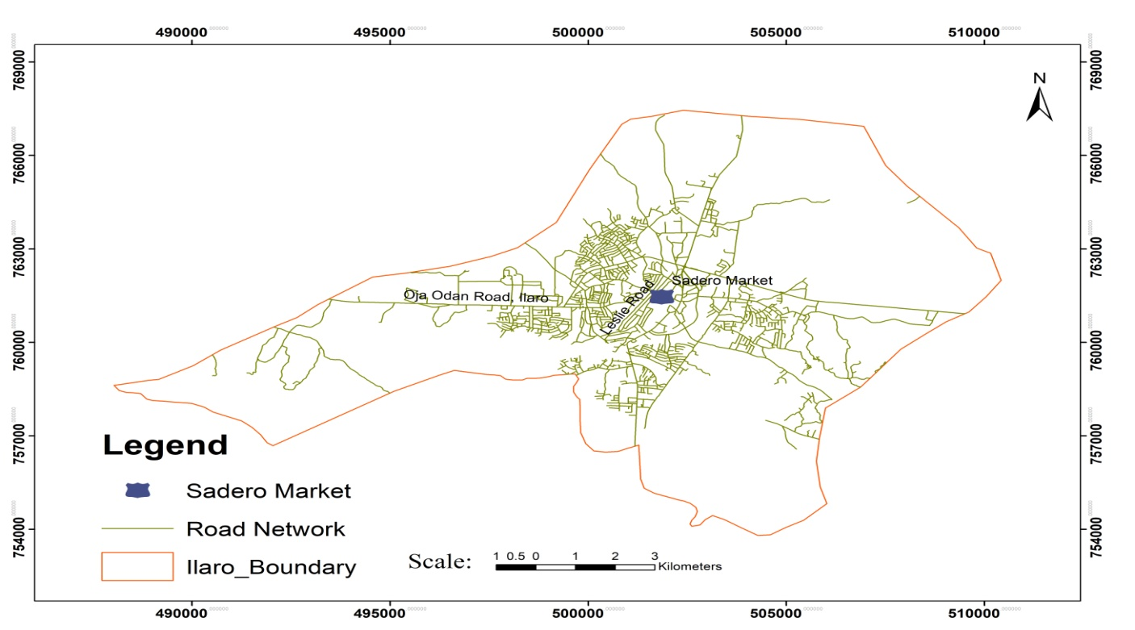
Figure 1: Study area Map. Source: Attah & Odunnaike, 2026

This study was carried out in Ilaro, the administrative headquarters of Yewa South Local Government Area, Ogun State, Nigeria. Ilaro community hosts Federal Polytechnic Ilaro (FPI), and it is proximate to Ibese, where Dangote Cement Company is situated. The population of the staff and students of FPI and staff of Dangote Cement Company has led to an increase in housing demand in the community. This situation contributes to an increase in housing development without proper planning and indiscriminate increases in house rent annually. This unplanned development and lack of rent regulation make Ilaro a relevant case study for housing challenges in Nigerian higher education institutions.

3.2 Research Design

This study used a cross-sectional design to draw on both quantitative survey data and geospatial data. This design allowed for the assessment of socioeconomic and geospatial factors influencing housing challenges across the study area.

s

3.3 Sampling

A total of 83 staff and students of FPI residing in Ilaro were purposively selected for this study. This approach was chosen because the study specifically aimed to identify the most significant housing challenges faced by staff and students of Federal Polytechnic Ilaro. For the housing condition survey, 100 units were selected through systematic random sampling, with every third building sampled along transect routes in four cardinal directions from the campus

3.4 Data Collection

Data were collected through three instruments. First, a pre-tested structured questionnaire was administered to the 83 sampled staff and students. It covered four areas: (i) accommodation type and residential status; (ii) travel time and mode of transport to campus; (iii) preference rankings for four possible housing interventions, scored on a three-point scale comprising Most Preferred, More Preferred, and Preferred; and (iv) perceived housing difficulties. Second, a condition checklist was completed for each of the 100 sampled housing units. This recorded annual rent, electricity supply, water supply, and security features such as gates, fencing, and lockable entrances. Third, the position of every sampled unit was recorded using a Garmin eTrex 10 GPS receiver at an accuracy of ±5 m. The road network was digitised from Google Earth Pro to assess accessibility between housing locations and the campus.

3.5 Data Processing and Analysis
The data on housing conditions obtained through the administered questionnaire were processed using Microsoft Excel to identify the major housing challenges, and the preferred intervention that could mitigate housing challenges for staff and students of FPI. Data on the geospatial location of the 100 sampled house units and the road network were processed using ArcGIS 10.6.1 to prepare thematic maps to understand the geospatial pattern of housing occupied by sstaff and students, their accessibility, road network, and proximity to the campus.

4.0 DATA ANALYSIS AND DISCUSSION OF FINDINGS

4.1 Housing and Financial Challenges
Accommodation Type | Frequency | Percentage (%)
Private rental | 37 | 44.58
Institutional housing | 23 | 27.71
Owned property | 19 | 22.89
Family house | 4 | 4.82
Total | 83 | 100.00
Table 1: The distribution of accommodation types
Table 1 shows the distribution of the type of accommodation the respondents reside in. It reveals that a total of 37 respondents (44.58%) reside in privately owned rental housing, while only 23 respondents (27.71%) live in school hostels or staff quarters. This indicates housing provided by the institution is insufficient to meet the needs of its staff and students. 19 respondents (22.89%) own properties, and 4 respondents (4.82%) reside in family houses. The study suggests a gap between housing demand from FPI staff and students and what the institution is able to provide.
Travel Time | Frequency | Percentage (%)
Below 15 minutes | 28 | 33.73
15–30 minutes | 46 | 55.42
30–45 minutes | 7 | 8.43
Above 45 minutes | 2 | 2.41
Total | 83 | 100.00

Table 2: Commuting Times. Source: Field Survey, 2026.

4.2 Transportation Challenges
Table 2 shows the travel time of respondents to the campus. The 55.42% of the respondent travel between 15 to 30 minute and 10.84% travel for over 30 minutes. The study found that many of the respondent faced transportation challenges.
Mode of Transportation | Frequency | Percentage (%)
Personal Motorcycle | 36 | 43.37
Personal car | 27 | 32.53
Public car/bus | 11 | 13.25
Walking | 9 | 10.84
Total | 83 | 100.00
Table 3: Transportation Challenges. Source: Field Survey, 2026.
Table 3 shows the mode of transportation used by respondents to get to campus. 75.90% of the respondents rely on either a private motorcycle (43.37%) or a personal car (32.53%) for their daily commute. Only 13.25% use public transport, while 10.84% travel on foot. The higher percentage of respondents relying on personal transportation could suggest limited availability of affordable and reliable transit services connecting residential areas to the institution.

4.3 Preferred Housing Solutions
Four housing interventions were put to respondents for ranking. Tables 4 and 5 show the results by frequency and by percentage, respectively.
Preference Level | Salary-Deductible Loans | Staff Transport | Rent Control | PPP
Most Preferred | 49 | 43 | 38 | 46
More Preferred | 21 | 31 | 23 | 13
Preferred | 13 | 9 | 22 | 24
Total | 83 | 83 | 83 | 83
Table 4: Frequency for Housing Solutions. Source: Field Survey, 2026.

Preference Level | Salary-Deductible Loans (%) | Staff Transport (%) | Rent Control (%) | PPP (%)
Most Preferred | 59.04 | 51.81 | 45.78 | 55.42
More Preferred | 25.30 | 37.35 | 27.71 | 15.66
Preferred | 15.66 | 10.84 | 26.51 | 28.92
Table 5: Preference Percentage for Housing Solutions. Source: Field Survey, 2026.

Many respondents preferred salary-deductible housing loans and public-private partnerships as interventions that could alleviate housing challenges. 59.04% indicated salary-deductible housing loans, 55.42% preferred public-private partnerships, and 51.81% preferred a dedicated transport service and 45.78% preferred rent control. The findings suggest respondents preferred interventions that ease financial burden (salary-deductible loans, partnerships). The preference for dedicated transport and rent control indicates transportation costs and unaffordable rents are significant challenges.

4.4 Condition of Surveyed Housing Units

Figure 2: Annual rent distribution of 100 surveyed housing units.

4.4.1 Rental Values
Figure 2 shows the rent distribution across the 100 surveyed units. A total of 41 units (41%) attract annual rents ranging from ₦150,000 to ₦350,000. Outside this range, 22 units fall within ₦350,000–₦450,000 and 18 units within ₦50,000–₦150,000. A further 12 units are priced at ₦450,000–₦550,000, and 7 units exceed ₦550,000. Overall, 82 of the 100 units record rents at or above ₦150,000 per year. Affordable units are few. This indicates that most available stock places a considerable financial burden on staff and students.

4.4.2 Distribution of Housing Amenities

Figure 3: Distribution of Housing Amenities Across the Sampled Units

4.4.2 Water
Water access from a pipe or borehole was recorded in 60 of the 100 sampled units, representing 60% of the sample. The remaining 40 units (40%) had no on-site water supply. Residents in these units depend on external sources to meet their daily water needs.
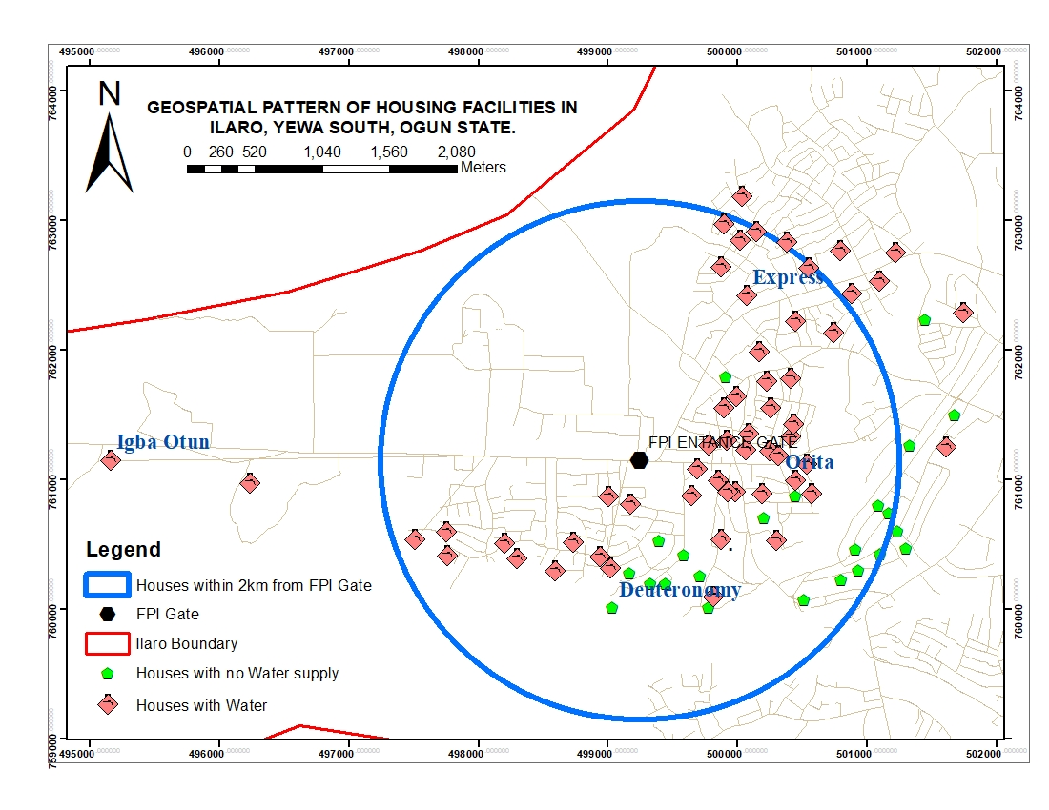Figure 4: Spatial distribution of water supply.
Figure 4 shows the spatial distribution of water accessibility across the 100 sampled housing units within a 2 km radius of the campus. Units closer to the campus have better water access than those further away. Aluko (2011) found a similar pattern in off-campus housing around the University of Lagos, where water supply deficiency was among the most frequently reported problems by residents. The World Health Organisation (2018) establishes reliable water access as a basic requirement for healthy living. The spatial pattern of water accessibility for staff and students of Federal Polytechnic Ilaro as found in this study falls short of this standard.
4.4.3 Power Supply
Figure 3 shows the power supply distribution across the 100 surveyed units. A total of 52 units (52%) have an electricity connection, while the remaining 48 units (48%) do not. This near-equal division points to a gap in the electrical infrastructure. Housingunits without a power supply pose a challenge for staff and students who depend on electronic devices for academic work and daily tasks. 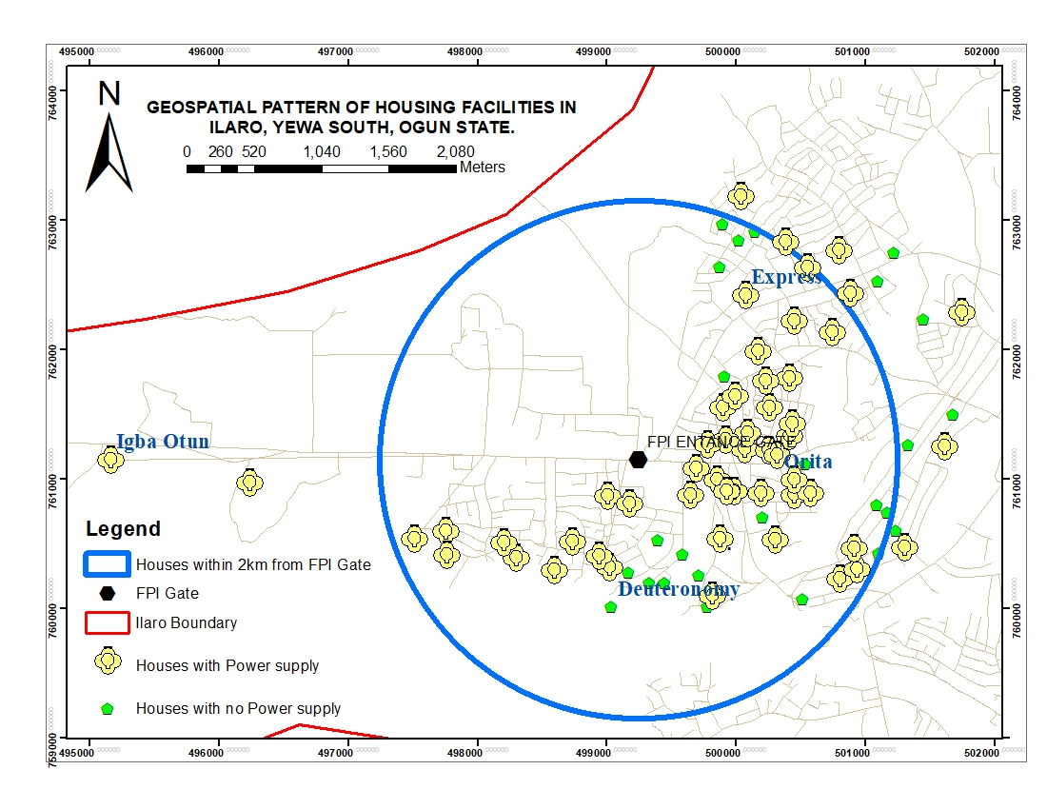Figure 5: Spatial distribution of power supply among surveyed housing units.
Figure 5 reveals the spatial pattern of electricity access across the 100 sampled housing units. As shown on the map, many units within the 2 km buffer from the campus lack access to electricity. This suggests that proximity to the campus does not guarantee access to basic infrastructure. This finding is consistent with Aluko (2011) and Olotuah&Bobadoye (2009), who identified inadequate electricity supply as one of the challenges faced by of off-campus housing in Nigerian tertiary institutions. UN-Habitat (2016) further noted that rapid urbanisation without corresponding infrastructure investment can results in uneven access to basic services in residential areas of developing countries.
4.4.4 Security Infrastructure
Security features comprising entrance gates, perimeter fencing, or a combination of both were recorded in 85 of the 100 surveyed units (85%). The remaining 15 units (15%) had no security features. Secured housing units are mainly found in the higher-density student zones of Orita, Express, Deuteronomy, and Igba Otun, while unsecured units are concentrated beyond 2 km from the campus. Adeboyejo & Olujimi (2012) and Aluko (2011) found that security inadequacy is a recurring challenge in off-campus student housing across Nigeria.
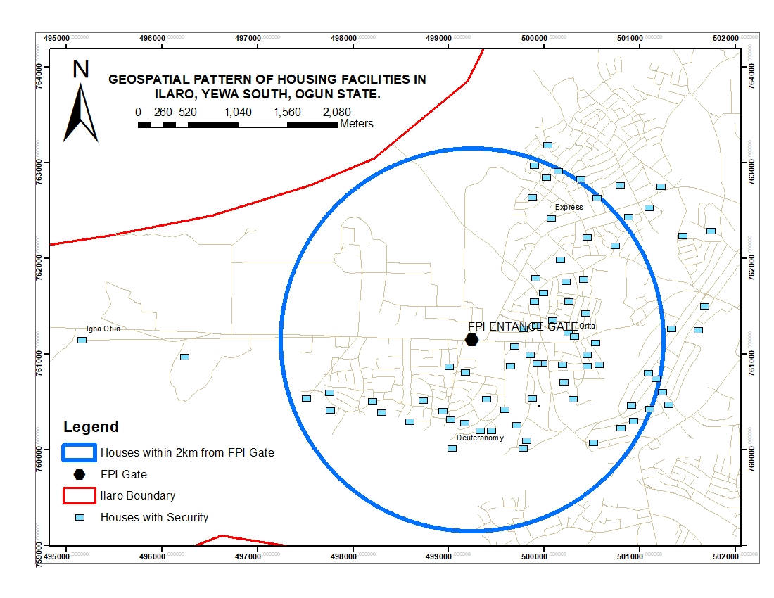Figure 6: Spatial distribution of housing with Security Infrastructure

Figure 6 shows the spatial pattern of housing with security infrastructure within the 2 km buffer from the campus. As revealed on the map, most of the surveyed units have security features comprising entrance gates and perimeter fencing. This finding suggests that most housing in the study area is secured with perimeter fencing and entrance gates. However, Adzande&Gyuse (2017) found that physical security features such as perimeter fencing and entrance gates alone do not guarantee the safety of occupants. Security effectiveness depends on the broader neighbourhood'senvironment.

4.5 Discussion of Findings
The findings reveal housing challenges faced by staff and students at Federal Polytechnic Ilaro, a pattern consistent with evidence from other Nigerian polytechnics and universities (Adeboyejo and Olujimi, 2012; Ibem and Amole, 2013). A total of 44.58% of respondents lack access to institutional hostel accommodation or staff quarters. Out of the 100 sampled units, 82% attract an annual rent of ₦150,000 or above. For a single self-contained unit in a semi-urban setting, this level of rent is high relative to what most staff earn on the ₦70,000 government minimum wage, or what students can meet from bursary stipends or the Nigerian Education Loan Fund (NELFUND). Ibem and Amole (2021) noted that rental costs in towns hosting tertiary institutions tend to rise faster than the incomes of their primary occupants, and the figures presented here reflect that pattern. A total of 48% of sampled units lack a reliable power supply, while 40% lack adequate on-site water. These figures suggest that basic service provision has not kept pace with housing demand in the area surrounding the institution. Respondents identify two preferred Salary-deductible and provision of shuttle service as the most preferred intervention that could mitigate the housing challenges
5.0 CONCLUSION AND RECOMMENDATIONS
This study examined housing conditions among staff and students of Federal Polytechnic Ilaro using household surveys and geospatial mapping. The study finds that housing challenges exist among both groups. These challenges include insufficient institutional accommodation, poor housing conditions in privately rented units, and limited access to basic amenities. The following recommendations are proposed based on the findings:
- The polytechnic management should partner with commercial banks or the Federal Mortgage Bank of Nigeria to establish a salary-deductible housing loan scheme for staff. This approach can increase access to affordable housing.
- The institution should introduce a dedicated shuttle service connecting key residential areas to the campus. This could reduce transport costs and commuting time for staff and students.
- Management should engage private developers through public-private partnerships to construct additional hostel facilities on or near the campus. This could increasethe number of affordable accommodation options.
- Staff and student unions should engage with Yewa South Local Government Authority and landlord associations to establish rental price guidelines to protect staff and students from exploitative rent increases

REFERENCES
Adeboyejo, O. A., & Olujimi, J. A. (2012). Housing challenges in Nigerian tertiary institutions: A case study of Obafemi Awolowo University, Ile-Ife. Journal of Sustainable Development in Africa, 14(4), 267–280. Retrieved from https://jsd-africa.com
Ademiluyi, I. A. (2010). Public housing delivery strategies in Nigeria: A historical perspective of policies and programmes. Journal of Sustainable Development in Africa, 12(6), 153–161. Retrieved from https://jsd-africa.com
Adzande, P., &Gyuse, T. T. (2017). Territoriality and safety in urban residential neighbourhoods in Nigeria. Journal of Urbanism: International Research on Placemaking and Urban Sustainability, 10(3), 333–355. https://doi.org/10.1080/17549175.2017.1295095
Agbola, T., & Jinadu, A. M. (1997). Forced eviction and forced relocation in Nigeria: The experience of those evicted from Maroko in 1990. Environment and Urbanisation, 9(2), 271–288. https://doi.org/10.1177/095624789700900220
Aluko, O. E. (2011). The assessment of the housing situation among students at the University of Lagos. African Research Review: An International Multidisciplinary Journal, 5(3), 104–118. https://doi.org/10.4314/afrrev.v5i3.67338
Aribigbola, A. (2008). Housing policy formulation in developing countries: Evidence of programme implementation from Akure, Ondo State, Nigeria. Journal of Human Ecology, 23(2), 125–134. Retrieved from https://www.krepublishers.com
Bredenoord, J., & van Lindert, P. (2010). Pro-poor housing policies: Rethinking the potential of assisted self-help housing. Habitat International, 34(3), 278–287. https://doi.org/10.1016/j.habitatint.2009.12.001
Ekpo, A. (2019). Housing deficit in Nigeria: Issues, challenges and prospects. CBN Economic and Financial Review, 57(4), 177–188. Retrieved from https://dc.cbn.gov.ng/efr/vol57/iss4/13/
Housing Europe. (2021). The state of housing in Europe 2021. Brussels: Housing Europe. Retrieved from https://www.housingeurope.eu/resource-1323/the-state-of-housing-in-europe-2021
Ibem, E. O., & Amole, D. (2013). Affordable housing in Nigerian cities: A review of policy and practice. Journal of Housing and the Built Environment, 28(2), 429–447. https://doi.org/10.1007/s10901-012-9295-0
Ibem, E. O., & Amole, D. (2021). Housing affordability in Nigerian urban centres: Issues and policy directions. International Journal of Housing Policy, 21(3), 367–386. https://doi.org/10.1080/19491247.2020.1716111
Ibem, E. O., & Ayo-Vaughan, E. A. (2017). Public-private partnerships (PPPs) in housing provision for students in Nigerian universities. International Journal of Housing Markets and Analysis, 10(5), 708–729. https://doi.org/10.1108/IJHMA-08-2016-0060
Malczewski, J. (2006). GIS-based multicriteria decision analysis: A survey of the literature. International Journal of Geographical Information Science, 20(7), 703–726. https://doi.org/10.1080/13658810600661508
Nubi, T. O. (2008). Affordable housing delivery in Nigeria. In Proceedings of The South African Foundation International Conference and Exhibition (pp. 1–18). Cape Town: South African Foundation. Retrieved from https://housingfinanceafrica.org
Nwaka, G. I. (2005). The urban informal sector in Nigeria: Towards economic development, environmental health, and social harmony. Global Urban Development Magazine, 1(1), 1–11. Retrieved from https://www.globalurban.org
Olotuah, A. O., &Bobadoye, S. A. (2009). Sustainable housing provision for the urban poor: A review of public sector intervention in Nigeria. The Built & Human Environment Review, 2(1), 51–63. Retrieved from http://www.tbher.org
Phang, S. Y. (2018). Policy innovations for affordable housing in Singapore. Housing Policy Debate, 28(5), 709–723. https://doi.org/10.1080/10511482.2018.1443129
UN-Habitat. (2016). World cities report 2016: Urbanisation and development – emerging futures. Nairobi: United Nations Human Settlements Programme. Retrieved from https://unhabitat.org/world-cities-report
World Health Organisation. (2018). WHO housing and health guidelines. Geneva: World Health Organisation. Retrieved from https://www.who.int/publications/i/item/9789241550376

