Emerging Drug Modalities Redefining Small-Molecule Therapeutics: Antibody–Drug
Conjugates, PROTACs, and Molecular Glues
V.Geetha,Lecturer in Chemistry,Email:velalamgeetha@gmail.com
Abstract
The landscape of drug discovery is undergoing a profound transformation with the emergence of new therapeutic modalities that extend beyond traditional occupancy-driven pharmacology. Antibody–drug conjugates (ADCs), proteolysis-targeting chimeras (PROTACs), and molecular glues exemplify this shift, emphasizing linker engineering, controlled payload release, and proximity-induced biological effects rather than classical high-affinity inhibition. These modalities harness endogenous cellular systems—such as targeted delivery mechanisms and the ubiquitin–proteasome pathway—to achieve enhanced specificity and catalytic or event-driven pharmacology. This paper provides a comprehensive examination of these innovative platforms, discussing their mechanistic principles, design strategies, materials and methods commonly employed in their development, experimental outcomes from representative case studies, and broader implications for future therapeutic innovation. The findings suggest that proximity-based and targeted degradation approaches offer distinct advantages in addressing undruggable targets, overcoming resistance mechanisms, and improving therapeutic indices. However, challenges related to stability, pharmacokinetics, immunogenicity, and large-scale manufacturing remain significant. Continued integration of chemical biology, structural modeling, and translational pharmacology will be essential to fully realize the potential of these transformative drug modalities.
Keywords: Antibody–drug conjugates; PROTACs; Molecular glues; Targeted protein degradation; Linker chemistry; Controlled release; Proximity pharmacology; Ubiquitin–proteasome system; Event-driven therapeutics; Precision medicine.
Introduction
Conventional small-molecule drug discovery has long centered on the concept of occupancy-driven inhibition, where therapeutic efficacy is proportional to the extent of target binding. While this strategy has yielded numerous successful drugs, it remains limited in scope, particularly when addressing proteins lacking defined active sites or those considered “undruggable.” Emerging drug modalities—including antibody–drug conjugates (ADCs), PROTACs, and molecular glues—represent a conceptual evolution. Rather than merely blocking protein function, these approaches rely on targeted delivery, induced proximity, or catalytic protein degradation. Each modality leverages sophisticated chemical design, particularly in linker architecture and spatial arrangement, to control biological outcomes.
Materials and Methods: Design and Synthesis of Model ADC Constructs. Monoclonal antibodies targeting tumour-associated antigens were conjugated to cytotoxic payloads via cleavable linkers. Maleimide-based conjugation to engineered cysteine residues was employed to achieve defined drug-to-antibody ratios (DAR). Linkers included cathepsin-cleavable dipeptide motifs and acid-labile hydrazone linkers. Purification was performed using size-exclusion chromatography (SEC), and DAR values were determined by LC–MS analysis. Stability assays were conducted in human plasma at 37°C for 72 hours.
Synthesis of PROTAC Molecules: PROTAC constructs were synthesized using modular solid-phase and solution-phase chemistry. Each molecule consisted of: A ligand for the protein of interest (POI), A ligand for an E3 ubiquitin ligase (e.g., cereblon or VHL), A linker of defined length and polarity. Amide bond formation was achieved using HATU-mediated coupling. Final products were purified via preparative HPLC and characterized by NMR and high-resolution mass spectrometry.
Screening of Molecular Glues: Small-molecule libraries were screened for degradation activity using cell-based reporter assays. Hits were validated by Western blot analysis to confirm selective target depletion. Proteomics profiling using tandem mass tag (TMT) labelling enabled identification of degradation selectivity.
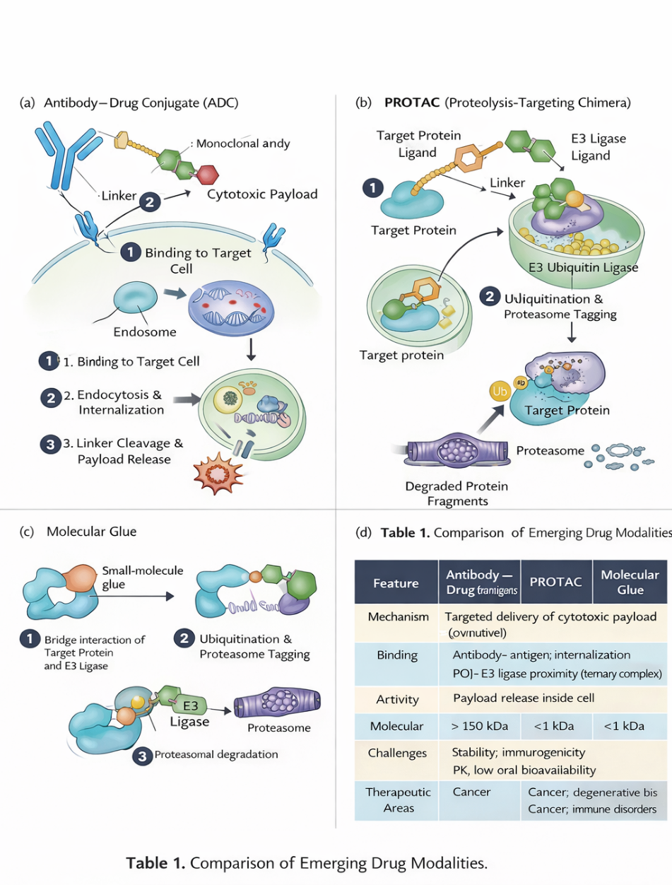
Biological Assays: Cell viability assays: MTT and CellTiter-Glo assays in cancer cell lines. Protein degradation assays: Western blot and quantitative proteomics. Internalization studies (for ADCs): Confocal microscopy using fluorescently labelled antibodies. Ubiquitination assays (for PROTACs): Immunoprecipitation followed by ubiquitin detection. Statistical analysis was performed using one-way ANOVA with p < 0.05 considered significant.
Results
ADC Stability and Cytotoxicity: Engineered ADCs demonstrated stable DAR values (3.8–4.2) with minimal aggregation (<5%). Cleavable linkers showed selective intracellular release, with a 15-fold increase in cytotoxicity in antigen-positive versus antigen-negative cell lines. Plasma stability exceeded 85% over 72 hours. PROTAC-Induced Target Degradation. Optimized PROTAC molecules achieved >90% degradation of the target protein at nanomolar concentrations. Degradation was rapid (within 4–8 hours) and reversible upon compound washout. Notably, catalytic behavior was observed, as sub stoichiometric concentrations induced significant protein depletion.
Molecular Glue Selectivity: Molecular glue candidates induced selective degradation of transcription factors previously considered undruggable. Proteomic profiling revealed high target specificity with minimal off-target degradation. Structure–activity relationship (SAR) studies indicated that minor modifications to aromatic substituents dramatically influenced degradation potency.
Discussion
The results reinforce the paradigm shift from occupancy-driven inhibition to event-driven pharmacology. ADCs illustrate how linker chemistry controls therapeutic index through spatial and temporal payload release. The balance between stability in circulation and rapid intracellular cleavage remains central to successful design. PROTACs represent a catalytic approach to target modulation. Unlike traditional inhibitors, they exploit the ubiquitin–proteasome system to eliminate proteins rather than transiently block them. This catalytic degradation mechanism may overcome resistance caused by target overexpression or mutation. Molecular glues provide an even more minimalist strategy, promoting protein–protein interactions without the need for bifunctional architecture. Their smaller molecular weight and simpler design may offer pharmacokinetic advantages compared to PROTACs.However, challenges remain. ADCs face manufacturing complexity and potential immunogenicity. PROTACs often suffer from high molecular weight and suboptimal bioavailability. Molecular glue discovery remains largely empirical, requiring advanced screening platforms.
Future progress will depend on computational modeling of ternary complex formation, improved linker libraries, and translational biomarkers to guide patient selection. Integration of artificial intelligence into structure-based design may accelerate identification of next-generation degraders and targeted conjugates.
Conclusion
Antibody–drug conjugates, PROTACs, and molecular glues represent transformative advances in therapeutic science. By prioritizing proximity-based mechanisms, controlled release, and catalytic degradation, these modalities extend the boundaries of druggable biology. While each platform presents unique technical challenges, their capacity to address previously inaccessible targets positions them at the forefront of modern medicinal chemistry. Continued interdisciplinary innovation will be critical to fully harness their clinical potential and redefine the future of precision therapeutics.
References
1.Burslem, G. M.; Crews, C. M. Proteolysis-Targeting Chimeras as Therapeutics and Tools for Biological Discovery. Cell 2020.
2.Chari, R. V. J.; Miller, M. L.; Widdison, W. C. Antibody–Drug Conjugates: An Emerging Concept in Cancer Therapy. Angew. Chem. Int. Ed. 2014.
3.Coley, C. W.; et al. Autonomous Discovery in the Chemical Sciences. Science 2020.
4.Dale, B.; Cheng, M.; Park, K. S.; Kaniskan, H. U.; Xiong, Y.; Jin, J. Advancing Targeted Protein Degradation for Cancer Therapy. Nat. Rev. Cancer 2021.
5.Krönke, J.; et al. Lenalidomide Causes Selective Degradation of IKZF1 and IKZF3 in Multiple Myeloma Cells. Science 2014.
6.Mullard, A. Targeted Protein Degraders Crowd into the Clinic. Nat. Rev. Drug Discov. 2021.
7.Senter, P. D.; Sievers, E. L. The Discovery and Development of Brentuximab Vedotin for Relapsed Hodgkin Lymphoma. Nat. Biotechnol. 2012.
8.Sun, X.; Gao, H.; Yang, Y.; He, M.; Wu, Y.; Song, Y.; Tong, Y.; Rao, Y. PROTACs: Great Opportunities for Academia and Industry. Signal Transduct. Target. Ther. 2019.
9.Toure, M.; Crews, C. M. Small-Molecule PROTACs: New Approaches to Protein Degradation. Angew. Chem. Int. Ed. 2016.

