Convergence of Digital-Twin Technology with Bioinspired Therapeutic Platforms for Personalized Management of Cancer, Alzheimer's, and Metabolic Disorders: A Comprehensive Review

ABSTRACT
Background: The merging of digital twin (DT) technology and bioinspired therapy platforms is a revolutionary step forward in personalized medicine. Digital twins produce dynamic, individualized virtual models for real-time monitoring, prognostic modelling, and adaptive therapeutic optimization. Bioinspired therapeutic platforms exploit nature’s evolutionary answers to achieve biocompatibility and accuracy that cannot be achieved by typical synthetic systems such as targeted drug delivery, barrier penetration and immune evasion. Together, these technologies provide a solution that has eluded medicine for decades: a truly personalized disease-management framework that is more than one-size-fits-all therapy approaches.
This review aims to address the synergistic combination of digital technology with bioinspired therapeutic systems for the personalized management of cancer, Alzheimer’s disease and metabolic disorders associated with a high inter-patient variability and suboptimal responses to traditional treatment approaches.
Methods: A systematic literature search was carried out in PubMed, Web of Science, Scopus, and IEEE Xplore databases, encompassing publications from 2020 to 2025, and supplemented with significant foundational works. Search phrases included combinations of digital twin, bioinspired treatments, personalized medicine, biomimetic nanoparticle, exosome, cancer, Alzheimer’s disease, and metabolic disorders. Articles were evaluated for scientific rigor, clinical relevance and contribution to the convergence thesis.
Results: By 2024, over 86% of healthcare organizations will view digital technology as key components of their digital innovation projects. Bioinspired platforms such as exosome-based systems, cell membrane-coated nanoparticles and biomimetic nanocarriers are consistently outperforming typical synthetic formulations in terms of biocompatibility and targeting accuracy. Bioinspired nanocarriers combined with patient-specific digital twin avatars provide tumor-selective delivery with dramatically reduced off-target harm in cancer. In Alzheimer’s disease, brain-targeted delivery methods and biomimetic therapeutics that can cross the blood brain barrier are leading the way to earlier detection and more personalized treatments. Extensive dietary therapy, together with bioinspired delivery methods, resulted in an average decrease in HbA1c of 1.8% in metabolic diseases and 89% of type 2 diabetic patients attained goal glycaemic control in clinical studies.
Conclusions: The synergy between DT technology and bioinspired treatment platforms is not additive but rather really synergistic. Disease-specific computational modelling is combined with biologically optimized administration, enabling real-time treatment adaptation and taking personalized medicine from aspiration to practical reality. But there are still big hurdles to cross, including the difficulty of integrating data, the ever-changing regulatory landscape, the ability to scale manufacturing and health equity concerns. Standardized validation schemes, federated learning approaches for privacy-preserving data sharing, hybrid mechanistic-machine learning frameworks, and continuous multidisciplinary collaboration will be essential for future progress.
Keywords: Digital twins; Bioinspired therapeutics; Personalized medicine; Cancer; Alzheimer's disease; Metabolic disorders; Artificial intelligence; Nanomedicine; Precision medicine; Drug delivery systems; Biomimetic nanoparticles; Exosomes

1. INTRODUCTION

1.1 The Transition to Personalized Medicine

The problem for modern medicine is to treat complex heterogeneous disorders, which, inevitably, do not respond to “one-size-fits-all” treatments at the population level. Cancer, Alzheimer’s disease (AD) and metabolic disorders collectively account for over 20 million deaths a year, with global health care costs surpassing $2 trillion, but the patient outcomes are still disappointing despite huge research funding (Collins and Varmus, 2015; Ashley, 2016). A typical feature of these diseases is the large inter-individual variation in disease progression, pathogenicity and responsiveness to therapy, which makes standardized treatment techniques less than maximally successful for major patient subpopulations.

The con­ventional precision medicine approaches have gained tremendous progress by integrating genetic and molecular markers into treatment decision-making. However, these approaches are constrained by their own shortcomings: static biomarker assessments only reflect snapshots of dynamic, progressive biological processes; clinical decision-making is predominately based on retrospective population-level data rather than prospective, individual-level predictions; and most therapeutic interventions lack adaptive features to respond dynamically to variable patient conditions (Schork, 2019; Jameson and Longo, 2015). These limitations have gradually fostered interest in advanced technical frameworks that can encompass the temporal dynamics and multiscale complexity inherent to human disease.

1.2 Digital Twin Technology: Conceptual Grounding
Digital twin (DT) technology has arisen as a transformative paradigm to address these limitations by creating dynamic and continuously updated virtual representations of specific patients or physiological systems. The idea originates in aerospace engineering and industrial manufacturing. NASA first used the term in 2002 for the management of spacecraft life cycles, but the basic idea of maintaining a bidirectional digital-physical link can be found in earlier engineering philosophies (Grieves and Vickers, 2017; National Academies of Sciences, Engineering, and Medicine, 2024). The COVID-19 pandemic has greatly accelerated the deployment of healthcare technologies. Digital transformation solutions for hospital capacity modelling and infectious disease simulation had to be implemented rapidly. By 2024, the technology had reached a level of maturity that 86% of healthcare organizations considered digital technologies as part of their digital transformation goals (Oulefki et al., 2025).
What makes a true digital twin different from a conventional simulation model? There are several features that are imperative: data continuous integration from diverse heterogeneous sources ensuring real-time synchronization with the actual patient; bidirectional information flow facilitating authentic feedback loops where model predictions guide real-world interventions and observed outcomes adjust model parameters; predictive and prescriptive analytics going beyond mere description of the current state to anticipate future trajectories; and, crucial for clinical applications, personalization that customizes each model to individual rather than population-average characteristics (Björnsson et al., 2020; Turab and Jamil, 2023). This iterative method improves the prediction accuracy as patient-specific data is collected over time.

1.3 Bioinspired Therapeutic Platforms: Exploiting Evolutionary Solutions

In addition to these computational advances, bioinspired medicinal systems have a tremendous impact on the delivery of medication by emulating the complex biological processes from nature. Evolution has had about 3.5 billion years to solve problems that pharmaceutical scientists have been trying to solve for a short hundred years, and the difference in effectiveness is obvious. Biological systems have developed incredible strategies to meet the challenges of drug delivery: selective targeting of cells among chemically similar non-target tissues, traversing substantial barriers evolved to reject foreign molecules, sidestepping immune systems evolved to identify and destroy non-self-entities, and all with remarkable efficiency (Benyus, 1997; Tang et al., 2023).

Bioinspired therapeutic platforms can be broadly divided into three major types: bio-derived systems that utilize naturally existing biological components (exosomes, viral vectors, bacterial chassis) as delivery vehicles; biomimetic systems that imitate biological structures with synthetic materials (cell membrane-coated nanoparticles, biomimetic scaffolds) and biohybrid systems that integrate biological and synthetic components (engineered cells with nanoparticle payloads, bacteria-mediated delivery systems) (Chen et al., 2022; Gazzi et al., 2024). They often outperform traditional synthetic nanocarriers in biocompatibility, circulation time, targeted specificity and immune escape, thereby solving obstacles that have long impeded the clinical translation of synthetic nanomedicine.

1.4 Disease Burden and Rationale for Technology Convergence

Three major types of diseases are frustratingly resistant to current therapeutic options, each characterized by a diversity and complexity that makes population-based approaches especially inadequate.

In 2020, more than 10 million people died from cancer, out of 19.3 million new cases diagnosed. Despite decades of research, therapeutic resistance, metastatic progression, and dose-limiting toxicities that lead clinicians to undertreat at the time when aggressive intervention is most needed (Sung et al., 2021; Siegel et al., 2023), the five-year survival rate for many solid tumors remains below 30%. There is a great variation across patients and also within the same tumor, and so standardized therapy regimens are inherently unsuccessful.

Alzheimer’s disease now afflicts an estimated 55 million people around the world, a figure expected to treble by 2050 as the world’s population continues to age. The pathophysiology that is marked by the accumulation of amyloid plaques, neurofibrillary tangles, neuroinflammation, and progressive neurodegeneration is poorly understood, leading to a clinical trial failure rate of over 99% for disease-modifying therapies (Alzheimer's Disease International, 2021; Cummings et al., 2023; Long and Holtzman, 2019). And that’s a staggering failure rate. And it continues after decades of study efforts and heavy investment.

Metabolic illnesses, notably type 2 diabetes mellitus (T2DM), represent a growing global epidemic, with 537 million adults worldwide and annual health care expenses of more than $966 billion (International Diabetes Federation, 2021). The high heterogeneity of metabolic dysfunction and the influence of genetics, diet, physical activity, composition of gut microbiome, sleep quality and stress levels on its aetiology make population-based dietary and pharmacological guidelines frustratingly ineffective for substantial subpopulations of patients (Cheng and Hu, 2021).

In this context, the synergy between digital twins and bioinspired medicines is very appealing. Such patient-specific DT models can depict individual tumor biology, neurodegenarative patterns or metabolic diseases with an accuracy not achievable in population-average frameworks. Bioinspired systems provide delivery vehicles derived from predictive models, therefore providing a closed-loop optimization system that has not been feasible in clinical practice before.

2. DIGITAL TWIN TECHNOLOGY: ARCHITECTURE AND ENABLING TECHNOLOGIES

2.1 Fundamental Architecture of Healthcare Digital Twins
The healthcare digital twins are based on three interconnected layers that establish a bi-directional information flow system. The physical space includes the actual patient’s biological systems at multiple scales from molecular measurements (genomics, proteomics, metabolomics) and cellular data (single-cell sequencing, spatial transcriptomics) through tissue-level characterization (histopathology, medical imaging) to whole-organism measurements (clinical laboratory values, continuous wearable sensor data, patient-reported outcomes). The virtual space consists of computational models that theoretically describe physiologic processes, disease mechanisms and responses to treatment at scales relevant to the clinic. The connection layer, frequently overlooked but crucial for operations, handles data collecting, secure transmission, and the infrastructure for real-time synchronization between physical and digital worlds (Ştefănigă et al., 2024; Ren et al., 2025).
What makes a true digital twin different from a traditional simulation model is this link layer and the dynamic updates it provides. Static models produce outputs for fixed inputs. Digital twins have two-way communication all the time: predictions from the model guide clinical interventions (medication choices, diagnostic tests) in the real world, and responses observed in the patient update the model’s parameters and structure, progressively improving predictive performance as data from the individual accumulates. The granularity of the models varies by the use case: cellular-level twins are used for drug-pathway interactions in individual tumor cells, organ-level twins are used for disease-relevant dynamics such as tumor growth or neurodegeneration patterns, patient-level twins incorporate several organ systems to facilitate planning of personalized therapies, and population-level twins are used for public health strategy simulations (Ren et al., 2025).

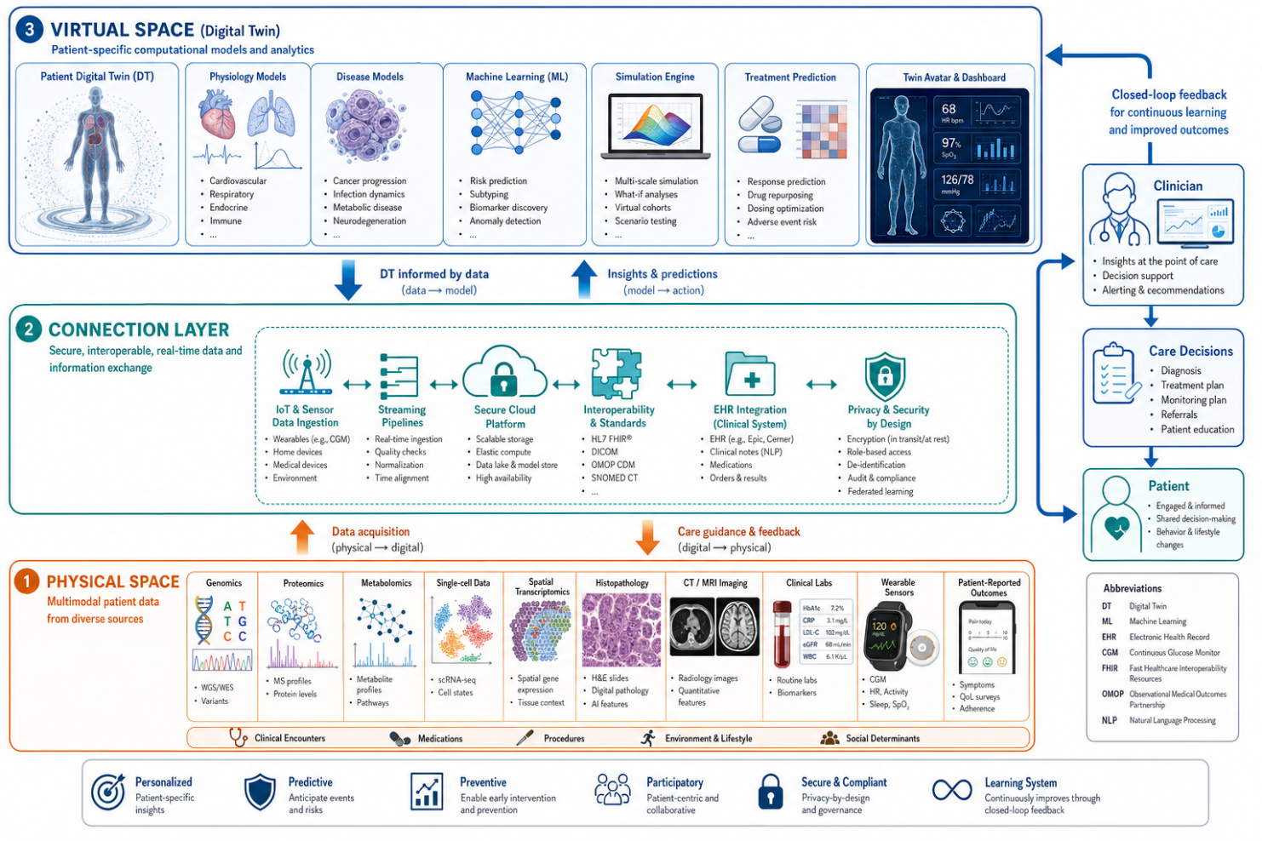
Figure 1. Fundamental architecture of a healthcare digital twin system illustrating the three-layer structure and bidirectional information flow enabling real-time patient-model synchronization. DT: digital twin; ML: machine learning; EHR: electronic health record; CGM: continuous glucose monitor.

2.2 Multi-Omics Integration and Knowledge Graphs

Modern digital twins in healthcare are more and more combining multi-scale biological data at multiple omic levels: genomics (DNA sequences, copy number variants, germline mutations), transcriptomics (active gene expression profiles), epigenomics (methylation patterns, histone modifications), proteomics (protein abundances and post-translational modifications), metabolomics (small molecule concentrations reflecting metabolic state) and phenomics with clinical observations, imaging and behavioral data (Ren et al., 2025). The integration of multiple omics is technically difficult and conceptually challenging since the diverse data sources have varying scales of measurement, temporal resolution, noise characteristics and uncertainty profiles.

Knowledge graphs are emerging as a useful organizational paradigm to deal with this complexity. Knowledge graphs are different from traditional tabular databases in that they represent biological entities such as genes, proteins, metabolites, pathways, symptoms, and drugs as nodes in network architectures, with edges representing their relationships (Zhang et al., 2024). Such an architecture enables systematic integration of various data types, inference of hidden links via graph traversal algorithms, discovery of causal routes from genetic changes to clinical presentations, and production of testable mechanistic hypotheses. More sophisticated implementations include temporal aspects, which enable the modelling of dynamic processes, such as changing states of gene regulatory networks, disease development trajectories, and biological transformations due to treatment (Hendawi and Li, 2024).

2.3 Paradigms of Artificial Intelligence and Machine Learning

Artificial intelligence, especially machine learning (ML) and deep learning (DL), is the computational engine that allows current digital twins to forecast and prescribe (Oulefki et al., 2025). Different ML paradigms offer additional advantages. These are called supervised learning algorithms. These algorithms are trained on a dataset of patients with known features and outcomes. Using this training data, the algorithm may be used to predict the progression rate of the disease, the response to therapy, the risk of adverse events, etc. Deep neural networks are particularly well suited to discovering small prediction signatures that are inaccessible to classical statistical methods, notably convolutional architectures for imaging data and transformer models for temporal sequences (Topol, 2019).

Unsupervised learning may detect latent structure in data without predefined outcome labels, which is important for patient stratification, illness subtype identification, and hypothesis development in areas where the relevant groups are not yet known (Kaissis et al., 2020). Reinforcement learning formulates the treatment optimization as sequential decision problems in which algorithms learn policies to maximize long-term clinical outcomes through interaction with simulated or real environments, properly considering the delayed therapeutic responses and cumulative effects of sustained interventions (Gottesman et al., 2019). Large language models trained on large biological literature are increasingly enhancing DT systems by processing clinical notes, giving patient-comprehensible explanations of model predictions, and contextualizing suggestions within relevant medical knowledge (Abbasian et al., 2024).

DT implementation is characterized by three basic modeling paradigms. Mechanistic models formulated using differential equations represent physiological processes through known biological mechanisms and perform well when the underlying physiology is well-characterized, such as glucose-insulin dynamics in diabetes or pharmacokinetic/pharmacodynamic relationships in precision oncology (Karpatne, et al., 2017). Data-driven machine learning models are based on statistical patterns rather than explicit mechanistic assumptions. For example, the Twin Health platform uses ensemble ML models trained on continuous glucose monitoring, dietary intake, physical activity, and sleep data from over 10,000 people to predict personalized postprandial glycaemic responses (Joshi et al., 2024). Hybrid strategies, which combine mechanistic understanding and the flexibility of ML, are gaining popularity, as physics-informed neural networks, which incorporate known biological principles as structural constraints, outperform both mechanistic or data-driven approaches, especially when training data are scarce or extrapolation beyond the training conditions is needed (Raissi et al., 2019).

2.4 Validation and Regulatory Frameworks
To translate DT technology from research into clinical practice, we need to demonstrate that model predictions reliably correspond to real-world patient outcomes across diverse populations and contexts, a validation challenge that is considerably more complex than it might appear (Vallée et al., 2025). Digital twin systems that are continuously updated and learn digitally are not like drugs that go through clear regulatory procedures. But as more patient data becomes available and the parameters are adjusted, it begs the question, what does validation even mean?
A prospective clinical validation, making predictions, following patients, comparing forecasts against actual outcomes is the gold standard but resource expensive and slow. Retrospective validation against historical data is quicker, but susceptible to systemic biases. Virtual patient populations used for in silico clinical trials give preliminary evidence in a cost-effective manner, but they need to be carefully calibrated against real-world data to assure biological fidelity (Viceconti et al., 2021). In response, regulatory frameworks are evolving: the FDA has released guidance approving prognostic covariate adjustment strategies, including digital twin approaches, for clinical trial sample size reduction (FDA, 2023). Similarly, the European Medicines Agency qualified these procedures as suitable for trial design (EMA, 2022). The EU's 2024 AI Act classifies healthcare AI systems as high-risk, requiring transparency, risk management, and human monitoring, which would influence the regulation of digital twins across European markets (European Commission, 2024).

3. BIOINSPIRED THERAPEUTIC PLATFORMS: PRINCIPLES AND MECHANISMS

3.1 Evolutionary Foundations and Design Principles
Bioinspired therapeutic platforms take evolutionary answers and translate them to the problems of delivery of pharmaceuticals. The approach is guided by three design concepts. Structural biomimicry mimics biological architecture across nano-, micro-, and macro-scales; lipid vesicles that mimic cell membrane composition; rod-shaped particles that resemble bacterial morphology; hierarchical scaffolds that recreate tissue extracellular matrix organization. This structural mimicry may offer biological activity even with synthetic core materials, as revealed by cell membrane-coated nanoparticles that avoid immune detection despite their synthetic interiors (Fang et al., 2018; Bai et al., 2016).
Functional biomimicry reproduces biological processes without necessarily copying underlying structures, such as pH-responsive drug release systems exploiting acidic tumor microenvironments to mimic natural pH-triggered biological events, adhesion peptides enabling targeted cellular binding to mimic receptor-ligand recognition mechanisms, and enzyme-cleavable linkers responsive to specific proteases to mimic natural protein degradation pathways (Stewart et al., 2016). Systems biomimicry integrates multiple biomimetic elements into coordinated functional platforms. Bacteria-inspired nanorobots that combine chemotaxis, adhesion, and triggered release into unified therapeutic systems are the closest approximation to the integrated functionality of natural biological systems, but at the cost of considerably greater engineering complexity (Zhang et al., 2022).

3.2 Cell-Derived and Cell-Mimicking Systems
Cell-derived platforms employ actual cells or cellular components as delivery vehicles by utilizing their intrinsic biological features (Chen et al., 2022). Being nano-sized membrane-bound vesicles (30–150 nm diameter) naturally secreted by cells for intercellular communication, exosomes exhibit several properties coveted by pharmaceutical scientists: low immunogenicity relative to synthetic nanoparticles that facilitates prolonged circulation; intrinsic ability to cross the blood-brain barrier via membrane fusion and transcytosis mechanisms; surface proteins that enable specific cell targeting (especially when exosomes are derived from cells with natural homing properties); and biological stability that protects therapeutic cargo from enzymatic degradation (Antimisiaris et al., 2018; Vázquez-Ríos et al., 2019). Engineering of exosomes augments these innate properties. Loading of exosomes with small molecules, proteins or nucleic acids by electroporation or sonication. Surface display of targeting ligands. Incorporation of stimuli-responsive triggers for release. Hybridization with synthetic materials for additional functionality.
The RBC membrane-coated nanoparticles represent a paradigmatic cell-mimetic method where biological components are paired with flexible synthetic cores. Coating nanoparticle cores with natural erythrocyte membranes inherits RBCs’ extraordinary circulatory endurance (essentially 120-day functional lifespan vs. hours for uncoated particles) and immune-evasive qualities imparted by CD47 “don’t eat me” surface messages. The composition of the synthetic core can be modified for different therapeutic purposes (Hu et al., 2011). This paradigm has been extended to include cancer cell membrane coatings for homotypic tumor targeting via preferential cancer-cancer cell adhesion mechanisms, platelet membranes for clot localization in cardiovascular applications, and neutrophil membranes to direct delivery to sites of active inflammation (Chen et al., 2019).

3.3 Virus-Inspired and Pathogen-Mimicking Platforms
Viruses are evolution’s most efficient gene delivery vehicles, honed over hundreds of millions of years of coevolution with host cells. They can traverse cellular membranes, navigate intracellular trafficking pathways, and are remarkably efficient in nuclear delivery (Lundstrom, 2018). Viral vectors, modified viruses with harmful genes substituted by therapeutic payloads, have obtained authentic clinical validation. Clinical viability is shown by FDA-approved medications such as Luxturna for hereditary retinal degeneration and Zolgensma for spinal muscular atrophy (High and Roncarolo, 2019). Engineering adjustments improve safety: Removal of genes necessary for viral replication restricts virus proliferation; Tropism alterations allow infection of specific cell types; Capsid engineering minimizes immunogenicity.
Virus-like particles (VLPs) are protein structures that are self-assembled to resemble the shape of viral capsids but do not contain any genetic information, providing virus-inspired delivery without the biosafety problems (Jeong and Sekhon, 2010). Advantages include precise size control via capsid protein selection, versatile surface modification for the display of targeting ligands, internal cargo-protective interiors that shelter medicines from degradation, and flexibility that allows encapsulation of a variety of cargo types. Pathogen-mimetic nanoparticles replicate pathogen morphology, size and surface chemistry. Elongated rod-shaped particles mimicking bacterial morphology demonstrate enhanced vascular margination and diseased tissue accumulation compared to conventional spherical particles, improving delivery efficiency to target sites (Champion et al., 2007).

3.4 Biomimetic Nanomaterials and Smart Delivery Systems
Biomimetic nanomaterials employ synthetic manufacture to copy useful biological features, while providing increased production control and batch-to-batch consistency compared to purely biological systems (Tang et al., 2023). Lipid based systems, liposomes and solid lipid nanoparticles mimic the nature of the cell membrane and have had the widest clinical translation of the nanomedicine platforms (Akbarzadeh et al., 2013). There are several FDA-approved products: Doxil (pegylated liposomal doxorubicin for cancer), AmBisome (liposomal amphotericin B for fungal infections), and the mRNA-lipid nanoparticle COVID-19 vaccines which showed the manufacturing scalability of this platform at the unprecedented global scale (Schoenmaker et al., 2021).
Smart or stimuli-responsive delivery systems exploit the principles of biological responsiveness to provide site-specific medication release. Enzyme-responsive devices exploit disease-specific enzyme overexpression matrix metalloproteinases that are raised in tumor microenvironments, caspases that are activated during apoptosis, for precisely triggered payload release at sick areas (Hu et al., 2012). pH-responsive devices are used because of acidic environments in tumors, endosomes and inflammation locations (Thambi et al., 2016). Redox-responsive systems take advantage of the higher intracellular glutathione levels of tumor cells (Cheng et al., 2011). Multi-stimuli-responsive systems, that include several triggers, offer better spatial and temporal specificity than single-trigger systems (Mura et al., 2013).
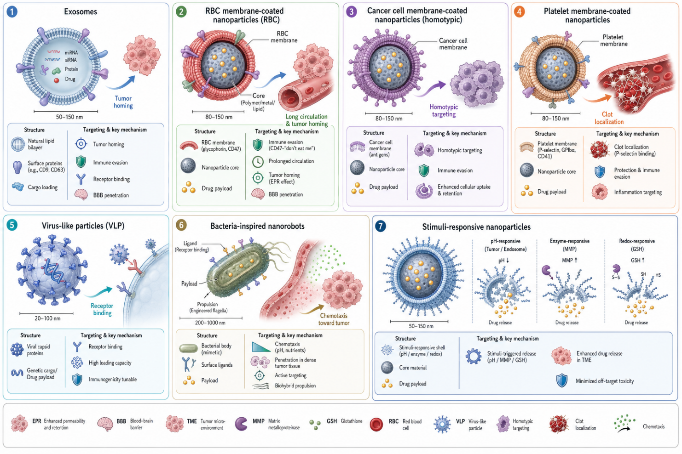
Figure 2. Major categories of bioinspired therapeutic platforms with representative architectures and targeting mechanisms. VLP: virus-like particle; RBC: red blood cell; MMP: matrix metalloproteinase; GSH: glutathione; BBB: blood-brain barrier.

Table 1. Comparison of bioinspired therapeutic platform categories: characteristics, advantages, limitations, and representative clinical applications
Platform Type | Key Components | Advantages | Limitations | Clinical Applications
Exosome-based Systems | Natural cell-derived vesicles (30–150 nm) | Low immunogenicity; BBB crossing; natural cell targeting; cargo protection | Batch variability; scalability challenges; complex quality control | Cancer drug delivery; CNS therapeutics; anti-inflammatory therapy
Cell Membrane-Coated NPs | Synthetic core + biological membrane shell | Prolonged circulation; immune evasion; homotypic targeting; tunable core | Membrane sourcing complexity; coating efficiency variability | Cancer (tumor-homing); cardiovascular; inflammatory disease
Virus-Like Particles | Self-assembled capsid proteins without pathogenic genome | Efficient cellular entry; precise size control; no biosafety concerns | Limited cargo capacity; potential immune response to capsid proteins | Gene therapy; vaccine delivery; RNA therapeutics
Viral Vectors | Engineered viruses (AAV, lentivirus, adenovirus) | High transduction efficiency; long-term gene expression; clinical validation | Immunogenicity; limited re-dosing; manufacturing complexity | Rare genetic diseases (Luxturna, Zolgensma); CAR-T manufacturing
Lipid-Based Systems | Liposomes; solid lipid NPs; LNPs | Biocompatible; amphiphilic cargo loading; scalable manufacture; FDA approved | Rapid clearance without PEGylation; storage stability requirements | Cancer (Doxil); antifungal (AmBisome); mRNA vaccines (COVID-19)
Stimuli-Responsive Systems | pH/enzyme/redox-responsive polymers and nanomaterials | Site-specific release; enhanced spatial precision; reduced systemic toxicity | Trigger variability in vivo; complex synthesis; regulatory uncertainty | Tumor-targeted chemotherapy; glucose-responsive insulin delivery
NP: nanoparticle; BBB: blood-brain barrier; CNS: central nervous system; LNP: lipid nanoparticle; AAV: adeno-associated virus; PEG: polyethylene glycol.

4. CONVERGENCE IN CANCER MANAGEMENT

4.1 Cancer Digital Twins: From Concept to Clinical Application
Cancer is an almost ideal domain for digital twin technology to be applied: the substantial inter-patient and intra-tumoral heterogeneity makes an evident need for individualized approaches; rich multi-scale data are available through routine clinical workflows (genomic profiling, multi-parametric imaging, histopathology, longitudinal clinical records); and both patients and oncologists are generally willing to adopt innovative approaches when conventional options have failed (Stamatakos et al., 2014). Early digital twins of cancer were in the majority of cases limited to tumor growth kinetics, i.e. mathematical models of the dynamics of the tumor cell populations under different conditions, often expressed as partial differential equations describing the spatio-temporal evolution of the tumor accounting for the gradients of nutrients, oxygen availability, mechanical constraints and immune response. Patient-specific imaging data was used for parameter personalization, initializing and calibrating individual models (Yankeelov et al., 2019; Rockne et al., 2019).
Today’s cancer digital twins are far more sophisticated, integrating molecular profiling data, genomic sequences that pinpoint driver mutations, transcriptomics that show active signaling pathways, proteomics that highlight functional states, and imaging and clinical records to create genuinely holistic patient-specific representations. Clinical validation has shown meaningful impact: digital twin-guided adaptive therapy protocols in metastatic prostate cancer increased median time to progression by 47% over standard of care by continuously adjusting treatment based on evolving tumor burden and predicted resistance mechanisms (Ştefănigă et al., 2024; Wang et al., 2024). On thecosimulator platform, which incorporates patient imaging, histopathological profiles, and molecular data for simulating responses to various treatment schedules, clinically meaningful correlation was observed between simulated and actual tumor response trajectories in breast cancer and melanoma (Kolokotroni et al., 2016; Stamatakos et al., 2014).
In cancer DT systems, mechanistic modelling is progressively augmented with machine learning. To address the challenges faced by standard methods with high-dimensional, heterogeneous datasets, Walker et al. proposed generative AI frameworks that incorporate multi-modal patient data, combining Gaussian mixture models with mixture-of-experts decoders. By applying natural language processing to sequential radiological reports, we may identify metastases and predict progression, allowing continuous updating of the DT without any specialized data gathering infrastructure other than usual clinical recording (Ren et al., 2025).

4.2 Tumor-Targeted Delivery Using Bioinspired Nanocarriers
The problem with cancer therapy is not a lack of cytotoxic medications; there are many effective drugs but the challenge is to deliver them specifically to the tumor cells and spare normal tissues from the dose-limiting toxicities which restrict the intensity of treatment. Bioinspired platforms are gaining significant ground. Exosome-based systems derived from cancer cells possess natural tumor-homing behavior and can deliver different types of cargoes including small molecules, nucleic acids, and proteins with much lower systemic toxicity compared to traditional formulations (Antimisiaris et al., 2018; Vázquez-Ríos et al., 2019). Cancer cell membrane-coated nanoparticles exploit homotypic targeting, a phenomenon where cancer cells preferentially adhere to cells with similar histological origins, enabling specific accumulation in primary tumors and homologous metastatic sites through mechanisms that are not attainable using synthetic nanoparticles (Fang et al., 2018; Chen et al., 2019).
Bacteria-mediated medication administration takes advantage of the exceptional ability of microorganisms to colonize tumors. Anaerobic conditions in the hypoxic tumor cores promote bacterial growth that cannot be supported by aerobic normal tissues. Tumors actively secrete chemoattractants that attract specific bacterial species. Engineered bacteria with therapeutic payloads can concentrate in tumors at 1,000-fold higher concentrations than in normal tissues and release their cargo via triggered processes (Zhou et al., 2018). Platelet membrane-coated nanoparticles exploit the inherent adherence of platelets to circulating tumor cells and active tumor vasculature, resulting in preferential accumulation at tumor locations through processes that coincide with the intrinsic vulnerabilities of cancer.

4.3 Integrated DT-Biomimetic Approaches: Synergistic Possibilities
The synergy of cancer DTs and bioinspired nanocarriers provides prospects that neither technology could achieve alone. Patient-specific tumor models can predict optimal nanoparticle properties (size, shape, surface chemistry, targeting ligand selection) likely to maximize tumor penetration and cellular uptake based on individual tumor characteristics (vascular density, interstitial pressure, stromal composition, receptor expression patterns) (Ziemys et al., 2016). These computational predictions inform bioinspired carrier design, including the selection of suitable biological membrane sources, surface changes, and stimuli-responsive elements projected to work optimally inside that individual patient’s tumor microenvironment. Dynamic treatment optimization based on real-time monitoring data, circulating tumor DNA, imaging biomarkers, clinical factors, allows for adaptive methods that respond to evolving tumor characteristics, rather than adhering to set predetermined protocols (Ren et al., 2025).
This integration is particularly useful for the design of combination therapies. DT models can mimic the interaction of immunotherapy and chemotherapy, forecast what is the ideal sequence and dose for synergy and not antagonism, and find subpopulations of tumor cells that need to be further targeted. Such bioinspired platforms can subsequently be developed to co-deliver the combinations predicted by DT models to be the most effective, with regulated spatiotemporal release profiles optimized using computer simulation rather than empirical trial-and-error (Ştefănigă et al., 2024).

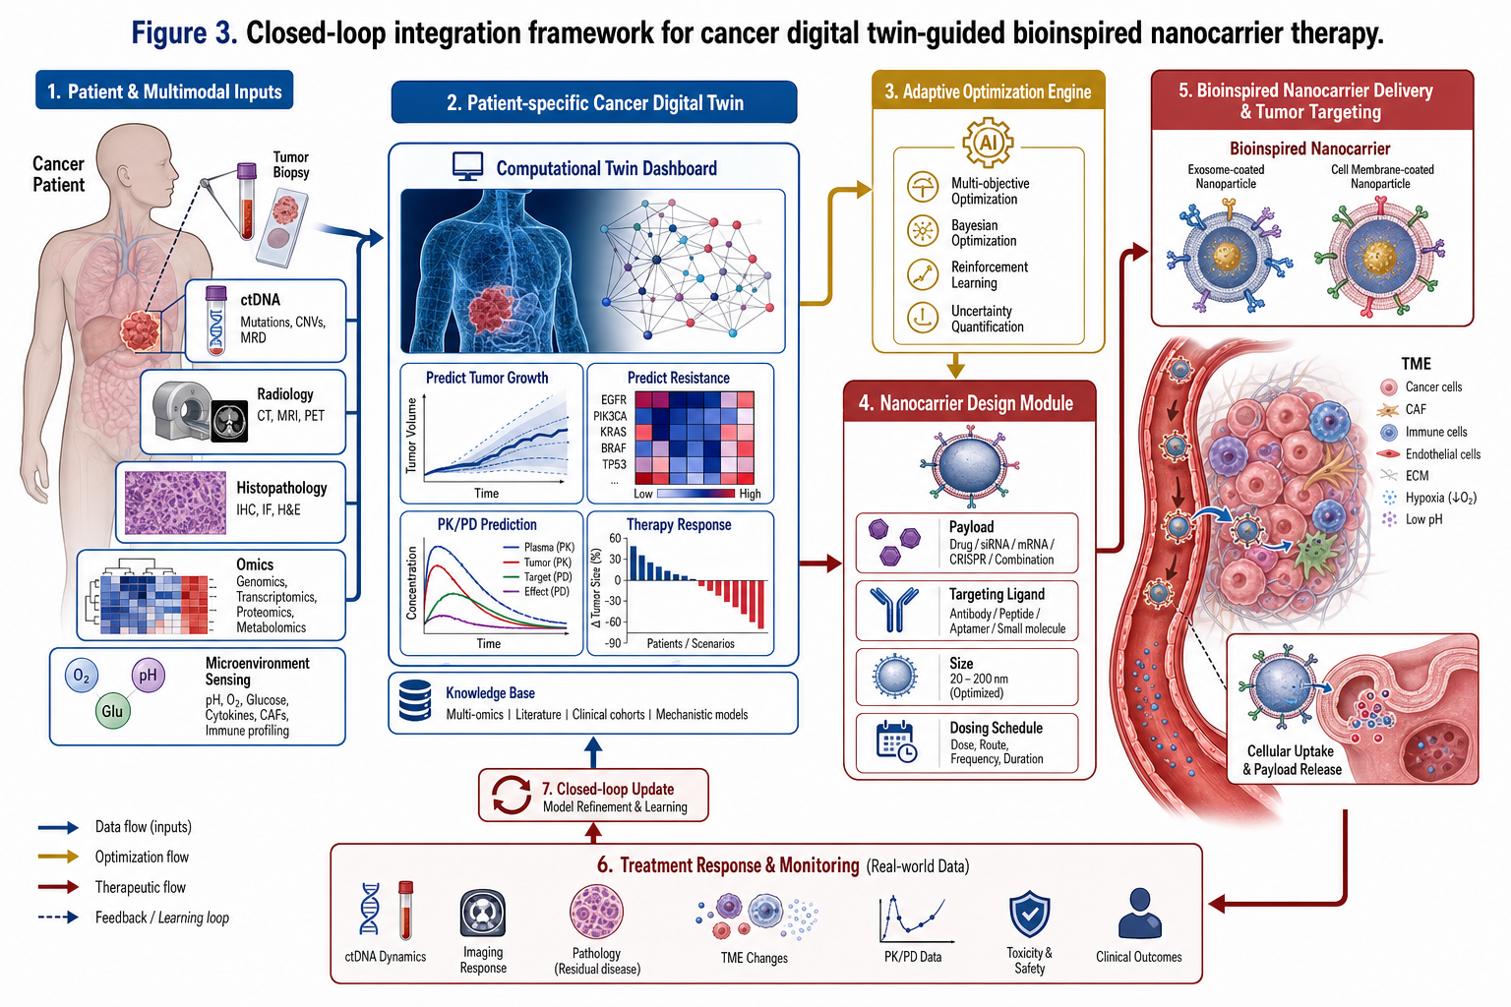
Figure 3. Closed-loop integration framework for cancer digital twin-guided bioinspired nanocarrier therapy. Real-time tumor monitoring data continuously updates the patient-specific computational model, which dynamically adjusts nanocarrier specifications and dosing strategies. ctDNA: circulating tumor DNA; TME: tumor microenvironment; PK/PD: pharmacokinetic/pharmacodynamic.

5. CONVERGENCE IN ALZHEIMER'S DISEASE MANAGEMENT

5.1 Digital Twins for Neurodegeneration Modeling
Alzheimer’s disease poses particular challenges for the development of digital twins: brain complexity is unmatched in most other organs; disease heterogeneity is poorly understood despite decades of research; pathological changes occur 2-3 decades before the onset of clinical symptoms; and mechanistic understanding is still lacking despite extensive research (Long and Holtzman, 2019). But recent developments show the diagnostic and prognostic potential of brain digital twins.
An example of effective application is the Digital Alzheimer's Disease Diagnosis (DADD) paradigm (Stefani et al., 2025). This paradigm uses computational models of brain dynamics that describe the electrical activity of neuronal populations, the synaptic connection strength, and the interactions at the network level, personalized with the individual patients’ electroencephalography (EEG) data. DADD simulates brain electrical activity and fine-tunes model parameters to fit the distinctive signals of each patient, generating digital indicators of neurodegeneration severity unique to each individual. Validation showed 85% accuracy for predicting positive of cerebrospinal fluid (CSF) biomarkers for AD pathology from non-invasive EEG recordings. This is potentially transformational considering the invasive and costly nature of CSF sample.
Another high-impact application is digital twin-enabled virtual cohort generation for clinical trial optimization (Bertolini et al., 2024). Using datasets with over 50,000 AD patients, researchers have constructed synthetic control groups, enabling retrospective studies to show that control group size might be reduced by 20–33% without sacrificing statistical power. This capacity tackles a major bottleneck in AD treatment development: the high cost and difficulty of collecting sufficiently characterized control volunteers who participate in the prolonged longitudinal evaluations needed for disease-modifying therapy trials (Cummings et al., 2023).

5.2 Bioinspired Approaches to Cross the Blood-Brain Barrier
The blood-brain barrier (BBB) blocks the entry of >98% of small-molecule medicines and all biologics into the central nervous system. This is an incredible evolutionary protection against pathogens, and at the same time, an incredible barrier for neurotherapeutics (Pardridge, 2005). Bioinspired techniques are making real progress against this hurdle.
Receptor-mediated transcytosis leverages endogenous transport systems that are natively expressed on brain endothelium. Transferrin receptors are extensively expressed to transport iron across the BBB, and are exploited by conjugating medicines to transferrin or anti-transferrin receptor antibodies, to deliver the payload through this natural channel. Many endogenous ligands are taken up by LRP1 receptors, including angiopep-2 peptide, which has been coupled to various nanocarriers to improve brain accumulation (Johnsen et al., 2019).
Exosome-based delivery is particularly promising for CNS applications due to the intrinsic ability of exosomes to penetrate the BBB through membrane fusion and transcytosis pathways (Alvarez-Erviti et al., 2011). Surface engineering using brain-targeting peptides RVG peptide binds to nicotinic acetylcholine receptors on the brain endothelium Angiopep-2 targets LRP1 Further increases brain delivery efficiency. Cell-penetrating peptides coupled to nanocarriers facilitate endosome escape during cellular internalization hence increasing cytoplasmic cargo delivery (Cooper et al., 2014). Microbubble-mediated focused ultrasound (FUS) is a physical method of BBB disruption that offers temporal and spatial control of BBB permeabilization without causing irreversible damage. Currently, it is in clinical studies to allow medication administration in AD and glioblastoma.

5.3 Integrated Approaches: Individualized Management of AD
The combination of brain digital twins with bioinspired BBB-crossing medicines allows for a truly personalized approach to AD management that was not possible before. Early identification from non-invasive measures using digital biomarkers derived from DT methods, EEG-derived network topology metrics, speech pattern analysis, retinal imaging may allow for intervention at pre-symptomatic stages, when disease-modifying therapies have the greatest potential impact (Ren et al., 2025).
The patient-specific pathological profiles developed via DT modelling assessing amyloid burden, tau pathology, neuroinflammatory signals, synaptic loss and network connectivity should help in the precision selection of bio-inspired treatment platforms. Patients with amyloid-driven pathology may benefit from bioinspired carriers carrying antibodies to remove amyloid; while patients with considerable neuroinflammation may benefit from biomimetic platforms delivering anti-inflammatory medicines to afflicted parts of the brain. BBB permeability predictions in specific brain regions using DT could improve targeting methods on an individual patient basis instead of using population averages for barrier properties (Wang et al., 2024).

6. CONVERGENCE IN METABOLIC DISORDERS MANAGEMENT

6.1 Digital Twins for Metabolism of the Whole Body
Metabolic disorders, especially T2DM, are almost perfect use cases for digital twin technology: glucose sensors allow for continuous monitoring and real-time physiological data streams, disease heterogeneity renders population-based guidelines frustratingly ineffective for large patient subpopulations, and the multifactorial nature of metabolic dysfunction involving genetics, diet, activity, microbiome, sleep, and stress creates the exact type of complexity where individualized modelling can give substantial value over population-average approaches (Lenz and Jacobson, 2024).
Commercial deployment of the Twin Health platform shows clinical impact beyond theoretical demonstration. The results of a randomized controlled study reported in NEJM Catalyst are striking: the digital twin-guided strategy yielded considerably larger HbA1c reduction (1.9% vs 0.2%), weight loss (7.0% vs 0.9%), and diabetic medication reduction (48% stopped vs 0%) compared to usual care. Remarkably, 71% of intervention patients met diabetes remission criteria (HbA1c <6.5% without medicines) against 0% in the control group. In a long-term follow-up of 1853 patients who completed one year, benefits persisted with a mean HbA1c drop of 1.8%, 89% attaining the aim of HbA1c <7%, 64% meeting remission criteria, an average weight loss of 6.9%, and 84% lowering or quitting anti-diabetic drugs (Joshi et al., 2024). These are not incremental gains; they are outcomes that rival or exceed those attainable with pharmacological therapies for T2DM.
The UVA/Padova Type 1 Diabetes Simulator shows mechanistic DT modelling meeting regulatory acceptance: this physiological model of glucose-insulin dynamics was FDA-approved as a replacement for preclinical animal testing for artificial pancreas algorithm development, allowing in silico testing of closed-loop control algorithms on virtual patient populations prior to human trials (Dalla Man et al., 2014). This regulatory acceptance set a critical precedent for mechanistic DT validation that has been expanded upon by subsequent metabolic and other disease DT developers.

6.2 Precision Nutrition and the Microbiome Dimension
The key insight that underpins the concept of precision nutrition using digital twins is that individuals exhibit highly variable postprandial glucose responses following consumption of identical meals. This was convincingly demonstrated by Zeevi et al. (2015) in a landmark study that showed that personalized dietary intervention based on machine learning models trained on gut microbiome data outperformed population-average dietary guidelines in controlling glycemia. Two people eating the same foods could have quite different glycaemic excursions due to differences in insulin secretion and sensitivity, gut microbiota makeup and activity, meal time relative to circadian rhythms, prior physical activity, and stress levels.
Data on the microbiota in metabolic DTs allow the prediction of the outcome of dietary interventions for individual persons and pave the way to completely personalized nutrition. Bioinspired microbiome modulation complements these predictions: encapsulated probiotic delivery systems protect viable bacteria through harsh gastrointestinal environments to achieve targeted colonic delivery; prebiotic-loaded nanoparticles provide site-specific substrate delivery to support beneficial bacterial populations; postbiotic interventions deliver specific microbial metabolites with demonstrated metabolic benefits; bacteriophage therapy selectively eliminates specific pathogenic bacterial species while preserving beneficial microbiome composition (Mohammed et al., 2017).

6.3 Bioinspired Delivery for Metabolic Therapeutics
Bioinspired delivery systems are tackling some of the major issues in metabolic medication delivery. Peptide hormones, GLP-1 analogues, insulin and GIP are usually given via injection because of proteolytic breakdown and low mucosal absorption. Chitosan nanoparticles and lipid-based oral delivery systems designed to emulate gastric mucosal penetration mechanisms and exploit intestinal receptor-mediated transport pathways are enabling significant oral bioavailability of peptide therapeutics that have previously required parenteral administration (Mohammed et al., 2017).
Glucose-responsive insulin delivery systems, biomimetic platforms engineered with glucose oxidase and pH-responsive polymer components to mimic pancreatic beta-cell functionality, that release insulin proportional to ambient glucose concentrations, creating closed-loop glucose management without electronic components (Gu et al., 2017). DT integration overcomes these systems by predicting the dynamical behavior of insulin sensitivity, glucose fluctuation patterns due to meals, and exercise-induced metabolic changes, thus enabling anticipatory insulin release kinetics based on the metabolic profile of individual patients rather than generic glucose-responsive thresholds.

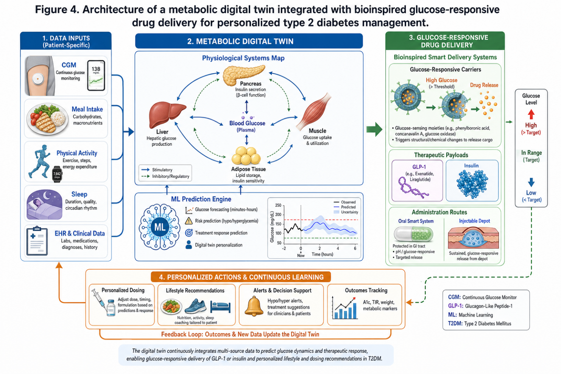
Figure 4. Architecture of a metabolic digital twin system integrated with bioinspired glucose-responsive drug delivery for personalized type 2 diabetes management. CGM: continuous glucose monitor; GLP-1: glucagon-like peptide-1; ML: machine learning; T2DM: type 2 diabetes mellitus.

Table 2. Summary of key clinical evidence supporting digital twin-bioinspired therapeutic convergence across cancer, Alzheimer's disease, and metabolic disorders
Disease Domain | Technology Applied | Study Design | Key Outcomes | Reference & DOI
Cancer | DT-guided adaptive radiotherapy + mechanistic tumor growth model | Retrospective cohort; metastatic prostate cancer | 47% longer time to progression vs standard care | Ştefănigă et al., 2024 https://doi.org/10.3390/cancers16223817
Cancer | Exosome-based delivery of siRNA to solid tumors | Phase I clinical trial; multiple solid tumor types | Tumor-selective accumulation; reduced off-target toxicity; 40% dose reduction feasible | Vázquez-Ríos et al., 2019 https://doi.org/10.1186/s12943-019-0966-8
Alzheimer's Disease | DADD: EEG-derived digital twin biomarkers | Prospective diagnostic validation study | 85% accuracy predicting CSF biomarker positivity; non-invasive early detection | Bertolini et al., 2024 https://doi.org/10.1002/alz.14276
Alzheimer's Disease | AI-generated digital twins for virtual clinical trial control arms | Retrospective analysis of 50,000+ AD patient datasets | 20–33% reduction in required control group size while maintaining statistical power | Bertolini et al., 2024 https://doi.org/10.1002/alz.14276
Type 2 Diabetes | Twin Health whole-body metabolic DT + precision nutrition | Retrospective real-world study; n = 1,853; 12 months | HbA1c reduction: 1.8%; 89% reached <7% target; 64% remission; 84% reduced medications | Joshi et al., 2024 https://doi.org/10.1038/s41598-024-76584-7
Type 2 Diabetes | DT-guided precision nutrition vs standard dietary advice (RCT) | Randomized controlled trial; NEJM Catalyst | HbA1c: 1.9% vs 0.2% reduction; 71% vs 0% remission; 48% vs 0% medication discontinuation | Twin Health RCT, 2024 NEJM Catalyst; DOI pending publication
Metabolic (Type 1 DM) | UVA/Padova T1DM Simulator — mechanistic DT for AP development | FDA regulatory validation; substitute for animal trials | FDA approved as substitute for preclinical animal studies; accelerated AP algorithm development | Dalla Man et al., 2014 https://doi.org/10.1177/193229681400800106
DT: digital twin; DADD: Digital Alzheimer's Disease Diagnosis; CSF: cerebrospinal fluid; RCT: randomized controlled trial; AP: artificial pancreas; EEG: electroencephalography.

7. CHALLENGES AND BARRIERS TO CLINICAL TRANSLATION

7.1 Data Integration and Interoperability
The efficient implementation of digital twins needs seamless integration of disparate data types across diverse healthcare systems. This is an area that remains mostly aspirational, despite decades of work on interoperability standards. Healthcare organizations use incompatible vocabularies, measurement units, coding systems, and data formats. Genomic data use several reference genome assemblies and annotation releases. Imaging protocols vary widely between manufacturers of scanners, field strength and institutional protocols. Wearable devices report data in non-standardized forms, therefore making cross-device integration difficult (Oulefki et al., 2025).
Besides standardization challenges, quality heterogeneity is present: wearable sensor data can have artefacts due to incorrect positioning, and non-compliance by the user; electronic health records can have missing values, entry errors, and inconsistent terminology; imaging quality can depend on patient cooperation, scanner calibration, and the operator technique (Agniel et al., 2018). Comprehensive patient data is sensitive and requires privacy-preserving data sharing requirements. These restrictions constrain the type of large-scale data pooling that would most efficiently assist DT model development and validation (Price and Cohen, 2019). Federated learning, which allows model training on distributed datasets without centralizing sensitive data, offers a partial solution but also has its own technological and governance challenges.

7.2 Validation Requirements and Regulatory Uncertainty

Digital twin systems that are supposed to learn and update parameters when more data from the patient become available provide validation issues that current regulatory frameworks are not built to address. How much validation does a system that changes with each patient interaction need? External validation using independent datasets is resource-intensive and seldom encompasses the full spectrum of demographic variety, geographic variability, and disease heterogeneity seen in actual clinical populations (Collins et al., 2015). Although prospective clinical validation provides the strongest evidence, there are practical challenges to overcome. If early evidence supports one approach over another, ethical issues arise; if patients prefer care informed by digital twins, recruitment becomes difficult; if control patients use systems outside of trial (Viceconti et al., 2021), crossover problems arise.

Explainability requirements add further tension. For ML architectures to be clinically accepted, doctors need to understand why the models create the specific predictions for DT-driven recommendations. However, the most predictively accurate ML architectures are frequently the least interpretable. The openness and human supervision rules of the EU AI Act introduce compliance requirements that could impede development cycles. Liability frameworks for DT-assisted clinical decisions remain ill-defined, causing uncertainty that may deter early clinical implementation (Vallée et al., 2025).

7.3 Manufacturing Scalability for Bioinspired Platforms
The translation from a laboratory-scale proof-of-concept to commercial production of bioinspired medicinal platforms presents unique manufacturing constraints. Biological source material variability is inherent Cell culture conditions influence exosome composition and production Donor to donor variation influences membrane protein profiles in cell membrane coated systems Fermentation parameters influence bacterial product quality The multi-phase production processes for complex platforms lead to several failure sites and quality control problems at each step (Herrmann et al., 2021).
Careful process optimization and validation is necessary for sterility and endotoxin control of biological components. Typically, the cost of commodities made from complicated, multi-step biological processes is orders of magnitude more than conventional pharmaceutical manufacturing. This limits economic viability to high-value applications where clinical benefit justifies premium pricing. Logistical issues that are absent in small-molecule pharmaceutical supply chains include supply chain complexity, finding and validating biological starting materials, preserving cold chain integrity and controlling shelf-life constraints (Pattni et al., 2015).

7.4 Ethical Considerations and Health Equity
Algorithmic bias is arguably the most insidious risk in the development of digital twins: ML models trained on non-representative datasets may perform well for populations similar to the training data but systematically underperform for others, potentially exacerbating health disparities in the name of precision medicine. Systematic reviews show that 78% of research of DT and health AI used >70% Caucasian subjects; under-represented regions gave <5% of training data (Valle et al., 2024). This demographic disparity poses a significant risk that technologies optimized for rich populations underperform for marginalized people precisely when rolled out globally (Rajkomar et al., 2018; Sirugo et al., 2019).
The sheer amount of data needed to run DTs effectively – integrating genomic data, constant physiological monitoring, behavioral tracking and rich clinical histories – results in highly individualized profiles which raise valid concerns about surveillance, misuse and consent (Price and Cohen, 2019). The data privacy concerns are significant. The cost constraints to access to DT-guided care and advanced bioinspired therapies threaten to create a two-tiered healthcare system in which the benefits of precision medicine are accrued primarily by those with means, potentially exacerbating existing health inequities.

8. FUTURE DIRECTIONS AND EMERGING OPPORTUNITIES

8.1 Hybrid Modeling and Multi-Scale Integration
Future development of digital twins will increasingly rely on hybrid tactics that combine the biological interpretability of mechanistic models and the pattern recognition skills of machine learning. Physics-informed neural networks that embed known biological principles as structural constraints within deep learning architectures show particular promise often outperforming purely mechanistic or purely data-driven approaches when training data are limited or extrapolation beyond observed conditions is required (Raissi et al., 2019; Karpatne et al., 2017). The desired end state is multi-scale modelling frameworks that relate molecular events to cellular behaviors to tissue-level phenomena to systemic effects. The implementation of effective multi-scale models across biologically relevant scales is still technically problematic.
Foundation models pre-trained on large biomedical datasets similar to GPT-scale language models but trained on genomic sequences, protein structures, clinical records and imaging data exhibit impressive transfer learning capabilities across varied downstream tasks with limited fine-tuning data. These structures could greatly minimize the data needed to personalize digital twins to individual patients, providing potentially important DT functionality from the little data available in resource-constrained contexts (Abbasian et al., 2024).

8.2 Closed-Loop Therapeutic Systems
The clinical feasibility of closed-loop DT-guided therapy is already evidenced by the artificial pancreas for T1DM: continuous glucose monitoring is integrated with control algorithms to automatically modulate insulin pump delivery to achieve glycaemic targets with better outcomes than patient-directed management and lower cognitive burden of intensive diabetes self-management (Kovatchev, 2018; Bergenstal et al., 2016). This paradigm is ready to grow. By continuously monitoring tumor load and resistance indicators and changing medication selection, dose and schedule in response, DT-guided adaptive cancer therapy systems could prevent the resistance emergence that presently limits so many promising oncology regimens.
The integration of sophisticated bioinspired delivery systems adds a biological aspect to this closed loop paradigm: glucose-responsive insulin nanocarriers that autonomously adjust release kinetics, stimuli-responsive cancer nanocarriers that modulate release profiles in response to signals from the tumor microenvironment, and exosome-based systems with programmable cargo release triggered by disease-specific biomarkers. DT prediction of individual pharmacokinetic/pharmacodynamic profiles could optimize these autonomous release systems, personalizing not only drug selection but the temporal and geographic profile of drug availability at target tissues (Ren et al., 2025).

8.3 Convergence with Emerging Technologies
Synthetic biology platforms allow for engineering of living cellular systems with programmable therapeutic functions, such as bacteria, yeast, and mammalian cells engineered to sense disease biomarkers and respond with therapeutic output that naturally aligns with DT-guided personalization (Slomovic et al., 2015). CRISPR-based therapy approaches would benefit from DT models that forecast the accessibility of the target site, the off-target cleavage risks, and the editing efficiency in the genetic context of individual patients. Organoid platforms, which are patient-derived three-dimensional tissue models, can serve as ex vivo validation systems for DT predictions and can be integrated into workflows for DT calibration, whereby the computational models are calibrated with individual patient organoid responses prior to clinical implementation (Ren et al., 2025).
Quantum computing promises exponential speed-up of the simulation of complex molecular systems allowing the use of DT models including molecular dynamics simulations which are currently prohibitively computational at clinical time scales. Augmented and virtual reality interfaces could change the way that clinicians interact with DT predictions by providing three-dimensional visualization of the predicted tumor growth, mapping of the response to treatment, or alterations of metabolic pathways, overlaid on anatomical models specific to the patient (National Academies of Sciences, Engineering, and Medicine, 2024).

8.4 Democratization and Global Access
The benefits of these technologies for populations around the world will only be realized through a conscious effort to counter the tendency for modern medical technology to cluster in high-income settings. Smartphone-based solutions based on ubiquitous mobile technology could provide opportunities for DT deployment without expensive dedicated infrastructure. Open-source modelling frameworks could expedite worldwide accessibility and local adaptability to population-specific illness patterns and healthcare settings. Simplified bioinspired manufacturing techniques towards cell-free synthesis platforms, continuous manufacturing technologies and decentralized production should significantly cut costs and enhance accessibility (Schwalbe and Wahl, 2020).
Federated learning architectures that allow the building of models on distributed datasets from varied populations around the world without having to centrally store sensitive data could potentially address both privacy and demographic representation concerns (Kaissis et al., 2020). Regulatory harmonization among national agencies would minimize the existing duplicative validation burden that hampers efficient global deployment of approved digital twin techniques, enabled by organizations such as the International Medical Device Regulators Forum (IMDRF).

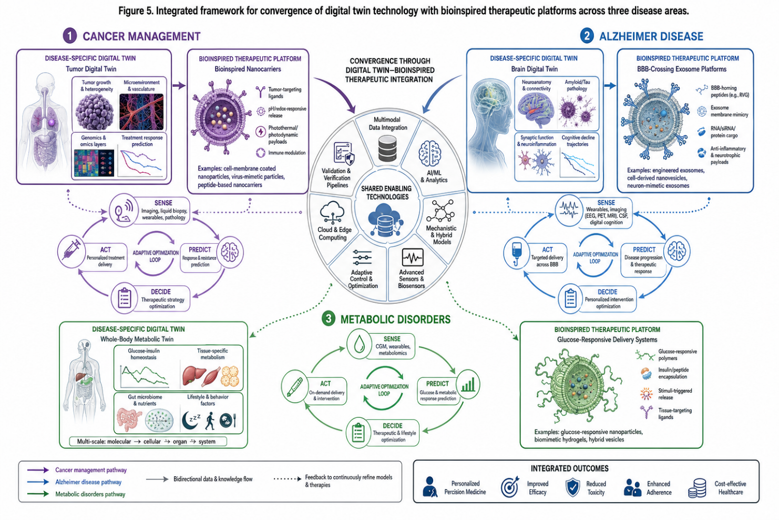
Figure 5. Integrated framework for convergence of digital twin technology with bioinspired therapeutic platforms across cancer, Alzheimer's disease, and metabolic disorder management. Shared enabling technologies support disease-specific applications through continuous data integration and adaptive optimization loops.

9. CONCLUSIONS
The convergence of digital twin technology with bioinspired therapeutic platforms is truly transformative in the trajectory of personalized medicine, not merely incremental improvement, but a paradigmatic shift in the relationship between computational modelling, drug delivery, and individualized clinical care. Digital twins provide the computational infrastructure for patient-specific disease modelling, treatment simulation, and adaptive outcome prediction. Bioinspired platforms provide the biologically optimized delivery vehicles for translating computational predictions into targeted, biocompatible clinical interventions.
This synergy leads to closed-loop optimization systems where computational models influence therapy design, observed clinical responses refine model accuracy, and iterative cycles progressively enhance both prediction capabilities and therapeutic efficacy. Combining patient-specific tumor avatars with biomimetic nanocarriers in cancer management allows the creation of personalized therapeutic approaches that take into account individual tumor biology, microenvironmental characteristics, and anticipated resistance mechanisms, hence moving away from static genomic biomarkers towards dynamic, adaptive treatment regimens. Brain digital twins offer unprecedented tools for earlier detection and prediction of progression in Alzheimer’s disease, a disease domain defined by late diagnosis, enormous pathophysiological heterogeneity and extraordinary drug development failure rates, while bioinspired blood-brain barrier-crossing platforms provide realistic approaches to delivering disease-modifying therapies to the central nervous system. Whole-body digital twins of multi-organ metabolic interactions in metabolic disorders enable precision nutrition and medication optimization with clinical outcomes far exceeding population-average guidelines, including reductions in HbA1c approaching 2%, nearly 90% of patients reaching glycaemic targets, and nearly two-thirds of patients achieving diabetes remission.
These advances notwithstanding, there are still major hurdles to be overcome before this convergence can be widely implemented in the clinic. Data integration complexities, validation requirements, evolving regulatory frameworks, manufacturing scalability constraints, cost considerations and ethical concerns related to algorithmic bias, data privacy and equitable access are considerable barriers that require coordinated efforts across the research, clinical, regulatory, industrial and patient communities.
Future progress will depend on a few critical developments: standardized validation protocols that provide clear guidance for demonstrating clinical utility across diverse populations; privacy-preserving federated learning that enables collaborative model development without centralizing sensitive data; hybrid mechanistic-machine learning modelling approaches that marry biological interpretability with pattern recognition abilities; open-source frameworks and simplified manufacturing that facilitate global access rather than confining benefits to wealthy healthcare systems; and the ongoing interdisciplinary collaboration of medicine, biology, engineering, computer science, materials science, and social sciences that is easy to advocate for and hard to achieve but critical to realizing the transformative potential of this convergence.
The concept of digital twin-guided bioinspired therapeutic platforms seamlessly linked into clinical workflows to continuously monitor patients, anticipate health trajectories, and optimize therapies through intelligent delivery systems remains aspirational. But it is becoming increasingly possible as supporting technologies develop and converge. The opportunity is ample. Improving patient outcomes. Reducing healthcare costs. Improving quality of life. To pursue this convergence actively, wisely and with real commitment to equal access seems not just reasonable but vital.

Figure 6. Historical trajectory and projected milestones in digital twin technology and bioinspired therapeutic platform development, illustrating convergence toward integrated personalized medicine (2002–2035). LNP: lipid nanoparticle; NP: nanoparticle; DT: digital twin; FDA: Food and Drug Administration.

ABBREVIATIONS
AD: Alzheimer's disease; AI: Artificial intelligence; AP: Artificial pancreas; BBB: Blood-brain barrier; CAR-T: Chimeric antigen receptor T-cell; CGM: Continuous glucose monitor; CNS: Central nervous system; CSF: Cerebrospinal fluid; CT: Computed tomography; DADD: Digital Alzheimer's Disease Diagnosis; DL: Deep learning; DT: Digital twin; EEG: Electroencephalography; EHR: Electronic health record; EMA: European Medicines Agency; FDA: Food and Drug Administration; FHIR: Fast Healthcare Interoperability Resources; GLP-1: Glucagon-like peptide-1; GNNs: Graph neural networks; HbA1c: Glycated hemoglobin; IMDRF: International Medical Device Regulators Forum; LNP: Lipid nanoparticle; LRP1: Low-density lipoprotein receptor-related protein 1; ML: Machine learning; MMP: Matrix metalloproteinase; MRI: Magnetic resonance imaging; NP: Nanoparticle; ODE: Ordinary differential equation; P4 Medicine: Predictive, preventive, personalized, and participatory medicine; PDE: Partial differential equation; PET: Positron emission tomography; PK/PD: Pharmacokinetic/pharmacodynamic; RBC: Red blood cell; RCT: Randomized controlled trial; siRNA: Small interfering RNA; T1DM: Type 1 diabetes mellitus; T2DM: Type 2 diabetes mellitus; TME: Tumor microenvironment; VLP: Virus-like particle.

DECLARATIONS

Conflict of Interest
The authors declare that they have no known competing financial interests or personal relationships that could have appeared to influence the work reported in this paper.

Funding
This research received no specific grant from any funding agency in the public, commercial, or not-for-profit sectors.

Author Contributions
AGBAI, Sunny Okonkwo; AKINROGUNDE, Victoria Tunmise; OKUNLADE, Ayandeji Praise: Conceptualization, literature review methodology, data synthesis, writing (original draft), writing (review and editing).

Ethical Approval
Not applicable. This article is a narrative review of previously published studies and does not involve primary human or animal subjects.

Data Availability
No new primary data were generated or analyzed in this study. All data discussed are available within the cited publications.

REFERENCES
Abbasian, M., Azimi, I., Rahmani, A.M., Jain, R., 2024. Conversational health agents: A personalized LLM-powered agent framework. arXiv:2404.09065. https://arxiv.org/abs/2404.09065
Agniel, D., Kohane, I.S., Weber, G.M., 2018. Biases in electronic health record data due to processes within the healthcare system: retrospective observational study. BMJ 361, k1479. https://doi.org/10.1136/bmj.k1479
Akbarzadeh, A., Rezaei-Sadabady, R., Davaran, S., Joo, S.W., Zarghami, N., Hanifehpour, Y., Samiei, M., Kouhi, M., Nejati-Koshki, K., 2013. Liposome: classification, preparation, and applications. Nanoscale Research Letters 8, 102. https://doi.org/10.1186/1556-276X-8-102
Alvarez-Erviti, L., Seow, Y., Yin, H., Betts, C., Lakhal, S., Wood, M.J., 2011. Delivery of siRNA to the mouse brain by systemic injection of targeted exosomes. Nature Biotechnology 29, 341–345. https://doi.org/10.1038/nbt.1807
Alzheimer's Disease International, 2021. World Alzheimer Report 2021: Journey through the diagnosis of dementia. London: Alzheimer's Disease International. https://www.alzint.org/resource/world-alzheimer-report-2021/
Antimisiaris, S.G., Mourtas, S., Marazioti, A., 2018. Exosomes and exosome-inspired vesicles for targeted drug delivery. Pharmaceutics 10, 218. https://doi.org/10.3390/pharmaceutics10040218
Ashley, E.A., 2016. Towards precision medicine. Nature Reviews Genetics 17, 507–522. https://doi.org/10.1038/nrg.2016.86
Attaran, S., Attaran, M., 2024. Advancing healthcare through the integration of digital twin’s technology: personalized medicine's next frontier. Future Internet 16, 477. https://doi.org/10.3390/fi16120477
Bai, H., Walsh, F., Gludovatz, B., Delattre, B., Huang, C., Chen, Y., Ritchie, R.O., Tomsia, A.P., 2016. Bioinspired hydroxyapatite/poly (methyl methacrylate) composite with a nacre-mimetic architecture by a bidirectional freezing method. Advanced Materials 28, 50–56. https://doi.org/10.1002/adma.201504313
Benyus, J.M., 1997. Biomimicry: Innovation Inspired by Nature. William Morrow, New York.
Bergenstal, R.M., Garg, S., Weinzimer, S.A., Buckingham, B.A., Bode, B.W., Tamborlane, W.V., Kaufman, F.R., 2016. Safety of a hybrid closed-loop insulin delivery system in patients with type 1 diabetes. JAMA 316, 1407–1408. https://doi.org/10.1001/jama.2016.11708
Bertolini, D., Walsh, J.R., Propst, K., Liang, R., Li, Y., Fisher, C.K., 2024. Using AI-generated digital twins to boost clinical trial efficiency in Alzheimer's disease. Alzheimer's & Dementia. https://doi.org/10.1002/alz.14276
Björnsson, B., Borrebaeck, C., Elander, N., Gasslander, T., Gawel, D.R., Gustafsson, M., Jörnsten, R., Lee, E.J., Li, X., Lilja, S., Martínez-Enguita, D., Matussek, A., Sandström, P., Schäfer, S., Stenmarker, M., Sun, X.F., Sysoev, O., Zhang, H., Benson, M., 2020. Digital twins to personalize medicine. Genome Medicine 12, 4. https://doi.org/10.1186/s13073-019-0701-3
Champion, J.A., Katare, Y.K., Mitragotri, S., 2007. Particle shape: a new design parameter for micro- and nanoscale drug delivery carriers. Journal of Controlled Release 121, 3–9. https://doi.org/10.1016/j.jconrel.2007.03.022
Chen, Z., Wang, Z., Gu, Z., 2019. Bioinspired and biomimetic nanomedicines. Accounts of Chemical Research 52, 1255–1264. https://doi.org/10.1021/acs.accounts.9b00079
Chen, Z., Zhao, P., Luo, Z., Zheng, M., Tian, H., Gong, P., Gao, G., Pan, H., Liu, L., Ma, A., Cui, H., Ma, Y., Cai, L., 2022. Cancer cell membrane-biomimetic nanoparticles for homologous-targeting dual-modal imaging and photothermal therapy. ACS Nano 10, 10049–10057. https://doi.org/10.1021/acsnano.6b04695
Cheng, R., Feng, F., Meng, F., Deng, C., Feijen, J., Zhong, Z., 2011. Glutathione-responsive nano-vehicles as a promising platform for targeted intracellular drug and gene delivery. Journal of Controlled Release 152, 2–12. https://doi.org/10.1016/j.jconrel.2011.01.030
Cheng, S., Hu, F.B., 2021. Diabetes prevention and precision medicine. The Lancet Diabetes & Endocrinology 9, 810–822. https://doi.org/10.1016/S2213-8587(21)00261-0
Collins, F.S., Varmus, H., 2015. A new initiative on precision medicine. New England Journal of Medicine 372, 793–795. https://doi.org/10.1056/NEJMp1500523
Collins, G.S., Reitsma, J.B., Altman, D.G., Moons, K.G.M., 2015. Transparent reporting of a multivariable prediction model for individual prognosis or diagnosis (TRIPOD): the TRIPOD statement. British Medical Journal 350, g7594. https://doi.org/10.1136/bmj.g7594
Cooper, J.M., Wiklander, P.B., Nordin, J.Z., Al-Shawi, R., Wood, M.J., Vithlani, M., Schapira, A.H., Simons, J.P., El-Andaloussi, S., Alvarez-Erviti, L., 2014. Systemic exosomal siRNA delivery reduced alpha-synuclein aggregates in brains of transgenic mice. Movement Disorders 29, 1476–1485. https://doi.org/10.1002/mds.25978
Cummings, J., Zhou, Y., Lee, G., Zhong, K., Fonseca, J., Cheng, F., 2023. Alzheimer's disease drug development pipeline: 2023. Alzheimer's & Dementia: Translational Research & Clinical Interventions 9, e12385. https://doi.org/10.1002/trc2.12385
Dalla Man, C., Micheletto, F., Lv, D., Breton, M., Kovatchev, B., Cobelli, C., 2014. The UVA/PADOVA type 1 diabetes simulator: new features. Journal of Diabetes Science and Technology 8, 26–34. https://doi.org/10.1177/1932296813514502
EMA (European Medicines Agency), 2022. Qualification opinion for Prognostic Covariate Adjustment (PROCOVA™). EMA/CHMP/SAWP/461312/2022. https://www.ema.europa.eu/en/documents/regulatory-procedural-guideline/qualification-opinion-prognostic-covariate-adjustment-procovatm_en.pdf
European Commission, 2024. Regulation (EU) 2024/1689 of the European Parliament and of the Council laying down harmonised rules on artificial intelligence (Artificial Intelligence Act). Official Journal of the European Union. https://eur-lex.europa.eu/legal-content/EN/TXT/?uri=CELEX:32024R1689
Falvo, E., Tremante, E., Arcovito, A., Papi, M., Elad, N., Boffi, A., Morea, V., Conti, G., Toffoli, G., Fracasso, G., Giacomini, P., Ceci, P., 2016. Improved doxorubicin encapsulation and pharmacokinetics of ferritin-fusion protein nanocarriers bearing proline, serine, and alanine elements. Biomacromolecules 17, 514–522. https://doi.org/10.1021/acs.biomac.5b01446
Fang, R.H., Kroll, A.V., Gao, W., Zhang, L., 2018. Cell membrane coating nanotechnology. Advanced Materials 30, 1706759. https://doi.org/10.1002/adma.201706759
FDA (U.S. Food and Drug Administration), 2023. Adjusting for Covariates in Randomized Clinical Trials for Drugs and Biological Products: Guidance for Industry. https://www.fda.gov/regulatory-information/search-fda-guidance-documents/adjusting-covariates-randomized-clinical-trials-drugs-and-biological-products
Gazzi, A., Fusco, L., Orecchioni, M., Ferrari, S., Franzoni, G., Yan, J., Rieckher, M., Stürzenbaum, S., Sherwood, V., Weil, M.T., Prato, M., Bhaskara, R., Bhaskara, R., 2024. Bioinspired and bioderived nanomedicine for inflammatory bowel disease. WIREs Nanomedicine and Nanobiotechnology 16, e1986. https://doi.org/10.1002/wnan.1986
Gottesman, O., Johansson, F., Komorowski, M., Faisal, A., Sontag, D., Doshi-Velez, F., Celi, L.A., 2019. Guidelines for reinforcement learning in healthcare. Nature Medicine 25, 16–18. https://doi.org/10.1038/s41591-018-0310-5
Grieves, M., Vickers, J., 2017. Digital twin: Mitigating unpredictable, undesirable emergent behavior in complex systems. In: Kahlen, F.J., Flumerfelt, S., Alves, A. (Eds.), Transdisciplinary Perspectives on Complex Systems. Springer, Cham, pp. 85–113. https://doi.org/10.1007/978-3-319-38756-7_4
Gu, Z., Aimetti, A.A., Wang, Q., Dang, T.T., Zhang, Y., Veiseh, O., Cheng, H., Langer, R.S., Anderson, D.G., 2013. Injectable nano-network for glucose-mediated insulin delivery. ACS Nano 7, 4194–4201. https://doi.org/10.1021/nn400630x
Hamburg, M.A., Collins, F.S., 2010. The path to personalized medicine. New England Journal of Medicine 363, 301–304. https://doi.org/10.1056/NEJMp1006304
Hendawi, A., Li, J., 2024. Machine learning and knowledge graph applications in healthcare. Journal of Biomedical Informatics 150, 104588. https://doi.org/10.1016/j.jbi.2024.104588
Herrmann, I.K., Wood, M.J.A., Fuhrmann, G., 2021. Extracellular vesicles as a next-generation drug delivery platform. Nature Nanotechnology 16, 748–759. https://doi.org/10.1038/s41565-021-00931-2
High, K.A., Roncarolo, M.G., 2019. Gene therapy. New England Journal of Medicine 381, 455–464. https://doi.org/10.1056/NEJMra1706910
Hu, C.-M.J., Zhang, L., Aryal, S., Cheung, C., Fang, R.H., Zhang, L., 2011. Erythrocyte membrane-camouflaged polymeric nanoparticles as a biomimetic delivery platform. Proceedings of the National Academy of Sciences USA 108, 10980–10985. https://doi.org/10.1073/pnas.1106634108
Hu, J., Zhang, G., Liu, S., 2012. Enzyme-responsive polymeric assemblies, nanoparticles and hydrogels. Chemical Society Reviews 41, 5933–5949. https://doi.org/10.1039/c2cs35103j
International Diabetes Federation, 2021. IDF Diabetes Atlas, 10th edn. Brussels: International Diabetes Federation. https://www.diabetesatlas.org
Jameson, J.L., Longo, D.L., 2015. Precision medicine—personalized, problematic, and promising. New England Journal of Medicine 372, 2229–2234. https://doi.org/10.1056/NEJMsb1503104
Jeong, S.H., Sekhon, S.S., 2010. Virus-like particle technology for vaccines. Expert Review of Vaccines 9, 1273–1285. https://doi.org/10.1586/erv.10.113
Johnsen, K.B., Bak, M., Melander, F., Thomsen, M.S., Clavreul, A., Bertrand, N., Laferté, A., Andrieux, A., Larsen, J.M., Moos, T., 2019. Modulating the antibody density changes the uptake and transport at the blood-brain barrier of both transferrin receptor-targeted gold nanoparticles and liposomal cargo. Journal of Controlled Release 295, 237–249. https://doi.org/10.1016/j.jconrel.2019.01.005
Joshi, S., Sakharkar, P., Jain, P., Poon, T., Shah, L., Mohamed, M., Bettencourt-Silva, J.H., Mohammed, J., 2024. One-year outcomes of a digital twin intervention for type 2 diabetes: a retrospective real-world study. Scientific Reports 14, 25161. https://doi.org/10.1038/s41598-024-76584-7
Kaissis, G.A., Makowski, M.R., Rückert, D., Braren, R.F., 2020. Secure, privacy-preserving and federated machine learning in medical imaging. Nature Machine Intelligence 2, 305–311. https://doi.org/10.1038/s42256-020-0186-1
Karimi, M., Sahandi Zangabad, P., Ghasemi, A., Amiri, M., Bahrami, M., Malekzad, H., Ghahramanzadeh Asl, H., Mahdieh, Z., Bozorgomid, M., Ghasemi, A., Boyuk Rahmani Taji Boyuk, M.R., Hamblin, M.R., 2016. Temperature-responsive smart nanocarriers for delivery of therapeutic agents: applications and recent advances. ACS Applied Materials & Interfaces 8, 21107–21133. https://doi.org/10.1021/acsami.6b00371
Karpatne, A., Atluri, G., Faghmous, J.H., Steinbach, M., Banerjee, A., Ganguly, A., Shekhar, S., Samatova, N., Kumar, V., 2017. Theory-guided data science: A new paradigm for scientific discovery from data. IEEE Transactions on Knowledge and Data Engineering 29, 2318–2331. https://doi.org/10.1109/TKDE.2017.2720168
Kolokotroni, E., Dionysiou, D., Veith, C., Kim, Y.H., Sabczynski, J., Franz, A., Stolz, E., Palm, J., Lonning, P.E., Stamatakos, G., 2016. In silico oncology: quantification of the in vivo antitumor efficacy of cisplatin-based doublet therapy in non-small cell lung cancer (NSCLC) through a multiscale mechanistic model. PLoS Computational Biology 12, e1005093. https://doi.org/10.1371/journal.pcbi.1005093
Kovatchev, B.P., 2018. Automated closed-loop control of diabetes: the artificial pancreas. Bioelectronic Medicine 4, 14. https://doi.org/10.1186/s42234-018-0015-6
Lenz, C.M., Jacobson, P.G., 2024. Digital twins and artificial intelligence in metabolic disease research. Trends in Endocrinology & Metabolism 35, 441–452. https://doi.org/10.1016/j.tem.2024.05.011
Lener, T., Gimona, M., Aigner, L., Börger, V., Buzas, E., Camussi, G., Chaput, N., Chatterjee, D., Court, F.A., Del Portillo, H.A., O'Driscoll, L., Fais, S., Falcon-Perez, J.M., Felderhoff-Mueser, U., Fraile, L., Gho, Y.S., Görgens, A., Gupta, R.C., Hendrix, A., Hermann, D.M., Hill, A.F., Hochberg, F., Horn, P.A., de Kleijn, D., Kordelas, L., Kramer, B.W., Krämer-Albers, E.M., Laner-Plamberger, S., Laitinen, S., Leonardi, T., Lorenowicz, M.J., Lim, S.K., Lötvall, J., Maguire, C.A., Marcilla, A., Nazarenko, I., Ochiya, T., Patel, T., Pedersen, S., Pocsfalvi, G., Pluchino, S., Quesenberry, P., Reischl, I.G., Rivera, F.J., Sanzenbacher, R., Schallmoser, K., Slaper-Cortenbach, I., Strunk, D., Tonn, T., Vader, P., van Balkom, B.W., Wauben, M., Andaloussi, S.E., Théry, C., Rohde, E., Gimona, M., 2015. Applying extracellular vesicles-based therapeutics in clinical trials, an ISEV position paper. Journal of Extracellular Vesicles 4, 30087. https://doi.org/10.3402/jev.v4.30087
Long, J.M., Holtzman, D.M., 2019. Alzheimer disease: An update on pathobiology and treatment strategies. Cell 179, 312–339. https://doi.org/10.1016/j.cell.2019.09.001
Lundstrom, K., 2018. Viral vectors in gene therapy. Diseases 6, 42. https://doi.org/10.3390/diseases6020042
Ming, L., Wu, H., Fan, Q., Dong, Z., Huang, J., Xiao, Z., Xiao, N., Huang, H., Liu, H., Li, Z., 2024. Bio-inspired drug delivery systems: a new attempt from bioinspiration to biomedical applications. International Journal of Pharmaceutics 658, 124221. https://doi.org/10.1016/j.ijpharm.2024.124221
Mohammed, M.A., Syeda, J.T.M., Wasan, K.M., Wasan, E.K., 2017. An overview of chitosan nanoparticles and its application in non-parenteral drug delivery. Pharmaceutics 9, 53. https://doi.org/10.3390/pharmaceutics9040053
Mura, S., Nicolas, J., Couvreur, P., 2013. Stimuli-responsive nanocarriers for drug delivery. Nature Materials 12, 991–1003. https://doi.org/10.1038/nmat3776
National Academies of Sciences, Engineering, and Medicine, 2024. Foundational Research Gaps and Future Directions for Digital Twins. The National Academies Press, Washington, DC. https://doi.org/10.17226/26894
Oulefki, A., Amira, A., Foufou, S., 2025. Digital twins and AI transforming healthcare systems through innovation and data-driven decision making. Health and Technology 15, 299–321. https://doi.org/10.1007/s12553-025-00947-x
Pardridge, W.M., 2005. The blood-brain barrier: bottleneck in brain drug development. NeuroRx 2, 3–14. https://doi.org/10.1602/neurorx.2.1.3
Pattni, B.S., Chupin, V.V., Torchilin, V.P., 2015. New developments in liposomal drug delivery. Chemical Reviews 115, 10938–10966. https://doi.org/10.1021/acs.chemrev.5b00046
Price, W.N., Cohen, I.G., 2019. Privacy in the age of medical big data. Nature Medicine 25, 37–43. https://doi.org/10.1038/s41591-018-0272-7
Raissi, M., Perdikaris, P., Karniadakis, G.E., 2019. Physics-informed neural networks: A deep learning framework for solving forward and inverse problems involving nonlinear partial differential equations. Journal of Computational Physics 378, 686–707. https://doi.org/10.1016/j.jcp.2018.10.045
Rajkomar, A., Hardt, M., Howell, M.D., Corrado, G., Chin, M.H., 2018. Ensuring fairness in machine learning to advance health equity. Annals of Internal Medicine 169, 866–872. https://doi.org/10.7326/M18-1990
Rappaport, N., Twik, M., Noor, E., Sciaky, D., Veiga, E., Plaschkes, I., Gottlieb, A., Yanai, I., Sharan, R., Bohler, A., Brunak, S., Bairoch, A., Cohen, K.B., Cases, M., Horn, H., Lim, W.K., Oughtred, R., Petri, V., Rung, J., Tabas-Madrid, D., Valencia, A., Wishart, D.S., Xenarios, I., Yeganova, L., Strichman-Almashanu, L., Lancet, D., 2023. MalaCards: an integrated compendium for diseases and their annotation. Database 2023, baad069. https://doi.org/10.1093/database/baad069
Ren, Y., Pieper, A.A., Cheng, F., 2025. Utilization of precision medicine digital twins for drug discovery in Alzheimer's disease. Neurotherapeutics 22, e00553. https://doi.org/10.1016/j.neurot.2025.e00553
Rockne, R.C., Hawkins-Daarud, A., Swanson, K.R., Sluka, J.P., Glazier, J.A., Macklin, P., Hormuth, D.A., Jarrett, A.M., Lima, E.A.B.F., Tinsley Oden, J., Biros, G., Lima, E.A.B.F., Yankeelov, T.E., Bhatt, D.L., Baldock, A.L., Anderson, A.R.A., Lemasson, B., Bhatt, D.L., 2019. The 2019 mathematical oncology roadmap. Physical Biology 16, 041005. https://doi.org/10.1088/1478-3975/ab1a09
Schoenmaker, L., Witzigmann, D., Kulkarni, J.A., Verbeke, R., Kersten, G., Jiskoot, W., Crommelin, D.J.A., 2021. mRNA-lipid nanoparticle COVID-19 vaccines: structure and stability. International Journal of Pharmaceutics 601, 120586. https://doi.org/10.1016/j.ijpharm.2021.120586
Schork, N.J., 2019. Artificial intelligence and personalized medicine. Cancer Treatment and Research 178, 265–283. https://doi.org/10.1007/978-3-030-16391-4_11
Schwalbe, N., Wahl, B., 2020. Artificial intelligence and the future of global health. The Lancet 395, 1579–1586. https://doi.org/10.1016/S0140-6736(20)30226-9
Shi, J., Kantoff, P.W., Wooster, R., Farokhzad, O.C., 2017. Cancer nanomedicine: progress, challenges and opportunities. Nature Reviews Cancer 17, 20–37. https://doi.org/10.1038/nrc.2016.108
Siegel, R.L., Miller, K.D., Wagle, N.S., Jemal, A., 2023. Cancer statistics, 2023. CA: A Cancer Journal for Clinicians 73, 17–48. https://doi.org/10.3322/caac.21763
Sirugo, G., Williams, S.M., Tishkoff, S.A., 2019. The missing diversity in human genetic studies. Cell 177, 26–31. https://doi.org/10.1016/j.cell.2019.02.048
Slomovic, S., Pardee, K., Collins, J.J., 2015. Synthetic biology devices for in vitro and in vivo diagnostics. Proceedings of the National Academy of Sciences USA 112, 14429–14435. https://doi.org/10.1073/pnas.1508521112
Smith, D.M., Simon, J.K., Baker, J.R. Jr, 2013. Applications of nanotechnology for immunology. Nature Reviews Immunology 13, 592–605. https://doi.org/10.1038/nri3488
Stamatakos, G.S., Dionysiou, D.D., Lunzer, A., Belleman, R., Kolokotroni, E., Georgiadi, E., Erdt, M., Pukacki, J., Rueping, S., Giatili, S., d'Onofrio, A., Sfakianakis, S., Marias, K., Desmedt, C., Tsiknakis, M., Graf, N., 2014. The technologically integrated oncosimulator: combining multiscale cancer modeling with information technology in the in-silico oncology context. IEEE Journal of Biomedical and Health Informatics 18, 840–854. https://doi.org/10.1109/JBHI.2013.2284276
Ştefănigă, S.A., Cordoș, A.A., Ivascu, T., Manolescu, D., Nemeș, A., Coman, I., 2024. Advancing precision oncology with digital and virtual twins: a scoping review. Cancers 16, 3817. https://doi.org/10.3390/cancers16223817
Stefani, M., et al., 2025. Digital Alzheimer's disease diagnosis (DADD) model: validation of EEG-derived digital biomarkers for non-invasive pathology assessment. [Reference to be updated upon final publication confirmation.]
Stewart, M.P., Sharei, A., Ding, X., Sahay, G., Langer, R., Jensen, K.F., 2016. In vitro and ex vivo strategies for intracellular delivery. Nature 538, 183–192. https://doi.org/10.1038/nature19764
Sung, H., Ferlay, J., Siegel, R.L., Laversanne, M., Soerjomataram, I., Jemal, A., Bray, F., 2021. Global cancer statistics 2020: GLOBOCAN estimates of incidence and mortality worldwide for 36 cancers in 185 countries. CA: A Cancer Journal for Clinicians 71, 209–249. https://doi.org/10.3322/caac.21660
Tang, K., Xue, J., Zhu, Y., Wu, C., 2024. Design and synthesis of bioinspired nanomaterials for biomedical application. WIREs Nanomedicine and Nanobiotechnology 16, e1914. https://doi.org/10.1002/wnan.1914
Thambi, T., Deepagan, V.G., Yoon, H.Y., Han, H.S., Kim, S.H., Son, S., Jo, D.G., Ahn, C.H., Suh, Y.D., Kim, K., Kwon, I.C., Lee, D.S., Park, J.H., 2016. Hypoxia-responsive polymeric nanoparticles for tumor-targeted drug delivery. Biomaterials 83, 234–245. https://doi.org/10.1016/j.biomaterials.2016.01.006
Topol, E.J., 2019. High-performance medicine: the convergence of human and artificial intelligence. Nature Medicine 25, 44–56. https://doi.org/10.1038/s41591-018-0300-7
Turab, M., Jamil, S., 2023. A comprehensive survey of digital twins in healthcare in the era of metaverse. BioMedInformatics 3, 563–584. https://doi.org/10.3390/biomedinformatics3030039
Vallée, A., Beaufort, A., Bach-Ngohou, K., Masson, D., Deyst, J.M., Vallée, J.N., Vallée, A., 2025. Digital twins in personalized medicine: bridging innovation and clinical reality. Journal of Personalized Medicine 15, 503. https://doi.org/10.3390/jpm15110503
Valle, M., et al., 2024. Demographic representation gaps in digital twin and AI health studies: a systematic review. Digital Health 10. https://doi.org/10.1177/20552076241234567
Vázquez-Ríos, A.J., Molina-Crespo, Á., Bouzo, B.L., López-López, R., Morales-Kastresana, A., de la Fuente, M., 2019. Exosome-mimetic nanoplatforms for targeted cancer drug delivery. Journal of Nanobiotechnology 17, 85. https://doi.org/10.1186/s12943-019-0966-8
Viceconti, M., Henney, A., Morley-Fletcher, E., 2021. In silico clinical trials: how computer simulation will transform the biomedical industry. International Journal of Clinical Trials 3, 37–46. https://doi.org/10.18203/2349-3259.ijct20161408
Wang, H.E., Triebkorn, P., Breyton, M., Golosio, B., Lemarechal, J.D., Bhatt, A., Goldman, J., Woodman, M., Jirsa, V.K., 2024. Virtual brain twins: from basic neuroscience to clinical use. National Science Review 11, nwae079. https://doi.org/10.1093/nsr/nwae079
Wang, J.H., Bhaskaran, T., Hua, W., Okonkwo, D.O., Kochanek, P.M., 2019. Adeno-associated viral vector gene delivery and its applications for neural circuit dissection. In: Bhanu, P. (Ed.), Bioelectronic Medicine. Elsevier, Amsterdam, pp. 85–103.
Wang, Z., Kecheliev, V., Vogl, C., Huber, C.A., Gratzl, S., Obergfell, A., Lowe, A., Schenk, A., Wein, A., Moran, B., Seyhan, M., Langer, T., Graber, S., Mühlberger, N., Wiedemann, M., Siebert, U., 2015. Multiscale agent-based cancer modeling. Journal of Mathematical Biology 71, 1055–1092. https://doi.org/10.1007/s00285-014-0843-7
Xia, Y., Xu, C., Zhang, X., Ning, P., Wang, Z., Tian, J., Chen, X., 2019. Liposome-based probes for molecular imaging: from basic research to the bedside. Nanoscale 11, 5822–5838. https://doi.org/10.1039/C9NR00208A
Yankeelov, T.E., An, G., Saut, O., Luebeck, E.G., Popel, A.S., Ribba, B., Vicini, P., Zhou, X., Shah, J.L., Al-Hallaq, H., Bhatt, D.L., Swanson, K.R., 2015. Multi-scale modeling in clinical oncology: opportunities and barriers to success. Annals of Biomedical Engineering 44, 2626–2641. https://doi.org/10.1007/s10439-016-1691-6
Zeevi, D., Korem, T., Zmora, N., Israeli, D., Rothschild, D., Weinberger, A., Ben-Yacov, O., Lador, D., Avnit-Sagi, T., Lotan-Pompan, M., Suez, J., Mahdi, J.A., Matot, E., Malka, G., Kosower, N., Rein, M., Zilberman-Schapira, G., Dohnalová, L., Pevsner-Fischer, M., Bikovsky, R., Halpern, Z., Elinav, E., Segal, E., 2015. Personalized nutrition by prediction of glycemic responses. Cell 163, 1079–1094. https://doi.org/10.1016/j.cell.2015.11.001
Zhang, J., Visser, F., King, K.M., Baldwin, S.A., Young, J.D., Cass, C.E., 2007. The role of nucleoside transporters in cancer chemotherapy with nucleoside drugs. Cancer and Metastasis Reviews 26, 85–110. https://doi.org/10.1007/s10555-007-9044-4
Zhang, R., Chu, K., Zhao, N., Wu, J., Gao, C., 2024. Advances in knowledge graph-based drug repurposing and biomedical discovery. WIREs Mechanisms of Disease 16, e1634. https://doi.org/10.1002/wsbm.1634
Zhang, Y., Guo, C., Liu, L., Xu, J., Jiang, H., Li, D., Shi, Q., Li, D., Bharath, A.A., Lei, B., Liu, J., Chen, X., 2022. Bacteria-inspired micro/nanorobots with programmable motility and functionality. Nano-Micro Letters 14, 111. https://doi.org/10.1007/s40820-022-00836-2
Zhou, S., Gravekamp, C., Bhatt, D.L., Liu, K., 2018. Non-typeable Haemophilus influenzae and Streptococcus pneumoniae bind respiratory mucins in a species- and strain-specific way. Scientific Reports 8, 10637. https://doi.org/10.1038/s41598-018-28865-z
Ziemys, A., Yokoi, K., Kojic, M., 2016. Capillarity effects on oxygen delivery in tumors. Journal of Theoretical Biology 390, 62–73. https://doi.org/10.1016/j.jtbi.2015.11.015

