“Microsphere-Based Tablet Formulation of Apixaban: A Novel Approach for Controlled Drug Delivery in

ABSTRACT
Thrombophilia is a condition where blood clots form easily. It often needs long-term treatment with blood medicines. Apixaban is a medicine that stops blood clots from forming. It is commonly used to treat blood clot disorders. However, taking Apixaban in the way can be hard for patients. They have to take it which can be annoying. This study is about making Apixaban tablets that release the medicine slowly. This way the medicine works better. Patients have to take it less often. The Apixaban tablets are made with spheres that contain the medicine. These spheres are made using a method with materials like hydroxypropyl methylcellulose and sodium alginate. The spheres were tested for their size, surface and how well they hold the medicine. The best spheres were then made into tablets. Tested for their hardness, how well they hold together and if the medicine is evenly spread. The results showed that the medicine is released slowly from the tablets. This makes the tablets work better and patients have to take them often. This new way of making Apixaban tablets seems promising for treating blood clot disorders. The Apixaban tablets can help patients take their medicine easily. Apixaban is a medicine, for stopping blood clots. Apixaban works well when it is released slowly in the body
Keywords: Apixaban, Microspheres, Ionic gelation technique, Thrombophilia, Controlled release, Sodium alginate, Tablet formulation

INTRODUCTION

Thrombophilia is a condition where the blood forms clots easily. This often means that people, with Thrombophilia need to take medicine to prevent blood clots for a time. Apixaban is a medicine that helps prevent blood clots. It is used to treat conditions where blood cloture a problem. The usual way of taking Apixaban is to take it times a day. This can be hard for people to remember to do. So, we tried to make a kind of tablet that would release Apixaban slowly over time. This way people would not have to take it often. We made tiny balls called microspheres that had Apixaban inside them. We used a technique to make these microspheres. The microspheres were made with a material called hydroxypropyl methylcellulose. We looked at the microspheres to see how big they were and what they looked like. We also checked to see how well they worked. Then we made tablets using the microspheres and other ingredients. We tested the tablets to make sure they were quality. We checked things like how hard they were and if they broke easily.
We also did a test to see how the Apixaban was released from the tablets. We used a machine to do this test. The results showed that the tablets released Apixaban over time. This is what we wanted to happen. The Apixaban was released because of the way the microspheres worked.
⁽⁹⁾

MATERIALS AND METHODS

Apixaban API was procured from SM Pharma. HPMC K 15 and Calcium Chloride were obtained by Research lab fine chem industry Mumbai were, Sodium Alginate was purchased from Sentalab Industries for the preparation of microspheres.
Talc, magnesium stearate was obtained by Research lab fine chem industry Mumbai for the preparation of tablets.

Solubility Study:
Excess drug was added slowly to 10 ml of buffer solutions in a conical flask. I used a spatula to add it while stirring. This went on until I got a mixture of solid and liquid. The solution with solid was then closed tightly and stirred at 150 rpm on the room temperature for a day. After that I filtered the solution with solid using a filter. Next, I made dilutions and checked them using a UV spectrophotometer. I did this at the required nanometer range, for the drug. The drug was checked in buffer solutions. The drug was analyzed properly^{. (2)}

PREPARATION OF CALIBRATION CURVE
Accurately weigh 10 mg of Apixaban and dissolve in methanol to prepare a stock solution (1000µg/mL).
Dilute the stock solution with suitable medium to obtain concentrations (e.g., 2–20µg/mL).
Measure absorbance at λmax ≈ 278 nm using a UV spectrophotometer. Plot concentration vs absorbance to obtain the calibration curve. ⁽²⁾ ⁽⁹⁾

FORMULATION DESIGN

Batches | Type | Drug | HPMC | Sodium  Alginate | Calcium Chloride | Distilled water
F1 | Blank | 0 | 50 | 100 | 5 | 100
F2 | Blank | 0 | 100 | 500 | 5 | 100
F3 | Blank | 0 | 200 | 750 | 10 | 100
F4 | Blank | 0 | 500 | 1000 | 15 | 100
F5 | Loaded | 10 | 100 | 500 | 5 | 100
F6 | Loaded | 10 | 200 | 750 | 10 | 100
F7 | Loaded | 10 | 500 | 1000 | 15 | 100
Table no. 1 formulation design for Apixaban microsphere using different ratio of polymer

“The first batch (F1) failed to form microspheres, likely due to insufficient polymer concentration or improper cross-linking conditions during the formulation procedure.”

Procedure:
Method used: Ionic Gelation Technique:
Microspheres of Apixaban were prepared by ionotropic gelation method using Drug & Sodium alginate, and Polymers HPMC K15M, and calcium chloride.
Step 1: Add the weighed quantity of Sodium alginate and dissolved in 25ml of distilled water. Step 2: Next to this, weighed quantity of drug and polymers were added to sodium alginate solution with stirring at about 800 rpm.
Step 3: The mixture was extruded dropwise through a 22G syringe needle into drop wise to 100 ml of calcium chloride (1%) solution under continuous stirring. Stirring was continued for 60 minutes. The obtained microspheres were filtered and washed with purified water and then dried for 12 hours at 70°C. Preparation of microspheres was optimized based on entrapment efficiency and release data. ⁽¹²⁾

Preparation of Microsphere-Loaded Tablets

Ingredients | F1 | F2
Microsphere containing drug equivalent | 50 mg* | 50 mg*
MCC | 125mg | 120mg
Talc | 15mg | 15mg
Magnesium Stearate | 5mg | 5mg
Starch | 5mg | 10mg
Total weight of Tablet | 200mg | 200mg
Table no. 2 formulation design for Tablets

Method: Dry Granulation Procedure:
1. First, we need to sieve the microspheres and the other things that are added to it. We do this by passing the microspheres and excipients through a sieve that has tiny holes the size of the holes is, between 40 and 60.
2. Next we have to mix the microspheres with some powder called MCC and a disintegrant. We need to make sure that the microspheres and these powders are mixed together well so that they are uniform.
3. Then we add some magnesium stearate and a glidant to the mix. We have to blend these so that everything is combined properly.
4. Finally, we use a machine called a tablet press to compress the mixture into tablets the tablet press is used to make the microspheres and the other things into the shape of a tablet. ⁽¹¹⁾

RESULTS AND DISCUSSION:
Solubility studies:
Sr. No | Solvent | Saturation Solubility | Inference
1. | Water | 1.0 | Sparingly Soluble
2. | Methanol | 1.50 | Highly Soluble
3. | Ethanol | 1.20 | Freely Soluble
4. | Phosphate buffer 6.8 | 0.12 | Moderate Solubility
Table No.3 Solubility studies
UV Spectrum of Apixaban: (In methanol)
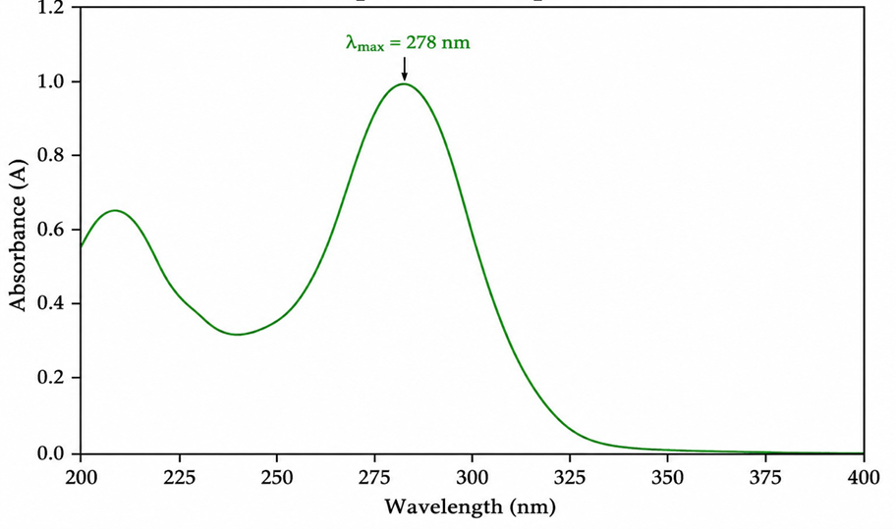
Fig No 2: UV Spectrum of Apixaban at 278 nm
Discussion: The Apixaban analysis using a light test showed a big peak at 278 nm when we used the right liquid. This peak is from the way the molecules, in Apixaban are arranged. It helped us measure how much of the drug was present. The graph we got was clear. Always looked the same which means the Apixaban sample we used was pure and the method we used was good enough to use again in other studies. We used this method to learn more about Apixaban.
Standard Calibration Curve:
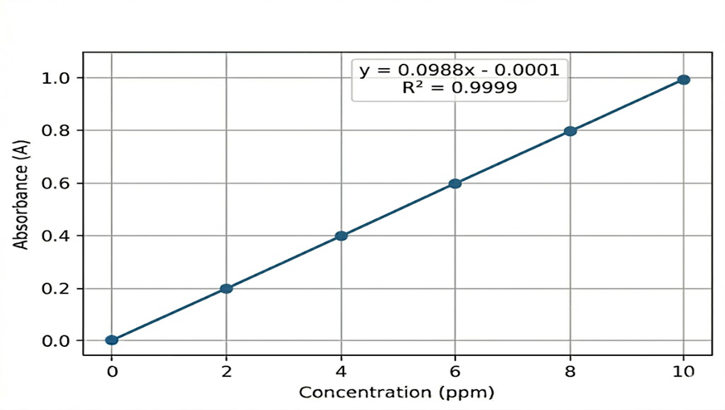
Fig No: 3 Standard Calibration Curve

Discussion: The calibration curve of apixaban was made by using the amounts of apixaban at 278 nm. We saw that the amount of apixaban and how much it was absorbed were connected in a line. This follows the rules of Beer-Lambert’s law. The connection is very strong, with a correlation coefficient of about 0.999. This means the method of measuring apixaban is good and can be trusted to give the results for the amount of apixaban in a sample.
IR Spectra of Apixaban:
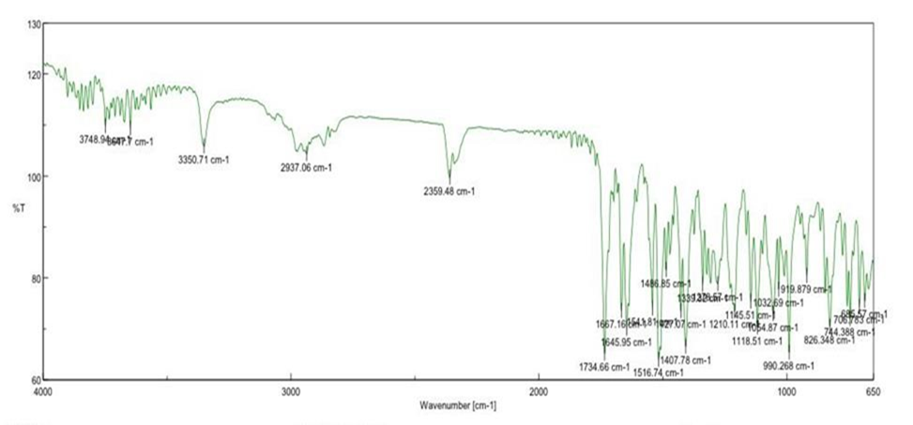
Fig No 4: IR Spectra of Apixaban
Discussion: The IR spectrum of apixaban has some peaks that match its different parts. There is a peak at around 3300 cm⁻¹ and that shows N–H stretching. The peaks at 1650 cm⁻¹ are from C=O stretching of amide groups. Apixaban also has peaks at around 1600 cm⁻¹, which's from aromatic C=Cheh peaks, between 1200–1300 cm⁻¹ show C–N stretching and that proves apixabans core structure is there. The IR spectrum of apixaban shows these peaks. They help identify apixaban.

Flow Properties of Microsphere:

Parameter | Bulk Density (gm/ml) | Tapped Density (gm/ml) | Angle of Repose | Hausner’s Ratio
F2 | 0.48 ±0.02 | 0.60±0.01 | 27.12±0.45 | 1.25±0.03
F3 | 0.50 ±0.01 | 0.61±0.02 | 26.45±0.38 | 1.22±0.04
F4 | 0.52 ±0.03 | 0.64±0.01 | 28.30±0.52 | 1.23±0.02
F5 | 0.54 ±0.02 | 0.66±0.02 | 29.10±0.60 | 1.22±0.03
F6 | 0.56 ±0.01 | 0.68±0.01 | 27.85±0.41 | 1.21±0.02
F7 | 0.65±0.04 | 0.69±0.02 | 28.20±0.41 | 1.20±0.02
Table No.4 Flow Properties of Microsphere
Discussion: Formulations F1–F6 show good flow properties with angle of repose below 30° and Hausner’s ratio around 1.20–1.25. Bulk and tapped density increase gradually, indicating better packing.

Evaluation of Microspheres:
Parameter | Particle size (µm) | Percentage Yield (%) | Entrapment Efficiency (%) | Drug Content (%) | Zeta Potential (mV) | Swelling Index
F2 | 180 ± 8 | 68.2 ± 2 | - | - | -12.5±1.1 | 82.2±2.3
F3 | 260 ± 10 | 73.6 ± 2.3 | - | - | -16.2±1.2 | 98.6±2.8
F4 | 360 ± 12 | 77.8± 2.5 | - | - | -20.1±1.5 | 115.2±3.2
F5 | 220 ± 10 | 74.5 ± 2.2 | 70.4 ± 2.1 | 78.4 ± 1.2 | -14.8±1.2 | 92.7±2.6
F6 | 310 ± 11 | 86.8 ± 2.8 | 84.6 ± 2.5 | 91.6 ± 1.0 | -25.2±1.7 | 118.5±3.4
F7 | 420 ± 15 | 80.3 ± 2.6 | 79.2 ± 2.3 | 86.8 ± 1.4 | -23.0±1.6 | 138.6±3.8
Table No.5 Evaluation of Microspheres Discussion:
Particle size and percentage yield increased from F1 to F6 indicating improved microsphere formation. Drug-loaded batches (F4–F6) showed good entrapment efficiency and high drug content. This suggests effective incorporation of drug and better formulation performance in later batches.
In Vitro Drug Release Study:
Time | F5 | F6 | F7
1 | 12.5 ± 1.0 | 14.2 ± 1.1 | 10.8 ± 0.9
2 | 22.8 ± 1.2 | 26.8 ± 1.3 | 20.4 ± 1.1
4 | 40.6 ± 1.5 | 45.6 ± 1.5 | 36.2 ± 1.4
6 | 58.2 ± 1.7 | 61.3 ± 1.7 | 52.8 ± 1.6
8 | 72.4 ± 1.6 | 74.8 ± 1.6 | 66.5 ± 1.5
10 | 82.7 ± 1.4 | 85.6 ± 1.4 | 78.2 ± 1.3
12 | 88.9 ± 1.3 | 92.4 ± 1.3 | 85.6 ± 1.2
Table No.6 Dissolution Study

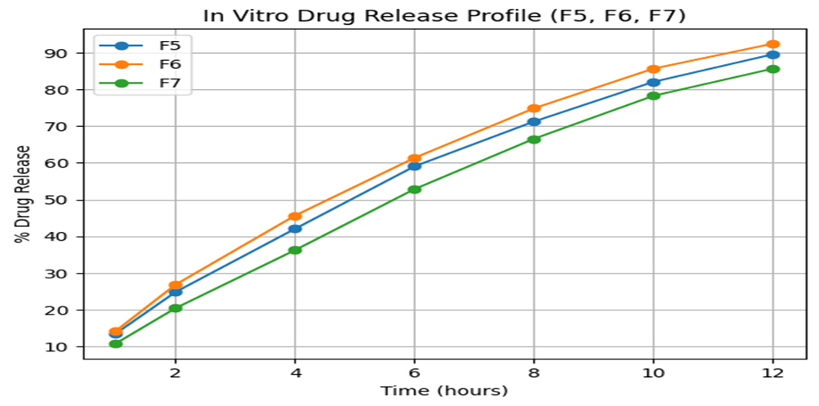
Fig. No 5 In Vitro drug release from microsphere
Medium used: Phosphate buffer pH 6.8

Discussion: At first Apixaban was released a little at a time. This showed that it did not release much all, at once. Then it kept releasing more Apixaban. This steady release happened because Apixaban moved out of the polymer mix. For the spheres Apixaban release lasted 12 hours. This showed that the Apixaban release was controlled. When the tiny spheres were pressed into tablets, the best formulation, F6 released Apixaban over a time. It released all of the Apixaban about 92% in 24 hours. This means it can be taken once a day and still work well. The way Apixaban was released may be because of two things the polymer getting bigger and soaking up liquid and Apixaban moving out of the polymer mix. This mix of things helped Apixaban release happen steadily. The Apixaban release was. Steady. The Apixaban release happened over a time.
Evaluation of Tablets:
Formulation | F1 | F2
Thickness (mm) | 3.8± 0.05 | 3.9±0.04
Diameter (mm) | 8.0±0.03 | 8.0±0.02
Hardness (kg/s) | 4.8±0.12 | 5.6±0.10
Weight Variation (mg) | 199±3 | 200±2
Friability (%) | 0.82±0.04 | 0.48±0.03
Table No.7 Evaluation of Tablets

F2 shows better characteristics for a controlled-release microsphere-loaded tablet due to:
• higher hardness,
• lower friability,
• and better weight uniformity,
indicating improved mechanical strength and tablet stability.

In vitro Dissolution Study (Tablet)

Time (hrs.) | % Drug Release
1 | 12.5
2 | 21.8
4 | 40.6
6 | 57.8
8 | 72.3
10 | 85.6
12 | 95.8
Table No.8 In-vitro Dissolution Study (Tablet)

Discussion:
The microsphere loaded tablets released the drug in a steady way over 12 hours. At first 12.5 percent of the drug was released after 1 hour. By the end of 12 hours the microsphere loaded tablets had released 95.8 percent of the drug. This shows that the microsphere loaded tablets can deliver the drug over a period of time. The microsphere loaded tablets did not release the drug, at once which is what we want for controlled release therapy. The microsphere system is a way to give people the drug they need in a slow and steady way.
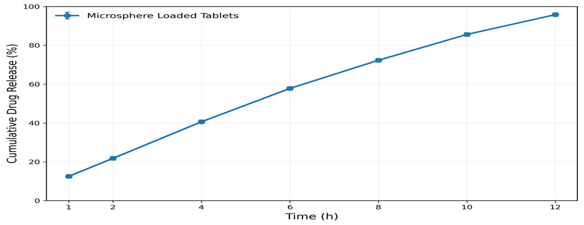
Fig No.6 In Vitro drug release from tablet

Conclusion:
This study was done to make and test apixaban loaded microspheres that are in controlled release tablets. These tablets were made using a method called ionic gelation technique. The microspheres that were made had properties like the right size and the amount of apixaban in them. They also worked well when they were made into tablets. The tablets had the hardness and were not too thick or too thin. They were also the weight. One of the batches of tablets was better than the others. Had the best properties. This batch was chosen to do tests to see how the apixaban is released from the tablets. The loaded microspheres, in this batch were very good and the tablets made from them were very good too. The apixaban loaded microspheres were used to make the controlled release tablets.
The study on how the tablet breaks down showed that the special tablet with balls inside it can give a steady and controlled release of the drug for up to 12 hours. This tablet can help keep the amount of drug in the blood at a level. It can also reduce the ups and downs that happen with tablets. The tablet can be taken often and that makes it easier for patients to take their medicine. The way we made the tiny balls was simple and did not use any solvents. This is good for drugs like apixaban that're sensitive. The tablet with the balls is a good way to make the drug work better and safer for people with blood clot problems. The microsphere loaded tablet is an idea for helping people with blood clots. The microsphere loaded tablet can make the drug work better. Be safer for people, with thromboembolic disorders.
References:

- Apixaban versus warfarin in patients with atrial fibrillation Granger CB, Alexander JH, McMurray JJV, Lopes RD, Hylek EM, Hanna M, et al. Apixaban versus warfarin in patients with atrial fibrillation. N Engl J Med. 2011;365(11):981–92.
- Apixaban prescribing information Bristol-Myers Squibb Company. Apixaban prescribing information. Princeton (NJ): Bristol-Myers Squibb; 2021.
- Modern Pharmaceutics Banker GS, Rhodes CT. Modern pharmaceutics. 4th ed. New York: Marcel Dekker Inc.; 2002.
- Aulton’s Pharmaceutics: The Design and Manufacture of Medicines Aulton ME, Taylor K. Aulton’s pharmaceutics: the design and manufacture of medicines. 5th ed. London: Elsevier; 2018.
- Targeted and Controlled Drug Delivery: Novel Carrier Systems Vyas SP, Khar RK. Targeted and controlled drug delivery: novel carrier systems. 1st ed. New Delhi: CBS Publishers; 2002.
- Controlled and Novel Drug Delivery Jain NK. Controlled and novel drug delivery. 1st ed. New Delhi: CBS Publishers; 2008.
- Siepmann J, Peppas NA. Modeling of drug release from delivery systems based on hydroxypropyl methylcellulose (HPMC). Adv Drug Deliv Rev. 2012; 64:163–74.
- Patel JK, Patel RP, Amin AF. Formulation and evaluation of mucoadhesive glipizide microspheres. AAPS PharmSciTech. 2005;6(1): E49–55.
- Indian Pharmacopoeia Indian Pharmacopoeia Commission. Indian pharmacopoeia. Ghaziabad: IPC; 2018.
- United States Pharmacopeia 43–National Formulary 38 United States Pharmacopeial Convention. United States Pharmacopeia 43–National Formulary 38. Rockville (MD): USP; 2020.
- Singh C, Purohit S, Singh M, Pandey BL. Design and evaluation of microsphere. J Drug Deliv Res. 2013; 2:18–27.
- Yenubothula S. Formulation and in vitro evaluation of rivaroxaban microspheres. World J Pharm Sci. 2025;13(2):1–250.
- Blann AD, Lip GYH. Non-vitamin K antagonist oral anticoagulants (NOACs) for the management of venous thromboembolism. Heart. 2016; 102:975–9.
- Hirschl M, Kundi M. New oral anticoagulants in the treatment of acute venous thromboembolism—a systematic review within direct comparisons. Vasa Eur J Vasc Med. 2014; 43:353–64.
- Jadhav KR, Kadam VJ, Pisal SS. Formulation and evaluation of microspheres: an overview. Int J Pharm Tech Res. 2009;1(3):478–84.
- Gholap SB, Banarjee SK, Gaikwad DD, Jadhav SL, Thorat RM. Hollow microsphere: a review. Int J Pharm Sci Rev Res. 2010;1(1):74–79.
- Soppimath KS, Aminabhavi TM, Kulkarni AR, Rudzinski WE. Biodegradable polymeric nanoparticles as drug delivery devices. J Control Release. 2001;70(1–2):1–20.
- Dash S, Murthy PN, Nath L, Chowdhury P. Kinetic modeling on drug release from controlled drug delivery systems. Acta Pol Pharm. 2010;67(3):217–23.
- Higuchi T. Mechanism of sustained-action medication: theoretical analysis of rate of release of solid drugs dispersed in solid matrices. J Pharm Sci. 1963;52(12):1145–49.
- World Health Organization World Health Organization. Guidelines for the prevention and treatment of thromboembolic disorders. Geneva: WHO; 2020.

