Intelligent Plant Watering System

Mr. Manas S Tambekar Electronics and Telecommunication Vishwakarma Institute of Technology Pune, India
manas.1252100003@vit.edu
Ms. Sanjana U. Joshi Electronics and Telecommunication Vishwakarma Institute of Technology
Pune, India sanjana.1252100010@vit.edu
Mr. Ajay Raina Electronics and Telecommunication Vishwakarma Institute of Technology
Pune, India ajay.1252100006@vit.edu
Mr. Sunil Tayde
Electronics and Telecommunication Vishwakarma Institute of Technology Pune, India
Sunil.tayde@vit.edu

Abstract— Efficient and proper control of water supply through an effective and proper irrigation system is vital to maintain the growth and development of plants and save water too from wast- age, as improper utilization of water leads to wastage through tra- ditional watering methods, such as manual watering, which causes overwatering and underwatering of vegetation. In this paper, an IoT-based intelligent plant watering system with the ESP32 smart microcontroller is proposed to implement an automated and effi- cient system involving proper control and maintenance of plant growth, which includes the integration of a capacitive sensor to as- sess the moisture level and pH sensor module to assess the soil health of the associated plant with the proposed system. The ESP32 significantly enables effective control and automation, as proper control of moisture levels with the activation of a DC water pump connected through a relay is maintained when moisture lev- els drop below the set threshold levels, and the pump will be switched off when moisture levels are appropriately achieved, as the ESP32, which supports WiFi, facilitates discrete transmission of moisture levels and pH values to the proposed dashboard sys- tem.
Index Terms— Intelligent Irrigation System, IoT, ESP32, Soil Moisture Sensor, Soil pH Monitoring, Automatic Water Pump Control, Smart Agriculture, Real-Time Monitoring.
- Introduction
Water management is very efficient for plant growth and de- velopment. For better plant growth and development, a certain quantity of water is very necessary. Watering crops may be done by simply observing and following a routine schedule. This might not be enough since it does not consider the exact condition of the soil. This may lead to over- or underwatering and reduction in soil nutrients. For water-scarce countries or regions, watering practices may influence or affect plant growth.
The recent advancements in embedded system technology and Internet of Things (IoT) have made the implementation of intelli- gent monitoring systems popular among the farming sector as well as domestic gardening practices. IoT technology helps con- nected devices to fetch data in real-time from various sensors, process the information using microcontrollers, and provide ac- cess to the data on the cloud. Smart irrigation systems work on the same principle.system can provide plants with adequate water at suitable times.
Among the various microcontrollers, ESP32 has received sig- nificant attention for its high processing capacity, low power con- sumption, and the presence of inbuilt wifi. By utilizing different
types of soil sensor kits, which may include moisture and pH, the system has the ability to control all operations through ESP32. In other words, by using moisture and pH measurement, the required water supply to the plants can be ensured, and healthiness of the soil can be maintained.
This Paper aims to explain the design and implementation of Intelligent Plant Watering System using ESP32 and IoT tech- nology. The system is proposed as such that it would automati- cally control the water pump depending on the soil moisture levels, as well as send real-time data to the web dashboard. The system would reduce human intervention, save water, effective- ly manage plant health, and promote smart agriculture by using IoT technology.
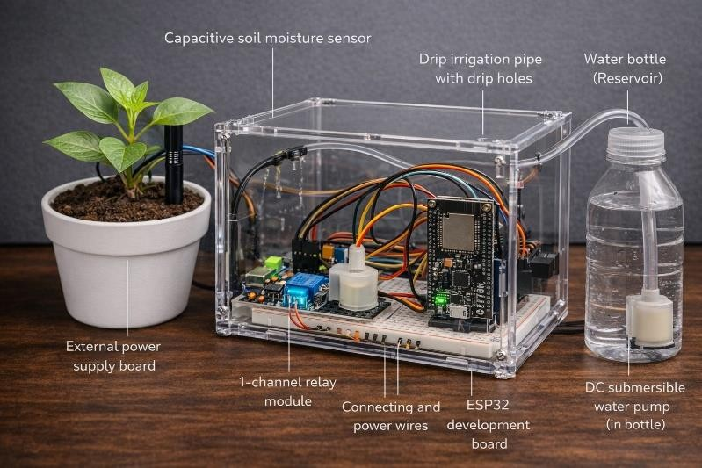
Fig. 1. Intelligent Plant Watering System

LITERATURE REVIEW
The idea of automation for irrigation systems has been receiv- ing significant interest in recent years due to the rising demand for efficient management systems. The first automated system developed for watering plants was achieved through the imple- mentation of basic microcontrollers, as well as Arduino, paired with a sensor for checking moisture levels within the soil. The automated systems implemented could control a water pump when it detected a fall in the moisture levels to a certain thresh- old.
With the development in embedded systems, researchers were able to integrate wireless modules in embedded systems, thereby

facilitating the remote monitoring of the irrigation system. The use of WiFi microcontrollers helped in the transfer of the sensor data to the cloud, where the soil condition could be monitored using web-based platforms or mobile apps. The convenience of the system increased remarkably.
Some studies aimed at improving the accuracy of irrigation by improving the reliability and calibration methods of the sensors. Capacitive sensors replaced the resistive sensors due to their longer lifespan and the fact that they, unlike the resistive sensors, were less susceptible to corrosion. The calibration of the sensors' readings was deemed necessary to prevent over-irrigation, which harmed the roots of the plants.
Another aspect emphasized by recent research involves moni- toring various parameters like temperature, humidity, and pH value in the soil. The pH value of soils is an important aspect with respect to nutrient absorption by plants, as both higher acidi- ty and higher alkalinity can affect plant development in certain ranges. However, current automated systems implemented mostly address only moisture levels.
Additionally, IoT-based smart agricultural systems have incor- porated cloud storage and data visualization technologies to ana- lyze long-term trends of soils. This helps users remotely monitor the states of their plants, thus optimizing watering schedules via past trends. MICROCONTROLLERS FOR BUILDING INTEL- LIGENT SMART FARMING SYSTEMS: ESP32, an IoT micro-
controller, has offered compact and affordable technologies for the development of intelligent systems due to its enhanced capa- bilities and presence of WiFi connectivity in the chip.
The proposed Intelligent Plant Watering System enhances the concept based on the developments in the field, considering the integration of automatic watering based on the water content of the soil, soil pH monitoring, and the integration of the cloud dashboard in real time using ESP32.

SYSTEM DESIGN
The Intelligent Plant Watering System is composed of both hardware and software components. The main components in- clude the ESP32 microcontroller, capacitive soil moisture sensor, soil pH sensor module, relay module, DC water pump, and power supply. It is designed to monitor the condition of the soil and supply water automatically.
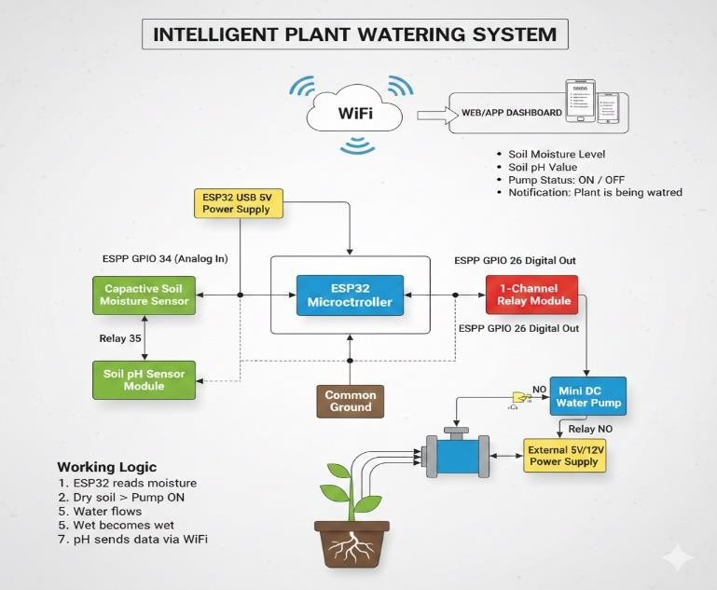

Fig. 2 Block Diagram of the System
The capacitive soil moisture sensor detects whether the soil is dry or wet and sends analog data to the ESP32 through GPIO 34. The pH sensor detects the acidity and alkalinity of the soil, sending its analog data to GPIO 35. These values are continuously processed by the ESP32 to determine the appro- priate irrigation action.
The relay module is connected to GPIO 26 of the ESP32 and acts as an electronic switch for the water pump. When the soil moisture level falls below the predefined threshold, the ESP32 sends a signal to activate the relay, turning the pump ON. Once sufficient moisture is detected, the relay is deactivated automatically, turning the pump OFF.
The ESP32 transmits soil moisture level, pH value, and pump status to a web dashboard through its onboard WiFi module. This allows users to remotely monitor plant condi- tions using a smartphone or computer, ensuring efficient irri- gation management and real-time status updates.

METHODOLOGY
The Intelligent Plant Watering System entails the integration of several hardware and software components aimed at ensuring effective and automatic watering of plants, as well as the provi- sion of real-time monitoring capabilities. The ESP32 acts as the CPU core, which includes receiving sensor data from the soil moisture and pH sensors, calculating the results, and then send- ing the output to the cloud dashboard through WiFi communica- tions. The system monitors the soil and makes automatic deci- sions to switch the water pump on or off based on the set thresh- old values, thus ensuring effective and optimal conditions neces- sary for plant growth without manual interference.

- System Overview
The system can monitor the soil’s moisture levels as well as the pH levels of the soil in real time, which can further enable the con- trol of the irrigation system based on the soil’s condition. The ca- pacitive sensor can identify the soil’s condition as wet or dry, and it will send analog values to the ESP32. The pH sensor can identify the acidity or alkalinity of the soil, thus enabling the
monitoring of the health of the soil. The ESP32 module can con- trol the relay module, which is connected to the DC water pump, depending on the values from the capacitive soil sensor. Moreo- ver, the ESP32 module can send the values of the soil sensor to the web interface via WiFi, which can display the condition of the pump as well as send notifications such as “Plant is being watered.”

- Hardware Implementation
The hardware configuration includes ESP32 microcontroller, Capacitive Soil Moisture Sensor, Soil pH Sensor Module, 1 Channel Relay Module, mini DC water pump, tubes, power supply, and wires. The Capacitive Soil Moisture sensor module is connected to GPIO34 on the ESP32 (Analog Input), while the Soil pH Sensor Module is connected to GPIO35 on the ESP32 board. The 1 Channel Relay Module is connected to GPIO26 on the ESP32 board, which controls the external power source to switch on the water pump. A common grounding point is main- tained for all the hardware devices to ensure smooth operation. The hardware devices are integrated using a breadboard for

compact size.

- Software Implementation
  - ESP32 Programming
The ESP32 microcontroller is operated by the Arduino Inte- grated Development Environment, where embedded C/C++ codes are developed to carry out sensor data acquisition, pro- cessing, decision-making, and control operations. The software is designed to constantly read the analog values from the capac- itive-type soil moisture sensor, connected to GPIO34, and the soil pH sensor module, connected to GPIO35. The continuous analog values obtained from these sensors are processed to ob- tain meaningful values depending on these parameters. Depend- ing on the threshold values entered into the program, various decisions, whether to irrigate or not, are made by connecting or disconnecting the relay module, connected to GPIO26.
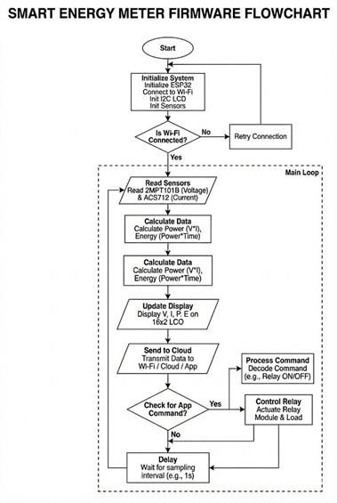
Fig. 3. Working Flowchart of the System

The program comprises a constant loop that ensures real- time monitoring of the soil. The WiFi credentials and cloud API keys are hard-coded into the firmware, thereby allowing secure communication between the ESP32 board and the remote dashboard. Additionally, the program comprises au- tomatic WiFi re-connection mechanisms, error-checking fa- cilities, time-stamped data transmission, amongst other func- tionalities. This ensures the system operates normally throughout its time of use.
    - Web Dashboard / App Development
The interface to monitor the condition is designed in the format of a web application, which can be accessed through any device with an internet connection. The dashboard displays soil moisture lev- els, soil pH values, and the pump states (ON/OFF). The data is updated dynamically, and users can view changes in soil condi- tions in real time using a smartphone, tablet, or computer from any location.
The interface is intended to be simple, interactive, and visually comprehensible to improve usability. Features such as soil status notifications (e.g., “The plant is being watered”), threshold detec- tion indicators, and historical data visualization can be imple- mented as added advantages. With remote access and real-time
visualization of soil parameters, the system ensures transparency and eliminates the need for physical monitoring.
- Communication Protocol
The system utilizes WiFi communication between the ESP32 and the cloud server via HTTP and/or MQTT protocols. Sensor readings are formatted as structured data packets, typically in JSON format, and transmitted at regular time intervals to ensure continuous moni- toring.
With MQTT protocol, publish–subscribe functionality enables the ESP32 to publish sensor data to a cloud broker efficiently, while HTTP requests are used for structured data updates and retrieval. This bidirectional communication framework ensures synchroniza- tion between the hardware system and the cloud platform.
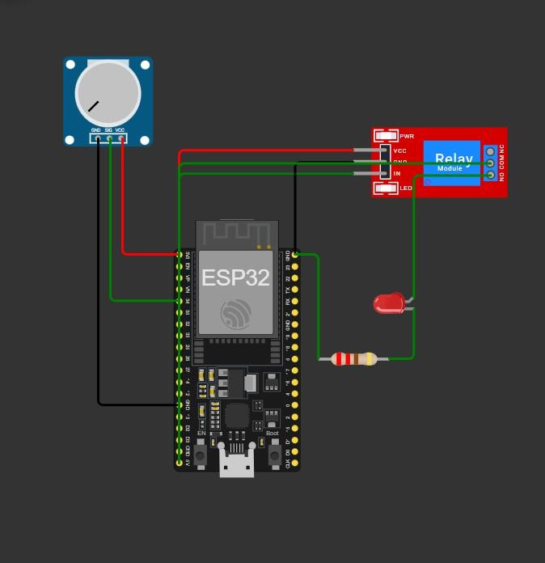

Fig. 4. Hardware Implementation Setup

This architecture guarantees stable and reliable cloud connectivity, ensuring that users receive accurate and real-time updates regarding soil conditions and irrigation status

ADVANTAGES AND FUTURE SCOPE
- Advantages
- Automated Irrigation: The system waters the plants automati- cally using real-time soil moisture levels. This saves time as there is no need to monitor the moisture level to water the plant.
- Water Conservation: Since it will function when the soil mois- ture levels drop below a predetermined point, cases of over- watering will be avoided, thus ensuring proper use of water.
  - Soil Health Monitoring: The integration of a soil pH sensor makes it possible to measure the level of soil acidity and al- kalinity. Sustained pH levels are essential for nutrients and plant growth. • Remote Monitoring: Users can monitor the moisture level and the pH value through the ESP32 integrat- ed Wi-Fi system, and the status of the pump can be seen from any location through the webpage. • Low Cost and Scalabil- ity: The system features affordable parts, and the design can be easily expanded up to multiple plants.

- Future Scope
    - Integration of Additional Sensors: The enhancements may include temperature, humidity, and light sensors, which will make the smart agricultural system more comprehensive. Increasing the number of monitoring parameters will make environmental control more precise.
    - Machine Learning-Based Irrigation: Predictive algorithms can actually be implemented to dynamically optimize wa- tering schedules based on historical data about the soil.
    - Mobile Application Development: A dedicated app for mo- bile devices, providing immediate notifications for changes in soil conditions, can be developed by implementing the feature of sending notifications. • Solar-Powered Operation: The system can be integrated with solar panels to enable the system to be energy-efficient and appropriate for use in ru- ral agriculture areas due to the limited power supply. • Cloud Data Analytics: Long-term cloud storage and analyt- ics can aid in determining the growth of plants, soil, or wa- ter, thus facilitating the decision-making process in agricul- ture.
water supply once the required moisture level is achieved. Additionally, the pH sensors were generating stable values, confirming proper soil health monitoring.

- Cloud Data Monitoring
To check how well remote monitoring works, the system was linked with a cloud platform for continuous data logging and visualization. The ESP32 sent soil moisture percentage, pH value, and pump status to separate cloud fields through WiFi communication at regular intervals. Each data point was saved with a time stamp for the precise follow, up.
The chart on the web page ascertained that during watering the moisture sensor readings got changed slowly and the pump status got updated immediately. There was no packet loss or delay in the transmission. The cloud platform was able to show the time, series graphs of changes in soil moisture
and pH levels.

Fig. 6 illustrates the soil moisture and Ph level data kept on the cloud platform.

RESULTS AND DISCUSSION
- Result
The IoT-based Intelligent Plant Watering System was subjected to several tests with varying soil moisture levels to assess the accuracy of the system’s response to a situa- tion, the pump control efficacy of the system itself, and the reliability of the system’s real-time cloud communication. The results of the test will be based on the extent of the accuracy of moisture detection by the system, the automat- ic pump response to the moisture detected by the system
1) Hardware Output:
The device was tested by placing the moisture sensor in dry soil, moderately moist soil, and fully wet soil condi- tions. The readings were taken by observing the analog voltage readings. The ESP32 module successfully turned ON the relay module and the DC pump when the soil moisture value fell below the threshold. The pump got au- tomatically switched OFF when the soil moisture value reached the desired level. As illustrated in the Table, the system is very precise in recording voltage, current, and power for various household loads. The computed energy consumption (kWh) along with the billing amount based on the meter.

Fig. 5. Hardware Output of System

TABLE I Experimental Results of System

Soil Condition | Moisture Value (%) | pH Value | Pump Status
Dry Soil
Moderate Soil
Wet Soil

From the table above, it is evident that the system can effi- ciently detect the soil status and react accordingly. It should only run the pumps during dry conditions and cut off the
From these experiments, we can infer that stable WiFi con- nectivity and reliable IoT communication between hardware and cloud infrastructure have been achieved.

- Mobile / Web Dashboard Output
The mobile app/control panel shows the current soil moisture level as a percentage, the soil's pH value and the working sta- tus of the pump (ON/OFF). It was noticed during the experi- ments that each time the pump was turned on the dashboard showed the change of the pump status at once. Also, the dash- board moisture and pH levels got updated automatically with- out any noticeable delay.
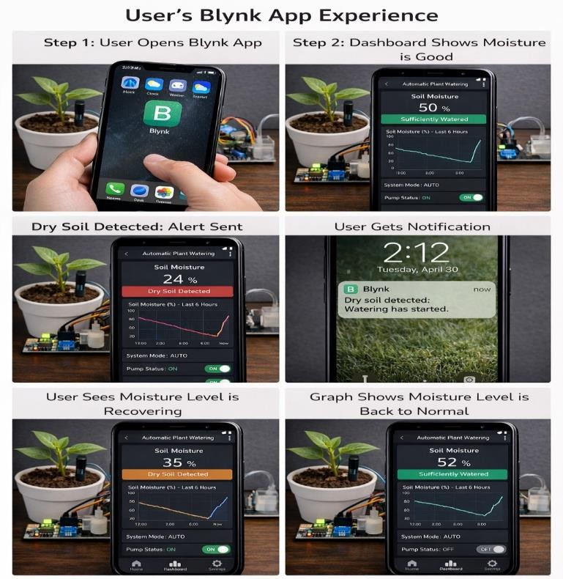

Fig.7. illustrates the control panel of the application showing live soil parameters.

The app is intended for an easy and intuitive understanding of the soil condition at any time. A successful alignment of the ESP32 and the dashboard proves the capability of the real, time IoT, based plant monitoring system.

- Discussion:

  - Analysis of Irrigation Accuracy and Control Response. The experimental data in Table I clearly show that the sys- tem quickly and accurately reacted to changes in soil moisture. At 28% moisture, the pump was switched on without any delay. Irrigation continued until the soil mois- ture reached 45% and above at which point the pump went off by itself. Hence, it is proved that the threshold, based control algorithm is free from errors in triggering the con- trol actions. The soil moisture levels kept going up during irrigation showing that the water was well absorbed by the soil and the sensors were running normally. Capacitive moisture sensor readings were stable, without any drop in accuracy due to corrosion problems that usually occur in resistive ones. At the same time, pH values stayed in the normal range for agriculture (6. 5, 6. 8), confirming that soil health monitoring remained stable. The system logic transitions were so regular and accurate that plants didn't get too much water or lack it. Thus, the use of ESP32 for remote watering control has been proven successful. 2) System Latency and IoT ReliabilityOne of the key param- eters of an IoT irrigation system is the delay between the physical soil moisture level change and the update on the dashboard reflecting that change. It was noticed during the performance evaluation that the time lapse from the detec- tion of soil moisture level going beyond the threshold to the relay turning over was less than one second. Likewise, the data sent to the cloud could be seen or accessed in just about no time. The time, series cloud graphs showed con- tinuous data.

CONCLUSION

The Intelligent Plant Watering System using ESP32 and IoT presents an efficient solution to automate the irriga- tion and monitoring of the plant's soil. The proposed sys- tem successfully integrates the moisture sensor, pH sen- sor, relay module, pump, and cloud-based real-time data transmission. The experimental results proved that the system was reliable, efficient, and cost-effective, making it suitable for IoT-based smart agriculture. The proposed project presents one of the efficient solutions for modern- izing traditional farming habits using IoT technology.

REFERENCES

- S. R. Nandurkar, V. R. Thool, and R. C. Thool, “Design and De- velopment of Precision Agriculture System Using Wireless Sensor Network,” IEEE International Conference on Automation, Con- trol, Energy and Systems, pp. 1–6, 2014.
- N. Jain, S. Singhal, and S. Bhatia, “Smart Irrigation System Using IoT,” IEEE International Conference on Communication and Sig- nal Processing, pp. 1–5, 2018.
- K. Lakshmisudha, S. Hegde, N. Kale, and S. Iyer, “Smart Preci- sion Based Agriculture Using Sensors,” International Journal of Computer Applications, vol. 146, no. 11, pp. 1–6, 2016.
- A. Kumar and G. P. Hancke, “Energy Efficient Environment Moni- toring System Based on the IEEE 802.15.4 Standard for Low Cost Requirements,” IEEE Sensors Journal, vol. 14, no. 8, pp. 2557–2566, 2014.
- M. R. Shukla and P. Sharma, “Automated Irrigation System Using Microcontroller and Soil Moisture Sensor,” International Conference on Advances in Computing and Communication Engineering, pp. 1– 4, 2017.
- A. Raut, V. Varma, C. Mulla, and P. Pawar, “IoT Based Smart Irriga- tion System Using ESP8266,” International Journal of Innovative Re- search in Computer and Communication Engineering, vol. 5, no. 3,
pp. 1–7, 2017.
- D. Gutierrez, J. F. Villa-Medina, A. Nieto-Garibay, and M. A. Porta- Gandara, “Automated Irrigation System Using a Wireless Sensor Network and GPRS Module,” IEEE Transactions on Instrumentation and Measurement, vol. 63, no. 1, pp. 166–176, 2014.

